CCSDS Order of processing for Telecommand using SDLS[1].docx
5/08/21
G. Kazz

CCSDS Order of processing for Telecommand User Data Frames using SDLS (Sequential with Figure 6-3):

On the Ground: (sending side)
1. Virtual Channel Generation Function with SDLS | 232.0-B-3 | 6.4.2.1
Frame Initialization Procedure  The Frame Initialization Procedure generates a (partial) TC Transfer Frame for the Frame Data Unit. The (partial) frame includes Transfer Frame Primary Header, provision for the Security Header, Transfer Frame Data Field and for optional Security Trailer. | Future 232.0-B-3 | 6.4.2.1
2. SDLS ApplySecurity Function | 232.0-B-3 | - (b)
Encrypt only the Transfer Frame Data Field | 355.0-B-1 | 4.2.3.3
Populate the optional Security Trailer with the computed MAC*(Authentication only) | 355.0-B-1 | 4.2.3.4
3. FOP-1 (Frame Operation Procedure) | 232.0-B-3 | 4.3.5.3
Frame Finalization Procedure (within VC Generation Function) | 232.0-B-3 | 4.3.5.4
. Virtual Channel Multiplexing Function | 232.0-B-3 | 4.3.6
. Master Channel Multiplexing Function | 232.0-B-3 | 4.3.7
. All Frames Generation Function | 232.0-B-3 | 4.3.8
Compute and add CRC to FECF | 232.0-B-3 | 4.3.8.2
7. Encode & Randomize the Transfer Frame (When BCH encoding, Randomization is done first; the opposite for LDPC) | 231.0-B-3 | 3 (BCH) or 4 (LDPC); 6
8. Modulate onto Subcarrier/Carrier and transmit | 401.0-B-31 | 2.2

Notes: * MAC (authentication) is computed over Masked TF Header, Complete Security Header, Complete Frame Data Field.

-Space Link –

On the Spacecraft: (receiving side)
9. Receive and Demodulate | 401.0-B-31 | 2.2
10. Decode & Derandomize the Transfer Frame (Note the order is dependent uopn the coding scheme) | 231.0-B-3 | 6.3,3.5 or 4.5
11. All Frames Reception Function with SDLS | 232.0-B-3 | - (c)
Frame Delimiting and Fill Removal Procedure (invalid code blocks reported by C&S sublayer + fill removal ) | 232.0-B-3 | 4.4.8.2
Frame Validation Check Procedure (includes optional CRC) | 232.0-B-3 | 4.4.8.3
12. Master Channel Demultiplexing Function | 232.0-B-3 | 4.4.7
13. Virtual Channel Demultiplexing Function | 232.0-B-3 | 4.4.6
14. Virtual Channel Reception Function | 232.0-B-3 | 4.4.5
15. FARM-1 (Frame Acceptance and Reporting Mechanism, subprocedure of the COP-1) | 232.0-B-3 | 4.4.5.2
16. CLCW (Command Link Control Word) downlinked in the OCF Field within either TM, AOS, or USLP | 232.0-B-3 | 4.4.5.2
17. SDLS ProcessSecurity Function | 232.0-B-3 | 6.5.2.1 (b)
Optional: Validate the MAC, if invalid, report security error in Frame Status Report into the OCF in telemetry frame | 355.0-B-1 | 4.2.4.4
Decrypt the Transfer Frame Data Field | 355.0-B-1 | 4.2.4.5
18. SDLS FSR (Frame Status Report) downlinked in the OCF Field within either TM, AOS, or USLP | 132.0-B-3  732.0-B-3  732.1-B-2 | 4.1.5.5  4.1.5.5  4.1.5.2.2
Thereafter, Frame Data Units provided to on-board processing (i.e., perform VC Packet Extraction function or MAP Demultiplexing function or VCA Service User)

Comments about the visio diagram reported here below for convenience.
- Color code is not explained. On the sending it seems there is a splitting between ited SDLS affected and items not SDLS affected. If this was the case, it should be applied consistently to receiving side.
- As the diagrams does not the “normal components” in a Fucnntion, it may be nt required to avoid showing the Frame Initialization Procedure and have it mentioned only in the textual description in the table.
- The sequence in which encoding and randomization is not important for SDLS. I suggest to have a single box named Encode & Randomize. Then readers can check details in the textual part, or a nate can state e.g. “Encode & Randomize order depends on applied coding scheme”

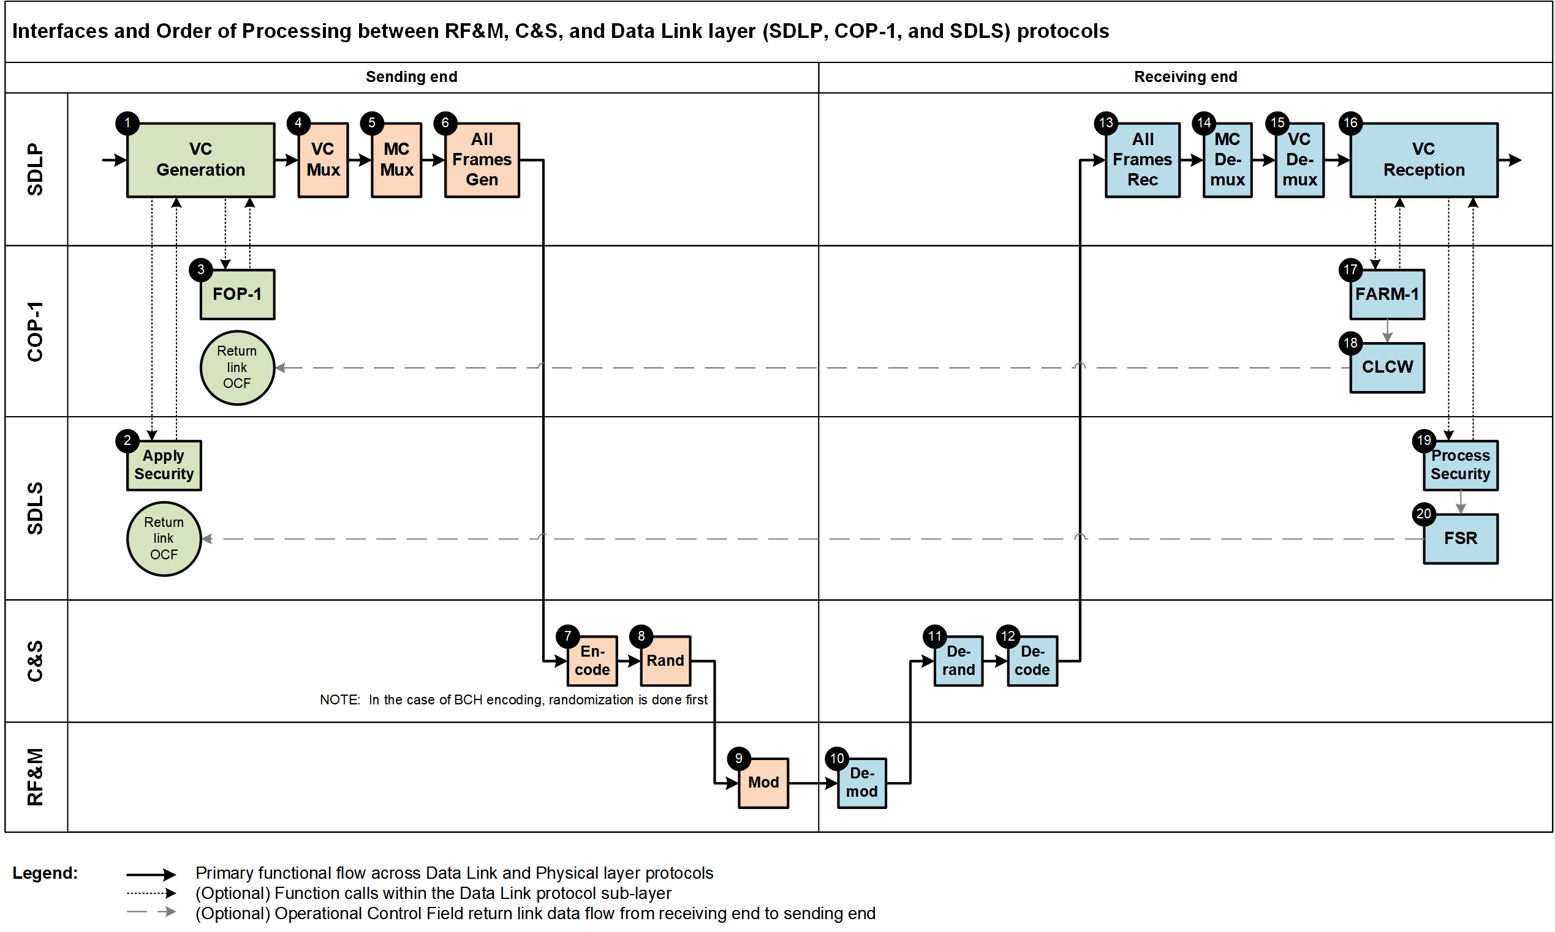

This is a Procedure required only by SDLP to accommodate the different processing required. It is not mentioned in 4.3.5.2 but it shall be mentioned in the revised 6.4.2.1. Unless the reference to 4.3.5.2 has to be intended as new addition in 355.0-B.

