

Recommendation for Space Data System Standards

|  |
| --- |
| CCSDS Recommended Procedures for Cloud based Interoperability Testing |

Proposed Draft Recommended Procedures

CCSDS xxxxx

Yellow Book

October 2016

AUTHORITY

|  |  |  |  |
| --- | --- | --- | --- |
|  |  |  |  |
|  | Issue: | Proposed Draft Recommended Procedures, Issue 1 |  |
|  | Date: | October 2016 |  |
|  | Location: | Washington, DC, USA |  |
|  |  |  |  |

This document has been approved for publication by the Management Council of the Consultative Committee for Space Data Systems (CCSDS) and represents the consensus technical agreement of the participating CCSDS Member Agencies. The procedure for review and authorization of CCSDS documents is detailed in *Organization and Processes for the Consultative Committee for Space Data Systems* (CCSDS A02.1-Y-4), and the record of Agency participation in the authorization of this document can be obtained from the CCSDS Secretariat at the e-mail address below.

This document is published and maintained by:

CCSDS Secretariat

National Aeronautics and Space Administration

Washington, DC, USA

E-mail: secretariat@mailman.ccsds.org

STATEMENT OF INTENT

The Consultative Committee for Space Data Systems (CCSDS) is an organization officially established by the management of its members. The Committee meets periodically to address data systems problems that are common to all participants, and to formulate sound technical solutions to these problems. Inasmuch as participation in the CCSDS is completely voluntary, the results of Committee actions are termed **Recommended Standards** and are not considered binding on any Agency.

This **Recommended Standard** is issued by, and represents the consensus of, the CCSDS members. Endorsement of this **Recommendation** is entirely voluntary. Endorsement, however, indicates the following understandings:

o Whenever a member establishes a CCSDS-related **standard**, this **standard** will be in accord with the relevant **Recommended Standard**. Establishing such a **standard** does not preclude other provisions which a member may develop.

o Whenever a member establishes a CCSDS-related **standard**, that member will provide other CCSDS members with the following information:

-- The **standard** itself.

-- The anticipated date of initial operational capability.

-- The anticipated duration of operational service.

o Specific service arrangements shall be made via memoranda of agreement. Neither this **Recommended Standard** nor any ensuing **standard** is a substitute for a memorandum of agreement.

No later than five years from its date of issuance, this **Recommended Standard** will be reviewed by the CCSDS to determine whether it should: (1) remain in effect without change; (2) be changed to reflect the impact of new technologies, new requirements, or new directions; or (3) be retired or canceled.

In those instances when a new version of a **Recommended Standard** is issued, existing CCSDS-related member standards and implementations are not negated or deemed to be non-CCSDS compatible. It is the responsibility of each member to determine when such standards or implementations are to be modified. Each member is, however, strongly encouraged to direct planning for its new standards and implementations towards the later version of the Recommended Standard.

FOREWORD

This document describes a best practices and lessons learned from a pilot study between the National Aeronautics and Space Administration (NASA) and the European Space Agency (ESA). The pilot study was to investigate the feasibility of performing interoperability testing utilizing cloud infrastructure. Upon successful completion of the pilot, it was decided to develop a Yellow Book documenting the best practices and lessons learned so other working groups with CCSDS could leverage cloud infrastructure to perform their interoperability tests. CCSDS working groups will be encouraged to leverage cloud based technologies going forward as it will be considered a best practice due to its effectiveness and efficiency.

This Recommended Standard is therefore subject to CCSDS document management and change control procedures, which are defined in *Organization and Processes for the Consultative Committee for Space Data Systems* (CCSDS A02.1-Y-4). Current versions of CCSDS documents are maintained at the CCSDS Web site:

http://www.ccsds.org/

Questions relating to the contents or status of this document should be sent to the CCSDS Secretariat at the e-mail address indicated on page i.

At time of publication, the active Member and Observer Agencies of the CCSDS were:

Member Agencies

* Agenzia Spaziale Italiana (ASI)/Italy.
* Canadian Space Agency (CSA)/Canada.
* Centre National d’Etudes Spatiales (CNES)/France.
* China National Space Administration (CNSA)/People’s Republic of China.
* Deutsches Zentrum für Luft- und Raumfahrt (DLR)/Germany.
* European Space Agency (ESA)/Europe.
* Federal Space Agency (FSA)/Russian Federation.
* Instituto Nacional de Pesquisas Espaciais (INPE)/Brazil.
* Japan Aerospace Exploration Agency (JAXA)/Japan.
* National Aeronautics and Space Administration (NASA)/USA.
* UK Space Agency/United Kingdom.

Observer Agencies

* Austrian Space Agency (ASA)/Austria.
* Belgian Federal Science Policy Office (BFSPO)/Belgium.
* Central Research Institute of Machine Building (TsNIIMash)/Russian Federation.
* China Satellite Launch and Tracking Control General, Beijing Institute of Tracking and Telecommunications Technology (CLTC/BITTT)/China.
* Chinese Academy of Sciences (CAS)/China.
* Chinese Academy of Space Technology (CAST)/China.
* Commonwealth Scientific and Industrial Research Organization (CSIRO)/Australia.
* Danish National Space Center (DNSC)/Denmark.
* Departamento de Ciência e Tecnologia Aeroespacial (DCTA)/Brazil.
* Electronics and Telecommunications Research Institute (ETRI)/Korea.
* European Organization for the Exploitation of Meteorological Satellites (EUMETSAT)/Europe.
* European Telecommunications Satellite Organization (EUTELSAT)/Europe.
* Geo-Informatics and Space Technology Development Agency (GISTDA)/Thailand.
* Hellenic National Space Committee (HNSC)/Greece.
* Indian Space Research Organization (ISRO)/India.
* Institute of Space Research (IKI)/Russian Federation.
* KFKI Research Institute for Particle & Nuclear Physics (KFKI)/Hungary.
* Korea Aerospace Research Institute (KARI)/Korea.
* Ministry of Communications (MOC)/Israel.
* National Institute of Information and Communications Technology (NICT)/Japan.
* National Oceanic and Atmospheric Administration (NOAA)/USA.
* National Space Agency of the Republic of Kazakhstan (NSARK)/Kazakhstan.
* National Space Organization (NSPO)/Chinese Taipei.
* Naval Center for Space Technology (NCST)/USA.
* Scientific and Technological Research Council of Turkey (TUBITAK)/Turkey.
* South African National Space Agency (SANSA)/Republic of South Africa.
* Space and Upper Atmosphere Research Commission (SUPARCO)/Pakistan.
* Swedish Space Corporation (SSC)/Sweden.
* Swiss Space Office (SSO)/Switzerland.
* United States Geological Survey (USGS)/USA.

DOCUMENT CONTROL

|  |  |  |  |
| --- | --- | --- | --- |
| **Document** | **Title** | **Date** | **Status** |
|  | CCSDS Recommended Procedures for Cloud based Interoperability Testing, Proposed Draft Recommended Procedures, Issue 1 | October 2016 | Original issue |
|  |  |  |  |
|  |  |  |  |

# introduction

## Purpose and Scope

The purpose of this document is to specify the best practices for performing inter-agency CCSDS standards interoperability testing using cloud technologies. This book contains the necessary information regarding planning, acquiring, and configuring cloud and related testing functions.

## Applicability

This yellow book applies to any CCSDS interoperability testing that requires closed loop/real time interfacing between implementations between the systems of two or more entities (e.g. agencies). For example, some standards have been tested asynchronously via sending CCSDS frames via email. A closed loop/real time interfacing example would be the transmitting data via Command Operation Procedures-1 (COP-1) where a feedback loop is required.

This yellow book applies to all entities within the CCSDS community that have the ability to utilize cloud technologies.

## Rationale

Based on the successful pilot using cloud technologies by the CCSDS Security Working Group (SWG) the CCSDS Engineering Steering Group (CESG) came to a unanimous agreement that CESG should adopt this approach as a CCSDS best practice when performing inter-agency/interoperability testing.

# Background and Motivation

During the Consultative Committee for Space Data Systems (CCSDS) Security Working Group (SWG) meeting in London in November 2014, the topic of interoperability testing between agencies was discussed. Several members of the Security Working Group described the difficulties they have had in the past performing point-to-point interoperability testing between two agencies. Therefore a more effective and efficient means to conduct interoperability testing is needed. With evolving technologies and agency polices, cloud-based technologies appears to be a viable solution to alleviate past interoperability issues between CCSDS participating agencies.

Closed looped/real time interoperability testing between CCSDS participating agencies has proven to be difficult at times due to the security implementations (i.e. Firewalls) by each agency. It has been difficult to get firewall change requests approved or new Virtual Private Network (VPN) tunnels established. Therefore a potential solution to alleviate these networking issues was to perform the interoperability tests in “the cloud”. The Space Data Link Security (SDLS) Working Group / Security Working Group (SWG) was chosen by the CESG to be a pilot for interoperability testing in the cloud. Based on the research performed, below describes the work performed and some best practices during the pilot cloud testing for CCSDS.

# Considerations for testing in the Cloud

Cloud-based technologies provide the necessary means for successfully performing interoperability testing between CCSDS agencies; however, several considerations are necessary to be successful.

This section will outline steps to be taken to be successful when using cloud-based technologies to perform CCSDS interoperability testing. The following needs to be considered when using cloud in the context of CCSDS:

* Deployment architecture
* Cloud Provider
* Cost model / Procurement Method
* Computing Resources Needed
* Virtual Machine Deployment
* Virtual Networking
* Virtual Machine Accessibility

## Cloud Deployment Architecture

Three options were considered during the pilot phase of CCSDS cloud testing. Not all of the advantages and/or disadvantages for each option are discussed in this document. Only the high level architecture is discussed with the probability of acceptance by each agency. It needs to be noted that when discussing “the cloud”, it is the publically routable cloud environments and not cloud based services hosted by government agencies behind their government firewalls. For example, the GovCloud instance within NASA is not being considered because it doesn’t solve the problem about getting firewall exceptions or separate VPNs established.

### Option # 1: Shared Virtual Machine

In this option all agencies share a single virtual machine to perform testing. The main benefit of this approach is the test environment is totally self-contained which would allow all traffic to stay within a single virtual machine instance. In the event problems occurred with interoperability testing, having it all on one machine would eliminate networking issues from the equation. However the main issue with option #1 is it would be difficult to convince the participating agencies that other agencies would have access (at the admin level) to machines containing their intellectual property. Due to these reasons, option #1 was not viable. Figure 1: Shared VM depicts option #1.

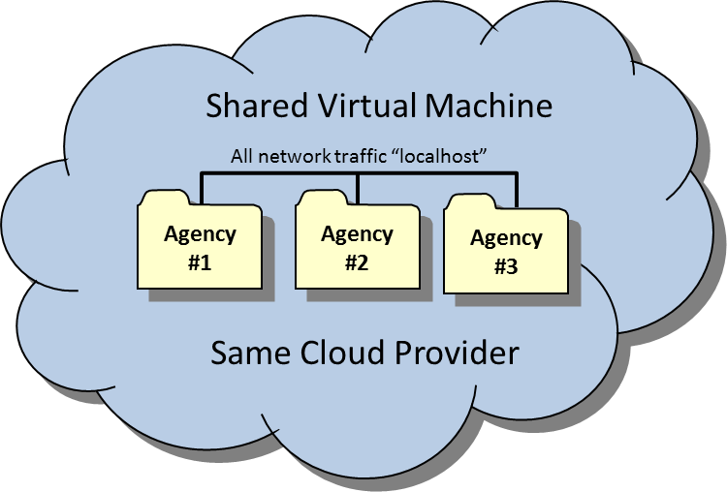

Figure 1: Shared VM Approach

### Option # 2: Shared Cloud Provider

In this option all agencies share the same cloud provider but different virtual machines to perform testing. The main benefit of this approach is the test environment is totally self-contained within a virtual private network, which would allow all traffic to stay within the virtual network. In the event problems occurred with interoperability testing, having the environments sharing a single virtual private network would eliminate networking issues from the equation. Option #2 eliminates the concerns about exposing intellectual property to other agencies; however one issue to overcome with this approach is getting the involved agencies to agree on a single cloud provider. For example, an agency may be restricted to a single provider or an agency requires a cloud provider to be certified (i.e. FEDRAMP). It may be difficult to achieve an intersection where a cloud provider is certified (i.e. FEDRAMP) and is also approved by the other participating agencies. There currently is not an internationally recognized standard for cloud technologies where a provider could get certified and it recognized by all CCSDS agencies. If agreement between any of the participating agencies can occur, option #2 would be the ideal approach. Figure 2 depicts option #2

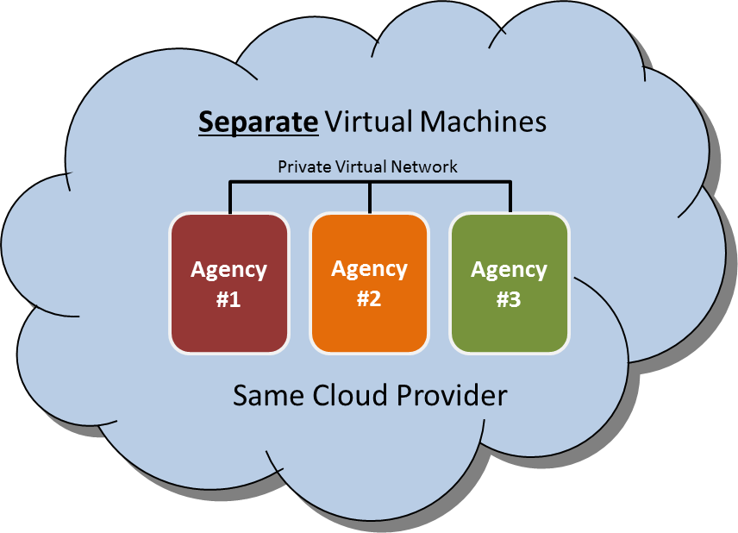

Figure 2: Shared Cloud Provider Approach

### Option # 3: Separate Cloud Provider

In this option all agencies procure their own cloud provider and maintain their own virtual machines. This approach will alleviate some of the concerns discussed in options #1 and #2. Each agency will host their environment in the cloud provider of their choosing. This approach has advantages where no agency has to come to consensus on a provider, the location of the data center isn’t an issue, and the funding mechanism can easily be handled by each participating agency. The disadvantage to this approach is the introduction of networking issues between the simulations (latency, etc.) and the use of public IP space to pass information between simulation environments. Depending on the information being exchanged, the public IP space may not be a concern. But it would need to be evaluated during the risk assessment to ensure sensitive unencrypted data isn’t being passed between agencies. For example this would not be a concern for SDLS testing because the use of the SDLS protocol will keep the information secured during transmission. Figure 3: Separate Cloud Providers Approach depicts option #3.

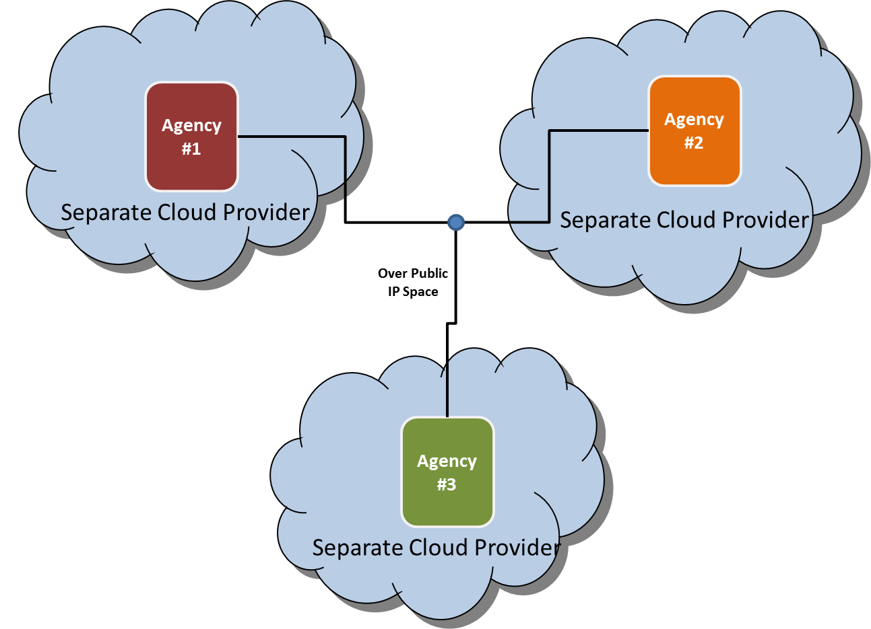

Figure 3: Separate Cloud Providers Approach

### Recommend Options

Recommendations for CCSDS projects looking to perform interoperability testing in the cloud are to utilize one of the two approaches depicted below Figure 4: Best Approaches. Utilizing the same cloud provider brings some policy challenges but also eliminates some technical challenges. An example of a policy challenge is each agency’s policy on which cloud providers can be utilized. Some agencies have a strict cloud policy while others do not and it depends on the data being hosted in the cloud.

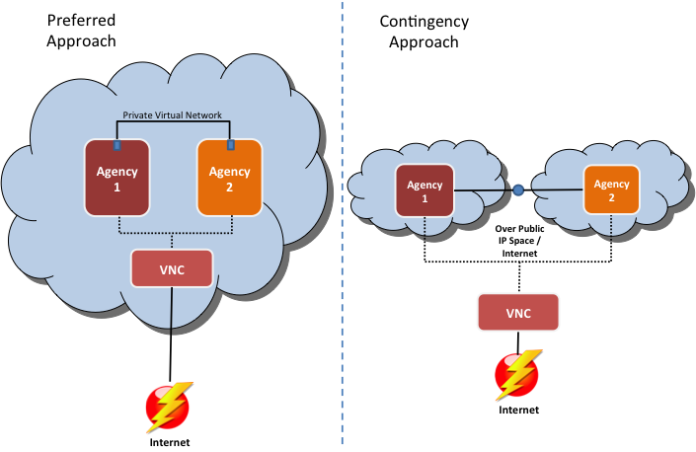

Figure 4: Best Approaches

The above depicts the two best options with the setup on the left being the preferred approach. Sharing the same cloud provider, interfacing on a private virtual network and using Virtual Network Computing (VNC) to interact with the VM is more secure (i.e. minimizes internet exposure) and eliminates technical issues that have been experienced by previous CCSDS interoperability tests. The approach depicted above on the left utilizes the same cloud provider with different virtual machines where the information passed between the two virtual machines occurs on a separate Virtual Local Area Network (VLAN). It is important to communicate with the cloud provider and ensure the capability is available to connect two virtual machines on an isolated VLAN. Using this approach the virtual machines are not exposed to the Internet thereby reducing the risk of external cyber attacks. Each agency interacts with their virtual machine via VNC connection. The contingency approach on the right utilizes two different cloud providers and it incurs more risk. The virtual machines from the respective agencies would be exposed to the Internet and thereby have a high exposure to cyber attack. Therefore additional controls would need to be put in place like host-based firewalls and/or host-based intrusion detection to lock down communications and only allow the necessary ports and protocols inbound and outbound. In the contingency scenario, all the traffic traverses public IP space and if unencrypted could be subject to eavesdropping. However, in most cases the data being utilized during CCSDS testing is non-sensitive test data therefore eavesdropping may not be a concern.

## Cloud Provider

Depending on the participating agencies the cloud provider selection could be driven by a multitude of factors (i.e. policy, location, technical capability, cost). See ANNEX B: Agencies Policies on Cloud for information on some of the CCSDS participating agencies’ approved cloud providers or polices on cloud. Cloud technologies and agency polices are evolving and each CCSDS participating agency should contact their appropriate cloud point of contact to verify that the data presented in Table 2: Agencies Cloud Policy is applicable and accurate.

A best practice is to utilize the same cloud provider when possible as it reduces cyber risk, as the communication between the virtual machines is locally on a private virtual network. Additionally each agency should procure their own cloud services vice a combined procurement to eliminate intellectual property or legal concerns.

## Cost Models

The cost for cloud utilization varies depending on cloud provider. Some cloud providers are time-based subscriptions while others operate with the pay-as-you-go model. The subscription model simply purchases virtual machines of a certain size for a fixed amount of time. Based on experience with the pilot the subscription model would not be the preferred approach. It is recommended to procure cloud services using the pay-as-you-go model. Experience tells us that performing testing within a fixed window is difficult especially when piloting new technologies and working with different agencies. Therefore a best practice is to establish a balance with a cloud provider and pull from that balance as used (i.e. pay-as-you-go). For example, establish a balance of $500 USD with a cloud provider and the balance will be reduced as the virtual machines are used. Depending on the rules and regulations for the agencies involved, one agency can procure the cloud services on behalf of the other. However, lessons learned from the pilot study are some agencies have strict rules on this and each agency procured their own services. Therefore, to mitigate any potential legal issues, it is recommended that each agency procure their own services.

## Procurement Method

Depending on the agency’s procurement regulations, procuring service from the cloud provider can be as easy as a credit card purchase or it could require a full purchase order with substantial paperwork and oversight. Each agency will have to work within their procurement rules but the most efficient approach is simply procuring the desired amount of computing resources by establishing a balance (i.e. $500 USD) with a cloud provider and burning down the balance over time using the most efficient cost model (i.e. on-demand or subscription) for the particular implementation.

## Computing and storage Resources

An important factor to consider when understanding the cost of cloud technologies is Central Processing Unit (CPU), Random-Access Memory RAM, and Storage with network throughput sometimes being a factor as well. In addition to the technical specifications is the required uptime for each virtual machine. The longer the machines are operating, the higher the cost. Based on experience with the cloud pilot, uptime can be reduced to only when testing is occurring which is different than most standard cloud implementations (i.e. web servers) where the machines are required to be on at all times. The ability to pay-as-you-go and only power-on the virtual machine when testing is occurring makes the cloud approach extremely cost effective.

The table below depicts an example comparison between two costing models and the two approaches discussed earlier. When using the subscription model the cloud provider projects 24x7 usage and applies a discount for bulk purchase whereas the pay-as-you-go model assumes only 160 hours of usage (8hrs x day for 20 working days). Most cloud providers charge more for the pay-as-you-go model but the required uptime for interoperability testing in most cases will be relatively low. However, it is recommended to perform your own cost comparison to ensure the most cost effective approach. The main difference with the two approaches is the level of cyber risk associated as having virtual machines directly exposed to the Internet with limited protection (i.e. only cloud provider firewall) is a risky proposition unless proper controls are implemented.

|  |  |  |  |
| --- | --- | --- | --- |
| Example Cloud Provider | Virtual Machine Specs | Cost Model 1 month | Comments |
| Amazon Web Services | * 2 CPUs * 2 GBs of RAM * 100 GBs of Storage | Subscription: $27 | Similar costs were seen with other cloud providers |
| On-Demand: $8 |

Table 1: Cost Comparison Subscription vs. On-Demand

## Virtual Machine Deployment

As described in the cloud deployment architecture section each participating agency will more than likely use separate virtual machines vice sharing a virtual machine to eliminate intellectual property or legal concerns. When deploying virtual machines to the cloud there are two options are available: building from scratch on a fresh operating system or migrating an existing virtual machine in the cloud. For more complex environments, the most efficient option is to migrate an existing virtual machine (or convert existing physical machine to a virtual machine and then migrate). Migrating a preconfigured machine eliminates the setup time as often times these environments require a lengthy setup procedures. However, in some instances redeploying on a fresh operating system can occur with minimal effort and in those instances migration should be avoided.

If migration is the preferred approach the following should be considered when deploying or even selecting a cloud provider. The cloud provider will have to support uploading custom virtual disk image via VDI, VMDK or RAW disk image. Not all cloud providers provide this capability therefore it should be considered upfront when selecting the provider. Additionally it is beneficial for the provider to support the ability to upload ISOs for use as that allows for uploading custom operating system or even full virtual machine migration. See section A1.1 for detailed instructions on how to import full virtual machine using an ISO.

## Virtual Networking

The virtual networking setup is important and the cloud provider’s capability should be considered before selecting a provider. Depending on the deployment architecture selected multiple virtual networking options are available. The ability to securely transfer information two and from the virtual machine (i.e. SCP, SFTP) is necessary but the best practice is to have this as an on-demand capability to limit Internet exposure.

When two virtual machines are being used and communication between them is required a best practice as described in the section 3.1.4 is the ability to connect two or more virtual machines on an isolated VLAN to establish a local connection. It is important to inquire to see if two machines purchased by different customers can be interconnected on the same VLAN. This is likely to require assistance by cloud provider.

When setting up the virtual networking a best practice is to only in rare cases expose the virtual machines directly to the Internet. This will reduce risk of cyber attack.

## Virtual Machine Accessibility

If direct Internet connection (i.e. SSH access) is only limited to rare cases, then accessibility needs to be considered as well. Utilizing a web based VNC connection to interact with virtual machine instead of direct Internet connection is ideal. See section 3.1.4 for additional information.

1. : CCSDS Cloud Pilot – ESA and NASA

The following section describes a case study by the SDLS WG / SWG WG for testing the Space Data-Link Layer Security Protocol Extended Procedures. In this case study, ESA and NASA were the two agencies performing the testing. Using the same cloud provider approach depicted earlier, NASA and ESA had to navigate IT Security polices to come to an agreement on the same cloud provider. In the case of NASA, they have a process ([ITS-HBK 2810. 02-05](https://nodis-dms.gsfc.nasa.gov/NASA_Wide/restricted_directives/OCIO_Docs/ITS-HBK_2810_%20%2002_05.pdf) - February 2016) for hosting IT systems / Information external to NASA. Therefore, the fact that it was cloud based had no bearing on the approval process. In the case of ESA, their polices are more stringent on hosting systems externally especially on the cloud. Therefore the decision was to utilize one of ESA’s approved cloud providers.

For the CCSDS cloud pilot and SDLS Extended Procedure interoperability testing, NASA and ESA utilized the approach depicted below in Figure 5: NASA and ESA Pilot Cloud Setup.

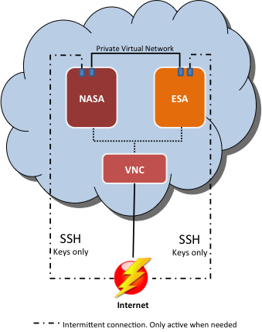

Figure 5: NASA and ESA Pilot Cloud Setup

NASA and ESA had their own separate virtual machines that were procured separately. This is an important point as from ESA’s perspective if NASA paid for the virtual machine then that brought in Intellectual Property Rights (IPR) challenges. Therefore each agency deposited money in their cloud account, which will get billed as the virtual machines are used. This means also that each agency has full control over its virtual machine. As for billing, below depicts the cost burn down over the first month for NASA. Figure 6: Cost Burn SDLS Pilot for 1 Month demonstrates the low cost for performing the pilot of two separate agencies communicating “in the cloud”. As you can see, for the first 30 days it cost approximately $34 USD. ESA’s cost would be similar.

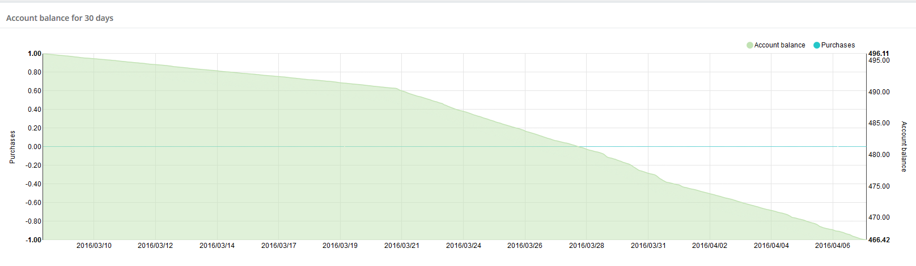

Figure 6: Cost Burn SDLS Pilot for 1 Month

Taking into account the labor that went into standing up the cloud and getting virtual machines imported and communicating over an isolated separate VLAN, it was estimated around 10 hours which included meetings with NASA, ESA, the cloud provider, ESA management, NASA HQ management. This would not be the case in the future since both agencies have successfully piloted this capability. It is estimated to take less than 2 hours to take existing virtual machine from a particular agency and importing into the cloud.

* 1. Tests Performed

This section describes the tests performed to claim success for the CCSDS cloud pilot.

* + 1. Test Case #1: Import Custom VM

The initial test for the pilot was to import a custom VM for each agency. This test was not as straightforward as one would imagine due to what the cloud provider supported. The option existed to import a raw disk image but due to size limitations, this was not a feasible option therefore in order to import the custom VMs the following was performed:

* Utilize “[ghost for Linux](https://sourceforge.net/projects/g4l/)” (G4L.iso) on the custom VM to create a compressed image (LZOP recommended compression)
* Create Linux VM (Ex. Ubuntu) on the cloud with two virtual hard disks
* Copy (Ex. SCP) the compressed custom image to the secondary hard drive
* Upload the G4L.iso to cloud drive library and add the G4L drive to the VM
* Boot to G4L on the VM
* Restore image from secondary (Ex. /dev/sdb) drive to primary (Ex. /dev/sda)
* Reboot and now the VM on the cloud should be the custom VM and not the standard Linux VM
  + 1. Test Case #2: Basic Ping Test

The second test performed was to ensure network traffic could traverse the isolated VLAN between the two custom VMs. The following was performed:

* On the ESA VM run a bash script provided by the cloud provider to connect the ESA VM to the NASA VLAN
* In the GUI, confirm the shared VLAN is present and connect the VM to it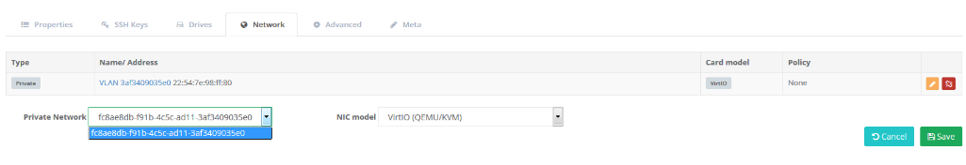

Figure 7: VLAN Selection

* Start the VM and ensure the adapter is present and assign IP address on same subnet
  + ifconfig
  + ifconfig eth0 192.168.21.3
* Issue the ping command to confirm traffic can traverse
  + ping 192.168.21.2
    1. Test Case #3: Connect via SLE

The final test before claiming success for the pilot was connecting the ESA ground system simulator to NASA’s flight system simulator via SLE and sending commands. Figure 8: NASA and ESA SDLS Pilot Environment depicts the setup for SLE test.

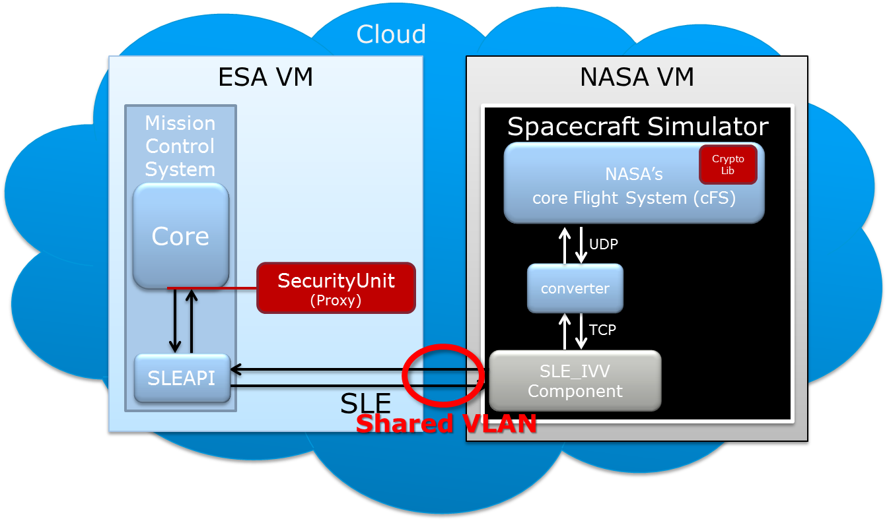

Figure 8: NASA and ESA SDLS Pilot Environment

The test was to send command (TC) from ESA to NASA over the shared VLAN using SLE. Figure 9: SLE Bind Between NASA and ESA depicts NASA’s response to receiving the command from ESA.

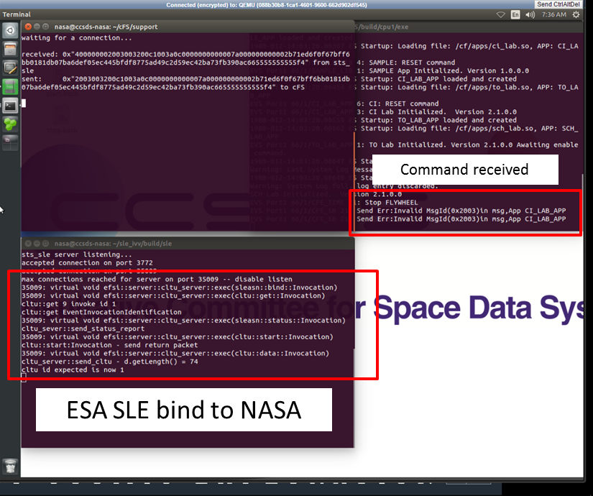

Figure 9: SLE Bind Between NASA and ESA (NASA Side)

Figure 10: SLE Bind Between NASA and ESA (ESA Side)below shows the same SLE connection on ESA side.

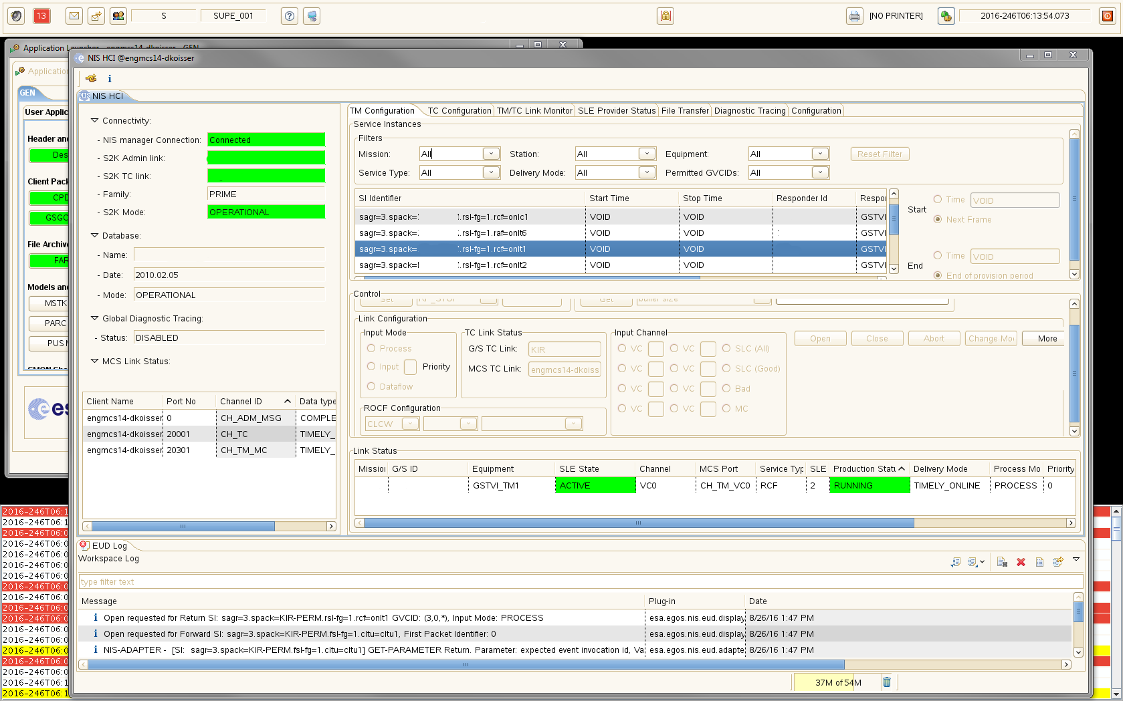

Figure 10: SLE Bind Between NASA and ESA (ESA Side)

* 1. CCSDS Cloud Pilot Summary

The cloud pilot was deemed successful and can be used as proof of concept for future interoperability testing for CCSDS working groups. The cloud setup described herein was used to perform the SDLS Extended Procedure interoperability testing. This pilot proved that testing in the cloud is a low cost, efficient option for CCSDS working groups to interface their implementations. This approach could possibly decrease the amount of time to perform interoperability testing as agencies will not have to wait until the technical meetings every six months or get bogged down with IT security and firewall modification requests.

1. : Agencies Policies on Cloud

Each Agency has different policies with respect to hosting information on the cloud. This is the main reason why a single cloud provider can be difficult to achieve. For example, Agency X only allows for Agencies to use local in-country cloud providers. This may not work if an agency has certain requirements (i.e. FEDRAMP) that must be met. Table 2: Agencies Cloud Policy describes several agencies policy on cloud technologies at the time of the development of this document. Cloud technologies and agency polices are evolving and each CCSDS participating agencies should contact their appropriate cloud point of contact to verify that the data presented in Table 2: Agencies Cloud Policy is applicable and accurate.

| Agency | Cloud Provider | Comments |
| --- | --- | --- |
| NASA | -- | NASA’s [Enterprise Managed Cloud Computing (EMCC)](https://intranet.share.nasa.gov/agency/cloudservices/Pages/GettingStarted.aspx) organization is an Agency-level program, managed by the Computing Services Program Office (CSPO). EMCC on boards cloud providers for NASA use. Currently only Amazon Web Services have been approved by EMCC. However, as described within this document, NASA also has a process for hosting IT systems outside of NASA’s firewall ([ITS-HBK 2810. 02-05](https://nodis-dms.gsfc.nasa.gov/NASA_Wide/restricted_directives/OCIO_Docs/ITS-HBK_2810_%20%2002_05.pdf) - February 2016) which is recommended for the purposes of CCSDS testing. |
| Amazon Web Services (AWS) - GovCloud | NASA has multiple avenues using AWS as the provider. AWS is FEDRAMP certified and can be procured through the EMCC organization. |
| VMware vCloud Government Service (vCGS) | vCGS was FEDRAMP approved but not on boarded by NASA’s EMCC. |
| Other(s) | There are other FEDRAMP approved vendors (<https://www.fedramp.gov/marketplace/compliant-systems/>) but for the purpose of this document and pilot only AWS and vCGS were considered. With NASA, being “in the cloud” has no bearing on CCSDS testing from NASA’s perspective as the working group involved would simply adhere to [ITS-HBK 2810. 02-05](https://nodis-dms.gsfc.nasa.gov/NASA_Wide/restricted_directives/OCIO_Docs/ITS-HBK_2810_%20%2002_05.pdf) when establishing the testing environment. |
| ESA | Interoute | Getting cloud services with these providers should be achievable. These providers specifically stated compliance to specific requirements on security & privacy from ESA’s perspective. |
| Cloud Sigma |
| OBS |

Table 2: Agencies Cloud Policy

| Agency | Cloud Provider | Comments |
| --- | --- | --- |
| CNES | No restrictions as long as they meet IT security policy/requirements | CNES has some Software as a Service (SaaS) contracts and are investigating Infrastructure as a Service (IaaS) and Platform as a Service (PaaS).  Cloud usage is not forbidden within CNES, but as any technology, it has to answer to their security requirements established by risk analysis. Test software in the scope of CCSDS should not be an issue.  CNES has to follow security guidelines from the ANSSI (Agence Nationale de la Sécurité des Systèmes d’Information).  CNES does not have any restrictions regarding the provider, as long as it answers to the security plan and can deal with CNES’s procurement process and contracts. |
| UK Space Agency | None | The UK Space Agency uses the same networks as their host government department – BIS (Business Innovations & Skills). As such, they have had no involvement with the Cloud and have no policies about it. |
| DLR | T-Systems | The possibility exists that if a cloud provider has a "comparable security level" to T-Systems; DLR Central IT Security may approve the use of a different cloud provider. However, once IT approval was give, it would be necessary to check with the legal department to see if there are any problems with export control. |