
Draft Recommendation for
Space Data System Standards
SDLS Extended Procedures
PROPOSED Draft Recommended Standard
CCSDS 000.0-W-0
White Book
March 2015

AUTHORITY

 | Issue: | White Book, Issue 0
 | Date: | March 2015
 | Location: | Not Applicable
(WHEN THIS RECOMMENDED STANDARD IS FINALIZED, IT WILL CONTAIN THE FOLLOWING STATEMENT OF AUTHORITY:)
This document has been approved for publication by the Management Council of the Consultative Committee for Space Data Systems (CCSDS) and represents the consensus technical agreement of the participating CCSDS Member Agencies. The procedure for review and authorization of CCSDS documents is detailed in Organization and Processes for the Consultative Committee for Space Data Systems (CCSDS A02.1-Y-3), and the record of Agency participation in the authorization of this document can be obtained from the CCSDS Secretariat at the address below.

This document is published and maintained by:

CCSDS Secretariat
Space Communications and Navigation Office, 7L70
Space Operations Mission Directorate
NASA Headquarters
Washington, DC 20546-0001, USA

FOREWORD
[Foreword text specific to this document goes here. The text below is boilerplate.]
Attention is drawn to the possibility that some of the elements of this document may be the subject of patent rights. CCSDS shall not be held responsible for identifying any or all such patent rights.
Through the process of normal evolution, it is expected that expansion, deletion, or modification of this document may occur. This Recommended Standard is therefore subject to CCSDS document management and change control procedures, which are defined in Organization and Processes for the Consultative Committee for Space Data Systems (CCSDS A02.1-Y-3). Current versions of CCSDS documents are maintained at the CCSDS Web site:
http://www.ccsds.org/
Questions relating to the contents or status of this document should be addressed to the CCSDS Secretariat at the address indicated on page i.
At time of publication, the active Member and Observer Agencies of the CCSDS were:
Member Agencies
- Agenzia Spaziale Italiana (ASI)/Italy.
- Canadian Space Agency (CSA)/Canada.
- Centre National d’Etudes Spatiales (CNES)/France.
- China National Space Administration (CNSA)/People’s Republic of China.
- Deutsches Zentrum für Luft- und Raumfahrt (DLR)/Germany.
- European Space Agency (ESA)/Europe.
- Federal Space Agency (FSA)/Russian Federation.
- Instituto Nacional de Pesquisas Espaciais (INPE)/Brazil.
- Japan Aerospace Exploration Agency (JAXA)/Japan.
- National Aeronautics and Space Administration (NASA)/USA.
- UK Space Agency/United Kingdom.
Observer Agencies
- Austrian Space Agency (ASA)/Austria.
- Belgian Federal Science Policy Office (BFSPO)/Belgium.
- Central Research Institute of Machine Building (TsNIIMash)/Russian Federation.
- China Satellite Launch and Tracking Control General, Beijing Institute of Tracking and Telecommunications Technology (CLTC/BITTT)/China.
- Chinese Academy of Sciences (CAS)/China.
- Chinese Academy of Space Technology (CAST)/China.
- Commonwealth Scientific and Industrial Research Organization (CSIRO)/Australia.
- Danish National Space Center (DNSC)/Denmark.
- Departamento de Ciência e Tecnologia Aeroespacial (DCTA)/Brazil.
- European Organization for the Exploitation of Meteorological Satellites (EUMETSAT)/Europe.
- European Telecommunications Satellite Organization (EUTELSAT)/Europe.
- Geo-Informatics and Space Technology Development Agency (GISTDA)/Thailand.
- Hellenic National Space Committee (HNSC)/Greece.
- Indian Space Research Organization (ISRO)/India.
- Institute of Space Research (IKI)/Russian Federation.
- KFKI Research Institute for Particle & Nuclear Physics (KFKI)/Hungary.
- Korea Aerospace Research Institute (KARI)/Korea.
- Ministry of Communications (MOC)/Israel.
- National Institute of Information and Communications Technology (NICT)/Japan.
- National Oceanic and Atmospheric Administration (NOAA)/USA.
- National Space Agency of the Republic of Kazakhstan (NSARK)/Kazakhstan.
- National Space Organization (NSPO)/Chinese Taipei.
- Naval Center for Space Technology (NCST)/USA.
- Scientific and Technological Research Council of Turkey (TUBITAK)/Turkey.
- South African National Space Agency (SANSA)/Republic of South Africa.
- Space and Upper Atmosphere Research Commission (SUPARCO)/Pakistan.
- Swedish Space Corporation (SSC)/Sweden.
- Swiss Space Office (SSO)/Switzerland.
- United States Geological Survey (USGS)/USA.
PREFACE
This document is a draft CCSDS Recommended Standard. Its ‘White Book’ status indicates that its contents are not stable, and several iterations resulting in substantial technical changes are likely to occur before it is considered to be sufficiently mature to be released for review by the CCSDS Agencies.
Implementers are cautioned not to fabricate any final equipment in accordance with this document’s technical content.
Recipients of this draft are invited to submit, with their comments, notification of any relevant patent rights of which they are aware and to provide supporting documentation.

DOCUMENT CONTROL

Document | Title and Issue | Date | Status
CCSDS 000.0-W-0 | SDLS Extended Procedures, Proposed Draft Recommended Standard, Issue 0 | March 2014 | Obsolete
CCSDS 000.0-W-0 | SDLS Extended Procedures, Proposed Draft Recommended Standard, Issue 0.3 | November 2014 | Obsolete
CCSDS 000.0-W-0 | SDLS Extended Procedures, Proposed Draft Recommended Standard, Issue 0.4 | March 2015 | Obsolete
CCSDS 000.0-W-0 | SDLS Extended Procedures, Proposed Draft Recommended Standard, Issue 0.5 | October 2015 | Obsolete
CCSDS 000.0-W-0 | SDLS Extended Procedures, Proposed Draft Recommended Standard, Issue 0.6 | December 2015 | Current draft
CCSDS 000.0-W-0 | SDLS Extended Procedures, Proposed Draft Recommended Standard, Issue 0.7 | March 2016 | Current draft

CONTENTS
Section Page
DOCUMENT CONTROL v
CONTENTS vi
1 Introduction 1-1
1.1 Purpose 1-1
1.2 Scope 1-1
1.3 Applicability 1-1
1.4 Rationale 1-2
1.5 Definitions 1-2
1.6 References 1-3
2 Overview 2-4
2.1 Purpose of SDLS Extended Procedures 2-4
2.2 Features of SDLS Extended Procedures 2-4
2.3 Services provided by SDLS Extended Procedures 2-4
2.3.1 Key Management Service 2-4
2.3.2 Security Association (SA) Management Service 2-6
2.3.3 SDLS Management & Control Service 2-7
3 Service Definition 3-8
3.1 Overview 3-8
3.2 Key Management Service 3-8
3.2.1 Overview 3-8
3.2.2 Service Parameters 3-8
3.2.3 Service Procedures 3-10
3.3 Security Associations Management Service 3-22
3.3.1 Service Parameters 3-22
3.3.2 Service procedures 3-23
3.4 Monitoring & Control Service 3-28
3.4.1 Overview 3-28
3.4.2 Service Parameters 3-28
3.4.3 Service Procedures 3-30
4 Interface with SLP & SDLS 4-39
4.1 Overview 4-39
4.2 Interface with SLP 4-39
4.2.1 Transfer of EP Service PDU Over the Space Link 4-39
4.2.2 Frame Security Report (FSR) 4-39
4.3 Interface with SDLS 4-43
4.3.1 Transfer of EP Service PDU 4-43
5 Procedures Specification 5-44
5.1 Overview 5-44
5.2 Procedure Identification 5-44
5.3 Protocol Data Units 5-44
5.3.1 Overview 5-44
5.3.2 Extended Procedures PDU 5-45
5.4 Key Management 5-49
5.4.1 Key Types and Key Lifecycle 5-49
5.4.2 Key Management Procedures 5-49
5.5 Security Associations Management 5-57
5.5.1 SA Parameters 5-57
5.5.2 SA Management PDU 5-57
5.5.3 SA Management Procedures 5-57
5.6 SDLS Monitoring and Control (M&C) 5-58
5.6.1 M&C Procedures 5-58
6 Managed Parameters 6-62
7 Conformance Requirements 7-63

Figure 2-1. SDLS Extended Procedures Cryptographic Key Lifecycle 2-5
Figure 2-2. Variable State Model for Security Association Management 2-6
Figure 4-1: Frame Security Report (FSR) 4-40
Figure 5-1: TLV Format Specification 5-45
Figure 5-2: Extended Procedures PDU 5-45
Figure 5-3: OTAR Command PDU 5-50
Figure 5-4: Key Activation Command PDU 5-51
Figure 5-5: Key Deactivation Command PDU 5-52
Figure 5-6: Key Destruction Command PDU 5-52
Figure 5-7: Key Verification Command PDU 5-53
Figure 5-8: Key Verification Reply PDU 5-54
Figure 5-9: Key DB Status Request Command PDU 5-55
Figure 5-10: Key DB Status Request Reply PDU 5-56

Introduction

Purpose
The purpose of this Recommended Standard is to specify the Space Data Link Security Protocol Extended Procedures. It defines the Key Management, Security Association Management and Monitoring and Control Services and data structures required to operate the SDLS protocol over a space link. Further, it defines the interfaces and required data structures for proper interaction with the Space Data-Link (SDL) protocols and a security unit status reporting mechanism.

Scope
This Recommended Standard defines the SDLS Extended Procedures in terms of:
- the protocol data units employed by the service provider; and
- the procedures performed by the service provider; and
- the interfaces with the SDLS and SDL protocols.
It does not specify:
- individual implementations or products;
- the implementation of service interfaces within real systems;
- the methods or technologies required to perform the procedures; or
- the space-link security protocol itself.
This Recommended Standard does not mandate the use of any particular cryptographic algorithm for key generation and management. However, CCSDS Cryptographic Algorithms [7] should be used where possible.

Applicability
This Recommended Standard applies to the creation of Agency standards and to data communications over space links between CCSDS Agencies in cross-support situations. The Recommended Standard includes comprehensive specification of the service for inter-Agency cross support. It is neither a specification of, nor a design, for real systems that may be implemented for existing or future missions.
The Recommended Standard specified in this document is to be invoked through the normal standards programs of each CCSDS Agency, and is applicable to those missions for which cross support based on capabilities described in this Recommended Standard is anticipated. Where mandatory capabilities are clearly indicated in sections of the Recommended Standard, they must be implemented when this document is used as a basis for cross support. Where options are allowed or implied, implementation of these options is subject to specific bilateral cross support agreements between the Agencies involved.

Rationale
The goals of this Recommended Standard are to:
- provide standard specification for the extended procedures required to operate the Space Data-Link Layer Security (SDLS) Protocol, in particular:
- Key Management;
- Security Associations Management; and
- Security Monitoring and Control.
- Specify a new type of Operational Control Field (OCF), the Frame Security Report (FSR) for reporting of link security status events fully compatible with the existing SDL protocols (TM and AOS);
- facilitate the development of common commercial implementations to improve interoperability across agencies.
More discussion of the goals of the SDLS Extended Procedures and design choices, including its interaction with other CCSDS services, may be found in reference [D4Error: Reference source not found].

Document Structure
Section 1 presents the purpose, scope, applicability, and rationale of this Recommended Standard and lists the conventions, definitions, and references used throughout the document.
Section 2 (informative) provides an overview of the Space Data Link Security Protocol Extended Procedures.
Section 3 (normative) defines the services provided by the protocol entity.
Section 4 (normative) specifies the interfaces of the SDLS Extended Procedures with the SL and SDLS protocols.
Section 5 (normative) specifies the protocol data units provided for these services and the procedures employed by the service provider.
Section 6 (normative) lists the managed parameters associated with these services.
Section 7 (normative) specifies how to verify an implementation’s conformance with the Security Protocol.
Annex A (normative) provides a Protocol Implementation Conformance Statement (PICS) proforma for the Security Protocol.
Annex B (informative) provides an overview of security, SANA registry, and patent considerations related to this Recommended Standard.
Annex D (informative) [OPEN]
Annex D (informative) provides a list of informative references.
Annex E (informative) defines baseline implementations suitable for a large range of space missions.

  - Definitions
For the purposes of this document, the following definitions apply:
NOTE – Generic definitions for the security terminology applicable to this and other CCSDS documents are provided under reference [3Error: Reference source not found].
Initiator: The Initiator of an SDLS Extended Procedure is one of the two peers involved in an SDLS communication session. The Initiator is managing the SDLS session parameters, provides the necessary resources to execute a procedure, and always initiates a procedure.
Recipient: The Recipient of an SDLS Extended Procedure is one of the two peers involved in an SDLS communication session. It configures the SDLS session parameters based on procedures and instructions initiated by the Initiator.
NOTE – In most cases the Initiator is the ground control facility and the Recipient is the spacecraft.

Conventions

Nomenclature
The following conventions apply for the normative specifications in this Recommended Standard:
- the words ‘shall’ and ‘must’ imply a binding and verifiable specification;
- the word ‘should’ implies an optional, but desirable, specification;
- the word ‘may’ implies an optional specification;
- the words ‘is’, ‘are’, and ‘will’ imply statements of fact.
NOTE – These conventions do not imply constraints on diction in text that is clearly informative in nature.

Informative Text
In the normative sections of this document, informative text is set off from the normative specifications either in notes or under one of the following subsection headings:
- Overview;
- Background;
- Rationale;
- Discussion.

References
The following publications contain provisions which, through reference in this text, constitute provisions of this document. At the time of publication, the editions indicated were valid. All publications are subject to revision, and users of this Recommended Standard are encouraged to investigate the possibility of applying the most recent editions of the publications indicated below. The CCSDS Secretariat maintains a register of currently valid CCSDS publications.
[1] Space Data Link Security Protocol, Issue 1, Recommendation for Space Data System Standards (Blue Book), CCSDS 355.0-B-1. Washington, D.C.: CCSDS, September 2015.
[2] Symmetric Key Management for Space Missions, Issue 1, Recommendation for Space Data System Standards (Magenta Book), CCSDS xxx.0-M-1. Washington, D.C.: CCSDS, May 2016.
[3] Information Security Glossary of Terms, Issue 1, Report concerning Space Data System Standards (Green Book), CCSDS 350.8-G-1. Washington, D.C.: CCSDS, November 2012
[4] TM Space Data Link Protocol. Issue 2. Recommendation for Space Data System Standards, CCSDS 132.0-B-2. Blue Book. Washington, D.C.: CCSDS, September 2015.
[5] AOS Space Data Link Protocol. Issue 3. Recommendation for Space Data System Standards, CCSDS 732.0-B-3. Blue Book. Issue 3. Washington, D.C.: CCSDS, September 2015.
[6] TC Space Data Link Protocol. Issue 3. Recommendation for Space Data System Standards, CCSDS 232.0-B-3. Blue Book. Issue 3. Washington, D.C.: CCSDS, September 2015.
[7] CCSDS Cryptographic Algorithms. Issue 1. Recommendation for Space Data System Standards (Blue Book), CCSDS 352.0-B-1. Washington, D.C.: CCSDS, November 2012.
[8] Space Packet Protocol. Issue 1. Recommendation for Space Data System Standards (Blue Book), CCSDS 133.0-B-1. Washington, D.C.: CCSDS, September 2003.

NOTE – Informative references are listed in annex ANNEX D.

Overview

Concept of SDLS Extended Procedures
The Space Data-Link Layer Security (SDLS) protocol [Error: Reference source not found1] is a data processing method for space missions that need to apply authentication and/or confidentiality to the contents of Transfer Frames used by the Space Data Link Protocols over a space link.
The purpose of the SDLS Extended Procedures is to provide a standardized set of auxiliary services that are necessary to operate an implementation of the SDLS protocol. These services are categorized into Key Management, Security Association (SA) Management, and SDLS Monitoring & Control.

Features of SDLS Extended Procedures

The SDLS Extended Procedures specify, for each of the services provided, the following features:
- Procedures Description and Breakdown (actions to be performed by sender and recipient)
- Data Formats of the information exchanged as part of the procedures
In addition, the SDLS Extended Procedures specify a Frame Security Report (FSR) that is reported as an Operational Control Field with TM or AOS frames and contains a brief report on the status of the on-board security unit.
The SDLS Extended Procedures do not specify the means by which the data is exchanged between the sender and recipient (i.e. the interface to the SLP protocol suite). The rationale behind this is that implementers can have different approaches in this respect.

Services provided by SDLS Extended Procedures
The SDLS Extended Procedures provide three different services:
- Key Management Service
- Security Association (SA) Management Service
- SDLS Management & Control Service

Key Management Service
The Key Management Service for the SDLS protocol implements the abstract description of some of the Key Management Procedures that are specified in the Symmetric Key Management Recommended Practice [2]. Thus terminology from this recommended practice is used within this specification.
The Key Management Services are designed to support a symmetric key management infrastructure for secure communications (authentication, confidentiality, and integrity) using the SDLS protocol. Key Management is necessary to ensure that both communication end points (i.e. the sender and the recipient) are synchronized in terms of cryptographic keys and key states.
A number of different key management infrastructure designs exist, however for reasons of scalability, security, and reduced complexity, the SDLS Key Management Services baseline is built around a two-tier symmetric key infrastructure, consisting of a static or master key tier, and an ephemeral or session key tier. Master Keys are used exclusively for the purpose of management (with few notable exceptions) while Session Keys are used to support the actual SDLS cryptographic operations. The concept of over-the-air-rekeying (OTAR) is used to ensure frequent update of the session keys by distributing new session keys that have been generated by the Initiator to the Recipient.
The Key Management Procedures are built around a cryptographic key lifecycle, as shown in Figure 2-1. The lifecycle is a state machine and many of the key management procedures enable the transitions between states. The CCSDS Symmetric Key Management Recommended Practice specifies in detail the various states and the transition rules.

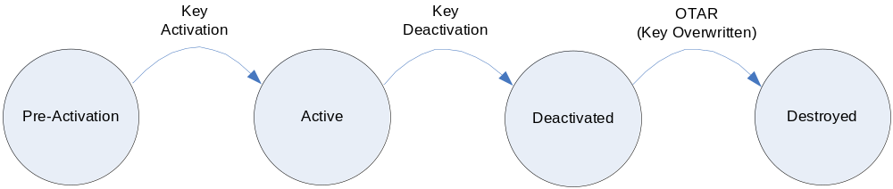
Figure 2-1. SDLS Extended Procedures Cryptographic Key Lifecycle

Security Association (SA) Management Service
The SDLS protocol provides encryption, authentication, or authenticated encryption for data link layer services of the TC, TM, and AOS protocols. The Security Association (SA) Management Service for the SDLS protocol is designed to carry out the most basic functions of Security Association setup, activation, status, and control necessary to command the configurable Security Association parameters of a remote system’s SDLS implementation into a state suitable for operations.
The SA Management Service is designed to support an operational state model that may be simple or complex as mission needs indicate. Many missions of ordinary duration and lower data rates can be satisfied with support for statically-defined Security Associations and pre-loaded cryptographic keys and algorithms. For these, it is sufficient to choose which SA to use on a particular virtual channel along with all of its pre-loaded attributes.
It is anticipated that future complex or long-duration missions may need the capability to reuse and/or reconfigure Security Associations as the SAs and keys loaded into the system prior to the mission are used up over time. For this reason, the SA Management Service state model includes optional directives supporting over-the-air rekeying, or even instantiation on demand of Security Associations. Figure 2-2 illustrates the state model for Security Associations.
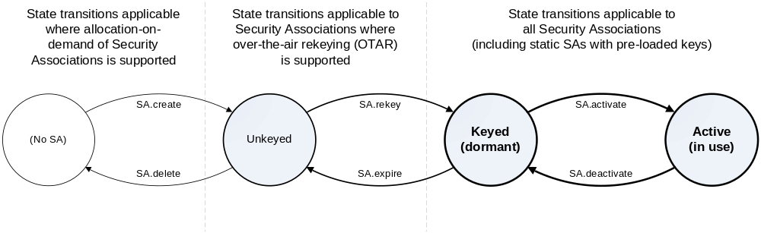
Figure 2-2. Variable State Model for Security Association Management

SDLS Management & Control Service
The SDLS Management and Control Service is designed to support the monitoring and control of the on-board security processor. This is done via a set of messages sent to the security processor (Commands) or received from it (Reports). These messages allow for complete control / command of the on-board security processor(s). A security processor may be a complete equipment or a piece of software providing security functions as defined in the SDLS standard, applied to one communication link : TC, TM or AOS.

Frame Security Report (FSR)
The SDLS Extended Procedures also specify a new type of Operational Control Field for the Space Data Link Layer protocols. This Frame Security report contains information about the status of the security unit and about the security processing (e.g. indicating a recent authentication failure). Since a TM or AOS frame cannot contain two OCFs at the same time, it is expected that the FSR sampling alternates with the OCF Type 1 (CLCW) sampling.

Service Definition

Overview
This Section provides the service definition for the SDLS Extended Procedures.
The services that the SDLS Extended Procedures provide are defined as procedures with sequential execution steps to be executed by the Initiator or the Recipient. These procedural execution steps are independent of specific implementations.
The parameters used by the procedures are specified in an abstract sense and specify the information associated with a particular procedure step and passed in either direction between the Initiator and the Recipient. The way in which a specific implementation makes this information available is not constrained by this specification.
This Section defines the Key Management Service, the Security Association Management Service, and the SLDS Monitoring & Control Service.

Key Management Service

Overview
The Key Management Service Procedures specified in this Section are an SLDS-specific instantiation of the abstract Key Management Procedures specified in reference [2].
The following service procedures are specified:
- Over-the-air-rekeying (OTAR)
- Key Activation
- Key Deactivation
- Key Destruction
- Key Verification
- Key DB Status Request

Service Parameters

Over-the-air-rekeying (OTAR)
The OTAR Rekeying procedure shall have the following Service Parameters:
- Key ID of the Master Key (managed)
- Number of Upload Keys (unmanaged)
- Set of Upload Keys (managed)
NOTE – The size of the session keys is mission specific.
- Upload Key IV (managed)
- Upload Key ID (managed)
- Encrypted Upload Key (managed)
- Upload Key MAC (managed)
- Set of Protected Upload Keys (managed)
- Agreed Cryptographic Algorithm (managed)
NOTE – The actual possible identifier numbers for the Key ID are mission specific.
NOTE – The actual number of session keys to be uploaded is defined through the Number of Upload Keys parameter and indicated by the length field of the TLV format.

Key Activation
The Key Activation procedure shall have the following Service Parameters:
- Number of Session Keys (managed)
- Set of Key IDs (unmanaged)
NOTE – The actual possible identifier numbers for the Key ID are mission specific.
NOTE – The actual number of session keys to be activated is defined through the Number of Session Keys parameter and indicated by the length field of the TLV format.

Key Deactivation
The Key Deactivation procedure shall have the following Service Parameters:
- Number of Session Keys (managed)
- Set of Key IDs (unmanaged)
NOTE – The actual possible identifier numbers for the Key ID are mission specific.
NOTE – The actual number of session keys to be deactivated is defined through the Number of Session Keys parameter and indicated by the length field of the TLV format.

Key Destruction
The Key Destruction procedure shall have the following Service Parameters:
- Number of Session Keys (managed)
- Set of Key IDs (unmanaged)
NOTE – The actual possible identifier numbers for the Key ID are mission specific.
NOTE – The actual number of session keys to be destroyed is defined through the Number of Session Keys parameter and indicated by the length field of the TLV format.

Key Verification
The Key Verification procedure shall have the following Service Parameters:
- Number of Session Keys (managed)
- Set of Key IDs (unmanaged)
- Set of Challenges (unmanaged)
- Response IV (managed)
- Response Encrypted Challenge (managed)
- Response MAC (managed)
- Set of Challenge Responses (managed)
NOTE – The actual possible identifier numbers for the Key ID are mission specific.
NOTE – The actual number of session keys to be verified is defined through the Number of Session Keys parameter and indicated by the length field of the TLV format.

Key DB Status Request
The Key Status Request procedure shall have no Service Parameters.

Service Procedures

Over-the-air-rekeying (OTAR)
Over-the-air-rekeying (OTAR) addresses the secure (encrypted and authenticated) transmission of session keys over a communication channel from the Initiator to the Recipient. The session keys that are uploaded replace session keys with the same Key ID that are already stored at the Recipient side.

Preconditions for the Procedure
- The Initiator shall have a set of session keys in pre-activation state available.
- Both entities shall have an identical master key in pre-activation or active state.
NOTE – This is the master key that will be used to ensure authenticated confidentiality of the session keys during transmission from the Initiator to the Recipient.

Procedural Steps

The OTAR procedure shall include the following mandatory execution steps:
- Encryption of set of Upload Keys; Role: Initiator
- Signaling of set of Protected Upload Keys; Role: Initiator
- Processing of Protected Upload Keys; Role: Recipient

Encryption of set of Upload Keys

This step shall be executed by the Initiator.

This step shall have the following inputs:
- Set of Upload Keys
- Key ID of the Master Key

This step shall have the following outputs:
- Protected Set of Upload Keys ready for upload
- Master Key in Active State

This step shall execute the following:
- The State of the master key identified by the Key ID of the Master Key shall be transitioned to Active State if the Master Key is not already in Active State.
- For each Key in the Set of Upload Keys, the Initiator shall perform authenticated encryption of the key using the agreed cryptographic algorithm under the master key identified by the Master Key Key ID . The encryption shall include the upload key itself, while the authentication shall include also the IV and the Key ID. The results of this shall be a Protected Set of Upload Keys ready for upload.

Signaling of Set of Protected Upload Keys

This step shall be executed by the Initiator.

This step shall have the following inputs:
- Protected Set of Session Keys
- Key ID of the Master Key

This step shall have the following outputs:
- The Protected Set of Session Keys and the Key ID of the Master Key transmitted to the Recipient
NOTE – The signaling uses the interface to the SLP as described in Section 4.

This step shall execute the following:
- An OTAR Command PDU as defined in Section 5.4.2.1 shall be created and transmitted to the Recipient using the SLP interface specified in Section 4.

Processing of Set of Encrypted Upload Keys

This step shall be executed by the Recipient.

This step shall have the following inputs:
- The Protected Set of Session Keys and the Key ID of the Master Key received from the Initiator.

This step shall have the following outputs:
- None

This step shall execute the following:
- For each entry in the set of Protected Upload Keys, the Recipient shall use the Master Key identified by the Key ID of the Master Key to (1) authenticate the entry, and (2) decrypt the Upload Key
- For each decrypted Upload Key, the Recipient shall store it at the indicated Upload Key ID.
NOTE – This implies that other keys that are stored at the indicated Upload Key ID are overridden. Proper management of the key memory is not the subject of this recommended standard and mission specific.

Key Activation
The Key Activation procedure activates a set of (potentially previously uploaded session keys) at both ends of the communication channel (Initiator & Recipient) so that these keys are assigned the Active State and subsequently can be used for cryptographic operations.

Preconditions for the Procedure

Both entities shall have an identical set of session keys in pre-activation state.
NOTE – A subset of these pre-active keys is activated by this procedure.

Procedural Steps

The Key Activation procedure shall include the following mandatory execution steps:
- Activation of Initiator Session Keys; Role: Initiator
- Signaling of Key IDs for Session Keys to be activated; Role: Initiator
- Activation of Recipient Session Keys; Role: Recipient

Activation of Initiator Session Keys

This step shall be executed by the Initiator.

This step shall have the following inputs:
- Set of Key IDs

This step shall have the following outputs:
- All keys identified by the Set of Key IDs in State Activated.
NOTE – See Section 5.4.1.2 and reference [222222222] for more information on key states.

This step shall execute the following:
- The Session Keys identified by set of Key IDs shall be transitioned from Pre-Active State to Active State

Signaling of Keys to be Activated

This step shall be executed by the Initiator.

This step shall have the following inputs:
- Set of Key IDs of session keys activated in Step 1.

This step shall have the following outputs:
- The Set of Key IDs of session keys activated in Step 1 transmitted to the Recipient
NOTE – The signaling uses the interface to the SLP as described in Section 4.

This step shall execute the following:
- A Key Activation Command PDU as defined in Section 5.4.2.2 shall be created and transmitted to the Recipient using the SLP interface specified in Section 4.

Activation of Recipient Session Keys

This step shall be executed by the Recipient.

This step shall have the following inputs:
- The Set of Key IDs of keys activated in Step 1 received from the Initiator

This step shall have the following outputs:
- All session keys identified by the set of key IDs in State Active.

This step shall execute the following:
- The session keys identified by the Key IDs in the set of Key IDs shall be transitioned from Pre-Active State to Active State

Key Deactivation
The Key Deactivation (or revocation) procedure deactivates a set of previously uploaded session (ephemeral) keys at both ends of the communication channel (Initiator & Recipient) so that these keys are assigned the Deactivated State and subsequently cannot be used for cryptographic operations anymore. The keys are not destroyed (erased) by this procedure.

Preconditions for the Procedure

Both entities shall have an identical set of session keys in active state.
NOTE – A subset of these active keys is revoked by this procedure.

Procedural Steps

The Key Deactivation procedure shall include the following mandatory execution steps:
- Deactivation of Initiator session keys; Role: Initiator
- Signaling of Key IDs of the session keys to be deactivated; Role: Initiator
- Deactivation of Recipient session keys; Role: Recipient

Deactivation of Initiator Session Keys

This step shall be executed by the Initiator.

This step shall have the following inputs:
- The set of key IDs of keys to be deactivated

This step shall have the following outputs:
- All keys identified by the set of key IDs in State Deactivated.
NOTE – See Section 5.4.1.2 and reference [222] for more information on key states.

This step shall execute the following:
- The session keys identified by the Key IDs in the set of Key IDs shall be transitioned from Active State to Deactivated State

Signaling of Keys to be deactivated

This step shall be executed by the Initiator.

This step shall have the following inputs:
- The set of Key IDs of keys deactivated in Step 1.

This step shall have the following outputs:
- The set of Key IDs of keys deactivated in Step 1 transmitted to the Recipient
NOTE – The signaling uses the interface to the SLP as described in Section 4.

This step shall execute the following:
- A Key Deactivation Command PDU as defined in Section 5.4.2.3 shall be created and transmitted to the Recipient using the SLP interface specified in Section 4.

Deactivation of Recipient Session Keys

This step shall be executed by the Recipient.

This step shall have the following inputs:
- The set of Key IDs of keys deactivated in Step 1 received from the Initiator.

This step shall have the following outputs:
- All keys identified by the set of key IDs in State Deactivated.

This step shall execute the following:
- The session keys identified by the Key IDs in the set of Key IDs shall be transitioned from Active State to Deactivated State.

Key Destruction
The Key Destruction deletes a number of session keys from both, Initiator and Recipient key databases.

Preconditions for the Procedure

Both entities shall have an identical set of session keys in deactivated state.
NOTE – A subset of these deactivated keys is revoked by this procedure.

Procedural Steps

The Key Destruction procedure shall include the following mandatory execution steps:
- Destruction of Initiator session keys; Role: Initiator
- Signaling of Key IDs to be destroyed; Role: Initiator
- Destruction of Recipient session keys; Role: Recipient

Destruction of Initiator Session Keys

This step shall be executed by the Initiator.

This step shall have the following inputs:
- The set of key IDs of keys to be destroyed

This step shall have the following outputs:
- All keys identified by the set of key IDs in State Destroyed.
NOTE – See Section 5.4.1.2 and reference [222] for more information on key states.

This step shall execute the following:
- The session keys identified by the Key IDs in the set of Key IDs shall be transitioned from Deactivated State to Destroyed State

Signaling of Keys to be destroyed

This step shall be executed by the Initiator.

This step shall have the following inputs:
- The set of Key IDs of keys destroyed in Step 1.

This step shall have the following outputs:
- The set of Key IDs of keys destroyed in Step 1 transmitted to the Recipient
NOTE – The signaling uses the interface to the SLP as described in Section 4.

This step shall execute the following:
- A Key Destruction Command PDU as defined in Section 5.4.2.4 shall be created and transmitted to the Recipient using the SLP interface specified in Section 4.

Destruction of Recipient Session Keys

This step shall be executed by the Recipient.

This step shall have the following inputs:
- The set of Key IDs of keys destroyed in Step 1 received from the Initiator
NOTE – The signaling uses the interface to the SLP as described in Section 4.

This step shall have the following outputs:
- All keys identified by the set of key IDs in State Destroyed.

This step shall execute the following:
- The session keys identified by the Key IDs in the set of Key IDs shall be transitioned from Deactivated State to Destroyed State

Key Verification
The procedure allows the verification of a set of active session keys at the Recipient. This gives confirmation to the Initiator that the keys are not corrupted or modified and fully operational. It should be noted that this procedure may not be executed for session or static keys associated with pre-activation state since this would imply a transition to active state.

Preconditions for the Procedure

Both entities shall have an identical set of session keys in Active State.
NOTE – A subset of these keys is verified by this procedure.

Procedural Steps

The Key Verification procedure shall include the following mandatory execution steps:
- Challenge Creation; Role: Initiator
- Signaling of Challenges and Key IDs to be verified; Role: Initiator
- Computation of Challenge Responses; Role: Recipient
- Signaling of Challenge Responses; Role: Recipient
- Response Verification; Role: Initiator

Challenge Creation

This step shall be executed by the Initiator.

This step shall have the following inputs:
- The Set of Key IDs of session keys to be verified.

This step shall have the following outputs:
- Set of Challenges corresponding to the number of keys to be verified

This step shall execute the following:
- For each key in the set of Key IDs, a challenge shall be created in the Set of Challenges. Each challenge shall be associated with a Key ID.
NOTE – The specification of the algorithm for the creation of the Challenges is outside the scope of this recommendation.

Signaling of Challenges and Key IDs to be verified

This step shall be executed by the Initiator.

This step shall have the following inputs:
- The set of Key IDs to be verified and the Set of Challenges created in Step 1.

This step shall have the following outputs:
- Key IDs to be verified and the Set of Challenges transmitted to the Recipient
NOTE – The signaling uses the interface to the SLP as described in Section 4.

This step shall execute the following:
- A Key Verification Command PDU as defined in Section 5.4.2.5 shall be created and transmitted to the Recipient using the SLP interface specified in Section 4.

Computation of Challenge Responses

This step shall be executed by the Recipient.

This step shall have the following inputs:
- Key IDs to be verified and the Set of Challenges received from the Initiator.

This step shall have the following outputs:
- The Set of Challenge Responses

This step shall execute the following:
- For each key in the set of Key IDs and each associated Challenge in the Set of Challenges, a response shall be created in the Set of Challenge Responses.

Signaling of Challenge Responses

This step shall be executed by the Recipient.

This step shall have the following inputs:
- The set of Key IDs and the Set of Challenge Responses created in Step 3.

This step shall have the following outputs:
- Key IDs and the Set of Responses transmitted to the Initiator
NOTE – The signaling uses the interface to the SLP as described in Section 4.

This step shall execute the following:
- A Key Verification Response PDU as defined in Section 5.4.2.5 shall be created and transmitted to the Initiator using the SLP interface specified in Section 4.

Challenge Response Verification

This step shall be executed by the Initiator.

This step shall have the following inputs:
- Key IDs and the Set of Challenge Responses transmitted to the Recipient

This step shall have the following outputs:
- None

This step shall execute the following:
- For each key in the set of Key IDs and each associated response in the Set of Challenge Responses, the challenge shall be computed and compared with the associated challenge in the Set of Challenges. In case of a match, the Session Key is verified.

Key DB Status Request

Overview
The procedure allows the Initiator to request the status of the Key DB from the Recipient. The main purpose is to check whether the Key DB is operational before starting the key management operations.

Preconditions for the Procedure

This procedure shall have no preconditions.

Procedural Steps

The Key DB Status Request procedure shall include the following mandatory execution steps:
- Signaling of Key DB Status Request; Role: Initiator
- Computation of Key DB Status Response; Role: Recipient
- Signaling of Key DB Status Response; Role: Recipient

Signaling of Key DB Status Request

This step shall be executed by the Initiator.

This step shall have the following inputs:
- None.

This step shall have the following outputs:
- DB Status Request transmitted to the Recipient
NOTE – The signaling uses the interface to the SLP as described in Section 4.

This step shall execute the following:
- A Key DB Status Request Command PDU as defined in Section 5.4.2.6 shall be created and transmitted to the Recipient using the SLP interface specified in Section 4

Computation of DB Status Response

This step shall be executed by the Recipient.

This step shall have the following inputs:
- Key DB Status Request received from the Initiator.
NOTE – The signaling uses the interface to the SLP as described in Section 4.

This step shall have the following outputs:
- Key DB Status Response

This step shall execute the following:
- Upon reception of the Key DB Status request, the Recipient shall run a Key DB status check and create the Key DB Status Response.
NOTE – The Key DB status DB check is implementation specific.

Signaling of DB Status Response

This step shall be executed by the Recipient.

This step shall have the following inputs:
- The set Key DB Status Response created in Step 2.

This step shall have the following outputs:
- Key DB Status Response transmitted to the Initiator
NOTE – The signaling uses the interface to the SLP as described in Section 4.

This step shall execute the following:
- A Key DB Status Request Reply PDU as defined in Section 5.4.2.6 shall be created and transmitted to the Initiator using the SLP interface specified in Section 4.

Security Associations Management Service
The Security Association Management Service establishes the context of a Security Association for a particular Global Virtual Channel and/or Global MAP ID. The user manages the operations of a Security Association by invoking the service primitives defined below.

Service Parameters

Activate SA
The Activate SA directive shall have the following Service Parameters:
- Security parameter index (SPI);
- Global Virtual Channel ID with which the SA is to be used;

Deactivate SA
The Deactivate SA directive shall have the following Service Parameters:
- Security parameter index (SPI);
- Global Virtual Channel ID with which the SA is being used;

Load SA
The Load SA directive shall have the following Service Parameters:
- Security parameter index (SPI);
- Authentication key | Encryption key;

Modify SA
The Modify SA directive shall have the following Service Parameters:
- Security parameter index (SPI);
- Authentication key | Encryption key;

Create SA
The Create SA directive shall have the following Service Parameters:
- Security parameter index (SPI);

Delete SA
The Delete SA directive shall have the following Service Parameters:
- Security parameter index (SPI);

Set Anti-Replay Counter
The Set Anti-Replay Counter directive shall have the following Service Parameters:
- Security parameter index (SPI);
- Anti-replay counter value;

Set Anti-Replay Window
The Set Anti-Replay Window directive shall have the following Service Parameters:
- Security parameter index (SPI);
- Anti-replay window value;

SA Status Request
The SA Status Request directive shall have the following Service Parameters:
- Security parameter index (SPI);

SA Self-Test

Service procedures

Activate SA
The Activate SA directive is used to begin using a particular Security Association on a channel.

Preconditions for the Procedure
The Security Association must already exist in the ‘Keyed’ state.

Procedural Steps

The Activate SA procedure shall include the following mandatory execution steps:
- The requestor shall indicate the SPI of the Security Association to activate and the GVC/GMAP ID upon which to activate it.
- The recipient shall verify that the new SA exists and is keyed.
- The recipient shall verify that the new SA is authorized for use with the requested channel (GVC/GMAP).
- If another SA is currently active on the channel, the recipient shall invoke the ‘Deactivate SA’ procedure to stop using the current SA on the channel.
- The recipient shall add the GVC/GMAP ID into the new SA to mark it active for that channel.

Deactivate SA
The Deactivate SA directive is used to stop using a particular Security Association on a channel.

Preconditions for the Procedure
The Security Association must already exist in the ‘Active’ state.

Procedural Steps

The Deactivate SA procedure shall include the following mandatory execution steps:
- The requestor shall indicate the SPI of the Security Association and the GVC/GMAP ID upon which to deactivate (stop using) it.
- The recipient shall verify that the SA exists and is active.
- The recipient shall remove the requested GVC/GMAP ID from the SA to mark it inactive for that channel.

Rekey SA
The Rekey SA directive is used to associate a cryptographic key with a particular Security Association prior to the Security Association being activated for use on a channel. This directive may be implicit.

Preconditions for the Procedure
The Security Association must already exist in the ‘Unkeyed’ state.

        - Procedural Steps

The Rekey SA procedure shall include the following mandatory execution steps:
- The requestor shall indicate the SPI of the Security Association and the key [index] with which to load it.
- The recipient shall verify that the SA exists.
- The recipient shall verify that the SA’s service type and algorithm matches the requested key.
- If the SA is in the ‘Keyed’ state, the recipient shall invoke the ‘Expire SA’ procedure to de-associate the current key from the SA.
- The recipient shall verify that the SA is in the ‘Unkeyed’ state.
- The recipient shall import the requested key [index] into the SA and transition the SA into the ‘Keyed’ state.

Expire SA
The Expire SA directive is used to de-associate a cryptographic key from a particular Security Association in order that another key may be associated with that same SA using the ‘Rekey SA’ directive. This directive may be implicit.

Preconditions for the Procedure
The Security Association must already exist in the ‘Keyed’ or ‘Active’ state.

Procedural Steps

The Expire SA procedure shall include the following mandatory execution steps:
- The requestor shall indicate the SPI of the Security Association.
- The recipient shall verify that the SA exists.
- If the SA is in the ‘Active’ state, the recipient shall invoke the ‘Deactivate SA’ procedure to stop using the SA.
- The recipient shall verify that the SA is in the ‘Keyed’ state.
- The recipient shall remove the requested key [index] from the SA and transition the SA into the ‘Unkeyed’ state.

Create SA
The Create SA directive is used to initialize a Security Association with the parameters supplied by the service user. This directive may be implicit.

Delete SA
The Delete SA directive is used to remove a Security Association entirely. This directive may be implicit.

Set Anti-Replay Counter
The Set Anti-Replay Counter directive is used to initialize the managed anti-replay sequence number for a Security Association to the value supplied by the service user.

Preconditions for the Procedure
The Security Association must already exist.

Procedural Steps
The Set Anti-Replay Counter procedure shall include the following mandatory execution steps:
- The requestor shall indicate the SPI of the Security Association and the requested new value for the managed anti-replay sequence number.
- The recipient shall verify that the SA exists and that its service type is Authentication or Authenticated Encryption.
- The recipient shall replace the current value of the managed anti-replay sequence number with the requested value.

Set Anti-Replay Window
The Set Anti-Replay Window directive is used to initialize the managed anti-replay sequence number window for a Security Association to the value supplied by the service user.

Preconditions for the Procedure
The Security Association must already exist.

Procedural Steps
The Set Anti-Replay Window procedure shall include the following mandatory execution steps:
- The requestor shall indicate the SPI of the Security Association and the requested new value for the managed anti-replay sequence number window.
- The recipient shall verify that the SA exists and that its service type is Authentication or Authenticated Encryption.
- The recipient shall replace the current value of the managed anti-replay sequence number window with the requested value.

SA Status Request
The SA Status Request directive is used to request a summary of the current status of a Security Association.

Preconditions for the Procedure
None.

Procedural Steps
The SA Status Request procedure shall include the following mandatory execution steps:
- The requestor shall indicate the SPI of the Security Association.
- The recipient shall return a status message.

SA Self-Test

Monitoring & Control Service

Overview
The following service procedures are specified:
- Ping
- Log Status Request
- Dump Log
- Erase Log
- Self-Test
- Read Sequence Number
- Reset Alarm Flag

Service Parameters

Ping
The Ping procedure shall have the following Service Parameters :
- Security Parameter Index (Boolean[16])
NOTE – This is the SPI of the SA used for issuing the Ping Command. The SPI is transmitted as part of the SDLS Security Header.

Log Status Request
The Log Status Request procedure shall have the following Service Parameters:
- Number of Security Messages stored in the Security Log (Integer).
- Available space in the Security Log file (Integer).

Dump Log
The Dump Log procedure shall have the following Service Parameter :
- Set of Security Messages.
NOTE – The content of each security message is implementation specific and not specified by this recommended standard.

Erase Log
The Erase Log shall have the following service parameter :
- Number of messages in the log file after erasing (Integer, normally 0)
- Space available in the log file (Integer)

Self-Test
The Self-Test procedure shall have the following Service Parameters :
- Set of actions necessary to test the functionality of the Security Processor
NOTE – The set of actions necessary to test the functionality of the Security Processor
is implementation specific and not specified by this recommended standard.
- Self-Test Result: OK / NOK (Boolean[1])

Read Sequence Number
The Read Sequence Number (SN) procedure shall have the following Service Parameters :
- Security Parameter Index (Boolean[16])
NOTE – This is the SPI of the SA to which the SN belongs.
- Sequence Number Value (Boolean[Length as managed by the SA])
NOTE – The length of the SN is a managed parameter within the SN. It can vary.

Reset Alarm Flag
The Reset Alarm Flag procedure shall have the following Service Parameters :
- Alarm Flag (Boolean[1])

Service Procedures

Ping
The ping procedure (PING) is used to test the status of a SDLS TC or AOS protected link. This directive generates a report. The intention behind the Ping procedure is to check that the recipient’s security unit is still alive.

Preconditions for the procedure
None.

Procedural steps

The Ping procedure shall include the following mandatory execution steps:
- Signaling of the Ping request; Role: Initiator
- Generation and Signaling of the “Ping Reply” message. Role: Recipient

Signaling of the Ping request

This step shall be executed by the Initiator.

This step shall have the following inputs:
- None

This step shall have the following outputs:
- The Ping request transmitted to the Recipient.

This step shall execute the following:
- The Initiator shall send a Ping request to the Recipient.

Generation and Signaling of the “Ping Reply” message

This step shall be executed by the Recipient.

This step shall have the following inputs:
- None

This step shall have the following outputs:
- “Ping Reply” message generated by the Recipient.

This step shall execute the following:
- The Recipient shall generate a “Ping Reply” message and send it to the Initiator.
NOTE – Any report generated by the recipient, including the “Ping Reply” message, shall be logged in the recipient’s log file.

Log Status Request
The Log Status Request (LOGSR) directive is used to read the status of the security log, by asking for the number of events stored in the security log.

Preconditions for the procedure
None.

Procedural steps

The Log Status Request procedure shall include the following mandatory execution steps:
- Signaling of the Log Status request; Role: Initiator
- Generation and Signaling of the “Log Status” message. Role: Recipient

Signaling of the Log Status request

This step shall be executed by the Initiator.

This step shall have the following inputs:
- None

This step shall have the following outputs:
- The Log Status request transmitted to the Recipient.

This step shall execute the following:
- The Initiator shall send a Log Status request to the Recipient.

Generation and Signaling of the “Log Status” message

This step shall be executed by the Recipient.

This step shall have the following inputs:
- Reception of Log Status request from the Initiator.

This step shall have the following outputs:
- The Log Status and capacity left transmitted to the Initiator.

This step shall execute the following:
- The Recipient shall assess the status of the security log and derive
  - Number of entries in the log
  - Remaining capacity in the log
- Generate Log Status reply message and signal it to the Initiator

Dump Log
The Dump Log (DMPLOG) directive is used to send to the ground the security log. This directive does not erase the log.

Preconditions for the procedure
None.

Procedural steps

The Dump Log procedure shall include the following mandatory execution steps:
- Signaling of the Dump Log request; Role: Initiator
- Message Generation and Signaling of the entire set of messages stored in the security log. Role: Recipient

Signaling of the Dump Log request

This step shall be executed by the Initiator.

This step shall have the following inputs:
- None

This step shall have the following outputs:
- The Dump Log request transmitted to the Recipient.

This step shall execute the following:
- The Initiator shall send a Dump Log request to the Recipient.

Message Generation and Signaling of the entire set of messages stored in the security log

This step shall be executed by the Recipient.

This step shall have the following inputs:
- Reception of Dump Log request from the Initiator.

This step shall have the following outputs:
- All security log entries transmitted to the Initiator.

This step shall execute the following:
- The Recipient shall derive the List of Log Security Messages from the security unit log.
- Generate Log Dump reply message and signal it to the Initiator

Erase Log
The Erase Log (ERSLOG) directive is used to erase the security log.

Preconditions for the procedure
None.

Procedural steps

The Erase Log procedure shall include the following mandatory execution steps:
- Signaling of Erase Log Request; Role : Initiator
- Erasing of the entire set of messages stored in the security log; Role : Recipient

Signaling of the Erase Log request

This step shall be executed by the Initiator.

This step shall have the following inputs:
- None

This step shall have the following outputs:
- The Erase Log request transmitted to the Recipient.

This step shall execute the following:
- The Initiator shall send a Erase Log request to the Recipient.

Erasing of the entire set of messages stored in the security log

This step shall be executed by the Recipient.

This step shall have the following inputs:
- Reception of Erase Log request from the Initiator.

This step shall have the following outputs:
- The Log Status and the available space in the log file transmitted to the Initiator.

This step shall execute the following:
The Recipient shall :
- Erase all Security Messages from the security unit’s log
- Assess the status of the security log and derive
  - Number of entries in the log
  - Remaining capacity in the log
- Generate Erase Log reply message and signal it to the Initiator

Self-Test
The Self-Test (SLFTST) directive is used to trigger a security processor self-test.

Preconditions for the procedure
None.

Procedurals steps

The Self-Test procedure shall include the following mandatory execution steps:
- Signaling of Self-Test Request; Role : Initiator
- Execution of a set of actions in order to test the functionality of the Security Processor and generation of the Self-Test Result message; Role : Recipient

Signaling of Self-Test Request

This step shall be executed by the Initiator.

This step shall have the following inputs:
- None

This step shall have the following outputs:
- The Self-Test Request transmitted to the Recipient

This step shall execute the following:
- The Initiator shall send a Self-Test Request to the Recipient

Execution of a set of actions in order to test the functionality of the Security Processor and generation of the Self-Test Result message

This step shall be executed by the Recipient.

This step shall have the following inputs:
- Reception of Self-Test Request from the Initiator

This step shall have the following outputs:
- Self-Test Result message

This step shall execute the following:
- The recipient shall execute a set of Set of actions necessary to test the functionality of the Security Processor
NOTE – The set of actions necessary to test the functionality of the Security Processor is implementation specific and not specified by this recommended standard.
- The recipient shall generate the Self-Test Result message and signal it to the Initiator.

Read Sequence Number (SN)
The Read SN directive is used to read the current Sequence Number value stored in the security processor.

Preconditions for the procedure
None.

Procedural steps

The Read Sequence Number procedure shall include the following mandatory execution steps:
- Signaling of Read Sequence Number Request; Role : Initiator
- Generation of the Sequence Number Value message; Role : Recipient

Signaling of Read Sequence Number Request

This step shall be executed by the Initiator.

This step shall have the following inputs:
- Security Parameter Index of the SA

This step shall have the following outputs:
- The Read Sequence Number Request transmitted to the Recipient

This step shall execute the following:
- The Initiator shall send a Read Sequence Number Request to the Recipient including the SPI identifying the SA

Generation of the Sequence Number Value message

This step shall be executed by the Recipient.

This step shall have the following inputs:
- Reception of Read Sequence Number Request from the Initiator, including the SPI of the SA

This step shall have the following outputs:
- Sequence Number Value message

This step shall execute the following:
- The recipient shall read the Sequence Number Value corresponding to the SA identified by the SPI, generate the Sequence Number Value message and signal it to the Initiator.

Reset Alarm Flag

Preconditions for the procedure
None.

Procedurals steps

The Reset Alarm Flag procedure shall include the following mandatory execution steps:
- Signaling of Reset Alarm Flag Request; Role : Initiator
- Resetting the Alarm Flag of the Frame Security Report; Role : Recipient

Signaling of Reset Alarm Flag Request

This step shall be executed by the Initiator.

This step shall have the following inputs:
- None

This step shall have the following outputs:
- The Reset Alarm Flag Request transmitted to the Recipient

This step shall execute the following:
- The Initiator shall send a Reset Alarm Flag Request to the Recipient

Resetting the Alarm Flag of the Frame Security Report

This step shall be executed by the Recipient.

This step shall have the following inputs:
- Reception of Reset Alarm Flag Request from the Initiator

This step shall have the following outputs:
- Alarm Flag of the FSR reset.

This step shall execute the following:
- The recipient shall reset the Alarm Flag of the FSR, and generate an Alarm Flag Reset message

Interface with SLP & SDLS

Overview
The SDLS Extended Procedures are interfacing with the Space Link Protocols (SLP) for transport of the procedures protocol data units. This recommended practice does not mandate or recommend the transport data structures except for a new Operational Control Field (OCF), the Frame Security Report (FSR). The SDLS Extended Procedures Concept of Operations ] describes various options to implement the interface.
Since the SDLS Extended Procedures are meant to provide additional capabilities to the core protocol, they do require interfacing with it. The interfaces however are generally on the Initiator and Recipient side, and not directly on protocol level. However, a Security Association should be allocated to the management channel.

Interface with SLP

Transfer of EP Service PDU Over the Space Link

The SDLS Extended Procedures PDUs shall be transported using the space packet protocol (reference [8]).
NOTE – The SDLS protocol protects supported space-link protocols (TM, TC, AOS) at the data-link layer or above. Thus, it also protects the space packet protocol.

Frame Security Report (FSR)

General

The Frame Security Report (FSR), which is the protocol data unit transmitted from the Recipient to the Initiator of an SDLS secured TC uplink, shall provide the systematic, real-time mechanism by which the SDLS function at the receiving end reports the status of TC frame acceptance at the sending end.
NOTE - The FSR is not the only reporting mechanism for this SDLS protocol. Several on-demand or on-event reporting mechanisms and corresponding messages are specified in this recommendation (see Section 3.4). They provide non real-time or non-systematic reporting of the frame acceptance status at the receiving end of the SDLS secured TC uplink.

The FSR shall be carried in the Operational Control Field of TM or AOS Transfer Frames (references [5], [6]) using the MC_OCF or the VC_OCF Service.

The FSR shall be sampled by the Recipient for each received SDLS protected frame.

The 32-bit FSR shall consist of 6 fields, positioned contiguously, in the following sequence:
- Control Word Type (1 bit, mandatory)
- FSR Version Number (3 bits, mandatory)
- Alarm field (1 bit, mandatory)
- Security event flags (3 bits, mandatory)
- Last SPI field (16 bits, mandatory)
- SN Value field (8 bits, mandatory)
NOTE – The structural components of the FSR are shown in Figure 4-3.
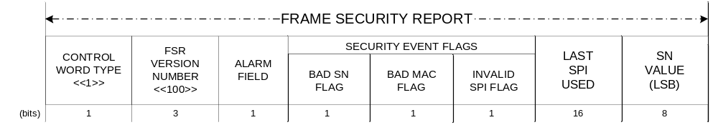
Figure 4-3: Frame Security Report (FSR)

Control Word Type

Bit 0 of the FSR shall contain the Control Word Type
NOTE – This field is used to distinguish Command Link Control Word (CLCW) – control word type “0” specified in [7] from other type of Control Word (type “1”) like the FSR, that may be alternatively carried in the Operational Control Field (OCF) of TM and AOS transfer frames.

This one-bit field shall be set to ‘1’.

FSR Version Number

Bits 1-3 of the FSR shall contain the FSR Version Number

This 3-bit field shall be set to ‘100’
NOTE – The FSR Version Number first bit (‘1’) identifies a CCSDS defined Type-2 OCF. The last 2 bits (‘00’) identifies a ‘Version-1’ FSR, whose binary encoded Version Number is ‘00’. At present, a single version is defined in this recommendation. The FSR Version Number is included to provide future growth flexibility.

Alarm Field

Bit 4 of the FSR shall contain the Alarm Flag

The Alarm Flag shall indicate whether a TC Transfer Frame has been rejected by the on-board SDLS function

A setting of ‘0’ in the Alarm Flag shall indicate that all TC Transfer Frames have been accepted by the on-board SDLS function since the last reset of the Alarm Flag.

A setting of ‘1’ in the Alarm Flag shall indicate that at least one TC Transfer Frame has been rejected by the on-board SDLS function since the last reset of the Alarm Flag.

The Alarm Flag shall apply to all Virtual Channels and Security Associations of the TC uplink.

The Alarm Flag shall be updated at each TC Transfer Frame processed by the SDLS on-board function, its state ‘1’ being remanent.

It shall be possible to reset (to ‘0’: NoAlarm state) the Alarm Flag by a dedicated command (SDLS directive) sent from the ground.

Security Event Flags

General
Bits 5-7 of the FSR shall contain the Flags specified in the following subsections.

Bad Sequence Number Flag

Bit 5 of the FSR shall contain the Bad Sequence Number Flag.

The Bad Sequence Number Flag shall indicate whether the Sequence Number (SN) of the last received TC Transfer Frame by the SDLS on-board function is valid.

A setting of ‘0’ in the Bad Sequence Number Flag shall indicate that the SN carried by the last received TC Transfer Frame by the on-board SDLS function is valid (i.e. within the SN window)

A setting of ‘1’ in the Bad Sequence Number Flag shall indicate that the SN carried by the last received TC Transfer Frame by the on-board SDLS function is invalid (i.e. outside the SN window)

The Bad Sequence Number Flag shall be updated at each TC Transfer Frame processed by the SDLS on-board function, its states not being remanent.

Bad MAC Flag

Bit 6 of the FSR shall contain the Bad MAC Flag.

The Bad MAC Flag shall indicate whether the last received TC Transfer Frame by the SDLS on-board function failed MAC verification.

A setting of ‘0’ in the Bad MAC Flag shall indicate that the MAC carried by the last received TC Transfer Frame by the on-board SDLS function is valid (i.e. matches the MAC computed over the received Transfer Frame)

A setting of ‘1’ in the Bad MAC Flag shall indicate that the MAC carried by the last received TC Transfer Frame by the on-board SDLS function is invalid (i.e. does not match the MAC computed over the received Transfer Frame)

The Bad MAC Flag shall be updated at each TC Transfer Frame processed by the SDLS on-board function, its states not being remanent.

Invalid SPI Flag

Bit 7 of the FSR shall contain the Invalid SPI Flag.

The Invalid SPI Flag shall indicate whether the last received TC Transfer Frame by the SDLS on-board function failed SA verification.

A setting of ‘0’ in the Bad SPI Flag shall indicate that the SPI carried by the last received TC Transfer Frame by the on-board SDLS function is valid (i.e. SPI points to an SA that is associated with the GVCID and/or GMAP of the received Transfer Frame)

A setting of ‘1’ in the Bad SPI Flag shall indicate that the SPI carried by the last received TC Transfer Frame by the on-board SDLS function is invalid (i.e. SPI points to an SA that is not associated with the GVCID and/or GMAP of the received Transfer Frame)

The Bad SPI Flag shall be updated at each TC Transfer Frame processed by the SDLS on-board function, its states not being remanent.

Last SPI used

Bits 8-23 of the FSR shall contain the SPI carried in the last received TC Transfer Frame by the on-board SDLS function.

Sequence Number Value (LSB)

Bits 24-31 of the FSR shall contain the 8 Least Significant Bits (LSB) of the Sequence Number (SN) carried in the last received TC Transfer Frame by the on-board SDLS function.

Interface with SDLS

Transfer of EP Service PDU

Two Security Associations associated with master keys shall be reserved for use with the SDLS Extended Procedures and shall be active upon start of a mission phase.

A Security Association cannot be used to execute any SA Management Procedure that would affect itself. Another security association must be used in this case.
NOTE – SDLS has two reserved SPIs. These could be used by SDLS Extended Procedures Management Security Associations.

Procedures Specification

Overview
This Section describes the procedures that are used to provide the Key Management, Security Association Management, and SDLS Monitoring & Control Services.

Procedure Identification

The Extended Procedures PDU header shall identity the type of procedure to which the contents of the Extended Procedures PDU data field is associated.
NOTE – For a mapping of field values to procedures, see Table 5-1.

Protocol Data Units

Overview
Extended Procedures Protocol Data Units (PDUs) are the data structures that carry the information related to Extended Procedures commands and reports.

Tag, Length, Value Notation
SLDS Extended Procedures commands and reports share a common message format, based on the “Tag, Length, Value” (TLV) concept. The Tag field uniquely identifies the command or the report. The Length field indicates the length of the Value field (may be zero). The (optional) Value field contains additional data pertaining to the message. As long as the Tag and Length fields are of fixed length, the TLV concept is very flexible, allowing to define new commands and reports while maintaining full compatibility with previously defined messages. Figure 5-4 shows the TLV format.
For example, this flexibility may be used by an implementer who needs to define some proprietary messages, while still retaining full CCSDS compatibility (as long as CCSDS defined messages are correctly implemented, proprietary messages will simply be skipped if not recognized, thanks to the TLV format). It should be noted that TLV concept allows nesting: the Value field can itself be composed of one or more TLV messages.

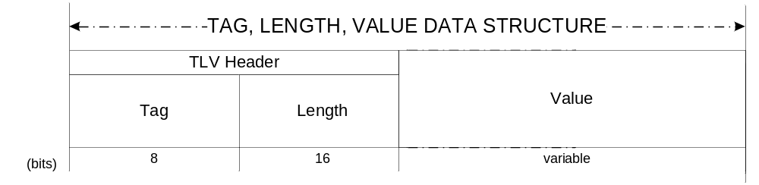
Figure 5-4: TLV Format Specification

Extended Procedures PDU

General

The Extended Procedures PDU is mandatory to use for transport of SDLS Extended Procedures.

The Extended Procedures PDU shall consist of three mandatory fields, positioned contiguously, in the following sequence:
- Extended Procedures PDU Header (24 bits; mandatory)
- Extended Procedures PDU Data Field (variable; mandatory)
NOTE – The format of the Extended Procedures PDU is shown in Figure 5-5.
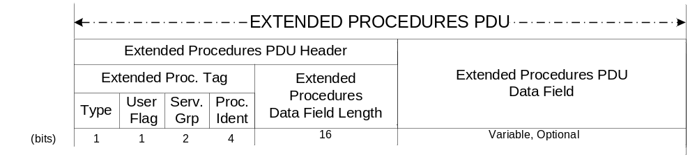
Figure 5-5: Extended Procedures PDU

Extended Procedures PDU Header

The Extended Procedures PDU Header shall consist of two mandatory fields, positioned contiguously, in the following sequence:
- Extended Procedures Tag (8 bits; mandatory)
- Extended Procedures Data Field Length (16 bits; mandatory)

The Extended Procedures Tag shall consist of four mandatory fields, positioned contiguously, in the following sequence:
- Procedure Type (1 bit; mandatory)
- User Flag (1 bit; mandatory)
- Service Group Field (2 bits; mandatory)
- Procedure Identification Field (4 bits; mandatory)

The Procedure Type Flag

The Procedure Type Flag shall identify if the Extended Procedures PDU is associated with a command from the Initiator to the Recipient, or a reply from the Recipient.

A setting of “0” shall identify a command.

A setting of “1” shall identify a reply.

User Flag

The User Flag shall identify if the Extended Procedures PDU is carrying a CCSDS defined procedure or a user defined procedure.

A setting of “0” shall identify a CCSDS defined procedure.

A setting of “1” shall identify a user defined procedure.

Service Group Field

The Service Group shall identify the Extended Procedures Service that the Extended Procedures PDU is associated with.

A setting of “00” shall identify a Key Management procedure.

A setting of “01” shall identify a Security Association Management procedure.

A setting of “10” shall identify a Security Monitoring & Control procedure.

Procedure Identification Field

The Procedure Identification Field shall identify the procedure that is being communicated through the Extended Procedures PDU.

For CCSDS-defined procedures (see Section 5.3.2.2.2.2), the field shall have the settings as identified in Table 5-1.

Procedure Identification | Assignment
0001 | Over-the-air-rekeying (OTAR)
0010 | Key Activation
0011 | Key Deactivation
0100 | Key Verification
0101 | Key DB Status Request
0110 | Key Destruction
0000 | Self-Test SA
0010 | Deactivate SA
0011 | Activate SA
0100 | Expire SA
0101 | Rekey SA
1000 | Create SA (1 of 4)
1001 | Create SA (2 of 4)
1010 | Create SA (3 of 4)
1011 | Create SA (4 of 4)
1101 | Set Anti-Replay Counter
1110 | Set Anti-Replay Counter Window
1111 | Delete SA
1001 | SA Status Request
0001 | Ping
0010 | Log Status Request
0011 | Dump Log
0100 | Erase Log
0101 | Self-Test
0110 | Read Sequence Number
0111 | Reset Alarm Flag
Table 5-1: Extended Procedures PDU Header Values

Extended Procedures PDU Data Field Length

The Extended Procedures Data Field Length shall signal the length of the Extended Procedures PDU Data Field in bits.

Extended Procedures PDU Data Field

The presence of the Extended Procedures PDU Data Field is optional.

The size of the Extended Procedures PDU Data Field shall be as specified by the Extended Procedures Data Field Length.

If the Extended Procedures PDU Data Field Length is zero, the Extended Procedures PDU Data Field shall not be present.

Key Management

Key Types and Key Lifecycle

Key Types
Key Types shall be specified and used according to the recommendations provided in reference [222] Section 3.1.

Key Lifecycle
Key Lifecycle shall be specified and used according to the recommendations provided in reference [222] Section 3.2.

Key Management Procedures

Over-the-air-rekeying (OTAR)

The OTAR Rekeying Procedure shall support one Extended Procedures PDU data field structure:
- OTAR command PDU

OTAR command PDU

The OTAR command PDU shall be associated with Steps 2 of the OTAR Procedure as defined in Section 3.2.3.1.

The OTAR command PDU shall consist of a managed number of contiguously positioned mandatory fields:
- Key ID of the master key used for encryption of session keys
- (Initialization Vector, Key ID Field, Encrypted Upload Key Field, Key MAC) pairs fields (managed length; mandatory)
NOTE – The number of (Initialization Vector, Key ID Field, Encrypted Upload Key Field, Key MAC) pairs fields in the PDU data field and the size of the initialization vector, key ID fields, encrypted key upload and key MAC are managed parameters.
NOTE – The format of the OTAR command PDU is shown in Figure 5-6.
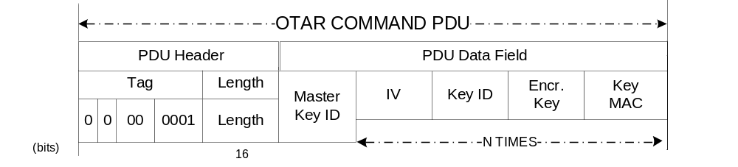
Figure 5-6: OTAR Command PDU

The Master Key ID field shall signal the Key ID of the master key used for encrypted authentication of the session keys transported with this procedure.

The Initialization Vector fields shall signal, if applicable, the Initialization Vector required by the cryptographic algorithm used for authenticated encryption of the upload key.

The Key ID fields shall signal die identifiers of the session keys to be replaced with the uploaded keys at the Recipient.

The Encrypted Upload Key fields shall signal, in encrypted format, the cryptographic keys to be replaced uploaded to the Recipient.

The Key MAC fields shall signal, the Message Authentication Code computed by the cryptographic algorithm used for authenticated encryption of the upload key.

Key Activation

The Key Activation Procedure shall support one Extended Procedures PDU data field structure:
- Key Activation Command PDU.

Key Activation Command PDU

The Key Activation Command PDU shall be associated with Step 2 of the Key Activation Procedure as defined in Section 3.2.3.2.

The Key Activation Command PDU shall consist of a managed number of contiguously positioned mandatory fields:
- Key ID field (managed length; mandatory)
NOTE – The number of Key ID fields in the PDU data field and the size of the key ID fields are managed parameters.
NOTE – The format of the Key Activation Command PDU is shown in Figure 5-7.
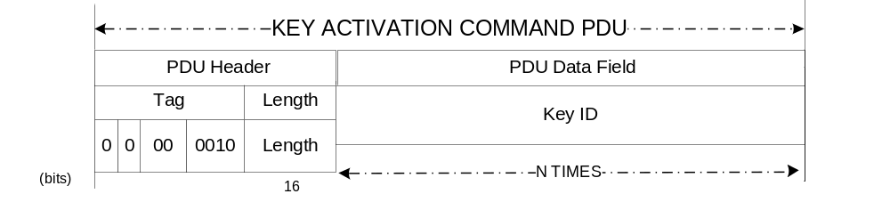
Figure 5-7: Key Activation Command PDU

The Key ID fields shall signal die identifiers of the cryptographic keys to be activated on the recipient.

Key Deactivation

The Key Deactivation Procedure shall support one Extended Procedures PDU data field structure:
- Key Deactivation Command PDU

Key Deactivation Command PDU

The Key Deactivation Command PDU shall be associated with Step 2 of the Key Deactivation Procedure as defined in Section 3.2.3.3.

The Key Deactivation Command PDU shall consist of a managed number of contiguously positioned mandatory fields:
- Key ID field (managed length; mandatory)
NOTE – The number of Key ID fields in the PDU data field and the size of the key ID fields are managed parameters.
NOTE – The format of the Key Deactivation Command PDU is shown in Figure 5-8.
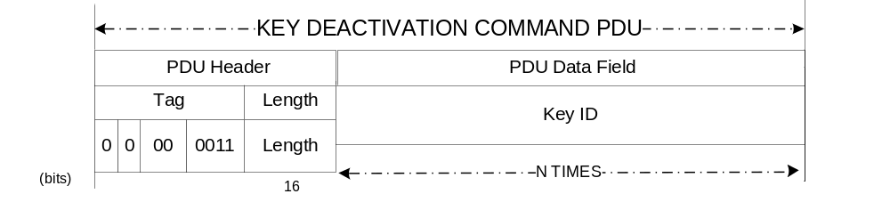
Figure 5-8: Key Deactivation Command PDU

The Key ID fields shall signal die identifiers of the cryptographic keys to be deactivated on the recipient.

Key Destruction

The Key Destruction Procedure shall support one Extended Procedures PDU data field structure:
- Key Destruction Command PDU

Key Destruction Command PDU

The Key Destruction Command PDU shall be associated with Step 2 of the Key Destruction Procedure as defined in Section 3.2.3.4.

The Key Destruction Command PDU shall consist of a managed number of contiguously positioned mandatory fields:
- Key ID field (managed length; mandatory)
NOTE – The number of Key ID fields in the PDU data field and the size of the key ID fields are managed parameters.
NOTE – The format of the Key Destruction Command PDU is shown in Figure 5-9.
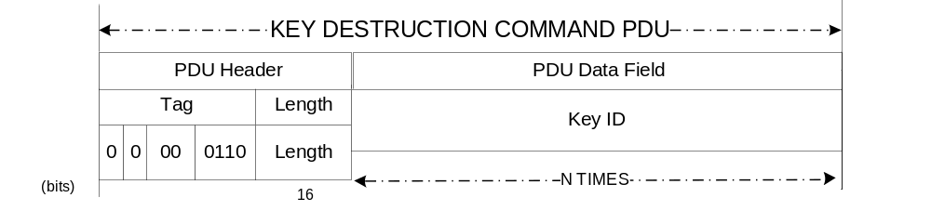
Figure 5-9: Key Destruction Command PDU

The Key ID fields shall signal die identifiers of the cryptographic keys to be destroyed on the recipient.

Key Verification

The Key Verification Procedure shall support two Extended Procedures PDU data field structures:
- Key Verification Command PDU
- Key Verification Reply PDU

Key Verification Command PDU

The Key Verification Command PDU shall be associated with Step 2 of the Key Verification Procedure as defined in Section 3.2.3.5.

The Key Verification Command PDU shall consist of a managed number of contiguously positioned mandatory fields:
- (Key ID Field, Challenge Field) pairs fields (managed length; mandatory)
NOTE – The number of (Key ID Field, Challenge Field) pairs fields in the PDU data field and the size of the key ID fields and challenge fields are managed parameters.
NOTE – The format of the Key Verification Command PDU is shown in Figure 5-6.
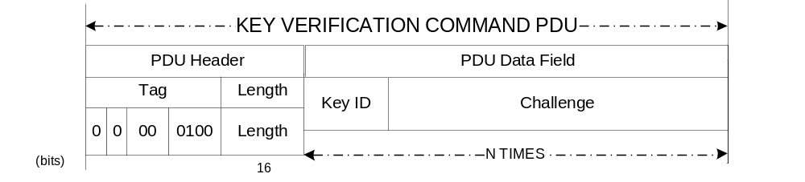
Figure 5-10: Key Verification Command PDU

The Key ID fields shall signal die identifiers of the keys to be verified.

The Challenge fields shall signal, the challenges to be used for verification of keys at the Recipient.

Key Verification Reply PDU

The Key Verification Reply PDU shall be associated with Step 4 of the Key Verification Procedure as defined in Section 3.2.3.5.

The Key Verification Reply PDU shall consist of a managed number of contiguously positioned mandatory fields:
- (Key ID Field, Response Field) pairs fields (managed length; mandatory)
NOTE – The number of (Key ID Field, Response Field) pairs fields in the PDU data field and the size of the key ID fields and response fields are managed parameters.
NOTE – The format of the Key Verification Reply PDU is shown in Figure 5-11.
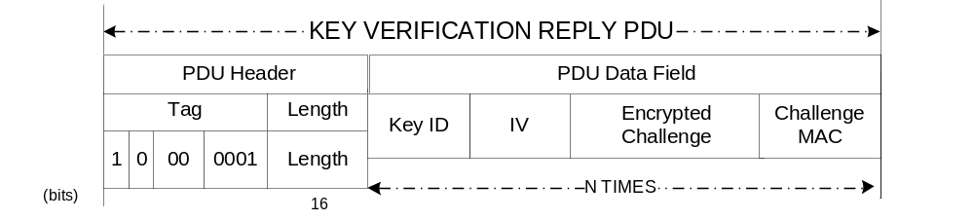
Figure 5-11: Key Verification Reply PDU

The Key ID fields shall signal die identifiers of the keys to be verified.

The Response fields shall signal, in encrypted format, the responses to the challenges.

Key DB Status Request

The Key DB Status Request Procedure shall support two Extended Procedures PDU data field structures:
- Key DB Status Request Command PDU
- Key DB Status Request Reply PDU

Key DB Status Request Command PDU

The Key DB Status Request Command PDU shall be associated with Step 2 of the Request DB Status Procedure as defined in Section 3.2.3.6.

The Key DB Status Request Command PDU shall consist of a managed number of contiguously positioned mandatory fields:
- DB Status Request (managed length; mandatory)
NOTE – The format of the Key DB Status Request Command PDU is shown in Figure 5-12.
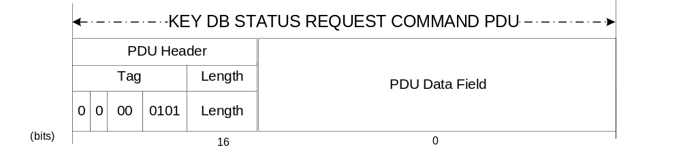
Figure 5-12: Key DB Status Request Command PDU

The Key DB Status Request field shall contain the request for status information the fields shall signal die identifiers of the keys to be verified.

Key DB Status Request Reply PDU

The Key DB Status Request Reply PDU shall be associated with Step 4 of the Request DB Status Procedure as defined in Section 3.2.3.6.

The Key DB Status Request Reply PDU shall consist of a managed number of contiguously positioned mandatory fields:
- DB Status Response (managed length; mandatory)
NOTE – The format of the Key DB Status Request Reply PDU is shown in Figure 5-13.
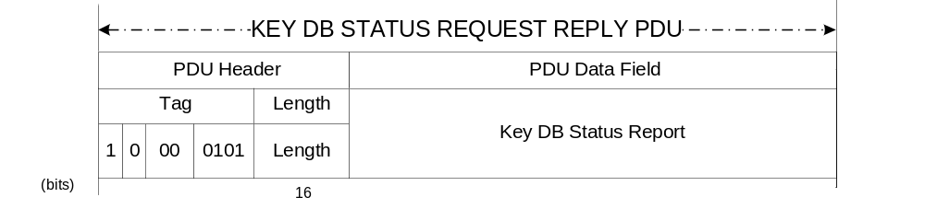
Figure 5-13: Key DB Status Request Reply PDU

The Key DB Status Response field shall contain the response for status information the fields shall signal die identifiers of the keys to be verified

Security Associations Management

    - SA Management Procedures

Activate SA

The Activate SA Procedure shall support one Extended Procedures PDU data field structure:
- Activate SA PDU

Activate SA PDU

The Activate SA PDU shall be associated with the Activate SA Procedure as defined in Section 3.3.2.1.

The Activate SA PDU shall consist of a managed number of contiguously positioned mandatory fields:
- SPI of the applicable Security Association (16 bits, mandatory);
- One or more Global Virtual Channels (GVC) / Global Multiplexer Access Points (GMAP) with which to use the SA (32 bits each; mandatory)
NOTE – The GVC / GMAP ID is a unique identifier comprising the values of the Master Channel ID, Virtual Channel ID and (if applicable) Multiplexer Access Point fields. The precise method of encoding these into a unique 32-bit field is mission-specific.
NOTE – The format of the Activate SA PDU is shown in Figure 5-6.
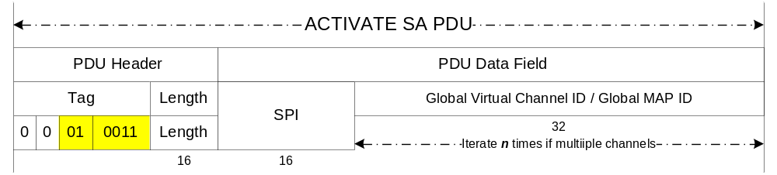 Figure 5-14: Activate SA PDU

The SPI field shall signal the applicable Security Association.

The GVC ID / GMAP ID field shall signal the Global Virtual Channel(s) / Global Multiplexer Access Point(s) with which the SA is to be activated.

Deactivate SA

The Deactivate SA Procedure shall support one Extended Procedures PDU data field structure:
- Deactivate SA PDU

Deactivate SA PDU

The Deactivate SA PDU shall be associated with the Deactivate SA Procedure as defined in Section 3.3.2.2.

The Deactivate SA PDU shall consist of a managed number of contiguously positioned mandatory fields:
- SPI of the applicable Security Association (16 bits, mandatory);
- One or more Global Virtual Channels (GVC) / Global Multiplexer Access Points (GMAP) with which the SA is used (32 bits each; mandatory)
NOTE – The GVC / GMAP ID is a unique identifier comprising the values of the Master Channel ID, Virtual Channel ID and (if applicable) Multiplexer Access Point fields. The exact method of encoding these into a unique 32-bit field is mission-specific.
NOTE – The format of the Deactivate SA PDU is shown in Figure 5-6.
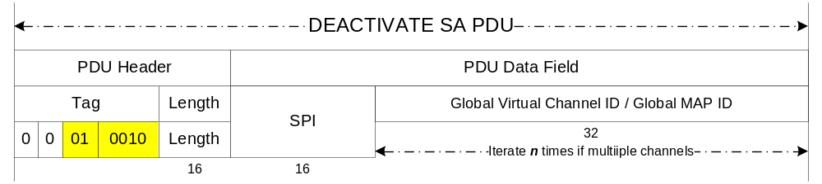 Figure 5-15: Deactivate SA PDU

The SPI field shall signal the applicable Security Association.

The GVC ID / GMAP ID field shall signal the Global Virtual Channel(s) / Global Multiplexer Access Point(s) with which the SA is to be deactivated.

Rekey SA

The Rekey SA Procedure shall support one Extended Procedures PDU data field structure:
- Rekey SA PDU

Rekey SA PDU

The Rekey SA PDU shall be associated with the Rekey SA Procedure as defined in Section 3.3.2.3.

The Rekey SA PDU shall consist of a managed number of contiguously positioned mandatory fields:
- SPI of the applicable Security Association (16 bits, mandatory)
- New encryption key ID for the SA (16 bits; mandatory)
- New authentication key ID for the SA (16 bits; mandatory)
NOTE – The format of the Rekey SA PDU is shown in Figure 5-6.
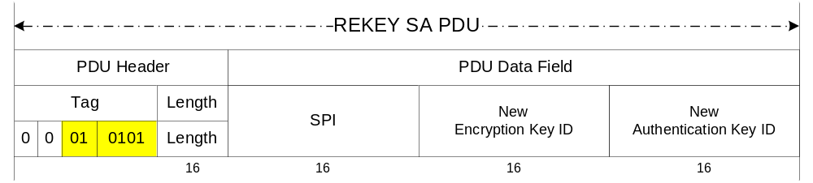
Figure 5-16: Rekey SA PDU

The SPI field shall signal the SPI of the Security Association to be rekeyed.

The New Encryption Key ID field shall signal the new encryption key.

The New Authentication Key ID field shall signal the new authentication key.

If the SA service type is Encryption, the New Authentication Key ID field shall contain zeros.

If the SA service type is Authentication, the New Encryption Key ID field shall contain zeros.

If the SA service type is Authenticated Encryption using a combined authenticated-encryption algorithm, the new key ID shall be present in both fields (New Encryption Key ID and New Authentication Key ID).

Expire SA

The Expire SA Procedure shall support one Extended Procedures PDU data field structure:
- Expire SA PDU

Expire SA PDU

The Expire SA PDU shall be associated with the Expire SA Procedure as defined in Section 3.3.2.4.

The Expire SA PDU shall consist of a managed number of contiguously positioned mandatory fields:
- SPI of the applicable Security Association (16 bits, mandatory);
NOTE – The format of the Expire SA PDU is shown in Figure 5-6.
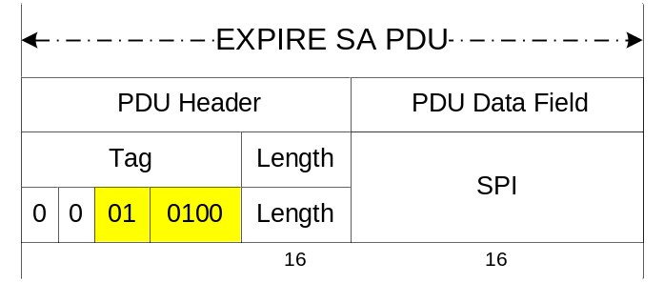
Figure 5-17: Expire SA PDU

The SPI field shall signal the SPI of the Security Association whose key is to be expired.

Create SA

The Create SA Procedure shall support four Extended Procedures PDU data field structures:
- Create SA PDU #1
- Create SA PDU #2
- Create SA PDU #3
- Create SA PDU #4

Create SA Step #1 PDU

The Create SA Step #1 PDU shall be associated with the Create SA Procedure as defined in Section 3.3.2.5.

The Create SA Step #1 PDU shall consist of a managed number of contiguously positioned mandatory fields:
- SPI of the applicable Security Association (16 bits, mandatory)
- SA Service Type flag for Encryption (1 bit, mandatory)
- SA Service Type flag for Authentication (1 bit, mandatory)
- Security Header IV Field Length (6 bits, mandatory)
- Security Header SN Field Length (6 bits, mandatory)
- Security Header PL Field Length (2 bits, mandatory)
- Security Trailer MAC Field Length (8 bits, mandatory)

Create SA Step #2 PDU

The Create SA Step #2 PDU shall be associated with the Create SA Procedure as defined in Section 3.3.2.5.

The Create SA Step #2 PDU shall consist of a managed number of contiguously positioned mandatory fields:
- SPI of the applicable Security Association (16 bits, mandatory)
- Encryption cipher suite length (8 bits, mandatory)
- Initialization vector length (8 bits, mandatory)
- Encryption cipher suite identifier (managed length; optional)
- Initialization Vector (IV) value (managed length; optional)

Create SA Step #3 PDU

The Create SA Step #3 PDU shall be associated with the Create SA Procedure as defined in Section 3.3.2.5.

The Create SA Step #3 PDU shall consist of a managed number of contiguously positioned mandatory fields:
- SPI of the applicable Security Association (16 bits, mandatory)
- Authentication cipher suite length (8 bits, mandatory)
- Anti-replay counter (ARC) length (8 bits, mandatory)
- Anti-replay counter window length (8 bits, mandatory)
- Authentication cipher suite identifier (managed length; optional)
- Anti-replay counter (ARC) value (managed length; optional)
- Anti-replay counter window value (managed length; optional)

Create SA Step #4 PDU

The Create SA Step #4 PDU shall be associated with the Create SA Procedure as defined in Section 3.3.2.5.

The Create SA Step #4 PDU shall consist of a managed number of contiguously positioned mandatory fields:
- SPI of the applicable Security Association (16 bits, mandatory)
- Authentication bit mask length (16 bits, mandatory)
- Authentication bit mask value (managed length; optional)
NOTE – The format of the Create SA PDUs are shown in Figure 5-6.
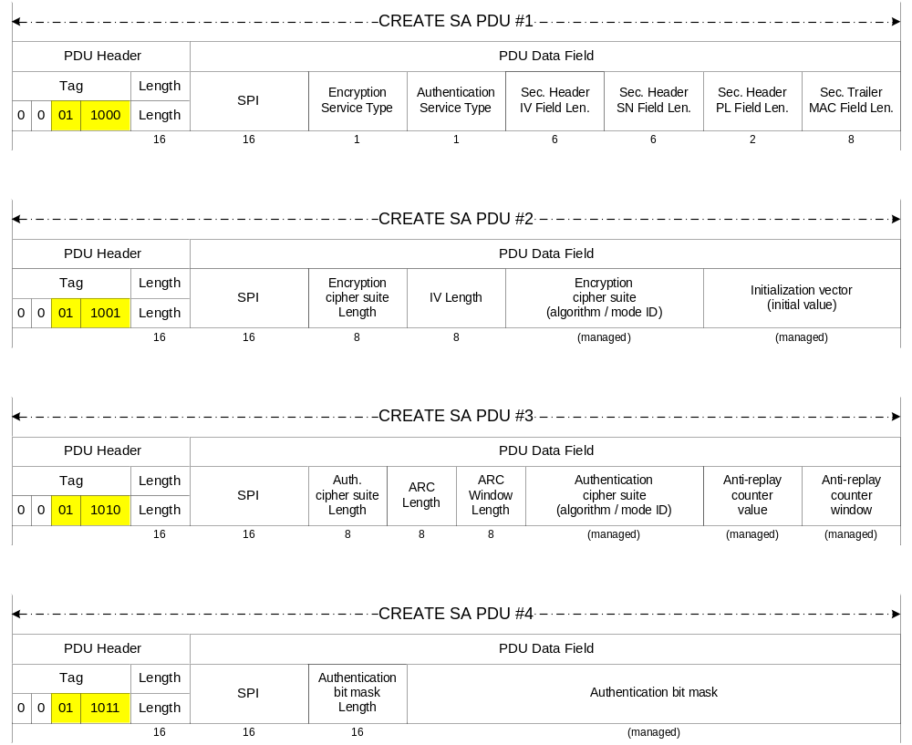
Figure 5-18: Create SA PDUs

The SPI field shall signal the SPI of the Security Association to be created.

The SA Service Type flag for Encryption shall signal

The SA Service Type flag for Authentication shall signal

The Security Header IV Field Length shall signal the length of the Initialization Vector field in the Security Header.

The Security Header SN Field Length shall signal the length of the Sequence Number field in the Security Header.

The Security Header PL Field Length shall signal the length of the Pad Length field in the Security Header.

The Security Trailer MAC Field Length shall signal the length of the MAC field in the Security Trailer.

The Encryption cipher suite length shall signal the length of the Encryption cipher suite field in the PDU.

The Initialization vector length shall signal the length of the Initialization vector field in the PDU.

The Encryption cipher suite identifier shall signal the encryption algorithm and mode of operation for the SA.

The Initialization Vector (IV) value shall signal the initial value of the managed Initialization Vector for the SA.

The Authentication cipher suite length shall signal the length of the Authentication cipher suite field in the PDU.

The Anti-replay counter (ARC) length shall signal the length of the Anti-replay counter field in the PDU.

The Anti-replay counter window length shall signal the length of the Anti-replay counter window field in the PDU.

The Authentication cipher suite identifier shall signal the authentication algorithm and mode of operation for the SA.

The Anti-replay counter (ARC) value shall signal the initial value of the managed anti-replay counter for the SA.

The Anti-replay counter window value shall signal the initial value of the managed anti-replay counter window for the SA.

The Authentication bit mask length shall signal the length of the Authentication bit mask field in the PDU.

The Authentication bit mask shall signal the authentication bit mask value for the SA.

Delete SA

The Delete SA Procedure shall support one Extended Procedures PDU data field structure:
- Delete SA PDU

Delete SA PDU

The Delete SA PDU shall be associated with the Delete SA Procedure as defined in Section 3.3.2.6.

The Delete SA PDU shall consist of a managed number of contiguously positioned mandatory fields:
- SPI of the applicable Security Association (16 bits, mandatory)
NOTE – The format of the Delete SA PDU is shown in Figure 5-6.
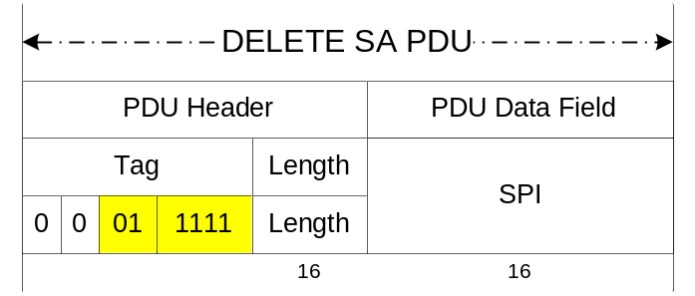
Figure 5-19: Delete SA PDU

The SPI field shall signal the SPI of the Security Association to be deleted.

Set Anti-Replay Counter (ARC)

The Set Anti-Replay Counter (ARC) Procedure shall support one Extended Procedures PDU data field structure:
- Set Anti-Replay Counter (ARC) PDU

Set Anti-Replay Counter (ARC) PDU

The Set ARC PDU shall be associated with the Set ARC Procedure as defined in Section 3.3.2.7.

The Set ARC PDU shall consist of a managed number of contiguously positioned mandatory fields:
- SPI of the applicable Security Association (16 bits, mandatory);
- Length of the Anti-Replay Counter (8 bits, mandatory)
- New value of the Anti-Replay Counter (managed length; mandatory)
NOTE – The format of the Set ARC PDU is shown in Figure 5-6.
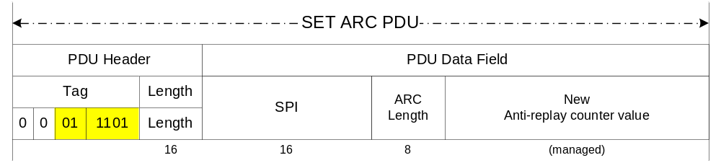Figure 5-20: Set ARC PDU

The SPI field shall signal the SPI of the Security Association whose ARC is to be modified.

The ARC Length field shall signal the length of the ARC field in the PDU.

The ARC field shall signal the new anti-replay counter value.

Set Anti-Replay Counter (ARC) Window

The Set Anti-Replay Counter Window Procedure shall support one Extended Procedures PDU data field structure:
- Set ARC Window PDU

Set ARC Window PDU

The Set ARC Window PDU shall be associated with the Set ARC Window Procedure as defined in Section 3.3.2.8.

The Set ARC Window PDU shall consist of a managed number of contiguously positioned mandatory fields:
- SPI of the applicable Security Association (16 bits, mandatory);
- Length of the anti-replay counter window (8 bits, mandatory)
- New value of the anti-replay counter window (managed length; mandatory)
NOTE – The format of the Set ARC Window PDU is shown in Figure 5-6.
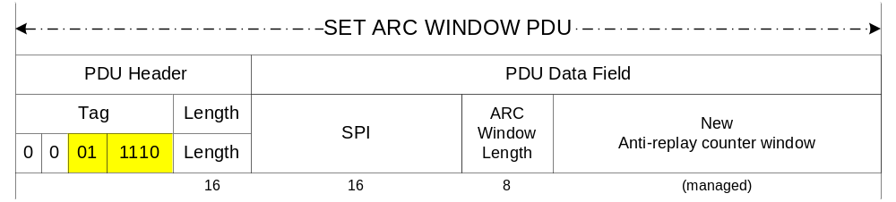 Figure 5-21: Set ARC Window PDU

The SPI field shall signal the SPI of the Security Association whose ARC window is to be modified.

The ARC Length field shall signal the length of the ARC Window field in the PDU.

The ARC Window field shall signal the new anti-replay counter window value.

SDLS Monitoring and Control (M&C)

M&C Procedures

Ping

Ping Command PDU
The Ping Command PDU is a TLV formatted message with the following values :
T : 0x0403
L : 0x0000
V : <none>

Ping Reply PDU
The “Ping Reply” message PDU shall consist of a TLV formatted message with the following values :
T : 0x8403
L : 0x0000
V : <none>

Log Status Request

Log Status Request Command PDU
The Log Status Request Command PDU is a TLV formatted message with the following values :
T : 0x0402
L : 0x0000
V : <none>

Log Status Reply PDU
The Log Status Reply message PDU shall consist of a TLV formatted message with the following values :
T : 0x8402
L : <Length of the message>
V : <number of events in the log, remaining space in the log>

Dump Log

Dump Log Command PDU
The Dump Log Command PDU is a TLV formatted message with the following values :
T : 0x0405
L : 0x0000
V : <none>

Dump Log Reply PDU
The Dump Log Reply message PDU shall consist of a TLV formatted message with the following values :
T : 0x8405
L : <Length of the message>
V : <Set of security messages>

Erase Log

Erase Log Command PDU
The Erase Log Command PDU is a TLV formatted message with the following values :
T : 0x0404
L : 0x0000
V : <none>

Erase Log Reply PDU
The Erase Log reply message PDU shall consist of a TLV formatted message with the following values :
T : 0x8404
L : <Length of the message>
V : <number of events in the log, remaining space in the log>

Self-Test

Self-Test Command PDU
The Self-Test Command PDU is a TLV formatted message with the following values :
T : 0x0408
L : 0x0000
V : <none>

Self-Test Reply PDU
The Self-Test reply message PDU shall consist of a TLV formatted message with the following values :
T : 0x8408
L : 0x0001
V : 0x00 : OK; 0xFF : NOK; Others values undefined.

Read Sequence Number

Read Sequence Number Command PDU
The Read Sequence Number Command PDU is a TLV formatted message with the following values :
T : 0x0410
L : 0x0002
V : <SPI of the SA>

Read Sequence Number Reply PDU
The Self-Test reply message PDU shall consist of a TLV formatted message with the following values :
T : 0x8410
L : <0x0002 + (Length of the sequence number in octets)>
V : <SPI, Sequence Number Value>

Alarm Flag Reset

Alarm Flag Reset Command PDU
The Alarm Flag Reset Command PDU is a TLV formatted message with the following values :
T : 0x0420
L : 0x0000
V : <none>

Alarm Flag Reset Reply PDU
The Alarm Flag Reset reply message PDU shall consist of a TLV formatted message with the following values :
T : 0x8420
L : 0x0001
V : 0x00 : OK; 0xFF : NOK; Others values undefined.

Managed Parameters

Conformance Requirements
An implementer of the Security Protocol shall verify conformance with this Recommended Standard by completing a Protocol Implementation Conformance Statement (PICS) based on a CCSDS-defined PICS proforma for the protocol.
NOTE – A compliant PICS proforma is provided in annex A of this document.

[ANNEX TITLE]
[EITHER Normative or Informative]
[Annexes contain ancillary information. Normative annexes precede informative annexes. Informative references are placed in an informative annex. See CCSDS A20.0-Y-3, CCSDS Publications Manual (Yellow Book, Issue 3, December 2011) for discussion of the kinds of material contained in annexes.]

Security
(Informative)
  - Introduction

  - security concerns with respect to the CCSDS document
    - Data privacy

    - Data integrity

    - Authentication of communicating entities

    - Control of access to resources

    - Availability of resources

    - Auditing of resource usage

  - Potential threats and attack scenarios

  - Consequences of not applying security to the technology

Informative References
(Informative)
[D4] Information Technology—Open Systems Interconnection—Basic Reference Model: The Basic Model. 2nd ed. International Standard, ISO/IEC 7498-1:1994. Geneva: ISO, 1994.
[D5] Information Processing Systems—Open Systems Interconnection—Basic Reference Model—Part 2: Security Architecture. International Standard, ISO 7498-2:1989. Geneva: ISO, 1989.
[D6] Space Data Link Security Concept of Operation. Report Concerning Space Data System Standards, CCSDS 350.5-G. Washington, D.C.: CCSDS, forthcoming.
[D7] The Application of CCSDS Protocols to Secure Systems. Issue 2. Report Concerning Space Data System Standards (Green Book), CCSDS 350.0-G-2. Washington, D.C.: CCSDS, January 2006.
[D8] Security Architecture for Space Data Systems. Issue 1. Recommendation for Space Data System Practices (Magenta Book), CCSDS 351.0-M-1. Washington, D.C.: CCSDS, November 2012.
[D9] Space Missions Key Management Concept. Issue 1. Report Concerning Space Data System Standards (Green Book), CCSDS 350.6-G-1. Washington, D.C.: CCSDS, November 2011.
[D10] Overview of Space Communications Protocols. Issue 2. Report Concerning Space Data System Standards (Green Book), CCSDS 130.0-G-2. Washington, D.C.: CCSDS, December 2007.
[D11] National Information Assurance (IA) Glossary. CNSS Instruction No. 4009. Fort Meade, Maryland: CNSS, April 2010.
[D12] Glossary of Key Information Security Terms. Rev. 1. Edited by Richard Kissel. NIST IR 7298. Gaithersburg, Maryland: NIST, February 2011.
[D13] Elaine Barker, et al. Recommendation for Key Management—Part 1: General. National Institute of Standards and Technology Special Publication 800-57. Gaithersburg, Maryland: NIST, March 2007.
[D14] Information Technology—Open Systems Interconnection—Conformance Testing Methodology and Framework—Part 7: Implementation Conformance Statements. International Standard, ISO/IEC 9646-7:1995. Geneva: ISO, 1995.
NOTE – Normative references are listed in Section 1.8.

Baseline Implementation Mode
(Informative)

  - Frame Security Report
This section specifies the baseline implementation mode for the Frame Security Report (FSR) and its integration into the transfer service protocol.
    - Transfer Service Interface
      - FSR USE WITH TM
The baseline implementation mode to be used for integrating the FSR into the TM transfer service shall be as follows:
- The FSR shall be reported as Operational Control Field (OCF) Type 2 (see also Section 4.2.2.3.2.
- In case COP-1 is in operation of the same virtual channel, the FSR reporting shall alternate with the Command Link Control Word (OCF Type 1) reporting.
      - FSR USE WITH AOS
The baseline implementation mode to be used for integrating the FSR into the AOS transfer service shall be as follows:
- The FSR shall be reported as Operational Control Field (OCF) Type 2 (see also Section 4.2.2.3.2.
- In case COP-1 is in operation of the same virtual channel, the FSR reporting shall alternate with the Command Link Control Word (OCF Type 1) reporting.
      - INTERFACE WITH SDLS
The SLDS implementation used for the SDLS Extended Procedures shall be the SDLS baseline implementation mode (see reference [1] Annex E). 1111
  - Protocol Data Units
The baseline implementation of the TLV format shall not make use of nesting.
  - Reserved SPIs/SAs
The baseline implementation mode uses two reserved SPIs for the master key channels as specified in Section 4.3.
These two reserved SPIs are all zeros’ (0) and ‘all ones’ (65535) (see also reference [1]).
  - Key Management Service
This section specifies the baseline implementation mode for the Key Management Service Extended Procedures.
The baseline implementation mode shall not include the Key Destruction and Key DB Status Request Procedures.
    - Security Algorithm and Key Configuration
The following security algorithm configuration shall be used to support the Key Management Service Extended Procedures in the baseline implementation mode.
      - Algorithm for OTAR
The baseline implementation to be used for OTAR interoperability testing and operation is authenticated encryption, using the AES algorithm in the Galois/Counter Mode (GCM) mode as defined in reference [Error: Reference source not foundError: Reference source not foundError: Reference source not foundError: Reference source not found7777]. In addition:
- the key is 128 bits in total length;
- the output MAC shall be 32 bit.
    - Key Management Services Parameters
      - OTAR
The baseline implementation configuration to be used for OTAR procedure (Sections 3.2.3.1 and 5.4.2.1) interoperability testing and operation is:
- The Master Key ID field of the OTAR Command PDU shall have a size of 7 bit.
NOTE: This means that the Master Key ID range is between 0 and 127.
- The Key ID fields of the OTAR Command PDU shall have a size of 10 bit. Values 0-127 shall not be used to reference session keys.
- The Initialization Vector fields of the OTAR Command PDU shall have a size of 96 bit.
- The Encrypted Upload Key fields of the OTAR Command PDU shall have a size of 128 bit.
- The MAC fields of the OTAR Command PDU shall have a size of 32 bit.
- The total length of the PDU (Header + Data Field) shall not exceed 988 octets (=upload of 29 session keys). This is to ensure that the complete Command PDU fits into one frame of 1024 octets.
- The Length field shall indicate a number of N*266+10, where N is the number of session keys to be uploaded, N<30.
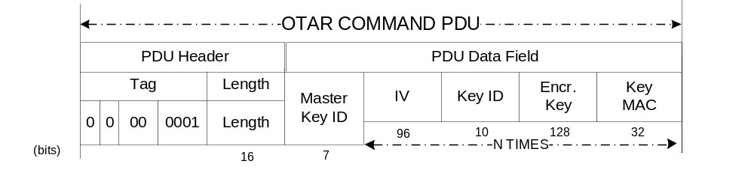
Baseline Implementation Mode OTAR Command PDU

      - Key Activation
The baseline implementation configuration to be used for Key Activation procedure (Sections 3.2.3.2 and 5.4.2.2) interoperability testing and operation is:
- The Key Activation command does not require a Master Key ID.
- The Key ID fields of the Key Activation PDU data field structure shall have a size of 10 bit. Values 0-127 shall not be used to reference session keys.
- The total length of the PDU (Header + Data Field) shall not exceed 988 octets (=activation of 98 session keys). This is to ensure that the complete Command PDU fits into one frame of 1024 octets.
- The Length field shall indicate a number of N*10, where N is the number of session keys to be activated, N<99.
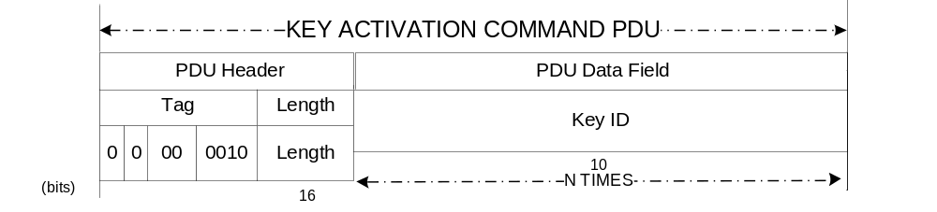
Baseline Implementation Mode Key Activation Command PDU

      - Key Deactivation
The baseline implementation configuration to be used for Key Deactivation procedure (Sections 3.2.3.3 and 5.4.2.3) interoperability testing and operation is:
- The Key Deactivation command does not require a Master Key ID.
- The Key ID fields of the Key Deactivation PDU data field structure shall have a size of 10 bit. Values 0-127 shall not be used to reference session keys.
- The total length of the PDU (Header + Data Field) shall not exceed 988 octets (=activation of 98 session keys). This is to ensure that the complete Command PDU fits into one frame of 1024 octets.
- The Length field shall indicate a number of N*10, where N is the number of session keys to be deactivated, N<99.
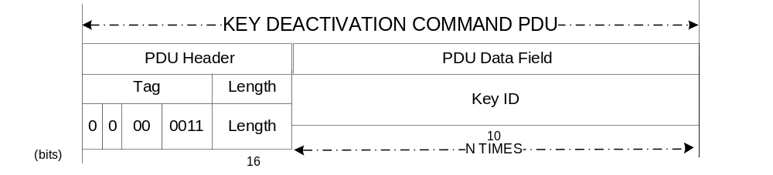
Baseline Implementation Mode Key Deactivation Command PDU
      - Key Verification
The baseline implementation configuration to be used for Key Verification procedure (Sections 3.2.3.5 and 5.4.2.5) interoperability testing and operation is:
- The Key Verification command does not require a Master Key ID.
- The Key ID fields of the Key Verification Command PDU shall have a size of 10 bit. Values 0-127 shall not be used to reference session keys.
- The Challenge fields of the Key Verification Command PDU shall have a size of 128 bit.
- The total length of the PDU (Header + Data Field) shall not exceed 988 octets (=verification of 29 session keys). This is to ensure that the complete Reply PDU to this Command PDU fits into one frame of 1024 octets.
- The Length field of the Command PDU shall indicate a number of N*10, where N is the number of session keys to be deactivated, N<29.
- The Key Verification reply PDU does not require a Master Key ID.
- The Key ID fields of the Key Verification Reply PDU shall have a size of 10 bit. Values 0-127 shall not be used to reference session keys.
- The Encrypted Challenge fields of the Key Verification Reply PDU shall have a size of 128 bit.
- The Challenge MAC fields of the Key Verification Reply PDU shall have a size of 32 bit.
- The IV fields of the Key Verification Reply PDU shall have a size of 96 bit.
- The total length of the PDU (Header + Data Field) shall not exceed 988 octets (=verification of 29 session keys). This is to ensure that the complete Reply PDU fits into one frame of 1024 octets.
- The Length field of the Reply PDU shall indicate a number of N*10, where N is the number of session keys to be deactivated, N<29.

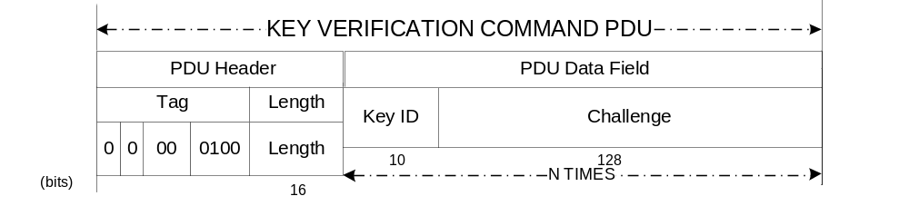Baseline Implementation Mode Key Verification Command PDU
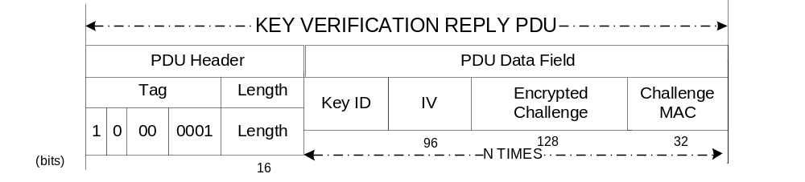
Baseline Implementation Mode OTAR Reply PDU

  - Security Associations Management Service
This section specifies the baseline implementation mode for the Security Associations Management Service Extended Procedures.
[SDLS3015/07]
  - Monitoring and Control Service
This section specifies the baseline implementation mode for the Monitoring and Control Service Extended Procedures.
    - Monitoring and Control Services Parameters
      - Ping
- No specific configuration needed.
      - Log Status Request
The baseline implementation configuration to be used for Log Status Request procedure interoperability testing and operation is:
- TBD (need to define security messages first to have their size…)
      - Dump Log
The baseline implementation configuration to be used for Dump Log procedure interoperability testing and operation is:
- TBD (need to define security messages first…)
      - Erase Log
The baseline implementation configuration to be used for Erase Log procedure interoperability testing and operation is:
- TBD (need to define security messages first to have their size…)
      - Self-Test
The baseline implementation configuration to be used for Self-Test procedure interoperability testing and operation is:
- No specific configuration needed.
      - Read Sequence Number
The baseline implementation configuration to be used for Read Sequence Number procedure interoperability testing and operation is:
- For TC : The length of the Sequence Number is 0x0004 (32 bits)
- For TM / AOS : The length of the Sequence Number / Initialisation Vector is 0x000C (12 octets, 96 bits)
      - Alarm Flag Reset
The baseline implementation configuration to be used for Alarm Flag Reset procedure interoperability testing and operation is:
- No specific configuration needed.

