
Report Concerning Space Data System Standards
space data link security protocol –
summary of concept and rationale
Draft Informational Report
CCSDS 350.5-G-0
Draft Green Book
April 2012

AUTHORITY

 | Issue: | Draft Green Book, Issue 0
 | Date: | March 2015
 | Location: | Not Applicable
(WHEN THIS INFORMATIONAL REPORT IS FINALIZED, IT WILL CONTAIN THE FOLLOWING STATEMENT OF AUTHORITY:)
This document has been approved for publication by the Management Council of the Consultative Committee for Space Data Systems (CCSDS) and reflects the consensus of technical panel experts from CCSDS Member Agencies. The procedure for review and authorization of CCSDS Reports is detailed in Organization and Processes for the Consultative Committee for Space Data Systems (CCSDS A02.1-Y-4).

This document is published and maintained by:

CCSDS Secretariat
Space Communications and Navigation Office, 7L70
Space Operations Mission Directorate
NASA Headquarters
Washington, DC 20546-0001, USA

FOREWORD
This document is a CCSDS Report, which contains background, rationale and a concept of operation to support the CCSDS Recommended Standard on the Space Data Link Security Protocol (reference [1]).
Through the process of normal evolution, it is expected that expansion, deletion, or modification of this document may occur. This document is therefore subject to CCSDS document management and change control procedures which are defined in the Procedures Manual for the Consultative Committee for Space Data Systems (CCSDS A02.1-Y-4). Current versions of CCSDS documents are maintained at the CCSDS Web site:
http://www.ccsds.org/
Questions relating to the contents or status of this document should be addressed to the CCSDS Secretariat at the address indicated on page i.
At time of publication, the active Member and Observer Agencies of the CCSDS were:

Member Agencies

- Agenzia Spaziale Italiana (ASI)/Italy.
- British National Space Centre (BNSC)/United Kingdom.
- Canadian Space Agency (CSA)/Canada.
- Centre National d’Etudes Spatiales (CNES)/France.
- China National Space Administration (CNSA)/People’s Republic of China.
- Deutsches Zentrum für Luft- und Raumfahrt e.V. (DLR)/Germany.
- European Space Agency (ESA)/Europe.
- Federal Space Agency (FSA)/Russian Federation.
- Instituto Nacional de Pesquisas Espaciais (INPE)/Brazil.
- Japan Aerospace Exploration Agency (JAXA)/Japan.
- National Aeronautics and Space Administration (NASA)/USA.

Observer Agencies

- Austrian Space Agency (ASA)/Austria.
- Belgian Federal Science Policy Office (BFSPO)/Belgium.
- Central Research Institute of Machine Building (TsNIIMash)/Russian Federation.
- Centro Tecnico Aeroespacial (CTA)/Brazil.
- Chinese Academy of Sciences (CAS)/China.
- Chinese Academy of Space Technology (CAST)/China.
- Commonwealth Scientific and Industrial Research Organization (CSIRO)/Australia.
- Danish National Space Center (DNSC)/Denmark.
- European Organization for the Exploitation of Meteorological Satellites (EUMETSAT)/Europe.
- European Telecommunications Satellite Organization (EUTELSAT)/Europe.
- Hellenic National Space Committee (HNSC)/Greece.
- Indian Space Research Organization (ISRO)/India.
- Institute of Space Research (IKI)/Russian Federation.
- KFKI Research Institute for Particle & Nuclear Physics (KFKI)/Hungary.
- Korea Aerospace Research Institute (KARI)/Korea.
- MIKOMTEK: CSIR (CSIR)/Republic of South Africa.
- Ministry of Communications (MOC)/Israel.
- National Institute of Information and Communications Technology (NICT)/Japan.
- National Oceanic and Atmospheric Administration (NOAA)/USA.
- National Space Organization (NSPO)/Chinese Taipei.
- Naval Center for Space Technology (NCST)/USA.
- Space and Upper Atmosphere Research Commission (SUPARCO)/Pakistan.
- Swedish Space Corporation (SSC)/Sweden.
- United States Geological Survey (USGS)/USA.

DOCUMENT CONTROL

Document | Title and Issue | Date | Status
CCSDS 350.5-G-0 | Space Data Link Security Protocol – Summary of Concept and Rationale, Draft Informational Report, Issue 0 | May 2011 | First draft
CCSDS 350.5-G-0 | Space Data Link Security Protocol – Summary of Concept and Rationale, Draft Informational Report, Issue 0 | November 2011 | Second draft
CCSDS 350.5-G-0 | Space Data Link Security Protocol – Summary of Concept and Rationale, Draft Informational Report, Issue 0 | April 2012 | Third draft
CCSDS 350.5-G-0 | Space Data Link Security Protocol – Summary of Concept and Rationale, Draft Informational Report, Issue 0 | March 2014 | Fourth draft

CONTENTS
Section Page
DOCUMENT CONTROL iv
CONTENTS v
1 Introduction 1-1
1.1 purpose 1-1
1.2 scope 1-1
1.3 organization of this report 1-1
1.4 conventions and definitions 1-2
1.5 References 1-3
2 overview 2-1
2.1 sdls protocol 2-1
2.2 motivation 2-1
2.3 major design goals and constraints 2-2
2.3.1 mission network topologies 2-2
2.3.2 security objectives and corresponding user services 2-5
2.3.3 compatibility with sdl services 2-6
2.3.4 compatibility with sle services 2-7
2.3.5 cryptographic algorithm support 2-8
2.3.6 decoupling of sdl and sdls data integrity performance 2-9
2.4 requirements 2-9
3 design concepts 3-11
3.1 security services selection 3-11
3.1.1 threat analysis 3-11
3.1.2 baseline security services 3-14
3.2 security association 3-14
3.3 protocol position in ccsds stacks 3-15
3.3.1 telecommand 3-16
3.3.2 telemetry 3-17
3.3.3 advanced orbiting systems 3-18
3.4 protocol data structures, fields and functions 3-19
3.4.1 security header 3-20
3.4.2 security trailer 3-23
3.5 protocol management 3-24
3.5.1 security association 3-24
3.5.2 managed Parameters 3-25
3.5.3 signalling 3-25
3.5.4 redundancy 3-25
3.5.5 cryptographic keys 3-26
3.5.6 telecommand 3-26
3.5.7 telemetry 3-26
3.5.8 advanced orbting systems 3-26
4 concept of operation 4-27
4.1 security association 4-27
4.2 synchronization 4-28
4.2.1 cryptographic key synchronization 4-29
4.2.2 initialization vector synchronization 4-29
4.2.3 sequence count synchronization 4-29
4.3 authentication 4-29
4.3.1 authentication payload processing 4-29
4.3.2 replay protection 4-29
4.4 encryption 4-29
4.5 authenticated encryption 4-30
4.6 SDL protocol interaction 4-30
4.6.1 telecommand 4-30
4.6.2 telemetry 4-31
4.6.3 advanced oriting systems 4-32
4.7 scenarios 4-32
4.7.1 Basic Scenario 4-33
4.7.2 Complex Scenario 4-33
4.7.3 Onboard Processing 4-34
4.7.4 Ground Processing 4-34
4.7.5 Recovery SA scenario 4-35

Introduction

purpose
This Report has been developed to present the concept and rationale of the CCSDS Recommend Standard on the Space Data Link Security Protocol (reference [1]).
It has specifically been prepared to document the following:
- architectural overview of the Space Data Link Security Protocol;
- interaction between Space Data Link and Space Data Link Security Protocols;
- justification of protocol services, elements, procedures and design choices as well as the recommended profiles;
- security analyses;
- guidelines for the selection of Space Data Link Security Protocol parameters.

scope
The information contained in this Report is not part of the CCSDS Recommended Standards on the Space Data Link Security Protocol [1]. In the event of any conflict between the Recommended Standard and the material presented herein, the Recommended Standard shall prevail.

organization of this report
This document is divided into 4 numbered sections and 5 annexes:
- section 1 presents the purpose, scope, and organization of this Report, and lists the definitions and references used throughout the Report;
- section 2 presents an overview of the protocol; the motivation for its development, the major design goals and constraints as well as the main requirements are discussed;
- section 3 provides a detailed description and discussion of the key design concepts of the protocol; in particular the selection of security services, the position of the protocol in CCSDS stacks, and its data structures, fields and functions are given;
- section 4 presents the operation of the protocol in detail;

- Annex A elaborates on the baseline implementations;
- Annex B provides a detailed analysis of the ISO/OSI security services ;
- Annex C includes the latest version of the User Requirements Document (URD);
- Annex D illustrates the protocol interaction with data link performance;
- Annex E provides a list of acronyms and abbreviations.

conventions and definitions
Generic definitions for the security terminology applicable to this and other CCSDS documents are provided in [8]. For any terms not defined therein, the following definitions apply for the purposes of this document.
Authentication: The process of verifying the identity or other attributes claimed by or assumed of an entity (user, process, or device), or to verify the source and integrity of data. Error: Reference source not found See also peer entity authentication. See also data origin authentication.
Cipher text: Data produced through the use of encipherment. The semantic content of the resulting data is not available. Error: Reference source not found
Confidentiality: The property that information is not made available or disclosed to unauthorized individuals, entities, or processes. Error: Reference source not found
Data Integrity: The property that data has not been altered or destroyed in an unauthorized manner. Error: Reference source not found
Data Origin Authentication: The corroboration that the source of data received is as claimed. Error: Reference source not found
Denial of Service: The prevention of authorized access to resources or the delaying of time-critical operations. Error: Reference source not found
Encipherment: see encryption.
Encryption: The cryptographic transformation of data (see cryptography) to produce ciphertext. Error: Reference source not found

Encryption Algorithm: A set of mathematically expressed rules for rendering data unintelligible by executing a series of conversions controlled by a key. Error: Reference source not found
Initialization Vector: A vector used in defining the starting point of a cryptographic process. Error: Reference source not found
Message Authentication Code (MAC): A cryptographic checksum that results from passing data through a message authentication algorithm. Error: Reference source not found
Padding: Fill data required by certain cipher modes.
Peer-entity Authentication: The corroboration that a peer entity in an association is the one claimed. Error: Reference source not found
Plaintext: Unencrypted information. Error: Reference source not found
Risk: Possibility that a particular threat will adversely impact an information system by exploiting a particular vulnerability. Error: Reference source not found
Security Policy: The set of criteria for the provision of security services (see also identity-based and rule-based security policy). Error: Reference source not found
Threat: A potential violation of security. Error: Reference source not found

References
The following documents are referenced in this Report. At the time of publication, the editions indicated were valid. All documents are subject to revision, and users of this Report are encouraged to investigate the possibility of applying the most recent editions of the documents indicated below. The CCSDS Secretariat maintains a register of currently valid CCSDS documents.
[1] | Space Data Link Security Protocol. Recommendation for Space Data System Standards, CCSDS 355.0-B-1. Blue Book. Issue 1. Washington, D.C.: CCSDS, forthcoming.
[2] | Security Architecture for the Internet Protocol, RFC 4301, The Internet Society, December 2005.
[3] | Space Link Extension Services – Executive Summary, Informational Report, CCSDS 910.0-G-2. Green Book, Issue 1. Washington, D.C.: CCSDS, March 2006.
[1] | TM Space Data Link Protocol. Recommendation for Space Data System Standards, CCSDS 132.0-B-1. Blue Book. Issue 1. Washington, D.C.: CCSDS, September 2003.
[2] | TC Space Data Link Protocol. Recommendation for Space Data System Standards, CCSDS 232.0-B-2. Blue Book. Issue 2. Washington, D.C.: CCSDS, September 2010.
[3] | AOS Space Data Link Protocol. Recommendation for Space Data System Standards, CCSDS 732.0-B-2. Blue Book. Issue 2. Washington, D.C.: CCSDS, July 2006.
[4] | TM Synchronization and Channel Coding. Recommendation for Space Data System Standards, CCSDS 131.0-B-2. Blue Book. Issue 2. Washington, D.C.: CCSDS, August 2011.
[5] | TC Synchronization and Channel Coding. Recommendation for Space Data System Standards, CCSDS 231.0-B-2. Blue Book. Issue 2. Washington, D.C.: CCSDS, September 2010.
[6] | Space Link Identifiers. Recommendation for Space Data System Standards, CCSDS 135.0-B-4. Blue Book. Issue 4. Washington, D.C.: CCSDS, October 2009.
[7] | CCSDS Cryptographic Algorithms. Recommendation for Space Data System Standards, CCSDS 352.0-B-1. Blue Book. Issue 1. Washington, D.C.: November 20102.
[8] | Information Security Glossary of Terms. Report Concerning Space Data System Standards, CCSDS 350.8-G-1. Green Book. Issue 1. Washington, D.C.: CCSDS, November 2012.
[9] | Information Technology—Open Systems Interconnection—Basic Reference Model—Part 2: Security Architecture. International Standard, ISO/IEC 7498-2: 1989. Geneva: ISO, 1989.
[10] | M. Bellare, N. Namprere, “Authenticated Encryption: Relations among notions and analysis of the generic composition paradigm”, Advances in Cryptology | ASIACRYPT 2000, Volume 1976 of Lecture Notes in Computer Science, pages 531-545, Kyoto, Japan, December 3-7, 2000.
[12] | Reference for section D3
[13] | Reference2 for section D3 (ESA TC Standard)
[14] | Recommendation for Block Cipher Modes of Operation: The CMAC Mode for Authentication, NIST Special Publication 800-38B, National Institute of Standards and Technology, May 2005.
[15] | Recommendation for Block Cipher Modes of Operation: Galois/Counter Mode (GCM) and GMAC, NIST Special Publication 800-38D, National Institute of Standards and Technology, November 2007.
[TBD] | ECRYPT II Yearly Report on Algorithms and Keysizes(2011-2012), ICT-2007-216676, European Network of Excellence in Cryptology II, Revision 1.0, 30 Sept 2012.
[TBD] | p. 362, definition 9.78, chapter 9, Handbook of Applied Cryptography, Alfred J. Menezes, Paul C. van Oorschot and Scott A. Vanstone, October 1996.  Include Key Management Green Book (referenced in section 2.4, Requirements).
[TBD] | Space Missions Key Management Concept, Report Concerning Space Data Systems Standards, CCSDS 350.6-G-1, Green Book, November 2011.

overview

sdls protocol
The Space Data Link Security protocol [1] is a security protocol that implements user-selected Security Services to the data transported by the Space Data Link protocol in space-to-ground links. The SDLS protects the Service Data Units transported by the SDL protocol and, in addition, selected SDL protocol data structures taking into account compatibility constraints with SDL and Space Link Extension services.

motivation
The Consultative Committee for Space Data Systems (CCSDS) is working to provide security standards for space missions as well as security guidance to other areas of CCSDS standardization. The CCSDS Security Working Group has developed a space security architecture, a space mission threat document, security protocol guidance, and is in the process of standardizing cryptographic algorithms for data confidentiality and authentication. In this context, CCSDS also developed a network security protocol (SCPS-SP), which was a “thin” analogy to IP Security (IPSec)[2].
However, while other network standards were developed, no security standards for the bulk of CCSDS missions where there is a single spacecraft in contact with its control center through a ground station are available today. As a result, if uplink command authentication and/or downlink payload data confidentiality requirements are specified for a space mission that is otherwise CCSDS compliant, up to this point each mission had to invent their own solutions. CCSDS realized that a standardized concept to integrate security on space missions with a simple network topology could be proposed at the data link layer. This would avoid the above mentioned problem of individual developments and would deliver the benefits of standardization also in the area of secure space link communication.
The CCSDS Space Link Extension (SLE) transfer services [3] de facto translate the management of the Space Data Link (SDL) protocols [4,5,6] from the ground station, typically on a remote location with limited or no personnel, to the mission control centre, where mission operations are conducted and manned 24-hour/7-days a week. SLE has security provisions to guarantee identification, authentication and confidentiality between the two exchanging parties, which for the case of SLE are the ground control centre and the ground station(s). Protection on ground networks is thus ensured. The space link, which is not protected by SLE, requires additional protection.
To develop this protection CCSDS formed a joint working group made up of members from both the Space Link and the System Engineering (Security) areas. The goal was to develop a CCSDS standard for link layer security services for use with existing CCSDS telecommand (TC) [4], telemetry (TM) [5], and advanced orbiting systems (AOS) [6] standards without having to modify those standards. Rather the aim was to allow security services to be used with TC, TM, and AOS and not force a reengineering of those standards, which are in wide use by many missions and planned for use in many new missions.
In summary, the SDLS protocol implements an additional security function tightly integrated within the Data Link of the International Standards Organization Open Systems Interconnection (ISO/OSI) model (see Fig. 1).
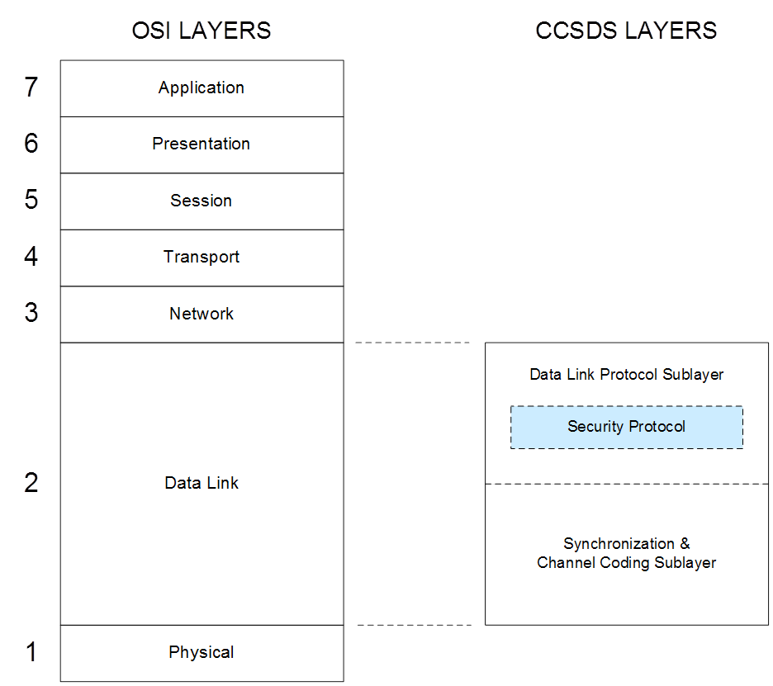
Figure 1.

major design goals and constraints

mission network topologies
The target space missions for the SDLS protocol are those in which basically a mission control center communicates with a satellite with a single ground station (see Fig. 2). The ground network between the ground station and the mission control center implements SLE services. The SLE services extend the ground side of the space data link protocol, formerly placed at the ground station site, up to the mission control center. The SLE services are based on ground network and transport protocols. The reader is referred to [3] for a detailed overview of SLE.
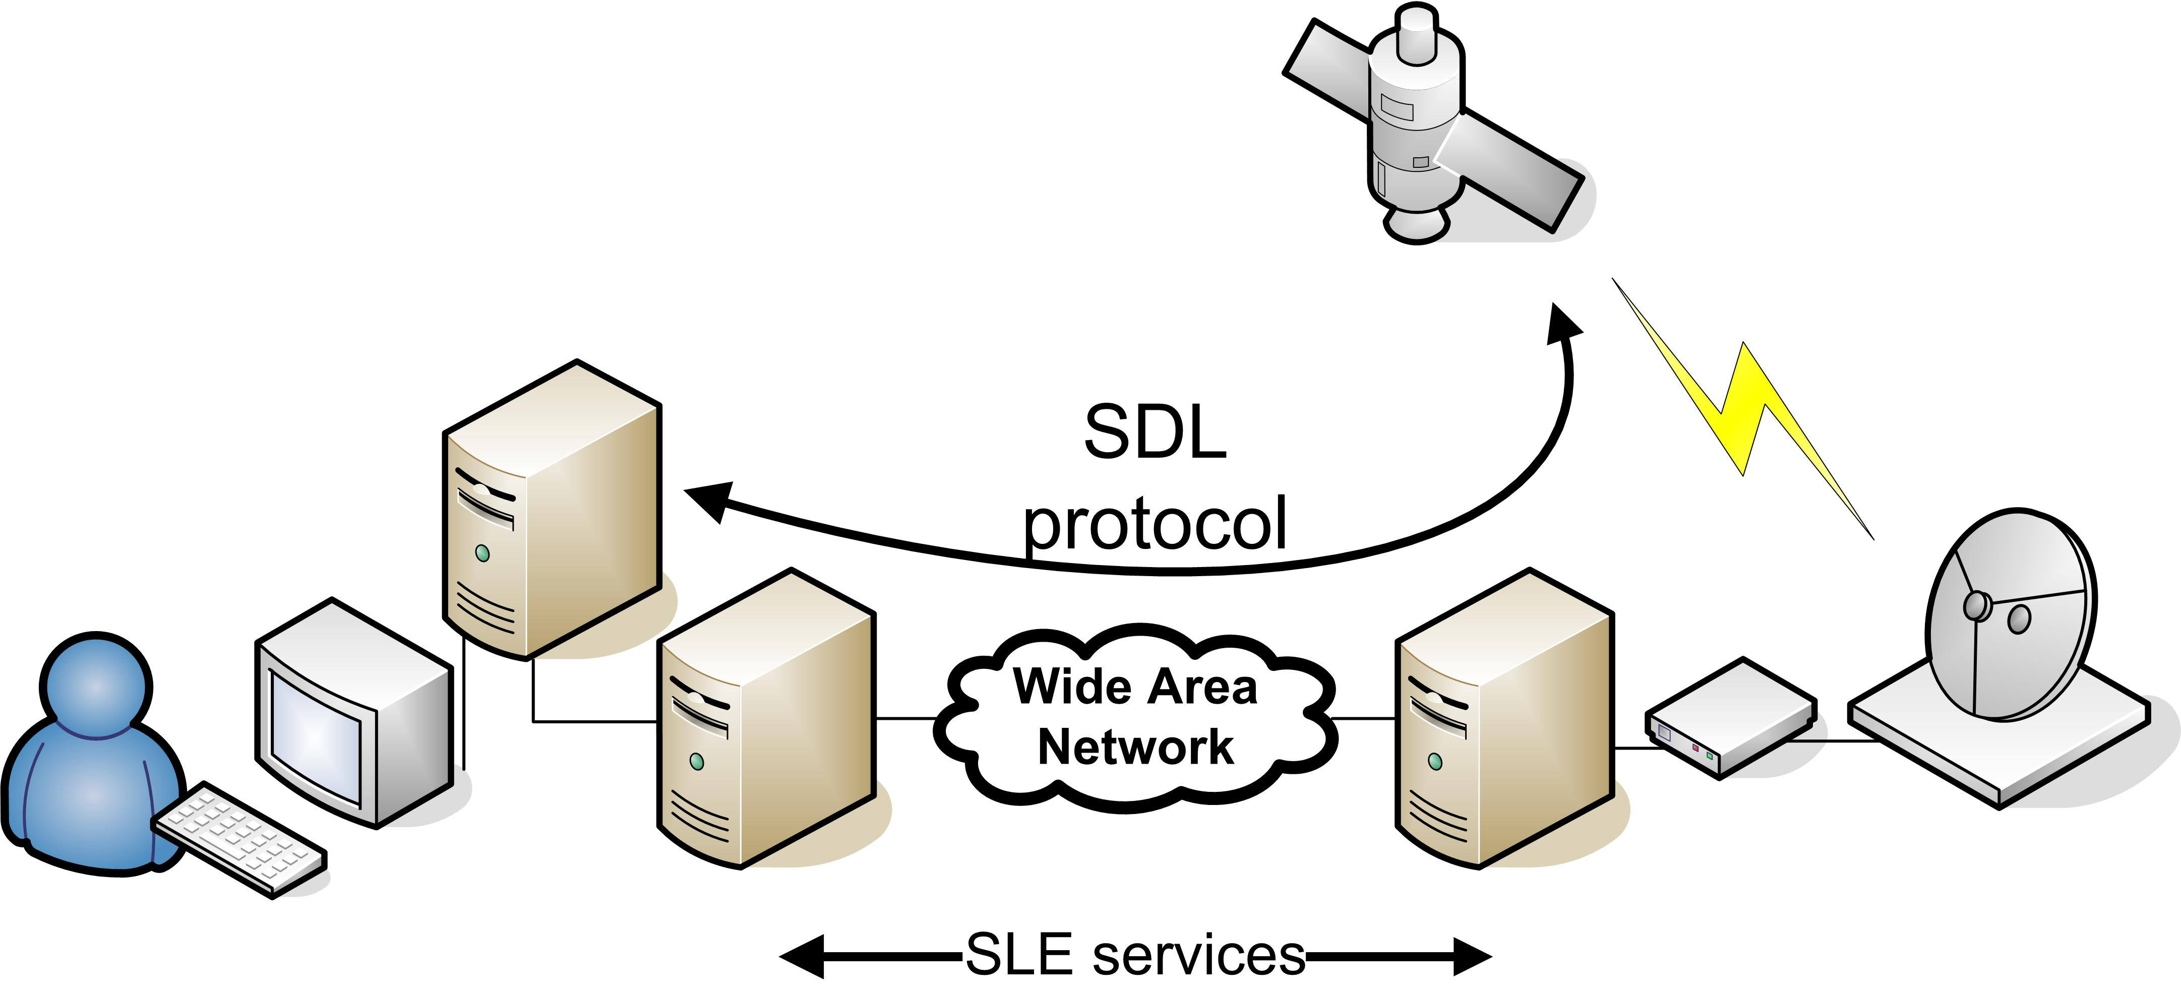
Figure 2 Mission Network Topology A

In this simple topology payload and housekeeping telemetry are multiplexed on the same space link. In many missions those telemetry data flows are segregated, thus employing two space downlinks (see Fig. 3).
Securing end-to-end communications between the mission control center and the spacecraft is divided into two tasks. The first task is protecting the SLE services and ground network interconnecting the mission control center and ground station(s).

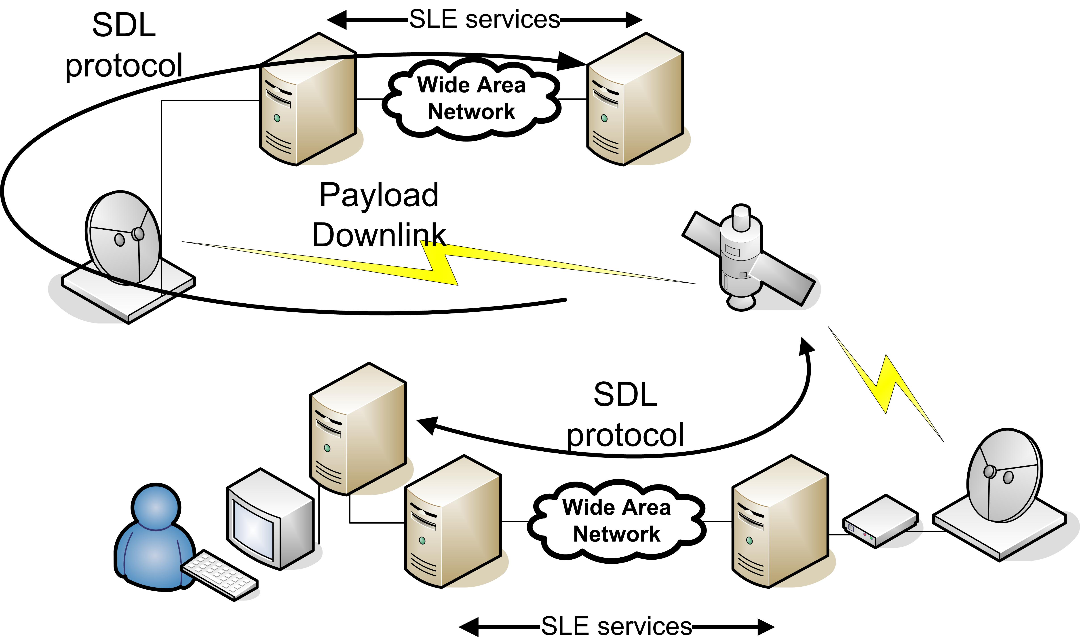
Figure 3. Mission Network Topology B
The second task, the subject of the SDLS protocol, involves protecting the end-to-end space data link protocols now closed at the mission control system on the ground side.
This communications and data systems architecture provides interoperability between space agencies with SLE services and end-to-end security between a space agency and its spacecraft. A service level agreement is required to ensure secure cross-support with SLE services between the agency or operator owning the mission control center and the agency owning or operating the ground station. If needed, protection against denial of service on the TC space link can be achieved by using TRANSEC techniques in the physical layer (e.g., spread spectrum), which are perfectly compatible with SDLS protocol.
Data links between ground stations and mission control centers are protected with SLE services and corresponding protocols.
These simple network topologies are found on many Earth Observation and Science missions. Those topologies can also be applicable to Geostationary Telecommunication missions. Classical telecommunication missions rely on a single Telemetry, Command and Ranging (TCR) link. Some advanced telecommunication payloads have segregated direct payload control and configuration (PCC) links that could benefit from the second topology with the addition of an up-link.

security objectives and corresponding user services
The CCSDS SDL protocols provide a number of user services to different Service Data Units (SDUs) [5]. The SDUs are the data that are delivered to the receiving user. Table 1 shows the services selected for protection with the SDLS protocol.
The word “Mandatory” implies that the SDLS protocol shall support the protection of all of those mentioned services. The user is free to use them or not.
The word “Optional” implies that, for a given implementation of the SDLS protocol, the protection for the listed services may or may not be present.
Table 1 User Services
User Services |  | Type of Service Data Unit | Protection by SDLS protocol
TC Services | Multiple Access Point (MAP) Packet | Packets with authorized Packet Version Number (PVN) | Mandatory
TC Services | MAP Access | Variable-length private data | Mandatory
TC Services | Virtual Channel (VC) Packet | Packets with authorized PVN | Optional
TC Services | VC Access (VCA) | Variable-length private data | Optional
TM Services | Packet | Packets with authorized PVN | Mandatory
TM Services | VCA | Variable-length private data | Mandatory
AOS Services | Packet | Packets with authorized PVN | Mandatory
AOS Services | VCA | Variable-length private data | Mandatory
AOS Services | Bitstream | Bistream | Optional
AOS Services | Insert | Short fixed-length data | Not supported

Security objectives have been analyzed and determined for both TC and TM space-to-ground links. The following security objectives have been established for TC link:
- Command Authenticity, which ensures that the spacecraft can validate that the command is originating from a genuine source (i.e., the authorized mission control centre);
- Command Integrity, which ensures that random or malicious command manipulation will be detected;
- Command Confidentiality, which ensures only those authorized entities will be able to read the command (i.e., the right spacecraft);
- Command Anti-replay protection, which avoids the re-use of previously recorded commands to attack the system.
For TM link the established security objectives are:
- TM data Authenticity, which ensures that the mission control centre can validate that the telemetry is originating from a genuine source (i.e., the authorized spacecraft);
- TM data Integrity, which ensures that random or malicious telemetry manipulation will be detected;
- TM data Confidentiality, which ensures only those authorized entities will be able to read the telemetry (i.e., the right mission control centre);
- TM data Anti-replay protection, which avoids the re-use of previously recorded telemetries to attack the system.
The Security Services that allow fulfilling above selected security objectives are the following:
- Authentication, which provides authentication, integrity, and the anti-replay function, to be used on a space link when the data confidentiality is not required;
- Encryption, which provides data confidentiality but no authentication or integrity;
- Authenticated Encryption, which is a combination of encryption and authentication, thus providing data confidentiality, data integrity, authentication, and anti-replay function

compatibility with sdl services
The SDLS standard has been developed for use with existing CCSDS TC, TM, and AOS SDL standards. Avoiding reengineering of those widely used SDL standards has been an overriding priority.
There are two key aspects that drive SDL compatibility:
- The extent to which SDL frame protocol data structures other than the SDU to be protected are impacted by SDLS and the consequences of such impact in SDL protocol processing.
- The distinction between frames that transport SDUs and those that do not. This case is only relevant for TC SDL.

Supported Services
Services that transport typical application layer SDUs like packets or variable-length private data (e.g. segments) can be protected with SDLS. The user can select among authentication, encryption and authenticated encryption. A compromise was achieved with VC Frame Secondary Header service: only authentication is provided.

Optional Services
Initially, the following services were anticipated to be optional: VC Packet, VC Access and Bitstream. It was not a firm requirement to protect those services. However, the actual design has left no options: SDL services are either supported or not supported. VC Packet, VC Access and Bit-stream are supported.

Excluded Services
Services that transport transfer frames or other auxiliary data (e.g. audio samples on AOS Insert, Master Channel Frame Secondary Header data on TM) produced elsewhere but multiplexed on the space link are not secured. Their security is handled at their data source.
Given the impact on current implementations or compatibility with SLE as well as the acceptable residual risk, a few specific services are not protected. This is the case for TM and AOS services concerned with the Operational Control Field (OCF), which is actually a protocol data unit (PDU).
Command Operations Procedure (COP) Management is a particular case. Although it does not transport SDUs, its role is essential for sequence-controlled telecommand transmission. The residual risk remaining when not protecting the directives of this service (BC frames) is acceptable. In addition, provision of security would basically imply incompatibility with TC protocol and its implementations.

Summary
The table 2 contains a complete and exhaustive list of TM, TC and AOS SDL services and their available protection.
Table 2 Summary of SDLS Services
Space Data Link Protocol | Service | Service Data Unit | Authentication | Encryption | Authenticated Encryption
TM | Packet | Packets with authorized Packet Version Number (PVN) | Protected | Protected | Protected
TM | Virtual Channel (VC) Access | Variable-length private data | Protected | Protected | Protected
TM | VC_FSH | Fixed-length data | Protected | Not protected | Authentication only
TM | VC_OCF | Fixed-length data | Not protected | Not protected | Not protected
TM | VC Frame | Transfer frame | Not protected | Not protected | Not protected
TM | MC_FSH | Fixed-length data | Not protected | Not protected | Not protected
TM | MC_OCF | Fixed-length data | Not protected | Not protected | Not protected
TM | MC Frame | Transfer frame | Not protected | Not protected | Not protected
TC | Multiple Access Point (MAP) Packet | Packets with authorized PVN | Protected | Protected | Protected
TC | MAP Access | Variable-length private data | Protected | Protected | Protected
TC | VC Packet | Packets with authorized PVN | Protected | Protected | Protected
TC | VC Access | Variable-length private data | Protected | Protected | Protected
TC | COP Management | N/A | Not protected¹ | Not protected¹ | Not protected¹
TC | VC Frame | Transfer frame | Not protected | Not protected | Not protected
TC | MC Frame | Transfer frame | Not protected | Not protected | Not protected
AOS | Packet | Packet with authorized PVN | Protected | Protected | Protected
AOS | Bitstream | Bit stream | Protected | Protected | Protected
AOS | VC Access | Variable-length private data | Protected | Protected | Protected
AOS | VC_OCF | Fixed-length data | Not protected | Not protected | Not protected
AOS | VC Frame | Transfer frame | Not protected | Not protected | Not protected
AOS | MC Frame | Transfer frame | Not protected | Not protected | Not protected
AOS | Insert | Short fixed-length data | Not protected | Not protected | Not protected

compatibility with sle services
The currently defined and specified SLE services rely on their ability to identify and process SDL frames or parts of it for further processing and transfer between the SLE end points.
The application of security services (e.g., confidentiality) at the SDL protocol with the new SDLS may impact the SLE service ability to ‘read’ and process the SDL frames, and in turn, the SLE service compatibility with SDLS.
The goal is to apply space data link security with SDLS only at the end points of the space end-to-end data link. In this way mission-specific cryptographic functions needed to implement SDLS security services will be located at the spacecraft and the mission control center. Hence, SDLS should be transparent for SLE service processing.
In practice this approach implies to keep certain protocol data structures of SDL frames visible and unaltered by the security processing. Those SLE services for which the required SDL frame data is not visible due to alteration by SDLS will not be supported.
Some decisions like routing may be taken by the ground station SLE processing equipment without validating the integrity of the SDL frame protocol data structure. However, the risk brought by such approach is acceptable as discussed in section 3.1.

Supported Services
The following service compatibility goals have been established:
- For TC Services, Forward Command Link Transmission Unit (F-CLTU) Service and Forward Telecommand Frames (F-TCF) Service shall be compatible;
- For TM/AOS Services, Return All Frames (RAF), Return Channel Frames (RCF) and possibly Return Operational Control Field (OCF) shall be compatible.
These service compatibility goals can only be achieved if the full SDL frame header remains unaltered by the SDLS protocol.

Excluded Services
SLE services that require the identification of packets will not be supported. The application of SDLS will cause two impacts. First, SDLS will insert a new header between the SDL frame header and the frame data field. Second, if encryption is applied the SDU will be unreadable.
The result of those impacts is that SLE services can no longer process data inside the SDU, that is, packets. Thus the following two SLE services are not supported:
- Return Space Packet (RSP), which enables single users to receive packets with selected Application Process Identifiers (APIDs) from one spacecraft VC;
- Forward Space Packet (FSP), which enables single users to provide packets for uplink to a spacecraft without needing to co-ordinate with other users of the spacecraft.
In addition, the following SLE service is supported but its authentication cannot be guaranteed by the user on its own:
- Return Frame Secondary Header (RFSH), which provides MC or VC Frame Secondary Headers (FSHs), as specified by each RFSH service user.
Although not advisable, the extraction of the RFSH is technically possible at the ground station without performing Frame Authentication. However, the SLE user of such service will not have the complete authenticated data payload to perform the authentication verification of the FSH.

cryptographic algorithm support
It is also an objective to provide a method independent of the underlying cryptographic algorithms employed by any particular space mission. Because cryptographic algorithms are subject to ongoing mathematical analysis to discover potential weaknesses (e.g., cryptanalysis), and increasingly susceptible to exhaustive “brute-force” key attacks as computational resources multiply, it is desirable that the SDLS specification should not require redefinition even if future discoveries of cryptographic weaknesses necessitate that CCSDS modify its baseline recommendations for authentication and encryption algorithms as described in Annex C of the SDLS Blue Book [1].

Authentication
Authentication primitives produce a MAC out of the input data as a result of a cryptographic operation with the selected cryptographic algorithm and a secret key. The SDU and additional SLP protocol data unit or fields are the input data subject to authentication. Thus, the MAC is generated and attached to the authenticated data as an additional protocol overhead.
In addition, to guarantee the ‘freshness’ of the authentication process (see transaction authentication in [TBD, Handbook of Applied Cryptography]), a critical requirement for space communications applications, the input data is jointly authenticated with a time-dependent data unit. It can be typically a counter or a time-stamp. The insertion of such time-dependent data element as part of the message authentication is designated as Anti-replay. In SDLS the preference is for a counter value labelled as the Sequence Counter.
Certain authentication algorithms require as well an IV as an input. Strictly speaking, its transmission would not be required but there are substantial implementation, operational and robustness advantages if it is fully or partly transmitted.
Certain cipher-based authentication algorithms may require input data in multiples of a specified block length (e.g. GMAC). If the input data is not a multiple, additional data is added to complete the last input block, i.e., the padding. The receiving end needs to identify the presence of padding and its length.
Therefore, SDLS includes the provision of protocol data unit fields for the transport of the MAC and the Sequence Counter as well as the optional IV and padding.

Encryption
Encryption primitives transform a block of plain-text data into cipher-text data. As explained elsewhere in this document, for reasons of compatibility with SLE and SDL services only the SDU of the SDL protocol is subject to encryption.
While there are encryption algorithms that operate without IV (e.g. electronic code book (ECB)), most secure encryption algorithms require an IV as input. Strictly speaking, its transmission would not be required but there are substantial implementation, operational and robustness advantages if it is fully or partly transmitted.
Therefore, SDLS includes the provision of protocol data unit field for the transport of the optional IV.

Authenticated Encryption
Authenticated encryption algorithms combine authentication and encryption algorithms with a single cryptographic key and algorithm. There are three generic compositions of authentication and encryption [10]:
- Encrypt-then-MAC;
- MAC-then-Encrypt;
- MAC-and-Encrypt.
The SDLS is specified assuming the Encrypt-then-MAC, that is, at source the SDU is first ciphered. Afterwards, the ciphered SDU together with certain SLP PDU fields is authenticated. In the receiving end the opposite order of operations takes place. The interested reader is referred to [10] for a thorough discussion of the security aspects of those compositions and in particular on the preference for the Encrypt-then-MAC composition.
Authenticated encryption algorithms represent an efficient alternative to the separate application of authentication and encryption algorithms. For this reason, they are extremely popular.
Furthermore, these algorithms offer the possibility to authenticate metadata accompanying the plain-text which is not encrypted (Additional Authenticated Data or AAD). This is particularly useful to protect readable protocol data units against forgery.
Authenticated Encryption is the CCSDS-recommended solution to provide authentication and confidentiality services to SLP SDUs and selected PDU fields.
Support for Authenticated encryption algorithms may imply for SDLS the provision of protocol data unit fields for the transport of MAC, Sequence Counter, IV and padding. However, certain authenticated encryption algorithms like AES-GCM (see baseline modes) do with a subset of those.

Authentication and Encryption
For missions that have specific security requirements, SDLS may accommodate separate authentication and encryption algorithms within certain constraints. Each algorithm would require its own cryptographic key as well as possibly its own parameters like IV, Sequence Counter and padding.
Note, however, that SDLS limits its provision to a single IV, single Sequence Counter and single Padding field.
Furthermore, the SPI may constrain key management for each algorithm. Although a change of SPI could be used as a way to signal a key change, the SPI field is limited in length. Furthermore, cryptoperiods for the authentication and encryption key may differ, requiring additional SPI values.
The adequate selection of authentication and encryption algorithms that can be operated together (paired) requires knowledge of cryptography, which is beyond the scope of CCSDS (no such pairing recommendations are provided in [7] and, therefore, in this report or its related Blue Book [1]). The user interested in such particular use of SDLS is recommended to obtain adequate cryptographic expertise to pair authentication and encryption algorithms.

decoupling of sdl and sdls data integrity performance
When the authentication service is applied, the SDLS protocol protects against malicious attempts to manipulate the data or spoof the data source. The SDL protocol protects to a certain extent the data transactions against communications channel transmission errors.
For Failure Detection Isolation and Recovery (FDIR) and operational reliability, it is advisable that the integration of the SDLS and the SDL protocols is such that it allows an easy distinction and identification of the nature of errors (communications or security) when they manifest themselves. This is of particular concern for TC application.
Theoretically, the efficiency of an authentication mechanism in detecting integrity errors on a message is much higher than classical communications integrity error detection mechanisms like the cyclic redundancy check (CRC). The typically much greater length of the MAC compared to the CRC is the main reason for this.
The analysis provided in Annex D shows that the undetected error performance of SDL is sufficient as currently specified to allow for a discrimination of communications and security data integrity events in TC.
For what concerns TM and AOS, it is important to note that undetected error performance is dependent on the selected channel coding. In contrast to TC, there are several channel coding options available to implementers. Channel codes like Reed-Solomon (E=16) provide superb undetected error performance, thus ensuring excellent decoupling of transmission and security data integrity events. Links using other codes will benefit from the addition of a CRC to reduce the number of authentication events due to undetected transmission errors.

requirements
The SDLS protocol has been specified to fulfil a set of well identified requirements. The following is a selection of some key requirements. The complete set of requirements is found in Annex C.
The Secure Space Data Link Protocol shall support two operational modes for each logical communication channel managed over TC and TM / AOS links:
- Clear Mode (or transparent mode) where the SDU is left unchanged but the SDLS protocol data fields are present;
- Secure Mode providing Authentication, Encryption, or Authenticated Encryption services.
The protocol shall provide the capability to support independent secure channels. Thus, clear and secure channels can coexist in a physical channel.
The detailed specification of a cryptographic church key management concept supporting the SDLS security services has been identified as part of the future extended services of the protocol. The first release of the SDLS protocol is specified to accommodate the required level of flexibility. The SDLS protocol shall be compatible with the following schemes for key management:
- Scheme 1: all session keys are pre-loaded on satellite before launch and cover the whole mission lifetime;
- Scheme 2: a subset of keys (master keys/key encryption keys (KEKs) and session keys) are pre-loaded on satellite before launch; session keys are uploaded encrypted during satellite operation (Over The Air Rekeying, OTAR);
- Scheme 3: a subset of keys (master keys/KEKs and session keys) are pre-loaded on satellite before launch; session keys are generated on-board from master keys and an input uploaded non secret seed.
CCSDS has produced general documentation on key management [6]. In addition, it has been decided to undertake the specification of such concept on a companion document as part of the future extended procedures.
Concerning command and monitoring, the SDLS protocol shall support a set of on-board TC Security control directives managed either as in-band commands (i.e., interpreted and executed internally by the security device immediately after the authentication/decryption process), or out-of-band commands (executed at application level).
The data overhead is limited to 32 octets per transfer frame for the complete protocol.
No interference between frame verification and validation process shall occur.

design concepts

security services selection
This section presents the rationale for the selection of the agreed security services (authentication, confidentiality, integrity and combinations thereof).
The selected security services are taken out of the ISO OSI Security Architecture. An important element of information will be constituted by the residual risk for not implementing a security service or by considering the performance of the selected service.
Among the link layers protected by SDLS, TC is the only protocol that includes an optional re-transmission mechanism (Communications Operation Procedure-1 or COP-1). The mechanism relies on state machines at both ends of the link and a corresponding set of directives. Some of these directives are transmitted from ground to space in order to allow for the remote control of the flight segment state machine. These directives are formatted in TC frames and are labelled BC frames. These directives do not transport SDUs.
Maintaining a separation between transmission control and security is considered essential as the security layer needs to work on an error-free frame. Therefore, the directives to ensure a reliable transmission cannot be secured.
Furthermore, because the VC_OCF is a SDU inserted in TM and AOS frames to support link layer operations like the COP, its protection cannot be taken into account by SDLS.
In AOS, the Insert Zone is added to the transfer frame shortly before transmission when the frame has already been constructed. Thus, there is no opportunity to secure this portion of the frame. If the Insert Zone needs to be protected, it has to be done at the source by the user.
The SDLS protocol works only on Virtual Channels. Therefore, Master Channels services, such as MC_FSH and the MC_OCF, cannot be secured.
VCs that carry exclusively OID Frames are not protected for the following reasons:
- The functional/physical location where OID frames are generated and inserted on the sending side and identified and extracted on the receiving side may not be the same as where security is processed. Sequence control and management issues may be avoided.
- Repetitive patterns on clear text message can potentially ease cryptanalysis and, therefore, introduce a vulnerability.
- Exposure of OID Frames only leaks traffic and activity patterns in the spacecraft operation and communication; risks of such exposure are considered acceptable for the scope of this SDLS protocol.
Modularity. Security services can be applied individually or combined. Repeat warning concerning separate authentication and encryption algorithms.

threat analysis

Trust between CCSDS Agencies
Trust between participating CCSDS Agencies is a fundamental pillar for interoperability and is taken for granted when CCSDS Agencies exchange data. While certain SDLS security services like Authentication can provide protection against threats like malicious data manipulation along the end-to-end data path, it is not the goal of the SDLS protocol to protect against a CCSDS agency that intends to apply malicious action to the communications services provided to another CCSDS agency. Thus, malicious denial-of-service or data manipulation by an Agency are not threats considered in this analysis.

Threats
In general protecting SDUs carried by the SDL protocols in a space link will imply ensuring the Confidentiality, Integrity and Availability of these SDUs as required by the user.
Threats to Confidentiality and Integrity are within the scope of the attacks that the SDLS shall protect. The SDLS constitutes the countermeasure against those threats. The effectiveness to which the SDLS protects against those attacks will depend on various factors like the selected cryptographic algorithm, the choice of cryptographic and protocol parameters and their implementation.
Threats to the Availability of the space link, however, are excluded. Protection against Availability threats like Radiofrequency jamming, blocking signal reception, or Denial-of-service attacks at the data level by entertaining the SDL protocol processors with unwanted data-modulated signals is not within the scope of the SDLS protocol. Protection against those threats requires counter-measures like cryptographic spread-spectrum modulation, which is taken at the Physical Layer of the CCSDS protocol stacks, and therefore beyond the scope of SDLS.

Relationship with ISO Security Architecture
The ISO Security Architecture [9] established the optional security services and some of the security mechanisms to implement them that can be provided optionally within the framework of the OSI reference model.
It is interesting to note that the ISO Security Architecture postulated that the only security services that could be provided at the data link layer of the OSI reference model are connection confidentiality and connectionless confidentiality. In contrast, SDLS implements additional security services like authentication that according to the OSI security architecture should only be implemented at the network layer and above.
The analysis of the OSI security services applicable to SDL protocol and its data services is provided in Annex B. Out of this analysis, the following security services as shown in table 3 have been adopted.

Table 3. OSI Security Services vs. SDLS
OSI Security Services |  | SDLS | Remarks
Authentication
 | Peer entity authentication | Not adopted | Too complex
 | Data origin authentication | Adopted | TC, TM and AOS
Access Control |  | Not adopted | Relevant for TC, residual risk acceptable
Data Confidentiality
 | Connection confidentiality | Adopted | TC only
 | Connectionless confidentiality | Adopted | TC, TM and AOS
 | Selective field confidentiality | Not adopted
 | Traffic flow confidentiality | Not adopted
Data integrity
 | Connection integrity with recovery | Adopted | TC only
 | Connection integrity without recovery | Adopted | TC, TM and AOS
 | Selective field connection integrity | Not adopted
 | Connectionless integrity | Adopted | TC, TM and AOS
 | Selective field connectionless integrity | Not adopted
Non-repudiation
 | Non-repudiation with proof of origin | Not adopted
 | Non-repudiation with proof of delivery | Not adopted

Residual Risks
The decision not to protect TC control frames (BC) implies that an attacker could access and disrupt the operation of the COP leading to a denial of service. However, these are the only type of frames that an attacker will have successfully executed on board. The service can be recovered once the legal operator has the opportunity to reset the on-board protocol processor. This residual risk is considered acceptable since there is an easy recovery (see access control in Table 3 above).
Protection against Traffic Analysis would imply the encryption of all SDL protocol data structures. Given its negative implications on compatibility with both SLE services and SDL protocols, because of the inability by the corresponding SLE service and SDL protocol processors to ‘read’ and process the affected protocol data structures, protection against Traffic Analysis has not been considered a security objective to be covered by SDLS. Such decision brings a residual security risk, which is considered acceptable for the intended clientele of the CCSDS SDLS protocol. Missions that require protection (encryption) of all protocol data structures shall consider the application of bulk-encryption techniques (see reference [TBD]).
Demultiplexing is carried out at the ground station based on protocol fields like the VCID that have not yet been authenticated at that location. The risk of malicious manipulation of any of the relevant fields cannot be excluded before demultiplexing. However, for a VC that has implemented SDLS the end processor, located at the mission control, will detect this manipulation and will reject the attack.

baseline security services

security association
The concept of Security Association (SA), borrowed from IPSec [10] but somewhat adapted to space communications, is crucial to the SDLS protocol. The following paragraphs, excerpts from [1], provide a detailed description.
Concept—
The Security Protocol provides security associations for defining the cryptographic communications parameters to be used by both the sending and receiving ends of a communications session, and for maintaining state information for the duration of the session. A Security Association (SA) defines a simplex (one-way), stateful cryptographic session for providing authentication, data integrity, replay protection, and/or data confidentiality.

Operation—Both the sender and the receiver must create an SA, associate it with cryptographic key(s), and activate it before the SA may be used to secure Transfer Frames on a channel. SAs may be statically pre-loaded prior to the start of a mission. SAs may also be created dynamically as needed, even while other existing SAs are active.
The mechanism for switching from one active Security Association to another is an application-layer function.
All Transfer Frames that share the same SA on a physical channel constitute a Secure Channel. A Secure Channel consists of one or more Global Virtual Channels or Global Multiple Access Point Identifiers (MAP IDs, for TC only) assigned to an SA at the time of its creation.
The Security Parameter Index (SPI) is a transmitted value that uniquely identifies the SA applicable to a Transfer Frame. All Transfer Frames having the same SPI on a physical channel share a single Security Association. A maximum of 254 simultaneous Security Associations may be defined across an entire physical channel.
When an SA is created, one of the following cryptographic functions is selected to be carried out for all transfer frames using that SA:
a) Authentication;
b) Encryption;
c) Authenticated Encryption.
Once an SA is created, the authentication and/or encryption algorithms specified, along with their modes of operation, are fixed and cannot be changed for the duration of the SA.
Rationale— The notion of SA parameter negotiation before establishing a secure channel, a common practice in terrestrial networks, is considered to be too complex. In some occasions this is not feasible given the available time to establish communications between mission control center and spacecraft (e.g., short contact times, latency due to distance).
In addition, space links are by nature very asymmetrical:
- the ground control center wants to retain full authority (master) on the on-board system (slave) when needed;
- the on-board data system is limited in terms of processing power and anomaly handling.
Some of those parameters like the choice of cryptographic algorithms are simply excluded of negotiation (pre-selected and coded before mission operations start).
Similarly, the notion of SA Database as understood in IPSec is an unaffordable or unneeded luxury for most space communications applications. Therefore, a simpler concept than the IPSec-like SA Database has been defined in the CCSDS SDLS protocol development called Security Association Context (SAC).
Security Association Context—The Security Association Context will pre-exist on-board and in the control center. This managed parameter establishes the set of GVCIDs and/or Global MAP IDs associated to a given SA. No negotiation will be needed before use of a given SA/SAC.

authentication bit mask
The authentication bit mask is a mechanism to enforce the inclusion or exclusion of fields during the authentication process.
Certain fields need to be omitted from Authentication. Simplest implementation is a bit mask.
Necessary not to authenticate Insert Zone and Master Channel Frame Counter.
A minimum definition of the authentication bit mask is provided by the standard considering as a minimum the protection of the complete identification of the VCs to which the SA applies as well as the SDLS Security Header. The Spacecraft ID is excluded because it is already protected by the frame validation process.
Additional fields can be protected. For instance a mission may want to protect its VC_FSH if it carries sensitive data.

protocol position in ccsds stacks
The objective of the SDLS protocol development is to add a security function at the data link layer of space links using either one of the CCSDS space data link protocols, namely: Telecommand (TC) [12], Telemetry (TM) [13] or Advanced Orbiting Systems (AOS) [14]. The relation of CCSDS protocol layers with OSI (Open Systems Interconnection model of ISO – ref. [5]) layers, together with position of SDLS security functions are depicted in Fig. 3.

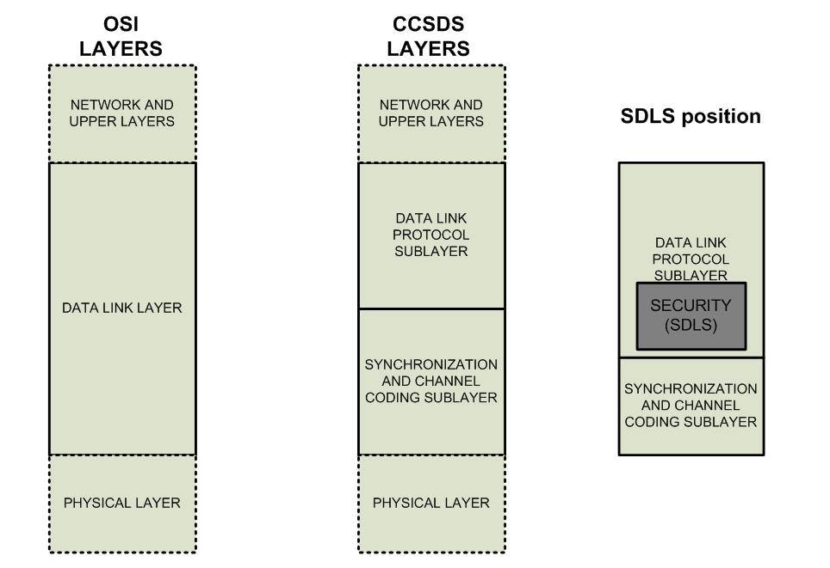
Figure 1. OSI vs. CCSDS layers and SDLS security functions position
Two sub-layers of the Data Link layer are defined for CCSDS space link protocols: data link protocol sub-layer, and synchronization & channel coding sub-layer. SDLS protocol and functions are part of the CCSDS data link protocol sub-layer and fully integrated in the TC, TM and AOS data link protocols. SDLS functions insert themselves inside the stack of functions of CCSDS data link protocols. SDLS protocol is not as such a distinct sub-layer but rather a set of additional security features for existing data link protocols. Each of those data link protocols provides a set of communication services. SDLS will protect only part of those services as shown in table 2.

telecommand
The conceptual order of processing of SDLS functions with respect to other functions of the TC protocol is shown in Fig. 2. Depending on the services actually used, not all the functions may be present in a real system. The services not supported by SDLS protocol are greyed –out in Fig. 2.
The Encryption function, when implemented and selected in a given SA, processes the full data field of the TC frame providing confidentiality to its content, i.e., TC packets and/or TC segments. TC transfer frame header, COP management commands and Frame Error Control Field (FECF) are not encrypted to maintain compatibility with existing infrastructure and protocols (e.g. :some Space Link Extension (SLE) protocols services [7] which require a clear text header for ground routing of TC frame).
The Authentication function, when implemented and selected in a given SA, processes the full TC transfer frame apart from the optional Frame Error Control Field (FECF) and user selected subfields of the transfer frame header. It therefore provides integrity and authenticity verification on selected subfields of the transfer frame header as well as the data field. FECF and TC channel coding (BCH code) are used to detect transmission errors, while authentication is used to detect security (intentional) errors.
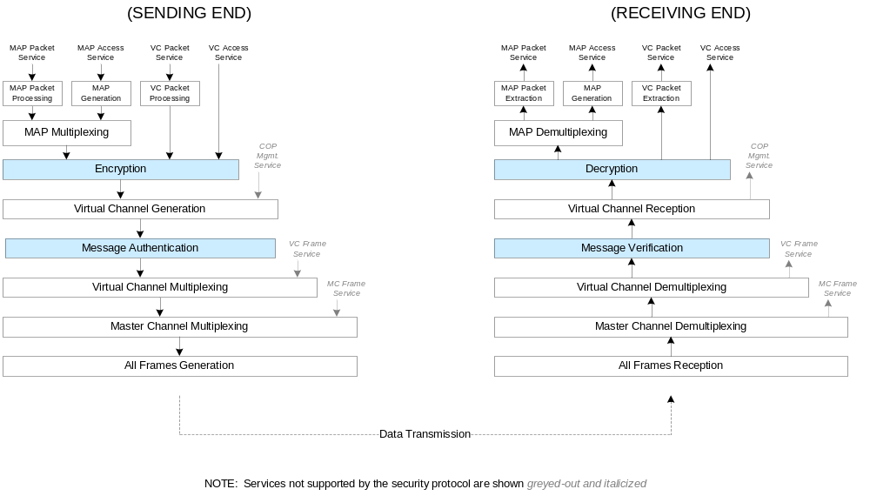
Figure 2. Conceptual Order of Processing within TC Stack
COP-1 and SDLS protocol interaction?

telemetry
The conceptual order of processing of SDLS functions with respect to other functions of the TM protocol is shown in Fig. 3. Depending on the services actually used, not all the functions may be present in a real system. On this figure, the services not supported by SDLS protocol are greyed –out.
The Encryption function, when implemented and selected in a given SA, processes the full data field of the TM transfer frame apart from Operational Control Field (OCF), Frame Secondary Header (FSH) and Frame Error Control Field (FECF). It provides confidentiality to its content: i.e., TM packets. TM transfer frame primary header and secondary header together with OCF are not encrypted to maintain compatibility with existing infrastructure and protocols (e.g. TC protocol [4], which requires a clear text OCF for operating the TC retransmission protocol (COP)).
The Authentication function, when implemented and selected in a given SA, processes the full TM transfer frame apart from the optional Frame Error Control Field (FECF), the optional OCF and user selected subfields of the transfer frame header. It therefore provides integrity and authenticity verification on selected subfields of the transfer frame header as well as the data field. FECF and TM channel coding (e.g. Reed-Solomon code) are used to detect transmission errors, while authentication is used to detect security (intentional) errors. OCF was excluded from the authenticated fields since, in most implementations, the TC retransmission protocol (COP) has to extract and use it before authentication can be performed on the ground.
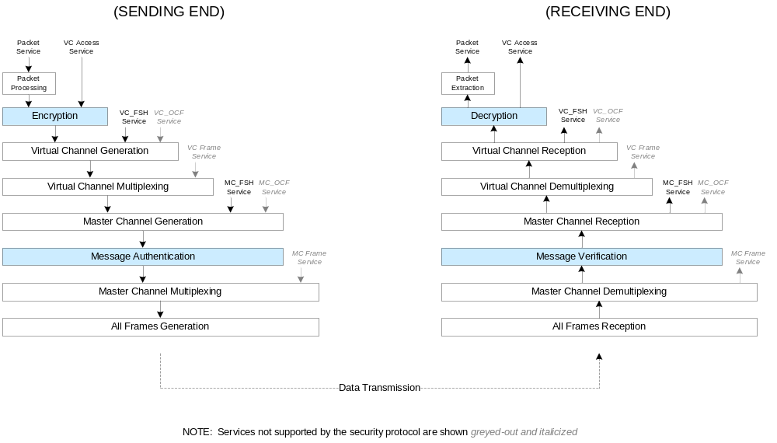
Figure 3. Conceptual Order of Processing within TM Stack

advanced orbiting systems
The conceptual order of processing of SDLS functions with respect to other functions of the AOS protocol is shown in Fig. 4. Depending on the services actually used, not all the functions may be present in a real system. On this figure, the services not supported by SDLS protocol are greyed –out.
The Encryption function, when implemented and selected in a given SA, processes the full data field of the AOS transfer frame apart from Operational Control Field (OCF) and Frame Error Control Field (FECF). It provides confidentiality to its content, i.e., TM packets. AOS transfer frame primary header together with OCF and FECF are not encrypted to maintain compatibility with existing infrastructure and protocols (e.g. TC protocol [4], which requires a clear text OCF for operating the TC retransmission protocol (COP)).
The Authentication function, when implemented and selected in a given SA, processes the full AOS transfer frame apart from the optional Frame Error Control Field (FECF), the optional OCF, the Insert zone and user selected subfields of the transfer frame primary header. It therefore provides integrity and authenticity verification on selected subfields of the frame primary header as well as the frame data field. FECF and TM channel coding (e.g. Reed-Solomon code) are used to detect transmission errors, while authentication is used to detect security (intentional) errors. OCF was excluded from the authenticated fields since, in most implementations, the TC retransmission protocol (COP) has to extract and use it before authentication can be performed on the ground.
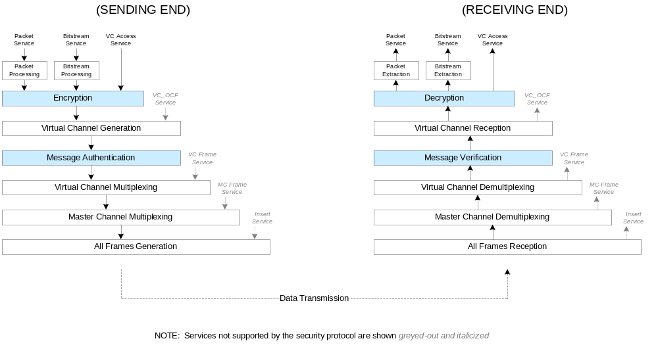
Figure 4. Conceptual Order of Processing within AOS Stack.
Insert zone is not authenticated as well because this field is physically inserted on the fly when the frame is shifted to the modulator to preserve synchronicity of data transmitted in the insert zone. It is therefore impractical to authenticate this field. The application behind the Insert Zone service will have to incorporate its specific security, if required.

protocol data structures, fields and functions
Organization and description of the various protocol data structures and fields with their corresponding function.
Incorporate the inputs received from Craig Biggerstaff and update section accordingly.
Justifications.
The SDLS encapsulates processed application-layer data carried in Space Data Link Protocol transfer frames between two protocol data structures: a Security Header and Trailer. While in theory such a protocol can be designed with just one additional protocol data structure (a header or a trailer), the provision of two protocol data structures allows to optimize implementations, in particular for very high data rate application.
The Security Header and Trailer contain the contextual information necessary to perform decryption and/or integrity verification at the receiving end. This contextual information does impose some additional transmission overhead; the sender must ensure that the overall length of the transfer frame does not exceed the maximum allowed by the underlying Space Data Link Protocol. The amount of overhead will depend upon the options chosen for each Security Association.

security header
The structural components of the Security Header are shown in Fig.7. The actual specification of the Security Header is defined in reference [11].
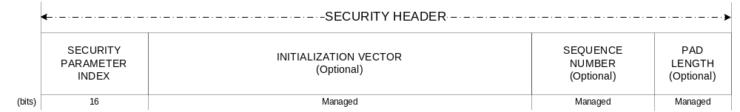
Figure 7. Security Header
The Security Header contains a mandatory two-byte Security Parameter Index identifying the Security Association context.
For SAs that employ encryption (cipher) or certain authentication (e.g., GMAC) algorithms, the Security Header includes optional fields for initialization vector and pad length. These fields may or may not be needed depending upon the specific algorithm and mode of operation implemented. Fields that are not needed for a Security Association may be omitted, but if present must remain present in all frames using that Security Association.
For SAs that employ authentication algorithms, the Security Header includes an optional field for an anti-replay sequence number. Since replay protection is easily defeated unless the sequence number is protected, this field is used only where authentication is used.

Security Parameter Index
The Security Parameter Index is a 2-byte mandatory and critical data field of the Security Header. There can be up to 65534 SAs per Master Channel; two values are reserved for future use (0, 65534). The receiver uses the SPI to reference the corresponding SA, and therefore to determine the presence and lengths of optional fields in the Security Header and Trailer.

Initialization Vector
The Initialization Vector is an optional data field in the security header, specified in the SDLS protocol to provide flexibility with respect to the choice of cryptographic algorithms. Thus, some recommended cryptographic algorithms require an initial block of input before processing the user data. This initial block of data is called Initialization Vector. It serves to pre-load the cryptographic process and enhance its security by adding variability.
Those cryptographic algorithms that require IVs usually specify particular requirements to their IVs. Some have to be unique, that is, not used more than once for all the invocations of the algorithm with a given cryptographic key. Some have to be random, that is, it shall not be possible to predict which will be the next value taken by the IV for the next invocation of the cryptographic algorithm. The reader is referred to [TBD] for further guidance concerning the particular requirements of IVs.
In general, the length of the IV is driven by the block size of the cryptographic algorithm to be used. Thus, with currently recommended algorithms with a 128-bit block size, a maximum value of 128-bit can be specified for an IV. However, in the usual quest for efficiency (lower protocol overhead) particular constructs allow for shorter IVs even when the underlying algorithm block size is 128-bit.
Those constructs are unique to each cryptographic algorithm. They may combine the transmission of a part of the IV with the synchronized regeneration by the user receiver processor of the non-transmitted part. While constructs like this may improve protocol efficiency, they do it at the expense of operational robustness and an additional synchronization process.
In some particular cases, a single block of data can fulfill the role of IV but also Sequence Number as will be illustrated in the next section.
It is important to warn users that improper management of the IV, that is, not respecting their particular construct and management requirements can result in critical degradation of the security service provided to the point of render it useless. Thus, extreme care shall be exercised in conceiving and implementing an IV concept for a particular SDLS implementation.

Sequence Number
This field is used if authentication or authenticated encryption is selected for an SA. This field may be a portion of a longer managed anti-replay sequence number. The Sequence Number field length is managed and is fixed for the duration of the SA.
Including the sequence number as part of the transmitted data, while not strictly needed, has clear design and operational advantages. The validity of a received message is broken down in two separate tests: MAC and sequence count value.
The receiver can verify first the validity of a MAC without needing to recreate the sequence counter. The received value is used for the computation. Without such transmission and assuming the receiver manages a range of acceptable sequence count values (window), the receiver would need to test the received message with every possible MAC in accordance to every possible sequence count value. While this would be technically possible, it would add substantial complexity to the receiver in exchange of a minimum protocol efficiency gain.
Afterwards, in a second validity check the receiver can compare the received value against the range of expected values.
Only if both tests are successful will the message be accepted.
For systems which implement authenticated encryption algorithms that use a simple incrementing counter as an initialization vector (i.e., as in Galois/Counter-Mode algorithms), the Initialization Vector field of the Security Header may serve also as the transmitted portion of the Sequence Number. In this case, the separate Sequence Number field is unnecessary and is omitted from the Security Header.

Pad Length
The cryptographic algorithms recommended by CCSDS do not require external padding. The SDLS baseline modes adopt those recommended algorithms. Thus, introducing a pad length field in SDLS could appear to be superfluous. However, in order to support the protocol flexibility and its independence of cryptographic algorithms padding needs to be considered.
Certain cryptographic algorithm implementation modes (i.e., encryption block modes) require that their input data be an exact multiple of a data block size. Whenever the input data is not an exact multiple, the SDLS protocol has to fill in the last remaining input data block with additional data: the padding. The amount of padding (pad length) and its position has to be established with a proper convention. The receiver processor shall be able to determine if padding is present and where in order to process the data and deliver the initial SDU to the user application. The padding may not need to be transmitted with the data. Its proper regeneration by the receiver processor is sufficient.
Concept. The padding concept adopted by the SDLS protocol is the following:
Encryption example: Cipher Block Chaining (CBC);
Authentication example: CBC-MAC;

limit padding to cases where it is needed;

If padding is present security header includes 1 octet, placed at the end of the security header, to indicate the number of padding bits (0-127)
Padding pattern does not need to be transmitted;
Padding convention: 1, 10, 100, 1000, 10000,…known as ISO/IEC 9797-1 Padding Method 2.
Padding is granular at bit level.
Security:
Concerning the security aspects, the suitability of the proposed padding pattern has been studied for CBC and CBC-MAC. An assessment is required for other algorithms. Add a disclaimer for other algorithms. It is a user’s responsibility.
Definition of padding pattern and corresponding security can be left to implementer if algorithms other than above are used; recall that CCSDS recommended algorithms do not require padding; text to be added in BB and GB accordingly.
The Pad Length field specifies the number of fill bytes used to pad the last input data block in the encryption process. In recognition of the fact that other encryption algorithms that can be used with SDLS do not require padding (e.g., stream modes like the Counter mode), the field will be omitted when those are used.

security trailer

Message Authentication Code
Role of authentication mask for the generation of a MAC. Flexibility offered by the authentication mask.
Boundaries and guidelines for the MAC length.
Considerations for the minimum and maximum length. In establishing the acceptable range of values for the MAC length, consideration shall be taken of the attainable security strength, the cryptographic algorithm to be used and the length of its cryptographic key. In general, given a certain cryptographic key length l, in order to achieve the full potential security strength provided by such key for attacks like the birthday attack, the MAC shall have a length 2*l.
Since currently recommended cryptographic algorithms employ keys that range from 128 to 256 bits, it follows that the MAC could range between 256 and 512 bits. The latter has been selected as the maximum value for the MAC length. Longer MAC lengths with currently recommended cryptographic algorithms would result in inefficient design (no security gain, additional useless overhead).
For the minimum value of the MAC length consideration is taken as well to the possibility to change keys more frequently thus allowing for shorter MACs and the potential benefit this could provide for applications where the 256 bits is considered onerous (e.g., Telecommand). Note that the recommended authenticated encryption algorithm (AES GMAC, see [TBD]) mandates a 128-bit MAC length. Similar efficiency considerations are reflected in recommended standards (see [TBD]), which allow for MACs as short as TBD value.
Constraint on MAC length introduced by GMAC when using Authenticated Encryption.
MAC computation is the latest cryptographic data processing operation for authentication or authenticated encryption services. Thus, the position of the MAC after the data required for its computation favors implementations for very high data rate application.

protocol management
Presentation and discussion of management aspects. Among other things Security Association is treated here.
Consider Bruno Saba’s presentation.
Protocol Management support: In-band and out-of-band signaling, guidelines for implementation.
Exceptions to SDLS specification: implementations, service interfaces, methods or technologies, management activities.
Announce SDLS Extensions to avoid getting too much into detail here.

security association
The concept of Security Association (SA), borrowed from IPSec [10] but somewhat adapted to space communications, is crucial to the SDLS protocol. The following paragraphs, excerpts from [11], provide a detailed description.
Concept—The selected security services for SDLS are implemented with cryptographic algorithms and functions. The SDLS protocol provides SAs for defining the cryptographic parameters to be used by both the sending and receiving ends of a communications session, and for maintaining state information for the duration of the session. The SA defines a simplex (one-way), stateful cryptographic session for providing authentication, data integrity, replay protection, and/or data confidentiality.
Rationale—The notion of SA parameter negotiation before establishing a secure channel, a common practice in terrestrial networks, is considered to be too complex and in some occasions not feasible given the available time to establish communications between mission control center and spacecraft (e.g., short contact times, latency due to distance) and the very conservative space engineering approach emphasizing safety of operation.
In addition, space links are by nature very asymmetrical links between a ground control center that wants to retain full authority (master) on the on-board system (slave) when needed, and an on-board data system that is limited in terms of processing power and anomaly handling. Some of those parameters like the choice of cryptographic algorithms are simply excluded of negotiation (pre-selected and coded before mission operations start).
Similarly, the notion of SA Database as understood in IPSec is an unaffordable or unneeded luxury for most space communications applications. Therefore, a simpler concept than the IPSec-like SA Data Base has been defined in the frame of CCSDS SDLS protocol development called Security Association Context (SAC).
Security Association Context—The Security Association Context (SAC) will pre-exist on-board and in the control center. No negotiation will be needed before use and a given SC can be used on any combination of Virtual Channel or MAP.. This lightweight approach has been traded off favorably with the more capable fully dynamic SA Data Base approach.
The main difference between the two concepts lies on Key Management. As a compromise, the SA has been adapted to include an additional attribute as part of the security header: the in-line presence of a key index. If present, the key index would be included as a 16-bit field in the security header.
Association-oriented security measures, a refinement of end-to-end security measures.

Clear Mode Management
Ignacio to write.

Clear mode as a security risk. Not recommended.
Clear mode because of request by projects.
Possible clear mode definition. It is possible to create a ‘clear mode’ SA using one of the defined service types by specifying the algorithm as a ‘no-op’ function (no actual cryptographic operation to be performed). Such an SA might be used, e.g., during development testing of other aspects of data link processing before cryptographic capabilities are available for integrated testing. Presence of security header and trailer is maintained even though there is no security processing.
Transition from secure to clear and the opposite, systematically through Secure Control SA. This Secure Control SA is always active, present and part of the SDLS Extended Procedures.
Clear mode activated by FDIR on-board mechanism. Trade-off between safety and security for most civilian missions, where the risk of losing a spacecraft due to a safety issue prevails over security.
Possible use of reserved SPI values for Control SA (control commands)?Not compulsory for control channels. Point under development with SDLS Extended Procedures.

Recovery SA in Telecommand
A SA can only cover a single VC on Telecommand. However, SDLS does not exclude the duplication of SAs over a given Telecommand VC. Experience acquired with previous ad-hoc implementations of security functions for the protection of Telecommand [TBD] has shown that the existence of a redundant SA, only to be called as a last resource, could be very beneficial. When the ‘nominal’ SA has failed and possibly left the spacecraft telecommanding unavailable, this ‘redundant’ SA will allow to restore telecommanding without jeopardizing security. This special SA is labelled Recovery SA.
Special care should be taken to store and segregate the context of this SA at both ends of the space link. This Recovery SA should not be used for regular operations. Preferably the on-board keys associated with this Recovery SA should be neither erasable nor reloadable nor revocable, in order to maximize operational safety.

managed Parameters

signalling
In-band vs. Out-of-band signaling.
Guidelines for implementation.

redundancy
Spacecraft communications systems and processors at both ends of the space link implement redundancy for reliability purpose. Some agencies and corresponding implementations exploit certain features of the data communications protocol to manage redundancy. For instance, different virtual channels of an implementation following the SDL protocol may be assigned to the primary and secondary receiver communications protocol processor. Thus, the capability to address a particular logic (virtual) channel is used to select which of the receiver processors will handle the incoming data.
SDLS has been designed to be agnostic with respect to redundancy management concept. Thus it is compatible with implementations that want to exploit the addressing capability of SDL protocol and with implementations that do not. For the latter case, the SDLS receiver protocol processor behaves like a radio unit. Two identical physical and logical SDLS processors handle simultaneously the incoming data flows. The user application selects one of the two in accordance to criteria and solution which is beyond the scope of this document. Such concept requires a full synchronization of all the relevant SDLS managed parameters so that the behavior of the processors will always be identical. Failure in one of the processors may trigger different behavior.

cryptographic keys

telecommand
Restriction one SA per Virtual Channel.

telemetry

advanced orbting systems

extended procedures

concept of operation
Integrates the content produced by Craig Biggerstaff on the GB Conops. In particular look at cryptographic service processing flow diagrams. Drawings updated by Graig and available.
Furthermore the section explains what happens at both ends and why when the protocol is executed. It describes as well the interfaces and interaction with the other protocol layers. Possibly new drawings concerning those interfaces to be prepared.
Functions performed by service provider: discussion, justification.
Section requires revision considering content of section 3 (e.g. avoid overlaps). Plus Red-3 rationale.
Discuss failed verification.

security association
Discuss SA Management Procedures. Not much can be done since it will be part of the extended procedures.

Operation—Both the sender and the receiver must create an SA, associate it with cryptographic key(s), and activate it before the SA may be used to secure Transfer Frames on a channel.
SAs may be statically pre-loaded prior to the start of a mission. SAs may also be created dynamically as needed, even while other existing SAs are active.
The mechanism for switching from one active Security Association to another is an application-layer function. Add consideration of SPI usage to change cryptographic key dynamically (by actually changing the SA).
All Transfer Frames carrying data that share the same SA on a physical channel constitute a Secure Channel. A Secure Channel consists of one or more Global Virtual Channels or Global Multiple Access Point Identifiers (MAP IDs, for TC only) assigned to an SA at the time of its creation.
The Security Parameter Index (SPI) is a transmitted value that uniquely identifies the SA applicable to a Transfer Frame. All Transfer Frames having the same SPI on a physical channel share a single Security Association. A maximum of 254 simultaneous Security Associations may be defined across an entire physical channel.
When an SA is created, one of the following cryptographic functions is selected to be carried out for all transfer frames using that SA:
a) Authentication;
b) Encryption;
c) Authenticated Encryption. Explain the composition Encrypt-then-MAC.
Once an SA is created, the authentication and/or encryption algorithms specified, along with their modes of operation, are fixed and cannot be changed for the duration of the SA.

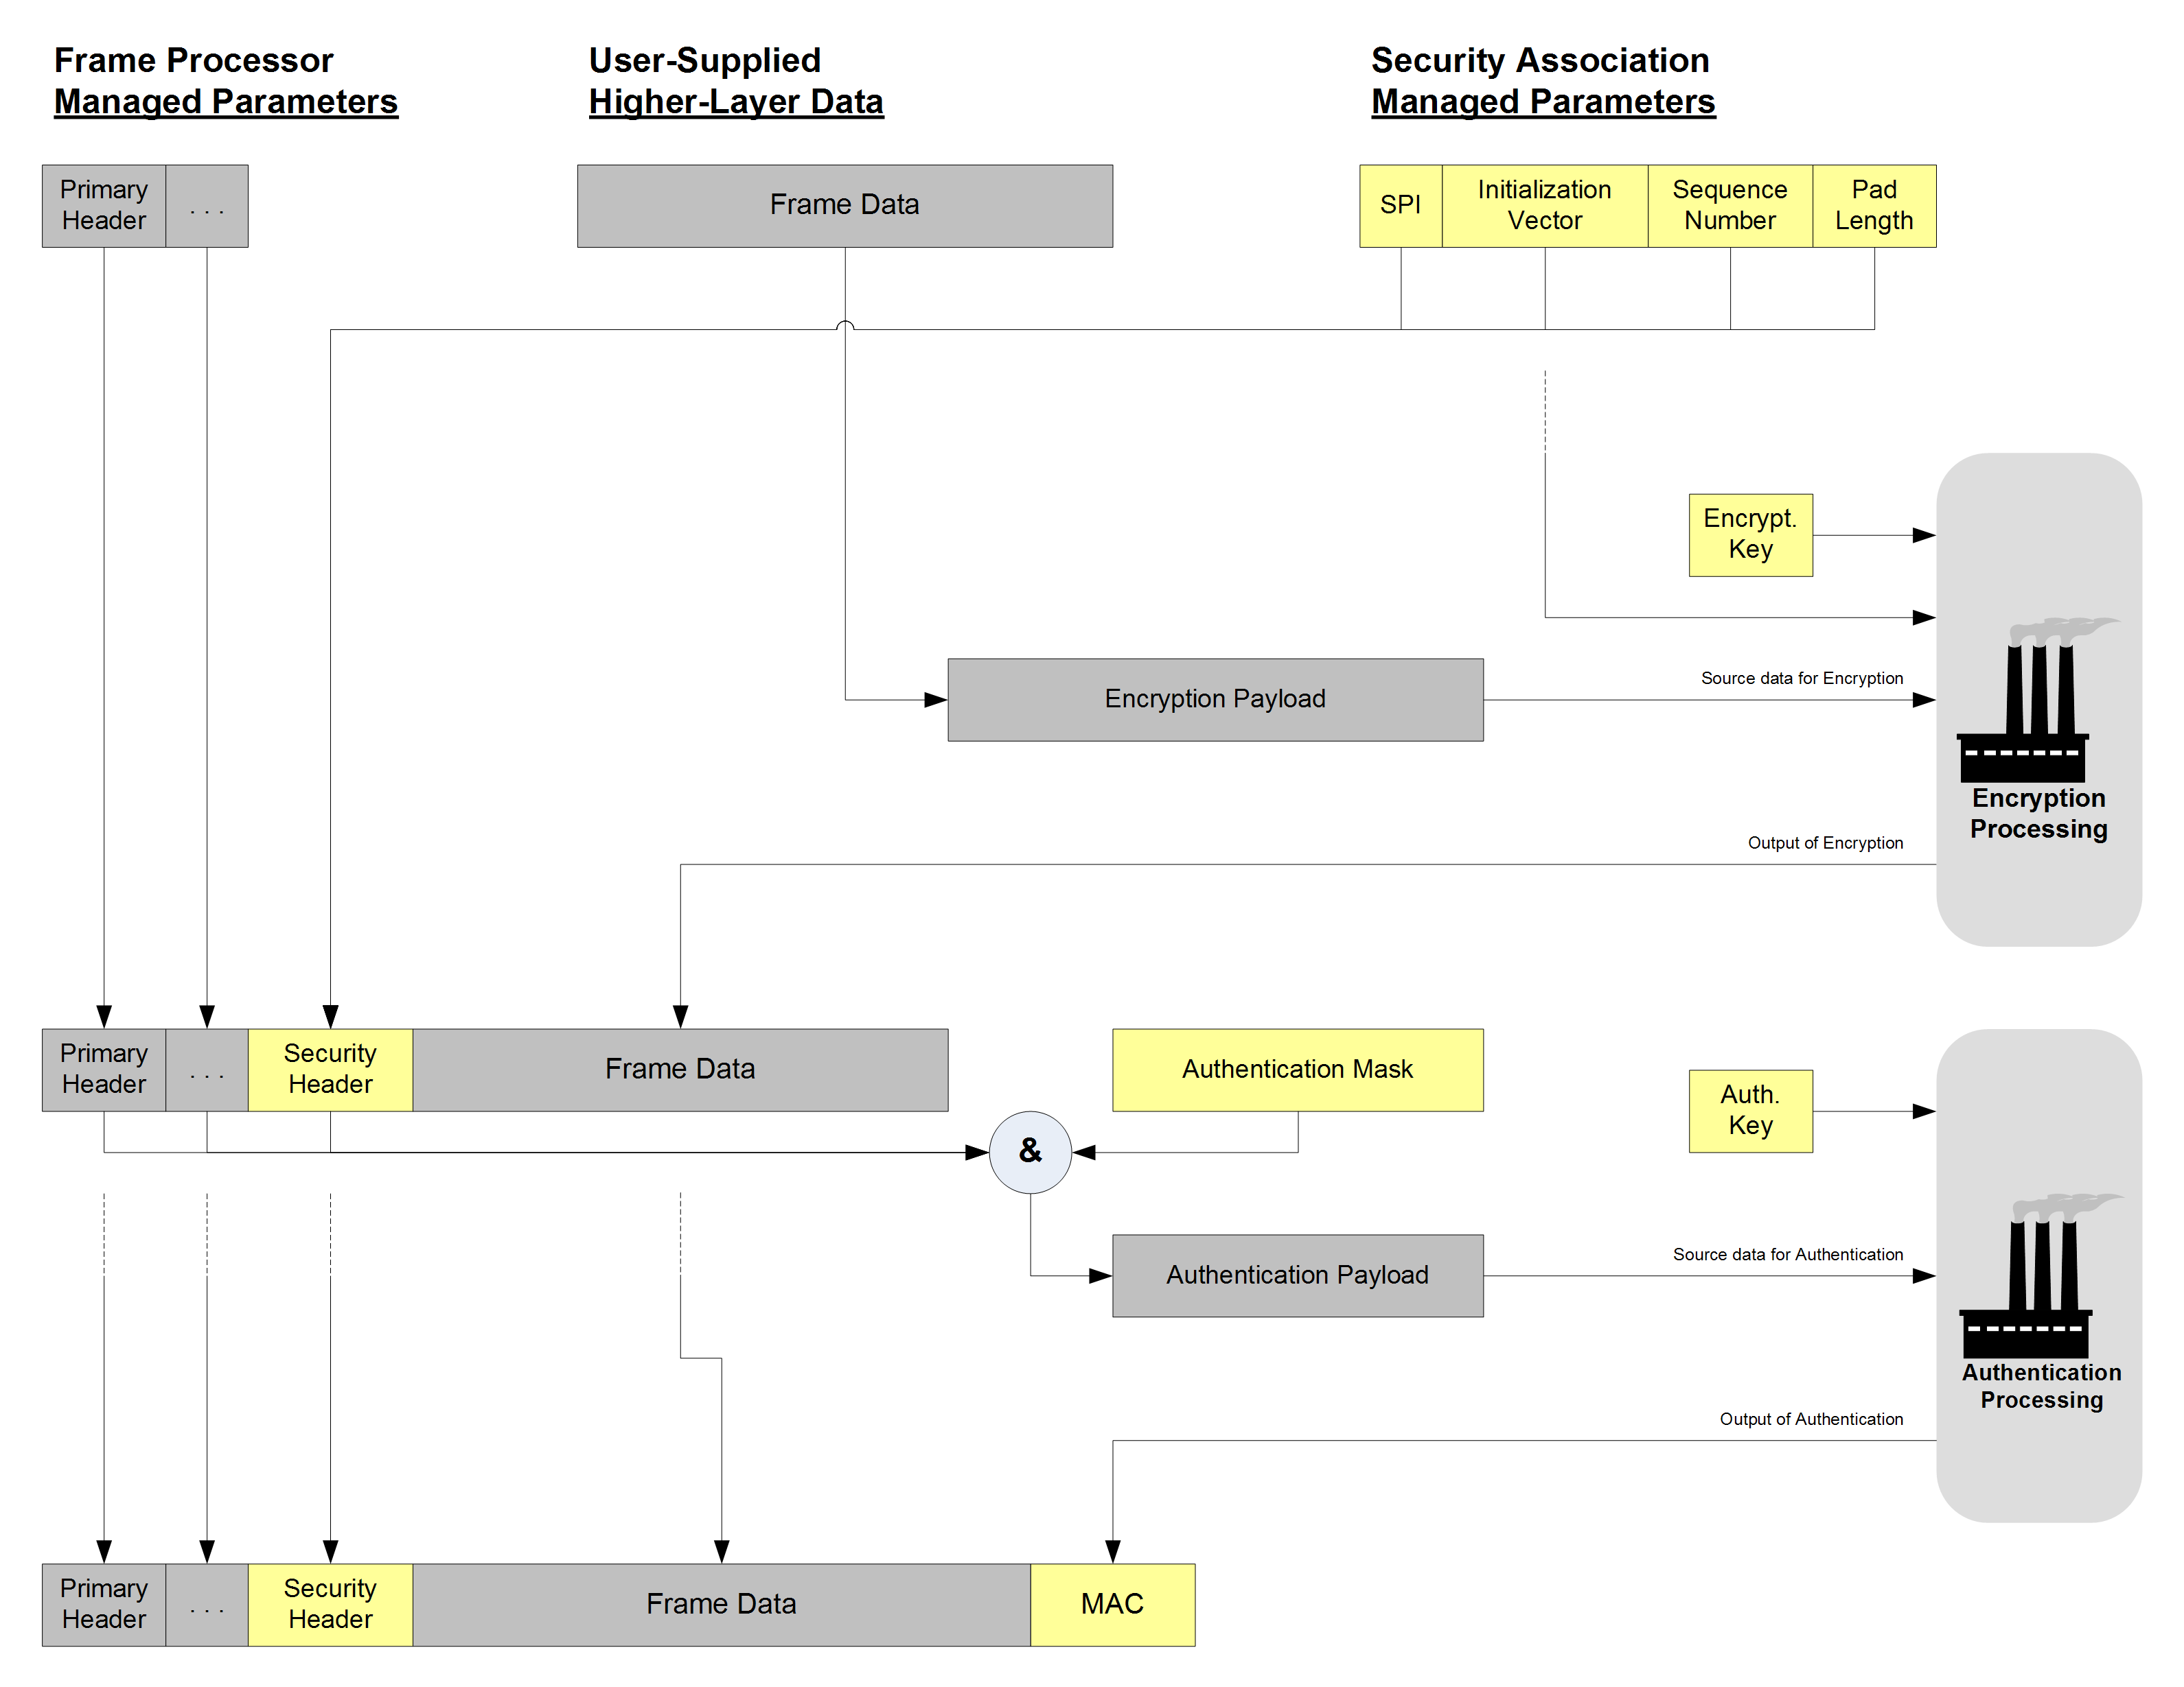
Figure 2 Generic operation of SDLS

synchronization
For an effective operation of the implemented SDLS protocol, the following cryptographic and protocol parameters require synchronization and management:
- Cryptographic Key;
- Initialization Vector;
- Sequence Count.
The following subsections address each of them.

cryptographic key synchronization
Essential for effective operation of the SDLS protocol is the synchronization of cryptographic keys employed at both ends of the communications link by the corresponding transmit and receive cryptographic algorithms. Failure to maintain key synchronization will result in meaningless SDUs for the receiving user application and, therefore, service failure.
As discussed in section 3.5.3, in-band or out-of-band directives can be incorporated to ensure cryptographic key synchronization. A typical example of in-band synchronization consists of transmitting an index to point a position in a logical table (key memory) where the key to be used is stored. Obviously such approach requires the proper management of mirrored tables on ground and onboard that always store identical sets of keys.
Role of SPI in changing keys dynamically. And the operation to update the key store corresponding to a certain SPI.
This cryptographic key synchronization is a necessary condition for the effective operation of the protocol. However, with security services that employ authentication an additional synchronization process is required: sequence count.

initialization vector synchronization

sequence count synchronization

authentication

authentication payload processing

replay protection

encryption

authenticated encryption

SDL protocol interaction

telecommand

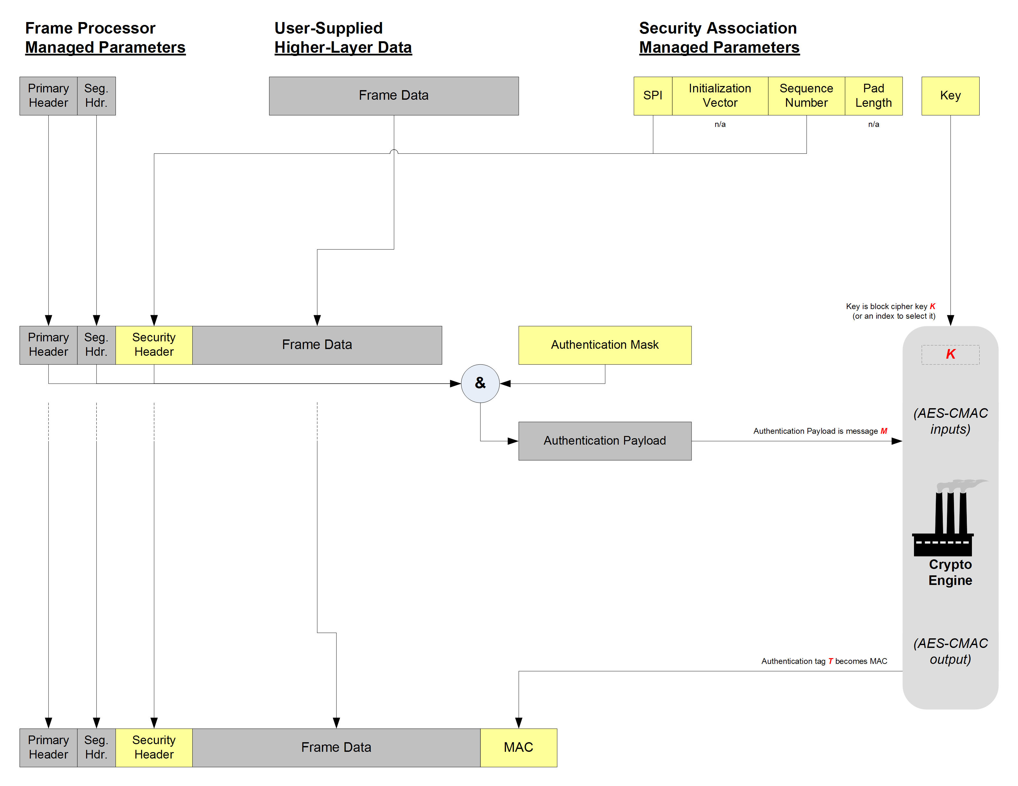

telemetry
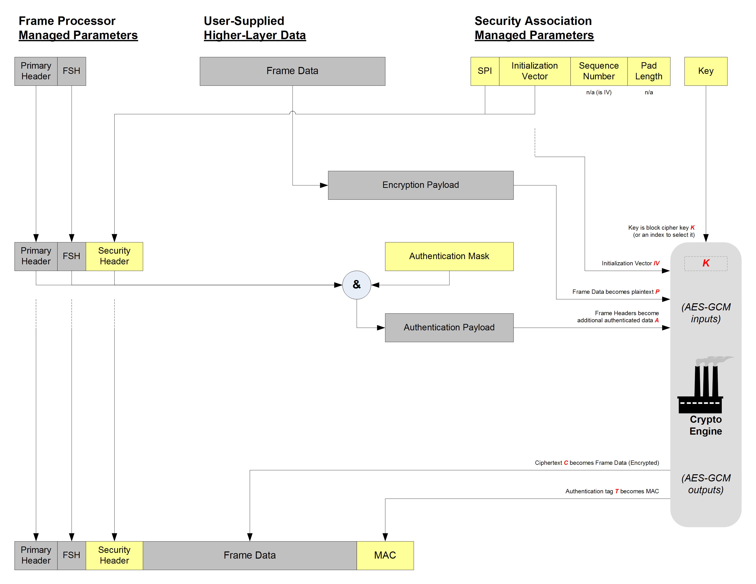

advanced oriting systems
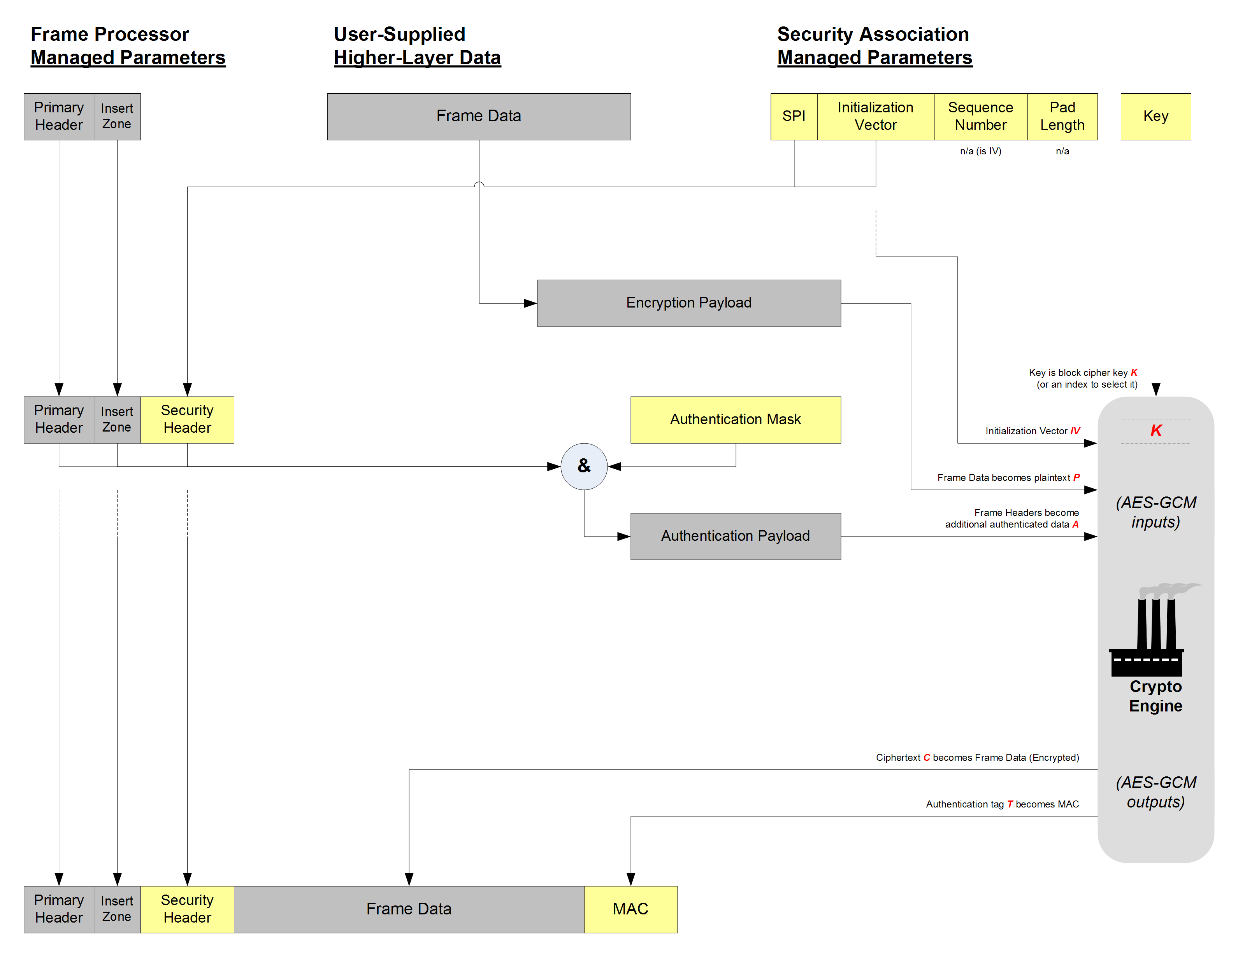

scenarios
Captures and elaborates further the section 4 of the CONOPS document. Inputs (text and illustrations) have been provided by Craig Biggerstaff and will be incorporated.
Include hybrid scenarios with VCs with SA, no SA, SECURE, CLEAR,.. and combinations thereof.
Transitions between Clear and Secure modes in a SA are not signaled. The synchronization of Clear/Secure mode at the two ends of the space link is an application layer responsibility. Furthermore, trap door or back door considerations.
Scenario for TC (Authentication only).
Scenario for TM with multiple VCs protected by the same SA and some excluded.
This section provides examples that illustrate the implications of some of the Cryptographic Service design options on mission planning and overall system infrastructure.

Basic Scenario
Perhaps the simplest operational scenario, depicted below in Figure 4-3 and Figure 4-4, is one in which a ground operations center sends spacecraft telecommand data over a forward link. Following information security conventional usage, red is used to denote the condition in which data requires protection and black is used to denote the condition in which data is secured.
In this conceptual processing flow (not intended to imply any specific physical implementation), the element marked “Authentication/Encryption Processing” carries out the actual cryptographic operations defined in each Security Association upon each applicable transfer frame, for instance TC Authentication as specified in Baseline Mode (see Annex A). In a real system, some of these functions could be combined in a single hardware or software processing unit, as shown in Figure 4-4.
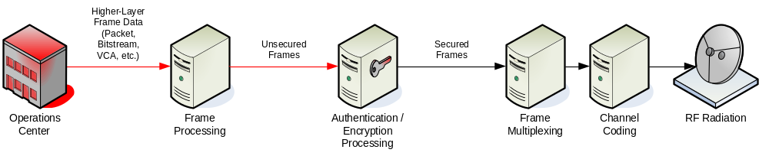
Figure 4-3. Simple Forward Link Scenario (Ground)
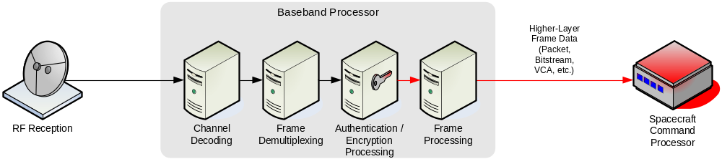
Figure 4-4. Simple Forward Link Scenario (Onboard)

Complex Scenario
A more complex operational scenario, involving a spacecraft with multiple onboard elements providing return link data to multiple ground support elements, is depicted in Figure 4-5 and Figure 4-6 below. Three data flows are illustrated. Two of these (shown in red and orange) require protection, while the third (shown in black) needs no protection. The separate red and orange data flows represent the use of separate Security Associations and cryptographic keys by each data flow.

Onboard Processing
In Figure 4-5, each of three onboard processing elements provides its own individual portion of a return link channel as a higher-layer service (e.g., Packet, Bitstream, or Virtual Channel Access). Link-layer security processing and cryptographic key management is shown as provided in common by a trusted baseband processor unit.
Because the Cryptographic Service does not obscure the transfer frame primary header information, it is possible that multiple data flows may each have a separate Security Association (with its own context, algorithms, and keys). In practice, this is likely to be limited by the capabilities of available cryptographic processing hardware and software.

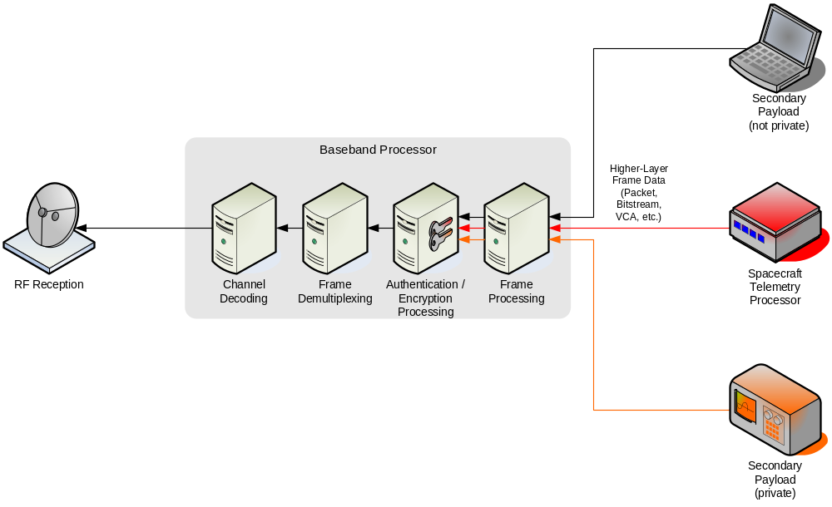
Figure 4-5. Complex Return Link Scenario (Onboard)

Ground Processing
Figure 4-6 depicts the same three return data flows. Two of them separately implement link-layer security; the third simply receives channel frames without any link-layer protection. Each of several ground processing elements receives its own individual portion of a return link channel as a VC Frame or MC Frame service and performs its own link-layer security processing and frame data extraction. Each ground processing element that performs link-layer security processing manages its own cryptographic keys. Because the Cryptographic Service does not obscure the transfer frame primary header information, CCSDS Space Link Extensions (SLE) return services may be used where applicable.
The ground operations scenario of Figure 4-6 represents how cross-support at the link layer might be accomplished between multiple entities sharing a space link physical channel but with each entity separately providing security for its own data. This scenario could represent the sharing of a physical RF channel by multiple missions (each conducting operations separately), or it could represent the sharing of a single mission’s physical channel by multiple operations groups (e.g., spacecraft housekeeping and payload operations).
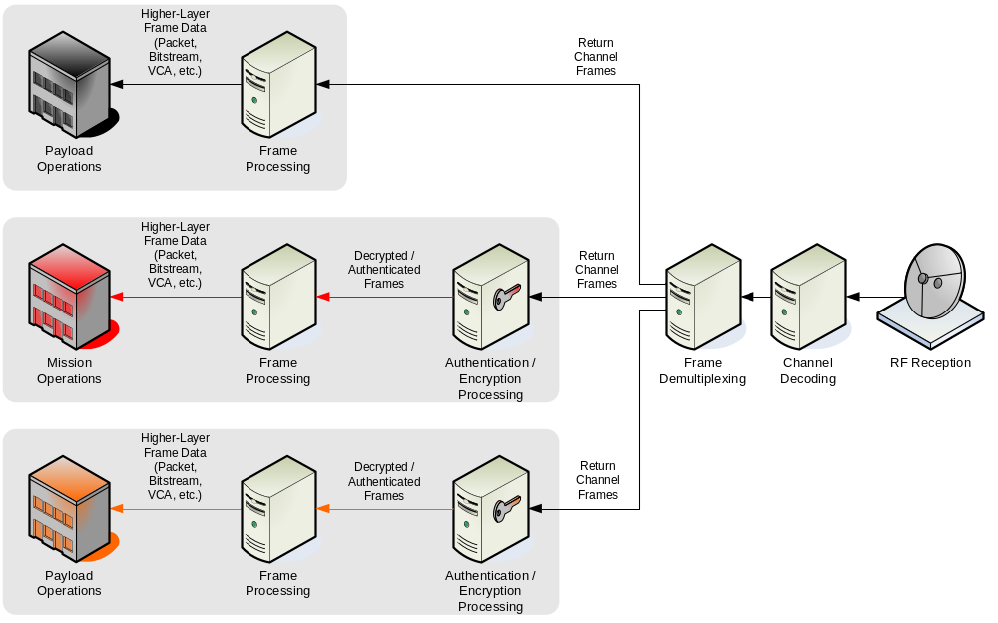
Figure 4-6. Complex Return Link Scenario (Ground)

Recovery SA scenario
To be written. Consider the input provided by TAS-F on SDLS red-2 comments.
This subsection elaborates on the need for so-called recovery SA(s) in order to cope with emergency situations where the use of operational SAs is no longer possible.
Some emergency situations impacting SDLS operation and likely to be encountered can be listed as follows (not limitative):
- Spacecraft tumbling or TM sub-system failure on-board, resulting in the TM downlink being interrupted. This forces the use of blind commanding meaning no reporting from the on-board SDLS function is available. In that configuration, it is impossible to guarantee that secured TC frames, sent with operational SA, will be accepted on-board by the SDLS function. Moreover, a mismatch in anti-replay counter between the ground sending end and the on-board receiving end is likely. Telecommands need to be sent to the spacecraft in a secure manner to restore the TM link (e.g., by switching to the redundant TM transmitter) or the attitude control of the spacecraft.
- Content of the programmable keys storage has been corrupted by the environment or a malfunction (i.e. programmable keys are not known anymore). New value for operational keys needs to be uploaded in a secure manner by telecommand.
- Synchronization on the anti-replay counter of operational SA in use has been lost between SDLS ground sending end and on-board receiving end. Re-initialization of anti-replay counter (i.e. re-initialization of the SA context) on-board is needed.
In all those emergency situations, there is a need to re-establish a secure TC channel. The usual way to achieve that is to define so-called Recovery SA(s), only to be called at last resource. When the ‘nominal’ SA has failed and possibly left the spacecraft telecommanding unavailable, this Recovery SA will allow to restore telecommanding without jeopardizing security. Special care should be taken to store and segregate the context of this SA at both ends of the space link. This Recovery SA should never be used for regular operations. The context of this(these) Recovery SA(s), including the on-board keys associated with it, should be kept in non-erasable, non-volatile memory so as to survive on-board transient power loss and operational errors.

BASELINE MODES
  - Introduction
This annex provides the rationale for the Baseline Implementations specified in Annex C of the SDLS Blue Book [1].
  - Telecommand
    - Selection of security services
Authentication as defined in [1] is the key security service for the protection of space asset control. Telecommands will only be processed by the spacecraft computer and/or hardware decoders once their legitimate origin and their integrity, including their freshness, has been verified on-board.
    - Selection of cryptographic algorithm
The cryptographic algorithm is selected from the CCSDS Standard on Cryptographic Algorithms [7], in particular from the recommended algorithms for Authentication. The Cipher-based Message Authentication Code (CMAC) presents the following attractive properties:
- Standard algorithm, originally coming from the United States National Institute of Standards and Technology (NIST).
- Planned to become ISO Standard, according to EUROCRYPT.
- Does not require an IV.
- Does not require padding.
- Being cipher-based offers both versatility and efficiency for implementations; CMAC implementation can reuse cipher for Authentication Key Management (Authentication Key Encryption, Authentication Key Decryption), which is a key support function of the authentication algorithm.
    - Design of cryptographic algorithm parameters
MAC and Key lengths.
Anti-replay counter span.
    - Dimensioning protocol data fields
SDLS Authentication requires both a header and a trailer. The presence or absence of certain protocol data fields in the header is driven by the selected cryptographic algorithm for authentication. The length of the trailer is driven by the selected by a key parameter of the algorithm: the MAC length.
  - telemetry
    - Selection of security services
Authenticated Encryption as defined in [1] is the key security service for the protection of mission products, i.e., instrument and housekeeping telemetry data. Encryption alone provides confidentiality but does not provide protection against integrity attacks (e.g. forgery, impersonation). Higher security is achieved if the data is protected with Authentication as well. Thus, the CCSDS recommendation is to couple Encryption with Authentication. The preferred CCSDS approach is by means of the Authenticated Encryption Service.
    - Selection of cryptographic algorithm
The cryptographic algorithm is selected from the CCSDS Standard on Cryptographic Algorithms [7], in particular from the recommended algorithms for Authenticated Encryption. Therefore, the AES-GCM is the recommended algorithm for the TM Baseline mode.
Recent cryptographic research on AES-GCM has identified a weakness concerning certain keys [TBD]. The user is invited to carefully consider the key generation and selection process for
        - Design of cryptographic algorithm parameters: MAC and Key lengths
With the selection of AES-GCM, the selection of MAC and key length is as follows.
- The MAC length is automatically set to 128 bits, which is the only specified value. This value is considered sufficiently secure for civilian missions.
- The key length is limited to three possible values: 128, 192 and 256 bits. A value of 128 bits is considered sufficient for civilian missions.
    - IV Construction
AES-GCM requires an Initialization Vector. There are too specified approaches to construct an IV for AES-GCM (see section 8.2 of [TBD]). The recommended construction is the following: deterministic with 96 bits in total length.
To maintain security, it is essential to avoid a repetition of the IV with the same cryptographic key.
    - Dimensioning protocol data fields
The Security Header is as follows.
The Security Trailer has to accommodate a MAC of 128 bits.
  - advanced orbiting systems
    - Selection of security services.
    - Selection of cryptographic algorithm.
    - Dimensioning protocol data fields.
    - Design of cryptographic algorithm parameters: MAC and Key lengths.
  - security aspects
    - IV Generation Constraints.
- Particulars of each algorithm. IVs are delicate and critical cryptographic parameters. Their proper management during operations is vital to maintain security. Cryptographic algorithms that do not require IV are, therefore, favored whenever their use is viable for the required security services. This is the case for Authentication and the CMAC algorithm.
- However, for other security services like Authenticated Encryption their presence is unavoidable and their management critical to maintain security. In particular for the GMAC algorithm the IV shall not repeat under a given cryptographic key. Failure to meet this requirement will imply a security leakage. Further details can found in [TBD].
Authentication.
Authenticated Encryption.
Absence of Encryption-only.
Security performance.
- Number of invocations
- Strength against known attacks for Authentication.

ISO/OSI security services vs. sdl protocols

  - Introduction
This Annex provides a justified selection of the Security Services found in the ISO OSI Security Architecture to be implemented by the Space Data Link Security Protocol.
  - Selection Methodology
The security services defined in ISO OSI Security Architecture are listed. For each service the following is provided:
- Its definition;
- The threats the security service is mitigating;
- The impact if the security service is not implemented;
- The priority for selection, inclusion and implementation as part of SDLS Security Services;
- The applicability as an objective to be covered by SDLS;
- The residual risks following its adoption;
- Additional remarks.

Table 4 Telecommand Selection
 |  | Telecommand Space Data Link Protocol analysis
Security Service |  | Definition | Threats | Impact | Priority | Applicability | Residual Risk | Remarks
Authentication
 | Peer entity authentication | The corroboration that a peer entity in association is the one claimed.  This service, when provided by the (N)-layer, provides corroboration to the (N+l)-entity that the peer entity is the  claimed (N+l)-entity. | Impersonation, spoofing. |  | Low. | Telecommand implements a master-slave relationship rather than peer-to-peer. Considered too costly and complex for space missions where precious time could be lost and where network effects are not applicable. | Minor if Data origin authentication is implemented.  However, session keys may not be fresh. Longer session keys may be required. | Used extensively in ground networks, where typically peer entity authentication precedes the establishment of secured communications sessions.  Difficult to conceive this service without Data origin authentication as well.
 | Data origin authentication | The corroboration that the source of data received is as claimed.  This service, when provided by the (N)-layer, provides corroboration to an (N+l)-entity that the source of the data  is the claimed peer (N+1)-entity. | Impersonation, spoofing. | Mission loss. | High. | Considered a very critical objective of SDLS protocol. | Minor if implementation of countermeasure is adequate and well managed. | Dependent on cryptographic strength (MAC length, key length, algorithm) and key management policy.
Access Control |  | The prevention of unauthorized use of a resource, including the prevention of use of a resource in an unauthorized manner. | - Unauthorized access to TC receiver  - Denial of access to TC receiver (e.g., jamming);  - Unauthorized access to COP-1 protocol state machine (FARM);  - Denial of access to COP-1 protocol state machine;  - Unauthorized access to security processor;  - Denial of access to security processor. | Command availability hampered. | N/A | Denial of service is not an objective for SDLS protocol. | Unavailability due to jamming or blockage by unauthorized uplink.  Alteration of FARM counters that can be recovered with Control frame from legal operator. | Spacecraft autonomy, ground station diversity, spread spectrum modulations and null-steering antennas can counteract this threat. Note that those are countermeasures beyond the scope of SDLS.
Data Confidentiality
 | Connection confidentiality | This service provides for the confidentiality of all (N)-user-data on an (N)-connection. | Information is disclosed to an unauthorized party. | Confidentiality compromised. Impact in accordance to information value and the possibility to elaborate more sophisticated attacks to user assets. | High. | Confidentiality in connection mode is an objective of the SDLS protocol. | Minor if implementation of countermeasure is adequate and well managed. | Dependent on cryptographic strength (key length, algorithm) and key management policy.
 | Connection less confidentiality | This service provides for the confidentiality of all (N)-user-data in a single connectionless (N)-SDU. | Information is disclosed to an unauthorized party. | Confidentiality compromised. Impact in accordance to information value and the possibility to elaborate more sophisticated attacks to user assets. | High. | Confidentiality in connectionless is an objective of the SDLS protocol. | Minor if implementation of countermeasure is adequate and well managed. | Dependent on cryptographic strength (key length, algorithm) and key management policy.
 | Selective field confidentiality | This service provides for the confidentiality of selected fields within the (N)-user-data on an (N)-connection or in a single connectionless (N)-SDU. |  |  | N/A. |  |  | The SDLS protocol will protect the SDUs identified and defined in the TC Space Link Protocol. There is no need identified to protect part of an SDU.
 | Traffic flow confidentiality | This service provides for the protection of the information which might be derived from observation of traffic flows. | Observation of traffic flows indicate spacecraft operation activity. | Understanding by hostile entity about spacecraft operations. | Medium. | Traffic flow protection may be required by high-security missions. | Exploitation of certain information may support other attacks like denial of service. However, the latter is not an objective of SDLS. | Traffic flow protection should be considered as a candidate for future SDLS protocol update/extension.
Data Integrity
 | Connection integrity with recovery | This service provides for the integrity of all (N)-user-data on an (N)-connection and detects any modification, insertion, deletion or replay of any data within an entire SDU sequence (with recovery attempted). | Malicious message modification. | Up to loss of mission. | High. | Considered a very critical objective of SDLS protocol. Recovery to be address with SDLS Extended Procedures. | Minor if implementation of countermeasure is adequate and well managed. | Recovery requires manual intervention with supporting information (e.g. protocol reports, diagnosis). Dependent on cryptographic strength (MAC length, key length, algorithm) and key management policy.
 | Connection integrity without recovery | This service provides for the integrity of all (N)-user-data  on an (N)-connection and detects any modification, insertion,  deletion or replay of any data within an entire SDU sequence (with no recovery attempted). | Malicious message modification. | Up to loss of mission. | High. | Considered a very critical objective of SDLS protocol. | Minor if implementation of countermeasure is adequate and well managed. | Dependent on cryptographic strength (MAC length, key length, algorithm) and key management policy.
 | Selective field connection integrity | This service provides for the integrity of selected fields  within the (N)-user- data of an (N)-SDU transferred over a  connection and takes the form of determination of whether the selected fields have been modified, inserted, deleted  or replayed. |  |  |  | N/A. |  | The SDLS protocol will protect the SDUs identified and defined in the TC Space Link Protocol. There is no need identified to protect part of an SDU.
 | Connection less integrity | This service, when provided by the (N)-layer, provides integrity assurance to the requesting (N+l)-entity.  This service provides for the integrity of a single connectionless  SDU and may take the form of determination of whether a received SDU has been modified. Additionally,  a limited form of detection of replay may be provided. | Malicious message modification. | Up to loss of mission. | High. | Considered a very critical objective of SDLS protocol. | Minor if implementation of countermeasure is adequate and well managed. | Dependent on cryptographic strength (MAC length, key length, algorithm) and key management policy.  Replay detection is an integral part of SDLS.
 | Selective field connection less integrity | This service provides for the integrity of selected fields  within a single connectionless SDU and takes the form of  determination of whether the selected fields have been  modified. |  |  |  | N/A. |  | The SDLS protocol will protect the SDUs identified and defined in the TC Space Link Protocol. There is no need identified to protect part of an SDU.
Non-repudiation
 | Non-repudiation with proof of origin | The recipient of data is provided with proof of the origin of data. This will protect against any attempt by the sender  to falsely deny sending the data or its contents. |  |  |  | Not relevant for space data links. |  | The TC application is not concerned with denial of telecommand sending.
 | Non-repudiation with proof of delivery | The sender of data is provided with proof of delivery of data.  This will protect against any subsequent attempt by the recipient to falsely deny receiving the data or its contents. |  |  |  | Not relevant for space data links. |  | The TC application is not concerned with denial of telecommand reception.

Table 5 Telemetry Selection
 |  | Telemetry Space Data Link Protocol analysis
Security Service |  | Definition | Threats | Impact | Priority | Applicability | Residual Risk | Remarks
Authentication
 | Peer entity authentication | The corroboration that a peer entity in association is the one claimed.  This service, when provided by the (N)-layer, provides corroboration to the (N+l)-entity that the peer entity is the  claimed (N+l)-entity. | Impersonation, spoofing. |  | Low. | Telemetry reflects a master-slave relationship rather than peer-to-peer. Considered too costly and complex for space missions where precious time could be lost and where network effects are not applicable. | Minor if Data origin authentication is implemented.  However, session keys may not be fresh. Longer session keys may be required. | Used extensively in ground networks, where typically peer entity authentication precedes the establishment of secured communications sessions.  Difficult to conceive this service without Data origin authentication as well.
 | Data origin authentication | The corroboration that the source of data received is as claimed.  This service, when provided by the (N)-layer, provides corroboration to an (N+l)-entity that the source of the data  is the claimed peer (N+1)-entity. | Impersonation, spoofing. | Up to mission loss if operator commands spacecraft based on faulty housekeeping telemetry.  TBD for instrument telemetry. | High. | Considered a very critical objective of SDLS protocol. | Minor if implementation of countermeasure is adequate and well managed. | Dependent on cryptographic strength (MAC length, key length, algorithm) and key management policy.
Access Control |  | The prevention of unauthorized use of a resource, including the prevention of use of a resource in an unauthorized manner. | - Unauthorized access to TM receiver;  - Denial of access to TM receiver (e.g., jamming)  - Unauthorized access to COP-1 protocol state machine (FOP);  - Denial of access to COP-1 protocol state machine (FOP). | Telemetry availability hampered. Telecommand availability hampered by wrong COP-1 parameters. | N/A | Denial of service is not an objective for SDLS protocol | Unavailability due to jamming or blockage by unauthorized downlink. | Ground station diversity, spread spectrum modulations and null-steering antennas can counteract this threat. Note that those are countermeasures beyond the scope of SDLS.
Data Confidentiality
 | Connection confidentiality | This service provides for the confidentiality of all (N)-user-data on an (N)-connection. |  |  |  | N/A |  | Telemetry does not have connection mode.
 | Connection less confidentiality | This service provides for the confidentiality of all (N)-user-data in a single connectionless (N)-SDU. | Information is disclosed to an unauthorized party. | Confidentiality compromised. Impact in accordance to information value and the possibility to elaborate more sophisticated attacks to user assets. | High. | Confidentiality in connectionless is an objective of the SDLS protocol. | Minor if implementation of countermeasure is adequate and well managed. | Dependent on cryptographic strength (key length, algorithm) and key management policy.
 | Selective field confidentiality | This service provides for the confidentiality of selected fields within the (N)-user-data on an (N)-connection or in a single connectionless (N)-SDU. |  |  | N/A. |  |  | The SDLS protocol will protect the SDUs identified and defined in the TM Space Link Protocol. There is no need identified to protect part of an SDU.
 | Traffic flow confidentiality | This service provides for the protection of the information which might be derived from observation of traffic flows. | Observation of traffic flows indicate spacecraft operation activity. | Understanding by hostile entity about spacecraft operations. | Medium. | Traffic flow protection may be required by high-security missions. | Exploitation of certain information may support other attacks like denial of service. However, the latter is not an objective of SDLS. | Traffic flow protection could be considered as a candidate for future SDLS protocol update/extension.
Data Integrity
 | Connection integrity with recovery | This service provides for the integrity of all (N)-user-data on an (N)-connection and detects any modification, insertion, deletion or replay of any data within an entire SDU sequence (with recovery attempted). |  |  |  | N/A |  | Telemetry does not have connection mode.
 | Connection integrity without recovery | This service provides for the integrity of all (N)-user-data  on an (N)-connection and detects any modification, insertion,  deletion or replay of any data within an entire SDU sequence (with no recovery attempted). |  |  |  | N/A |  | Telemetry does not have connection mode.
 | Selective field connection integrity | This service provides for the integrity of selected fields  within the (N)-user- data of an (N)-SDU transferred over a  connection and takes the form of determination of whether the selected fields have been modified, inserted, deleted  or replayed. |  |  |  | N/A. |  | Telemetry does not have connection mode.
 | Connection less integrity | This service, when provided by the (N)-layer, provides integrity assurance to the requesting (N+l)-entity.  This service provides for the integrity of a single connectionless  SDU and may take the form of determination of whether a received SDU has been modified. Additionally,  a limited form of detection of replay may be provided. | Malicious message modification. | Up to mission loss if operator commands spacecraft based on faulty housekeeping telemetry.  TBD for instrument telemetry. | High. | Considered a very critical objective of SDLS protocol. | Minor if implementation of countermeasure is adequate and well managed. | Dependent on cryptographic strength (MAC length, key length, algorithm) and key management policy.  Replay detection is an integral part of SDLS.
 | Selective field connection less integrity | This service provides for the integrity of selected fields  within a single connectionless SDU and takes the form of  determination of whether the selected fields have been  modified. |  |  |  | N/A. |  | The SDLS protocol will protect the SDUs identified and defined in the TC Space Link Protocol. There is no need identified to protect part of an SDU.
Non-repudiation
 | Non-repudiation with proof of origin | The recipient of data is provided with proof of the origin of data. This will protect against any attempt by the sender  to falsely deny sending the data or its contents. |  |  |  | Not relevant for space data links. |  | The TM application is not concerned with denial of telemetry sending.
 | Non-repudiation with proof of delivery | The sender of data is provided with proof of delivery of data.  This will protect against any subsequent attempt by the recipient to falsely deny receiving the data or its contents. |  |  |  | Not relevant for space data links. |  | The TM application is not concerned with denial of telemetry reception.

Table 6 Advanced Orbiting Systems Selection
 |  | Advanced Orbiting Systems Space Data Link Protocol analysis
Security Service |  | Definition | Threats | Impact | Priority | Applicability | Residual Risk | Remarks
Authentication
 | Peer entity authentication | The corroboration that a peer entity in association is the one claimed.  This service, when provided by the (N)-layer, provides corroboration to the (N+l)-entity that the peer entity is the  claimed (N+l)-entity. | Impersonation, spoofing. |  | Low. | Both Telecommand and Telemetry implement a master-slave relationship rather than peer-to-peer. Considered too costly and complex for space missions where precious time could be lost and where network effects are not applicable. | Minor if Data origin authentication is implemented.  However, session keys may not be fresh. Longer session keys may be required. | Used extensively in ground networks, where typically peer entity authentication precedes the establishment of secured communications sessions.  Difficult to conceive this service without Data origin authentication as well.
 | Data origin authentication | The corroboration that the source of data received is as claimed.  This service, when provided by the (N)-layer, provides corroboration to an (N+l)-entity that the source of the data  is the claimed peer (N+1)-entity. | Impersonation, spoofing. | Mission loss (mainly for TC). | High. | Considered a very critical objective of SDLS protocol. | Minor if implementation of countermeasure is adequate and well managed. | Dependent on cryptographic strength (MAC length, key length, algorithm) and key management policy.
Access Control |  | The prevention of unauthorized use of a resource, including the prevention of use of a resource in an unauthorized manner. | - Unauthorized access to TC or TM receiver;  - Denial of access to TC or TM receiver (e.g., jamming). | Command availability hampered | N/A | Denial of service is not an objective for SDLS protocol | Unavailability due to jamming or blockage by unauthorized uplink. | Spacecraft autonomy, ground station diversity, spread spectrum modulations and null-steering antennas can counteract this threat. Note that those are countermeasures beyond the scope of SDLS.
Data Confidentiality
 | Connection confidentiality | This service provides for the confidentiality of all (N)-user-data on an (N)-connection. |  |  |  | N/A |  | AOS does not provide a connection mode.
 | Connection less confidentiality | This service provides for the confidentiality of all (N)-user-data in a single connectionless (N)-SDU. | Information is disclosed to an unauthorized party. | Confidentiality compromised. Impact in accordance to information value and the possibility to elaborate more sophisticated attacks to user assets. | High. | Confidentiality in connectionless is an objective of the SDLS protocol. | Minor if implementation of countermeasure is adequate and well managed. | Dependent on cryptographic strength (key length, algorithm) and key management policy.
 | Selective field confidentiality | This service provides for the confidentiality of selected fields within the (N)-user-data on an (N)-connection or in a single connectionless (N)-SDU. |  |  | N/A. |  |  | The SDLS protocol will protect the SDUs identified and defined in the AOS Space Link Protocol. There is no identified need to protect part of an SDU.
 | Traffic flow confidentiality | This service provides for the protection of the information which might be derived from observation of traffic flows. | Observation of traffic flows indicate spacecraft operation activity. | Understanding by hostile entity about spacecraft operations. | Medium. | Traffic flow protection may be required by high-security missions. | Exploitation of certain information may support other attacks like denial of service. However, the latter is not an objective of SDLS. | Traffic flow protection could be considered as a candidate for future SDLS protocol update/extension.
Data Integrity
 | Connection integrity with recovery | This service provides for the integrity of all (N)-user-data on an (N)-connection and detects any modification, insertion, deletion or replay of any data within an entire SDU sequence (with recovery attempted). |  |  |  | N/A |  | Telecommand or Telemetry do not have connection mode under AOS. Telecommand may have recovery at application layer, which is beyond SDLS scope.
 | Connection integrity without recovery | This service provides for the integrity of all (N)-user-data  on an (N)-connection and detects any modification, insertion,  deletion or replay of any data within an entire SDU sequence (with no recovery attempted). | Malicious message modification. | Up to loss of mission. | High. | Considered a very critical objective of SDLS protocol. | Minor if implementation of countermeasure is adequate and well managed. | Dependent on cryptographic strength (MAC length, key length, algorithm) and key management policy.
 | Selective field connection integrity | This service provides for the integrity of selected fields  within the (N)-user- data of an (N)-SDU transferred over a  connection and takes the form of determination of whether the selected fields have been modified, inserted, deleted  or replayed. |  |  |  | N/A. |  | The SDLS protocol will protect the SDUs identified and defined in the TC Space Link Protocol. There is no identified need to protect part of an SDU.
 | Connection less integrity | This service, when provided by the (N)-layer, provides integrity assurance to the requesting (N+l)-entity.  This service provides for the integrity of a single connectionless  SDU and may take the form of determination of whether a received SDU has been modified. Additionally,  a limited form of detection of replay may be provided. | Malicious message modification. | Up to loss of mission. | High. | Considered a very critical objective of SDLS protocol. | Minor if implementation of countermeasure is adequate and well managed. | Dependent on cryptographic strength (MAC length, key length, algorithm) and key management policy.  Replay detection is an integral part of SDLS.
 | Selective field connection less integrity | This service provides for the integrity of selected fields  within a single connectionless SDU and takes the form of  determination of whether the selected fields have been  modified. |  |  |  | N/A. |  | The SDLS protocol will protect the SDUs identified and defined in the TC Space Link Protocol. There is no need identified to protect part of an SDU.
Non-repudiation
 | Non-repudiation with proof of origin | The recipient of data is provided with proof of the origin of data. This will protect against any attempt by the sender  to falsely deny sending the data or its contents. |  |  |  | Not relevant for space data links. |  | The TC application is not concerned with denial of telecommand sending.
 | Non-repudiation with proof of delivery | The sender of data is provided with proof of delivery of data.  This will protect against any subsequent attempt by the recipient to falsely deny receiving the data or its contents. |  |  |  | Not relevant for space data links. |  | The TC application is not concerned with denial of telecommand reception.

URD

CCSDS Space Data Link Security Protocol

User’s Requirements Document

Version 3 – 10/10/2012

Table of contents

1 Introduction 3
2 Purpose and scope 3
2.1 Purpose 3
2.2 Scope 3
3 Reference documents 4
4 Applicable documents 4
5 Requirements 5
5.1 Overview 5
5.2 Conventions 5
5.3 COMPatibility with CCSDS standards 5
5.3.1 TM space data Link 5
5.3.2 TC space data link 5
5.3.3 AOS space data link protocol 6
5.3.4 COP-1 6
5.4 User services requirements 6
5.5 Secure channels and protocol selectivity 7
5.6 Security requirements 8
5.6.1 Security objectives 8
5.6.2 Security services 9
5.7 Security services description 11
5.7.1 Authentication 11
5.7.2 Authenticated encryption 11
5.8 Security functions position 11
5.9 Protected fields 12
5.10 Cryptographic algorithms and protocol dependancy 13
5.11 Operation modes 14
5.11.1 Secure / Clear modes 14
5.11.2 Key Management 16
5.11.3 On-board TM/TC control and monitoring 17
5.12 Design constraints 20
5.12.1 Performances 20
5.12.2 Operational constraints 21
5.12.3 Compatibility with on board configurations 22
5.12.4 Compatibility with ground configurations 23
5.12.5 Security constraints 23

  - Introduction
This version is the final version, resulting from various discussions and a conclusion at the October 2012 meeting of the WG. This URD was the agreed basis for the protocol development to be undertaken.
  - Purpose and scope
    - Purpose
The purpose of the document is to list all the functional, operational, performance and non-functional requirements applicable to a future CCSDS interoperable data link layer security protocol. In this document, we want to avoid specifying any solution or pieces of it.
    - Scope
This URD focuses on the security protocol to be integrated with the data link layer of CCSDS space links. Choice and definition of algorithms (authentication and/or encryption) are not part of this specification, only constraints (if any) applicable to algorithms are listed.

  - Reference documents
[RD 1] : CCSDS handbook, “Overview of space link protocols”, CCSDS 130.0-G-2
[RD 2] : CCSDS handbook, “Space data link protocols – Summary of concept and rationale”, CCSDS 130.2-G-1
[RD 3] : ECSS standard, “Space data links – Telecommand protocols, synchronization and channel coding”, ECSS-E50-04A
[RD 4] : ECSS standard, « Space data links – Telemetry transfer frame protocol”, ECSS-E50-03A
[RD 5] : Agence Spatiale Européenne, « Telecommand Decoder Specification », ESA PSS-04-151 Issue 1, September 1993

  - Applicable documents
[AD 1] : CCSDS recommendation, “TM space data link protocol”, CCSDS 132.0-B-1
[AD 2] : CCSDS recommendation, “TC space data link protocol”, CCSDS 232.0-B-1
[AD 3] : CCSDS recommendation, “Proximity-1 Space data link protocol – Data Link Layer”, CCSDS 211.0-B-4
[AD 4] : CCSDS recommendation, “AOS space data link protocol”, CCSDS 732.0-B-1
[AD 5] : CCSDS draft recommended practice, “CCSDS recommended practice for symmetric encryption”, CCSDS 353.0-R-1
[AD 6] : CCSDS draft recommended practice, “CCSDS recommended practice for authentication”, CCSDS 352.0-R-0
[AD 7] : CCSDS recommendation, “Communications Operations Procedure -1 (COP-1)”, CCSDS 232.1-B-1

  - Requirements
    - Overview
The security protocol operates at the data link layer. It protects the data field of transfer frames, not the header. The frame headers and Operational Control Field (OCF) are left in clear so that the security protocol is transparent for frame synchronisation, acquisition and validation. Security protocol may contribute to frame validation.
Security protocol is based on symmetric cryptographic system. The keys are kept secret between sending entity and receiving entity.
The security protocol shall be compatible with the three CCSDS data link protocols (TM, TC, AOS) [AD1, 2, 4].
    - Conventions
The following conventions apply throughout this Recommendation:
- the words ‘shall’ and ‘must’ imply a binding and verifiable specification;
- the word ‘should’ implies an optional, but desirable, specification;
- the word ‘may’ implies an optional specification;
- the words ‘is’, ‘are’, and ‘will’ imply statements of fact.
    - COMPatibility with CCSDS standards
      - TM space data Link
N£ SECTMTC_URD_1010 £N
T£ The Secure Space Data Link Protocol shall be compatible with the CCSDS TM Space Data Link Protocol, as defined in [AD 1]. It shall not interfere with frame synchronization, acquisition and validation (also it can contribute to frame validation when active) . Presently defined fields of primary header of transfer frames should be unaltered by the security protocol. £T
[COMPLIANT]

      - TC space data link
N£ SECTMTC_URD_1020 £N
T£ The Secure Space Data Link Protocol shall be compatible with the CCSDS TC Space Data Link Protocol, as defined in [AD 2]. It shall not interfere with frame synchronization , acquisition and validation (also it can contribute to frame validation when active). Presently defined fields of primary header of transfer frames should be unaltered by the security protocol. £T
[COMPLIANT]
      - AOS space data link protocol
N£ SECTMTC_URD_1030 £N
T£ The Secure Space Data Link Protocol shall be compatible with the CCSDS AOS Space Data Link Protocol, as defined in [AD 4], both for uplink and downlink. It shall not interfere with frame synchronization , acquisition and validation (also it can contribute to frame validation when active).. Presently defined fields of primary header of transfer frames should be unaltered by the security protocol. £T
[COMPLIANT]
      - COP-1
N£ SECTMTC_URD_1040 £N
T£ The Secure Space Data Link Protocol shall be compatible with the Communications Operations Procedure-1 (COP-1), as described in [AD 7] when used in conjunction with the TC space data link protocol or with the AOS space data link protocol (both uplink and downlink). £T
[COMPLIANT]
    - User services requirements
N£ SECTMTC_URD_2010 £N
T£ For the TC space data link, the Secure Space Data Link Protocol shall protect the following user services :
- MAPP, MAPA : mandatory
- VCP, VCA, VCF, MCF : optional. £T
[COMPLIANT]

N£ SECTMTC_URD_2020 £N
T£ For the TM space data link, the Secure Space Data Link Protocol shall protect the following user services :
- PACKET, VCA : mandatory
- VC_FSH, MC_FSH, VCF, MCF : optional. £T
[COMPLIANT]

N£ SECTMTC_URD_2030 £N
T£ For the AOS space data link, the Secure Space Data Link Protocol shall protect the following user services :
- PACKET, VCA : mandatory
- BITSTREAM, INSERT, VCF, MCF : optional. £T
[COMPLIANT]
    - Secure channels and protocol selectivity
N£ SECTMTC_URD_3010 £N
T£ For the TC link, the Secure Space Data Link Protocol shall provide establishment and management of end to end logical secure channels between a ground system and a spacecraft, these logical secure channels being based on a combination of :
- MAPID
- VCID
- MCID i.e. on SCID (support of multi-satellites configuration). £T
[PARTIALLY COMPLIANT]
[The current version of the SDLS is compatible with this requirement. However, no establishment or management procedure is defined in the standard.]

N£ SECTMTC_URD_3020 £N
T£ For the TC link, the Secure Space Data Link Protocol shall provide establishment and management of end to end logical secure channels between a ground system and a spacecraft, these logical secure channels being based on a combination of :
- VCID
- MCID i.e. on SCID . £T
[PARTIALLY COMPLIANT]
[The current version of the SDLS is compatible with this requirement. However, no establishment or management procedure is defined in the standard.]

N£ SECTMTC_URD_3030 £N
T£ The Secure Space Data Link Protocol shall allow establishment of several concurrent secure channels (i.e. simultaneously active) over a physical channel. £T
[COMPLIANT]

N£ SECTMTC_URD_3040 £N
T£ The Secure Space Data Link Protocol shall allow establishment of new secure channels while other secure channels are already established and active. £T
[COMPLIANT]

N£ SECTMTC_URD_3050 £N
T£ The Secure Space Data Link Protocol shall insure independent management of each secure channel, this covering at least (non exhaustive list):
- Security service selection and configuration (cryptographic algorithm, mode of operation,…)
- Key management
- Anti-replay counter management,
- … £T
[PARTIALLY COMPLIANT]
[The current version of the SDLS is compatible with this requirement. However, no management procedure is defined in the standard.]

N£ SECTMTC_URD_3060 £N
T£ The Secure Space Data Link Protocol shall be compatible with the multiplexing of both clear and secure channels over a physical channel. £T
[COMPLIANT]

    - Security requirements
      - Security objectives
The Secure Space Data Link Protocol shall implement four security functions based on cryptographic mechanisms : Confidentiality, integrity, authentication, anti-replay. The non-repudiation function is not seen as necessary for space data links and therefore not part of the Secure Space Data Link Protocol .

N£ SECTMTC_URD_4010 £N
T£ The Secure Space Data Link Protocol shall fulfil the following security objectives for all secure channels established over a TC / Forward link :
- Command Authenticity
- Command Integrity
- Command Confidentiality
- Command Anti-replay protection
- Denial of Service Protection for Sequenced Control Service (COP-1 procedure) (TBC)
- Protection against TC link Traffic Analysis applicable at least at APID level. £T
[PARTIALLY COMPLIANT]
[The current version of the SDLS does not allow Denial of Service protection of the Sequenced Control Service (COP-1 procedure).]
[The current version of the SDLS does not allow TC link Traffic Analysis protection at APID level (MAPID always transmitted in cleartext).]

N£ SECTMTC_URD_4020 £N
T£ The Secure Space Data Link Protocol shall fulfil the following security objectives for all secure channels established over a TM / AOS Return link :
- TM data Authenticity
- TM data Integrity
- TM data Confidentiality
- TM Frame Anti-replay protection (optional)
- Protection against TM link Traffic Analysis applicable at least at APID level. £T
[PARTIALLY COMPLIANT]
[The current version of the SDLS does not allow TM link Traffic Analysis protection at APID level.]

N£ SECTMTC_URD_4030 £N
T£ Anti-replay protection shall be an optional facility for TM/AOS links, i.e. it shall be possible to select it or not for a given mission. £T
[COMPLIANT]

      - Security services
Considering the following :
- Encryption only (without data integrity) is not recommended for a space link, even for the TM link, as it can lead to security breaches,
- The Data Integrity function also provides Authentication,
Then two security services can be defined :
- Authentication service, which provides authentication, integrity, and anti-replay functions, to be used on a space link when the data confidentiality function is not required,
- Encryption + Authentication, called Authenticated Encryption, which provides data confidentiality, data integrity, authentication, and anti-replay functions.
[The current version of the SDLS defines a third service, “Encryption Only”, to be used only on the TM link. Although theoretically not secure, it provides confidentiality, and can be secure if the authentication service is achieved by another channel. It has been judged useful for some missions (ex. Video channel)]

N£ SECTMTC_URD_5010 £N
T£ The Secure Space Data Link Protocol shall provide two independent security services applicable to the secure channels established over a TC link :
- Authentication service, which provides command authenticity, integrity, and anti-replay protection,
- Authenticated Encryption service, which provides command confidentiality, integrity, authenticity, and anti-replay protection. £T
[COMPLIANT]

N£ SECTMTC_URD_5020 £N
T£ The Secure Space Data Link Protocol shall provide two independent security services applicable to the secure channels established over a TM / AOS link :
- Authentication service, which provides TM data authenticity, integrity, and (optional) anti-replay protection,
- Authenticated Encryption service, which provides TM data confidentiality, integrity, authenticity, and (optional) anti-replay protection. £T
[COMPLIANT]
[The current version of the SDLS also defines a third service, “Encryption Only”, to be used only on the TM link. Although theoretically not secure, it provides confidentiality and can be secure if the authentication service is achieved by another channel. It has been judged useful for some missions (ex. Video channel)]

N£ SECTMTC_URD_5030 £N
T£ For a TC / Forward link, the Secure Space Data Link Protocol shall allow the selection between Authentication service or Authenticated Encryption service for any secure channel. £T
[COMPLIANT]

N£ SECTMTC_URD_5040 £N
T£ For a TM / Return link, the Secure Space Data Link Protocol shall allow the selection between Authentication service or Authenticated Encryption service for any secure channel. £T
[COMPLIANT]

N£ SECTMTC_URD_5050 £N
T£ The Secure Space Data Link Protocol shall insure full independence of security services selection between the TC / Forward link and the TM/ Return link. £T
[COMPLIANT]

N£ SECTMTC_URD_5060 £N
T£ For anti-replay protection over a given secure channel, the Secure Space Data Link Protocol shall use a dedicated counter which is part of the authenticated data and which size shall not be less than 32 bits (TBC). £T
[PARTIALLY COMPLIANT]
[The current version of the SDLS allows a transmitted counter size down to 16 bits.]

N£ SECTMTC_URD_5070 £N
T£ For the anti-replay counter management, the Secure Space Data Link Protocol shall allow a jump / forward mechanism within a sliding window. £T
[COMPLIANT]

    - Security services description
      - Authentication
N£ SECTMTC_URD_6010 £N
T£ The Secure Space Data Link Protocol shall implement a security function allowing authentication of the sender. This security function shall be based on a cryptographic algorithm and a mode of operation as specified in [AD 6] for symmetric keys systems. Authentication without confidentiality should be implemented using a “clear text with appended Message Authentication Code (MAC)” system. £T
Also full flexibility of choice is left to the user for the cryptographic algorithm to be used with this Data Link Security protocol (cf. requirement 5.6.1), a baseline algorithm for authentication is selected to enable interoperability testing. This baseline algorithm for authentication with symmetric keys is : HMAC with SHA256 (cf. [AD6]).
[COMPLIANT]

      - Authenticated encryption
N£ SECTMTC_URD_6020 £N
T£ The Secure Space Data Link Protocol shall implement a security function allowing authentication of the sender and integrity/confidentiality of the frame data field. This security function shall be based on a cryptographic algorithm and a mode of operation as specified in [AD5] for symmetric keys systems and authentication encryption mode. £T
Also full flexibility of choice is left to the user for the cryptographic algorithm to be used with this Data Link Security protocol (cf. requirement 5.6.1), a baseline algorithm for authenticated encryption is selected to enable interoperability testing. This baseline algorithm for authenticated encryption with symmetric keys is : Galois Counter Mode (GCM) of AES block cipher algorithm (cf. [AD5]).
[COMPLIANT]
    - Security functions position
N£ SECTMTC_URD_7010 £N
T£ The Secure Space Data Link Protocol shall operate within the data link protocol sub-layer of the CCSDS data link layer. £T
[COMPLIANT]

N£ SECTMTC_URD_7020 £N
T£ The full TC security function covering both Authentication and Authenticated Encryption security services shall be located in a unique position within the TC data link protocol sub-layer. £T
[COMPLIANT]

N£ SECTMTC_URD_7030 £N
T£ The full TM / AOS security function covering both Authentication and Authenticated Encryption security services shall be located in a unique position within TM or AOS data link protocol sub-layer. £T
[COMPLIANT]

    - Protected fields
N£ SECTMTC_URD_8010 £N
T£ The Secure Space Data Link Protocol shall operate on the TC transfer frame data field. £T
[COMPLIANT]

N£ SECTMTC_URD_8020 £N
T£ The Secure Space Data Link Protocol shall let both TC transfer frame header and FEC trailer in clear form (i.e. unencrypted) whatever the selected security service for a secure channel is. £T
[COMPLIANT]

N£ SECTMTC_URD_8030 £N
T£ The Secure Space Data Link Protocol shall operate on the TM/AOS transfer frame data field. £T
[COMPLIANT]

N£ SECTMTC_URD_8040 £N
T£ The Secure Space Data Link Protocol shall let both TM/AOS transfer frame header and OCF/FEC trailer in clear form (i.e. unencrypted) whatever the selected security service for a secure channel is. £T
[COMPLIANT]

N£ SECTMTC_URD_8050 £N
T£ The Secure Protocol Data Unit (SPDU) shall consist of :
- a security header,
- a secure data field
- a security trailer (optional). £T
[COMPLIANT]
N£ SECTMTC_URD_8060 £N
T£ The security header shall include all required security context information from the sending side about the concerned secure channel to allow the receiving side to perform authentication / encryption or decryption on the received SPDU. £T
[COMPLIANT]

N£ SECTMTC_URD_8070 £N
T£ The secure data field shall contain the result of the clear data field authentication / encryption operation performed by the sending side. £T
[COMPLIANT]

N£ SECTMTC_URD_8080 £N
T£ The (optional) security trailer may contain the Integrity Check Value (ICF) computed by the authentication process. £T
[COMPLIANT]

N£ SECTMTC_URD_8090 £N
T£ The authentication process shall apply at least to the full frame data field including the security header (if any) inserted by the Secure Space Data Link Protocol. £T
[COMPLIANT]

N£ SECTMTC_URD_8100 £N
T£ The encryption process shall apply to the frame data field. £T
[COMPLIANT]

    - Cryptographic algorithms and protocol dependancy
N£ SECTMTC_URD_9000 £N
T£ The Secure Space Data Link Protocol shall not be dependant on a particular cryptographic algorithm. It shall be able to work with a family of algorithms, as described in [AD 5] and [AD 6]. This family is part of the symmetric-key algorithms family.
The Secure Space Data Link Protocol shall be independent from the three following data link protocols : TC, TM, AOS, and should be able to operate with the same data formats with all three protocols. £T
[COMPLIANT]

    - Operation modes
      - Secure / Clear modes
N£ SECTMTC_URD_ 10000 £N
T£ The Secure Space Data Link Protocol shall support two operational modes for each logical communication channel managed over TC and TM / AOS links :
- Clear Mode, or transparent mode, where data is left unchanged
- Secure Mode covering either Authentication or Authenticated Encryption services. £T
[COMPLIANT]

N£ SECTMTC_URD_ 10010 £N
T£ The Secure Space Data Link Protocol shall support the following configurations for TC and TM / AOS Clear Mode :
- Clear Mode is limited to ground activities only
- Clear Mode is limited to ground activities and on-board contingency situations
- Clear Mode can be selected on-board at any time from ground segment. £T
[COMPLIANT]

N£ SECTMTC_URD_ 10020 £N
T£ The on-board TC or TM / AOS Clear Mode selection from ground shall only be possible via a secure command. £T
[PARTIALLY COMPLIANT]
[The current version of the SDLS is compatible with this requirement. However, it does not define any clear mode / secure mode selection command]

N£ SECTMTC_URD_10030 £N
T£ For a TC link it shall be possible to either authorise on-board automatic switch to Clear Mode following a set of predefined on-board events (emergency situation, safe mode, TC timer expiration,…) or to forbid on-board automatic switch to Clear Mode. £T
[PARTIALLY COMPLIANT]
[The current version of the SDLS is compatible with this requirement. However, it does not define any management for switching between clear mode / secure mode]

N£ SECTMTC_URD_ 10040 £N
T£ For a TC link, it shall be possible in case on-board automatic switch in Clear Mode is forbidden, to authorise on-board automatic switch in a Reduced Secure Mode following a set of predefined on-board events (Emergency situation ,safe mode, TC timer expiration,...). £T
[PARTIALLY COMPLIANT]
[The current version of the SDLS is compatible with this requirement. However, it does not define any management for switching between clear mode / secure mode]

N£ SECTMTC_URD_ 10050 £N
T£ The TC Reduced Secure Mode shall include at least :
- Deactivation of TC encryption function (i.e. Authentication only)
- Deactivation of anti-replay protection or acceptation of TC which are out of sequence (ARC sliding window). £T
[PARTIALLY COMPLIANT]
[The current version of the SDLS is compatible with this requirement. However, it does not define any Reduced Secure Mode]

N£ SECTMTC_URD_10060 £N
T£ The TC Reduced Secure Mode may allow (TBC) a subset of telecommands to be transmitted in clear form (only low priority commands which can endanger neither satellite safety nor the mission). £T
[PARTIALLY COMPLIANT]
[The current version of the SDLS is compatible with this requirement. However, it does not define any Reduced Secure Mode]

N£ SECTMTC_URD_10070 £N
T£ The Secure Space Data Link Protocol shall be compatible with a constant TM / AOS frame length (fixed value for a given mission) whatever TM / AOS Clear Mode or Secure Mode is selected on the logical communication channel. £T
[COMPLIANT]

N£ SECTMTC_URD_10080 £N
T£ The Secure Space Data Link Protocol shall insure a constant TM / AOS frame data field useful length available to TM / AOS users. £T
[COMPLIANT]

N£ SECTMTC_URD_10090 £N
T£ For the secure TM / AOS protocol and for a given secure channel, the current Clear / Secure mode shall be explicitly indicated within the dedicated security protocol data unit (security header or trailer). £T
[NOT COMPLIANT]
[The current version of the SDLS does not define any flag explicitly indicating clear or secure mode]

      - Key Management

N£ SECTMTC_URD_11010 £N
T£ The Secure Space Data Link Protocol shall support the use of shared keys between ground and on-board security functions. £T
[COMPLIANT]

N£ SECTMTC_URD_11020 £N
T£ The Secure Space Data Link Protocol shall be compatible with the following schemes for key management :
- Scheme 1 : all session keys are pre-loaded on satellite before launch and cover the whole mission lifetime,
- Scheme 2 : a subset of keys (master keys / KeK and session keys) are pre-loaded on satellite before launch; session keys are uploaded encrypted during satellite operation (On The Air Rekeying, OTAR),
- Scheme 3 : a subset of keys (master keys / KeK and session keys) are pre-loaded on satellite before launch; session keys are generated on-board from master keys and an input uploaded non secret seed. £T
[COMPLIANT]

N£ SECTMTC_URD_11030 £N
T£ The Secure Space Data Link Protocol shall provide an efficient reporting mechanism, detailing key status (last key used, integrity of master keys and sessions keys stored on-board,…) as well as the status of key reception / generation / validation / storage process of the OTAR facility. £T
[PARTIALLY COMPLIANT]
[The current version of the SDLS is compatible with this requirement. However, it does not define any reporting mechanism]

N£ SECTMTC_URD_11040 £N
T£ The Secure Space Data Link Protocol shall support explicit key selection for all TC or TM channels (key number / identifier present in TC / TM security header). £T
[COMPLIANT]

N£ SECTMTC_URD_11050 £N
T£ The Secure Space Data Link Protocol shall provide the following facilities via security control directives :
- Key selection (for TM link),
- Key upload (OTAR) or on-board key renewal,
- Key status request covering from one key up to the complete key set,
- Key disabling (i.e. deactivation). £T
[PARTIALLY COMPLIANT]
[The current version of the SDLS is compatible with this requirement. However, it does not define any key management procedure]

      - On-board TM/TC control and monitoring

N£ SECTMTC_URD_12010 £N
T£ The Secure Space Data Link Protocol shall support a set of on-board TC Security control directives managed as in-band commands, i.e. interpreted and executed internally by the security device immediately after the security process (Authentication / Decryption). £T
[PARTIALLY COMPLIANT]
[The current version of the SDLS is compatible with this requirement. However, it does not define any security control directive]

N£ SECTMTC_URD_12020 £N
T£ For a given secure channel, the TC Security control directives shall cover :
- ARC value setting
- ARC window value setting
- On-board security function test request
- On-board keys status request
- Key upload (OTAR facility) or on-board key renewal
- Dummy command (Requiring no action. Used for test purposes)
- (Others commands to be defined). £T
[PARTIALLY COMPLIANT]
[The current version of the SDLS is compatible with this requirement. However, it does not define any security control directive]

N£ SECTMTC_URD_12030 £N
T£ The TC Security control directives shall be protected at least at the same level as the one currently applied to the TC link and carried through a dedicated secure TC channel. £T
[PARTIALLY COMPLIANT]
[The current version of the SDLS is compatible with this requirement. However, it does not define any security control directive]

N£ SECTMTC_URD_12040 £N
T£ The Secure Space Data Link Protocol shall support a set of on-board TC Security monitoring data covering at least :
- Acknowledgement / response to on-board security control directives
- Status of on-board current security session (identifier of last key used, current ARC value, current ARC window value,…)
- Events / Alarms associated with on-board security function
- (Others to be defined). £T
[PARTIALLY COMPLIANT]
[The current version of the SDLS is compatible with this requirement. However, it does not define any TC security monitoring data]

N£ SECTMTC_URD_12050 £N
T£ The TC Security monitoring data management shall be compatible with ground secure TC protocol operation and synchronisation constraints (ex : ground automation for ARC synchronisation from TM). £T
[PARTIALLY COMPLIANT]
[The current version of the SDLS is compatible with this requirement. However, it does not define any TC security monitoring data]

N£ SECTMTC_URD_12060 £N
T£ The TC Security monitoring data shall be carried by a dedicated TM channel, secure if necessary. £T
[PARTIALLY COMPLIANT]
[The current version of the SDLS is compatible with this requirement. However, it neither defines any TC security monitoring data nor the way to transmit them to ground]

N£ SECTMTC_URD_12070 £N
T£ The Secure Space Data Link Protocol shall support a set of on-board TM/AOS security control directives covering at least :
- Key selection
- On-board security function test request
- On-board key status request
- Key upload (OTAR facility) or on-board key renewal
- (Others to be defined). £T
[PARTIALLY COMPLIANT]
[The current version of the SDLS is compatible with this requirement. However, it does not define any TM/AOS security control directives]

N£ SECTMTC_URD_12080 £N
T£ The TM/AOS security control directives shall be protected at least as the same level as the one currently applied to the TC link and carried through a dedicated TC secure channel. £T
[PARTIALLY COMPLIANT]
[The current version of the SDLS is compatible with this requirement. However, it does not define any TM/AOS security control directives]

N£ SECTMTC_URD_12090 £N
T£ The Secure Space Data Link Protocol shall support a set of on-board TM/AOS monitoring data covering at least :
- Acknowledgement / response to on-board security control commands
- Status of on-board current TM security session
- Events / Alarms associated with on-board TM/AOS security function
- (Others to be defined). £T
[PARTIALLY COMPLIANT]
[The current version of the SDLS is compatible with this requirement. However, it does not define any TM/AOS security monitoring data]

N£ SECTMTC_URD_12100 £N
T£ The TM/AOS Security monitoring data shall be carried by a dedicated TM/AOS channel, secure if necessary. £T
[PARTIALLY COMPLIANT]
[The current version of the SDLS is compatible with this requirement. However, it does not define any TM/AOS security monitoring data]

N£ SECTMTC_URD_12110 £N
T£ The Secure Space Data Link Protocol shall provide efficient reporting of on-board TC / TM security functions status, allowing adequate diagnostic of failure cases. £T
[PARTIALLY COMPLIANT]
[The current version of the SDLS is compatible with this requirement. However, it does not define any on-board TC/TM security functions status]

    - Design constraints
      - Performances

N£ SECTMTC_URD_ 13010 £N
T£ The Secure Space Data Link Protocol shall not introduce more than 50% overhead on shortest CLTU (for TC), depending on security associations settings, so that emergency operations (e.g. : tumbling spacecraft) could be potentially be conducted in secure mode. £T
[PARTIALLY COMPLIANT]
[The current version of the SDLS may introduce more than 50% overhead on short CLTU]

N£ SECTMTC_URD_13020 £N
T£ The Secure Space Data Link Protocol shall support the management of at least 256 (TBC) secure channels over a physical channel. £T
[COMPLIANT]

N£ SECTMTC_URD_13030 £N
T£ The Secure Space Data Link Protocol shall insure via adequate secure channel configuration (selection of authentication or authenticated encryption algorithms) a probability of non detection and rejection of an invalid TC less than 10⁻²⁰ (TBC). £T
[PARTIALLY COMPLIANT]
[The current version of the SDLS is compatible with this requirement. However, the minimum length allowed for the transmitted MAC is 8 octets, leading to a probability of non detection and rejection of an invalid TC of 5.42 10⁻²⁰]

N£ SECTMTC_URD_13040 £N
T£ The Secure Space Data Link Protocol shall not introduce more than 5% overhead on TM/AOS link. £T
[COMPLIANT]

N£ SECTMTC_URD_13050 £N
T£ The Secure Space Data Link Protocol shall not impact availability and reliability of so-called High Priority Commands supporting critical commands (ON/OFF, nominal/redundant equipment selection,…) used during satellite bus configuration / reconfiguration operations. £T
Note : in the current ESA TC decoder, this apply to direct commands using MAP0 address which are routed to the CPDU interface of the TC decoder.
[NOT APPLICABLE]
[Implementation dependant]

N£ SECTMTC_URD_13060 £N
T£ The Secure Space Data Link Protocol shall allow the generated security monitoring data to be managed as high priority TM and by-pass the on-board computer if required. £T
[PARTIALLY COMPLIANT]
[The current version of the SDLS is compatible with this requirement. However, it does not define any security monitoring data]

N£ SECTMTC_URD_13070 £N
T£ The Secure Space Data Link Protocol shall allow adequate secure channel configuration (selection of efficient cryptographic algorithm and modes of operation) to insure there is no error propagation for a given space link. £T
[COMPLIANT]

N£ SECTMTC_URD_13080 £N
T£ The Secure Space Data Link Protocol shall not allow any loss of a frame for a secure channel following a change of key. £T
[COMPLIANT]

N£ SECTMTC_URD_13090 £N
T£ The Secure Space Data Link Protocol shall not allow any loss of frame for a secure channel following the switch from Clear Mode to Secure Mode or from Secure Mode to Clear Mode. £T
[COMPLIANT]

      - Operational constraints

N£ SECTMTC_URD_14010 £N
T£ The Secure Space Data Link Protocol shall insure a clear separation between the telecommunication function and the security function within the data link layer. £T
[COMPLIANT]

N£ SECTMTC_URD_14020 £N
T£ The Secure Space Data Link Protocol shall not interfere with standard SDLP TC or TM/AOS frame verification and validation procedures. £T
[COMPLIANT]
N£ SECTMTC_URD_14030 £N
T£ The Secure Space Data Link Protocol shall provide efficient recovery and reporting from contingency situations linked to on-board security unit (ARC or session key corruption, on-board authentication failure, power loss, …). £T
[PARTIALLY COMPLIANT]
[The current version of the SDLS is compatible with this requirement. However, it does not define any reporting or recovery policy]

N£ SECTMTC_URD_14040 £N
T£ The Secure Space Data Link Protocol shall provide efficient recovery and reporting from contingency situations at satellite level (ex : TM loss, on-board reconfiguration). £T
[PARTIALLY COMPLIANT]
[The current version of the SDLS is compatible with this requirement. However, it does not define any reporting or recovery policy]

      - Compatibility with on board configurations
N£ SECTMTC_URD_15010 £N
T£ The Secure Space Data Link Protocol shall allow establishment of end to end secure channels between a ground system and a spacecraft accessed via an on-board space network, without implying implementation of TC or TM/AOS security functions in intermediate space relay nodes (ex : relay satellites). £T
[COMPLIANT]

N£ SECTMTC_URD_15020 £N
T£ The Secure Space Data Link Protocol shall be compatible with both :
- On-board centralised security architecture (i.e. it shall not cause unexpected spreading of on-board security functions)
- On-board distributed security architecture. £T
[COMPLIANT]

N£ SECTMTC_URD_15030 £N
T£ The Secure Space Data Link Protocol shall not impact on-board TC chain and TM chain redundancy. £T
[COMPLIANT]

      - Compatibility with ground configurations
N£ SECTMTC_URD_16010 £N
T£ The Secure Space Data Link Protocol shall allow establishment of end to end secure channels between a spacecraft and either a ground station or an operation control or data processing centre, without implying implementation of TC or TM/AOS security functions in any intermediate ground nodes. £T
[COMPLIANT]

N£ SECTMTC_URD_16020 £N
T£ The Secure Space Data Link Protocol shall be compatible with the following CCSDS SLE services for ground segment :
- For TC : F-CLTU, F-TCF
- For TM / AOS : R-AF, R-CF, R-OCF (TBC). £T
[COMPLIANT]

N£ SECTMTC_URD_16030 £N
T£ The Secure Space Data Link Protocol shall not impact ground segment TC chain and TM chain redundancy. £T
[COMPLIANT]

N£ SECTMTC_URD_16040 £N
T£ The Secure Space Data Link Protocol shall be compatible with both :
- Ground segment centralised security architecture (i.e. it shall not cause unexpected spreading of ground security functions)
- Ground segment distributed security architecture. £T
[COMPLIANT]

      - Security constraints
N£ SECTMTC_URD_17010 £N
T£ The Secure Space Data Link Protocol shall be compatible with secure on-board or ground configurations where the security unit is physically in-line. £T
[COMPLIANT]

N£ SECTMTC_URD_17020 £N
T£ The Secure Space Data Link Protocol shall be compatible with security evaluation of corresponding on-board and ground security functions implementations based on Common Criteria requirements. £T
[COMPLIANT]

N£ SECTMTC_URD_17030 £N
T£ The Secure Space Data Link Protocol shall be compatible with security validation of corresponding on-board and ground security functions implementations based on NIST FIPS-140-2. £T
[COMPLIANT]

interaction with data link performance
  - Purpose
This analysis illustrates the compatibility of TC SDL and SDLS protocols in what concerns data integrity performance.
  - Introduction
When the authentication service is applied, the SDLS protocol protects against malicious attempts to manipulate the data or spoof the data source. The SDL protocol protects to a certain extent the data transactions against communications channel transmission errors. Thus, although for different objectives both protocols incorporate integrity error detection mechanisms.
For Failure Detection Isolation and Recovery (FDIR) and operational reliability, it would be advisable that the integration of the SDLS and the SDL protocols is such that it allows an easy distinction and identification of the nature of integrity errors (communications or security) when they manifest themselves. This is of particular concern for TC application.
Theoretically, the efficiency of an authentication mechanism in detecting integrity errors on a message is much higher than classical communications integrity error detection mechanisms like the cyclic redundancy check (CRC). The typically much longer length of the MAC, ranging from 64 to 512 bits in SDLS, compared to the CRC (16-bits) is the main reason for this.
If the data received before security processing is not sufficiently protected against undetected data bit transmission errors, there could be a risk that such errors will be detected by the security mechanism (MAC) but not by the channel error detection (and correction) mechanism. Such event could lead to confusion and unreliable error detection and recovery during mission operations.
In order to prevent that mission operations event and anticipating a deficit in SDL performance the following two options to reinforce the separation between SDL and SDLS were identified, considered and investigated:
- Recommend the mandatory use of a CRC on the TC SDL protocol (now optional) when implementing as well the SDLS protocol;
- Introduce an additional CRC mechanism on the SDLS protocol for the sole purpose of ensuring a ‘cleaner’ message before security processing.
The first option appeared to introduce a reasonable penalty in data throughput with a clear operational benefit. Nevertheless, the performance advantage in using such CRC on undetected error detection had to be evaluated. The second option would duplicate functions typical of SDL into the SDLS and would, therefore, not be advisable.
Actions were taken to determine numerical requirements for the separation between security and transmission error detections and to evaluate the performance advantage in using such CRC on undetected error detection considering all channel coding options supported by TC SDL and conclude on a broader recommendation for the need (or not) of CRCs.
  - Analysis
Reference [12] provides detailed rationale for the TC channel coding and in particular tables reporting the undetected error performance data and its relationship to Bit Error Rate (BER) in accordance to the coding mode and considering the presence or absence of CRC.
The TC channel coding provides two modes of Bose-Chaudhuri-Hocquenhem (BCH) channel coding: Triple Error Detection (TED) and Single Error Correction (SEC).
The decision to incorporate a CRC is left to the discretion of the user. However, the choices made by the user shall be consistent with meeting the required SDL integrity performance.
TC Frame undetected error rate requirement—The requirement for TC transfer frame undetected error rate is provided in ref. [12, section 8.2.3]. Quoting from the document: “A maximum of one TC Transfer Frame for every 10⁹ frames transmitted is erroneously accepted (that is, contains one or more undetected bit errors)”.
The examination of the previously mentioned tables on undetected error performance indicates that such requirement is met with the following conditions:
Evaluation without CRC:
- BER< 10⁻⁴ when in TED mode, regardless of the number of codeblocks;
- BER<10⁻⁵ when in SEC mode, regardless of the number of codeblocks;
Evaluation with CRC:
- BER<10⁻⁴ when in TED mode, regardless of the number of codeblocks;
- BER<10⁻⁴ when in SEC mode, regardless of the number of codeblocks.
Some points are worth to be recalled:
- TED mode offers a better performance than SEC mode for undetected error. SEC mode cannot meet the requirement when 10⁻⁵<BER<10⁻⁴.
- The presence of CRC substantially reduces the probabilities.
Shall the SDL integrity performance requirement (10⁻⁹) remain or become more stringent when security is applied? The requirement implies that in average one in a billion frames could contain an undetected error.
To have an indication of what this means in practice, with a 8-kbit/s TC uplink (~1 frame/s with 1000 octet frame) it would take approximately 500 million seconds (~ 16 years) of continuous transmission to face an undetected error.
As an example ESA has adopted the SEC mode and the mandatory presence of CRC in its TC Standard [13]. With BER<10⁻⁴, the achievable undetected frame error rate is below 10⁻¹⁵. This is 6 orders of magnitude better than the requirement.
  - Conclusion
A modification of the performance requirement for undetected error (10⁻⁹) does not appear to be required.
As long as the BER conditions to fulfill this performance are met for the particular missions, undetected error is expected to be present typically once in 10 years of operation.
Given this frequency of undetected error, it does not seem worthwhile to impose a mandatory CRC for frames, when security is applied, in order to reduce even more the likelihood that an undetected error is only detected by security (MAC).

Acronyms and Abbreviations
This annex lists the acronyms and abbreviations used in this Report.
AAD Additional Authenticated Data
AES Advanced Encryption Standard
AOS Advanced Orbiting Systems
APID Application Process Identifier
BER Bit Error rate
BCH Bose-Chaudhuri-Hocquenhem
CCSDS Consultative Committee for Space Data Systems
CLTU Command Link Transmission Unit
CMAC Cipher-based Message Authentication Code
COP-1 Communications Operation Procedure-1
CRC Cyclic Redundancy Check
CTR Counter Mode
E Error Correcting Capability of Reed-Solomon Code
ECB Electronic Code Book
F-CLTU Forward Command Link Transmission Unit
FTCVCA Forward Telecommand Virtual Channel Access
FDIR Failure Detection, Isolation and Recovery
FSH Frame Secondary Header
FSP Forward Space Packet
GCM Galois Counter Mode
GMAC Galois Message Authentication Code
HMAC Hash-based Message Authentication Code
IEC International Electrotechnical Commission
IP Internet Protocol
IPSec Internet Protocol Security
ISO International Standards Organization
IV Initialization Vector
KEK Key Encryption Key
MAC Message Authentication Code
MAP Multiplexer Access Point
MC Master Channel
MCID Master Channel Identifier
N/A Not Applicable
OCF Operational Control Field
OID Only Idle Data
OSI Open Systems Interconnection
OTAR Over-the-air Rekeying
PCC Payload Control and Configuration
PDU Protocol Data Unit
PVN Packet Version Number
RAF Return All Frames
RCF Return Channel Frames
RFSH Return Frame Secondary Header
RS Reed-Solomon
RSP Return Space Packet
SA Security Association
SCID Spacecraft Identifier
SCPS-SP Space Communications Protocol Standard - Security Protocol
SDL Space Data Link
SDLS Space Data Link Security Protocol
SDU Service Data Unit
SEC Single Error Correction
SLP Space Link Protocol
SLE Space Link Extension
SPI Security Parameter Index
TC Telecommand
TCR Telemetry, Command and Ranging
TED Triple Error Detection
TM Telemetry
TTC Telemetry, Tracking and Command
TRANSEC Transmission Security
URD User Requirements Document
VC Virtual Channel
VCA Virtual Channel Access
VCID Virtual Channel Identifier

COP-1 Control directives are transmitted as type-C frames without any security protection.

