CCSDS 883.0-BBv1-0-0 (July 2020) Comments
Chairman’s suggestions on how to dispose of this document introduced by SLS-RFM_20-10

1) Sections and parts thereof relevant to CCSDS RFM WG
It appears that only the following texts are relevant to CCSDS RFM WG.
2.1 EXECUTIVE SUMMARY
Specific spectrum recommendations for the Lunar Gateway and lunar surface-to-surface proximity wireless network communications are provided (see Table 2-3). Space Frequency Coordination Group (SFCG) spectrum coordination and additional allocation requests are identified and it is recommended that cognizant space agency spectrum personnel initiate additional spectrum assignments from the SFCG.
2.2 MISSION DESIGN DRIVERS
International space agencies have an urgent need to identify a modern communication architecture to provide proximity communications in the vicinity (up to 10 km) of a space vehicle or planetary habitat. The chosen architecture must be able to support a broad class of future exploration missions, both robotic and manned. International space agencies, including NASA, CSA, Roscosmos and ESA, have identified a similar need. The chosen architecture must be able to support many different applications, often simultaneously, including all of the following:
Table 2-1: Space Exploration Mission Activities

- EVA | - Telemetry data transport
- Telerobotic activities | - Environmental/structural monitoring
- Rendezvous and docking | - Payload communications
- Crew audio and video streaming | - Wireless medical instrumentation

The enabling characteristics of the architecture, which can be mapped to the operational requirements of many different missions that encompass the applications listed above, as well as others, include:
– Support for data rates up to 100+ Mbps for individual nodes and up to 1+ Gbps for total network throughput

2.3 WIRELESS COMMUNICATION RANGE AND DATA RATES
Wireless communications coverage ranges and data rates, at the time of document publication, are generically classified as shown below in Table 2-2.

Table 2-2: Wireless Communications Coverage Ranges and Data Rates

Range Class | Wireless Range | Data Rate Class | Data Rate
Short range | Less than 100 m | Low rate | Less than 1 Mbps
Medium range | 100m to 1 km | Medium rate | 1 Mbps to 1 Gbps
Long range | Greater than 1 km | High rate | 1 Gbps to 100 Gbps
Very Long range | Greater than 10 km | Very High rate | Greater than 100 Gbps

2.4.2 SPECTRUM UTILIZATION AND CONCERNS
Table 2-3, below, summarizes RF spectrum candidate bands of operation for the IEEE 802.11 and 3GPP LTE wireless technologies. Spectrum allocation concerns are identified for which space agency mission planners and spectrum managers need to be cognizant, and potentially, advocate to the Space Frequency Coordination Group (SFCG) for allocation consideration - with improper spectrum allocation the recommendations in this document are obviated.
Table 2-3: Spectrum Utilization and SFCG Concerns [7]

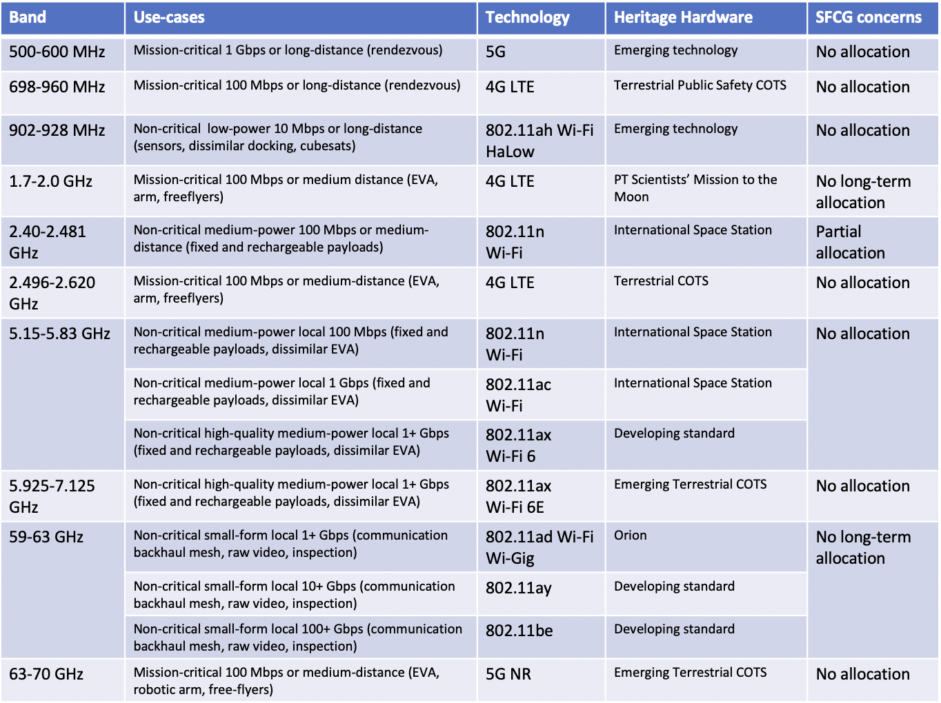

2) Chairman’s and deputy chairman’s analysis of sections and parts thereof relevant to CCSDS RFM WG
The only topics of interest to the RFM WG in this book are Table 2-2 “Wireless Communications Coverage Ranges and Data Rates “ and Table 2-3 “Spectrum Utilization and SFCG Concerns”.
Based on the discussion in section 2.1 of CCSDS 883.0-BBv1-0-0 leading up to Table 2-2, there is not a direct correlation between the range class and data rate class justifying that longer range class provides higher data rate capability; therefore, a reformat of Table 2-2 is proposed for clarity.

Concerning Table 2-3, the bands in this table are currently under consideration by SFCG for inclusion in a future version of SFCG recommendation 32-2R2 on frequencies for lunar applications except two ( 5.9-7.1 GHz and 63-70 GHz) which may be considered by SFCG at a later stage if proposed by SFCG member agencies.
SLS-RFM_20-10 by the deputy chairman already provided the following considerations to the SOIS-WIR WG chair:
“The frequency bands under consideration are in Table 2-3 of the Blue Book. The table lists under concerns that many of the bands are not allocated by the ITU for use in space-to-space links. However, given that these wireless links are short range (< 10 km) and located far from Earth, the ITU has generally allowed these frequencies to be used on a non-interference basis.
A more important consideration is if these frequency bands are also used by other satellites or spacecraft for communications or remote sensing applications that could suffer interference from these wireless networks. For example, the 1720.530 MHz and 6668.518 MHz frequencies have been identified in ITU Recommendation RA.314 as a spectral lines of significant importance for radio astronomy. These frequencies overlap with the 1.7-2 GHz and 5.925-7.125 GHz bands, respectively, identified for wireless network use in the table below. Lunar wireless networks using these frequencies could cause RFI to radio astronomers, which is an issue given the recent proposal to build a radio telescope on the far side of the Moon. The far side of the Moon is especially prized by radio astronomers because it is isolated from Earth-based sources of RFI.
In addition, the 902-928 MHz ISM band is sometimes used by amateur satellites and could also result in interference. The 2.4 GHz and 5 GHz bands are already in use onboard the ISS external WiFi network, and no issues are expected for these bands
It should be noted the frequency bands in the CCSDS 883.0 Blue Book differs considerably from the recommended frequency bands for lunar surface wireless networks in SFCG Recommendation 32-2R2. In the SFCG recommendation, the frequency bands given for lunar surface wireless networks are 390-405 MHz, 410-420 MHz, 435-450 MHz, 2.4-2.48 GHz, 25.25-25.60 GHz, and 27.225-27.5 GHz. This may indicate a need to align the SFCG Recommendation with certain bands in the table below at a future SFCG meeting.”
It could be added :
Radio astronomers are hoping to benefit from the isolation provided by the far side of the Moon to perform radioastronomy observations in bands non allocated for radio astronomy by ITU. This, with possible future optimization of the targeted data rate regarding accurate needs, might be 2 of the reasons of an eventual down selection of the frequency bands of table 2-3 in evolutions of SFCG recommandation 32-2R2.
The 2.4 GHz and 5 GHz bands are already in use onboard the ISS external WiFi network, and no issues are expected for these bands actually in Earth Orbits. The 2.496-2.620 GHz band if selected by SFCG might be however slightly troncated for the lunar environments, in order to avoid overlapping on the 2.4835-2.5000 GHz band beeing part of the “orbiter to surface” bands of SFCG recommandation 32-2R2. The same remark apply for the mars environments.
3) Chairman’s and deputy chairman’s proposed RFM WG response to SOIS-WIR WG
The CCSDS RFM WG has read and discussed in details CCSDS 883.0-BBv1-0-0 (July 2020). The RFM WG recommends reorganization of Table 2-2 in Section 2.3 and amendments to Section 2.4.2 as shown below.
With inclusion of these suggested changes in the book, the RFM WG has no issue with the publication of this recommended standard.

Wireless Communication Range and Data Rates

Wireless communications coverage ranges and data rates, at the time of document publication, are generically classified as shown below in Table 2-2.
Table 2-2: Wireless Communications Coverage Ranges and Data Rates
Range Class | Wireless Range
Short range | Less than 100 m
Medium range | 100m to 1 km
Long range | Greater than 1 km
Very Long range | Greater than 10 km
Data Rate Class | Data Rate
Low rate | Less than 1 Mbps
Medium rate | 1 Mbps to 1 Gbps
High rate | 1 Gbps to 100 Gbps
Very High rate | Greater than 100 Gbps

Spectrum and use-cases for space-based wireless networks

Existing spectrum allocations used in the 802.11 and 3GPP standards are allocated by the ITU for terrestrial use on Earth and not in space, and may not be directly transferrable for use in the lunar region. For non-mission critical communications, certain bands (e.g., 2.40-2.481 GHz) may be used for wireless proximity communications in space on a non-interference basis to allocated services, and without any claims to protection from interference from other services. Mission planners should consult with Space Frequency Coordination Group (SFCG) Recommendations or with their Agency’s SFCG representative as to the appropriate frequency bands to use for wireless proximity links in space, especially in the lunar and Mars regions.
The frequency band of SFCG recommandation 32-2R2 provided with a mass market heritage have each been examined relatively to the interference risk with the other ITU services in the same bands. The concerned SFCG representatives should aim to see the related interference calculations for the new candidate bands. The higher are the data rates, the higher are the related transmitted powers and the PFD, and therefore the higher are the interference risks.
Table 2-3, below, summarizes different use-cases for mission-critical and non-critical space proximity links, and the envisioned application of IEEE 802.11 and 3GPP LTE wireless technologies.
At the time of publication of this recommended standard, most of the frequency bands which the identified standards operate in are not included in the SFCG recommendation 32-2R2 on lunar frequencies use or in recommendation 22-1R3 on Mars region frequencies but several of them are currently under consideration by SFCG for possible inclusion in a future release thereof. The readers should therefore check with SFCG or with the Agency's SFCG representative for the results of such discussion before selecting any of these frequency bands.
Table 2-3: Wireless Technology for Different Space Proximity Link Use-cases
