2.4.18 MODULATION METHODS AT HIGH SYMBOL RATE TRANSMISSIONS, EARTH EXPLORATION SATELLITES (EES) 8 GHZ BAND, SPACE-TO-EARTH

The CCSDS,

considering
- that efficient use of RF spectrum resources is becoming increasingly important with the increasing congestion of the frequency bands;
- that the 8025–8400 MHz band is heavily used and interference conflicts may become increasingly frequent in this band;
- that the SFCG has approved a Recommendation which specifies a spectrum mask for emissions with symbol rates below and above 2 Ms/s;
- that the SFCG has approved a Recommendation on the use of the 8025–8400 MHz band recommending that bandwidth- and power-efficient modulation and coding techniques be used;
- that CCSDS 131.0-B-3, CCSDS 131.2-B-1, and CCSDS 131.3-B-1 foresee a number of coding schemes, some of which may be incompatible with the bandwidth-efficient use of the 8025–8400 MHz band;
- that contiguous to 8400 MHz, a particularly sensitive allocation to Space Research, deep space, requires adequate protection from unwanted emissions generated by EES;
- that only filtered suppressed carrier systems can meet the bandwidth efficiency of the SFCG spectrum mask Recommendation for symbol rates in excess of 2 Ms/s and limit unwanted emissions into the neighboring bands;Error: Reference source not found
- that Square Root Raised Cosine (SRRC) filtered 4-Dimensional 8PSK Trellis Coded Modulation (SRRC-4D 8PSK TCM), SRRC-QPSK, SRRC-OQPSK, SRRC-8PSK, SRRC-16APSK, SRRC-32APSK, and SRRC-64APSK, and some filtered OQPSK modulations spectra can meet the SFCG emission mask for symbol rates in excess of 2 Ms/s with acceptable end-to-end losses;
- that baseband filtered QPSK, OQPSK, and 8PSK receivers are readily available in most space agencies’ ground networks;
- that baseband filtered receivers for higher order modulations are available through a number of vendors;
- that a phase imbalance of less than 3 degrees and an amplitude imbalance of less than 0.5 dB should result in acceptable performance degradation;
2.4.18 MODULATION METHODS AT HIGH SYMBOL RATE TRANSMISSIONS, EARTH EXPLORATION SATELLITES (EES) 8 GHZ BAND, SPACE-TO-EARTH (Continued)

- that a channel with in-band ripple up to 0.1 dB, out-of-band rejection of at least 30 dB, and in-band (within channel symbol rate) group-delay variations up to 10 percent of the signal duration should result in acceptable performance degradations even in case no equalization is used at the receiver;
noting
- that filtered OQPSK signals can also be demodulated by unfiltered OQPSK receivers with some mismatching losses;
- that many missions are currently operating in this band with a signaling efficiency over 1.75 source bits/channel symbol;
- that recommended maximum values of phase noise and HPA linearity are needed to ensure small end-to-end losses;
- that linearization techniques (pre-distortion) or compensation (equalization, centroid tuning) or both can reduce the channel losses, especially for APSK modulations;
- that the use of a frame header and of pilot symbols can improve the acquisition time as well as tracking performance;
- that the constellation bit mapping for SRRC-4D 8PSK TCM is natural, while constellation bit mappings for SRRC-8PSK, SRRC-16APSK, SRRC-32APSK, and SRRC-64APSK are Gray coded and are different for coding in accordance with CCSDS 131.0-B-3, CCSDS 131.2-B-1 and CCSDS 131.3-B-1;

recommends

- that a mission planning to operate in the 8025–8400 MHz band shall use SRRC-4D 8PSK TCMError: Reference source not found or SRRC-QPSK, SRRC-OQPSK, SRRC-8PSK, SRRC-16APSK, SRRC-32APSK, and SRRC-64APSK or filtered OQPSK;

- that a mission planning to use this band should select the most bandwidth-efficient channel coding scheme from CCSDS 131.0-B-3 or 131.2-B-1 or 131.3-B-1 compatible with the mission constraints;

2.4.18 MODULATION METHODS AT HIGH SYMBOL RATE TRANSMISSIONS, EARTH EXPLORATION SATELLITES (EES) 8 GHZ BAND, SPACE-TO-EARTH (Continued)

- that Variable Coding and Modulation (VCM) or Adaptive Coding and Modulation (ACM) techniques should be used where practicable;

- that linearization techniques (pre‐distortion) at the transmitter or compensation (such as equalization or centroid tuning) at the receiver should be used to minimize the end-to-end losses at least for 16APSK and higher-order modulations, and in any case if the channel is worse than in considering (k);

- that a frame header (see A2.5) and pilot symbols should be used to improve the acquisition and tracking performance especially for modulations with order higher than 8PSK;

- that the phase noise of the communication chain should be limited according to the mask given in Annex 1 or Annex 2 depending on the selected scheme;

- that the modulator’s phase imbalance shall not exceed 5 degrees for SRRC-QPSK, SRRC-OQPSK, SRRC-4D 8PSK TCM, SRRC-8PSK, and SRRC-16APSK and 3 degrees for SRRC-32APSK and SRRC-64APSK, and the amplitude imbalance shall not exceed 0.5 dB between the constellation points;

- that the AM/PM slope for the non-linear amplifier shall be less than 5°/dB unless appropriate equalization at the receiver is performed.

2.4.18 MODULATION METHODS AT HIGH SYMBOL RATE TRANSMISSIONS, EARTH EXPLORATION SATELLITES (EES) 8 GHZ BAND, SPACE-TO-EARTH (Continued)

ANNEX 1
4-Dimensional 8PSK Trellis Coded Modulation Specifications

(Normative)

A1.1 General

The 4D-8PSK trellis-coded modulator consists of a serial-to-parallel converter, a differential coder, a trellis encoder (convolutional coder), a constellation mapper, and an 8PSK modulator (see figure 2.4.18-1). It should be noted that in this figure, ‘wi’ (with index i = 1, … , m) represent the uncoded bits and ‘xj’ (with index j = 0, … , m) are the coded bits. The trellis encoder is based on a 64-state systematic convolutional coder and can be considered as the inner code if an outer block code is introduced. Carrier phase ambiguity is resolved by the use of a differential coder located prior to the trellis encoder. Spectral efficiencies of 2, 2.25, 2.5, and 2.75 bits/channel-symbol are achieved with four possible architectures of the constellation mapper. The output switch addresses successively one of the four symbols ( Z⁽⁰⁾ – Z⁽³⁾ ) from the constellation mapper to the 8PSK modulator.

The present standard is based on the following parameters:

- size of the constellation: M=8 phase states (8PSK);
- number of signal set constituents: L=4 (shown as Z⁽⁰⁾ … Z⁽³⁾ in figure 2.4.18-1);
- number of states for the trellis encoder: 64;
- rate of the convolutional coder used for the construction of the trellis: R=3/4;
- rate of the modulation: R_{m}=m/(m+1) selectable to 8/9, 9/10, 10/11, or 11/12;
- efficiency of the modulation:
- R_{eff}=2 bits per channel-symbol (for R_{m}=8/9);
- R_{eff}=2.25 bits per channel-symbol (for R_{m}=9/10);
- R_{eff}=2.5 bits per channel-symbol (for R_{m}=10/11);
- R_{eff}=2.75 bits per channel-symbol (for R_{m}=11/12).
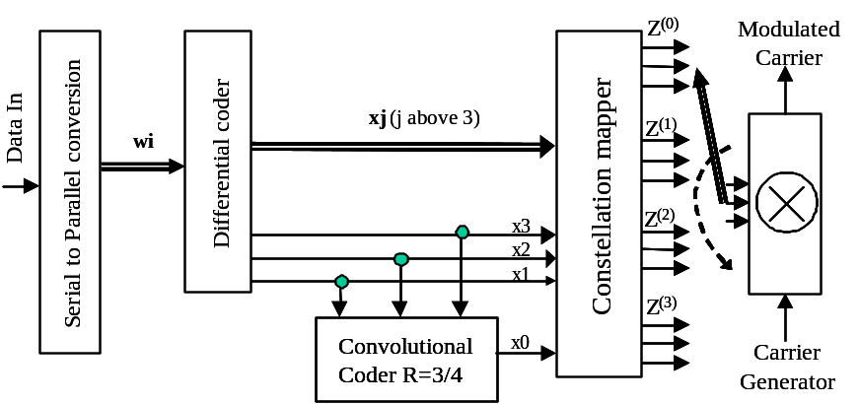
Figure 2.4.18-1: Structure of the 4D 8PSK-TCM Coder/Mapper
2.4.18 MODULATION METHODS AT HIGH SYMBOL RATE TRANSMISSIONS, EARTH EXPLORATION SATELLITES (EES) 8 GHZ BAND, SPACE-TO-EARTH (Continued)

ANNEX 1 (Continued)

A1.2 Differential Coder

The differential coder is depicted in figure 2.4.18-2. Table 2.4.18-1 gives the bit reference at input and output of the differential coder in each case.
Table 2.4.18-1: Bit Mapping for Differential Coder with Modulo-8 Addition
Efficiencies in bits /channel-symbol
2 |  | 2.25 |  | 2.5 |  | 2.75
bit IN | bit OUT | bit IN | bit OUT | bit IN | bit OUT | bit IN | bit OUT
w1 | x1 | w2 | x2 | w3 | x3 | w4 | x4
w5 | x5 | w6 | x6 | w7 | x7 | w8 | x8
w8 | x8 | w9 | x9 | w10 | x10 | w11 | x11

An example of differential encoder connections is given in figure 2.4.18-2 for the 2 bits/channel-symbol case. The structure of the modulo-8 adder is also shown; it is applicable to both the coder mapper and differential coder.

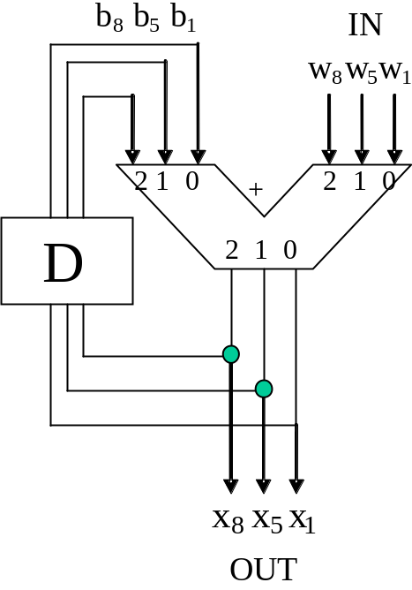 | 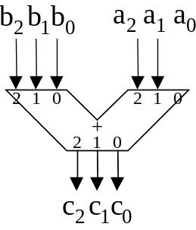  c₀ = a₀ ⊕ b₀ with carry r₀  c₁ = a₁ ⊕ b₁ ⊕ r₀ with carry r₁  c₂ = a₂ ⊕ b₂ ⊕ r₁  r₀ = a₀.b₀  r₁ = (a₁.b₁)+(a₁.r₀)+(b₁.r₀)  where . corresponds to a logical AND, and + to a logical OR
Figure 2.4.18-2: Differential Coder and Modulo-8 Adder Principle

2.4.18 MODULATION METHODS AT HIGH SYMBOL RATE TRANSMISSIONS, EARTH EXPLORATION SATELLITES (EES) 8 GHZ BAND, SPACE-TO-EARTH (Continued)

ANNEX 1 (Continued)

A1.3 Convolutional Coder

The convolutional coder used to implement the trellis is depicted in figure 2.4.18-3. The shift registers of the encoder are clocked at the rate of R_{ChS}/4.

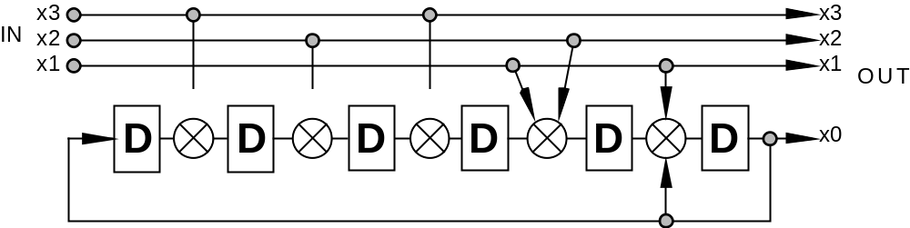
Figure 2.4.18-3: Convolutional Coder Recommended for High Data Rates
A1.4 Constellation Mapper for 4D-8PSK-TCM

The constellation mapper principles are given in figures 2.4.18-4 to 2.4.18-7 for the four possible efficiencies of this modulation (i.e., 2 bits/channel-symbol, 2.25 bits/channel-symbol, 2.5 bits/channel-symbol, and 2.75 bits/channel-symbol). These mappers implement the straightforward logical mapping described in the figures below. The correspondence between the signals Z ^{(i)} at the input of the modular and the 8PSK phase states of the constellations follows a natural mapping (i.e., 0, 1, 2 …, 7 anticlockwise).

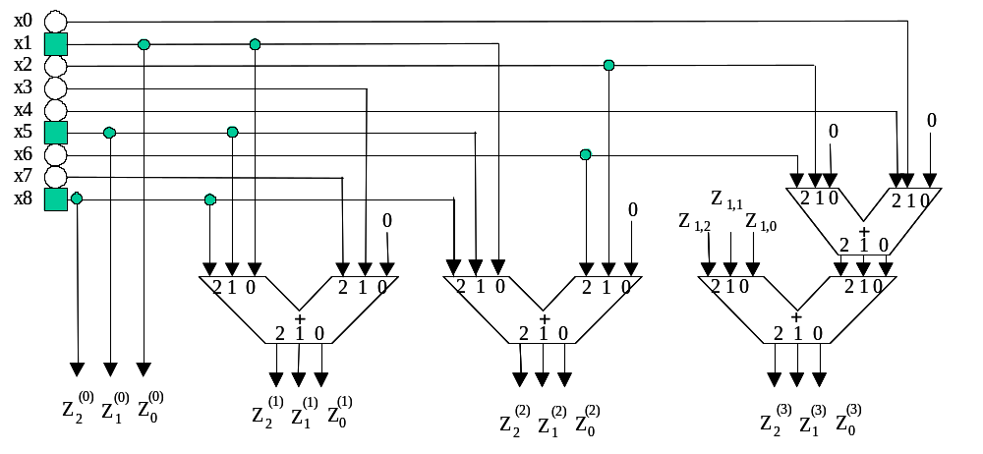
= line connected to differential coder
= line connected to serial-to-parallel converter or convolutional coder
Figure 2.4.18-4: Constellation Mapper for 2 Bits/Channel-Symbol
2.4.18 MODULATION METHODS AT HIGH SYMBOL RATE TRANSMISSIONS, EARTH EXPLORATION SATELLITES (EES) 8 GHZ BAND, SPACE-TO-EARTH (Continued)

ANNEX 1 (Continued)

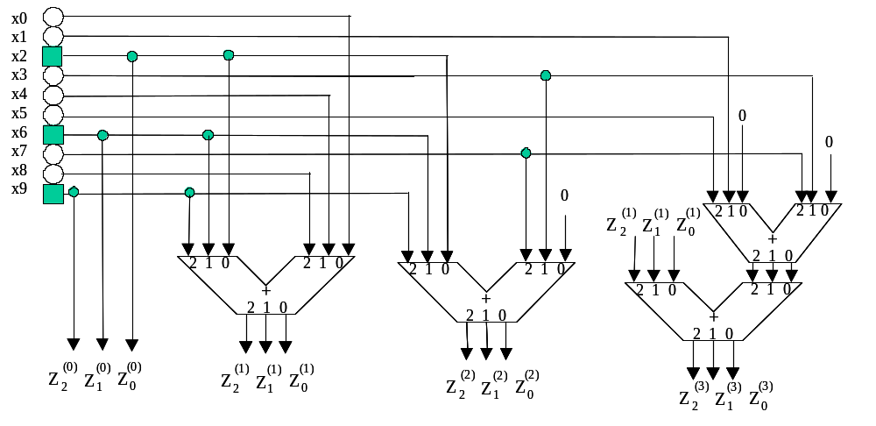
= line connected to differential coder
= line connected to serial-to-parallel converter or convolutional coder
Figure 2.4.18-5: Constellation Mapper for 2.25 Bits/Channel-Symbol

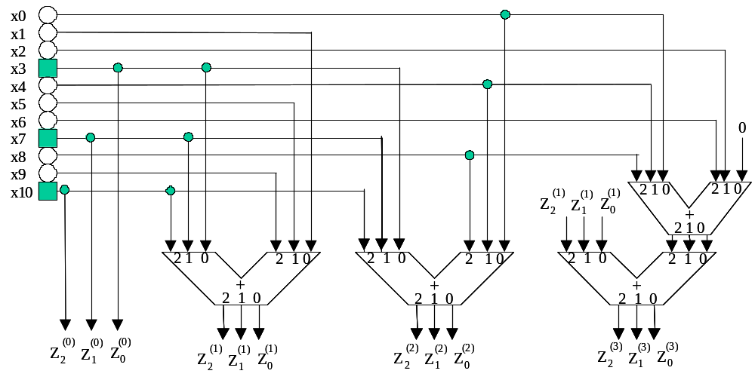
= line connected to differential coder
= line connected to serial-to-parallel converter or convolutional coder
Figure 2.4.18-6: Constellation Mapper for 2.5 Bits/Channel-Symbol

2.4.18 MODULATION METHODS AT HIGH SYMBOL RATE TRANSMISSIONS, EARTH EXPLORATION SATELLITES (EES) 8 GHZ BAND, SPACE-TO-EARTH (Continued)

ANNEX 1 (Continued)
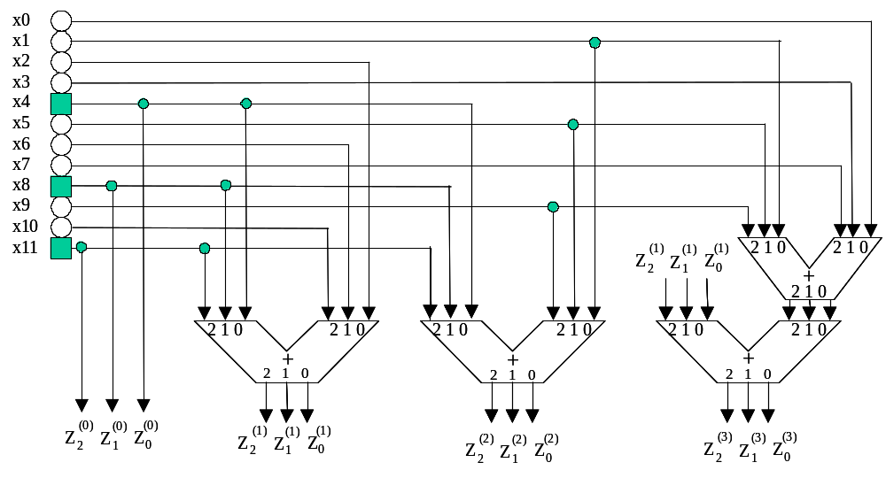
= line connected to differential coder
= line connected to serial to parallel converter or convolutional coder
Figure 2.4.18-7: Constellation Mapper for 2.75 Bits/Channel-Symbol
2.4.18 MODULATION METHODS AT HIGH SYMBOL RATE TRANSMISSIONS, EARTH EXPLORATION SATELLITES (EES) 8 GHZ BAND, SPACE-TO-EARTH (Continued)

ANNEX 1 (Continued)

A1.5 Coder/Mapper Implementation at 2, 2.25, 2.5, and 2.75 Bits/Channel-Symbol Efficiency

The principle of the coder-mapper for 2, 2.25, 2.5, and 2.75 bits/channel-symbol efficiency is given in figures 2.4.18-8 through 2.4.18-11.
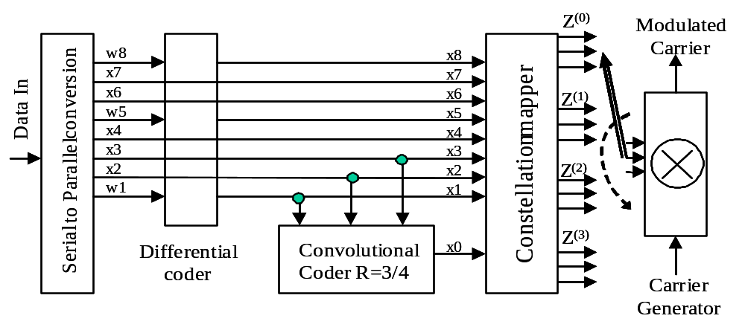
Figure 2.4.18-8: Coder and Mapper Implementation for 2 Bits/Channel-Symbol Efficiency

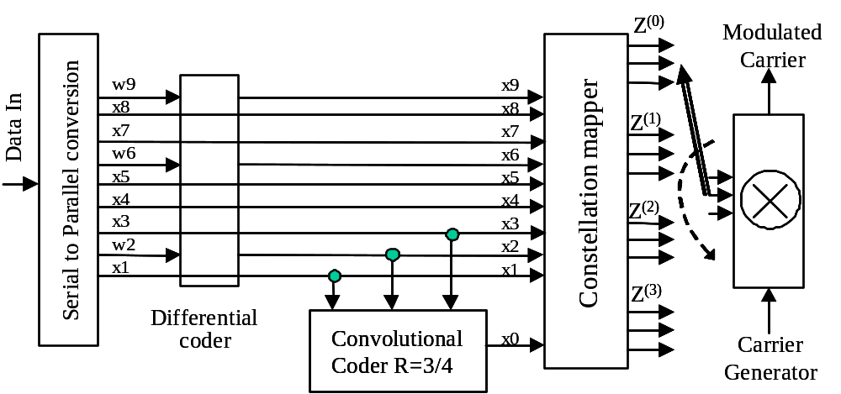
Figure 2.4.18-9: Coder and Mapper Implementation at 2.25 Bits/Channel-Symbol Efficiency

2.4.18 MODULATION METHODS AT HIGH SYMBOL RATE TRANSMISSIONS, EARTH EXPLORATION SATELLITES (EES) 8 GHZ BAND, SPACE-TO-EARTH (Continued)

ANNEX 1 (Continued)

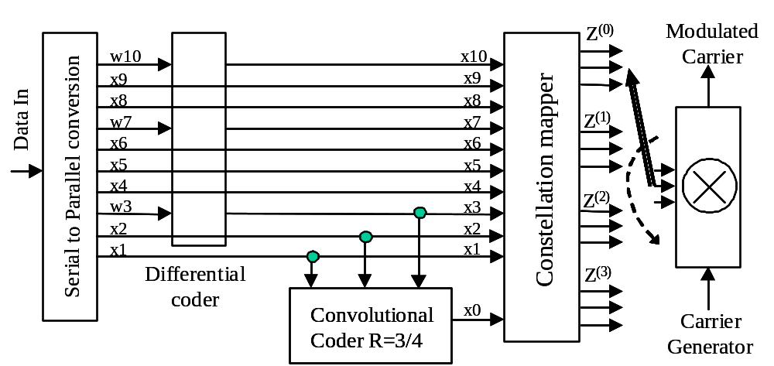
Figure 2.4.18-10: Coder and Mapper Implementation at 2.5 Bits/Channel-Symbol Efficiency

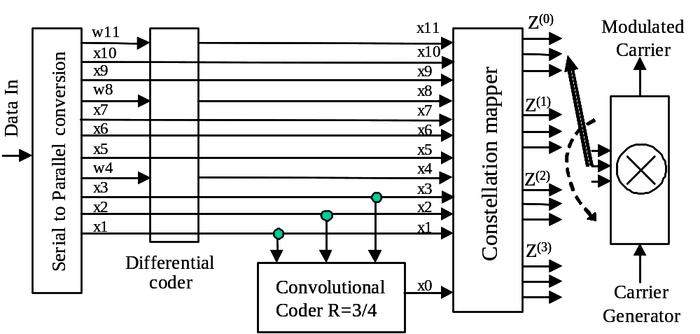
Figure 2.4.18-11: Coder and Mapper Implementation at 2.75 Bits/Channel-Symbol Efficiency
2.4.18 MODULATION METHODS AT HIGH SYMBOL RATE TRANSMISSIONS, EARTH EXPLORATION SATELLITES (EES) 8 GHZ BAND, SPACE-TO-EARTH (Continued)

ANNEX 1 (Continued)

A1.6 SRRC Channel Filtering

The normalized transfer function of the SRRC filter shall be:,
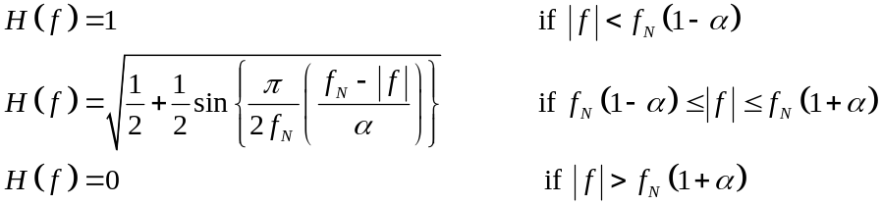
where 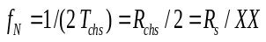 is the Nyquist frequency and α is the roll-off factor.
The specified values for the roll-off factor are α = 0.35 and 0.5.
A1.7 PHASE NOISE

The phase noise for all the oscillators of the communication chain shall be limited according to the mask given in figure 2.4.18-12 for channel symbol rates above 1 Ms/s.

NOTE – The figure shows the double sided phase noise mask 2L(f) in dBc/Hz versus frequency in Hz.

2.4.18 MODULATION METHODS AT HIGH SYMBOL RATE TRANSMISSIONS, EARTH EXPLORATION SATELLITES (EES) 8 GHZ BAND, SPACE-TO-EARTH (Continued)

ANNEX 1 (Continued)

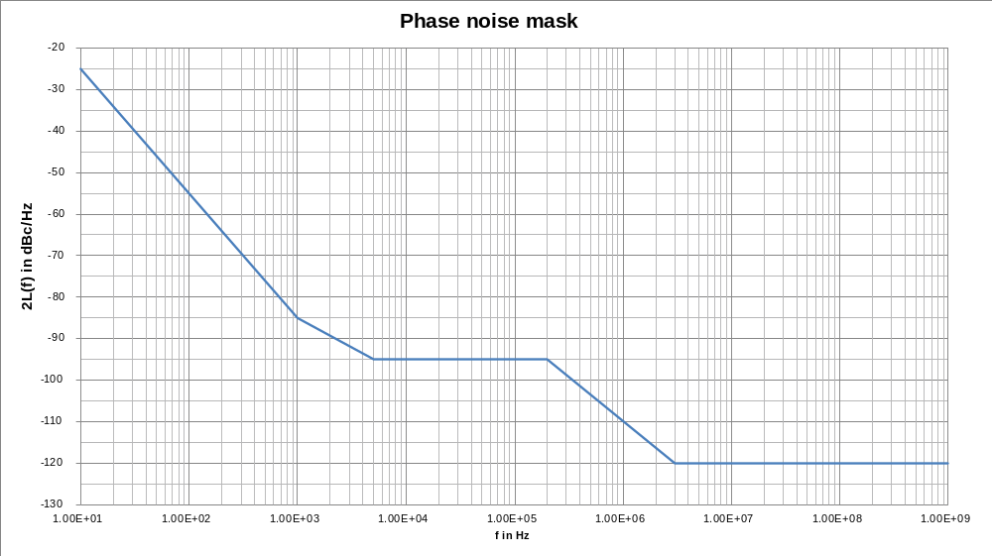
Figure 2.4.18-12: 8PSK Phase Noise Mask Recommendation
2.4.18 MODULATION METHODS AT HIGH SYMBOL RATE TRANSMISSIONS, EARTH EXPLORATION SATELLITES (EES) 8 GHZ BAND, SPACE-TO-EARTH (Continued)

ANNEX 1 (Continued)

A1.8 bit mapping to constellation

The following convention is used to identify each bit in an N-bit field. The first bit in the field to be transmitted (i.e., the most left justified when drawing a figure) is defined to be ‘Bit 0’, the following bit is defined to be ‘Bit 1’, and so on up to ‘Bit N−1’. When the field is used to express a binary value (such as a counter), the Most Significant Bit (MSB) shall be the first transmitted bit of the field, i.e., ‘Bit 0’ (see figure 2.4.18-13).

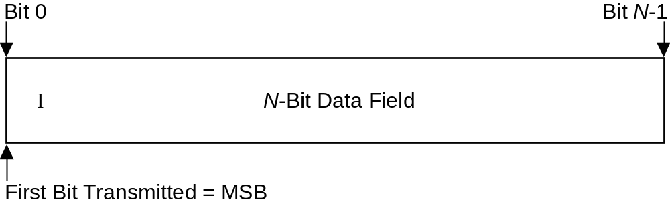
Figure 2.4.18-13: Bit Numbering Convention

For instance, bits 3i, 3i+1, 3i+2 of the modulator input determine the i^{th} 8PSK symbol, where i = 0, 1, 2,… (N/3)−1 and N is the block size to be transmitted.

The modulation shall employ a natural mapping constellation (i.e., 0, 1, 2, …, 7 anticlockwise) as in figure 2.4.18-14 with associated bit numbering convention as in figure 2.4.18-13.

Z^{(i)} represents the signals (three lines) at the input of the modulator, with Z⁽⁰⁾ being the signal set of the first constellation and Z⁽³⁾ being the signal set of the fourth constellation.

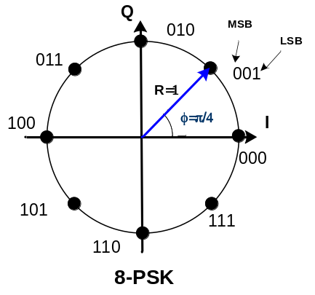
  Phase state | Phase angle (°) | Z^{(i)}
  A | 0 | 000
  B | 45 | 001
  C | 90 | 010
  D | 135 | 011
  E | 180 | 100
  F | 225 | 101
  G | 270 | 110
  H | 315 | 111
Figure 2.4.18-14: 4D-8PSK-TCM Symbol Mapping into Constellation
2.4.18 MODULATION METHODS AT HIGH SYMBOL RATE TRANSMISSIONS, EARTH EXPLORATION SATELLITES (EES) 8 GHZ BAND, SPACE-TO-EARTH (Continued)

ANNEX 2

QPSK/OQPSK/8PSK/16APSK/32APSK/64APSK Modulation Specifications

(Normative)

A2.1 GENERAL
The modulation formats here specified shall follow the template provided in table 2.4.18-2, with the relevant parameters that define each constellation. For multi-circle constellations, and in particular for 16- and 32-APSK, different values are provided for the ratio of outer to inner circle radius, optimized based on the code rate used in CCSDS 131.2-B-1 and CCSDS 131.3-B-1.

Table 2.4.18-2: Modulation Definition

Item | QPSK and OQPSK | 8PSK | 16APSK | 32APSK | 64APSK
Number of constellation concentric circumferences | 1 | 1 | 2 | 3 | 4
Number of uniformly spaced points per circumference | N₁=4 | N₁=8 | N₁=4, N₂=12 | N₁=4, N₂=12, N₃=16 | N₁=4, N₂=12, N₃=20, N₄=28
Ratio of outer circle to inner circle radius | N.A. | N.A. | γ₁=R₂/R₁ as per CCSDS 131.2-B-1 and CCSDS 131.3-B-1; when codes from 131.0-B-3 are used as described in 431.0-B-1, the ratios in Table 2.4.18-3 shall be used.  (See also ) | γ₁=R₂/R₁ and γ₂=R₃/R₁ as per CCSDS 131.2-B-1 and CCSDS 131.3-B-1; when codes from 131.0-B-3 are used as described in 431.0-B-1, the ratios in Table 2.4.18-3 shall be used.  (See also ) | γ₁=R₂/R₁ = 2.73, γ₂=R₃/R₁= 4.52, γ₃=R₄/R₁= 6.31
Radii relation for unit average symbol level (average symbol energy =1) | N.A. | N.A. | [R₁]²+3[R₂]²=4 | [R₁]²+3[R₂]²  +4[R₃]²=8 | [R₁]²+3[R₂]²  +5[R₃]²+7[R₄]²=16
Bit-to-symbol mapping | Bits 2i (MSB) and 2i+1 (LSB) determine the i^{th} QPSK symbol | Bits 3i (MSB), 3i+1 and 3i+2 (LSB) determine the i^{th} 8PSK symbol | Bits 4i (MSB), 4i+1, 4i+2 and 4i+3 (LSB) determine the i^{th} 16APSK symbol | Bits 5i (MSB), 5i+1, 5i+2, 5i+3 and 5i+4 (LSB) determine the i^{th} 32APSK symbol | Bits 6i (MSB), 6i+1, 6i+2, 6i+3, 6i+4 and 6i+5 (LSB) determine the i^{th} 64APSK symbol
Constellation proper | (See figure 2.4.18-17) | (See figures 2.4.18-18 and 2.4.18-19) | (See figure 2.4.18-20) | (See figure 2.4.18-21) | (See figure 2.4.18-22)

Table 2.4.18-3: Radii Ratios when codes from 131.0-B-3 are used as described in 431.1-B-1

VCM Mode | Modulation | Code Rate | γ₁ = R₂/R₁ | γ₂ = R₃/R₁
16 | 16-APSK | ½ | 3.15 | N.A.
17 | 16-APSK | 2/3 | 3.15 | N.A.
18 | 16-APSK | 4/5 | 2.75 | N.A.
19 | 16-APSK | 223/255 | 2.60 | N.A.
20 | 32-APSK | ½ | 2.84 | 5.27
21 | 32-APSK | 2/3 | 2.84 | 5.27
22 | 32-APSK | 4/5 | 2.72 | 4.87
23 | 32-APSK | 223/255 | 2.57 | 4.41
2.4.18 MODULATION METHODS AT HIGH SYMBOL RATE TRANSMISSIONS, EARTH EXPLORATION SATELLITES (EES) 8 GHZ BAND, SPACE-TO-EARTH (Continued)

ANNEX 2 (Continued)

A2.2 SRRC Channel Filtering

The transfer function of the SRRC filter shall be:,
where is the Nyquist frequency and α is the roll-off factor. The specified values for the roll-off factor are α = 0.2, 0.25, 0.3, and 0.35.

A2.3 PHASE NOISE

The phase noise for all the oscillators of the communication chain shall be limited according to the mask given in figure 2.4.18-15 for channel symbol rates above 1 Ms/s.

NOTE – The figure shows the double-sided phase noise mask 2L(f) in dBc/Hz versus frequency in Hz.

2.4.18 MODULATION METHODS AT HIGH SYMBOL RATE TRANSMISSIONS, EARTH EXPLORATION SATELLITES (EES) 8 GHZ BAND, SPACE-TO-EARTH (Continued)

ANNEX 2 (Continued)

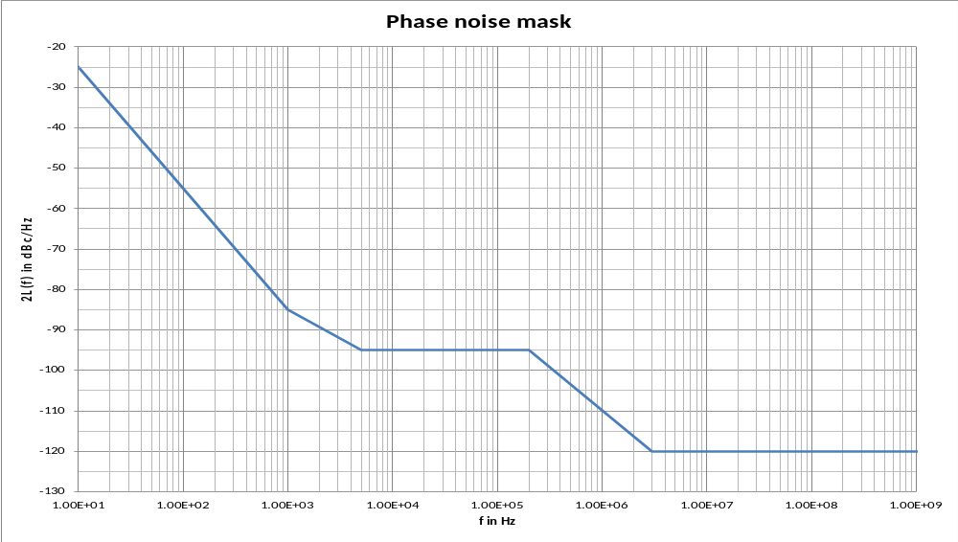
Figure 2.4.18-15: Phase Noise Mask Recommendation

2.4.18 MODULATION METHODS AT HIGH SYMBOL RATE TRANSMISSIONS, EARTH EXPLORATION SATELLITES (EES) 8 GHZ BAND, SPACE-TO-EARTH (Continued)

ANNEX 2 (Continued)

A2.4 BIT MAPPING TO CONSTELLATION

The following convention is used to identify each bit in an N-bit field. The first bit in the field to be transmitted (i.e., the most left justified when drawing a figure) is defined to be ‘Bit 0’, the following bit is defined to be ‘Bit 1’, and so on up to ‘Bit N−1’. When the field is used to express a binary value (such as a counter), the Most Significant Bit (MSB) shall be the first transmitted bit of the field, i.e., ‘Bit 0’ (see figure 2.4.18-16).

Figure 2.4.18-16: Bit Numbering Convention

For instance, bits 3i, 3i+1, 3i+2 of the modulator input determine the i^{th} 8PSK symbol, where i = 0, 1, 2,…, (N/3)−1, and N is the block size to be transmitted.

2.4.18 MODULATION METHODS AT HIGH SYMBOL RATE TRANSMISSIONS, EARTH EXPLORATION SATELLITES (EES) 8 GHZ BAND, SPACE-TO-EARTH (Continued)

ANNEX 2 (Continued)

A2.4.1 QPSK and OQPSK

Modulations in accordance with CCSDS 131.2-B-1, CCSDS 131.3-B-1 or when used with coding schemes specified in CCSDS 131.0-B-3, shall employ a conventional Gray-coded constellation with absolute mapping (no differential coding) as in figure 2.4.18-17 with associated bit numbering convention as in figure 2.4.18-16.

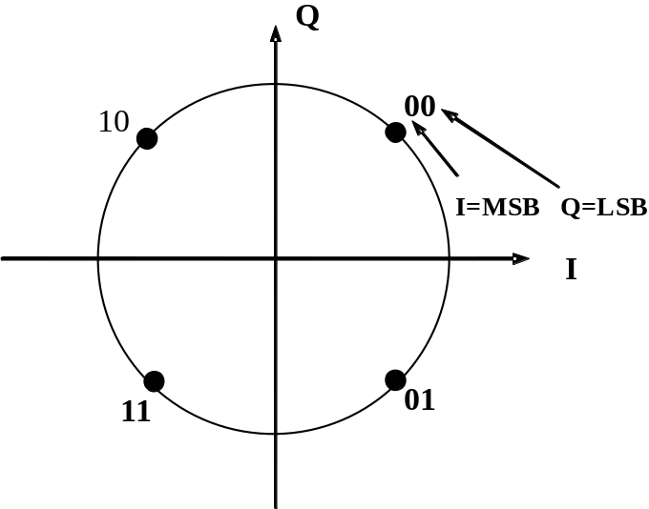
Figure 2.4.18-17: QPSK and OQPSK Symbol Mapping into Constellation

2.4.18 MODULATION METHODS AT HIGH SYMBOL RATE TRANSMISSIONS, EARTH EXPLORATION SATELLITES (EES) 8 GHZ BAND, SPACE-TO-EARTH (Continued)

ANNEX 2 (Continued)

A2.4.2 8PSK

Modulation in accordance with CCSDS 131.2-B-1 shall employ a conventional Gray-coded constellation with absolute mapping (no differential coding) as in figure 2.4.18-18 with associated bit numbering convention as in figure 2.4.18-16. Alternatively, modulation in accordance with CCSDS 131.3-B-1 or when used with coding specified in CCSDS 131.0-B-3 shall employ a conventional Gray-coded constellation with absolute mapping (no differential coding) as in figure 2.4.18-19 with associated bit numbering convention as in figure 2.4.18-16.

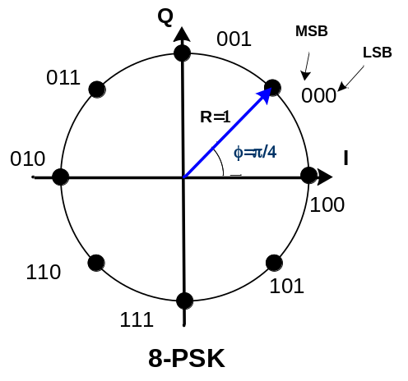
Figure 2.4.18-18: 8PSK Symbol Mapping into Constellation (CCSDS 131.2-B-1)

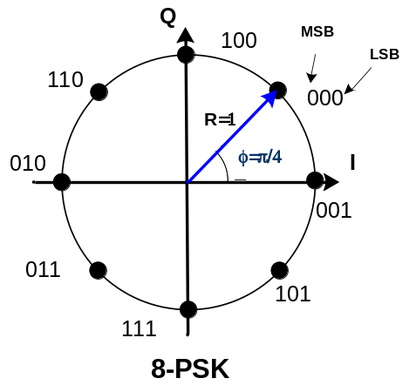
Figure 2.4.18-19: 8PSK Symbol Mapping into Constellation (CCSDS 131.3-B-1 and CCSDS 131.0-B-3)
2.4.18 MODULATION METHODS AT HIGH SYMBOL RATE TRANSMISSIONS, EARTH EXPLORATION SATELLITES (EES) 8 GHZ BAND, SPACE-TO-EARTH (Continued)

ANNEX 2 (Continued)

A2.4.3 16APSK

Modulations in accordance with CCSDS 131.2-B-1, CCSDS 131.3-B-1 or when used with coding schemes specified in CCSDS 131.0-B-3, shall employ a constellation as in figure 2.4.18-20 and with associated bit numbering convention as in figure 2.4.18-16.

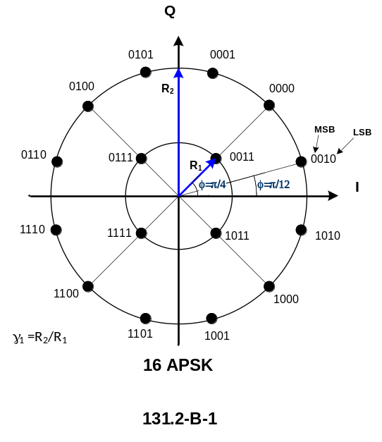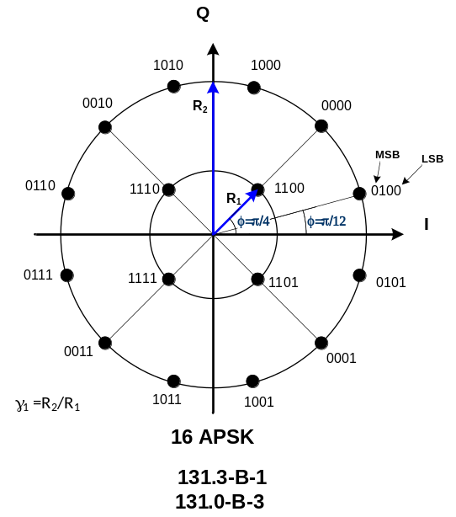
Figure 2.4.18-20: 16APSK Symbol Mapping into Constellation

2.4.18 MODULATION METHODS AT HIGH SYMBOL RATE TRANSMISSIONS, EARTH EXPLORATION SATELLITES (EES) 8 GHZ BAND, SPACE-TO-EARTH (Continued)

ANNEX 2 (Continued)

A2.4.4 32APSK

Modulations in accordance with CCSDS 131.2-B-1, CCSDS 131.3-B-1 or when used with coding schemes specified in CCSDS 131.0-B-3, shall employ a constellation as in figure 2.4.18-21 and with associated bit numbering convention as in figure 2.4.18-16.

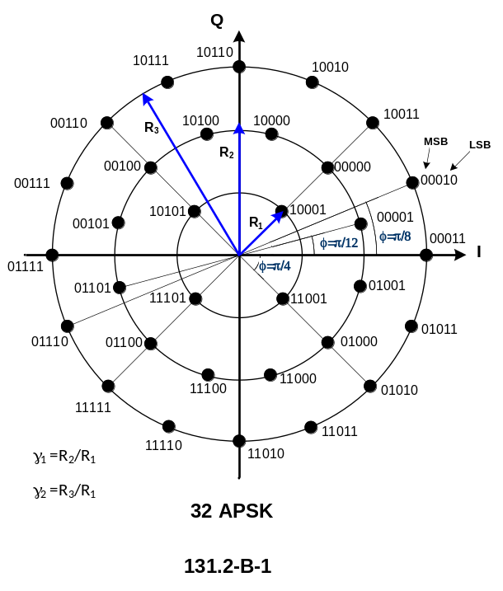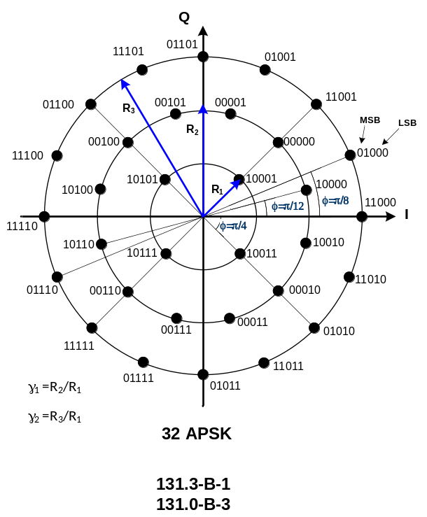
Figure 2.4.18-21: 32APSK Symbol Mapping into Constellation

2.4.18 MODULATION METHODS AT HIGH SYMBOL RATE TRANSMISSIONS, EARTH EXPLORATION SATELLITES (EES) 8 GHZ BAND, SPACE-TO-EARTH (Continued)

ANNEX 2 (Continued)

A2.4.5 64APSK

Modulations in accordance with CCSDS 131.2-B-1 or when used with coding schemes specified in CCSDS 131.0-B-3, shall employ a conventional Gray-coded constellation with absolute mapping (no differential coding) as in figure 2.4.18-22 and with associated bit numbering convention as in figure 2.4.18-16.

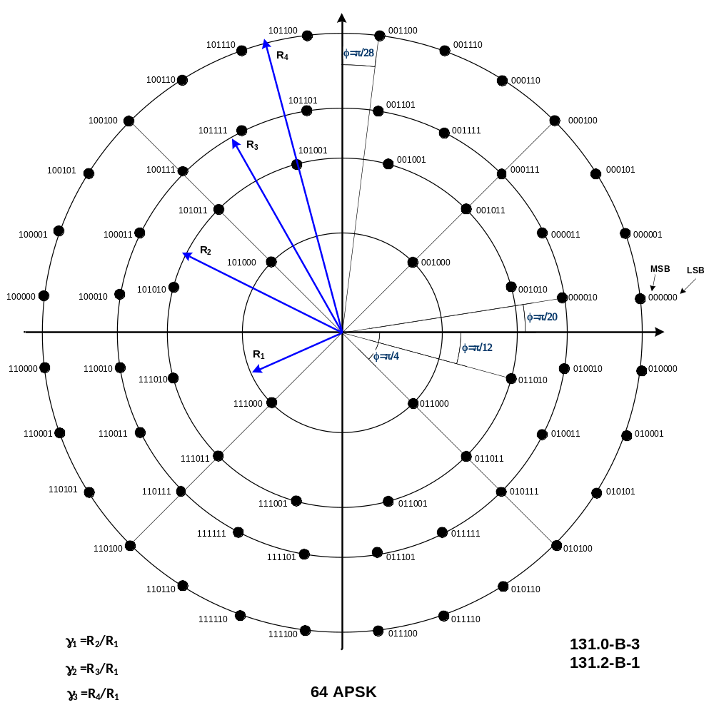
Figure 2.4.18-22: 64APSK Symbol Mapping into Constellation

2.4.18 MODULATION METHODS AT HIGH SYMBOL RATE TRANSMISSIONS, EARTH EXPLORATION SATELLITES (EES) 8 GHZ BAND, SPACE-TO-EARTH (Continued)

ANNEX 2 (Continued)

A2.5 FRAME HEADER MODULATION

The frame header shall consist of π/2-BPSK modulated symbols as defined below.

Assuming that the frame header binary sequence of length N is denoted as:

(x₁,x₂,...,x_{N})

then the in-phase (I) and the quadrature (Q) components of the N π/2-BPSK modulated symbols shall be determined according to the following rule:

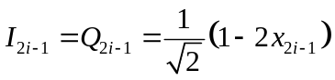
for i = 1, 2, ..., N / 2
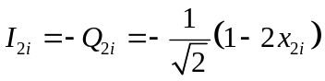

See SFCG Recommendation 21-2R4 or latest version.
See SFCG Recommendation 14-3R10 or latest version.
See SFCG Recommendation 14-1R1 or latest version.
Square Root Raised Cosine (α = 0.35 and α = 0.5) 4D 8PSK Trellis Coded Modulation (see Annex 1).
Square Root Raised Cosine with α = 0.2, 0.25, 0.3, and 0.35 (see Annex 2).
Filtered (Square Root Raised Cosine α = 0.5) Offset QPSK; Butterworth 6 poles, BT_{S} = 0.5; agencies may also utilize filtered OQPSK modulation with other types of bandpass filters provided that the equivalent baseband BT_{S} is not greater than 0.5 and they ensure compliance with SFCG Recommendation 21-2R4 (or latest version) and interoperability with the cross-supporting networks. B refers to the one-sided 3-dB bandwidth of the filter.
1 ns at 100 Ms/s (channel symbol rate).
See annex B4 of CCSDS 413.0-G-3 for SRRC and Butterworth filtered OQPSK mismatching losses.
Ratio of source data rate to channel symbol rate.
Available options are 2.0 b/s/Hz, 2.25 b/s/Hz, 2.5 b/s/Hz, and 2.75 b/s/Hz; Square Root Raised Cosine filter with α = 0.35 or α = 0.5 (see Annex 1).
Square Root Raised Cosine filter with α = 0.2, 0.25, 0.3, and 0.35 (see Annex 2).
Filtered (Square Root Raised Cosine α = 0.5) Offset QPSK; baseband Butterworth 6 poles, BT_{S} = 0.5; agencies may also utilize filtered OQPSK modulation with other types of bandpass filters provided that the equivalent baseband BT_{S} is not greater than 0.5 and they ensure compliance with SFCG Recommendation 21-2R4 (or latest version) and interoperability with the cross-supporting networks. B refers to the one-sided 3-dB bandwidth of the filter.
Relative Recommended Practices (Magenta Books) are under preparation.
For systems compliant with CCSDS 131.2-B-1 and CCSDS 131.3-B-1, the relevant standard should be consulted. For systems compliant with CCSDS 131.0-B-3 (see CCSDS 431.1-R-1).
For filtered OQPSK,Error: Reference source not found Annex 2 applies.
SRRC filtering can be practically implemented either with baseband filters or with RF post-amplifier filters, each able to fulfill SFCG Recommendation 21-2R4 (see CCSDS 413.0-G-3).
This formulation yields an impulse-response function with dimensions of Hz (or 1/s). Sometimes in literature the transfer function is shown with a multiplication factor 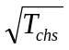 in front.
For a multistandard system, the range to be covered for γ₁ varies from 2.57 to 3.15.
For a multistandard system, the range to be covered for γ₁ varies from 2.53 to 2.84 and the range for γ₂ varies from 4.30 to 5.27.
SRRC filtering can be practically implemented with baseband filters able to fulfill SFCG Recommendation 21-2R4 (see CCSDS 413.0-G-3).
This formulation yields an impulse response function with dimensions of Hz (or 1/s). Sometimes in literature the transfer function is shown with a multiplication factor in front.
The mapping is the same as in recommendation Error: Reference source not found.

