The CCSDS,

considering

- that the technique for supporting Delta-DOR measurements with spacecraft transmitting sinusoidal signals as given in Recommendation 2.5.6B is widely used and contributes to deep space navigation;
- that Delta-DOR measurement accuracy for spacecraft transmitting sinusoidal DOR tones as given in Recommendation 2.5.6B can be limited by spectral mismatching between spacecraft and quasar signals;
- that the spacecraft delay measurement precision $ε_{τ_{SC}}$ depends upon the received DOR signal power-to-noise density ratio ($P_{DOR}/N_{0}$) in each of the two most widely spaced DOR signal fundamental harmonics, separated by spanned bandwidth, $f_{BW}$, Hz apart, and on observation time $T_{obs}$, as shown in the error relationship:
$$ε_{τ_{SC}}=\frac{1}{πf_{BW}\sqrt{\frac{2P_{DOR}}{N_{0}}T_{obs}}} s$$
- that quasar data are recorded in channels centered on the spacecraft DOR signal frequencies, and that quasar delay measurement precision $ε_{τ_{QU}}$depends upon quasar signal-to-noise ratio within a channel, $SNR_{QU}$, and on the spanned bandwidth, $f_{BW}$, as shown in the error relationship:
$$ε_{τ_{QU}}= \frac{\sqrt{2}}{2πf_{BW}}\frac{1}{SNR_{QU}} s$$
- that quasar signals are broadband white noise;
- that measurement errors introduced by instrumental phase dispersion will cancel to the extent that the spacecraft signal spectrum matches the quasar signal spectrum;
- that multiplication of a sine-wave subcarrier with a PN code can generate spread-spectrum DOR signals which are broadband;
- that Gold PN codes have both good auto-correlation and good cross-correlation properties;
- that the number of chips N in a Gold code is related to the code period, $P$, and chip rate, $R_{chs}$, by
$$N=\log_{2}\left(P∙R_{chs}+1\right)$$
- that delay ambiguity can be as high as 1 millisecond for spacecraft with sparse tracking, or spacecraft with unmodeled non-gravitational accelerations, or spacecraft coming out of hibernation;
- that pulse shaping by a Square Root Raised Cosine Filter (SRRC) can flatten the spectrum of a Gold code signal;
- that a sine-wave subcarrier modulated by a Gold code shaped by a SRRC is flat across 90% of a bandwidth $BW$ provided that the chip rate, $R_{chs}$, is at least 90% of $BW$ and the roll-off factor, $α$, is no more than 0.1;
- that the quasar catalog is sufficiently dense with sources that can be detected with a recorded channel bandwidth of at least 8 MHz at X-band;
- that the quasar catalog is sufficiently dense with sources that can be detected with a recorded channel bandwidth of at least 32 MHz at Ka-band;
recommends

- that DOR signals shall be a sine-wave subcarrier multiplied by a PN code when dispersive phase is the limiting factor in navigation accuracy and accuracies better than about 5 nrad are required;
- that the PN code shall be a Gold code;
- that the Gold code shall have the number of chips and use the characteristic polynomials for X-band and Ka-band as shown in Table 2.5.7B-1, with the code generator circuit as specified in Annex A1.1;
Table 2.5.7B-1: Recommended PN DOR Gold Code Polynomials
RF Band | N Chips | 1st Polynomial | 2nd Polynomial
X-Band | 13 | $$1+x^{9}+x^{10}+x^{12}+x^{13}$$ | $$1+x^{3}+x^{4}+x^{6}+x^{8}+x^{9}+x^{13}$$
Ka-Band | 15 | $$1+x^{14}+x^{15}$$ | $$1+x^{3}+x^{12}+x^{14}+x^{15}$$

- that pulse shaping by a Square Root Raised Cosine Filter, as defined in Annex A1.2, shall be used;

- that the chip rate and roll-off factor should be as shown in Table 2.5.7B-2 for X-band and Ka-Band;
Table 2.5.7B-2: Recommended PN DOR Chip Rate & Roll-Off Factor
RF Band | Chip Rate | Roll-Off Factor
X-Band | 7.2 Mcps | 0.1
Ka-Band | 28.8 Mcps | 0.1

NOTE – Chip Rate and Roll-Off Factor can be varied over a large trade space to obtain flat spectrum above 80% of quasar bandwidth.

- that the sine-wave subcarrier frequency used in X-band or Ka-band shall be in the range given in Table 2.5.7B-3;
Table 2.5.7B-3: Recommended DOR Subcarrier Signals
Space-to-Earth  Frequency Band | Number of DOR Subcarriers | Sine-wave Subcarrier  Frequency Range | Notes
X-Band | 1 | 19 MHz
Ka-Band | 1 | 76 to 153 MHz | 1
NOTES
- Quasar delay precision improves linearly with spanned bandwidth. The two DOR sidebands should be spread as far apart as practical, within current technology, up to 306 MHz, to achieve the best navigation accuracy. This might be accomplished with a high rate subcarrier if the assigned carrier channel is near the center of the spectrum allocation. Alternatively, DOR signals near the two edges of the spectrum allocation could be provided by synthesizing frequency sidebands that are not symmetric about the carrier.

- that DOR subcarrier and the chip rate shall be coherent with the downlink RF carrier frequency if carrier-aided detection is used;

- that PN spreading of DOR signals shall not be used at S-band;
- that if spacecraft DOR data are to be acquired in the one-way mode, the spacecraft’s oscillator stability over a 1-second averaging time shall be:
Δf/f ≤ 1.0 × 10 ⁻¹⁰ at X-Band,
Δf/f ≤ 3.0 × 10 ⁻¹¹ at Ka-Band,
where: Δf/f denotes the spacecraft oscillator’s frequency variations (square root of Allan’s variance);
- that sufficient power shall be available in the DOR signal so that the mission requirements in terms of orbit determination accuracy are met (see NOTE below and Table 2.5.7B-4);
NOTE – Good engineering practice recommends limiting the error contribution due to spacecraft delay measurement $ε_{τ_{SC}}$ to ¼ of the total measurement accuracy requirement $ε_{{∆τ}_{RSS}}$ when all error contributions are considered.
This implies that the minimum received $P_{DOR}/N_{0}$ depends on spanned bandwidth $f_{BW}$ and spacecraft observation time $T_{obs}$, as well as on the accuracy requirement. For PN spreading, $P_{DOR}$ is the power in the received subcarrier signal after de-spreading by local correlation with the code model. The relation between $P_{DOR}/N_{0}$ and $ε_{τ_{SC}}$ is:
$$\frac{P_{DOR}}{N_{0}}=\frac{1}{2{\left(πf_{BW}ε_{τ_{SC}}\right)}^{2}T_{obs}} in Hz$$
Because of geographical constraints on where stations are actually located and related mutual visibility issues, a typical observation time $T_{obs}$ of 5 to 10 minutes is used.
Some representative values for $P_{DOR}/N_{0}$ based on the above best practice considerations are shown in Table 2.5.7B-4.
Table 2.5.7B-4: Representative $P_{DOR}∕N_{0}$ for Selected Values of System Parameters
$ε_{Δτ_{RSS}}$ (ns) | $ε_{τ_{SC}}$ (ns) | Band | $f_{BW}$ (Hz) | $T_{obs}$ (s) | $P_{DOR}/N_{0}$ (dB•Hz)  (after despreading)
0.22 | 0.054 | X | 38.25x10⁶ | 600 | 13.0
0.12 | 0.03 | X | 38.25x10⁶ | 600 | 18.1
0.06 | 0.015 | X | 38.25x10⁶ | 600 | 24.1
0.06 | 0.015 | X | 38.25x10⁶ | 300 | 27.1
0.03 | 0.0075 | Ka | 153x10⁶ | 300 | 27.1
0.015 | 0.00375 | Ka | 306x10⁶ | 300 | 27.1

GOLD CODE GENERATOR CIRCUITS

At X-band the recommended gold code generator to be used is specified in Figure 2.5.7B-VI-1, below.

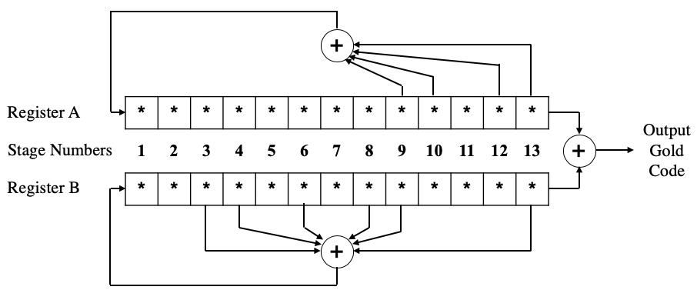
Figure 2.5.7B-VI-1: X-Band Gold Code Generator Circuit
At Ka-band the recommended gold code generator to be used is specified in Figure 2.5.7B-VI-2, below.
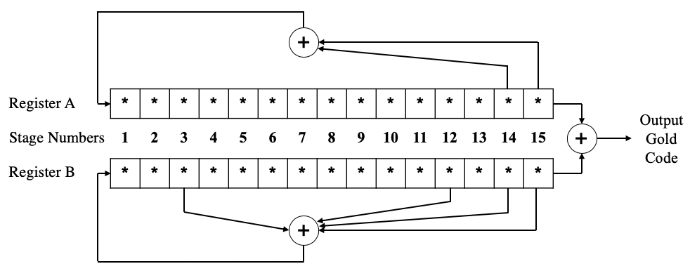
Figure 2.5.7B-VI-2: Ka-Band Gold Code Generator Circuit
The initial seeds for Register A and Register B require inter-agency coordination for spacecraft that have spectral overlap and might fall within the same antenna beam. This is required to avoid potential interference between spacecraft. This is denoted by the *’s in the bits of both Register A and Register B. The final design of each register on a spacecraft will have a binary initial seed.

SRRC CHANNEL FILTERING

The normalized transfer function of the SRRC filter shall be:

$$\begin{aligned}H\left(f\right)= \left\{\begin{matrix}1 & if & \left|f\right|<f_{N}\left(1-α\right) \\ \sqrt{\frac{1}{2}+\frac{1}{2}\sin\left\{\frac{π}{2f_{N}}\left(\frac{f_{N}-\left|f\right|}{α}\right)\right\}} & if & f_{N}\left(1-α\right)≤\left|f\right|≤ f_{N}\left(1+α\right) \\ 0 & if & \left|f\right|>f_{N}\left(1+α\right)\end{matrix}\right.\#\end{aligned}$$

Where $f_{N}=1/(2 T_{chs}) =R_{chs}/2$ is the Nyquist frequency and $α$ is the roll-off factor.

The spanned bandwidth is the widest separation between detectable signals in the spacecraft downlink spectrum.
The initial Linear Feedback Shift Registers seeds require inter-agency coordination for spacecraft that have spectral overlap and might fall within the same antenna beam, in order to avoid potential interference

