Proposed Additional Frequency Channel for Proximity-1 Physical Layer Recommendation

Dennis Lee, NASA/JPL

Introduction

The Proximity-1 Physical Layer Blue Book [1] is used by Mars surface assets (rovers and landers) for communications with Mars relay orbiters, both in the forward and return directions. The forward Prox-1 link uses the 435 - 450 MHz band, while the return link uses the 390 - 405 MHz band. Table 3-4 of the 211.1-B-4 Blue Book defines 8 different UHF channel assignments to be used for Prox-1 links. However the center frequencies for four of these channels are undefined, and the four channel frequency pairs that are defined only occupy a fraction of the available bandwidth.

This paper proposes the definition of additional frequency channel pairs for the Proximity-1 Physical Layer standard. These frequencies are based on the channel center frequencies that are already implemented in the Electra UHF radio currently being used by the Mars Science Laboratory rover and other Mars missions. The definition of additional UHF proximity channels will allow for more efficient utilization of the available spectrum, and help avoid potential interference as the number of Mars landed assets increases. Next year alone will see the launch of 3 additional Mars rovers – the NASA Mars 2020 rover, the ESA/Roscosmos ExoMars Rover/Surface Platform (RSP), and the CNSA HX-1 rover.

Proximity-1 Channel Frequencies

The current Prox-1 channel assignments in Table 3-4 of the 211.1-B-4 Blue Book is shown below. Note that only the frequencies for four channels are specified.
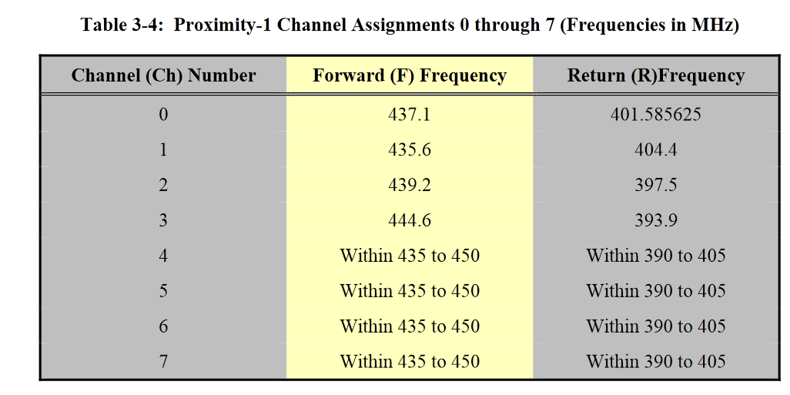

It is proposed to leave unchanged the frequencies for channels 0-3, since they are already in use by a number of missions. Frequencies for the remaining channels 4 through 15 are proposed using the frequencies in the Electra radio specification for MSL, as shown in Table 1. The spacing between these channels is roughly 1 MHz, although in some cases it is much less (e.g., there is only 158.5 kHz between channels 0 and 4 on the return link). Prox-1 software defined radios (SDRs) are typically implemented with a configurable digital coherent turnaround ratio, so a single fixed turnaround ratio between the forward and return frequencies is not needed.

In general, the new frequencies in Table 1 (starting with channel 4) on the forward link increment by 1 MHz beginning at the bottom of the band, with gaps in some cases to accommodate the pre-existing frequencies on channels 0-3. For the return link, the frequencies on channels 4-7 start at 401.4 MHz and increment in 600 kHz steps before restarting at the bottom of the band and incrementing in 1 MHz steps with gaps at 394 MHz and 397 MHz to accommodate the pre-existing return frequencies on Ch. 3 and Ch. 2, respectively.

Table 1. Proposed Prox-1 Channel Frequencies
Channel (Ch) Number | Forward (F) Frequency | Return (R) Frequency
0 | 437.1 | 401.585625
1 | 435.6 | 404.4
2 | 439.2 | 397.5
3 | 444.6 | 393.9
4 | 436 | 401.4
5 | 438 | 402
6 | 440 | 402.6
7 | 441 | 403.2
8 | 442 | 391
9 | 442.5 | 392
10 | 443 | 393
11 | 445 | 395
12 | 446 | 395.5
13 | 447 | 396
14 | 448 | 399
15 | 449 | 400

Note that the SET TRANSMITTER PARAMETERS and SET RECEIVER PARAMETERS directives in the Prox-1 Data Link standard are used to configure the channel assignment for the remote vehicle’s transmitter and receiver for Channels 0 through 7, while the SET PL EXTENSIONS directive is used to configure the radio frequencies for Channels 8 to 15.

Summary

In order to accommodate an increasing number of Mars surface assets requiring relay links for communications, it is proposed to expand the UHF channel frequency assignment table in the Proximity-1 Physical Layer Blue Book (CCSDS 211.1-B-4). The revised table will include center frequencies for 12 additional channels.

A proposed revision of section 3.3.2.4.2 of CCSDS 211.1-B-4, including Table 3-4, is attached in the Annex below.

References

[1] Proximity-1 Space Link Protocol—Physical Layer Issue 4. Recommendation for Space Data System Standards (Blue Book), CCSDS 211.1-B-2. Washington, D.C.: CCSDS, December 2013.

ANNEX

3.3.2.4.2 Table 3-4 details Proximity-1 channel assignments 0 through 15.
NOTE − Channels 8 through 15 are defined in the SET PL EXTENSIONS directive (see annex A of the reference [3]. The assignment of specific frequencies to these channels is reserved by the CCSDS.
Table 3-4: Proximity-1 Channel Assignments 0 through 15 (Frequencies in MHz)
Channel (Ch) Number | Forward (F) Frequency | Return (R)Frequency
0 | 435.6 | 404.4
1 | 437.1 | 401.585625
2 | 439.2 | 397.5
3 | 444.6 | 393.9
4 | 436 | 401.4
5 | 438 | 402
6 | 440 | 402.6
7 | 441 | 403.2
8 | 442 | 391
9 | 442.5 | 392
10 | 443 | 393
11 | 445 | 395
12 | 446 | 395.5
13 | 447 | 396
14 | 448 | 399
15 | 449 | 400

