Proposed Recommendation for DDOR PN Spread Spectrum Systems

Chris Volk, Jet Propulsion Laboratory, California Institute of Technology

# Introduction

Currently, instrumental phase dispersion is a large error term in the Delta-Differential One-way Ranging (DDOR) error budget. This error arises from the spectral difference between the narrowband spacecraft signal and the broadband quasar signal. This error term can be reduced in modern transponders by implementing a pseudo-noise (PN) spread spectrum DOR signal instead of the classic sinusoidal DOR signal. To standardize PN DDOR cross-support, this paper proposes the definitions and specifications required to support a PN DDOR system.

The motivation for PN DDOR is first presented. Then, informational background is presented on code selection, pulse shaping, and code parameters. Finally, Appendix A presents a new proposed Recommendation 2.5.7B for Spread Spectrum DDOR, to be included in CCSDS 401.

# Motivation

The error budget for a DDOR measurement is based on many factors, including: quasar signal level, observation geometry, spacecraft transponder design, receiver performance, and more. The draft CCSDS 500.1-G-2 (available upon request) provides discussion of PN spreading in Section 3.2. Section 4.3 presents a series of equations and factors that can be used to determine the baseline DDOR error budget. Section 5 presents trade-offs in DDOR performance for sinusoidal DOR vs PN DOR.

Figure II‑1 shows the baseline DDOR error budget using Green Book assumptions.



Figure II‑1: Baseline X-Band DDOR Error Budget

As previously mentioned, the leading term in this error budget is the instrumental dispersive phase. This is the error caused by a difference in the phase response of the instrumentation between the narrowband spacecraft signal and the wideband quasar signal. The spacecraft signal in a DDOR measurement is a sinusoidal signal with a discrete frequency component. The quasar signal however is a broadband, white-noise signal. To visualize this spectral difference, consider Figure II‑2, below, which shows a spacecraft signal and a quasar signal recorded within the same 8 MHz channel.

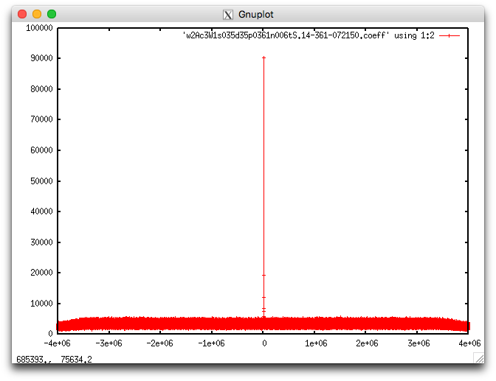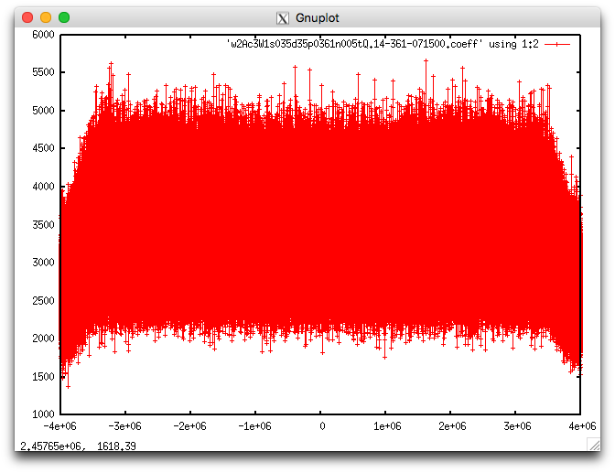

Figure II‑2: Spacecraft Signal (left) and Quasar Signal (right) in the Same 8 MHz Channel

Reducing the instrumental dispersive phase is possible by spreading the spacecraft signal with a PN sequence and shaping the spectrum with a shaping filter. The more closely the spacecraft signal can match the quasar white-noise signal, the more dispersive phase error is reduced.

Figure II‑3 shows the X-Band DDOR Error Budget with PN Spreading. The 90% reduction in dispersive phase corresponds to a 15% reduction in RSS error. Under favorable geometry, error reduction of 40% is expected at X-band.



Figure II‑3: X-Band DDOR Error Budget with PN Spreading

DDOR at Ka-band may provide a significant performance increase over X-band, depending on other technology developments. It is expected that the instrumental phase dispersion error at Ka-band will be larger than at X-band if 32 MHz quasar channels are used. Using PN DOR for Ka-band will reduce this error. The next leading error term is the tropospheric error which can be reduced by implementing tropospheric calibration. Modest improvements in baseline and earth orientation measurements are also expected. The remaining leading error source at Ka-band is the increased quasar thermal noise. This error is inversely proportional to the widest frequency separation between DOR signals, the spanned bandwidth. Thus to have the highest level of accuracy, the spanned bandwidth should be increased by at least a factor of 4 to 8 from X-band. This is possible because the Deep Space allocation at Ka-band is 500 MHz instead of 50 MHz at X-band. The transmitted DOR signals must remain within the 500 MHz spectrum allocation. Therefore, it may be necessary then to produce an asymmetric spectrum about the carrier. Figure II‑4, below, shows such an example with a 306 MHz spanned bandwidth. Notice that while the spacing between the widest channels is increasing, the actual signal being transmitted only occupies a small portion of the spectrum. With each of these technology developments implemented at Ka-band the DDOR accuracy can be improved by 4x over the current X-band level. These trade-offs are outlined in more detail in Section 4.4 of CCSDS 500.1-G-2.

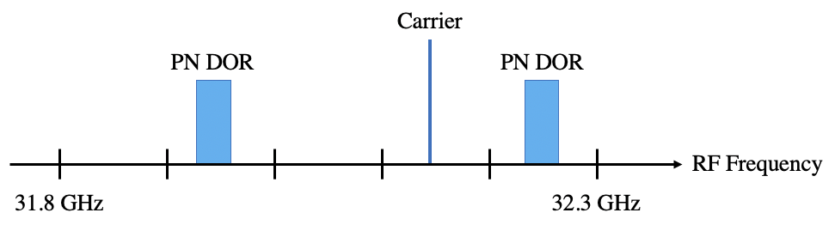

Figure II‑4: Ka-Band Example of an Asymmetric PN DOR Spectrum

Use of a PN sequence also has other benefits for DDOR. The code period of the PN sequence can be used for ambiguity resolution in place of a narrowly spaced DOR tone. This would eliminate the need for the currently recommended 1 MHz DOR tone, saving power aboard the spacecraft or allowing more power into the PN DOR signals. Also, multiple spacecraft can transmit PN DOR signals within the same beamwidth and frequency space without significant interference if unique PN codes with low cross-correlation properties are used. In this case, de-spreading the PN signals before correlation would have to be performed to separate the signals. This is valuable for future cubesat missions which may have to share antenna time with larger projects.

# PN Spread Spectrum Background

There are numerous options for generating PN sequences. One popular set of sequences is the set of maximum length sequences. These sequences have the property that the code length is $2^{N}-1$, where $N$ is the number of bits in the sequence. These codes have very good auto-correlation properties, but poor cross-correlation properties. For example, for maximum length sequences of length 8191 (13-bits) there are 730 unique sequences available but at most only a set of 4 sequences will share good cross-correlation properties. Since PN DDOR may be used on clusters of cubesats in flight, it is desired to have more sequences available than this. Gold codes build upon maximum length sequences for better cross-correlation properties. For example, for Gold Codes of length 8191, there is a set of 8193 sequences which have good cross-correlation properties. For this reason, it is recommended that Gold Codes be used for PN DDOR.

CCSDS 415.1-B-1 Section 1.6.2 and Section 4.4 define Linear Feedback Shift Registers (LFSR) and a representative Gold Code generator circuit. The same basic principles will be used in generating a Gold Code for PN DOR. However, PN DOR will require a circuit with more bits to create a longer sequence. The characteristic polynomials and initial seed of the generator circuit will change as well.

Determining the characteristic polynomials to use is fairly straightforward. The two LFSRs used to generate a Gold Code are each a maximum length sequence. The characteristic polynomial for a maximum length sequence must be a primitive polynomial. These primitive polynomials are well documented and well tabulated in literature. Then, both of the maximum length sequences selected must have a cross-correlation value less than or equal to $2^{\frac{N+2}{2}}$, where $N$ is the number of bits.

The number of bits in the LFSR is chosen so that the code period will satisfy the ambiguity resolution for spacecraft navigation. For cubesats or other missions with limited tracking data and unknown dynamics, it is conservative to have an ambiguity resolution of 1 millisecond. The number of bits in the LFSR sequence can then be computed from the ambiguity requirement, $P$, and the chiprate, $R$.

$$\begin{aligned}N=l{og}_{2}\left(PR+1\right)\#\left(1\right)\end{aligned}$$

Since the number of bits in a LFSR must be an integer, the $N$ must be rounded to the next largest integer. Also, since there are no Gold Code sequences when $N$ is divisible by 4, the solution may again have to be rounded to the next largest integer until a Gold Code pair is found. There is no large penalty for using a larger code period than necessary.

Once the number of bits in the LFSR is known, the polynomial pairs can be selected, as noted above, by finding a pair of maximum length sequences with good cross-correlation properties. Then a circuit similar to that in CCSDS 415.1-B-1 Section 4.4 can be implemented to generate the sequence.

# Pulse Shaping Background

If the Gold Code sequence is transmitted as square pulses, the resulting spectrum will have a rounded shape in the frequency spectrum. This rounded spectrum does not closely resemble the flat quasar spectrum, and will not reduce the phase dispersion error by a large factor. The spectrum can be flattened, however, by the use of a Square Root Raised Cosine (SRRC) filter. The transfer function of a Square Root Raised Cosine Filter is listed in Equation 2, below, and depends on both the chip rate, $R$, and the roll-off factor, $β$.

$$\begin{aligned}H\left(f\right)= \left\{\begin{matrix}1 & for & \left(0 ≤\left|f\right|≤\frac{R\left(1-β\right)}{2}\right) \\ \sqrt{\frac{1}{2}\left\{1+\sin\left[\frac{π}{Rβ}\left(\frac{R}{2}-\left|f\right|\right)\right]\right\}} & for & \left(\frac{R\left(1-β\right)}{2}≤\left|f\right|≤\frac{R\left(1+β\right)}{2}\right) \\ 0 & for & \left(\left|f\right|>\frac{R\left(1+β\right)}{2}\right)\end{matrix}\right.\#\left(2\right)\end{aligned}$$

The frequency response for a variety of roll-off factors, $β$, is visualized in Figure IV‑1, below. It is clear that a lower roll-off factor creates a flatter spectrum. But as the roll-off factor approaches zero, the filter is harder to implement in a digital transponder. So in practice there is a limit to how low the roll-off factor can be.



Figure IV‑1: SRRC Filter Response for a Variety of Roll-off Factors

To have a spectrum that closely resembles the white-noise quasar signal, the frequency response should be within 1 dB of flat across at least 90% of the quasar channel bandwidth. This level of performance would result in a 90% reduction of the phase dispersion error. If the flatness of the transmitted spectrum is less than this, then the performance will also be reduced accordingly. It is possible to rearrange the SRRC frequency response equation to solve for what percentage of the desired spectrum is flat. This solution is in Equation (3a) and (3b) where $BW_{qsr}$ is the desired quasar channel bandwidth. Considering the expected flux at each band, the quasar channel bandwidth should be chosen wide enough so that thermal noise on the quasar measurement is not a dominant error. For X-band the typical quasar channel bandwidth is 8 MHz, and for Ka-band it is 32 MHz.

$$\begin{aligned}\%_{flat}=\frac{2R}{BW_{qsr}}\left(\frac{1}{2}-\frac{β}{π}\sin^{-1}\left[2{\left(-1 dB\right)}^{2}-1\right]\right)\#\left(3a\right)\end{aligned}$$

$$\begin{aligned}\%_{flat}=\frac{2R}{BW_{qsr}}\left(\frac{1}{2}-\frac{β}{π}\sin^{-1}\left[0.262\right]\right)\#\left(3b\right)\end{aligned}$$

There is a trade-off between the chip rate and the roll-off factor that can provide a satisfactory level of flatness. This trade can be visualized in the contour plot of Figure IV‑2. In this plot, the normalized chip rate is the chip rate divided by the desired quasar channel bandwidth (8 MHz for X-band and 32 MHz for Ka-Band). Note, that if $R\left(1+β\right)>BW_{qsr}$ then some power will be wasted outside of the quasar bandwidth. The amount of power wasted is denoted by the red contour lines. The black contour lines denote what percentage of the spectrum is within 1 dB of flat. Any combinations where $R\left(1+β\right)<BW_{qsr}$ were omitted since in those cases the PN signal did not span the entire quasar bandwidth.



Figure IV‑2: Trade Between Chip Rate and Roll-off Factor

Figure IV‑2, shows that there are many combinations that create a suitably flat spectrum, though some come at a cost of transmitting power outside the desired spectrum.

Any analog filters after the digital spectrum is generated can add further unwanted shaping to the spectrum. This is common in designs that include an analog low pass filter (LPF) after a digital-to-analog converter. Figure IV‑3 and Figure IV‑4 show the result of an LPF adding undesired shaping to the spectrum. Note, that there is roughly 3 dB of power variation across the 8 MHz PN spectrum, which should otherwise be flat.

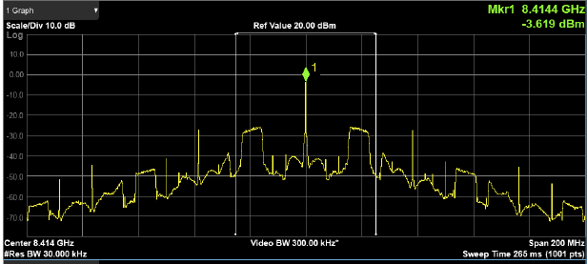

Figure IV‑3: PN Spectrum Shaping as a Result of an Analog LPF, 200 MHz Bandwidth

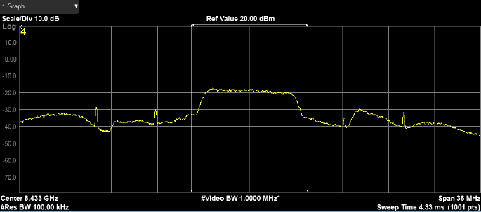

Figure IV‑4: PN Spectrum as a Result of an Analog LPF, 36 MHz Bandwidth

A corresponding equalization/pre-distortion filter can be designed to counteract this shaping. The design criterion is to create a flat power spectrum over the final output PN spectrum. Figure IV‑5 shows the same signal as Figure IV‑4, but with an equalization/pre-distortion filter applied to remove the 3 dB power variation, leaving a flat spectrum.

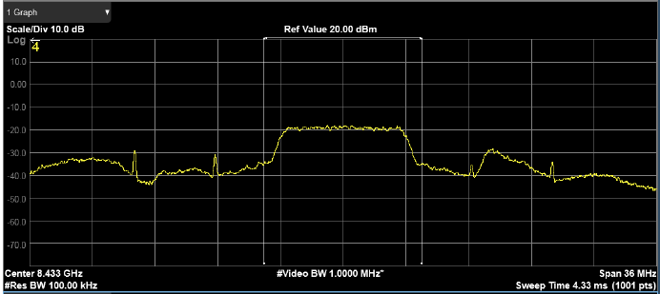

Figure IV‑5: PN Spectrum Flattened by Equalization/Pre-Distortion Filter, 36 MHz Bandwidth

For the best error reduction, the transmitted analog spectrum should be as flat as possible. This means that a digital pre-distortion filter is required for any cases where analog filters add an unacceptable amount of shaping to the spectrum.

# Recommended PN Code Parameters

The recommended roll-off factor is 0.1. This creates a reasonably flat spectrum without an unreasonable amount of complexity in implementing the digital filter. At this roll-off factor, the chip rate must be 90% of the quasar bandwidth to have a spectrum where 90% of the spectrum is within 1 dB of flat and none of the power is transmitted outside the quasar bandwidth. Since the quasar bandwidth is 8 MHz for X-band and is 32 MHz for Ka-band, the recommended chip rate can be easily computed and is shown in Table V‑1, below.

Table V‑1: Recommended Chip Rate and Roll-Off Factors

|  |  |  |  |
| --- | --- | --- | --- |
| RF Band | Quasar Bandwidth | Chip Rate | Roll-Off Factor |
| X-Band | 8 MHz | 7.2 Mcps | 0.1 |
| Ka-Band | 32 MHz | 28.8 Mcps | 0.1 |

With the chip rate known, the code length is then determined from Equation 1 where the required ambiguity resolution is 1 millisecond. The recommended code length is shown in Table V‑2, below.

Table V‑2: Recommended Code Length

|  |  |  |  |  |
| --- | --- | --- | --- | --- |
| RF Band | Chip Rate | N Bits | Code Length | Code Period |
| X-Band | 7.2 Mcps | 13 bits | 8191 chips | 1.14 ms |
| Ka-Band | 28.8 Mcps | 15 bits | 32767 chips | 1.14 ms |

Finally, with the number of bits known, the polynomial pair for the Gold Code can be selected. This process is somewhat arbitrary since there are many combinations with the same performance, but all spacecraft need to use the same polynomials to prevent interference. The recommended polynomials are shown in Table V‑3, below. The initial LFSR seeds require inter-agency coordination for spacecraft that transmit on the same center frequency and might fall within the same antenna beam, in order to avoid potential interference.

Table V‑3: Recommended Gold Code Polynomials

|  |  |  |
| --- | --- | --- |
| RF Band | 1st Polynomial | 2nd Polynomial |
| X-Band | $$1+x^{9}+x^{10}+x^{12}+x^{13}$$ | $$1+x^{3}+x^{4}+x^{6}+x^{8}+x^{9}+x^{13}$$ |
| Ka-Band | $$1+x^{14}+x^{15}$$ | $$1+x^{3}+x^{12}+x^{14}+x^{15}$$ |

These recommended specifications are designed to provide the best DDOR performance. Deviations from the recommended chip rate, roll-off factor, and code length may result in poorer performance, but may be acceptable based on a mission’s needs. Deviations from the recommended polynomial pairs may result in interference with other spacecraft and will require advanced coordination between agencies.

For cross-supports between ground stations, the ground stations must be capable of recording the entire bandwidth (8 MHz for X-band and 32 MHz for Ka-band) of each frequency channel containing a spacecraft PN signal, just as is now done for the quasar signal. This change to the spacecraft signal improves DDOR performance. However, the Raw Data Exchange Format (CCSDS 506.1-B-1) and the Recommended Practice for DDOR Operations (CCSDS 506.0-M-2) do not change.

# Summary

Instrumental dispersive phase is currently the leading error term in the X-band DDOR error budget and a moderate error source in the Ka-band DDOR error budget, but by adding PN spreading to the DOR signals this error term can be reduced by 90%. A new recommended standard is needed to define and standardize these PN codes between agencies. Based on the technical background previously presented, a recommended standard has been drafted and the proposed recommendation is attached below in Appendix A.

The research was carried out at the Jet Propulsion Laboratory, California Institute of Technology, under a contract with the National Aeronautics and Space Administration.

© 2019. California Institute of Technology. Government sponsorship acknowledged.

**Appendix A**

**The CCSDS,**

**considering**

1. that the technique for supporting Delta-DOR measurements with spacecraft transmitting sinusoidal signals as given in Recommendation 2.5.6B is widely used and contributes to deep space navigation;
2. that Delta-DOR measurement accuracy for spacecraft transmitting sinusoidal DOR tones as given in Recommendation 2.5.6B can be limited by spectral mismatching between spacecraft and quasar signals;
3. that the spacecraft delay measurement precision $ε_{τ_{SC}}$ depends upon the received DOR signal power-to-noise density ratio ($P_{DOR}/N_{0}$) in each of the two most widely spaced DOR signal fundamental harmonics, separated by spanned bandwidth[1], , Hz apart, and on observation time $T_{obs}$, as shown in the error relationship:
$$ε_{τ_{SC}}=\frac{1}{πf_{BW}\sqrt{\frac{2P_{DOR}}{N_{0}}T_{obs}}} s$$

4. that quasar data are recorded in channels centered on the spacecraft DOR signal frequencies, and that quasar delay measurement precision $ε_{τ_{QU}}$ depends upon quasar signal-to-noise ratio within a channel, $SNR_{QU}$, and on the spanned bandwidth, $f_{BW}$, as shown in the error relationship:
$$ε_{τ_{QU}}= \frac{\sqrt{2}}{2πf_{BW}}\frac{1}{SNR_{QU}} s$$

5. that quasar signals are broadband white noise;
6. that measurement errors introduced by instrumental phase dispersion will cancel to the extent that the spacecraft signal spectrum matches the quasar signal spectrum;
7. that multiplication of a sine-wave subcarrier with a PN code can generate spread-spectrum DOR signals which are broadband;
8. that Gold PN codes have both good auto-correlation and good cross-correlation properties;
9. that the number of chips *N* in a Gold code is related to the code period, $P$*,* and chip rate, $R_{chs}$, by
$$N=\log_{2}\left(P∙R_{chs}+1\right)$$

10. that delay ambiguity can be as high as 1 millisecond for spacecraft with sparse tracking, or spacecraft with unmodeled non-gravitational accelerations, or spacecraft coming out of hibernation;
11. that pulse shaping by a Square Root Raised Cosine Filter (SRRC) can flatten the spectrum of a Gold code signal;
12. that a sine-wave subcarrier modulated by a Gold code shaped by a SRRC is flat across 90% of a bandwidth $BW$ provided that the chip rate, $R_{chs}$, is at least 90% of $BW$ and the roll-off factor, $α$, is no more than 0.1;
13. that the quasar catalog is sufficiently dense with sources that can be detected with a recorded channel bandwidth of at least 8 MHz at X-band;
14. that the quasar catalog is sufficiently dense with sources that can be detected with a recorded channel bandwidth of at least 32 MHz at Ka-band;

**recommends**

1. that DOR signals shall be a sine-wave subcarrier multiplied by a PN code when dispersive phase is the limiting factor in navigation accuracy and accuracies better than about 5 nrad are required;
2. that the PN code shall be a Gold code;
3. that the Gold code shall have the number of chips and use the characteristic polynomials[2] for X-band and Ka-band as shown in Table 2.5.7B‑1, with the code generator circuit as specified in Annex A1.1;

Table 2.5.7B‑1: Recommended PN DOR Gold Code Polynomials

|  |  |  |  |
| --- | --- | --- | --- |
| **RF Band** | **N Chips** | **1st Polynomial** | **2nd Polynomial** |
| X-Band | 13 | $$1+x^{9}+x^{10}+x^{12}+x^{13}$$ | $$1+x^{3}+x^{4}+x^{6}+x^{8}+x^{9}+x^{13}$$ |
| Ka-Band | 15 | $$1+x^{14}+x^{15}$$ | $$1+x^{3}+x^{12}+x^{14}+x^{15}$$ |

1. that pulse shaping by a Square Root Raised Cosine Filter, as defined in Annex A1.2, shall be used;
2. that the chip rate and roll-off factor should be as shown in Table 2.5.7B‑2 for X-band and Ka-Band;

Table 2.5.7B‑2: Recommended PN DOR Chip Rate & Roll-Off Factor

|  |  |  |
| --- | --- | --- |
| **RF Band** | **Chip Rate** | **Roll-Off Factor** |
| X-Band | 7.2 Mcps | 0.1 |
| Ka-Band | 28.8 Mcps | 0.1 |

1. that the sine-wave subcarrier frequency used in X-band or Ka-band shall be in the range given in Table 2.5.7B‑3;

Table 2.5.7B‑3: Recommended DOR Subcarrier Signals

|  |  |  |  |
| --- | --- | --- | --- |
| **Space-to-Earth**  **Frequency Band** | **Number of DOR Subcarriers** | **Sine-wave Subcarrier**  **Frequency Range** | **Notes** |
| X-Band | 1 | 19 MHz |  |
| Ka-Band | 1 | 76 to 153 MHz | 1 |
| NOTES   1. Quasar delay precision improves linearly with spanned bandwidth. The two DOR sidebands should be spread as far apart as practical, up to 306 MHz, to achieve the best navigation accuracy.  This might be accomplished with a high rate subcarrier if the assigned carrier channel is near the center of the spectrum allocation.  Alternatively, DOR signals near the two edges of the spectrum allocation could be provided by synthesizing frequency sidebands that are not symmetric about the carrier. | | | |

1. that DOR subcarrier and the chip rate shall be coherent with the downlink RF carrier frequency if carrier-aided detection is used;
2. that the DOR subcarrier modulation index onto the carrier shall be between 45° and 75°;
3. that PN spreading of DOR signals shall not be used at S-band;
4. that if spacecraft DOR data are to be acquired in the one-way mode, the spacecraft’s oscillator stability over a 1-second averaging time shall be:

f/f  1.0 × 10 -10 at X-Band,

f/f  3.0 × 10 -11 at Ka-Band,

where: f/f denotes the spacecraft oscillator’s frequency variations (square root of Allan’s variance);

1. that sufficient power shall be available in the DOR signal so that the mission requirements in terms of orbit determination accuracy are met (see NOTE below and Table 2.5.7B‑4);

NOTE – Good engineering practice recommends limiting the error contribution due to spacecraft delay measurement $ε_{τ_{SC}}$ to ¼ of the total measurement accuracy requirement $ε_{{∆τ}_{RSS}}$ when all error contributions are considered.

This implies that the minimum received $P_{DOR}/N_{0}$ depends on spanned bandwidth $f_{BW}$ and spacecraft observation time $T_{obs}$, as well as on the accuracy requirement. For PN spreading, $P_{DOR}$ is the power in the received subcarrier signal after de-spreading by local correlation with the code model. The relation between $P_{DOR}/N_{0}$ and $ε_{τ_{SC}}$ is:

$$\frac{P_{DOR}}{N_{0}}=\frac{1}{2{\left(πf_{BW}ε_{τ_{SC}}\right)}^{2}T_{obs}} in Hz$$

Because of geographical constraints on where stations are actually located and related mutual visibility issues, a typical observation time $T_{obs}$ of 5 to 10 minutes is used.

Some representative values for $P_{DOR}/N_{0}$ based on the above best practice considerations are shown in Table 2.5.7B‑4.

Table 2.5.7B‑4: Representative $P_{DOR}∕N_{0}$ for Selected Values of System Parameters

|  |  |  |  |  |  |
| --- | --- | --- | --- | --- | --- |
| $ε_{Δτ_{RSS}}$ (ns) | $ε_{τ_{SC}}$ (ns) | Band | $f_{BW}$ (Hz) | $T_{obs}$ (s) | $P_{DOR}/N_{0}$ (dB•Hz)  (after despreading) |
| 0.22 | 0.054 | X | 38.25x106 | 600 | 13.0 |
| 0.12 | 0.03 | X | 38.25x106 | 600 | 18.1 |
| 0.06 | 0.015 | X | 38.25x106 | 600 | 24.1 |
| 0.06 | 0.015 | X | 38.25x106 | 300 | 27.1 |
| 0.03 | 0.0075 | Ka | 153x106 | 300 | 27.1 |
| 0.015 | 0.00375 | Ka | 306x106 | 300 | 27.1 |

## GOLD CODE GENERATOR CIRCUITS

At X-band the recommended gold code generator to be used is specified in Figure 2.5.7B‑VI‑1, below.

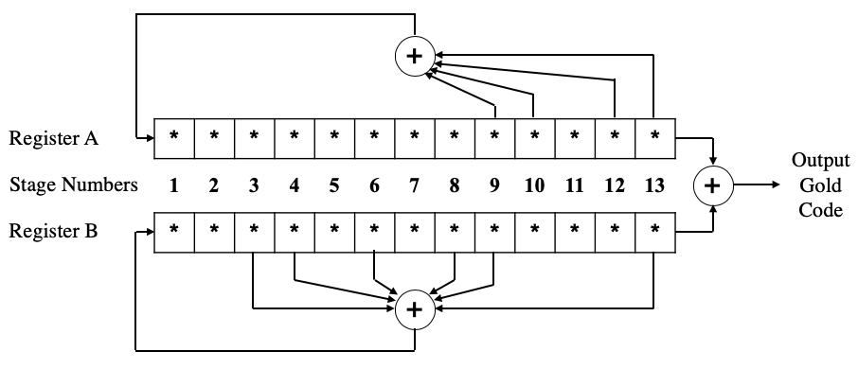

Figure 2.5.7B‑VI‑1: X-Band Gold Code Generator Circuit

At Ka-band the recommended gold code generator to be used is specified in Figure 2.5.7B‑VI‑2, below.

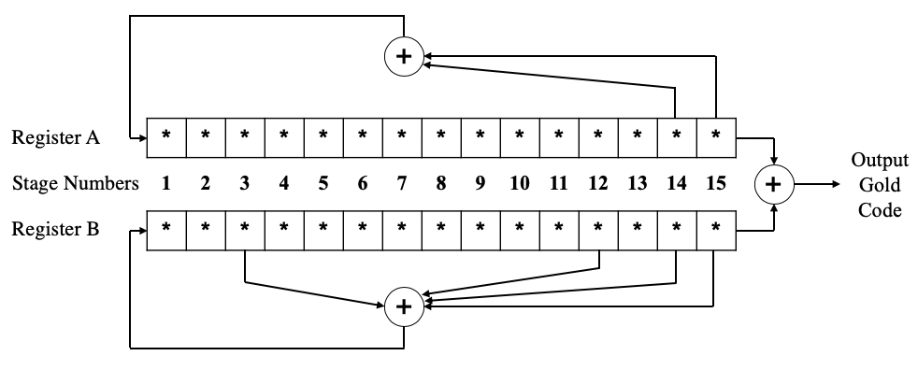

Figure 2.5.7B‑VI‑2: Ka-Band Gold Code Generator Circuit

The initial seeds for Register A and Register B require inter-agency coordination for spacecraft that have spectral overlap and might fall within the same antenna beam. This is required to avoid potential interference between spacecraft. This is denoted by the *’s in the bits of both Register A and Register B. The final design of each register on a spacecraft will have a binary initial seed.

## SRRC CHANNEL FILTERING

The normalized transfer function of the SRRC filter shall be:

$$\begin{aligned}H\left(f\right)= \left\{\begin{matrix}1 & if & \left|f\right|<f_{N}\left(1-α\right) \\ \sqrt{\frac{1}{2}+\frac{1}{2}\sin\left\{\frac{π}{2f_{N}}\left(\frac{f_{N}-\left|f\right|}{α}\right)\right\}} & if & f_{N}\left(1-α\right)≤\left|f\right|≤ f_{N}\left(1+α\right) \\ 0 & if & \left|f\right|>f_{N}\left(1+α\right)\end{matrix}\right.\#\end{aligned}$$

Where $f_{N}=1/(2 T_{chs}) =R_{chs}/2$ is the Nyquist frequency and $α$ is the roll-off factor.

1. The spanned bandwidth is the widest separation between detectable signals in the spacecraft downlink spectrum.
2. The initial Linear Feedback Shift Registers seeds require inter-agency coordination for spacecraft that have spectral overlap and might fall within the same antenna beam, in order to avoid potential interference