

Research and Development for  
Space Data Systems Standards

|  |
| --- |
| Optical High Data Rate (HDR) Communication –1550 nm |

Proposed Draft Experimental Specification

CCSDS 000.0-O-0

DRAFT ORANGE BOOK

December 2021

AUTHORITY

|  |  |  |  |
| --- | --- | --- | --- |
|  | | | |
|  | Issue: | Orange Book, Issue 0 |  |
|  | Date: | December 2021 |  |
|  | Location: | Washington, DC, USA |  |
|  | | | |

**(WHEN THIS EXPERIMENTAL SPECIFICATION IS FINALIZED, IT WILL CONTAIN THE FOLLOWING STATEMENT OF AUTHORITY:)**

This document has been approved for publication by the Management Council of the Consultative Committee for Space Data Systems (CCSDS). The procedure for review and authorization of CCSDS documents is detailed in *Organization and Processes for the Consultative Committee for Space Data Systems* (CCSDS A02.1-Y-4).

This document is published and maintained by:

CCSDS Secretariat

Space Communications and Navigation Office, 7L70

Space Operations Mission Directorate

NASA Headquarters

Washington, DC 20546-0001, USA

FOREWORD

This document is a CCSDS Experimental Specification for the channel coding, synchronization, and physical layer of high data rate signals to be used in free-space optical communications of space systems. It was authored and contributed to CCSDS by NASA, CNES, JAXA, and NICT.

Attention is drawn to the possibility that some of the elements of this document may be the subject of patent rights. CCSDS shall not be held responsible for identifying any or all such patent rights.

Through the process of normal evolution, it is expected that expansion, deletion, or modification of this document may occur. This document is therefore subject to CCSDS document management and change control procedures which are defined in *Organization and Processes for the Consultative Committee for Space Data Systems* (CCSDS A02.1-Y-4). Current versions of CCSDS documents are maintained at the CCSDS Web site:

http://www.ccsds.org/

Questions relating to the contents or status of this document should be addressed to the CCSDS Secretariat at the address indicated on page i.

At time of publication, the active Member and Observer Agencies of the CCSDS were:

Member Agencies

* Agenzia Spaziale Italiana (ASI)/Italy.
* Canadian Space Agency (CSA)/Canada.
* Centre National d’Etudes Spatiales (CNES)/France.
* China National Space Administration (CNSA)/People’s Republic of China.
* Deutsches Zentrum für Luft- und Raumfahrt (DLR)/Germany.
* European Space Agency (ESA)/Europe.
* Federal Space Agency (FSA)/Russian Federation.
* Instituto Nacional de Pesquisas Espaciais (INPE)/Brazil.
* Japan Aerospace Exploration Agency (JAXA)/Japan.
* National Aeronautics and Space Administration (NASA)/USA.
* UK Space Agency/United Kingdom.

Observer Agencies

* Austrian Space Agency (ASA)/Austria.
* Belgian Federal Science Policy Office (BFSPO)/Belgium.
* Central Research Institute of Machine Building (TsNIIMash)/Russian Federation.
* China Satellite Launch and Tracking Control General, Beijing Institute of Tracking and Telecommunications Technology (CLTC/BITTT)/China.
* Chinese Academy of Sciences (CAS)/China.
* Chinese Academy of Space Technology (CAST)/China.
* Commonwealth Scientific and Industrial Research Organization (CSIRO)/Australia.
* Danish National Space Center (DNSC)/Denmark.
* Departamento de Ciência e Tecnologia Aeroespacial (DCTA)/Brazil.
* European Organization for the Exploitation of Meteorological Satellites (EUMETSAT)/Europe.
* European Telecommunications Satellite Organization (EUTELSAT)/Europe.
* Geo-Informatics and Space Technology Development Agency (GISTDA)/Thailand.
* Hellenic National Space Committee (HNSC)/Greece.
* Indian Space Research Organization (ISRO)/India.
* Institute of Space Research (IKI)/Russian Federation.
* KFKI Research Institute for Particle & Nuclear Physics (KFKI)/Hungary.
* Korea Aerospace Research Institute (KARI)/Korea.
* Ministry of Communications (MOC)/Israel.
* National Institute of Information and Communications Technology (NICT)/Japan.
* National Oceanic and Atmospheric Administration (NOAA)/USA.
* National Space Agency of the Republic of Kazakhstan (NSARK)/Kazakhstan.
* National Space Organization (NSPO)/Chinese Taipei.
* Naval Center for Space Technology (NCST)/USA.
* Scientific and Technological Research Council of Turkey (TUBITAK)/Turkey.
* South African National Space Agency (SANSA)/Republic of South Africa.
* Space and Upper Atmosphere Research Commission (SUPARCO)/Pakistan.
* Swedish Space Corporation (SSC)/Sweden.
* Swiss Space Office (SSO)/Switzerland.
* United States Geological Survey (USGS)/USA.

PREFACE

This document is a CCSDS Experimental Specification. Its Experimental status indicates that it is part of a research or development effort based on prospective requirements, and as such it is not considered a Standards Track document. Experimental Recommendations are intended to demonstrate technical feasibility in anticipation of a ‘hard’ requirement that has not yet emerged. Experimental work may be rapidly transferred onto the Standards Track should a hard requirement emerge in the future.

DOCUMENT CONTROL

|  |  |  |  |
| --- | --- | --- | --- |
| **Document** | **Title and Issue** | **Date** | **Status** |
| CCSDS 000.0-O-0 | Document Title, Experimental Specification, Issue 0 | December 2021 |  |

CONTENTS

Section Page

DOCUMENT CONTROL v

CONTENTS vi

1 Introduction 1-1

1.1 Purpose 1-1

1.2 Scope 1-1

1.3 Applicability 1-1

1.4 Rationale 1-2

1.5 Document Structure 1-2

1.6 Nomenclature 1-2

1.6.1 Normative text 1-2

1.6.2 Informative text 1-3

1.7 Conventions 1-3

1.8 References 1-4

2 Overview 2-1

2.1 Architectural Considerations 2-1

2.2 Layer Architecture 2-4

3 Coding and Synchronization 3-5

3.1 Overview 3-5

3.2 Input Frames 3-6

3.3 Synchronization-Marked Frames 3-7

3.3.1 Attached Synchronization Marker 3-7

3.3.2 Generic Frame Procedure 3-8

3.4 Slicer 3-9

3.5 Cyclic Redundancy Check Attachment 3-12

3.5.1 Description 3-12

3.5.2 Cyclic Redundancy Check Sequence Specification 3-12

3.6 Forward Error Correction 3-14

3.6.1 DVB-S2 BCH + LDPC Code 3-14

3.6.2 Reed Solomon Code 3-14

3.7 Channel Interleaver 3-14

3.7.1 Channel Interleaver Input Notation 3-14

3.7.2 Channel Interleaver Parameters 3-15

3.7.3 Channel Interleaver Initialization 3-15

3.7.4 Channel Interleaver Operation 3-15

3.8 Repeat 3-16

3.9 Physical Layer Framing 3-16

3.9.1 Description 3-16

3.9.2 Unique Word Field 3-17

3.9.3 Channel State Information Field 3-18

3.9.4 Frame Sequence Number Field 3-20

3.9.5 Physical Layer Control Field 3-22

3.10 Pseudo-Randomizer 3-22

3.10.1 Sequence Specification 3-23

3.10.2 Sequence Initialization 3-23

3.11 Frame Validation USING DECODER 3-23

3.12 Sequence Indicator 3-24

4 Physical Layer 4-1

4.1 Center Frequency 4-1

4.1.1 Center Frequency Specification 4-1

4.1.2 Center Frequency Tolerance 4-1

4.2 Laser Linewidth 4-1

4.3 Polarization 4-1

4.3.1 Polarization Type 4-1

4.3.2 Polarization Extinction Ratio 4-2

4.4 Modulation 4-2

4.4.1 Phase Modulation 4-2

4.4.2 Intensity Modulation 4-3

4.4.3 Burst Mode Modulation 4-5

4.4.4 Symbol Modulation Rate 4-6

4.4.5 Doppler Compensation 4-6

4.4.6 Symbol Modulation Rate Tolerance 4-6

4.4.7 Timing Jitter 4-6

5 Managed Parameters 5-1

5.1 Overview 5-1

5.2 Managed Parameters for Coding and Synchronization 5-1

5.3 Managed Parameters for Physical Layer 5-2

ANNEX A Service (NORMATIVE) A-1

ANNEX B Security, SANA, and PATENT Considerations (INFORMATIVE) B-2

ANNEX C PHYSICAL LAYER AND CODING AND SYNCHRONIZATION SUBLAYER IMPLEMENTATION (INFORMATIVE) C-1

ANNEX D Informative References D-2

ANNEX E Acronyms and Abbreviations E-1

Figures

Figure 1‑1: Bit Numbering Convention 1-3

Figure 2‑1: Link Scenarios Showing Possible Optical (Red) and Radio-Frequency (Black) Links. 2-1

Figure 2‑2 Architecture of the Optical Communications Type 1 System 2-2

Figure 2‑3: Architecture of the Optical Communications Type 2 System 2-3

Figure 2‑4: Relationship with OSI layers 2-4

Figure 3‑1: Functional Diagram for Coding and Synchronization Signaling 3-6

Figure 3‑2: ASM Attachment 3-8

Figure 3‑3: Slicer. 3-10

Figure 3‑4: Shift Register Implementation of CRC Attachment 3-13

Figure 3‑5: Convolutional Channel Interleaver 3-14

Figure 3‑6: Physical Layer Frame 3-17

Figure 3‑7: Pseudo-randomizer Implementation Example 3-23

Figure 4‑1: QPSK Constellation Map 4-3

Figure 4‑2: Reference RZ50 and RZ33 Pulse Shapes for a Slot Rate of 10.0 GHz 4-4

Tables

Table 3‑1: Information Block Sizes for BCH + LDPC Coding 3-11

Table 3‑2: Information Block Sizes for RS Coding 3-11

Table 3‑3 Channel State Information Value Based on Correlation Results 3-19

Table 3‑4: (127,8) BCH Generator Polynomial Coefficients 3-20

Table 3‑5: (127,22) BCH Generator Polynomial Coefficients 3-21

Table 5‑1. Managed Parameters for Coding and Synchronization 5-1

Table 5‑2. Managed Parameters for Physical Layer 5-2

# Introduction

## Purpose

The purpose of this Experimental Specification is to specify channel coding, synchronization schemes, and physical layer modulation for free-space optical communications systems used by space missions. The applications addressed with this Experimental Specification include space-to-space, space-to-air, air-to-space, space-to-ground, and ground-to-space links where optical communications at high data rates—possibly through an atmospheric channel, which can distort the received optical signal—using a modulated carrier wavelength of around 1550 nm are employed. When provided with a set of fixed-length, fixed-rate CCSDS Transfer Frames produced by the Data Link Protocol Sublayer (as specified, for example, in references [1], [2], and [3]) or potentially variable-length variable-rate transfer frames, which may be defined by CCSDS or by other methods, this Experimental Specification describes the applied coding and synchronization signaling as well as the physical layer optical signal that is generated for transmission.

## Scope

This Experimental Specification defines coding and synchronization sublayer (section 3) and physical layer (section 4) schemes in terms of the signal characteristics and procedures involved in the encoding, synchronization, and physical transmission of optical signals. It does not specify:

1. individual implementations or products;
2. the methods or technologies required to perform the procedures; or
3. the management activities required to configure and control the system.

This Experimental Specification describes High Data Rate (HDR) optical communications in which the data rate of the link is of primary concern.

## Applicability

This Experimental Specification may be applied to future data communications over optical links between CCSDS Agencies in cross-support situations. It includes comprehensive specifications of the data formats and procedures for interagency cross support. It is neither a specification of, nor a design for, real systems that may be implemented for existing or future missions.

The Experimental Specification described in this document may be invoked through the normal standards program of each CCSDS Agency and is applicable to those missions for which cross support based on capabilities described in this Experimental Specification is anticipated. Where mandatory capabilities are clearly indicated in sections of this Experimental Specification, they must be implemented when this document is used as a basis for cross support. Where options are allowed or implied, implementation of these options is subject to specific bilateral cross support agreements between the Agencies involved.

## Rationale

This Experimental Specification facilitates cross support at the coding and synchronization sublayer and physical layer of optical communications systems used by CCSDS member agencies. Such cross support requires specification of the slicing of transfer frames, synchronization markers, channel encoding, channel interleaving, physical layer framing, modulation on an allowable set of center frequencies, and other details of the coding and synchronization sublayer and physical layer.

The CCSDS believes it is important to document the rationale underlying the recommendations chosen, so that future evaluations of proposed changes or improvements will not lose sight of previous decisions. Where appropriate, rationale has been included in the description of the signaling characteristics.

## Document Structure

This document is divided into five numbered sections and four annexes.

1. Section 1 presents the purpose, scope, applicability, rationale, document structure, conventions, and references;
2. Section 2 provides an overview of the architecture and summary of functions of the optical coding and synchronization sublayer and physical layer;
3. Section 3 specifies the HDR optical coding and synchronization sublayer;
4. Section 4 specifies the HDR physical layer;
5. Section 5 lists the managed parameters;
6. Annex A defines the service provided to the users;
7. Annex B discusses security and Space Assigned Numbers Authority (SANA) considerations;
8. Annex C provides a list of informative references;
9. Annex D lists acronyms and terms used within this document.

## Nomenclature

### Normative text

The following conventions apply throughout this Specification:

1. the words ‘shall’ and ‘must’ imply a binding and verifiable specification;
2. the word ‘should’ implies an optional, but desirable, specification;
3. the word ‘may’ implies an optional specification;
4. the words ‘is’, ‘are’, and ‘will’ imply statements of fact.

### Informative text

In the normative sections of this document, informative text is set off from the normative specifications either in notes or under one of the following subsection headings:

– Overview;

– Background;

– Rationale;

– Discussion.

## Conventions

In this document, the following convention is used to identify each bit in an *N*-bit field. The first bit in the field to be transmitted (i.e., the most left-justified when drawing a figure) is defined to be ‘Bit 0’, the following bit is defined to be ‘Bit 1’, and so on up to ‘Bit *N*-1’. When the field is used to express a binary value (such as a counter), the Most Significant Bit (MSB) shall be the first transmitted bit of the field, i.e., ‘Bit 0’ (see Figure 1‑1).



Figure 1‑1: Bit Numbering Convention

In accordance with standard data-communications practice, data fields are often grouped into 8-bit ‘words’, which conform to the above convention. Throughout this Specification, such an 8-bit word is called an ‘octet’. The numbering for octets within a data structure starts with ‘0’.

NOTE – Throughout this document, ‘bit’ refers to the contents of the transfer frames. A bit is a binary digit transferred between the data link protocol sublayer and the coding and synchronization sublayer. Other symbols, whether binary or nonbinary, will be referred to by other names, such as ‘binary digits’. It should be understood that the ordering conventions described above apply equally to other types of symbols.

## patented technologies

The CCSDS draws attention to the fact that it is claimed that compliance with this document may involve the use of patents.

The CCSDS takes no position concerning the evidence, validity, and scope of these patent rights.

The holders of these patent rights have assured the CCSDS that they are willing to negotiate licenses under reasonable and non-discriminatory terms and conditions with applicants throughout the world. In this respect, the statements of the holders of these patent rights are registered with CCSDS. Information can be obtained from the CCSDS Secretariat at the address indicated on page i. Contact information for the holders of these patent rights is provided in annex B.

Attention is drawn to the possibility that some of the elements of this document may be the subject of patent rights other than those identified above. The CCSDS shall not be held responsible for identifying any or all such patent rights.

## References

The following publications contain provisions which, through reference in this text, constitute provisions of this Experimental Specification. At the time of publication, the editions indicated were valid. All publications are subject to revision, and users of this Experimental Specification are encouraged to investigate the possibility of applying the most recent editions of the documents indicated below. The CCSDS Secretariat maintains a register of currently valid CCSDS publications.

1. *TM Space Data Link Protocol*. Issue 2. Recommendation for Space Data System Standards (Blue Book), CCSDS 132.0-B-2. Washington, D.C.: CCSDS, September 2015.
2. *AOS Space Data Link Protocol*. Issue 3. Recommendation for Space Data System Standards (Blue Book), CCSDS 732.0-B-3. Washington, D.C.: CCSDS, September 2015.
3. *Unified Space Data Link Protocol.* Issue 1. Recommendation for Space Data System Standards (Blue Book), CCSDS 732.1-B-1. Washington, D.C.: CCSDS, October 2018.
4. *Information Technology–Open Systems Interconnection–Basic Reference Model: The Basic Model*. 2nd ed. International Standard, ISO/IEC 7498-1:1994. Geneva: ISO, 1994.
5. *Generic Frame Procedure.* Recommendation ITU-T G.7041/Y.1303 (08/2016). International Telecommunications Union, August 2016.
6. *Digital Video Broadcasting (DVB); Second generation framing structure, channel coding and modulation systems for Broadcasting, Interactive Services, News Gathering and other broadband satellite applications (DVB-S2).* ETSI EN 302 307 V1.2.1 (2009-08). ETSI, August 2009.
7. *TM Synchronization and Channel Coding*. Issue 3. Recommendation for Space Data System Standards (Blue Book), CCSDS 131.0-B-3. Washington, D.C.: CCSDS, September 2017.
8. *IEEE Standard Test Procedures for Antennas*. ANSI/IEEE Standard 149-1979.

# Overview

## Architectural Considerations

This Experimental Specification aims to address a variety of near-Earth optical communications link applications, including relay, crosslink, and direct-to-Earth links from ground, airborne, and space users, as depicted in Figure 2‑1, using fiber-telecommunications-compatible wavelengths in the 1550-nm regime. To support such a wide array of applications, the optical signaling must be very flexible. For relay applications, data transfer to and from users on the ground, in the air, or in low- to medium-Earth orbit to a ground terminal via a relay satellite (or multiple satellites) in geosynchronous orbit is envisioned. This Experimental Specification supports operation of such links at user rates of ~15 Mbps to ~100 Gbps. For direct-to-Earth links, the specification aims to support the higher link rates afforded by short link distances from, say, low Earth orbit to ground. Such links are expected to operate at rates ~100 Gbps to support large data transfers with short contact times.

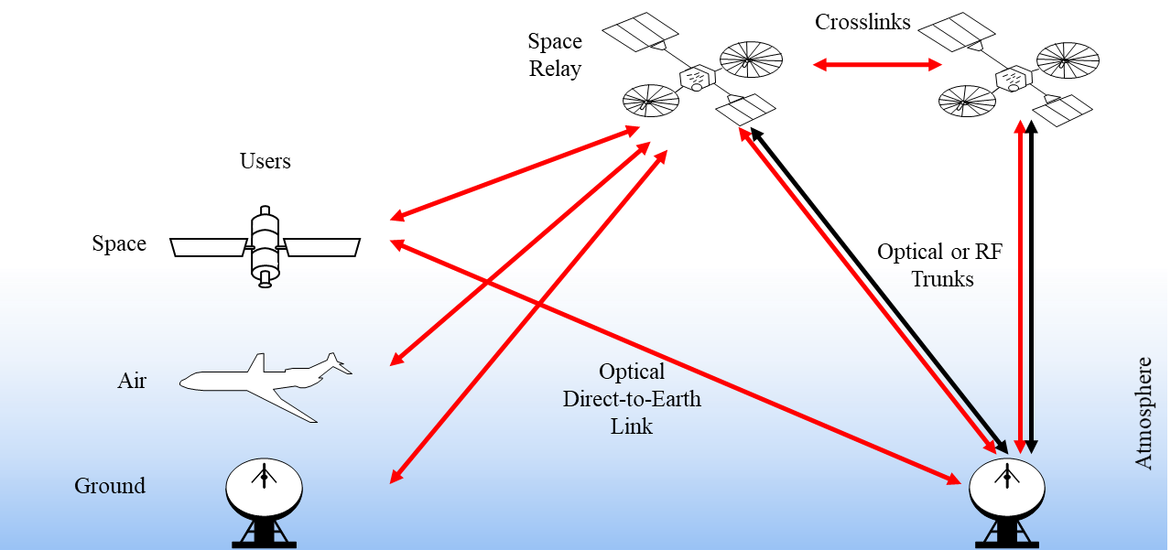

Figure 2‑1: Link Scenarios Showing Possible Optical (Red) and Radio-Frequency (Black) Links.

High-level features of the Experimental Specification include: acceptance of transfer frames at the data link interface, use of multiple high-efficiency forward error correction (FEC) codes, physical layer framing that supports multi-hop edge-to-edge forward error correction, and variable-rate burst-mode phase-shift keying modulation on a 1550-nm carrier, which can be demodulated with either a non-coherent (e.g., differential phase-shift keying) or a coherent (e.g., homodyne or heterodyne binary phase-shift keying) receiver. Data rate flexibility required for the various link applications is provided by varying the code and modulation rates as well as using standard fiber telecommunications approaches such as Wavelength Division Multiplexing (WDM).

The optical links supported by the Experimental Specification may be either unidirectional or bidirectional. For bidirectional links, wavelength and polarization are used to distinguish transmit and receive signals that may share a common terminal aperture, as described in section 4. Such systems requiring a separate signal for spatial acquisition are referred to as Type 1 systems, as depicted in Figure 2‑2. Such an acquisition signal would be modulated on a carrier frequency in the Acquisition Band, defined in section 4.1.1. Systems that do not require a separate signal for spatial acquisition are referred to as Type 2 systems, as depicted in Figure 2‑3. Each system involves two terminals, a Type A and a Type B. As depicted in Figure 2‑2 and Figure 2‑3 and defined in section 4.1.1, Type A1 and Type A2 terminals transmit signals with carrier frequencies selected from a range of frequencies in Data Communications Band A and Type B1 and Type B2 terminals transmit signals with carrier frequencies selected from a range of frequencies in Data Communications Band B.

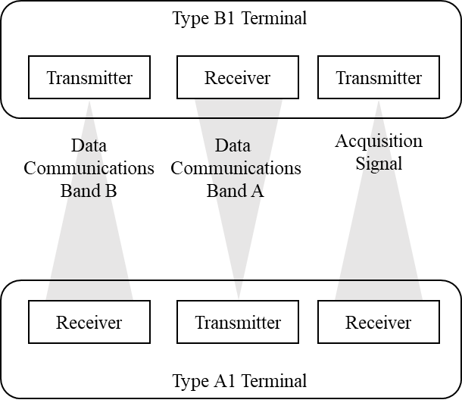

Figure 2‑2 Architecture of the Optical Communications Type 1 System

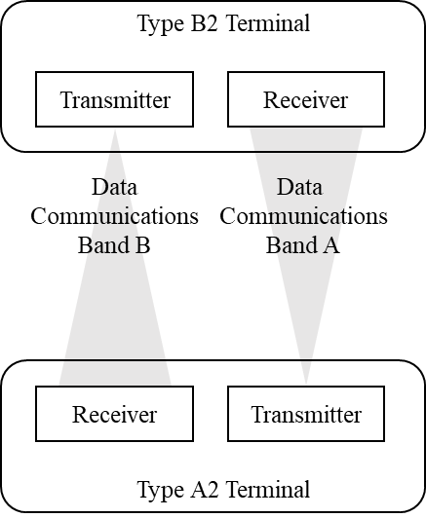

Figure 2‑3: Architecture of the Optical Communications Type 2 System

This Experimental Specification does not address system-specific requirements that would be addressed in an interface control document (ICD). For example, it does not include details of physical layer frame multiplexing and possible required insertion of idle frames at edge terminals to enable multiplexing functionality at a relay. Such details are expected to be specific to particular system implementations and, therefore, would be addressed in system-specific ICDs.

Optical communications systems often require sophisticated methods for pointing and spatial acquisition and tracking. The uncertainty of the pointing direction from one terminal to another terminal, which is derived from the positional knowledge of terminals and their pointing accuracy, is often larger than the divergence angle of the transmitted light or the field of view of the receiver. The details of methods for spatial acquisition of optical communications links and their implementation are not addressed in this Experimental Specification beyond the allocation of certain transmission frequencies that may be used for spatial acquisition. It is expected that a system-specific ICD or interface control specification would address details such as:

* specifics of the transmitted signals used for acquisition, including carrier frequency, frequency stability, polarization, and modulation;
* requirements for position accuracy of the terminals involved in the link and how that position is communicated prior to the establishment of the link;
* a description of the process or sequence of steps for performing spatial acquisition between the terminals, including the size and duration of scans associated with pointing uncertainties; and
* the required irradiances (minimum and maximum) at the receiving terminals for the various steps of the acquisition process.

## Layer Architecture

Figure 2‑4 illustrates the relationship of this Experimental Specification to the Open Systems Interconnection (OSI) reference model (reference [4]). Two sublayers of the data link layer are defined for CCSDS space link protocols. The data link protocol sublayer provides functions for producing frames; examples include the Telemetry (TM) Space Data Link Protocol (reference [1]), the Advanced Orbiting Systems (AOS) Space Data Link Protocol (reference [2]), and the Unified Space Data Link Protocol (USLP) (reference [3]). The optical coding and synchronization protocol and physical layer specified in this Experimental Specification provide the functions of the synchronization and channel coding sublayer of the data link layer and the physical layer for transferring frames over an optical space link.

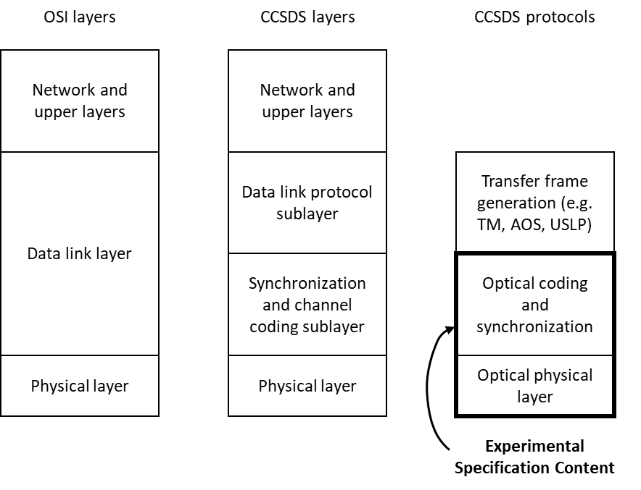

Figure 2‑4: Relationship with OSI layers

# Coding and Synchronization

## Overview

This Experimental Specification operates by taking frames and producing a modulated optical carrier for transmission. This section of the Experimental Specification describes the coding and synchronization sublayer, which produces a binary vector for transmission based on an input stream of frames. The functional blocks of the coding and synchronization signaling architecture are shown in Figure 3‑1.

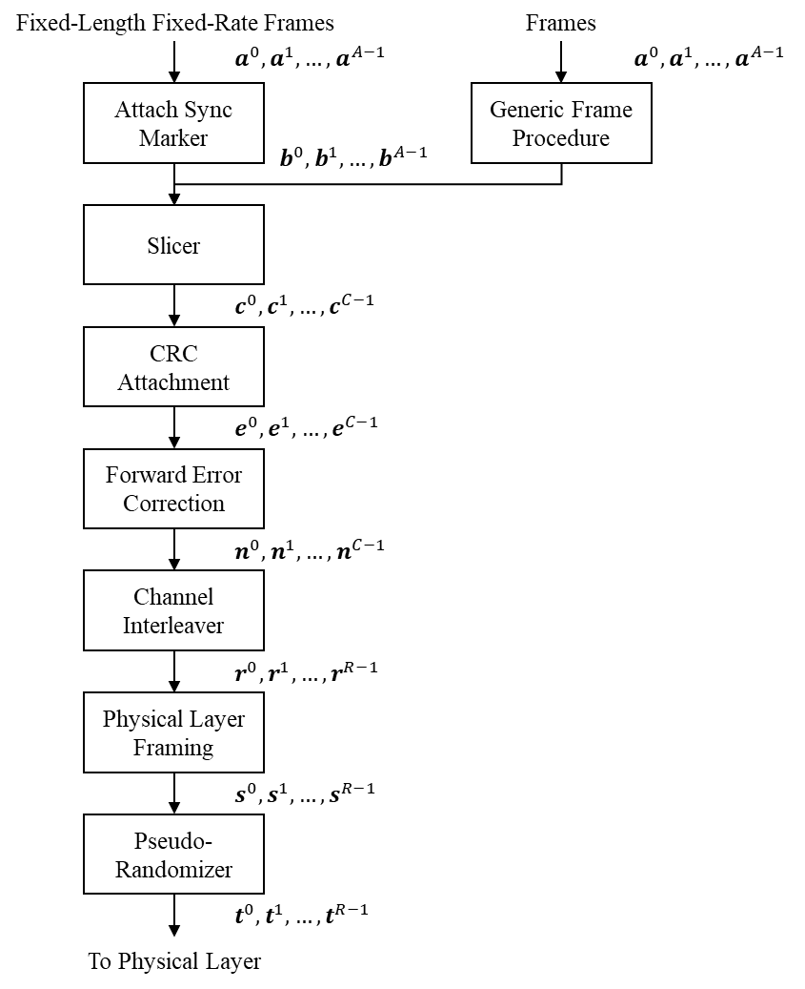

Figure 3‑1: Functional Diagram for Coding and Synchronization Signaling

## Input Frames

The input to the coding and synchronization sublayer shall be a sequence of input frames.

The input frames may be CCSDS Transfer Frames conforming to the structure as defined in references [1], [2], or [3]. Alternatively, octet-aligned input frames defined by other standards or methods may be used. The sequence of input frames is denoted by

$$a^{0}, a^{1}, …,a^{A-1};$$

and for *i*  {0, 1, …, *A*−1}, the *i*th input frame is denoted

$a^{i}=a_{0}^{i}, a_{1}^{i},…, a_{T_{i}-1}^{i}$,

where  is the *j*th bit of the *i*th input frame, and *Ti* is the number of bits in the *i*th input frame.

NOTES:

* This integrated approach for space data link encoding enables arbitrary octet-aligned input frame types to be provided to the coding and synchronization sublayer, including CCSDS transfer frames such as TM, AOS, and Unified Space Data Link Protocol (USLP), as well as non-CCSDS octet-aligned frame types such as Internet protocol/point-to-point protocol (IP/PPP) or Ethernet media access control frames defined in clause 3.1 of reference [C1].
* The input frames may be fixed length or variable length.
* When using the Generic Frame Procedure method for generating Synchronization-Marked Frames (see Section 3.3.2), the number of bits in the input frames must be divisible by 8 and in the range of 0 to 524,280 – *Y* bits, where *Y* is the number of bits in the Generic Frame Procedure Payload Header described in Reference [5].
* The encoding described in this subsection may be performed in a streaming fashion; that is, not all *A* input frames of a full communications session need be available at the time encoding is begun, and the value of *A* need not be known a priori.

## Synchronization-Marked Frames

Synchronization-Marked Frames (SMFs) shall be formed using either the Attached Synchronization Marker method described in subsection 3.3.1, or the Generic Frame Procedure method described in subsection 3.3.2. If the input frames are variable length, then the method described in subsection 3.3.2 shall be used. The method for generating SMFs is a managed parameter.

### Attached Synchronization Marker

#### Attachment Method

A 32-binary-digit Attached Synchronization Marker (ASM) shall be prepended to each input frame, resulting in an SMF, as follows: For *i*  {0, 1, …, *A*−1} the *i*th SMF is denoted

$$b^{i}=b_{0}^{i},b_{1}^{i},…, b_{B_{i}-1}^{i},$$

where *Bi* = *Ti* + 32 and

$$b_{j}^{i}= \left\{\begin{matrix}s_{j}, & if 0≤j<32 \\ a_{j-32}^{i}, & if 32≤j<B_{i}.\end{matrix}\right.$$

NOTE – Construction of SMFs is shown in Figure 3‑2.

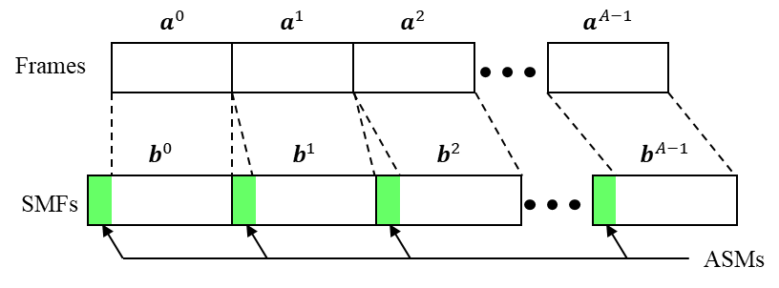

Figure 3‑2: ASM Attachment

#### Sequence Specification

The ASM shall be the sequence ***s*** = *s*0, *s*1, …, *s*31, represented in hexadecimal notation as

***s*** = 1ACFFC1D.

### Generic Frame Procedure

When Generic Frame Procedure (GFP) is used, SMFs shall be formed using the short GFP mode or the full GFP mode defined in this subsection. The selected GFP mode is a managed parameter.

For *i*  {0, 1, …, *A*−1} the *i*th SMF is denoted

$$b^{i}=b_{0}^{i},b_{1}^{i},…, b_{B_{i}-1}^{i},$$

where *Bi* is number of bits in the *i*th SMF.

NOTE – when using short or full GFP mode, the number of bits in each SMF, *Bi*, may vary from frame to frame. The lengths of GFP SMFs are divisible by 8 and may vary from 32 bits (for GFP idle frames, see section 3.3.2.3) to a maximum of 524,312 bits, as described in reference [5].

#### Short GFP Mode

When the short GFP mode is used, SMFs shall be formed by preceding each input frame with the core header as defined in section 6.1.1 of reference [5], where the term ‘payload area’ in reference [5] is to be understood as referring to the input frame.

NOTE – The short GFP mode has the same overhead as the ASM approach defined in subsection 3.3.1.

#### Full GFP Mode

When the full GFP mode is used, each SMF shall be the GFP client data frame that results from designating an input frame as the GFP payload information field and applying the frame-mapped GFP encapsulation methods defined in sections 6 and 7 of reference [5].

NOTES:

* The full GFP mode may be useful for multiplexed trunk lines with fixed or variable length input frames with the added overhead present in the payload headers.
* Reference [5] describes two modes of GFP: frame-mapped (GFP-F) and transparent-mapped (GFP-T). This Experimental Specification utilizes only the GFP-F mode.

##### Payload Frame Check Sequence (pFCS)

The payload frame check sequence (pFCS) field of GFP shall not be used.

##### User Payload Identifier

When CCSDS transfer frames are used, the user payload identifier within the payload header shall be set to 1111 0000.

NOTE – as provided for by the GFP standard, this setting can be used to indicate data types not enumerated in the GFP standard, such as the CCSDS client data type.

#### GFP Idle Frame

In either the short or long GFP modes, when an input frame is not available an SMF may be formed using a GFP idle frame, i.e., a core header only with no payload area, as defined in section 6.2.1 of reference [5].

NOTE – The addition of GFP idle frames will result in more than *A* SMFs. For simplicity in the description below, the notation *A* is still used to refer to the number of SMFs.

## Slicer

The sequence of SMFs shall be zero-padded and sliced into information blocks of length $k$, as shown in Figure 3‑3 and described herein.

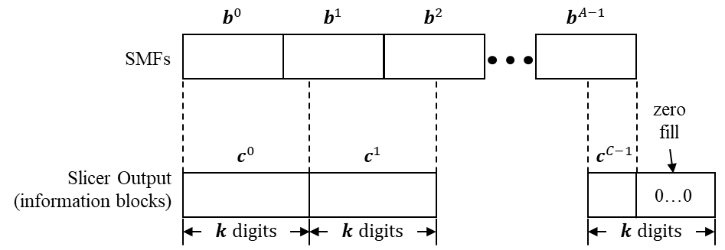

Figure 3‑3: Slicer.

The sequence of SMFs, $$b^{0}, b^{1}, …,b^{A-1},$$

is a vector of vectors that can be viewed as a single vector with binary digits in the same order, $$\hat{b}={\hat{b}}_{0},{\hat{b}}_{1}, …, {\hat{b}}_{B-1},$$

where

$B=\sum_{i=0}^{A-1}{B_{i}}$.

The forward error correction code (Digital Video Broadcast Second Generation [DVB-S2] Bose–Chaudhuri–Hocquenghem [BCH]+ low-density parity-check [LDPC] or Reed Solomon [RS]) is a managed parameter. Additionally, for the DVB-S2 code, the code rate, $r$, is a managed parameter. The choice of code and code rate, $r$, determines the information block size, $k$. Table 3‑1 and Table 3‑2 give the information block sizes for the various code and code rate options, including the 32-bit Cyclic Redundancy Check (CRC) described in section 3.5. The sequence $\hat{b}$ shall be padded at its end with the minimum number of zeroes so that its length is a multiple of $k.$ The sequence $\tilde{b}$ is denoted by

$$\tilde{b}={\hat{b}}_{0},{\hat{b}}_{1}, …, {\hat{b}}_{B-1},\underset{P}{\underbrace{0, 0, …,0 }},$$

where

$${\tilde{b}}_{i}= \left\{\begin{matrix}{\hat{b}}_{i}, & if 0≤i<B \\ 0, & if B≤i<B+P,\end{matrix}\right.$$

and $$P=\min\left\{ p :k \right| B+p \}.$$

The slicer re-indexes $\tilde{b}$ into $C = (B+P)/k$ blocks each of length $k$:

$$c^{0},c^{1}, …,c^{C-1},$$

where for $i∈\left\{0, 1, …, C-1\right\}$ the $i^{th}$ block is denoted $c^{i}=c_{0}^{i},c_{1}^{i},…, c_{k-1}^{i}$, and for $j∈\left\{0, 1, …, k-1\right\}$ the $j^{th}$ symbol of the $i^{th}$ block is

$$c_{j}^{i}={\tilde{b}}_{ki+j}.$$

Table 3‑1: Information Block Sizes for BCH + LDPC Coding

|  |  |  |
| --- | --- | --- |
| LDPC Code Rate | Information block size | Length of information block with CRC-32 added |
| $$r$$ | $$k$$ | $$\hat{k}$$ |
| 1/4 | 15976 | 16008 |
| 1/3 | 21376 | 21408 |
| 2/5 | 25696 | 25728 |
| 1/2 | 32176 | 32208 |
| 3/5 | 38656 | 38688 |
| 2/3 | 43008 | 43040 |
| 3/4 | 48376 | 48408 |
| 4/5 | 51616 | 51648 |
| 5/6 | 53808 | 53840 |
| 8/9 | 57440 | 57472 |
| 9/10 | 58160 | 58192 |

Table 3‑2: Information Block Sizes for RS Coding

|  |  |
| --- | --- |
| Information block size | Length of information block with CRC-32 added |
| $$k$$ | $$\hat{k}$$ |
| 60160 | 60192 |

## Cyclic Redundancy Check Attachment

### Description

Thirty-two CRC binary digits shall be appended to the end of each information block to produce forward error correction (FEC) as described herein.

The $i^{th}$ FEC input frame is $e^{i}=e_{0}^{i},e_{1}^{i},…,e_{k+31}^{i}$, where

$$e_{j}^{i}=\left\{\begin{matrix}c_{j}^{i}, & if 0≤j<k \\ z_{j-k}^{i}, & if k≤j<k+32,\end{matrix}\right.$$

and where $z_{j-k}^{i}$ is defined in section 3.5.2.

### Cyclic Redundancy Check Sequence Specification

The CRC parity binary digits shall be computed as follows. For $i∈\{0,1,…,C-1\}$, the $i^{th}$ block $c^{i}$ is padded with 32 zeroes and expressed in polynomial notation as

$$c^{i}\left(X\right)=c_{0}^{i}X^{k+31}+c_{1}^{i}X^{k+30}+…+c_{k-2}^{i}X^{33}+c_{k-1}^{i}X^{32}.$$

The polynomial notation for the thirty-two binary digit CRC is

$$z^{i}\left(X\right)=z_{0}^{i}X^{31}+z_{1}^{i}X^{30}+…+z_{30}^{i}X+z_{31}^{i}$$

and is given by

$$z^{i}\left(X\right)=\left[ c^{i}\left(X\right)+ \sum_{j=0}^{31}{X^{k+j}}\right] mod h\left(X\right),$$

where all arithmetic is modulo 2 and $h(X)$ is the generator polynomial given by

$$h\left(X\right)= X^{32}+X^{29}+X^{18}+X^{14}+X^{3}+1.$$

NOTE – In the expression for $z^{i}(X)$ the $\sum_{j=0}^{31}{X^{k+j}}$ term has the effect of presetting the shift registers to ‘1’ prior to encoding.

A possible technique for generating the CRC binary digits is given in Figure 3‑4. For each block, the shift register cells are initialized to ‘1’. The ganged switch is in position (1) while the $k$ binary digits from the block are being transferred and is in position (2) for the thirty-two CRC digits.

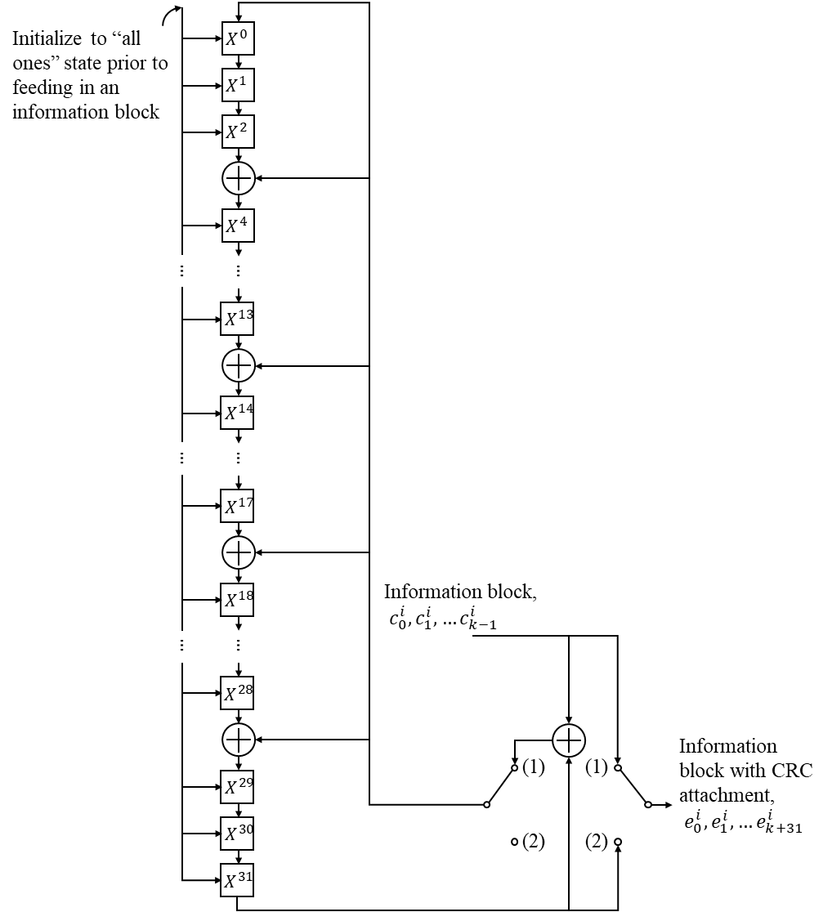

Figure 3‑4: Shift Register Implementation of CRC Attachment

## Forward Error Correction

A forward error correction code shall be applied to the FEC input frames, $e^{i}=e_{0}^{i},e_{1}^{i},…,e_{k+31}^{i}$, to produce FEC output frames, $n^{i}=n_{0}^{i},n_{1}^{i},…,n_{64799}^{i}$, as described herein. This Experimental Specification describes two possible approaches for forward error correction: a BCH code followed by an LDPC code based on the DVB-S2 signaling [6] or a Reed Solomon code. The choice of code is a managed parameter. Note that all of the codes described herein produce FEC output frames comprising 64800 binary digits.

### DVB-S2 BCH + LDPC Code

When DVB-S2 BCH+LDPC coding is used, the FEC output frames shall be computed from the FEC input frames as described in section 5.3 of reference [6].

### Reed Solomon Code

When Reed Solomon coding is used, the FEC output frames shall be computed from the FEC input frames as described in section 4 of reference [7]. When used as part of this recommendation, the Reed Solomon code shall have the following parameters: J=8, E=8, I=36, and Q=1080, producing a (8100,7524) Reed Solomon code block containing 64800 bits.

## Channel Interleaver

The sequence of FEC output frames shall be channel-interleaved as symbols with a convolutional interleaver as shown in Figure 3‑5 and described herein.



Figure 3‑5: Convolutional Channel Interleaver

### Channel Interleaver Input Notation

The sequence of FEC output frames, $n=n^{0},n^{1}, …, n^{C-1}$ is a vector of vectors that can be viewed as a single vector of interleaver binary digits, $$\hat{n}={\hat{n}}_{0},{\hat{n}}_{1}, …, {\hat{n}}_{64800C-1},$$

where for $i∈\left\{0, 1, …, C-1\right\}$ and $j∈\left\{0, 1, …, 64799\right\}$, $${\hat{n}}_{64800i+j}=n_{j}^{i}.$$

### Channel Interleaver Parameters

The interleaver is parameterized with three managed parameters: $m$, the number of binary digits per interleaver symbol; $N$, the number of tap delay lines in the channel interleaver; and $B$, the relative delay between the tap delay arms, expressed in $m$-bit symbols. The number of binary digits per interleaver symbol, $m$, is a managed parameter and shall be 1 or 8. Parameters $N$ and $B$ shall be chosen so that $BN$ is a multiple of $64800/m$, which in turn is a multiple of $N$. The interleaver has $N$ rows, with the $i^{th}$ row containing a shift register of length $iB$, meaning that it holds $iB$ interleaver symbols.

NOTE – The parameter $m$ is used to improve performance of the channel interleaver on channels with burst errors when an FEC code that operates on symbols is used. For example, the Reed Solomon code described in section 3.6.2 operates on 8-bit symbols. In this case, setting $m=8$ ensures that burst errors on the channel are confined to the minimum number of symbols entering the FEC decoder after deinterleaving.

### Channel Interleaver Initialization

Prior to channel interleaving, the shift registers shown in Figure 3‑5 may be in any state.

### Channel Interleaver Operation

#### Channel Interleaver Arm Positions

The input interleaver binary digits $\hat{n}$ are de-multiplexed $m$ bits at a time into the $N$ rows, sequentially and in circular fashion, beginning with row 0. The outputs of the $N$ shift registers are multiplexed $m$ bits at a time, sequentially and in circular fashion, beginning with row 0. During each step of the operation of the channel interleaver, the de-multiplexer arm shall be positioned at the same row as the multiplexer arm.

The $i^{th}$ interleaver output is

$${\hat{r}}_{i}={\hat{n}}_{σ\left(\left\lfloor \frac{i}{m}\right\rfloor \right)m+\left(i-\left\lfloor \frac{i}{m}\right\rfloor m\right)},$$

where $σ(i)$ is defined recursively by

$$σ(i)=\left\{\begin{aligned}i, &if i=0 mod N \\ σ(i-1)-NB+1, &otherwise.\end{aligned}\right.$$

Negative values of $σ(i)$ refer to initial interleaver register contents and values of $σ(i)$ greater than $64800C-1$ refer to terminal register contents. In these cases, ${\hat{r}}_{i}$ may be any value.

NOTE – For example, when $m=1, N=4,$ and $B=1$, the input ${\hat{n}}_{0},{\hat{n}}_{1},{\hat{n}}_{2},…$ will produce an interleaver output of $${\hat{r}}_{0},{\hat{r}}_{1},{\hat{r}}_{2}, {\hat{r}}_{3},{\hat{r}}_{4},{\hat{r}}_{5},{\hat{r}}_{6},{\hat{r}}_{7},{\hat{r}}_{8},{\hat{r}}_{9}, {\hat{r}}_{10}, …={\hat{n}}_{0},{\hat{n}}_{-3},{\hat{n}}_{-6}, {\hat{n}}_{-9}, {\hat{n}}_{4}, {\hat{n}}_{1}, {\hat{n}}_{-2}, {\hat{n}}_{-5}, {\hat{n}}_{8}, {\hat{n}}_{5}, {\hat{n}}_{2}, …$$

#### Completion of the Channel Interleaver Operations

After the last symbol, ${\hat{n}}_{64800C-1}$, is input, the interleaver shall be operated another $BN\left(N-1\right)$ steps before ${\hat{n}}_{64800C-1}$ appears at the output. Thus, the output contains $BN\left(N-1\right)$ more symbols than the input. This output of the channel interleaver is

$$\hat{r}={\hat{r}}_{0},{\hat{r}}_{1},…, {\hat{r}}_{64800C+BN\left(N-1\right)-1}.$$

For $i∈\{0,1,…,64800C+BN\left(N-1\right)-1\}$, the $i^{th}$ interleaver output is as defined in section 3.7.4.1.

#### Reindexing Channel Interleaver Output to Form Interleaved Codewords

The sequence $\hat{r}$ can be re-indexed into $R=C+BN\left(N-1\right)/64800$ blocks each containing 64800 binary digits: $$r^{0}, r^{1}, …, r^{R-1},$$

where for $i∈\left\{0, 1, …, R-1\right\}$ the $i^{th}$ block is denoted $r^{i}=r_{0}^{i},r_{1}^{i},…, r_{64799}^{i}$, and for $j∈\left\{0, 1, …, 64799\right\}$, $$r_{j}^{i}={\hat{r}}_{64800i+j.}$$

Each $r^{i}$ is called an interleaved codeword (notwithstanding the fact that it contains binary digits from many different codewords).

NOTE – Since $BN(N-1)$ is a multiple of $64800$, there are no leftover symbols in the last interleaved codeword.

## Repeat

This section is currently omitted.

## Physical Layer Framing

Interleaved codewords shall be transmitted in physical layer frames, which include physical layer frame markers (PLFM) to enable some physical layer functions such as switching in relay nodes or coordinated link control between terminals.

### Description

A physical layer frame marker (PLFM) consisting of 1024 binary digits shall be prepended to each interleaved codeword to create a physical layer frame. After PLFM attachment, the $j^{th}$ symbol of the $i^{th}$ interleaved codeword is:

$${\hat{s}}_{j}^{i}=\left\{\begin{aligned}w_{j}^{i}, & if 0≤j<1024 \\ r_{j-1024}^{i}, if 1024≤j<65824.\end{aligned}\right.$$

The sequence of physical layer frames is $\hat{s}={\hat{s}}^{0}, {\hat{s}}^{1}, …, {\hat{s}}^{R-1}$.

The 1024-bit PLFM contains four fields as shown in Figure 3‑6 and described herein:

* unique word field (384 bits);
* channel state information field (128 bits);
* frame sequence number field (384 bits);
* physical layer control information field (128 bits).

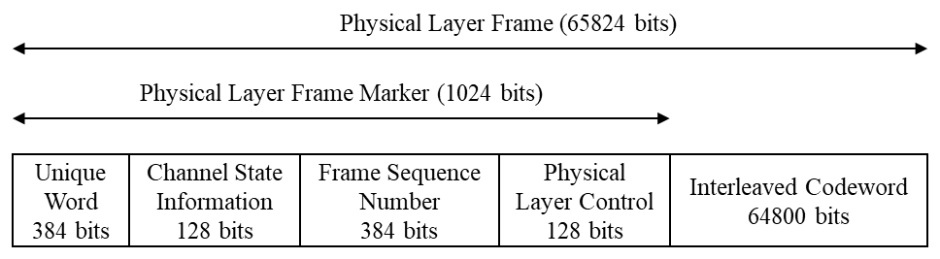

Figure 3‑6: Physical Layer Frame

### Unique Word Field

The first 384 binary digits of the PLFM $\left(w_{0}^{i},w_{1}^{i},…,w_{383}^{i}\right)$ constitute a unique word, which may be used for codeword synchronization, channel state estimation, and identification of frame data content. The first 96 binary digits of the unique word $\left(w_{0}^{i},w_{1}^{i},…,w_{95}^{i}\right)$ shall be a fixed frame alignment sequence represented in hexadecimal notation as

$$0xEBE2 587B 22EE 5319 A15A A382.$$

The remaining 288 binary digits of the unique word $\left(w_{96}^{i},w_{97}^{i},…,w_{383}^{i}\right)$ are a managed parameter selected by the mission. This managed parameter may be used to specify link details such as data source and destination or modulation and coding used in the interleaved codeword within the physical layer frame.

NOTE – The 288-bit identifier, while not specified here, should be selected to minimize possible correlations with the first 96 bits of the unique word and with other 288-bit identifiers in use by the system in the presence of noise.

### Channel State Information Field

The 128 binary digits in the PLFM $\left(w_{384}^{i},w_{385}^{i},…,w_{511}^{i}\right)$, which follow the unique word, provide channel state information, which may be useful for decoding the frame contents in multi-hop link scenarios. In such scenarios, the quality of the channel is estimated by comparing the received unique word field for a given frame against the set of known unique words that could be present on that link. The correlation (i.e., number of matching bits) between the received unique word field and the correct unique word provides an estimate of the quality of the channel. Since the correct unique word is not known a priori, the highest two correlation values are placed into the sub-fields.

The correlation values shall be mapped to 4-bit channel state values, as shown in Table 3‑3.

Table 3‑3 Channel State Information Value Based on Correlation Results

|  |  |  |
| --- | --- | --- |
| **Number Correlated Greater than or Equal to** | **Number Correlated Less than or Equal to** | **Channel State Value** |
| 373 | 384 | 1111 |
| 361 | 372 | 1110 |
| 349 | 360 | 1101 |
| 337 | 348 | 1100 |
| 325 | 336 | 1011 |
| 313 | 324 | 1010 |
| 301 | 312 | 1001 |
| 289 | 300 | 1000 |
| 277 | 288 | 0111 |
| 265 | 276 | 0110 |
| 253 | 264 | 0101 |
| 241 | 252 | 0100 |
| 229 | 240 | 0011 |
| 217 | 228 | 0010 |
| 205 | 216 | 0001 |
| 0 | 204 | 0000 |

An 8-bit channel state sequence, $\left(m_{7},m_{6},…,m_{0}\right)$, shall be used to represent the channel state estimate based on channel state values for the two most likely unique words with $\left(m_{7},m_{6},m_{5},m_{4}\right)$ being the channel state value for the most likely unique word and $\left(m_{3},m_{2},m_{1},m_{0}\right)$ being the channel state value for the second most likely unique word. For the first hop in a multi-hop link, where the unique word is certain, the channel state sequence shall be (1,1,1,1,0,0,0,0).

The channel state parity bits shall be obtained by BCH encoding the 8-bit channel state sequence as follows:

* Multiply the message channel state sequence polynomial $m\left(x\right)=m_{7}x^{7}+m_{6}x^{6}+…+m_{1}x+m_{0}$ by $x^{119}$.
* Divide $x^{119}m\left(x\right)$ by $g(x)$, the generator polynomial with coefficients defined in Table 3‑4. Let $d\left(x\right)=d_{118}x^{118}+d_{117}x^{117}+…+d_{1}x+d_{0}$ be the remainder.

Table 3‑4: (127,8) BCH Generator Polynomial Coefficients



The 128-binary-digit channel state information field of the PLFM shall be defined as:

$$w_{j}^{i}=\left\{\begin{aligned}0, & if j=384 \\ d_{503-j}^{i}, if 385≤j<504 \\ m_{511-j}^{i}, if 504≤j<512\end{aligned}\right.$$

### Frame Sequence Number Field

The 384 binary digits in the PLFM $\left(w_{512}^{i},w_{513}^{i}, …, w_{895}^{i}\right)$, which follow the channel state information, provide a frame sequence number. The frame sequence number may be useful in identifying dropped frames in a multi-hop link scenario. The frame sequence number field is generated as follows:

* Let $\left(m_{21}^{i},m_{20}^{i}, …, m_{0}^{i}\right)$ be a 22-bit frame sequence number for the *i*th frame, with MSB $m_{21}^{i}.$
* Multiply the frame sequence number polynomial $m^{i}\left(x\right)=m_{21}^{i}x^{21}+m_{20}^{i}x^{20}+…+m_{1}^{i}x+m_{0}^{i}$ by $x^{105}$.
* Divide $x^{105}m^{i}\left(x\right)$ by $g(x)$, the generator polynomial with coefficients defined in Table 3‑5. Let $d^{i}\left(x\right)=d_{104}^{i}x^{104}+d_{103}^{i}x^{103}+…+d_{1}^{i}x+d_{0}^{i}$ be the remainder.

Table 3‑5: (127,22) BCH Generator Polynomial Coefficients



The 384-binary-digit frame sequence number field of the PLFM shall be defined as:

$$w_{j}^{i}=\left\{\begin{aligned}0, & if j=512 \\ d_{617-j}^{i}, if 513≤j<618 \\ m_{639-j}^{i}, if 618≤j<640 \\ \begin{aligned}0, & if j=640 \\ d_{745-j}^{i}, if 641≤j<746 \\ m_{767-j}^{i}, if 746≤j<768 \\ \begin{aligned}0, & if j=768 \\ d_{873-j}^{i}, if 769≤j<874 \\ m_{895-j}^{i}, if 874≤j<896\end{aligned}\end{aligned}\end{aligned}\right.$$

The 22-bit frame sequence number represented by the frame sequence number field shall be incremented with each transmitted frame at the data source for a particular unique word.

### Physical Layer Control Field

The 128 binary digits in the PLFM $\left(w_{896}^{i},w_{897}^{i}, …, w_{1023}^{i}\right)$, which follow the frame sequence number field, provide a physical layer control field. The physical layer control field may be used for a reliable, low-rate bidirectional communication channel between two terminals over the optical link. This channel transports messages with acknowledgements. The purpose of the channel is to support end-to-end feedback loops involving the cooperation of both terminals. The frame sequence number field is generated as follows:

* Let $\left(m_{21}^{i},m_{20}^{i}, …, m_{0}^{i}\right)$ be a 22-bit physical layer control message for the *i*th frame, with MSB $m_{21}^{i}.$
* Multiply the physical layer control message polynomial $m^{i}\left(x\right)=m_{21}^{i}x^{21}+m_{20}^{i}x^{20}+…+m_{1}^{i}x+m_{0}^{i}$ by $x^{105}$.
* Divide $x^{105}m^{i}\left(x\right)$ by $g(x)$, the generator polynomial with coefficients defined in Table 3‑5. Let $d^{i}\left(x\right)=d_{104}^{i}x^{104}+d_{103}^{i}x^{103}+…+d_{1}^{i}x+d_{0}^{i}$ be the remainder.

The 128-binary-digit frame sequence number field of the PLFM shall be defined as:

$$w_{j}^{i}=\left\{\begin{aligned}0, & if j=896 \\ d_{1001-j}^{i}, if 897≤j<1002 \\ m_{1023-j}^{i}, if 1002≤j<1024\end{aligned}\right.$$

## Pseudo-Randomizer

Each physical layer frame shall be pseudo-randomized by performing the digit-wise modulo-2 addition with a pseudo-random sequence as shown in Figure 3‑7 and described herein.

For $i∈\left\{0,1,…,R-1\right\}$, the $i^{th}$ pseudo-randomized physical layer frame is denoted $t^{i}=t_{0}^{i}, t_{1}^{i},…, t_{k-1}^{i}$, where for $j∈\{0,1,…,65823\}$, the $j^{th}$ symbol of the $i^{th}$ block is

$$t_{j}^{i}=\left\{\begin{aligned}{\hat{s}}_{j}^{i}, & if 0≤j<384 \\ {\hat{s}}_{j}^{i}⊕p_{j-384}, if 384≤j<65824,\end{aligned}\right.$$

where $⊕$ represents modulo-2 addition.

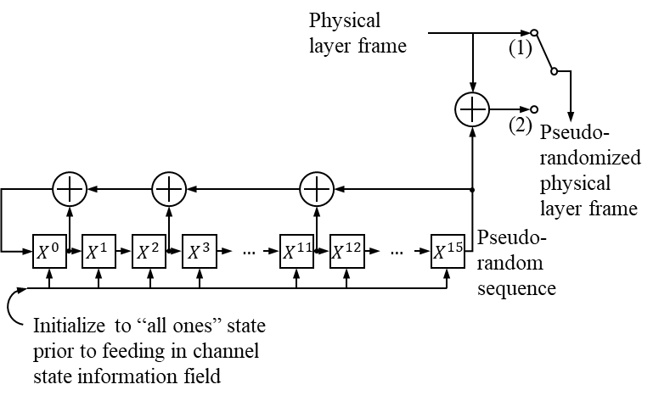

Figure 3‑7: Pseudo-randomizer Implementation Example

### Sequence Specification

The pseudo-random sequence $p_{0},p_{1},…,p_{65439}$ shall be generated by the polynomial:

$$g\left(D\right)= D^{16}+D^{12}+D^{3}+D+1.$$

### Sequence Initialization

This pseudo-random sequence shall begin at the first digit of the channel state information field in the physical layer frame. The registers in the sequence generator shall be initialized to ‘1’ at the start of the channel state information field.

## Frame Validation USING DECODER

A transfer frame shall be marked valid if its associated SMF is recovered from correctly decoded DVB-S2 or RS codeword(s); a transfer frame shall be marked invalid if it is recovered from one or more incorrectly decoded codewords.

NOTE – For the CCSDS transfer frame types defined in references [1], [2], or [3] the use of the Frame Error Control Field (FECF) is optional, and the system designer may choose to use it for additional frame validation.

## Sequence Indicator

A sequence indicator shall be ‘zero’ when a frame is the direct successor of the previous frame, and ‘one’ when a gap has been detected.

# Physical Layer

## Center Frequency

### Center Frequency Specification

The center frequency of the optical carrier shall be 193.1 + *n*×0.1 THz, where *n* is an integer ranging from -15 to 18.

NOTE – These center frequencies in the optical C-band are a subset of those defined in the ITU-T G.694.1 frequency grid with 100 GHz channel spacing (reference [C2]). The frequencies range from 191.6 THz to 194.9 THz and correspond to wavelengths in vacuum ranging from 1538.19 nm to 1564.68 nm.

Center frequencies between 191.6 THz and 193.2 THz, inclusive, ($n=-15 \text{to} 1$) are designated as Data Communications Band A and shall be used by transmitters in Type A terminals.

Center frequencies between 193.3 THz and 194.9 THz, inclusive, ($n=2 \text{to} 18$) are designated as Data Communications Band B and shall be used by transmitters in Type B terminals.

NOTE – To achieve high data rates, some systems may simultaneously modulate and transmit signals on multiple center frequencies within Data Communications Band A or B. This is commonly referred to as wavelength division multiplexing (WDM).

For systems utilizing an acquisition signal at a separate frequency from the communications frequency (Type 1 systems), acquisition signal frequencies shall be selected between 195.0 THz and 195.6 THz.

### Center Frequency Tolerance

The transmitter center frequency shall be accurate to within a tolerance of ± 1.5 GHz.

## Laser Linewidth

The laser linewidth shall be less than 300MHz for noncoherent systems and less than 100 kHz for coherent systems.

## Polarization

### Polarization Type

For systems transmitting a single polarized signal, the following shall apply:

* Type A terminals shall transmit right-hand circularly polarized signals, as defined in reference [8].
* Type B terminals shall transmit left-hand circularly polarized signals, as defined in reference [8].

For systems transmitting in two orthogonal polarizations simultaneously, the transmitted polarization is unspecified.

### Polarization Extinction Ratio

The polarization extinction ratio shall be greater than 10 dB.

## Modulation

The vector of pseudo-randomized physical layer frames received from the coding and synchronization sublayer defined in section 3 shall be used to modulate the emitted light within each transmission slot using a combination of phase and intensity modulation.

### Phase Modulation

The choice of phase modulation format is a managed parameter and may be either Differential Phase-Shift Keying (DPSK), Differential Quadrature Phase-Shift Keying (DQPSK), Binary Phase-Shift Keying (BPSK), or Quadrature Phase-Shift Keying (QPSK) as described herein.

#### Differential Phase-Shift Keying

For systems employing DPSK, each binary digit in the pseudo-randomized physical layer frame, $d_{j}^{i},$ shall be modulated onto the optical carrier such that the difference in modulated carrier phase between successive slot modulation intervals is 0 radians for a binary 0 and $π$ radians for a binary 1.

#### Differential Quadrature Phase-Shift Keying

For systems employing DQPSK, the sequence of binary digits in the pseudo-randomized physical layer frame shall be divided so that even bits (i.e., bits $2i$, where $i=0,1,2,…,32911$) are modulated onto the I-channel and odd bits (i.e., bits $2i$ +1, where $i=0,1,2,…,32911$) are modulated onto the Q-channel. The angular difference in the IQ plane of the modulated carrier phase between successive slot modulation intervals shall have the following meanings:

* 0 degrees represents a ‘00’ IQ binary digit pair;
* 90 degrees represents a ‘10’ IQ binary digit pair;
* 180 degrees represents a ‘11’ IQ binary digit pair; and
* -90 degrees represents a ‘01’ IQ binary digit pair.

#### Binary Phase-Shift Keying

For systems employing BPSK, each binary digit in the pseudo-randomized physical layer frame, $d_{j}^{i},$ shall be modulated onto the optical carrier with a phase shift of 0 radians for a binary 0 and $π$ radians for a binary 1.

#### Quadrature Phase-Shift Keying (QPSK)

For systems employing QPSK, the sequence of binary digits in the pseudo-randomized physical layer frame shall be divided so that even bits (i.e., bits $2i$, where $i=0,1,2,…,32911$) are modulated onto the I-channel and odd bits (i.e., bits $2i$ +1, where $i=0,1,2,…,32911$) are modulated onto the Q-channel. The modulated carrier phase shall have the following meanings as shown in Figure 4‑1:

* 45 degrees represents a ‘00’ IQ binary digit pair;
* 135 degrees represents a ‘10’ IQ binary digit pair;
* 225 degrees represents a ‘11’ IQ binary digit pair; and
* 315 degrees represents a ‘01’ IQ binary digit pair.
* 
* Figure 4‑1: QPSK Constellation Map

### Intensity Modulation

The intensity modulation pulse shape shall be either non-return-to-zero (NRZ), return-to-zero 50 (RZ50) or return-to-zero 33 (RZ33).

#### RZ50 Modulation

For RZ50 modulation the reference pulse intensity shape of the modulated communications beam transmitted by a terminal is a single period of a 50-percent return-to-zero waveform defined by:

$$I_{REF,RZ50}=\left\{\begin{matrix}\cos^{2}\left(π\frac{V\left(t\right)}{V_{π}}\right) & 0≤t≤T, \\ 0 & \text{otherwi}s\text{e}\end{matrix}\right.$$

where $V\left(t\right)=\frac{V_{π}}{4}\cos\left(2πft\right)+\frac{V_{π}}{4}$;

 is a voltage; and

ƒ = 1/*T* is the symbol modulation rate.

Figure 4‑2 shows the intensity profile for the reference RZ50 pulse.

The laser transmitter is not necessarily required to implement the exact reference pulse shape; however, transmitter implementation loss may be assessed relative to the reference waveform.

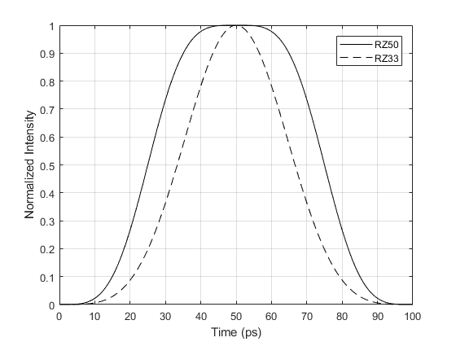

Figure 4‑2: Reference RZ50 and RZ33 Pulse Shapes for a Slot Rate of 10.0 GHz

#### RZ33 Modulation

For RZ33 modulation the reference pulse intensity shape of the modulated communications beam transmitted by a terminal is a single period of a 33-percent return-to-zero waveform defined by:

$$I_{REF,RZ33}=\left\{\begin{matrix}\cos^{2}\left(π\frac{V\left(t\right)}{V_{π}}\right) & 0≤t≤T, \\ 0 & \text{otherwi}s\text{e}\end{matrix}\right.$$

where $V\left(t\right)=\frac{V_{π}}{2}\cos\left(πft\right)$;

 is a voltage; and

ƒ = 1/*T* is the symbol modulation rate.

Figure 4‑2 shows the intensity profile for the reference RZ33 pulse.

The laser transmitter is not necessarily required to implement the exact reference pulse shape; however, transmitter implementation loss may be assessed relative to the reference waveform.

### Burst Mode Modulation

Modulated data shall be transmitted in bursts, which are characterized by the burst parameter, $D∈\left\{0,1,3,7,23,39\right\}$, as described herein.

For $D=0$, the data shall be transmitted as a continuous stream with one phase-and-intensity modulated symbol, as defined in section 4.4, transmitted in each transmission slot.

For $D>0$, the data shall be transmitted as a series of bursts with each burst containing 176 phase-and-intensity modulated symbols, as defined in section 4.4, with one modulated symbol transmitted in each transmission slot. The bursts shall be aligned such that the first transmitted binary digit in a burst corresponds to the first binary digit in the payload frame header.

NOTE – There are 374 bursts in a physical layer frame when BPSK or DPSK modulation format is used. There are 187 bursts in a physical layer frame when QPSK or DQPSK modulation format is used.

For $D>0$ and BPSK and QPSK modulation formats, the transmission of a 176-symbol burst shall be followed by a period of $176×D$ transmission slots during which the intensity of the transmitted signal is 0.

For $D>0$ and DPSK and DQPSK modulation formats, the transmission of a 176-symbol burst shall be followed by a period of $\left(176×D\right)-1$ transmission slots during which the intensity of the transmitted signal is 0. This period shall be followed by a single transmitted optical pulse with an intensity profile as defined in section 4.4.2.

NOTE – This single pulse, which precedes the next burst transmission, provides a phase reference for the next transmitted symbol with the differential modulation formats.

### Symbol Modulation Rate

The symbol modulation rate shall be 2.5 GHz or 10.0 GHz.

### Doppler Compensation

Transmitters are not required to pre-compensate for Doppler shifts on the symbol modulation rate.

### Symbol Modulation Rate Tolerance

The symbol modulation rate shall be accurate to within a tolerance of ± 10 ppm.

### Timing Jitter

The root mean square jitter on the symbol modulation clock at frequencies higher than 10 Hz shall be less than 5 percent of the period of the symbol modulation clock

# Managed Parameters

## Overview

Some parameters for high data rate optical signaling are handled by management rather than by an inline communications protocol. The managed parameters are those that tend to be static for long periods of time, and whose change generally signifies a major reconfiguration of the high data rate signaling associated with a particular mission. A management system conveys the required information to the high data rate optical signaling systems.

This section lists the managed parameters used by synchronization and channel coding systems. These parameters are defined in an abstract sense and are not intended to imply any particular implementation of a management system.

## Managed Parameters for Coding and Synchronization

The managed parameters for coding and synchronization shall be those specified in Table 5‑1**.**

Table 5‑1. Managed Parameters for Coding and Synchronization

|  |  |
| --- | --- |
| **Managed Parameter** | **Allowed Values** |
| SMF generation method | ASM or GFP |
| CCSDS Transfer Frame Length for ASM SMF generation method | Integer (max 65536) |
| GFP mode | Short or full |
| Forward Error Correction Code | BCH+LDPC, RS |
| LDPC Code rate, $r$ | 1/4, 1/3, 2/5, 1/2, 3/5, 2/3, 3/4, 4/5, 5/6, 8/9, 9/10 |
| Interleaver Symbol Size, $m$ | 1 or 8 |
| Number of rows in channel interleaver, $N$ | The parameters N and B shall satisfy the following constraints:   1. BN shall be a multiple of 64800/m, and 2. 64800/m, shall be a multiple of N. |
| Shift register length increment in channel interleaver, $B$ |
| Unique word content identifier | 288-bit sequence of binary digits, as described in section 3.9.2 |





## Managed Parameters for Physical Layer

The managed parameters for the physical layer shall be those specified in Table 5‑2.

Table 5‑2. Managed Parameters for Physical Layer

|  |  |
| --- | --- |
| **Managed Parameter** | **Allowed Values** |
| Terminal Type | A1, A2, B1, or B2 |
| Transmitted Center frequency parameter, *n* | *n* = 17 to 33 for Type B terminals  *n*=0 to 16 for Type A terminals |
| Polarization | Dual or Single Polarization |
| Modulation | DPSK, DQPSK, BPSK, QPSK |
| Intensity Modulation Pulse Shape | NRZ, RZ50 or RZ33 |
| Symbol Clock Rate | 2.5 GHz or 10.0 GHz |
| Burst Parameter, *D* | 0, 1, 3, 7, 23, or 39 |

1. Service  
     
   (NORMATIVE)
   1. Overview
      1. Introduction

This annex provides service definition in the form of primitives, which present an abstract model of the logical exchange of data and control information between the service provider and the service user. The definitions of primitives are independent of specific implementation approaches.

The parameters of the primitives are specified in an abstract sense and specify the information to be made available to the user of the primitives. The way in which a specific implementation makes this information available is not constrained by this specification. In addition to the parameters specified in this annex, an implementation can provide other parameters to the service user (e.g., parameters for controlling the service, monitoring performance, facilitating diagnosis, and so on).

* + 1. OVERVIEW OF THE SERVICEs

This Experimental Specification provides unidirectional (one way) transfer of a sequence of frames over a Physical Channel across a space link, using one of a number of specified channel coding and modulation methods.

Two types of services can be provided, but both types of service cannot be provided simultaneously:

1. ASM Generation Service—unidirectional transfer of a sequence of fixed-length TM, AOS, or USLP Transfer Frames at a constant frame rate over a Physical Channel across a space link, or
2. GFP Generation Service—unidirectional transfer of a sequence of variable-length octet-aligned frames defined by other standards over a Physical Channel across a space link.

The ASM Generation Service is provided when the SMF generation method described in Table 5-1 is set to ASM.

The GFP Generation Service is provided when the SMF generation method described in Table 5-1 is set to GFP.

* 1. Frame Service Parameters
     1. Optical Frame

The Optical Frame (OF) parameter is the service data unit of the two services.

* + - 1. When the ASM Generation Service is provided, as described in section 3.3.1, the OF shall be a CCSDS transfer frame as defined in references [1], [2], or [3].
      2. When the GFP Generation Service is provided, as described in section 3.3.2, the OF shall be an octet-aligned frame defined by other standards or methods.
      3. When the ASM Generation Service is provided, as described in section 3.3.1, the length of any frame transferred on a Physical Channel shall be established by management.
      4. When the GFP Generation Service is provided, as described in section 3.3.2, the length of any frame transferred on a Physical Channel is unspecified and may vary from frame to frame.
    1. Quality Indicator

The Quality Indicator parameter shall be used to notify the user at the receiving end of the service that the received frame was not able to be successfully decoded.

* + 1. Sequence Indicator

The Sequence Indicator parameter shall be used to notify the user at the receiving end of the service that one or more frames of the Physical Channel have been lost as the result of a loss of frame synchronization.

* 1. Service Primitives
     1. General
        1. The service primitives associated with this service are

a) OF ChannelAccess.request; and

b) OF ChannelAccess.indication.

* + - 1. The OF ChannelAccess.request primitive shall be passed from the service user at the sending end to the service provider to request that a Frame be transferred through the Physical Channel to the user at the receiving end.
      2. The OF ChannelAccess.indication shall be passed from the service provider to the service user at the receiving end to deliver a Frame.
    1. OF CHANNELACCESS.REQUEST
       1. Function

The OF ChannelAccess.request primitive is the service request primitive for this service.

* + - 1. Semantics

The OF ChannelAccess.request primitive shall provide a parameter as follows:

OF ChannelAccess.request (OF Frame)

* + - 1. When Generated

The OF ChannelAccess.request primitive shall be passed to the service provider to request it to process and send the Frame.

* + - 1. Effect on Receipt

Receipt of the OF ChannelAccess.request primitive shall cause the service provider to perform the functions described in sections 3 and 4 and to transfer the resulting pulsed slot sequence.

* + 1. OF CHANNELACCESS.INDICATION
       1. Function

The OF ChannelAccess.indication primitive is the service indication primitive for this service.

* + - 1. Semantics

The OF ChannelAccess.indication primitive shall provide parameters as follows:

OF ChannelAccess.indication (OF Frame, Quality Indicator, Sequence Indicator)

* + - 1. When Generated

The OF ChannelAccess.indication primitive shall be passed from the service provider to the service user to deliver a Frame.

* + - 1. Effect on Receipt

The effect of receipt of the OF ChannelAccess.indication primitive by the service user is undefined.

1. PHYSICAL LAYER AND CODING AND SYNCHRONIZATION SUBLAYER IMPLEMENTATION  
     
   (INFORMATIVE)

The Experimental specification described in this document was developed in coordination with multiple space agencies as an extension of existing systems in development that will enable interoperability between future systems. Thus, it includes adaptations to those existing systems such that those systems themselves do not implement the specification. However, those adaptations are based on existing standards and capabilities that have been demonstrated via standards development processes, in existing system implementations, in academic publications, in software simulations, and/or in commonly available commercial products.

There is a corresponding CCSDS Yellow Book, “Independent Implementations for Optical High Data Rate (HDR) Communication –1550 nm”, CCSDS 720.4-Y-1. That document is a record of implementations of the coding and synchronization and physical layer requirements for optical communications proposed in this Experimental specification.

1. Informative References
2. IEEE 802.3-2015, “IEEE Standard for Information technology – Telecommunications and information exchange between systems – Local and metropolitan area networks – Specific requirements – Part 3: Carrier Sense Multiple Access with Collision Detection (CSMA/CD) Access Method and Physical Layer Specifications.”
3. *Spectral Grids for WDM Applications: DWDM Frequency Grid*. ITU-T Recommendation G.694.1. Geneva: ITU, 2012.
4. Acronyms and Abbreviations

|  |  |
| --- | --- |
| AOS | Advanced Orbiting Systems |
| ASM | Attached Synchronization Marker |
| BCH | Bose–Chaudhuri–Hocquenghem |
| BPSK | Binary Phase-Shift Keying |
| CSMA/CD | Carrier Sense Multiple Access with Collision Detection |
| CRC | Cyclic Redundancy Check |
| DPSK | Differential Phase-Shift Keying |
| DQPSK | Differential Quadrature Phase-Shift Keying |
| DVB-S2 | Digital Video Broadcasting, Second Generation |
| FEC | Forward Error Correction |
| FECF | Frame Error Control Field |
| GFP | Generic Frame Procedure |
| GFP-F | Generic Frame Procedure frame-mapped |
| GFP-T | Generic Frame Procedure transparent-mapped |
| HDLC | High-Level Data Link Control |
| HDR | High Data Rate |
| ICD | Interface Control Document |
| IP/PPP | Internet Protocol/Point-to-Point Protocol |
| LDPC | Low-Density Parity-Check |
| MSB | Most Significant Bit |
| NRZ | Non-Return-to-Zero |
| OSI | Open Systems Interconnection |
| PLFM | Physical Layer Frame Marker |
| PPP | Point-to-Point Protocol |
| QPSK | Quadrature Phase-Shift Keying |
| RS | Reed Solomon |
| SANA | Space Assigned Numbers Authority |
| SMF | Synchronization-Marked Frame |
| TM | Telemetry |
| USLP | Unified Space Data Link Protocol |
| WDM | Wavelength Division Multiplexing |