

Draft Recommendation for  
Space Data System Practices

|  |
| --- |
| Atmospheric Characterization and Forecasting for Optical Link Operations |

PROPOSED Draft Recommended Practice

CCSDS 000.0-W-0

WHITE Book

SPRING 2019

AUTHORITY

|  |  |  |  |
| --- | --- | --- | --- |
|  | | | |
|  | Issue: | White Book, Issue 0 |  |
|  | Date: | April 2019 |  |
|  | Location: | Not Applicable |  |
|  | | | |

**(WHEN THIS RECOMMENDED PRACTICE IS FINALIZED, IT WILL CONTAIN THE FOLLOWING STATEMENT OF AUTHORITY:)**

This document has been approved for publication by the Management Council of the Consultative Committee for Space Data Systems (CCSDS) and represents the consensus technical agreement of the participating CCSDS Member Agencies. The procedure for review and authorization of CCSDS documents is detailed in *Organization and Processes for the Consultative Committee for Space Data Systems* (CCSDS A02.1-Y-4), and the record of Agency participation in the authorization of this document can be obtained from the CCSDS Secretariat at the e-mail address below.

This document is published and maintained by:

CCSDS Secretariat

National Aeronautics and Space Administration

Washington, DC, USA

E-mail: secretariat@mailman.ccsds.org

STATEMENT OF INTENT

**(WHEN THIS RECOMMENDED PRACTICE IS FINALIZED, IT WILL CONTAIN THE FOLLOWING STATEMENT OF INTENT:)**

The Consultative Committee for Space Data Systems (CCSDS) is an organization officially established by the management of its members. The Committee meets periodically to address data systems problems that are common to all participants, and to formulate sound technical solutions to these problems. Inasmuch as participation in the CCSDS is completely voluntary, the results of Committee actions are termed **Recommendations** and are not in themselves considered binding on any Agency.

CCSDS Recommendations take two forms: **Recommended Standards** that are prescriptive and are the formal vehicles by which CCSDS Agencies create the standards that specify how elements of their space mission support infrastructure shall operate and interoperate with others; and **Recommended Practices** that are more descriptive in nature and are intended to provide general guidance about how to approach a particular problem associated with space mission support. This **Recommended Practice** is issued by, and represents the consensus of, the CCSDS members.  Endorsement of this **Recommended Practice** is entirely voluntary and does not imply a commitment by any Agency or organization to implement its recommendations in a prescriptive sense.

No later than five years from its date of issuance, this **Recommended Practice** will be reviewed by the CCSDS to determine whether it should: (1) remain in effect without change; (2) be changed to reflect the impact of new technologies, new requirements, or new directions; or (3) be retired or canceled.

In those instances when a new version of a **Recommended Practice** is issued, existing CCSDS-related member Practices and implementations are not negated or deemed to be non-CCSDS compatible. It is the responsibility of each member to determine when such Practices or implementations are to be modified.  Each member is, however, strongly encouraged to direct planning for its new Practices and implementations towards the later version of the Recommended Practice.

FOREWORD

Through the process of normal evolution, it is expected that expansion, deletion, or modification of this document may occur. This Recommended Practice is therefore subject to CCSDS document management and change control procedures, which are defined in the *Organization and Processes for the Consultative Committee for Space Data Systems* (CCSDS A02.1-Y-4). Current versions of CCSDS documents are maintained at the CCSDS Web site:

http://www.ccsds.org/

Questions relating to the contents or status of this document should be sent to the CCSDS Secretariat at the e-mail address indicated on page i.

At time of publication, the active Member and Observer Agencies of the CCSDS were:

Member Agencies

* Agenzia Spaziale Italiana (ASI)/Italy.
* Canadian Space Agency (CSA)/Canada.
* Centre National d’Etudes Spatiales (CNES)/France.
* China National Space Administration (CNSA)/People’s Republic of China.
* Deutsches Zentrum für Luft- und Raumfahrt (DLR)/Germany.
* European Space Agency (ESA)/Europe.
* Federal Space Agency (FSA)/Russian Federation.
* Instituto Nacional de Pesquisas Espaciais (INPE)/Brazil.
* Japan Aerospace Exploration Agency (JAXA)/Japan.
* National Aeronautics and Space Administration (NASA)/USA.
* UK Space Agency/United Kingdom.

Observer Agencies

* Austrian Space Agency (ASA)/Austria.
* Belgian Federal Science Policy Office (BFSPO)/Belgium.
* Central Research Institute of Machine Building (TsNIIMash)/Russian Federation.
* China Satellite Launch and Tracking Control General, Beijing Institute of Tracking and Telecommunications Technology (CLTC/BITTT)/China.
* Chinese Academy of Sciences (CAS)/China.
* Chinese Academy of Space Technology (CAST)/China.
* Commonwealth Scientific and Industrial Research Organization (CSIRO)/Australia.
* Danish National Space Center (DNSC)/Denmark.
* Departamento de Ciência e Tecnologia Aeroespacial (DCTA)/Brazil.
* Electronics and Telecommunications Research Institute (ETRI)/Korea.
* European Organization for the Exploitation of Meteorological Satellites (EUMETSAT)/Europe.
* European Telecommunications Satellite Organization (EUTELSAT)/Europe.
* Geo-Informatics and Space Technology Development Agency (GISTDA)/Thailand.
* Hellenic National Space Committee (HNSC)/Greece.
* Indian Space Research Organization (ISRO)/India.
* Institute of Space Research (IKI)/Russian Federation.
* KFKI Research Institute for Particle & Nuclear Physics (KFKI)/Hungary.
* Korea Aerospace Research Institute (KARI)/Korea.
* Ministry of Communications (MOC)/Israel.
* National Institute of Information and Communications Technology (NICT)/Japan.
* National Oceanic and Atmospheric Administration (NOAA)/USA.
* National Space Agency of the Republic of Kazakhstan (NSARK)/Kazakhstan.
* National Space Organization (NSPO)/Chinese Taipei.
* Naval Center for Space Technology (NCST)/USA.
* Scientific and Technological Research Council of Turkey (TUBITAK)/Turkey.
* South African National Space Agency (SANSA)/Republic of South Africa.
* Space and Upper Atmosphere Research Commission (SUPARCO)/Pakistan.
* Swedish Space Corporation (SSC)/Sweden.
* Swiss Space Office (SSO)/Switzerland.
* United States Geological Survey (USGS)/USA.

PREFACE

This document is a draft CCSDS Recommended Practice. Its ‘Red Book’ status indicates that the CCSDS believes the document to be technically mature and has released it for formal review by appropriate technical organizations. As such, its technical contents are not stable, and several iterations of it may occur in response to comments received during the review process.

Implementers are cautioned **not** to fabricate any final equipment in accordance with this document’s technical content.

Document Control

|  |  |  |  |
| --- | --- | --- | --- |
| **Document** | **Title and Issue** | **Date** | **Status** |
| CCSDS 000.0-W-0 | Atmospheric Characterization and Forecasting for Optical Link Operations, Proposed Draft Recommended Practice, Issue 0 | [Month Year] | Current proposed draft |
|  |  |  |  |
|  |  |  |  |

Contents

Section Page

Document Control vi

Contents vii

1 Introduction 1-1

1.1 Purpose 1-1

1.2 Scope and applicability 1-1

1.3 Conventions and Definitions 1-2

1.4 Structure of this Document 1-3

1.5 References 1-4

2 Overview 2-1

2.1 General 2-1

2.2 Instrumentation and parameters 2-2

2.3 Applications 2-7

3 Physical Quantities to be Measured 3-1

3.1 Temperature 3-2

3.2 Relative Humidty (RH) 3-2

3.3 Wind Speed and Direction 3-2

3.4 Surface Air Pressure 3-2

3.5 Solar Insolation 3-2

3.6 Rainfall Rate 3-3

3.7 Backscatter 3-4

3.8 Sky Radiance 3-4

3.9 Fried Coherence Length 3-4

3.10 Aerosol Attenuation 3-4

4 Quantities to be Derived 4-1

4.1 Cloud Base Height 4-1

4.2 Cloud Mask 4-1

4.3 Cloud Attenuation 4-1

4.4 Skydome Cloud Fraction 4-2

4.5 Skydome Cloud Correlation 4-2

4.6 Isoplanatic Angle 4-3

5 Historical Characterization Statistics 5-1

5.1 Skydome Cloud Fraction 5-1

5.2 Line-of-Sight Cloud Fraction 5-1

5.3 Meteorological Variable Statistics 5-1

5.4 Fried Coherence Length 5-1

6 Real-time Characterization and Predictions for Decision Making 6-1

6.1 Short-Term Predictions 6-1

6.2 Long-term Predictions 6-1

7 Data Formats 7-1

7.1 Overview 7-1

7.2 Scalar Data 7-1

7.3 Multi-dimensional Data 7-2

8 Instrument Siting 8-1

8.1 Overview 8-1

8.2 Infrared Whole Sky Imager 8-1

8.3 Ceilometer 8-2

8.4 Meteorological Sensor Suite 8-2

8.5 Differential Image Motion Monitor (DIMM) 8-2

9 Cloud Retrievals from Geostationary Satellites 9-1

9.1 Overview 9-1

9.2 General Recommendations 9-5

ANNEX A Example XML Schema For Scalar Data A-1

ANNEX B Example XML Schema For Multi-dimensional Data B-1

ANNEX C Security Considerations (Informative) C-1

ANNEX D Abbreviations and Acronyms (Informative) D-1

# Introduction

## Purpose

Space-to-ground free-space optical communications (FSOC) are primarily affected by cloud cover, aerosols, and optical turbulence. Other atmospheric parameters that cause secondary impacts to FSOC include surface winds and humidity. The ability to accurately measure, characterize, and ultimately predict these atmospheric parameters will be critical to:

* evaluate the atmospheric characteristics of potential optical ground station (OGS) sites,
* select optimal OGS sites for future missions,
* adapt OGS design (e.g., adaptive optics) to the local meteorological conditions,
* make informed decisions about operational link handovers between OGSs, and,
* enable member agencies to support one another through interoperable OGSs.

A CCSDS Green Book, *Realtime Weather and Atmospheric Characterization Data,* [1], provides detailed descriptions of the critical atmospheric parameters, the physical quantities that must be measured or derived to analyze and characterize these parameters, and example instruments that can be used to collect the supporting atmospheric data.

The purpose of this Magenta Book is to provide a set of recommendations to facilitate interagency collection of atmospheric data and characterization of atmospheric parameters that affect space-to-ground FSOC. These recommendations can be useful now and can evolve to meet future needs and requirements. This document provides a set of recommended practices for the deployment of instruments, collection and analysis of atmospheric data, and the application of this data to inform FSOC-related decisions by the member space agencies. It is believed that implementing these recommendations will reduce development and operations costs, while improving the ability to consistently characterize sites across the globe. It is the intent that participating CCSDS agencies will share atmospheric data as defined in this Magenta Book to facilitate ground site selection and to promote interoperability.

## Scope and applicability

The collection of atmospheric data and the characterization of atmospheric parameters are applicable to space agencies that operate or will operate space-to-ground optical communication links to support near-Earth missions in any orbit and missions in deep space orbit (e.g., L1, L2). These recommended practices will be most applicable to space agencies that desire to characterize the atmospheric transmission loss due mainly to clouds to facilitate selection of future OGS sites, support interoperability, predict anticipated transmission losses for missions in real time, and carry out link handovers between OGSs.

## Conventions and Definitions

### Nomenclature

#### Normative Text

The following conventions apply for the normative specifications in this Recommend practice:

* The words ‘shall’ and ‘must’ imply a binding and verifiable specification;
* The word ‘should’ implies and optional, but desirable, specification;
* The word ‘may’ implies an optional specification;
* The words ‘is’, ‘are’, and ‘will’ imply statements of fact.

NOTE: These conventions do not imply constraints on diction in text that is clearly informative in nature.

#### Informative Text

In the normative sections of this document, informative text is set off from the normative specifications either in notes or under one of the following subsection headings:

* Overview;
* Background;
* Rationale;
* Discussion.

### Common Terminology

Part of the recommended practice process involves the determination of common interagency terminology, definitions, and conventions that apply to the deployment of instruments to collect atmospheric data and the characterization of atmospheric parameters. For example, unless otherwise stated, agencies will use the meter-kilogram-second (MKS) system of units for data collection and parameter characterization. The following terms are used in this recommended practice.

|  |  |
| --- | --- |
| **TERM** | **MEANING** |
| Sky dome | The observable portion of the sky as viewed from the ground; in this case from a camera with a fish-eye lens |
| Network CFLOS | The percent of time at least one site in a network of sites has a Cloud-Free Line of Sight (CFLOS) expressed in % |
| Prediction | A forecast of a parameter sometime in the future |
| Network Outage | A time when no ground sites in a network have CFLOS |
| Zenith angle | The angle between the zenith (z-axis in spherical coordinates) and the line of sight. |
| Elevation angle | The angle between the horizon and the line of sight. |
| Azimuth | The distance in degrees as measured from north in a clockwise fashion. |
| Measurement range | Range at which physical quantities can be measured by a given instrument |
| Obscuration mask | Plot of obscuration for an instrument at a particular location, as a function of azimuth and elevation angle |

## Structure of this Document

In addition to this section, this document contains the following sections and annexes:

* Section 2 provides an overview and background for this recommended practice.
* Section 3 provides a set of recommended practices for the measurement of the physical quantities.
* Section 4 provides a set of recommended practices for quantities derived from measurements described in section 3.
* Section 5 provides a set of recommended practices for using the physical and derived quantities for historical characterization.
* Section 6 provides a set of recommended practices for using the physical and derived quantities for real-time characterization and predictions for decision making.
* Section 7 discusses data formats.
* Section 8 discusses recommended practices for siting instrumentation.
* Section 9 describes a method that can be used to obtain initial, limited information regarding the suitability of potential optical ground station sites. This method involves the analysis of cloud climatologies using data from various geostationary meteorological satellites.

## References

1. *Realtime Weather and Atmospheric Characterization Data*. Issue 1. Informational Report for Space Data System Standards (Green Book), CCSDS 140.1-G-1. Washington, D.C.: CCSDS, May 2017.
2. *Optical Link Study Group Final Report*. IOAG.T.OLSG.2012.V1. Washington, D.C: IOAG, June 2012. <https://www.ioag.org/Public%20Documents/Forms/AllItems.aspx>.
3. *Optical Link Study Group Addendum to Final Report*. IOAG.T.OLSG.2012.V1A. Washington, D.C.: IOAG, November 2012. <https://www.ioag.org/Public%20Documents/Forms/AllItems.aspx>.
4. L. C. Andrews and R. L. Phillips. *Laser Beam Propagation through Random Media*, 2nd ed. Bellingham, WA: SPIE press, 2005.
5. G. Loos and C. Hogge. “Turbulence of the upper atmosphere and isoplanatism.” *Applied Optics* 18, no. 15 (1979): 2654-2661.

# Overview

## General

As space agencies deploy new sensors in Earth orbit and satellites venture into deep space to deploy advanced missions and instruments, data collection rates will increase rapidly. FSOC has the potential to meet the needs of these escalating data requirements. However, free-space optical signals are adversely affected by clouds and optical turbulence present in the atmosphere. These challenges to operational optical communications systems are illustrated in Figure 2‑1, which shows geostationary (GEO) and low Earth orbit (LEO) satellites interacting with atmospheric effects and working around the resulting atmospheric transmission losses. Each of these atmospheric effects may require one or more different mitigation strategies, which may, in turn, be dependent on the operational design of a particular system.

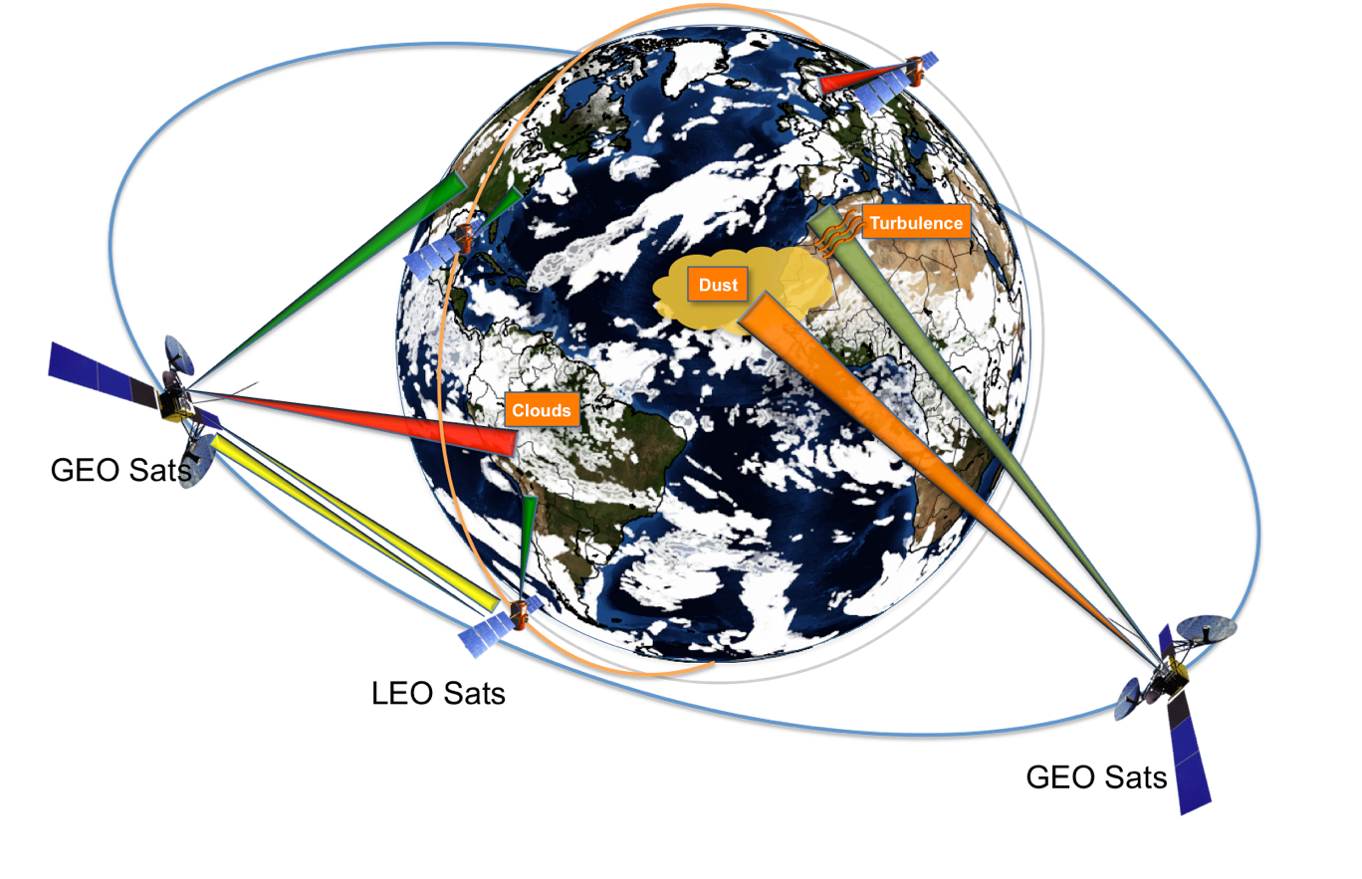

Figure 2‑1. Conceptual illustration of atmospheric effects experienced by space-to-ground optical communications. GEO and LEO satellites are shown orbiting Earth. Optical links are shown by the cones: dark green represents a Cloud-Free Line of Sight (CFLOS), light green represents a CFLOS possibly degraded by turbulence, orange represents a CFLOS possibly attenuated by aerosols, red represents a link blocked by clouds, and yellow indicates crosslinks between LEO and GEO satellites.

Clouds are the largest source of atmospheric attenuation for space-to-ground optical signals. Although it is possible to successfully communicate through some clouds, it is not practical to include sufficient margin in the link budget (i.e., > 3 to 10 dB) to completely prevent cloud blockages. In the example shown in Figure 2‑1, the negative impact of clouds on the optical links from the GEO satellites is reduced by ground station diversity. In this concept, multiple ground stations have the potential to communicate with satellites when other sites are cloud-covered or unavailable due to elevation angle constraints. This mitigation strategy is effective since clouds have finite correlation lengths. Therefore, combinations of ground station sites can be identified to improve the CFLOS of optical communications systems. The number and spacing of the ground stations will be highly dependent on the particular mission concept. The effective mitigation of communication outages due to clouds is improved by statistically characterizing the historical nature of clouds and accurately predicting clouds in real time to support link handovers between OGSs.

Although clouds are the primary source of optical signal attenuation, optical turbulence (OT) also degrades optical transmissions. OT distorts light as it travels through the atmosphere. OT creates fluctuations in the power received by the ground station and distorts the phase of the transmitted wave. There are several strategies to reduce or compensate for the effects of OT. One method is to use adaptive optics (AO) to correct phase distortions. The severity of OT, and thus the amount of correction required, is largely dependent upon the local turbulence at the site. Therefore it is critical to characterize OT at potential OGS sites.

Optical communications systems may also be affected by local meteorological conditions. For example, an OGS may need to be closed during high wind conditions to protect optics or the covering on the dome. Precipitation or condensation may force closure of a dome to protect sensitive optical equipment. Aerosol loading in the atmosphere from sand and dust may cause reduced visibilities and thus optical attenuation. Understanding of the local meteorological conditions is thus critical to assess potential OGS locations and evaluate the performance of operational OGSs.

The following subsections provide a high-level overview of the instrumentation required to collect relevant atmospheric data and the application of this data to support FSOC.

## Instrumentation and parameters

### **Overview**

Sections 2.2.1-2.2.5 describe the types of instruments that are required to collect the atmospheric data needed to characterize the parameters that affect FSOC. Additional instruments, such as a pyranometer (Sun photometer) used to measure aerosol attenuation can also be deployed (section 2.2.6). Table 1 summarizes the measured and derived quantities that these instruments enable; detailed requirements are provided in sections 3 and 4.

Table 1. Summary of Quantities to be Measured/Derived (NOTES: # - optional parameter; * - aggregate across the skydome)

|  | **Section** | **Data Source** | **Units** | **Measurement Interval (seconds)** | **Range** | **Accuracy** | **Precision** |
| --- | --- | --- | --- | --- | --- | --- | --- |
| **Quantities to be Measured** | | | | | | | |
| Temperature | 3.1 | Thermometer in Meteorological Sensor Suite | °C | ≤ 60 | -80 to 60 | 0.3 | 0.1 |
| Relative Humidity | 3.2 | Hygrometer in Meteorological Sensor Suite | % | ≤ 60 | 0 to 100 | 2.0 | 0.1 |
| Wind Speed | 3.3 | Anemometer in Meteorological Sensor Suite | ms-1 | ≤ 60 | 0 to 75 | 0.3 | 0.1 |
| Wind Direction | 3.3 | Anemoscope in Meteorological Sensor Suite | Degrees (°) | ≤ 60 | 0 to 360 | 3 | 1 |
| Surface air pressure | 3.4 | Barometer in Meteorological Sensor Suite | Hpa | ≤ 60 | 500 to 1100 | 0.5 | 0.1 |
| Solar insolation | 3.5 | Pyranometer (Sun Photometer) in Meteorological Sensor Suite | Wm-2 | ≤ 60 | 0 to 1800 | 1.0 | 0.1 |
| Rainfall rate | 3.6 | Tipping Bucket Rain Gauge in Meteorological Sensor Suite | mmh-1 | ≤ 60 | 0 to 1800 | 6 | 0.6 |
| Backscatter | 3.7 | Ceilometer | sr-1m-1 | ≤ 6 | 0 to 10,000 × 10-8 | 10 | 1 |
| Sky radiance | 3.8 | Infrared Whole Sky Imager | Wm-2 | ≤ 60 | 0 to 30 | 0.1 | 0.1 |
| Fried Coherence Length | 3.9 | Differential Image Motion Monitor | cm | ≤ 60 | ≥ 1 cm | 0.5 | 0.1 |
| Aerosol attenuation# | 3.10 | Pyranometer (Sun Photometer) | dB | ≤ 60 | 1 to 10 | 0.5 | 0.1 |
| **Quantities to be Derived** | | | | | | | |
| Cloud base height | 4.1 | Derived from backscatter as measured by a ceilometer | m | ≤ 60 | 0 to 13000 | 10.0 | 1.0 |
| Cloud Mask | 4.2 | Derived from sky radiance measurements from Whole Sky Imager | Unitless | ≤ 60 | 0 or 1 | *5% | n/a |
| Cloud Attenuation | 4.3 | Derived from Whole Sky Imager and Ceilometer data | dB | ≤ 60 | 0 to 10 | *10% | *0.5 |
| Skydome cloud fraction | 4.4 | Derived from cloud mask | % | ≤ 60 | 0 to 100 | *5% | *0.1% |
| Skydome cloud correlation | 4.5 | Derived from cloud mask | Unitless | n/a | -1.0 to 1.0 | n/a | 0.01 |
| Isoplanatic angle# | 4.6 | Derived from Differential Image Motion Monitor data (or may be measured isoplanometer) | microradian | ≤ 60 | 1 to 20 | 1.0 | 0.5 |

### **Infrared Whole Sky Imager**

Advances in microbolometer long-wave infrared (LWIR) detectors have led to the common use of infrared cameras that operate without active temperature stabilization, but the responses of these cameras vary with camera temperature. Therefore, obtaining quantitative data requires a calibration that compensates for possible temperature variation. The infrared whole sky imager (IWSI) is a passive (non-emissive) system that acquires images of the sky dome to assess and characterize clouds. The received sky images can be used to evaluate the presence, distribution, shape, and radiance of clouds over the entire sky, but only after a calibration. In particular, the IWSI is used to determine cloud coverage and, in conjunction with a ceilometer’s backscatter profile of the cloud particles, to estimate cloud attenuation. The calibration process could be performed operationally with the IWSI in the field or prior to deployment. Although a whole sky imager with a visible camera can provide high-resolution depictions of clouds during the day, a whole sky imager with an infrared camera is recommended to enable depictions of clouds both day and night. An IWSI with a fish-eye lens mounted on top is shown in Figure 2‑2.

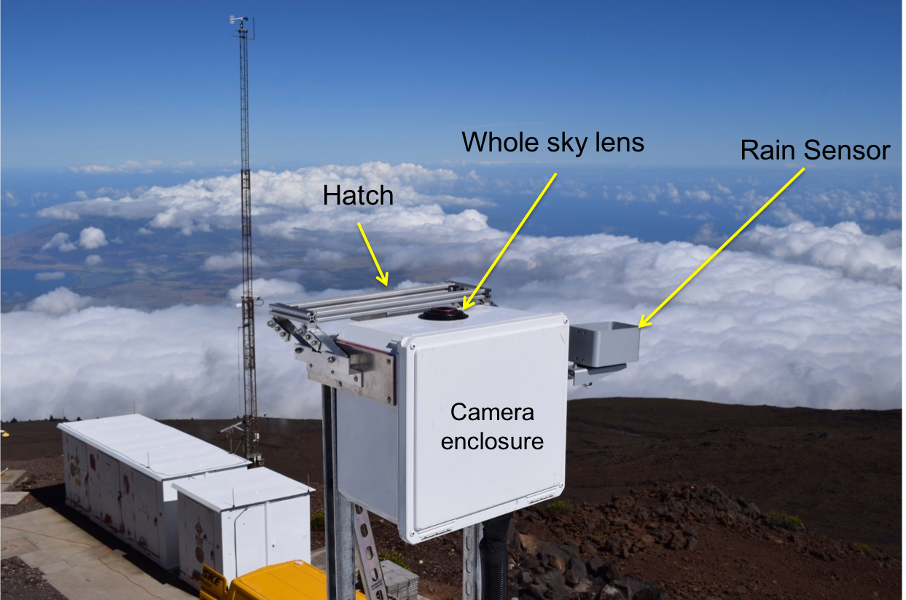

Figure 2‑2. An infrared whole sky imager with a fish-eye lens mounted on top of camera housing. The fish-eye lens provides nearly horizon-to-horizon coverage of clouds.

The left-hand image in Figure 2‑3 shows an example of a calibrated sky radiance obtained from the IWSI in Figure 2‑2. The units are Watts per meter squared (W/m2) and have been calibrated against a black body source in a laboratory using the Planck function. The sky radiance is effectively a measure of the amount of emission from the atmosphere, including clouds. Clouds of varying optical thicknesses appear in shades of white and emit typical values greater than a few W/m2. Clear sky is represented by a darker shade of blue. An example of the corresponding estimated cloud attenuation is shown on the right in Figure 2‑3. This derived field is transmission loss expressed in decibels (dB) of atmospheric fade at 1550 nm. Cloud fraction statistics may be derived from an IWSI and used to determine the suitability of a site for FSOC.

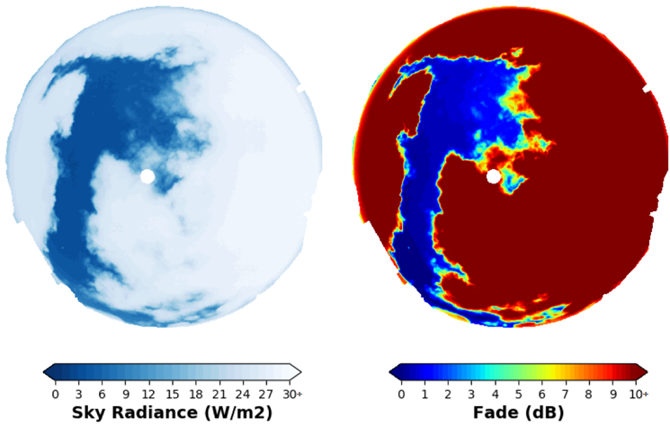

Figure 2‑3. Calibrated sky radiance (emission due to clouds) from an IWSI (left). Low sky radiances are associated with clear sky or thin clouds and high sky radiances are associated with thicker clouds. The derived cloud attenuation from the sky radiance is shown on the right and expressed in values of decibels (dB) of atmospheric fade. Fades greater than 10 dB are shown in dark red. In this image, the Sun may be observed as a circular disk near zenith.

### **Ceilometer**

A ceilometer is a device that uses a light source to determine cloud base height. Ceilometer data can be used in conjunction with IWSI data to derive cloud attenuation through inspection of the backscatter properties from water and ice clouds. A laser ceilometer consists of a vertically pointing laser and a lidar receiver. The instrument sends a short laser pulse (~ns) through the atmosphere. The lidar receiver detects the returning light due to scattering by aerosols (Mie scattering). The cloud base height is obtained by measuring the delay between the sent and returned signal. Such laser ceilometers are regularly used at airports, and are compliant with eye-safety regulations.

An example of a ceilometer can be found in Figure 2‑4. In this example, the ceilometer is mounted so that it is pointed to zenith. However, if desired, a mount could be created to point the instrument off-zenith (i.e., in the direction of a satellite fixed in the sky). However, tilting the ceilometer off zenith will limit the measurable height of the cloud, depending on how far it is pointed (i.e., cosine of the zenith angle).

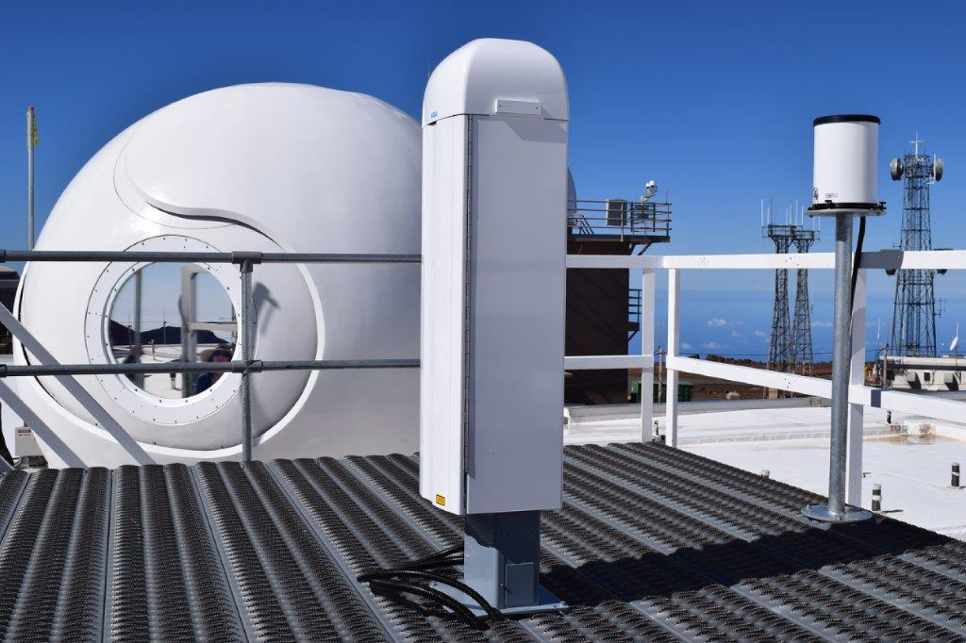

Figure 2‑4. Zenith-pointing ceilometer that measures backscatter from clouds and aerosols.

Figure 2‑5 shows the backscatter detected by the ceilometer shown in Figure 2‑4 as a function of height and time. The orange and red colors indicate strong backscatter and thus optically thick clouds. The cloud base height and, to a lesser extent, the cloud top height can be identified. Over the course of the seven-hour period, varying cloud thickness is observed, with cloud base heights in the 2,000 meter (m) to 3,000 m range and clouds with top heights up to approximately 6,000 m above ground level (AGL).

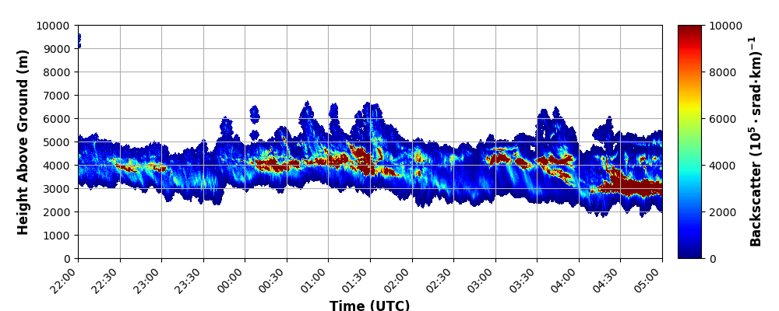

Figure 2‑5. Time series of zenith-pointing backscatter as a function of height from the ceilometer depicted in Figure 2‑4. Large values of backscatter indicate areas of thicker clouds.

### **Meteorological Sensor Suite**

A standard suite of meteorological observations is desired to characterize any potential OGS site. Observations of temperature, pressure, humidity, wind speed, and wind direction are all critical parameters to collect. An example of a meteorological sensor suite is shown in Figure 2‑6. An example time series of measurements is shown in Figure 2‑7. In this example, a 24-hour time series of temperature, dew point (a measure of how much water vapor exists in the air and related to humidity, upper panel), wind speed and direction (2nd panel), cloud base height (3rd panel, derived from a ceilometer), solar insolation from a pyranometer (Sun photometer) (4th panel) and an estimate of atmospheric attenuation in the line of sight to the Sun (lower panel) is shown.

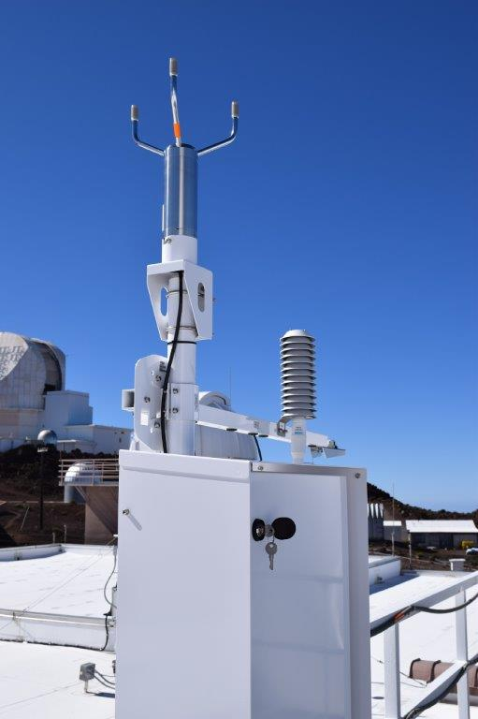

Figure 2‑6. Example meteorological sensor suite with measures of temperature, humidity, wind speed and direction, pressure and solar insolation.

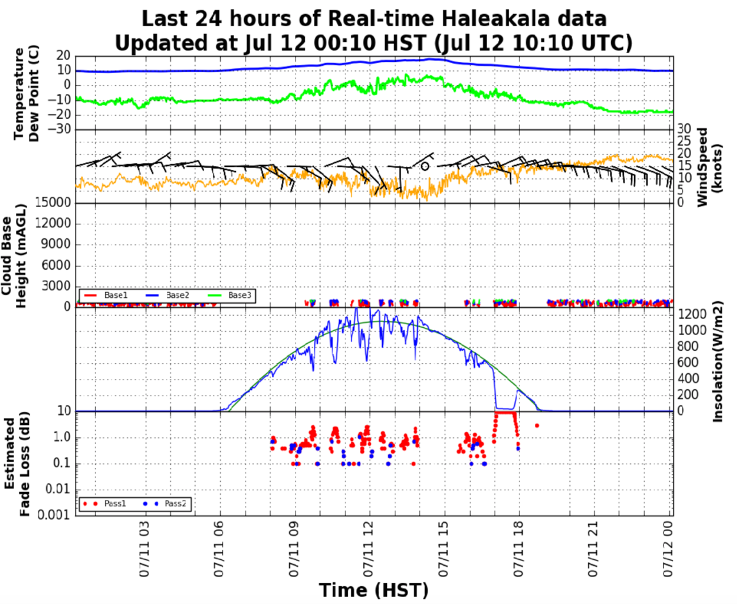

Figure 2‑7. Time series of temperature, dew point (from which surface humidity is derived), wind speed and direction, cloud base height (ceilometer), and solar insolation from the Vaisala AWS310 meteorological sensor suite. A measure of attenuation in the line of sight to the Sun is also shown in the lower panel.

### **Differential image motion monitor (DIMM)**

A differential image motion monitor (DIMM) is an instrument used to evaluate the seeing conditions at any potential OGS site. The Fried Coherence Length parameter, r0 (cm) is measured with a DIMM. This parameter characterizes the strength of atmospheric turbulence and is typically used to design adaptive optics systems to compensate for optical turbulence. More detailed information on the Fried Coherence Length parameter and the design and an example of a DIMM can be found in theCCSDS Green Book, *Realtime Weather and Atmospheric Characterization Data* [1].

### Pyranometer (Sun Photometer)

A valid approach to measure the optical properties of the atmosphere is to directly monitor the variation in the spectral irradiance of a known exo-atmospheric source. In particular, Sun photometry is a well-established remote sensing technique for the characterization of atmospheric optical properties, including aerosol attenuation, sky radiance, and particle distribution. More detailed information on the measurement of aerosol attenuation and associated fade and an example of a pyranometer (Sun photometer) can be found in the CCSDS Green Book, *Realtime Weather and Atmospheric Characterization Data* [1].

## Applications

Sections 2.3.1 and 2.3.2 explain how atmospheric data analyses can be applied to support FSOC—for both historical characterization and real-time decision making.

### **Historical Characterization**

A desirable OGS location will have very high CFLOS, good optical seeing (i.e., large r0), and local meteorology that is not significantly impacted by high winds, humidity, aerosols, or other local meteorological conditions. Although satellite-based cloud climatologies that span more than two decades are available for such historical OGS investigations [2][3], it is recommended that in situ data collection takes place for not less than two years prior to installation of an OGS. The collection and analysis of in situ data recommended in this Magenta Book will assist space agencies to identify whether a proposed OGS location meets the desired performance requirements for their respective missions. If multiple ground locations are instrumented simultaneously, then CFLOS network statistics can be developed, as shown in Figure 2‑8. Japan’s National Institute of Information and Communications Technology (NICT) deployed Atmospheric Monitoring Stations (AMSs) that have been collecting atmospheric data at ten sites for the last several years. Together, these ten sites form a potential OGS network and CFLOS statistics can be derived to determine whether this network meets a particular mission’s requirements. Figure 2‑8 shows an example of a derived CFLOS study as a function of time of year for different thresholds of cloudiness.

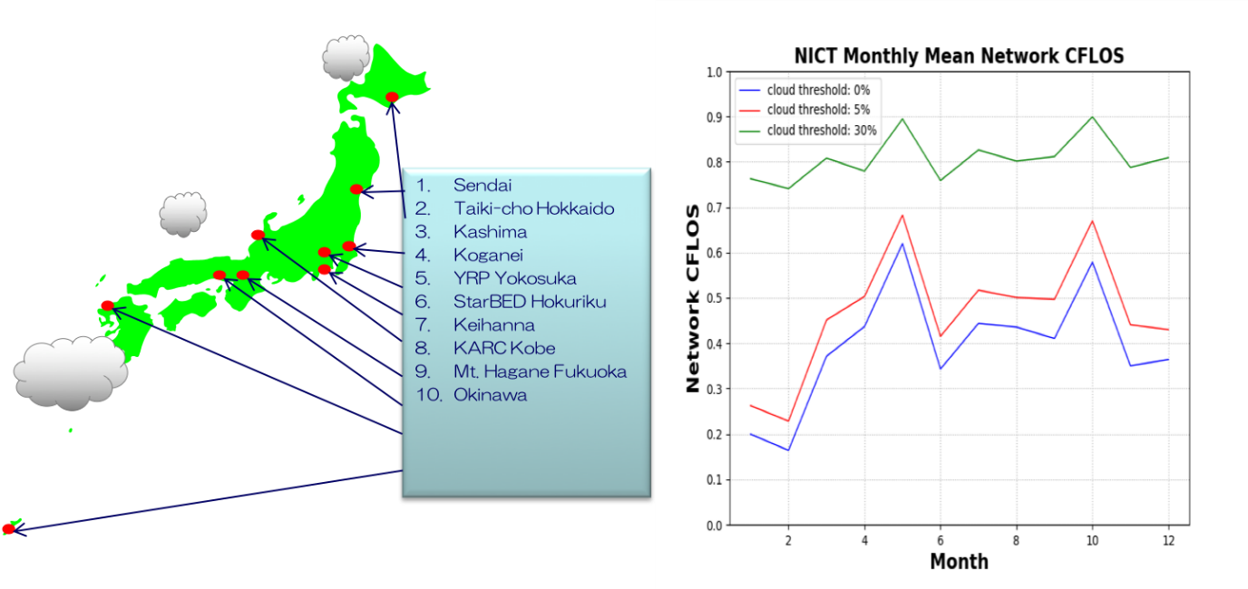

Figure 2‑8. Map of NICT network of Atmospheric Monitoring Stations (left). Derived network CFLOS based on several years of cloud data under various thresholds as a function of month of the year is shown on the right.

In addition, this historical data can be used to develop prediction algorithms necessary for use in future operational scenarios where an agency will require awareness about current and future OGS availability to support FSOC.

### **Real-time Decision Making**

In addition to the collection of the atmospheric data for the purpose of historical evaluation, some situational awareness is required for an OGS to support real-time missions. For example, if a space agency is running a deep space mission and needs to know whether OGS A or B is currently available for FSOC or whether either station is anticipated to be available over the next few hours, real-time collection and processing of atmospheric data will be critical to quantify the local atmospheric attenuation at each OGS. In another example, space agency A may want to use space agency B’s OGS for a mission several days in the future. In this instance, space agency A would desire an atmospheric prediction for agency B’s OGS so that space agency A can decide whether using agency B’s OGS will meet mission requirements. The real-time collection of AMS data will facilitate these types of predictions.

# Physical Quantities to be Measured

Unless otherwise indicated, agencies shall use the meter-kilogram-second (MKS) system of units for data collection and parameter characterization. Units of measurement for each quantity shall be identical to those stated in the recommended practices below. I.e., temperature measurements shall be in °C, wind speed measurements shall be in ms-1, etc.

## Temperature

### Temperature shall be measured by a thermometer with a measurement range of -80.0 °C to 60.0 °C.

### Temperature measurements shall be collected at intervals ≤ 60 seconds (s).

### Temperature measurements must be accurate to within +/- 0.3 °C and shall have a precision of 0.1 °C.

## Relative Humidty (RH)

### Relative humidity shall be measured by a humidity probe with a measurement range of 0 to 100%.

### Relative humidity measurements shall be collected at intervals ≤ 60 s.

### Relative humidity measurements must be accurate to within +/- 2.0 % and shall have a precision of 0.1%.

## Wind Speed and Direction

### Wind speed and direction shall be measured by an ultrasonic wind sensor with a measurement range of 0.0 to 75.0 ms-1 for wind speed and a measurement range of 0° to 360° for wind direction.

### Wind speed and direction measurements shall be collected at intervals ≤ 60 s.

### Wind speed measurements must be accurate to within 0.3 meters/second (ms-1) or 3% of reading, whichever is greater, and shall have a precision of 0.1 ms-1.

### Wind direction measurements must be accurate to within +/- 3° and shall have a precision of 1°.

## Surface Air Pressure

### Surface air pressure shall be measured by a barometer with a measurement range of 500.0 to 1100 hectopascals (hPa).

### Surface air pressure measurements shall be collected at intervals ≤ 60 s.

### Surface air pressure measurements must be accurate to within +/-0.5 hPa and shall have a precision of 0.1 hPa.

## Solar Insolation

### Solar insolation should be measured by a pyranometer (Sun photometer) with a 180° field of view and a maximum measurement range value ≥ 1800 Wm-2.

### Solar insolation measurements should be collected at intervals ≤ 60 s.

### Solar insolation measurements should be accurate to within 1.0 Wm-2 and shall have a precision of 0.1 Wm-2.

NOTE: Solar insolation measurements are used for daytime estimates of cloud attenuation in the line of sight of the Sun only.

## Rainfall Rate

### Rainfall should be measured by a tipping bucket rain gauge or equivalent with a measurement range of 0.0 mmh-1 to 1800.0 mmh-1.

### Rainfall measurements should be collected at intervals ≤ 60 s.

### Rainfall measurements should have an accuracy of +/- 6 mmh-1 with a precision of 0.6 mmh-1.

NOTE: Rainfall rate can be used to inform closure of the IWSI hatch during times of rain.

## Backscatter

### Backscatter shall be measured using a ceilometer capable of taking measurements over a vertical distance from 0.0 m to ≥ 13,000.0 m above ground level at 10-meter vertical resolution. The measurement range shall be 0 to 10,000 × 10-8 steradian-1 meter-1.

### Backscatter shall be measured at intervals ≤ 6 s.

### Backscatter must be accurate within +/- 10.0 steradian-1 meter-1 and shall have a precision of 1 steradian-1 meter-1.

### The ceilometer’s laser source may be an indium gallium arsenide diode laser with a center wavelength of 950 nm +/- 10 nm at 25 °C.

## Sky Radiance

### Calibrated sky radiance shall be measured using an IWSI (horizon-to-horizon) that is capable of operating day and night. The wavelength measurement range of the IWSI camera shall be 8.0 to 14.0 microns () and the IWSI infrared camera shall have a resolution not less than 480 pixels by 640 pixels.

### Calibrated sky radiance measurements shall be collected at intervals ≤ 60 s.

### The IWSI calibrated sky radiances shall have a dynamic range of at least 0.0 to 30.0 Wm-2 with an accuracy of 0.1 Wm-2 and a precision of 0.1 Wm-2.

## Fried Coherence Length

### The Fried coherence length (r0) should be measured by a DIMM or equivalent device with a measurement range of 1.0 cm to not less than 20.0 cm. The wavelength of the device measurement should be at 500 nanometers (nm) and the measurement should be referenced to zenith.

### The Fried coherence length (r0) should be measured at intervals ≤ 60 s.

### The Fried coherence length (r0) should be accurate within +/- 0.5 cm and should have a precision of 0.1 cm.

## Aerosol Attenuation

### Aerosol attenuation may be measured during the daylight hours using a pyranometer (Sun photometer) with a measurement range of 1.0 dB to 10 dB.

### Aerosol attenuation measurements may be collected at intervals ≤ 60 s.

### Aerosol attenuation may be accurate within +/- 0.5 dB and have a precision of 0.1 dB.

# Quantities to be Derived

## Cloud Base Height

### It is the responsibility of each CCSDS member agency to develop and validate an algorithm to compute cloud base height that is compatible with the following requirements.

### Cloud base height shall be derived from the backscatter profiles from a ceilometer capable of measuring backscatter from 0.0 m to 13,000.0 m.

### Cloud base height shall be derived at intervals ≤ 60 s.

### Cloud base heights must be accurate within +/- 10.0 m and shall have a precision of 1 m.

## Cloud Mask

### It is the responsibility of each CCSDS member agency to develop and validate an algorithm to compute cloud mask that is compatible with the following requirements.

### A cloud mask shall be computed for each pixel in an IWSI image using the calibrated sky radiances defined in section 3.8.

### The cloud mask shall have a horizontal resolution of not less than 480 pixels by 640 pixels so as to fully capture the entire sky from horizon to horizon.

### The value assigned to each IWSI pixel shall be 0 for clear sky and 1 for cloudy and Not a Number (NaN) for indeterminate.

### The temporal resolution of the cloud mask shall be ≤ 60 s.

### The aggregate accuracy of the cloud determination across all pixels shall be within 5.0 %.

### The array of cloud determinations may be stored as a matrix of rows and columns (see section 7 below).

## Cloud Attenuation

### It is the responsibility of each CCSDS member agency to develop and validate an algorithm to compute cloud attenuation that is compatible with the following recommendations.

### A cloud attenuation (or fade) shall be computed for each pixel in an IWSI image using the calibrated sky radiances defined in section 3.8.

### The temporal resolution of the cloud attenuation shall be ≤ 60 s.

### The cloud attenuation shall have a horizontal resolution of not less than 480 pixels by 640 pixels so as to fully capture the entire sky from horizon to horizon.

### The cloud attenuation shall be derived in units of dB loss at 1550 nm and/or 1060 nm.

### Valid cloud attenuation values shall range from 0.0 dB to not less than 10 dB and have a precision of at least 0.5 dB.

### The aggregate accuracy of the cloud attenuation shall be no more than +/- 10%.

### The array of cloud attenuation determinations may be stored as a matrix of rows and columns (see section 7 below).

## Skydome Cloud Fraction

### A skydome cloud fraction shall be computed based on the non-indeterminate cloud mask values derived in section 4.2.4 at intervals ≤ 60 s.

### The skydome cloud fraction shall be expressed in units of percent and range from 0.0 to 100.0.

### The skydome cloud fraction should be defined for zenith angles less than 80° and shall have a range of 0% to 100%.

### The skydome cloud fraction should have an accuracy less than or equal to +/- 5.0 % and the precision shall be 0.1%.

## Skydome Cloud Correlation

### The skydome cloud correlation (SCC) is the correlation between the zenith pixel (or any pixel the user selects) and every other pixel in the IWSI image.

### The SCC shall consist of a matrix not less than 480 pixels by 640 pixels containing values ranging from -1.0 to 1.0 with a precision of 0.01.

### The SCC may be derived for each image to understand the temporal and spatial nature of the clouds at each potential OGS site.

NOTE: Figure 4‑1 shows an example of a skydome cloud correlation referenced to a point in the sky that is off-zenith. The correlation ranges from 0.0 to 1.0, and this example shows that clouds across the skydome are generally very highly correlated with the position just off-zenith (i.e., dark red pixel denoting 1.0 correlation).

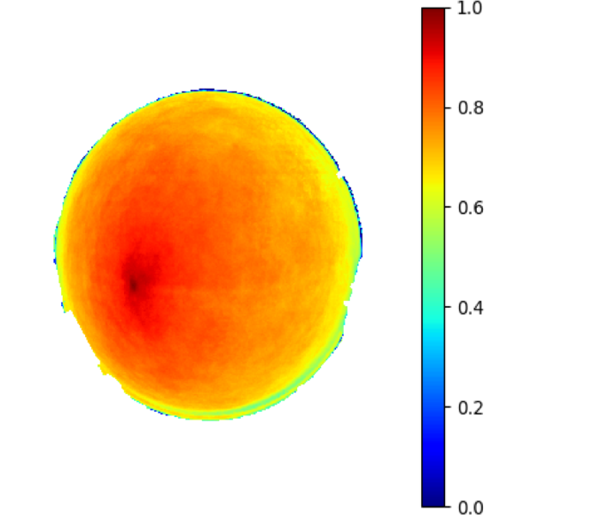

Figure 4‑1. Example of a skydome cloud correlation.

## Isoplanatic Angle

### The isoplanatic angle may be derived from the Fried Coherence Length (r0) and a measure of the refractive index structure function ($C_{n}^{2}$). If direct measurements of $C_{n}^{2}$ are not available, it may be approximated by a model such as the Huffnagel-Valley model [4].

### Direct measurement of the isoplanatic angle may be obtained from an isoplanometer [5] at intervals ≤ 60 s.

### The measurement range of the isoplanatic angle should be from 1.0 to 20.0 microradians.

### The accuracy of the isoplanatic angle measurement/value should not be more than +/- 1.0 microradian; however, it will be up to each member agency to define this parameter given the difficult nature of accurate measurements.

### The precision of the isoplanatic angle measurement/value may be 0.5 microradians; however, it will be up to each member agency to define this parameter given the difficult nature of accurate measurements.

# Historical Characterization Statistics

## Skydome Cloud Fraction

### A probability density function (PDF) shall be computed for the skydome cloud fraction defined in section 4.4. The bin size of the PDF shall be ≤ 5.0%. The PDF shall be updated at least annually.

### A PDF for the skydome cloud fraction may be computed for time of year (e.g., season, month) or for time of day (e.g., day or night).

### A time series of skydome cloud fraction may be computed for various time scales including seasonal and diurnal. The time series may be presented in terms of the mean skydome cloud fraction by time of day or year.

## Line-of-Sight Cloud Fraction

### Statistics of line-of-sight cloud fraction may be derived for the point or points in the skydome that define the location or trajectory of the satellite containing the optical transmitter.

### Statistics of line-of-sight cloud fraction may include, but are not limited to, frequency of occurrence of cloud freeness or conditional statistics (e.g., given that it is clear now, what is the probability it remains clear for at least *n*-minutes, where *n* equals the number of minutes).

### A time series of line-of-sight cloud fraction may be computed for various time scales including seasonal and diurnal. The time series may be presented in terms of the mean line-of-sight cloud fraction by time of day or year.

### Correlations between sites may be calculated if multiple sites have time-by-time estimates of line-of-sight cloud fraction.

### Network CFLOS may be computed if multiple sites have time-by-time estimates of line-of-sight cloud fraction.

## Meteorological Variable Statistics

### A PDF shall be computed for the meteorological quantities defined in section 3.1 through section 3.4. The bin size of each PDF shall be not more than 0.1 units of each respective measurement (e.g., 0.1 °C for temperature). The PDF shall be updated at least annually.

### A PDF may be computed for the meteorological quantities defined in sections 3.5 and 3.6. If PDFs are computed for these quantities, the bin size of each PDF shall be not more than 0.1 units of each respective measurement and the PDFs shall be updated at least annually.

### A time series of any of the meteorological variables may be computed for various time scales including seasonal and diurnal. The time series may be presented in terms of the mean of the variable by time of day or year.

## Fried Coherence Length

### A PDF may be computed for the Fried Coherence Length (r0) defined in section 3.9. If a PDF is computed for r0, the bin size shall be 0.5 cm and the PDF shall be updated at least annually.

### A diurnal time series composed of the mean or median r0 for some period (month, season) may be computed along with the 5th and 95th percentile of the distribution.

# Real-time Characterization and Predictions for Decision Making

Real-time characterization and predictions to support operational FSOC missions are encouraged to optimize system performance. Several prediction quantities are recommended below.

## Short-Term Predictions

Short-term predictions refer to those predictions that are up to one hour long and primarily will be used to inform link handover decisions.

### Probability of CFLOS

#### Each CCSDS member agency shall develop and validate an algorithm to predict CFLOS in accordance with the following recommendations.

#### A probability of CFLOS from the OGS to the satellite shall be computed using data derived in section 4.2. The prediction length shall be for 1 to 60 minutes at one-minute intervals and shall be updated at intervals ≤ 5 minutes.

#### The accuracy of each prediction shall be within +/- 10 %. Accuracy will be determined by comparing the predictions to observed CFLOS as defined in section 4.2.

### Cloud Attenuation

#### Each CCSDS member agency shall develop and validate an algorithm to predict cloud attenuation in accordance with the following recommendations.

#### A prediction of cloud attenuation shall be computed using data derived from section4.3.

#### The cloud attenuation prediction length shall be for 1 to 60 minutes at one-minute intervals and shall be updated at intervals ≤ 5 minutes.

#### The accuracy of each prediction shall be within +/- 10 % of the actual cloud attenuation as defined in section 4.3.

## Long-term Predictions

Long-term predictions refer to those forecasts that exceed one hour and may be as long as two weeks. Long-term predictions are intended to assist space agencies to schedule the use of an OGS or multiple OGSs to meet mission objectives. In some cases the long-term predictions can be used to deconflict missions.

### Meteorological Parameters

#### Each CCSDS member agency shall set up, run, and validate a Numerical Weather Prediction (NWP) model to predict temperature, humidity, wind, wind direction, and pressure in accordance with the following recommendations.

#### The prediction length should be at least 72 hours, in increments of one hour. The predictions should be updated not less than once per day.

#### The forecast accuracy should be determined by comparing the predictions to observations from each OGS. The forecast accuracy should be within +/- 2 to +/-3 percent of truth.

### Clouds

#### Each CCSDS member agency shall derive a prediction of the probability of CFLOS in accordance with the following recommendations.

#### The prediction of the probability of CFLOS shall be made using an NWP and may be derived from an ensemble of NWP simulations or from a deterministic run of an NWP. In either case, the CFLOS shall be derived from the model’s cloud and ice water path variables.

#### The prediction length should be at least 72 hours, in increments of one hour. The predictions should be updated not less than once per day.

#### The forecast accuracy should be determined by comparing the predictions to observations from each OGS. The forecast accuracy should be within +/- 2 to +/-3 percent of truth.

### Fried Coherence Length

#### Each CCSDS member agency should derive r0 and validate its accuracy in accordance with the following recommendations.

#### A prediction of the optical seeing parameter r0 should be made using an NWP model.

#### The prediction length of r0 should be determined by each CCSDS member agency.

#### The r0 prediction shall be referenced to 1550 nm and/or 1060 nm and shall have units of cm. The r0 prediction shall be scaled to zenith.

#### The forecast accuracy of the r0 prediction should be determined by comparing it to observed values of r0 defined in section 3.9 and should be within 10% of the observed values.

# Data Formats

## Overview

To ensure atmospheric data collected/derived are impactful to all member space agencies, it is recommended that agencies employ a standard format for each AMS message. An extensible markup language (XML) is an appropriate way to store AMS data since XML is designed to store and transport large amounts of data and to be both human- and machine-readable, and is self-descriptive. Another benefit of XML is that it is extensible. Thus, it is quite easy to add new data later using XML. Data is often collected and stored in various formats that can be incompatible with different computer operating systems. Exchanging incompatible data between systems (or upgraded systems) is a time-consuming task. Large amounts of data must be converted, and incompatible data is often lost. XML stores data in plain text format, which provides a software- and hardware-independent way of storing, transporting, and sharing data. XML also makes it easier to expand or upgrade to new operating systems, new applications, or new browsers without losing data. With XML, data can be available to all kinds of "reading machines," enabling seamless interoperability between space agencies.

The following are suggested recommended practices that space agencies should consider when formatting their AMS data messages.

## Scalar Data

Scalar data is defined as those parameters that have only magnitude. They include the following parameters from sections 3 and 4 above:

* Temperature
* Relative humidity
* Wind speed
* Wind direction
* Surface air pressure
* Solar insolation
* Rainfall rate
* Fried coherence length
* Aerosol attenuation
* Cloud base height
* Skydome cloud fraction
* Isoplanatic angle

Scalar data shall be stored in a separate XML message from multi-dimensional data.

### Scalar Data Format

#### All scalar data shall be measured and/or derived at the same time intervals and formatted using the XML schema found in ANNEX A.

#### All scalar data shall be location- and time-tagged using the following format:

* Location: latitude in degrees (-90 to 90), where -90 indicates the South Pole and 90 represents the North Pole; minutes (0 to 60); and seconds (0 to 60) and longitude in degrees, minutes, and seconds measured from 0.0° (Greenwich) longitude to 359.99°.
* Time: Integer year (4-digit, 2018 to 2128), month (2-digit, 01 to 12), day (2-digit, 01 to 31), hour (2-digit, 00 to 59), minute (2-digit, 00 to 59), second (2-digit, 00 to 59); hour, minute, and seconds shall be referenced to Coordinated Universal Time (UTC).
* The minimum and maximum values of each scalar parameter are defined in sections 3 and 4 above.

## Multi-dimensional Data

Multi-dimensional data is defined as those parameters measured or derived that have more than one dimension. They include the following parameters from sections 3 and 4 above:

* Backscatter (1-Dimensional array)
* Sky radiance (2-Dimensional array)
* Cloud mask (2-Dimensional array)
* Cloud attenuation (2-Dimensional array)
* Skydome cloud correlation (2-Dimensional array)

Multi-dimensional data shall be stored in a separate XML message from scalar data.

### **Multi-Dimensional Data Format**

#### All multi-dimensional data shall be measured and/or derived at the same time intervals (with exception of ceilometer backscatter, which shall be archived at 6-second intervals) and formatted using the XML schema in ANNEX B.

#### All multi-dimensional data shall be location- and time-tagged using the following format:

* Location: latitude in degrees (-90 to 90), where -90 indicates the South Pole and 90 represents the North Pole; minutes (0 to 60); and seconds (0 to 60) and longitude in degrees, minutes, and seconds measured from 0.0° (Greenwich) Longitude to 359.99°.
* Time: Integer year (4-digit, 2018 to 2128), month (2-digit, 01 to 12), day (2-digit, 01 to 31), hour (2-digit, 00 to 59), minute (2-digit, 00 to 59), second (2-digit, 00-59); hour, minute, and seconds shall be referenced to Coordinated Universal Time (UTC).
* The minimum and maximum values of each multi-dimensional parameter are defined in sections 3 and 4 above.

# Instrument Siting

## Overview

The siting of atmospheric monitoring instruments at a potential OGS location often involves critical decisions. Great care must be taken to locate these instruments in areas that maximize the usefulness of the data to be collected. For example, since observations of clouds are so critical for FSOC, it is important to locate an infrared whole sky imager in an area that minimizes obstructions due to nearby buildings or other structures. Information about the wind loading on a dome may be critical to determine whether an OGS could be used at a given time. Therefore, to sample the winds properly, an anemometer would need to be installed in such a way to measure wind adjacent the dome. It is the responsibility of each space agency to deploy its instruments optimally at potential and existing OGSs. The following guidelines are presented and described for proper siting of AMS instruments.

## Infrared Whole Sky Imager

### An IWSI shall be sited in such a way so as to keep any structures in its field of view below 20°.

### An IWSI should be sited in such a way so as to keep any structures in its field of view below 15°.

### An obscuration mask (e.g., made using a theodolite) may be generated to facilitate locating an IWSI (Figure 8‑1).

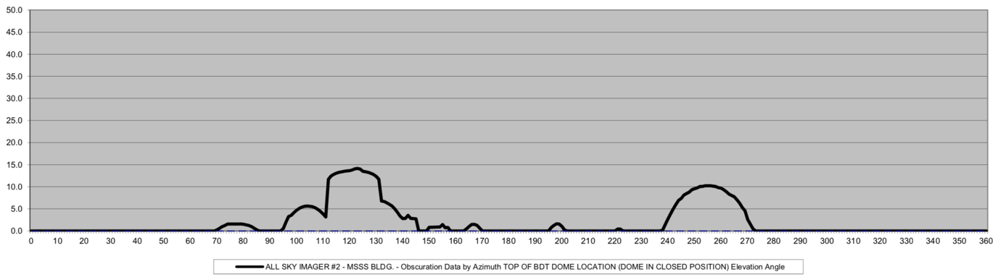

Figure 8‑1. Obscuration mask as a function of azimuth and elevation angle taken to determine the suitability for placing an infrared whole sky imager.

### An IWSI shall be geolocated so that its camera is referenced to zenith and true north with an accuracy of 1°.

### To enable accurate atmosphere characterization, an azimuth and zenith angle mapping of detected clouds, the IWSI per pixel field of view (FOV) shall be measured.

## Ceilometer

### The ceilometer may be mounted on a mount that allows for the ceilometer to record measurements of backscatter towards zenith or off zenith (e.g., towards a GEO satellite).

### The ceilometer shall be mounted such that it has an unobstructed view to zenith (i.e., 90° elevation angle) or to other off-zenith directions.

## Meteorological Sensor Suite

### A meteorological suite capable of measuring temperature, humidity, pressure, wind speed and direction shall be located in an area with the following considerations:

* Adequate ventilation
* No physical structure obscurations that will impact wind speed and direction measurements
* Sited within 10 meters of the potential/existing OGS dome facility

## Differential Image Motion Monitor (DIMM)

### A DIMM shall be housed inside a dome structure within 10 meters of the potential/existing OGS dome facility.

### The DIMM should be mounted at a height that is within one meter of the height of the potential/existing OGS ground aperture.

# Cloud Retrievals from Geostationary Satellites

## Overview

While the recommended best practice for characterizing the atmospheric parameters for an OGS is to use data from ground-based instrumentation, some space agencies may desire a more inexpensive option, at least initially. The method described below may avoid the costs associated with planning, developing, deploying, and maintaining atmospheric instrumentation and can provide an initial evaluation of possible ground sites, including their historical CFLOS statistics. It should be stressed, however, that because of the limited horizontal and temporal resolution of satellite data, this method is no substitute for use of in situ data. Furthermore, satellite data only provides information on clouds, on a relatively large scale.

Several agencies—including NOAA, ESA, and JAXA—operate geostationary meteorological satellites. These satellites provide routine coverage of clouds from approximately 60° North Latitude to 60° South Latitude, both day and night. NOAA, for example, operates and maintains the Geostationary Operational Environmental Satellite (GOES) system. NOAA operates two GOES spacecraft—one at 75° West Longitude and the other at 135° West Longitude. The GOES horizontal data resolution at the subpoint is approximately 0.5 kilometers in the visible and 2.0 kilometers in the infrared. GOES includes the Advanced Baseline Imager (ABI), which provides temporal coverage of approximately five minutes.

JAXA and the Japanese Meteorological Agency (JMA) operate a similar satellite called Himawari that also includes the ABI. Himawari provides the same horizontal coverage and similar temporal refresh as the GOES satellites. Similarly, ESA operates two Meteosat Second Generation (MSG) satellites, which share many of the same spectral, horizontal, and temporal resolution characteristics as the GOES and Himawari spacecraft. Figure 9‑1shows a composite global image using infrared images from these five satellites.

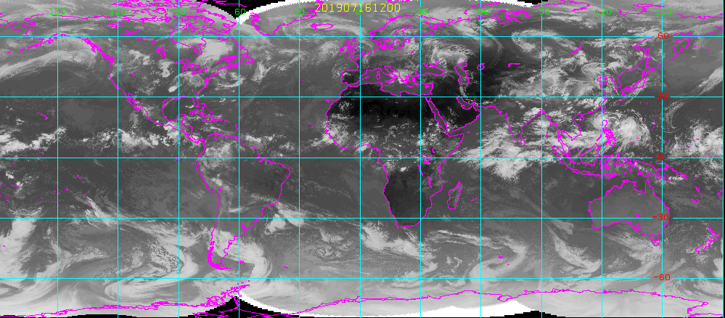

Figure 9‑1 Composite infrared image of the Himawari, GOES and MSG satellites.

Many of the agencies that operate geostationary meteorological satellites offer online access to the cloud retrieval products derived from their respective imagers. In many cases, multi-year, archived, cloud products such as a pixel-level cloud, no-cloud determinations are available for download and analysis. The algorithms developed to retrieve these cloud products are developed and validated by the respective meteorological agencies.

Several examples of pixel-level cloud retrieval are shown below. In Figure 9‑2, a NOAA GOES-16 image over the Continental United States is shown. Figure 9‑3 shows a cloud retrieval product from the JMA Himawari satellite. Figure 9‑4 shows an example of a CFLOS analysis based on a cloud dataset derived from GOES. In this analysis, the mean monthly CFLOS or availability is shown. The individual red dots represent the CFLOS for each of the 22 years analyzed. The blue line represents the mean of all 22 years of data. Similar analyses can assist in determining whether a site is suitable as an optical ground station or, at a minimum, help decide whether to deploy local instrumentation.

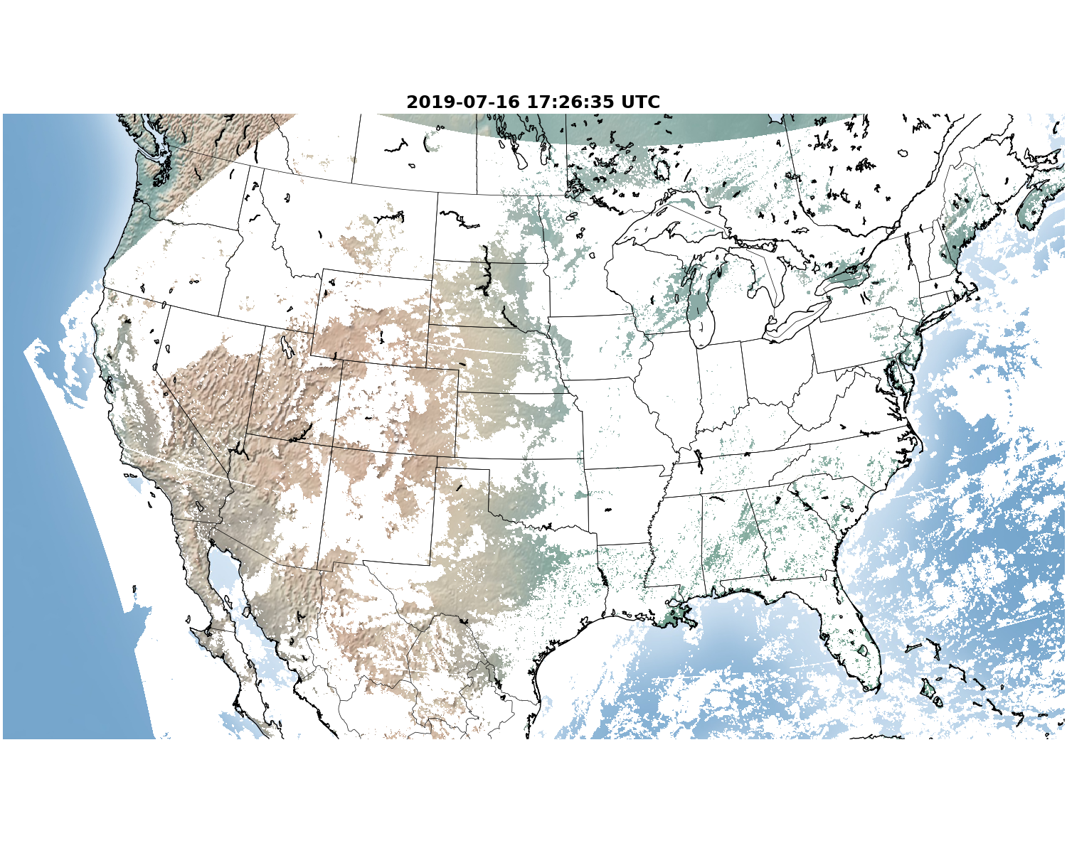

Figure 9‑2. GOES 16 pixel-level cloud determination over the continental U.S.

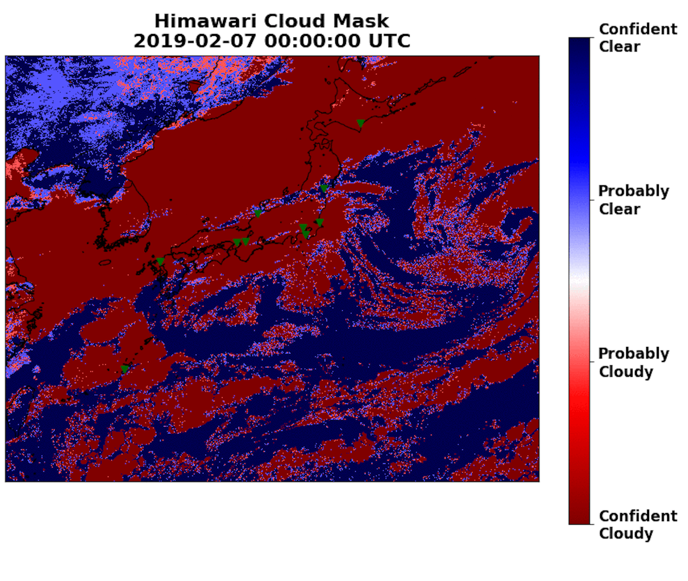

Figure 9‑3 Himawari pixel-level cloud determination, with confidence intervals, over Asia and adjacent Pacific ocean. Green markers represent the locations of NICT existing Atmospheric Monitoring sites.

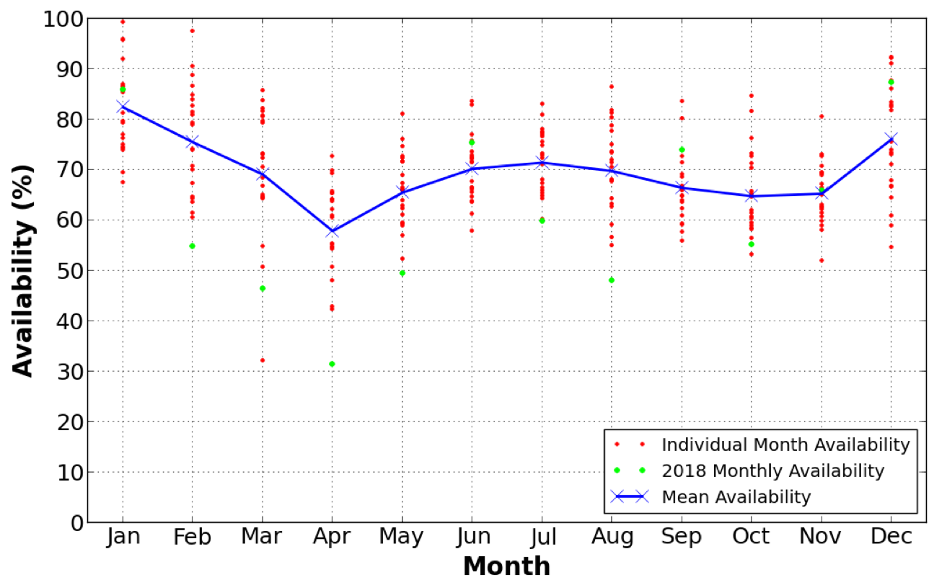

Figure 9‑4. The mean availability (or CFLOS) of a site as derived from GOES data for the period 1997 – 2018 as a function of each month of the year. The blue line represents the mean availability for all months and the individual red dots represent the availabilities for each of the 22 years.

Guidelines for the collection and analysis of the satellite-derived cloud retrievals for the purpose of characterizing CFLOS are found below.

## General Recommendations

### Cloud, no-cloud retrievals from geostationary meteorological satellites may be used to characterize potential OGSs prior to deployment of a local atmospheric monitoring system.

### It is the sole responsibility of each CCSDS member agency to obtain the pixel-level cloud retrieval products from the respective meteorological service operating the meteorological satellite over the area of interest.

### Historical CFLOS analysis for candidate ground sites shall be based on a minimum seven-year period of record.

### Statistics of CFLOS may include, but are not limited to, frequency of occurrence of cloud freeness and conditional statistics (e.g., given that it is clear now, what is the probability it remains clear for at least *n*-minutes, where *n* equals the number of minutes).

### Statistics of CFLOS shall be decomposed into yearly, seasonal, monthly, and diurnal variations.

### Correlations between sites may be calculated if multiple sites have coincident time-by-time cloud determinations.

### Network CFLOS or availability may be computed if multiple sites have coincident time-by-time cloud determinations.

### A cross-correlation analysis with local data shall be conducted if such local data exists.

1. Example XML Schema For Scalar Data

<?xml version="1.0" ?>

<xs:schema xmlns:xs="http://www.w3.org/2001/XMLSchema">

<xs:element name="ScalarData">

<xs:complexType>

<xs:sequence>

<xs:element name="Location">

<xs:complexType>

<xs:sequence>

<xs:element name="Latitude">

<xs:complexType>

<xs:sequence>

<xs:element minOccurs="1" name="LatDegrees">

<xs:simpleType>

<xs:restriction base="xs:integer">

<xs:minInclusive value="-90.0"/>

<xs:maxExclusive value="90.0"/>

</xs:restriction>

</xs:simpleType>

</xs:element>

<xs:element minOccurs="1" name="LatMinutes">

<xs:simpleType>

<xs:restriction base="xs:integer">

<xs:minInclusive value="0.0"/>

<xs:maxExclusive value="60.0"/>

</xs:restriction>

</xs:simpleType>

</xs:element>

<xs:element minOccurs="1" name="LatSeconds">

<xs:simpleType>

<xs:restriction base="xs:integer">

<xs:minInclusive value="0.0"/>

<xs:maxExclusive value="60.0"/>

</xs:restriction>

</xs:simpleType>

</xs:element>

</xs:sequence>

</xs:complexType>

</xs:element>

<xs:element name="Longitude">

<xs:complexType>

<xs:sequence>

<xs:element minOccurs="1" name="LonDegrees">

<xs:simpleType>

<xs:restriction base="xs:integer">

<xs:minInclusive value="0.0"/>

<xs:maxExclusive value="360.0"/>

</xs:restriction>

</xs:simpleType>

</xs:element>

<xs:element minOccurs="1" name="LonMinutes">

<xs:simpleType>

<xs:restriction base="xs:integer">

<xs:minInclusive value="0.0"/>

<xs:maxExclusive value="60.0"/>

</xs:restriction>

</xs:simpleType>

</xs:element>

<xs:element minOccurs="1" name="LonSeconds">

<xs:simpleType>

<xs:restriction base="xs:integer">

<xs:minInclusive value="0.0"/>

<xs:maxExclusive value="60.0"/>

</xs:restriction>

</xs:simpleType>

</xs:element>

</xs:sequence>

</xs:complexType>

</xs:element>

</xs:sequence>

</xs:complexType>

</xs:element>

<xs:element name="Date">

<xs:simpleType>

<xs:restriction base="xs:date"/>

</xs:simpleType>

</xs:element>

<xs:element name="Time">

<xs:simpleType>

<xs:restriction base="xs:time"/>

</xs:simpleType>

</xs:element>

<xs:element minOccurs="1" name="Temperature">

<xs:simpleType>

<xs:annotation>

<xs:documentation>Temperature (in Celcius)</xs:documentation>

</xs:annotation>

<xs:restriction base="xs:float">

<xs:minInclusive value="-80.0"/>

<xs:maxExclusive value="60.0"/>

<xs:fractionDigits value="1"/>

</xs:restriction>

</xs:simpleType>

</xs:element>

<xs:element minOccurs="1" name="RelativeHumidity">

<xs:simpleType>

<xs:annotation>

<xs:documentation>Relative humidity (in %)</xs:documentation>

</xs:annotation>

<xs:restriction base="xs:float">

<xs:minInclusive value="0.0"/>

<xs:maxExclusive value="100.0"/>

<xs:fractionDigits value="1"/>

</xs:restriction>

</xs:simpleType>

</xs:element>

<xs:element minOccurs="1" name="WindSpeed">

<xs:simpleType>

<xs:annotation>

<xs:documentation>Wind speed (in ms-1)</xs:documentation>

</xs:annotation>

<xs:restriction base="xs:float">

<xs:minInclusive value="0.0"/>

<xs:maxExclusive value="75.0"/>

<xs:fractionDigits value="1"/>

</xs:restriction>

</xs:simpleType>

</xs:element>

<xs:element minOccurs="1" name="WindDirection">

<xs:simpleType>

<xs:annotation>

<xs:documentation>Wind direction (in degrees)</xs:documentation>

</xs:annotation>

<xs:restriction base="xs:integer">

<xs:minInclusive value="0"/>

<xs:maxExclusive value="360"/>

<xs:fractionDigits value="0"/>

</xs:restriction>

</xs:simpleType>

</xs:element>

<xs:element minOccurs="1" name="SurfaceAirPressure">

<xs:simpleType>

<xs:annotation>

<xs:documentation>Surface pressure (in hPa)</xs:documentation>

</xs:annotation>

<xs:restriction base="xs:float">

<xs:minInclusive value="500.0"/>

<xs:maxExclusive value="1100.0"/>

<xs:fractionDigits value="1"/>

</xs:restriction>

</xs:simpleType>

</xs:element>

<xs:element minOccurs="1" name="SolarInsolation">

<xs:simpleType>

<xs:annotation>

<xs:documentation>Solar insolation (in Wm-2)</xs:documentation>

</xs:annotation>

<xs:restriction base="xs:float">

<xs:minInclusive value="0.0"/>

<xs:maxExclusive value="2400.0"/>

<xs:fractionDigits value="1"/>

</xs:restriction>

</xs:simpleType>

</xs:element>

<xs:element minOccurs="0" name="RainfallRate">

<xs:simpleType>

<xs:annotation>

<xs:documentation>Rainfall rate (in mmh-1)</xs:documentation>

</xs:annotation>

<xs:restriction base="xs:float">

<xs:minInclusive value="0.0"/>

<xs:maxExclusive value="1800.0"/>

<xs:fractionDigits value="1"/>

</xs:restriction>

</xs:simpleType>

</xs:element>

<xs:element minOccurs="0" name="FriedCoherencelength">

<xs:simpleType>

<xs:annotation>

<xs:documentation>Fried coherence length (in cm)</xs:documentation>

</xs:annotation>

<xs:restriction base="xs:float">

<xs:minInclusive value="0.0"/>

<xs:maxExclusive value="100.0"/>

<xs:fractionDigits value="1"/>

</xs:restriction>

</xs:simpleType>

</xs:element>

<xs:element minOccurs="0" name="AerosolAttenuation">

<xs:simpleType>

<xs:annotation>

<xs:documentation>Aerosol attenuation (during daylight hours, in dB)</xs:documentation>

</xs:annotation>

<xs:restriction base="xs:float">

<xs:minInclusive value="1.0"/>

<xs:maxExclusive value="10.0"/>

<xs:fractionDigits value="1"/>

</xs:restriction>

</xs:simpleType>

</xs:element>

<xs:element minOccurs="1" name="CloudbaseHeight">

<xs:simpleType>

<xs:annotation>

<xs:documentation>Cloud base height (from ceilometer profile, in meters)</xs:documentation>

</xs:annotation>

<xs:restriction base="xs:integer">

<xs:minInclusive value="0"/>

<xs:maxExclusive value="13000"/>

<xs:fractionDigits value="0"/>

</xs:restriction>

</xs:simpleType>

</xs:element>

<xs:element minOccurs="0" name="SkydomeCloudFraction">

<xs:simpleType>

<xs:annotation>

<xs:documentation>Skydome cloud fraction (derived from CloudMask, in %)</xs:documentation>

</xs:annotation>

<xs:restriction base="xs:float">

<xs:minInclusive value="0.0"/>

<xs:maxExclusive value="100.0"/>

<xs:fractionDigits value="1"/>

</xs:restriction>

</xs:simpleType>

</xs:element>

<xs:element minOccurs="0" name="IsoplanaticAngle">

<xs:simpleType>

<xs:annotation>

<xs:documentation>Isoplanatic angle derived from Fried coherence length (microradians)</xs:documentation>

</xs:annotation>

<xs:restriction base="xs:float">

<xs:minInclusive value="0.0"/>

<xs:maxExclusive value="20.0"/>

<xs:fractionDigits value="1"/>

</xs:restriction>

</xs:simpleType>

</xs:element>

</xs:sequence>

</xs:complexType>

</xs:element>

</xs:schema>

1. Example XML Schema For Multi-dimensional Data

<?xml version="1.0" ?>

<xs:schema xmlns:xs="http://www.w3.org/2001/XMLSchema">

<xs:element name="1D2D_Data">

<xs:complexType>

<xs:sequence>

<xs:element name="Location">

<xs:complexType>

<xs:sequence>

<xs:element name="Latitude">

<xs:complexType>

<xs:sequence>

<xs:element minOccurs="1" name="LatDegrees">

<xs:simpleType>

<xs:restriction base="xs:integer">

<xs:minInclusive value="-90.0"/>

<xs:maxExclusive value="90.0"/>

</xs:restriction>

</xs:simpleType>

</xs:element>

<xs:element minOccurs="1" name="LatMinutes">

<xs:simpleType>

<xs:restriction base="xs:integer">

<xs:minInclusive value="0.0"/>

<xs:maxExclusive value="60.0"/>

</xs:restriction>

</xs:simpleType>

</xs:element>

<xs:element minOccurs="1" name="LatSeconds">

<xs:simpleType>

<xs:restriction base="xs:integer">

<xs:minInclusive value="0.0"/>

<xs:maxExclusive value="60.0"/>

</xs:restriction>

</xs:simpleType>

</xs:element>

</xs:sequence>

</xs:complexType>

</xs:element>

<xs:element name="Longitude">

<xs:complexType>

<xs:sequence>

<xs:element minOccurs="1" name="LonDegrees">

<xs:simpleType>

<xs:restriction base="xs:integer">

<xs:minInclusive value="0.0"/>

<xs:maxExclusive value="360.0"/>

</xs:restriction>

</xs:simpleType>

</xs:element>

<xs:element minOccurs="1" name="LonMinutes">

<xs:simpleType>

<xs:restriction base="xs:integer">

<xs:minInclusive value="0.0"/>

<xs:maxExclusive value="60.0"/>

</xs:restriction>

</xs:simpleType>

</xs:element>

<xs:element minOccurs="1" name="LonSeconds">

<xs:simpleType>

<xs:restriction base="xs:integer">

<xs:minInclusive value="0.0"/>

<xs:maxExclusive value="60.0"/>

</xs:restriction>

</xs:simpleType>

</xs:element>

</xs:sequence>

</xs:complexType>

</xs:element>

</xs:sequence>

</xs:complexType>

</xs:element>

<xs:element name="Date">

<xs:simpleType>

<xs:restriction base="xs:date"/>

</xs:simpleType>

</xs:element>

<xs:element name="Time">

<xs:simpleType>

<xs:restriction base="xs:time"/>

</xs:simpleType>

</xs:element>

<xs:element name="CeilometerBackscatter">

<xs:simpleType>

<xs:restriction>

<xs:simpleType>

<xs:list>

<xs:simpleType>

<xs:annotation>

<xs:documentation>Ceilomter backscatter profile (per steradian)</xs:documentation>

</xs:annotation>

<xs:restriction base="xs:integer">

<xs:minInclusive value="-1000"/>

<xs:maxExclusive value="100000"/>

<xs:fractionDigits value="0"/>

</xs:restriction>

</xs:simpleType>

</xs:list>

</xs:simpleType>

<xs:maxLength value="2000"/>

</xs:restriction>

</xs:simpleType>

</xs:element>

<xs:simpleType name="SkyRadianceNil">

<xs:restriction base="xs:string">

<xs:enumeration value="NA"/>

</xs:restriction>

</xs:simpleType>

<xs:simpleType name="SkyRadianceVal">

<xs:restriction base="xs:float">

<xs:minInclusive value="0.0"/>

<xs:maxInclusive value="30.0"/>

</xs:restriction>

</xs:simpleType>

<xs:simpleType name="SkyRadiancePix">

<xs:union memberTypes="SkyRadianceVal SkyRadianceNil"/>

</xs:simpleType>

<xs:simpleType name="SkyRadianceList">

<xs:list itemType="SkyRadiancePix"/>

</xs:simpleType>

<xs:element name="SkyRadianceRowData" type="SkyRadianceList">

<xs:simpleType>

<xs:restriction base="SkyRadianceList">

<xs:minLength value="640"/>

<xs:maxLength value="unbounded"/>

</xs:restriction>

</xs:simpleType>

</xs:element>

<xs:element name="SkyRadianceImage">

<xs:complexType>

<xs:sequence maxOccurs="unbounded" minOccurs="480">

<xs:element name="SkyRadianceRow" type="SkyRadianceRowData"/>

</xs:sequence>

</xs:complexType>

</xs:element>

<xs:simpleType name="CloudMaskNil">

<xs:restriction base="xs:string">

<xs:enumeration value="NA"/>

</xs:restriction>

</xs:simpleType>

<xs:simpleType name="CloudMaskVal">

<xs:restriction base="xs:integer">

<xs:minInclusive value="0"/>

<xs:maxInclusive value="1"/>

</xs:restriction>

</xs:simpleType>

<xs:simpleType name="CloudMaskPix">

<xs:union memberTypes="CloudMaskVal CloudMaskNil"/>

</xs:simpleType>

<xs:simpleType name="CloudMaskList">

<xs:list itemType="CloudMaskPix"/>

</xs:simpleType>

<xs:element name="CloudMaskRowData" type="CloudMaskList">

<xs:simpleType>

<xs:restriction base="CloudMaskList">

<xs:minLength value="640"/>

<xs:maxLength value="unbounded"/>

</xs:restriction>

</xs:simpleType>

</xs:element>

<xs:element name="CloudMaskImage">

<xs:complexType>

<xs:sequence maxOccurs="unbounded" minOccurs="480">

<xs:element name="CloudMaskRow" type="CloudMaskRowData"/>

</xs:sequence>

</xs:complexType>

</xs:element>

<xs:simpleType name="CloudAttenuationNil">

<xs:restriction base="xs:string">

<xs:enumeration value="NA"/>

</xs:restriction>

</xs:simpleType>

<xs:simpleType name="CloudAttenuationVal">

<xs:restriction base="xs:float">

<xs:minInclusive value="0.0"/>

<xs:maxInclusive value="10.0"/>

</xs:restriction>

</xs:simpleType>

<xs:simpleType name="CloudAttenuationPix">

<xs:union memberTypes="CloudAttenuationVal CloudAttenuationNil"/>

</xs:simpleType>

<xs:simpleType name="CloudAttenuationList">

<xs:list itemType="CloudAttenuationPix"/>

</xs:simpleType>

<xs:element name="CloudAttenuationRowData" type="CloudAttenuationList">

<xs:simpleType>

<xs:restriction base="CloudAttenuationList">

<xs:minLength value="640"/>

<xs:maxLength value="unbounded"/>

</xs:restriction>

</xs:simpleType>

</xs:element>

<xs:element name="CloudAttenuationImage">

<xs:complexType>

<xs:sequence maxOccurs="unbounded" minOccurs="480">

<xs:element name="CloudAttenuationRow" type="CloudAttenuationRowData"/>

</xs:sequence>

</xs:complexType>

</xs:element>

<xs:simpleType name="SkydomeCloudCorrelationNil">

<xs:restriction base="xs:string">

<xs:enumeration value="NA"/>

</xs:restriction>

</xs:simpleType>

<xs:simpleType name="SkydomeCloudCorrelationVal">

<xs:restriction base="xs:float">

<xs:minInclusive value="0.0"/>

<xs:maxInclusive value="1.0"/>

</xs:restriction>

</xs:simpleType>

<xs:simpleType name="SkydomeCloudCorrelationPix">

<xs:union memberTypes="SkydomeCloudCorrelationVal SkydomeCloudCorrelationNil"/>

</xs:simpleType>

<xs:simpleType name="SkydomeCloudCorrelationList">

<xs:list itemType="SkydomeCloudCorrelationPix"/>

</xs:simpleType>

<xs:element name="SkydomeCloudCorrelationRowData" type="SkydomeCloudCorrelationList">

<xs:simpleType>

<xs:restriction base="SkydomeCloudCorrelationList">

<xs:minLength value="640"/>

<xs:maxLength value="unbounded"/>

</xs:restriction>

</xs:simpleType>

</xs:element>

<xs:element name="SkydomeCloudCorrelationImage">

<xs:complexType>

<xs:sequence maxOccurs="unbounded" minOccurs="480">

<xs:element name="SkydomeCloudCorrelationRow" type="SkydomeCloudCorrelationRowData"/>

</xs:sequence>

</xs:complexType>

</xs:element>

</xs:sequence>

</xs:complexType>

</xs:element>

</xs:schema>

1. Security Considerations  
     
   (Informative)
   1. Introduction
   2. security concerns with respect to the CCSDS document
      1. Data privacy
      2. Data integrity
      3. Authentication of communicating entities
      4. Control of access to resources
      5. Availability of resources
      6. Auditing of resource usage
   3. Potential threats and attack scenarios
   4. Consequences of not applying security to the technology
2. Abbreviations and Acronyms   
     
   (Informative)

This annex lists key abbreviations and acronyms that are used throughout this Recommended Practice.

|  |  |
| --- | --- |
| **ACRONYM** | **DEFINITION** |
| ABI | Advanced Baseline Imager |
| AGL | Above Ground Level |
| AMS | Atmospheric Monitoring Station |
| AO | Adaptive Optics |
| ASA | Austrian Space Agency |
| ASI | Agenzia Spaziale Italiana |
| BFSPO | Belgian Federal Science Policy Office |
| CAS | Chinese Academy of Sciences |
| CAST | Chinese Academy of Space Technology |
| CCSDS | Consultative Committee for Space Data Systems |
| CFLOS | Cloud-Free Line of Sight |
| CLTC/BITTT | China Satellite Launch and Tracking Control General, Beijing Institute of Tracking and Telecommunications Technology |
| CNES | Centre National d’Etudes Spatiales |
| CNSA | China National Space Administration |
| CSA | Canadian Space Agency |
| CSIRO | Commonwealth Scientific and Industrial Research Organization |
| DCTA | Departamento De Ciência e Tecnologia Aeroespacial |
| DIMM | Differential Image Motion Monitor |
| DLR | Deutsches Zentrum für Luft- und Raumfahrt |
| DNSC | Danish National Space Center |
| ESA | European Space Agency |
| ETRI | Electronics and Telecommunications Research Institute |
| EUMETSAT | European Organization for The Exploitation of Meteorological Satellites |
| EUTELSAT | European Telecommunications Satellite Organization |
| FOV | Field Of View |
| FSA | Federal Space Agency |
| FSOC | Free Space Optical Communications |
| GEO | Geostationary |
| GISTDA | Geo-Informatics And Space Technology Development Agency |
| GOES | Geostationary Operational Environmental Satellite |
| HNSC | Hellenic National Space Committee |
| IKI | Russian Institute of Space Research |
| INPE | Instituto Nacional de Pesquisas Espaciais |
| ISRO | Indian Space Research Organization |
| IWSI | Infrared Whole Sky Imager |
| JAXA | Japan Aerospace Exploration Agency |
| JMA | Japanese Meteorological Agency |
| KARI | Korea Aerospace Research Institute |
| KFKI | KFKI Research Institute For Particle & Nuclear Physics |
| LEO | Low Earth orbit |
| LWIR | long-wave infrared |
| m | Meter |
| MKS | meter-kilogram-second |
| MOC | Ministry Of Communications |
| MSG | Meteosat Second Generation |
| NaN | Not a Number |
| NASA | National Aeronautics And Space Administration |
| NCST | Naval Center for Space Technology |
| NICT | National Institute of Information and Communications Technology |
| NOAA | National Oceanic And Atmospheric Administration |
| NSARK | National Space Agency of the Republic of Kazakhstan |
| NSPO | National Space Organization |
| NWP | Numerical Weather Prediction |
| OGS | Optical Ground Station |
| OT | Optical Turbulence |
| PDF | Probability Density Function |
| RH | Relative Humidity |
| SANSA | South African National Space Agency |
| SCC | Skydome Cloud Correlation |
| SSC | Swedish Space Corporation |
| SSO | Swiss Space Office |
| SUPARCO | Space And Upper Atmosphere Research Commission |
| TUBITAK | Scientific and Technological Research Council of Turkey |
| USGS | United States Geological Survey |
| UTC | Coordinated Universal Time |
| XML | Extensible markup language |