CCSDS Optical Communications (OPT) Working Group
Generic Framing Procedure (GFP) Project
Concept Paper

Section 1: Background
Recently, the CCSDS Optical Communications Working Group has been investigating the use of Generic Framing Procedure (GFP), a frame encapsulation technique defined by the International Telecommunications Union (ITU) G.7041/Y.1303 standard. GFP has been proposed for inclusion in the Orange Book on High Data Rate Optical Communications at 1550 nm under development by the Centre National d’Etudes Spatiales (CNES), Japan Aerospace Exploration Agency (JAXA), National Aeronautics and Space Administration (NASA), and Japan’s National Institute of Information and Communications Technology (NICT), and the team developing that experimental standard briefed its merits to the larger working group.
In the published Blue Books on optical communications, the optical coding and synchronization layers accept fixed-length frames rate-matched to the optical channel. As shown in Figure 1, this approach works for CCSDS fixed-length transfer frames such as frames from CCSDS Telemetry (TM) or from the CCSDS Advanced Orbiting Systems (AOS) protocols. This approach also works well for fixed-length frames from the CCSDS Universal Space Link Protocol (USLP). However, this method does not work for variable length USLP or for directly accepting Ethernet frames without encapsulation; directly accepting Ethernet frames has been mentioned by several industry participants in the working group as a cost-effective approach to meeting the needs of their customers.
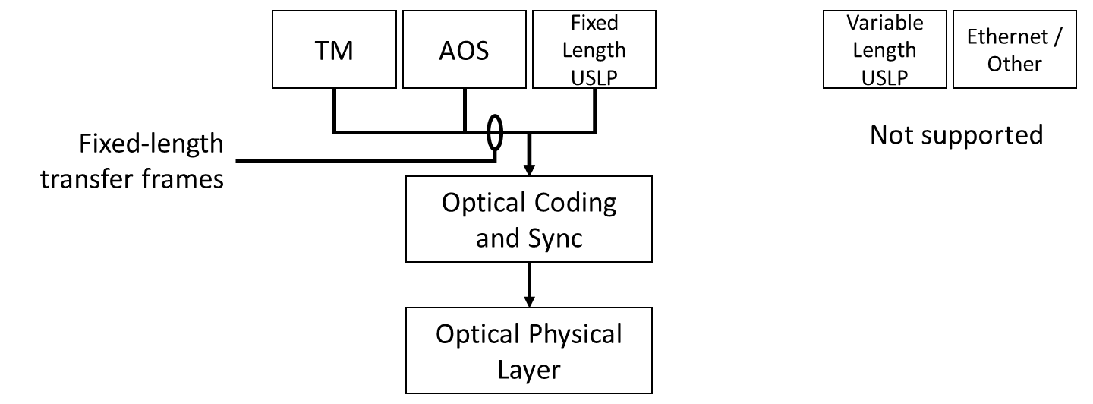

Figure 1: Frame transfer services provided by the currently published CCSDS Optical Communications Recommendations
A GFP frame consists of a core header, a payload header, an optional extension header, a GFP payload, and an optional payload frame check sequence.
Most of the working group members believe strongly that CCSDS optical communications signaling recommendations would be more widely applicable if they accepted variable-rate variable-length frames at the input to the coding and synchronization layer. This scenario could easily be accomplished by using Generic Framing Procedure to adapt higher-layer frame formats to the fixed-rate octet transport service, which is why GFP is being used in the CNES, JAXA, NASA, NICT Orange Book previously mentioned. GFP is now being investigated by more working group members because it is a widely adopted industry standard for terrestrial optical communications systems and it supports many common client interfaces. Figure 2 shows how GFP could be used in the CCSDS recommendations already published.

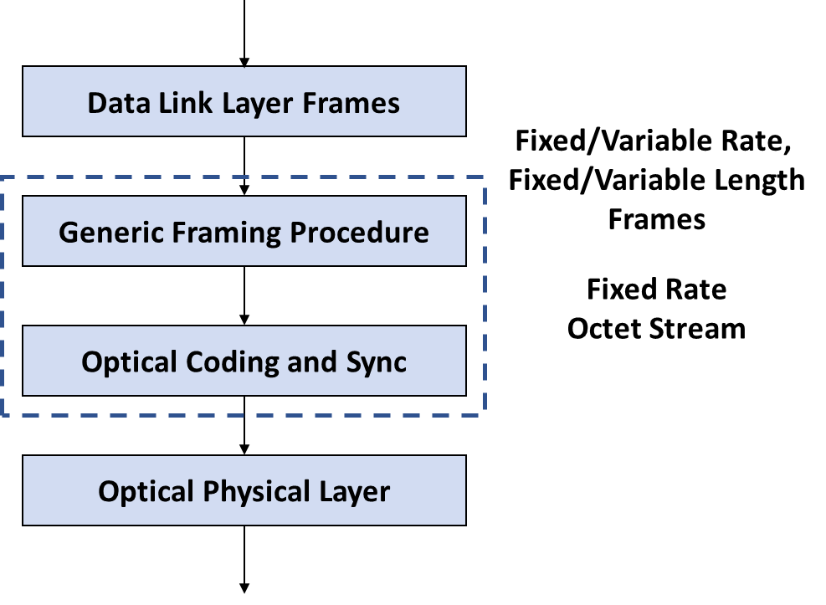
Figure 2: Proposal for Generic Frame Transport
SECTION 2: Tentative Work Plan

The following tentative work plan is established.
The CCSDS Optical Communications Working Group members have reached consensus to start a new project to incorporate GFP into the existing Optical Communications Coding & Synchronization Layer Blue Book. Specifically, the working group members would like to see GFP incorporated in the High Photon Efficiency (HPE) chapter of the book via pink sheets.
 |  | Start | End
1 | Generic Framing Procedure (GFP) for High Photon Efficiency (HPE) chapter within the Optical Communications Coding & Synchronization Blue Book | Jan 20 | June 21

The above dates will be refined by the working group (WG) according to work progress.
The CCSDS Optical Communications Working Group recognizes that it will have to work with the other working groups within the Space Link Services Area of CCSDS. Specifically, the working group will hold joint meetings with the Space Link Coding and Synchronization Working Group (SLS-C&S) and the Space Link Protocols Working Group (SLS-SLP). The plan is to hold several joint telecons among the working groups and to hold a joint session at the Spring 2020 Technical Meeting and at the Fall 2020 CCSDS Technical Meeting.

ANNEX A
CCSDS Optical Communications (OPT) Working Group

Generic Framing Procedure (GFP) Project

1) Pink Sheets for the High Photon Efficiency Chapter of the Optical Communications Coding and Synchronization Layer Blue Book

Title: Optical Communications Coding & Synchronization Layer

Document Type: Blue Book

Description of Existing Document: This Blue Book defines the coding, synchronization, interleaving parameters, and techniques required for interoperability of optical communications space-Earth and space-space links.

New Material to be included via Pink Sheets: The use of Generic Framing Procedure (GFP), a frame encapsulation technique defined by the International Telecommunications Union (ITU) G.7041/Y.1303 standard.

Applicable Patents: None

Patents Comments: None

Book Editor (estimated resources + Agency Volunteering): 2nn NASA

Prototype 1 (estimated resources + Agency Volunteering): 1mm NASA

Prototype 2 (estimated resources + Agency Volunteering): 1mm TBD

Expected Contributing Agencies: CNES, Deutsches Zentrum für Luft- und Raumfahrt (DLR), European Space Agency (ESA), JAXA, NASA, NICT

Expected Monitoring Agencies:

Schedule: Jan 2020 – June 2021

Schedule Milestones | Forecast | Comments
Project Approved | 1 Jan 2020
Internal WG Review
- First draft circulated to WG | 30 May 2020 | After Spring 2020 Meeting
- First draft comments due | 30 June 2020
- Second draft circulated to WG | 30 September 2020 | Before Fall 2020 Meeting
- Second draft comments due | 30 October 2020 | Before Fall 2020 Meeting
- Final WB submitted to AD for further processing | 1 December 2020 | After Fall 2020 Meeting
Secretariat Document Processing | 1 January 2021 | Start of Review after CESG + CMC Polls
First Agency Review | 1 March 2021 | End of Review
RID Resolution | 1 May 2021 | At Spring 2021 Meeting
Secretariat Document Processing | N/A | The working group projects that these will be simple Pink Sheets that will not require a second round of processing and review
Final Agency Review | N/A | N/A
RID Resolution | N/A | N/A
First Prototype Development | 31 Dec 2020 | NASA
Second Prototype Development | 31 Dec 2020 | TBD
CMC Approval | 1 June 2021 | Includes Final Secretariat Document Processing + CESG Poll + CMC Poll for PUBLICATION

