CONTENTS
Section Page
CONTENTS i
1 Introduction 1-1
1.1 Purpose 1-1
1.2 Scope 1-1
1.3 Document Structure 1-1
1.4 References (to be formatted correctly in next version) 1-1
2 Overview 2-1
2.1 Background on Atmospherics 2-1
2.2 Value of Long-term Statistics for Site Characterization 2-4
2.2.1 Clouds 2-4
2.2.2 Optical Turbulence 2-6
3 Physical quantities to be measured or Derived 3-1
3.1 Primary Physical Quantities 3-1
3.1.1 Clouds 3-1
3.1.2 Optical Turbulence (Seeing Parameters) 3-2
3.1.3 Aerosols Optical Depth/sky radiance measurements 3-5
3.1.4 standard meteorological quantities 3-9
3.2 Secondary Physical Quantities 3-10
3.2.1 rayleigh scattering 3-11
3.2.2 molecular absorptioN 3-12
4 Instruments to Measure Physical Quantities 4-1
4.1 whole sky imager (cloud coverage and CLOUD attenuation) 4-1
4.1.1 Visible 4-1
4.1.2 Infrared 4-3
4.2 ceilometer (cloud attenuation and cloud base height) 4-7
4.3 Differential image motion monitor (DIMM) (seeing parameters) 4-7
4.4 Measurements of Atmosphere Transmittance aNd Radiance: SUN-Photometery 4-8
4.4.1 Measurements of Atmospheric Attenuation from a Sun-Photometer 4-8
4.4.2 Sky Radiance 4-11
4.4.3 Particle Distribution 4-11
4.5 meteorological station 4-13
4.5.1 Temperature 4-13
4.5.2 Wind 4-13
4.5.3 Relative Humidity 4-14
4.5.4 Pressure 4-15
5 Requirements for Real-time Collection of Physical Quantities 5-1
5.1 Minutes to an Hour 5-1
5.1.1 Cloud Coverage 5-1
5.1.2 Cloud Attenuation 5-1
5.1.3 Cloud Base Height 5-1
5.1.4 Aerosols/ Sky Radiance Measurements 5-2
5.1.5 Standard Meteorological Quantities 5-2
5.2 Seconds to Minutes 5-2
5.2.1 Optical Turbulence (Seeing Parameters) 5-2
6 Using the Physical Quantities to Predict Future Site Conditions 6-1
6.1 Lead time for Weather predictions 6-1
6.1.1 Dependence on the Concept of OPerations 6-1
6.2 Technology required for atmospheric predictions 6-1
6.2.1 Persistence 6-2
6.2.2 Advection (recent cloud motion) 6-3
6.2.3 Numerical Weather Prediction (cloud prediction) 6-5
7 USING THE PHYSICAL QUANTITIES TO EVALUTE LONG-TERM CHARACTERISTICS OF A SITE 7-1

Introduction

Purpose
Space-to-ground optical communications are affected by the presence of cloud cover and other atmospheric effects. Therefore, it is critical to accurately measure the long-term characteristics of critical atmospheric parameters for purposes of site selection. In addition, to mitigate the effects of atmospherics in an operational system, it will be desirable to have real-time knowledge of atmospheric characteristics to make link handover decisions. The purpose of this report is to identify and characterize the atmospheric constituents that are most responsible for transmission losses in optical communications links. A full description of these atmospherics is given, along with a description of the types of instruments that are required to characterize these atmospherics in real time and to develop long-term climatologies. Requirements for the collection of these atmospherics in real time are given, including an explanation of how they might be used in a handover prediction system, as well as for long-term characterization.

Scope
The scope of this report is to provide a detailed description of the critical atmospheric parameters (e.g., clouds, turbulence, aerosols) and how they may be measured using ground-based instrumentation. This report does not recommend any particular instruments or manufacturer for in situ collection; rather, it provides a high-level description of the types of instruments required. It does, however, provide examples of existing instruments that have been deployed and are currently being used for optical communications applications. This report also describes types of prediction systems that have been considered by governments and discusses the resources necessary to enable them.

Document Structure
This report is divided into four main areas. A background on the history and importance of atmospheric data collection is given in section 2. Section 3 lists and describes the critical atmospheric parameters suggested for collection and archival. Section 4 describes the instruments necessary for the real-time and long-term collection of the atmospheric parameters described in section 3. Sections 5 and 6 describe the requirements for the temporal collection of the atmospheric parameters and explain how this data may be used in a predictive system based on the desired forecast length for each site.

References (to be formatted correctly in next version)
The following documents are referenced in this Report. At the time of publication, the editions indicated were valid. All documents are subject to revision, and users of this Report are encouraged to investigate the possibility of applying the most recent editions of the documents indicated below. The CCSDS Secretariat maintains a register of currently valid CCSDS documents.
- Randall J. Alliss and Billy Felton, “Realtime Atmospheric Decision Aids in Support of the Lunar Laser Communications Demonstration,” Proc. International Conference on Space Optical Systems and Applications (ICSOS) 2014, S2-3, Kobe, Japan, May 7-9 (2014)
- OLSG Final Report Addendum https://www.ioag.org/Public%20Documents/Forms/AllItems.aspx
- W. Paul Menzel and James F. W. Purdom, 1994: Introducing GOES-I: The First of a New Generation of Geostationary Operational Environmental Satellites. Bull. Amer. Meteor. Soc., 75, 757–781.
- Wojcik, Gary S. et al., Deep-space to ground laser communications in a cloudy world (Free-Space Laser Communications V. Edited by Voelz, David G.; Ricklin, Jennifer C., Proceedings of the SPIE, Volume 5892, pp. 17-27, 2005).
- OLSG Final Report https://www.ioag.org/Public%20Documents/Forms/AllItems.aspx
- Alliss, R.J, and B.W. Felton: “Numerical Simulations of Optical Turbulence Using an Advanced Atmospheric Prediction Model: Implications for Adaptive Optics Design” (AMOS) Proceedings, 2014.
- NWP reference
- Felton, B.D., and R.J. Alliss: “Improved Atmospheric Characterization for Free-Space Link Analysis using Numerical Weather Prediction”, SPIE Proceedings, Vol. 8380, 838008 (2012).
- Rec. ITU-R P.840-2
- http://science-edu.larc.nasa.gov/SCOOL/cldhgt.html
- E. L. Andreas, “Estimating C_{n}² over snow and sea ice from meteorological data,” Journal of the Opt. Soc. In America A, vol. 5, no. 4, Apr. 1988.
- B. Edlen, “The refractive index of air,” Metrologia 2, 71–80, 1966.
- James C. Owens, “Optical Refractive Index of Air: Dependence on Pressure, Temperature and Composition,” Appl. Opt. 6, 51-59, 1967.
- Philip E. Ciddor, “Refractive index of air: new equations for the visible and near infrared,” Appl. Opt. 35, 1566-1573 1996.
- Liu Peng, K. Kazaura, K. Wakamori, M. Matsumoto, “Studies on C_{n}² and its effects on free space optical communication system,” APSITT 2010, p. 1-6, 2010.
- L. C. Andrews, R. L. Phillips, “Laser Beam Propagation through Random Media”, second edition, SPIE press, 2005.
- L. C. Andrews, R. L. Phillips, C. Y. Hopen, “Laser Beam Scintillation with Applications,” SPIE press, 2001.
- J. L. Mohr, R. A. Johnston, P. L. Cottrell, Optical Turbulence Measurements and Models for Mount John University Observatory, DOI:10.1071/AS10008
- M. Toyoshima, “Lightwave Propagation in the Presence of Random Turbulent Media and Pointing Jitter in Optical Space Communications,” doctor thesis, 2003.
- Jingquan Cheng, “The Principles of Astronomical Telescope Design,” Springer, 2009
- A. Berk, L. S. Bernstein, and D. C. Robertson, ‘MODTRAN: A moderate resolution code for LOWTRAN 7,’ GL-RT-89-0122 (1989)
- M. G. Dittman 'Contamination Scatter Functions for Stray Light Analysis,' Proc. SPIE, 4774, 99, 2002
- www.windfinder.com
- Bodhaine, B.A., N.B. Wood, E.G. Dutton, & J.R. Slusser, ‘On Rayleigh Optical Depth Calculations’, J. Atmos. Ocean. Tech., 16, 1854-1861, (1999)
- G.P. Anderson, F.X. Kneizys, J.H. Chetwind, J. Wand, M.L. Hoke, L.S. Rothman, L.M.Kimball, R.A. McClatchey, E.P. Shettle, S.A. Clough, W.O. Gallery, L.W. Abreu, J.E.A. Selby,“FASCODE/MODTRAN/LOWTRAN: Past/Present/Future”, 18th Annual Review Conference on Atmospheric Transmission Models, 1995.
- H.J.P. Smith, D.J. Dube, M.E. Gardner, S.A. Clough, F.X. Kneizys, and L.S. Rothman, FASCODE- Fast Atmospheric Signature Code (Spectral Transmittance and Radiance), Air Force Geophysics Laboratory Technical Report AFGL-TR-78-0081, Hanscom AFB, MA, 1978.
- Wang, G. P. Anderson, H. E. Revercomb, and R. O. Knuteson,’Validation of FASCOD3 and MODTRAN3: comparison of model calculations with ground-based and airborne interferometer observations under clear-sky conditions,’ Applied Optics, Vol. 35, Issue 30, pp. 6028-6040 (1996)
- Klebe, D., Sebag, J., Blatherwick, R. D., and Zimmer, P. C.: All-sky mid-infrared imagery to char- acterize sky conditions and improve astronomical observational performance, Publ. Astron. Soc. Pac., 124, 1309–1317, 2012.
- A. Tokovinin, “From Differential Image Motion to Seeing”, Publication of the Astronomical Society of the Pacific, 114:1156-1166, 2002.
- https://www-n.oca.eu/aristidi/hivernage/Manips/dimm.html
- S. A. Ehgamberdiev, et. Al.: “The astroclimate of Maidanak Observatory in Uzbekistan,” Astron. Astrophys. Suppl. Ser., Vol. 145, No. 2, pp. 293-304, 2000.
- Glenn E. Shaw, ‘Sun Photometery,’ Bulletin of the American Meteorological Society, 64, Issue 1 (January 1983).
- B.N. Holben ,T.F. Eck, I. Slutsker, D. Tanré, J.P. Buis, A. Setzer, E. Vermote, J.A. Reagan, Y.J. Kaufman, T. Nakajima , F. Lavenu, I. Jankowiak, A. Smirnov, ‘AERONET—A Federated Instrument Network and Data Archive for Aerosol Characterization,’ Remote Sens. Environ 66:1-16 (1998).
- Smirnov A., B. N. Holben, T. F. Eck, O. Dubovik, and I. Slutsker, 2000: Cloud screening and quality control algorithms for the AERONET database, Rem.Sens.Env., 73, 337-349
- Dubovik, O., A. Smirnov, B. N. Holben, M. D. King, Y.J. Kaufman, T. F. Eck, and I. Slutsker, 2000: Accuracy assessments of aerosol optical properties retrieved from AERONET sun and sky-radiance measurements, J. Geophys. Res., 105, 9791-9806.
- http://www.electronics-tutorials.ws/io/io_3.html
- http://www.metoffice.gov.uk/learning/learn-about-the-weather/weather-phenomena/humidity
- http://www.owlstonenanotech.com/humidity/measurement-methods

Overview

Background on Atmospherics
Space-to-ground optical communications are adversely affected by the presence of cloud cover and optical turbulence, and to a lesser extent by atmospheric extinction due to the presence of aerosols. These atmospheric effects require different mitigation strategies.
Typical clouds produce optical transmission losses (fades) that far exceed several decibels (dB), the amount often considered as the limit in any link budget. Therefore, it may not be feasible to include enough link margin in the link budget to prevent outages. It should be noted, however, that some cirrus clouds may have optical fades less than a few dB when averaged over a very short period of time (e.g., minutes). However, an optical communications link directed through the atmosphere may encounter “knots” or areas within thin cirrus that may far exceed three dB (Figure 2-1). These conditions were observed in past optical communication demonstrations (e.g., LLCD) [1]. Therefore, a mitigation strategy ensuring a high likelihood of a Cloud Free Line of Sight (CFLOS) between a ground station and the spacecraft is needed to maximize the transfer of data and the overall availability of the network.
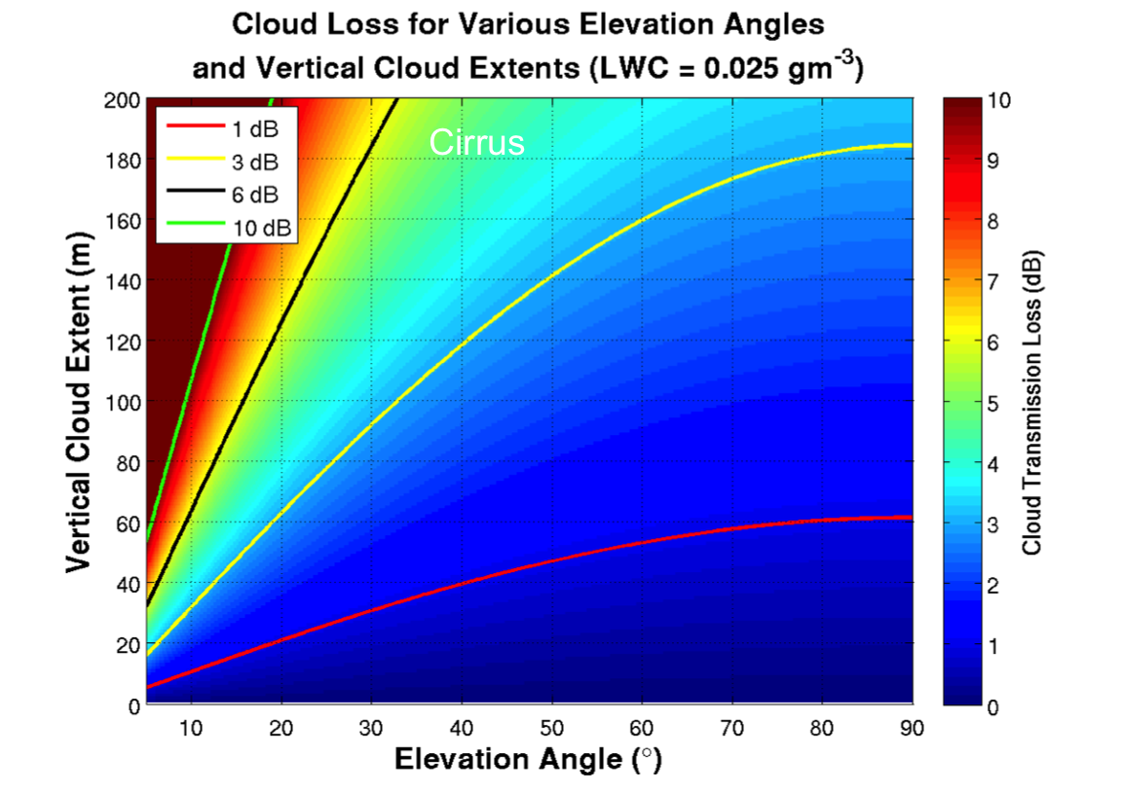
Figure 2-1. Fade (cloud transmission loss) due to a typical cirrus cloud as a function of elevation angle and physical thickness of the cloud. Fade increases with increased cloud thickness and decreased elevation angle [1].
One strategy to address the problem of cloud outages in optical communications involves “ground station diversity,” where multiple stations have the potential to receive communications when other sites are cloud-covered or unavailable due to geometric visibility limitations. The availability of a communication link between a spacecraft and a ground station network depends on many factors, including the number and location of the sites in the network and the orbit of the spacecraft, which together determine the elevation angle of the link and the path length of transmission through the atmosphere. A ground station is typically considered available for communication when it has a CFLOS at an elevation angle to the spacecraft terminal of approximately 20° or more. Below 20° the atmospheric effects of turbulence and aerosols may be too large to close the link without substantial fading errors. In most cases, the network is available for communication when at least one of its sites has CFLOS, depending on the Concept of Operations (CONOPS). Typical meteorological patterns cause the cloud cover at stations within a few hundred kilometers of each other to be correlated because cloud systems generally occur on scales of many hundreds of kilometers. Consequently, stations within the network should be placed far enough apart to minimize these correlations, thus maximizing the probability of CFLOS. This requirement may lead to the selection of a station that has a lower CFLOS than sites not selected, but has a cloud cover that is less correlated with other network sites. The stations also need to be close enough to each other to maintain continuous access with the spacecraft as its position with respect to the ground changes with time. An example of this situation is given in Figure 2-2, which shows the results of a site selection optimization for a proposed ten-site network with connectivity to a satellite in an L1 orbit [2]. These ten sites together produce a network availability of approximately 95%. Note the average station spacing in this example is on the order of 10³ km partly due to the L1 orbit and partly due to the desire to minimize the effects of correlated atmospherics. The highest availability of any one ground station in this network is ~32% taking into account satellite access and CFLOS.
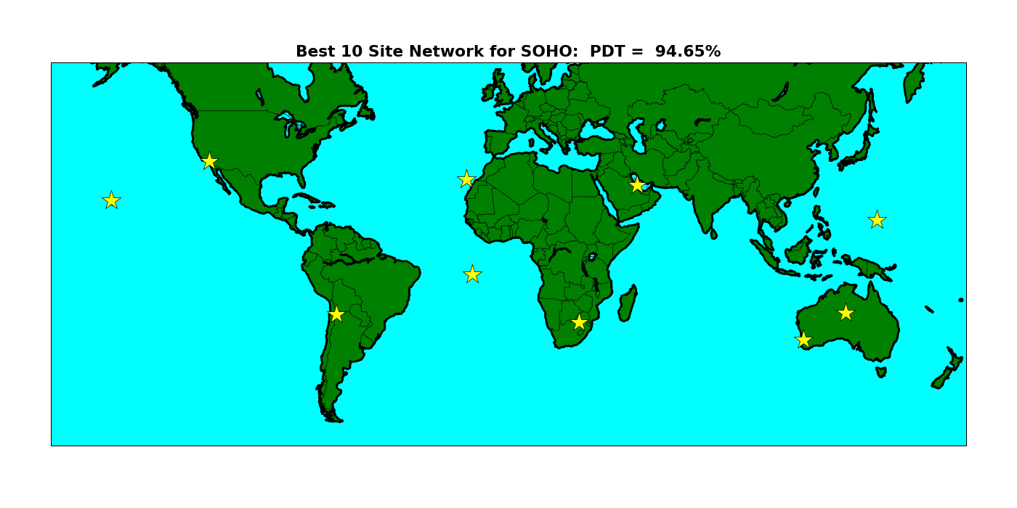
Figure 2-2. Diverse network of ground sites for a L1 Space-to-Ground CONOPS. Percent Data Transferred (PDT) is 94.65% [2].

Real-time local characterization of clouds enables intelligent handover decisions. Figure 2-3 shows results from a study of an optical link from Geostationary orbit to five ground sites. The study was intended to evaluate the availability of the network when the spacecraft had a priori knowledge of the cloud conditions at each site, but with different cloud detection accuracies. It trades that performance with a scenario when the spacecraft has no prior knowledge of the cloud conditions. The network availability is a function of satellite handover time for a single-head spaceborne transmitter. The red line shows the network availability when no a priori knowledge of clouds is available to make handover decisions. The various blue lines show the network availability when cloud data is available with varying degrees of measurement accuracy. In nearly all cases network availability benefits from local knowledge of cloud cover. This study supports the use of ground-based sensors to assist in station handover, at least for this CONOPS. Although not shown, it is believed that ground-based cloud data may also benefit a LEO-to-ground scenario where contact time at a site is not continuous, but is on the order of 5-10 minutes, as in the case of a geostationary scenario,. Accurate detection of cloud properties is also critical to maximize performance and availability.
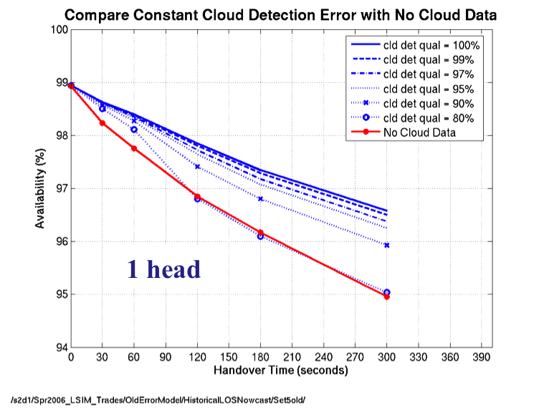
Figure 2-3. Network availability of a free-space-to-ground optical communication (FSOC) network as a function of handover time and cloud detection quality (cld det qual). The red line shows a scenario where there is no a priori knowledge of the cloud condition at each site.

Optical turbulence (OT) acts to distort light in the atmosphere, degrading imagery collected by ground-based astronomical and other telescopes. In addition, OT may also reduce the quality of service of a free-space optical communications link. Some of the degradation due to OT can be corrected by adaptive optics. However, the severity of OT, and thus the amount of correction required, is largely dependent upon the turbulence at the location of interest. Therefore, it is vital to understand the real-time characteristics and climatology of OT at such locations. In many cases, it is impractical and expensive to set up instrumentation to characterize the long-term statistics (climatology) of OT, particularly in remote locations. Computer simulations are a convenient and less expensive alternative for developing long-term climatologies (see section 2.2). However, for a real-time optical communications system, such simulations are not applicable, and thus a stable, in situ, measuring system is desired.

Although aerosols are not a primary attenuating parameter for optical communications, it is still important to characterize and account for aerosols in the system’s link budget. The aerosol loading in the atmosphere can vary significantly according to location and time of year. For example, an optical ground station located on Tenerife would experience large transmission losses due to the Calima (Saharan dust) events that occur periodically in the spring and summer months.

Value of Long-term Statistics for Site Characterization

Clouds
Clouds are atmospheric phenomena that occur on scales from less than a single kilometer to thousands of kilometers. Because they are composed of water droplets and/or ice crystals, clouds pose a serious attenuation problem for space-to-Earth communications at optical wavelengths (e.g., 1060 nm and 1550 nm). Atmospheric fades exceeding several dB are frequent even for cirrus clouds. Therefore, the mitigation of clouds is a key driver in the performance of free-space-to-ground optical communication (FSOC) systems. One mitigation technique is to identify geographically diverse ground sites where clouds are uncorrelated from a climatological perspective (see section 2.1). Geographic diversity increases the probability that a CFLOS exists to at least one ground site in a network at any given time.
Two capabilities are required to quantify the impacts of clouds on an optical communications system: (1) the ability to obtain a long-duration, high-fidelity, and highly accurate cloud climatology, and (2) a simulation tool that, along with a chosen CONOPS, seeks to find networks of sites that provide high CFLOS availability. A sophisticated, high-fidelity cloud database has been developed by the US Government and customized for optical communication applications over the last two decades. The climatology is derived from data provided by visible and infrared wavelength sensors onboard geostationary meteorological satellites including the US National Oceanic And Atmospheric Administration (NOAA) Geostationary Operational Environmental Satellite (GOES) program [3], the European Meteosat Second Generation (MSG) program, and the Japanese (MTS) program. The Cloud Mask Generator (CMG) [4] ingests the raw infrared and visible radiance images from these satellites. Using clear-sky background modeling and threshold tests, the CMG determines a probability for the existence of clouds in each pixel in the image. The horizontal resolution of the database is approximately 4 km and the temporal resolution ranges from 15 minutes over the continental United States (CONUS) to hourly outside of CONUS (OCONUS). Recently, a real-time 1-km version of the CMG was developed to support the Lunar Laser Communications Demonstration (LLCD). Nearly 20 years (1995–2014) of cloud retrievals have been developed over CONUS and Hawaii for the purposes of long-term characterization of clouds specifically for optical communication applications. The OCONUS database consists of nearly nine years (2005–2014) of hourly retrievals. The OCONUS cloud database currently includes the following regions: Chile and the Rio de Janeiro areas (South America), Ascension Island (Atlantic Ocean), Canary Islands, Spain and Italy, parts of South Africa, parts of South Korea and Japan, and the Perth and Canberra areas in Australia. This cloud database has been validated against in situ data and during LLCD. CMG can be used to develop new cloud-analysis regions for any regions not indicated above.
The Laser Communications Network Optimization Tool (LNOT) uses the cloud databases developed by the CMG to compute the optimal configuration of sites based on a specific mission scenario (e.g., deep space-to-ground), and other constraints like minimum elevation angle from the ground to the spacecraft [4]. For each time step LNOT computes whether the ground terminal will have “access” to the space terminal via a direct elevation angle calculation. If the elevation angle to the satellite is above a specified threshold and the site is determined to be cloud-free, then that site is considered available for communications. A site is determined to be cloud-free if the line of sight between the ground and the space terminal is cloud-free when corrected for the parallax between the meteorological satellite and the communications satellite. A quasi-simulated annealing algorithm is employed to choose networks that will maximize availability and avoid being caught in local availability extrema. LNOT has incorporated the following mission scenarios into its software: GEO, MEO, LEO, L1, L2, and deep space. Recently, LNOT has been updated with the capability to include the impacts of onboard satellite storage. Onboard storage allows the satellite to buffer data onboard during periods of time when no ground station is available for communication (e.g., because of clouds or geometric access limitations). The satellite can then transmit the data to an available site at a future time. In this mode, LNOT computes the percent data transferred or PDT of a network.
First- and second-order statistics are accumulated and saved for each LNOT simulation to study the specific behavior of the optimized networks. Diurnal, monthly, seasonal, and inter-annual variations in network performance are computed. Along with output from the CMG, LNOT has been used over the last two decades to study different mission scenarios including NASA’s recent LLCD as well as the upcoming Laser Communications Relay Demonstration (LCRD). In addition, many simulations using LNOT were conducted during the Interagency Operations Advisory Group (IOAG) Optical Link Study Group (OLSG) activities [2] [5], demonstrating a number of mission scenarios including LEO, L1, L2, and deep space missions. For example, in the LEO scenario, LNOT determined that a four-site network including Haleakala (Hawaii), Tenerife Optical Ground Station (OGS) (Canary Islands), Table Mountain Facility (California), and Hartebeesthoek (South Africa) could produce a PDT of up to 99.6%. The cloud diversity between these sites is responsible for the high performance—a very high probability that at least one site is available.

Optical Turbulence
The characterization of the OT at ground station locations is vital to the mitigation of its effects on the optical communications link. The wavefront of radiation traveling through the atmosphere is distorted as it encounters the optical turbulence created by inhomogeneities in the refractive index of the atmosphere, degrading optical signal quality. These inhomogeneities are caused by small-scale temperature and moisture fluctuations in the atmosphere. The intensity of the turbulent fluctuations of the atmospheric refractive index is described by the refractive index structure parameter, C_{n}². The ability to characterize the OT above a ground station and to understand its vertical distribution is vital and can affect decisions on adaptive optics design and site selection for new locations.
OT can be characterized at sites of interest with instruments such as Differential Image Motion Monitors (DIMM). These instruments are useful for accurately measuring the seeing conditions along particular lines of site for the location at which the DIMM is deployed. However, such instruments are expensive to build and maintain over long durations of time and may not be the most efficient way to determine initial estimates of atmospheric seeing for candidate sites.
Numerical simulations of OT are an attractive alternative to local observations in regions where infrastructure (i.e., electrical power) is lacking. Numerical simulations offer many advantages over direct measurements including a three-dimensional description of C_{n}² over regions of interest, simulations that can be performed anywhere on Earth at any time, and the ability to provide forecasts of OT that can be used for observational scheduling purposes. The quality of these types of simulations for describing the climatology of OT has recently been shown to be quite accurate [6].
A novel approach to simulate OT employs a model used to predict tropospheric weather—Numerical Weather Prediction (NWP). NWP models are routinely used by meteorologists to predict everyday weather; however, in this application the model is modified to make simulations of C_{n}² [7]. The Weather Research & Forecasting (WRF) model developed jointly between the National Center for Atmospheric Research (NCAR) and the National Oceanic and Atmospheric Administration (NOAA) is used to develop climatologies of OT. The model is based on the Navier-Stokes equations, which are solved numerically on a three dimensional grid. The model simulates four basic atmospheric properties—wind, pressure, temperature, and atmospheric water vapor. All other variables are derived from these four parameters.
The WRF model is used to develop climatologies of optical turbulence for several regions around the world including Albuquerque, New Mexico, the summits of Hawaii, and Tenerife OGS. Details of the formulation of the simulation can be found in Felton et. al. (2012) [8]. Figure 2-4 shows the cumulative distributions of both WRF-derived and in situ measurements of the hourly Fried Parameter (r₀) as a function of time of day. The median and 5th and 95th percentile values of the distributions are shown. Data is referenced to 1550 nm and to zenith. Results show a good correlation between the model and actual measurements. The seeing parameter varies significantly by time of day with large values of r₀ observed and modeled at night and lower values observed and modeled during the warmest time of the day. The overall difference between r₀ values generated using the WRF model and observations is approximately 8%.
Although simulated climatologies of OT have great value for initial site selection and perhaps adaptive optics design, it is desired that in situ observations be available to better characterize OT’s local nature. The OT simulations are unable to fully model this phenomena due to limitations in model resolution and surface characterization. In addition, local data collection will be useful in real-time systems to describe the performance of the link.
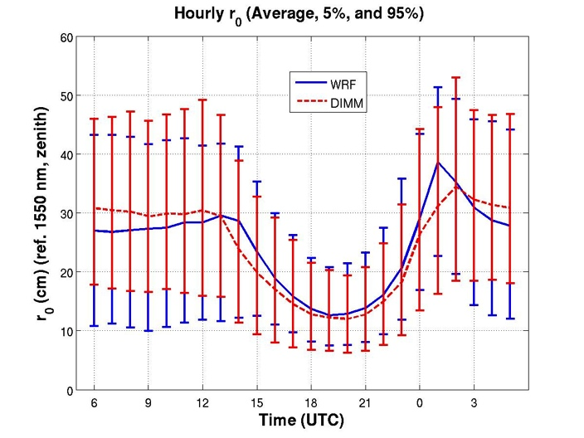
Figure 2-4. Hourly r₀ derived from WRF and compared to in situ measurements at Albuquerque, NM. Data is referenced to 1550 nm and zenith [8].

Physical quantities to be measured or Derived
This section presents the physical quantities to be measured or derived in real time for weather and atmospheric characterization. Atmospheric effects can be separated into losses due to random distortion of the propagating laser beam, scattering, and absorption. To ensure a reliable laser link it is important to gather real-time data for a wide variety of weather and atmospheric parameters to support the application of different techniques to mitigate the atmosphere’s negative impacts on free space optical communications. The collection of real-time data will support the short term prediction of these quantities. These physical quantities are separated into two main groups—primary and secondary. The primary physical quantities provide basic information regarding the atmospheric path quality, and their real-time measurement is essential for link quality estimation and proper system operation. Such physical quantities describe clouds, which are obstacles for lasercom links due to the high attenuation they impose on an optical link. An additional primary physical quantity is optical turbulence, which has a constant effect on the link and can lead to burst errors, quality of signal issues, or even a loss of the link. Finally, selected other physical quantities (e.g., relative humidity and surface wind speed) are also considered to be primary since exceeding certain limits of these parameters can lead to the decision to close the dome and terminate the connection to a given site.
Secondary physical quantities concerning scattering and absorption can be used for general characterization of the optical channel at a given site. Periodic measurements at long intervals of time (months or years) can facilitate identification of significant changes in the optical path characteristics. The real-time values of the secondary physical quantities are not critical for the system operation, however, and the instruments measuring them should be considered optional.

Primary Physical Quantities

Clouds
Clouds are defined as visible mass of liquid droplets or frozen crystals made of water or various chemicals suspended in the atmosphere above the surface of a planetary body. They strongly affect the optical communications signal strength and the attenuation varies widely with the cloud content (water or ice) and physical thickness of the clouds.

Cloud Coverage
Cloud coverage refers to the fraction of the sky obscured by clouds when observed from a particular location. There are four different types of cloud cover as described in Table 3-1:
Table 3-1. Types of cloud cover
1. | Clear | 0-1/10th covered
2. | Scattered | 1/10th – 5/10th covered
3. | Broken | 5/10th – 9/10th covered
4. | Overcast | fully covered
Generally, clouds are considered obstacles to laser communication links because they attenuate the signal There are a few exceptions where clouds produce minor attenuation (e.g., cirrus clouds), but even in such cases the attenuation fluctuations in time are strong enough to interfere with laser communication. Therefore, the cloud coverage parameter is extremely important for estimating link reliability and planning handovers to between sites.

Cloud Attenuation
One of the main problems in ground-to-space and space-to-ground laser communications is the attenuation of the laser beam by clouds, which can lead to link fading for very long periods of time (hours or even days). Clouds insert very high attenuation in optical links because they consist entirely of small water droplets and/or ice crystals, generally less than 0.01 cm in diameter [9], that cause light scattering and absorption. Apart from the physical thickness of the clouds, which varies widely with the cloud type and fluctuates in time, the cloud contents play a critical role in the attenuation. Typically, a water-based cloud will cause a 10 dB loss or more, while an ice-based cloud will cause a loss of approximately 1-8 dB.

Cloud Base Height
The cloud base is the lowest altitude of the visible portion of cloud. It is expressed in meters above mean sea level or as the corresponding pressure level in hectopascal (hPa, equivalent to millibar). In well-defined air masses most of the clouds may have a similar cloud base because this variable is controlled by the thermodynamic properties of that mass, which are relatively homogenous on a large spatial scale. Therefore, cloud height is described with cloud base height and not with the cloud tops that vary widely from cloud to cloud.
Cloud base height can be used to describe the laser communication propagation media and to determine if the cloud is water based or ice based, which is important when estimating signal attenuation. Low clouds (e.g., cumulus, stratus, etc.) are generally made of water droplets and their bases are below 2 km [10]. They can be made of ice at high altitudes in winter. Often fog is also included in this class. Mid-level clouds are those whose base is between 2 and 6 km altitude (e.g., altocumulus) and are generally, but not always, water clouds, depending on the atmosphere’s temperature and other conditions at the cloud altitude. High clouds are those whose base is above 6 km (e.g., cirrus). They can be made of ice or water, but more often consist of ice. There is often more than one cloud layer, which can lead to higher attenuation levels than anticipated. To eliminate such uncertainties, clouds are generally considered as laser communication link obstacles. As such, cloud coverage is a critical parameter for site selection, link reliability evaluation, and handover decision-making.

Optical Turbulence (Seeing Parameters)
As the wavefront propagates through the atmosphere it gets distorted by inhomogeneities in the index of refraction of the air due to variations in the temperature, humidity, pressure, and CO₂ concentration. As a result, the wavefront in the receiver plane is substantially distorted. The overall degradation in image quality due to random phase aberrations is called seeing. The random variations of the index of refraction are described with very good approximation by the stationary Kolmogorov Turbulence model.
The refractive index structure parameter (C_{n}²) describes the atmospheric effects and is widely used in theoretical work to evaluate system performance (probability density functions, fade statistics, etc.). C_{n}²is defined as:

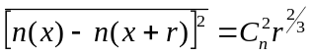. (3.1)
where n is the turbulent refractive index fluctuation, x and x+r are two points in space, r is the magnitude, and the over bar denotes a time average. Andreas [11] gives a complete model for the refractive index structure parameter for a wide range of wavelengths—in the visible, infrared, radio and near millimeter regions. Andreas also discusses the connection between C_{n}² and air parameters as temperature, humidity, pressure, and CO₂ concentration. In Edlén [12] and later in Owens [13] and Ciddor [14], the exact connection between index of refraction of air and the mentioned air parameters can be found.
For a horizontal path propagation, the refractive index structure parameter is assumed to be essentially constant and can be calculated from the received power fluctuations [15]:
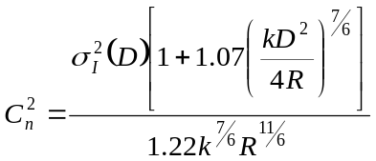, (3.2)
where σ_{I}²(D) is the variance of intensity fluctuation with aperture averaging, k is the wave number (k=2π/λ), D is the receiver aperture diameter, and R is the propagation distance.
Propagation in vertical or slant path requires a C_{n}²(h) profile model to describe the varying strength of optical turbulence as a function of the altitude, h. There are several widely used models for ground-to-space and space-to-ground applications.
The Hufnagel-Valley (H-V) model is described by [16]:
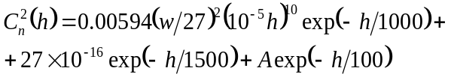, (3.3)
where h is the altitude in meters, A is the nominal value of C_{n}²(0) at the ground in m^{-2/3}, and w is the rms wind speed in m/s, averaged over the 5-10 km above ground level range given by:

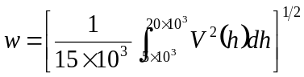, (3.4)
where V(h) is described by Bufton wind model:
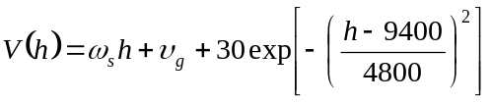. (3.5)
where υ_{g} is the ground wind speed and ω_{s} is the slew rate, associated with satellite moving with respect to an observer on the ground.
Another widely used model is the submarine laser communication studies (SLC) day and night model [16].
The above SLC models represent median values of C_{n}² above the Air Force Maui Optical Station (AMOS) on Mt. Haleakala, Maui, Hawaii, and therefore may not be correct for other geographical locations.
Note that these models of C_{n}² may not produce accurate representations of the turbulence at specific locations, and should only be used in the absence of site-specific measurements or simulations (see section 2.2.2).
C_{n}² provides a connection between the parameters described in Sections 3.1.2.1, 3.1.2.2, and 3.1.2.3. Thus, if one of these parameters is measured, by C_{n}² transition it is possible to derive the other two without measurement.

Atmospheric Coherence Length (Fried parameter, r₀)
As noted above, variations in the index of refraction produce variations in a wavefront of light as it propagates through those variations. As light travels slower in areas with a higher index, the same absolute path length becomes effectively longer or shorter from an optical standpoint in regions of greater or lesser n. This leads to random phase aberrations in the wavefront in the receiving plane. Using the parameterization of Fried, the phase structure function for the inertial range of atmospheric turbulence can be written as [17]:
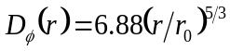. (3.6)
where r₀ is the Fried Parameter (coherence length), defined as [18] [19]
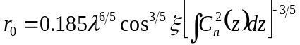, (3.7)
where λ is the wavelength and ξ is the zenith angle (ξ=0 at the zenith and π/2 at the horizon). The Fried parameter is a measure of the aperture over which there is approximately 1 radian of rms phase aberration, so it is a crucial parameter for describing the seeing through a turbulent atmosphere.

The seeing width is inversely proportional to the Fried parameter:
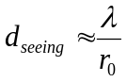 (3.8)
where r₀<D_{T} (D_{T} is the diameter of the telescope primary mirror). If D_{T} is smaller than r₀, the seeing is given by the diffraction limit d_{DL}:
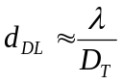. (3.9)

Isoplanatic Angle
It is important to consider the coherence of the same turbulence pattern, as defined by the Fried parameter, over the sky. By definition, the region over which the turbulence pattern is the same is called the isoplanatic patch. The isoplanatic patch is usually defined in terms of isoplanatic angle [20]:
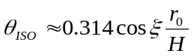, (3.10)
where H is the average distance of the layer most responsible for the seeing scale r₀:
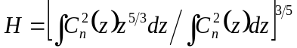. (3.11)

Greenwood Frequency
Adaptive optics is a technology used to improve the link performance by reducing the effect of wavefront distortions. The distortions induced by the atmosphere will change over time due to winds and changes in differential heating at the surface. To properly mitigate these distortions, it is important to measure the aberrations caused by turbulence, and compensate for their effect before they change. Greenwood frequency is the frequency or bandwidth required for optimal correction with an adaptive optic system and is defined as [18]:
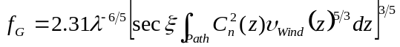 (3.12)
where υ_{Wind}(z) is the wind speed as a function of height. Knowledge of the Greenwood frequency provides information necessary to mitigate wavefront distortion.

Aerosols Optical Depth/sky radiance measurements
When a beam propagates through the atmosphere, it experiences an extinction of the power/irradiance transmitted according to Beer’s law as
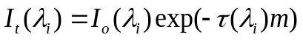 (3.13)
where λ_{i} is the wavelength of interest, I_{t}(λ_{i}) is the irradiance after a path, I_{o}(λ_{i}) is the initial signal irradiance, τ(λ_{i}) is the total atmospheric optical depth (or atmospheric optical thickness), and m is the air mass defined for a slant path with a zenith angle θ as
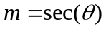 (3.14)
The above equations (3.13 and 3.14) are valid for ground-to-space and space-to-ground links with a zenith angle up to 70º based on the plane-parallel atmosphere model.
Note that the total atmospheric optical depth in Eq. 3.13 refers to a vertical path, and is a function of the atmospheric attenuation coefficient, α (λ_{i} ,z) as
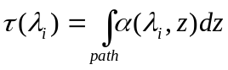 (3.15)
The total atmospheric optical depth represents the absorption and scattering of the propagating optical beam, either by the molecules of the constituent gases of the atmosphere or by the aerosols suspended in the atmosphere itself. Therefore one can specify the total atmospheric optical depth as
(3.16)
where τ_{a}^{s} (λ_{i}) is the contribution due to aerosol scattering, τ_{a}ª (λ_{i}) is the contribution due to aerosol absorption, τ_{m}^{s} (λ_{i}) is the contribution due to molecular scattering, and τ_{m}ª (λ_{i}) is due to molecular absorption.
Finally, the total atmospheric transmittance can be defined by the total atmospheric optical depth as
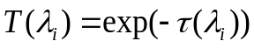 (3.17)
Note that Eq. 3.17 defines the loss that a beam experiences on a given vertical path at a wavelength λ_{i}.
The total atmospheric transmittance can vary greatly over the optical spectrum because of the various contributions to the total optical depth as shown in Eq. 3.16. This spectral variation is shown in Figure 3-5, which depicts the total atmospheric transmittance over a wavelength range between 320nm (UV range) and 1700nm (IR range). The plot may be representative of a ground-to-space scenario where the ground station is at sea level with clear sky condition (no clouds, no haze). The data of atmospheric transmittance in Figure 3-5 are obtained using MODTRAN, a radiative transfer code able to calculate, among different things, the atmospheric transmittance under different weather conditions [21].
The atmospheric optical loss in decibel (dB) can be derived from total atmospheric transmittance or optical depth by the expression

(3.18)

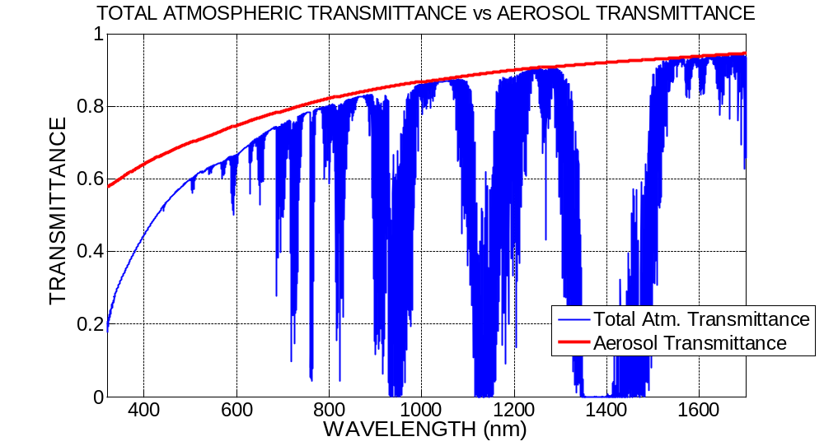
Figure 3-5. Example of spectrum of total atmospheric transmittance and aerosol transmittance. The curves describe a ground to space scenario at zenith. The ground station is at sea level with clear sky and rural aerosol distribution. The curves are obtained by computer simulations using MODTRAN, a radiative transfer code.

Aerosols Attenuation
Aerosols are particles and droplets suspended in the atmosphere that vary in size, origin, and concentration depending on the location on Earth, the season, and/or the time of day. The largest concentration of aerosols is in the boundary layer of the atmospheric profile, which is a layer of thickness between 1 and 2 km from the ground. Aerosol content varies for different environments. For instance, the aerosol content in a maritime environment can be modeled as an aggregation of salt crystal and water droplets, whereas the aerosols in desert locations are mainly composed of dust particles whose concentration and size varies in relation to the ground wind speed. In urban locations, aerosols can be considered as a mixture of combustion byproducts, water molecules, and industrial pollutants. A rural aerosol model refers to a combination of dust and organic particles mixed with water. Aerosol concentration levels and content can also vary with different meteorological conditions in the boundary layer, a condition that would change the atmospheric optical depth due to the aerosol contribution terms in Eq 3.18. Above the boundary layer the aerosol concentration decreases. However, in the stratosphere around the globe there is a noticeable aerosol layer constituted mainly of residual volcanic dust that appears to be generally constant in time, unless recent volcanic eruptions inject a fresh layer of dust into the stratosphere.
The aerosol contribution to the atmospheric transmittance (i.e., atmosphere optical depth) manifests itself mainly as scattering of the propagating signal. Because the wavelengths used in optical communications are either comparable or smaller than the size of aerosol particles, the effects of aerosol scattering can be modeled via Mie scattering theory. Results of the scattering theory indicate that there is a sizable contribution from the aerosol optical depth to the overall atmospheric transmittance. MODTRAN code with an accurate model of the aerosol distribution for a specific environment can provide a close prediction of the aerosol optical depth or the aerosol transmittance [defined as: T_{a}(λ_{i}) = exp(-τ_{a}^{s} (λ_{i})-τ_{a}ª (λ_{i}))]. Figure 3-5 provides a visual comparison of the total atmospheric transmittance and aerosol transmittance. It is very apparent that the aerosol transmittance is the dominant component of the total atmospheric transmittance in the near infrared region (unless the atmospheric transmittance is blocked by other factors such as molecular absorption, as explained in section 3.2.2). At shorter wavelengths (e.g., UV and visible), the aerosol transmittance component still dominates the total transmittance.

Sky Radiance
The Sun is the dominant source of light in the atmosphere during the day. Direct sunlight is not the only source of noise for daytime optical links. When not pointed directly at the Sun, a ground receiver can still detect a bright diffuse scattered light caused by the presence of gasses and aerosols in the atmosphere scattering the solar irradiance. This diffuse light is also known as spectral sky radiance L_{λ}(λ_{i}) and described with units of W/cm²/sr/μm or μW/cm²/sr/nm. Predicting the amount of spectral sky radiance can be very complex, but atmospheric radiative programs such as MODTRAN can provide an accurate description of the problem provided an accurate input model. The strength of sky radiance is dependent on the angular distance from the Sun, increasing with closer proximity because the scattering angle of the direct solar irradiance is more effective. Sky radiance typically increases with air mass and aerosol concentration.
The sky background noise power, P_{t}(λ_{i}) collected at the ground receiver with sky radiance L_{λ}(λ_{i}) at the wavelength of operation λ_{i} can be calculated as
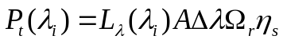 (3.19)
where A is the receiver (or telescope) area, Δλ is the receiver wavelength band of interest, Ω_{r} is the receiver field of view in solid angle, and η_{s} is the optical loss of the receiver.

Particle Distribution
As indicated in section 3.1.3.1, aerosols are most concentrated in the boundary layer. Careful measurement of particle concentration and distribution can provide a correlation of aerosol optical depth and particle distribution. There is also a relation between particle distribution and telescope optics contamination by dust/particle deposition. Increases in contamination level on the mirror may increase the amount of detected stray light and inadvertently sky background light [22]. A measure of this contamination level is the bidirectional distribution function (BRDF) of the (primary) mirror. The BRDF is larger at smaller separation angles from the Sun, and it also increases with contamination level (or particle deposition). The spectral radiance, SL_{λ}(λ_{i}), originated by the BRDF, can be computed as
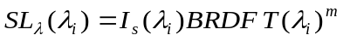 (3.20)
where I_{s}(λ_{i}) is the Sun’s irradiance at the top of the atmosphere. Note that SL_{λ}(λ_{i}) is a function of the atmospheric transmittance and of the air mass m.
Using Eq. 3.20 in addition to Eq. 3.19, one can determine the additional optical noise power captured by a receiver due to contamination of the primary mirror.

standard meteorological quantities

Temperature
Temperature is a measure of warmth or coldness of an object or substance with reference to some standard value. Another convenient definition is that temperature is a measure of the average translational kinetic energy associated with the disordered microscopic motion of atoms and molecules. Temperatures are measured in one of the three standard temperature scales (Celsius, Kelvin, and Fahrenheit). Temperature in the same body of material can vary from place to place and time to time.
Generally, scientific measurements use the Kelvin (K) temperature scale, also called the absolute temperature scale. Its zero point, 0 K, is defined to coincide with the coldest physical temperature possible (called absolute zero) at 0 K = -273.15° C.
For common temperature measurements, the empirically defined Celsius scale is used. 0º C is defined by the freezing point of water, and 100º C is the boiling point of water, both at sea-level atmospheric pressure.
Thermal instability driven by differences in air temperature is the main cause of optical turbulence. Also atmospheric temperature is used to determine cloud composition (water or ice), which in turn is used to estimate the signal attenuation produced by the clouds. Finally, extreme air temperatures may affect the design of optical ground stations and/or influence ground station operations.

Wind
Wind is the flow of gases on a large scale. In the atmosphere wind is caused by differences in the atmospheric pressure, where the air moves from a higher to a lower pressure area. On the Earth, due to the rotation of the planet, the air is deflected by the Coriolis effect, except at the Equator.
Wind direction is usually expressed in terms of the direction from which it originates. Wind speed is reported globally [23] at 10 meters height and averaged over 10 minute time frame. It is given in km/h or m/s.
Wind is an important parameter affecting laser communications because it moves the air and, together with satellite movement, leads to changes in the air volume on the laser path. These changes give rise to different atmospheric turbulence profiles that result in signal level fluctuations. Furthermore, wind is the main reason for cloud movement that could lead to higher or lower cloud cover percentage in time. Finally, some locations on Earth experience very strong winds that can cause movement and vibrations in optical receivers and possibly damage elements of the ground station such as the telescope dome. Therefore, wind speed characteristics must be considered in the physical design and construction of optical ground stations.

Relative Humidity
Relative humidity is the ratio of the partial pressure of water vapor to the equilibrium vapor pressure at the same temperature. It depends on temperature and pressure and contributes to changes in the refractive index of the air, and respectively to optical turbulence, though its effects are much smaller than those of the temperature. High relative humidity levels imply that the dew point (the saturation temperature for water in air) is closer to the current air temperature, which can lead to condensation on the laser communications equipment in the ground station. To prevent that situation, humidity levels should be considered before and during equipment operation, and if critical levels are achieved, handover is recommended (i.e., the telescope dome should be closed).

Pressure
Atmospheric pressure is the force per unit area extended on a surface by the weight of the air above that surface in the atmosphere. On average, a column of air one square centimeter in cross-section, measured from sea level to the top of the atmosphere, has a mass of about 1.03 kg. Average sea-level pressure is 101.325 kPa (1013.25 hPa or millibar).
Atmospheric pressure varies with altitude and generally decreases with increasing altitude. It depends on temperature and humidity. Atmospheric pressure slightly affects the refractive index of air and is also one of the main causes of wind formation, which makes it an important parameter to understand for optical communications.

Secondary Physical Quantities
Gas molecules suspended in the atmosphere interact with a propagating optical beam and attenuate the signal. These effects are best described by the molecular scattering optical depth (or Rayleigh optical depth) τ_{m}^{s} (λ_{i}), and by the optical depth due to molecular absorption τ_{m}ª (λ_{i}).

rayleigh scattering
A number of analytical models are available to characterize the impact of Rayleigh scattering on the optical depth with high fidelity [24].
Radiative transfer codes, such as MODTRAN and FASCODE [25], can also accurately produce values of Rayleigh optical depth for different locations when appropriate atmospheric conditions are input into the model.
Rayleigh or molecular scattering is originated by the interaction of bound electrons of molecules or atoms of gasses in the atmosphere with the incident light. The magnitude of Rayleigh scattering mainly depends on the gas concentration at the observation location [24]. One can approximate the Rayleigh optical depth to first order as
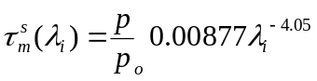 (3.21)
where p is the atmospheric pressure at the location of interest, p_{o} is the atmospheric pressure at sea level, and the wavelength λ_{i} is in micron.
The exponent term in Eq. 3.23 clearly indicates that at longer wavelengths the effects of Rayleigh scattering are greatly reduced, resulting in a smaller contribution of molecular scattering in the total atmospheric transmittance. Figure 3-6 provides a visual description of the total atmospheric transmittance (blue curve) plotted against the portion of atmospheric transmittance related/caused by Rayleigh scattering (black curve). These data were produced using MODTRAN code, and describe a vertical path at sea level in the wavelength range 320-1700 nm. The effects of Rayleigh scattering are barely detectable at wavelengths larger than 1000 nm, and while the scattering increasingly affects the atmospheric transmittance in the visible and is even greater in the UV range, scattering is not a concern at 1060 and 1550 nm.
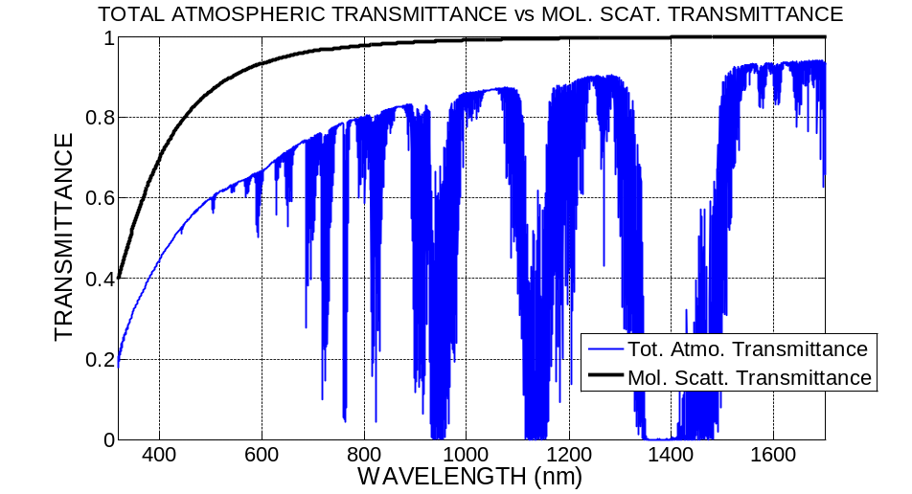
Figure 3-6. Example of spectrum of total atmospheric transmittance and molecular (Rayleigh) scattering transmittance. The curves describe a ground to space scenario at zenith. The example is for ground at sea level with clear sky and rural aerosol distribution. The curves are obtained after of the atmospheric modeling using MODTRAN, a radiative transfer code.

molecular absorptioN
Molecular absorption originates when molecules and/or atoms present in the atmosphere absorb photon energy along discrete levels, changing their vibration, rotational, and electronic energy levels. A number of radiative transfer codes are currently available to calculate the effects of atmospheric absorption under different atmospheric conditions at different site locations. All the software codes use similar algorithms to calculate and define molecular absorption with line-by-line resolution. One model regularly used to calculate molecular absorption is named FASCODE (Fast Atmospheric Signature CODE) [26]. FASCODE can cover a wavelength range from the UV to the infrared, and describes absorption lines with resolution up to 0.001 cm⁻¹. To run FASCODE, a user needs to first model/describe the ground location of interest and then input information about the spectral line and spectroscopic parameters of different components of the atmosphere. FASCODE uses HITRAN (HIgh-resolution TRANsmission), which is a dedicated database that contains spectroscopic parameter of 38 molecular constituents of the atmosphere and their related (over one million) spectral lines.
FASCODE reliability has been validated in a number of programs and studies [27] and is currently considered the benchmark for line-by-line atmospheric transfer codes.
Molecular absorption occurs when the photon energy of the propagating beam is absorbed by molecules or atoms of the gasses present in the atmosphere. These changes in energy states are manifested as very narrow absorption lines in the atmospheric transmittance spectrum at wavelength regions where the transmittance are close to zero. The impact of molecular absorption on the atmosphere can be seen in the spectral profile of the total atmospheric transmittance (blue curve) in Figure 3-6. The strong atmospheric absorption lines in the plot are mostly contributed by the presence of H₂O molecules in the atmosphere. At the optical communication wavelengths being considered by the CCSDS (1060 and 1550 microns), molecular absorption is considered to be a tertiary factor and therefore is not to be measured.

Instruments to Measure Physical Quantities
This section is a guideline, providing examples of the current instruments that are used to measure the physical quantities explained in section 3. There is no obligation to implement the same instruments, as long as each site is sufficiently equipped to provide real-time measurements at least of the primary physical quantities.

whole sky imager (cloud coverage and CLOUD attenuation)
The whole sky imager (WSI) is a passive (non-emissive) system that acquires images of the sky dome used for assessing and documenting cloud fields and cloud field dynamics. The received sky images can be used to evaluate the presence, distribution, shape, and radiance of clouds over the entire sky.

Visible
The visible WSI provides clouds information during the day and has a fish eye lens with wide field of view (FOV) that focuses the whole sky image into a CCD camera. To guarantee proper operation under all weather conditions, a closed module heater and cooling fan are implemented (Figure 4-7). Figure 4-8 shows an example image from the WSI used in a NICT weather monitoring system. The CCD specifications are shown in Table 4-2 and the fish eye lens information is available in Table 4-3.
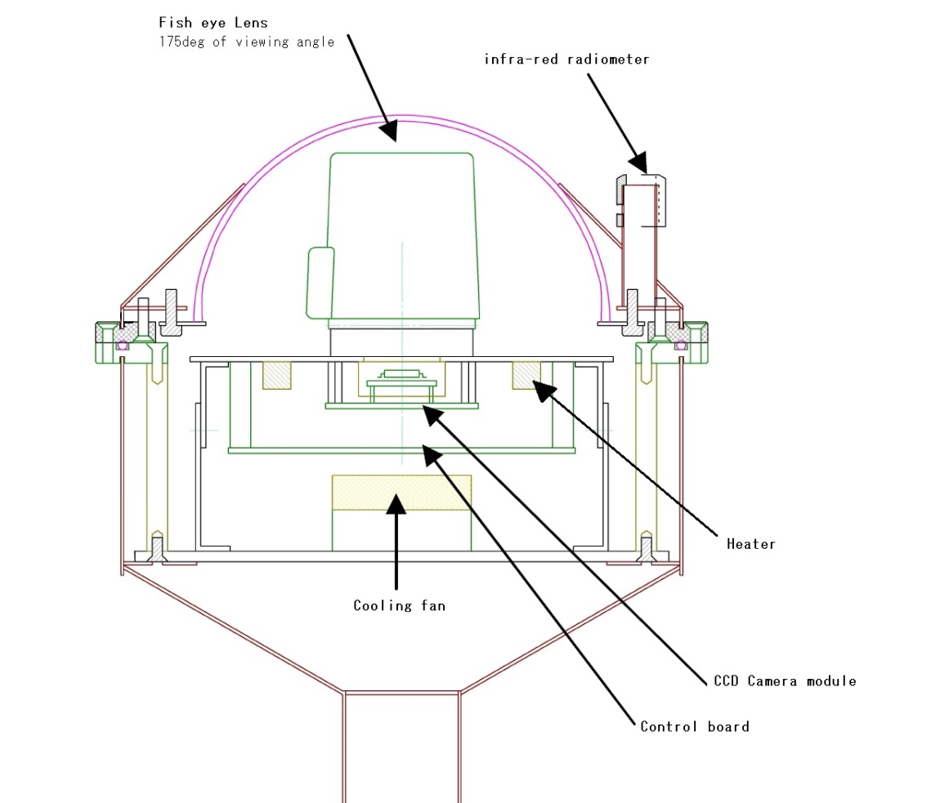
Figure 4-7. Whole sky imager structure
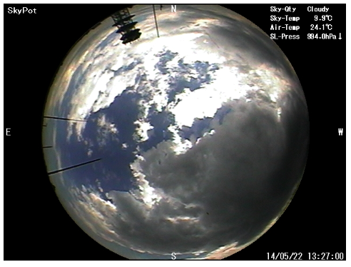
Figure 4-8. Example image from the whole sky imager

Table 4-2. CCD camera characteristics
Parameter | Color camera mode
TV system | NTSC
Number of pixels | 4.1 Mpix (811(H) x 508(V))
Minimum luminance (Normal Operation) | 0.1 lux
Minimum luminance (Starlight Operation) | 0.0014 lux
Gain control mode | Automatic Gain Control (ON/OFF)
Gain control range | 0~18 dB
S/N (AGC OFF mode) | minimum 50 dB/ typical 58 dB
Shutter AES | 1/60~1/12000 sec
Shutter FIX | 1/60,1/100,1/250,1/1000,1/2000,1/4000,1/10000 sec
SENS-UP (accumulation) | X2,4,8,16,32,64,128,256

Table 4-3. Variable focus fish eye lens characteristics
Model | FUJINON YV2.2 x 1.4A-SA2
Focal length | 1.4-3.1 mm (2.2x)
Aperture range | F1.4~T360
Focusing range (from lens front) | ∞~0.2 (m)
Zoom | Manual
Focus | Manual
Iris | Automatic (DC type)
Field of view (H x V) 1/3 wide | 185º (ϕ3.45 mm)
Field of view 1/3 tile | 94º47’ x 69º26’
FOV 1/4 wide | 185º x 121º
FOV 1/4 tile | 69º26’ x 51º30’
Back focal distance (In air) | 7.82 mm

Infrared
Apart from the visible WSI that uses a CCD camera and fish-eye lens, an IR (infrared) cloud sensor could also be used for cloud coverage estimation during the night. An example of IR cloud sensor is shown in Figure 4-9. It consists of five passive infrared temperature sensors that are pointed in the north, south, east, west and vertical directions. Figure 4-10 shows the percentage of cloud coverage in each of the five areas, according to data received from the instrument shown in Figure 4-9.
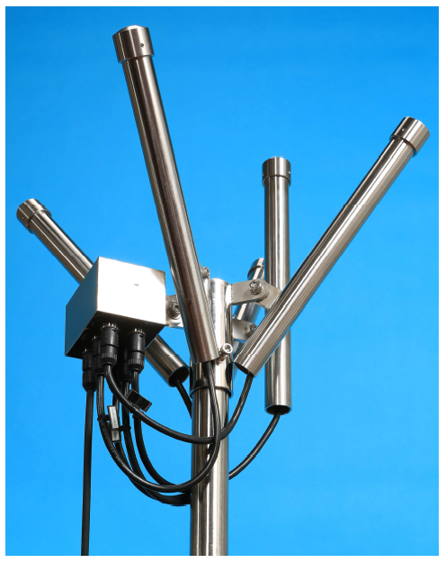
Figure 4-9. Infrared cloud sensor
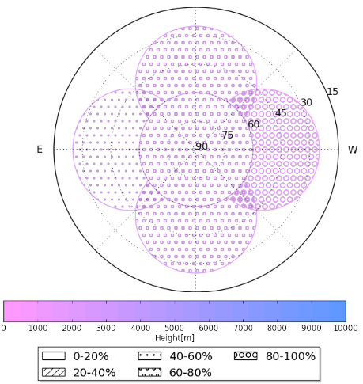
Figure 4-10. Cloud coverage diagram from IR cloud sensor
The IR temperature sensor structure is shown on Figure 4-11. It has an internal thermometer and connection to an external thermometer to measure the temperatures, and a heater to ensure equal temperatures inside the sensor and outside the system, which is important to guarantee suitable operation conditions for the front lens.
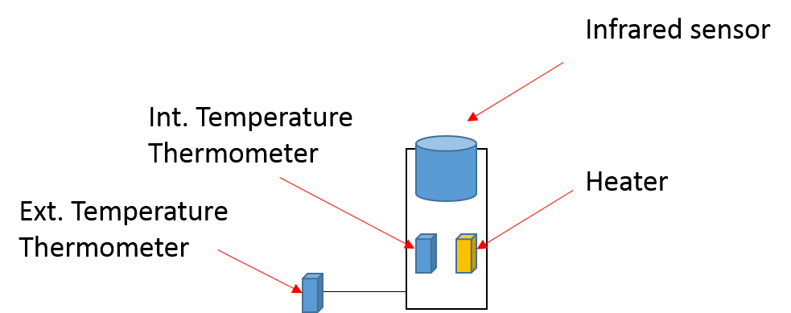
Figure 4-11. IR thermometer
The field of view (FOV) of the IR sensor used in NICT weather monitoring system is 60º.
Another example of an infrared instrument is shown in Figure 4-12 below [28]. The All Sky Infrared Visible Analyzer (ASIVA), a multi-purpose visible and infrared sky imaging and analysis instrument whose primary function is to provide radiometrically calibrated imagery in the mid-infrared (mid-IR). This functionality enables the determination of diurnal hemispherical cloud fraction (HCF) and estimates of sky/cloud temperature from which one can derive estimates of cloud emissivity and cloud height.
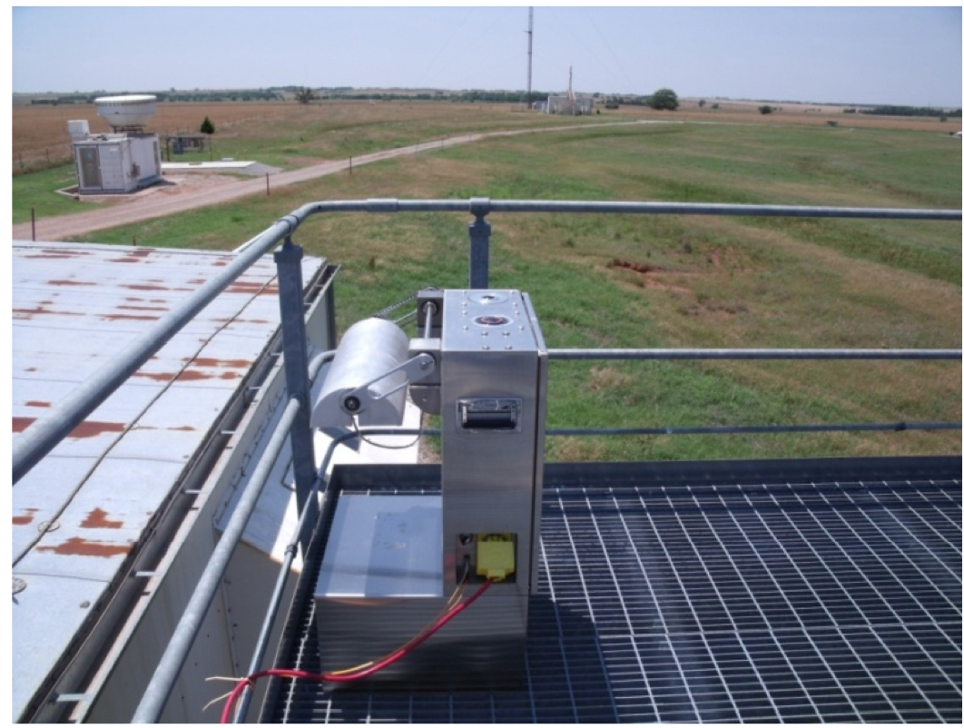
Figure 4-12. ASIVA infrared cloud instrument [28].
An example of output from the ASIVA is shown in Figure 4-13.
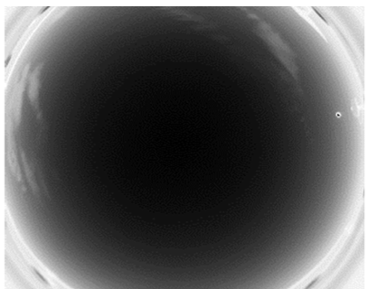
Figure 4-13. Infrared image of clouds from the ASIVA instrument.

ceilometer (cloud attenuation and cloud base height)
The ceilometer is a device that uses a laser or other light source to determine the height of a cloud base.
An optical drum ceilometer uses triangulation to determine the height of a spot of light projected onto the base of the cloud. The rotating transmitter emits an intense beam of light above into the sky at an angle that varies with the rotation. When the receiver detects the projected light returned from the cloud base, the detector notes the angle and a calculation gives the height of the clouds.
A laser ceilometer consists of a vertically pointing laser and a lidar receiver in the same location. A laser pulse with a duration on the order of nanoseconds is sent through the atmosphere. As the beam travels through the atmosphere, tiny fractions of the light are scattered by aerosols (Mie scattering). A small part of this scattered light is directed back to the lidar receiver and a calculation gives the height of the clouds. These ceilometers are regularly used at airports, and are certified to be eye-safe.
In the NICT system, the infrared cloud sensor data (Figure 4-9) is used to measure the sky radiation temperature. By using the reference -45ºC at 8000 m and measuring the temperature of the cloud and next to the ceilometer, cloud base height can be calculated:
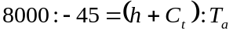. (4.1)

Differential image motion monitor (DIMM) (seeing parameters)
A differential image motion monitor (DIMM) is used to measure the Fried parameter, the Isoplanatic Angle and the Greenwood Frequency. One possible structure is shown in Figure 4-14 [29].
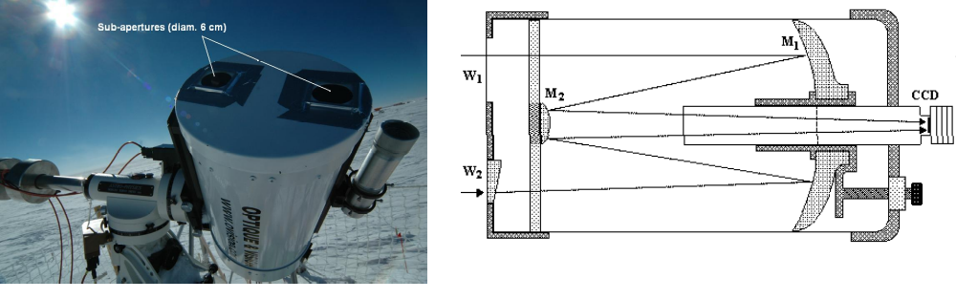
Figure 4-14. Example of a DIMM structure [30], [31]
At the front of the telescope is installed a mask with two small apertures, covered with optical prisms. The light from a light source will be refracted by the prisms and two images are obtained on the receiving CCD camera. The Fried parameter can be found by calculating the variance of the relative position of each centroid. Depending on the size of the apertures, such a setup can measure the Fried parameter on the order of 3 to 7 cm. The variances of the relative position of each centroid in both longitudinal σ_{L} (parallel to direction between apertures) and transverse σ_{T} (perpendicular to direction between apertures) can be calculated by:
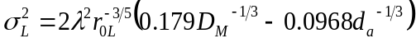, (4.2)
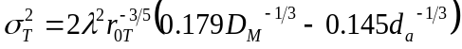, (4.3)
Where r_{0L} is the Fried parameter in longitudinal direction and r_{0T} is the Fried parameter in the transverse direction, d_{a} is the distance between the apertures, and D_{M} is the mask aperture diameter. The NICT DIMM parameters are listed in Table 4-4.
Table 4-4. NICT setup parameters
Telescope aperture | 100mm
Focal length | 800mm
Mask aperture diameter D_{M} | 20mm
Distance between apertures d_{a} | 80mm
Prism vertical angle | 0.5deg

Measurements of Atmosphere Transmittance aNd Radiance: SUN-Photometery
Sun photometry is a well-established remote sensing technique for the characterization of atmospheric optical properties, including spectral atmospheric transmittance, sky radiance, and aerosol distribution. Sun photometer instruments are capable of covering a number of wavelength channels ranging from the UV to the near infrared [30].

Measurements of Atmospheric Attenuation from a Sun-Photometer
The operation principles of a sun photometer can be explained as follows: a sensor head mounted on a gimbal tracks the Sun and at given intervals of time takes measurements of the Sun’s irradiance and sky radiance at different wavelengths. These wavelength channels are selected in a way such that they do not experience molecular absorption. Therefore the measured Sun irradiance only experiences extinction due to molecular scattering (which is approximately constant in time at the same location) and aerosols (whose concentration varies in time).
Generally, the collected solar flux that is measured by a sun photometer provides a reading as
, (4.4)
where: λ_{i} is the wavelength of interest, V(t,λ_{i} ) is the voltage read by the instrument, C(λ_{i}) is a wavelength dependent constant of the instrument, I_{s}(λ_{i}) is the Sun’s irradiance on the above atmosphere, τ_{m}(λ_{i}) is the wavelength dependent optical depth (or atmospheric optical thickness) related to molecular scattering (Rayleigh’s scattering), τ_{a}(t, λ_{i}) is the optical depth related to the aerosol concentration, and m is the atmosphere air mass.
Assuming a well-calibrated instrument and that the optical depth due to molecular scattering is constant in time, the aerosol optical depth is given by

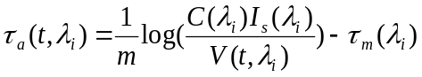 (4.5)
While the general characteristics and operation of sun photometers are similar among instruments from different manufacturers, it is noteworthy here to reference the operations and data products available by AERONET (AErosol RObotic NETwork) [33]
AERONET is an extensive network of automated sun photometers deployed around the world measuring aerosol optical depth, sky radiance, aerosol temporal and size distribution, molecular scattering, and precipitable water vapor. However, to manage such a large network of instruments (in excess of 600 units up to date) and enormous database, AERONET maintains rigorous standardized procedures. This includes keeping all instruments consistent (all the instruments are from the same manufacturer), each instrument is calibrated annually, and data are processed and formatted consistently.
Figure 4-15 shows a sun photometer deployed at the NASA JPL Goldstone facility (CA) which is part of the AERONET. The instrument consists of a sensor head mounted on a gimbal, which is connected to a motor control unit (with angular precision of 0.05º). It is programmed to track the Sun based on the site location latitude, longitude, and universal time (UTC). A battery charged by a solar cell provides the power to the entire system. The sun photometer sensor head consists of two collimators of 33 cm of length with built-in high stray-light rejection to provide accurate radiance measurements. The collimators are able to track the Sun with the help of an external co-aligned QUAD cell. The detectors of each collimator have a field of view of 1.3º, and a filter wheel housing a number of interference filters allows the instrument to take measurements of spectral Sun irradiance (and optical depth). There are eight different wavelength channels for the most recent sun photometer models used in AEROENT: 340, 380, 440, 500, 675, 870, 1020 and 1640 nm, as shown in Figure 4-16. These particular channels were chosen because they experience only atmospheric extinctions due to molecular scattering (that does not change over time) and aerosol optical depth (that is variable in time). The filter bandwidth for the channels in the visible and near infrared is 10 nm, while the channels at 340 nm and 380 nm have a filter bandwidth on the order of 20 nm. The instrument also monitors the water vapor concentration using an additional channel at 936 nm where the variation of water vapor is the main factor affecting the extinction of the solar flux.
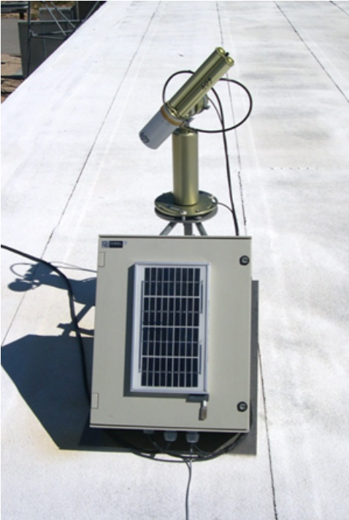
Figure 4-15. Sun-photometer at the NASA-JPL’s facility of Goldstone, CA. The solar cells are used to charge the internal battery that powers the sun-tracker and the instrument electronics. In the picture, the instrument is pointing at the Sun and taking measurements. This instrument at Goldstone is part of the AERONET network.
During operations, the sensor head first locates the Sun with the help of the QUAD cell. When the solar disc is in the field of view of the detectors, the instrument sequentially starts the measurement of the solar irradiance for the eight channels of interest. The sequence is repeated three times, generating a set of three measurements (triplets) for each wavelength channel for a time duration of 30 s each. Because the aerosol optical depth variation over the time to measure a triplet can be considered minimal, the presence of clouds can be inferred if either one of the triplet set of values is different. This approximation is applied as an initial filter to screen the data for “cloudy” data [34]. Aerosol optical depth is derived for each channel from these set of measurements, with an uncertainty of + 0.01 for the channels in the visible and near infrared, and + 0.02 for the UV channels.
The instrument is also equipped with a moisture sensor to detect rain, high humidity, or fog. The control unit is informed of conditions in which measurements are temporarily suspended until the controller unit detects more favorable weather conditions.
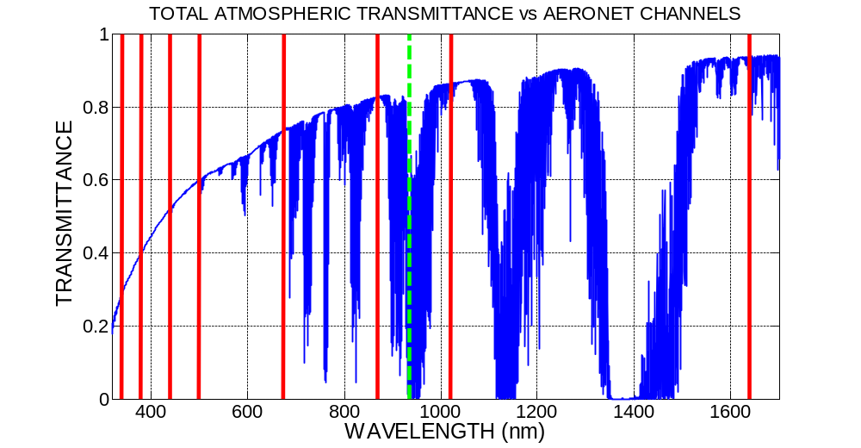
Figure 4-16. Sun photometer wavelength channels and the spectrum of total atmospheric transmittance. The atmosphere transmittance spectrum is pertinent to a location at sea level with clear sky and rural aerosol distribution. The transmittance curve is obtained using MODTRAN code. The vertical (red) bars indicate the wavelength channels that are measured by an AERONET sun photometer. The dashed (green) bar, indicates the 936 nm channel, that is used to measure the precipitable water vapor.

Sky Radiance
Sky radiance is measured by the sun photometer at six wavelength channels of 440, 500, 675, 870, 1020 and 1640 nm. The data are acquired at different angular distances from the Sun and posted by AERONET as μW/cm²/sr/nm. The instrument performs two types of data acquisition scans: principle plane (Sun’s meridian) and almucantar sweeps. Principal plane mode scans the sky vertically starting at 6º below the Sun and moves at fixed zenith angle increments along the principal plane. During this sweep, sky brightness is recorded along with the associated solar zenith angle and photometer zenith angle for each wavelength channel. During almucantar mode, the instrument is fixed at the solar zenith angle and scans the full 360º in azimuth. Sky brightness is recorded along with the associated solar zenith angle and instrument azimuth angle for each wavelength channel. The accuracy of these measurements is assumed to be less than + 5%.

Particle Distribution
Sun photometer radiance measurements are of importance because with the help of proper inversion algorithms [35], they can be used to derive a number of optical properties of the aerosols in the atmosphere. These algorithms are used in conjunction with measurements of aerosol optical depth and characteristics of the site to produce a description of the aerosol, including aerosol size distributions, aerosol refractive index, asymmetry factor, and spectral phase functions.
The sun photometer inversion algorithm provides data regarding the overall aerosol distribution and size over a vertical profile. These data, therefore, are integrated from the ground to the top of the atmosphere.
In the case of a ground station, measurements should also be focused on particle distribution close to the ground (near the ground station) to assess the particle distribution strictly in the boundary layer and assess possible contamination of the telescope optics. An instrument dedicated to this purpose can be a particle profiler, such as the one that is deployed at the NASA JPL Goldstone facility (see Figure 4-17). This instrument measures particle concentration by pumping a constant air flux into an internal chamber where a nephelometer is used to count particle concentration and size. A particle profiler cannot provide particle counts over a continuous range of particle sizes. Instead particle sizes are discretized to form a number of smaller range of sizes (or bins). The specific instrument shown in Figure 4-17 measures particle concentration over eight bins that cover particle sizes ranging from 0.3 to 10μm. The system update rate is between 1 to 60 seconds, which is adequate to cover the temporal variation of the outdoor particle concentration.

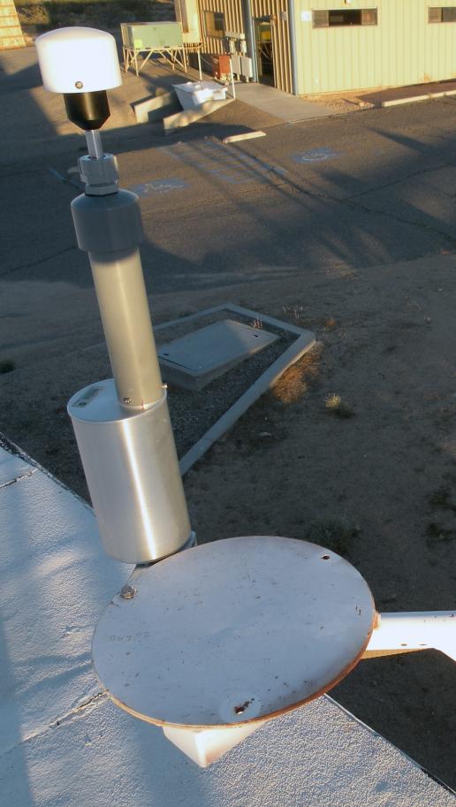
Figure 4-17. Particle profiler deployed at the NASA-JPL’s facility of Goldstone, CA. The instrument measures aerosol particle concentration in the range 0.3-10 m with selectable update rate varying from 1 to 60.

meteorological station

Temperature
Temperature sensors measure the amount of heat energy that is generated by an object or system, allowing the detection of any physical change to that temperature. Temperature sensors produce either an analog or digital output. There are several types of temperature sensors [36].
The thermostat is a contact-type electro-mechanical temperature sensor or switch that consists of two different metals bonded together to form a bi-metallic strip. The different linear expansion rates of the two dissimilar metals produce a mechanical bending movement when the strip is subjected to heat.
The thermistor is a special type of resistor that changes its physical resistance when exposed to changes in temperature. Thermistors are generally made from ceramic materials such as oxides of nickel, manganese, or cobalt coated in glass, which makes them easily damaged. Most types of thermistors have a negative temperature coefficient of resistance.
Another type of electrical resistance temperature sensor is the resistance temperature detector (RTD). RTDs are temperature sensors made from high-purity conducting metals such as platinum, copper, or nickel wound into a coil. The electrical resistance of RTDs changes as a function of temperature, similar to the thermistor. RTDs have positive temperature coefficients, but unlike the thermistor, their output is extremely linear, producing very accurate measurements of temperature. The more common types of RTDs are made from platinum and are called platinum resistance thermometers or PRTs, with the most commonly available of them all the Pt100 sensor, which has a standard resistance value of 100 Ω at 0º C.
Thermocouples are popular because of their simplicity, ease of use, and their speed of response to changes in temperature, due mainly to their small size. They have the widest temperature range of all the temperature sensors, and can measure temperatures from below 200º C to over 2000º C. Thermocouples are thermoelectric sensors that consist of two junctions of dissimilar metals, such as copper and constantan, that are welded or crimped together. One junction is kept at a constant temperature and is called the reference (cold) junction, while the other is the measuring (hot) junction. When the two junctions are at different temperatures, the voltage that arises across the junction is used to measure the temperature.
The resistance temperature detector (Pt100) used by NICT can measure temperatures in the interval -60 ~ +60º C (±0.2º C@20º C).

Wind
An anemoscope is a device used to show the direction of the wind or to foretell a change of wind direction or weather. An anemometer is a device used for measuring wind speed. Figure 4-18 shows the anemometer/anemoscope at the NICT weather station. Its main characteristics are described in Table 4.4. The anemoscope is set at 0º when pointing north, and respectively at 90º when pointing east, 180º when pointing south, and 270º when pointing west. It captures 16 different wind directions – N, NEN, NE, etc. every 100 ms. The most frequent wind direction is saved at one minute time intervals. Wind speed samples are taken every second and the average value is also saved every minute.
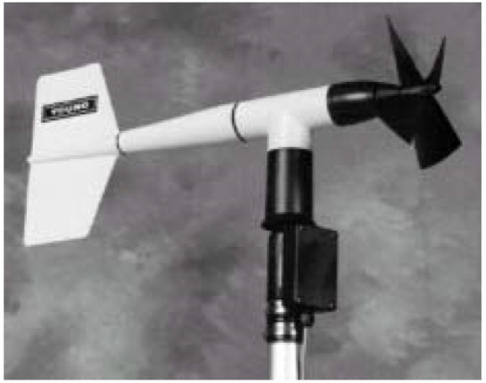
Figure 4-18. Anemometer/anemoscope at NICT
Table 4-5. Characteristics of the NICT Anemometer/Anemoscope
 | Wind speed | Wind direction
Measurement range | 0~60 m/s | 360º mechanical range 355º electrical range (5º open)
Survival wind speed | 100 m/s
Start-up wind speed | 1 m/s (0.5 for breeze) | 1.1 m/s (10º move, 0.5º for breeze)
Accuracy | ±0.3 m/s | ±3º
Resolution | 0.098 m/s | 1º
Measuring method | frequency method | Potentiometer

Relative Humidity
Relative humidity (RH) is the most commonly referenced measurement as it is related to how humans perceive temperature [37]. It is measured by hygrometer [38].
The simplest type of hygrometer is a psychrometer, which consists of a pair of thermometers placed in a wet air stream. One of the thermometers (the wet bulb) has a wet wick around it; evaporation causes this thermometer to read a lower temperature than the other. The difference in the thermometers’ temperatures, and the absolute temperature of the wet thermometer can be used to calculate the RH of the air.
Mechanical hygrometers indicate RH by measuring the change in the dimensions of various porous materials (such as wet paper and hair) as they absorb/exude water vapor.
Electrical impedance hygrometers indicate RH by measuring the changes in electrical capacitance or resistance of a hygroscopic material. The material will absorb or desorb water depending on the partial vapor pressure in the atmosphere around it, thus changing its electrical properties.
Dew-point RH hygrometers measure the temperature of the surrounding air and the dew-point of a small sample thereof. The humidity of the air is then inferred from the dew-point temperature and the initial air temperature.
Capacitive RH hygrometers (like the one used in NICT weather system) consist of ceramic substrate on which a thin film of polymer is deposited between two conductive electrodes. The sensing surface is coated with a micropourous metal electrode, allowing the polymer to absorb moisture, while protecting it from contamination and exposure to condensation. As the polymer absorbs water, the dielectric constant changes incrementally and is nearly directly proportional to the RH of the surrounding environment. Thus, by monitoring the change in capacitance, RH can be inferred.

Pressure
A pressure sensor measures pressure, typically of gases or liquids. Some pressure sensors use a force collector to measure strain due to applied force over an area. Such sensors can be piezoresistive strain gauge, capacitive, electromagnetic, optical, etc. Other types of pressure sensors are resonant and thermal. The main characteristics of the capacitive pressure sensor used in NICT weather monitoring system are listed in Table 4-6.
Table 4-6. Characteristics of pressure sensor CVS-PTB210D-A
Parameter | Value
Measurement range | 500~1100 hPa
Operating temperature | -40~60º C
Accuracy (20 º C) | ±0.25 hPa (±0.15 hPa)
Aging stability | ±0.10 hPa/year
Response time | 1 s

Requirements for Real-time Collection of Physical Quantities
As discussed in previous sections, physical quantities in the atmosphere can degrade or prevent optical communications links between satellites and ground stations. To minimize the impacts of atmospheric phenomena, it is critical to measure those phenomena periodically, and to use that information to determine the site or sites to which the satellites should attempt to send data. Sometimes it will be necessary to repoint (handover) the satellite laser communications transmitter from one ground station to another due to the different atmospheric states at each site. For example, if station A is receiving a downlink and is becoming cloudy, but station B is clear, it may be desirable to repoint the transmitter to station B to minimize any downtime. Some atmospheric quantities change more rapidly than others, and it is important to define how often data on atmospheric conditions should be collected (refresh rate) to support the real-time operations of optical communications systems. The refresh rate may depend on the system CONOPS.

Minutes to an Hour

Cloud Coverage
Clouds produce the largest fades in optical links and are the most important atmospheric quantity to mitigate for successful FSOC systems. Clouds can be blown quickly by the wind, often moving in and out of the line-of-sight of an optical link. Similarly, clouds can form and dissipate rapidly, with these processes occurring on time scales on the order of minutes. Therefore, a ground-based cloud sensor is required to characterize small-scale cloud features and the potential rapid evolution of clouds above ground stations. The cloud data should be collected at time scales on the order of minutes.

Cloud Attenuation
A measure of the attenuation due to clouds is required to make decisions on whether the site is available to close a link based on the available link margin. Generally, communication through thin clouds (attenuation less than 3 dB) may be acceptable, but may greatly vary by link margin. The ability to measure the cloud attenuation at minute time scales is also important. For example, the sky may be partially obscured with thin cirrus producing attenuation on average of less than 3 dB. However, small areas of opaque cirrus (producing attenuation much greater than 3 dB) may exist within the larger cloud, and in this case FSOC to this site may not be desirable.

Cloud Base Height
Although not as important as cloud attenuation, the cloud base height is another measurement to collect on time scales between several minutes and an hour. The total attenuation produced by the cloud may be affected by the down wind distance of the cloud base and will also be affected by whether the cloud is water- or iced-based. If the cloud base is low than the cloud is likely water- based and will produce a larger attenuation. Likewise, if the cloud base is high, the cloud is probably ice-based, and will produce a smaller attenuation.

Aerosols/ Sky Radiance Measurements
In general, the atmospheric attenuation due to aerosols and the sky radiance does not vary significantly on minute timescales. The atmosphere is much more homogeneous with respect to aerosols than clouds. The mean attenuation loss due to aerosols is likely to average less than 0.5 dB 99% of the time (show figure to support this) even at the least desirable sites. Therefore, it is anticipated that it will be sufficient to collect measurements of aerosols and sky radiance at time scales of an hour.

Standard Meteorological Quantities
The standard surface meteorological variables (temperature, wind, relative humidity, pressure) are important to collect in some cases on time scales of minutes but generally an hourly update is sufficient. Issues of condensation are an important consideration for making decisions on dome closures to protect the sophisticated optics inside. In addition, ground stations will have a wind speed threshold for which they can no longer safely keep the dome open for FSOC.

Seconds to Minutes

Optical Turbulence (Seeing Parameters)
As previously discussed, OT can produce a significant degradation to the communications link. Unlike clouds, OT varies on millisecond to second time scales. Therefore, it is critical to capture the time varying OT seeing parameters (r₀, 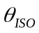, 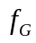). Instruments like a DIMM (discussed in section 4.3) are required to measure the parameters on these time scales. These measurements are routinely collected today at many astronomical observatories and at NASA JPL (Sabino we need a reference here). Although decisions on handover may not be made based on OT, it will be important to use this data to describe any link outages or fading in the absence of clouds.

Using the Physical Quantities to Predict Future Site Conditions

Lead time for Weather predictions
Predictive weather for optical communications is a critical requirement in order to achieve the desired high availabilities. Station handover, which is the repointing of the space terminal from station A to B, will rely on local weather predictions. Depending on the system CONOPS, station handover is accomplished with a “make before break” or a “break before make” methodology. In a “make before break” CONOPS, there is more than one space terminal, and a link with a new site is established before the current one is broken. For a “break before make” CONOPS, there is assumed to be only one space terminal, which must end communications with one site to establish a link with a different site. The amount of lead time required for weather predictions will vary with the system CONOPS, and will be a function of the distance between the space terminal and the ground.

Dependence on the Concept of OPerations

Minutes
A predictive weather system for FSOC will need to forecast whether a CFLOS for those sites in the network that have access to the space terminal exists at the current time and for some amount of time in the future. The amount of time in the future will be heavily dependent on the system CONOPS. However, for near-Earth applications (i.e., LEO and/or GEO to Earth scenarios) it is anticipated that a lead-time of several minutes will be required.

Hours
A deep space-to-ground scenario may require up to an hour lead time to predict CFLOS because of the long transit time. For a Mars scenario the transit time may approach 30 minutes, requiring at least a 30-minute lead time for the CFLOS prediction.

Days
Weather predictions a day long or more may be required to support the scheduling of site maintenance. For example, if a site requires some routine maintenance, it may be desirable to schedule that site to be offline during a time when CFLOS is not available.

Technology required for atmospheric predictions
Depending on the CONOPS of the mission, varying technologies will be required for atmospheric prediction. All CONOPS, however, will require local instrumentation, as discussed in section 4, to provide superior temporal and spatial resolution. The following sections discuss three different possible methods that could be deployed based on specific requirements.

Persistence
The persistence forecast predicts that whatever is observed at the current time will persist for some time into the future. For example, if the whole sky imager indicates a CFLOS at time zero then the persistence forecast says that a CFLOS will be maintained indefinitely. By definition, the persistence forecast does not predict a change of state. Ultimately the persistence forecast will fail in that the CFLOS state will not last forever. A persistence cloud forecast is most helpful for very short-range forecasts on the order of a few minutes to maybe as much as one half hour. For some FSOC applications this type of forecast may be all that is necessary to maintain high link availability. Figure 6-19 shows the probability that, given a site is cloud-free, it will remain cloud free for some specified time. The probabilities are derived from GOES cloud analyses over the period 1997-2013 at 15-minute resolution. The probability of a conditional clear streak lasting 1 hour or longer drops to 55% - 65% and to 35% - 45% by 3 hours, showing that errors using a persistence forecast grow rapidly with time. A similar result could be obtained using higher temporal resolution data collected from a locally based sensor, providing a climatology at intervals of less than 15 minutes.

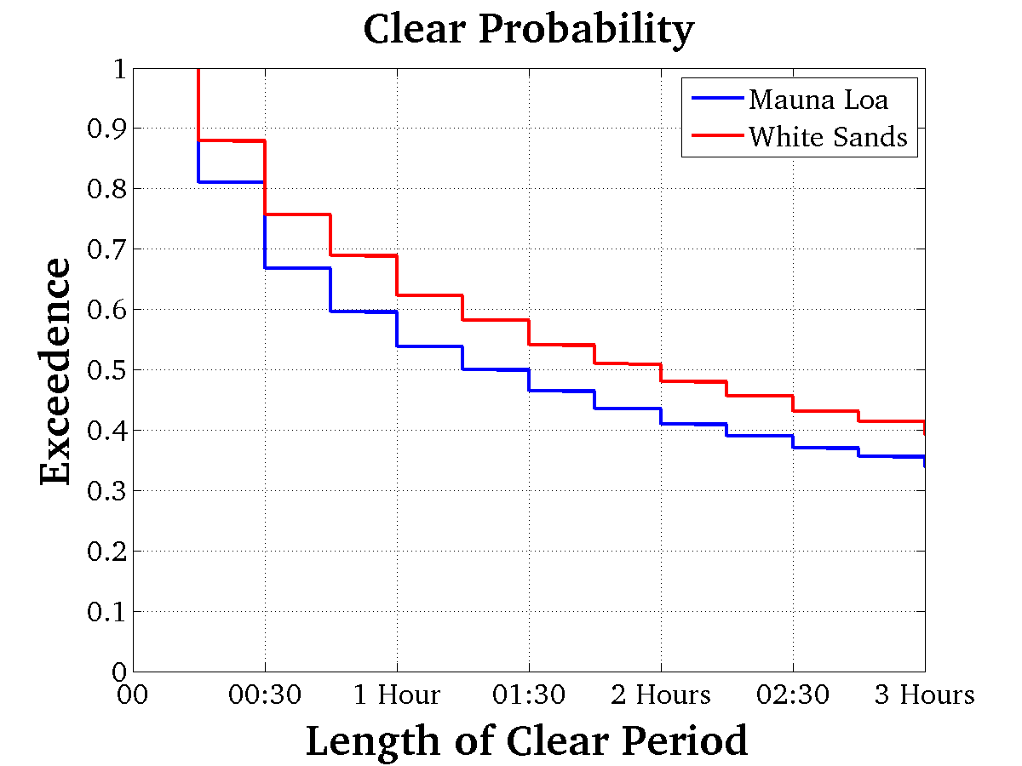
Figure 6-19. Conditional probability of cloud-free duration for sites at Mauna Loa and White Sands.

Advection (recent cloud motion)
A cloud forecast can be derived from the recent motion of cloud elements, whether they be observed from a satellite looking down or from the ground looking up. The idea behind the advection forecast is to look for patterns in motion and assume they will continue over some period of time. An example of an advection cloud forecast is the Cloud Propagator Forecast (CPF). The CPF operates on successive cloud analyses to produce reliable probability forecasts of future cloud cover conditions at each point location. Alternatively, the CPF can forecast the expected amount of sky cover in a local skydome about each point location. The CPF uses the CMG dataset as an input and produces a forecast valid at a specified time in the future. The CPF retains model data from previous runs for the same location, and is capable of boot-strapping itself rapidly if no prior run model data are available.
The forecasting algorithm is a combination of empirical Lagrangian and Eulerian regression over multiple spatial scales, but treats time auto-regressively. Input cloud masks are transformed into proxies first. A cloud cover proxy is a variable which has a more Gaussian distribution than literal cloud cover. For a given pixel, the cloud cover proxy is computed by determining whether at the initialization time the pixel was clear or cloudy. Clear pixels will be assigned only positive proxies; cloudy pixels will be given only negative proxies. The degree to which the assigned proxy is different than zero depends on the fraction of pixels in a small neighboring space that have similar cloudy/clearness. The neighboring space is approximately the spatial scale of a skydome and has a temporal scale of one hour. Pixels which are unlike their neighbors will have proxies close to zero, those largely identical to their neighbors will have proxies close to plus or minus one. Final cloud proxies are computed using a non-linear transform to stretch out the extremes into a pseudo-Gaussian distribution.
The model then decomposes the proxy fields into scale-filtered components. Longer spatial scale patterns are expected to be more predictable over time; shorter scales less so. Differentiating the scales allows the model to retain the maximum predictive skill through training. The training is performed in pure-hindsight. A hindsight forecast is constructed from past data and is evaluated against current proxies to update motion vectors and regression weights. Motion vectors are computed on each scale using a fast local search, which maximizes offset spatial pattern correlations. The motion vectors are an exponentially de-weighted running mean. Regression predictors are extracted from the predictor field centered at the motion vector offset, with a 3x3 or 5x5 array (configurable) of samples taken spaced at the characteristic length of the spatial component. The prior regression models are de-weighted exponentially, similarly to the motion vectors, so that evolving weather patterns can be followed rapidly by the modeling. The regression models produce minimum error estimates of the current time proxy, as a function of a proxy offset from the past. If multiple forecast lead times are configured for the run, then multiple motion/regression models are independently used.
Additionally, the hindsight proxy forecasts of the initialization time are tracked in concert with actual cloud/no-cloud statuses of the hindsight training data. These forecasts are accumulated in reliability tables which have separate slots for eight three-hour times of day to allow forecast accuracy to be diurnally variable. These tables are also exponentially de-weighted, but with a time-scale over days rather than hours. Finally, training is not executed for time steps where input data quality is thought to be low. This decision is made by examining the absolute change in regional cloud cover over a single time step and comparing it to a user-configurable threshold. The motion/regression models are saved, and then the model is run from the current time, forward, to create a future cloud forecast. The results are shown as probabilities of cloud at each pixel in the forecast image. A high level schematic is shown in Figure 6-20, which outlines the CPF generation.

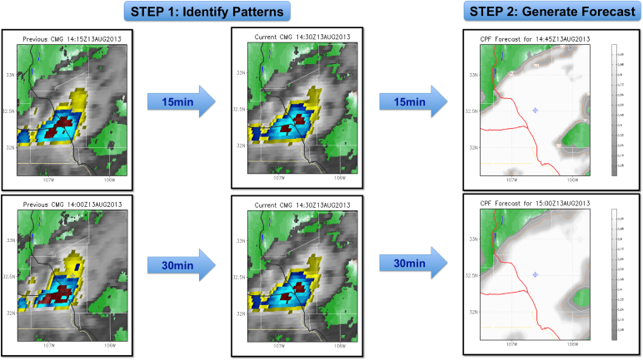
Figure 6-20. CPF is generated by analyzing sequential images of clouds derived from the CMG. Patterns of motion are established and a forecast for future locations is generated.
The CPF represents but one type of cloud advection type algorithm. Other algorithms could make use of neural networks that train the algorithm based on many types of situations.
Results have shown that the cloud advection forecast may be superior in skill to the simple persistence forecast because by nature it can predict change. The advection forecast, however, is also intended to be a short term forecast out to several hours. It will work well for organized, well-behaved cloud systems with consistent movement in a single direction. However, the advection forecast will not generally perform well in situations where clouds are forming and dissipating on short time scales. Figure 6-21 shows the correlation between CPF forecasts and truth at White Sands, NM. A forecast lead time of two hours is generated. The correlation between forecast and truth starts at 1.0 for the zero hour forecast and decreases to approximately 0.9 by two hours. The correlation is for both cloudy and clear forecasts.
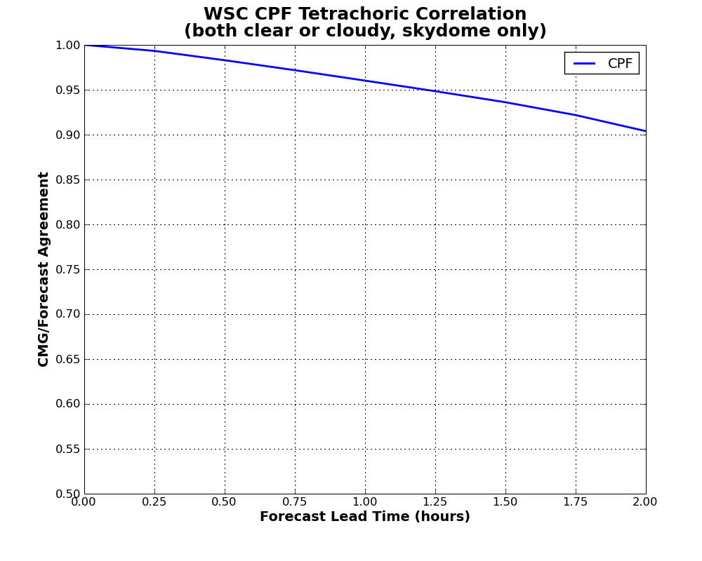
Figure 6-21. Correlation between CPF and truth at White Sands, NM.

Numerical Weather Prediction (cloud prediction)
There may be some FSOC applications that could benefit from longer-lead cloud predictions. For example the ability to predict whether a site will be cloudy so that maintenance can be scheduled may be desirable. Predicting when the next network outage might occur and how long it is likely to last could benefit data dissemination strategies. The simple persistence and advection techniques may be beneficial out to several hours. However, they have no ability to predict the formation and dissipation of clouds, particularly beyond several hours.
Numerical weather prediction (NWP) uses mathematical models of the atmosphere and oceans to predict the weather based on current weather conditions. A number of global and regional forecast models are run in different countries worldwide, using current weather observations relayed from radiosondes (i.e., weather balloons) or meteorological satellites as inputs to the models. Factors affecting the accuracy of numerical predictions include the density and quality of observations used as input to the forecasts, along with deficiencies in the numerical models themselves. Generally, there is skill in NWP forecasting out to 5 to 7 days. Over the last decade, ensemble NWP forecasts have been used operationally to account for the stochastic nature of weather processes—that is, to resolve their inherent uncertainty. The ensemble method involves analyzing multiple forecasts created with an individual forecast model by using different physical parameterizations or varying initial conditions. The goal is to better define the uncertainty in the forecast. The ensemble method may be a critical capability for predicting clouds for FSOC applications. Although the NWP models lack the horizontal resolution necessary to describe the line-of-sight from the ground to the communications satellite, they can provide horizontal resolution as high as 1 km. Typically, however, NWP models provide horizontal resolutions that describe cloud systems on scales of 10 km. Figure 6-22 shows the correlation between two different ensemble NWP systems and truth for White Sands, NM. The period of evaluation is for 11 months. The forecast lead time ranges from 84 hours for the Short Range Ensemble Forecast (SREF) to nearly 120 hours for the Global Ensemble Forecast (GENS). The SREF system is a regional model (CONUS only) composed of 21 members predicting the skydome cloud fraction at White Sands, NM. The model’s horizontal resolution is approximately 12 km. Its correlation to truth ranges from 0.8 at 6 hours to 0.6 at 84 hours. The GENS system is also composed of 21 members. The GENS is a global model, meaning it forecasts for the entire Earth, with 111 km horizontal resolution. The reduced resolution of the GENS relative to the SREF is due to the fact that GENS is a global model versus a regional model, and therefore takes much longer to run. Because of its reduced horizontal resolution, the GENS correlation to truth starts at 0.7 and drops to 0.5 by 120 hours (5 days). Further improvements to NWP technology are required to increase the cloud forecast reliability to levels similar to the persistence and advection techniques at 1 to 2 hours. One area of improvement would be to assimilate local cloud information from WSI into the model, which would improve initial conditions and produce a better quality forecast.
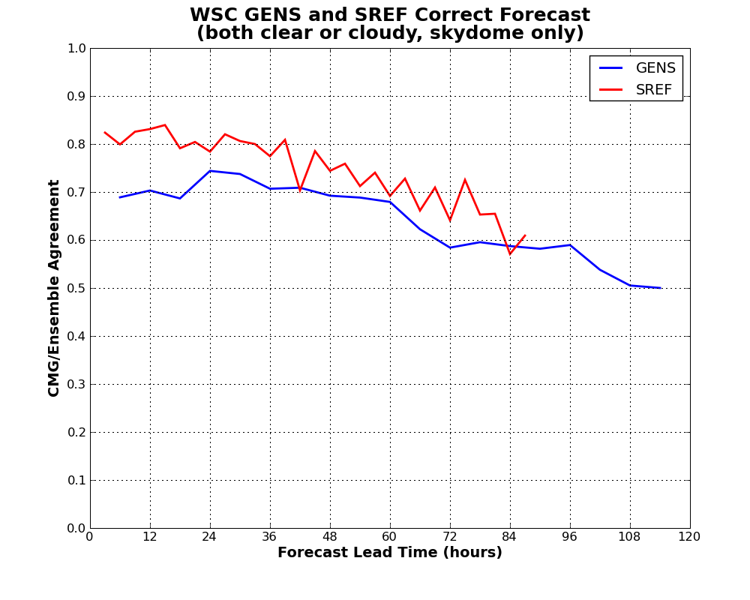
Figure 6-22. The correlation between ensemble NWP and truth.

USING THE PHYSICAL QUANTITIES TO EVALUTE LONG-TERM CHARACTERISTICS OF A SITE
Text to be provided in the next version.

State of the instrument Market
Discuss the state of the instrument market today and what is required to mature instruments and algorithms to support such missions

