

Space Optical
Communications:
SUMMARY OF CONCEPT

WHITE BOOK

October 2010



 | Issue: | White Book, Issue 1
 | Date: | October 2010
 | Location: | London, UK

DOCUMENT CONTROL

Document | Title and Issue | Date | Status
CCSDS XXX.1-W-1 | Space Optical Communications | October  2010 | Issue 1

CONTENTS
Section Page
1 INTRODUCTION 1
1.1 PURPOSE 1
1.2 SCOPE 1
1.3 REFERENCES 2
2 overview 5
2.1 architecture 5
2.2 general goals 7
3 OptiCAL COMMUNICATIONS 8
3.1 General background 8
3.2 specific characteristics 8
4 SpaCE Application profiles 9
4.1 Scenario categories 9
4.2 Proximity links 10
4.3 Exploration links 18
5 conclusions 22
6 Annex 1: study of the Optical channel 23
6.1 Doppler shift 23
6.2 Background light 23
6.3 Rx-power dynamic 23
6.4 Atmospheric channel 25
6.5 Optical tracking 28
7 Annex 2 : Study of the optical technology 29
7.1 Laser Transmitters 29
7.2 Detection techniques 29
7.3 Metrics for modulation and coding solutions 30
7.4 Modulations 30
7.5 Channel Coding 32
8 annex 3 : Study of the Operation services 35
9 annex 4 : Acronyms 44

INTRODUCTION

PURPOSE
This document presents a summary of concept for space optical communications and, in this respect, shall be considered as a White Book.
Free-space communications at optical wavelengths are now mature enough to represent an alternative to conventional RF communications.
The purpose of the document is to provide CCSDS with sufficient input information on space optical communications technology to identify application profiles and parts of the optical communication systems that require a standardization process and thus the creation of a CCSDS working group.

SCOPE
This summary of concept for space optical communications presents future operational scenarios and domains where standardization can be applied. In addition, technical descriptions on communication channels and coding & modulation techniques used for space optical communication systems are attached as annexes to this document.

These are technical information of space optical communications in physical layer and data link sublayer and will be an input information to relevant CCSDS documents already existing or new CCSDS documents in these layers. This document consists of 5 main components and 2 other supplementary components below.

Section 1 presents purpose, scope and lists the references used for this document.
Section 2 presents introduction and general goal toward standardization
Section 3 explains general characteristics of space optical communications compared to radio
compared to radio communications
Section 4 presents future scenarios where space optical communications technology can be
used in the future space operations.
Section 5 concludes on what technical standards are to be developed in relation to existing
CCSDS standard documents in each protocol layers and how future services of
space optical communications can be practically realized with other existing
CCSDS documents in SLS area.
Annex 1 presents the technical components used for space optical communications
Annex 2 presents the technical components in space optical communications
Annex 3 presents Acronyms

REFERENCES
The following documents are referenced in the text of this document. At the time of publication, the editions indicated were valid. All documents are subject to revision, and readers of this report are encouraged to investigate the possibility of applying the most recent editions of the documents indicated below. The CCSDS Secretariat maintains a register of currently valid CCSDS Recommendations.

[1] “TELECOMMAND SUMMARY OF CONCEPT AND RATIONALE CCSDS 200.0-G-6 GREEN BOOK JANUARY 1987”

[2] “TC SYNCHRONIZATION AND CHANNEL CODING- SUMMARY OF CONCEPT AND RATIONALE CCSDS 230.1-G-1 GREEN BOOK JUNE 2006”

[3]”TELEMETRY SUMMARY OF CONCEPT AND RATIONALE CCSDS 100.0-G-1
GREEN BOOK DECEMBER 1987”

[4] “TM SYNCHRONIZATION AND CHANNEL CODING- SUMMARY OF CONCEPT AND RATIONALE CCSDS 130.1-G-1 GREEN BOOK JUNE 2006”

[5] “ADVANCED ORBITING SYSTEMS, NETWORKS AND DATA LINKS;
SUMMARY OF CONCEPT AND RATIONALE CCSDS 700.0-G-3 GREEN BOOK NOVEMBER 1992”

[6] “TC SYNCHRONIZATION AND CHANNEL CODING CCSDS 231.0-B-1 BLUE BOOK SEPTEMBER 2003”

[7] “TM SYNCHRONIZATION AND CHANNEL CODING CCSDS 131.0-B-1 BLUE BOOK SEPTEMBER 2003”

[8] “TC SPACE DATA LINK PROTOCOL CCSDS 232.0-B-1 BLUE BOOK SEPTEMBER 2003”

[9] “TM SPACE DATA LINK PROTOCOL CCSDS 132.0-B-1 BLUE BOOK SEPTEMBER 2003”

[10] “SPACE PACKET PROTOCOL CCSDS 133.0-B-1 BLUE BOOK SEPTEMBER 2003”

[11] “SPACE LINK EXTENSION FORWARD CLTU SERVICE SPECIFICATION CCSDS 912-B-3 BLUE BOOK JULY 2009”

[12] “RETURN ALL FRAMES SERVICE SPECIFICATION CCSDS 911.1-B-3 JANUARY 2010”

[13] “RETURN CHANNEL FRAMES SERVICE SPECIFICATION CCSDS 911.2-B-2 JANUARY 2010”
[14] “AOS SPACE DATA LINK PROTOCOL CCSDS 732.0-B-2 BLUE BOOK JULY 2006”

[15]”RADIO FREQUENCY AND MODULATION SYSTEMS PART1 EARTH STATIONS AND SPACECRAFT CCSDS 401.0-B-2 APRIL 2009”

[16] A. Alonso, M. Reyes, Z. Sodnik, “Performance of satellite-to-ground communications link between ARTEMIS and the Optical Ground Station”, Proceedings of SPIE 2003

[17] L. Andrews, R. Phillips, Laser Beam Propagation through Random Media, 2nd Edition, SPIE Press, Bellingham, WA, (2005).

[18] Biswas, A. and S. Piazzolla, "Deep-Space Optical Communications Downlink Budget from Mars: System Parameters," IPN PR 42-154, April-June 2003, pp. 1-38, August 15, 2003

[19] B. Mayer, S. Shabdanov, D. Giggenbach, "Electronic Database of atmospheric absorption coefficients", DLR-internal report by DLR-IPA and DLR-IKN-DN-OCG, DLR-Oberpfaffenhofen, December 2002, based on the atmospheric constituents profiles according to "G.P. Anderson, et al: AFGL Atmospheric Constituent Profiles (0-120km), AFGL-TR-86-0110, Hanscom Air Force Base, MA 01736, 1986".

[20] B. Furch, Z. Sodnik, J. Perdigues, “ESA’s activities on optical communications and quantum entanglement”, ESA-ESTEC, Workshop GOLCE, Tenerife, January 2010.

[21]G. D. Gatewood, “The Multichannel Astrometric Photometer and Atmospheric Limitations in the Measurement of Relative Precisions,” Astronomical Journal, vol. 94, no. 1, pp. 213–224, 1987.

[22] Tatsuyuki HANADA, Space Applications Program Systems Engineering Office Japan Aerospace Exploration Agency (JAXA), “R&D activities of JAXA in the field of space laser communication”, CCSDS meeting on May 4, 2010, Portsmouth, USA

[23] H. Hemmati (ed.), "Deep-space optical Communications", Wiley-Interscience (2006)

[24] H. Hemmati, “Status of Lasercom Technology Development at JPL”, NASA JPL
(USA),Workshop GOLCE, Tenerife, January 2010.

[25] J. Horwath, N. Perlot, M. Knapek, and F. Moll, "Experimental Verification of Optical Backhaul Links for High-Altitude Platform Networks: Atmospheric Turbulence and Downlink Availability", International Journal of Satellite Communications and Networking, Special Issue (2007)

[26] Statement of Work for ESA’s ITT, AO/1-6121/09/NL/AF,
“Interplanetary Communications Technology Review and Roadmap”, April 2009

[27] N. Kadowaki (NICT, Japan), “Opening Address”, Workshop GOLCE, Tenerife, January 2010.

[28] K. Kudielka, T. Dreischer, B. Thieme, M. Tuechler, "Experimental Demonstration of Optical Telemetry Transmission from Mars to Earth", International Conference on Space Optical Systems, Tokyo (2009)

[29] A. Kylling and B. Mayer, “Technical note: the libRadtran software package for radiative transfer calculations – description and examples of use,” in Atmos. Chem. Phys. Discuss., 2005, pp. 1855-1877.

[30] Walter R. Leeb, "Degradation of signal to noise ratio in optical free space data links due to background illumination," Appl. Opt. 28, 3443-3449 (1989)

[31] B. Mayer, S. Shabdanov, D. Giggenbach, "Electronic Database of atmospheric absorption coefficients", DLR-internal report by DLR-IPA and DLR-IKN-DN-OCG, DLR-Oberpfaffenhofen (2002), based on the atmospheric constituents profiles according to "G.P. Anderson, et al: AFGL Atmospheric Constituent Profiles (0-120km), AFGL-TR-86-0110, Hanscom Air Force Base, MA 01736 (1986)"

[32]NASA's Mission Operations and Communications Services, January 2009,
http://deepspace.jpl.nasa.gov/advmiss/docs/NASA_MO&CS.pdf

[33] “High-Capacity Communications From Martian Distances”, NASA/TM-2007-214415

[34] G. W. Null, W. M. Owen, Jr., and S. P. Synnott, “Deep-Space Navigation Applications of Improved Ground-Based Optical Astrometry,” The Telecommunications and Data Acquisition Progress Report 42-110, April–June 1992, Jet Propulsion Laboratory, Pasadena, California, pp. 118–127, August 15, 1992.
http://ipnpr.jpl.nasa.gov/progress_report/

[35] G. W. Null, W. M. Owen, Jr., and S. P. Synnott, “Systems Analysis for Ground-Based Optical Navigation,” The Telecommunications and Data Acquisition Progress Report 42-111, July–September 1992, Jet Propulsion Laboratory, Pasadena, California, pp. 23–40, November 15, 1992.http://ipnpr.jpl.nasa.gov/progress_report/

[36] N. Perlot, M. Knapek, D. Giggenbach, J. Horwath, M. Brechtelsbauer, Y. Takayama and T. Jono,'' Results of the optical downlink experiment KIODO from OICETS satellite to optical ground station Oberpfaffenhofen (OGS-OP)", Free-Space Laser Communication Technologies XIX, Proc. of SPIE, 645704 (2007).

[37] J. Rush, NASA Space Communication & Navigation Systems Planning Division (USA), “An Overview of Current Programs and Future Plans for NASA's Optical Communication Capability”, Workshop GOLCE, Tenerife, January 2010.

[38]University of Washington, Department of Atmospheric Sciences.
http://www.atmos.washington.edu/~ignatius/CloudMap/, 2006.

overview

architecture
CCSDS documents used by space agencies generally provide us with recommendations for implementation towards cross support operations based on general protocol stack from physical layer to application layer. Recommended frequency & modulation are described in the physical layer. Recommended synchronization & coding belong to the data link sublayer. Technical descriptions for other required items continue up to application layer with technical interfaces between layers.

Figure 2-1 shows where the space optical communications will be positioned in the CCSDS protocol stack. Space transmission protocol stack is different from protocol stack between stations connected normally through dedicated leased lines.

OSI LAYERS
CCSDS LAYERS
CCSDS PROTOCOL

NETWORK AND
UPPER LAYERS

NETWORK AND
UPPER LAYERS

DATA LINK LAYER
DATA LINK
PROTOCOL
SUBLAYER

SPACE DATA LINK
PROTOCOL

SYNCHRONIZATION
AND CHANNEL
CODING SUBLAYER
SYNCHRONIZATION
AND
CHANNEL CODING

PHYSICAL LAYER

PHYSICAL LAYER

FREQUENCY AND
MODULATION SYSTEMS

Figure 2-1 : Relationship between OSI Layers and CCSDS layers

general goals
As indicated in Figure 2-1, the technical information of space optical communications technology can be divided into physical layer and data link sublayers CCSDS documents on optical communications should follow this layer structure in order to comply with other CCSDS documents on RF communications.

Optical transmission characteristics are very much different from RF transmission characteristics. Therefore, new standards for the lowest networking layers are required when considering space optical communications.

Based on the above situation, our goals will be followings:

a) Concept Document
The summary of concept for space optical communications will be first described in this document to create a consensus among associated participants and categorized as a white book. Parts of this White Book can be used for future Green Books.

b) Standard Document
b)-1 Physical layer Document
Based on the concept document stated above, discussion between associated groups will be continuously held and the technical information of the space optical communications belonging to the physical layer will be expected to be finally brought into standards.

b)-2 Data Link Layer Document
Also in a same manner, the technical information belonging to data link layer will be expected to be brought into the standards for TC, TM for the data link sublayer.

c) Others
If required, any type of joint work between groups will be initiated and find an appropriate CCSDS documentation to define the technical interface for the space optical communications in these 2 layers.

OptiCAL COMMUNICATIONS

General background
Optical communication is any form of telecommunication using electromagnetic waves ranging from ultraviolet to infrared. Compared to fiber communications, space optical communications has many differences. In particular, space communications is based on a free-space medium and on moving terminals. However, the development of terrestrial fiber communication systems can impact on the development on FSO communication systems and also the choice of a standard.

specific characteristics
In comparison with legacy radio communication systems, space optical communication systems have following characteristics shown in Table 3-1.
Space Optical Communications
Advantages | Disadvantages
a) Larger signal bandwidth available  b) Lower size (possibly weight) of terminals  c) Power efficient  d) No spectrum regulation (no interference with µwave) | a) Stronger atmospheric perturbations (cloud, turbulence)  b) Accurate pointing system required  c) Eye safety issues
Table 3-1: Characteristics of Space Optical communications

From the Table 3-1 comparing space optical communications with radio communications, it can be summarized into the following 3 point of views.

a) It may find an application in most point-to-point space links which requires high speed and broad band services like transmission and receiving of ex: high resolution image data and live video data for earth exploration and space science missions, because of its advantages.

b) It can be complementary to radio communications whose case would reach the power and band limitation in radio regulation or it is better to say these two systems can complement each system. Therefore, these two communication technologies may be considered for one scenario and developed in parallel. Typically, optical terminal with RF backup for acceptable availability.

c) Scenarios shall not be attributed exclusively to either optical or radio communications

SpaCE Application profiles

Scenario categories
Scenarios can be categorized roughly into following 2 groups and 8 groups in detail according to their mission purposes. Group A is a proximity link where the communication link is set in the short distance and Group B is an exploration link set in the long distance.

In each scenario, there are 2 cases which are with or without atmospheric conditions and therefore, the characteristics in transmission path and the combination of modulation and coding will maybe differ from item 4.2, only the underlined expected plans are summarized with requirements within a possible predictable range, because the rest of them are not clear at moment.

In CCSDS, Missions located more than 2 x 10⁶ km away from the Earth are defined as Category B (deep-space) missions. Missions located closer are defined as Category A missions.

Group I: Proximity link (Short Distance Communications)

1. without significant atmosphere in
a) Earth proximity (e.g., LEO-GEO inter-satellite links) : Category A Mission
b) Celestial-body proximity (e.g., Lander-Orbiter links) : Category B Mission

2. with Earth atmosphere
a) Earth proximity (e.g., LEO-GND direct links) : Category A Mission
b) Earth Proximity (e.g., GEO-GND direct links) : Category A Mission

Group II: Exploration link (Long Distance Communications)

1. without significant atmosphere
Deep Space Exploration (e.g., Earth orbiter-Relay links) : Category B Mission

2. with Earth atmosphere.
a) Moon Exploration (e.g., Moon-Earth direct links) : Category A Mission
b) Deep Space Exploration (e.g., Lagrange points-Earth direct links) : Category A Mission
c) deep-space probes (e.g., deep space probe direct links) : Category B Mission

Proximity links

LEO-GEO inter-satellite links
In the history of data relay satellite system using inter-optical communication with a time frame from 1985 to 2005, the optical inter-satellite system with 0.8 µm, 2 Mbps for the forward link and 50 Mbps for return link was first developed and evaluated between ARTEMIS (21.5E) and SPOT-4 for return link by ESA and CNES and also between ARTEMIS (21.5E) and OICETS for forward and return links by ESA and JAXA.
The European data relay satellite ARTEMIS (21.5E) is still in operation, while the experiment between ARTEMIS (21.5E) and OICETS was finally completed with great success in around 2006.
Based on this long term experience and continuous requirements to relay and deliver science data like earth observation for disaster monitoring and so on, some of agency have new plans to deploy and operate their own data relay satellite systems where the optical terminal will be mounted as one of communication functions along with S and Ka band system. Figure 4-1 shows the scenario model.
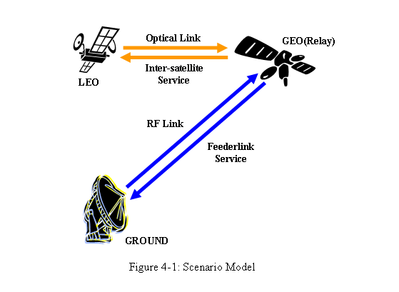
•Time frame from 2013 (ESA)
•Time frame from around 2015 to 20XX (JAXA)

Originally, services of the inter-satellite data relay link have been provided to non-geostationary satellites by using a band for existing legacy communications which are S, Ku and Ka band with a band limitation defined in Radio regulation, but if band width over these band width will be required for high speed and broad band data transmission, the inter-optical communication links will be necessary to relay science data with a high resolution in the near future. Some example is shown from item 4.2.1.1 and 4.2.1.2.

Note: Future Data Relay Links
1) European Data Relay System (EDRS) and Alphasat [ESA/DLR]
2) Next Data Relay System [JAXA]

JAXA
Starting with some experimental GEO satellites for inter-satellite links, JAXA has been operating the DRTS-W (90.75E) for earth observation satellites and the International Space Station.
This kind of data relay satellite system is very important not only for TT&C operations but also for down link of huge size of data and real time data and it can be supposed that there will be a continuously increasing demand for this kind of systems in the future.

Japanese data relay satellite system after DRTS-W(90.75E) is officially written in a basic space plan dated on July 2009 and indicated on website of Strategic headquarter for space policy. In this space plan, one to two data relay satellites are required for space applications like disaster monitoring including earth observations by 2 or 4 L band and optical Radar satellites and also international space station. The system overview is shown in Figure 4-2.
Reference: Basic Plan for Space Policy:http://www.kantei.go.jp/jp/singi/utyuu/basic_plan.pdf
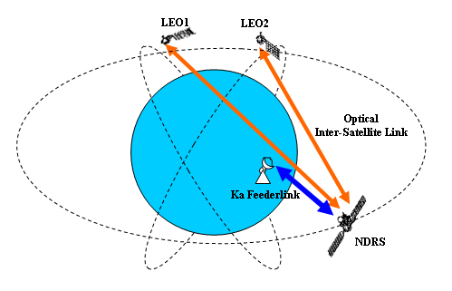
Figure 4-2: Overview of JAXA’s NDRS System [Ref to No.22]

ESA
ESA has two missions involving LEO-GEO optical links:
- Alphasat Satellite System
- European Data Relay Systems (EDRS): Envisaged data rate is 600 Mbit/s (Figure 4-3)
According to the ESA website, next European data relay satellite system after ARTEMIS (21.5E) is dealt with in the ARTES program (Advanced Research on Telecommunication Systems). This ARTES program is split into several programs and two of these programs (ARTES 7 and ARTES 8) are related to the EDRS system.
First, ARTES 7 program is for EDRS which is a specific element dedicated to the development and implementation of EDRS system and this system is planned to relay information via EDRS satellite to/from non–geostationary satellites, other vehicles and earth stations.

In addition, the ARTES 8 program is for Alphasat which is a geostationary satellite to provide jointly commercial services in partnership with Inmarsat and laser link service to be mounted as technology demonstration payloads (TDP) lead by DLR (Deutsches Zentrum für Raumfahrt Agentur) and there is a plan to use an optical inter-satelliite communication link between the Aplphasat and the Sentinel satellites.

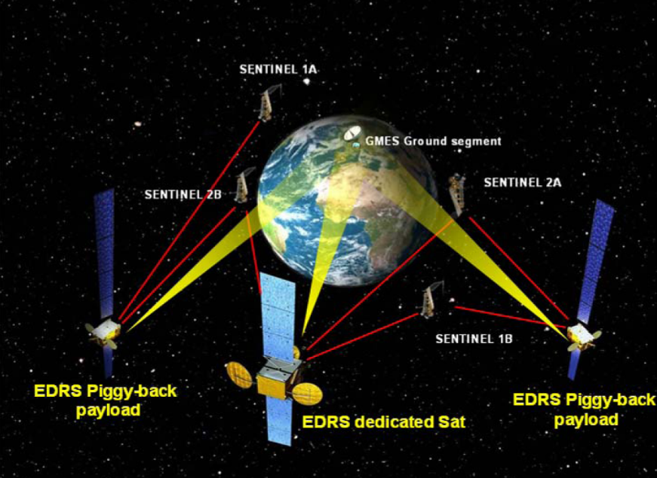
Figure 4-3: Overview of ESA’s EDRS System (Ref to No.20)

REQUIREMENTS
According to the existing inter-satellite services in radio frequencies which are S, Ku and Ka bands, the data rate goes from 100kbps to 300Mbps. But it is expected that the requirements of transmission rate will increase year by year, because of more requirements of higher resolutions to scientific images taken by earth observation satellites.

For the deliveries of scientific images to end users, there are 3.5GHz (wide band) frequency allocations in Ka band to be used for inter-satellite services and also for the feederlink of data-relay satellite systems. This means that the band width up to 3.5GHz can be surely used for any kind of data-relay for earth observation and disaster monitoring. This is the reason why space agencies will use radio frequency in Ka band for data-relay system, unless a bandwidth higher than 3.5 GHz is required in the inter-satellite and feederlink services.

On the other hands, legacy modulation and demodulation schemes like BPSK and QPSK are still used in the existing systems. This cannot be probably met for band efficient transmission if this kind of legacy schemes are to be used for high data rate requirements such as 1.5 Gbps or 2.5Gbps, because there will be possibilities the band width of spectrum will be over the allocation defined internationally.

Moreover, it might not be effective to use radio communication systems for this kind of high data rate because their power consumptions and weight will also increase in comparison with optical communication systems and will be a large design load on the systems. If the other band efficient scheme (QAM) is used, somehow it might be possible to put the wide-range spectrum in the 3.5GHz band with a filter technique, but the issue of power, weight and regulatory matter like PFD limit will appear soon. This is, in another word, can be viewed as a technical bottle neck. This is an important reason why optical communications will be required for high speed and broad band data transmission of high resolution images.

It results that the services for high-speed data transmissions can be provided by a combination of optical inter-satellite and RF for feederlinks (atmospheric links). However, if a bandwidth larger than 3.5 GHz is required for feederlinks, it might be necessary to use millimeter waves or optical beams.

Some countries like Japan have heavy-rain seasons and may not favour millimeter waves or optical communications for the feederlink. But other countries with better weather condition may support a data relay satellite system providing more than 3.5 GHz band. Taking into account above assumptions, services required for the optical inter-satellite link in the future are following patterns.
A1a): Data Relay Link example:
Service Requirements of optical inter-satellite communications
No | Type | Optical Intersatellite Link | Type | RF Feederlink
1 | LEO | 1.2Gbps×1 link  (Single Access):FWD/RTN | Relay  (GEO) | 1.2Gbps ×1 link  (Single Access)
2 | LEO | More than 2.5Gbps×1 link  (Single Access): FWD/RTN | Relay  (GEO) | More than  2.5Gbps ×1 link  (Single Access)
Table 4-1: Service Requirement for Inter-Satellite Link

LanDER-ORBITER links
As another case of proximity link scenario, there is the communication link between Earth and Mars/Moon. This communication link will be established between a rover and Earth via some relay satellite.

NASA/JPL has a concept of proximity optical link for Mars involving a Mars rover and orbiter with low mass and power burden on host spacecraft and low-complexity acquisition tracking pointing. Targeted performances are 50 to 250 Mbps for the link from rover to orbiter and 10 to 100 kb/s for the link from orbit to surface. Figure 4-4 shows the scenario model.
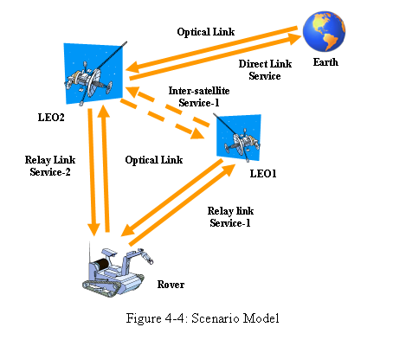

NASA/JPL
Activities of NASA/JPL on Mars/Moon access/proximity links are summarized by Figure 4-5.
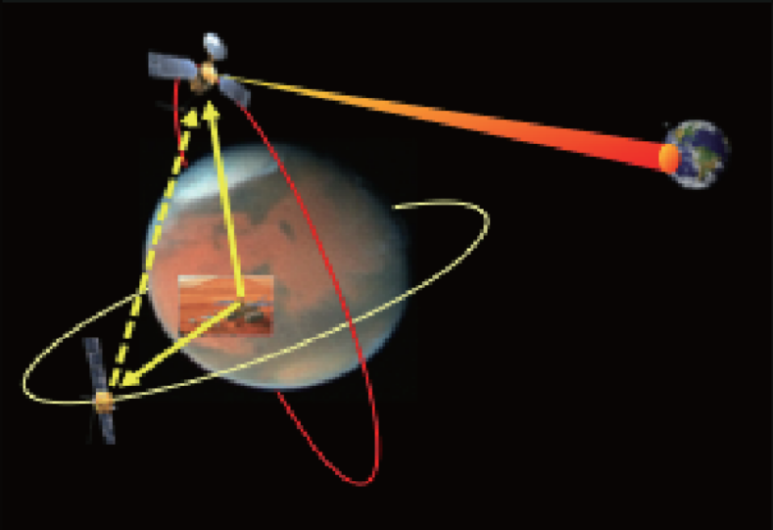
Figure 4-5: Overview of NASA/JPL Lander-Orbiter Link System [Ref to No.24]

LEO-GND Direct links
In Japan, an optical terminal for the inter-satellite communications was developed and the feasibility of its forward and return links was evaluated between ARTEMIS and OICETS.

This was a basic experiment of ARTEMIS-OICETS international program led by ESA and JAXA. As an additional experiment for future applications of optical communications, the first experiments of direct optical links between OICETS and ground stations were done by NICT (Japan) and DLR (Germany) in 2006.

In 2008 other experiments of direct optical links were also done within worldwide international frameworks among ESA, DLR and NICT with TerraSAR-X.

In 2009 experiments of direct optical links between OICETS and ground stations were also done within larger world wide international frame works among JAXA/NICT, ESA, DLR and NASA/JPL. These worldwide communication experiments were done for another feasibility check of direct optical links for future space applications. Figure 4-6 shows the scenario model.
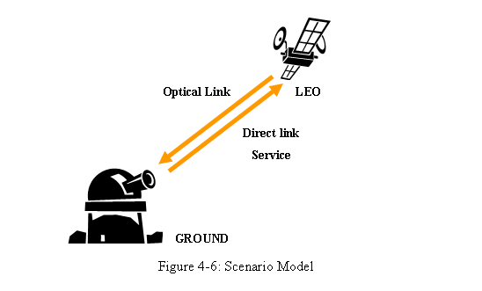
As another cases, two German earth observation satellites (TerraSAR-X & Tandem-X) were launched and extensive experiments of optical direct link with some optical ground stations located Calar Alto(Spain), Maui(Hawaii) and Tenerife(Spain) have been done up to today.

There has been several optical direct communications experimented and operated as stated above and if future use of optical direct link assumed, there would be probably some other cases to appear, but the atmospheric effects strongly depend on locations where optical ground stations are placed.Some example is shown from item 4.2.3.1 and 4.2.3.2. expected timeline would be followings.

•Time frame from 2007 to later period (DLR)
•Time frame from 2013 to later period (JAXA/NICT)

Note: Future Plans for optical direct links
1) Laser downlink experiment (OSIRIS) for micro satellite [DLR]
2) Compact 10 Gb/s LEO terminal and Airplane tests planned in 2010 or 2011[NASA/JPL]
3) Very Small Satellite Demonstration Project [NICT]

DLR
In Europe, an earth observation satellite with optical communication functions have been in operation and some experiment of direct optical communication links with some optical ground station has been done recently.

•TerraSAR-X: Earth observation Satellite from 2007 to later period

This satellite is currently in operation and has a function of direct optical link to optical ground stations (OGS).

JAXA/NICT
In Japanese basic space plan, the delivery of scientific earth observation data for disaster monitoring with high resolutions to the end users are basically required and the data relay systems are mainly planned with several earth observation satellites for this purpose.

This optical direct link is one of applications in the future and it is also true that any data relay satellite systems have some operational suspended time periods every year because of maintenance, accident and also weather conditions.

Therefore, the optical ground terminal in remote area can be a back up to the relay system for high speed data transmission. Besides, plural OGSs connected via terrestrial networks provide LEO/GEO-OGS links with avoiding weather influences such as link blockage by clouds. The question whether direct-downlink applications appear in the future depends on a technical trade off and feasibility study against transmission requirements.

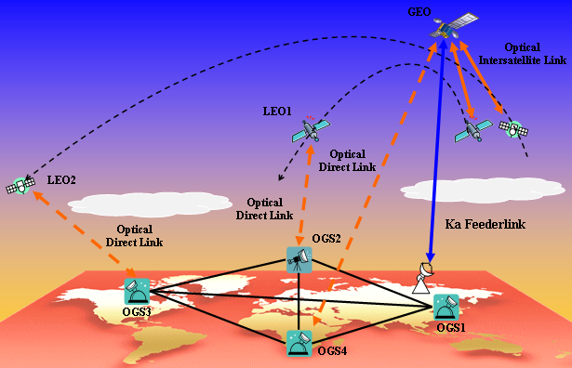
Figure 4-7: Overview of Optical Direct Link System

REQUIREMNTS
Most services of direct links between satellite and ground station, are currently provided in S, X, and Ka band. But 90MHz is given for TT&C in S band and these bands such as X and Ka bands are given not only for TT&C but also for mission down link.

For downlink of mission data, X and Ka bands have been used. Whereas X band (475MHz) is more dedicated to the direct downlink of scientific data like Earth observations and Ka band (1.5GHz) is for also same purpose including space science mission.

However, higher requirement of scientific data downlink with a high resolution can not be satisfied by these bands if the band width will be over 1.5GHz, because there is a band limitation up to 475MHz for X band and 1.5GHz for Ka band.

Below 475MHz band width, X band which is, to some extent, strong for rain attenuation can be used and up to 1.5GHz band width, Ka band which can be weak in case of lower elevation with a long slant range can be used with a higher elevation with a short slant range. These bands can be used for data downlink, but it is true that there are clearly limitations of band width and elevation. These are a kind of operational disadvantages in case of wider band width and higher data rate.

The optical direct communications can change these disadvantages into advantages, though it has also disadvantage of cloud blockage which can be solved by selecting diversified remote areas in a world where there are not any X and Ka band stations.

As written in above, the optical terminals can not be a winner in a place with X and Ka band stations which can provide services to receive data with a band width to be fallen in the band from 475MHz to 1.5GHz and therefore they should be in other remote areas as a backup stations providing receiving services over 1.5GHz. One of application might be a backup station for Ka band feederlink stations of data-relay system.

Assumed that the direct downlink service would probably play a role as a complementary system to a relay satellite system when it stops its service because of system check or weather conditions, and considering that the direct downlink could provide broadband data communication channels, services required for the direct downlink in the future are following patterns. No.1 is for the complementary role, and No.2 is for the high speed data transmission.

A2a): Optical Direct Link example:
Service Requirements of Optical Direct Communications
No. | Type | Optical direct Link | Earth Station
1 | LEO | More than 1.5Gbps×1 link (Single Access) | More than  1.5Gbps ×1 link  (Single Access)
2 | LEO | More than 10Gbps×1 link (Single Access) | More than  10Gbps ×1 link  (Single Access)
Table 4-2: Service Requirement for Direct Link

Exploration links

Martian- and LUNAR -EARTH LINKS
Exploration is on the Agenda of all major space agencies of the world [Ref to No.26]. NASA and ESA have clearly identified the exploration of Mars as one of their main objectives in addition to their contribution to the international effort on the exploration of the solar system. In this frame, various robotic missions are being investigated in preparation for human exploration.
Currently, both microwave and optical technologies are considered for communication systems. The Lunar and Martian trunk are based on Lunar and Martian relay elements to support robotic and human exploration at the Moon and Mars. A high data rate trunk is foreseen from these bodies to the Earth for information exchange and to connect to the Lunar and Martian local area networks on the surface and orbits of these bodies. Figure 4-9 shows the scenario model of a Moon trunk link.
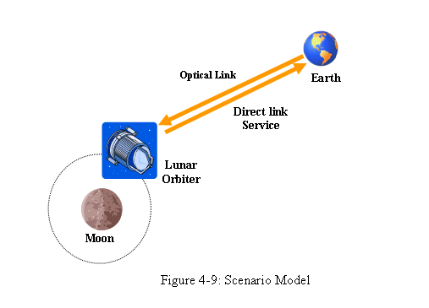

Deep space-Earth LINKS
Figure 4-10 and 4-11 show the scenario models for other exploration links
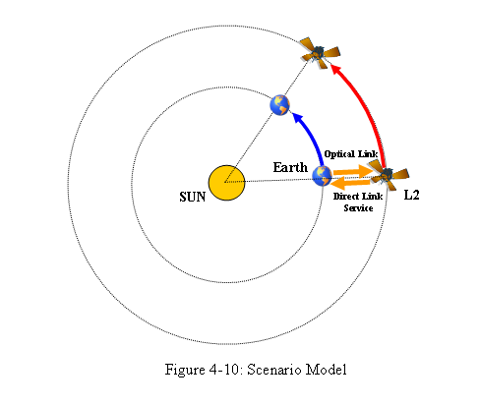
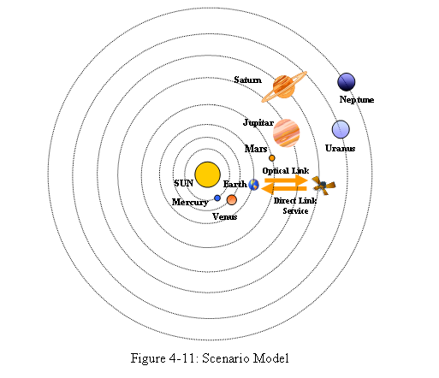

NASA
a) The Lunar Laser Communication Demonstration (LLCD) is planned for 2013(?). An overview of the LLCD is shown in Figure 4-12.
b) Additionally, NASA develops the DOT (Deep-Space Optical Terminal) potentially used on a 2018 example mission.
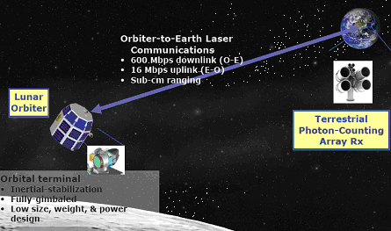
Figure 4-12: Overview of NASA’s Lunar Direct Link System [Ref to No.37]

ESA
a) ESA designed an optical communication system for optical links to Lagrange points. Link parameters are given in Figure 4-13.
b) Mars-Earth (OGS ground demonstration in ESA’s ROSA project): an integrated RF-optical approach is foreseen for the laser terminal
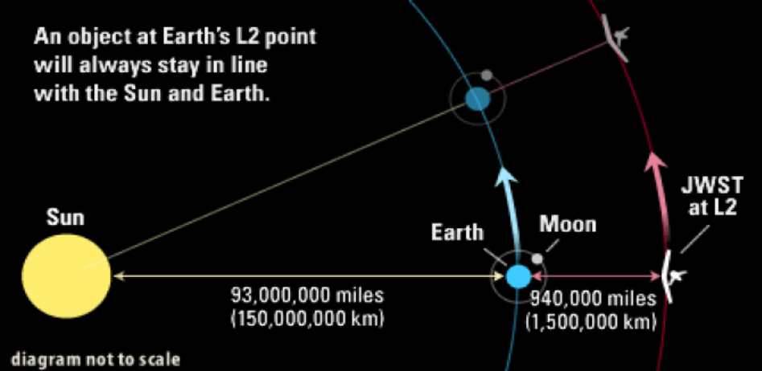
Figure 4-13: Overview of ESA’s Lagrange Points-Earth Link System [Ref to No.20]

Requirements
The possible services required for exploration missions are shown in Figure 4-14 together with the related data rate. On the long-term, technologies and architectures must evolve so as to provide the necessary services.
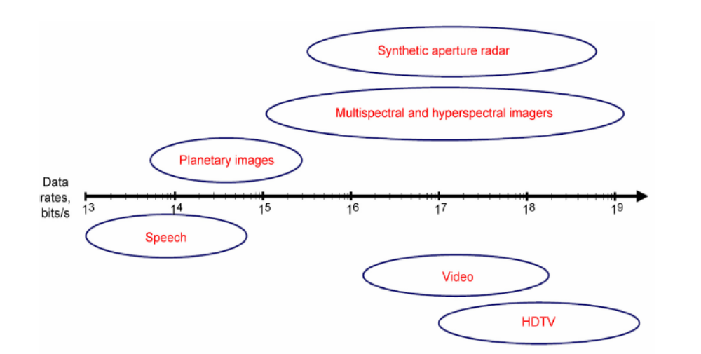
Figure 4-14: Applications and data rate for future space missions [Ref to No.33]

conclusions

This document describes the architecture of CCSDS protocol stack related to the space optical communications. It also identifies, with the consensus of the group the foreseen scenarios where standardization could be applied.

Finally it is noted that although a modification of existing CCSDS protocols is not necessary, it is necessary to add technical information of space optical communications into the relevant layer and sublayer.

Annex 1: study of the Optical channel

Doppler shift
For near-Earth links with a LEO satellite, the link distance variation goes up to approximately v = 7 km/s. At λ = 1 µm (f = 300 THz), the Doppler effect leads then to a wavelength shift up to  0.023 nm and a frequency shift up to  7 GHz.
For a Mars downlink, the Doppler shift can be higher because the link distance variation can reach 20 km/s. [Ref to No.18]

Background light
The conclusion from [Lee89] is
“Direct detection receivers will typically suffer a degradation of between 5 and 15 dB at λ = 0.85 µm and λ = 1.3 µm when illuminated by the sun. Heterodyne/homodyne receivers at 10.6 µm degrade more with sun radiation (typically 4 dB) than at the smaller wavelengths (≈0.3 dB).”
Photon counting is more sensitive to background light.

Rx-power dynamic
With a constant Tx-power, variations of the link distance or variations of the atmospheric attenuation induce an Rx-power dynamic.

LEO downlink
For a LEO-GND link, Figure 6-1 shows the dependence of free-space loss and clear-sky attenuation on the elevation angle. A satellite altitude of 600 km was assumed for the free-space loss and clear-sky attenuation was evaluated as a function of altitude for a wavelength λ = 0.810µm [Ref to No.31].

Even though atmospheric effects are extreme at 0° elevation, there is no minimum elevation for communication unless the line of sight is obstructed e.g. by the landscape. The very high atmospheric attenuation experienced at 0° elevation can be greatly reduced by setting the OGS on a mountain.

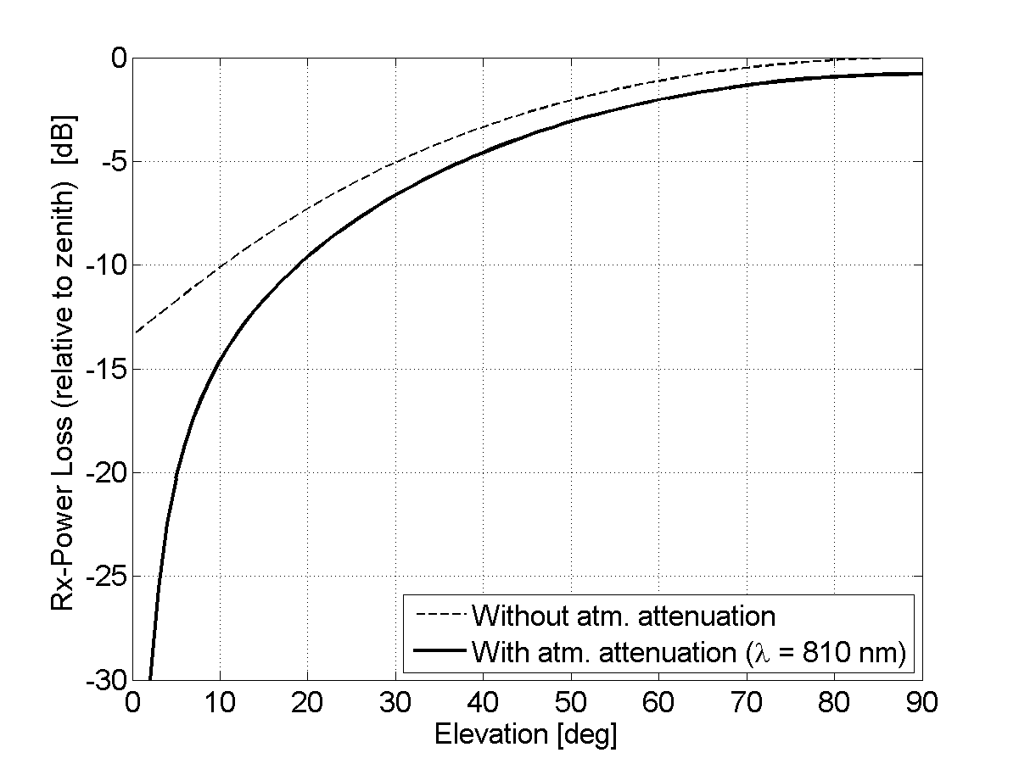
Figure 6-1: Dependence of the optical-power loss with respect to elevation. The thin curve represents the geometrical loss relative to the zenith link. the thick curve includes atmospheric attenuation at 0.810µm.

LEO-GEO
The distance varies approximately from 35 000 km to 44 000 km which corresponds to a distance dynamic of 1 dB and a power dynamic of 2 dB.

Mars downlink
The distance varies approximately from 6e10 m to 4e11 m which corresponds to a distance dynamic of 8 dB and a power dynamic of 16 dB.

Atmospheric channel

Atmospheric transmission
Figure 6-2 shows the transmission based on molecular absorption only and with a logarithmic scale for the wavelength. Nine windows were identified. For wavelengths longer than 25 µm, absorption of atmospheric water molecules does not allow any transmission.
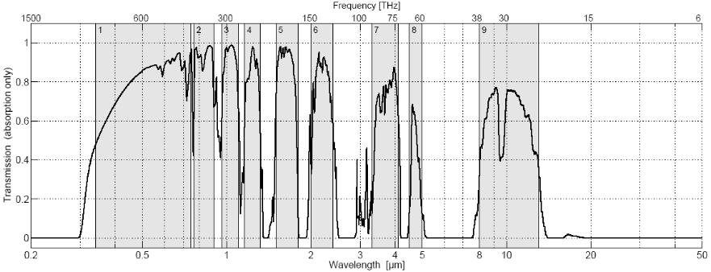
Figure 6-2: Transmission of the optical spectrum based on molecular absorption of the clear atmosphere. The transmission at zenith and down to the sea level is considered. The spectrum was calculated with the software suite libRadtran using the model LOWTRAN [Ref to No.29].

The transmission windows 3 and 5 around 1064nm and 1550nm are plotted with higher resolution in Figure 6-3. Calculations correspond to a zenith path from sea level to space. We observe that transmission bandwidths of 100 nm are available, allowing WDM.
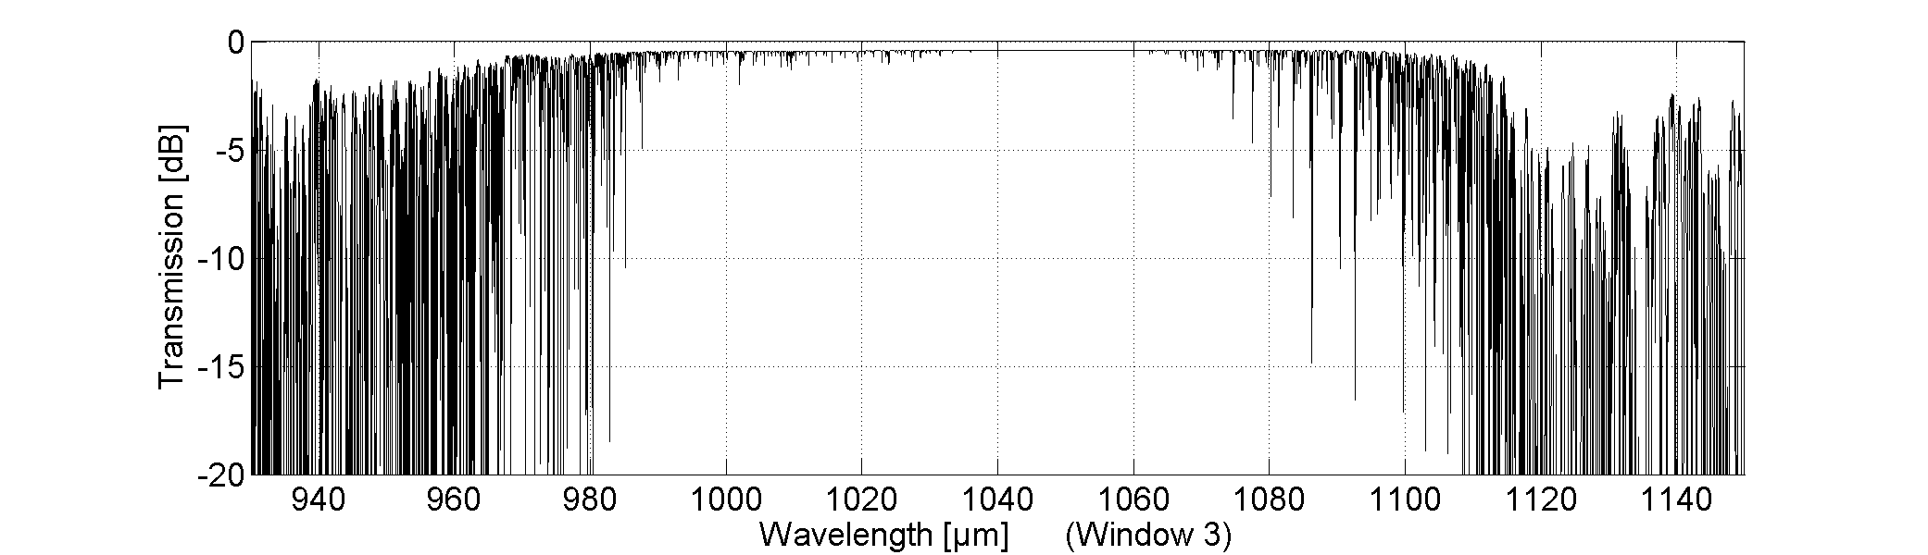
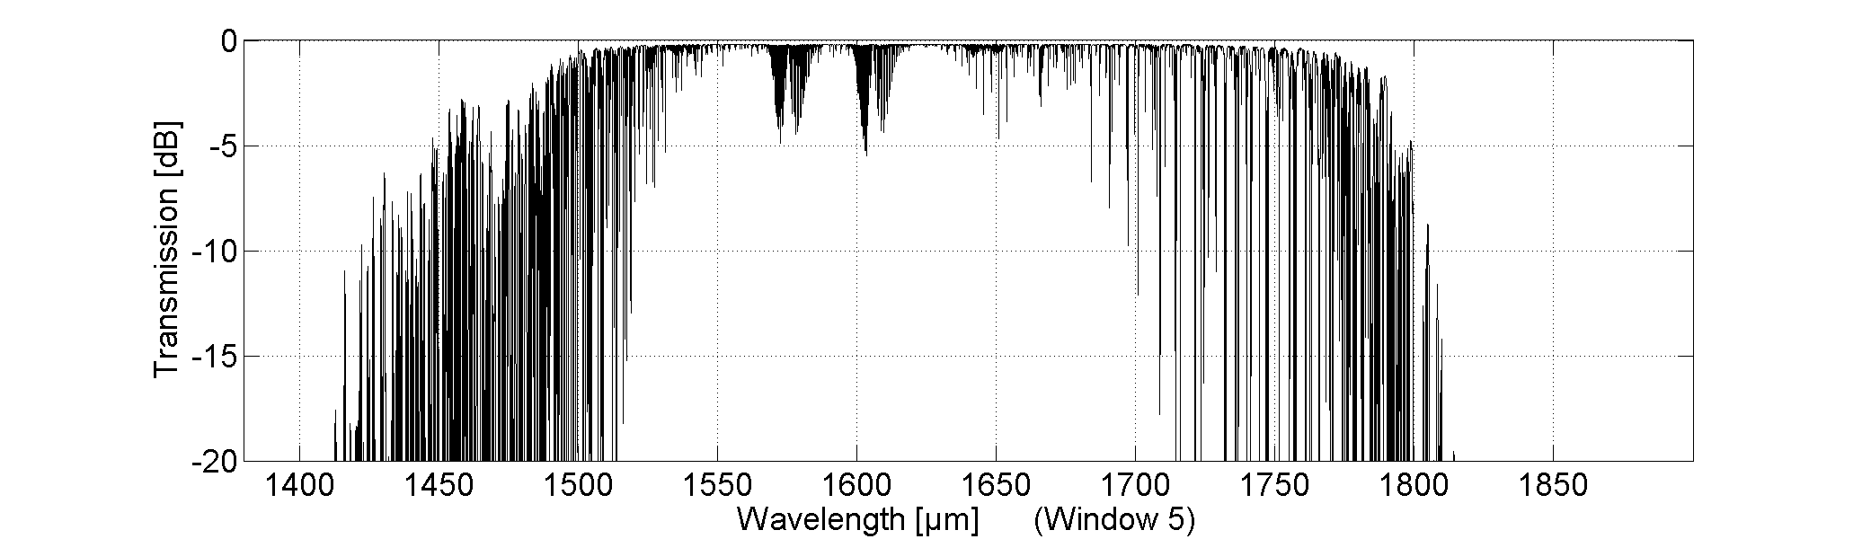
Figure 6-3: Transmission windows 3 and 5 at high resolution based on an atmospheric absorption database operated by DLR [Ref to No.19]. The wavelength resolution is 0.02 nm. Parameters are Zenith view, midlatitude summer, moderate volcanic extinction.

Optical Turbulence (downlink)

Scintillation
Scintillation is the random fluctuation of the optical power because of atmospheric turbulence. The fluctuation strength is measured by the scintillation index (variance of normalized power) which increases for lower elevation angles until saturation is reached. Figure 6-4 shows the scintillation index σ_{P}² measured during the KIODO downlinks [Ref to No.36]. Because of aperture averaging, σ_{P}² is much smaller for a collecting-aperture diameter of 40 cm than for a point receiver. Figure 6-5 shows a recorded pupil image in which one can observe the scintillation speckles that actually contain the signal energy.
In the weak-fluctuation regime (elevation > 20°), σ_{P}² is proportional to λ^{-7/6} for small apertures. But the wavelength-dependence decreases for larger apertures.
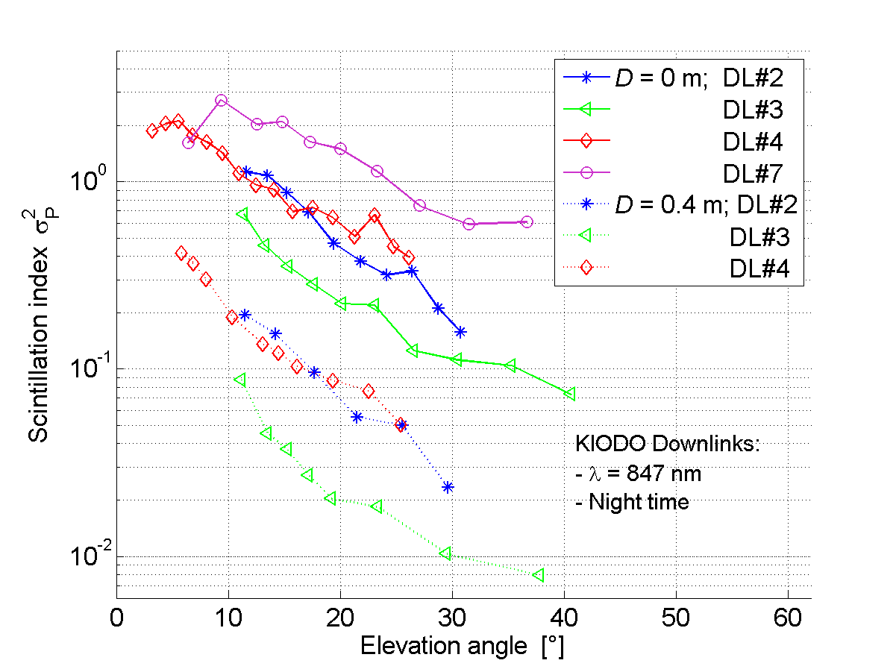  Figure 6-4: Measured scintillation index vs. elevation. Data are from the KIODO experiment (optical downlink from a Japanese LEO satellite, λ = 0.847µm). The power was collected over two different apertures of diameters 0.4 m and ~ 0 m (camera pixel). [Ref to No.36] | 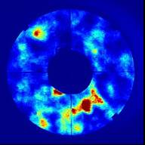  Figure 6-5: Measured intensity field in the pupil plane of a 40-cm telescope. Scintillation speckled can be observed.  [Ref to No.25]
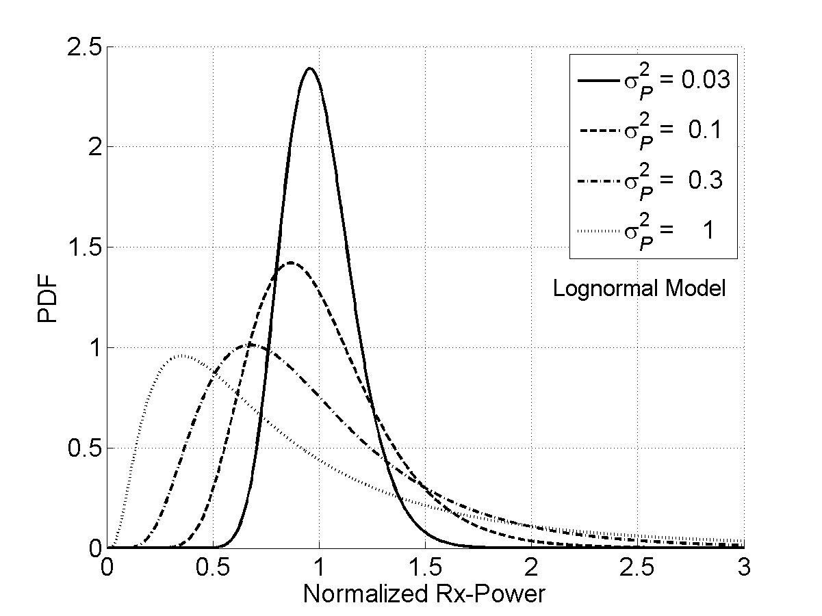
Figure 6-6: Lognormal probability distribution of received power normalized over its mean

Wavefront distortions

Fried parameter
Fried introduced the coherence diameter r₀ (also called Fried parameter) as a statistical measure of spatial coherence for waves distorted by turbulence. Figure 6-7 gives a stochastic realization of a distorted wavefront with D/r₀ = 5, D being the telescope diameter. In Figure 6-8, theoretical plots of r₀ as a function of the elevation angle are shown.
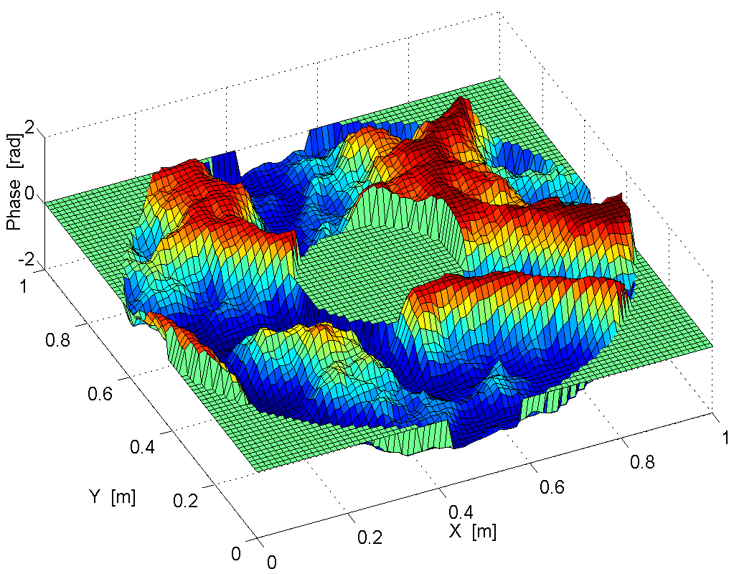  Figure 6-7: Numerically simulated distorted wavefront. | 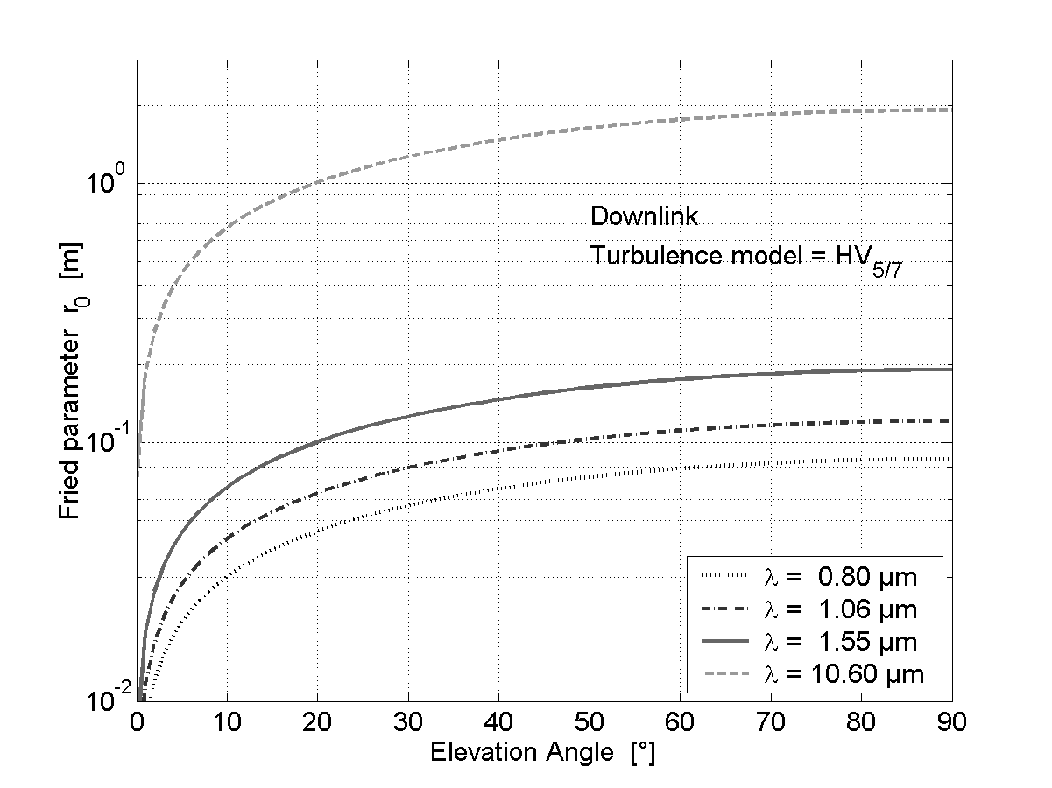  Figure 6-8: Fried parameter r₀ as a function of downlink elevation for different wavelengths. The model used for optical turbulence is the Hufnagel-Valey model HV_{5/7} [Ref to No.17].

Spatial Coherence and Spot Size
Typical focal-spot intensities are illustrated in Figure 6-9 for different r₀ relative to the Rx-aperture diameter D. The dashed circles for the last two images show the long-term spot diameters which define the distribution area of the received optical power
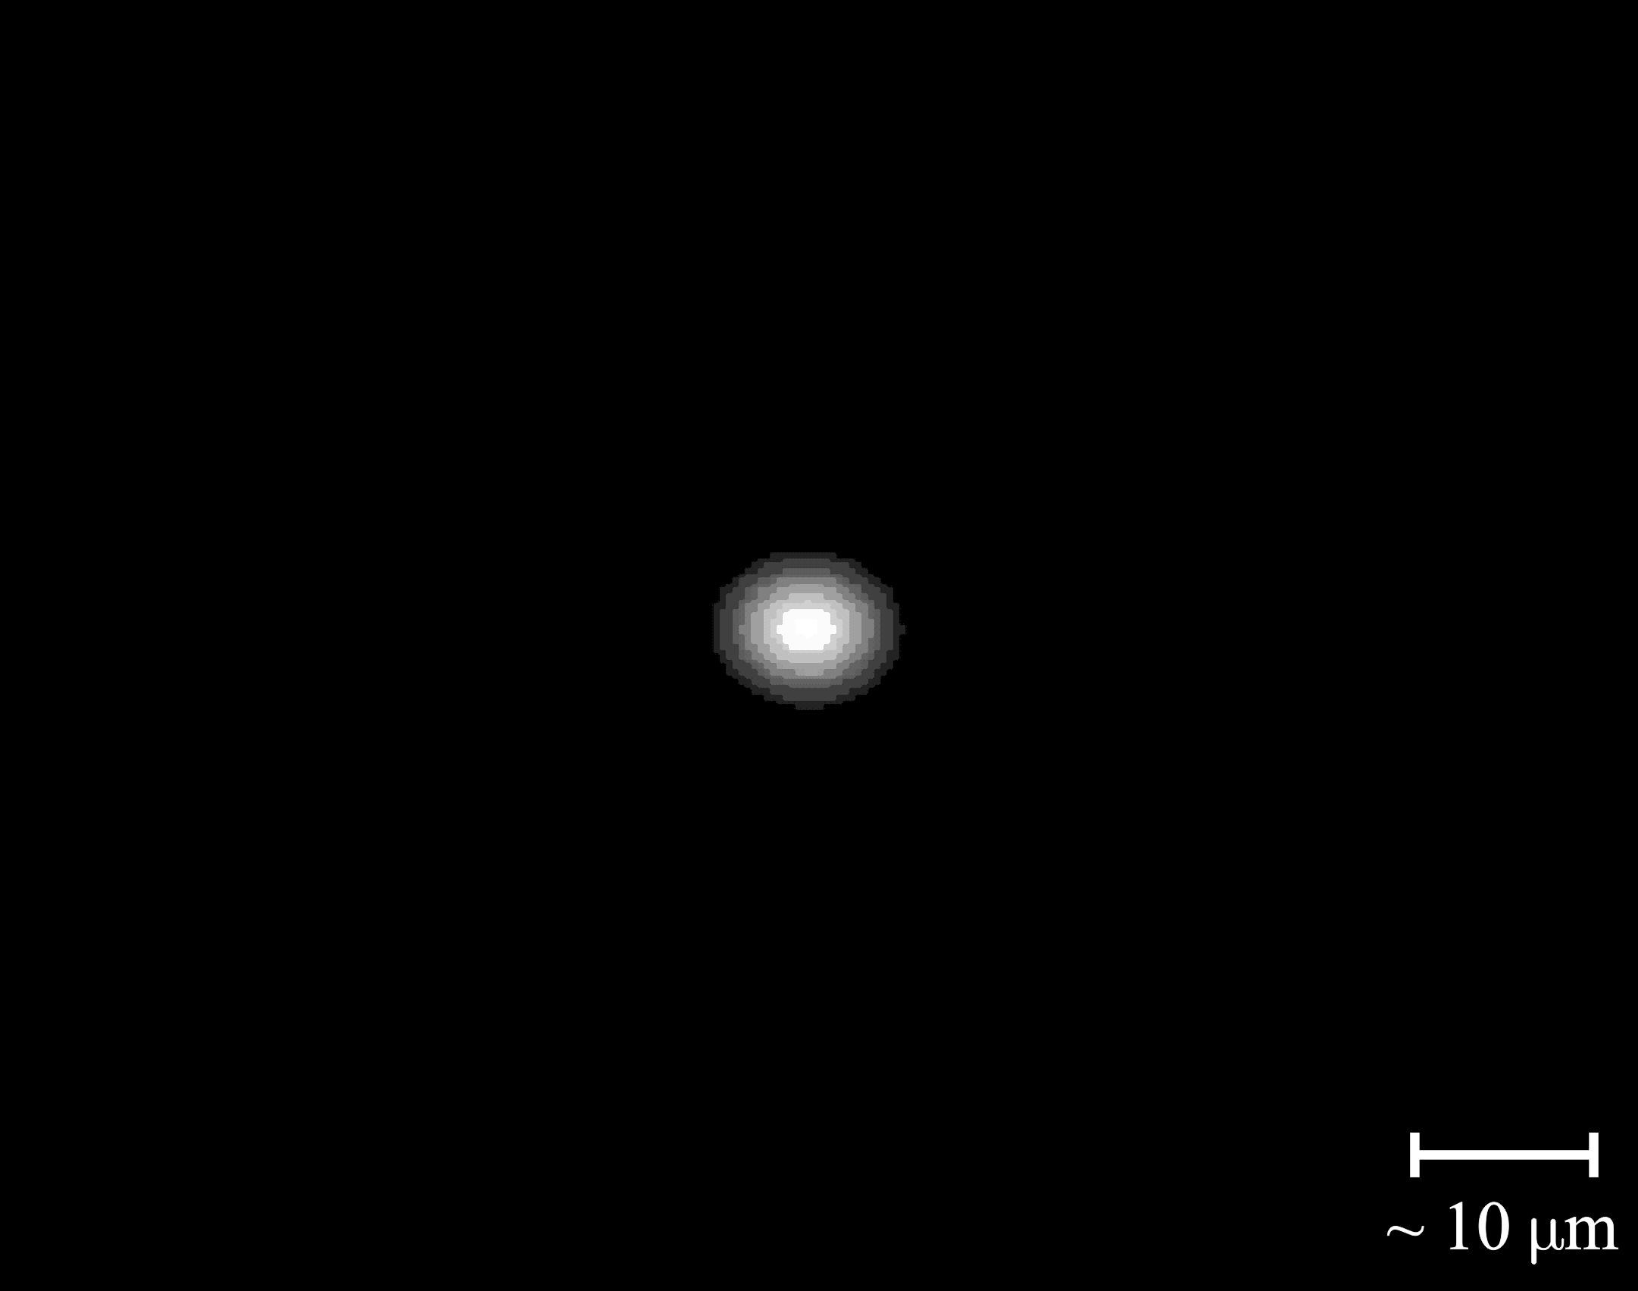 | 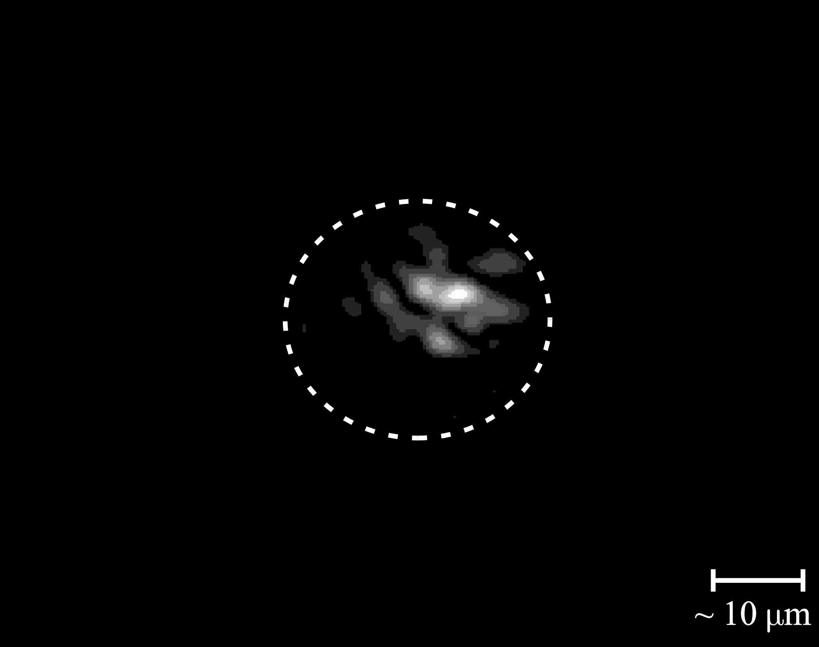 | 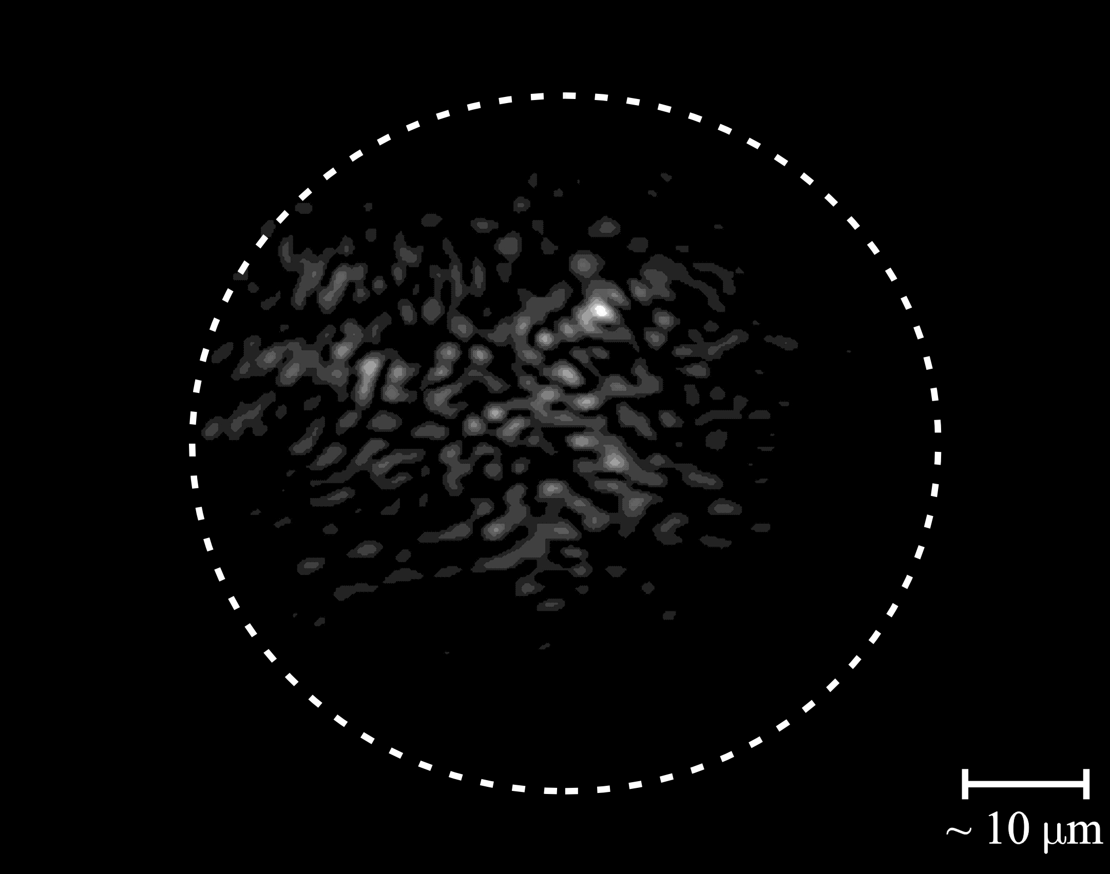
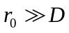 | 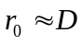 | 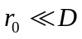
Figure 6-9: Short-term spots in the focal plane under different levels of turbulence.
The dashed circles for the last two images show the long-term spot diameters.
The Strehl ratio (SR) quantifies the discrepancy between the coherence of the received wave and first spatial mode (piton mode) of the receiver. Thus, SR represents a turbulence-induced loss for single-mode receivers. The mean SR is generally expressed as
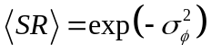 for 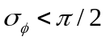
where 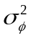 is the variance of the aperture-averaged phase.

Optical tracking
In general, the tracking system has an impact on the data link. For example, an adaptive data rate is associated with an Rx-power dynamic which the tracking system must cope with. Therefore, a tracking model shall be assumed for the channel characterization.

Annex 2 : Study of the optical technology

Laser Transmitters
High peak-power transmitters…
- are required for low-duty cycle modulations (restricts to 1.064, 1.550µm)
- ultimately limits achievable duty-cycles
Pulse duration is limited by laser bandwidth
Phase-stable lasers are required for PSK (many solutions exist)
Simultaneous transmission of mutually incoherent beams is required to introduce the atmospheric averaging effect in laser transmission.

Detection techniques
A signal with a given modulation can be detected differently (e.g., coherently or incoherently). A detection model may be used to support a modulation or coding schemes, but the detection model will not be part of the recommendation.
Detection type |  | Technology | Possible modulations | Remarks
Direct detection | Electrical amplification | PMT, APD, PIN | Intensity  (OOK,PPM,.), or DPSK. | - easy implementation
Direct detection | Optical amplification | e.g., EDFA  +PIN diode | Intensity  (OOK,PPM,.), or DPSK. | - widely available  - WDM scalable
Direct detection | Photon counting | Cooled receiver | Intensity modulations, PPM | - high theoretical sensitivity  - requires strong FEC  - in development
Coherent detection |  | LO superposition | Any. | - Rx limited to shot-noise
Quantum |  | Dolinar receiver |  | - large theoretical gains  -technology relatively immature.
Table 7-1: Overview of detection types
Coherent detection is compared to direct detection is given in Table 7-2.
Heterodyne detection (vs. direct detection)
Advantages | Disadvantages
- can detect signals of any modulation  - provides enhanced sensitivity  - negligible background-light noise | - higher system complexity (LO required)  - requires LO match (single-mode detection)  - requires a narrow spectral line width (or short coherence time) for the emitted beam.  - requires a frequency-acquisition phase prior to communication
Table 7-2: Pros and cons of the heterodyne (or homodyne) receiver
Advantages of single mode and multimode detection are summarized in Table 7-3.
Single-mode detection (vs. multi-mode detection)
Advantages | Disadvantages
- allows higher data rates  - less background light is detected | - high loss for distorted wavefronts  (low Strehl ratio)  - smaller field of view
Table 7-3:Pros and cons of single-mode detection

Metrics for modulation and coding solutions
- Transmitter Complexity
- Receiver Complexity (must include implied system requirements, e.g., a LO for coherent detection, or adaptive optics for atmospheric mitigation)
- Power efficiency (bits/photon)
- Bandwidth Efficiency (bits/s/Hz or bits/channel use)
- Capability of adapting the data rate (metrics for modulations and coding schemes)
- Capability of multiplexing (e.g. WDM)
- Robustness to atmospheric or pointing fades
- Robustness to background light (e.g., PPM strongly affected by background light, BPSK quasi immune)

Modulations
Description of figure → JPL

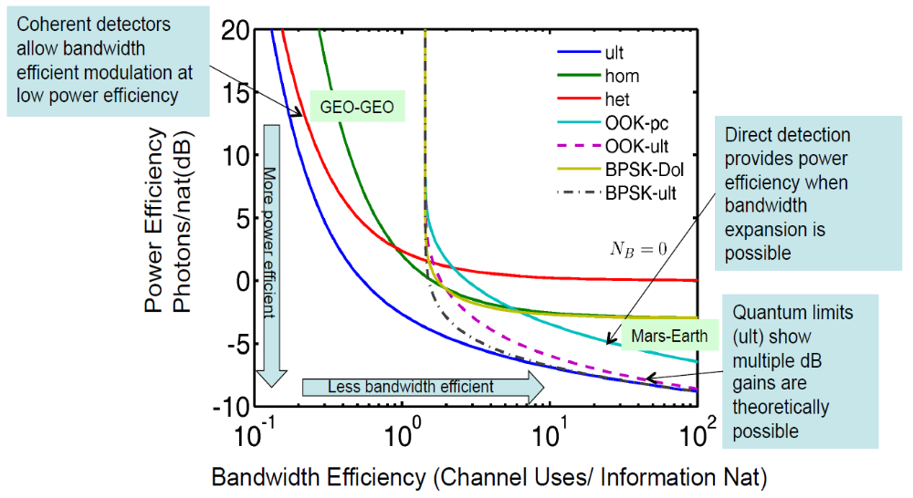
Figure 7-1:Power efficiency vs. Bandwidth efficiency for various modulations

- Given the potential application profiles and candidate technologies, we can enumerate a list of potential modulations to be considered in a standard.
Phase-shift-keying (BPSK, MPSK)
- Efficient for bandwidth constrained links (relative to, for example, PPM)
- Requires coherent detection (Homodyne, Heterodyne)
- May be combined with PPM to extend coherent modulations to low duty-cycle links.
- May be restricted to non-atmospheric links. (Pollara checks)
- Requires single-mode detection

Differential Phase Shift Keying (DPSK)
- A potential use of PSK in atmosphere. (Pollara checks)
- Requires single-mode detection if single-mode fiber coupling

Pulse-Position-Modulation (PPM, MPPM)
- May be implemented with direct detection.
- Very efficient at low average power, when peak power and bandwidth constraints are inactive, typical of a deep-space link.
- Bandwidth overhead makes it inefficient for bandwidth constrained link, e.g., inter-satellite.

Binary Shaping
- An alternative to PPM for low-duty cycle Modulations
- Borrows techniques developed for shaping codes for modems
Polarization Shift Keying (POLSK)
- Requires ability to detect polarization
Frequency-shift-Keying (FSK)
- Requires the ability to transmit and detect varying frequencies, adding complexity to receiver and transmitter, e.g. Fiber Bragg Grating + power detectors.
- Complexity comparable to PSK.
- Efficient for power constrained links compared to PSK.

Higher-order amplitude and phase shift keying (16QAM, 64QAM)
- High order modulation efficient for bandwidth constrained links.
- Requires coherent detection (Homodyne, Heterodyne).
- Suits to higher-rate coded modulation.

Channel Coding

Candidates
The choice of an error correction code (ECC) is, in turn, driven by the modulation and channel model.
Description of figure → JPL
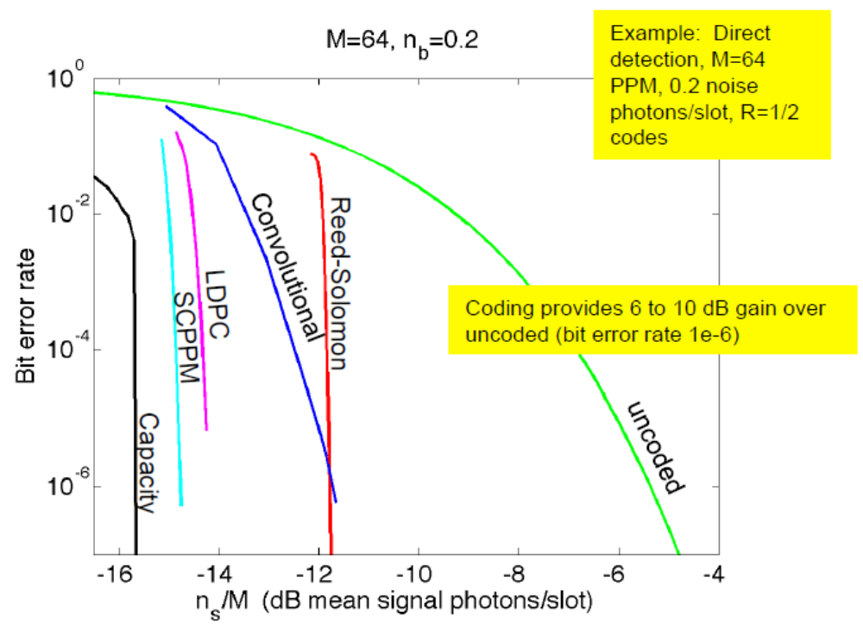
Figure 7-2:BER vs n_{s}/M(dB mean signal photon/slot)

Reed-Solomon
• low complexity encoder and decoder implementation
• less power efficient than iterative codes (hard decision)--with soft-decision decoding may be a power efficient candidate
• well suited to combination with PPM by encoding over complementary field

Serially Concatenated PPM
• Iteratively decoded code
• Very power efficient
• The best candidate for high-order modulations where the modulation may be used as an inner code.
• Mature implementation for deep-space channel at JPL and LL
Convolutional
• Low complexity encoder and decoder implementation
• Comparable to RS codes, may be a candidate for regions where coding gain is desired but complexity trumps power efficiency, e.g., proximity links

Low Density Parity Check
• Iteratively decoded code
• very power efficient
• standards for BPSK may be pulled directly from RF
• codes over high-order fields may be applicable for PPM

Product Codes
• Iteratively decoded code
• Less power efficiency than alternative iterative codes (LDPC, SCPPM)
• Well suited to high speed/parallel decoding

Turbo (Parallel Concatenated)
• Iteratively decoded code
• Power efficient--but less so than alternative iterative codes for high-order modulations (LDPC, SCPPM)
• Standards exist for BPSK RF

Concatenated RS+Convolutional
• Middling Power Efficiency(>RS or CC, < LDPC or SCPPM)
• Standard for RF BPSK channel

Coded modulation
• Enhanced version of convolutional code.
• Combines channel coding with modulation so as to obtain an extra Euclidean distance.
• (bit-interleaved) coded modulation is suited to higher rate transmission.
• Requires coherent detection.

Trade-off for high duty-cycle modulations
Better determine the weights of each metric for each scenario.
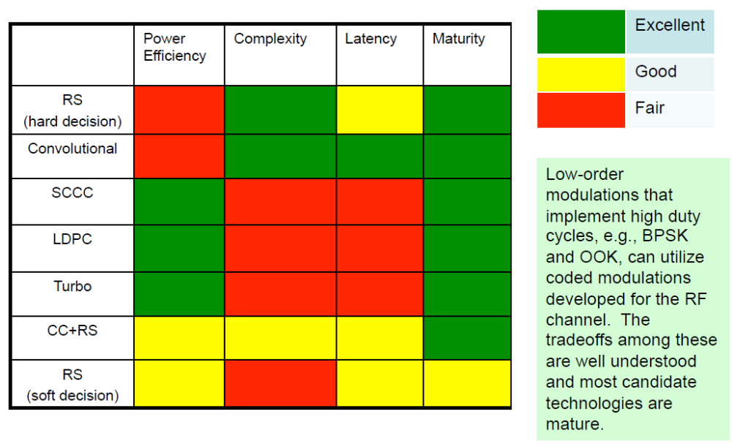
Figure 7-3: Trade off for high duty-cycle modulations

Trade-off for low duty-cycle modulations
Better determine the weights of each metric for each scenario.
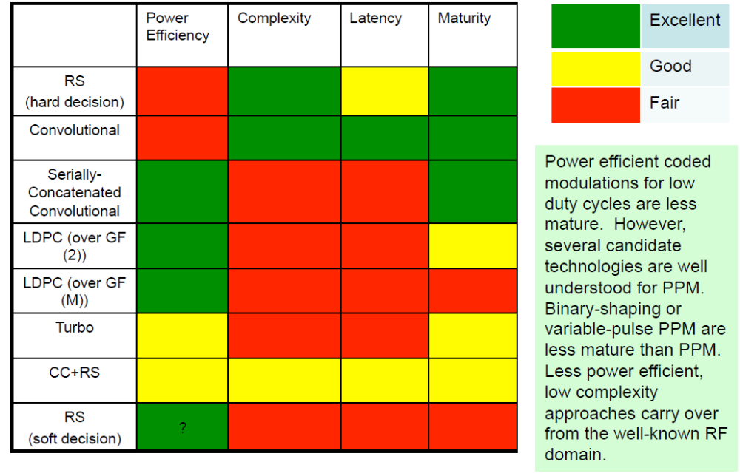
Figure 7-4: Trade off for low duty-cycle modulations

annex 3 : Study of the Operation services
In this annex, examples of operation contents are given for some scenarios mentioned in this document. But any other suitable types of operation contents shall also be considered.

Group A |  | Table 8-1 : SCENARIO : LEO - GEO INTER-SATELLITE LINKS |  |  |  |  |  |  | SUMMARY
 |  | Earth to GEO |  |  | GEO to LEO |  |  |  | SUMMARY
1-a) | LINK | λ , f | MODEM | CODEC | LINK | λ , f | MODEM | CODEC | Technical Reason
1-a) | Up | λ:0.01[m]  f:30 GHz band | BPSK  QPSK | RS  Conv/Viterbi | FWD | λ:0.8[μm]  f:375 THz band  λ:1.064[μm]  f:282 THz band  λ:1.550[μm]  f:194 THz band | PPM(INCOH)/IMDD  DPSK(COH)/Hetero  BPSK(COH)/Homo  QPSK(COH)/Homo | RS  LDPC | [λ , f]  RF:  -Strong for weather and  better for Asia region  up to 3.5GHz band  Optical  -For regions with a  nice weather and no  band limit. For high  rate services with a high power cases,  1.064 and 1.550  [μm] are suitable.  [MODEM]  DPSK:  -High Sesitivity  -Simpler Receiver  -Technology exists  BPSK/QPSK  -Higher Sesitivity  -Moderate Receiver  -New Technology  [CODEC]  RS  -Real use in fiber com  -LSI exists  LDPC  -Better Coding Gain  -New Technology
1-a) | Up | λ:0.8[μm]  f:375 THz band  λ:1.064[μm]  f:282 THz band  λ:1.550[μm]  f:194 THz band | OOK,  DPSK(COH)/Hetero  BPSK(COH)/Homo  QPSK(COH)/Homo | RS  LDPC
1-a) | Down | λ:0.015[m]  f:20 GHz band | OOK,  BPSK  QPSK | RS/RS  Conv/Viterbi | RTN | λ:0.8[μm]  f:375 THz band  λ:1.064[μm]  f:282 THz band  λ:1.550[μm]  f:194 THz band | PPM(INCOH)/IMDD  DPSK(COH)/Hetero  BPSK(COH)/Homo  QPSK(COH)/Homo | RS  LDPC
1-a) | Down | λ:0.8[μm]  f:375 THz band  λ:1.064[μm]  f:282 THz band  λ:1.550[μm]  f:194 THz band | OOK,  DPSK(COH)/Hetero  BPSK(COH)/Homo  QPSK(COH)/Homo | RS  LDPC

Group A |  | Table 8-3 : SCENARIO : LEO - GND DIRECT LINKS |  |  |  |  |  |  | SUMMARY
 |  | Earth to LEO |  |  | - |  |  |  | SUMMARY
2-a) | LINK | λ , f | MODEM | CODEC | LINK | λ , f | MODEM | CODEC | Technical Reason
2-a) | Up | λ:0.8[μm]  f:375 THz band  λ:1.064[μm]  f:282 THz band  λ:1.550[μm]  f:194 THz band | OOK,  PPM(INCOH)/IMDD  DPSK(COH)/Hetero  BPSK(COH)/Homo  QPSK(COH)/Homo | RS, SC-PPM, Conv, LDPC, Product，Turbo, Concatenated RS+LDPC, Concatenated RS+Convolutional, Coded Mod | - | - | - | - | [λ , f]  Other than 1.064 and 1.550[μm], as an existing technology,  0.8[μm]:  -2PPM evaluated  -Band Efficiency  -High Sensitivity  -Simple System  -Strong for Turbulance  -Low power for short  Distance less than 1000[km] with around  100Mbps(Mideum)  [MODEM]  DPSK:  -High Sesitivity  -Simpler Receiver  -Technology exists  BPSK/QPSK  -Higher Sesitivity  -Moderate Receiver  -New Technology  [CODEC]  RS  -Real use in fiber com  -LSI exists  LDPC  -Better Coding Gain  -New Technology
2-a) | Down | λ:0.8[μm]  f:375 THz band  λ:1.064[μm]  f:282 THz band  λ:1.550[μm]  f:194 THz band | OOK,  PPM(INCOH)/IMDD  DPSK(COH)/Hetero  BPSK(COH)/Homo  QPSK(COH)/Homo | RS, SC-PPM, Conv, LDPC, Product，Turbo, Concatenated RS+LDPC, Concatenated RS+Convolutional, Coded Mod | - | - | - | -

Group B |  | Table 8-8 : DEEP SPACE PROBES DIRECT LINKS |  |  |  |  |  |  | SUMMARY
 |  | Earth to Deep Space Probe |  |  | - |  |  |  | SUMMARY
2-c) | LINK | λ , f | MODEM | CODEC | LINK | λ , f | MODEM | CODEC | Technical Reason
2-c) | Up |  |  |  | - | - | - | -
2-c) | Down |  |  |  | - | - | - | -

annex 4 : Acronyms
ADR | Adaptive Data Rate
ALOS-2 | Advanced Land Observation Satellite-2
ALOS-Xs | Advanced Land Observation Satellite-X
AOS | Advanced Orbiting Systems
APD | Avalanche Photo Diode
ARTES | Advanced Research on Telecommunication Systems
ARTEMIS | Advanced Relay and Technology Mission
BER | Bit Error Rate
BGL | Background light
BPSK | Binary Phase Shift Keying
CC | Convolutional Coding
CNES | Centre National d’Etudes Spatiales
DLR | German Space Center
DOTT | Deep Space Optical Terminal
DR | Data Rate
DPSK | Differential Phase Shift Keying
DRTS | Data Relay Test Satellite
ECC | Error Correction Code
EDFA | Erbium Doped Fiber Amplifier
EDRS | European Data Relay System
ESTEC | European Space Technology Center
EO | Electro Optical
ESA | European Space Agency
FAR | Focal Array Receiver
FB | Fabry-Perot
FDM | Frequency Division Multiplexing
FSOC | Free-Space Optical Communications
FSK | Frequency Shift Keying
FWD | Forward (Link)
GMES | Global Monitoring for Environment and Security
GND | Ground
GS | Ground Station
HDTV | High Definition Television
JAXA | Japan Aerospace Exploration Agency
JPL | Jet Propulsion Laboratory
LA | Link Availability
LADEE | Lunar Atmosphere Dust Environment Explorer
LDPC | Low Density Parity Check
LEO | Low Earth Orbit
LLCD | Lunar Laser Communication Demonstration
LO | Local Oscillator
MPSK | Multi Phase Shift Keying
MPPM | Multi Pulse Position Modulation
NASA | National Aeronautics and Space Administration
NDRTS | Next Data Relay Test Satellite
NICT | National Institute of Information and Communications Technology
OOK | On-Off Keying
OGS | Optical Ground Station
OICETS | Optical Inter-Orbit Communications Engineering Test Satellite
PFD | Power Flux Density
PIN | PIN(Positive Intrinsic Negative) Photo Diode
PMT | Photo Multiplier Tube
POLSK | Polarization Shift Keying
PPM | Pulse Position Modulation
PSK | Phase Shift Keying
QAM | Qauadrature Amplitude Modulation
RF | Radio Frequency
RS | Reed-Solomon Coding
RTN | Return(Link)
SCPPM | Serially Concatenated Pulse Position Modulation
SOTA | Small Optical Transponder
SPOT-4 | Satellite Pour l’ Observation de la Terre 4
SR | Strehl Ratio
TC | Telecommand
TerraSAR-X | German Earth Observation Satellite
Tandem-X | TerraSAR-X add-on for Digital Elevation Measurement
TDX | Tandem-X
TDM | Time Division Multiplexing
TM | Telemetry
TT&C | Telemetry Tracking and Command
WDM | Wavelength Division Multiplexing

