
Recommendation for Space Data System Standards
TM Synchronization and Channel Coding
Recommended Standard
CCSDS 131.0-B-6
Blue Book
October 2023
AUTHORITY

 | Issue: | Recommended Standard, Issue 5
 | Date: | September 2023
 | Location: | Washington, DC, USA
This document has been approved for publication by the Management Council of the Consultative Committee for Space Data Systems (CCSDS) and represents the consensus technical agreement of the participating CCSDS Member Agencies. The procedure for review and authorization of CCSDS documents is detailed in Organization and Processes for the Consultative Committee for Space Data Systems (CCSDS A02.1-Y-4), and the record of Agency participation in the authorization of this document can be obtained from the CCSDS Secretariat at the email address below.

This document is published and maintained by:

CCSDS Secretariat
National Aeronautics and Space Administration
Washington, DC, USA
Email: secretariat@mailman.ccsds.org
STATEMENT OF INTENT
The Consultative Committee for Space Data Systems (CCSDS) is an organization officially established by the management of its members. The Committee meets periodically to address data systems problems that are common to all participants, and to formulate sound technical solutions to these problems. Inasmuch as participation in the CCSDS is completely voluntary, the results of Committee actions are termed Recommended Standards and are not considered binding on any Agency.
This Recommended Standard is issued by, and represents the consensus of, the CCSDS members. Endorsement of this Recommendation is entirely voluntary. Endorsement, however, indicates the following understandings:
o Whenever a member establishes a CCSDS-related standard, this standard will be in accord with the relevant Recommended Standard. Establishing such a standard does not preclude other provisions which a member may develop.
o Whenever a member establishes a CCSDS-related standard, that member will provide other CCSDS members with the following information:
-- The standard itself.
-- The anticipated date of initial operational capability.
-- The anticipated duration of operational service.
o Specific service arrangements shall be made via memoranda of agreement. Neither this Recommended Standard nor any ensuing standard is a substitute for a memorandum of agreement.
No later than five years from its date of issuance, this Recommended Standard will be reviewed by the CCSDS to determine whether it should: (1) remain in effect without change; (2) be changed to reflect the impact of new technologies, new requirements, or new directions; or (3) be retired or canceled.
In those instances when a new version of a Recommended Standard is issued, existing CCSDS-related member standards and implementations are not negated or deemed to be non-CCSDS compatible. It is the responsibility of each member to determine when such standards or implementations are to be modified. Each member is, however, strongly encouraged to direct planning for its new standards and implementations towards the later version of the Recommended Standard.
FOREWORD
This document is a technical Recommended Standard for use in developing synchronization and channel coding systems and has been prepared by the Consultative Committee for Space Data Systems (CCSDS). The synchronization and channel coding concept described herein is intended for missions that are cross-supported between Agencies of the CCSDS.
Through the process of normal evolution, it is expected that expansion, deletion, or modification of this document may occur. This Recommended Standard is therefore subject to CCSDS document management and change control procedures, which are defined in the Organization and Processes for the Consultative Committee for Space Data Systems (CCSDS A02.1-Y-4). Current versions of CCSDS documents are maintained at the CCSDS Web site:
http://www.ccsds.org/
Questions relating to the contents or status of this document should be sent to the CCSDS Secretariat at the email address indicated on page i.
At time of publication, the active Member and Observer Agencies of the CCSDS were:
Member Agencies
- Agenzia Spaziale Italiana (ASI)/Italy.
- Canadian Space Agency (CSA)/Canada.
- Centre National d’Etudes Spatiales (CNES)/France.
- China National Space Administration (CNSA)/People’s Republic of China.
- Deutsches Zentrum für Luft- und Raumfahrt (DLR)/Germany.
- European Space Agency (ESA)/Europe.
- Federal Space Agency (FSA)/Russian Federation.
- Instituto Nacional de Pesquisas Espaciais (INPE)/Brazil.
- Japan Aerospace Exploration Agency (JAXA)/Japan.
- National Aeronautics and Space Administration (NASA)/USA.
- UK Space Agency/United Kingdom.
Observer Agencies
- Austrian Space Agency (ASA)/Austria.
- Belgian Science Policy Office (BELSPO)/Belgium.
- Central Research Institute of Machine Building (TsNIIMash)/Russian Federation.
- China Satellite Launch and Tracking Control General, Beijing Institute of Tracking and Telecommunications Technology (CLTC/BITTT)/China.
- Chinese Academy of Sciences (CAS)/China.
- China Academy of Space Technology (CAST)/China.
- Commonwealth Scientific and Industrial Research Organization (CSIRO)/Australia.
- Danish National Space Center (DNSC)/Denmark.
- Departamento de Ciência e Tecnologia Aeroespacial (DCTA)/Brazil.
- Electronics and Telecommunications Research Institute (ETRI)/Korea.
- European Organization for the Exploitation of Meteorological Satellites (EUMETSAT)/Europe.
- European Telecommunications Satellite Organization (EUTELSAT)/Europe.
- Geo-Informatics and Space Technology Development Agency (GISTDA)/Thailand.
- Hellenic National Space Committee (HNSC)/Greece.
- Hellenic Space Agency (HSA)/Greece.
- Indian Space Research Organization (ISRO)/India.
- Institute of Space Research (IKI)/Russian Federation.
- Korea Aerospace Research Institute (KARI)/Korea.
- Ministry of Communications (MOC)/Israel.
- Mohammed Bin Rashid Space Centre (MBRSC)/United Arab Emirates.
- National Institute of Information and Communications Technology (NICT)/Japan.
- National Oceanic and Atmospheric Administration (NOAA)/USA.
- National Space Agency of the Republic of Kazakhstan (NSARK)/Kazakhstan.
- National Space Organization (NSPO)/Chinese Taipei.
- Naval Center for Space Technology (NCST)/USA.
- Netherlands Space Office (NSO)/The Netherlands.
- Research Institute for Particle & Nuclear Physics (KFKI)/Hungary.
- Scientific and Technological Research Council of Turkey (TUBITAK)/Turkey.
- South African National Space Agency (SANSA)/Republic of South Africa.
- Space and Upper Atmosphere Research Commission (SUPARCO)/Pakistan.
- Swedish Space Corporation (SSC)/Sweden.
- Swiss Space Office (SSO)/Switzerland.
- United States Geological Survey (USGS)/USA.

DOCUMENT CONTROL

Document | Title | Date | Status
CCSDS 131.0-B-1 | TM Synchronization and Channel Coding, Issue 1 | September  2003 | Original issue, superseded
CCSDS 131.0-B-2 | TM Synchronization and Channel Coding, Recommended Standard, Issue 2 | August 2011 | Issue 2, superseded
CCSDS 131.0-B-3 | TM Synchronization and Channel Coding, Recommended Standard, Issue 3 | September 2017 | Issue 3, superseded
CCSDS 131.0-B-4 | TM Synchronization and Channel Coding, Recommended Standard, Issue 4 | April 2022 | Issue 4, superseded
CCSDS 131.0-B-5 | TM Synchronization and Channel Coding, Recommended Standard, Issue 5 | September 2023 | Current issue:  provides a revised pseudo-randomizer (section 10) for the purpose of obviating spectral spikes in high-data-rate links (note).
CCSDS 131.0-B-6 | TM Synchronization and Channel Coding, Draft | October 2023 | Adds turbo code channel interleaver, and moves slicing to its own section, applicable to all block codes
NOTE – Substantive changes from the previous issue are marked with change bars in the inside margin.

CONTENTS
Section Page
1 Introduction 1-1

1.1 Purpose 1-1
1.2 Scope 1-1
1.3 Applicability 1-1
1.4 Rationale 1-2
1.5 Document Structure 1-2
1.6 conventions and Definitions 1-3
1.7 PATENTED TECHNOLOGIES 1-7
1.8 References 1-8

2 OVERVIEW 2-1

2.1 ARCHITECTURE 2-1
2.2 SUMMARY OF FUNCTIONS 2-1
2.3 INTERNAL ORGANIZATION OF SUBLAYER 2-3

3 Convolutional CodING 4-1

3.1 Overview 4-1
3.2 General 4-1
3.3 BASIC CONVOLUTIONAL CODE SPECIFICATION 4-2
3.4 PUNCTURED CONVOLUTIONAL CODES 4-4

4 Reed-Solomon CodING 5-1

4.1 Overview 5-1
4.2 General 5-1
4.3 SPECIFICATION 5-1
4.4 Discussion 5-6

5 Concatenated Coding 6-1

6 Turbo Coding 7-1

6.1 Overview 7-1
6.2 General 7-1
6.3 SPECIFICATION 7-1

CONTENTS (continued)
Section Page
7 Low-Density Parity-Check CodING of a Transfer Frame 8-1

7.1 Overview 8-1
7.2 General 8-1
7.3 Low-Density Parity-Check Code with Rate 223/255 8-2
7.4 Low-Density Parity-Check Code Family with
Rates 1/2, 2/3, and 4/5 8-7

8 Low-Density Parity-Check CodING OF A STREaM OF
Sync-Marked Transfer Frames 8-1

8.1 Overview 8-1
8.2 SYNCHRONIZATION 8-1
8.3 Randomization 8-1

9 FRAME SYNCHRONIZATION 9-2

9.1 Overview 9-2
9.2 THE ATTACHED SYNC MARKER (ASM) 9-3
9.3 ASM BIT PATTERNS 9-3
9.4 LOCATION OF ASM 9-5
9.5 RELATIONSHIP OF ASM TO REED-SOLOMON, TURBO, and
LDPC CODEBLOCKS and Codewords 9-5
9.6 ASM FOR EMBEDDED DATA STREAM 9-6

10 PSEUDO-RANDOMIZER 10-1

10.1 Overview 10-1
10.2 PSEUDO-RANDOMIZER DESCRIPTION 10-1
10.3 SYNCHRONIZATION AND APPLICATION OF PSEUDO-
RANDOMIZER 10-2
10.4 SEQUENCE SPECIFICATION 10-3
10.5 LOGIC DIAGRAM 10-3

11 TRANSFER FRAME LENGTHS 11-1

11.1 Overview 11-1
11.2 General 11-1
11.3 Case 1: Uncoded 11-1
11.4 Case 2: Convolutional Only 11-1
11.5 Case 3: Reed-Solomon Only 11-2

CONTENTS (continued)
Section Page
11.6 Case 4: CONCATENATED 11-2
11.7 Case 5: TURBO 11-3
11.8 Case 6: LDPC Applied to A Transfer Frame (Section 7) 11-3
11.9 Case 7: LDPC Applied to a Stream of SMTFS (section 8) 11-3

12 Managed Parameters 12-1

12.1 OVERVIEW 12-1
12.2 General 12-1
12.3 Managed Parameters FOR SELECTED OPTIONS 12-1
12.4 Managed Parameters FOR CONVOLUTIONAL Code 12-2
12.5 Managed Parameters FOR REED-SOLOMON Code 12-2
12.6 Managed Parameters FOR TURBO Code 12-3
12.7 Managed Parameters FOR LOW-DENSITY PARITY-
CHECK Coding of a Transfer Frame 12-3
12.8 Managed Parameters for Low-Density Parity-
Check Coding of a Stream of SMTFs 12-3
12.9 Managed Parameters FOR FRAME SYNCHRONIZATION 12-3

13 USE OF TELECOMMUNICATIONS CHANNEL CODES FOR
GROUND-TO-SPACE AND SPACE-TO-SPACE LINKS 13-1

13.1 overview 13-1
13.2 turbo codes 13-1
13.3 Low-Density Parity-Check codes 13-2
13.4 coding of a stream of SMTFs 13-2

ANNEX A SERVICE (Normative) A-1
ANNEX B Security, SANA, and Patent COnsiderations (Informative) B-1
ANNEX C Annex to Subsection 7.3, Low-Density Parity-
Check Code with Rate 223/255 (INformative) C-1
ANNEX D Abbreviations and ACRONYMS (Informative) D-1
ANNEX E INFORMATIVE REFERENCES (Informative) E-2
ANNEX F TRANSFORMATION BETWEEN BERLEKAMP AND
CONVENTIONAL REPRESENTATIONS (Informative) F-1
ANNEX G EXPANSION OF REED-SOLOMON COEFFICIENTS
(Informative) G-1

CONTENTS (continued)
Figure Page
1-1 Bit Numbering Convention 1-7
2-1 Relationship with OSI Layers 2-1
2-2 Internal Organization of the Sublayer at the Sending End 2-4
2-3 Internal Organization of the Sublayer at the Receiving End 2-5
3-1 Basic Convolutional Encoder Block Diagram 4-3
3-2 Punctured Encoder Block Diagram 4-4
4-1 Reed-Solomon Codeblock Partitioning 5-5
4-2 Functional Representation of R-S Interleaving 5-7
6-1 Interpretation of Permutation 7-4
6-2 Turbo Encoder Block Diagram 7-5
6-3 Turbo Codewords for Different Code Rates 7-7
6-4 Turbo Codeword with Attached Sync Marker 7-8
7-1 Base Parity Check Matrix of the Basic (8176,7156) LDPC Code 8-3
7-2 Systematic Circulant Generator Matrix 8-6
7-3 Shortened Codeword 8-7
8-1 Transfer Frames Sliced to Form LDPC Codeblocks 8-1
8-2 Sending and Receiving End Processes 8-1
8-3 Pseudo-Randomizer Configuration 8-1
9-1 ASM Bit Pattern for Uncoded, Convolutional, Reed-Solomon,
Concatenated, Rate 7/8 LDPC (Applied to a Transfer Frame), and
all LDPC (Applied to a Stream of SMTFs) Coded Data 9-4
9-2 ASM Bit Pattern for Rate 1/2 Turbo and Rates 1/2, 2/3, and 4/5 LDPC
(Applied to a Transfer Frame) Coded Data 9-4
9-3 ASM Bit Pattern for Rate 1/3 Turbo Coded Data 9-4
9-4 ASM Bit Pattern for Rate 1/4 Turbo Coded Data 9-5
9-5 ASM Bit Pattern for Rate 1/6 Turbo Coded Data 9-5
9-6 Embedded ASM Bit Pattern 9-6
10-1 Pseudo-Randomizer Configuration 10-2
10-2 Pseudo-Randomizer Logic Diagram for the 131071-Bit Sequence 10-4
10-3 Pseudo-Randomizer Logic Diagram for the 255-Bit Sequence (Only
for Backward Compatibility with Legacy Systems) 10-4
F-1 Transformational Equivalence F-2
Table
3-1 Puncture Code Patterns for Convolutional Code Rates 4-4
6-1 Specified Information Block Lengths 7-3
6-2 Codeword Lengths for Supported Code Rates (Measured in Bits) 7-3
6-3 Parameters k₁ and k₂ for Specified Information Block Lengths 7-4
7-1 Specification of Circulants 8-4

CONTENTS (continued)
Table Page
7-2 Values of Submatrix Size M for Supported Codes 8-7
7-3 Description of ϕ_{k}(0,M) and ϕ_{k}(1,M) 8-9
7-4 Description of ϕ_{k}(2,M) and ϕ_{k}(3,M) 8-10
7-5 Codeword Lengths for Supported Code Rates (Measured in Bits) 8-11
8-1 CSM Bit Patterns 8-1
9-1 Channel Access Data Unit Content with Different Coding Schemes 9-2
12-1 Managed Parameters for Selected Options 12-2
12-2 Managed Parameters for Convolutional Code 12-2
12-3 Managed Parameters for Reed-Solomon Code 12-2
12-4 Managed Parameters for Turbo Code 12-3
12-5 Managed Parameters for Low-Density Parity-Check Code Applied
to a Transfer Frame 12-3
12-6 Managed Parameters for Low-Density Parity-Check Code Applied
to a Stream of Sync-Marked Transfer Frames 12-3
12-7 Managed Parameters for Frame Synchronization 12-3
C-1 Table of Circulants for the Generator Matrix C-1
F-1 Equivalence of Representations F-5

Introduction

Purpose
The purpose of this Recommended Standard is to specify synchronization and channel coding schemes used with the TM Space Data Link Protocol (reference [1]), the AOS Space Data Link Protocol (reference [2]), or the Unified Space Data Link Protocol (USLP) (reference [6]). These schemes are to be used over space-to-ground, space-to-space, or ground-to-space communications links by space missions over the RF Physical Layer defined in reference [5].

Scope
This Recommended Standard defines synchronization and channel coding schemes in terms of:
- the services provided to the users of this specification;
- data formats; and
- the procedures performed to generate and process the data formats.
It does not specify:
- individual implementations or products;
- the methods or technologies required to perform the procedures; or
- the management activities required to configure and control the system.

Applicability
This Recommended Standard applies to the creation of Agency standards and to the future data communications over space links between CCSDS Agencies in cross-support situations. This Recommended Standard includes comprehensive specification of the data formats and procedures for inter-Agency cross support. It is neither a specification of, nor a design for, real systems that may be implemented for existing or future missions.
The Recommended Standard specified in this document is to be invoked through the normal standards programs of each CCSDS Agency, and is applicable to those missions for which cross support based on capabilities described in this Recommended Standard is anticipated. Where mandatory capabilities are clearly indicated in sections of this Recommended Standard, they must be implemented when this document is used as a basis for cross support. Where options are allowed or implied, implementation of these options is subject to specific bilateral cross support agreements between the Agencies involved.

Rationale
The CCSDS believes it is important to document the rationale underlying the recommendations chosen, so that future evaluations of proposed changes or improvements will not lose sight of previous decisions.

Document Structure
This document is divided into thirteen numbered sections and seven annexes:
- section 1 presents the purpose, scope, applicability and rationale of this Recommended Standard and lists the conventions, definitions, and references used throughout the document;
- section 2 provides an overview of synchronization and channel coding;
- section 3 describes an optional procedure for slicing Transfer Frames into Information Blocks of a different length
- section 4 specifies convolutional coding;
- section 5 specifies Reed-Solomon coding;
- section 6 specifies concatenated coding;
- section 7 specifies Turbo coding;
- section 8 specifies low-density parity-check coding of a Transfer Frame;
- section 9 specifies the frame synchronization scheme;
- section 10 specifies the Pseudo-Randomizer;
- section 11 specifies the allowed lengths of Transfer Frames;
- section 12 lists the managed parameters associated with synchronization and channel coding;
- section 13 specifies use of these codes for ground-to-space and space-to-space links;
- annex ANNEX A defines the service provided to the users;
- annex ANNEX D discusses security issues related to TM Channel Coding;
- annex ANNEX E provides the generator matrix circulant table applicable to rate-223/255 LDPC coding (see 8.3);
- annex ANNEX F lists acronyms and terms used within this document;
- annex ANNEX G provides a list of informative references;
- annex ANNEX H provides information on transformation between the Berlekamp (dual basis) and Conventional representations;
- annex ANNEX I provides information on Reed-Solomon coefficients.

conventions and Definitions

definitions

Definitions from the Open System Interconnection (OSI) Basic Reference Model
This Recommended Standard makes use of a number of terms defined in reference [3]. The use of those terms in this Recommended Standard shall be understood in a generic sense; i.e., in the sense that those terms are generally applicable to any of a variety of technologies that provide for the exchange of information between real systems. Those terms are:
- Data Link Layer;
- Physical Layer;
- service;
- service data unit.

Definitions from OSI Service Definition Conventions
This Recommended Standard makes use of a number of terms defined in reference [4]. The use of those terms in this Recommended Standard shall be understood in a generic sense; i.e., in the sense that those terms are generally applicable to any of a variety of technologies that provide for the exchange of information between real systems. Those terms are:
- indication;
- primitive;
- request;
- service provider;
- service user.

Definition of Terms Used in This Recommended Standard
For the purposes of this Recommended Standard, the following definitions apply. Many other terms that pertain to specific items are defined in the appropriate sections.
block encoding: A one-to-one transformation of sequences of length k of elements of a source alphabet to sequences of length n of elements of a code alphabet, n>k.
CADU: channel access data unit, i.e., a codeword, codeblock (if R-S), or transfer frame (if uncoded data), possibly randomized, with attached the CSM.
circulant: In LDPC coding, a square matrix with binary entries, where each row is a one-entry right cyclic shift of the preceding row.
code rate: The average ratio of the number of binary digits at the input of an encoder to the number of binary digits at its output.
codeblock: The aggregation of one or more codewords. In this document, the term codeblock is used for R-S coding only. An R-S codeblock is the aggregation of I codewords, where I is the interleaving depth. If I=1, the terms codeblock and codeword are used interchangeably.
coded symbol: The unit of output of the Synchronization and Coding sublayer, input to the Physical layer.
codeword: In a block code, one of the sequences in the range of the one-to-one transformation (see block encoding). A codeword of an (n,k) block code is a sequence of n coded symbols which are produced by encoding a sequence of k information symbols.
concatenation: The use of two or more codes to process data sequentially with the output of one encoder used as the input of the next.
connection vector (backward): In Turbo coding, a vector used to specify the feedback to the shift registers in the encoder. For a shift register with s stages, a backward connection vector is an s-bit binary number. A bit equal to ‘one’ in position i (counted from the left) indicates that the output of the ith stage of the shift register is to be used in computing the feedback value, except for the leftmost bit which is ignored.
connection vector (forward): In convolutional and Turbo coding, a vector used to specify one of the parity checks to be computed by the shift register(s) in the encoder. For a shift register with s stages, a connection vector is an s-bit binary number. A bit equal to ‘one’ in position i (counted from the left) indicates that the output of the ith stage of the shift register is to be used in computing that parity check.
constraint length: In convolutional coding, the number of consecutive input bits that are needed to determine the value of the output symbols at any time.
convolutional code: As used in this document, a code in which a number of output symbols are produced for each input information bit. Each output symbol is a linear combination of the current input bit as well as some or all of the previous k-1 bits where k is the constraint length of the code.
differential encoding: a signaling technique used to resolve phase ambiguities with certain modulations, equivalent to NRZ-M signaling.
expurgated code: A subcode of lower rate obtained by deleting some of the codewords from another code. This may be accomplished by removing rows from a generator matrix, or adding rows to a parity-check matrix.
GF(n): The Galois Field consisting of exactly ‘n’ elements.
inner code: In a concatenated coding system, the last encoding algorithm that is applied to the data stream. The data stream here consists of the codewords generated by the outer decoder.
LDPC code: An error correcting code with codewords taken as the set of vectors in the nullspace of a sparse matrix, called a low-density parity-check matrix. In this document, modifications of such codes through puncturing, expurgation, etc., are also considered LDPC codes.
Mission Phase: a period of a mission during which specified communications characteristics are fixed. The transition between two consecutive mission phases may cause an interruption of the communications services.
modulating waveform: A way of representing data bits (‘1’ and ‘0’) by a particular waveform.
NRZ-L: A data format in which a data ‘one’ is represented by one of two levels, and a data ‘zero’ is represented by the other level.
NRZ-M: A data format in which a data ‘one’ is represented by a change in level and a data ‘zero’ is represented by no change in level.
outer code: In a concatenated coding system, the first encoding algorithm that is applied to the data stream.
Physical Channel: a stream of bits transferred over a space link in a single direction.
punctured code: As used in this document, a code obtained by deleting some of the parity symbols generated by the convolutional encoder before transmission. The bandwidth efficiency obtained by puncturing is increased compared to the original code, although the minimum weight (and therefore its error-correcting performance) will be less than that of the original code.
Reed-Solomon (R-S) symbol: A set of J bits that represents an element in GF(2J), the code alphabet of a J-bit Reed-Solomon code.
space link: a communications link between a spacecraft and its associated ground system or between two spacecraft. A space link consists of one or more Physical Channels in one or both directions.
Synchronization and Channel Coding Sublayer: That sublayer of the Data Link Layer used by CCSDS space link protocols which uses a prescribed coding technique to reliably transfer Transfer Frames through the potentially noisy Physical Layer.
systematic code: A code in which the input information sequence appears in unaltered form as part of the output codeword.
SMTF: synch-marked transfer frame, i.e., a transfer frame with attached the ASM.
transparent code: A code that has the property that complementing the input of the encoder or decoder results in complementing the output.
trellis termination: The operation of filling with zeros the s stages of each shift register used in the Turbo encoder, after the end of the information block. During trellis termination the encoders continue to output encoded symbols for s-1 additional clock cycles.
Turbo code permutation: A fixed bit-by-bit permutation of the entire input block of information bits performed by an interleaver, used in Turbo codes.
Turbo code: As used in this document, a block code formed by combining two component recursive convolutional codes. A Turbo code takes as input a block of k information bits. The input block is sent unchanged to the first component code and bit-wise interleaved (see Turbo code permutation) to the second component code. The output is formed by the parity symbols contributed by each component code plus a replica of the information bits.
virtual fill: In a systematic block code, a codeword can be divided into an information part and a parity (check) part. Suppose that the information part is k symbols long (a symbol is defined here to be an element of the code’s alphabet) and that the parity part is n symbols long. A ‘shortened’ code is created by taking only S (S < k) information symbols as input, appending a fixed string of length k-S and then encoding in the normal way. This fixed string is called ‘fill’. Since the fill is a predetermined sequence of symbols, it need not be transmitted over the channel. Instead, the decoder appends the same fill sequence before decoding. In this case, the fill is called ‘virtual fill’.

Nomenclature
The following conventions apply for the normative specifications in this Recommended Standard:
- the words ‘shall’ and ‘must’ imply a binding and verifiable specification;
- the word ‘should’ implies an optional, but desirable, specification;
- the word ‘may’ implies an optional specification;
- the words ‘is’, ‘are’, and ‘will’ imply statements of fact.
NOTE – These conventions do not imply constraints on diction in text that is clearly informative in nature.

Conventions
In this document, the following convention is used to identify each bit in an N-bit field. The first bit in the field to be transmitted (i.e., the most left justified when drawing a figure) is defined to be ‘Bit 0’, the following bit is defined to be ‘Bit 1’, and so on up to ‘Bit N-1’. When the field is used to express a binary value (such as a counter), the Most Significant Bit (MSB) shall be the first transmitted bit of the field, i.e., ‘Bit 0’ (see figure 1-1).
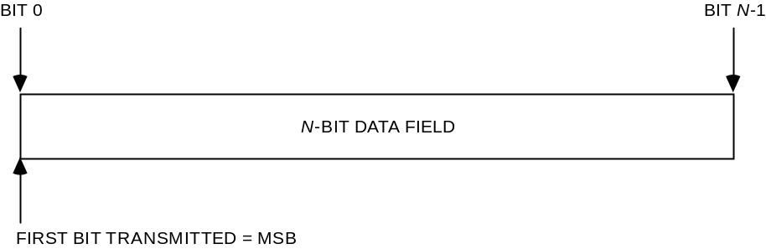
Figure 1-11: Bit Numbering Convention
In accordance with standard data-communications practice, data fields are often grouped into 8-bit ‘words’ which conform to the above convention. Throughout this Recommended Standard, such an 8-bit word is called an ‘octet’.
The numbering for octets within a data structure starts with ‘0’.

PATENTED TECHNOLOGIES
The CCSDS draws attention to the fact that it is claimed that compliance with this document may involve the use of patents concerning Turbo Coding (section 7) and Low-Density Parity-Check Coding (section 8).
The CCSDS takes no position concerning the evidence, validity, and scope of these patent rights.
The holders of these patent rights have assured the CCSDS that they are willing to negotiate licenses under reasonable and non-discriminatory terms and conditions with applicants throughout the world. In this respect, the statements of the holders of these patent rights are registered with CCSDS. Information can be obtained from the CCSDS Secretariat at the address indicated on page i. Contact information for the holders of these patent rights is provided in annex ANNEX D.
Attention is drawn to the possibility that some of the elements of this document may be the subject of patent rights other than those identified above. The CCSDS shall not be held responsible for identifying any or all such patent rights.

References
The following documents contain provisions which, through reference in this text, constitute provisions of this Recommended Standard. At the time of publication, the editions indicated were valid. All documents are subject to revision, and users of this Recommended Standard are encouraged to investigate the possibility of applying the most recent editions of the documents indicated below. The CCSDS Secretariat maintains a register of currently valid CCSDS Recommended Standards.
[1] TM Space Data Link Protocol. Issue 3. Recommendation for Space Data System Standards (Blue Book), CCSDS 132.0-B-3. Washington, D.C.: CCSDS, October 2021.
[2] AOS Space Data Link Protocol. Issue 4. Recommendation for Space Data System Standards (Blue Book), CCSDS 732.0-B-4. Washington, D.C.: CCSDS, October 2021.
[3] Information Technology—Open Systems Interconnection—Basic Reference Model: The Basic Model. 2nd ed. International Standard, ISO/IEC 7498-1:1994. Geneva: ISO, 1994.
[4] Information Technology—Open Systems Interconnection—Basic Reference Model—Conventions for the Definition of OSI Services. International Standard, ISO/IEC 10731:1994. Geneva: ISO, 1994.
[5] Radio Frequency and Modulation Systems—Part 1: Earth Stations and Spacecraft. Issue 32. Recommendations for Space Data System Standards (Blue Book), CCSDS 401.0-B-32. Washington, D.C.: CCSDS, October 2021.
[6] Unified Space Data Link Protocol. Issue 2. Recommendation for Space Data System Standards (Blue Book), CCSDS 732.1-B-2. Washington, D.C.: CCSDS, October 2021.
NOTE – Informative references are listed in annex ANNEX G.

OVERVIEW

ARCHITECTURE
Figure 2-2 illustrates the relationship of this Recommended Standard to the Open Systems Interconnection reference model (reference [3]). Two sublayers of the Data Link Layer are defined for CCSDS space link protocols. The TM, AOS, and Unified Space Data Link Protocols specified in references [1], [2], and [6], respectively, correspond to the Data Link Protocol Sublayer and provide functions for transferring data using the protocol data unit called the Transfer Frame. The Radio Frequency and Modulation Systems specified in reference [5] corresponds to the Physical Layer. The Synchronization and Channel Coding Sublayer provides additional functions necessary for transferring Transfer Frames over a space link. These functions are error-control coding/decoding, Transfer Frame delimiting/synchronizing, and bit transition generation/removal.
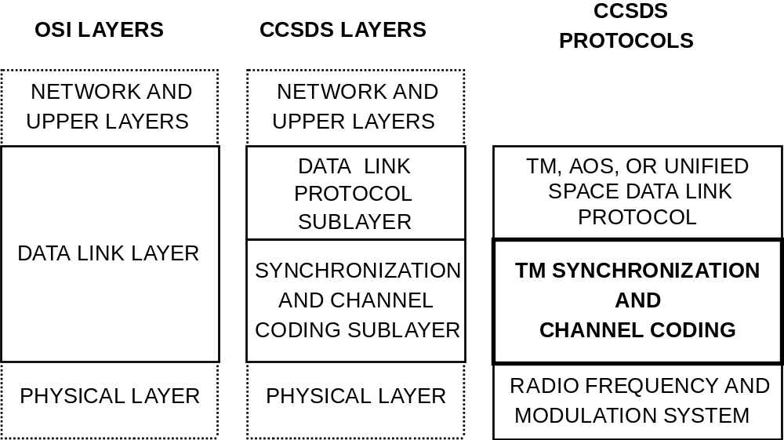
Figure 2-22: Relationship with OSI Layers

SUMMARY OF FUNCTIONS

General
The Synchronization and Channel Coding Sublayer provides the following three functions for transferring Transfer Frames over a space link:
- error-control coding, including frame validation;
- synchronization; and
- pseudo-randomizing.

error-control coding
This Recommended Standard specifies the following four types of error-control coding:
- convolutional coding (section 4);
- Reed-Solomon coding (section 5);
- Turbo coding (section 6);
- Low-Density Parity-Check (LDPC) coding (section 8).
One of the convolutional codes described in section 4 alone may be satisfactory depending on performance requirements.
For Physical Channels, which are bandwidth-constrained and cannot tolerate the increase in bandwidth required by the basic convolutional code specified in 4.3, the punctured convolutional codes specified in 4.4 have the advantage of smaller bandwidth expansion.
Alternatively, the Reed-Solomon codes and the high rate LDPC code specified in sections 5 and 8 also have the advantage of smaller bandwidth expansion and have the capability to indicate the presence of uncorrectable errors. Where a greater coding gain is needed than can be provided by a convolutional code or Reed-Solomon code alone, a concatenation of a convolutional code as the inner code with a Reed-Solomon code as the outer code may be used for improved performance (see section 6).
The Turbo codes specified in section 7 or the LDPC codes specified in section 8 may be used to obtain even greater coding gain where the environment permits.
AOS and USLP are symmetrical and may be used over space-to-ground, ground-to-space, or space-to-space (in both directions).
NOTE
- In this Recommended Standard, the characteristics of the codes are specified only to the extent necessary to ensure interoperability and cross-support. The specification does not attempt to quantify the relative coding gain or the merits of each approach discussed, nor does it specify the design requirements for encoders or decoders.

Frame Validation
After decoding is performed, the upper layers at the receiving end also need to know whether or not each decoded Transfer Frame can be used as a valid data unit; i.e., an indication of the quality of the received frame is needed. This function is called Frame Validation. The Reed-Solomon and LDPC decoders can determine, with a very high probability, whether or not they can correctly decode a codeword. Therefore, the Reed-Solomon and LDPC codes are also used for Frame Validation. When the Reed-Solomon or LDPC codes are not used, the Frame Error Control Field defined in references [1] or [2] is used for Frame Validation.

synchronization
This Recommended Standard specifies an optional method for slicing Transfer Frames into Information Blocks of a different length. When this is used, the standard specifies a method for synchronizing Transfer Frames using an Attached Sync Marker (ASM) (see section 3). In this case, the standard also specifies a second method for synchronizing codeblocks using a Code Synchronization Marker (CSM) (see section 9).
When slicing is not used, each codeword contains exactly one Transfer Frame, and only one set of synchronization markers is needed. It is referred to interchangeably as the ASM or the CSM.
The CSM may also be used for resolution of data ambiguity (sense of ‘1’ and ‘0’) if data ambiguity is not resolved by the modulation method used in the Physical Layer.

pseudo-randomizing
This Recommended Standard specifies a pseudo-randomizer to improve several aspects of the telemetry link that aid receiver acquisition, bit synchronization (see section 10), convolutional code synchronization, and proper Frame Validation (see 2.2.3).

INTERNAL ORGANIZATION OF SUBLAYER

Sending End
Figure 2-3 shows the internal organization of the Synchronization and Channel Coding Sublayer of the sending end. This figure identifies functions performed by the sublayer and shows logical relationships among these functions. The figure is not intended to imply any hardware or software configuration in a real system. Depending on the options actually used for a mission, not all of the functions may be present in the sublayer.
At the sending end, the Synchronization and Channel Coding Sublayer accepts Transfer Frames of fixed length from the Data Link Protocol Sublayer (see figure 2-2), performs functions selected for the mission, attaches Code Synchronization Markers, and delivers a continuous and contiguous stream of coded symbols to the Physical Layer.
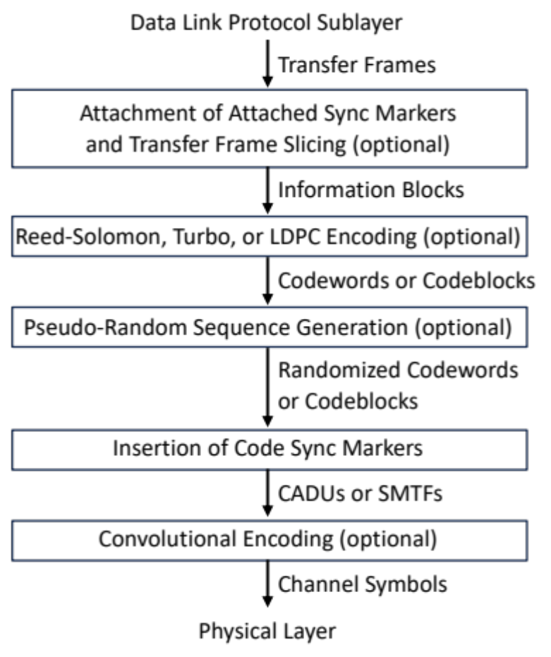
Figure 2-33: Internal Organization of the Sublayer at the Sending End

Receiving End
Figure 2-4 shows the internal organization of the Synchronization and Channel Coding Sublayer of the receiving end. This figure identifies functions performed by the sublayer and shows logical relationships among these functions. The figure is not intended to imply any hardware or software configuration in a real system (e.g., some implementations perform frame synchronization before convolutional decoding when convolutional code rate 1/2 is used). Depending on the options actually used for a mission, not all of the functions may be present in the sublayer.
At the receiving end, the Synchronization and Channel Coding Sublayer accepts a continuous and contiguous stream of coded symbols from the Physical Layer, performs functions selected for the mission, and delivers Transfer Frames to the Data Link Protocol Sublayer.
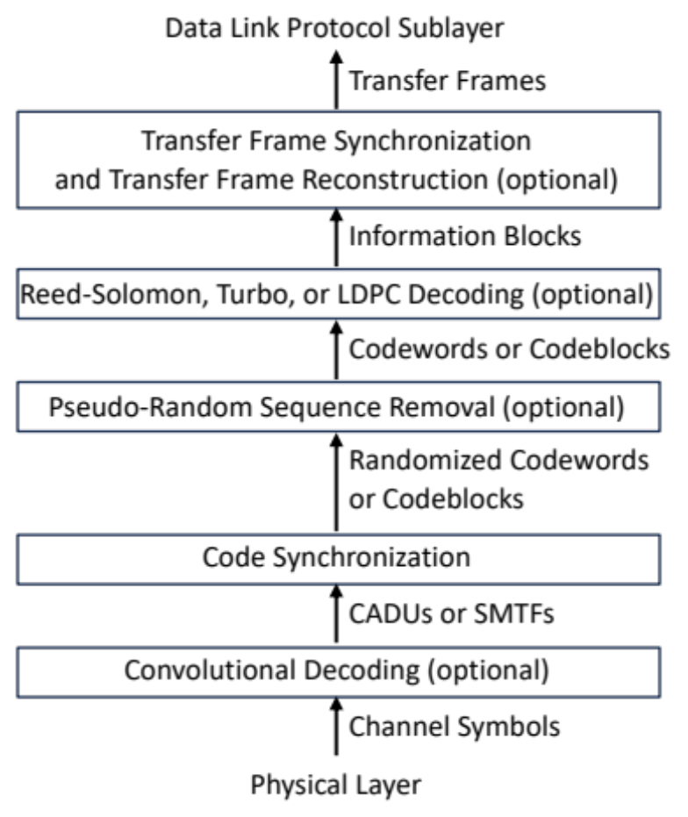
Figure 2-44: Internal Organization of the Sublayer at the Receiving End

Transfer Frame Slicing

Overview
Most error correcting codes in this specification have constraints on the length of the information blocks that they can encode. Sometimes it is straightforward to generate Transfer Frames that satisfy these length constraints, and sometimes this imposes undesirable constraints on the rest of a communications system design. To meet this need, a stream of Transfer Frames may be sliced into information blocks of a different length prior to encoding. This slicing procedure is optional, and its use is managed and fixed for a given mission phase.
Transfer Frame slicing introduces a small amount of overhead, and also it generally results in information block boundaries that do not coincide with Transfer Frame boundaries. For both of these reasons, a communications link is most efficient if the slicing can be avoided. However, slicing allows the use of Transfer Frames that are longer than the maximum information block length, and may offer practical advantages in implementation. Slicing shall not be used if there is no coding, or with convolutional coding (Section 4), because these alternatives do not constrain the information block length. Likewise, Reed-Solomon codes (Sections 5 and 6) provide some flexibility in the Transfer Frame length with their virtual fill and interleaving options, and so slicing offers less value. The greatest benefit of slicing is expected with Turbo Codes (Section 7) and LDPC Codes (Section 8).
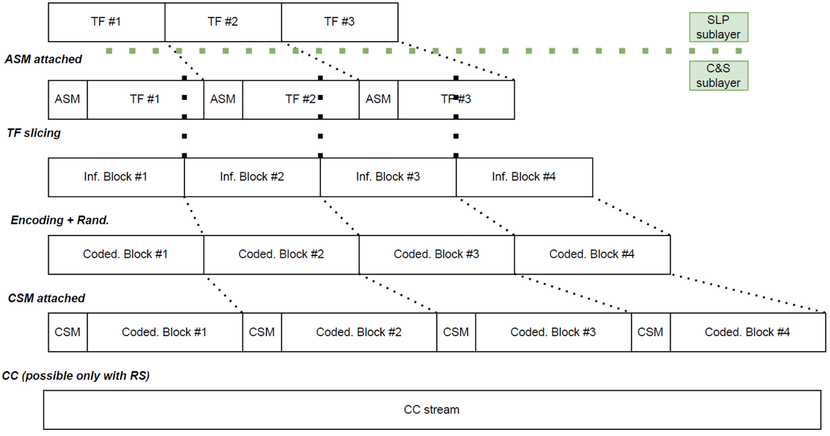
Figure 3-55: Procedure at the sending end when slicing is used

Specification
    - Transfer Frame slicing is optional with Reed-Solomon, Turbo, or LDPC coding. Its use is managed and fixed for a given mission phase.
    - Transfer Frame slicing shall not be used with uncoded data, or if convolutional coding is used alone.
    - If used, slicing is performed at the sending end as follows, and as shown in Figure 3-5.
- Each M-bit Transfer Frame is prepended with a 32-bit ASM, to yield a stream of M+32 bit Synchronization-Marked Transfer Frames (SMTFs). The ASM bit pattern shall be as shown in Figure 3-6, and represented in hexadecimal as 1ACF FC1D.

FIRST TRANSMITTED BIT
(Bit 0)
↓
0001 | 1010 | 1100 | 1111 | 1111 | 1100 | 0001 | 1101
↑
LAST TRANSMITTED BIT
(Bit 31)
Figure 3-66: ASM Bit Pattern When Slicing is Used
NOTE – The ASM bit pattern matches the 32-bit CSM pattern specified in Section 9. They cannot be confused by the receiver, because the ASM is encoded and randomized.
- The stream of SMTFs is divided into k-bit Information Blocks for encoding.
- If Turbo or LDPC coding is used, then each k-bit Information Block is encoded into an n-bit codeword, as described in Section 7 or Section 8, respectively. If Reed-Solomon coding is used, then sets of I k-bit Information Blocks are encoded and interleaved into an nI-bit codeblock, where I is the interleaving depth, as described in Section 5.
- Each codeword or codeblock is randomized, as described in Section 10. Randomization is mandatory.
- CSMs are prepended to each randomized codeword or codeblock, as described in Section 9.
    - If slicing is used, the reverse process is followed at the receiving end, as follows.
- Code synchronization is performed to identify the CSMs, and extract the codewords or codeblocks.
- The codewords or codeblocks are de-randomized.
- Each codeword is decoded (or set of I interleaved codewords, in the case of Reed-Solomon codes).
- The decoded Information Blocks are concatenated to form a stream of SMTFs.
- Transfer Frame synchronization is performed to identify the ASMs, and extract the Transfer Frames.
    - If slicing is not used, then the sending end acts in a simpler way, as shown in Figure Figure 3-77: Procedure at the sending end when slicing is not used.
- Each Transfer Frame is an Information Block.
- If Turbo or LDPC coding is used, then each k-bit Information Block is encoded into an n-bit codeword, as described in Section 7 or Section 8, respectively. If Reed-Solomon coding is used, then sets of I k-bit Information Blocks are encoded and interleaved into an nI-bit codeblock, where I is the interleaving depth, as described in Section 5.
- If the randomizer is used, each codeword or codeblock is randomized, as described in Section 10.
- CSMs are prepended to each randomized codeword or codeblock, as described in Section 9.
    - If slicing is not used, the reverse process at the receiving end is simplified, as follows.
- Code synchronization is performed to identify the CSMs, and extract the codewords or codeblocks. Because there is only one level of synchronization, CSMs also serve the function of ASMs, and the two terms may be used interchangeably.
- The codewords or codeblocks are de-randomized.
- Each codeword is decoded (or set of I interleaved codewords, in the case of Reed-Solomon codes).
- The decoded Information Blocks are Transfer Frames.

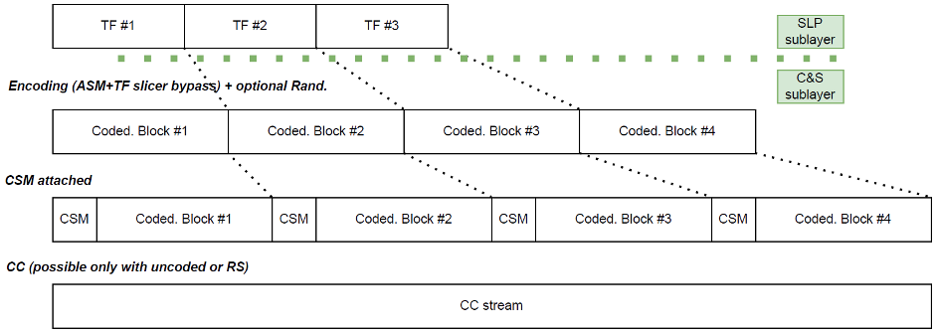
Figure 3-77: Procedure at the sending end when slicing is not used

Transfer Frame Validation
    - With Reed-Solomon, Concatenated, or LDPC coding, the decoder may be used to validate Information Blocks. A Transfer Frame shall be marked invalid if any part of it is contained in an invalid Information Block.
    - With no coding, with convolutional coding, or with turbo coding, the FECF shall be used to validate Information Blocks. The FECF is specified in references [1], [2], and [6] for TM, AOS, and USLP Transfer Frames, respectively.
NOTE – With Reed-Solomon, Concatenated, or LDPC coding, the FECF specified in references [1], [2], and [6] is optional. If present, the FECF may be used for Transfer Frame validation.

Convolutional CodING

Overview
The basic convolutional code is a rate (r) 1/2, constraint-length (K) 7 transparent code which is well suited for channels with predominantly Gaussian noise. This code is defined in 4.3. When this code is punctured according to 4.4, higher code rates may be achieved although with lower error correcting performance.
Puncturing allows a single code rate of either 2/3, 3/4, 5/6 or 7/8 to be selected. The four different puncturing schemes allow selection of the most appropriate level of error correction and symbol rate for a given service or data rate.

General

CODE SYNCHRONIZATION Marker
The Code Sync Marker used with convolutional code shall be the 32-bit pattern specified in 9.2, and it shall always be inserted before performing convolutional encoding.

Data Randomization
The pseudo-randomizer defined in section 10 shall be used unless the system designer verifies that the concerns identified in the note below are resolved by other means.
NOTE – An inverter is specified with the basic convolutional code to assure sufficient bit transitions to keep receiver symbol synchronizers in lock, when used with Binary Phase Shift Keying (BPSK) modulation. Sufficient bit transitions cannot be guaranteed by the inverter alone if some multiplexing schemes are used, e.g., with Quadrature Phase Shift Keying (QPSK) modulation, or if a punctured convolutional code is used. There are also data patterns for which convolutional code synchronization cannot be determined. The pseudo-randomizer is also used to aid signal acquisition and to mitigate spectral lines in the transmitted signal.

Frame Validation
When TM, AOS, or USLP Transfer Frames are used, the Frame Error Control Field (FECF) specified in references [1], [2], or [6] shall be used to validate the Transfer Frame, unless the convolutional code is concatenated with an outer Reed-Solomon code (see section 5).
NOTE – If the decoder’s correction capability is exceeded, undetected bursts of errors may appear in the output.

Quantization
Soft bit decisions with at least three-bit quantization should be used whenever constraints (such as complexity of decoder) permit.

BASIC CONVOLUTIONAL CODE SPECIFICATION
    - The basic convolutional code shall be the non-systematic code with the following characteristics:
(1) Nomenclature: Convolutional code with maximum-likelihood
decoding.
(2) Code rate (r): 1/2 bit per symbol.
(3) Constraint length (K): 7 bits.
(4) Connection vectors: G1 = 1111001 (171 octal); G2= 1011011(133 octal).
(5) Symbol inversion: On output path of G2.
NOTE – An encoder block diagram is shown in figure 4-8. When a single encoder is used, G2 inversion provides no benefit to data randomization when even-order modulations higher than BPSK are used. G2 inversion does provide value when coding is done after channel splitting and with separate encoders on each channel.
    - The output symbol sequence shall be: C₁(1), , C₁(2), . . . .
    - When suppressed-carrier modulation systems are used:
- Non-Return-to-Zero-Mark (NRZ-M) or Non-Return-to-Zero-Level (NRZ-L) may be used as a modulating waveform.
- If the user contemplates differential encoding, i.e., conversion of his modulating waveform from NRZ-L to NRZ-M, such conversion should be performed at the input to the convolutional encoder.
NOTES
- Since the convolutional codes are transparent, differential encoding can be used before the convolutional encoder to help phase ambiguity resolution and, correspondingly, the conversion at the receiving end from NRZ-M to NRZ-L should be performed at the output of the convolutional decoder. Differential encoding after the convolutional encoder is not advised because it introduces considerable loss of performance. It also would require differential detection, which is more complex with soft symbols.
- When a fixed pattern (the fixed part of the convolutionally encoded Attached Sync Marker) in the symbol stream is used to provide node synchronization for the convolutional decoder, any modification of the pattern resulting from the modulating waveform conversion needs to be accounted for.
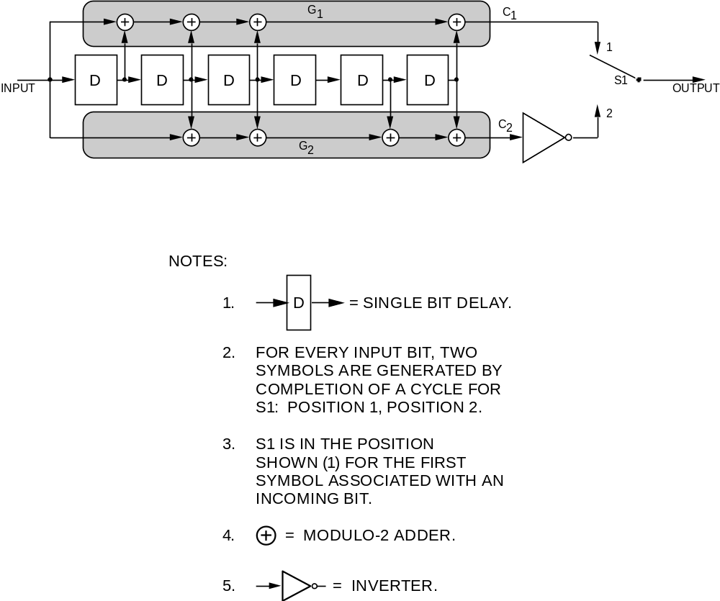
Figure 4-88: Basic Convolutional Encoder Block Diagram

PUNCTURED CONVOLUTIONAL CODES
    - The punctured convolutional code shall have the following characteristics:
(1) Nomenclature: Punctured convolutional code with
maximum-likelihood decoding.
(2) Code rate (r): 1/2, punctured to 2/3, 3/4, 5/6 or 7/8.
(3) Constraint length (K): 7 bits.
(4) Connection vectors: G1 = 1111001 (171 octal); G2 = 1011011 (133 octal).
(5) Symbol inversion: None.
    - The puncturing patterns for each of the punctured convolutional code rates shall be as specified in table 4-1.
NOTE – Figure 4-9 depicts the punctured encoding scheme.
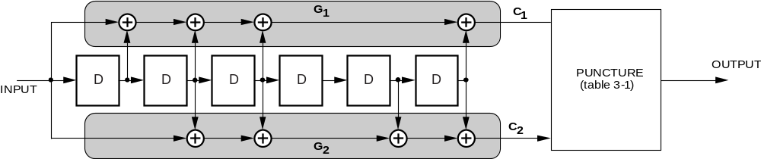
Figure 4-99: Punctured Encoder Block Diagram
Table 4-11: Puncture Code Patterns for Convolutional Code Rates
Puncturing Pattern  1 = transmitted symbol  0 = non-transmitted symbol | Code Rate | Output Sequence  C1(t), C2(t) denote values at bit time t
C1: 1 0  C2: 1 1 | 2/3 | C1(1) C2(1) C2(2) ...
C1: 1 0 1  C2: 1 1 0 | 3/4 | C1(1) C2(1) C2(2) C1(3) ...
C1: 1 0 1 0 1  C2: 1 1 0 1 0 | 5/6 | C1(1) C2(1) C2(2) C1(3) C2(4) C1(5) ...
C1: 1 0 0 0 1 0 1  C2: 1 1 1 1 0 1 0 | 7/8 | C1(1) C2(1) C2(2) C2(3) C2(4) C1(5) C2(6) C1(7) ...

Reed-Solomon CodING

Overview
The Reed-Solomon (R-S) codes defined in this section are powerful burst error correcting codes. One of two different error-correcting options may be chosen. For maximum performance (at the expense of accompanying overhead) the E=16 option can correct 16 R-S symbols in error per codeword. For lower overhead (with reduced performance) the E=8 option can correct 8 R-S symbols per codeword. The Reed-Solomon code may be used alone, and as such it provides an excellent forward error correction capability in a burst-noise channel. However, should the Reed-Solomon code alone not provide sufficient coding gain, it may be concatenated with the convolutional code defined in section 4. Used this way, the Reed-Solomon code is the outer code, while the convolutional code is the inner code.

General

Data Randomization
The pseudo-randomizer defined in section 10 shall be used unless the system designer verifies that the concerns identified in the note below are resolved by other means.
NOTE – The recommended Reed-Solomon codes, by themselves, cannot guarantee sufficient bit transitions to keep receiver symbol synchronizers in lock. Because of the quasi-cyclic nature of these codes, undetected decoding errors may result from incorrect codeblock synchronization. The pseudo-randomizer is also used to aid signal acquisition and to mitigate spectral lines in the transmitted signal.

Frame Validation
The FECF specified in references [1], [2], and [6] is optional. The system designer may choose to use it for additional Transfer Frame validation, particularly with the E=8 code.
NOTE – The Reed-Solomon code with E=16 has an extremely low undetected error rate, and that with E=8 has an undetected error rate low enough for some applications. Therefore the R-S decoder may be used alone to validate the Information Block, and consequently the contained Transfer Frame(s).

SPECIFICATION

parameters
The parameters of the selected Reed-Solomon (R-S) code are as follows:
- J shall be 8 bits per R-S symbol.
- E shall be 16 or 8 R-S symbols.
NOTE – E is the Reed-Solomon error correction capability, in symbols, within a R-S codeword.

General Characteristics
The code shall conform to the following general characteristics:
- J, E, and I (the depth of interleaving) are independent parameters.
- n = 2^{J}–1 = 255 symbols per R-S codeword.
- 2E is the number of R-S symbols among n symbols of an R-S codeword representing parity checks.
- k = n–2E is the number of R-S symbols among n R-S symbols of an R-S codeword representing information.

Field Generator Polynomial
The field generator polynomial shall be:
F(x) = x⁸ + x⁷ + x² + x + 1
over GF(2).

Code Generator Polynomial
The code generator polynomial shall be:
g(x) = =
over GF(2⁸), where F(α) = 0.
NOTES
- It should be recognized that α¹¹ is a primitive element in GF(2⁸) and that F(x) and g(x) characterize a (255,223) Reed-Solomon code when E = 16 and a (255,239) Reed-Solomon code when E = 8.
- The selected code is a systematic code. This results in a systematic codeblock.

Symbol Interleaving
      - The allowable values of interleaving depth are I=1, 2, 3, 4, 5, and 8.
NOTE – I=1 is equivalent to the absence of interleaving.
      - The interleaving depth shall normally be fixed on a Physical Channel for a Mission Phase.
NOTE – Discussion of symbol interleaving is contained in 5.4.1.

Maximum Codeblock Length
The maximum codeblock length, in R-S symbols, shall be determined by the following equation:
L_{max} = nI = (2^{J} – 1)I = 255I

Shortened Codeblock Length
      - A shortened codeblock length may be used to accommodate frame lengths smaller than the maximum.
NOTE – However, since the Reed-Solomon code is a block code, the decoder must always operate on a full block basis.
      - To achieve a full codeblock, ‘virtual fill’ shall be added to make up the difference between the shortened block and the maximum codeblock length.
NOTES
- The characteristics and limitations of virtual fill are covered in 5.3.8.2.
- Since the virtual fill is not transmitted, both encoder and decoder need to be set to insert it with the proper length for the encoding and decoding processes to be carried out properly.
      - When an encoder (initially cleared at the start of a block) receives kI–Q symbols representing information (where Q, representing fill, is a multiple of I, and is less than kI), 2EI check symbols shall be computed over kI symbols, of which the leading Q symbols shall be treated as all-zero symbols.
NOTE – A (nI–Q, kI–Q) shortened codeblock results.
      - The leading Q symbols (all zeros) of the resulting shortened codeblock shall be neither entered into the encoder nor transmitted.
NOTE – Shortening the transmitted codeblock length in this way changes the overall performance to a degree dependent on the amount of virtual fill used. Since it incorporates no virtual fill, the maximum codeblock length allows full performance. In addition, as virtual fill in a codeblock is increased (at a specific bit rate), the number of codeblocks per unit time that the decoder must handle increases. Therefore, care should be taken so that the maximum operating speed of the decoder (codeblocks per unit time) is not exceeded.

Reed-Solomon Codeblock Partitioning and Virtual Fill
      - Parts of the partitioned Reed-Solomon codeblock (see figure 5-10) are defined as follows:
- The Reed-Solomon Check Symbols shall consist of the trailing 2EI symbols (2EIJ bits) of the codeblock.
NOTES
- As an example, when E = 16 and k = 223, for I=5 this is always 1280 bits.
- If Transfer Frame slicing is used, the Information Block is constructed according to Section 3. Otherwise, the Information Block is the same as a Transfer Frame, defined by the TM Space Data Link Protocol (reference [1]), the AOS Space Data Link Protocol (reference [2]), or the Unified Space Data Link Protocol (reference [6]). (For constraints on the length of the Transfer Frame, see section 11.)
- The Code Sync Marker used with R-S code
- shall be the 32-bit pattern specified in section 9;
- shall precede the transmitted codeblock.
NOTE – Frame synchronizers should therefore be set to expect a marker at every transmitted codeblock + 32 bits.
- The Reed-Solomon codeblock shall consist of the Information Block (without the 32-bit sync marker) and R-S check symbols.
NOTES
- The Reed-Solomon codeblock is the received data entity physically fed into the R-S decoder. (As an example, when E = 16 and k = 223, using I=5 and no virtual fill, the length of the transmitted codeblock will be 10,200 bits; if virtual fill is used, it will be incrementally shorter, depending on the amount used.)
- The logical codeblock is the logical data entity operated upon by the R-S decoder. It can have a different length than the transmitted codeblock because it accounts for the amount of virtual fill that was introduced. (As an example, when E = 16 and k = 223, for I=5 the logical codeblock always appears to have exactly 10,200 bits in length.)
- The R-S codeblock is partitioned as shown in figure 5-10.
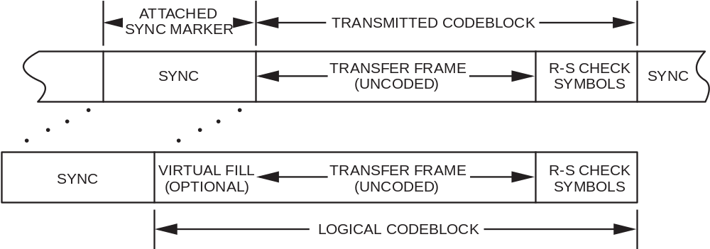
Figure 5-1010: Reed-Solomon Codeblock Partitioning
      - Virtual fill shall be used to logically complete the codeblock. If used, virtual fill shall:
- consist of all zeros;
- not be transmitted;
- not change in length for a Mission Phase on a particular Physical Channel;
- be inserted only at the beginning of the codeblock (i.e., after the code sync marker but before the beginning of the transmitted codeblock);
- be inserted only in integer multiples of 8I bits.

Dual Basis Representation
      - Dual basis representation shall be used.
      - The order of transmission shall be dual basis eight-bit string z₀, z₁, . . ., z₇ (i.e., with z₀ transmitted first).
      - The relationship between the two representations shall conform to the following two equations:
[z₀, . . ., z₇] = [u₇, . . ., u₀] |  | 1 | 0 | 0 | 0 | 1 | 1 | 0 | 1
[z₀, . . ., z₇] = [u₇, . . ., u₀] |  | 1 | 1 | 1 | 0 | 1 | 1 | 1 | 1
[z₀, . . ., z₇] = [u₇, . . ., u₀] |  | 1 | 1 | 1 | 0 | 1 | 1 | 0 | 0
[z₀, . . ., z₇] = [u₇, . . ., u₀] |  | 1 | 0 | 0 | 0 | 0 | 1 | 1 | 0
[z₀, . . ., z₇] = [u₇, . . ., u₀] |  | 1 | 1 | 1 | 1 | 1 | 0 | 1 | 0
[z₀, . . ., z₇] = [u₇, . . ., u₀] |  | 1 | 0 | 0 | 1 | 1 | 0 | 0 | 1
[z₀, . . ., z₇] = [u₇, . . ., u₀] |  | 1 | 0 | 1 | 0 | 1 | 1 | 1 | 1
[z₀, . . ., z₇] = [u₇, . . ., u₀] |  | 0 | 1 | 1 | 1 | 1 | 0 | 1 | 1
and
[u₇, . . ., u₀] = [z₀, . . ., z₇] |  | 1 | 1 | 0 | 0 | 0 | 1 | 0 | 1
[u₇, . . ., u₀] = [z₀, . . ., z₇] |  | 0 | 1 | 0 | 0 | 0 | 0 | 1 | 0
[u₇, . . ., u₀] = [z₀, . . ., z₇] |  | 0 | 0 | 1 | 0 | 1 | 1 | 1 | 0
[u₇, . . ., u₀] = [z₀, . . ., z₇] |  | 1 | 1 | 1 | 1 | 1 | 1 | 0 | 1
[u₇, . . ., u₀] = [z₀, . . ., z₇] |  | 1 | 1 | 1 | 1 | 0 | 0 | 0 | 0
[u₇, . . ., u₀] = [z₀, . . ., z₇] |  | 0 | 1 | 1 | 1 | 1 | 0 | 0 | 1
[u₇, . . ., u₀] = [z₀, . . ., z₇] |  | 1 | 0 | 1 | 0 | 1 | 1 | 0 | 0
[u₇, . . ., u₀] = [z₀, . . ., z₇] |  | 1 | 1 | 0 | 0 | 1 | 1 | 0 | 0
NOTES
- Discussion of dual basis representation is contained in 5.4.2.
- Further information relating the dual basis (Berlekamp) and conventional representations is given in annex ANNEX H. Also included is a recommended scheme for permitting the symbols generated in a conventional encoder to be transformed to meet the symbol representation required by this document.

Codeblock Synchronization
Codeblock synchronization of the Reed-Solomon decoder shall be achieved by synchronization of the Code Sync Marker associated with each codeblock. (See section 9.)
NOTE – At the receiving end, the ambiguity between true and complemented data must be resolved so that only true data is provided to the Reed-Solomon decoder. Data in NRZ-L form is normally resolved using the 32-bit Code Sync Marker, while NRZ-M data is self-resolving.

Discussion

Symbol Interleaving
Symbol interleaving is accomplished in a manner functionally described with the aid of figure 5-11. (It should be noted that this functional description does not necessarily correspond to the physical implementation of an encoder.)
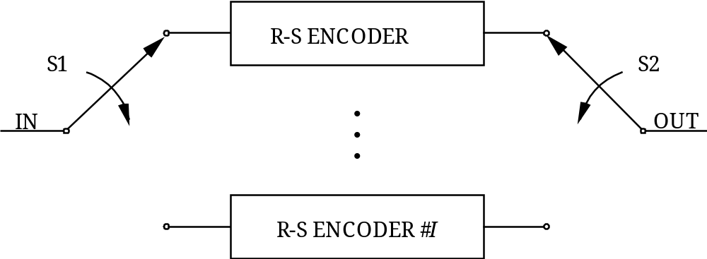
Figure 5-1111: Functional Representation of R-S Interleaving
Data bits to be encoded into a single Reed-Solomon codeblock enter at the port labeled ‘IN’. Switches S1 and S2 are synchronized together and advance from encoder to encoder in the sequence 1,2, . . ., I, 1,2, . . ., I, . . ., spending one R-S symbol time (8 bits) in each position.
One codeblock will be formed from kI R-S symbols entering ‘IN’. In this functional representation, a space of 2EI R-S symbols in duration is required between each entering set of kI R-S information symbols.
Because of the action of S1, each encoder accepts k of these symbols, with each symbol spaced I symbols apart (in the original stream). These k symbols are passed directly to the output of each encoder. The synchronized action of S2 reassembles the symbols at the port labeled ‘OUT’ in the same way as they entered at ‘IN’.
Following this, each encoder outputs its 2E check symbols, one symbol at a time, as it is sampled in sequence by S2.
If, for I=5, the original symbol stream is
d. . . dd . . . d . . . d . . . d [2E × 5 spaces]
then the output is the same sequence with the [2E × 5 spaces] filled by the [2E× 5] check symbols as shown below:
p . . . p . . . p . . . p
where
d d . . . d p . . . p
is the R-S codeword produced by the ith encoder. If q virtual fill symbols are used in each codeword, then replace k by (k – q) in the above discussion.
With this method of interleaving, the original kI consecutive information symbols that entered the encoder appear unchanged at the output of the encoder with 2EI R-S check symbols appended.

Dual basis symbol representation and ordering for transmission
Each 8-bit Reed-Solomon symbol is an element of the finite field GF(256). Since GF(256) is a vector space of dimension 8 over the binary field GF(2), the actual 8-bit representation of a symbol is a function of the particular basis that is chosen.
One basis for GF(256) over GF(2) is the set ( 1, α¹, α², . . ., α⁷). This means that any element of GF(256) has a representation of the form
u₇α⁷ + u₆α⁶ + . . . + u₁α¹ + u₀α⁰
where each u_{i} is either a zero or a one.
Another basis over GF(2) is the set ( 1, β ¹, β ², . . ., β ⁷) where β = α ¹¹⁷. To this basis there exists a so-called ‘dual basis’ (l₀, l₁, . . ., l₇). It has the property that
Tr(l_{i}β ^{j} ) =
for each j = 0, 1, . . ., 7. The function Tr(z), called the ‘trace’, is defined by
Tr(z) =
for each element z of GF(256). Each Reed-Solomon symbol can also be represented as
z₀l₀ + z₁l₁ + . . . + z₇l₇
where each z_{i} is either a zero or a one.

Concatenated Coding
  - Concatenated codes shall consist of a combination of a Reed-Solomon code defined in section 5 with one of the convolutional codes defined in section 4.
  - The Reed-Solomon code shall be the outer code, and the convolutional code shall be the inner code.

Turbo Coding

Overview
Turbo codes are binary block codes with large codewords (hundreds or thousands of bits). Turbo codes may be used to obtain even greater coding gains than those provided by concatenated coding systems. They are systematic and inherently non-transparent.

General

Data Randomization
The pseudo-randomizer defined in section 10 shall be used unless the system designer verifies that the concerns identified in the note below are resolved by other means.
NOTE – The recommended Turbo codes, by themselves, cannot guarantee sufficient bit transitions to keep receiver symbol synchronizers in lock. The pseudo-randomizer is also used to aid signal acquisition and to mitigate spectral lines in the transmitted signal.

Frame Validation
When Turbo codes are used with TM, AOS, or USLP Transfer Frames, the FECF specified in references [1], [2], or [6], respectively, shall be used to validate the Transfer Frame.
NOTE – While providing outstanding coding gain, Turbo codes may still leave some undetected errors in the decoded output.

SPECIFICATION
NOTE – A Turbo encoder is a combination of two simple encoders. The input is a frame of k information bits. The two component encoders generate parity symbols from two simple recursive convolutional codes, each with a small number of states. The information bits are also sent uncoded. A key feature of Turbo codes is an interleaver, which permutes bit-wise the original k information bits before input to the second encoder.
The recommended Turbo code is a systematic code that shall conform to the following specifications:
- Code type shall be systematic parallel concatenated Turbo code.
- Number of component codes shall be two (plus an uncoded component to make the code systematic).
- Type of component codes shall be recursive convolutional codes.
- Number of states of each convolutional component code shall be 16.
- Nominal code rates shall be r = 1/2, 1/3, 1/4, or 1/6 (selectable).
NOTE – Because of ‘trellis termination’ symbols (see 7.3j)), the true code rates (defined as the ratios of the information block lengths to the codeword lengths in table 7-3) are slightly smaller than the nominal code rates. In this Recommended Standard, the term ‘code rate’ always refers to the nominal code rates, r = 1/2, 1/3, 1/4, or 1/6.
- The specified information block lengths k shall be those specified in table 7-2. The corresponding codeword lengths in bits, n=(k+4)/r, for the specified code rates shall be those specified in table 7-3.
NOTE – Information block lengths are chosen for compatibility with the corresponding Reed-Solomon interleaving depths, also shown in table 7-2.
Table 7-22: Specified Information Block Lengths
Information block length k, bits | Corresponding Reed-Solomon interleaving depth I | Notes
1784 (=223 × 1 octets) | 1 | For very low data rates or low latency
3568 (=223 × 2 octets) | 2
7136 (=223 × 4 octets) | 4
8920 (=223 × 5 octets) | 5 | For highest coding gain
Table 7-33: Codeword Lengths for Supported Code Rates (Measured in Bits)
Information block length k | Codeword length n
Information block length k | rate 1/2 | rate 1/3 | rate 1/4 | rate 1/6
1784 | 3576 | 5364 | 7152 | 10728
3568 | 7144 | 10716 | 14288 | 21432
7136 | 14280 | 21420 | 28560 | 42840
8920 | 17848 | 26772 | 35696 | 53544
- Turbo code permutation for each specified block length k shall conform to a particular reordering of the integers 1, 2, . . ., k as generated by the following algorithm.
NOTE – The interleaver is a fundamental component of the Turbo encoding and decoding process. The interleaver for Turbo codes is a fixed bit-by-bit permutation of the entire block of data. Unlike the symbol-by-symbol rectangular interleaver used with Reed-Solomon codes, the Turbo code permutation scrambles individual bits and resembles a randomly selected permutation in its lack of apparent orderliness.
- k shall be expressed as k=k₁k₂; the parameters k₁ and k₂ for the specified block sizes shall be selected from table 7-4.
Table 7-44: Parameters k₁ and k₂ for Specified Information Block Lengths
Information block length | k₁ | k₂
1784 | 8 | 223
3568 | 8 | 223 × 2
7136 | 8 | 223 × 4
8920 | 8 | 223 × 5
- The following operations shall be performed for s=1 to s=k to obtain permutation numbers π(s):
p₁ = 31; p₂ = 37; p₃ = 43; p₄ = 47; p₅ = 53; p₆ = 59; p₇ = 61; p₈ = 67
NOTE – In the equation below, ⎣x⎦ denotes the largest integer less than or equal to x, and p_{q} denotes one of the following eight prime integers:
m | = | (s – 1) mod 2
i | =
j | = | – i k₂
t | = | (19i + 1) mod
q | = | t mod 8 + 1
c | = | (p_{q} j + 21m) mod k₂
π(s) | = | 2(t + c + 1) – m
The permutation numbers shall be interpreted such that the sth bit read out on line ‘in b’ in figure 7-13 is the π(s)th bit of the input information block, as shown in figure 7-12.
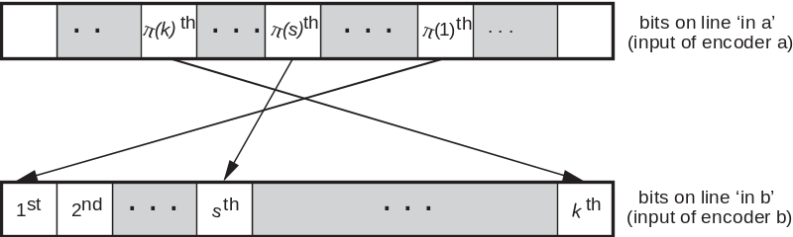
Figure 7-1212: Interpretation of Permutation
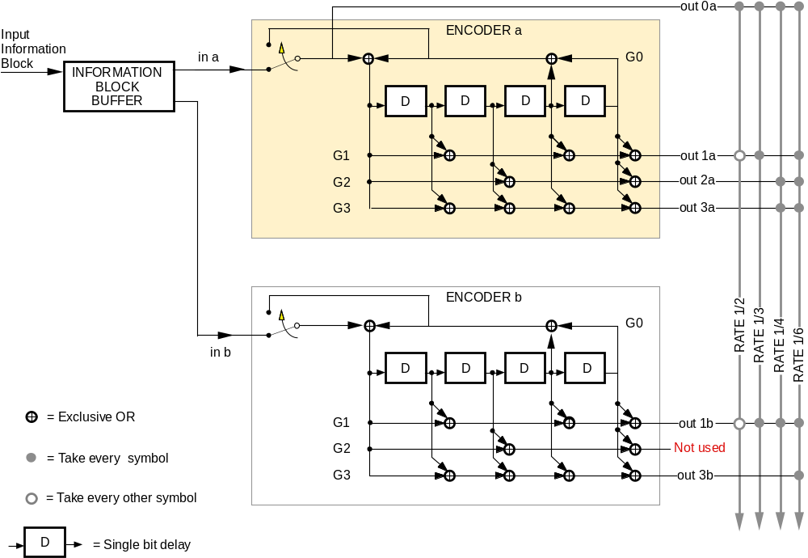
Figure 7-1313: Turbo Encoder Block Diagram
- Backward and forward connection vectors (see figure 7-13) shall be as follows:
- Backward connection vector for both component codes and all code rates shall be G0 = 10011.
- Forward connection vector for both component codes and rates 1/2 and 1/3 shall be G1 = 11011.
- Puncturing of every other symbol from each component code shall be done for rate 1/2.
- No puncturing shall be done for rate 1/3.
- Forward connection vectors for rate 1/4 shall be G2 = 10101, G3 = 11111 (1st component code); G1 = 11011 (2nd component code). No puncturing shall be done for rate 1/4.
- Forward connection vectors for rate 1/6 shall be G1 = 11011, G2 = 10101, G3 = 11111 (1st component code); G1 = 11011, G3 = 11111 (2nd component code). No puncturing shall done for rate 1/6.
- Turbo encoder operation:
- Each input frame of k information bits shall be held in a frame buffer, and the bits in the buffer shall be read out in two different orders for the two component encoders.
- The first component encoder (a in figure 7-3) shall operate on the bits in unpermuted order (‘in a’), while the second component encoder (b figure 7-3) shall receive the same bits permuted by the interleaver (‘in b’).
NOTES
- The read-out addressing for ‘in a’ is a simple counter, while the addressing for ‘in b’ is specified by the Turbo code permutation described in 7.3g).
- The recommended encoder block diagram is shown in figure 7-3.
- The component encoders are recursive convolutional encoders realized by feedback shift registers as shown in figure 7-3. The circuits shown in this figure implement the backward connection vector, G0, and the forward connection vectors, G1, G2, G3, specified in 7.3h). A key difference between these convolutional component encoders and the standalone convolutional encoder recommended in section 4 is their recursiveness. In the figure this is indicated by the signal (corresponding to the backward connection vector G0) fed back into the leftmost adder of each component encoder.
- Turbo codeword specification:
- Both component encoders (see figure 7-13) shall be initialized with ‘0’s in all registers, and both shall run for a total of k+4 bit times, producing an output codeword of (k+4)/r encoded symbols, where r is the nominal code rate.
- For the first k bit times, the input switches shall be in the lower position (as indicated in figure 7-13) to receive input data.
- For the final four bit times, these switches shall move to the upper position to receive feedback from the shift registers.
NOTE – This feedback cancels the same feedback sent (unswitched) to the leftmost adder and causes all four registers to become filled with zeros after the final 4 bit times. Filling the registers with zeros is called terminating the trellis.
- During trellis termination the encoder shall continue to output nonzero encoded symbols. In particular, the ‘systematic uncoded’ output (line ‘out 0a’ in the figure) shall include an extra four bits from the feedback line in addition to the k information bits.
NOTE – In figure 7-13, the encoded symbols are multiplexed from top-to-bottom along the output line for the selected code rate to form the Turbo codeword. For the rate 1/3 code, the output sequence is (out 0a, out 1a, out 1b); for rate 1/4, the sequence is (out 0a, out 2a, out 3a, out 1b); for rate 1/6, the sequence is (out 0a, out 1a, out 2a, out 3a, out 1b, out 3b). These sequences are repeated for (k+4) bit times. For the rate 1/2 code, the output sequence is (out 0a, out 1a, out 0a, out 1b), repeated (k+4)/2 times. This pattern implies that out 1b is the first to be punctured, out 1a is the second, and so forth. The Turbo codewords constructed from these output sequences are depicted in figure 7-14 for the four nominal code rates.
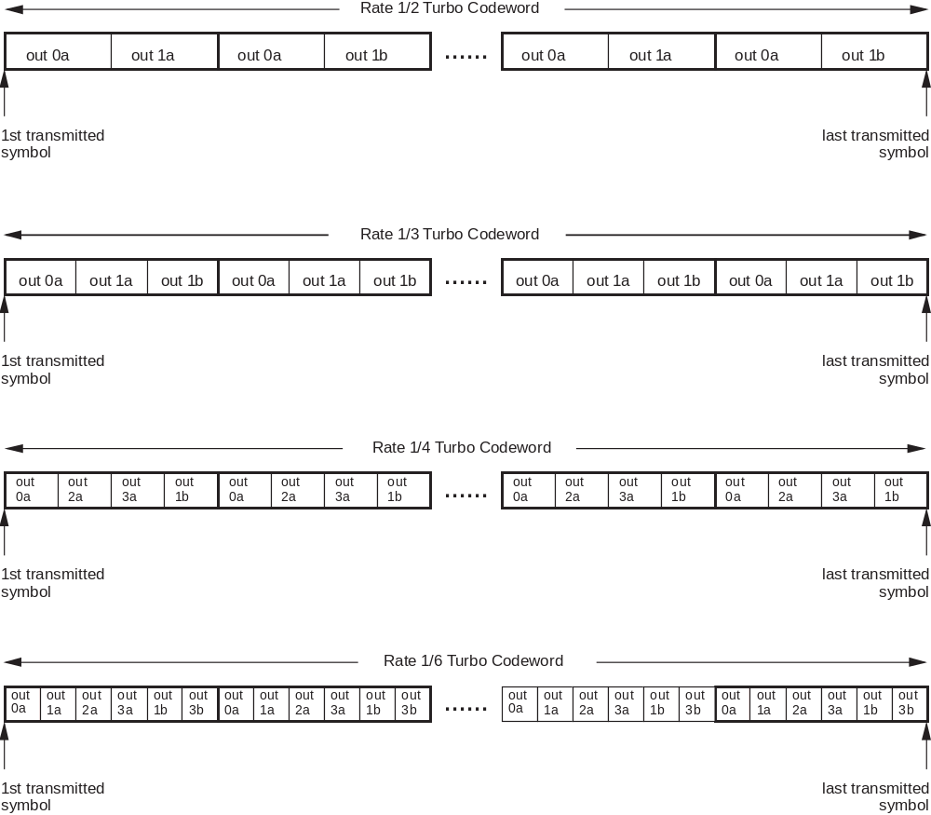
Figure 7-1414: Turbo Codewords for Different Code Rates
- Turbo codeword synchronization:
A Code Sync Marker (CSM) shall be associated with each Turbo codeword (see section 9), and it shall precede the Turbo codeword.
NOTES
- The CSM is used to achieve codeword synchronization of the Turbo decoder (i.e., frame synchronizers are normally set to expect a marker at a recurrence interval equal to the length of the CSM plus that of the Turbo codeword).
- Differential encoding does not provide benefits with Turbo Codes, and the CSM can also be used to resolve phase ambiguities. In fact, differential encoding before the Turbo encoder cannot be used because the Turbo codes recommended in this document are non-transparent, and differential encoding after the Turbo encoder is not advised because it introduces considerable loss of performance. It also would require differential detection, which is more complex with soft symbols. This implies that phase ambiguities have to be detected and resolved before decoding.
- A diagram of a Turbo codeword with CSM is shown in figure 7-15. The length of the Turbo codeword is inversely proportional to the nominal code rate r. Each codeword is placed between Code Sync Markers.
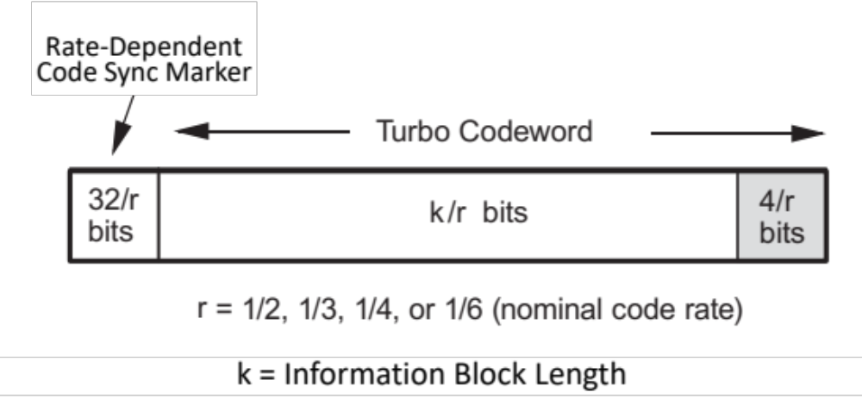
Figure 7-1515: Turbo Codeword with Code Sync Marker

- Channel interleaver:
A channel interleaver should be used to improve the communication channel against burst errors, unless the system designer verifies that the concerns identified in the note below are resolved by other means (e.g. improved fading margin in the link budget).
The use of the channel interleaver is a managed parameter.
NOTE – The turbo codes, by themselves, are vulnerable to burst errors. A channel interleaver is highly recommended for turbo codes in case of tumbling spacecraft or solar scintillation [E8], [E9] and [E10].
NOTE – This channel interleaver is external to the Turbo encoding process and must not be confused with the intrinsic interleaver (bit permutation) between the two constituent convolutional codes. While the intrinsic interleaver changes the order of information bits, the channel interleaver changes the order of coded symbols.
The channel interleaver is a row-column interleaver with a depth of 4, constructed as follows:
- At the sending end (encoder side), each of the n=(k+4)/r coded symbols produced by the turbo encoder and randomizer (if selected) of rate r=1/2, 1/3, 1/4, or 1/6, are written on the channel interleaver rows of size N_{c}=4/r =8, 12, 16, or 24. Each row thus contains four consecutive outputs of the two constituent encoders of the turbo encoder, see Error: Reference source not found.
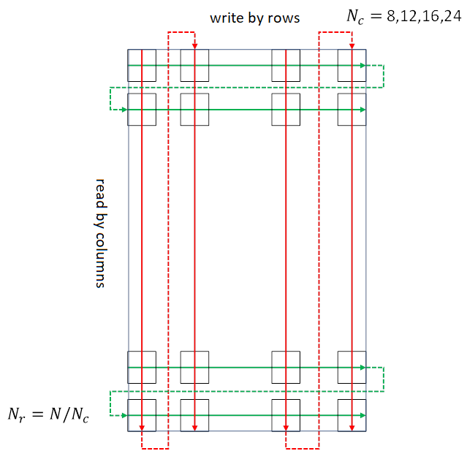
Figure 7-16: Writing and Reading operations in the Row-Column Channel Interleaver
- The symbols are then read out from channel interleaver column by column. The column length N_{r} depends on the codeword length as N_{r}= n/N_{c}.
NOTE – The resulting values of parameters N_{r}, n, and N_{c} for the 16 available code configurations are reported in 5. Notice that the number of columns depends only on the code rate r and the number of rows only on the block size k.
Table 7-5: Number of Rows and Columns of Row-Column Channel Interleavers
r | 1/2 |  | 1/3 |  | 1/4 |  | 1/6
N_{c} | 8 |  | 12 |  | 16 |  | 24
k | n | N_{r} | n | N_{r} | n | N_{r} | n | N_{r}
1784 | 3576 | 447 | 5364 | 447 | 7152 | 447 | 10728 | 447
3568 | 7144 | 893 | 10716 | 893 | 14288 | 893 | 21432 | 893
7136 | 14280 | 1785 | 21420 | 1785 | 28560 | 1785 | 42840 | 1785
8920 | 17848 | 2231 | 26772 | 2231 | 35696 | 2231 | 53544 | 2231
- At the receiving end (decoder side), the channel de-interleaver performs the complementary function. Hence, the received symbols with the interleaved codewords are written in columns and read out in rows, using the same size for N_{c} and N_{r} defined in Table 7-5.

Low-Density Parity-Check CodING

Overview
Low-Density Parity-Check (LDPC) codes are binary block codes with large codewords (hundreds or thousands of bits). They may be used to obtain greater coding gains than those provided by concatenated coding systems.
An LDPC code is specified indirectly by a v-by-w parity check matrix H consisting of v linearly independent rows. Parity check matrices may include additional linearly dependent rows without changing the code. A coded sequence of w bits must lie in the w–v dimensional dual space of H; that is, it must satisfy all v parity check equations corresponding to the v rows of H. Alternatively, the code can be described through a (w–v)-by-w generator matrix G; such that a coded sequence lies in the w–v dimensional space of G. An encoder maps an input frame of k information bits uniquely into a codeword of n bits. LDPC codes may be shortened or expurgated so that k<w–v, and the remaining dimensions of the code remain unused. LDPC codes may also be extended or punctured to make n greater or less than w.
The distinguishing feature of LDPC codes is to have a low density of ones in the matrix H. Conversely, the generator matrix G is usually dense; that is, its density of ones is in the same order of that of zeros, at least for the non-systematic part of G.
Subsection 8.3 describes a code with a rate of 223/255 (approximately 7/8), and 8.4 describes a set of nine codes with rates 1/2, 2/3, and 4/5. These codes are systematic and non-transparent.

General

SYNCHRONIZATION
      - The (8160,7136) code defined in 8.3 shall be used with the 32-bit CSM shown in figure 9-20.
      - All of the nine codes with rates 1/2, 2/3, and 4/5, defined in 8.4, shall be used with the 64-bit CSM shown in figure 9-21.
NOTE – Differential encoding does not provide benefits with LDPC codes, and the CSM can also be used to resolve phase ambiguities. In fact, differential encoding before the LDPC encoder cannot be used because the LDPC codes recommended in this document are non-transparent, and differential encoding after the LDPC encoder is not advised because it introduces considerable loss of performance. It also would require differential detection, which is more complex with soft symbols. This implies that phase ambiguities have to be detected and resolved before decoding.

Data Randomization
The pseudo-randomizer defined in section 10 shall be used unless the system designer verifies that the concerns identified in the note below are resolved by other means.
NOTE – The recommended LDPC codes, by themselves, cannot guarantee sufficient bit transitions to keep receiver symbol synchronizers in lock. Because of the quasi-cyclic nature of these codes, undetected decoding errors may result from incorrect codeword synchronization. The pseudo-randomizer is also used to aid signal acquisition and to mitigate spectral lines in the transmitted signal.

Frame Validation
      - The LDPC decoder may be used alone to validate the Information Block, and consequently the contained Transfer Frame(s).
      - The FECF specified in references [1], [2], and [6] is optional, and the system designer may choose to use it for additional Transfer Frame validation.
NOTE – The undetected frame and bit error rates of these LDPC codes lie several orders of magnitude below the corresponding detected error rates for any given operating signal-to-noise ratio.

Low-Density Parity-Check Code with Rate 223/255

Overview
The (8160,7136) recommended code is an expurgated, shortened, and extended version of a basic (8176,7156) LDPC code.
The recommended code has rate 223/255, and matches the length and dimension of the (255,223) I=4 Reed-Solomon code.
The basic code is transparent, although the modified version of this code is not, because of the sense of the fill bits.
Construction of the initial code is described in 8.3.2, expurgation and encoding are described in 8.3.4, and the shortening and extension that yield the recommended code are described in 8.3.5.

BasIC (8176,7156) LDPC Code used in construction
      - The parity check matrix for the (8176,7156) LDPC code shall be formed by using a 2 × 16 array of 511 × 511 square circulants.
NOTE – This creates a parity check matrix of size 1022 × 8176 and rank 1020.
      - The structure of the parity check base matrix shall be as shown in figure 8-17.
Figure 8-1716: Base Parity Check Matrix of the Basic (8176,7156) LDPC Code

Discussion
Each A i,j is a 511 × 511 circulant. The row weight of each of the 32 circulants is two; i.e., there are two ‘1’s in each row. The total row weight of each row in the parity check matrix is 2 × 16 = 32. The position of the ‘1’s in the first row of each circulant is defined in the second column of table 8-6; each subsequent row is given by a one-bit right cyclic shift of the preceding row. There are 511 possible positions, with position numbers between 0 and 510. The third column represents the absolute position of the ‘1’s in the parity check matrix. There are 8176 possible positions; therefore these numbers are between 0 and 8175.
Table 8-65: Specification of Circulants
Circulant | ‘1’s position in 1st row of circulant | Absolute ‘1’s position in 1st row of Parity Check Matrix
A_{1,1} | 0, 176 | 0, 176
A_{1,2} | 12, 239 | 523, 750
A_{1,3} | 0, 352 | 1022, 1374
A_{1,4} | 24, 431 | 1557, 1964
A_{1,5} | 0, 392 | 2044, 2436
A_{1,6} | 151, 409 | 2706, 2964
A_{1,7} | 0, 351 | 3066, 3417
A_{1,8} | 9, 359 | 3586, 3936
A_{1,9} | 0, 307 | 4088, 4395
A_{1,10} | 53, 329 | 4652, 4928
A_{1,11} | 0, 207 | 5110, 5317
A_{1,12} | 18, 281 | 5639, 5902
A_{1,13} | 0, 399 | 6132, 6531
A_{1,14} | 202, 457 | 6845, 7100
A_{1,15} | 0, 247 | 7154, 7401
A_{1,16} | 36, 261 | 7701, 7926
A_{2,1} | 99, 471 | 99, 471
A_{2,2} | 130, 473 | 641, 984
A_{2,3} | 198, 435 | 1220, 1457
A_{2,4} | 260, 478 | 1793, 2011
A_{2,5} | 215, 420 | 2259, 2464
A_{2,6} | 282, 481 | 2837, 3036
A_{2,7} | 48, 396 | 3114, 3462
A_{2,8} | 193, 445 | 3770, 4022
A_{2,9} | 273, 430 | 4361, 4518
A_{2,10} | 302, 451 | 4901, 5050
A_{2,11} | 96, 379 | 5206, 5489
A_{2,12} | 191, 386 | 5812, 6007
A_{2,13} | 244, 467 | 6376, 6599
A_{2,14} | 364, 470 | 7007, 7113
A_{2,15} | 51, 382 | 7205, 7536
A_{2,16} | 192, 414 | 7857, 8079

Encoding
NOTE – Two bits of information lie outside the structure of the quasi-cyclic encoder and increase complexity of the generator matrix for the basic (8176,7156) LDPC code. They are not included in this specification, which results in a generator matrix for a systematic (8176,7154) subcode that can be constructed entirely of circulants as shown in figure 8-18.
      - The generator matrix for the systematic (8176,7154) subcode shall be that illustrated in figure 8-18.
      - The left portion of the matrix shall be a 7154 × 7154 identity matrix, shown here as a block matrix, where I denotes the identity matrix of size 511 × 511, and 0 denotes the all-zero matrix of size 511 × 511.
      - The right portion of the matrix shall contain two columns of 511 × 511 circulants, denoted B_{i,j}, and constructed as follows:
- 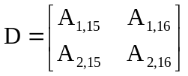 shall be defined from figure 8-17 and table 8-6.
NOTE – This equation describes a 1022 × 1022 matrix.
- u = (1 0 0 0 …. 0) shall be the unit 511 tuple, i.e., a vector quantity of length 511 with a ‘1’ at the leftmost position and ‘0’s in the rest.
- z_{i} = (b_{i,1} b_{i,2}) shall be defined, where i = 1, 2, ..., 14 and the b_{i,j}s are the first rows of the B_{i,j} circulants.
NOTE – For i = 1, 2, ..., 14, z_{i} is a vector with 1020 elements.
- 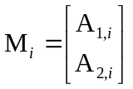 shall be defined, where i = 1, 2, …, 14.
NOTE – The parity check matrix can now be represented as: [M₁ M₂ … M₁₄ D].
- The 511th and 1022nd elements of z_{i} shall be set to zero and 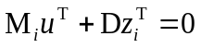 shall be solved for z_{i}, where i = 1, 2, …, 14 and T superscript represents matrix transpose.
NOTE – Since the rank of D is 1020 and not 1022, there are two linearly dependent columns. These columns can be taken to be the 511th and 1022nd.
- The b_{i,j}s shall be extracted from the z_{i}s.
NOTE – The b_{i,j}s are numerically tabulated in annex ANNEX E.
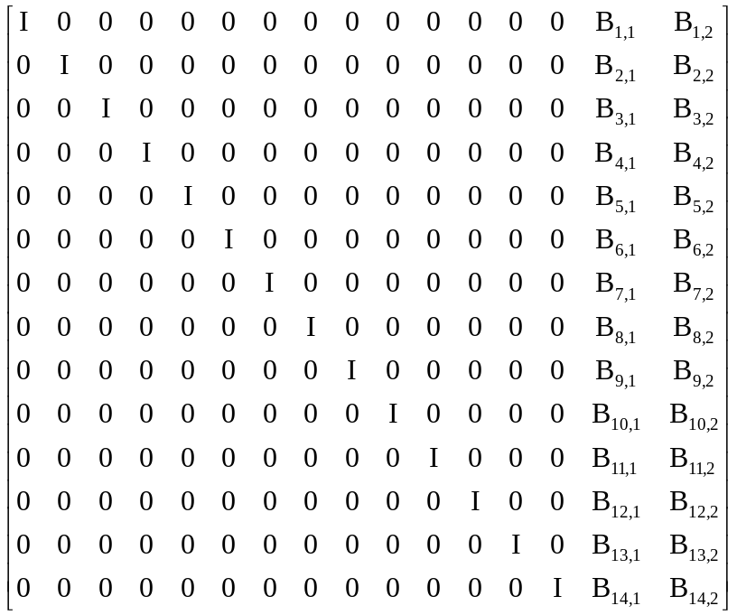
Figure 8-1817: Systematic Circulant Generator Matrix

Recommended (8160,7136) Code
NOTE – The generator matrix in 8.3.4 describes an (8176,7154) subcode of the (8176,7156) code defined by the parity check matrix in 8.3.2.2.
The (8176,7154) subcode shall be shortened and extended as follows to form an (8160,7136) code with parameters that are multiples of 32.
- The encoder shall accept as input an Information Block of 7136 bits (i.e. 892 octets matching the length and dimension of (255,223) I=4 Reed-Solomon),
- 18 zeros shall be prefixed to the 7136-bit message to be encoded, yielding a 7154-element row vector.
- This vector shall be multiplied by the generator matrix of section 6.2.3, yielding an 8176-element vector consisting of 18 zeros, 7136 systematic message symbols, and 1022 parity symbols.
- From this vector, the 18 leading zeros shall be discarded, and two zeros shall be appended, yielding a codeword of 8160 symbols.
NOTE – The arrangement of these 18 virtual fill bits, information bits, parity bits, and two zero-fill bits is shown in figure 8-19.
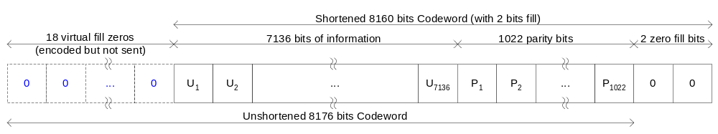
Figure 8-1918: Shortened Codeword

Low-Density Parity-Check Code Family with Rates 1/2, 2/3, and 4/5

Overview
Nine punctured LDPC codes are specified, with information block lengths k=1024 bits, 4096 bits, and 16384 bits, and code rates r=1/2, 2/3, and 4/5. These parameters and the corresponding codeword lengths, n=k/r, are shown in table 8-10.

Parity check matrices
      - The parity check matrices shall be constructed from M×M submatrices, where the submatrix size is listed in table 8-7.
Table 8-76: Values of Submatrix Size M for Supported Codes
Information block length k | Submatrix size M
Information block length k | rate 1/2 | rate 2/3 | rate 4/5
1024 | 512 | 256 | 128
4096 | 2048 | 1024 | 512
16384 | 8192 | 4096 | 2048
      - The parity check matrices for the rate-1/2 codes shall satisfy the following equation:
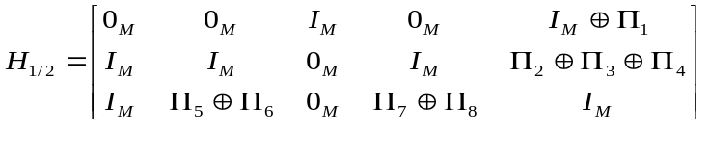
where and are the M×M identity and zero matrices, respectively, and through are permutation matrices.
      - The parity check matrices for the rate-2/3 and rate-4/5 codes are specified with additional columns and permutation matrices and shall satisfy the following equations:
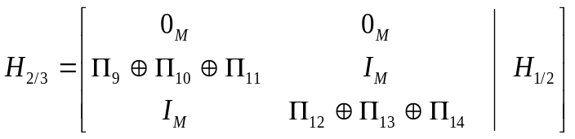
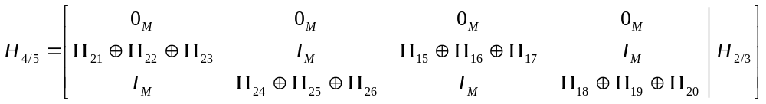
      - The permutation matrix shall have non-zero entries in row i and column for i ∈ {0,..., M-1} and
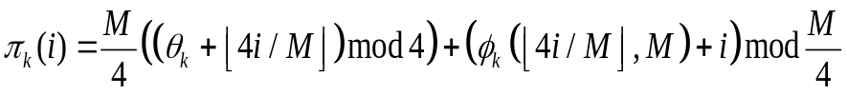
where the functions θ_{k} and φ_{k}(j,M) are defined in table 8-19 and table 8-9.
NOTE – Values defined in tables 8-19 and 8-9 describe φ_{k}(j,M)s using 7-tuples where consecutive positions in a tuple correspond to submatrix sizes from the set M={128, 256, 512, 1024, 2048, 4096, 8192}.
      - For each of the parity check matrices, the code symbols corresponding to the last M columns shall be punctured (not transmitted).
Table 8-87: Description of ϕ_{k}(0,M) and ϕ_{k}(1,M)
k | θ_{k} | ϕ_{k}(0,M) |  |  |  |  |  |  | ϕ_{k}(1,M)
k | θ_{k} | M = 2⁷ … 2¹³ |  |  |  |  |  |  | M = 2⁷ … 2¹³
1 | 3 | 1 | 59 | 16 | 160 | 108 | 226 | 1148 | 0 | 0 | 0 | 0 | 0 | 0 | 0
2 | 0 | 22 | 18 | 103 | 241 | 126 | 618 | 2032 | 27 | 32 | 53 | 182 | 375 | 767 | 1822
3 | 1 | 0 | 52 | 105 | 185 | 238 | 404 | 249 | 30 | 21 | 74 | 249 | 436 | 227 | 203
4 | 2 | 26 | 23 | 0 | 251 | 481 | 32 | 1807 | 28 | 36 | 45 | 65 | 350 | 247 | 882
5 | 2 | 0 | 11 | 50 | 209 | 96 | 912 | 485 | 7 | 30 | 47 | 70 | 260 | 284 | 1989
6 | 3 | 10 | 7 | 29 | 103 | 28 | 950 | 1044 | 1 | 29 | 0 | 141 | 84 | 370 | 957
7 | 0 | 5 | 22 | 115 | 90 | 59 | 534 | 717 | 8 | 44 | 59 | 237 | 318 | 482 | 1705
8 | 1 | 18 | 25 | 30 | 184 | 225 | 63 | 873 | 20 | 29 | 102 | 77 | 382 | 273 | 1083
9 | 0 | 3 | 27 | 92 | 248 | 323 | 971 | 364 | 26 | 39 | 25 | 55 | 169 | 886 | 1072
10 | 1 | 22 | 30 | 78 | 12 | 28 | 304 | 1926 | 24 | 14 | 3 | 12 | 213 | 634 | 354
11 | 2 | 3 | 43 | 70 | 111 | 386 | 409 | 1241 | 4 | 22 | 88 | 227 | 67 | 762 | 1942
12 | 0 | 8 | 14 | 66 | 66 | 305 | 708 | 1769 | 12 | 15 | 65 | 42 | 313 | 184 | 446
13 | 2 | 25 | 46 | 39 | 173 | 34 | 719 | 532 | 23 | 48 | 62 | 52 | 242 | 696 | 1456
14 | 3 | 25 | 62 | 84 | 42 | 510 | 176 | 768 | 15 | 55 | 68 | 243 | 188 | 413 | 1940
15 | 0 | 2 | 44 | 79 | 157 | 147 | 743 | 1138 | 15 | 39 | 91 | 179 | 1 | 854 | 1660
16 | 1 | 27 | 12 | 70 | 174 | 199 | 759 | 965 | 22 | 11 | 70 | 250 | 306 | 544 | 1661
17 | 2 | 7 | 38 | 29 | 104 | 347 | 674 | 141 | 31 | 1 | 115 | 247 | 397 | 864 | 587
18 | 0 | 7 | 47 | 32 | 144 | 391 | 958 | 1527 | 3 | 50 | 31 | 164 | 80 | 82 | 708
19 | 1 | 15 | 1 | 45 | 43 | 165 | 984 | 505 | 29 | 40 | 121 | 17 | 33 | 1009 | 1466
20 | 2 | 10 | 52 | 113 | 181 | 414 | 11 | 1312 | 21 | 62 | 45 | 31 | 7 | 437 | 433
21 | 0 | 4 | 61 | 86 | 250 | 97 | 413 | 1840 | 2 | 27 | 56 | 149 | 447 | 36 | 1345
22 | 1 | 19 | 10 | 1 | 202 | 158 | 925 | 709 | 5 | 38 | 54 | 105 | 336 | 562 | 867
23 | 2 | 7 | 55 | 42 | 68 | 86 | 687 | 1427 | 11 | 40 | 108 | 183 | 424 | 816 | 1551
24 | 1 | 9 | 7 | 118 | 177 | 168 | 752 | 989 | 26 | 15 | 14 | 153 | 134 | 452 | 2041
25 | 2 | 26 | 12 | 33 | 170 | 506 | 867 | 1925 | 9 | 11 | 30 | 177 | 152 | 290 | 1383
26 | 3 | 17 | 2 | 126 | 89 | 489 | 323 | 270 | 17 | 18 | 116 | 19 | 492 | 778 | 1790
Table 8-98: Description of ϕ_{k}(2,M) and ϕ_{k}(3,M)
k | θ_{k} | ϕ_{k}(2,M) |  |  |  |  |  |  | ϕ_{k}(3,M)
k | θ_{k} | M = 2⁷ … 2¹³ |  |  |  |  |  |  | M = 2⁷ … 2¹³
1 | 3 | 0 | 0 | 0 | 0 | 0 | 0 | 0 | 0 | 0 | 0 | 0 | 0 | 0 | 0
2 | 0 | 12 | 46 | 8 | 35 | 219 | 254 | 318 | 13 | 44 | 35 | 162 | 312 | 285 | 1189
3 | 1 | 30 | 45 | 119 | 167 | 16 | 790 | 494 | 19 | 51 | 97 | 7 | 503 | 554 | 458
4 | 2 | 18 | 27 | 89 | 214 | 263 | 642 | 1467 | 14 | 12 | 112 | 31 | 388 | 809 | 460
5 | 2 | 10 | 48 | 31 | 84 | 415 | 248 | 757 | 15 | 15 | 64 | 164 | 48 | 185 | 1039
6 | 3 | 16 | 37 | 122 | 206 | 403 | 899 | 1085 | 20 | 12 | 93 | 11 | 7 | 49 | 1000
7 | 0 | 13 | 41 | 1 | 122 | 184 | 328 | 1630 | 17 | 4 | 99 | 237 | 185 | 101 | 1265
8 | 1 | 9 | 13 | 69 | 67 | 279 | 518 | 64 | 4 | 7 | 94 | 125 | 328 | 82 | 1223
9 | 0 | 7 | 9 | 92 | 147 | 198 | 477 | 689 | 4 | 2 | 103 | 133 | 254 | 898 | 874
10 | 1 | 15 | 49 | 47 | 54 | 307 | 404 | 1300 | 11 | 30 | 91 | 99 | 202 | 627 | 1292
11 | 2 | 16 | 36 | 11 | 23 | 432 | 698 | 148 | 17 | 53 | 3 | 105 | 285 | 154 | 1491
12 | 0 | 18 | 10 | 31 | 93 | 240 | 160 | 777 | 20 | 23 | 6 | 17 | 11 | 65 | 631
13 | 2 | 4 | 11 | 19 | 20 | 454 | 497 | 1431 | 8 | 29 | 39 | 97 | 168 | 81 | 464
14 | 3 | 23 | 18 | 66 | 197 | 294 | 100 | 659 | 22 | 37 | 113 | 91 | 127 | 823 | 461
15 | 0 | 5 | 54 | 49 | 46 | 479 | 518 | 352 | 19 | 42 | 92 | 211 | 8 | 50 | 844
16 | 1 | 3 | 40 | 81 | 162 | 289 | 92 | 1177 | 15 | 48 | 119 | 128 | 437 | 413 | 392
17 | 2 | 29 | 27 | 96 | 101 | 373 | 464 | 836 | 5 | 4 | 74 | 82 | 475 | 462 | 922
18 | 0 | 11 | 35 | 38 | 76 | 104 | 592 | 1572 | 21 | 10 | 73 | 115 | 85 | 175 | 256
19 | 1 | 4 | 25 | 83 | 78 | 141 | 198 | 348 | 17 | 18 | 116 | 248 | 419 | 715 | 1986
20 | 2 | 8 | 46 | 42 | 253 | 270 | 856 | 1040 | 9 | 56 | 31 | 62 | 459 | 537 | 19
21 | 0 | 2 | 24 | 58 | 124 | 439 | 235 | 779 | 20 | 9 | 127 | 26 | 468 | 722 | 266
22 | 1 | 11 | 33 | 24 | 143 | 333 | 134 | 476 | 18 | 11 | 98 | 140 | 209 | 37 | 471
23 | 2 | 11 | 18 | 25 | 63 | 399 | 542 | 191 | 31 | 23 | 23 | 121 | 311 | 488 | 1166
24 | 1 | 3 | 37 | 92 | 41 | 14 | 545 | 1393 | 13 | 8 | 38 | 12 | 211 | 179 | 1300
25 | 2 | 15 | 35 | 38 | 214 | 277 | 777 | 1752 | 2 | 7 | 18 | 41 | 510 | 430 | 1033
26 | 3 | 13 | 21 | 120 | 70 | 412 | 483 | 1627 | 18 | 24 | 62 | 249 | 320 | 264 | 1606

Encoding
      - The encoder shall accept as input an information block of length k as per table 8-10.
      - Codewords consistent with the parity-check matrices in 8.4.2 shall be produced by performing matrix multiplication by block-circulant generator matrices.
NOTE – This family of codes supports rates K/(K+2), where K=2 for a rate 1/2 code, K=4 for rate 2/3, and K=8 for rate 4/5. Corresponding generator matrices, G, have size MK × M(K + 3) if punctured columns are described in the encoding, or MK × M(K + 2) if punctured columns are omitted.
Table 8-109: Codeword Lengths for Supported Code Rates (Measured in Bits)
Telemetry Transfer Frame Length or Information block length k | Codeword length n
 | rate 1/2 | rate 2/3 | rate 4/5
1024 | 2048 | 1536 | 1280
4096 | 8192 | 6144 | 5120
16384 | 32768 | 24576 | 20480
      - The generator matrices shall be constructed as follows:
- P shall be the 3M × 3M submatrix of H consisting of the last 3M columns. Q shall be the 3M × MK submatrix of H consisting of the first MK columns.
- 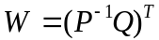 shall be computed, where the arithmetic is performed modulo-2.
      - The matrix 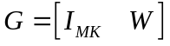 shall be constructed, where is the MK × MK identity matrix, and W is a dense matrix of circulants of size MK × 3M.
      - The last M columns of G shall be punctured.

CODE SYNCHRONIZATION

Overview

Synchronization
Codeblock synchronization is necessary for proper decoding of Reed-Solomon, Turbo, and LDPC codewords, and it is necessary for synchronization of the pseudo-random generator, if used (see section 10). It is also useful in assisting the node synchronization process of the decoder for the convolutional code. Frame synchronization is necessary for subsequent processing of the Transfer Frames, as specified in Section 3.
For a coding system using the basic convolutional code specified in 4.3, the CSM can be acquired either in the coded symbol domain (i.e., before any decoding) or in the domain of bits decoded by the convolutional decoder.
For a concatenated Reed-Solomon and convolutional coding system using the basic convolutional code specified in 4.3, the CSM can be acquired either in the coded symbol domain (i.e., before any decoding) or in the domain of bits decoded by the inner code (i.e., the code symbol domain of the Reed-Solomon code).
For a coding system using the punctured convolutional codes specified in 4.4, the CSM can only be acquired in the domain of bits decoded by the convolutional decoder. It cannot be acquired in the coded symbol domain (i.e., before any decoding).
For a concatenated Reed-Solomon and convolutional coding system using the punctured convolutional codes specified in 4.4, the CSM can only be acquired in the domain of bits decoded by the inner code (i.e., the code symbol domain of the Reed-Solomon code); i.e.; it cannot be acquired in the coded symbol domain (i.e., before any decoding).
For a Turbo or LDPC coding system, the CSM can only be acquired in the coded symbol domain (i.e., before any decoding in the code symbol domain of the Turbo or LDPC code).

Channel Access Data Unit
This Recommended Standard defines a data unit called the Channel Access Data Unit (CADU) whose contents are as per attached table 9-11. The Transfer Frame, codeword, or codeblock in the CADU may or may not be randomized.
Table 9-1110: Channel Access Data Unit Content with Different Coding Schemes
Applied Coding Scheme | CADU
Convolutional Coding | CSM and the Transfer Frame
Reed-Solomon Coding | CSM and Reed-Solomon codeblock
Concatenated Coding | CSM and Reed-Solomon codeblock
Turbo Coding | CSM and Turbo codeword
Low-Density Parity-Check Coding (of a Transfer Frame) | CSM and LDPC codeword

THE CODE SYNCHRONIZATION MARKER (CSM)
      - The CSM shall immediately follow the end of the preceding codeword or codeblock; i.e., there shall be no intervening bits preceding the CSM.
      - When convolutional coding (section 4) or no coding is used, CSMs shall be placed between the Transfer Frames.
      - When Reed-Solomon coding (section 5) or Concatenated coding (section 6) is used, ASMs shall be placed between the Reed-Solomon codeblocks.
      - When Turbo coding (section 7) or LDPC coding of Transfer Frames (section 8) is used, CSMs shall be placed between the codewords.
NOTE – Synchronization is acquired on the receiving end by recognizing the specific bit pattern of the regularly spaced CSMs; synchronization may be verified by making further checks.
      - If convolutional coding is used, the CSM shall be convolutionally encoded.
      - If an inner convolutional code is used in conjunction with an outer Reed-Solomon code, the CSM shall be encoded by the inner code but not by the outer code. (See section 4.)

CSM BIT PATTERNS
    - The CSM for data that is not Turbo or LDPC coded shall consist of a 32-bit (4-octet) marker with a pattern shown in figure 9-20.
    - The CSM for data that is Turbo coded with nominal code rate r = 1/2, 1/3, 1/4, or 1/6 shall consist of a 32/r-bit (4/r-octet) marker with bit patterns shown in figures 9-21 through 9-24.
    - The CSM for data that is LDPC coded as the result of applying LDPC coding to a Transfer Frame (section 8) with nominal code rate r = 7/8 shall consist of a 32-bit marker with bit pattern shown in figure 9-20.
    - The CSM for data that is LDPC coded as the result of applying LDPC coding to a Transfer Frame (section 8) with code rate r = 1/2, 2/3, or 4/5 shall consist of a 64-bit marker with bit pattern shown in figure 9-21.
    - The CSM for data that is LDPC coded as the result of applying LDPC coding to a stream of SMTFs (section Error: Reference source not found) shall consist of a 32-bit marker with bit pattern shown in figure 9-20.
NOTE – The CSM bit patterns are represented in hexadecimal notation as:

CSM for uncoded data, convolutional, Reed-Solomon, concatenated, and rate-7/8 LDPC coded data: | 1ACFFC1D
CSM for rate-1/2 Turbo and rates 1/2, 2/3, and 4/5 Transfer Frame LDPC coded data: | 034776C7272895B0
CSM for rate-1/3 Turbo coded data: | 25D5C0CE8990F6C9461BF79C
CSM for rate-1/4 Turbo coded data: | 034776C7272895B0 FCB88938D8D76A4F
CSM for rate-1/6 Turbo coded data: | 25D5C0CE8990F6C9461BF79C DA2A3F31766F0936B9E40863

FIRST TRANSMITTED BIT
(Bit 0)
↓
0001 | 1010 | 1100 | 1111 | 1111 | 1100 | 0001 | 1101
↑
LAST TRANSMITTED BIT
(Bit 31)
Figure 9-2019: CSM Bit Pattern for Uncoded, Convolutional, Reed-Solomon, Concatenated, and Rate 7/8 LDPC Coded Data

FIRST TRANSMITTED BIT
(Bit 0)
↓
0000001101000111011101101100011100100111001010001001010110110000
↑
LAST TRANSMITTED BIT
(Bit 63)
Figure 9-2120: CSM Bit Pattern for Rate 1/2 Turbo and Rates 1/2, 2/3, and 4/5 LDPC (Applied to a Transfer Frame) Coded Data

FIRST TRANSMITTED BIT
(Bit 0)
↓
001001011101010111000000110011101000100110010000111101101100100101000110000110111111011110011100
↑
LAST TRANSMITTED BIT
(Bit 95)
Figure 9-2221: CSM Bit Pattern for Rate 1/3 Turbo Coded Data

FIRST TRANSMITTED BIT
(Bit 0)
↓
0000001101000111011101101100011100100111001010001001010110110000
1111110010111000100010010011100011011000110101110110101001001111
↑
LAST TRANSMITTED BIT
(Bit 127)
Figure 9-2322: CSM Bit Pattern for Rate 1/4 Turbo Coded Data

FIRST TRANSMITTED BIT
(Bit 0)
↓
001001011101010111000000110011101000100110010000111101101100100101000110000110111111011110011100
110110100010101000111111001100010111011001101111000010010011011010111001111001000000100001100011
↑
LAST TRANSMITTED BIT
(Bit 191)
Figure 9-2423: CSM Bit Pattern for Rate 1/6 Turbo Coded Data

LOCATION OF CSM
    - The CSM shall be attached to (i.e., shall immediately precede) the codeblock (if Reed-Solomon encoded), the codeword (if Turbo or LDPC encoded), or the Transfer Frame (if convolutionally encoded only or uncoded).
    - The CSM shall immediately follow the end of the preceding codeblock (if Reed-Solomon encoded), the codeword (if Turbo or LDPC encoded), or the Transfer Frame (if convolutionally encoded only or uncoded); i.e., there shall be no intervening bits (data or fill) preceding the CSM.

RELATIONSHIP OF CSM TO REED-SOLOMON, TURBO, and LDPC CODEBLOCKS and Codewords
    - The CSM shall NOT be a part of the encoded data space of the Reed-Solomon codeblock, and it shall not be presented to the input of the Reed-Solomon encoder or decoder.
NOTE – This prevents the encoder from routinely regenerating a second, identical marker in the check symbol field under certain repeating data-dependent conditions (e.g., a test pattern of 01010101010 ... among others), which could cause synchronization difficulties at the receiving end. The relationship among the CSM, Reed-Solomon codeblock, and Information Block is illustrated in figure 5-10.
    - Similarly, the CSM shall not be presented to the input of the Turbo encoder or decoder. It shall be directly attached to the Turbo codeword (see figure 7-15).
    - Similarly, the CSM shall not be presented to the input of the LDPC encoder or decoder. It shall be directly attached to the LDPC codeword.

ASM FOR EMBEDDED DATA STREAM
NOTE – A different ASM pattern (see figure 9-25) may be required where another data stream (e.g., a stream of Transfer Frames played back from a tape recorder in the forward direction) is inserted into the data field of the Transfer Frame of the main stream appearing on the communications channel.
The ASM for the embedded data stream, to differentiate it from the main stream marker, shall consist of a 32-bit (4-octet) marker with a pattern as follows:

FIRST TRANSMITTED BIT
(Bit 0)
↓
0011 0101 0010 1110 1111 1000 0101 0011
↑
LAST TRANSMITTED BIT
(Bit 31)
Figure 9-2524: Embedded ASM Bit Pattern
NOTE – This pattern is represented in hexadecimal notation as:
352EF853

PSEUDO-RANDOMIZER

Overview
In order for the receiver system to work properly, every data capture system at the receiving end requires that the data stream be sufficiently random (have little periodicity) and that the incoming signal have sufficient bit transition density (see recommendation 2.4.9 in reference [5]), and allow proper synchronization of the decoder. The incoming signal must also be free of significant spectral lines, and be free of patterns that interfere with codeword synchronization and validation (see 2.2.2).
The Pseudo-Randomizer defined in this section is the preferred method to ensure sufficient randomness for all combinations of CCSDS-recommended modulation and coding schemes. The Pseudo-Randomizer defined in this section is required unless the system designer verifies proper operation of the system if this Randomizer is not used.
NOTE – Problems with telemetry links have been encountered because this Pseudo-Randomizer was not used, and sufficient randomness was not ensured by other means and properly verified.
The presence or absence of pseudo-randomization is fixed for a Physical Channel and is managed (i.e., its presence or absence is not signaled in the transmitted data stream but must be known a priori) by the receiver.

PSEUDO-RANDOMIZER DESCRIPTION
    - The method for ensuring sufficient randomization is to exclusive-OR each bit of the codeblock, codeword, or Transfer Frame with a standard pseudo-random sequence.
    - If the pseudo-randomizer is used, on the sending end it shall be applied to the codeblock, codeword, or Transfer Frame after Reed-Solomon, Turbo, or LDPC encoding (if any of these are used), but before convolutional encoding (if used). On the receiving end, it shall be applied to derandomize the data after convolutional decoding (if used) and codeblock or codeword synchronization but before Reed-Solomon, Turbo, or LDPC decoding (if any of these are used).
    - If the pseudo-randomizer is used with no coding, then at the sending end, it shall be applied to the Transfer Frame. On the receiving end, it shall be applied to derandomize the data.
    - If the pseudo-randomizer is used with convolutional coding alone, then at the sending end, it shall be applied to the Transfer Frame prior to encoding. On the receiving end, it shall be applied to derandomize the data after decoding.
    - If the pseudo-randomizer is used with concatenated Reed-Solomon and Convolutional coding, then at the sending end, it shall be applied to the codeblock (m≥1 Reed-Solomon codeblocks if slicing is used) after Reed-Solomon encoding, but before convolutional encoding. On the receiving end, it shall be applied to derandomize the data after convolutional decoding but before Reed-Solomon decoding.
    - If the pseudo-randomizer is used with Turbo or LDPC coding, then at athe sending end, it shall be applied to the codeword after encoding. At the receiving end, it shall be applied to the codeword to derandomize the data after decoding.
NOTE – The configuration at the sending end is shown in figure 10-26.
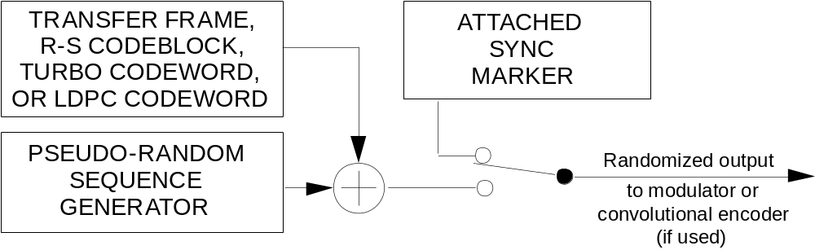
Figure 10-2625: Pseudo-Randomizer Configuration

SYNCHRONIZATION AND APPLICATION OF PSEUDO-RANDOMIZER
    - The Code Sync Marker (CSM) shall be used for synchronizing the pseudo-randomizer.
    - The pseudo-random sequence shall be applied starting with the first bit of the codeblock, codeword, or Transfer Frame. On the sending end, the codeblock, codeword, or Transfer Frame shall be randomized by exclusive-ORing the first bit of the codeblock, codeword, or Transfer Frame with the first bit of the pseudo-random sequence, followed by the second bit of the codeblock, codeword, or Transfer Frame with the second bit of the pseudo-random sequence, and so on.
    - On the receiving end, the original codeblock, codeword, or Transfer Frame shall be reconstructed (i.e., derandomized) using the same pseudo‐random sequence.
    - After locating the CSM in the received data stream, the data immediately following the CSM shall be derandomized.
NOTES
- The CSM was not randomized and is not derandomized.
- Derandomization can be accomplished by performing exclusive-OR with hard bits or by inverting the soft bit values corresponding to the ‘ones’ in the pseudo-random sequence.

SEQUENCE SPECIFICATION
    - The pseudo-random sequence shall be 131071 bits in length and shall be generated using the following polynomial of degree seventeen:
h(x) = x¹⁷ + x¹⁴ + 1
    - For backward compatibility with legacy systems, a 255-bit pseudo-random sequence may be generated instead, by using the following polynomial of degree eight:
h(x) = x⁸ + x⁷ + x⁵ + x³ + 1
NOTE – Designers should note that this 255-bit pseudo-randomizer may introduce spectral lines at 1/255 of the symbol rate, and these may be significant in some systems. In addition, it could not guarantee full compliance with ITU power flux density limits.
    - This sequence shall begin at the first bit of the codeblock, codeword, or Transfer Frame and shall repeat after 131071 bits or 255 bits, depending on the selected polynomial, continuing repeatedly until the end of the codeblock, codeword, or Transfer Frame. The sequence generator shall be initialized to ‘11000111000111000’ in case of the polynomial of degree 17, or to the ‘all-ones’ state, in case of the polynomial of degree 8, at the start of each codeblock, codeword, or Transfer Frame.
NOTES
- The initial seed for the 131071-bit pseudo-randomizer has been optimized for performance and to avoid a long sequence of ‘ones’ at the beginning of the generated sequence.
- The first 40 bits of the pseudo-random sequences of both polynomials are shown below. The leftmost bit is the first bit of the sequence to be exclusive-ORed with the first bit of the codeblock, codeword, or Transfer Frame; the second bit of the sequence is exclusive-ORed with the second bit of the codeblock, codeword, or Transfer Frame, and so on.
0001 1100 0111 0001 1011 1001 0001 1011 1010 1001. . . . (131071-bit randomizer)
1111 1111 0100 1000 0000 1110 1100 0000 1001 1010 . . . . (255-bit randomizer)

LOGIC DIAGRAM
NOTE – Figures 10-27 and 10-28 represent two possible generators for the 131071-bit and 255-bit sequences, respectively.
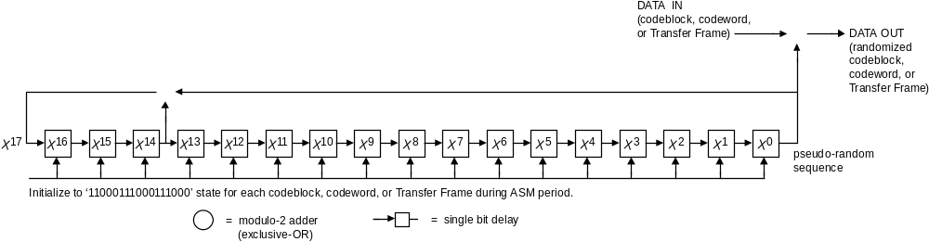
Figure 10-2726: Pseudo-Randomizer Logic Diagram for the 131071-Bit Sequence

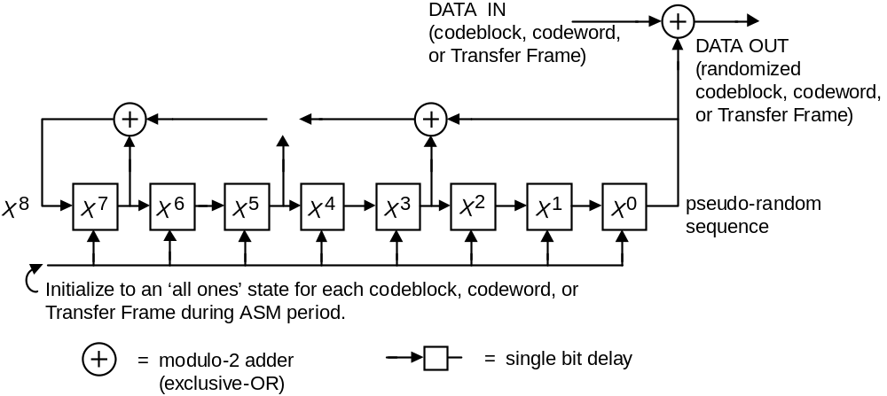
Figure 10-2827: Pseudo-Randomizer Logic Diagram for the 255-Bit Sequence (Only for Backward Compatibility with Legacy Systems)

TRANSFER FRAME LENGTHS

Overview
Neither the TM Space Data Link Protocol (reference [1]), the AOS Space Data Link Protocol (reference [2]), nor USLP (reference [6]) specifies the length of Transfer Frames because there are constraints on the Transfer Frame length depending on the selected coding options.
The Unified Space Data Link Protocol (reference [6]) contains a frame length field that is specified by the sender for both fixed- or variable-length transfer frames. However, that field is not used by the procedures defined in this Recommended Standard.
The constraints on Transfer Frame lengths specified in this section apply to TM, AOS, and USLP Transfer Frames.

General
    - Once selected, the Transfer Frame length shall be fixed for a Mission Phase on a particular Physical Channel.
NOTE – The Transfer Frame lengths shown here do not include the length of the Code Sync Marker (CSM) specified in section 9.

Case 1: Uncoded
The length of the Transfer Frames shall be any integer number of octets, as required by the using project, with a maximum of 2048 octets for TM SDLP, and 65536 octets for AOS SDLP and USLP.

Case 2: Convolutional Only
The length of the Transfer Frames shall be any integer number of octets, as required by the using project, with a maximum of 2048 octets for TM SDLP, and 65536 octets for AOS SDLP and USLP.

Case 3: WHEN TRANSFER FRAME SLICING IS USED
The length of the Transfer Frames shall be any integer number of octets, as required by the using project, with a maximum of 2048 octets for TM SDLP, and 65536 octets for AOS SDLP and USLP.

Case 4: Reed-Solomon Only, in absence of Transfer frame slicing
NOTES
- With the Reed-Solomon Codes specified in section 5, only certain specific lengths of Transfer Frames may be contained within the codeblock’s data space. In some cases these lengths can be shortened at a small sacrifice in coding gain.
- Since these R-S codes have a symbol length of 8 bits, the length of the codeblock (in octets) is a multiple of the interleaving depth, which provides ‘octet compatibility’.
    - If necessary, Transfer Frame lengths shall be shortened in discrete steps by using virtual fill.
    - If high-speed efficiency is needed for ‘32-bit compatibility’ (with 32-bit processors, for example), then the length of the codeblock shall be a combined multiple of 4 and the interleaving depth.
    - When only octet compatibility is required, lengths for Transfer Frames (L in octets) shall be determined using the following equation:
L = (255-2E-q) I
such that L is a positive integer,
where E = error correction capability,
q = number of virtual fill symbols per R-S codeword, and
I = interleaving depth.
    - When 32-bit compatibility is required, the Transfer Frame length must be chosen so that
- it is expressed by the equation in 11.6.3; and
- the codeblock length (255-q)I (in octets) is a multiple of 4.

Case 5: CONCATENATED, in absence of Transfer frame slicing
The allowable lengths of Transfer Frames when the concatenated (Reed-Solomon and convolutional) coding is used are the same as those for the Reed-Solomon–only case (Case 4) shown in 11.6.

Case 6: TURBO, in absence of Transfer frame slicing
    - The Transfer Frame lengths shall be selected to match the information block lengths for the selected Turbo code.
NOTE – The Turbo Codes specified in section 7 of this Recommended Standard are block codes.
    - Only the following information block lengths shall be used (values are in octets):
a) 223;
b) 446;
c) 892;
d) 1115.
NOTE – Performance for only the above block lengths (i.e., Transfer Frame lengths) has been validated by CCSDS and approved for use (values are in octets).

Case 7: LDPC, in absence of Transfer frame slicing
    - The Transfer Frame lengths must match the information block lengths for the selected LDPC code.
NOTE – The LDPC Codes specified in section 8 of this Recommended Standard are block codes.
    - When the rate-7/8 LDPC code is used, the only allowable Transfer Frame length is 892 octets.
    - When the 1/2-, 2/3-, and 4/5-rate LDPC codes are used, the allowable Transfer Frame lengths are 128 octets, 512 octets, or 2048 octets.

Managed Parameters

OVERVIEW
In order to conserve bandwidth on the space link, some parameters associated with synchronization and channel coding are handled by management rather than by inline communications protocol. The managed parameters are those which tend to be static for long periods of time, and whose change generally signifies a major reconfiguration of the synchronization and channel coding systems associated with a particular mission. Through the use of a management system, management conveys the required information to the synchronization and channel coding systems.
In this section, the managed parameters used by synchronization and channel coding systems are listed. These parameters are defined in an abstract sense and are not intended to imply any particular implementation of a management system.

General
    - All the managed parameters specified in this section shall be fixed for all Transfer Frames on a Physical Channel during a given Mission Phase.
    - When the Reed-Solomon or LDPC codes are not used, the Frame Error Control Field defined in references [1] or [2] shall be present.
NOTE – The presence or absence of the Frame Error Control Field is established by the management of the relevant Data Link Protocol. When the Reed-Solomon or LDPC codes are used, the Frame Error Control Field can still be present but no check is required by the decoding system.
    - If present, the Frame Error Control Field shall occur within every Transfer Frame transmitted within the same Physical Channel throughout a Mission Phase.

Managed Parameters FOR SELECTED OPTIONS
The managed parameters for a particular Physical Channel shall be those specified in table 12-12.
Table 12-1211: Managed Parameters for Selected Options
Managed Parameter | Allowed Values
Randomizer | Long (131071 bits)  Short (255 bits)  Absent
Coding Method | None  Convolutional  Reed-Solomon  Concatenated Code  Turbo  LDPC

Managed Parameters FOR CONVOLUTIONAL Code
The managed parameters for convolutional code shall be those specified in table 12-13.
Table 12-1312: Managed Parameters for Convolutional Code
Managed Parameter | Allowed Values
Code Rate (r) | 1/2, 2/3, 3/4, 5/6, 7/8
Slicing | Absent

Managed Parameters FOR REED-SOLOMON Code
The managed parameters for Reed-Solomon code shall be those specified in table 12-14.
Table 12-1413: Managed Parameters for Reed-Solomon Code
Managed Parameter | Allowed Values
Error Correction Capability (E, symbols) | 8, 16
Interleaving Depth (I) | 1, 2, 3, 4, 5, 8
Virtual Fill Length (Q, symbols) | Integer
Slicing | Present, Absent

Managed Parameters FOR TURBO Code
The managed parameters for Turbo code shall be those specified in table 12-15.
Table 12-1514: Managed Parameters for Turbo Code
Managed Parameter | Allowed Values
Nominal Code Rate (r) | 1/2, 1/3, 1/4, 1/6
Information Block Length (k, bits) | 1784, 3568, 7136, 8920
Slicing | Present, Absent
Channel Interleaver | Present, Absent

Managed Parameters FOR LOW-DENSITY PARITY-CHECK Coding
The managed parameters for LDPC coding shall be those specified in table 12-16.
Table 12-1615: Managed Parameters for Low-Density Parity-Check Code
Managed Parameter | Allowed Values
Code Rate (r) | 1/2, 2/3, 4/5, 7/8
Information Block Length (k, bits) | 1024, 4096, 16384 (if r=1/2, 2/3, or 4/5), 7136 (if r=7/8)
Slicing | Present, Absent

Managed Parameters FOR FRAME SYNCHRONIZATION
The managed parameters for frame synchronization shall be those specified in table 12-17.
Table 12-1716: Managed Parameters for Frame Synchronization
Managed Parameter | Allowed Values
Transfer Frame Length (octets) | ≤2048 (with no coding, convolutional coding, or slicing; and with TM SDLP),  ≤65536 (with no coding, convolutional coding, or slicing; and with AOS SDLP or USLP),  Must match the Information Block length (with Reed-Solomon, concatenated, Turbo, or LDPC coding)

USE OF TELECOMMUNICATIONS CHANNEL CODES FOR GROUND-TO-SPACE AND SPACE-TO-SPACE LINKS

overview
The error control codes specified in this document are designed for use with fixed-length Transfer Frames as defined in the TM Space Data Link Protocol (reference [1]), AOS Space Data Link Protocol (reference [2]), or Unified Space Data Link Protocol (reference [6]). The AOS and USLP protocols are defined for Telemetry (downlink) use, as is TM, but AOS and USLP are also designed for use for ground-to-space and space-to-space communications. This bidirectional use will typically be adopted for high-rate missions, missions for which the space-to-ground and ground-to-space links are symmetric, or for missions that are adopting upper-layer networking protocols like DTN or IP.
In some cases, it is most practical to use Transfer Frames with a fixed length that does not need to match the information block length of the error correcting code. To support this application, synchronization markers may be prepended to the Transfer Frames, the resulting SMTFs concatenated into a stream, and then ‘sliced’ according to the information block length of the code. This slicing is described in Section 3.

turbo codes

Discussion
Turbo codes are best suited to power-constrained links, for which the Signal-to-Noise Ratio (SNR), E_{b}/N₀, is a dominant concern. Their code rates of r ≤1/2 provide greater coding gain than LDPC codes, at a cost of greater bandwidth expansion and increased demodulator and decoding complexity. They are best suited to links beyond low-Earth orbit.

Specification
For AOS or USLP ground-to-space links, any of the turbo codes in section 7 shall be selected.
NOTES
- The turbo codes in section 7 offer code rates of r =1/2, 1/3, 1/4, and 1/6, and block lengths of 1784, 3568, 7136, and 8920 information bits.
- When a low-rate turbo code (particularly 1/4 or 1/6) is used near its decoding threshold, the symbol SNR may be below −5 dB. The radio receiver’s symbol tracking loop may require an uncommonly narrow loop bandwidth, as well as an external means for Doppler compensation.

Low-Density Parity-Check codes

Discussion
LDPC codes are best suited to high-data-rate links because of their code rates of r ≥1/2 and the potentially parallel implementation architecture for the decoder. They are best suited to links on which bandwidth is limited, onboard computational resources are available to support an iterative decoder, and a Physical Layer modulation that supports at least two code symbols per modulation symbol is available (e.g., QPSK/OQPSK and above—see reference [5]).

Specification
For AOS or USLP ground-to-space links, any of the LDPC codes in section 8 shall be selected.
NOTE – The LDPC codes in section 8 offer code rates of r=1/2, 2/3, 4/5, and approximately 7/8. Block lengths of 1024, 4096, and 16384 information bits are available with the first three code rates, and 7136 information bits in the last case.

SERVICE
(Normative)
  - Overview
    - Background
This annex provides service definition in the form of primitives, which present an abstract model of the logical exchange of data and control information between the service provider and the service user. The definitions of primitives are independent of specific implementation approaches.
The parameters of the primitives are specified in an abstract sense and specify the information to be made available to the user of the primitives. The way in which a specific implementation makes this information available is not constrained by this specification. In addition to the parameters specified in this annex, an implementation can provide other parameters to the service user (e.g., parameters for controlling the service, monitoring performance, facilitating diagnosis, and so on).
  - OVERVIEW OF THE SERVICE
The TM Synchronization and Channel Coding provides unidirectional (one way) transfer of a sequence of fixed-length TM, AOS, or USLP Transfer Frames at a constant frame rate over a Physical Channel across a space link, with optional error detection/correction.
Only one user can use this service on a Physical Channel.
  - SERVICE PARAMETERS
    - Frame
    - The Frame parameter is the service data unit of this service and shall be either a TM Transfer Frame defined in reference [1], an AOS Transfer Frame defined in reference [2], or a USLP Transfer Frame defined in reference [6].
    - The length of any Transfer Frame transferred on a Physical Channel must be the same, and is established by management.
    - Quality IndicatOR
The Quality Indicator parameter shall be used to notify the user at the receiving end of the service that there is an uncorrectable error in the received Transfer Frame.
    - SEQUENCE INDICATOR
The Sequence Indicator parameter shall be used to notify the user at the receiving end of the service that one or more Transfer Frames of the Physical Channel have been lost as the result of a loss of frame synchronization.
  - SERVICE PRIMITIVES
    - General
    - The service primitives associated with this service are:
- ChannelAccess.request;
- ChannelAccess.indication.
- The ChannelAccess.request primitive shall be passed from the service user at the sending end to the service provider to request that a Frame be transferred through the Physical Channel to the user at the receiving end.
- The ChannelAccess.indication shall be passed from the service provider to the service user at the receiving end to deliver a Frame.
    - ChannelAccess.request
      - Function
The ChannelAccess.request primitive is the service request primitive for this service.
      - Semantics
The ChannelAccess.request primitive shall provide a parameter as follows:
ChannelAccess.request (Frame)
      - When Generated
The ChannelAccess.request primitive is passed to the service provider to request it to process and send the Frame.
      - Effect On Receipt
Receipt of the ChannelAccess.request primitive causes the service provider to perform the functions described in 2.3.1 and to transfer the resulting coded symbols.
    - ChannelAccess.indication
      - Function
The ChannelAccess.indication primitive is the service indication primitive for this service.
      - Semantics
The ChannelAccess.indication primitive shall provide parameters as follows:
ChannelAccess.indication (Frame,
Quality Indicator,
Sequence Indicator)
      - When Generated
The ChannelAccess.indication primitive is passed from the service provider to the service user at the receiving end to deliver a Frame.
      - Effect On Receipt
The effect of receipt of the ChannelAccess.indication primitive by the service user is undefined.

Security, SANA, and Patent COnsiderations
(Informative)
  - Security Considerations
    - Security Background
It is assumed that security is provided by encryption, authentication methods, and access control to be performed at higher layers (application and/or transport layers). Mission and service providers are expected to select from recommended security methods, suitable to the specific application profile. Specification of these security methods and other security provisions is outside the scope of this Recommended Standard. The coding layer has the objective of delivering data with the minimum possible amount of residual errors. An LDPC, Reed-Solomon, or other code with FECF must be used to insure that residual errors are detected and the frame flagged. There is an extremely low probability of additional undetected errors that may escape this scrutiny. These errors may affect the encryption process in unpredictable ways, possibly affecting the decryption stage and producing data loss, but will not compromise the security of the data.
    - Security Concerns
Security concerns in the areas of data privacy, authentication, access control, availability of resources, and auditing are to be addressed in higher layers and are not related to this Recommended Standard. The coding layer does not affect the proper functioning of methods used to achieve such protection at higher layers, except for undetected errors, as explained above.
The physical integrity of data bits is protected from channel errors by the coding systems specified in this Recommended Standard. In case of congestion or disruption of the link, the coding layer provides methods for frame re-synchronization.
    - Potential Threats and Attack Scenarios
An eavesdropper can receive and decode the codewords, but will not be able to get to the user data if proper encryption is performed at a higher layer. An interferer could affect the performance of the decoder by congesting it with unwanted data, but such data would be rejected by the authentication process. Such interference or jamming must be dealt with at the Physical Layer and through proper spectrum regulatory entities.
    - Consequences of Not Applying Security
There are no specific security measures prescribed for the coding layer. Therefore consequences of not applying security are only imputable to the lack of proper security measures in other layers. Residual undetected errors may produce additional data loss when the link carries encrypted data.
  - SANA Considerations
The recommendations of this document do not require any action from SANA.
  - PATENT Considerations
    - Turbo Coding
Implementers should be aware that a wide class of Turbo codes is covered by a patent by France Télécom and Télédiffusion de France under US Patent 5,446,747 and its counterparts in other countries.
Potential user agencies should direct their requests for licenses to:
Mr. Christian Hamon
CCETT GIE/CVP
4 rue du Clos Courtel
BP59, 35512 CESSON SEVIGNE Cedex, France
Tel: +33 2 99 12 48 05, Fax: +33 2 99 12 40 98
E-mail: christian.hamon@cnet.francetelecom.fr
    - LDPC Coding
Implementers should be aware that the 1/2-, 2/3-, and 4/5-rate codes are covered by US Patent 7,343,539. Potential user agencies should direct their requests for licenses to:
Office of Technology Transfer
California Institute of Technology
1200 E. California Blvd., Mail Code 210-85
Pasadena, CA 91125
Tel: +1 626 395 3822, +1 626 577 2528
E-mail: Vieregg@Caltech.edu

Annex to Subsection 8.3,
Low-Density Parity-Check Code with Rate 223/255
(INformative)
  - Generator Matrix Circulant Table
Table 13-1817: Table of Circulants for the Generator Matrix
Circulant | 1st row of circulant
b_{1,1} | 55BF56CC55283DFEEFEA8C8CFF04E1EBD9067710988E25048D67525426939E2068D2DC6FCD2F822BEB6BD96C8A76F4932AAE9BC53AD20A2A9C86BB461E43759C
b_{1,2} | 6855AE08698A50AA3051768793DC238544AF3FE987391021AAF6383A6503409C3CE971A80B3ECE12363EE809A01D91204F1811123EAB867D3E40E8C652585D28
b_{2,1} | 62B21CF0AEE0649FA67B7D0EA6551C1CD194CA77501E0FCF8C85867B9CF679C18BCF7939E10F8550661848A4E0A9E9EDB7DAB9EDABA18C168C8E28AACDDEAB1E
b_{2,2} | 64B71F486AD57125660C4512247B229F0017BA649C6C11148FB00B70808286F1A9790748D296A593FA4FD2C6D7AAF7750F0C71B31AEE5B400C7F5D73AAF00710
b_{3,1} | 681A8E51420BD8294ECE13E491D618083FFBBA830DB5FAF330209877D801F92B5E07117C57E75F6F0D873B3E520F21EAFD78C1612C6228111A369D5790F5929A
b_{3,2} | 04DF1DD77F1C20C1FB570D7DD7A1219EAECEA4B2877282651B0FFE713DF338A63263BC0E324A87E2DC1AD64C9F10AAA585ED6905946EE167A73CF04AD2AF9218
b_{4,1} | 35951FEE6F20C902296C9488003345E6C5526C5519230454C556B8A04FC0DC642D682D94B4594B5197037DF15B5817B26F16D0A3302C09383412822F6D2B234E
b_{4,2} | 7681CF7F278380E28F1262B22F40BF3405BFB92311A8A34D084C086464777431DBFDDD2E82A2E6742BAD6533B51B2BDEE0377E9F6E63DCA0B0F1DF97E73D5CD8
b_{5,1} | 188157AE41830744BAE0ADA6295E08B79A44081E111F69BBE7831D07BEEBF76232E065F752D4F218D39B6C5BF20AE5B8FF172A7F1F680E6BF5AAC3C4343736C2
b_{5,2} | 5D80A6007C175B5C0DD88A442440E2C29C6A136BBCE0D95A58A83B48CA0E7474E9476C92E33D164BFF943A61CE1031DFF441B0B175209B498394F4794644392E
b_{6,1} | 60CD1F1C282A1612657E8C7C1420332CA245C0756F78744C807966C3E1326438878BD2CCC83388415A612705AB192B3512EEF0D95248F7B73E5B0F412BF76DB4
b_{6,2} | 434B697B98C9F3E48502C8DBD891D0A0386996146DEBEF11D4B833033E05EDC28F808F25E8F314135E6675B7608B66F7FF3392308242930025DDC4BB65CD7B6E
b_{7,1} | 766855125CFDC804DAF8DBE3660E8686420230ED4E049DF11D82E357C54FE256EA01F5681D95544C7A1E32B7C30A8E6CF5D0869E754FFDE6AEFA6D7BE8F1B148
b_{7,2} | 222975D325A487FE560A6D146311578D9C5501D28BC0A1FB48C9BDA173E869133A3AA9506C42AE9F466E85611FC5F8F74E439638D66D2F00C682987A96D8887C
b_{8,1} | 14B5F98E8D55FC8E9B4EE453C6963E052147A857AC1E08675D99A308E7269FAC5600D7B155DE8CB1BAC786F45B46B523073692DE745FDF10724DDA38FD093B1C
b_{8,2} | 1B71AFFB8117BCF8B5D002A99FEEA49503C0359B056963FE5271140E626F6F8FCE9F29B37047F9CA89EBCE760405C6277F329065DF21AB3B779AB3E8C8955400
b_{9,1} | 0008B4E899E5F7E692BDCE69CE3FAD997183CFAEB2785D0C3D9CAE510316D4BD65A2A06CBA7F4E4C4A80839ACA81012343648EEA8DBBA2464A68E115AB3F4034
b_{9,2} | 5B7FE6808A10EA42FEF0ED9B41920F82023085C106FBBC1F56B567A14257021BC5FDA60CBA05B08FAD6DC3B0410295884C7CCDE0E56347D649DE6DDCEEB0C95E
b_{10,1} | 5E9B2B33EF82D0E64AA2226D6A0ADCD179D5932EE1CF401B336449D0FF775754CA56650716E61A43F963D59865C7F017F53830514306649822CAA72C152F6EB2
b_{10,2} | 2CD8140C8A37DE0D0261259F63AA2A420A8F81FECB661DBA5C62DF6C817B4A61D2BC1F068A50DFD0EA8FE1BD387601062E2276A4987A19A70B460C54F215E184
b_{11,1} | 06F1FF249192F2EAF063488E267EEE994E7760995C4FA6FFA0E4241825A7F5B65C74FB16AC4C891BC008D33AD4FF97523EE5BD14126916E0502FF2F8E4A07FC2
b_{11,2} | 65287840D00243278F41CE1156D1868F24E02F91D3A1886ACE906CE741662B40B4EFDFB90F76C1ADD884D920AFA8B3427EEB84A759FA02E00635743F50B942F0
b_{12,1} | 4109DA2A24E41B1F375645229981D4B7E88C36A12DAB64E91C764CC43CCEC188EC8C5855C8FF488BB91003602BEF43DBEC4A621048906A2CDC5DBD4103431DB8
b_{12,2} | 2185E3BC7076BA51AAD6B199C8C60BCD70E8245B874927136E6D8DD527DF0693DC10A1C8E51B5BE93FF7538FA138B335738F4315361ABF8C73BF40593AE22BE4
b_{13,1} | 228845775A262505B47288E065B23B4A6D78AFBDDB2356B392C692EF56A35AB4AA27767DE72F058C6484457C95A8CCDD0EF225ABA56B7657B7F0E947DC17F972
b_{13,2} | 2630C6F79878E50CF5ABD353A6ED80BEACC7169179EA57435E44411BC7D566136DFA983019F3443DE8E4C60940BC4E31DCEAD514D755AF95A622585D69572692
b_{14,1} | 7273E8342918E097B1C1F5FEF32A150AEF5E11184782B5BD5A1D8071E94578B0AC722D7BF49E8C78D391294371FFBA7B88FABF8CC03A62B940CE60D669DFB7B6
b_{14,2} | 087EA12042793307045B283D7305E93D8F74725034E77D25D3FF043ADC5F8B5B186DB70A968A816835EFB575952EAE7EA4E76DF0D5F097590E1A2A978025573E
The numbers in the second column represent the hexadecimal representation of the first row of each circulant. Since there are only 511 possible positions, the leftmost bit is padded with a zero to allow a 128 digit hexadecimal number, i.e., the leftmost number in the specification of each circulant shall be interpreted as octal (=3 bits), as opposed to the others which shall be interpreted as hexadecimal (=4 bits). The generator matrix circulants do not have a low density of ‘1’s as do the parity-check matrix circulants in table 8-6. All Bi,j circulant shifting is done by a single-bit right shift of the previous row.

Abbreviations and ACRONYMS
(Informative)
  - Introduction
This annex lists key abbreviations and acronyms that are used throughout this Recommended Standard.
  - ACRONYMS
AOS Advanced Orbiting Systems
ASM Attached Sync Marker
CADU Channel Access Data Unit
CCSDS Consultative Committee For Space Data Systems
CSM Code Sync Marker
DTN delay/disruption-tolerant networking
FECF Frame Error Control Field
GF Galois Field
IP Internet Protocol
LDPC Low-Density Parity-Check
MSB Most Significant Bit
NRZ-L Non-Return-to-Zero-Level
NRZ-M Non-Return-to-Zero-Mark
OQPSK Offset Quadrature Phase Shift Keying
OSI Open Systems Interconnection
QPSK Quadrature Phase Shift Keying
R-S Reed-Solomon
SANA Space Assigned Numbers Authority
SMTF Sync-Marked Transfer Frame
TC Telecommand
TCM Trellis Coded Modulation
TM Telemetry
USLP Unified Space Link Protocol

INFORMATIVE REFERENCES
(Informative)
[E7] Organization and Processes for the Consultative Committee for Space Data Systems. Issue 4. CCSDS Record (Yellow Book), CCSDS A02.1-Y-4. Washington, D.C.: CCSDS, April 2014.
[E8] Telemetry Channel Coding. Issue 6-S. Recommendation for Space Data System Standards (Historical), CCSDS 101.0-B-6-S. Washington, D.C.: CCSDS, (October 2002) August 2005.
[E9] Advanced Orbiting Systems, Networks and Data Links: Architectural Specification. Issue 3-S. Recommendation for Space Data System Standards (Historical), CCSDS 701.0-B-3-S. Washington, D.C.: CCSDS, (June 2001) August 2005.
[E10] M. Perlman and J. J. Lee. Reed-Solomon Encoders—Conventional vs. Berlekamp's Architecture. JPL Publication 82-71. Pasadena, California: JPL, December 1, 1982.
[E11] Flexible Advanced Coding and Modulation Scheme for High Rate Telemetry Applications. Issue 2. Recommendation for Space Data System Standards (Blue Book), CCSDS 131.2-B-2. Washington, D.C.: CCSDS, February 2023.
[E12] CCSDS Space Link Protocols over ETSI DVB-S2 Standard. Issue 2. Recommendation for Space Data System Standards (Blue Book), CCSDS 131.3-B-2. Washington, D.C.: CCSDS, April 2022.
[E13] Analysis of CCSDS Turbo Codes in the Presence of Channel Fading. K. Andrews, N. Lay. Presented at CCSDS Fall Meeting 2017. Den Hague, The Netherlands, November 2017.
[E14] Morabito, D. (2003). IPN Progress Report 42-153 May 15, 2003 Solar Corona Amplitude Scintillation Modeling.
[E15] M. Baldi et al., "End-to-End Simulations of Coded Transmissions in Space Links Affected by Solar Scintillation," in IEEE Transactions on Aerospace and Electronic Systems, vol. 56, no. 4, pp. 3259-3275, Aug. 2020, doi: 10.1109/TAES.2020.2970733

NOTE – Normative references are listed in 1.7.

TRANSFORMATION BETWEEN BERLEKAMP
AND CONVENTIONAL REPRESENTATIONS
(Informative)
  - Purpose
This annex provides information to assist users of the Reed-Solomon code in this Recommended Standard to transform between the Berlekamp (dual basis) and Conventional representations. In addition, it shows where transformations are made to allow a conventional encoder to produce the dual basis representation on which this Recommended Standard is based.
  - Transformation
Referring to figure 13-29, it can be seen that information symbols I entering and check symbols C emanating from the Berlekamp R-S encoder are interpreted as
[z0, z1, ... , z7]
where the components zi are coefficients of li, respectively:
z0l0 + z1l1 + ... + z7l7
Information symbols I' entering and check symbols C' emanating from the conventional R-S encoder are interpreted as
[u7, u6, ... , u0]
where the components uj are coefficients of α j, respectively:
u7α7 + u6α6 + ... + u0
A pre- and post-transformation is required when employing a conventional R-S encoder.
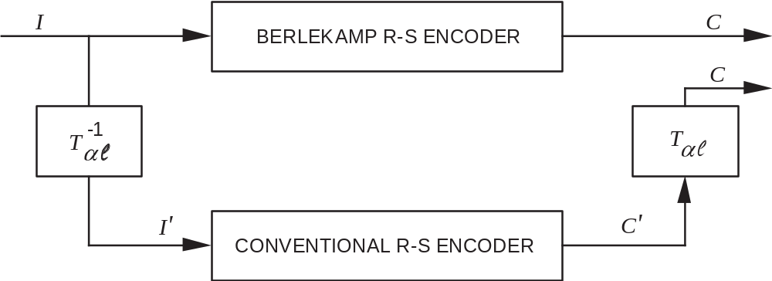
Figure 13-2928: Transformational Equivalence
Conventional and Berlekamp types of (255,k) Reed-Solomon encoders are assumed to have the same self-reciprocal generator polynomial whose coefficients appear in 5.3.3 and 5.3.4. The representation of symbols associated with the conventional encoder is the polynomials in ‘α’ appearing in table 13-19. Corresponding to each polynomial in ‘α’ is the representation in the dual basis of symbols associated with the Berlekamp type encoder.
Given
αi = u7α7 + u6α6 + ... + u0
where 0 ≤ i < 255 (and α* denotes the zero polynomial, u7, u6, ... = 0, 0, ...),
the corresponding element is
z = z0l0 + z1l1 + ... + z7l7
where
[z0, z1, ..., z7] = [u7, u6, ..., u0] Tαl
and
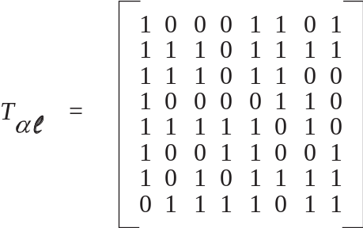
Row 1, row 2, ... , and row 8 in Tαl are representations in the dual basis of α7 (10 ... 0), α6 (010 ... 0), ... , and α0 (00 ... 01), respectively.
The inverse of Tαl is
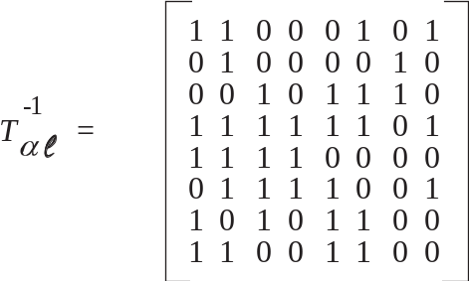
Row 1, row 2, ... , and row 8 in Tare polynomials in ‘α’ corresponding to l0 (10 ... 0),
l1 (010 ... 0), ... , and l7 (00, ... 01), respectively. Thus,
[z0, z1, ... , z7 ] T= [u7, u6, ... , u0]
Example 1:
Given information symbol I,
[z0, z1, ... , z7] = 10111001
then
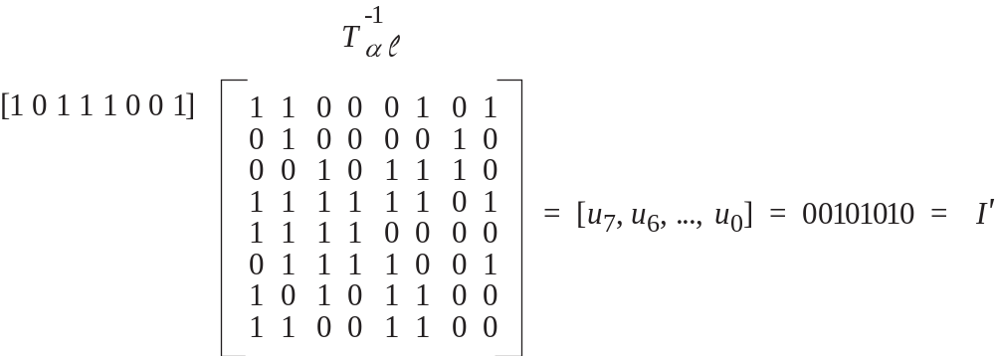
The arithmetic operations are reduced modulo 2. Also,
[z0, z1, ... , z7] = 10111001
and
[u7, u6, ... , u0] = 00101010 (α213)
are corresponding entries in table 13-19.
Example 2:
Given check symbol C',
[α7, α6, ..., α0] = 01011001 (α152)
Then,
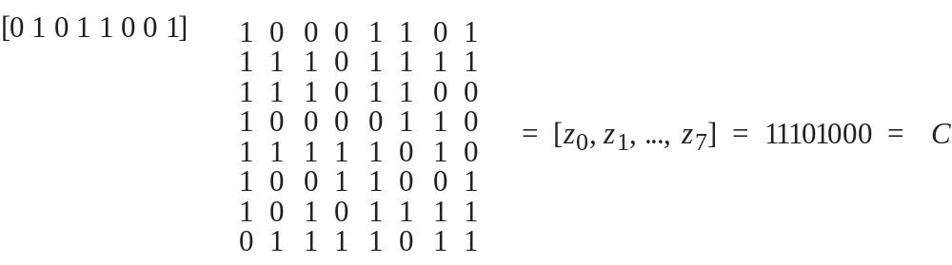
Table 13-1918: Equivalence of Representations,
P  O  W  E  R | POLY  IN  ALPHA | l01234567 | P  O  W  E  R | POLY  IN  ALPHA | l01234567
==== | =============== | ============= | ==== | =============== | =============
* | 00000000 | 00000000 | 31 | 11001101 | 01111010
0 | 00000001 | 01111011 | 32 | 00011101 | 10011110
1 | 00000010 | 10101111 | 33 | 00111010 | 00111111
2 | 00000100 | 10011001 | 34 | 01110100 | 00011100
3 | 00001000 | 11111010 | 35 | 11101000 | 01110100
4 | 00010000 | 10000110 | 36 | 01010111 | 00100100
5 | 00100000 | 11101100 | 37 | 10101110 | 10101101
6 | 01000000 | 11101111 | 38 | 11011011 | 11001010
7 | 10000000 | 10001101 | 39 | 00110001 | 00010001
8 | 10000111 | 11000000 | 40 | 01100010 | 10101100
9 | 10001001 | 00001100 | 41 | 11000100 | 11111011
10 | 10010101 | 11101001 | 42 | 00001111 | 10110111
11 | 10101101 | 01111001 | 43 | 00011110 | 01001010
12 | 11011101 | 11111100 | 44 | 00111100 | 00001001
13 | 00111101 | 01110010 | 45 | 01111000 | 01111111
14 | 01111010 | 11010000 | 46 | 11110000 | 00001000
15 | 11110100 | 10010001 | 47 | 01100111 | 01001110
16 | 01101111 | 10110100 | 48 | 11001110 | 10101110
17 | 11011110 | 00101000 | 49 | 00011011 | 10101000
18 | 00111011 | 01000100 | 50 | 00110110 | 01011100
19 | 01110110 | 10110011 | 51 | 01101100 | 01100000
20 | 11101100 | 11101101 | 52 | 11011000 | 00011110
21 | 01011111 | 11011110 | 53 | 00110111 | 00100111
22 | 10111110 | 00101011 | 54 | 01101110 | 11001111
23 | 11111011 | 00100110 | 55 | 11011100 | 10000111
24 | 01110001 | 11111110 | 56 | 00111111 | 11011101
25 | 11100010 | 00100001 | 57 | 01111110 | 01001001
26 | 01000011 | 00111011 | 58 | 11111100 | 01101011
27 | 10000110 | 10111011 | 59 | 01111111 | 00110010
28 | 10001011 | 10100011 | 60 | 11111110 | 11000100
29 | 10010001 | 01110000 | 61 | 01111011 | 10101011
30 | 10100101 | 10000011 | 62 | 11110110 | 00111110
Table 13-19: Equivalence of Representations (continued)

P  O  W  E  R | POLY  IN  ALPHA | l01234567 | P  O  W  E  R | POLY  IN  ALPHA | l01234567
==== | =============== | ============= | ==== | =============== | =============
63 | 01101011 | 00101101 | 95 | 10111010 | 10110010
64 | 11010110 | 11010010 | 96 | 11110011 | 11011100
65 | 00101011 | 11000010 | 97 | 01100001 | 01111000
66 | 01010110 | 01011111 | 98 | 11000010 | 11001101
67 | 10101100 | 00000010 | 99 | 00000011 | 11010100
68 | 11011111 | 01010011 | 100 | 00000110 | 00110110
69 | 00111001 | 11101011 | 101 | 00001100 | 01100011
70 | 01110010 | 00101010 | 102 | 00011000 | 01111100
71 | 11100100 | 00010111 | 103 | 00110000 | 01101010
72 | 01001111 | 01011000 | 104 | 01100000 | 00000011
73 | 10011110 | 11000111 | 105 | 11000000 | 01100010
74 | 10111011 | 11001001 | 106 | 00000111 | 01001101
75 | 11110001 | 01110011 | 107 | 00001110 | 11001100
76 | 01100101 | 11100001 | 108 | 00011100 | 11100101
77 | 11001010 | 00110111 | 109 | 00111000 | 10010000
78 | 00010011 | 01010010 | 110 | 01110000 | 10000101
79 | 00100110 | 11011010 | 111 | 11100000 | 10001110
80 | 01001100 | 10001100 | 112 | 01000111 | 10100010
81 | 10011000 | 11110001 | 113 | 10001110 | 01000001
82 | 10110111 | 10101010 | 114 | 10011011 | 00100101
83 | 11101001 | 00001111 | 115 | 10110001 | 10011100
84 | 01010101 | 10001011 | 116 | 11100101 | 01101100
85 | 10101010 | 00110100 | 117 | 01001101 | 11110111
86 | 11010011 | 00110000 | 118 | 10011010 | 01011110
87 | 00100001 | 10010111 | 119 | 10110011 | 00110011
88 | 01000010 | 01000000 | 120 | 11100001 | 11110101
89 | 10000100 | 00010100 | 121 | 01000101 | 00001101
90 | 10001111 | 00111010 | 122 | 10001010 | 11011000
91 | 10011001 | 10001010 | 123 | 10010011 | 11011111
92 | 10110101 | 00000101 | 124 | 10100001 | 00011010
93 | 11101101 | 10010110 | 125 | 11000101 | 10000000
94 | 01011101 | 01110001 | 126 | 00001101 | 00011000

Table 13-19: Equivalence of Representations (continued)

P  O  W  E  R | POLY  IN  ALPHA | l01234567 | P  O  W  E  R | POLY  IN  ALPHA | l01234567
==== | =============== | ============= | ==== | =============== | =============
127 | 00011010 | 11010011 | 159 | 10000101 | 01101111
128 | 00110100 | 11110011 | 160 | 10001101 | 10010101
129 | 01101000 | 11111001 | 161 | 10011101 | 00010011
130 | 11010000 | 11100100 | 162 | 10111101 | 11111111
131 | 00100111 | 10100001 | 163 | 11111101 | 00010000
132 | 01001110 | 00100011 | 164 | 01111101 | 10011101
133 | 10011100 | 01101000 | 165 | 11111010 | 01011101
134 | 10111111 | 01010000 | 166 | 01110011 | 01010001
135 | 11111001 | 10001001 | 167 | 11100110 | 10111000
136 | 01110101 | 01100111 | 168 | 01001011 | 11000001
137 | 11101010 | 11011011 | 169 | 10010110 | 00111101
138 | 01010011 | 10111101 | 170 | 10101011 | 01001111
139 | 10100110 | 01010111 | 171 | 11010001 | 10011111
140 | 11001011 | 01001100 | 172 | 00100101 | 00001110
141 | 00010001 | 11111101 | 173 | 01001010 | 10111010
142 | 00100010 | 01000011 | 174 | 10010100 | 10010010
143 | 01000100 | 01110110 | 175 | 10101111 | 11010110
144 | 10001000 | 01110111 | 176 | 11011001 | 01100101
145 | 10010111 | 01000110 | 177 | 00110101 | 10001000
146 | 10101001 | 11100000 | 178 | 01101010 | 01010110
147 | 11010101 | 00000110 | 179 | 11010100 | 01111101
148 | 00101101 | 11110100 | 180 | 00101111 | 01011011
149 | 01011010 | 00111100 | 181 | 01011110 | 10100101
150 | 10110100 | 01111110 | 182 | 10111100 | 10000100
151 | 11101111 | 00111001 | 183 | 11111111 | 10111111
152 | 01011001 | 11101000 | 184 | 01111001 | 00000100
153 | 10110010 | 01001000 | 185 | 11110010 | 10100111
154 | 11100011 | 01011010 | 186 | 01100011 | 11010111
155 | 01000001 | 10010100 | 187 | 11000110 | 01010100
156 | 10000010 | 00100010 | 188 | 00001011 | 00101110
157 | 10000011 | 01011001 | 189 | 00010110 | 10110000
158 | 10000001 | 11110110 | 190 | 00101100 | 10001111

Table 13-19: Equivalence of Representations (continued)

P  O  W  E  R | POLY  IN  ALPHA | l01234567 | P  O  W  E  R | POLY  IN  ALPHA | l01234567
==== | =============== | ============= | ==== | =============== | =============
191 | 01011000 | 10010011 | 223 | 01100100 | 10011010
192 | 10110000 | 11100111 | 224 | 11001000 | 10011000
193 | 11100111 | 11000011 | 225 | 00010111 | 11001011
194 | 01001001 | 01101110 | 226 | 00101110 | 00100000
195 | 10010010 | 10100100 | 227 | 01011100 | 00001010
196 | 10100011 | 10110101 | 228 | 10111000 | 00011101
197 | 11000001 | 00011001 | 229 | 11110111 | 01000101
198 | 00000101 | 11100010 | 230 | 01101001 | 10000010
199 | 00001010 | 01010101 | 231 | 11010010 | 01001011
200 | 00010100 | 00011111 | 232 | 00100011 | 00111000
201 | 00101000 | 00010110 | 233 | 01000110 | 11011001
202 | 01010000 | 01101001 | 234 | 10001100 | 11101110
203 | 10100000 | 01100001 | 235 | 10011111 | 10111100
204 | 11000111 | 00101111 | 236 | 10111001 | 01100110
205 | 00001001 | 10000001 | 237 | 11110101 | 11101010
206 | 00010010 | 00101001 | 238 | 01101101 | 00011011
207 | 00100100 | 01110101 | 239 | 11011010 | 10110001
208 | 01001000 | 00010101 | 240 | 00110011 | 10111110
209 | 10010000 | 00001011 | 241 | 01100110 | 00110101
210 | 10100111 | 00101100 | 242 | 11001100 | 00000001
211 | 11001001 | 11100011 | 243 | 00011111 | 00110001
212 | 00010101 | 01100100 | 244 | 00111110 | 10100110
213 | 00101010 | 10111001 | 245 | 01111100 | 11100110
214 | 01010100 | 11110000 | 246 | 11111000 | 11110010
215 | 10101000 | 10011011 | 247 | 01110111 | 11001000
216 | 11010111 | 10101001 | 248 | 11101110 | 01000010
217 | 00101001 | 01101101 | 249 | 01011011 | 01000111
218 | 01010010 | 11000110 | 250 | 10110110 | 11010001
219 | 10100100 | 11111000 | 251 | 11101011 | 10100000
220 | 11001111 | 11010101 | 252 | 01010001 | 00010010
221 | 00011001 | 00000111 | 253 | 10100010 | 11001110
222 | 00110010 | 11000101 | 254 | 11000011 | 10110110

EXPANSION OF REED-SOLOMON COEFFICIENTS
(Informative)
Purpose:
While the equations given in the Reed-Solomon Coding section of this Recommended Standard are fully specifying, this annex provides additional assistance for those implementing either the E = 16 or the E = 8 code.
For E = 16:

COEFFICIENTS OF g(x) |  |  |  |  | POLYNOMIAL IN α
 |  |  |  |  | α⁷ | α⁶ | α⁵ | α⁴ | α³ | α² | α¹ | α⁰
G₀ | = | G₃₂ | = | α⁰ | 0 | 0 | 0 | 0 | 0 | 0 | 0 | 1
G₁ | = | G₃₁ | = | α²⁴⁹ | 0 | 1 | 0 | 1 | 1 | 0 | 1 | 1
G₂ | = | G₃₀ | = | α⁵⁹ | 0 | 1 | 1 | 1 | 1 | 1 | 1 | 1
G₃ | = | G₂₉ | = | α⁶⁶ | 0 | 1 | 0 | 1 | 0 | 1 | 1 | 0
G₄ | = | G₂₈ | = | α⁴ | 0 | 0 | 0 | 1 | 0 | 0 | 0 | 0
G₅ | = | G₂₇ | = | α⁴³ | 0 | 0 | 0 | 1 | 1 | 1 | 1 | 0
G₆ | = | G₂₆ | = | α¹²⁶ | 0 | 0 | 0 | 0 | 1 | 1 | 0 | 1
G₇ | = | G₂₅ | = | α²⁵¹ | 1 | 1 | 1 | 0 | 1 | 0 | 1 | 1
G₈ | = | G₂₄ | = | α⁹⁷ | 0 | 1 | 1 | 0 | 0 | 0 | 0 | 1
G₉ | = | G₂₃ | = | α³⁰ | 1 | 0 | 1 | 0 | 0 | 1 | 0 | 1
G₁₀ | = | G₂₂ | = | α³ | 0 | 0 | 0 | 0 | 1 | 0 | 0 | 0
G₁₁ | = | G₂₁ | = | α²¹³ | 0 | 0 | 1 | 0 | 1 | 0 | 1 | 0
G₁₂ | = | G₂₀ | = | α⁵⁰ | 0 | 0 | 1 | 1 | 0 | 1 | 1 | 0
G₁₃ | = | G₁₉ | = | α⁶⁶ | 0 | 1 | 0 | 1 | 0 | 1 | 1 | 0
G₁₄ | = | G₁₈ | = | α¹⁷⁰ | 1 | 0 | 1 | 0 | 1 | 0 | 1 | 1
G₁₅ | = | G₁₇ | = | α⁵ | 0 | 0 | 1 | 0 | 0 | 0 | 0 | 0
 |  | G₁₆ | = | α²⁴ | 0 | 1 | 1 | 1 | 0 | 0 | 0 | 1
NOTE – G₃ = G₂₉ = G₁₃ = G_{19.}
Further information, including encoder block diagrams, is provided in reference [E10].
For E = 8:

COEFFICIENTS OF g(x) |  |  |  |  | POLYNOMIAL IN α
 |  |  |  |  | α⁷ | α⁶ | α⁵ | α⁴ | α³ | α² | α¹ | α⁰
G₀ | = | G₁₆ | = | α⁰ | 0 | 0 | 0 | 0 | 0 | 0 | 0 | 1
G₁ | = | G₁₅ | = | α³⁰ | 1 | 0 | 1 | 0 | 0 | 1 | 0 | 1
G₂ | = | G₁₄ | = | α²³⁰ | 0 | 1 | 1 | 0 | 1 | 0 | 0 | 1
G₃ | = | G₁₃ | = | α⁴⁹ | 0 | 0 | 0 | 1 | 1 | 0 | 1 | 1
G₄ | = | G₁₂ | = | α²³⁵ | 1 | 0 | 0 | 1 | 1 | 1 | 1 | 1
G₅ | = | G₁₁ | = | α¹²⁹ | 0 | 1 | 1 | 0 | 1 | 0 | 0 | 0
G₆ | = | G₁₀ | = | α⁸¹ | 1 | 0 | 0 | 1 | 1 | 0 | 0 | 0
G₇ | = | G₉ | = | α⁷⁶ | 0 | 1 | 1 | 0 | 0 | 1 | 0 | 1
 |  | G₈ | = | α¹⁷³ | 0 | 1 | 0 | 0 | 1 | 0 | 1 | 0

The term ‘coded symbol’ is used for the first time in this version of the book, replacing the term ‘channel symbol’ to avoid conflict with the definition in other books.
Figures 2-2 and 2-3 are limited to the contents of this Recommended Standard and do not cover, e.g., SCCC (reference [E11]) and DVB-S2 (reference [E12]).
US Patent 5446747 expired in 2012.
From table 4 of reference [E10]. Note: Coefficients of the ‘Polynomial in Alpha’ column are listed in descending powers of α, starting with α7.
The underlined entries correspond to values with exactly one non‐zero element and match a row in the matrix.

