SLS C&S Working Group
Minutes of the Meeting

Meetings took place in person in Huntsville, AL, and by teleconference (hybrid format). Meetings were held on May 10 and 11, 2023.

It is pointed out that remotely connected persons continuously reported difficulties in hearing the meeting room, and that they were unable to participate adequately to the discussion. Hence attendance for these persons is indicated separately in Annex 3, and it shall be intended as “partial attendance”.

Agenda is provided in Annex 1.

C&S meeting
The C&S meeting was held on May 10th. For the agenda item 2 (VCM Analysis), the meeting was done jointly with RFM working group (WG).

Release CCSDS 130.12-G-2 for closing poll CESG-P-2023-01-003

DVB-S2 Green Book (GB, 130.12-G) was approved for publication but pending resolution of comments of P. Shames/SEA AD (poll CESG-P-2023-01-003).
Comments were first discussed and implemented offline in the DVB-S2 GB draft by C. Dudal/CNES and A. Modenini/C&S Chair. Then, candidate draft was presented during this Spring meeting, for which the C&S WG resolved to release the draft book for publication.

In addition, SEA AD and C&S chair proposed to perform a harmonization of the GBs related to variable coding modulation (VCM). Namely, it was observed that DVB-S2 GB contains a VCM system description and performance results, while SCCC GB (130.11-G) focuses on the physical layer performance only (BER/FER, synchronization, etc.).

In this respect, it was proposed to have a VCM GB project that would perform the followings:
- make SCCC and DVB-S2 GBs more harmonized each other, by focusing mostly on physical layer aspects
- create a new VCM green book, that focuses on system results when using VCM with SCCC, DVB-S2, or LDPC codes.

The novel GB could be written by taking advantage of the analysis performed by W. Fong & W. Lee/NASA in input SLS-CS_23-01 (see next point), and those already existing in the DVB-S2 GB. Modenini/ESA also confirmed that could support the writing, since ESA already has VCM simulators implemented.

As first step, C&S chair took action to provide a concept paper for the VCM GB (AI_23_01) for formalizing better the proposal.

VCM Analysis (SLS-CS_23-01)

Presentation of W. Fong and W. Lee/NASA showing results of a VCM system analysis, when using as reference the physical layer performance reported in the SCCC and DVB-S2 GBs (CCSDS 130.11-G and 130.12-G, respectively).

Numerical results shows that VCM, either with SCCC or DVB-S2, achieves bandwidth efficiencies 30-60% higher than constant coding modulation (CCM) when using the lowest modcod (QPSK, rate ~1/4). This holds for different LEO scenarios with altitudes of 400, ~700, and 2000 km.

Input will be possibly adopted for the potential VCM GB project.

Introducing the new blue book on Slicing (SLS-CS_23-02)
Joint presentation of ESA and NASA (N. Maturo, K. Andrews, V. Sank) about the introduction of a transfer frame (TF) slicer in coding & synchronization blue book.

Namely, ESA and NASA presented draft pink sheets of a shim book (in response to AI_22_07) that describes a general slicer that can be used as applicable document to the 131.0-B (TM C&S), 131.2-B (SCCC), 131.3-B (DVB-S2), 142.0-B (OPT C&S).

During the discussion, A. Modenini/C&S Chair collected comments, observations, and proposals from the WG for deciding the way forward and presenting them the same afternoon in the joint meeting with SLP/OPT (see C&S Chair presentation about TF slicing).

The followings are highlighted:
- C&S WG preferred to not have a shim book: following the draft prepared by ESA and NASA, it was observed that the TF slicer cannot be an independent layer. In fact, the resulting shim book was highly intertwined with the other standards, while complicating the user reading. As a result, C&S preference is to simply embed changes in the 131.0-B, and then align the other Blue Books (131.2-B, 131.3-B, 142.0-B) including VCM BB (431.1-B) by means of a technical corrigendum
- That TF slicing shall not be used with uncoded and Convolutional coding, for avoiding users to enable the function without actual benefit
- When TF slicing is enabled, the randomizer shall be adopted (for not confusing ASM with CSM)
- When TF slicing is enabled, the ASM can be bypassed (but not the CSM) in case the SLP sublayer provides a TF synchronization mechanism (for providing an interface to GFP, although not foreseen by CCSDS, see MoM Fall 2022 and C&S Chair presentation)
- To add flushing for the termination of the last sliced block. When real data is terminated, dummy frames can be sent until the system is turned off.

With such changes, the TM C&S standard (131.0-B) would perform the following functions:
- ASM (to be used when TF slicing is ON and SLP has no synch marker)
- TF slicing (optional, but possible only with Turbo, LDPC, RS)
- Block Encoding (if Turbo, LDPC, RS)
- Pseudo-randomization (mandatory when TF slicing is ON)
- CSM (always mandatory)
- Convolutional (only if uncoded or RS)
that would lead to the framing depicted below, cases 1 & 2 (except for flushing, not depicted).

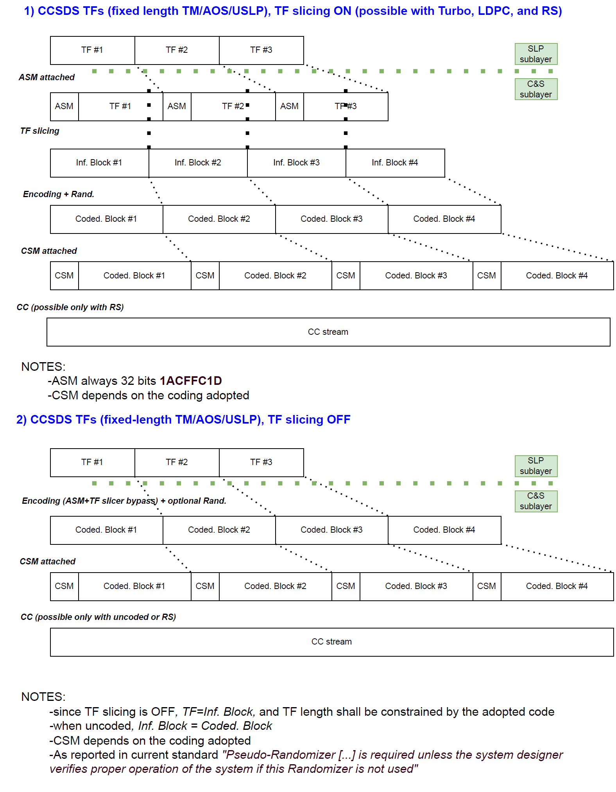
Figure 1: resulting framing, when using or not the proposed TF slicer, when running AOS/USLP/TM fixed-length TFs over the TM C&S (131.0-B)

As requested to C&S WG, such scheme allows also to use non-CCSDS frames. For instance, GFP with VLF can be adopted by simply keeping the TF slicing as ON. In addition, the user can also potentially adopt GFP with TF slicing OFF (for using uncoded and CC), but with the constraint that frames shall be fixed-length and there is a small overhead due to the presence of both CSM and cH.
For these two cases, the framing would be as reported below, cases A & B (that will be not explicitly reported in the blue book, but are a reference on how the standard can work with VLFs).

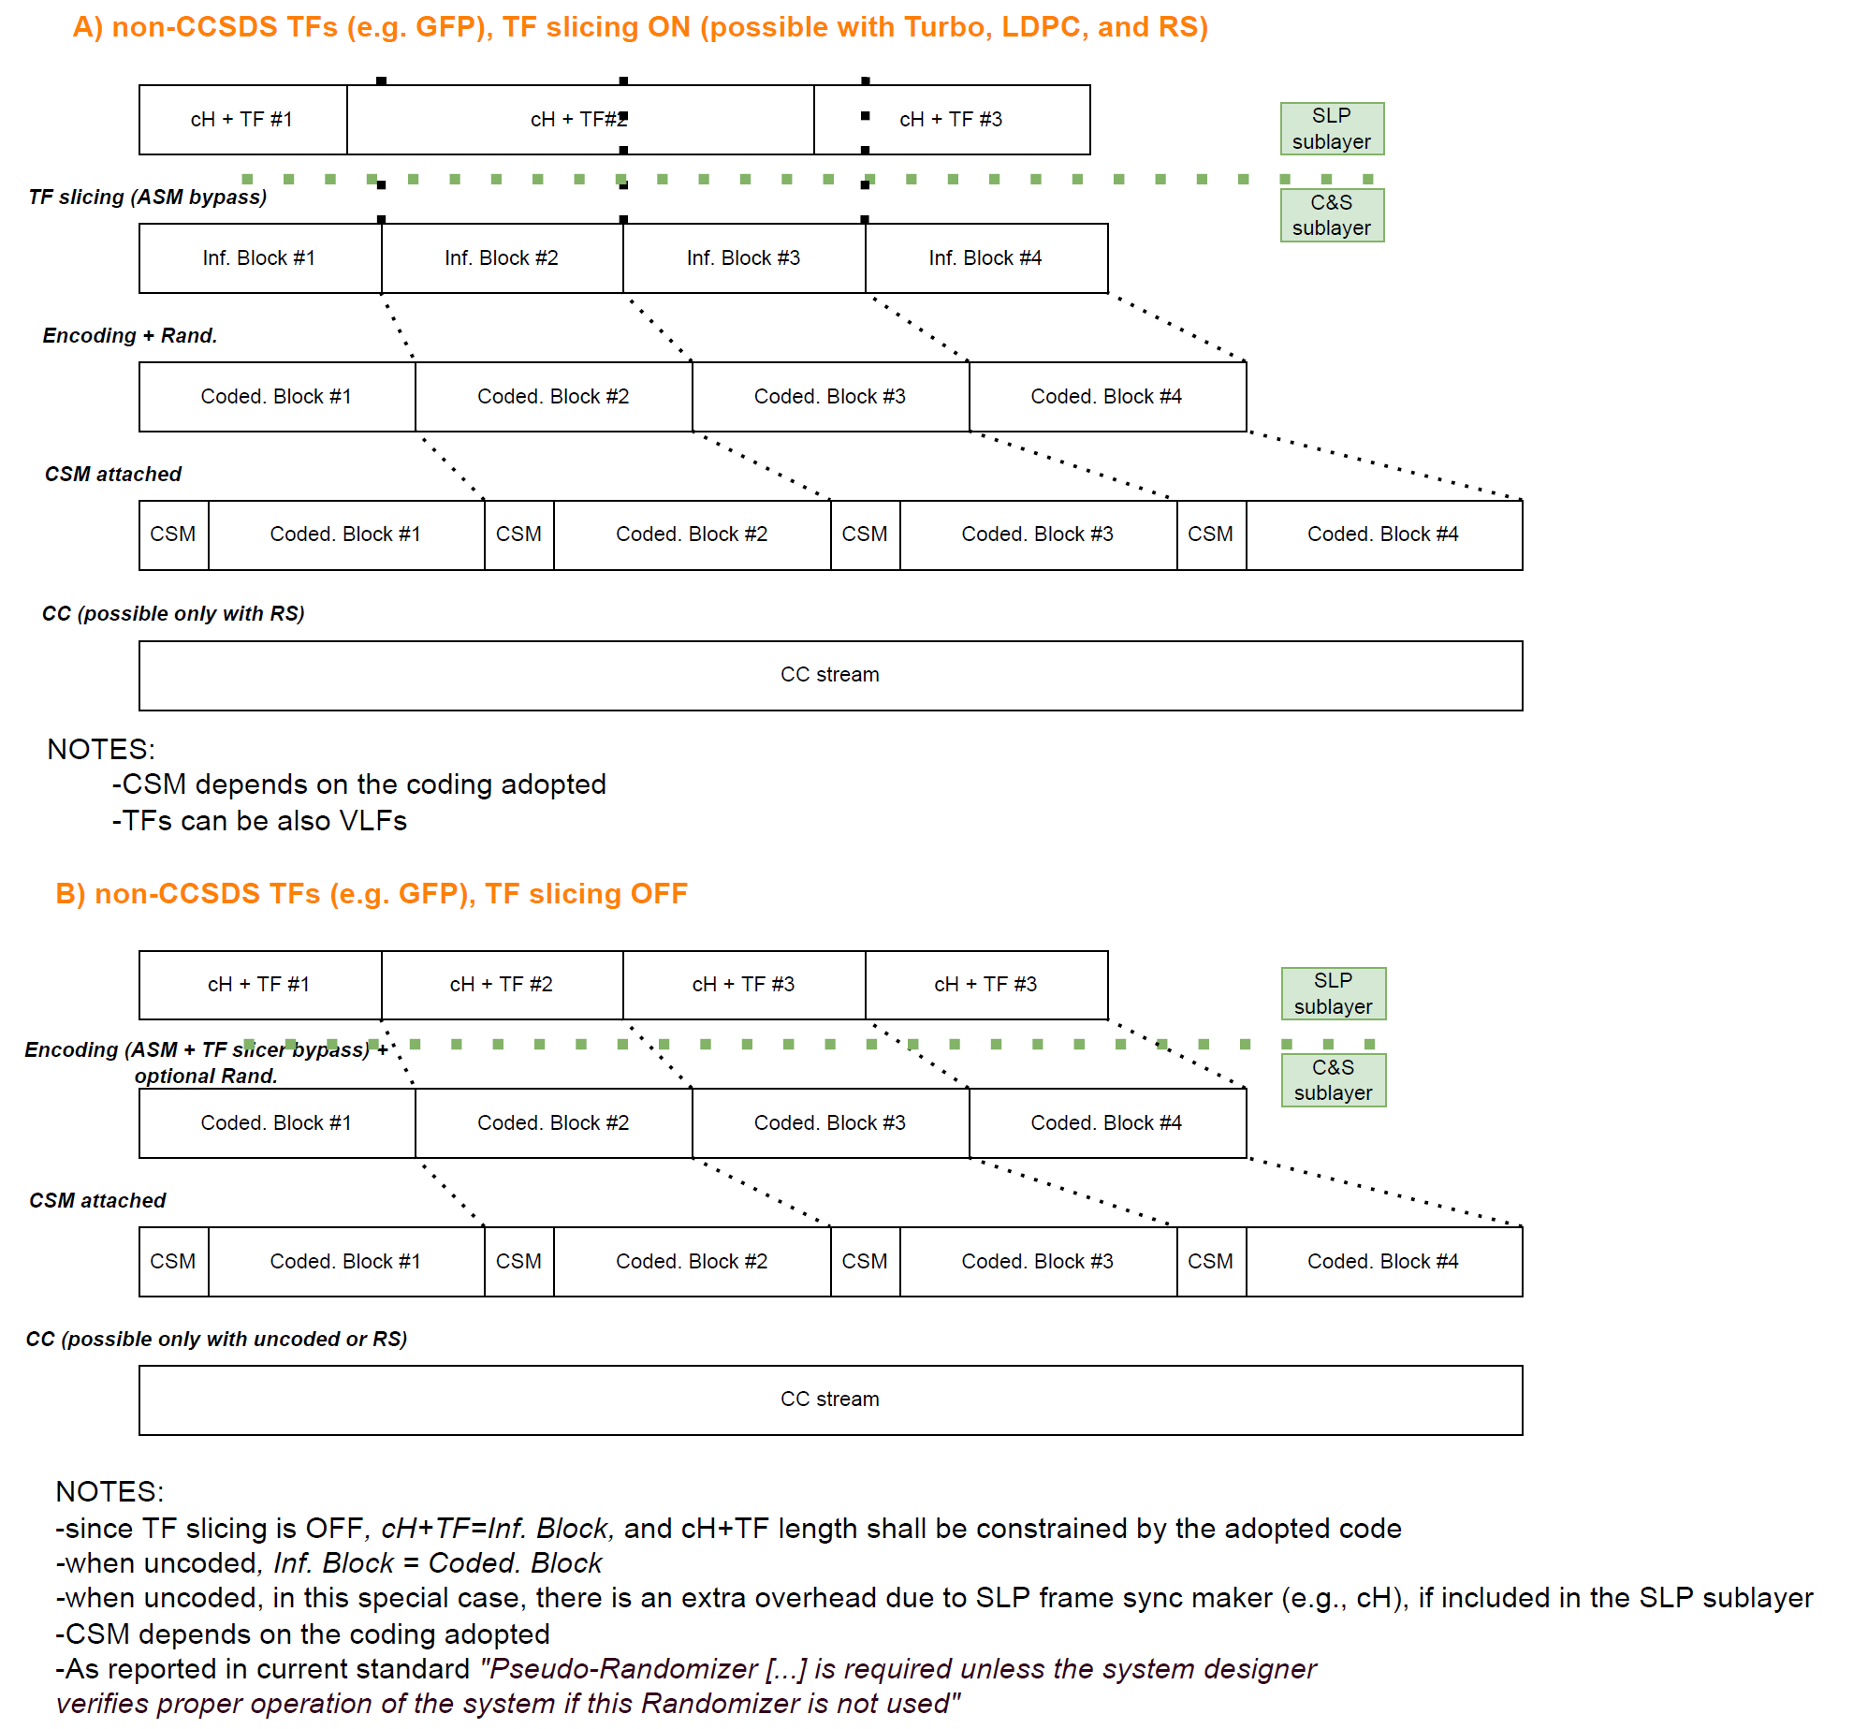
Figure 2: resulting framing, when using or not the proposed TF slicer, when running non-CCSDS frames (even variable-length) over the TM C&S (131.0-B)

As next step, K. Andrews/NASA will provide an update of 131.0-B accordingly (AI_23_02) that can be then reviewed by the WG.

IMPORTANT NOTE: although not part of this meeting, for the reader convenience, it is reported that during SLS plenary, it was recommended by G. Moury/SLS DAD to consider a different option where the C&S layer can have as input a binary stream, and is agnostic if this contains GFP with VLFs.

Namely, the TM C&S will use the following stack

CCSDS PROTOCOLS

132.x/732.x, TFs (AOS/USLP/TM), or binary stream
131.0-B, TM synchronization & coding
401.0-B, Radio Frequency and Modulation

and its functions will be (changes w.r.t. previous approach in red):
- ASM (to be used when TF slicing is ON and SLP has no synch marker TFs are transmitted)
- TF slicing (optional, but possible only with Turbo, LDPC, RS and when TF are at the C&S layer input. TF slicing is mandatory when there is a generic bitstream at C&S layer input)
- Block Encoding (if Turbo, LDPC, RS)
- Pseudo-randomization (mandatory when TF slicing is ON)
- CSM (always mandatory)
- Convolutional (only if uncoded or RS).
In this way, the framing would be as reported in the picture below.

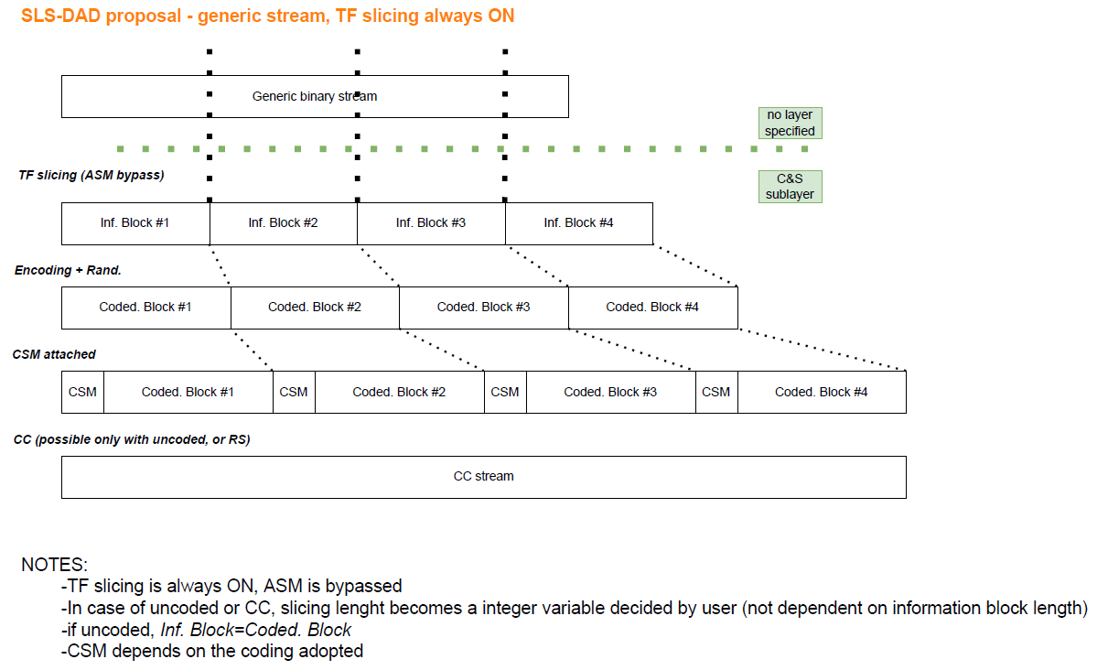
Figure 3: resulting framing, when using the proposed TF slicing while having a generic bitstream over the TM C&S (131.0-B)
During the SLS plenary, C&S chair informed that a similar option was discussed already during C&S meeting, by proposal of W. Fong/NASA: this was discarded since allows to input to C&S layer directly a bitstream (instead of TFs), a function already provided by the SLP layer. However, during SLS plenary (in agreement with SLS AD and DAD), this option can be re-considered by the WG if defined in a way that does not cause confusion with bitstream service, that allows the transmission of a bitstream at SLP sub-layer.

C&S chair will inform the WG about the possible recommendation, for letting the WG reconvene and decide which is the preferred option between Figure 2 and Figure 3.

Updates of 131.0-B (SLS-CS_23-03)
ESA and NASA presented draft pink sheets of 131.0-B with the following updates:
- Inclusion of the TF slicer, as provided in the shim book (see previous section)
- Technical corrigendum for AOS length and for having one codeword per CSM (in response to C&S resolution #1 and #2 in Fall 2022)
- Introduction of Turbo channel interleaver (in response to AI_21_02)

Concerning the first two points, a new update will be provided for including the TF slicer directly in the 131.0-B (see AI_23_02 discussed in previous section), and the technical corrigenda.

Concerning the introduction of a Turbo channel interleaver, a first draft was presented during the meeting. The WG agreed on the following changes:
- Interleaver shall be reported as optional, with possibly a note to designers of verifying that proper functionality (especially during solar scintillations, or spacecraft tumbling) when not adopted
- That the Interleaver can be adopted only with Turbo codes, thus to be defined as subsection or applicable Annex of the Turbo chapter (and not as a dedicated chapter and generic function of TM C&S layer).

J. Quintanilla/ESA will provide an updated draft for the Turbo channel interleaver based on the changes agreed (AI_23_03) that can be then reviewed by the WG.

Agency Review of 131.0-B (PN17 randomizer)
Two RIDs, by ESA, were received.

During the meeting NASA reported that they had 10 RIDs, although these were not received by the CCSDS coordinator within deadline. The WG accepts to include the NASA RIDs as part of the Agency review.

RIDs were discussed and resolved. C&S chair sent pink sheets to SLS AD and Secretariat for publication.

C&S WG status
Presentation of C&S chair reporting the status of WG activities. See presentation in CWE and Section 4 of this MoM.

Joint C&S/OPT/SLP meeting
The joint C&S/OPT/SLP meeting was held on May 10th, 16.30-17.30.

Summary of C&S activities on TF slicing for possibly enabling VLFs
A. Modenini/C&S chair held a summary presentation of the C&S activities about the definition of the TF slicer for possibly enabling VLFs.

As agreed in Fall 2022 meeting (for achieving consensus), the coding & synchronization layer in 131.0-B (TM C&S), 131.2-B (SCCC), 131.3-B (DVB-S2), 431.1-B (VCM), and 142.0-B will not explicitly allow VLFs, but will provide a generic interface that can work with non-CCSDS standards as GFP with VLFs.

During the presentation there were several technical questions and clarifications, but WGs had no objections on the approach adopted by C&S WG. Then, once the TF slicer definition is finalized, C&S WG will be book captain for updating all Blue Books, but the 142.0-B that will be updated by OPT WG.

The presentation can be found in CWE, and more technical details about the TF slicer are reported in Section 1.3 of this MoM.

Joint C&S/SLP/RFM MEETING
The meeting was held on May 11th.

Inputs for Proximity-1 (SLS-CS_23-05)
Input provided by S. Rodriguez/NASA in response to AI_22_10 of reviewing modcod profiles of future lunar missions (stemming from IOAG, ICSIS, and LunaNet). The objective was confirming if the addition of GMSK, OQPSK, and LDPC 2/3 (as discussed in Fall 2022) to Proximity-1 extension is sufficient for future Lunar mission needs.

The presentation shown that most of future Lunar missions rely on several modulations (OQPSK, GMSK, BPSK, SS CDMA, etc.), and mostly coding formats from 131.0-B, for having high-rate TM-like links, and possibly PN ranging (414.0-B). Concerning instead the specific Proximity-1 standards (211.x), lunar missions simply provide that their extension to S-Band (2-2.2 GHz) and K-Band (~23 and ~27 GHz), with additional modcods, could be beneficial.

Following discussion about possible mission needs, the WG agreed to include the following modulation and coding profiles for the extension (but without modifying the existing profiles for Proximity-1 UHF):
- GMSK BT=0.25, Bi-phase-L/PM, for having as minimum a suppressed carrier modulation and a residual carrier modulation, that allow also PN ranging (although not part of Proximity-1 standards). OQPSK instead to be discarded
- LDPC 1/2 (inf block of 1024 bits), LDPC 2/3 (4096 bits), and LDPC ~7/8 (7156 bits), from 131.0-B, for enabling different level of FEC protection
- Baud rates up to 4 Msps, for ensuring that bandwidth is limited to 6 MHz as required by provisional SFCG REC 41-1.

Presentation of pink sheets for Proximity-1 Data Link (211.0), C&S (211.2), and RFM (211.1), (SLS-CS_23-06 and 07)
Presentation of G. Kazz/SLP Chair and N. Maturo/ESA for showing the proposed changes to 211.0-B, 211.2-B, and 211.1 for including the extension.

Concerning Proximity-1 Data Link (211.0-B), proposal of SLP WG is to define a new directive from scratch the provide much larger flexibility with respect the one adopted in the current standard.

In particular, the frequency assignment and channel symbol rate can be provided as a 32-bit single precision that can provide a resolution from Hz to THz.

Modcods profiles are instead identified by 21 bits, allowing about ~2 Million combinations. The idea is to define a few tens as default combinations of the standard, and the remaining one to be mission specific.

The C&S and RFM WGs took AI to comment the SLP WG proposal, and provide a table of the default modcods (AI_23_04).

Concerning Proximity-1 RFM and C&S layer, draft pink sheets were presented. Main points of discussion were:
- Organization of all three blue books: during the drafting of the pink sheets, it was observed that the extension makes blue books highly interconnected (for instance, coding profiles depend on which frequency is adopted at RFM layer). Thus, the WG discussed the option of unifying the three blue books but, after discussion, it was agreed to keep the three books as separated (for not being too disruptive in the books organization) but to include a normative clause that shows the stack to be adopted, i.e., a diagram as reported below.

CCSDS PROTOCOLS

211.0-B, Proximity-1, SLP – Data link layer
211.2-B, Proximity-1, SLP – C&S layer
211.1-B Proximity-1, SLP – Physical layer

Additionally, the Proximity-1 physical layer 211.1-B will be structured in different chapters/sections for each frequency band (UHF, S-Band, and possibly K-Band) with an additional chapter that provide the commonalities.
- Frequency channels and polarization: considering that the new directive allows to directly define the absolute frequency assignment, rather than a channel number, it was discussed if channels should be completely left open to specific missions, or if SFCG should pre-allocate some channels for S- and K-Band Proximity-1. Similarly, the polarization could be selected by the specific missions, or could be fixed by SFCG.
In this respect, the WGs agreed to have SFCG to pre-allocate specific channels and the possible polarization. These will be then included in the standard. D. Lee/NASA will inform about latest outcomes of SFCG 2023 (AI_23_05) that can be then reflected in the Proximity-1, RFM 211.1-B.
- Oscillator Phase noise: the Proximity-1 RFM 211.1-B currently defines a phase mask for phase noise to be respected. This was recently re-assessed by NASA, and it is confirmed that can be valid also for S-Band and K-Band. Thus, it can be kept as applicable for all three bands.
- Discrete spurious spectral lines: it was agreed to keep as it is.
- Modcods: to be aligned with those reported in previous section of this MoM.

N. Maturo/ESA will provide an update of Proximity-1 physical layer and C&S sheets based on the above points (AI_23_06).

C&S WG Status
This section provides highlights of C&S activities. An executive summary can be found in the presentation in CWE.

Projects

Currently C&S WG is working on the following projects:
- TM synchronization and coding – new randomizer for high data rates
- TM synchronization and coding – new channel interleaver for Turbo codes

and has two project proposals (still pending CMC approval, but with activities already started)
- Proximity-1 extension
- Slicing of Transfer Frames
- OpenISN

With respect Fall 2022 meeting, it is reported that the project proposal about a Open Inter-satellite Network (OpenISN) is under discussion at CESG level if pursuing it further or not. Thus, activities are on-hold.

Resolutions
This section provides a list of C&S WG resolutions during CCSDS Spring 2023 meeting.

- Resolution#1: to release 130.12-G (DVB-S2) for publication.

Additionally, the following resolutions are planned in the next 6 months:

- Resolution#2: approval of CWE project for a VCM green book

Action Items status
Status of AIs is reported in Annex.

Annex 1: Agenda

N° | Author | Agenda Topic  C&S meeting |  | Estimated time allocation in minutes | REMARKS
1 | Chair | Opening of the meeting |  | 30 | N/A
1b | Chair | Release CCSDS 130.12-G-2 for closing pool CESG-P-2023-01-003 |  | 30 | N/A
2 | NASA | CCSDS VCM Analysis (with RFM working group) |  | 30 | SLS-CS_23-01
3 | ESA/NASA | Slicing  - Introducing the New Blue Book on slicing  - Introducing the updated version of 131.0 (according to the new Blue Book on slicing) |  | 60 | SLS-CS_23-02  SLS-CS_23-03
4 | WG | Agency Review of CCSDS 131.0-P-4.1 (PN17 randomizer) |  | 60 | N/A
5 | Chair | C&S Working status |  | 60 | N/A
6 | Chair | Summary of C&S activities on TF slicing for possibly enabling VLFs (with OPT/SLP working group) |  | 60 | N/A
 |  |  | TOTAL hours | 5.5

Joint SLP/C&S/RFM meeting, Thursday May 11, 2023 – starting at 8:45

N° | Author | Agenda Topic |  | Time allocation in minutes | REMARKS
1 | NASA | Inputs for Proximity-1 Extension |  | 30 | SLS-CS_23-05
2 | ESA | Introducing the updated Proximity-1 RFM Blue Book |  | 30 | SLS-CS_23-06
3 | ESA | Introducing the updated Proximtiy-1 C&S Blue Book |  | 30 | SLS-CS_23-07
4 | SLP WG | Presentation of the proposed updated directive (command) set for Proximity-1 |  | 30 | N/A
 |  |  | TOTAL hours | 2

Inputs and meeting supporting material are available on CWE (C&S WG private folder) at https://tinyurl.com/CCSDSSpring2023

Agency Review RIDs available on CWE (C&S WG private folder) at https://tinyurl.com/AgencyReviewsSLSCC

Annex 2: Action Item List
Open action items are listed in the table below.
AIs closed during this meeting are cancelled out in the table below (with traceability about their closure).

The New AIs are those starting from AI_23_01.

Latest version of AI list can be found on CWE (private folder, requires login): https://tinyurl.com/jyrjpz6a

AI# | Action | Actionee | Due date | Status | Traceability
AI_20_07 | Consider extending the simulator channel model work in order to establish procedures for the end-to-end assessment of coding proposals | W. Fong/NASA | Spring 2021  Fall 2021  Spring 2022  Fall 2022  Spring 2023 | Closed | Fall 2022 agreement to close if no inputs were submitted in Spring 2023
AI_21_02 | Provide a draft recommended standard (as edit of CCSDS 131.0) for including the Turbo interleaver  NOTE: to possibly use input provided by Deimos during Fall 2022 (SLS-CS_22-14), and to do in liaison with 131.0-B updates for the slicer (AI_22_07). | A. Modenini/ESA  N. Maturo/ESA  J. Quintanilla/ESA | Spring 2023 | Closed | SLS-CS_23-03
AI_22_06 | To prepare concept paper about slicing of transfer frames | A. Modenini/ESA | November 2022 | Closed | Mail on Oct 29, 2022
AI_22_07 | To prepare a draft blue book that defines the transfer frame slicing as a sub-layer. The draft blue book shall be possibly a shim book between TM/AOS/USLP BBs and C&S BBs. | K. Andrews/NASA  N. Maturo/ESA  V. Sank/NASA | Spring 2023 | Closed | SLS-CS_23-02
AI_22_08 | To implement a SW prototype for the Turbo Channel Interleaver | K. Andrews/NASA | Fall 2023 | Open
AI_22_09 | To prepare C&S resolution for AOS max length technical corrigendum, and possibly inject changes as part of TF slicer TM BB randomizer Agency Review  Edited between Fall 2022 and Spring 2023: SLS AD recommended as part of TF slicer | A. Modenini/ESA | Fall 2023 | Open
AI_22_10 | To review modulation and coding profiles of future lunar missions (stemming from IOAG, ICSIS, LunaNet, etc.) for confirming that GMSK, OQPSK, LDPC 2/3 are sufficient for covering future mission needs. | S. Rodriguez/NASA | Spring 2023 | Closed | SLS-CS_23_05
AI_22_11 | To provide draft pink sheets for Proximty-1 211.1-B (ph. Layer) and 211.2-B (c&s layer), implementing the changes agreed by the WG and pending confirmation of AI_22_10  NOTE: related action items for 211.1-B and 211.o-B (phy. Layer and data link layer) are tracked in SLP ad RFM WGs. | N. Maturo/ESA  A. Modenini/ESA | Spring 2023 | Closed | SLS-CS_23-06/07
AI_22_12 | to provide to SLP/C&S/RFM WG latest technical information coming from CESG discussion about Lunar ISN, and a draft of the concept paper for implementing a magenta book that defines the protocol stack | A. Modenini/C&S chair | November 2022 | Open | Mail on Oct 29, 2022
AI_23_01 | To draft CWE project for a VCM Green Book that provides system results of using VCM (SCCC, DVB, or LDPC) | A. Modenini/C&S Chair | Fall 2023 | Open
AI_23_02 | To prepare draft Blue Book (pink sheets) of 131.0-B with transfer frame slicing as agreed in Spring 2023 (see Spring 2023 MoM for technical details), including technical corrigendum for AOS length | K. Andrews/NASA | Fall 2023 | Open
AI_23_03 | To update Channel interleaver descrption in 131.0-B making it 'optional' (with possible Note about the implications of not using it) and make it applicable only to Turbo Codes (and not as an independent function in a dedicated chapter) | J. Quintanilla/ESA | Fall 2023 | Open
AI_23_04 | to comment SLP WG proposal for Proximty-1 extension and provide a default table of modcods to be adopted | C&S chair +  WG | Sep-23 | Open
AI_23_05 | to provide latest outcomes of SFCG 2023 about the definition of channels (frequency assignments and polarizations) in S-Band (and possible in K-Band) for Proximity-1 extension | D. Lee/NASA | Fall 2023 | Open
AI_23_06 | To provide update of pink sheets for Proximty-1 211.2-B (c&s layer) and 211.1-B (phy layer), implementing the changes agreed in Spring 2023  NOTE: related action items for 211.o-B (data link layer) is tracked in SLP WG. | N. Maturo/ESA | Fall 2023 | Open

Annex 3: list of participants

Name | Affiliation | C&S | C&S/OPT/SLP | C&S/OPT/RFM | Remote (p.t.)
Amanuel Geda | DLR | X | X | X
Andrea Modenini | ESA | X | X | X
Bryan Robinson | NASA |  | X
Dennis Lee | NASA | X | X | X
Eric Pitts | NASA | X
Faramaz Davarian | NASA |  |  | X
Geraldine Artoud | CNES |  | X
Greg Kazz | NASA | X
Gunther Sessler | ESA | X | X | X
Ignacio Aguilar | ESA | X |  | X
Jean-Luc Issler | CNES | X
Jennifer Downey | NASA |  | X
Jon Hamkins | NASA |  | X
Jorge Quintanilla | ESA | X | X | X
Kenneth Andrews | NASA | X | X | X
Kevan Moore | NASA |  | X
Klaus-Juergen Schulz | ESA |  | X | X
Matt Cosby | UKSA |  |  | X
Nicola Maturo | ESA | X | X | X
Nicolò Mazzali | ESA |  | X
Shannon Rodriguez | NASA | X | X | X
Stefan Veit | DLR
Stuart Golden | Vulcan Wireless |  | X | X
Tim Phan | NASA |  | X
Tom Gannet | NASA | X
Victor Sank | NASA | X | X | X
Wai Fong | NASA | X | X | X
Wing-Tsz Lee | NASA | X | X | X
Xavier Enrich | Eumetsat |  |  |  | X

BT=0.25 was agreed in line with future RFM 401.0-B recommendations for space-to-space links, that state that BT=0.25 should be preferred versus BT=0.5 when spectral efficiency is a concern.

