

Research and Development for Space Data System Standards

|  |
| --- |
| CCSDS Space link protocols over ETSI DVB-S2(X) Standard |

Experimental specification

CCSDS 131.6-O-1

orange book

November 2020

AUTHORITY

|  |  |  |  |
| --- | --- | --- | --- |
|  |  |  |  |
|  | Issue: | Orange Book, Issue 1 |  |
|  | Date: | November 2020 |  |
|  | Location: | Washington, DC, USA |  |
|  |  |  |  |

This document has been approved for publication by the Consultative Committee for Space Data Systems (CCSDS). The procedure for review and authorization of CCSDS documents is detailed in *Organization and Processes for the Consultative Committee for Space Data Systems* (CCSDS A02.1-Y-4).

This document is published and maintained by:

CCSDS Secretariat

Space Communications and Navigation Office, 7L70

Space Operations Mission Directorate

NASA Headquarters

Washington, DC 20546-0001, USA

FOREWORD

Through the process of normal evolution, it is expected that expansion, deletion, or modification of this document may occur. This Experimental Specification is therefore subject to CCSDS document management and change control procedures, which are defined in the *Procedures Manual for the Consultative Committee for Space Data Systems*. Current versions of CCSDS documents are maintained at the CCSDS Web site:

http://www.ccsds.org/

Questions relating to the contents or status of this document should be addressed to the CCSDS Secretariat at the address indicated on page i.

At time of publication, the active Member and Observer Agencies of the CCSDS were:

Member Agencies

* Agenzia Spaziale Italiana (ASI)/Italy.
* Canadian Space Agency (CSA)/Canada.
* Centre National d’Etudes Spatiales (CNES)/France.
* China National Space Administration (CNSA)/People’s Republic of China.
* Deutsches Zentrum für Luft- und Raumfahrt e.V. (DLR)/Germany.
* European Space Agency (ESA)/Europe.
* Federal Space Agency (FSA)/Russian Federation.
* Instituto Nacional de Pesquisas Espaciais (INPE)/Brazil.
* Japan Aerospace Exploration Agency (JAXA)/Japan.
* National Aeronautics and Space Administration (NASA)/USA.
* UK Space Agency/United Kingdom.

Observer Agencies

* Austrian Space Agency (ASA)/Austria.
* Belgian Federal Science Policy Office (BFSPO)/Belgium.
* Central Research Institute of Machine Building (TsNIIMash)/Russian Federation.
* China Satellite Launch and Tracking Control General, Beijing Institute of Tracking and Telecommunications Technology (CLTC/BITTT)/China.
* Chinese Academy of Sciences (CAS)/China.
* Chinese Academy of Space Technology (CAST)/China.
* Commonwealth Scientific and Industrial Research
* Organization (CSIRO)/Australia.
* CSIR Satellite Applications Centre (CSIR)/Republic of South Africa.
* Danish National Space Center (DNSC)/Denmark.
* Departamento de Ciência e Tecnologia Aeroespacial (DCTA)/Brazil.
* European Organization for the Exploitation of Meteorological Satellites (EUMETSAT)/Europe.
* European Telecommunications Satellite Organization (EUTELSAT)/Europe.
* Geo-Informatics and Space Technology Development Agency (GISTDA)/Thailand.
* Hellenic National Space Committee (HNSC)/Greece.
* Indian Space Research Organization (ISRO)/India.
* Institute of Space Research (IKI)/Russian Federation.
* KFKI Research Institute for Particle & Nuclear Physics (KFKI)/Hungary.
* Korea Aerospace Research Institute (KARI)/Korea.
* Ministry of Communications (MOC)/Israel.
* National Institute of Information and Communications Technology (NICT)/Japan.
* National Oceanic and Atmospheric Administration (NOAA)/USA.
* National Space Agency of the Republic of Kazakhstan (NSARK)/Kazakhstan.
* National Space Organization (NSPO)/Chinese Taipei.
* Naval Center for Space Technology (NCST)/USA.
* Scientific and Technological Research Council of Turkey (TUBITAK)/Turkey.
* Space and Upper Atmosphere Research Commission (SUPARCO)/Pakistan.
* Swedish Space Corporation (SSC)/Sweden.
* United States Geological Survey (USGS)/USA.

DOCUMENT CONTROL

|  |  |  |  |
| --- | --- | --- | --- |
| **Document** | **Title** | **Date** | **Status** |
| CCSDS 131.6-O-0 | CCSDS Space Link Protocols over ETSI DVB-S2(X) Standard, Experimental Specification, Issue 0 | November 2017 | Previous issue |
|  |  |  |  |
| CCSDS 131.6-O-1 | CCSDS Space Link Protocols over ETSI DVB-S2(X) Standard, Experimental Specification, Issue 1 | November 2020 | Current issue |

CONTENTS

Section Page

1 INTRODUCTION 8

1.1 Background 8

1.2 Purpose 8

1.3 Scope 8

1.4 Applicability 9

1.5 Document structure 9

1.6 NOMENCLATURE 10

1.7 Definitions and ConventioNs 11

1.8 PATENTED TECHNOLOGIES 12

1.9 Reference Documents 13

2 Overview 15

2.1 Architecture 15

2.2 Summary of functions 15

2.3 Internal organization 16

3 CADU stream generation 19

3.1 Overview 19

3.2 INPUT CCSDS Transfer Frames 19

3.3 Channel Access Data Unit 19

4 DVB-S2 transmission 20

4.1 Overview 20

4.2 DVB-S2 Mode adaptation format 20

4.3 Average signal energy 20

4.4 Shaping filtering 21

5 DVB-S2X transmission 22

5.1 Overview 22

5.2 DVB-S2X Mode adaptation format 22

5.3 Average signal energy 22

5.4 Shaping filtering 22

5.5 DVB-S2X excluded options 22

6 Optional DVB-S2X Time-slicing mode 23

6.1 Overview 23

6.2 Time slicing numbering 23

7 Managed parameters 24

7.1 Overview 24

7.2 PERMANENT MANAGED PARAMETERS 24

7.3 Variable MANAGED PARAMETERs 28

ANNEX A SERVICE Definition (Normative) A-1

ANNEX B Security, SANA, and patent CONSIDERATIONS (INFORMATIVE) B-1

ANNEX C Acronyms AND TERMS (INFORMATIVE) C-1

ANNEX D DVB-S2 Spectral efficiencies (INFORMATIVE) D-1

ANNEX E DVB-S2X Spectral efficiencies (INFORMATIVE) E-1

ANNEX F About frequency regulation when using this Experimental Specification (INFORMATIVE) F-3

ANNEX G SIMULATIONS RESULTS OVER AWGN AND NON-LINEAR CHANNELS (INFORMATIVE) G-6

ANNEX H Measurement RESULTS OVER AWGN CHANNEL (INFORMATIVE) H-9

# INTRODUCTION

## Background

The high demand in TV broadcasting has pushed the European Telecommunications Standards Institute (ETSI) to define a satellite communication standard called Digital Video Broadcasting—Satellite—Second Generation (DVB-S2) (reference [1]) and DVB-S2 Extensions (DVB-S2X) (reference [2]). This standard is suited to high data rate transmissions, and proposes variable or adaptive coding and modulation with high power and bandwidth efficiencies. All along this document, we design the overall standard ETSI 302 307 (references [1] and [2]) by DVB-S2(X).

## Purpose

The purpose of this document is to define a recommended interface between CCSDS Space Link Protocols (references [5], [6] and [10]) and the DVB-S2(X) telecom standard (references [1] and [2]), and to recommend options of the DVB-S2(X) standard suited to high data rate transmission applications, such as Earth Exploration Satellite Services (EESS) payload telemetry. However, this Experimental Specification may be also adopted for other high data rate applications (either space-to-ground, ground-to-space, and space-to-space) and services (e.g., the Space Research service), as long as compliance to CCSDS recommendations for Radio Frequency modulations in [4] is ensured.

## Scope

The DVB-S2(X) standard (references [1]) proposes advanced modulation techniques (up to 32APSK in [1], up to 256APSK in [2]) and a wide range of coding rates with near-Shannon coding schemes (LDPC codes). This high number of modulation and coding schemes allows a wide range of possibilities to satisfy specific mission constraints.

Moreover, to maximize the system throughput, it appears possible to adapt the transmitted waveform (and the useful data rate) to the variable conditions of the link. The DVB-S2(X) standard can actually implement Variable Coding and Modulation (VCM) mode, which adapts the transmission scheme to the channel conditions following a predetermined schedule (for example, following a dynamic link budget). When a channel is available to provide feedback (e.g., via a command link), the transmission scheme can be dynamically adjusted using the Adaptive Coding and Modulation (ACM) mode.

The use of the DVB-S2(X) standard for telemetry makes possible the use of generic Very High Scale Integrated Circuits (VHSIC) Hardware Description Language (VHDL) Intellectual Property (IP) modules for developments. The use of a widely implemented standard simplifies finding transmitting or receiving equipment to check compatibility. Finally, for the ground part, some telecom DVB-S2(X) receivers or Application Specific Integrated Circuits (ASICs) developed for the telecom market could be reused. In particular, a Time-Slicing mode was introduced in order to allow very low-cost mass market receivers. This mode can be reused for telemetry applications in order to reuse these very low-cost receivers.

This Experimental Specification is an adaptation profile describing how to use the DVB-S2(X) standard to transmit CCSDS Transfer Frames. The interface between CCSDS and DVB-S2(X) is based on the Attached Synchronization Marker (ASM) and Channel Access Data Unit (CADU) already introduced in reference [4].

This Experimental Specification is an extension of the Recommended Standard [3]. When using this Experimental Specification, the Recommended Standard [3] is consequently superseded by this Experimental Specification.

DVB-S2(X) is used in this adaptation profile as a complete and self-sufficient standard, and definitions and specifications taken from DVB-S2(X) are applicable only in the context of this Experimental Specification. However, individual DVB-S2(X) functions or components (e.g., VCM/ACM, 8-PSK, and higher-order modulations) might be reused, redefined, and/or respecified by CCSDS in other Recommended or Experimental Standards.

## Applicability

This Experimental Specification applies to cross-support situations for near Earth Exploration Satellite Services (EESS) and Space Research Services (SRS). It includes comprehensive specification of the data formats and procedures for inter-Agency cross support. It is neither a specification of, nor a design for, real systems that may be implemented for existing or future missions.

This Experimental Specification is applicable to those missions for which cross support based on capabilities described in this document is anticipated. Where mandatory capabilities are clearly indicated in sections of this Experimental Specification, it is mandatory to implement them when this document is used as a basis for cross support. Where options are allowed or implied, implementation of these options is subject to specific bilateral cross-support agreements between the Agencies involved.

## Document structure

Section 1 presents the background, purpose, scope, applicability, and rationale of this Experimental Specification, and lists the conventions, definitions, and references used throughout the document.

Section 2 provides an overview of the system architecture.

Section 3 specifies the CADU stream generation. This section is relevant for DVB-S2 and DVB-S2X uses.

Section 4 specifies the DVB-S2 transmission of the CADU stream. This section is only relevant for DVB-S2 use.

Section 5 specifies the DVB-S2X transmission of the CADU stream. This section is only relevant for DVB-S2X use.

Section 6 specifies the optional DVB-S2(X) Time-Slicing mode. This section is relevant for DVB-S2 and DVB-S2X uses (when the Time-Slicing mode option is used).

Section 7 specifies managed parameters.

Annex A provides the service definition.

Annex B discusses security, Space Assigned Numbers Authority (SANA), and patent considerations.

Annex C lists acronyms and terms used within this document.

Annex D lists MODCOD available in the DVB-S2 standard.

Annex E lists MODCOD available in the DVB-S2X standard.

Annex F presents an analysis of frequency regulation in EESS X-band and Ka-band when applied to this Experimental Specification.

## NOMENCLATURE

### Normative Text

The following conventions apply for the normative specifications in this Experimental Specification:

1. the words ‘shall’ and ‘must’ imply a binding and verifiable specification;
2. the word ‘should’ implies an optional, but desirable, specification;
3. the word ‘may’ implies an optional specification;
4. the words ‘is’, ‘are’, and ‘will’ imply statements of fact.

NOTE – These conventions do not imply constraints on diction in text that is clearly informative in nature.

### Informative Text

In the normative sections of this document, informative text is set off from the normative specifications either in notes or under one of the following subsection headings:

* Overview;
* Background;
* Rationale;
* Discussion.

## Definitions and ConventioNs

### Definitions

#### Definitions from the Open System Interconnection (OSI) Basic Reference Model

This Experimental Specification makes use of a number of terms defined in reference [7]. The use of those terms in this document shall be understood in a generic sense, i.e., in the sense that those terms are generally applicable to any of a variety of technologies that provide for the exchange of information between real systems. Those terms are:

1. Data Link Layer;
2. Physical Layer;
3. service;
4. service data unit.

#### Definitions from OSI Service Definition Conventions

This Experimental Specification makes use of a number of terms defined in reference [8]. The use of those terms in this document shall be understood in a generic sense, i.e., in the sense that those terms are generally applicable to any of a variety of technologies that provide for the exchange of information between real systems. Those terms are:

1. indication;
2. primitive;
3. request;
4. service provider;
5. service user.

#### Definition of CADU

The CADU is defined in reference [4]. In this Experimental Specification, CADU only consists in the concatenation of an ASM and a Transfer Frame.

#### Definitions from ETSI DVB-S2(X) Standard

This Experimental Specification makes use of a number of terms defined in references [1] and [2].

1. DATAFIELD and DFL are defined in paragraph 5.1.5 of references [1] and [2].
2. BBHEADER is defined in paragraph 5.1.6 of references [1] and [2].
3. FECFRAME is defined in paragraph 5.3 of references [1] and [2].
4. PLFRAME is defined in paragraph 5.5 of references [1] and [2].
5. Dummy PLFRAME is defined in paragraph 5.5.1 of references [1] and [2].
6. PLHEADER and MODCOD are defined in paragraph 5.5.2 of references [1] and [2].
7. PLHEADER, MODCOD and TSN are defined in annex M of references [1] and [2] when using the Time-Slicing mode.

### Conventions

In this document, the following convention is used to identify each bit in an *N*-bit field. The first bit in the field to be transmitted (i.e., the most left justified when drawing a figure) is defined to be ‘Bit 0’; the following bit is defined to be ‘Bit 1’ and so on up to ‘Bit *N*–1’. When the field is used to express a binary value (such as a counter), the Most Significant Bit (MSB) shall be the first transmitted bit of the field, i.e., ‘Bit 0’ (see Figure 1‑1).



Figure 1‑1: Bit Numbering Convention

In accordance with standard data-communications practice, data fields are often grouped into 8‑bit ‘words’ which conform to the above convention. Throughout this document, such an 8-bit word is called an ‘octet’.

The numbering for octets within a data structure starts with ‘0’.

## PATENTED TECHNOLOGIES

The CCSDS draws attention to the fact that it is claimed that compliance with this document may involve the use of patents.

The CCSDS takes no position concerning the evidence, validity, and scope of these patent rights.

The holders of these patent rights have assured the CCSDS that they are willing to negotiate licenses under reasonable and non-discriminatory terms and conditions with applicants throughout the world. In this respect, the statements of the holders of these patent rights are registered with CCSDS. Information can be obtained from the CCSDS Secretariat at the address indicated on page i. Contact information for the holders of these patent rights is provided in annex B.

Attention is drawn to the possibility that some of the elements of this document may be the subject of patent rights other than those identified above. The CCSDS shall not be held responsible for identifying any or all such patent rights.

## Reference Documents

The following publications contain provisions which, through reference in this text, constitute provisions of this document. At the time of publication, the editions indicated were valid. All publications are subject to revision, and users of this document are encouraged to investigate the possibility of applying the most recent editions of the publications indicated below. The CCSDS Secretariat maintains a register of currently valid CCSDS publications.

[1] *Digital Video Broadcasting (DVB); Second Generation Framing Structure, Channel Coding and Modulation Systems for Broadcasting, Interactive Services, News Gathering and other Broadband Satellite Applications; Part 1: DVB-S2*. ETSI EN 302 307-1 V1.4.1 (2014-07). Sophia-Antipolis: ETSI, 2014.

[2] *Digital Video Broadcasting (DVB); Second Generation Framing Structure, Channel Coding and Modulation Systems for Broadcasting, Interactive Services, News Gathering and other Broadband Satellite Applications; Part 2: DVB-S2 Extensions*. ETSI EN 302 307-2 V1.1.1 (2014-10). Sophia-Antipolis: ETSI, 2014.

NOTE – ETSI standards are available for free download at <http://www.etsi.org>.

[3] *CCSDS Space Link Protocol over ETSI DVB-S2 Standards.* Recommendation for Space Data System Standards, CCSDS 131.3-B-1. Blue Book. Issue 1. Washington, D.C.: CCSDS, March 2013.

[4] *TM Synchronization and Channel Coding*. Recommendation for Space Data System Standards, CCSDS 131.0-B-2. Blue Book. Issue 3. Washington, D.C.: CCSDS, August 2017.

[5] *TM Space Data Link Protocol*. Recommendation for Space Data System Standards, CCSDS 132.0-B-1. Blue Book. Issue 3. Washington, D.C.: CCSDS, September 2017.

[6] *AOS Space Data Link Protocol*. Recommendation for Space Data System Standards, CCSDS 732.0-B-2. Blue Book. Issue 3. Washington, D.C.: CCSDS, July 2015.

[7] *Information Technology—Open Systems Interconnection—Basic Reference Model: The Basic Model*. International Standard, ISO/IEC 7498-1:1994. 2nd ed. Geneva: ISO, 1994.

[8] *Information Technology—Open Systems Interconnection—Basic Reference Model—Conventions for the Definition of OSI Services*. International Standard, ISO/IEC 10731:1994. Geneva: ISO, 1994.

[9] *Consultative Committee on Space Data Systems Space Link Services Coding & Synchronization Working Group.* CNES DVB-S2 simulations with non-linear amplification. SLS-CS_13-17.

[10] *Unified Space Data Link Protocol*. Recommendation for Space Data System Standards, CCSDS 732.1-B-1. Blue Book. Issue 1. Washington, D.C.: CCSDS, October 2018.

[11] *Digital Video Broadcasting (DVB) User guidelines for the second generation system for Broadcasting, Interactive Services, News Gathering and other broadband satellite applications (DVB-S2)*. ETSI TR 102376-2 V1.1.1 (2005-02).

[12] *Radio Frequency and Modulation Systems—Part 1: Earth Stations and Spacecraft*. Issue 23. Recommendation for Space Data System Standards (Blue Book), CCSDS 401.0-B-23. Washington, D.C.: CCSDS, December 2013.

# Overview

## Architecture

Figure 2‑1 illustrates the relationship of this Experimental Specification to the Open Systems Interconnection reference model (reference [7]). Two sublayers of the Data Link Layer are defined for CCSDS space link protocols. The TM, AOS and Unified Space Data Link Protocols specified in references [5], [6] and [10], respectively, correspond to the Data Link Protocol Sublayer and provide functions for transferring data using the protocol data unit called the Transfer Frame. The Synchronization and Channel Coding Sublayer provides methods of synchronization and channel coding for transferring Transfer Frames over a space link, while the Physical Layer provides the RF and modulation methods for transferring a stream of bits over a space link in a single direction.

This Experimental Specification covers the functions of both the Synchronization and Channel Coding Sublayer and the Physical Layer, the latter for what concerns the modulation schemes. CCSDS 401.0-B [12] covers additional features of the Physical Layer like frequency bands, polarizations, etc. that are not described or referenced here.

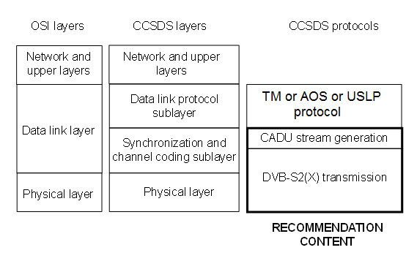

Figure 2‑1: Relationship with OSI Layers

## Summary of functions

### General

This Experimental Specification provides the following functions for transferring Transfer Frames via a stream of bits over a space link:

1. pseudo-randomizing;
2. error correction coding and modulation;
3. Transfer Frame synchronization;
4. Transfer Frame validation.

### Pseudo-randomizing

Pseudo-randomizing is specified in the DVB-S2(X) standard. No other pseudo-randomizing of Transfer Frames is required.

### error correction coding and modulation

Error correction coding and modulation are specified in the DVB-S2(X) standard. No other error correction coding of Transfer Frames is required.

### Transfer Frame synchronization

This Experimental Specification specifies an Attached Sync Marker (ASM) for synchronizing Transfer Frames at the receiver.

### Transfer Frame Validation

After decoding is performed, the upper layers at the receiving end also need to know whether or not each decoded Transfer Frame can be used as a valid data unit; i.e., an indication of the quality of the received frame is needed. This function is called Frame Validation. In this Experimental Specification, the Frame Error Control Field defined in references [5], [6] and [10] is used for Transfer Frame Validation at the receiver.

## Internal organization

### Sending end

#### General

Figure 2-2 illustrates the frame structures and stream formats at different stages of processing for the sending end.

#### CADU Stream Generation

This Experimental Specification specifies a method to generate a data stream including CCSDS Transfer Frames received from the layer above by embedding each CCSDS Transfer Frame into a CADU. This method also allows CCSDS Transfer Frame synchronization at the receiver by using an ASM. ASM and CADU are defined in reference [4].

#### DVB-S2(X) Transmission

This Experimental Specification specifies the DVB-S2(X) options to transmit the CADU stream.

DVB-S2(X) functions are not detailed here and the reader must refer to reference [1] or [2].

Some important characteristics of the DVB-S2(X) transmission, as used in this Experimental Specification, are summarized here:

* DVB-S2(X) transmission is frame oriented: a continuous binary stream to be transmitted is sliced into blocks of Data Field Length (DFL) bits, with DFL depending on the coding rate and the FECFRAME size; Physical Layer frames (PLFRAMEs) are then transmitted continuously on the RF link.
* For a given channel symbol rate, the input (CADU stream) data rate depends on the modulation, the coding rate, the FECFRAME size, the pilot insertion status and the Time-Slicing mode status; the input data rate can be derived from the channel symbol rate using tables in annexes D and E.
* A combination of a modulation and a coding rate is called a MODCOD as per DVB-S2(X) terminology.

131

Figure 2‑2: Stream Format While Transmitting CCSDS Transfer Frames Using DVB-S2(X)

### receiving end

At the receiving end:

* the DVB-S2(X) demodulator accepts a radio frequency modulated signal and delivers a CADU stream;
* Transfer Frame synchronization allows recovery of CCSDS Transfer Frames in the CADU stream for delivery of those frames to the Data Link Protocol Sublayer.

# CADU stream generation

## Overview

CCSDS Transfer Frame synchronization is necessary at the receiver. Consequently, an ASM is introduced before transmission. Error correction coding and pseudo-randomization are performed at the DVB-S2(X) transmission level.

This section is relevant for DVB-S2 and DVB-S2X uses.

## INPUT CCSDS Transfer Frames

* + 1. Input Transfer Frames shall be either TM Transfer Frames as specified in reference [5] or AOS Transfer Frames as specified in reference [6] or USLP Transfer Frame as specified in reference [10].
    2. The Transfer Frames length shall vary between the following minimum and maximum values: 223 octets (1784 bits) and 65536 octets (524288 bits).
    3. Error correction coding and pseudo-randomization shall be performed **only** at the DVB-S2(X) transmission level.

## Channel Access Data Unit

* + 1. For each Transfer Frame, the system shall construct a CADU containing the ASM and the Transfer Frame.
    2. The ASM shall be the 32-bit (4-octet) marker with value 1ACFFC1D in hex defined in reference [4].

NOTE – In his book, the CADU stream consists of a stream of fixed-length Transfer Frames with each Transfer Frame immediately preceded by an ASM. The ASM attached to a Transfer Frame immediately follows the end of the previous Transfer Frame.

# DVB-S2 transmission

## Overview

In this section, main characteristics of the DVB-S2 transmission of the CADU stream are specified. Definitions and vocabulary of the DVB-S2 standard (reference [1]) are used.

This section is only relevant for DVB-S2 use.

## DVB-S2 Mode adaptation format

* + 1. The RF signal shall conform to the DVB-S2 standard (reference [1]).
    2. The CADU stream shall be transmitted using the single input continuous Generic Stream (GS) mode adaptation format of the DVB-S2 standard (paragraph 5.1 of reference [1]).

NOTES

1. No particular alignment between the Transfer Frames of the CADU stream and the DVB-S2 DATAFIELD is needed.
2. Following table 3 of reference [1], the first 3 bits of the BBHEADER are consequently ‘011’ (‘01’: generic continuous stream, ‘1’: single input stream).
   * 1. The DVB-S2 slicer shall allocate a number of input bits equal to the maximum DVB-S2 DATAFIELD capacity.

NOTES

1. In other words, padding (paragraph 5.2.1 of reference [1]) is not used.
2. This maximum DATAFIELD capacity is equal to Kbch-80 bits and depends on the considered coding rate and FECFRAME size.
3. In the DVB-S2 standard, the channel symbol rate does not change during a transmission; consequently, the required input (CADU stream) data rate changes whenever the MODCOD changes during a transmission.
4. When the current MODCOD is modified during transmission using VCM or ACM, the DVB-S2 slicer applies the change without discarding or truncating or impairing the CADU stream, according to the DVB-S2 standard.

## Average signal energy

* + 1. The average channel symbol energy E shall be equal to 1 as defined in paragraphs 5.4.3 and 5.4.4 of reference [1].

## Shaping filtering

* + 1. The power spectral density mask in Annex A of reference [1] shall not be applied to the transmitted signal in this Experimental Specification.

# DVB-S2X transmission

## Overview

In this section, main characteristics of the DVB-S2X transmission of the CADU stream are specified. Definitions and vocabulary of the DVB-S2X standard (reference [2]) are used.

This section is only relevant for DVB-S2X use.

## DVB-S2X Mode adaptation format

* + 1. The RF signal shall conform to the DVBX-S2 standard (reference [2]).
    2. The CADU stream shall be transmitted using the single input continuous Generic Stream (GS) mode adaptation format of the DVB-S2X standard (paragraph 5.1 of reference [2]).
    3. The DVB-S2X slicer shall allocate a number of input bits equal to the maximum DVB-S2X DATAFIELD capacity.

NOTE – The NOTES in section 4.2 are also relevant in this section but replacing DVB-S2 by DVB-S2X.

## Average signal energy

* + 1. The average channel symbol energy E shall be equal to 1 (as defined in reference [1] paragraph 5.4.3 for 16APSK and paragraph 5.4.4 for 32APSK) for all constellations.

## Shaping filtering

* + 1. The power spectral density mask in Annex A of reference [2] shall not be applied to the transmitted signal in this Experimental Specification.

## DVB-S2X excluded options

* + 1. The Very-Low Signal-to-Noise Ratio mode of the DVB-S2X standard (in particular VL-SNR MODCOD, see Table 18a in reference [2]) shall not be used in this Experimental Specification.
    2. The Super-Framing Structure of the DVB-S2X standard (Annex E in reference [2]) shall not be used in this Experimental Specification.

# Optional DVB-S2X Time-slicing mode

## Overview

The optional Time-Slicing mode is described in Annex M of references [1] and [2]. This mode, when applied to this Experimental Specification, is of interest to reuse very low-cost receivers from the telecom mass-market.

## Time slicing numbering

* + 1. The Time-Slice Number (TSN) shall be a counter modulo NUMBER_OF_TS continuously incremented at each new transmitted Time-Slice (i.e. each new transmitted PLFRAME).

# Managed parameters

## Overview

* + 1. Some parameters associated with coding, synchronization, and modulation are handled by management rather than by inline communications protocol. The managed parameters are generally those which tend to be static for long periods of time, and whose change generally signifies a major reconfiguration of the modulation, synchronization, and channel coding systems associated with a particular mission, i.e., parameters that are fixed within a mission phase. However, as mentioned in annex A, the coding and modulation scheme defined in this book also supports parameters that can be changed from one time interval to the next, within a sequence of time intervals in a mission phase. These two types are referenced in this section respectively as Permanent Managed Parameters and Variable Managed Parameters.
    2. Through the use of a management system, management conveys the required information to the coding, synchronization, and modulation systems.
    3. In this section, the managed parameters used by coding, synchronization and modulation systems are listed. These parameters are defined in an abstract sense and are not intended to imply any particular implementation of a management system.

## PERMANENT MANAGED PARAMETERS

### GENERAL

* + - 1. All the managed parameters specified in this section shall be fixed for all Transfer Frames on a Physical Channel during a given Mission Phase.
      2. The Frame Error Control Field defined in reference [5], reference [6] or reference [10] shall be present.

NOTE – The Frame Error Control Field is used for Frame Validation as mentioned in 2.2.5.

### Managed parameters for Transfer Frame Synchronization

The managed parameters for Transfer Frame Synchronization shall be those specified in Table 7‑1.

Table 7‑1: Permanent Managed Parameters for Transfer Frame Synchronization

|  |  |
| --- | --- |
| Managed Parameter | Allowed Values |
| Transfer Frame Length (octets) | Integer: 223 to 65536 octets |

### Managed parameters for DVB-S2(X) transmission

* + - 1. The managed parameters for DVB-S2(X) transmission shall be those specified in Table 7‑2.

If DVB-S2 value is selected, the managed parameters are specified in Table 7‑3.

If DVB-S2X value is selected, the managed parameters are specified in Table 7‑4

Table 7‑2: Permanent Managed Parameters for DVB-S2(X) Transmission

|  |  |
| --- | --- |
| Managed Parameter | Allowed Values |
| DVB-S2(X) (ETSI EN 302 307) option | DVB-S2 or DVB-S2X |

### Managed parameters for DVB-S2 transmission

* + - 1. The managed parameters for DVB-S2 transmission shall be those specified in Table 7‑3.

NOTE – MODCOD, FECFRAME size, and pilot insertion status are variable managed parameters and are indicated with an asterisk in Table 7‑3.

Table 7‑3: Permanent Managed Parameters for DVB-S2 Transmission

|  |  |
| --- | --- |
| Managed Parameter | Allowed Values |
| Transmission mode | CCM, VCM, or ACM. |
| Baseband pulse shaping roll-off factor | 0.2, 0.25, or 0.35. |
| Dummy PLFRAME utilization | YES or NO. |
| Scrambling code number n | Integer: 0 to 262141 (see paragraph 5.5.4 of reference [1]). |
| Number of MODCOD* supported during a given mission phase | Integer: 1 to 29  (for MODCOD coding, see table 12 paragraph 5.5.2.2 of reference [1]). |
| List of MODCOD* supported during a given mission phase | List of integers (dimension = ‘Number of MODCOD supported during a given mission phase’).  Each integer of the list is in the range 0 to 28 and corresponds to a supported MODCOD.  (For MODCOD coding, see table 12 paragraph 5.5.2.2 of reference [1]) |
| Supported FECFRAME size* | Short, Normal, or both. |
| Supported pilot insertion status* | ON, OFF, or both. |

NOTE – The list of supported MODCOD is visible in ANNEX D.

### Managed parameters for DVB-S2X transmission

* + - 1. The managed parameters for DVB-S2X transmission shall be those specified in Table 7‑4.

NOTE – MODCOD, FECFRAME size, and pilot insertion status are variable managed parameters and are indicated with an asterisk in table 7‑4.

Table 7‑4: Permanent Managed Parameters for DVB-S2X Transmission

|  |  |
| --- | --- |
| Managed Parameter | Allowed Values |
| Transmission mode | CCM, VCM, or ACM. |
| Baseband pulse shaping roll-off factor | 0.05, 0.1, 0.15, 0.2, 0.25, or 0.35. |
| Dummy PLFRAME utilization | YES or NO. |
| Scrambling code number n | Integer: 0 to 262141 (see paragraph 5.5.4 of reference [1]). |
| Number of MODCOD* supported during a given mission phase | Integer (for MODCOD coding, see paragraph 5.5.2.2 of reference [2]). |
| List of MODCOD* supported during a given mission phase | List of integers (dimension = ‘Number of MODCOD supported during a given mission phase’).  Allowed integers are provided in Table 17a, paragraph 5.5.2.2 of [2], excluding 129 and 131. |
| Supported FECFRAME size* | Short, Normal, or both. |
| Supported pilot insertion status* | ON, OFF, or both. |

NOTE – The list of supported MODCOD is visible in ANNEX E.

### Managed parameters for optional DVB-S2(X) time-slicing mode

The managed parameters for optional DVB-S2(X) Time-Slicing mode shall be those specified in Table 7‑5.

Table 7‑5: Permanent Managed Parameters for optional DVB-S2(X) Time-Slicing mode

|  |  |
| --- | --- |
| Managed Parameter | Allowed Values |
| DVB-S2(X) Time-Slicing mode activation status | ON of OFF. |
| NUMBER_OF_TS | Integer: 1 to 256. |

## Variable MANAGED PARAMETERs

### Managed parameters for DVB-S2 transmission

The managed parameters specified in Table 7‑6 shall be fixed on a Physical Channel within one interval of a given Mission Phase.

Table 7‑6: Variable Managed Parameters for DVB-S2 transmission

|  |  |
| --- | --- |
| Managed Parameter | Allowed Values |
| Current MODCOD | Integer: 0 to 28  (for MODCOD coding, see table 12 paragraph 5.5.2.2 of reference [1]). |
| Current FECFRAME size | Short or Normal. |
| Current pilot insertion status | ON or OFF. |

NOTE – These variable managed parameters are indicated in the PLHEADER of the transmitted signal; it is consequently not needed to provide them to the receiver working in VCM/ACM mode.

### Managed parameters for DVB-S2X transmission

The managed parameters specified in Table 7‑7 shall be fixed on a Physical Channel within one interval of a given Mission Phase.

Table 7‑7: Variable Managed Parameters for DVB-S2X transmission

|  |  |
| --- | --- |
| Managed Parameter | Allowed Values |
| Current MODCOD | Integer (for MODCOD coding, see Table 17a, paragraph 5.5.2.2 of [2], excluding 129 and 131). |
| Current FECFRAME size | Short or Normal. |
| Current pilot insertion status | ON or OFF. |

NOTE – These variable managed parameters are indicated in the PLHEADER of the transmitted signal; it is consequently not needed to provide them to the receiver working in VCM/ACM mode.

1. SERVICE Definition  
     
   (Normative)
   1. Overview
      1. Background

This annex provides service definition in the form of primitives, which present an abstract model of the logical exchange of data and control information between the service provider and the service user. The definitions of primitives are independent of specific implementation approaches.

The parameters of the primitives are specified in an abstract sense and specify the information to be made available to the user of the primitives. The way in which a specific implementation makes this information available is not constrained by this specification. In addition to the parameters specified in this annex, an implementation can provide other parameters to the service user (e.g., parameters for controlling the service, monitoring performance, facilitating diagnosis, and so on).

* 1. OVERVIEW OF THE SERVICE

The present ‘CCSDS Space Link Protocols over ETSI DVB-S2(X)’ Experimental Specification provides unidirectional (one way) transfer of a sequence of fixed-length TM or AOS Transfer Frames at constant frame rate over a Physical Channel across a space link, with selectable error detection/correction.

The value of the constant frame rate can be changed from one-time interval to the next, within a sequence of time intervals in a mission phase. There can be multiple time intervals within a mission phase. This annex does not specify the method for synchronizing the data exchange between the service user and the service provider when there is a change of frame rate: the synchronization is considered to be part of system management and is out of the scope of this annex.

Only one user can use this service on a Physical Channel, and Transfer Frames from different users are not multiplexed together within one Physical Channel.

* 1. SERVICE PARAMETERS
     1. Frame

The Frame parameter is the service data unit of this service and shall be either a TM Transfer Frame defined in reference [5] or an AOS Transfer Frame defined in reference [6] or a USLP Transfer Frame defined in reference [10].

The length of any Transfer Frame transferred on a Physical Channel is established by management.

* + 1. Quality IndicatOR

The Quality Indicator parameter shall be used to notify the user at the receiving end of the service that there is an uncorrectable error in the received Transfer Frame.

* + 1. SEQUENCE INDICATOR

The Sequence Indicator parameter shall be used to notify the user at the receiving end of the service that one or more Transfer Frames of the Physical Channel have been lost as the result of a loss of frame synchronization.

* 1. SERVICE PRIMITIVES
     1. General

The service primitives associated with this service are:

1. ChannelAccess.request;
2. ChannelAccess.indication.

The ChannelAccess.request primitive shall be passed from the service user at the sending end to the service provider to request that a Frame be transferred through the Physical Channel to the user at the receiving end.

The ChannelAccess.indication shall be passed from the service provider to the service user at the receiving end to deliver a Frame.

* + 1. ChannelAccess.request
       1. Function

The ChannelAccess.request primitive is the service request primitive for this service.

* + - 1. Semantics

The ChannelAccess.request primitive shall provide a parameter as follows:

ChannelAccess.request (Frame)

* + - 1. When Generated

The ChannelAccess.request primitive shall be passed to the service provider to request it to process and send the Frame.

* + - 1. Effect On Receipt

Receipt of the ChannelAccess.request primitive shall cause the service provider to perform the functions described in 2.2 and to transfer the resulting channel symbols.

* + 1. ChannelAccess.indication
       1. Function

The ChannelAccess.indication primitive is the service indication primitive for this service.

* + - 1. Semantics

The ChannelAccess.indication primitive shall provide parameters as follows:

ChannelAccess.indication (Frame,  
Quality Indicator,  
Sequence Indicator)

* + - 1. When Generated

The ChannelAccess.indication primitive shall be passed from the service provider to the serviceuser at the receiving end to deliver a Frame.

* + - 1. Effect On Receipt

The effect of receipt of the ChannelAccess.indication primitive by the serviceuser is undefined.

1. Security, SANA, and patent CONSIDERATIONS  
     
   (INFORMATIVE)
   1. SECURITY CONSIDERATIONS
      1. SECURITY BACKGROUND

It is assumed that security is provided by encryption, authentication methods, and access control to be performed at higher layers (application and/or transport layers and/or data link layer). Mission and service providers are expected to select from recommended security methods, suitable to the specific application profile. Specification of these security methods and other security provisions is outside the scope of this Experimental Specification. The modulation, synchronization, and coding layers have the objective of delivering data with the minimum possible amount of residual errors. There is an extremely low probability of undetected errors that may escape the scrutiny performed during reception with the recommended DVB-S2(X) standard. If some extra performances are expected in terms of probability of undetected errors, the CRC code of the CCSDS Transfer Frame must be used with the data in order to insure that residual errors are detected and the frame flagged. These errors may affect the encryption process in unpredictable ways, possibly affecting the decryption stage and producing data loss, but will not compromise the security of the data.

* + 1. Security concerns with respect to the CCSDS document

Security concerns in the areas of data privacy, authentication, access to resources control, availability of resources, and auditing are to be addressed in higher layers and are not related to this Experimental Specification. The modulation, synchronization, and coding layers do not affect the proper functioning of methods used to achieve such protection at higher layers, except for undetected errors, as explained above.

Concerning the data integrity, the physical integrity of data bits is protected from channel errors by the modulation, synchronization, and coding systems specified in the DVB-S2(X) Standard. In case of congestion or disruption of the link, the modulation, synchronization, and coding layers described in this Experimental Specification based on DVB-S2(X) provide methods for frame resynchronization.

* + 1. Potential threats and attack scenarios

An eavesdropper can receive and decode the codewords insofar as the proposed standard is publicly available and widely used in the Digital Video and Data Broadcasting community, but will not be able to get to the user data if proper encryption is performed at a higher layer.

An interferer could affect the performance of the demodulator, degrading then the receive signal-to-noise ratio by an in-band signal (pure carrier, modulated bursts, radar, or ‘chirp’ signals, etc.) and cause data losses. Another type of interferer could send some properly modulated and also properly encoded data and could then produce a congestion of the receiver with unwanted data, but such data would be rejected by authentication if implemented at a higher layer. Such interference or jamming must be dealt with at the Physical Layer and through proper spectrum regulatory entities and/or anti-jamming modulation techniques, which are outside the scope of the present Experimental Specification.

* + 1. Consequences of not applying security to the technology

There are no specific security measures prescribed for the demodulation, synchronization, and coding layers. Therefore, consequences of not applying security are only imputable to the lack of proper security measures in upper layers. Residual undetected errors may produce additional data loss when the link carries encrypted data.

* 1. SANA CONSIDERATIONS

The recommendations of this document do not require any action from SANA.

* 1. Patent considerations

Implementers of this Experimental Specification should be aware that DVB-S2(X) is covered by a set of patents for which a global license can be obtained from:

S2 Licensing

Attention: John T. Whelan

135 West Dares Beach Road, Suite 204

Prince Frederick, Maryland 20678

United States of America

Telephone: 410-535-6554

Facsimile: 410-535-6077   
E-mail: jwhelan@S2licensing.com

1. Acronyms AND TERMS  
     
   (INFORMATIVE)

8PSK 8-ary Phase Shift Keying

16APSK 16-ary Amplitude and Phase Shift Keying

32APSK 32-ary Amplitude and Phase Shift Keying

64APSK 64-ary Amplitude and Phase Shift Keying

128APSK 128-ary Amplitude and Phase Shift Keying

256APSK 256-ary Amplitude and Phase Shift Keying

ACM Adaptive Coding and Modulation

AOS Advanced Orbiting Systems

ASIC Application Specific Integrated Circuit

ASM Attached Synchronization Marker

BB BaseBand

BBFRAME BaseBand Frame in the DVB-S2(X) standard

BBHEADER Header of BBFRAME in the DVB-S2(X) standard

BCH Bose-Chaudhuri-Hocquenghem

BPSK Binary Phase Shift Keying

CADU Channel Access Data Unit

CCM Constant Coding and Modulation

CCSDS Consultative Committee for Space Data Systems

CRC Cyclic Redundancy Check

DFL Data Field Length in the DVB-S2(X) standard

DVB Digital Video Broadcasting project

DVB-S2 DVB System of second generation for satellite broadcasting

DVB-S2X DVB-S2 Extensions

Eb/No bit Energy and Noise power spectral density No ratio

EESS Earth Exploration Satellites Systems

Es/No channel symbol Energy and Noise power spectral density No ratio

ETSI European Telecommunications Standards Institute

FEC Forward Error Correction

FECFRAME Forward Error Correction in the DVB-S2(X) standard

FER Frame Error Rate

GS Generic Stream

ITU International Telecommunications Union

LDPC Low Density Parity Check

MODCOD Modulation and Coding identifier of the DVB-S2(X) standard

MPEG Moving Pictures Experts Group

MSB Most Significant Bit

NA Not Applicable

OSI Open Systems Interconnection

PLFRAME Physical Layer Frame in the DVB-S2(X) standard

PLHEADER Header of the PLFRAME in the DVB-S2(X) standard

QPSK Quaternary Phase Shift Keying

RF Radio Frequency

SNR Signal power to Noise power Ratio

SOF Start Of Frame

SRC Square root Raised Cosine shaping

SRS Space Research Service

SYNC SYNChronization octet

TM TeleMetry

VCM Variable Coding and Modulation

VHDL VHSIC (Very High Scale Integrated Circuits) Hardware Description Language

1. DVB-S2 Spectral efficiencies  
     
   (INFORMATIVE)

The following spectral efficiencies consider the CADU stream as the useful content to be transmitted. Consequently, the required bit rate at the input of the DVB-S2 transmitter is equal to the product of the selected spectral efficiency listed in the following table with the channel symbol rate used on the physical link.

NOTE – The table values in the case “without time-slicing” are the same as the ones provided in ANNEX D of [1].

Table D‑1: DVB-S2 spectral efficiencies

|  |  |  |  |  |  |  |  |  |  |
| --- | --- | --- | --- | --- | --- | --- | --- | --- | --- |
| MODCOD decimal value | Canonical MODCOD name | spectral efficiency [bits/channel symbol] | | | | | | | |
| without time-slicing | | | | with time-slicing | | | |
| short frame with pilots | short frame without pilots | normal frame with pilots | normal frame without pilots | short frame with pilots | short frame without pilots | normal frame with pilots | normal frame without pilots |
| 0 | Dummy Frame | 0 | 0 | 0 | 0 | 0 | 0 | 0 | 0 |
| 1 | QPSK 1/4 | 0.3575 | 0.3653 | 0.4786 | 0.4902 | 0.3537 | 0.3614 | 0.4773 | 0.4889 |
| 2 | QPSK 1/3 | 0.6155 | 0.6291 | 0.6408 | 0.6564 | 0.609 | 0.6222 | 0.6391 | 0.6546 |
| 3 | QPSK 2/5 | 0.7446 | 0.7609 | 0.7706 | 0.7894 | 0.7366 | 0.7527 | 0.7685 | 0.7872 |
| 4 | QPSK 1/2 | 0.8306 | 0.8488 | 0.9653 | 0.9889 | 0.8217 | 0.8396 | 0.9627 | 0.9861 |
| 5 | QPSK 3/5 | 1.1317 | 1.1565 | 1.16 | 1.1883 | 1.1196 | 1.144 | 1.1569 | 1.185 |
| 6 | QPSK 2/3 | 1.2607 | 1.2884 | 1.2908 | 1.3223 | 1.2473 | 1.2744 | 1.2873 | 1.3186 |
| 7 | QPSK 3/4 | 1.3897 | 1.4203 | 1.4521 | 1.4875 | 1.3749 | 1.4048 | 1.4482 | 1.4834 |
| 8 | QPSK 4/5 | 1.4757 | 1.5082 | 1.5494 | 1.5872 | 1.46 | 1.4918 | 1.5452 | 1.5828 |
| 9 | QPSK 5/6 | 1.5618 | 1.5961 | 1.6153 | 1.6547 | 1.5452 | 1.5787 | 1.6109 | 1.6501 |
| 10 | QPSK 8/9 | 1.6908 | 1.728 | 1.7244 | 1.7665 | 1.6728 | 1.7092 | 1.7198 | 1.7616 |
| 11 | QPSK 9/10 | NA | NA | 1.746 | 1.7886 | NA | NA | 1.7413 | 1.7837 |
| 12 | 8PSK 3/5 | 1.692 | 1.7253 | 1.7396 | 1.78 | 1.6653 | 1.6975 | 1.7325 | 1.7726 |
| 13 | 8PSK 2/3 | 1.885 | 1.922 | 1.9357 | 1.9806 | 1.8551 | 1.891 | 1.9278 | 1.9725 |
| 14 | 8PSK 3/4 | 2.0779 | 2.1188 | 2.1775 | 2.2281 | 2.045 | 2.0846 | 2.1687 | 2.2189 |
| 15 | 8PSK 5/6 | 2.3351 | 2.3811 | 2.4223 | 2.4786 | 2.2982 | 2.3427 | 2.4125 | 2.4683 |
| 16 | 8PSK 8/9 | 2.528 | 2.5778 | 2.5859 | 2.646 | 2.488 | 2.5362 | 2.5755 | 2.6351 |
| 17 | 8PSK 9/10 | NA | NA | 2.6184 | 2.6792 | NA | NA | 2.6078 | 2.6681 |
| 18 | 16APSK 2/3 | 2.5052 | 2.5488 | 2.5746 | 2.6372 | 2.4528 | 2.4946 | 2.5608 | 2.6227 |
| 19 | 16APSK 3/4 | 2.7616 | 2.8097 | 2.8963 | 2.9667 | 2.7039 | 2.7499 | 2.8808 | 2.9504 |
| 20 | 16APSK 4/5 | 2.9326 | 2.9836 | 3.0905 | 3.1656 | 2.8712 | 2.9201 | 3.0739 | 3.1482 |
| 21 | 16APSK 5/6 | 3.1035 | 3.1575 | 3.2219 | 3.3002 | 3.0386 | 3.0903 | 3.2046 | 3.2821 |
| 22 | 16APSK 8/9 | 3.3599 | 3.4184 | 3.4395 | 3.5231 | 3.2896 | 3.3456 | 3.4211 | 3.5038 |
| 23 | 16APSK 9/10 | NA | NA | 3.4827 | 3.5673 | NA | NA | 3.464 | 3.5477 |
| 24 | 32APSK 3/4 | 3.4192 | 3.4931 | 3.6233 | 3.7033 | 3.331 | 3.4012 | 3.599 | 3.6779 |
| 25 | 32APSK 4/5 | 3.6308 | 3.7093 | 3.8662 | 3.9516 | 3.5372 | 3.6117 | 3.8403 | 3.9245 |
| 26 | 32APSK 5/6 | 3.8424 | 3.9255 | 4.0306 | 4.1195 | 3.7434 | 3.8222 | 4.0036 | 4.0913 |
| 27 | 32APSK 8/9 | 4.1599 | 4.2498 | 4.3029 | 4.3979 | 4.0527 | 4.138 | 4.2741 | 4.3677 |
| 28 | 32APSK 9/10 | NA | NA | 4.3569 | 4.453 | NA | NA | 4.3277 | 4.4225 |

1. DVB-S2X Spectral efficiencies  
     
   (INFORMATIVE)

The DVB-S2X spectral efficiencies include the ones provided in NOTE – The table values in the case “without time-slicing” are the same as the ones provided in ANNEX D of [1].

Table D‑1 and in Table E‑1.

NOTE – The table values in the case “without time-slicing” are the same as the ones provided in ANNEX D of [1].

Table E‑1: DVB-S2X additional spectral efficiencies

|  |  |  |  |  |  |  |
| --- | --- | --- | --- | --- | --- | --- |
| MODCOD (PLSCode) decimal value | Canonical MODCOD name | Implementation MODCOD name | Spectral efficiency [bits/channel symbol] | | | |
| without time-slicing | | with time-slicing | |
| with pilots | without pilots | with pilots | without pilots |
| 132 | QPSK 13/45 | QPSK 13/45 | 0.5543 | 0.5678 | 0.5528 | 0.5662 |
| 134 | QPSK 9/20 | QPSK 9/20 | 0.868 | 0.8891 | 0.8656 | 0.8867 |
| 136 | QPSK 11/20 | QPSK 11/20 | 1.0627 | 1.0886 | 1.0598 | 1.0856 |
| 138 | 8APSK 5/9-L | 2+4+2APSK 100/180 | 1.6098 | 1.6472 | 1.6033 | 1.6404 |
| 140 | 8APSK 26/45-L | 2+4+2APSK 104/180 | 1.6747 | 1.7136 | 1.6679 | 1.7065 |
| 142 | 8PSK 23/36 | 8PSK 23/36 | 1.8531 | 1.8962 | 1.8456 | 1.8883 |
| 144 | 8PSK 25/36 | 8PSK 25/36 | 2.0153 | 2.0621 | 2.0072 | 2.0536 |
| 146 | 8PSK 13/18 | 8PSK 13/18 | 2.0964 | 2.1451 | 2.088 | 2.1363 |
| 148 | 16APSK 1/2-L | 8+8APSK 90/180 | 1.9254 | 1.9723 | 1.9151 | 1.9614 |
| 150 | 16APSK 8/15-L | 8+8APSK 96/180 | 2.0549 | 2.1048 | 2.0439 | 2.0933 |
| 152 | 16APSK 5/9-L | 8+8APSK 100/180 | 2.1412 | 2.1932 | 2.1297 | 2.1812 |
| 154 | 16APSK 26/45 | 4+12APSK 26/45 | 2.2275 | 2.2816 | 2.2155 | 2.2691 |
| 156 | 16APSK 3/5 | 4+12APSK 3/5 | 2.3138 | 2.37 | 2.3014 | 2.357 |
| 158 | 16APSK 3/5-L | 8+8APSK 18/30 | 2.3138 | 2.37 | 2.3014 | 2.357 |
| 160 | 16APSK 28/45 | 4+12APSK 28/45 | 2.4001 | 2.4584 | 2.3872 | 2.4449 |
| 162 | 16APSK 23/36 | 4+12APSK 23/36 | 2.4648 | 2.5247 | 2.4516 | 2.5109 |
| 164 | 16APSK 2/3-L | 8+8APSK 20/30 | 2.5727 | 2.6352 | 2.5589 | 2.6208 |
| 166 | 16APSK 25/36 | 4+12APSK 25/36 | 2.6806 | 2.7457 | 2.6662 | 2.7306 |
| 168 | 16APSK 13/18 | 4+12APSK 13/18 | 2.7884 | 2.8562 | 2.7735 | 2.8405 |
| 170 | 16APSK 7/9 | 4+12APSK 140/180 | 3.0042 | 3.0772 | 2.9881 | 3.0603 |
| 172 | 16APSK 77/90 | 4+12APSK 154/180 | 3.3062 | 3.3866 | 3.2885 | 3.368 |
| 174 | 32APSK 2/3-L | 4+12+16rbAPSK 2/3 | 3.2209 | 3.292 | 3.1993 | 3.2694 |
| 176 | 32APSK 32/45 | 4+12+16rbAPSK 25/36 | 3.3534 | 3.4274 | 3.331 | 3.404 |
| 178 | 32APSK 32/45 | 4+8+4+16APSK 128/180 | 3.4344 | 3.5102 | 3.4114 | 3.4861 |
| 180 | 32APSK 11/15 | 4+8+4+16APSK 132/180 | 3.5424 | 3.6205 | 3.5186 | 3.5957 |
| 182 | 32APSK 7/9 | 4+8+4+16APSK 140/180 | 3.7583 | 3.8412 | 3.7331 | 3.8149 |
| 184 | 64APSK 32/45-L | 16+16+16+16APSK 128/180 | 4.1113 | 4.2064 | 4.0783 | 4.1719 |
| 186 | 64APSK 11/15 | 4+12+20+28APSK 132/180 | 4.2405 | 4.3387 | 4.2066 | 4.3031 |
| 190 | 64APSK 7/9 | 8+16+20+20APSK 7/9 | 4.499 | 4.6031 | 4.463 | 4.5654 |
| 194 | 64APSK 4/5 | 8+16+20+20APSK 4/5 | 4.6283 | 4.7354 | 4.5912 | 4.6965 |
| 198 | 64APSK 5/6 | 8+16+20+20APSK 5/6 | 4.825 | 4.9366 | 4.7863 | 4.8962 |
| 200 | 128APSK 3/4 | 128APSK 135/180 | 5.0536 | 5.1703 | 5.0065 | 5.121 |
| 202 | 128APSK 7/9 | 128APSK 140/180 | 5.2418 | 5.3629 | 5.1929 | 5.3118 |
| 204 | 256APSK 29/45-L | 256APSK 116/180 | 4.9568 | 5.0657 | 4.904 | 5.0106 |
| 206 | 256APSK 2/3-L | 256APSK 20/30 | 5.1288 | 5.2415 | 5.0742 | 5.1845 |
| 208 | 256APSK 31/45-L | 256APSK 124/180 | 5.3008 | 5.4173 | 5.2444 | 5.3585 |
| 210 | 256APSK 32/45 | 256APSK 128/180 | 5.4729 | 5.5932 | 5.4147 | 5.5324 |
| 212 | 256APSK 11/15-L | 256APSK 22/30 | 5.6449 | 5.769 | 5.5849 | 5.7063 |
| 214 | 256APSK 3/4 | 256APSK 135/180 | 5.774 | 5.9009 | 5.7125 | 5.8367 |
| 216 | QPSK 11/45 | QPSK 11/45 | 0.466 | 0.4768 | 0.4608 | 0.4714 |
| 218 | QPSK 4/15 | QPSK 4/15 | 0.5249 | 0.5373 | 0.5189 | 0.531 |
| 220 | QPSK 14/45 | QPSK 14/45 | 0.5725 | 0.5851 | 0.5664 | 0.5787 |
| 222 | QPSK 7/15 | QPSK 7/15 | 0.8736 | 0.8928 | 0.8643 | 0.8831 |
| 224 | QPSK 8/15 | QPSK 8/15 | 1.0026 | 1.0247 | 0.992 | 1.0135 |
| 226 | QPSK 32/45 | QPSK 32/45 | 1.3467 | 1.3763 | 1.3324 | 1.3614 |
| 228 | 8PSK 7/15 | 8PSK 7/15 | 1.3062 | 1.3319 | 1.2855 | 1.3104 |
| 230 | 8PSK 8/15 | 8PSK 8/15 | 1.4991 | 1.5286 | 1.4754 | 1.5039 |
| 232 | 8PSK 26/45 | 8PSK 26/45 | 1.6277 | 1.6597 | 1.602 | 1.633 |
| 234 | 8PSK 32/45 | 8PSK 32/45 | 2.0136 | 2.0532 | 1.9817 | 2.0201 |
| 236 | 16APSK 7/15 | 4+12APSK 7/15 | 1.736 | 1.7662 | 1.6997 | 1.7286 |
| 238 | 16APSK 8/15 | 4+12APSK 8/15 | 1.9924 | 2.0271 | 1.9507 | 1.9839 |
| 240 | 16APSK 26/45 | 4+12APSK 26/45 | 2.1633 | 2.201 | 2.1181 | 2.1541 |
| 242 | 16APSK 3/5 | 4+12APSK 3/5 | 2.2488 | 2.2879 | 2.2018 | 2.2392 |
| 244 | 16APSK 32/45 | 4+12APSK 32/45 | 2.6762 | 2.7227 | 2.6202 | 2.6648 |
| 246 | 32APSK 2/3 | 4+12+16rbAPSK 2/3 | 3.1017 | 3.1688 | 3.0218 | 3.0854 |
| 248 | 32APSK 32/45 | 4+12+16rbAPSK 32/45 | 3.3133 | 3.385 | 3.2279 | 3.2959 |

1. About frequency regulation when using this Experimental Specification   
     
   (INFORMATIVE)

The present Experimental Specification may be considered for use in the EESS X-band and in the EESS Ka-band. The objective of this annex is to provide all the technical material proving that this Experimental Specification (and in particular all possible MODCODs) can be used without violating frequency regulation rules and recommendations from ITU and SFCG, in EESS X-band and in EESS Ka-band.

* 1. Maximum Power flux density analysis
     1. EESS X-band

The following documents are currently applicable:

* 1) ITU Radio-Regulations, Table 21-4;
* 2) Recommendation SFCG 14-3R10, approved by SFCG in June 2016;
* 3) ITU-R SA.1810-1 (based on Recommendation SFCG 14-3R10), approved in July 2017.

It is worth noting here that previous SFCG and ITU recommendations (SFCG 14-3R9 and ITU-R SA.1810-0) were depending on the modulation. However, it was agreed during the discussion for the last releases that the relevant criteria to quantify or prevent radio-frequency interference is the Power Flux Density (PFD), and the recommendations for modulations have consequently been removed.

The maximum allowed PFD is given by the ITU Radio-Regulations. When considering the ITU-R SA.1810-1, this maximum PFD is actually limited to some types of on-board antennae (directional) and some latitudes (above +/- 65°). For other types of antennae and latitudes, the maximum recommended PFD is lower.

A received Es/N0 can be simply derived from these PFD using the following formula:

$$\frac{E_{s}}{N_{0}}=pfd∙\frac{λ^{2}}{4π}∙\frac{G}{T}∙\frac{1}{k_{B}}$$

Applying this formula to the highest allowed PFD, we get the maximum achievable received Es/N0. Typical values are shown in the following table. We can see that the achievable clear sky received Es/N0 can reach more than 50 dB when considering a large dish ground station. Then, it appears quite feasible to consider the transmission of most spectrally efficient MODCODs from the DVB-S2X standard, with required Es/N0 on AWGN channel equal to 19 dB (see [11], table 1).

It can also be raised here than this required Es/N0 around 19 dB for most spectrally efficient MODCODs with 256APSK from the DVB-S2X standard is very similar to the required Es/N0 of 19 dB for the most spectrally efficient MODCOD with 64APSK from the CCSDS 131.2-B-1 standard (the spectral efficiency being higher for the DVB-S2X MODCODs).

Table F-1: X-band characteristics for PFD analysis

|  |  |  |  |
| --- | --- | --- | --- |
| Frequency | GHz | 8.2 | 8.2 |
| pfd max | dBW/(m2.4KHz) | -140 | -140 |
| pfd max | dBW/Hz | -176.0 | -176.0 |
| Lambda^2/4pi | dBm2 | -39.7 | -39.7 |
| 1/kb | dBW.Hz-1-.K-1 | 228.6 | 228.6 |
| ground antenna diameter | m | 5.5 | 13 |
| clear sky G/T | dBK-1 | 30.5 | 38 |
| clear sky received Es/N0 | dB | 43.4 | 50.9 |

* + 1. EESS Ka-band

The currently applicable documents are limited to the ITU Radio-Regulations, Table 21-4. A similar analysis leads to the following table. The conclusions are similar to the case of the X-band.

Table F-2: Ka-band characteristics for PFD analysis

|  |  |  |
| --- | --- | --- |
| Frequency | GHz | 26.2 |
| pfd max | dBW/(m2.1MHz) | -105 |
| pfd max | dBW/Hz | -165.0 |
| lambda2/4pi | dBm2 | -49.8 |
| 1/kb | dBW.Hz-1-.K-1 | 228.6 |
| ground antenna diameter | m | 6 |
| clear sky G/T | dBK-1 | 36.0 |
| clear sky received Es/N0 | dB | 49.8 |

* 1. Power spectrAL density analysis

The currently applicable documents are limited to the Recommendation SFCG 21-2R4, approved by SFCG in August 2015, for both EESS X-band and Ka-band. Whereas Power Spectral Density (PSD) masks are not defined for 128APSK and 256APSK, it appears quite natural to extend the formula proposed up to 64APSK, as shown in the following figure.

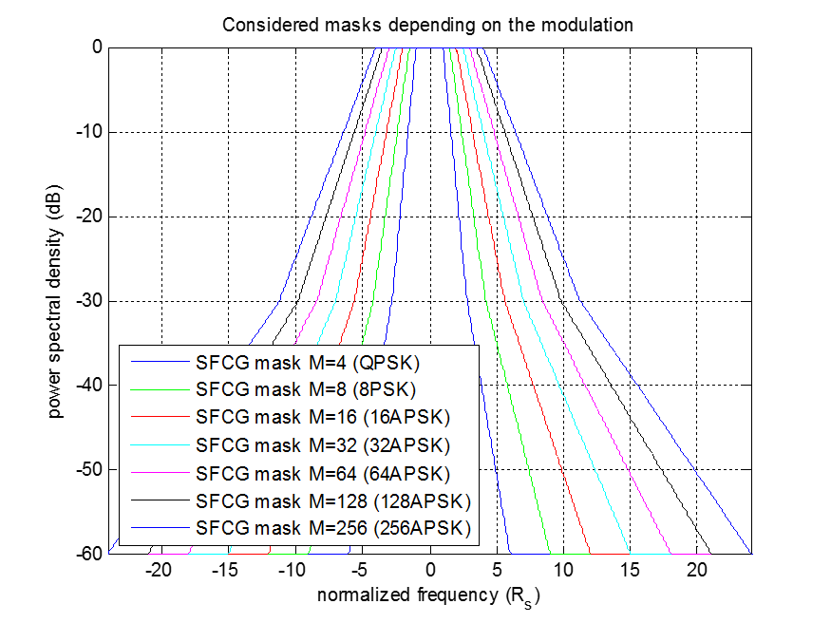

(Rs - channel symbol rate)

Figure F‑1: SFCG masks for APSK modulations

1. SIMULATIONS RESULTS OVER AWGN AND NON-LINEAR CHANNELS   
     
   (INFORMATIVE)

In order to establish preliminaries performances of the DVB-S2X MODCODs, simulations were run with a reduce set of MODCODS covering the amplitude of the new spectral efficiencies.

* 1. Simulation TOOL

The simulator used for these results is a DVB-S2X chain adapted for HDRT simulations. It is based on a C core with a Python HMI. It allows realistic simulations with introduction of phase noise, static or dynamic interferences, amplification and filtering degradation and real synchronization loop.

* 1. AWGN CHANNEL

These simulations provide reference performances for comparison. A real synchronization loop is used in reception with normalized loop bandwidth between 1e-4 and 4e-4. The theoretical performance for FER=1e-5 provided in [2] is shown.

The represented MODCODS are: 64APSK 7/9, 64APSK 5/6, 128APSK 3/4, 256APSK 32/45 and 256APSK 3/4.

Only normal frames are used for simulation. The roll-off is 0.2.

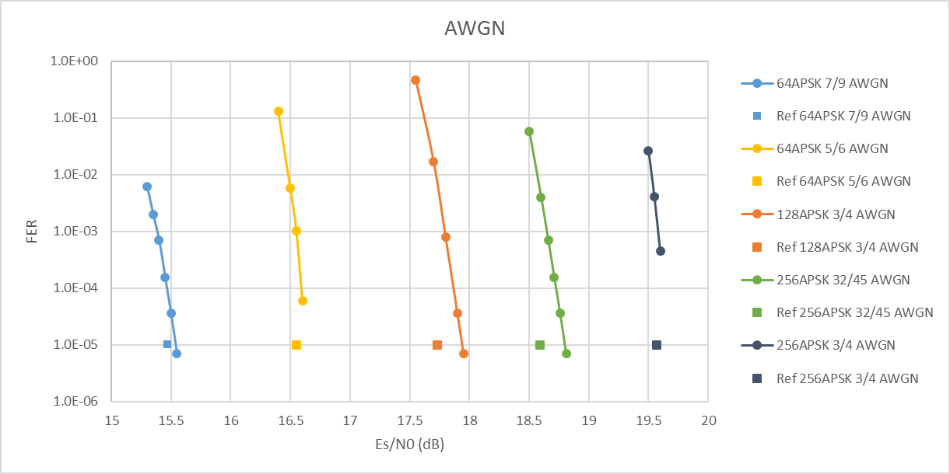

Figure G‑1: DVB-S2X AWGN performances for 5 MODCODs

* 1. NON-LINEAR Channel

The same MODCODs are simulated on a non-linear channel with optimization of the operating point.

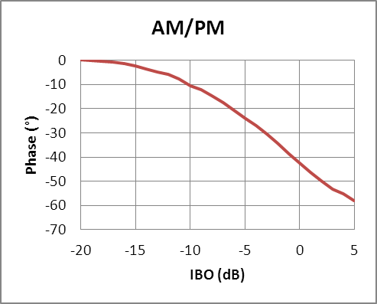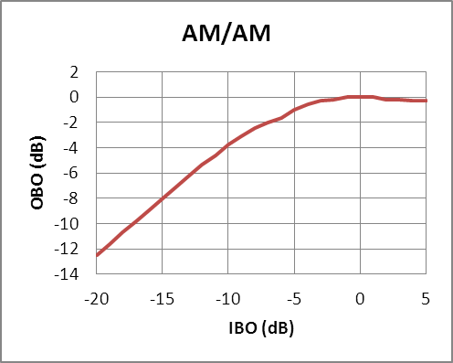The power amplifier is a typical Travelling Wave Tube Amplifier (TWTA) fully characterized by CW (Continuous Wave) AM/AM and AM/PM responses.

Figure G-2: Amplifier characterization curves

* + 1. Optimization of the operating Point

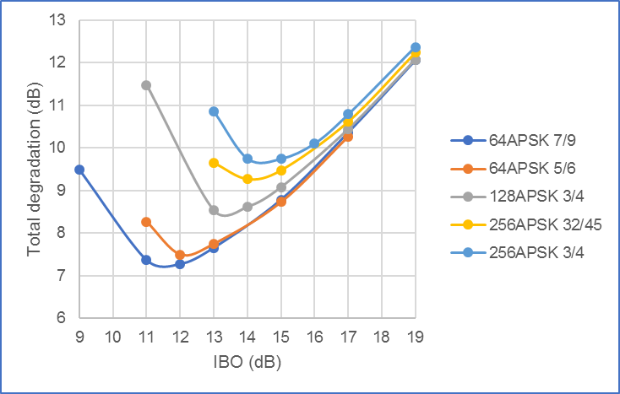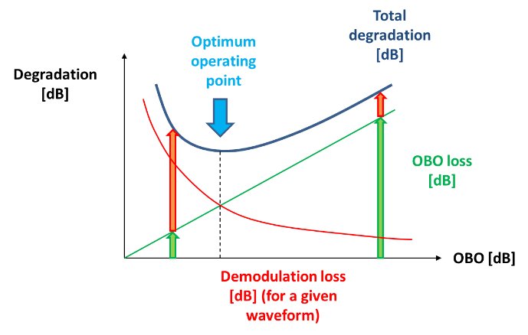An optimum OBO minimizing the total degradation (OBO + demodulation loss) can be found for each MODCOD. Studies for CCSDS DVB-S2 have shown that optimization can be done for each modulation as the operating point slightly changes for each MODCOD. The results are provided below. No amplification precompensation with constellation predistortion is applied.

Figure G‑3: Operating point optimization

Table G‑1: IBO and OBO for each tested MODCOD

|  |  |  |  |  |  |  |
| --- | --- | --- | --- | --- | --- | --- |
|  | **IBO** | **OBO** |  |  | **IBO** | **OBO** |
| 64APSK 7/9 | 12 | 5,77 |  | 256APSK 32/45 | 14 | 7,3 |
| 64APSK 5/6 | 12 | 5,7 |  | 256APSK 3/4 | 14 | 7,3 |
| 128APSK 3/4 | 13 | 6,5 |  |  |  |  |

* + 1. Simulation results

Simulations are done with real synchronization loop.

Results show a degradation lower than 2 dB for the less spectrally efficient MODCODs and around 2.5 dB for the highest efficiencies. It is worth noting that predistortion could help reducing this degradation.

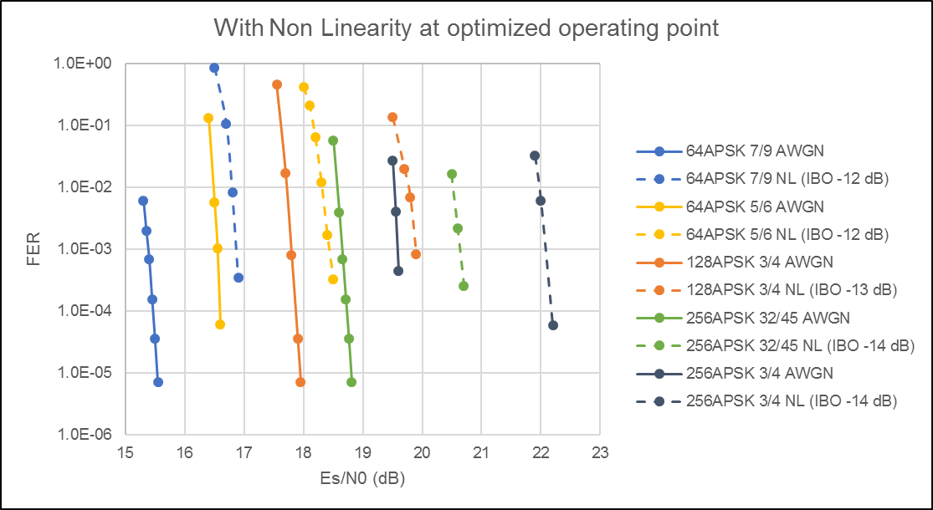Figure G‑4: DVB-S2X performances over a non-linear channel for 5 MODCODs

1. Measurement RESULTS OVER AWGN CHANNEL   
     
   (INFORMATIVE)

As part of its communication strategy for its future missions of space exploration, JAXA has developed a DVB-S2X transmitter prototype and setup a transmission chain environment to get in-lab hardware measurements.

Measurements were performed by JAXA in the JAXA Tsukuba space center RF telecommunication Laboratory. The prototype development includes only a reduce set of MODCOD: 1 coding rate (5/6) applied to 5 modulations (out of 7 available in the standard [2]). The frequency band used is the EESS Ka-band (25.5-27 GHz) for a symbol rate per modulator of 600 Mbaud.

* 1. Measurement setup

The measurement setup is provided in Figure H-1. The current prototype provides a signal at an intermediate frequency which is then upconverted to Ka-band. The receiving part is ensured by a Cortex HDR 4G+ from Safran (Zodiac Data System) with automatic normalized loop bandwidth (0.01% to 0.05%). This equipment also includes a test transmitter that can be used for autocalibration. Only an AWGN channel is considered for these preliminary hardware measurements.



Figure H-1: Transmission chain

The details of the test parameters are given in the Table H‑1.

Table H‑1: DVB-S2X test parameters

|  |  |  |
| --- | --- | --- |
| Item | Parameter value | Remarks |
| Signal information | | |
| Symbol rate | 600 Mbaud |  |
| Pulse shaping filter roll-off factor | 0.15 and 0.25 | Filter type: SRRC with a shape of x/sin(x) as amplitude compensation |
| MODCOD | 9 (QPSK 5/6)  15 (8PSK 5/6)  21 (16APSK 5/6)  26 (32APSK 5/6)  198 (64APSK 5/6) | Compatible with variable coding and modulation (VCM) scheme |
| FEC Frame length | 64800 bit | BCH + LDPC, Normal frame |
| Pilot insertion | ON |  |
| Test data | 23-stage Pseudo random noise code |  |
| Receiver information | | |
| Receiver center frequency | 1.2 GHz | via Ka-band (EESS: 26.625 GHz) @ Compatibility test |
| Matched filter roll-off factor | 0.15 and 0.25 | Filter type: SRRC |
| Adaptive equalizer | ON | Digital Equalization & Automatic Filtering (DEAF) |
| Adjacent channel rejection filters | ON | HBF, LPF |

* 1. Results

A first step of receiver calibration was carried out using the test transmitter available in the Cortex 4G+. The resulting curves are included for comparison purpose and referenced as HDR loop-back. The results of software simulations for the same configurations are also included.

* + 1. FER

The reference FER for comparison with theoretical curves is taken at 1e-5. Two roll-off values are tested as indicated in Table H‑1 (0.15 and 0.25).



Figure H‑2: FER results for 0.25 roll-off

For a 0.25 roll-off, the degradation of Es/N0 is less than 0.5 dB for a 10-5 FER for all modulations except for 64APSK where the degradation is less than 0.9 dB.



Figure H‑3: FER results for 0.15 roll-off

For a 0.15 roll-off, the degradation of Es/N0 is less than 0.6 dB for a 10-5 FER for all modulations except for 64APSK where the degradation is less than 1 dB.

* + 1. BER

The BER results show the same trend as the FER results for both roll-offs (0.25 and 0.15). In both cases, error-free was confirmed by increasing the SNR and it was confirmed that DVB-S2X baseband frame processing was correctly implemented.



Figure H‑4: BER results for 0.25 roll-off



Figure H‑5: BER results for 0.15 roll-off

1. Measurement RESULTS OVER Non-linear CHANNEL   
     
   (INFORMATIVE)

In prevision of improvement of the HDRT test bench in lab CNES, equipment supporting DVB-S2X with automated measurement process were provided and a measurement campaign run to validate the setup and provide complementary results to those provided in ANNEX H.

* 1. Measurement setup

The aimed use case for these measurement was monopolarisation X-band transmission with a symbol rate of 300 Mbaud using different sets of parameters. The accessible data rates are provided in the table I-1.

The transmitting and receiving part are ensured by a Cortex HDR 4G+ from Safran Data System and the measurements are automated.

The overall chain description is provided in Figure I-2 and involves a frequency conversion (up and down) from IF 1200 MHz to EESS X-band (8.025 - 8.4 GHz), a TWTA power amplifier (low level) with a RF filter at the output.

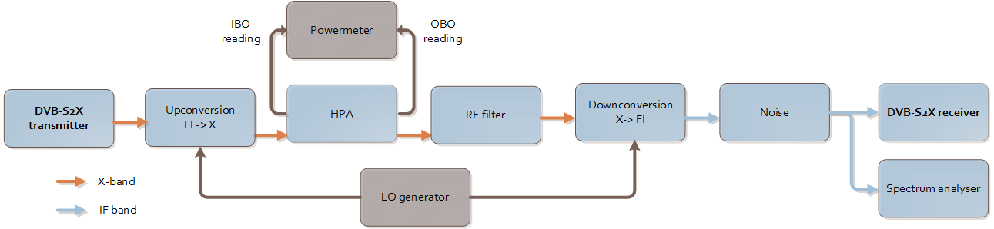

Figure I-2: Non-linear transmission chain

These measurements focused on the highest spectral efficiencies available in the standard (see ANNEX E) i.e. the MODCODs based on 64, 128 and 256APSK. 8 out of 13 MODCODs of highest spectral efficiencies were measured (see blue lines in the Table I-1).

The shaping filter roll-off was 0.1 (0.05 not available yet). Adaptive equalization was used in reception.

Table I‑1: DVB-S2X additional spectral efficiencies

|  |  |  |  |
| --- | --- | --- | --- |
| **MODCOD (PLSCode) decimal value** | **Canonical MODCOD name** | **Spectral efficiency with pilots [bits/channel symbol]** | **Useful data rate (Mbps)** |
| 184 | 64APSK 32/45-L | 4.1113 | 1233 |
| 186 | 64APSK 11/15 | 4.2405 | 1272 |
| 190 | 64APSK 7/9 | 4.499 | 1350 |
| 194 | 64APSK 4/5 | 4.6283 | 1388 |
| 198 | 64APSK 5/6 | 4.825 | 1448 |
| 200 | 128APSK 3/4 | 5.0536 | 1516 |
| 202 | 128APSK 7/9 | 5.2418 | 1573 |
| 204 | 256APSK 29/45-L | 4.9568 | 1487 |
| 206 | 256APSK 2/3-L | 5.1288 | 1539 |
| 208 | 256APSK 31/45-L | 5.3008 | 1590 |
| 210 | 256APSK 32/45 | 5.4729 | 1642 |
| 212 | 256APSK 11/15-L | 5.6449 | 1693 |
| 214 | 256APSK 3/4 | 5.774 | 1732 |

* 1. Results

A first step of AWGN measurements was achieved in order to validate the transmitter and receiver performances. The second step was the optimization of the operating points in non-linear channel for each MODCOD. Then the FER curves were measured at the different optimized operating points.

The reference FER for comparison with theoretical curves is taken at 1e-5.

* + 1. AWGN

Figure I‑3: FER results for 0.1 roll-off in AWGN channel

The degradation of Es/N0 is less than 0.5 dB for a 10-5 FER for all tested MODCOD confirming the good performances of the transmitter and the receiver.

* + 1. Non-Linear channel

Performances are compared to AWGN theoretical values provided in the standard. The IBO and OBO values are provided in the legend. The Es/N0 degradation values are provided in the Table I-2. No predistorsion scheme was used with these measurements. Future work will include such a scheme. Significant improvements are expected as already observed in other measurements with CCSDS DVB-S2 131.3-B-1 standard.

Figure I‑4: FER results for 0.1 roll-off in non-linear channel

The table below summarizes the Es/N0 degradation and the OBO without predistorsion for each MODCOD.

Table I‑2: Es/N0 degradation and OBO in non-linear channel

|  |  |  |
| --- | --- | --- |
| MODCOD | Es/N0 degradation (dB) | OBO without predistorsion (dB) |
| 64APSK32/45-L | 2.3 | 5.76 |
| 64APSK7/9 | 2.2 | 5.7 |
| 64APSK5/6 | 1.7 | 6.46 |
| 128APSK7/9 | 2.7 | 6.4 |
| 256APSK29/45-L | 2.2 | 8.57 |
| 256APSK32/45 | 2.6 | 8.06 |
| 256APSK3/4 | 2.2 | 8.09 |