
Draft Report Concerning
Space Data System Standards
Voice and audio Communications
Draft Informational Report
CCSDS 706.2-G-0
Draft Green Book
may 2017AUTHORITY

 | Issue: | Draft Green Book, Issue 0
 | Date: | May 2010
 | Location: | Not Applicable
(WHEN THIS INFORMATIONAL REPORT IS FINALIZED, IT WILL CONTAIN THE FOLLOWING STATEMENT OF AUTHORITY:)
This document has been approved for publication by the Management Council of the Consultative Committee for Space Data Systems (CCSDS) and reflects the consensus of technical working group experts from CCSDS Member Agencies. The procedure for review and authorization of CCSDS Reports is detailed in the Procedures Manual for the Consultative Committee for Space Data Systems.

This document is published and maintained by:

CCSDS Secretariat
Space Communications and Navigation Office, 7L70
Space Operations Mission Directorate
NASA Headquarters
Washington, DC 20546-0001, USA
FOREWORD
Through the process of normal evolution, it is expected that expansion, deletion, or modification of this document may occur. This Report is therefore subject to CCSDS document management and change control procedures, which are defined in the Procedures Manual for the Consultative Committee for Space Data Systems. Current versions of CCSDS documents are maintained at the CCSDS Web site:
http://www.ccsds.org/
Questions relating to the contents or status of this document should be addressed to the CCSDS Secretariat at the address indicated on page i.
At time of publication, the active Member and Observer Agencies of the CCSDS were:

Member Agencies

- Agenzia Spaziale Italiana (ASI)/Italy.
- British National Space Centre (BNSC)/United Kingdom.
- Canadian Space Agency (CSA)/Canada.
- Centre National d’Etudes Spatiales (CNES)/France.
- China National Space Administration (CNSA)/People’s Republic of China.
- Deutsches Zentrum für Luft- und Raumfahrt e.V. (DLR)/Germany.
- European Space Agency (ESA)/Europe.
- Russian Federal Space Agency (RFSA)/Russian Federation.
- Instituto Nacional de Pesquisas Espaciais (INPE)/Brazil.
- Japan Aerospace Exploration Agency (JAXA)/Japan.
- National Aeronautics and Space Administration (NASA)/USA.

Observer Agencies

- Austrian Space Agency (ASA)/Austria.
- Belgian Federal Science Policy Office (BFSPO)/Belgium.
- Central Research Institute of Machine Building (TsNIIMash)/Russian Federation.
- Centro Tecnico Aeroespacial (CTA)/Brazil.
- Chinese Academy of Sciences (CAS)/China.
- Chinese Academy of Space Technology (CAST)/China.
- Commonwealth Scientific and Industrial Research Organization (CSIRO)/Australia.
- CSIR Satellite Applications Centre (CSIR)/Republic of South Africa.
- Danish National Space Center (DNSC)/Denmark.
- European Organization for the Exploitation of Meteorological Satellites (EUMETSAT)/Europe.
- European Telecommunications Satellite Organization (EUTELSAT)/Europe.
- Geo-Informatics and Space Technology Development Agency (GISTDA)/Thailand.
- Hellenic National Space Committee (HNSC)/Greece.
- Indian Space Research Organization (ISRO)/India.
- Institute of Space Research (IKI)/Russian Federation.
- KFKI Research Institute for Particle & Nuclear Physics (KFKI)/Hungary.
- Korea Aerospace Research Institute (KARI)/Korea.
- Ministry of Communications (MOC)/Israel.
- National Institute of Information and Communications Technology (NICT)/Japan.
- National Oceanic and Atmospheric Administration (NOAA)/USA.
- National Space Organization (NSPO)/Chinese Taipei.
- Naval Center for Space Technology (NCST)/USA.
- Scientific and Technological Research Council of Turkey (TUBITAK)/Turkey.
- Space and Upper Atmosphere Research Commission (SUPARCO)/Pakistan.
- Swedish Space Corporation (SSC)/Sweden.
- United States Geological Survey (USGS)/USA.

DOCUMENT CONTROL

Document | Title | Date | Status
CCSDS 706.2-G-0 | Voice Communications, Draft Informational Report, Issue 0 | May 2010 | Current draft
CCSDS 706.2-G-0.1 | Voice Communications, Draft Informational Report, 1 | April 2016 | Current draft
CCSDS 706.2-G-0.2 | Voice Communications, Draft Informational Report, 2 | May 2017 | Current draft

CONTENTS
Section Page
1 INTRODUCTION 1-1
1.1 purpose and scope of this document 1-1
1.2 DOCUMENT STRUCTURE 1-1
1.3 Definitions 1-1
1.4 REFERENCES 1-4
2 VOICE COMMUNICATIONS in Flight operations 2-1
2.1 Introduction 2-1
2.2 Voice communications 2-2
2.3 Audio communications 2-7
2.4 GRound VOICE SySTEMS 2-8
2.5 spacecraft Audio communications 2-11
2.6 Soyuz 2-11
2.7 Commercial Crew (CIGNUS and SPACE-X Dragon), requirements for the voice system: 2-11
2.8 Orion 2-14
2.9 International Space Station 2-15
2.10 Voice connectivity among agencies 2-15
3 Technical Drivers 3-20
3.1 Introduction – Overall Approach 3-20
3.2 Earth Segment 3-22
3.3 local segment (Lunar or Mars on ground) 3-24
3.4 short-haul segment 3-26
3.5 long-haul segment 3-27

ANNEX A Acronyms and Abbreviations A-1
ANNEX B Codec Short descriptions B-1
Figures
2-1 The STS Flight Control Room 2-3
2-2 The Russian ISS Flight Control Room 2-3
2-3 Mission Operations Voice Context Diagram 2-5
3-1 Lunar Surface Operations 3-24

CONTENTS
Table Page
Fehler! Verwenden Sie die Registerkarte 'Start', um Heading 1 dem Text zuzuweisen, der hier angezeigt werden soll.-5 Communications Options 3-30

Interface-specific Recording (Interface Recording)

I

INTRODUCTION

purpose and scope of this document
This CCSDS Informational Report presents an overview of voice communications in human-in-space operations. Voice for satellite operations is a very reduced version of the one used for human space flight. Only LEOP (Launch and Early Orbit Phase) operations can be seeing as a similar complexity, but there is still a reduced version of a voice system dedicated to talk to astronauts. It has been prepared by the Voice Working Group of the CCSDS Space and Internetworking Services (SIS) area.
This document is not part of a Recommended Standard and is intended to provide supporting material for creating the Voice and Audio Communications Recommended Practice (reference Error: Reference source not found).

DOCUMENT STRUCTURE
This document has the following major sections:
- Section 1 contains administrative information, definitions, and references.
- Section 2 describes the current state of voice communications supporting human and non-human space flight.
- Section 3 describes the technical drivers for the future of voice communications.
- Annex ANNEX A contains acronyms and abbreviations.
- Annex ANNEX B contains short descriptions of codecs.

Definitions

General
Within the context of this document the following definitions apply:
Audio: may contain human voice, experiments’ noises, sounds, or music, all of which need more quality and more BW than voice to be transmitted (typically 20-20kHz);
Audio files: may contain recorded human voice or any kind of audio. Because they are files, they are transmitted like any other files, using file transfer standards.
Codec: Coder – Decoder, in the context of voice communications.
Encoding: Used in the context of analog to digital conversion, or the compression of digitally represented voice data.
Interoperability: The technical capability of two or more systems or components to exchange information via a common set of procedures or protocols, and to, understand the same voice and data formats while using the same or compatible protocols.
mission control center, MCC: A facility that manages human space flights.
NOTE – This book uses MCC because it is the term used for human space flight. Mission Operations Center (MOC) is the term used primarily for satellite missions and is thus used in many CCSDS books.
Sample Rate (Codecs): MHz or Kbps rate at which the data is sampled: For example the G.711 Codec algorithm samples the data at an 8KHz rate (8 bits per sample) or 64Kbps, which is the standard PCM Data Stream rate.
Summation: The mixing of multiple voice sources into a single conference loop, whether the mixing occurs via analog waveform and subsequently digitally encoded.
Voice Loop or Voice Conference: The result of summation – a single conference containing the voice of all participating talkers.
Voice format: a collection of voice loops grouped together to meet the requirements of a particular situation or mode of operation. Voice formats are typically negotiated between two or more MCCs to prioritize loop connectivity to best match communication needs with the available channels.
Because in each MCC there are many more internal voice loops (can be up to 5000 loops) than available circuits to transport the voice loops between the MCCs (typically 24, 48 or 92 channels), different operations modes must be defined by different voice formats. Each format contains a limited number of voice loops matched to the available channels for a specific operational aspect between MCCs. These formats are interchangeable and dynamic; they need to be clearly defined between MCCs. Examples of voice formats are Joint Simulation and System Test Format. It is extremely important to reserve a number of channels in each format to maintain normal operations during a test or simulation.
For the ISS program, voice formats are defined in OIP (Operational Interface Procedures) stored as internal NASA documents that are used for all the space agency’s participating in the project.
The voice formats are exchanged between agencies in a predefined Excel table. The integration in each voice system can be different, but the voice loops matching (can have different names in different space agencies) must be works before start operations.
To change a voice format or a voice loop a ECR (engineering change request) need to be raised and the change discussed between the agencies that will be affected for the change that can be two or several control centers.
Keyset: A keyset provides capabilities for selection of loops, as well as for audio input and output. Interaction with the keyset for loop selection is usually a physical interaction by pressing buttons. The interaction components of the device may be dedicated hardware buttons for each loop, or a software user interface shown as a touchscreen. Physical interaction is preferred for higher user awareness. For actual audio input, the physical interaction is done by actively pressing a PTT button to activate the microphone of the keyset for transmission of the voice signals to the selected loop. The keyset may be either an integrated or multipiece separated unit, or it can be a software application (soft keyset). The complete device is called a keyset and provides all necessary functionality for end-user interaction with the voice conferencing core.
User Role and Permissions: Monitoring, Talk/listen.
Each user of a voice system has one or more assigned Roles. Each role has a predefined amount of loops that can be used and with the corresponding permissions (M/T/L).
A role can also have a predefined format or a look and feel of the touchscreen and the pages and loops available for this role.
A user can and should have the possibility to configure their assigned keyset with his/her particular voice levels for the micro and speaker stored on it.
Each voice loop shows the permissions for this particular role (T/M/L). Monitoring is used in many console positions. Especially in the externals ones (e.g Payload operator) just to listen to a voice loop but have no permission to talk. For the positions that have talk/listen/monitoring permissions, the monitoring button is often used to not disturb the voice loop for talking in another loop simultaneously or to talk in a side conversation.
There is no difference between listen and monitoring, but the permission and the name on the button or key is different.
Normally a user or role has the possibility to listen or monitoring several loops but permission to talk in only one.
PTT and VOX: Press to talk is mandatory for the use of keysets in human space flight. It can be implemented physically via a button or pedal, or via VOX, where the voice level is monitored and the PTT is activated automatically. VOX (Voice Level Detection or Voice Activity Level or Voice Operated eXchange) may be to be implemented on keysets. If VOX is implemented, the VOX threshold must be adjustable between -26 db. and -94 db. The adjustment of the VOX must be fixed for each user.
The VOX system should also have a hang system (VoX time out) from 1 to 3 seconds to remain engaged during brief speech pauses. It must be possible to save and restore the VOX threshold settings for each individual user in a console position.

REFERENCES
The following documents are referenced in this Report. At the time of publication, the editions indicated were valid. All documents are subject to revision, and users of this Report are encouraged to investigate the possibility of applying the most recent editions of the documents indicated below. The CCSDS Secretariat maintains a register of currently valid CCSDS documents.

[1] Pulse Code Modulation (PCM) of Voice Frequencies. ITU-T Recommendation G.711. Geneva: ITU, 1988 and G.711 Appendix II (02/00)
[2] Lossless Compression of G.711 Pulse Code Modulation. ITU-T Recommendation G.711.0. Geneva: ITU, 2009.
[3] CCSDS File Delivery Protocol (CFDP). Issue 4. Recommendation for Space Data System Standards (Blue Book), CCSDS 727.0-B-4. Washington, D.C.: CCSDS, January 2007.
[4] CCSDS Bundle Protocol Specification. Issue 1. Recommendation for Space Data System Standards (Blue Book), CCSDS 734.2-B-1. Washington, D.C.: CCSDS, September 2015.
[5] Coding of Speech at 8 kbit/s Using Conjugate-Structure Algebraic-Code-Excited Linear Prediction (CS-ACELP, G.729). ITU-T Recommendation G.729. Geneva: ITU, 2012.
[6] J. Rosenberg, et al. SIP: Session Initiation Protocol. RFC 3261. Reston, Virginia: ISOC, June 2002.
[7] Packet-Based Multimedia Communications Systems. ITU-T Recommendation H.323. Geneva: ITU, 2009.
[8] Licklider Transmission Protocol (LTP) for CCSDS. Issue 1. Recommendation for Space Data System Standards (Blue Book), CCSDS 734.1-B-1. Washington, D.C.: CCSDS, May 2015.
[9] Coding of Speech at 16 kbit/s Using Low-Delay Code Excited Linear Prediction. ITU-T Recommendation G.728. Geneva: ITU, 2012.
[10] Information Technology—Generic Coding of Moving Pictures and Associated Audio Information—Part 7: Advanced Audio Coding (AAC). 4th ed. International Standard, ISO/IEC 13818-7:2006. Geneva: ISO, 2006.

VOICE COMMUNICATIONS in Flight operations

Introduction
This document provides an overview of voice communications in support of human space flight. The voice and audio communications used for non-human space flight can be considered as a subset of the ones used for human space flight. In this case the number of loops, excepting for the LEOP, is a lot less complex and not so dynamic. Also the use of voice formats is normally not needed. In satellite missions the voice loops for a mission are almost static. They change from mission to mission but not in the way of human space flight does. All the other concepts related to users, roles, permissions, keyset configuration, etc. are applicable here as well. Voice communications addresses many combinations of users, grouped largely by where these users reside. Different locations dictate different requirements and constraints upon the voice communication services that must be provided. This document establishes four segments for voice communication, each with unique characteristics:
- Earth segment (between terrestrial facilities, including emergency communications and SAR);
- Lunar or Mars segment (between Lunar or Mars facilities, astronauts and Earth, including emergency communications and SAR);
- Short-haul segment (between terrestrial and space borne facilities, including emergency communications); and
- Long-haul segment.(between terrestrial and space borne facilities, including emergency communications);
The purpose of this document is to establish a shared understanding of the technical drivers that affect each of these segments, in order to inform subsequent work in defining or adopting standards for voice communication to serve one or more segments.
The use and nature of voice communications in human spaceflight operations evolved largely from the operational concepts of military voice communications. Consider the early astronaut, a military jet pilot who endured short, lonely flights into low earth orbit. Compare today’s International Space Station (ISS) with its full crew compliment of 6, comprised of pilots, yes, but also and perhaps more importantly engineers, scientists, medical doctors and more. At one time, ISS hosted a crew of 7 from the US Space Shuttle bringing its population to 13 personnel for a short time, resulting in a significantly increased demand for the limited ISS voice communication resources. Clearly there has been significant evolution in both the requirements for and constraints upon voice communication: from a single user (analog), short-duration to multi-user, multi-spacecraft, very long duration operations with substantial variation in load over time.
As ground-based flight control teams grew in size; high capacity, high performance voice switch and conferencing equipment was introduced. This equipment was often custom developed, or modified commercial off the shelf. As the cost and complexity of space missions increased, joint international missions among multiple space agencies emerged. Digital voice conference systems as well as commercial telephony carriers and their capabilities were employed to provide connectivity among multiple flight centers for real-time mission operations support by the participating agencies.
Globally, the following describe some of the fundamental challenges of voice communications in human space flight:
- Flight operations personnel currently work close together in collocated environments such as flight control rooms, where low-latency and high capacity voice intercommunication is desired. However, greater access through remote operations is becoming a driving force, where flight operations team members are not collocated but rather may be found in their individual offices, ad-hoc geographically locations, or even working from home.
- Voice summation, the creation of a coherent voice conference is possible with analog mixing equipment, and with digital waveform codecs such as G.711[11]. But lossy voice codecs such as G.729 or G.722 cannot readily be ‘summed’ into a voice conference. They must be decoded, mixed, then re-encoded, which results in loss of voice quality. The new voice systems technologies are replacing the analog mixing equipment with digital ones and with pure software solutions as well.
- Transcoding at interface boundaries is often required to accommodate local and regional difference in telecommunications infrastructures and end user instrumentation, e.g., E1 to T1 from Europe to the US or Japan, or G.722 to/from G.729 between cellular carriers. This may impact voice quality as transcoding may occur between lossy codecs.
- Conventional voice communication technologies assume full-duplex or bidirectional communication paths, whereas for crew safety voice communications must operate independent of return path. And further, network transport technologies also require bidirectional communication, which again should not be employed for communications with in-flight spacecraft.
- Voice communications with a one-way light-time delay of about 5 seconds results in the participants engaging in message oriented conversation as opposed to being dialog oriented conversation.

Voice communications
A flight control room or a launch control room generally consists of a controlled access space in which flight control team (FCT) personnel work and communicate audibly through voice intercommunications equipment. Keysets provide the user interface to a rich set of user functionality. FCT members may participate concurrently in multiple conferences, or voice loops, while talking on one selected voice loop. Certain authorized personnel may talk on more than one voice loop. User control of the individual voice loop volume control complicates the user interface and the intercommunications equipment.
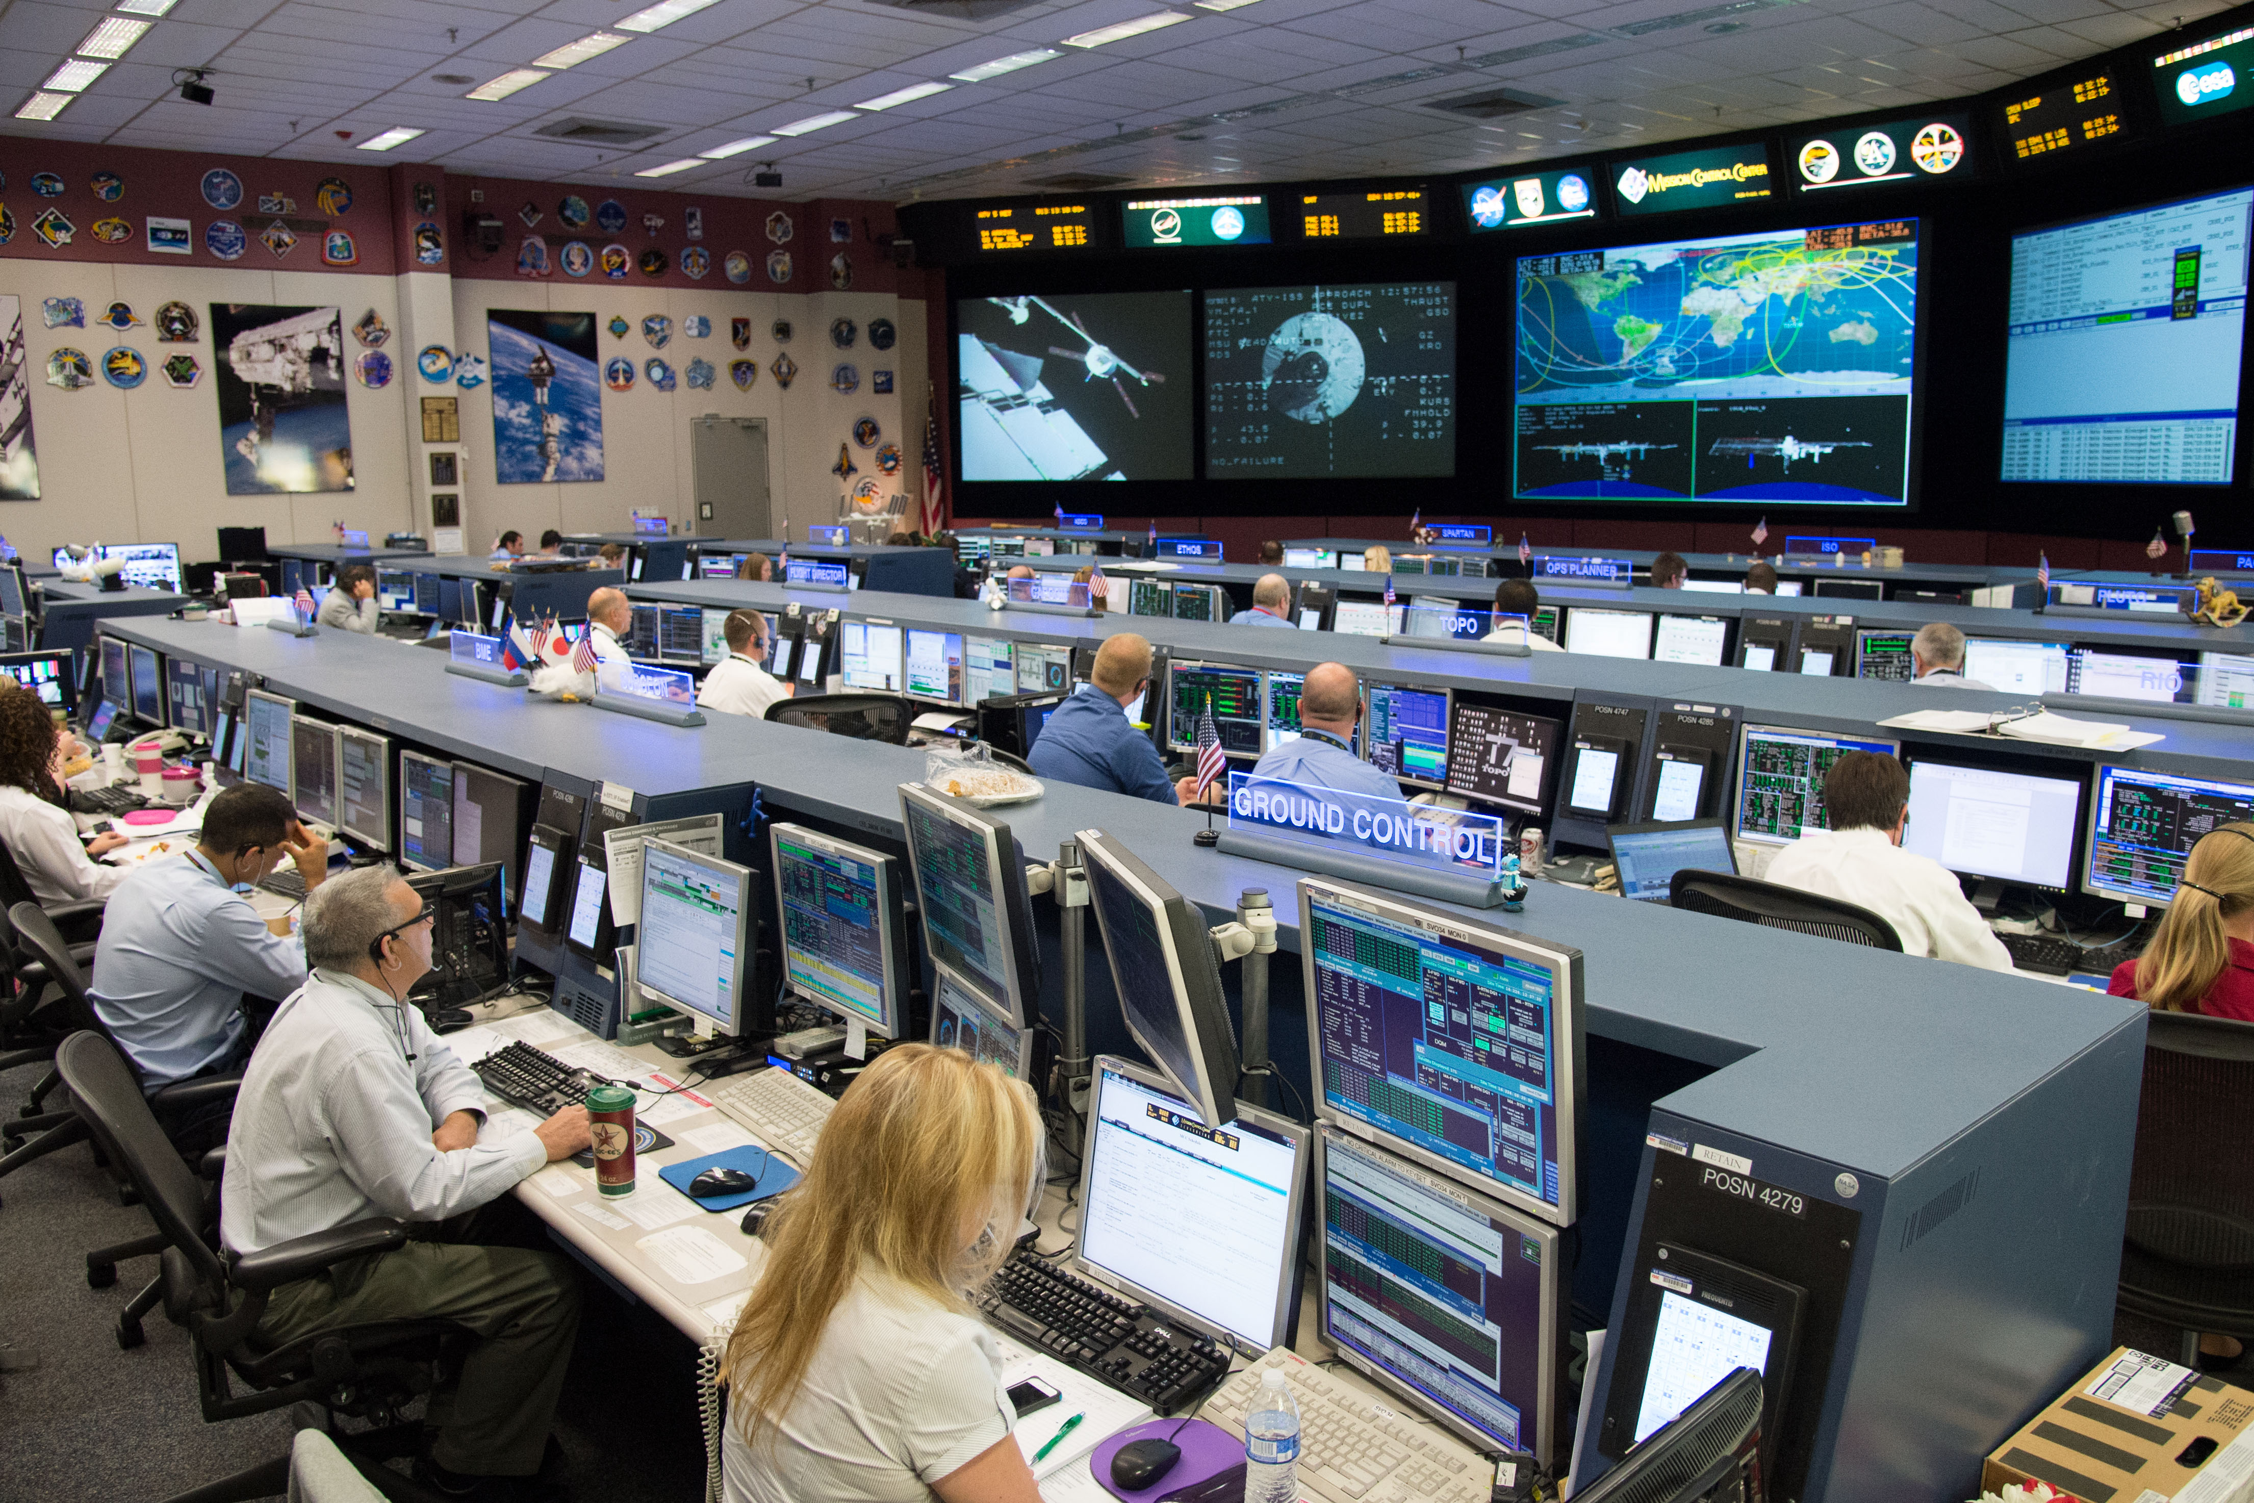
Figure 2-11: source: NASA
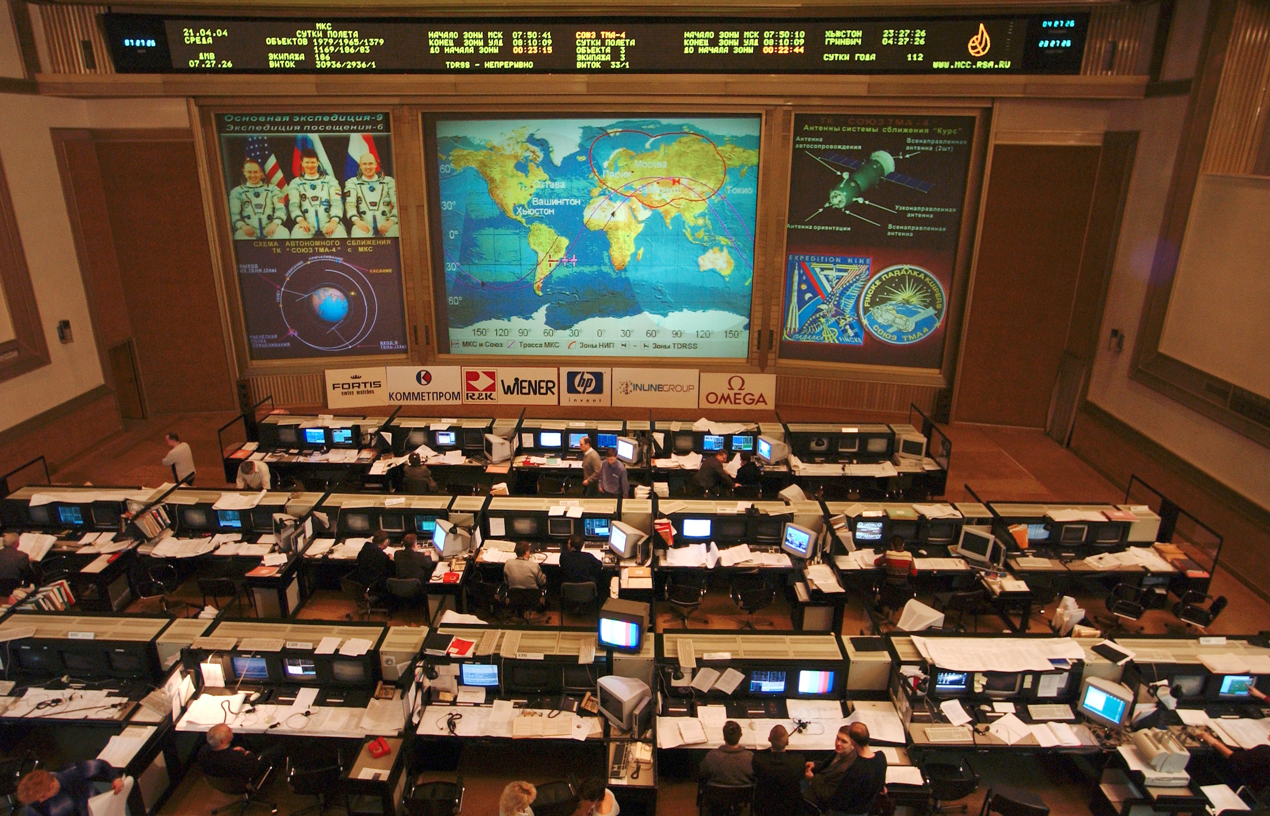
Figure 2-22: The Russian ISS Flight Control Room; source: Wikimedia
Given the real-time nature of their work and the extent of their voice intercommunications, flight control personnel generally require low latency, non-blocking voice equipment with fast access times through defined and administered roles. Complexity of mission support, and the training required to prepare the FCT result in high capacity of always-on conference loops ready for immediate use, thereby easing schedule constraints of voice resources.
Voice intercommunications must be recorded and affixed with appropriate time and flight meta-information for future use and play back. Recording of both individual keysets and whole voice loops is generally required. Archival storage is required.
High reliability, maintainability and availability (RMA) are the hallmarks of the voice intercommunications equipment intended for real-time mission operations support. Internally redundant architectures are typically necessary to reach the levels of RMA required.
At a mission control center there are several flight control rooms, mission evaluation rooms, and multi-purpose support rooms, each housing members of the flight control team in numbers ranging from 10 to 60 persons. Centralized voice equipment provides the high performance, high capacity voice intercommunications necessary. From launch to orbit, as many as 400 keysets may be engaged, accessing some 200 voice loops. While most FCT members listen to multiple voice loops concurrently, they are typically limited to talk on only one loop, whereas the CapCom and FD (Capsule Communicator and Flight Director respectively) often use a multi-talk mode – the ability to press PTT (Press To Talk) and have their voice included in up to 8 conference loops simultaneously.
To share voice loops among different centers, a voice loop in one center’s voice switch is connected by commercial carrier to a voice loop in another center’s voice switch, with each switch then serving the population of users in its respective center.
Given the operational concepts of a flight control team the following summarizes suitable voice communication requirements:
- hardware keysets for dedicated appliance-like performance; collocated personnel require low latency voice among themselves;
- up to 10 pages each containing up to 24 voice loops; user configured with user or role defined defaults, the number of pages and voice loops per page can vary in different voice systems ;
- individual voice loop controls including talk/monitor, monitor only, and volume level;
- each conference loop key is stateful, retaining whatever the current configuration settings are over its default configuration, as the user selects other voice loop pages on which that voice loop is found;
- VoIP hardware and software keysets deployed where low latency voice performance is not a driving requirement;
- voice latency requirements inside of control room:

- PTT to talk should be less than 15 ms.
- Talk and voice summation should be less than 150 ms
- VoIP latency ranges from about 100 ms to more than 200 ms;
- restricted talk configuration for critical voice loops; e.g., only the CapCom can talk on the Space-to-ground (S/G) loop during launch;
- high capacity includes 1,600 active conference loops, with 3,000 stored conference definitions;
- capacity is expandable to 5,000 connections, whether keysets or external signals;
- for critical flight control use, the central voice switch must have internally redundant voice paths such that no single failure can remove a voice loop from use.
The following context diagram provides a view of a typical centralized voice switch and ancillary equipment supporting human space flight. The diagram well describes the voice communication subsystem used at NASA’s JSC. The block titled External Voice Distribution Equipment provides the equipment necessary to support transcoding among voice and transport technologies such as G.711 to G.729, T1 to E1.
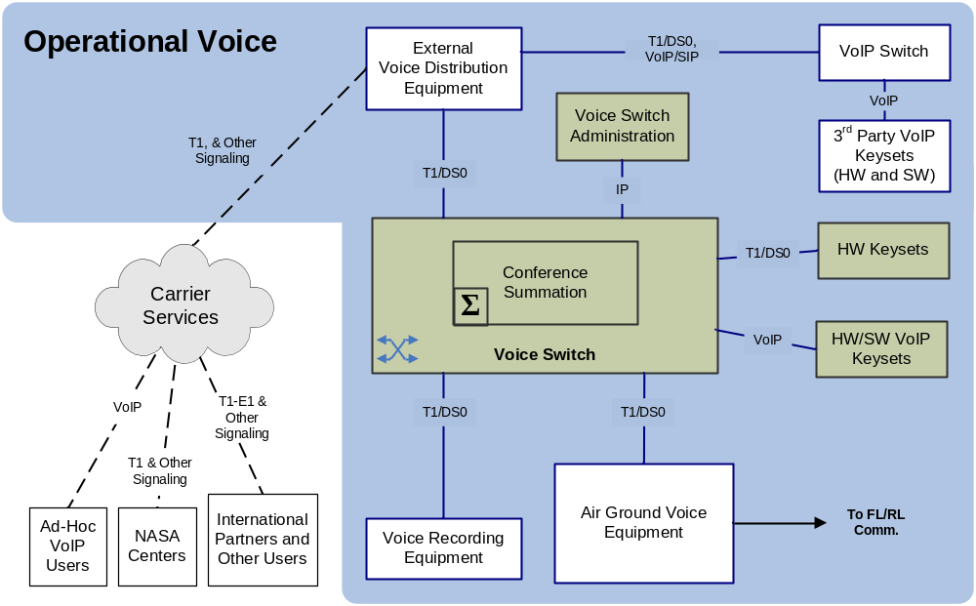
Figure 2-33: Mission Operations Voice Context Diagram
The following bullets provide more detail to the above diagram:
- The central switch complex consists of a Voice Switch and its Conference Summation components. These are Time Division Multiplexing based equipment that provides very low latency, high performance, and high capacity voice intercommunications.
- Interfaces with the central voice switch include
- Keysets. Hardware keysets may be T1 or VoIP connected, software keysets are only VoIP connected.
- External interface; T1 with typical telecommunications signaling options. Additional peripheral equipment may translate and transcode as required for external systems. For instance, a single DS0 channel of a T1 may be defined to carry a specific voice conference for interface with an external secondary voice switch such as a PABX (Private Branch Exchange) or a third party VoIP switch or even the central voice switch of another agency.
- Voice recording equipment provides for both loop and individual keyset recording. Voice recording includes IRIG (Inter Range Instrumentation Group Timecode) time stamp for storage and retrieval capability. Voice recording is typically stored digitally on a Storage Area Network.
- Local Site Administrator control PCs communicate with the voice switch via Internet Protocol (IP).
Air to Ground Voice Equipment (AGVE), provides interconnect between the central voice switch and the air to ground communications network that communicates with spacecraft. Included in this is any necessary translation and transcoding.
AGVE must accommodate one-way voice communications for crew safety. In the event that voice communication is not actively being received from a spacecraft, AGVE must continue to forward voice communications, for the crew may be receiving but cannot transmit.

Audio communications
Non-real-time communications are expected to be handled by the exchange of audio files.
Voice communication and audio data exchange are essential services for supporting space mission operations. They are especially important in a cooperative international environment in human space flight programs like the International Space Station (ISS). Between humans, one of the most common information exchanges is voice communication. In human space flight, the primary function of voice communication is to support the mission executed by astronauts, cosmonauts, taikonauts, and other space travelers. For purposes of this document, the following descriptions apply:
- voice is defined as the transport of human voice using low BW resources for transmission (typically 300-3000Hz);
- audio may contain human voice, experiments’ noises, sounds, or music, all of which need more quality and more BW to be transmitted (typically 20-20kHz);
- audio files either may contain recorded human voice or any kind of audio. Because they are files, they are transmitted like any other files, using file transfer standards.

For audio file transmission any method for file transfer can be used, CCSDS would use the CFDP [3]and for long distances DTN.
CFDP currently supports four classes of file transfer. Going forward, SIS recommends using one of the following two classes, each class can be supported over the DTN Bundle Protocol (reference [4]) and DTN Licklider Transport Protocol (LTP):
- Class 1—Unreliable CFDP Transfer over Bundle Protocol or directly over LTP-Red;
- Class 2—Reliable CFDP Transfer over Bundle Protocol or directly over LTP-Red or LTP-Green.
If Class-1 (Unreliable) CFDP is used over Bundle Protocol, then the expectation is that CFDP will invoke the Bundle Protocol reliable delivery option.
For more information related to DTN please refer to CCSDS 734.0-G-1.

GRound VOICE SySTEMS
Most of the current voice systems used in the Space Agencies are based on an Analog Hardware voice Matrix. New voice systems are going into the IP communications and have matrix based on IP (Hardware or Software)
Keyset devices typically have a headset with a microphone that converts the voice waveform into an analog signal. A voice codec is then used to convert this analog voice signal into a digitally encoded version. It accomplishes this by using algorithms to convert the analog voice waveform into a digital format or encoding. Choosing which algorithm involves evaluating voice quality verses bandwidth consumption, among other factors. Codecs may simply provide quantized waveform representation, sampled at appropriate rates. Other complex codecs are more CPU intensive, performing psycho-acoustic analysis and prediction of the waveform rendering parameter sets that are a very compressed description of sampled voice, e.g. G.729.
The benchmark coding scheme is Pulse Code Modulation, or PCM [[1]]. PCM was a product of the development of digital telephony in the 1970s which led to the T-carrier systems that are widely deployed today. PCM samples the voice signal at a rate of 8,000 samples per second and then assign each sample one of the 256 discrete levels using eight-bit code. This yields a data rate of 64 Kbps (8,000 samples/second * 8 bits/sample = 64000 bits/second). The discrete level is assigned in a logarithmic manner as opposed to linear which yields greater resolution with low signal levels, but the digital output is a constant 64 Kbps. In 1988 PCM encoding was standardized by the International Telecommunications Union (ITU) as Recommendation G.711[2].
The disadvantage of PCM/G.711 is that the bandwidth is a constant 64 Kbps. Speech signals contain some forms of redundancy that could be removed to help compress the output data rate which would in turn reduce the required bandwidth. This is where other bandwidth-reducing ITU codec standards have been developed, some of which are noted here with their corresponding bandwidth: G.722.1 (24/32 Kbps), G.723.1 (5.3/6.3 Kbps), G.726 (16/24/32/40 Kbps) G.728 (16 Kbps) and G.729 (8 Kbps).
Bandwidth saving codecs does come with some caveats. Guaranteed packet delivery becomes more important with the higher compression voice codecs. This is because more voice data is being squeezed into each packet, and the loss of a packet between the source and destination keyset will result in the loss of that part of the voice stream. This could be problematic in mission support when a series of numbers is being communicated.
In addition, codecs with significantly reduced bandwidth usage have the penalty of increased latency due to the sampling of a period of voice and the processing of that sample period.
Voice Summation: Voice summation remains an area of legacy equipment but is slowly being replaced by the new digital systems (VoIP). High performance and low latent voice intercommunication systems utilize Time Division Multiplexing (TDM) for the ‘voice bus’ and G.711 or other waveform quanta codecs for voice encoding and summation. A voice loop ‘talker’ consumes one slice of the TDM voice bus to carry their voice. Another slice of TDM carries the summed voice loop audio. The central switch either decodes the two audio voice slices and mixes them in an analog fashion, or provides a code book look-up for “adding” the voice quanta together. The resulting audio is the ‘summed’ voice of the talker and the voice loop, and this audio is placed back into the voice loop slice of the TDM voice bus for all to hear.
Voice summation with lossy codecs such as G.729 or G.722 is problematic, for the voice data must be decoded to waveform codec like G.711 or even to analog voice in order to create a conference, or voice loop. It is simply not possible to ‘add’ lossy codec voice data together. With each encoding/decoding of a lossy codec, voice quality is degraded.
Wideband Voice Codecs: Wideband codecs are available, such as G.722.2. Telecom standard toll quality voice (G.711) is considered narrow-band with a frequency range of 300 to 3,400 Hz, whereas wideband codecs are 50 to 7,000 Hz. This provides better audio acuity for plosives and fricatives - speaking the letters p, t, k, d, b, and of the letters s, f, v, z, respectively.
While wideband codecs are used in some VoIP internet telephony applications and in some cellular systems, conventional telecommunications infrastructure supports only narrow band and requires transcoding at boundaries resulting in the loss of the extra frequency data of the wideband codecs. However, the use of wideband codecs is on the increase, and this will prove a challenge to mission voice communications in the future.

Voice over IP systems:

The Marshal Space Flight Center used the most advanced and reliables VoIP voice system for operations in the space business, the system is called IVoDS - (IP Voice Distribution System)
The IVODS is used to receive, sum and distribute mission voice conferencing data i.e. “Loops”.The system uses a standard T1 facility to connect and exchange voice data between other NASA centers, International Partners and ancillary equipment (Voice Recorders, Telephone system and other sources of voice within MSFC).

The system is made up of several main sub systems:

Conferencing Server:
This has the system Data Base, VoIP System manager application (DICES/COTS), all required system monitoring, inventory and logging facilities. The HOSC Server is an HA (highly availability) and FT (fault tolerant) class. The T1 gateways and all user Keysets (Clients) connect back to the VoIP Manager. The System uses an Administration Terminal (SAT) for control, status and DB entry. The terminal software runs on MS Windows PC or a Linux workstation/PC. The conferencing server communicates with other network services for user authentication (LDAP, RSA or other), DNS, Time, Auditing, Logging, Backup, and other available network services.

T1 VoIP Gateway:
The gateway has 2 basic functions; the TDM side and the IP side. The TDM interfaces with external equipment solely over a standard T1/E1, and can be configured to support all framing, coding and signaling protocols. The T1 card supports 4 ports. The network/IP side performs voice exchange between the configured T1 voice channels and the conference server. The VoIP application converts TDM to IP and manages the associated signaling for all channels.

User Software Client:
The software client can be run on a PC or dedicated hardware solution.
Hardware Keysets; Have full color touch screens. The client can be configured to support as few as 4 keys or as many as 80 keys. The client supports multiple pages (i.e page 1 through 10). The client provides many visual indicators for user awareness an operator selection. The HOSC Keysets utilize a 12 inch touch screen and displays 45 keys. Every loop can be monitored simultaneously; Talking is limited to one loop at a time.

Software Keysets: (running on user PC or Workstation)
Users download the software from the HOSC Portal. A client is available for PC, MAC or Linux operating system. The software client has all the same functionality as the hardware keyset. Users can access the system from any IP network.

Software keyset installed on the external users may have problems related to the connection to the public internet and with other applications running in parallel into the same computer.

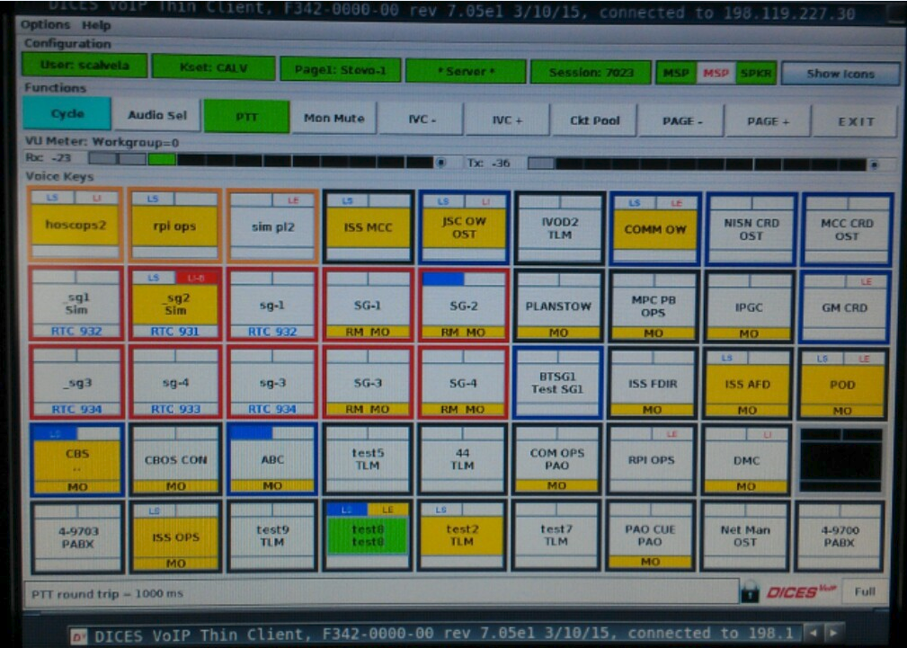
Figure 2-4: example of the keyset Layout

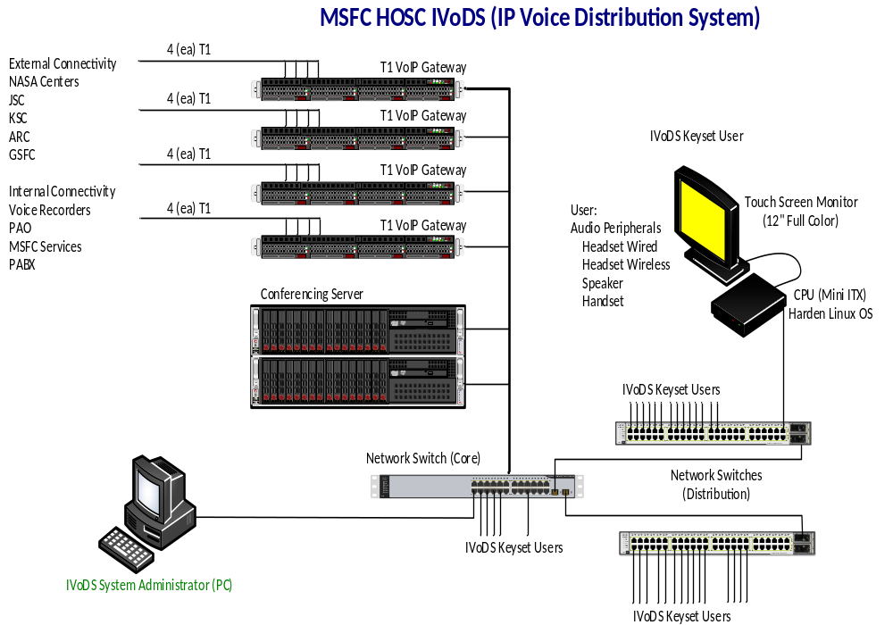
Figure 2-5: example of the keyset Layout

Costing considerations:

The Conferencing server Options:
Standard Class Server – Limited redundancy and not fault tolerant, inexpensive, availability 95.9%

High End Class - fully integrated software and hardware, is Highly Available and Fault Tolerant, availability achieves 99.999%, relatively higher cost.

The server choice depends on the site operations, but should be procured with the VoIP Application loaded, installed, verified and licensed.

T1 Gateway – standard server with some redundancy and supports 4 T1 ports, availability 99.5%. Purchased with the VoIP application. MSFC system is configured for 40 T1 Ports

User Keysets:
Dedicated CPU and Touch screen - Procured and loaded with the VoIP Client software and license, MSFC system is Licensed for 165 Keysets.

Software Client:
Can be run on any PC, MAC or Linux system/work station. Clients are licensed separately.

Headset Information – Other options are available, the items below are specific to MSFC.

HW251N | Monaural with Noise Cancellation Headset Top | 
SHS 2355 | USB with PTT Headset Bottom (This is the sound card) | 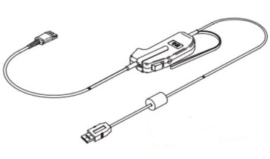
SSP 2468 | USB with PTT Adapter (This is the sound card and it is used to connect to the Wireless Units, handsets or speakers) | 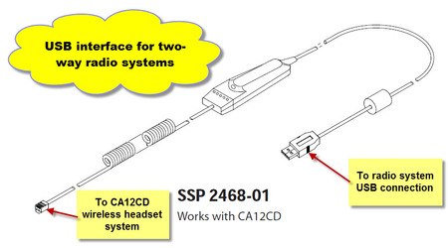
Model CA12 | Wireless Units (Base and wireless transmitter)  Note about the picture to right - do not use the coil cord with the PJ Plug (connect the SSP 2468 in its place) | 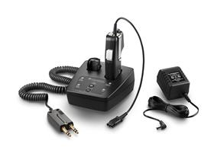

Table 2-1: Headset devices examples.
Latency, jitter, and packet loss: Voice quality is affected by all three of these factors.
Latency - the delay of voice communications due to the following:
- transport delay:
- light time delay;
- ground network transport delay;
- processing delay: the encoding and decoding of voice, along with the associated buffering of analog or digital voice signal;
- packet size buffer delay: where applicable, latency may be incurred when multiple samples of voice data are collected prior to transport;
- boundary delay: the buffering, processing and possible transcoding at the boundaries between transport domains.
Jitter: variations in the interval and arrival time of individual voice packets. Queuing and multiplexing of disparate data types and sizes within a communication channel results in some manner of jitter. Transports layer framing may have an impact on jitter.
Packet Loss: Normally occurs in IP networks as a result of network congestion, where incoming packets are thrown away. Within RF networks, packet loss may be due to signal loss or fade, or a too tight link budget. The impact on voice of an occasional random packet loss is negligible, but the impact for excessive packet loss is poor voice quality or loss of voice communications entirely.
Voice quality: Voice quality measure is possible through automated and subjective human evaluative methods. The long standing telecom standard MOS (Mean Opinion Score defined in ITU P-800) is 4.0 to 4.2 for G.711 encoded voice. Wideband codecs (e.g., G.722.2) may result in higher comparative scores, while narrow band digital compression codecs (e.g., G.729) may result in lower comparative scores.
The DRT/DAM testing (Diagnostic Rhyme Test / Diagnostic Acceptability Measure) provides for measuring intelligibility of voice communications.
Whereas the quality standard has been the MOS of G.711 encoded voice, the increasing use of wideband codecs will likely result in a new expectation for quality voice communications. As terrestrial systems evolve to handle wideband codecs the use of such codecs in human space flight can be expected.
QoE: quality of experience. The users on console carry out voice test regularly before important mission phases. Users uses normally the expression 5x5 , or 5x3 or 3x3 indicating the quality of the voice communication. This table from 1 indicating intelligible communication till 5 indicating good voice quality is specified in ITU-T P.800.
Quality of service is related to the network. Quality of Experience is related to the human perception, should be 5x5.
Meta Information for Voice Data: Traditional archival of voice data related to human space flight has been an administrative function. Voice is recorded with accurate date and time information, and that information is correlated with mission events by way of a method outside of the voice archive. Internet protocols provide for additional voice meta information, such as the source identifiers in RTP, and voice extensions in XML can provide richer meta information to a voice archive.
Record and Storage of Voice Data: Codecs which are most effective here store data at high compression rates without significant quality loss to optimize the efficient use of storage facilities. However, the cost of storage and archival media may allow the storage of voice data in its captured format.
Private Conferences: Private conferences occur with family and friends, a flight surgeon or other participants where private voice communication is desired by the participants or required by law. Executing a private conference is largely an administrative function of the voice technicians for Shuttle (in the past) and the ISS. Function keys provide the voice tech the ability to swing a forward link and return link voice channel from a common air-to-ground or space-to-ground voice loop to a private conference loop. Authorized parties are then connected to the private conference loop. Voice tech personnel also check and disable other interfaces as may be necessary to ensure a private conference.
Once the parties are connected and voice checks complete, the voice techs themselves disengage from the private conference and monitor voice performance only through audio meter readout of the circuits involved. The private conference continues as scheduled or until a designated party calls to notify the voice techs that the private conference has ended.

spacecraft Audio communications

Soyuz
The Russian Soyuz capsule is the only one used at the moment to transport humans to the ISS. Soyuz have two VHF channels:
- ISS VHF1: Used for S/G communication over Russian ground stations (RS ISS S/G 1 MH21) and also used as an alternate link for S/G communications when ISS is over NASA VHF ground stations. Uplink: 139.208 MHz; Downlink: 143.625 MHz.
- Soyuz VHF2: Used for S/G over Russian ground stations (RS ISS S/G 2 MH24) and space-to-space communication. This is the only VHF frequency pair carried on Soyuz. Soyuz VHF2 communication through NASA VHF ground stations is authorized for emergency use only per Flight Rule (D3-1). Uplink: 130.167 MHz; Downlink: 121.750 MHz.
Soyuz, when approaching proximity operations is done manually, severs the connection to the ground and uses only the VHF/S-band connection from spacecraft to spacecraft.

Commercial Crew (CYGNUS and SPACEX Dragon), requirements for the voice system:
ISS standard communications are used when the spacecraft closes to within tens of kilometers to the ISS and ship-to-ship voice communications are established
Communication and telemetry monitoring will be shared between the Commercial Vehicle Control Center (CVCC) and the ISS mission control facilities, Mission Control Center - Houston (MCC-H). MCC-H Mission Authority will be established to ensure ISS, spacecraft, and crew safety. When in close proximity to the ISS, after receiving approval from both the spacecraft and MCC-H, the spacecraft begins a final approach to a NASA-specified docking port on the ISS.
Voice Communication in Breathing Apparatus
The CTS (Crew Transportation System) shall provide voice communication between each of the crew members and the Voice Communication in Breathing Apparatus
Suit Communications
The suit shall provide two-way voice communications between each of the crew members and the CVCC. Rationale: When the crew is suited, they will not be able to hear each other. Additionally, the vehicle audio speakers will not be heard/intelligible, particularly in a vacuum. In these cases, the suit must allow for communication between crew members and between the crew and the CVCC.
Accommodate NASA Personnel at CVCC
The CTS shall accommodate 4 mission essential NASA personnel at the CVCC with capability to monitor the pre-launch and mission operations activities and communicate (including voice loops) with NASA personnel in ISS MCC-H.
Communications with CVCC after Landing
The spacecraft shall provide 2 hours of cumulative post landing two-way voice communications, over a 24 hour period, between the crew and the CVCC until recovery/rescue forces have removed the crew from the vehicle. The crew should have periodic two-way voice communications with the operations team sufficient to aid in spacecraft safing and coordinate the recovery or search and rescue and other crew survival efforts during this timeframe. The communication will need to be maintained until the search and rescue or recovery teams have recovered the crew
For nominal and off nominal landing scenarios 5 minutes of continuous two-way voice every hour for 24 hours will satisfy search and rescue needs. This requirement does not preclude the use of portable devices as part of a strategy to provide two-way voice communications between the crew and the CVCC until recovery forces have removed the crew from the vehicle.
Spacecraft Voice Communication with Recovery/Rescue Forces
The spacecraft shall provide two-way voice communication between the crew and the recovery/rescue forces from the time the recovery/rescue forces are within direct line-of-sight of the spacecraft until recovery/rescue forces have removed the crew from the spacecraft.
The spacecraft shall be capable of communicating on International Air Distress (IAD) frequency of 121.5 MHz and Military Air Distress (MAD) frequency of 243.0 MHz.
The crew should have two-way voice communications with the recovery/rescue forces that will be conducting the search and rescue and other crew survival efforts during this timeframe. The communication will need to be maintained until the search and rescue or recovery teams have recovered the crew for nominal and off nominal landing scenarios. It is assumed that it will take 4 hours for the rescue and recovery forces to remove the crew from the spacecraft. The CTS should develop and coordinate other special frequencies for use beyond the IAD and MAD frequencies for all operations that are not considered search and rescue. This requirement should not require the crew to open the egress hatches to maintain communication with recovery/rescue forces because the spacecraft may be in a contingency landing situation, such as in a water landing, which would preclude opening the hatches
Voice Communication with Crew
The CTS shall provide single failure tolerant two-way voice communication between the CVCC (s) and the spacecraft crew from pre-launch through landing and during aborts.
Two-way voice communication between the CVCC (s) and the crew is required to execute the mission and resolve anomalies should they occur. The intent of this requirement is to provide single failure tolerance in both the ground and onboard communications systems in order to ensure communications availability during all flight phases. This requirement is not meant to imply 100% continuous communication for all phases of flight. On orbit communications coverage requirements will be dictated by the specific design requirements of the spacecraft.
Communications Coverage
The CTS shall provide communications coverage (two-way voice and telemetry) between the integrated space vehicle and CVCC(s) during at least 90% of the powered ascent flight phase and 65% during the entry flight phase to supported landing sites.
Historically, the ascent and entry phases of human space flight have been the timeframe of greatest risk for LOC (loss of Communication). For powered ascent, there are a multitude of abort options and timely systems responses that ground personnel can assist with leading to the requirement near continuous communications that can be accommodated by ground and/or space based communication assets. For entry, although the risk is high, there are fewer options available for the crew and thus the requirement for continuous communication is less than that for ascent. Entry communications coverage to supported landing sites is intended to limit the number of trajectories for nominal entry assessment. The entry communication analysis should be focused on critical events (separations, chute deployment key navigation events) and the final phase of landing where the risk is the highest.
Private Audio
The CTS shall provide for a private audio communications capability between the NASA crew and the NASA flight surgeon during non-docked, on orbit operations.
This secured or private communication provides for privacy of medical information between the NASA crew and the NASA flight surgeons. Private voice communications are not required during ascent and entry due to the short nature of these flight phases. Voice communications are considered private with respect to those on the ground. No additional impacts to vehicle design should result from establishing private communication, as the information is not required to be private between crewmembers.
Integrated Voice Communications during ISS Proximity and Docked Operations
The CTS shall provide simultaneous two-way voice communications between the ISS, CTS spacecraft, CVCC, and ISS Mission Control Center during:
a. Free flight when the CTS spacecraft is within 10 kilometers of the ISS.
b. Docked operations when the crew is in the CTS spacecraft.
The intent of this requirement is that the CTS enables a multi-party voice loop conferencing the ISS, CTS spacecraft, CVCC, and ISS Mission Control Center when the CTS spacecraft is within 10 kilometers of the ISS to support nominal and contingency operations. This requirement includes providing voice communication when the crew is isolated in the CTS spacecraft while attached to ISS (i.e., Safe Haven). This requirement enables conferencing of all the operations entities (ISS crew, CTS spacecraft crew, CVCC flight control team, and ISS flight control team) to support proximity and docking operations. This does not require direct point-to-point communication between all parties.
Communication System Design
Audio Volume Control
The spacecraft shall provide a volume control from 5 to 100% of maximum for each audio channel carrying voice communications.
The crew must have the ability to adjust volume for each audio channel in order to hear and communicate under expected background and radio noise conditions. For example, volume control with 10 steps of 6 dB increments provides acceptable range. Adjustability down to 5% is significant, given the maximum audio level needed for the launch noise environment, as it ensures that crew can adjust volume to a comfortable level in the lower SPL on orbit environment and have adequate speech-to-ambient noise margin. Conversely, the system must ensure that crew does not miss radio calls due to low audio volume or elevated background noise (e.g., alarms present, multiple active communications channels). Visual indicators of audio signal can be an effective means for alerting crew to radio calls.
For commercial crew vehicles there are no redundancy requirements for the voice system and S/G voice loops.

Orion
The US Orion program specified a VoIP voice communications capability with the Orion capsule, G.729 in RTP/UDP/IP for air to ground voice communications through CCSDS AOS Encapsulation Service and multiplexed with command and telemetry. Initial EVA voice communications capability was specified as tethered LPCM to the Orion capsule. Additional voice communications capabilities were to include Emergency Communications (EC), Dissimilar Voice (DV), and Search and Rescue (SAR) voice communications
Emergency Communications: Emergency Communications (EC) was an outgrowth of the Apollo 13 experience where a near catastrophic failure led to a severe power shortage that required many on-board systems to be powered down. The concept for Orion was that some systems may be powered down, including the primary radio equipment. Low power EC equipment could then be engaged to transmit voice as well as a very limited amount of command/telemetry at a rate of perhaps 12.4 Kbps.
EC voice was encoded as G.729 data and transmitted over CCSDS AOS VCA (Advanced Orbital Systems Virtual Channel Access) with no IP/UDP/RTP protocol wrapping.
Dissimilar Voice: Dissimilar Voice (DV) provides assured voice communications through a parallel voice communications link with the crew during pre-launch, launch and ascent. Both ground operations and mission operations utilize DV. For Orion, DV was specified as G.729 encoded voice exchanged through S-Band RF from ground stations at the launch site and other selected sites as required to accommodate ascent trajectories. CCSDS AOS VCA service was the expected transport packaging. Given the latency and jitter expected with the communications systems, the Orion Program determined that onboard synchronization of DV with the primary voice communications was required. This was to be accomplished through the processing of the respective ‘presentation times’ associated with each frame of voice data and given their respective communication channels.

International Space Station
The International Space Station (ISS) utilizes MRELP (Modified Residual Excited Linear Predictive) a codec with data rate at 9.6 Kbps) for space to ground voice communications. As originally designed, the MRELP voice system was intended only for the early stages of ISS construction after which it was to become the backup voice system. However a primary voice system was never installed. Nowadays this system is still used for the S/G 1 and 2 loops.
Additional voice channels for ISS are implemented using VoIP G.729 within RTP/UDP/IP. These channels are the current S/G 3 and 4 voice loops.
ISS also supports ham radio communications primarily as a public affairs capability. UHF voice communications are used during proximity and docking operations with approaching crewed spacecraft.

Voice connectivity among agencies

General
Voice communication is one of the crucial mission applications running over the International Ground System Wide Area Network (IGS WAN). Consider the following mission control centers are:
Columbus CC (COL-CC)
MCC-Houston (MCC-H)
Huntsville Operations Support Center (HOSC)
European Astronaut Center (EAC)
MCC-Moscow (MCC-M)
Universities and other payload users use the internet with services like PIP services (premium IP)
Each center has one or more voice conferencing systems. These conferencing systems interconnect using synchronous TDM-based (E1/T1) or VoIP based interfaces. MCC-M uses 12 voice loops exchanged using Cisco-based VoIP with Col-CC.
The following table details the voice loops that may be configured between the various controls centers of different space agencies. Multiple configurations provide for the mapping of a large number of voice loops over a smaller number of physical circuits bridging between the agencies to accommodate different scenarios and mission phases according to the corresponding voice formats

CSA – MCC-H | Six major configurations provide concurrent access to between 64 and 66 voice channels.
JAXA – MCC-H | Six major configurations provide concurrent access to between 22 and 78 voice channels
COL-CC – MCC-H | Three major configurations provide concurrent access to up to 48 voice channels
MCC-M – MCCH | Three major configurations provide concurrent access to up to 48 voice channels
COL-CC – MCC-M | One configuration provides concurrent access to 12 voice channels
HOSC – COL-CC | Two mayor configurations provides concurrent access to 24 voice channels
HOSC-MCC-H | Two mayor configuration provides concurrent access to 48 voice channels
HOSC | IVODS, connections using the internet and T1to centers in Europe, to Col-CC and payload users
Table 2-2: Voice channels
Presently the E1/T1 synchronous voice communication is transported over MPLS. For the HOSC also internet is used. That can be change in the future.
All these voice channels can be mapped to different voice loops as is defined in the corresponding voice format.

Voice-to-Text Conversion
Voice-to-text, also known as Automatic Speech Recognition (ASR) [9][5]and the reverse process known as text-to-speech (TTS), has become a standard application for many smartphones, browsers, cars, and dictation devices.
When long transmission time becomes an issue, voice-to-text software should be considered; voice should be converted to text and sent to the MCC as a text file. The reply could be sent in the same way and could optionally be converted back to voice.
There are several voice-to-text and TTS software products available. Product selection is beyond the scope of this book.

Voice and Audio Communication Services

Lip Synchronization (Lip Sync) for Public Affairs
For public-relations events, an external facility communicates with the astronauts in space. The voice path normally uses S-band, and video uses Ku-band. The paths are different and have different latencies and need to be synchronized.
The final synchronization is done manually. The astronauts and the MCC test the whole path a few minutes before the event starts. The video personnel on the ground synchronize the video with the audio using the predefined values of the encoders. The personnel then either add or subtract steps of 10 milliseconds at a time to the encoder configuration until the lips are synchronized with the audio.
An automatic lip sync can be made possible if timestamps are used in the video and voice systems; however, this requires special equipment. Ideally, the synchronization of the video and audio should be done onboard and sent embedded from space.
Most of the new cameras are already using embedded audio (HD-SDI or SD-SDI) on the ISS.
In this case the downlinked audio is embedded in the video, but the audio going to the ISS is not always synchronized with the video. In those cases, in order to avoid echoes or artifacts the lip sync is recommended.
For some public affairs events with educational institutions where Vsee or Skpe are used the Lip Sync is not necessary because the audio is embedded in the video. The quality is less than the one used for TV or Governmental Events, but acceptable.

Voice Recording/Playback
Voice recording and playback are an essential part of space missions. Classic uses of recording are to store voice data for post analysis during failure investigation, for reconstruction of issues, for public relations activities, and for training purposes. A common use is short-term playback of unclear communication to avoid misunderstandings and frequent repetition over the channels.
Based on the use cases, three different types of recording are used: user-specific recording, loop-specific recording, and interface-specific recording.

User-specific Recording (Keyset Recording)
User-specific/keyset recording is the sum of all audio traffic for a specific user and is dependent on the user’s loop selection. User-specific recording represents the presence of all audio signals at a user position.
Keyset recording and playback of a user position is used for a short time span only. In this way a user is able to replay the last minutes of all audio arriving at the keyset. It is mainly used for replays of unclear communication.

Loop-specific Recording (Loop Recording)
Loop recording is defined as the sum of all audio traffic for a specific loop. It is user independent. Loop recording represents the presence of an audio signal within a loop.
Loop recording is the most common recording for space mission operations. All audio of a loop is stored separately within the recording system. This way, loop-specific investigations are possible (e.g., dialog between different positions).
Loop recording is very demanding in terms of storage capacity and correct time-tagging to allow replays of specific events based on a given time span.

Interface-specific Recording (Interface Recording)
Interface recording represents the presence of an audio signal at an interface and is able to identify the direction of the signal (outgoing/incoming)
Interface recording is a technical support recording to verify audio sources within loops. It is aligned to loop assignments of channels.
Interface recording is mainly used to identify failure sources such as noise bursts within a loop, open microphone conditions, or other audible misalignments.

Etiquette and protocol
To have access to the voice system in space operations etiquette and protocol are mandatory (roles and positions to talk);
For the correct functioning of the end-to-end voice system requires some support from the environment, particularly to support availability and reliability of the networks, but also to ensure that the people operating the system do so according to established rules. That means console operators must to be certified in the use of the voice system, as with the etiquette and protocol as well.
Each space agency has its own training programs for using their voice system but the etiquette and protocol are common for all the space agencies. The definitions are in the NASA SATERN (System for Administration, Training, and Educational Resources for NASA) educational system. This system is accessible for all the users of a voice loop in the ISS program, this training is mandatory.
For satellite missions similar trainings are provided for each space agency and are very similar in content, this training is also mandatory for each participant of a space mission.
There are rules of how to talk, mention your position, how to ask, to which position do you want to talk, which reduced and specific vocabulary should be used, etc.

Technical Drivers

Introduction – Overall Approach
The table and illustrations below describe the overall scenario for lunar missions and can be transposed for Mars missions.
In short, voice communications can be summarized in 4 defined segments:
- Earth segment (between terrestrial facilities, including emergency communications and SAR);
- Lunar or Mars segment (between Lunar or Mars facilities, astronauts and Earth, including emergency communications and SAR);
- Short-haul segment (between terrestrial and space borne facilities, including emergency communications); and
- Long-haul segment.(between terrestrial and space borne facilities, including emergency communications);

Voice Segments | Description | Technical Constraints
Earth ground | Control center system and interfaces to other control centers and remote users, emergency communications, SAR | Conference loop capability  Point to point  Latency for co-located personnel  Criticality, availability  Bidirectional network  Continual comm.
Lunar or Mars ground | Voice communications for EVA, Habitat, Rover; spacecraft, emergency communications, SAR | Conference loop capability  Point to point  Latency for co-located personnel  Criticality, availability  Bidirectional network  Continual comm.
Short-haul: near Earth, near Moon, near Mars | Voice communications to through orbital nodes to and among ground nodes, whether around the Earth, Moon or Mars; emergency communications, SAR | Point to point  Criticality and availability  Channelization and bandwidth  Intermittent to continual comm.  Bidirectional to non-bidirectional
Long-haul: Moon to Earth, Mars to Earth | Mars to Earth voice communications; emergency communications, SAR | Point to point  Criticality and availability  Channelization and bandwidth  Intermittent to continual comm.  Bidirectional to non-bidirectional
Table 3-3: The Voice Segments
Figure 3-6 depicts the following:
- lunar ground segment;
- lunar short-haul segment;
- lunar to Earth long-haul segment.
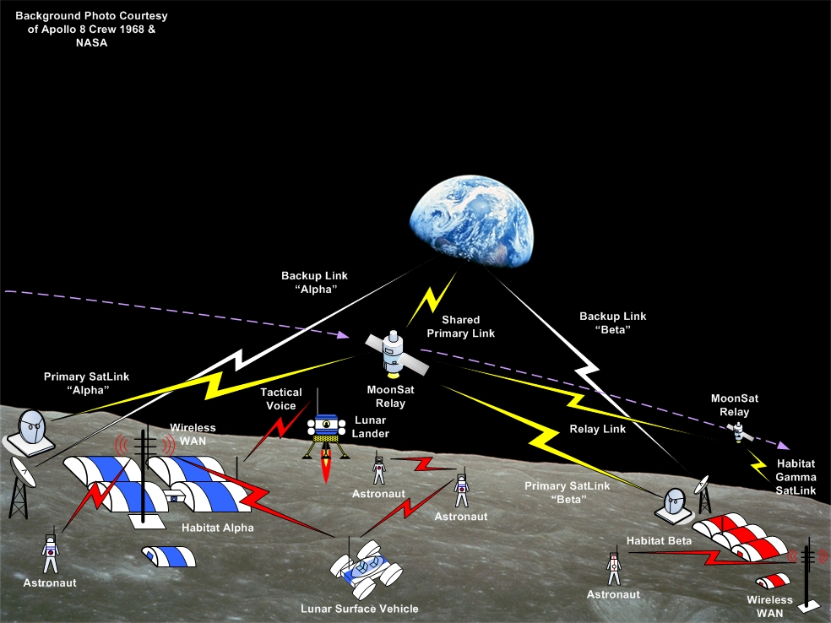
Figure 3-64: Lunar Surface Operations

Earth Segment

General
The earth segment is characterized by a collection of control centers, many having their own voice conferencing systems connected with each other via a limited number of parallel voice channels. Each center may have a number of remote voice users connected via VoIP/Internet, or MPLS, or other means. Commercially available equipment tends to dominate the Earth segment; consider the telecommunications, Internet, and networking domains.

key drivers
Latency: For co-located users, e.g., a FCT in a flight control room, voice latency must be near to the normal sound travel time among the users. For point to point connections, latency becomes much less an issue.
Channelization: Provide channelization of voice communications between centers for configuration management and security reasons.
Criticality/availability: Voice systems and their interfaces are critical capabilities. Experience shows that when they do not work, back-ups are immediately necessary. Hence not only should voice systems be on failure tolerant equipment, but their external interfaces should be supported by redundant communication channels as well with easy if not automatic fail-over.
Layer | Mechanism | Comments
Physical | E1, T1, 802.3
Data Link | MPLS, Ethernet
Network | IP (SDP, RTCP, RTP, SIPv2[6]), DTN | For interoperability point of view
Transport | TCP/UDP (IP), TDM, RTP, other
Session |  | PTT
Presentation layer | G.711, G.729, G.722, G.728, etc.
Application | Voice summation  Voice Recording/playback
Table 3-4: Earth segment communications options
CODEC: A number of compression schemes exist and are employed today. It is in the interest of interoperable agencies to adopt a common scheme for compression to avoid multiple protocol conversions at interface boundaries, which results in a degradation of signal and the possible introduction of audio artifacts.
Connectivity: VoIP is used in most of the new voice systems. Other technologies have a place in voice connectivity or distribution:
- MPLS: does not allow circuit based emulation, but has acceptable QoS/performance;
- IP (Internet): characterized by poor quality, packet loss but it is ubiquitous and relatively inexpensive;

Functional Aspects:

Voice summation and conferencing
It is likely that the requirement for large voice conferencing systems in the various control centers will remain for the foreseeable future. In these centers the following important factors remain:
- the number of keysets (i.e., users);
- the number of voice loops (voice conferences);
- the number of keysets (users) connected to any individual voice loop;
- the number of voice loops to which any individual keysets may be connected;
- the latency experienced by co-located users on common voice loops;
- the number of channels allocated to various external interfaces.
The high performance, high capacity central voice matrix remains TDM based voice processing and switch equipment. VoIP is used as a distribution technology and it is replacing the matrixes.

Channelization
It is important to define a limit for the number of channels available between centers as an unlimited number of channels would quickly allow the definition of too many loops between centers. Managing the number of loops between control centers is a key configuration issue.
Here is where the definition and use of voice formats becomes extremely important.
As previously explained a voice format is a collection of voice loops grouped together to meet the requirements of a particular situation or mode of operation. Voice formats are typically negotiated between two or more MCCs to prioritize loop connectivity to best match communication needs with the available channels.
Different operations modes must be defined by different voice formats. Each format contains a limited number of voice loops matched to the available channels for a specific operational aspect between MCCs. These formats are interchangeable and dynamic; they need to be clearly defined between MCCs. Examples of voice formats are Joint Simulation and System Test Format. It is extremely important to reserve a number of channels in each format to maintain normal operations during a test or simulation.

Security
On the Earth segment security for voice links is important for:
- ensuring access control to the voice systems;
- ensuring the privacy of medical conferences; or
- ensuring the privacy of ‘private’ calls (crew family conferences);
- ensuring the confidentiality of voice communications related to critical operations or events;
- controlling access to voice records.
Voice system access is traditionally based on username/password, sometimes on digital certificates (e.g., via a LDAP server). Voice recognition could be a future method for authentication.
Ensuring privacy or confidentiality: different techniques have been used traditionally such as voice scrambling and more recently encrypting digital voice communications. It should be noted that the need to store encrypted voice links in an encrypted format (and being able to decrypt the recorded voice) implies specific challenges in key management and implies metadata is carried by the voice signal which includes the key ID.

local segment (Lunar or Mars on ground)

General
Local segments, whether lunar or Mars ground segments, are likely to be dominated by the use of existing commercial telecommunications and networking capabilities adapted from the Earth ground segment. To overlay of these technologies upon hardware and the physical layers of communications in harsh environments will be a significant challenge.

Key drivers
This segment is the one that in the global scenario is defined by a local infrastructure composed of vehicles such as rovers (with crew or not), crew and teams in suits (EVAs), habitat modules, science modules, and perhaps communications infrastructure modules. The main driver is the criticality of the voice channels given the dangerous activities performed by the crew during EVAs:
- voice communications for EVA/rover need to be redundant;
- the voice intercommunications interface may be voice activated to select voice channels by EVA/rover;
- emergency voice channels and equipment should be availablefor the astronauts during EVAs and for the rescue teams.

Layer | Mechanism | Comments
Physical | 802.3, 802.16, Wireless LAN, RF links, Prox1 | HAM radio
Data Link | 802.3, 802.16, Wireless LAN, RF links, Prox1
Network | IP (SDP, RTCP, RTP, SIPv2), DTN, | DTN only considered from interoperability point of view (multiagency)
Transport | TCP/UDP (IP) | All the communications will be over IP
Session
Presentation layer | G.711, G.729, G.722, G.728, etc.
Application | Voice summation  Voice Recording
Table 3-5: Local segment communications options

Functional aspects

Voice summation
Voice loops, or voice conferences, shared among the members of a working team on EVA is required. Voice latency of the voice loop should be very low for those co-located. For example, two suited crew members working as a team may desire low latency voice between themselves, while the communications link to distant support personnel may experience a far longer latency.
In addition, it seems clear that as ground operations grows in complexity, multiple voice loops capability is necessary to support multiple and concurrent activities.

Secure Communications
Secure and confidential communications should be built into the capability.

Emergency Communications
In the event that communications with central modules is somehow interrupted, emergency communications capabilities should exist, whether to orbiting satellites or at a low level directly back to earth.

Mesh Capability to provide redundancy
Interoperable nodes or mesh-capable nodes would be ideal for a lunar or Mars local segment. In this concept any node can relay voice communication traffic to another node. This would allow EVA1 to communicate with the habitat via EVA2 in case EVA1 experienced loss of signal with the habitat.

short-haul segment

Key drivers
Bandwidth and channelization begin to be an issue with short-haul segments, though more so with long-haul segments. For the short-haul bandwidth must be shared with other traffic, and with prioritized traffic.
1
Layer | Mechanism | Comments
Physical | RF transmission, optical communications
Data Link | AOS, CCSDS Encapsulation Service, Prox 1,
Network | IP (SDP), BP
Transport | UDP (RTCP, RTP, SIPv2IP),VOIP (RTP, UDP, IP,CCSDS encapsulation, AOS
Session
Presentation layer | G.711, G.722, G.728, G.729, AAC
Application | Voice summation, Recorder
Table 3-6: Short Haul communications options

There are a number of options that may be explored for voice services in a local lunar or Mars segment. Some will parallel the technologies employed for voice communications on Earth. The following are a representative but by no means an exhaustive list:
- Option 1: Voice over DTN;
- Option 2: Voice over AOS (multiplexed voice traffic);
- Option 3: VoIP over CCSDS Encapsulation packet ;
- Option4: VoIP over typical network topologies

long-haul segment

Key driverS
Several key drivers exist in regard to long-haul segments. Consider the following:
- latency;
- channelization, bandwidth utilization, and traffic prioritization;
- secure communications;
- intermittent, bidirectional and unidirectional connectivity.

Layer | Mechanism | Comments
Physical | RF transmission
Data Link | AOS, CCSDS Encapsulation Service
Network | IP, DTN, CCSDS BP
Transport | AMS/CCSDS, SMTP/CCSDS, FTP/CCSDS
Session |  | file transfers
Presentation layer | MP3, AAC
Application | E-mail, Message service, CFDP
Table 3-7: Long Haul communications options

Functional Aspects

Latency
Latency in the Earth to Mars long-haul segment is a factor of the light-time necessary to space the distance. The one-way light time to Mars ranges from a minimum of about 5 minutes to a maximum of about 20 minutes. This latency will have an impact on the nature of voice communications. In this case the Voice communications with a one-way light-time delay of about 5 seconds results in the participants engaging in message oriented conversation as opposed to being dialog oriented conversation. Only file transfers using DTN can be used for establish a communication
Latency in the Earth to Moon long-haul segment is about two seconds, and thus the voice processing delay begins to impact total latency. A lunar crew member talking with an earth based support team member should expect a five second interval, at the least, between the end of their utterance and the beginning of a response utterance from Earth.

Channelization, Bandwidth Utilization, and Traffic Prioritization
As the operations of a lunar or Mars outpost may increase in complexity, crew population, science and in-situ activities; over-subscription of the long-haul bandwidth may become an issue. Bandwidth utilization must be long planned for and traffic prioritization schemes considered and employed.

Secure Communications
Secure communications are necessary to support the safety of the crew, and to support the private nature of personnel health and family conversations. In addition, as science and in-situ work increases, the associated data may be proprietary in nature and thus should be communicated through secure channels.

Intermittent, Bidirectional and Unidirectional Communications
Long-haul communication links to distant relay satellites and outposts may be intermittent in nature. Earth based assets used in the communications link may not have 24x7 line of sight with the distant node. In addition, the connection may be of such a latent nature that it should perhaps be considered a unidirectional link.
For this applications bundle protocol should be considered (DTN).

Acronyms and Abbreviations
Term Meaning
AGVE Air-Ground Voice Equipment
CTS Crew Transportation system
CVCC Commercial Vehicle Control Center
CCSDS Consultative Committee for Space Data Systems
CODEC Code-Decode
DV Dissimilar Voice
DVIS Digital Voice Intercommunications Subsystem
DSN Deep Space Network
FCT Flight Control Team
IEEE Institute of Electrical and Electronic Engineers
IP Internet Protocol
IP-MUX IP Multiplexer, demultiplexer
IRIG Inter Range Instrumentation Group
ITU-T International Telecommunication Union – Telecommunications
JSC Johnson Space Center
Kbps Kilobits per second
LPCM Linear Pulse Code Modulation
MOVE Mission Operations Voice Enhancement
MPLS Multi-Protocol Label Switching
MRELP Modified Residual Excited Linear Predictive
NEO Near Earth Object
OCA Orbiter Communication Adapter
PABX Private Automatic Branch Exchange
PTT Press to Talk
RAD RAD Data Communications company
RMA Reliability, Maintainability, Availability
SNMP Simple Network Management Protocol
STS Space Transport System
TDM Time Division Multiplexing
TDMoIP TDM over IP
TDRS Tracking and Data Relay Satellite
UHF Ultra High Frequency
VoIP Voice over IP
WAN Wide Area Network

Codec Short descriptions
The following is a selection of short descriptions of existing voice codecs. Other codecs exist and are not included here.
  - G.711
International Standard PCM Stream encoding telephone audio on 64Kbps channel:
- ITU–T G.711 Recommendation compliant
- Sample rate of 8 kHz, 8 bits per sample
- T1 platform compatible and available on any Digital Signal Processor and other platforms
- Normally 64 Kbps, can expand output rate to 104 and 112 Kbps
- A-law or m-law compressor output
- Selectable frame/buffer memory size according to system
- Usually simple API interface
- Compliant with non-eXpress DSP Standard
- Products need to be code re-entrant supporting multi-threading
- Dynamic memory allocation, can also allow static memory allocation
- Should be portable to any platform
- Usually thought of as good for resource (Band Width) constrained operations.
  - G.722
A wide-band voice codec in that the audio samples are twice that of G.711 and other traditional telcom codecs:
- ITU-T B.722 Recommendations compliant
- Sample rate of 48Kbps, 56Kbps, or 64Kbps, 14 bits per sample
- Based on Sub-Band Adaptive Differential Pulse Code Modulation (SB-ADPCM)
- Effective audio and speech compression for storing voice, digital circuit multiplication and telephony operations
- Provides direct interface with the PCM 8 KHz sampled data.
- Can process sample to sample, or from blocks of different length
- Compliant with TI’s eXpressDSP
- Code is normally re-entrant supporting multi-threading and dynamic memory allocation, can also enable static memory allocation
- Variants include G.722.1 and G.722.2
- Considered effective for situations in which Band Width is constrained and easy to integrate with applications.
  - G.723.1
A voice codec for digital circuit multiplication equipment (DCME) applications, audio/video conferencing and other multi-media devices:
- ITU-T G.723.1 recommendations.
- Sampling 8 kHz, 16 bits per sample
- High rate based on Multi-Pulse Maximum Likelihood Quantization (MP-MLQ), low rate on Algebraic Code Excited Linear Prediction (ACELP)
- Annex versions support Voice Activity Detection, and Comfort Noise Generation
- Code is normally re-entrant and supports multithreading and dynamic memory allocation
  - G.726 (Based on ADPCM)
Used primarily overseas trunks of the telephone network, as well as voice data storage and other telephony applications.
- ITU-T G.726 Recommendations compliant
- Bit rates include 16 Kbps, 24 Kbps, 32 Kbps, and 40 Kbps
- Based on Adaptive Differential Pulse Code Modulation (ADPCM)
- Sample based or block based input, A-law, 3-law, & 14 bit uniform 8kHz PCM input/ output
- Can process blocks of different lengths
- MIPS and memory optimized versions are available
- Compliant with T1’s eXpressDSP
- Code is normally re-entrant and supports multi-threading and dynamic memory allocation. Also allows direct interface to enable static memory allocation.
- Optimized for resource constrained applications.
  - G.728
A low latent codec used for voice data storage and voice communications:
- ITU-T G.728 and G.729 Annex 1
- Bit rate at 16 Kbps stream rate
- Based on Low Delay Code Excited Linear Prediction (LDCELP)
- Sample based or block based analog input
- Low latent at 0.625ms frame size with 0.625ms algorithmic delay
- Direct interface with 8KHz PCM sampled data
- Compliant with TIs eXpressDSP
- Code is normally re-entrant and supports multi-threading with dynamic memory allocation
- Allows direct interface to enable static memory allocation
- Considered good for high quality speech, low MIPS requirements and ease of integration
  - G.729.1
A primary codec for Voice over Internet Protocol (VoIP) applications:
- ITU-T G.729.1
- Scaleable bit rate 8-32Kbps
- Has multiple annexes (A, B, C, D, E, F, G, H, I, J, C+)
- Annex J provides a wide-band version, where the frequency range is 50 Hz to 7 kHz, known also as G.729.1
- Outputs a frequency range of 50-4000Hz at 8Kbps and 12Kbps rates
- Supports digital signal samples rate of 16kHz and 8kHz
- Uses CELP algorithm, and TDAC algorithm
- Considered very high quality audio speech results, and a robust codec system.
  - CVSD
Continuously Variable Slope Delta Modulation (CVSD), a voice encoding method used primarily in the military for digitally encrypted voice communications, an option for Bluetooth service:
- Not an ITU recommendation
- CVSD encodes voice at 1 bit per sample, to bit rates of 9.6 Kbps to 128 Kbps
- Immune to noise, robust to bit and synchronization losses, highly portable, and highly optimized.
  - GSM
Global System for Mobile Communications (GSM) is a popular voice encoding for mobile communications:
- ETSI 1987
- GSM 06.10 RPEL.TP (Regular Pulse Excitation-Long Term-Prediction-Linear Predictive Coder)
- Sample rate of 8kHz results in 200Hz -3.4kHz audio at 13Kbps
- Considered highly optimized code for situations where resource are constrained.
- Extensions include: Enhanced Full Rate (EFR) GSM; Adaptive Multi-Rate Narrow Band (AMR-NB); Adaptive Multi-Rate Wideband (AMR-WB); a Hybrid ACELP/TCX Technique GSM AMR WB+,
  - EVRC
Entrance Variable Rate Code (EVRC) provides improved error performance in variable rate operations.
- TIA-EIA-IS-127
- Relaxed Code Excited Linear Predictive (RCELP) algorithm, modified for variable rated operations, and for robustness in the CDMA (Code Division Multiple Access) environments
- Rates include 9.6 Kbps, 4.8 Kbps, and 1.2 Kbps
- Considered highly optimized and ideal for resource constrained applications.
  - iLBC (Low Bit Narrow Band)
Internet Low Bit Codec (iLBC), provides somewhat higher voice quality over G.729 yet with being robust to packet loss.
- Conforms with and Exceeds (in Quality) G.729A, and G.723.1.
- Operates at 13.3 Kbps, and 15.2 Kbps Rates. Frame size is 30ms for 13.3 Kbps, and 20ms for 15.2 Kbps.
- The code has been optimized for constrained resource applications.

ISS: MRELP at 9.6 Kbps.

Encoding | Type | Sample Rate | ms per Frame | Size Bytes | Ground-to-Ground  Current or Planned? | Space-to-Ground  Current or Planned?
DVI4 | sample | var. |  | 20
G.722 | sample | 16,000 |  | 14 | Current
G.711 | sample | 8,000 |  | 8 | current | Current
G.723 | frame | 8,000 | 30 | 16
G.726-40/32/24/16 | sample | 8,000 |  | 20
G.728 | frame | 8,000 | 2.5 | 20 | Current | Current
G.729A, D, E | frame | 8,000 | 10 | 20
G.729, G.729A | frame | 8,000 | 10 | 20 | Current | Current
GSM | frame | 8,000 | 20 | 20
GSM-EFR | frame | 8,000 | 20 | 20
L8 | sample | var. |  | 20
L16 | sample | var. |  | 20
LPC | frame | 8,000 | 20 | 20
MPA | frame | var. | var.
PCMA | sample | var. |  | 20 | Current
PCMU | sample | var. |  | 20 | Current
QCELP | frame | 8,000 | 20 | 8
VDVI | sample | var. |  | 20
Table 3-8: Long Haul communications options
  - Protocols Used for Voice Transmission
Depending of which kind of voice system will be implemented in the control center and the system’s functionality, one or a combination of the following protocols shown in table Error: Reference source not found will typically be used. These protocols are referenced from the normative sections of this document.

Protocol |  | Notes | Where  Defined | Ref #
UDP (User Datagram Protocol) |  | None. | RFC 768 (STD 6)
RTP (Real-time Transport Protocol) |  | RTP is used for MCC and space communications. | RFC 3550 (STD 64)
RTCP (Real-time Control Protocol) |  | RTCP’s primary function is to provide feedback on the QoS. | RFC 3550  (STD 64)
SRTP (Secure Real-time Transport Protocol) |  | SRTP has a sister protocol called Secure RTCP (SRTCP) | ECP 3711
TCP/IP (Transmission Control Protocol/Internet Protocol) |  | TCP/IP is appropriate for exchange of audio files.  TCP/IP is NOT recommended for voice communications. | RFC 675
E1/T1 |  | E1/T1 protocols support 30 (E1) or 24 (T1) digital channels simultaneously using TDM. | ANSI T1  ITU-T G.704/G.732
VoIP Signaling Protocols
Session Control Protocols | Session Initiation Protocol (SIP) | SIP is designed to serve VoIP services over Internet Protocol (IP).  SIP is an Application-Layer protocol that can operate over UDP or TCP.  SIP is currently (2014) at version 2. | RFC 3261 | [6]
Session Control Protocols | H.323 | H.323 is an ITU-T recommendation for call signaling and control, multimedia transport and control, and BW control for point-to-point and multi-point conferences for any packet network. | ITU-T H.323 | [7]
Media Control Protocols | Media Gateway Control Protocol (MGCP) | MGCP is one implementation for controlling media gateways on IP networks and the Public Switched Telephone Network (PSTN). | RFC 3435 | [7]
Media Control Protocols | Megaco (H.248) | H.248 follows the guidelines of the Application Programming Interface (API) MGCP architecture and requirements described in RFC 2805. It is obsolete since 2008 by ieft | RFC 2805 | [8]
Table 3-9: Protocols Used for Voice Transmission

