
Draft Report Concerning
Space Data System Standards
Voice Communications
Draft Informational Report
CCSDS 706.2-G-0
Draft Green Book

May 2010AUTHORITY

 | Issue: | Draft Green Book, Issue 0
 | Date: | May 2010
 | Location: | Not Applicable
(WHEN THIS INFORMATIONAL REPORT IS FINALIZED, IT WILL CONTAIN THE FOLLOWING STATEMENT OF AUTHORITY:)
This document has been approved for publication by the Management Council of the Consultative Committee for Space Data Systems (CCSDS) and reflects the consensus of technical working group experts from CCSDS Member Agencies. The procedure for review and authorization of CCSDS Reports is detailed in the Procedures Manual for the Consultative Committee for Space Data Systems.

This document is published and maintained by:

CCSDS Secretariat
Space Communications and Navigation Office, 7L70
Space Operations Mission Directorate
NASA Headquarters
Washington, DC 20546-0001, USA
FOREWORD
Through the process of normal evolution, it is expected that expansion, deletion, or modification of this document may occur. This Report is therefore subject to CCSDS document management and change control procedures, which are defined in the Procedures Manual for the Consultative Committee for Space Data Systems. Current versions of CCSDS documents are maintained at the CCSDS Web site:
http://www.ccsds.org/
Questions relating to the contents or status of this document should be addressed to the CCSDS Secretariat at the address indicated on page i.
At time of publication, the active Member and Observer Agencies of the CCSDS were:

Member Agencies

- Agenzia Spaziale Italiana (ASI)/Italy.
- British National Space Centre (BNSC)/United Kingdom.
- Canadian Space Agency (CSA)/Canada.
- Centre National d’Etudes Spatiales (CNES)/France.
- China National Space Administration (CNSA)/People’s Republic of China.
- Deutsches Zentrum für Luft- und Raumfahrt e.V. (DLR)/Germany.
- European Space Agency (ESA)/Europe.
- Russian Federal Space Agency (RFSA)/Russian Federation.
- Instituto Nacional de Pesquisas Espaciais (INPE)/Brazil.
- Japan Aerospace Exploration Agency (JAXA)/Japan.
- National Aeronautics and Space Administration (NASA)/USA.

Observer Agencies

- Austrian Space Agency (ASA)/Austria.
- Belgian Federal Science Policy Office (BFSPO)/Belgium.
- Central Research Institute of Machine Building (TsNIIMash)/Russian Federation.
- Centro Tecnico Aeroespacial (CTA)/Brazil.
- Chinese Academy of Sciences (CAS)/China.
- Chinese Academy of Space Technology (CAST)/China.
- Commonwealth Scientific and Industrial Research Organization (CSIRO)/Australia.
- CSIR Satellite Applications Centre (CSIR)/Republic of South Africa.
- Danish National Space Center (DNSC)/Denmark.
- European Organization for the Exploitation of Meteorological Satellites (EUMETSAT)/Europe.
- European Telecommunications Satellite Organization (EUTELSAT)/Europe.
- Geo-Informatics and Space Technology Development Agency (GISTDA)/Thailand.
- Hellenic National Space Committee (HNSC)/Greece.
- Indian Space Research Organization (ISRO)/India.
- Institute of Space Research (IKI)/Russian Federation.
- KFKI Research Institute for Particle & Nuclear Physics (KFKI)/Hungary.
- Korea Aerospace Research Institute (KARI)/Korea.
- Ministry of Communications (MOC)/Israel.
- National Institute of Information and Communications Technology (NICT)/Japan.
- National Oceanic and Atmospheric Administration (NOAA)/USA.
- National Space Organization (NSPO)/Chinese Taipei.
- Naval Center for Space Technology (NCST)/USA.
- Scientific and Technological Research Council of Turkey (TUBITAK)/Turkey.
- Space and Upper Atmosphere Research Commission (SUPARCO)/Pakistan.
- Swedish Space Corporation (SSC)/Sweden.
- United States Geological Survey (USGS)/USA.

DOCUMENT CONTROL

Document | Title | Date | Status
CCSDS 706.2-G-0 | Voice Communications, Draft Informational Report, Issue 0 | May 2010 | Current draft
CCSDS 706.2-G-0.1 | Voice Communications, Draft Informational Report, 1 | November 2015 | Current draft

CONTENTS
Section Page
1 INTRODUCTION 1-1
1.1 purpose and scope of this document 1-1
1.2 DOCUMENT STRUCTURE 1-1
1.3 Definitions 1-1
1.4 REFERENCES 1-2
2 VOICE COMMUNICATIONS in Flight operations 2-1
2.1 Introduction 2-1
2.2 Voice intercommunications 2-2
2.3 Space Transport System 2-9
2.4 International Space Station 2-10
2.5 The US Constellation program 2-10
2.6 Voice connectivity among agencies 2-11
2.7 PABX IP Migration 2-14
3 Technical Drivers 3-1
3.1 Introduction – Overall Approach 3-1
3.2 Earth Segment 3-2
3.3 local segment (Lunar or Mars on ground) 3-5
3.4 short-haul segment 3-7
3.5 long-haul segment 3-7

ANNEX A Acronyms and Abbreviations A-1
ANNEX B Codec Short descriptions B-1
ANNEX C Voice Technology survey summary C-1
Figure
2-1 The STS Flight Control Room 2-3
2-2 The Russian ISS Flight Control Room 2-3
2-3 Mission Operations Voice Context Diagram 2-5
3-1 Lunar Surface Operations 3-2

CONTENTS
Table Page
3-1 The Voice Segments 3-1
3-2 Communications Options 3-3
3-3 Communications Options 3-5
3-4 Communications Options 3-7
3-5 Communications Options 3-8
C-1 Current List of Known Voice Codecs C-2

INTRODUCTION

purpose and scope of this document
This CCSDS Informational Report presents an overview of voice communications in human-in-space operations. It has been prepared by the Voice Working Group of the CCSDS Space and Internetworking Services (SIS) area.
This document is not part of a Recommended Standard and is intended to provide supporting material for creating the Voice Communications Recommended Practice (reference Error: Reference source not found).

DOCUMENT STRUCTURE
This document has the following major sections:
- Section 1 contains administrative information, definitions, and references.
- Section 2 describes the current state of voice communications supporting human and non human space flight.
- Section 3 describes the technical drivers for the future of voice communications.
- Annex ANNEX A contains acronyms and abbreviations.
- Annex ANNEX B contains short descriptions of codecs.
- Annex ANNEX C is a compiled summary of a voice technology survey sent to all members and observing agencies.

Definitions

General
Within the context of this document the following definitions apply:
Codec: Coder – Decoder, in the context of voice communications.
Encoding: Used in the context of analog to digital conversion, or the compression of digitally represented data.
Interoperability: The technical capability of two or more systems or components to exchange information via a common set of business procedures, and to read, write and understand the same voice and data formats while using the same protocols.
Sample Rate (Codecs): MHz or Kbps rate at which the data is sampled: For example the G.711 Codec algorithm samples the data at an 8KHz rate (8 bits per sample) or 64Kbps, which is the standard PCM Data Stream rate.
Summation: The mixing of multiple voice sources into a single conference loop, whether the mixing occurs via analog waveform and subsequently digitally encoded.
Voice Loop or Voice Conference: The result of summation – a single conference containing the voice of all participating talkers.
Voice format: a collection of voice loops grouped together to meet the requirements of a particular situation or mode of operation. Voice formats are typically negotiated between two MCCs to prioritize loop connectivity to best match communication needs with the available channels.
Because in each MCC there are many more internal voice loops than available circuits to transport the voice loops between the MCCs, different operations modes must be defined by different voice formats. Each format contains a limited number of voice loops matched to the available channels for a specific operational aspect between MCCs. These formats are interchangeable and dynamic; they need to be clearly defined between MCCs. Examples of voice formats are Joint Simulation and System Test Format. It is extremely important to reserve a number of channels in each format to maintain normal operations during a test or simulation.

Keyset: A keyset provides capabilities for selection of loops, as well as for audio input and output. Interaction with the keyset for loop selection is usually a physical interaction by pressing buttons. The interaction components of the device may be dedicated hardware buttons for each loop, or a software user interface shown as a touchscreen. Physical interaction is preferred for higher user awareness. For actual audio input, the physical interaction is done by actively pressing a PTT button to activate the microphone of the keyset for transmission of the voice signals to the selected loop. The keyset may be either an integrated or multipiece separated unit, or it can be a software application (soft keyset). The complete device is called a keyset and provide all necessary functionality for end-user interaction with the voice conferencing core.
Permissions: monitoring, Talk/listen
Monitoring is used in many console positions. Especially in the externals ones (e.g Payload operator) just to heard in a voice loop but hat not permission to talk. For the positions have talk/listen/monitoring permissions, the monitoring button is often used to not disturb the voice loop for talking in another loop simultaneously or to talk in an side conversation.
There is not difference between listen and monitoring, but the permission is different

REFERENCES
The following documents are referenced in this Report. At the time of publication, the editions indicated were valid. All documents are subject to revision, and users of this Report are encouraged to investigate the possibility of applying the most recent editions of the documents indicated below. The CCSDS Secretariat maintains a register of currently valid CCSDS documents.

VOICE COMMUNICATIONS in Flight operations

Introduction
This document provides an overview of voice communications in support of human space flight. Voice communications addresses many combinations of users, grouped largely by where these users reside. Different locations dictate different requirements and constraints upon the voice communication services that must be provided. This document establishes four segments for voice communication, each with unique characteristics:
- Earth segment;
- Lunar or Mars segment;
- Short-haul segment; and
- Long-haul segment.
The purpose of this document is to establish a shared understanding of the technical drivers that affect each of these segments, in order to inform subsequent work in defining or adopting standards for voice communication to serve one or more segments.
The use and nature of voice communications in human spaceflight operations evolved largely from the operational concepts of military voice communications. Consider the early astronaut, a military jet pilot who endured short, lonely flights into low earth orbit. Compare today’s International Space Station (ISS) with its full crew compliment of 6, comprised of pilots, yes, but also and perhaps more importantly engineers, scientists, medical doctors and more. At one time, ISS hosted a crew of 7 from the US Space Shuttle bringing its population to 13 personnel for a short time, resulting in a significantly increased demand for the limited ISS voice communication resources. Clearly there has been significant evolution in both the requirements for and constraints upon voice communication: from a single user (analog), short-duration to multi-user, multi-spacecraft, very long duration operation with substantial variation in load over time.
As ground-based flight control teams grew in size high capacity, high performance voice switch and conferencing equipment was introduced. This equipment was often custom developed, or modified commercial off the shelf. For example the voice equipment used at NASA’s Johnson Space Center (JSC) in support of the International Space Station operations is known as DVIS (Digital Voice Intercommunications Subsystem), a custom developed solution that first entered service some 20 years ago.
As the cost and complexity of space missions increased joint international missions among multiple space agencies emerged. Commercial telephony carriers and their capabilities were employed to provide connectivity among multiple flight centers for real-time mission operations support by the participating agencies.
As the future is considered, the following describe some of the fundamental challenges of voice communications in human space flight:
- Flight operations personnel currently work close together in collocated environments such as flight control rooms, where low-latency and high capacity voice intercommunication is desired. However, greater access through remote operations is becoming a driving force, where flight operations team members are not collocated but rather may be found in their individual offices, ad-hoc geographically locations, or even working from home.
- Voice summation, the creation of a coherent voice conference is possible with analog mixing equipment, and with digital waveform codecs such as G.711. But lossy voice codecs such as G.729 or G.722 cannot readily be ‘summed’ into a voice conference. They must be decoded, mixed, then re-encoded, which results in loss of voice quality.
- Transcoding at interface boundaries is often required to accommodate local and regional difference in telecommunications infrastructures and end user instrumentation, e.g., E1 to T1 from Europe to the US, or G.722 to/from G.729 between cellular carriers. This may impact voice quality as transcoding may occur between lossy codecs.
- Conventional voice communication technologies assume full-duplex or bidirectional communication paths, whereas for crew safety voice communications must operate independent of return path. And further, network transport technologies also require bidirectional communication, which again should not be employed for communications with in-flight spacecraft.
- Voice communications with a one-way light-time delay of about 5 seconds results in the participants engaging in message oriented conversation as opposed to being dialog oriented conversation.

Voice intercommunications
A flight control room or a launch control room generally consists of a controlled access space in which flight control team (FCT) personnel work and communicate audibly through voice intercommunications equipment. Keysets provide the user interface to a rich set of user functionality. FCT members may participate concurrently in multiple conferences, or voice loops, listening to as many as 10 or 12 voice loops while talking on one selected voice loop. Certain authorized personnel may talk on more than one voice loop. User control of the individual voice loop volume control complicates the user interface and the intercommunications equipment.
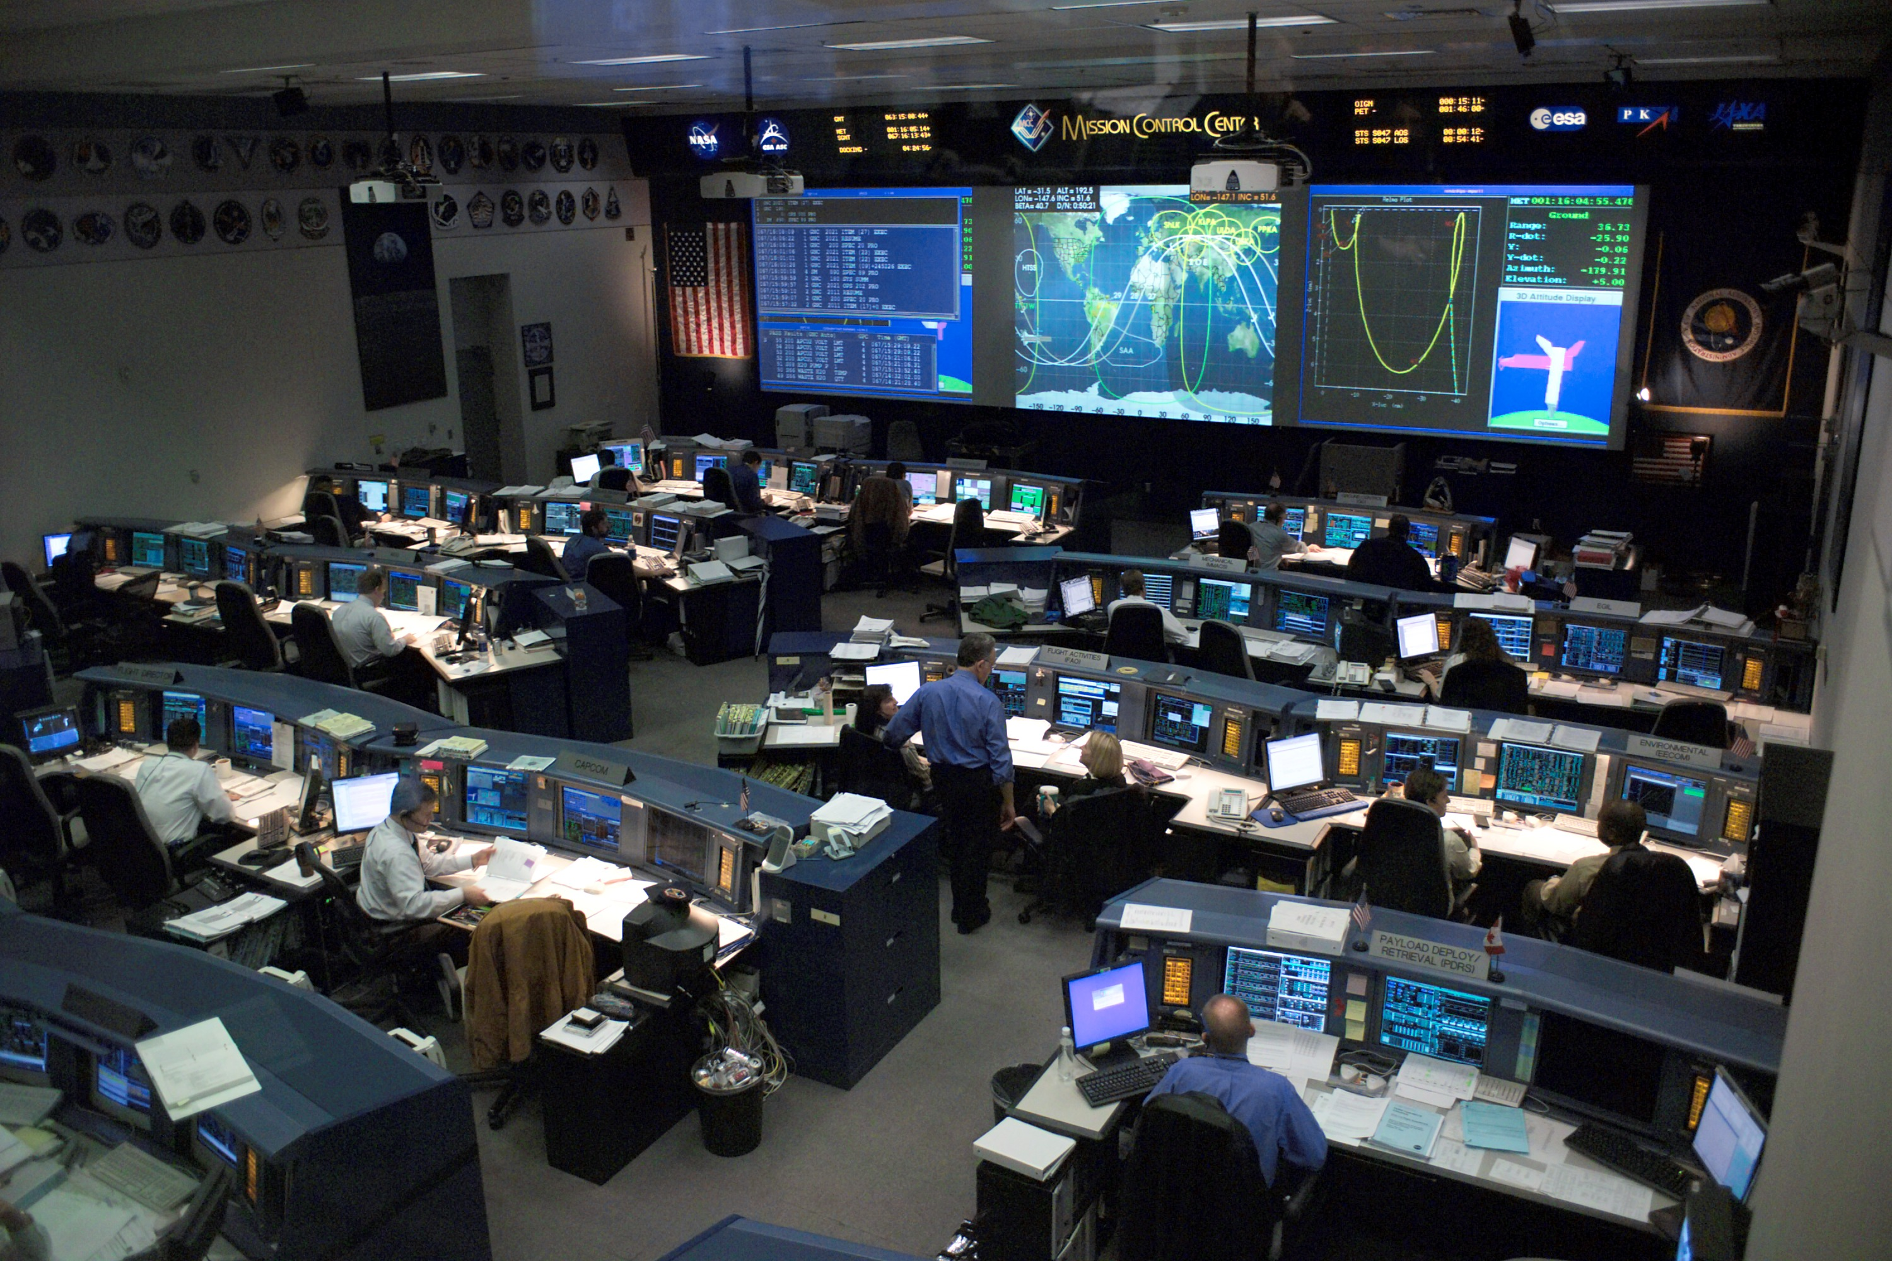
Figure 2-11: The STS Flight Control Room; source: Wikimedia
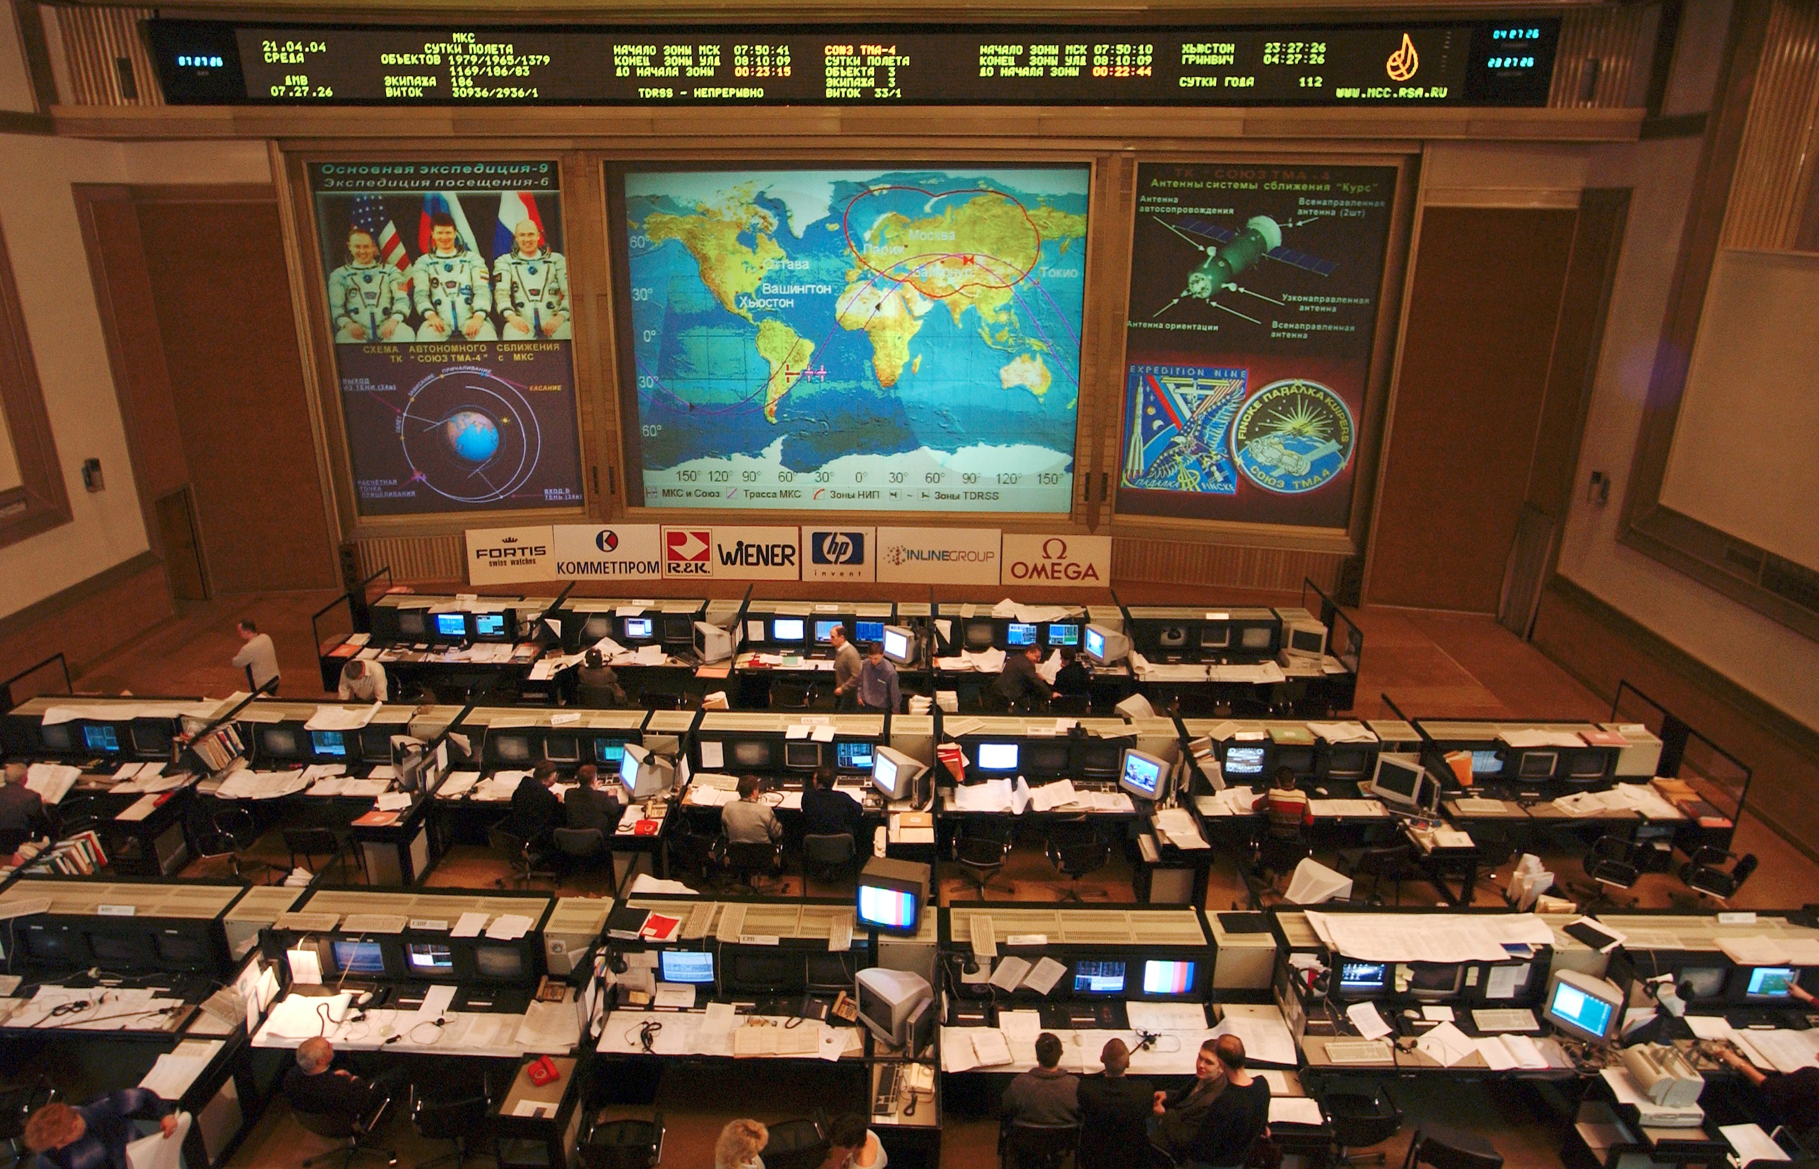
Figure 2-22: The Russian ISS Flight Control Room; source: Wikimedia
Given the real-time nature of their work and the extent of their voice intercommunications, flight control personnel generally require low latency, non-blocking voice equipment with fast access times through defined and administered roles. Complexity of mission support, and the training required to prepare the FCT result in high capacity of always-on conference loops ready for immediate use, thereby easing schedule constraints of voice resources.
Voice intercommunications must be recorded and affixed with appropriate time and flight meta-information for future use and play back. Recording of both individual keysets and whole voice loops is generally required. Archival storage is required.
High reliability, maintainability and availability (RMA) are the hallmarks of the voice intercommunications equipment intended for real-time mission operations support. Internally redundant architectures are typically necessary to reach the levels of RMA required.
At JSC there are several flight control rooms, mission evaluation rooms, and multi-purpose support rooms, each housing members of the flight control team in numbers ranging from 10 to 60 persons. Centralized voice equipment provides the high performance, high capacity voice intercommunications necessary. From launch to orbit, as many as 400 keysets may be engaged at JSC, accessing some 200 voice loops. While most FCT members listen to multiple voice loops concurrently, they are typically limited to talk on only one loop, whereas the CapCom and FD (Capsule Communicator and Flight Director respectively) often use a multi-talk mode – the ability to press PTT (Press To Talk) and have their voice included in up to 8 conference loops simultaneously.
To share voice loops among different centers, a voice loop in one center’s voice switch is connected by commercial carrier to a voice loop in another center’s voice switch, with each switch then serving the population of users in its respective center.
Given the operational concepts of a flight control team the following summarizes suitable voice communication requirements:
- hardware keysets for dedicated appliance-like performance; collocated personnel require low latency voice among themselves;
- up to 10 pages each containing up to 24 voice loops; user configured with user or position defined defaults;
- individual voice loop controls including talk/monitor, monitor only, and volume level;
- each conference loop key is stateful, retaining whatever the current configuration settings are over its default configuration, as the user selects other voice loop pages on which that voice loop is found;
- VoIP hardware and software keysets deployed where low latency voice performance is not a driving requirement;
- voice latency requirements:
- low latency voice at less than 15 ms;
- VoIP latency ranges from about 100 ms to more than 200 ms;
- restricted talk configuration for critical voice loops; e.g., only the CapCom can talk on the air-to-ground loop during launch;
- high capacity includes 1,600 active conference loops, with 3,000 stored conference definitions;
- capacity is expandable to 5,000 connections, whether keysets or external signals;
- for critical flight control use, the central voice switch must have internally redundant voice paths such that no single failure can remove a voice loop from use.
The following context diagram provides a view of a typical centralized voice switch and ancillary equipment supporting human space flight. The diagram well describes the voice communication subsystem used at NASA’s JSC. The block titled External Voice Distribution Equipment provides the equipment necessary to support transcoding among voice and transport technologies such as G.711 to G.729, T1 to E1.
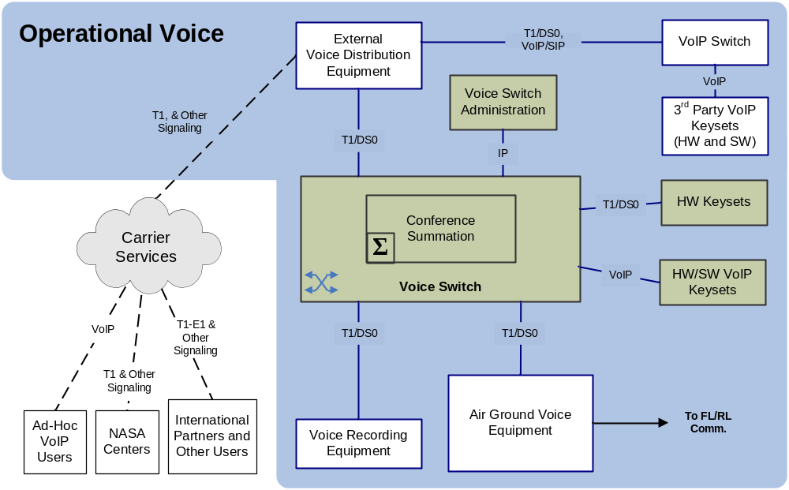
Figure 2-33: Mission Operations Voice Context Diagram
The following bullets provide more detail to the above diagram:
- The central switch complex consists of a Voice Switch and its Conference Summation components. These are Time Division Multiplexing based equipment that provide very low latency, high performance, and high capacity voice intercommunications.
- Interfaces with the central voice switch include
- Keysets. Hardware keysets may be T1 or VoIP connected, software keysets are only VoIP connected.
- External interface; T1 with typical telecommunications signaling options. Additional peripheral equipment may translate and transcode as required for external systems. For instance, a single DS0 channel of a T1 may be defined to carry a specific voice conference for interface with an external secondary voice switch such as a PABX (Private Branch Exchange) or a third party VoIP switch or even the central voice switch of another agency.
- Voice recording equipment provides for both loop and individual keyset recording. Voice recording includes IRIG time stamp for storage and retrieval capability. Voice recording is typically stored digitally on DVD discs, or perhaps a Storage Area Network.
- Local Site Administrator control PCs communicate with the voice switch via Internet Protocol (IP).
Air to Ground Voice Equipment (AGVE), provides interconnect between the central voice switch and the air to ground communications network that communicates with spacecraft. Included in this is any necessary translation and transcoding.
AGVE must accommodate one-way voice communications for crew safety. In the event that voice communication is not actively being received from a spacecraft, AGVE must continue to forward voice communications, for the crew may be receiving but cannot transmit.
The US Space Shuttle employed a Dissimilar Voice (DV) communications during launch and ascent, and during landing. This voice channel through analog UHF radio with Mission Control was delivered synchronously with the Operational Air to Ground channel (A/G-1). The threshold for synchronicity was 7 ms, where if the voice signals of DV and A/G-1 under waveform analysis wander further apart than 7 ms, automated delay equipment adjusted accordingly the DV channel to bring them back into synchronicity.
Whether future human spaceflight programs will use a Dissimilar Voice capability will become apparent with time. If future programs do, the challenge will be different then that experienced on the US Space Shuttle program. For when voice communication is exchanged as network data packets, which is likely in future programs, significant jitter is experienced, estimated to be some 400 ms for the US Constellation Program. And where two uncoupled systems are to render the audio output of voice communication in synchrony, the instantaneous jitter of each data path will have profound effect. A solution is to employ a ‘presentation time’ for each data packet in each voice channel, where the presentation times are calculated to encompass the bounds of expected latency and jitter of each data path. Thus, synchronous processing of voice data by uncoupled and disparate systems is facilitated. A similar concept is found in the specification IEEE 1722 Draft Standard for Layer 2 Transport Protocol for Time Sensitive Applications in Bridged Local Area Network.
Keyset devices typically have a headset with a microphone that converts the voice waveform into an analog signal. A voice codec is then used to convert this analog voice signal into a digitally encoded version. It accomplishes this by using algorithms to convert the analog voice waveform into a digital format or encoding. Choosing which algorithm involves evaluating voice quality verses bandwidth consumption, among other factors. Codecs may simply provide quantized waveform representation, sampled at appropriate rates. Other complex codecs are more CPU intensive, performing psycho-acoustic analysis and prediction of the waveform rendering parameter sets that are a very compressed description of sampled voice, e.g., G.729.
The benchmark coding scheme is Pulse Code Modulation, or PCM. PCM was a product of the development of digital telephony in the 1970s which led to the T-carrier systems that are widely deployed today. PCM samples the voice signal at a rate of 8,000 samples per second and then assign each sample one of the 256 discrete levels using eight-bit code. This yields a data rate of 64 Kbps (8,000 samples/second * 8 bits/sample = 64000 bits/second). The discrete level is assigned in a logarithmic manner as opposed to linear which yields greater resolution with low signal levels, but the digital output is a constant 64 Kbps. In 1988 PCM encoding was standardized by the International Telecommunications Union (ITU) as Recommendation G.711.
The disadvantage of PCM/G.711 is that the bandwidth is a constant 64 Kbps. Speech signals contain some forms of redundancy that could be removed to help compress the output data rate which would in turn reduce the required bandwidth. This is where other bandwidth-reducing ITU codec standards have been developed, some of which are noted here with their corresponding bandwidth: G.722.1 (24/32 Kbps), G.723.1 (5.3/6.3 Kbps), G.726 (16/24/32/40 Kbps) G.728 (16 Kbps) and G.729 (8 Kbps).
Bandwidth saving codecs do come with some caveats. Guaranteed packet delivery becomes more important with the higher compression voice codecs. This is because more voice data is being squeezed into each packet, and the loss of a packet between the source and destination keyset will result in the loss of that part of the voice stream. This could be problematic in mission support when a series of numbers is being communicated.
In addition, codecs with significantly reduced bandwidth usage have the penalty of increased latency due to the sampling of a period of voice and the processing of that sample period.
Voice Summation: Voice summation remains an area of legacy equipment. High performance and low latent voice intercommunication systems utilize Time Division Multiplexing (TDM) for the ‘voice bus’ and G.711 or other waveform quanta codecs for voice encoding and summation. A voice loop ‘talker’ consumes one slice of the TDM voice bus to carry their voice. Another slice of TDM carries the summed voice loop audio. The central switch either decodes the two audio voice slices and mixes them in an analog fashion, or provides a code book look-up for “adding” the voice quanta together. The resulting audio is the ‘summed’ voice of the talker and the voice loop, and this audio is placed back into the voice loop slice of the TDM voice bus for all to hear.
Voice summation with lossy codecs such as G.729 or G.722 is problematic, for the voice data must be decoded to waveform codec like G.711 or even to analog voice in order to create a conference, or voice loop. It is simply not possible to ‘add’ lossy codec voice data together. With each encoding/decoding of a lossy codec, voice quality is degraded.
Wideband Voice Codecs: Wideband codecs are available, such as G.722.2. Telecom standard toll quality voice (G.711) is considered narrow-band with a frequency range of 300 to 3,400 Hz, whereas wideband codecs are 50 to 7,000 Hz. This provides better audio acuity for plosives and fricatives - speaking the letters p, t, k, d, b, and of the letters s, f, v, z, respectively.
While wideband codecs are used in some VoIP internet telephony applications and in some cellular systems, conventional telecommunications infrastructure supports only narrow band and requires transcoding at boundaries resulting in the loss of the extra frequency data of the wideband codecs. However, the use of wideband codecs is on the increase, and this will prove a challenge to mission voice communications in the future.
Latency, jitter, and packet loss: Voice quality is affected by all three of these factors.
Latency - the delay of voice communications due to the following:
- transport delay:
- light time delay;
- ground network transport delay;
- processing delay: the encoding and decoding of voice, along with the associated buffering of analog voice signal;
- packet size buffer delay: where applicable, latency may be incurred when multiple samples of voice data are collected prior to transport;
- boundary delay: the buffering, processing and possible transcoding at the boundaries between transport domains.
Jitter – variations in the interval and arrival time of individual voice packets. Queuing and multiplexing of disparate data types and sizes within a communication channel results in some manner of jitter. Transports layer framing may have an impact on jitter.
Packet Loss – Normally occurs in IP networks as a result of network congestion, where incoming packets are thrown away. Within RF networks, packet loss may be due to signal loss or fade, or a too tight link budget. The impact on voice of an occasional random packet loss is negligible, but the impact for excessive packet loss is poor voice quality or loss of voice communications entirely.
Voice quality: Voice quality measure is possible through automated and subjective human evaluative methods. The long standing telecom standard MOS (Mean Opinion Score) is 4.0 to 4.2 for G.711 encoded voice. Wideband codecs (e.g., G.722.2) may result in higher comparative scores, while narrow band digital compression codecs (e.g., G.729) may result in lower comparative scores.
The DRT/DAM testing (Diagnostic Rhyme Test / Diagnostic Acceptability Measure) provides for measuring intelligibility of voice communications.
Whereas the quality standard has been the MOS of G.711 encoded voice, the increasing use of wideband codecs will likely result in a new expectation for quality voice communications. As terrestrial systems evolve to handle wideband codecsthe use of such codecs in human space flight can be expected.
Meta Information for Voice Data: Traditional archival of voice data related to human spaceflight has been an administrative function. Voice is recorded with accurate date and time information, and that information is correlated with mission events by way of a method outside of the voice archive. Internet protocols provide for additional voice meta information, such as the source identifiers in RTP, and voice extensions in XML can provide richer meta information to a voice archive. Such architectural shifts have yet to implemented but the they are on the horizon.
Record and Storage of Voice Data: Codecs which are most effective here store data at high compression rates without significant quality loss to optimize the efficient use of storage facilities. However, the cost of storage and archival media may allow the storage of voice data in its captured format.
Private Conferences: Private conferences occur with family and friends, a flight surgeon or other participants where private voice communication is desired by the participants or required by law. Executing a private conference is largely an administrative function of the voice technicians for Shuttle and ISS. Function keys provide the voice tech the ability to swing a forward link and return link voice channel from a common air-to-ground or space-to-ground voice loop to a private conference loop. Authorized parties are then connected to the private conference loop. Voice tech personnel also check and disable other interfaces as may be necessary to ensure a private conference.
Once the parties are connected and voice checks complete, the voice techs themselves disengage from the private conference and monitor voice performance only through audio meter readout of the circuits involved. The private conference continues as scheduled or until a designated party calls to notify the voice techs that the private conference has ended.

Space Transport System
The United States Space Transport System (STS), or Shuttle, uses an adaptive delta modulation codec in its space to ground voice communications. With a nominal forward communications link of 72 Kbps there are 2 voice communication channels at 32 Kbps each for a total of 64 Kbps, the remaining 8 Kbps for command/telemetry. The return link is at 192 Kbps, with the 2 voice channels there remains 128 Kbps for command/telemetry. For Shuttle down-mode to the 32 Kbps low rate on the forward link, a contingency mode, only one voice channel transmitted at 24 Kbps.
Voice data is contained in the forward and return links over S-band through the TDRS (Tracking and Data Relay Satellite) system. The transport protocols are proprietary and do not reflect CCSDS standards. However, voice data resides in specific and periodic bits of the space link akin to the CCSDS concept of Insert Zone.
During pre-launch, launch and for about 6 minutes of ascent, the operational link (command/telemetry/voice) over S-band is exchanged through a launch head ground station at KSC. A roll-to-heads-up maneuver turns the shuttle spaceward and the S-band re-locks to the TDRS system.
UHF dissimilar voice (DV) provides a separate and parallel path for voice communications during launch and landing. Being UHF, it is unaffected by the Shuttle plume, which can block S-band. And when the shuttle rolls heads up to re-lock S-band on TDRS, the DV link remains locked with the launch-head ground station. DV is synchronized with the S-band primary voice communications by way of inspecting the forward data at the launch head and UHF DV signal delay equipment at JSC. The DV capability is also used when a shuttle lands at KSC. Signaling and keying remains a fixture, being necessary to key the UHF transmitter to switch between send/receive.

International Space Station
The International Space Station (ISS) utilizes MRELP (Modified Residual Excited Linear Predictive) a codec with data rate at 9.6 Kbps) for space to ground voice communications. As originally designed, the MRELP voice system was intended only for the early stages of ISS construction after which it was to become the backup voice system. However a primary voice system was never installed.
Additional voice channels for ISS are being planned and implemented using VoIP G.729 within RTP/UDP/IP. These additional channels are not intended for use in primary flight operations.
ISS also supports ham radio communications primarily as a public affairs capability. UHF voice communications are used during proximity and docking operations with approaching crewed spacecraft.

The US Constellation program
The US NASA Constellation Program specified a VoIP voice communications capability with the Orion capsule, G.729 in RTP/UDP/IP for air to ground voice communications through CCSDS AOS Encapsulation Service and multiplexed with command and telemetry. Initial EVA voice communications capability was specified as tethered LPCM to the Orion capsule.Additional voice communications capabilities were to include Emergency Communications (EC), Dissimilar Voice (DV), and Search and Rescue (SAR) voice communications
Emergency Communications: Emergency Communications (EC) was an outgrowth of the Apollo 13 experience where a near catastrophic failure led to a severe power shortage that required many on-board systems to be powered down. The concept for Orion was that some systems may be powered down, including the primary radio equipment. Low power EC equipment could then be engaged to transmit voice as well as a very limited amount of command/telemetry at a rate of perhaps 12.4 Kbps.
EC voice was encoded as G.729 data and transmitted over CCSDS AOS VCA (Advanced Orbital Systems Virtual Channel Access) with no IP/UDP/RTP protocol wrapping.
Dissimilar Voice: Dissimilar Voice (DV) provides assured voice communications through a parallel voice communications link with the crew during pre-launch, launch and ascent. Both ground operations and mission operations utilize DV. For Constellation, DV was specified as G.729 encoded voice exchanged through S-Band RF from ground stations at the launch site and other selected sites as required to accommodate ascent trajectories. CCSDS AOS VCA service was the expected transport packaging. Given the latency and jitter expected with the communications systems, the Constellation Program determined that onboard synchronization of DV with the primary voice communications was required. This was to be accomplished through the processing of the respective ‘presentation times’ associated with each frame of voice data and given their respective communication channels.

Voice connectivity among agencies

General
Voice communication is one of the crucial mission applications running over the International Ground System Wide Area Network (IGS WAN). Consider the following mission control centers are:
Columbus CC (COL-CC)
MCC-Houston (MCC-H)
Huntsville Operations Support Center (HOSC)
Automated Transfer Vehicle Control Center (ATV-CC)
European Astronaut Center (EAC)
MCC-Moscow (MCC-M)
Each center has one or more voice conferencing systems. These conferencing systems interconnect using synchronous TDM-based (E1/T1) interfaces. The exception is MCC-M, for between MCC-M and COL-CC there are 12 voice loops exchanged using Cisco-based VoIP.
The interface definitions at various sites for the voice conferencing communication is as follows:
- MCC-H (E1) to COL-CC (E1) - redundant, Prime to Prime and Backup to Backup
- HOSC (2xT1) to COL-CC (E1) - only Prime to Prime
- ATV-CC (E1) to COL-CC (E1) - redundant, Prime to Prime and Backup to Backup
- EAC (E1) to COL-CC (E1) - only Prime to Prime
The following table details the voice loops that may be configured between the various agency centers. Multiple configurations provide for the mapping of a large number of voice loops over a smaller number of physical circuits bridging between the agencies to accommodate different scenarios and mission phases.

CSA – MCC-H | Six major configurations provide concurrent access to between 64 and 66 voice loops
JAXA – MCC-H | Six major configurations provide concurrent access to between 22 and 78 voice loops
COL-CC – MCC-H | Three major configurations provide concurrent access to up to 48 voice loops
MCC-M – MCCH | Three major configurations provide concurrent access to up to 48 voice loops
COL-CC – MCC-M | One configuration provides concurrent access to 12 voice loops
Presently the E1/T1 synchronous voice communication is transported over the WAN using Circuit Emulation over ATM. With the MPLS migration and deactivation of ATM network components this solution will not be available.
However, it was determined the all potential providers are having difficulties transferring synchronous TDM-based interfaces and communication protocols over the packetized MPLS networks. Thorough analyses and testing is needed to determine the best possible solution for the synchronous communication between the voice conferencing systems of the noted mission control centers.

implementations
There are various options available:
Separate synchronous Leased Lines
For the test phase, an E1 to E1 Lease line will be activated between EAC and COL-CC checking out the correct operation of the voice interfaces and communication using such line between the two sites.
A T1 to E1 Leased Line between HOSC and COL-CC and has the following:
Advantages:
- provision of needed synchronous communication and interfaces;
Disadvantages:
- no coherent communication platform;
- reduced visibility (status, management interface) – operational aspect;
- conversion needed for the MCC-H voice interface – provider delivering T1 interface in the USA. MCC-H needs an E1 interface (T1 to E1 converter needed);
- rigid setup/flexibility (in case of a failure no rerouting is available);
- extra costs.
Cisco Routers
TDMoIP using Cisco routers with dedicated interface cards (router with TDM interface card would be operated by the Service Provider), and has the following:
Advantages:
- unified platform;
- no additional communication costs;
- better flexibility than the dedicated leased lines.
Disadvantages:
- this is not a standard product being offered by the Service Provider;
- as the TDM routers would be managed by the provider the visibility and manageability would be reduced.
RAD Mux
TDMoIP using RAD high clocking accuracy TDM to IP converters: IP-MUX (IP-MUXs would be operated by COL-CC)
Based on latest information and analyses RAD seem to have an edge in implementing TDMoIP solutions. It is the company with most experience (strong involvement in TDMoIP standardization) and advanced technology available (special units with high clocking accuracy available)
Advantages:
- unified platform;
- no additional communication costs;
- better flexibility than the dedicated leased lines;
- good visibility and manageability (own-managed units – could be integrated in IMS with using SNMP).
- Disadvantages:
- extra costs.
Recommendation:
From engineering, operational and commercial perspective the RAD-based TDMoIP solution is preferred.
A key factor is the clocking of the synchronous voice communication components.
Nevertheless for all solutions, the most important qualification criteria are: operational reliability, and voice communication quality.

PABX IP Migration
Given the migration of a WAN ATM to an MPLS link, PABX-Telephony Exchange Units must then be migrated.. Presently the PABXs offer ISDN/analogue user interfaces at various sites. They are able to communicate directly over the WAN with each other and also with the main PABX units in COL-CC.
Current configuration of the PABX includes user initiated communication (DSS signaling) is mapped on to the WAN interface into ATM SVC signaling using QSIG. The ATM addressing of the PABXs is set up into a CUG (Closed User Group) with private numbering scheme.
For migration, the following PABX specific services are to be transferred over the MPLS network:
- ATV-CC keyset communication between MCC-M and ATV-CC;
- analog internal telephony between MCC-M and COL-CC;
- ISDN management interfaces in MCC-M (no ISDN available at MCC-M).
The PABX platforms to be migrated include the COL-CC Prime and Backup, MCC-M, ATV-CC.

Technical Drivers

Introduction – Overall Approach
The table and illustrations below describe the overall scenario for lunar missions and can be transposed for Mars missions.
In short, voice communications can be summarized in 4 defined segments:
- Earth segment;
- lunar or Mars segment;
- short-haul segment;
- long-haul segment.
Table 3-11: The Voice Segments
Voice Segments | Description | Technical Constraints
Earth ground | Control center system and interfaces to other control centers and remote users, | Conference loop capability  Point to point  Latency for co-located personnel  Criticality, availability  Bidirectional network  Continual comm.
Lunar or Mars ground | Voice communications between EVA, Habitat, Rover | Conference loop capability  Point to point  Latency for co-located personnel  Criticality, availability  Bidirectional network  Continual comm.
Short-haul: near Earth, near Moon, near Mars | Voice communications to through orbital nodes to and among ground nodes, whether around the Earth, Moon or Mars | Point to point  Criticality and availability  Channelization and bandwidth  Intermittent to continual comm.  Bidirectional to non-bidirectional
Long-haul: Moon to Earth, Mars to Earth | Mars to Earth voice communications | Point to point  Criticality and availability  Channelization and bandwidth  Intermittent to continual comm.  Bidirectional to non-bidirectional
Figure 3-4 depicts the following:
- lunar ground segment;
- lunar short-haul segment;
- lunar to Earth long-haul segment.
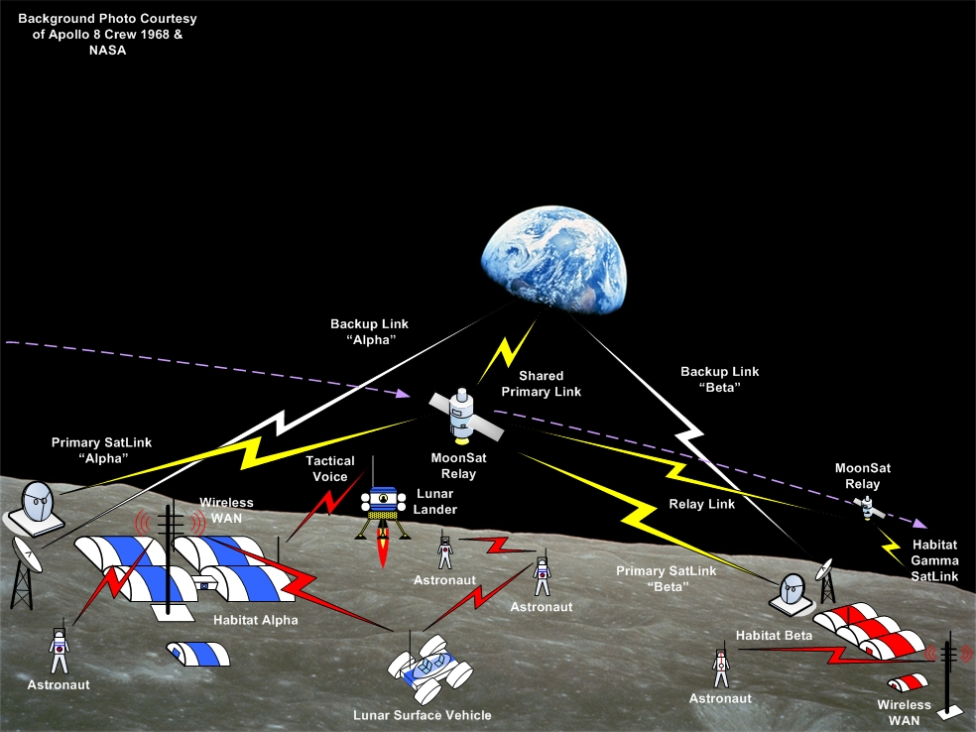
Figure 3-44: Lunar Surface Operations

Earth Segment

General
The earth segment is characterized by a collection of control centers, many having their own voice conferencing systems connected with each other via a limited number of parallel voice channels. Each center may have a number of remote voice users connected via VoIP/Internet, or ISDN, or other means. Commercially available equipment tends to dominate the Earth segment; consider the telecommunications, Internet, and networking domains.

key drivers
Latency: For co-located users, e.g., a FCT in a flight control room, voice latency must be near to the normal sound travel time among the users. For point to point connections, latency becomes much less an issue.
Channelization: Provide channelization of voice communications between centers for configuration management and security reasons.
Criticality/availability: Voice systems and their interfaces are critical capabilities. Experience shows that when they do not work, back-ups are immediately necessary. Hence not only should voice systems be on failure tolerant equipment, but their external interfaces should be supported by redundant communication channels as well with easy if not automatic fail-over.
Table 3-22: Communications Options
Layer | Mechanism | Comments
Physical | E1, T1, 802.3, DSL
Data Link | MPLS, ATM, X.21
Network | IP (SDP, RTCP, RTP, SIPv2), DTN | For interoperability point of view
Transport | TCP/UDP (IP), TDM, other | What other mechanism exists at transport level which would not be IP related?
Session |  | PTT?
Presentation layer | G.711, G.729, G.722, G.728, etc.
Application | Voice summation  Voice Recording/playback
CODEC: A number of compression schemes exist and are employed today. It is in the interest of interoperable agencies to adopt a common scheme for compression to avoid multiple protocol conversions at interface boundaries, which results in a degradation of signal and the possible introduction of audio artifacts.
Connectivity: Since it is possible to communicate compressed voice without using Voice/IP (VoIP), the question remains whether intercenter communications should or not be based on VoIP. With the advancement of VoIP conferencing, VoIP may be quite important, and for remote users this seems to be the ideal option. Other technologies have a place in voice connectivity or distribution:
- ATM: allows circuit based emulation;
- MPLS: does not allow circuit based emulation, but has acceptable QoS/performance;
- IP (Internet): characterized by poor quality, packet loss but it is ubiquitous and relatively inexpensive;
- ISDN (X.21): to be avoided for costs reasons in an operational setting (but is useful for early testing/development).

Functional Aspects:

Voice summation and conferencing
It is likely that the requirement for large voice conferencing systems in the various control centers will remain for the foreseeable future. In these centers the following important factors remain:
- the number of keysets (i.e., users);
- the number of voice loops (voice conferences);
- the number of keysets (users) connected to any individual voice loop;
- the number of voice loops to which any individual keysets may be connected;
- the latency experienced by co-located users on common voice loops;
- the number of channels allocated to various external interfaces.
The high performance, high capacity central voice matrix remains TDM based voice processing and switch equipment. VoIP may serve as a distribution technology, but as of yet, VoIP solutions have not emerged to adequately address the above noted factors.
However, IP based voice conferencing technology is evolving and may allow a less centralized scheme of voice conferencing by increasing the number of voice summation nodes in a network, replacing what is today a star topology with meshed connectivity, and which can be dynamically redefined according to mission needs.

Channelization
It is important to define a limit for the number of channels available between centers as an unlimited number of channels would quickly allow the definition of too many loops between centers. Managing the number of loops between control centers is a key configuration issue.

Security
On the Earth segment security for voice links is important for:
- ensuring access control to the voice systems;
- ensuring the privacy of medical conferences; or
- ensuring the privacy of ‘private’ calls (crew family conferences);
- ensuring the confidentiality of voice communications related to critical operations or events;
- controlling access to voice records.
Voice system access is traditionally based on username/password, sometimes on digital certificates (e.g., via a LDAP server). Voice recognition could be a future method for authentication.
Ensuring privacy or confidentiality: different techniques have been used traditionally such as voice scrambling and more recently encrypting digital voice communications. It should be noted that the need to store encrypted voice links in an encrypted format (and being able to decrypt the recorded voice) implies specific challenges in key management and implies metadata is carried by the voice signal which includes the key ID.

local segment (Lunar or Mars on ground)

General
Local segments, whether lunar or Mars ground segments, are likely to be dominated by the use of existing commercial telecommunications and networking capabilities adapted from the Earth ground segment. To overlay of these technologies upon hardware and the physical layers of communications in harsh environments will be a significant challenge..

Key drivers
This segment is the one that in the global scenario is defined by a local infrastructure composed of vehicles such as rovers (with crew or not), crew and teams in suits (EVAs), habitat modules, science modules, and perhaps communications infrastructure modules. The main driver is the criticality of the voice channels given the dangerous activities performed by the crew during EVAs:
- voice communications for EVA/rover need to be redundant;
- the voice intercommunications interface may be voice activated to select voice channels by EVA/rover;
- emergency voice channels need to be available.
Table 3-33: Communications Options
Layer | Mechanism | Comments
Physical | 802.3, 802.16, Wireless LAN, RF links
Data Link | 802.3, 802.16, Wireless LAN, RF links
Network | IP (SDP, RTCP, RTP, SIPv2), DTN, CCSDS | DTN only considered from interoperability point of view
Transport | TCP/UDP (IP), | What other mechanism exists at transport level which would not be IP related
Session
Presentation layer | G.711, G.729, G.722, G.728, etc.
Application | Voice summation  Voice Recording

Functional aspects

Voice summation
Voice loops, or voice conferences, shared among the members of a working team on EVA is required. Voice latency of the voice loop should be very low for those co-located. For example, two suited crew members working as a team may desire low latency voice between themselves, while the communications link to distant support personnel may experience a far longer latency.
In addition, it seems clear that as ground operations grows in complexity, multiple voice loops capability is necessary to support multiple and concurrent activities.

Secure Communications
Secure and confidential communications should be built into the capability.

Emergency Communications
In the event that communications with central modules is somehow interrupted, emergency communications capabilities should exist, whether to orbiting satellites or at a low level directly back to earth.

Mesh Capability to Mitigate Redundancy
Interoperable nodes or mesh-capable nodes would be ideal for a lunar or Mars local segment. In this concept any node can relay voice communication traffic to another node. This would allow EVA1 to communicate with the habitat via EVA2 in case EVA1 experienced loss of signal with the habitat.

short-haul segment

Key drivers
Bandwidth and channelization begin to be an issue with short-haul segments, though more so with long-haul segments. For the short-haul bandwidth must be shared with other traffic, and with prioritized traffic.
Table 3-44: Communications Options
Layer | Mechanism | Comments
Physical | RF transmission, optical communications
Data Link | AOS, CCSDS Encapsulation Service, Prox 1,
Network | IP (SDP, RTCP, RTP, SIPv2), BP,
Transport | /UDP (IP), | What other mechanism exists at transport level which would not be IP related?
Session
Presentation layer | , G.711. G. 722., G.728, G.729.
Application | Voice summation, Recorder
There are a number of options that may be explored for voice services in a local lunar or Mars segment. Some will parallel the technologies employed for voice communications on Earth. The following are a representative but by no means an exhaustive list:
- Option 1: Voice over DTN (with or without IP);
- Option 2: Voice over AOS (multiplexed voice traffic);
- Option 3: VoIP over CCSDS Encapsulation packet ;
- Option4: VoIP over typical network topologies

long-haul segment

Key driverS
Several key drivers exist in regard to long-haul segments. Consider the following:
- latency;
- channelization, bandwidth utilization, and traffic prioritization;
- secure communications;
- intermittent, bidirectional and unidirectional connectivity.
Table 3-55: Communications Options
Layer | Mechanism | Comments
Physical | RF transmission
Data Link | AOS, CCSDS Encapsulation Service
Network | IP, DTN, CCSDS
Transport | AMS/CCSDS, SMTP/CCSDS, FTP/CCSDS | What other mechanism exists at transport level which would not be IP related?
Session |  | PTT?
Presentation layer | MP3  AAC
Application | E-mail, Message service, CFDP

Functional Aspects

Latency
Latency in the Earth to Mars long-haul segment is a factor of the light-time necessary to space the distance. The one-way light time to Mars ranges from a minimum of about 5 minutes to a maximum of about 20 minutes. This latency will have an impact on the nature of voice communications.
Latency in the Earth to Moon long-haul segment is about two seconds, and thus the voice processing delay begins to impact total latency. A lunar crew member talking with an earth based support team member should expect a five second interval, at the least, between the end of their utterance and the beginning of a response utterance from Earth.

Channelization, Bandwidth Utilization, and Traffic Prioritization
As the operations of a lunar or Mars outpost may increase in complexity, crew population, science and in-situ activities; over-subscription of the long-haul bandwidth may become an issue. Bandwidth utilization must be long planned for and traffic prioritization schemes considered and employed.

Secure Communications
Secure communications is necessary to support the safety of the crew, and to support the private nature of personnel health and family conversations. In addition, as science and in-situ work increases, the associated data may be proprietary in nature and thus should be communicated through secure channels.

Intermittent, Bidirectional and Unidirectional Communications
Long-haul communication links to distant relay satellites and outposts may be intermittent in nature. Earth based assets used in the communications link may not have 24x7 line of sight with the distant node. In addition, the connection may be of such a latent nature that it should perhaps be considered a unidirectional link.

Acronyms and Abbreviations
Term Meaning
AGVE Air-Ground Voice Equipment

CCSDS Consultative Committee for Space Data Systems

CODEC Code-Decode
DV Dissimilar Voice
DVIS Digital Voice Intercommunications Subsystem
DSN Deep Space Network
FCT Flight Control Team
IEEE Institute of Electrical and Electronic Engineers
IP Internet Protocol
IP-MUX IP Multiplexer, demultiplexer
IRIG Inter Range Instrumentation Group
ITU-T International Telecommunication Union – Telecommunications
JSC Johnson Space Center
Kbps Kilobits per second
LPCM Linear Pulse Code Modulation

MOVE Mission Operations Voice Enhancement
MPLS Multi-Protocol Label Switching
MRELP Modified Residual Excited Linear Predictive
NEO Near Earth Object
OCA Orbiter Communication Adapter
PABX Private Automatic Branch Exchange
PTT Press to Talk
RAD RAD Data Communications company
RMA Reliability, Maintainability, Availability
SNMP Simple Network Management Protocol
STS Space Transport System
TDM Time Division Multiplexing
TDMoIP TDM over IP
TDRS Tracking and Data Relay Satellite
UHF Ultra High Frequency
VoIP Voice over IP
WAN Wide Area Network

Codec Short descriptions
The following is a selection of short descriptions of existing voice codecs. Other codecs exist and are not included here.
  - G.711
International Standard PCM Stream encoding telephone audio on 64Kbps channel:
- ITU–T G.711 Recommendation compliant
- Sample rate of 8 kHz, 8 bits per sample
- T1 platform compatible and available on any Digital Signal Processor and other platforms
- Normally 64 Kbps, can expand output rate to 104 and 112 Kbps
- A-law or m-law compressor output
- Selectable frame/buffer memory size according to system
- Usually simple API interface
- Compliant with non-eXpress DSP Standard
- Products need to be code re-entrant supporting multi-threading
- Dynamic memory allocation, can also allow static memory allocation
- Should be portable to any platform
- Usually thought of as good for resource (Band Width) constrained operations.
  - G.722
A wide-band voice codec in that the audio samples are twice that of G.711 and other traditional telcom codecs:
- ITU-T B.722 Recommendations compliant
- Sample rate of 48Kbps, 56Kbps, or 64Kbps, 14 bits per sample
- Based on Sub-Band Adaptive Differential Pulse Code Modulation (SB-ADPCM)
- Effective audio and speech compression for storing voice, digital circuit multiplication and telephony operations
- Provides direct interface with the PCM 8 KHz sampled data.
- Can process sample to sample, or from blocks of different length
- Compliant with TI’s eXpressDSP
- Code is normally re-entrant supporting multi-threading and dynamic memory allocation, can also enable static memory allocation
- Variants include G.722.1 and G.722.2
- Considered effective for situations in which Band Width is constrained and easy to integrate with applications.
  - G.723.1
A voice codec for digital circuit multiplication equipment (DCME) applications, audio/video conferencing and other multi-media devices:
- ITU-T G.723.1 recommendations.
- Sampling 8 kHz, 16 bits per sample
- High rate based on Multi-Pulse Maximum Likelihood Quantization (MP-MLQ), low rate on Algebraic Code Excited Linear Prediction (ACELP)
- Annex versions support Voice Activity Detection, and Comfort Noise Generation
- Code is normally re-entrant and supports multithreading and dynamic memory allocation
  - G.726 (Based on ADPCM)
Used primarily overseas trunks of the telephone network, as well as voice data storage and other telephony applications.
- ITU-T G.726 Recommendations compliant
- Bit rates include 16 Kbps, 24 Kbps, 32 Kbps, and 40 Kbps
- Based on Adaptive Differential Pulse Code Modulation (ADPCM)
- Sample based or block based input, A-law, 3-law, & 14 bit uniform 8kHz PCM input/ output
- Can process blocks of different lengths
- MIPS and memory optimized versions are available
- Compliant with T1’s eXpressDSP
- Code is normally re-entrant and supports multi-threading and dynamic memory allocation. Also allows direct interface to enable static memory allocation.
- Optimized for resource constrained applications.
  - G.728
A low latent codec used for voice data storage and voice communications:
- ITU-T G.728 and G.729 Annex 1
- Bit rate at 16 Kbps stream rate
- Based on Low Delay Code Excited Linear Prediction (LDCELP)
- Sample based or block based analog input
- Low latent at 0.625ms frame size with 0.625ms algorithmic delay
- Direct interface with 8KHz PCM sampled data
- Compliant with TIs eXpressDSP
- Code is normally re-entrant and supports multi-threading with dynamic memory allocation
- Allows direct interface to enable static memory allocation
- Considered good for high quality speech, low MIPS requirements and ease of integration
  - G.729.1
A primary codec for Voice over Internet Protocol (VoIP) applications:
- ITU-T G.729.1
- Scaleable bit rate 8-32Kbps
- Has multiple annexes (A, B, C, D, E, F, G, H, I, J, C+)
- Annex J provides a wide-band version, where the frequency range is 50 Hz to 7 kHz, known also as G.729.1
- Outputs a frequency range of 50-4000Hz at 8Kbps and 12Kbps rates
- Supports digital signal samples rate of 16kHz and 8kHz
- Uses CELP algorithm, and TDAC algorithm
- Considered very high quality audio speech results, and a robust codec system.
  - CVSD
Continuously Variable Slope Delta Modulation (CVSD), a voice encoding method used primarily in the military for digitally encrypted voice communications, an option for Bluetooth service:
- Not an ITU recommendation
- CVSD encodes voice at 1 bit per sample, to bit rates of 9.6 Kbps to 128 Kbps
- Immune to noise, robust to bit and synchronization losses, highly portable, and highly optimized.
  - GSM
Global System for Mobile Communications (GSM) is a popular voice encoding for mobile communications:
- ETSI 1987
- GSM 06.10 RPEL.TP (Regular Pulse Excitation-Long Term-Prediction-Linear Predictive Coder)
- Sample rate of 8kHz results in 200Hz -3.4kHz audio at 13Kbps
- Considered highly optimized code for situations where resource are constrained.
- Extensions include: Enhanced Full Rate (EFR) GSM; Adaptive Multi-Rate Narrow Band (AMR-NB); Adaptive Multi-Rate Wideband (AMR-WB); a Hybrid ACELP/TCX Technique GSM AMR WB+,
  - EVRC
Entrance Variable Rate Code (EVRC) provides improved error performance in variable rate operations.
- TIA-EIA-IS-127
- Relaxed Code Excited Linear Predictive (RCELP) algorithm, modified for variable rated operations, and for robustness in the CDMA (Code Division Multiple Access) environments
- Rates include 9.6 Kbps, 4.8 Kbps, and 1.2 Kbps
- Considered highly optimized and ideal for resource constrained applications.
  - iLBC (Low Bit Narrow Band
Internet Low Bit Codec (iLBC), provides somewhat higher voice quality over G.729 yet with being robust to packet loss.
- Conforms with and Exceeds (in Quality) G.729A, and G.723.1.
- Operates at 13.3 Kbps, and 15.2 Kbps Rates. Frame size is 30ms for 13.3 Kbps, and 20ms for 15.2 Kbps.
- The code has been optimized for constrained resource applications.

Voice Technology survey summary
NOTE – The following is a collated summary of the Voice Technology Surveys returned from the various space agencies that chose to respond. By 2005
  - Detail which voice encoding technologies are in use or planned for future use. Enter the information here or in the table below. Add additional encoding schemes if necessary.

Ground-to-Ground
ITU-T G711,G.729,PCMA.
ISDN circuit to connect with other organizations.
VoIP connection between routers, and codec is G.729.
4-wire analog is in use between the router and the voice system.
4-wire analog is converted into G.729 codec at the router.
G.711 codec is in use for JAXA internal voice system.
G728, G722 after the MPLS migration the intention is to use G.711 everywhere. Now is under testing in the test bed of MPLS.
G.711, G.729, and G.728 to/from International Partners. G711u - G.711a conversion, T1 - E1 conversion at international boundaries.
Flight-to-Ground
No direct connection, use interfaces with NASA and RSA.
HOSC Interface _E1/T1 interface, uses G.728 and G.711 (16 bits, 16.000 sample rate).
MCC-H (JSC) E1 to analog using a matrix and G.728.
MCC-M (Moscow) E1 using G.728.
After migration is planned to used G.711 for all the interfaces.
ISS: MRELP at 9.6 Kbps.
STS: Delta Modulation at 32 or 24 Kbps.
Future NASA codecs include G.729.

Table C-66: Representative List of Voice Codecs
Encoding | Type | Sample Rate | ms per Frame | Size Bytes | Ground-to-Ground  Current or Planned? | Space-to-Ground  Current or Planned?
DVI4 | sample | var. |  | 20
G.722 | sample | 16,000 |  | 20 | Current
G.723 | frame | 8,000 | 30 | 30
G.726-40/32/24/16 | sample | 8,000 |  | 20
G.728 | frame | 8,000 | 2.5 | 20 | Current
G.729A, D, E | frame | 8,000 | 10 | 20
G.729, G.729A | frame | 8,000 | 10 | 20 | Current and future use
GSM | frame | 8,000 | 20 | 20
GSM-EFR | frame | 8,000 | 20 | 20
L8 | sample | var. |  | 20
L16 | sample | var. |  | 20
LPC | frame | 8,000 | 20 | 20
MPA | frame | var. | var.
PCMA | sample | var. |  | 20 | Current and future use | Future Use
PCMU | sample | var. |  | 20 | Current and future use
QCELP | frame | 8,000 | 20 | 20
VDVI | sample | var. |  | 20
ADPCM |  |  |  |  | Current and future use
  - Rate the voice quality of the voice codec(s) from the previous question.

Ground-to-Ground
Not Acceptable _____
Acceptable G.729A; X
Superior G.711, ADPCM
Flight-to-Ground
Not Acceptable _____
Acceptable X, ISS is acceptable, though it is considered that Shuttle as voice quality.
Superior _____

Comments:
Inside of Europe is the quality of the communication is very good, sometimes we have problems with Houston because of issues with the HiQue cards of the Matrix and we HOSC with some background noises and low levels caused by the conversion T1/E1
  - Has voice encoding/decoding latency been an issue?.

Ground-to-Ground
Yes _____
No G.711: <10ms; X
Flight-to-Ground
Yes _____
No X

Comments:
For NASA/JSC internal use voice latency is not present is the existing voice system called DVIS.

  - Has voice latency been measured, if so what is the measure or range of measure (e.g., Voice Latency measured from keyset to keyset is 5 milliseconds, 125 milliseconds for VoIP keysets)?

Within a single facility
< 10ms; 10ms.
DVIS has 1 to 2 ms latency.
VoIP solutions have been tested from 70ms to 198ms.
Between two or more facilities
50msec locally; 50ms Europe, 150ms other facilities.
VoIP: 60 to 200msec in case of connecting with foreign organizations; Between 60 and 150 ms.
G.711 over T1 is about 40ms, G.729 is about 70ms, these measured at the mux/demux equipment and does not include additional voice switch latency.

Comments:
The latency is strong related to the network. Because the system is using with some centers ATM PVCs, with others -like EAC -matrix to Matrix with PABx and others just ISDN BRI lines, the latency is extremely variable.
Also depending of the country the line speed can vary a lot, example, Norway <-> Italy.
  - Describe the core technologies of your agency’s voice switch (e.g., linear PCM voice summation, G.711 voice encoding input/output over T1/E1 I/O port, other voice encoding supported via external equipment).

Comments:
VoIP is in use for the voice system between routers.
The VoIP is converted into analog voice (4-wire) at the JAXA router.
Domestic COTS (IPX-PABX) is in use for the voice system.
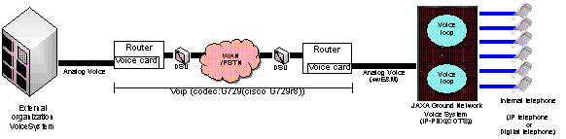
DLR:
The 4000 Series II intercom/conferencing system is configured for 16-bit audio at 16 KHz audio sampling, the heart of the VoCS system, are two 4000 Series II audio Matrices in N+N redundant Gemini configuration. In addition to the I/O processors on its interface cards each audio Matrix supports two CPU cards.
These cards support high level logic and audio routing/ mixing control facilities. Both cards support built in self-test. In operation one card is automatically assigned as master, the other assumes a slave role. The slave card mirrors the masters to allow takeover in case of master CPU card failure.
Of the four main CPU cards provided at each main element (two in each audio Matrix) only one requires to be functioning to provide normal system operation.
The system’s digital audio processing module (DMC card) implements audio routing and mixing.
Advanced voice compression algorithms are:
G.728 compression,
G.711 companding.
G.722 is also be provided (64 K)
Drake’s Digital Audio Matrix offers fully non-blocking conferencing for up to 1024 audio sources/destinations, with a virtually unlimited number of conference/loops. Audio is routed in a 16 bit digital format using one of a range of supported sample rates. For the VoCS application, the sample rate is 16 kHz, which provides an audio bandwidth of 7 kHz.
The 4000 Series II matrix supports built-in compression for connection to remote lines sites. 4:1 compression takes place via multiple digital signal processors (DSPs) on the Hi-Que interface card using G.728 encoding (16kbs LD-CELP). This compression function allows for reduced bandwidth and physical interface needs across the network.
Each T1/E1 line is connected to a digital redundancy switch that is connected to the physical E1/T1 interface (Hi-Que) contained in each of the redundant matrices. In each matrix, a T1/E1 interface consists of an active hot pluggable front Hi-Que card and a passive rear connector unit (RCU). The RCU provides an RJ-45 connector I/O for the interface set. The redundant T1/E1 units receive signals from the IGS while the transmit side is switched to the active matrix/E1-T1 combination.
Since compression/decompression is built into the E1/T1 line interface the Col-CC VoCS will not require additional end compression and decompression equipment.
The Hi-Que is configured via the EMS (Element Managee System). This system will program each channel of the Hi-Que/2 for participation in the voice loops of the VoCS. Continuous monitoring of the Hi-Que/2 is also performed to determine if a failure or fault has occurred.
At the MCC-M, MCC-H and HOSC sites there are minimally configured audio matrices to provide E1/T1 compression / decompression hardware and local interfacing for bridging conference/loops between the sites and the Col-CC VoCS. These matrices may be expanded to support Keysets, 4-wire lines, managements system etc. (as per the main sites).
The VoCS systems supplied at the EAC & ATV-CC sites include and support the E1/T1 compression / decompression hardware for bridging conference/loops between these sites and the Col-CC VoCS.
PTT activation utilizes simple E&M signaling bits for selected communications. Where this PTT is present this is within a dedicated, uncompressed, E1/T1 channel via the E1/T1 compression / decompression hardware.
The VoIP streaming solution is based on a COTS real time MPEG encoder specifically developed for broadcast quality audio streaming. 2 channels of analogue audio are encoded and directly output over IP using the unit’s 10BaseT connector as MP3 encoded audio. This audio can then be listened to using a wide variety of audio players, including Microsoft Media Player and Real Player.
The unit can be configured to encode audio data at a number of different sample rates and output the encoded data at various baud rates from 8-128 Kbps.
Features and functionality are as for the supplied Telos Audioactive Professional Hardware MPEG Real-time Encoder.
The NASA MOVE project, (Mission Operations Voice Enhancement), utilizes mod/cots from Frequentis USA. Frequentis of Austria has long been a vendor of high capacity/performance/availability intercommunications equipment. The core switch uses TDM and G.711u for connectivity and summation.
  - What technical issues are or have been encountered with voice communications at your center. Example, VoIP latency results in an unacceptable ‘perceived echo’ for flight control room use.
Comments:
Col-CC is analyzing different options, all of them are related to the new network technology MPLS, the preferred coded will be G. 711 and for the connections to the centers in Europe a VoIP is preferred.
NASA/JSC is deploying its first VoIP solution to an ISS training facility. Evaluations of its performance will be forthcoming.
  - Has VoIP been considered for collocated personnel, such as operations personnel working in a single flight control room? If so, please describe the targeted technologies. If not, please describe why not.
Flight-to-Ground:
Yes _____ No X
Description/Comments:
The idea is to use it for external centers, like USOCs or the antennas located across Europe.
  - What other technical issues are or have been encountered with voice communications at your center.
Comments:
One of the biggest issues in the monitoring, the system can be monitored and commanded using a web based interface. The information is pulled via SNMP and only few traps are generated by the system giving in case of problems a unknown status.
Other issue that often happens is the failover of the Matrix loosing some channels and generating noises, that is a firmware issue accepted by the vendor that is in a permanent improvement state.
The conversion E1/T1 some time causes problems and a typical issue is the impossibility of deselect loops in the keysets, this issue is easily solved by a download, but it should not happen.
In other way considering the complexity of the many projects and the number of people working simultaneously all around the world, it is a quite stable system.
  - Other comments regarding voice communications.
Comments:
Col-CC is planning to buy a new system, off-the-shelf and not a special developed solution as we have now.
The idea is also to separate the 3 big areas, Columbus, Galileo and satellite missions.

