Action list (London, Fall Session)

RTP over DTN Actions

1. Revise Blue Book content (remove RTCP, bundle protocol multicast, SDP content and RTP compression; include SDP content in Appendix E change text to informative explain unique circumstances how beneficial to DTN). POC: Joshua Deaton ECD: end Dec.
   1. Closed. Josh got the edits approved via STRIVES and provided in CWE: SIS-MIA>Draft Documents>RTP over DTN for Video>BlueBookNov 2024 Update Folder. Ref file Feb 4 dated file.
   2. Team Review and provide any comment to Walt by 4/4/25
      1. 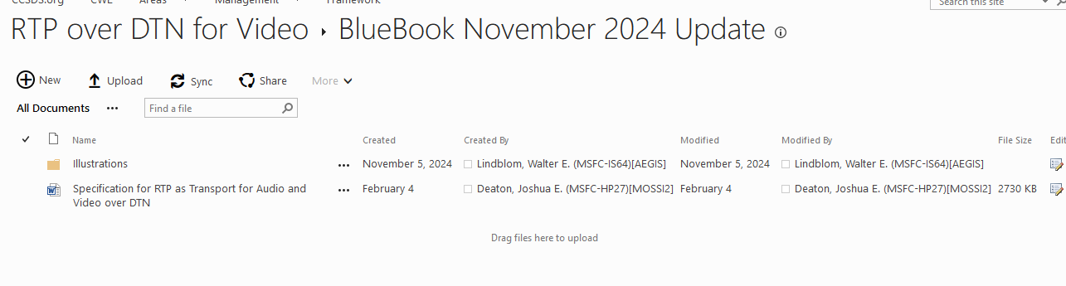
2. GRC implementation update w/ CBOR. POC: Nadia Kortas/Daniel Raible. ECD: before end Dec
   1. Updates should be completed in ~May 2025. Task is pending to see if it can be supported due to changes in priority.
3. Interoperability Testing. POC: Joshua Deaton & Nadia Kortas/Daniel Raible. ECD: end January
4. Document results in Yellow Book. POC: Joshua Deaton (content) & Walt L (formatting). ECD: end Feb
5. Review test results with MIA Working Group. POC: All. ECD: end March
6. Turn in yellow book for formal review. POC: Falk. ECD: end March
7. Determine if we create an Orange book for RTP Compression. POC: DLR Jeremy. ECD: mid Feb.

Next interim meeting will be scheduled in mid Feb.