

|  |
| --- |
| Motion Imagery And applications  Real-Time Transport Protocol (RTP) over Delay tolerant network (DTN) Test Plan |

2

MM/YYYY

FOREWORD

Through the process of normal evolution, it is expected that expansion, deletion, or modification of this document may occur. This Recommended Standard is therefore subject to CCSDS document management and change control procedures, which are defined in the *Procedures Manual for the Consultative Committee for Space Data Systems*. Current versions of CCSDS documents are maintained at the CCSDS Web site:

http://www.ccsds.org/

Questions relating to the contents or status of this document should be addressed to the CCSDS Secretariat at the address indicated on page i.

At time of publication, the active Member and Observer Agencies of the CCSDS were:

Member Agencies

* Agenzia Spaziale Italiana (ASI)/Italy.
* British National Space Centre (BNSC)/United Kingdom.
* Canadian Space Agency (CSA)/Canada.
* Centre National d’Etudes Spatiales (CNES)/France.
* Deutsches Zentrum für Luft- und Raumfahrt e.V. (DLR)/Germany.
* European Space Agency (ESA)/Europe.
* Federal Space Agency (FSA)/Russian Federation.
* Instituto Nacional de Pesquisas Espaciais (INPE)/Brazil.
* Japan Aerospace Exploration Agency (JAXA)/Japan.
* National Aeronautics and Space Administration (NASA)/USA.

Observer Agencies

* Austrian Space Agency (ASA)/Austria.
* Belgian Federal Science Policy Office (BFSPO)/Belgium.
* Central Research Institute of Machine Building (TsNIIMash)/Russian Federation.
* Centro Tecnico Aeroespacial (CTA)/Brazil.
* Chinese Academy of Sciences (CAS)/China.
* Chinese Academy of Space Technology (CAST)/China.
* Commonwealth Scientific and Industrial Research Organization (CSIRO)/Australia.
* Danish National Space Center (DNSC)/Denmark.
* European Organization for the Exploitation of Meteorological Satellites (EUMETSAT)/Europe.
* European Telecommunications Satellite Organization (EUTELSAT)/Europe.
* Hellenic National Space Committee (HNSC)/Greece.
* Indian Space Research Organization (ISRO)/India.
* Institute of Space Research (IKI)/Russian Federation.
* KFKI Research Institute for Particle & Nuclear Physics (KFKI)/Hungary.
* Korea Aerospace Research Institute (KARI)/Korea.
* MIKOMTEK: CSIR (CSIR)/Republic of South Africa.
* Ministry of Communications (MOC)/Israel.
* National Institute of Information and Communications Technology (NICT)/Japan.
* National Oceanic and Atmospheric Administration (NOAA)/USA.
* National Space Organization (NSPO)/Taiwan.
* Naval Center for Space Technology (NCST)/USA.
* Space and Upper Atmosphere Research Commission (SUPARCO)/Pakistan.
* Swedish Space Corporation (SSC)/Sweden.
* United States Geological Survey (USGS)/USA.

DOCUMENT CONTROL

|  |  |  |  |
| --- | --- | --- | --- |
| **Document** | **Title** | **Date** | **Status** |
| CCSDS 766.3-R-2 | Motion Imagery and Application – RTP Over DTN Test Plan | MM/YYYY | Current issue |

**CONTENTS**

Section Page

1 INTRODUCTION 1-1

1.1 PURPOSE 1-1

1.2 SCOPE 1-1

1.3 APPLICABILITY 1-1

1.4 RATIONALE 1-1

1.5 DOCUMENT STRUCTURE 1-2

1.6 REFERENCES 1-2

2 SUMMARY CONCLUSION/RECOMMENDATION 2-1

3 MIA RTP OVER DTN PROTOTYPE TESTING GOALS 3-1

4 TEST OVERVIEW 4-1

4.1 HISTORY OF RTP OVER DTN TEST CONFIGURATIONS 4-1

4.2 RTP OVER DTN FINAL TEST CONFIGURATION 4-3

5 TEST DETAILS 5-1

5.1 BASIC TEST CASES 5-1

5.1.1 TEST CASE #1: MOTION IMAGERY DATA USING RTP OVER DTN (MSFC TO DLR) 5-1

5.1.2 TEST CASE #1: MOTION IMAGERY DATA USING RTP OVER DTN (DLR TO MSFC) 5-2

ANNEX A PICS PERFORMA 4

A1 PICS PERFORMA REQUIREMENTS TESTED 4

ANNEX B ACRONYMS 5

# **INTRODUCTION**

## **1.1 PURPOSE**

The purpose of this document is to describe the prototype testing conducted on the CCSDS Concepts and Rationale for Video Streaming Services over Bundle Protocol (reference [13]).This is a draft test plan prepared by the members of the CCSDS group evaluating RTP over DTN for motion imagery.

## **1.2 SCOPE**

The scope of this document is testing to demonstrate compatibility between independently developed CCSDS 730.2-G-0 supporting implementations by exercising RTP capabilities, both individually and in combination, and by verifying different modes of operations as illustrated in the green book.

Two implementations were exercised and node locations for these tests are:

* MPEG-TS over RTP over the DTN implementation DTN Marshall Enterprise (DTNME) from a MSFC HOSC testing candidate.
* MPEG-TS over RTP over the DTN implementation Interplanetary Overlay Network (ION) from a DLR testing candidate.

## **1.3 APPLICABILITY**

The RTP over DTN prototype enables a more robust approach to the transmission of audio/video data via the Bundle Protocol compared to its predecessor in sole MPEG-TS. This document applies to the prototype testing required to advance the RTP over DTN technology from Magenta Book to Blue Book Status.

## **1.4 RATIONALE**

The CCSDS Procedures Manual states that for a Recommendation to become a Blue Book, the standard must be tested in an operational manner. The following requirements for an implementation exercise were excerpted from reference [1]:

“At least two independent and interoperable prototypes or implementations must have been developed and demonstrated in an operationally relevant environment, either real or simulated.”

This document outlines the MIA Working Group’s approach to meeting this requirement for referenced [2].

## **1.5 DOCUMENT STRUCTURE**

The first sections of this document describe the Test Plan for the prototyping activity; the last sections of the document provide a Test Report of the realized plan. Annex A provides acronyms and abbreviations.

## **1.6 REFERENCES**

The following documents are referenced in this document. At the time of publication, the editions indicated were valid. All documents are subject to revision, and users of this document are encouraged to investigate the possibility of applying the most recent editions of the documents indicated below. The CCSDS Secretariat maintains a register of currently valid CCSDS documents.

[1] *Digital Video Broadcasting (DVB); Measurement Guidelines for DVB Systems*. ETSI TR 101 290 V1.2.1 (2001-05). Sophia-Antipolis: ETSI, 2001.

[2] *Digital Motion Imagery*. Issue 2. Recommendation for Space Data System Standards (Blue Book), CCSDS 766.1-B-2. Washington, D.C.: CCSDS, August 2016.

[3] *Advanced Video Coding for Generic Audiovisual Services*. ITU-T H.264. Geneva: ITU, 2012.

[4] *CCSDS Bundle Protocol Specification*. Issue 1. Recommendation for Space Data System Standards (Blue Book), CCSDS 734.2-B-1. Washington, D.C.: CCSDS, September 2015.

[5] *Wireless Network Communications Overview for Space Mission Operations*. Issue 3. Report Concerning Space Data System Standards (Green Book), CCSDS 880.0-G-3. Washington, D.C.: CCSDS, May 2017.

[6] David Israel. “Disruption Tolerant Networking Experiments with Optical Communications.” 20 December 2013. National Aeronautics and Space Administration.

https://www.nasa.gov/directorates/heo/scan/news_DTN_Experiments_with_Optical_Communications.html.

[7] N. Spyropoulos. “UrtheCast: The System of Systems for Dynamic EO Monitoring Content.” In *Proceedings of the Symposium on International Safeguards: Linking Strategy, Implementation and People (20–24 October 2014, Vienna, Austria)*. IAEA‑CN—220. Vienna: IAEA, March 2015.

[8] Sotirios-Angelos Lenas, Scott C. Burleigh, and Vassilis Tsaoussidis. “Bundle Streaming Service: Design, Implementation and Performance Evaluation.” *Transactions on Emerging Telecommunications Technologies* 26, no. 5 (May 2015): 905–917.

[9] *CCSDS File Delivery Protocol (CFDP)*. Issue 4. Recommendation for Space Data System Standards (Blue Book), CCSDS 727.0-B-4. Washington, D.C.: CCSDS, January 2007.

[10] S. Burleigh. *CBHE-Compatible Bundle Multicast*. Internet-Draft draft-burleigh-dtnrg-imc-00 [expired]. Reston, Virginia: ISOC, April 9, 2009.

[11] *Licklider Transmission Protocol (LTP) for CCSDS*. Issue 1. Recommendation for Space Data System Standards (Blue Book), CCSDS 734.1-B-1. Washington, D.C.: CCSDS, May 2015.

[12] *Space Communication Cross Support - Architecture Requirements document*, Issue 1, Recommended Practice for Space Data Systems (Magenta Book), CCSDS 901.1-M-1. Washington, D.C.: CCSDS, May 2015

[13] *Concepts and Rationale for Streaming Services over Bundle Protocol*, Issue 1. Report Concerning Space Data System Standards (Green Book), CCSDS 730.2-G-1 , Washington, D.C.: CCSDS, Sept. 2018

# **SUMMARY CONCLUSION/RECOMMENDATION**

The test plan and test reports documented herein substantiate that the organizations participating in the CCSDS Motion Imagery Working Group have successfully conducted prototype testing of motion imagery using RTP over Delay Tolerant Network as defined in CCSDS 766.3-R-2 document. During the testing, RTP managed motion imagery was successfully encapsulated in DTN bundles and transferred across terrestrial links. The RTP Link was perturbed by standard internet data transmission behavior. Limitations on testing due to Covid precluded inserting significant data disruptions, such as delays, signal drop-outs, or out-of-order packets. As such, this standard is applicable to Low Earth Orbit applications and should be extensible to other space scenarios as the test configurations conform to Bundle Protocol standards. This will be tested in the future.

Based on the diversity of agencies able to transfer motion imagery over a diverse environment, and the positive test results, the MIA group recommends CCSDS 766.3-R-2 document be promoted to a Blue Book CCSDS Recommended Standard.

# **MIA RTP OVER DTN PROTOTYPE TESTING GOALS**

The RTP over DTN prototype test will exercise the prototype’s capability to deliver motion imagery/video transmission over this link according to the requirements listed in CCSDS 766.3-R-2. Section 4 contains an overview of the test plan. Section 5 contains test cases, descriptions, expected results, and actual results.

# **TEST OVERVIEW**

There are several iterations of the RTP over DTN Test Configuration. Due to complications regarding firewall issues, connectivity issues, and issues caused by the shift to teleworking in response to COVID-19, reductions were made to the test setup. This ultimately resulted in the test configuration described in section 4.2. Section 4.1 is a history of the previous test setups.

## **4.1 HISTORY OF RTP OVER DTN TEST CONFIGURATIONS**

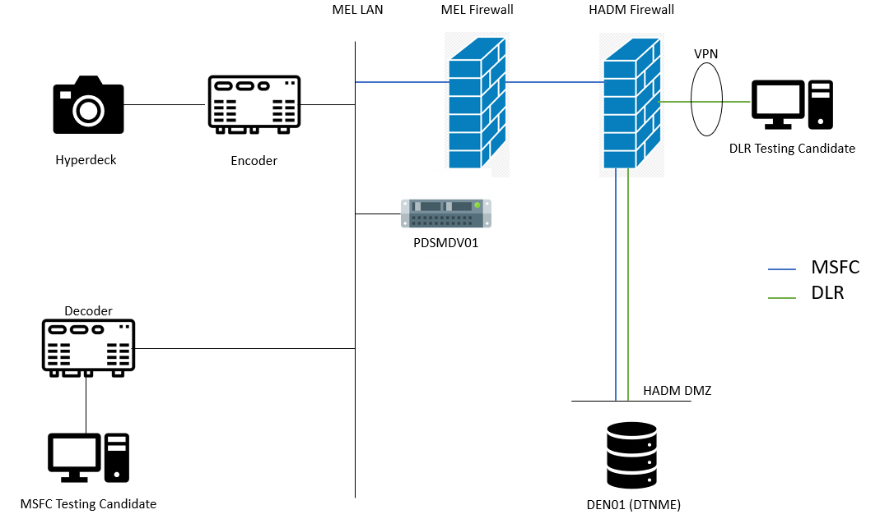

Figure 4.1.1: Initial Test Setup

The initial test configuration employed an encoder/decoder system connected to a Hyperdeck video streaming device and the MSFC testing candidate, respectively. For data going to the DLR testing candidate, RTP video data would be transmitted through a couple firewalls and then passed through the DEN01 server which hosts the DTN software DTNME. The RTP over DTN data then was transmitted to the DLR testing candidate.

Issues arose regarding the general connectivity of the encoder/decoder system (compounded with the issues described in the first paragraph of 4, so a reduction to the complexity of the test configuration was made as evidenced by Figure 4.1.2.

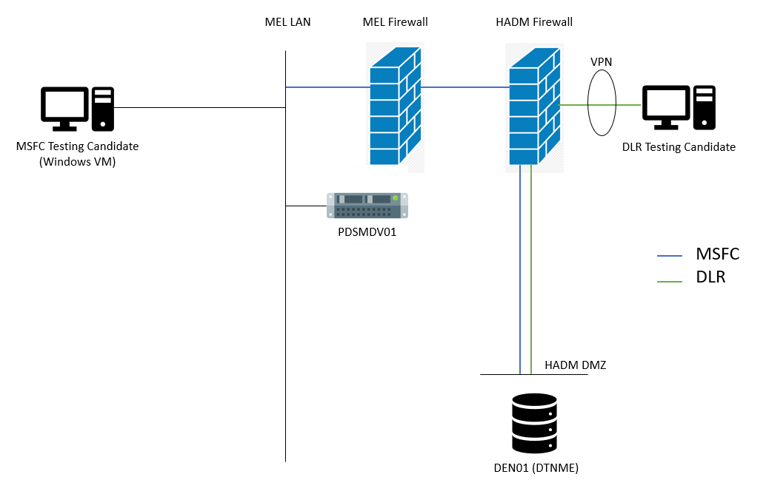

Figure 4.1.2: Secondary RTP over DTN Test Configuration

The secondary test configuration removed the Hyperdeck, encoder, and decoder components from the test setup. Video is now streaming directly from the MSFC testing candidate through the firewalls and DEN01 server to the DLR testing candidate, and vice versa. Testing was still impacted by connectivity issues however, so the test configuration was further simplified.

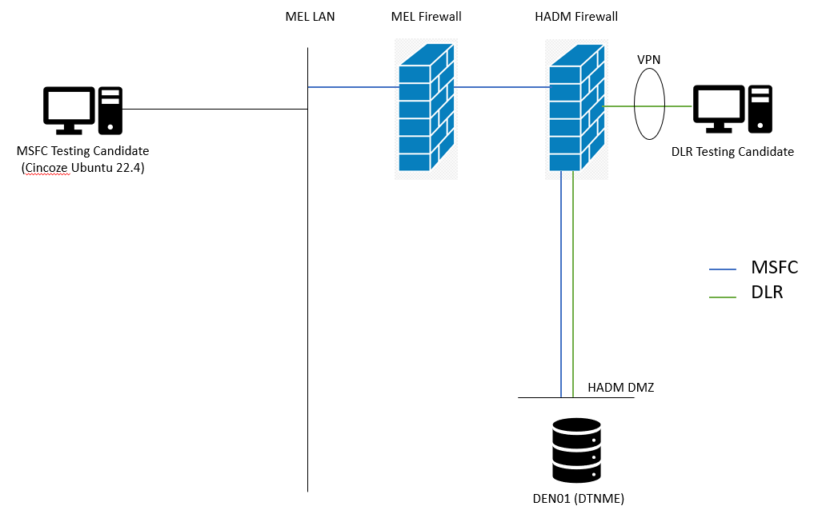

Figure 4.1.3: Third RTP over DTN Test Configuration

This third test configuration replaced the Windows VM with a Cincoze Ubuntu 22.4 box, and removed the PDSMDV01 server. The reductions made with this iteration did not alleviate connectivity issues. Thus, the testers proceeded with further reducing the test configuration.

## **4.2 RTP OVER DTN FINAL TEST CONFIGURATION**

The final test configuration removed all elements of data transmission through the HOSC LANs, firewalls, and servers. The MSFC and DLR testing candidates conducted testing with the coordinated configuration provided by each team, using the public internet. Each test participant configured internal/external networks to ensure DTN access (TCP/UDP port 4556). Port forwarding was configured on the DLR side to ensure Marshall test machine(s) could access DLR assets via the specified internet-facing IP.

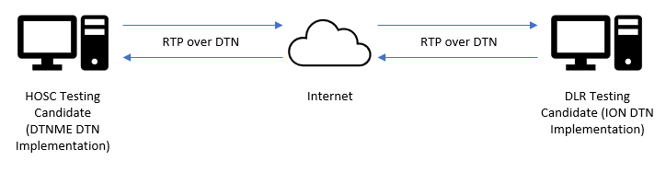

**Figure 4-1 Test Configuration**

Each participant established at least one node. Unique test stations were established at each test site based on test conductors’ particular setup.

A side-channel tele-conference was activated between both test conductors, allowing both parties to coordinate testing, view the received video, and analyze logs/KPIs.

Test activities were initiated from each participant in turn with coordination from the other participant. Motion imagery using RTP protocol is encapsulated in DTN bundles and transferred to the remote participant. A reciprocal test scenario was conducted allowing the other site to initiate and repeat the test scenario. Each test case of section 5 will be executed in both directions.

Software/hardware configuration

1. DLR
   * Ubuntu 20.04 LTS using Intel Xeon 64-bit processor
   * Video encoding and decoding provided via FFMPEG, using NVIDIA Quatro RTX 3000 GPU for hardware acceleration.
   * Implemented in C++ 11
2. MSFC HOSC
   * Linux based on RHEL7.6 with 64 bit
   * Executing on virtual server

Test goals are performance related and functional. That is to say, functionality at a reasonable and representative performance was tested. No attempt was made to establish upward performance bounds.

# **TEST DETAILS**

Two test cases were identified to be exercised. These two test scenarios exercised the basic flow of motion imagery data across an RTP over DTN link. Test case 5.1.1 tested the MSFC to DLR data flow, and 5.1.2 tested the opposite.

Testing originated from each source with unique imagery data sources. Video quality scoring was performed via subjective analysis, relying on the video-conference and knowledge of the sample motion imagery data.

## **5.1 BASIC TEST CASES**

Two basic test cases exercise the basic data flow originating at the participating node.

### **5.1.1 TEST CASE #1: MOTION IMAGERY DATA USING RTP OVER DTN (MSFC TO DLR)**

**5.1.1.1 Test Description**

For this test, MSFC sent DLR motion imagery data over a RTP over DTN link. DLR confirmed whether the data has been received successfully or not.

**5.1.1.2 Expected Results**

It was anticipated that DLR would successfully receive the complete motion imagery data from MSFC. Assuming that the criteria was met, this test would be considered successful. In the event of discrepancies, troubleshooting would be conducted by the participants in the test.

**5.1.1.3 Actual Results**

Figure 4-2 MSFC to DLR Motion Imagery data.

DLR received motion imagery data from MSFC. Video was successfully decoded, as shown in Figure 4-2 Video quality was satisfactory. Test was successfully re-run with multiple bitrates; issues were noted in higher bitrate testing (due to the internet connection between the test parties).

### **5.1.2 TEST CASE #1: MOTION IMAGERY DATA USING RTP OVER DTN (DLR TO MSFC)**

**5.1.2.1 Test Description**

For this test, DLR will send MSFC motion imagery data over a RTP over DTN link. MSFC will confirm whether the data has been received successfully or not.

**5.1.2.2 Expected Results**

It is anticipated that MSFC will successfully receive the complete motion imagery data from DLR. Assuming that the criteria are met, this test will be considered successful. In the event of discrepancies, troubleshooting will be conducted by the participants in the test.

**5.1.2.3 Actual Results**

MSFC received motion imagery data from DLR. All results supported completion of the PICS Proforma, with periodic issues being identified and then resolved against the specification. In particular, issues rising from fragmentation of the RTP stream caused by FFMPEG resulted in normative changes to the specification.

# **ANNEX A PICS PROFORMA**

## **A1 PICS PROFORMA REQUIREMENTS TESTED**

Below is the PICS PROFORMA from CCSDS 766.3-R-2, as well as the requirements that were tested and not tested.

**Table A-1: PICS PROFORMA**

|  |  |  |  |  |
| --- | --- | --- | --- | --- |
| Item | Description | Reference | Status | Support |
| 101 | IETF RTP Header used | 3.2.1, 3.2.2 | M | MSFC & DLR showed interoperable support |
| 102 | RTP Concatenation | 3.3 | O | Led to a re-write of §3.4 in the corresponding specification. It has been then successfully retested on the basis of the updated specification. |
| 103 | BP to Non-BP fragmentation | 3.4 | O |
| 104 | DTN Transmission of RTP packets | 3.5 | M | MSFC & DLR showed interoperable support |
| 105 | Signaling data | 3.6 | O | MSFC & DLR showed interoperable support, although some formatting issues existed in early tests. These were clarified between testing partners & blue book was updated. Accordingly new tests were later run to confirm that the original formatting issues were finally solved. |
| 106 | SDP | 3.6.2 | O |

# **ANNEX B ACRONYMS**

|  |  |
| --- | --- |
| CCSDS | Consultative Committee for Space Data Systems |
| CFDP | CCSDS File Delivery Protocol |
| DLR | German Aerospace Center |
| DTN | Delay Tolerant Network |
| HOSC | Huntsville Operations Support Center |
| IP | Internet Protocol |
| LTP | Licklider Transmission Protocol |
| KPI | Key Performance Indicator |
| MIA | Motion Imagery and Application |
| MPEG | Motion Picture Experts Group |
| MPEG-TS | MPEG Transport Stream |
| MSFC | Marshall Space Flight Center |
| RHEL | Red Hat Enterprise Linux |
| RTP | Real-Time Transport Protocol |
| TCP | Transport Control Protocol |
| UDP | User Datagram Protocol |
| VPN | Virtual Private Network |