
Draft Recommendation for
Space Data System Standards
Specification for RTP as Transport for Audio and Video over DTN
Draft Recommended Standard
CCSDS 766.3-R-2
Red Book
May 2020

AUTHORITY

 | Issue: | Red Book, Issue 1
 | Date: | December 2019
 | Location: | Not Applicable
(WHEN THIS RECOMMENDED STANDARD IS FINALIZED, IT WILL CONTAIN THE FOLLOWING STATEMENT OF AUTHORITY:)
This document has been approved for publication by the Management Council of the Consultative Committee for Space Data Systems (CCSDS) and represents the consensus technical agreement of the participating CCSDS Member Agencies. The procedure for review and authorization of CCSDS documents is detailed in Organization and Processes for the Consultative Committee for Space Data Systems (CCSDS A02.1-Y-4), and the record of Agency participation in the authorization of this document can be obtained from the CCSDS Secretariat at the email address below.

This document is published and maintained by:

CCSDS Secretariat
National Aeronautics and Space Administration
Washington, DC, USA
Email: secretariat@mailman.ccsds.org
STATEMENT OF INTENT
(WHEN THIS RECOMMENDED STANDARD IS FINALIZED, IT WILL CONTAIN THE FOLLOWING STATEMENT OF INTENT:)
The Consultative Committee for Space Data Systems (CCSDS) is an organization officially established by the management of its members. The Committee meets periodically to address data systems problems that are common to all participants, and to formulate sound technical solutions to these problems. Inasmuch as participation in the CCSDS is completely voluntary, the results of Committee actions are termed Recommended Standards and are not considered binding on any Agency.
This Recommended Standard is issued by, and represents the consensus of, the CCSDS members. Endorsement of this Recommendation is entirely voluntary. Endorsement, however, indicates the following understandings:
o Whenever a member establishes a CCSDS-related standard, this standard will be in accord with the relevant Recommended Standard. Establishing such a standard does not preclude other provisions which a member may develop.
o Whenever a member establishes a CCSDS-related standard, that member will provide other CCSDS members with the following information:
-- The standard itself.
-- The anticipated date of initial operational capability.
-- The anticipated duration of operational service.
o Specific service arrangements shall be made via memoranda of agreement. Neither this Recommended Standard nor any ensuing standard is a substitute for a memorandum of agreement.
No later than five years from its date of issuance, this Recommended Standard will be reviewed by the CCSDS to determine whether it should: (1) remain in effect without change; (2) be changed to reflect the impact of new technologies, new requirements, or new directions; or (3) be retired or canceled.
In those instances when a new version of a Recommended Standard is issued, existing CCSDS-related member standards and implementations are not negated or deemed to be non-CCSDS compatible. It is the responsibility of each member to determine when such standards or implementations are to be modified. Each member is, however, strongly encouraged to direct planning for its new standards and implementations towards the later version of the Recommended Standard.
FOREWORD
Through the process of normal evolution, it is expected that expansion, deletion, or modification of this document may occur. This Recommended Standard is therefore subject to CCSDS document management and change control procedures, which are defined in the Organization and Processes for the Consultative Committee for Space Data Systems (CCSDS A02.1-Y-4). Current versions of CCSDS documents are maintained at the CCSDS Web site:
http://www.ccsds.org/
Questions relating to the contents or status of this document should be sent to the CCSDS Secretariat at the email address indicated on page i.
At time of publication, the active Member and Observer Agencies of the CCSDS were:
Member Agencies
- Agenzia Spaziale Italiana (ASI)/Italy.
- Canadian Space Agency (CSA)/Canada.
- Centre National d’Etudes Spatiales (CNES)/France.
- China National Space Administration (CNSA)/People’s Republic of China.
- Deutsches Zentrum für Luft- und Raumfahrt (DLR)/Germany.
- European Space Agency (ESA)/Europe.
- Federal Space Agency (FSA)/Russian Federation.
- Instituto Nacional de Pesquisas Espaciais (INPE)/Brazil.
- Japan Aerospace Exploration Agency (JAXA)/Japan.
- National Aeronautics and Space Administration (NASA)/USA.
- UK Space Agency/United Kingdom.
Observer Agencies
- Austrian Space Agency (ASA)/Austria.
- Belgian Federal Science Policy Office (BFSPO)/Belgium.
- Central Research Institute of Machine Building (TsNIIMash)/Russian Federation.
- China Satellite Launch and Tracking Control General, Beijing Institute of Tracking and Telecommunications Technology (CLTC/BITTT)/China.
- Chinese Academy of Sciences (CAS)/China.
- China Academy of Space Technology (CAST)/China.
- Commonwealth Scientific and Industrial Research Organization (CSIRO)/Australia.
- Danish National Space Center (DNSC)/Denmark.
- Departamento de Ciência e Tecnologia Aeroespacial (DCTA)/Brazil.
- Electronics and Telecommunications Research Institute (ETRI)/Korea.
- European Organization for the Exploitation of Meteorological Satellites (EUMETSAT)/Europe.
- European Telecommunications Satellite Organization (EUTELSAT)/Europe.
- Geo-Informatics and Space Technology Development Agency (GISTDA)/Thailand.
- Hellenic National Space Committee (HNSC)/Greece.
- Hellenic Space Agency (HSA)/Greece.
- Indian Space Research Organization (ISRO)/India.
- Institute of Space Research (IKI)/Russian Federation.
- Korea Aerospace Research Institute (KARI)/Korea.
- Ministry of Communications (MOC)/Israel.
- Mohammed Bin Rashid Space Centre (MBRSC)/United Arab Emirates.
- National Institute of Information and Communications Technology (NICT)/Japan.
- National Oceanic and Atmospheric Administration (NOAA)/USA.
- National Space Agency of the Republic of Kazakhstan (NSARK)/Kazakhstan.
- National Space Organization (NSPO)/Chinese Taipei.
- Naval Center for Space Technology (NCST)/USA.
- Research Institute for Particle & Nuclear Physics (KFKI)/Hungary.
- Scientific and Technological Research Council of Turkey (TUBITAK)/Turkey.
- South African National Space Agency (SANSA)/Republic of South Africa.
- Space and Upper Atmosphere Research Commission (SUPARCO)/Pakistan.
- Swedish Space Corporation (SSC)/Sweden.
- Swiss Space Office (SSO)/Switzerland.
- United States Geological Survey (USGS)/USA.
PREFACE
This document is a draft CCSDS Recommended Standard. Its ‘Red Book’ status indicates that the CCSDS believes the document to be technically mature and has released it for formal review by appropriate technical organizations. As such, its technical contents are not stable, and several iterations of it may occur in response to comments received during the review process.
Implementers are cautioned not to fabricate any final equipment in accordance with this document’s technical content.
Recipients of this draft are invited to submit, with their comments, notification of any relevant patent rights of which they are aware and to provide supporting documentation.

DOCUMENT CONTROL

Document | Title | Date | Status
CCSDS 766.3-R-1 | Specification for RTP as Transport for Audio and Video over DTN, Draft Recommended Standard, Issue 1 | May 2020 | Current draft

CONTENTS
Section Page
1 Introduction 1-1

1.1 Overview 1-1
1.2 Purpose And Scope 1-1
1.3 Applicability 1-1
1.4 Rationale 1-1
1.5 NOMENCLATURE 1-2
1.6 References 1-2

2 Overview 2-1

2.1 General 2-1
2.2 Assumptions 2-1
2.3 Flow diagram—RTP in larger picture 2-2
2.4 Technical Overview 2-5
2.5 RTP Over DTN 2-12
2.6 Legacy Compatibility 2-14

3 RTP in Space-Based Links 3-1

3.1 Overview 3-1
3.2 RTP PDU Formatting 3-1
3.3 RTP Concatenation 3-1
3.4 BP-to-Non-BP Fragmentation 3-3
3.5 DTN Transmission of RTP Packets 3-3
3.6 Signaling Data (SDP Description and RTCP) 3-3

ANNEX A Implementation Conformance Statement (ICS) Proforma (normative) A-1
ANNEX B Security, SANA, and Patent Considerations (Informative) B-1
ANNEX C Informative References (Informative) C-1
ANNEX D Abbreviations and Acronyms (Informative) D-1
Figure
2-1 Flow Diagram—Onboard Assets 2-3
2-2 Flow Diagram—Ground Segment 2-4
2-3 RTP Packet Header 2-5
2-4 RTP Relationships 2-6
2-5 Spacecraft Network Design 2-7
2-6 RTCP Overview 2-8
2-7 RTCP Sender Report Message 2-9
2-8 Example of SDP Data 2-11
2-9 SDP Translation Between DTN and IP Domains 2-11
2-10 Theoretical IP-to-RTP System 2-13
3-1 RTP Concatenation—Overview 3-2
3-2 RTCP and Video Synchronization 3-6

Introduction

Overview
Motion Imagery/Video Transmission over Delay/Disruption Tolerant Networking (DTN) is not simple because of the nature of video over IP, which generally requires consistent data flow into a video decoder. Up to now, the use of MPEG Transport Stream (MPEG-TS) has been the default standard to encapsulate and format video transmission over IP. However, MPEG-TS does not work well in situations with frequent interruptions or excessive latency and is not very flexible with regard to packet size. Deutsches Zentrum für Luft- und Raumfahrt (DLR) has been testing Real-time Transport Protocol (RTP) (reference [1]) over DTN for video and has found it is much more forgiving of interruptions and long latencies in the network. The fact that RTP packet size is arbitrary makes it much more flexible for video over DTN.

Purpose And Scope
This document provides an overview and proposed methods for transmission of video over DTN using RTP. As more deep space missions will be utilizing DTN for data transmission and the use of video becomes even more prevalent, a standard method of formatting encoded video streams for transmission is required. Standardization of video transmission methodology makes it easier to design DTN nodes and networks. It also helps ensure higher reliability and quality of video transmission.

Applicability
This standard is intended for all future missions that produce, consume, or distribute video via the Bundle Protocol. The details (formats, resolutions, bitrates, etc.) of the video to be transmitted are largely omitted in order to prevent immediate obsolescence.

Rationale
This book is written with the assumption that future missions will rely upon a variety of cameras and imaging sensors. The encoding of these videos may be distributed throughout a spacecraft and/or mission, in which the only common thread will be the usage of IP. Following the current trends in the media industry, the various encoders are foreseen to use RTP and/or a format that can be encapsulated into RTP. As RTP has shown to be better suited to video over DTN, standardizing a video transmission methodology around current industry trends is an advantage to system designers.

NOMENCLATURE

Normative Text
The following conventions apply for the normative specifications in this Recommended Standard:
- the words ‘shall’ and ‘must’ imply a binding and verifiable specification;
- the word ‘should’ implies an optional, but desirable, specification;
- the word ‘may’ implies an optional specification;
- the words ‘is’, ‘are’, and ‘will’ imply statements of fact.
NOTE – These conventions do not imply constraints on diction in text that is clearly informative in nature.

Informative Text
In the normative sections of this document, informative text is set off from the normative specifications either in notes or under one of the following subsection headings:
- Overview;
- Background;
- Rationale;
- Discussion.

References
The following publications contain provisions which, through reference in this text, constitute provisions of this document. At the time of publication, the editions indicated were valid. All publications are subject to revision, and users of this document are encouraged to investigate the possibility of applying the most recent editions of the publications indicated below. The CCSDS Secretariat maintains a register of currently valid CCSDS publications.
[1] H. Schulzrinne, et al. RTP: A Transport Protocol for Real-Time Applications. STD 64. Reston, Virginia: ISOC, July 2003.
[2] CCSDS Bundle Protocol Specification. Issue 1. Recommendation for Space Data System Standards (Blue Book), CCSDS 734.2-B-1. Washington, D.C.: CCSDS, September 2015.
[3] M. Handley, V. Jacobson, and C. Perkins. SDP: Session Description Protocol. RFC 4566. Reston, Virginia: ISOC, July 2006.
[4] M. Handley, C. Perkins, and E. Whelan. Session Announcement Protocol. Experimental. RFC 2974. Reston, Virginia: ISOC, October 2000.
[5] S. Burleigh. Compressed Bundle Header Encoding (CBHE). RFC 6260. Reston, Virginia: ISOC, May 2011.

Overview

General
In the past two decades, crewed spaceflight has undergone many changes. What was once unthinkable is now typical, throughout various components of spacecraft programs. Within spacecraft video systems, the embrace of Commercial Off-The-Shelf (COTS) video equipment, such as action cameras and handheld devices, is widespread. As a result, the once-centralized nature of video transmission, in which all cameras transmitted to a single encoder and transmission system, has been forsaken for a distributed system, in which some cameras are encoded by a centralized system, while others have built-in encoders. Furthermore, the variety of ways video can be transmitted has increased; cameras may use wired networks, uncompressed video mechanisms such as Serial Data Interface (SDI), wireless networks, or point-to-point links. The Real-time Transport Protocol has been used as a single consistent factor for this variety of video transmission opportunities as it is robust to jitter, well-defined within the IETF, easy to implement, and extendable. In the modern broadcast world, everything from uncompressed video (SDI) to highly compressed video (H.265) may be transmitted via RTP, over IP and non-IP networks.
This paradigm shift is not unique to the video transmission world; spacecraft transmission has suffered the same fate. A single spacecraft may now have a variety of distinct up- and down-link mechanisms, as well as a variety of internal onboard connectivity for payloads and visiting vehicles, such as wireless networks based upon 802.11, Proximity-1, etc. The Bundle Protocol has been designed to unify this conglomeration by providing an overlay network for heterogeneous networks, in which the concepts of delay and disruption tolerance were integrated from conception.
This standard addresses the following:
- encapsulation of RTP data on space links;
- RTP performance tuning for BP-based space links;
- addressing of RTP data, in order to facilitate multiple-sender-multiple-receiver scenarios;
- interoperability of standards.

Assumptions
It is assumed that future deep-space networks will rely upon DTN and the Bundle Protocol for their communication, while using RTP for video transmission. Therefore it is pertinent that best-practices for the union of the two be well-defined prior to any future missions.
It is assumed that a Bundle Protocol implementation that is compliant with the CCSDS Bundle Protocol standard (reference [2]) will be used for the underlying transport for RTP data. However, while the utilization of Bundle Protocol multicast is foreseen for many complex video networks, no standard exists for bundle multicast, other than that outlined in reference [C6]. Therefore this book makes the following assumptions about the underlying Bundle Protocol multicast mechanism, if it is in use:
- arbitrary addressing—each multicast-based stream must be uniquely identifiable by a unique endpoint ID, similar to the (multicast group, port) tuple used for IP-based multicast;
- arbitrary bundle sizes—the multicast mechanism must not impose arbitrary limits that are less than the maximum bundle size on the size of bundles.

Flow diagram—RTP in larger picture

General
RTP provides a robust and mature infrastructure for the distribution of video within complex missions, while allowing for a relatively simple interface with onboard and ground hardware. Furthermore, RTP can be interfaced with legacy MPEG-TS-based hardware and software without altering the payload data (e.g., video data). The remainder of this section will provide a theoretical implementation of an onboard RTP-based video system for a partially crewed deep space mission before progressing to its associated ground segment.
The remainder of this section will solely focus on real-time video; as archived video acquired via LOS would also be encapsulated in RTP, the exact details of reordering and replay are outside the scope of this book.

Onboard Implementation
Given the operational experiences gained from the International Space Station, it is imperative that the video system of a next-generation spacecraft/mission be designed with extensive flexibility, allowing for new commercial cameras and video sources to be quickly added. Therefore this section envisions a ‘partitioned’ video system, which is, whenever possible, based entirely on IP. The basic concept of a partitioned video system is that while some core functionality (such as cameras and encoders) is inherent to the spacecraft and can be considered to be critical spacecraft data, other sources are transient and/or best-effort (scientific cameras, PR functionality, etc.). Furthermore, each spacecraft and rover within the mission may have its own subset of critical video sources. If it is considered that multiple spacecraft or components thereof may dock or otherwise be attached to each other via high-bandwidth connections, it is logical to design a video system that may use the encoders of one spacecraft to encode or transmit video from another. Besides the core encoding functionality, it must be expected that payloads may contain specialized cameras or video sources. Depending upon the location of the payload, it may be optimal to encode the video in the camera, while in other cases, that video should be transmitted to the core encoders.
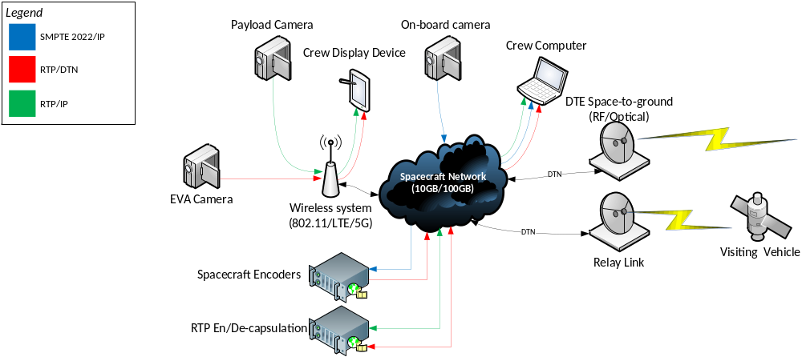
Figure 2-11: Flow Diagram—Onboard Assets
Such a system may be designed entirely around RTP as an encapsulation format; while the best-known uses of RTP are as conveyance for compressed video data, it is also possible to convey uncompressed (or lightly compressed) video data via RTP, using SMPTE-2022. Figure 2-1 shows an example of such a system, although redundant links have been omitted for clarity. This design allows for extreme flexibility and for increased redundancy, in that the failure of individual encoders does not affect the capability to encode video. If additional redundancy is required for individual cameras, multiple network links may be furnished for them. However, it must be noted that uncompressed (SMPTE-2022) video requires extremely high bandwidths, on the order of gigabits/second; therefore the mission designer must carefully design the network to ensure adequate capacity.
Additional assets, such as EVA cameras, which are provided with their own encoders, output compressed video streams via RTP. More interestingly, onboard system cameras may not contain their own encoders; instead, they output SDI via RTP (as permitted by SMPTE-2022), which is encoded by the ‘spacecraft encoders’, which can be positioned in a less extreme environment, such as inside the spacecraft. These devices can also be largely commercial, except for the DTN output functionality. Some payload cameras may also be commercial devices with integrated compressors, which can output RTP over IP, for encapsulation within the avionics system. This diagram also showcases a visiting vehicle link, which may also contain compressed RTP-formatted video, which may be viewed on the crew display. Finally, the space-to-ground link, based upon DTN, is utilized to transport RTP-encapsulated video.

Ground Segment
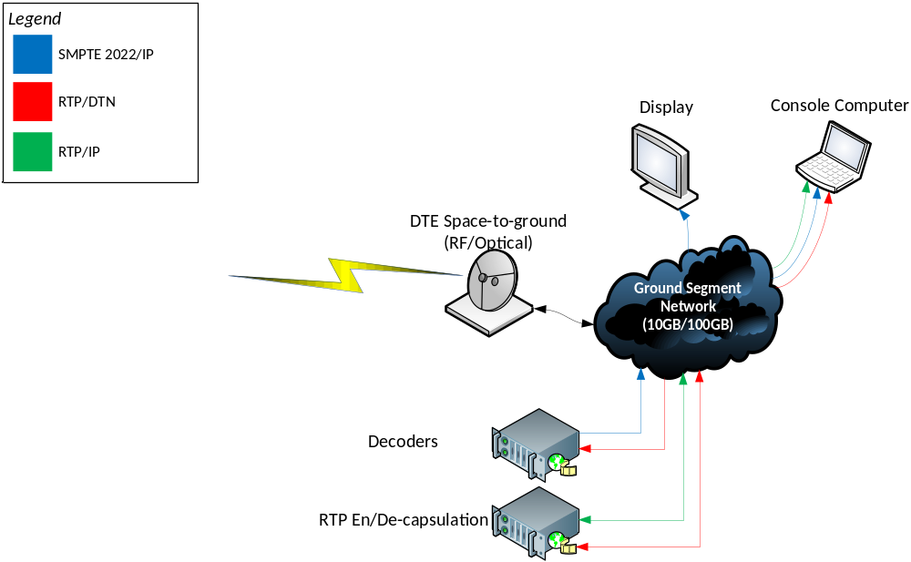
Figure 2-22: Flow Diagram—Ground Segment
Because of the homogeny provided by RTP, future ground segments may be simplified, thanks to both the usage of commercial software and hardware and the reduced number of interfaces required for reception. An example ground segment may be found in figure 2-2, in which the acute reader may notice many similarities to the onboard implementation. This figure omits some components, such as recording and archiving, although a proposed solution will be discussed in this section.
In the proposed ground segment, DTN-encapsulated RTP data containing compressed video is received from the Earth terminal of the space-to-ground link. This data is sent to the RTP encapsulation/decapsulation unit, which removes the Bundle Protocol headers and transmits the RTP data to the ground segment network. The RTP decapsulation is the only custom component of the system; all further data distribution may be accomplished with COTS hardware and software.
Individual console positions may use a COTS IPTV package (such as VLC Media Player) to select from various channels for display on their individual machines. Decoders may optionally be used, allowing the RTP streams to be decoded to SMPTE-2022. Displays without onboard decoding may be provided with uncompressed data via SMPTE-2022, using COTS IP/SDI converters. External users may make a VPN tunnel to the IPTV package (which, in some cases, also provides a Web site for channel selection), allowing them to select individual channels for display.
Finally, recording and archiving may be provided by the options from the same COTS IPTV packages, which capture RTP data from the network and encapsulate it into files, allowing for rapid archiving and subsequent exchange of video data.

Technical Overview

General
RTP (reference [1]) provides a lightweight packet format for the transmission of media-related payloads over IP-based networks and is a fundamental component of many higher-level protocols, such as the Session Initiation Protocol (SIP) (reference [C8]), used in IP telephony. The remainder of this section serves as a brief overview of RTP; it is not to be misconstrued as an attempt at a complete description of the protocol, which may be found in (reference [1]).
0 1 2 3
0 1 2 3 4 5 6 7 8 9 0 1 2 3 4 5 6 7 8 9 0 1 2 3 4 5 6 7 8 9 0 1
+-+-+-+-+-+-+-+-+-+-+-+-+-+-+-+-+-+-+-+-+-+-+-+-+-+-+-+-+-+-+-+-+
|V=2|P|X| CC |M| PT | sequence number |
+-+-+-+-+-+-+-+-+-+-+-+-+-+-+-+-+-+-+-+-+-+-+-+-+-+-+-+-+-+-+-+-+
| timestamp |
+-+-+-+-+-+-+-+-+-+-+-+-+-+-+-+-+-+-+-+-+-+-+-+-+-+-+-+-+-+-+-+-+
| synchronization source (SSRC) identifier |
+=+=+=+=+=+=+=+=+=+=+=+=+=+=+=+=+=+=+=+=+=+=+=+=+=+=+=+=+=+=+=+=+
| contributing source (CSRC) identifiers |
| .... |
+-+-+-+-+-+-+-+-+-+-+-+-+-+-+-+-+-+-+-+-+-+-+-+-+-+-+-+-+-+-+-+-+
Figure 2-33: RTP Packet Header
RTP is designed around a fixed 12-byte header, along with a variable-length header extension field, as can be seen in figure 2-3. Among other things, this header contains the Payload Type (PT) component, which specifies the type of data conveyed in this packet. Additionally, the header contains a timestamp and sequence counters, both of which will be discussed further. The last element to be aware of is the marker bit, which specifies that this packet contains ‘important data’, although the definition of importance is left to the payload type. Figure 2-4 provides an overview of the various IETF RFCs that describe RTP.
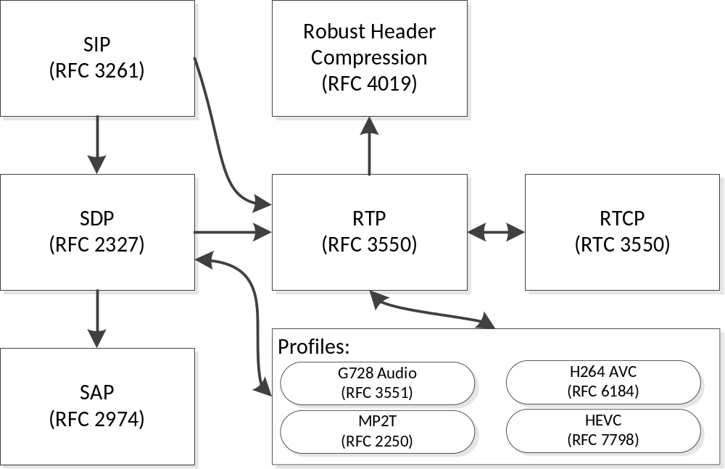
Figure 2-44: RTP Relationships
It is important to note that the RTP packet does not encode the size of the payload data, instead leaving that task to the underlying transport protocols. Furthermore, in order to prevent potential confusion, unless specifically mentioned, the term ‘payload’ refers to the payload of the RTP packet, as opposed to the bundle payload.

RTP Program structure

General
RTP profiles, with the exception of the RTP MPEG-TS profile, stipulate that each RTP stream contains a single type of data, such as audio or video. Therefore a single RTP program may comprise multiple RTP streams, each of which exists on their own channel. In an IP/multicast-based network, it is the responsibility of the receiver to subscribe to all relevant multicasts. This is a flexible mechanism that allows for robust programming; for example, a single RTP-based video encoder could transmit two unique video streams at different bitrates along with two audio streams in different languages. Based on the out-of-band signaling information, which is discussed further throughout section 3, the receiver may select the video stream that is best suited to the available bandwidth as well as the preferred audio language.
This model is also applicable to space-based RTP networks, albeit with some caveats. It is foreseen that the network within a spacecraft may be built around standard IP networking, while other networks, such as those used for space-to-ground communication, may be built around DTN with a range of underlying space link protocols, as shown in figure 2-5. In the case where RTP data must be transferred between these two types of networks, a variety of mechanisms may be used. While it is straightforward to encapsulate IP datagrams containing RTP PDUs into bundles, the small size and high frequency of these PDUs may cause excessive overhead. In such as case, the mechanisms described in 2.5.3 may be used.
As with standard IP-based networks, data destined for a DTN network may be transmitted in one of two ways: unicast or multicast. If more than two DTN endpoints have been factored into the mission design, BP Multicast (reference [C6]) may be used for transmission over space networks.
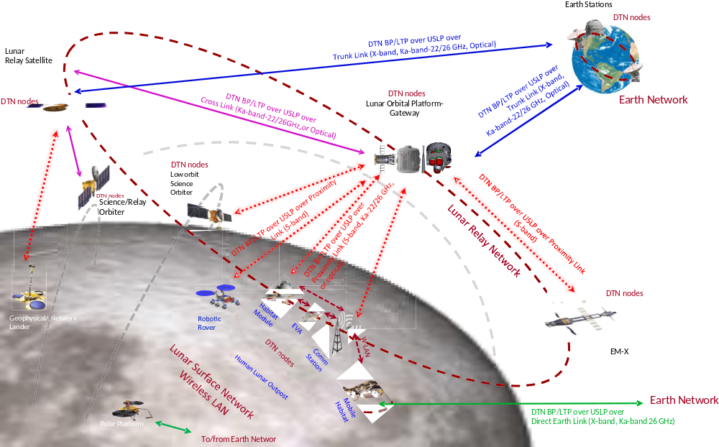
Figure 2-55: Spacecraft Network Design

RTP Concatenation Mechanisms
In order to facilitate variable Maximum Transmission Units (MTUs) in a single transmission path, it is possible to concatenate RTP packets. This capability is commonly used for IP-based transmission, and is not to be confused with the concatenation function provided by the H.264/265 Network Abstraction Layer (NAL). This concatenation function is applicable to data that is encapsulated within NAL transports and is relatively complex. It is not recommended to do NAL concatenation within the encoded video data stream with additional concatenation being performed at the Network Layer.
The timestamp contained within the RTP header is critical for the decoding of data, but may be constant across multiple packets. The presence of a non-incrementing timestamp across multiple packets indicates that the data from all packets must be decoded at once. Therefore the timestamp must be constant across all packets to be concatenated. Furthermore, when concatenating RTP data, care must be taken to avoid the loss of any data contained within the RTP header, as well as to prevent the interleaving of important and non-important data.
When concatenating RTP packets for DTN transport, a single RTP header is used followed by a variable-length blob of data. The transmitter is responsible for the concatenation, while the receiver must recreate the individual RTP packets, subject to the maximum applicable MTU for the receiving IP network. This is a similar approach to that which is taken by Robust Header Compression (RFC 4019), but is not identical. RFC 4019 relies upon packet identifiers and/or sequence numbers, while DTN-based RTP concatenation relies upon the sequence numbers and timestamps from within the Bundle Protocol.

RTP Synchronization Primitives
When compared to terrestrial RTP-based video systems, space-based networks are subject to unique difficulties with regards to the synchronization of video streams. Mission teams may require synchronization between received video and other sources of data, such as audio (either on camera or from a voice system) or telemetry. Therefore some care must be taken in order to ensure reliable synchronization of audio and video.
RTP timestamps are based upon the sampling frequency of the encoded data and are intended to be independent of each other. For example, the sampling frequency of most video codecs is 90 kHz, while the sampling frequency of telephone-quality audio is 8 kHz. Therefore even if these two programs are intended to be viewed simultaneously, their respective timestamps will increment by different quantities and at different frequencies. Furthermore, the timestamp may remain constant across multiple packets. RTP provides synchronization primitives that are applicable to streams sourced by a single encoder and/or multiple encoders and provides sufficient fidelity to achieve ‘wall-clock’ synchronization.
Inter-program synchronization may be accomplished via several mechanisms, each of which is covered in one or more IETF RFCs. The primary mechanism specified by the RTP standard is via the usage of Real-Time Control Protocol (RTCP) messages. RTCP, described in section 6 of reference [1] provides monitoring and control functionality for RTP streams. In an IP network, RTCP data for a given stream is provided on the next odd-numbered port. For example, an RTP stream that exists at 224.0.0.1:4220 would have an accompanying RTCP stream on port 4221. RTP and RTCP share similar packet structures, as shown in figure 2-6. However, an RTCP packet must be aligned on a 32-bit boundary.
0 1 2 3
0 1 2 3 4 5 6 7 8 9 0 1 2 3 4 5 6 7 8 9 0 1 2 3 4 5 6 7 8 9 0 1
+-+-+-+-+-+-+-+-+-+-+-+-+-+-+-+-+-+-+-+-+-+-+-+-+-+-+-+-+-+-+-+-+
|V=2|P| RC | PT=SR=200 | length |
+-+-+-+-+-+-+-+-+-+-+-+-+-+-+-+-+-+-+-+-+-+-+-+-+-+-+-+-+-+-+-+-+
| SSRC of sender |
+=+=+=+=+=+=+=+=+=+=+=+=+=+=+=+=+=+=+=+=+=+=+=+=+=+=+=+=+=+=+=+=+
Figure 2-66: RTCP Overview
RTCP has several defined message types, each of which is intended to accomplish different tasks, and will not be described here. For synchronization, the RTCP Sender Report (SR) must be used. The Sender Report, described in section 6.4.1 of reference [1] and shown in figure 2-7 is intended to be transmitted by all RTP senders or multiplexers, and contains all information required to synchronize RTP streams.
0 1 2 3
0 1 2 3 4 5 6 7 8 9 0 1 2 3 4 5 6 7 8 9 0 1 2 3 4 5 6 7 8 9 0 1
+-+-+-+-+-+-+-+-+-+-+-+-+-+-+-+-+-+-+-+-+-+-+-+-+-+-+-+-+-+-+-+-+
header |V=2|P| RC | PT=SR=200 | length |
+-+-+-+-+-+-+-+-+-+-+-+-+-+-+-+-+-+-+-+-+-+-+-+-+-+-+-+-+-+-+-+-+
| SSRC of sender |
+=+=+=+=+=+=+=+=+=+=+=+=+=+=+=+=+=+=+=+=+=+=+=+=+=+=+=+=+=+=+=+=+
sender | NTP timestamp, most significant word |
info +-+-+-+-+-+-+-+-+-+-+-+-+-+-+-+-+-+-+-+-+-+-+-+-+-+-+-+-+-+-+-+-+
| NTP timestamp, least significant word |
+-+-+-+-+-+-+-+-+-+-+-+-+-+-+-+-+-+-+-+-+-+-+-+-+-+-+-+-+-+-+-+-+
| RTP timestamp |
+-+-+-+-+-+-+-+-+-+-+-+-+-+-+-+-+-+-+-+-+-+-+-+-+-+-+-+-+-+-+-+-+
| sender's packet count |
+-+-+-+-+-+-+-+-+-+-+-+-+-+-+-+-+-+-+-+-+-+-+-+-+-+-+-+-+-+-+-+-+
| sender's octet count |
+=+=+=+=+=+=+=+=+=+=+=+=+=+=+=+=+=+=+=+=+=+=+=+=+=+=+=+=+=+=+=+=+
report | SSRC_1 (SSRC of first source) |
block +-+-+-+-+-+-+-+-+-+-+-+-+-+-+-+-+-+-+-+-+-+-+-+-+-+-+-+-+-+-+-+-+
1 | fraction lost | cumulative number of packets lost |
+-+-+-+-+-+-+-+-+-+-+-+-+-+-+-+-+-+-+-+-+-+-+-+-+-+-+-+-+-+-+-+-+
| extended highest sequence number received |
+-+-+-+-+-+-+-+-+-+-+-+-+-+-+-+-+-+-+-+-+-+-+-+-+-+-+-+-+-+-+-+-+
| interarrival jitter |
+-+-+-+-+-+-+-+-+-+-+-+-+-+-+-+-+-+-+-+-+-+-+-+-+-+-+-+-+-+-+-+-+
| last SR (LSR) |
+-+-+-+-+-+-+-+-+-+-+-+-+-+-+-+-+-+-+-+-+-+-+-+-+-+-+-+-+-+-+-+-+
| delay since last SR (DLSR) |
+=+=+=+=+=+=+=+=+=+=+=+=+=+=+=+=+=+=+=+=+=+=+=+=+=+=+=+=+=+=+=+=+
report | SSRC_2 (SSRC of second source) |
block +-+-+-+-+-+-+-+-+-+-+-+-+-+-+-+-+-+-+-+-+-+-+-+-+-+-+-+-+-+-+-+-+
2 : ... :
+=+=+=+=+=+=+=+=+=+=+=+=+=+=+=+=+=+=+=+=+=+=+=+=+=+=+=+=+=+=+=+=+
| profile-specific extensions |
+-+-+-+-+-+-+-+-+-+-+-+-+-+-+-+-+-+-+-+-+-+-+-+-+-+-+-+-+-+-+-+-+
Figure 2-77: RTCP Sender Report Message
The Sender Report message is divided into one sender block and one or more reporting blocks. Encoders and processors that generate this block may omit the reporting blocks, and they may be stripped by re-multiplexers. The sender block contains the NTP timestamp at the time of generation as well as the RTP timestamp for that media source, valid at the time of SR transmission. Receivers can use that information, along with the sampling frequency of the RTP stream, to determine the offset from real time. By receiving multiple sender reports for all components of the RTP stream, the streams may be coordinated.

Stream SIGNALING

General
RTP focuses upon the transmission of media and does not contain media description functionality as is present in the MPEG-TS standard. Therefore external protocols must be used to ensure that all parties are aware of the available video streams. The remainder of this section serves to describe the primary media description protocols that are in use in the RTP ecosystem.
In a full-featured implementation of RTP-over-DTN, it is assumed that there may be several signaling channels used for synchronization and discovery of various RTP programs. In order to simplify the transmission of these streams, all signaling may follow the basic rules outlined in 3.6, regardless of the content of the signaling channel, and outlined in the following subsections.

SDP

General
The Session Description Protocol (SDP) (reference [3]) is a versatile text-based format for the description of media streams. It provides a mechanism for the exchange of information that is required by a user or decoder, such as the multicast port and addresses for various stream types, as well as the start and end times, names, etc. SDP messages are designed to be relatively small, allowing for their conveyance in a multicast packet, file, or other mechanism (such as DLNA or another service-discovery mechanism).
An SDP description is formatted as a set of key=value tokens delimited by newline characters. Each key must be one-letter, while each value may be an indeterminate length. Per the specification, the key and value must be separated with an equal sign (‘=’) without spaces. The full list of keys is available in reference [3] and is not explained here. However, in order to describe the components of a single source uniquely, each component must be described by the connection information (c=) and the media name and transport address (m=). If the SDP file describes an IP-based stream, the connection parameter is typically a multicast address. The parameter is formatted as a 3-tuple of <nettype> <addrtype> <connection-address>.
If the connection parameter describes a multicast program, then nettype must be ‘IN’, addrtype must be ‘IP4’ or ‘IP6’ (depending upon the usage of IPv6), and the connection address must describe the message. If describing a IPv4 multicast stream, the connection address must be formatted as <base multicast>/<ttl>. Optionally, the address may be formatted as <base multicast>/[ttl]/<number of addresses>. If the number of addresses is provided, it is assumed that the data is encoded using a layered or hierarchical mechanism, and the network will prune unused addresses.
Within a DTN network, SDP occupies a similar position as in an IP-based network, acting as a mechanism to signal the presence, configuration, and location of program components. However, as the Bundle Protocol provides all necessary transport and validation mechanisms, SDP is transmitted ‘as is’, with no additional protocol overhead (e.g., SAP). Figure 2-8 shows an example of properly formatted SDP data, intended for transmission over the Bundle Protocol.
c=DTN BP IPN:1
m=video 2 RTP/AVP 96
a=rtpmap:96 H264/90000
a=fmtp:96 profile-level-id=640014;sprop-parameter-sets=Z2QAFKzZQ0R+f/zBfMMAQAAAAwBAAAAKI8UKZYA=,aOvssiw=
Figure 2-88: Example of SDP Data
As the video and SDP data transits the DTN network, the SDP data must be created or altered by the transmitting node. Therefore the following requirements apply to DTN-transmitted SDP data.
The details of SDP addressing as used within a DTN network is further expanded in 3.6.2.

Transport of SDP Messages
SDP may be transported over an IP-based network within (among others) Session Announcement Protocol (SAP) (reference [4]) and the Real Time Streaming protocol (RTSP) (reference [C7]). It is up to the implementer to determine which transport mechanisms should be supported within the DTN transmitter and receiver.

SDP Translation Between Network Domains
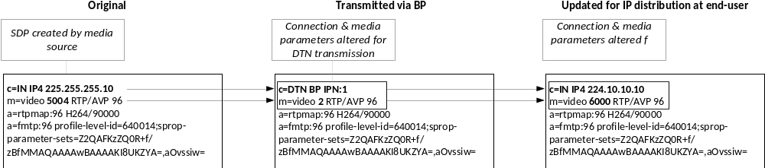
Figure 2-99: SDP Translation Between DTN and IP Domains
The SDP connection and media descriptor parameters are intended to identify the media source across networks. The addition of the DTN and BP parameter types extend SDP to identify media sources across RTP networks. Implementers may freely translate between IP and DTN environments by modifying the relevant portions of the SDP data, as shown in figure 2-9. An IP-to-DTN RTP converter may map the DTN EIDs containing media sources to multicast addresses and ports, allowing for a one-to-one modification of all connection information parameters to multicast addresses and media descriptors to ports within that particular address.

RTP Over DTN

General
RTP may be encapsulated into DTN bundles with minimal modification, instead treating the entirety of the RTP packet as the application data unit (ADU), to be encapsulated within a single bundle, as outlined in 2.5.2. However, astute observation of the RTP packet format may reveal redundancy between the RTP packet and the BP primary header; namely, both provide a timestamp and sequence number. Implementers of RTP over DTN must accept this redundancy and not attempt to remove the RTP timestamp and sequence, as they are designed to accomplish differing goals; while the RTP timestamp is based upon the sample rate of the payload, the BP timestamp is a wall-clock timestamp, expressed in seconds. Furthermore, the timestamp for the RTP packet can be repeated for a media stream in order to allow for fragmentation of RTP data. RTP states that all the payloads of all packets for a single stream with a single timestamp must be presented to the decoder at the same moment.

One-to-One Encapsulation of RTP in DTN
The one-to-one encapsulation of RTP within the payload of a bundle may be accomplished without any modification of the RTP packet structure. This is the most basic possible implementation, but may not be efficient because of the fact that the average IP-based RTP encoder is configured to issue packets suitable for an MTU size of 1400 bytes. While RTP packets that fit within MTUs of this size are acceptable for IP networks, given that the Bundle Protocol and convergence layer adapter will add their own headers, encapsulating each such RTP packet in a different bundle may create unnecessary amounts of overhead in a DTN network. Instead, it is preferable that the RTP concatenation mechanism from 3.3 be used to form larger application data units, termed RTP ADUs.

RTP-Over-DTN To IP

General
The normative section of this book specifies a robust set of guidelines that, taken in conjunction, allow for creation of an interoperable DTN-based video system. However, in many cases, the utility of such a system is limited by the lack of interfaces between standard IP and the DTN network. The remainder of this section provides an outline for an IP-to-DTN-to-IP-based video system.

Figure 2-10 shows a real-world example of an IP-to-DTN-to-IP as configured by DLR. ION 3.6.0B, as developed by JPL, was used as the DTN engine for his test. This configuration is in full compliance with section 3 of this book, as well as with references [1] and [3].
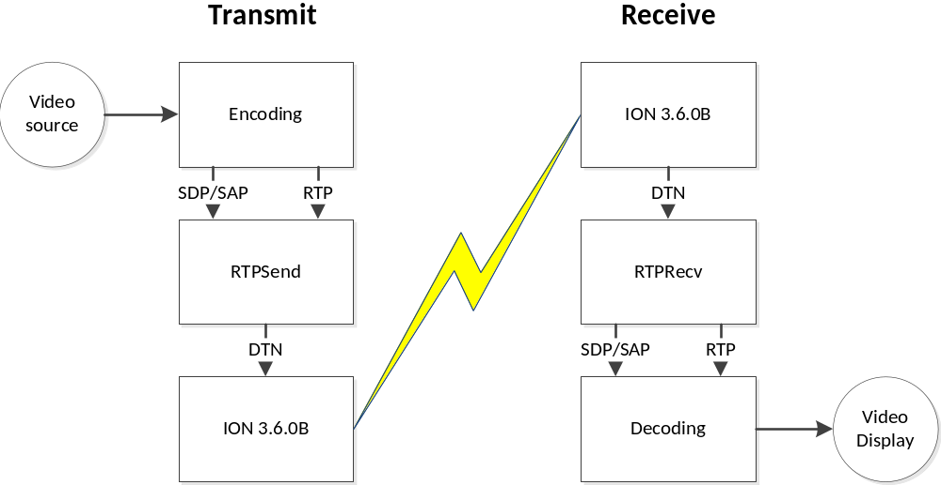
Figure 2-1010: Theoretical IP-to-RTP System

IP-to-RTP
In order to provide an easily usable interface between IP and DTN, SAP (reference [4]) is used to enumerate video sources within a multicast network. The media streams announced from SAP are described by multicast IP:port tuples and are subscribed to by the application, which assigns each media source a unique DTN EID. The SDP data received in the SAP message is permutated in order to remap the EIDs, as described in 3.6.2.
The RTP concatenation process is run on every RTP stream and sent to the DTN network alongside the stream of SDP messages.

RTP-to-IP
On the DTN receiver, a process listens to the specific EID containing the SDP data. The process from 3.6.2 is followed in reverse; the media sources described in the SDP data are mapped to a user-defined multicast IP, with incrementing ports, starting from a user-defined port.
The application listens to all the EIDs found within the SDP data and waits for the reception of RTP data on those endpoint IDs. Once RTP data is received, the fragmentation process from 3.4 is performed, creating a range of RTP streams. Finally, the SDP data (with the new multicast IP addresses) is forwarded as SAP messages.

Interoperability
As discussed in previous sections, the reception of DTN-encapsulated RTP ADUs (each of which may be the concatenation of multiple packets) for a single RTP program may be envisioned as a set of concurrent operations, each of which acts upon different DTN EIDs:
- extraction and forwarding of RTP packets;
- extraction and forwarding of RTCP packets, if required;
- reception and forwarding of signaling data, if required.
In order to facilitate a flexible and interoperable structure for the receiving applications, it is recommended that data structures be made available for exchange between the various applications.
Name | From | Description
EID Map | Signaling | A list of all EIDs for this program, used for subscription to BP multicast groups.
SSRC->port Map | RTP Transmitter | A list of all SSRCs, along with the multicast ports that are being used for transmission.

Legacy Compatibility
The progression from MPEG-TS to RTP has been a multi-decade process, supported by the vast resources of the broadcast industry. Therefore well-developed methods exist for legacy MPEG-TS support via RTP-based transports.
If the MPEG-TS RTP profile is used, it is the responsibility of the mission developer to announce the stream via SDP over the DTN network.

RTP in Space-Based Links

Overview
This section provides an implementer with requirements for the implementation of RTP over DTN. It is assumed that a Bundle Protocol implementation compliant with reference [2] is used.

RTP PDU Formatting
    - Each RTP ADU must begin with an RTP header that is compliant with reference [1].
    - The RTP header must start at byte 0 of the Bundle Protocol payload.
    - If stream signaling is used, all messages must be compliant with references [1], [3], and [4].
    - When transmitting RTP data over the Bundle Protocol, implementers must avoid the use of RTP fragmentation, instead relying upon BP fragmentation mechanisms.
    - For bundles containing RTP data generated from an external source, the RTP concatenation mechanism from 3.3 must be used to form the bundles’ ADUs.
    - If RTP packets must traverse from Bundle-Protocol- to non-Bundle-Protocol-based networks, those packets must be extracted from the bundle payload. If required, fragmentation may be implemented, as outlined in 3.4.

RTP Concatenation
    - While some video formats may support aggregation, these mechanisms must not be used in place of the RTP concatenation process.
NOTE – H.264 and 265 support a form of packet aggregation. However, this mechanism involves the modification of data within the RTP PDU payload section. As a result, the RTP concatenator process would require a deep insight into the packet content. Additionally, it is assumed that such processes may be used by encoders and/or other non-DTN-aware parts of the pipeline, and such functionality should not be repeated.
    - The padding bit of the RTP PDU header may be set; if set, RTP concatenation must not be attempted. Therefore, no application-level aggregation will be performed.
    - If secure RTP is used, RTP concatenation must not be attempted.
    - All concatenated packets must have the same RTP timestamp. Therefore concatenation shall be triggered based on a monotonic increase of the RTP timestamp. Optionally, the RTP sequence counter can be used in order to verify that there are no gaps prior to transmission of the concatenated data.
    - The marker bit for all packets within a single concatenated RTP ADU must be set to the same value. If the marker changes (regardless of all other packet similarities), the bundle containing the previously concatenated RTP ADU must be transmitted, and concatenation of a new RTP ADU shall start with that marked packet.
    - The state of the eXtension (X) bit must remain constant for all concatenated packets in a single RTP ADU. If the X bit is set, the extension data must remain constant across all packets. If the X bit is toggled or the extension data changes, then the bundle containing the previously concatenated RTP ADU must be transmitted, and concatenation of a new RTP ADU shall start with the changed packet.
    - All RTP packets concatenated in a single RTP ADU must be part of the same media stream, as defined by the RTP payload type as well as the RTP SSRC and/or multicast port. This extends the best practices established in section 5.2 of reference [1].
    - The SSRC identifier must not change through the managed transmission path.
    - Subject to 3.3.4, if any RTP packets destined for concatenation have set the padding bit, the padding must be removed and the bit must be unset.
    - The sequence counter must increase by one for each outgoing concatenated RTP packet.
    - Bundles containing concatenations of RTP packets must be transmitted as soon as concatenation is completed. Bitrate smoothing shall not be attempted.
NOTE – Figure 3-11 shows an example of a concatenated RTP ADU. The state of the marker bit is shown, while the sequence counters and timestamps are omitted.
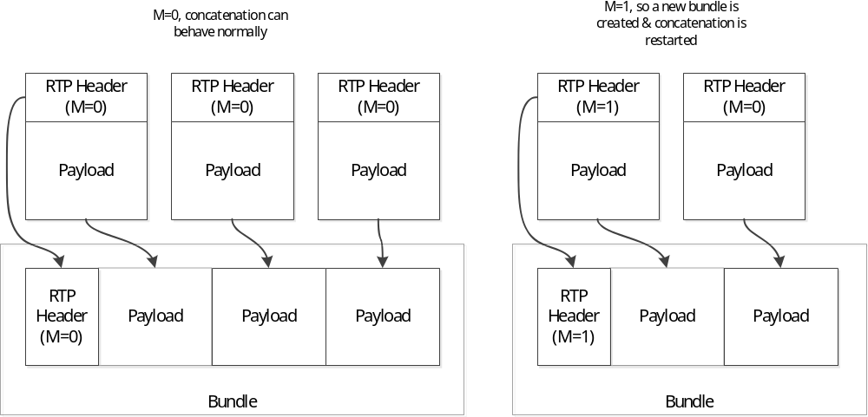
Figure 3-1111: RTP Concatenation—Overview

BP-to-Non-BP Fragmentation
NOTE – This subsection refers primarily to the refragmentation of DTN-encapsulated RTP data destined for non-BP networks. On the receiver, some basic rules need to be followed. These rules also need to be modified depending on the technology in use, and are expanded in following paragraphs.
    - Each incoming RTP ADU must be fragmented into acceptable segments based on the underlying output network MTU, which may be set via management or (for IP-based networks) via Network Path MTU Discovery.
NOTE – Any forwarding, fragmentation, and reassembly of bundles is expected to occur at the Bundle layer. Therefore it is expected that RTP fragmentation will only occur upon delivery of the complete bundle.
    - Each RTP segment must be prepended with a RTP header and transmitted. With the exception of the sequence count, the RTP header of the outgoing packet must contain all data that was transmitted within the incoming RTP packet.
    - The sequence numbers of the outgoing RTP packets shall be created independently from the input sequence number.

DTN Transmission of RTP Packets
    - Each RTP source that is a component of one or more programs shall be transmitted on an individual EID.
    - If a bundle size limit is required, it shall be decided by the implementer.

Signaling Data (SDP Description and RTCP)

General
      - All signaling messages shall be transmitted via a reliable convergence layer protocol, or in bundles for which custody transfer has been enabled.
      - All signaling messages shall be transmitted at least once every 30 seconds.
      - Each type of service message shall have its own unique EID.
      - If bundle multicast is used, multiple programs may transmit their service messages on the same EID.

SDP
      - Unless the MPEG-TS RTP profile is used, the stream must be announced via SDP over the DTN network.
      - For all connection information parameters (c=), the nettype shall be set to ‘DTN’.
      - For all connection information parameters (c=), the addrtype shall be set to ‘BP’.
      - For all connection information parameters (c=), the address field shall be the the longest character string with which the destination endpoint IDs of all program components begin, except that the terminal delimiter of this string (e.g., ‘.’) must be omitted.
Note: For endpoint IDs expressed with the IPN naming scheme, the address will be the node ID in the following form: 'ipn:<node number>'. For endpoint IDs expressed with the IMC naming scheme, the address will be the group ID in the following form: 'imc:<group number>'

For sources transmitted via multicast, the connection URI shall be the destination multicast group endpoint ID.

For sources transmitted via unicast, the connection URI shall be the destination node endpoint ID.
      - For each media descriptor (m=) in the SDP data, the port element must be changed to an unambiguous reference to the service (identified by the demultiplexing token in the destination endpoint ID) by which data for a given media component is conveyed.

For networks of nodes that conform to the CBHE specification [5], the port element shall be the service number of the BP EID that represents that media element.

For networks of non-CBHE-conformant nodes, the mapping between port numbers and BP service descriptions shall be stored in the Management Information Base (MIB) for a mission.
NOTE – SDP media descriptors can only express ports as a numeric value. For IPN-based streams, the preceding requirements allow the formulation of valid EIDs by appending the media descriptor 'm' to the connection information parameter 'c=', creating an endpoint ID of 'ipn:<c=.address>.<m=.port>'. Other naming schemes should only be used if they allow similar trivial creation of the endpoint ID or if an explicit mapping from connection information/media descriptor to endpoint ID is defined. In this case, the MIB should be able to perform bidirectional lookups between non-numeric BP service identifiers and numeric values. The exact port values are mission-specific, and do not require SANA registration.
Additionally, the address field of the connection information parameter may functionally represent zero or more DTN nodes.
      - The receiving node(s) shall determine the EID of each media component by combining the address field of the connection information parameter with the port element of the media descriptor.

By default, the combination must be performed by concatenating the string representation of the URI, as conveyed in the connection-information parameter, a delimiting character, and the port described in the media descriptor.

Unless otherwise specified, the delimiting character shall be “.”.
Note – The choice of delimiting character is based upon the IPN naming scheme from the CCSDS Bundle Protocol Blue Book.

Any combination rules not previously outlined in this section must be defined in the Management Information Base (MIB) for a mission.
      - Other elements of the media description must be transmitted without alteration.

Discussion
A connection parameter received from a (multicast-based) IP network can be formatted as:
c=IN IP4 224.1.0.1/255
The equivalent for a IPN-based BP network would be:
c=DTN BP ipn:1
Likewise, a media descriptor for a service transmitted on port 6000 of an IP multicast network would be formatted as:
m=video 6000 RTP/AVP 96
If CBHE service ID 2 is used for the outgoing media descriptor, this media descriptor would be formatted as:
m=video 2 RTP/AVP 96
Therefore a connection parameter describing ipn:1 as the root of the media service can be combined with the media descriptor describing service ID 2 in order to form the IPN name of ipn:1.2

RTCP Concatenation

Transmission Concatenation and Receiver Refragmentation
NOTE – RTCP concatenation is slightly more complex than the RTP concatenation mechanism specified in 3.3. RTCP packets are designed to be concatenated and can be combined into a compound RTCP packet, as outlined in section 6.1 of reference [1]. The rules in this section are normative and override the suggestions provided within the RFC (reference [1]).
        - If any incoming RTCP packets contain padding, it must be stripped during the concatenation process. The padding bit of all RTCP packets within the concatenated packet must be set to ‘0’.
        - All non-Sender Report RTCP packets must be ignored during the concatenation process.
        - The SSRCs within the RTCP packets shall not be changed.
        - The payload of each bundle conveying concatenated RTCP data must contain the latest RTCP sender report from each SSRC received since the last elapse of the transmission interval; no other RTCP packets may be contained within a single bundle.
NOTE – Unlike RTP concatenation, RTCP packets from multiple SSRCs can be multiplexed.
        - An RTCP Sender Report, as identified by a tuple of SSRC and timestamp, must not be repeated in multiple bundles.

RTCP Decapsulation
If the encapsulated RTCP packets are ultimately destined for an IP-based network, the following additional constraints must be applied:
- The receiver must decapsulate and forward every RTCP packet from a received and concatenated RTP ADU.
- Concatenated RTCP sender reports must be split into their component reports and transmitted to an odd-numbered port. Subject to the recommendations in section 11 of reference [1], this port must be one above that which is used for RTP transmission of a single media source.
NOTE – Since RTCP packets from multiple media sources may be concatenated, it is imperative that the implementer is aware that a single RTCP bundle may contain reports that will ultimately be destined for multiple ports on the IP network. Furthermore, as RTCP sender reports do not contain IP information, the only way to correlate the media sources from the RTCP packet with media sources on the network is via the SSRC of those component sources.

Packet Transmission Frequency
        - The packet transmission algorithm outlined in section 6.3.1 of reference [1] shall be ignored and replaced with a fixed transmission interval of less than or equal to 15 seconds.
NOTE – As shown in figure 3-12, the RTCP transmission interval determines the maximum period before real-time synchronization of RTP-based media streams with other sources (such as telemetry) can be achieved, and must be considered carefully. Decoding can begin at any time and is not affected by RTCP Sender Reports.
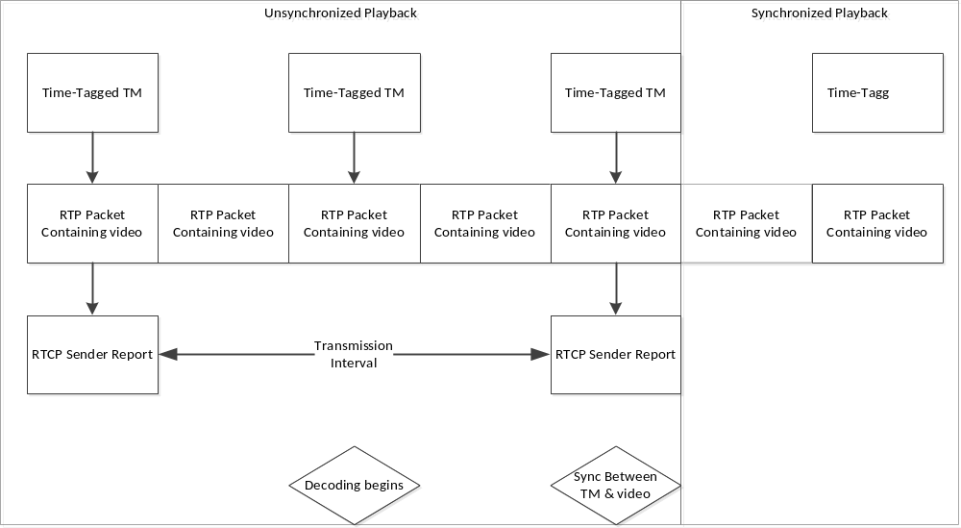
Figure 3-1212: RTCP and Video Synchronization

After the transmission interval has elapsed, the concatenated bundle shall be transmitted only if non-empty.
NOTE – As a result of these rules, it is strongly encouraged that the receiver maintain additional state-related information, such as a table of SSRCs and respective multicast addresses. Therefore as stated in reference [1], the receiver will retransmit the RTCP packet on a multicast port that is one above the associated RTP stream. However, if the RTP and RTCP demultiplexers are different applications, the SSRC-port mapping from 2.5.3.4 will be used for enquiry.

In-Band SPS/PPS Transmission of H264/H265 Data
If in-band transmission of H.264/H.265 SPS/PPS data is to be used for video source, SDP data must only be transmitted if multiple media sources exist within a single program and/or RTCP is used.

Implementation Conformance
Statement Proforma
(normative)
  - INTRODUCTION
    - OVERVIEW
This annex provides the Implementation Conformance Statement (ICS) Requirements List (RL) for an implementation of CCSDS 766.3-R-1. The ICS for an implementation is generated by completing the RL in accordance with the instructions below. An implementation claiming conformance must satisfy the mandatory requirements referenced in the RL.
    - ABBREVIATIONS AND CONVENTIONS
The RL consists of information in tabular form. The status of features is indicated using the abbreviations and conventions described below.
Item Column
The item column contains sequential numbers for items in the table.
Feature Column
The feature column contains a brief descriptive name for a feature. It implicitly means ‘Is this feature supported by the implementation?’
Status Column
The status column uses the following notations:
- M mandatory;
- O optional;
- C conditional;
- X prohibited;
- I out of scope;
- N/A not applicable.
Support Column Symbols
The support column is to be used by the implementer to state whether a feature is supported by entering Y, N, or N/A, indicating:
Y Yes, supported by the implementation.
N No, not supported by the implementation.
N/A Not applicable.
The support column should also be used, when appropriate, to enter values supported for a given capability.
    - INSTRUCTIONS FOR COMPLETING THE RL
An implementer shows the extent of compliance to the Recommended Standard by completing the RL; that is, the state of compliance with all mandatory requirements and the options supported are shown. The resulting completed RL is called an ICS. The implementer shall complete the RL by entering appropriate responses in the support or values supported column, using the notation described in A1.2. If a conditional requirement is inapplicable, N/A should be used. If a mandatory requirement is not satisfied, exception information must be supplied by entering a reference Xi, where i is a unique identifier, to an accompanying rationale for the noncompliance.
  - ICS PROFORMA FOR CCSDS 766.3-R-1
    - GENERAL INFORMATION
      - Identification of ICS
Date of Statement (DD/MM/YYYY)
ICS serial number
System Conformance statement cross-reference
      - Identification of Implementation Under Test
Implementation Name
Implementation Version
Special Configuration
Other Information
      - Identification of Supplier
Supplier
Contact Point for Queries
Implementation Name(s) and Versions
Other information necessary for full identification, for example, name(s) and version(s) for machines and/or operating systems;

System Name(s)
      - Identification of Specification
CCSDS 766.3-R-1
Have any exceptions been required?  NOTE – A YES answer means that the implementation does not conform to the Recommended Standard. Non-supported mandatory capabilities are to be identified in the ICS, with an explanation of why the implementation is non-conforming. | Yes [ ] No [ ]
    - REQUIREMENTS LIST
Item | Description | Reference | Status | Support
101 | IETF RTP Header used | 3.2.1, 3.2.2 | m
102 | RTP Concatenation | 3.3 | o
103 | BP to Non-BP fragmentation | 3.4 | o
104 | DTN Transmission of RTP packets | 3.5 | m
105 | Signaling data | 3.6 | o
106 | SDP | 3.6.2 | o
107 | RTCP Concatenation | 3.6.4 | o
108 | RTCP decapsulation | 3.6.4.2 | o
109 | Packet Transmission Frequency | 3.6.4.3 | c5
110 | SPS/PPS transmission for H264/H265 | 3.6.4.4 | o

Security, SANA, and Patent Considerations
(Informative)
  - Security Considerations
    - security concerns with respect to the CCSDS document
This specification does not provide any built-in facilities for the securing of RTP data; instead, this specification relies on the use of secure RTP (reference [C9]) and/or Streamlined Bundle Security Protocol (SBSP) (reference [C10]) on the underlying DTN network.
      - Data Privacy
This specification does not make any provision to privatize video data. It is the responsibility of the mission developer to, if required, incorporate secure RTP and/or SBSP into the mission infrastructure. If either of these security mechanisms are used, the relevant primitives for key management must be added to the Management Information Base (MIB) for the video hardware and/or avionics.
      - Data Integrity
This specification does not provide any mechanism to ensure end-to-end data integrity, instead relying upon the underlying Bundle Protocol implementation to provide these primitives. The SBSP Bundle Integrity Block (BIB) may be used.
      - Authentication of Communicating Entities
This specification does not provide any mechanism to authenticate the source of video data, instead relying upon the underlying Bundle Protocol implementation to provide these primitives. For example, LTP authentication (see reference [C11]) and/or the BIB may be used.
      - Control of Access to Resources
This specification assumes that access control is a task that is better performed by the underlying network, either via the use of encryption and/or network topologies. If encryption is used, individual video streams may be encrypted with unique keys; interested parties must possess those keys in order to access the video streams.
      - Availability of Resources
As this standard is intended to run within a heterogeneous DTN network, it is foreseen that other mechanisms, such as Bundle Protocol priorities, will be utilized to ensure reliability. If prioritization is used, the MIB must be extended to allow the control of priority for all video streams within the mission.
      - Auditing of Resource Usage
Auditing shall only be provided if an ancillary security mechanism is used. In this case, the security mechanism must present an audit trail.
    - Potential threats and attack scenarios
Several potential threat vectors exist for this standard: First, a malicious actor may inject non-compliant RTP data into the network, which could cause hardware decoders to crash. More significantly, since it is foreseen that the transition from IP to DTN to IP will be performed by software, this malicious RTP data may be used to exploit the underlying infrastructure (via a buffer overflow attack or other software-vector).
Video distribution networks are also susceptible to Denial of Service attacks, a risk that is increased when multicast is in use. In a Denial of Service attack, the attacker transmits malicious data and relies upon the underlying network topology to ‘amplify’ the data. This may cause an overload of the network.
Finally, RTP data may convey other data besides video; if a malicious actor has access to the underlying RTP encapsulation system, they may use non-video RTP packets to exfiltrate data from internal networks.
    - Consequences of not applying security to the technology
If confidentiality is not implemented, imagery might be visible to unauthorized entities resulting in disclosure of sensitive or private information.
Without source authentication or integrity verification, valid imagery could be corrupted or invalid imagery substituted in its place. Without access controls, authorized entities might be able to redistribute sensitive or proprietary information to unauthorized third parties.
  - SANA Considerations
The recommendations of this document do not require any action from SANA. It is expected that the DTN node numbers used for network entities as well as the requisite multicast group identifiers will be managed as required, in accordance with other CCSDS specifications, such as DTN Network Management.
  - Patent Considerations
The RTP standard has been provided to the IETF community and therefore is not patent encumbered.

Informative References
(Informative)
[C6] S. Burleigh. CBHE-Compatible Bundle Multicast. Internet-Draft draft-burleigh-dtnrg-imc-00 [expired]. Reston, Virginia: ISOC, April 9, 2009.
[C7] H. Schulzrinne, et al. Real-Time Streaming Protocol Version 2.0. RFC 7826. Reston, Virginia: ISOC, December 2016.
[C8] M. Handley, et al. SIP: Session Initiation Protocol. RFC 2543. Reston, Virginia: ISOC, March 1999.
[C9] M. Baugher, et al. The Secure Real-time Transport Protocol (SRTP). RFC 3711. Reston, Virginia: ISOC, March 2004.
[C10] CCSDS Streamlined Bundle Security Protocol Specification. Issue 1. Draft Recommendation for Space Data System Standards (Red Book), CCSDS 734.5-R-1. Washington, D.C.: CCSDS, March 2018.
[C11] Licklider Transmission Protocol (LTP) for CCSDS. Issue 1. Recommendation for Space Data System Standards (Blue Book), CCSDS 734.1-B-1. Washington, D.C.: CCSDS, May 2015.

Abbreviations and Acronyms
(Informative)
Term Meaning
BIB SBSP Bundle Integrity Block
CBHE Compressed Bundle Header Encoding
COTS commercial off-the-shelf
DLNA Digital Living Network Alliance
DTN Delay/Disruption Tolerant Networking
EID endpoint identifier
EVA extravehicular activity
ICS implementation conformance statement
IETF Internet Engineering Task Force
IP Internet Protocol
IPN interplanetary network
IPTV Internet Protocol television
LTP Licklider Transmission Protocol
MIB management information base
MPEG-TS MPEG transport stream
MTU maximum transmission unit
NAL network abstraction layer
PDU protocol data unit
PPS picture parameter set
PT payload type
RTCP Real-Time Control Protocol
RTP Real-Time Transport Protocol
RTP/AVP RTP Profile for Audio and Video
RTSP Real Time Streaming Protocol
SAP Session Announcement Protocol
SBSP Streamlined Bundle Security Protocol
SDI serial data interface
SDP Session Description Protocol
SIP Session Initiation Protocol
SMPTE Society of Motion Picture and Television Engineers
SPS sequence parameter set
SR sender report
SSRC synchronization source
URI Uniform Resource Identifier
VLC VideoLAN client
VPN virtual private network
X extension

ST 2022-6:2012 Transport of High Bit Rate Media Signals over IP Networks.

