
Draft Recommendation for
Space Data System Standards
Real Time Protocol over Delay Tolerant Networking for Video Applications
PROPOSED Draft Recommended Standard
CCSDS 000.0-W-0
White Book
February 2018

AUTHORITY

 | Issue: | White Book, Issue 0
 | Date: | February 2018
 | Location: | Not Applicable
(WHEN THIS RECOMMENDED STANDARD IS FINALIZED, IT WILL CONTAIN THE FOLLOWING STATEMENT OF AUTHORITY:)
This document has been approved for publication by the Management Council of the Consultative Committee for Space Data Systems (CCSDS) and represents the consensus technical agreement of the participating CCSDS Member Agencies. The procedure for review and authorization of CCSDS documents is detailed in Organization and Processes for the Consultative Committee for Space Data Systems (CCSDS A02.1-Y-4), and the record of Agency participation in the authorization of this document can be obtained from the CCSDS Secretariat at the address below.

This document is published and maintained by:

CCSDS Secretariat
Space Communications and Navigation Office, 7L70
Space Operations Mission Directorate
NASA Headquarters
Washington, DC 20546-0001, USA

FOREWORD
[Foreword text specific to this document goes here. The text below is boilerplate.]
Attention is drawn to the possibility that some of the elements of this document may be the subject of patent rights. CCSDS shall not be held responsible for identifying any or all such patent rights.
Through the process of normal evolution, it is expected that expansion, deletion, or modification of this document may occur. This Recommended Standard is therefore subject to CCSDS document management and change control procedures, which are defined in Organization and Processes for the Consultative Committee for Space Data Systems (CCSDS A02.1-Y-4). Current versions of CCSDS documents are maintained at the CCSDS Web site:
http://www.ccsds.org/
Questions relating to the contents or status of this document should be addressed to the CCSDS Secretariat at the address indicated on page i.
At time of publication, the active Member and Observer Agencies of the CCSDS were:
Member Agencies
- Agenzia Spaziale Italiana (ASI)/Italy.
- Canadian Space Agency (CSA)/Canada.
- Centre National d’Etudes Spatiales (CNES)/France.
- China National Space Administration (CNSA)/People’s Republic of China.
- Deutsches Zentrum für Luft- und Raumfahrt (DLR)/Germany.
- European Space Agency (ESA)/Europe.
- Federal Space Agency (FSA)/Russian Federation.
- Instituto Nacional de Pesquisas Espaciais (INPE)/Brazil.
- Japan Aerospace Exploration Agency (JAXA)/Japan.
- National Aeronautics and Space Administration (NASA)/USA.
- UK Space Agency/United Kingdom.
Observer Agencies
- Austrian Space Agency (ASA)/Austria.
- Belgian Federal Science Policy Office (BFSPO)/Belgium.
- Central Research Institute of Machine Building (TsNIIMash)/Russian Federation.
- China Satellite Launch and Tracking Control General, Beijing Institute of Tracking and Telecommunications Technology (CLTC/BITTT)/China.
- Chinese Academy of Sciences (CAS)/China.
- Chinese Academy of Space Technology (CAST)/China.
- Commonwealth Scientific and Industrial Research Organization (CSIRO)/Australia.
- Danish National Space Center (DNSC)/Denmark.
- Departamento de Ciência e Tecnologia Aeroespacial (DCTA)/Brazil.
- European Organization for the Exploitation of Meteorological Satellites (EUMETSAT)/Europe.
- European Telecommunications Satellite Organization (EUTELSAT)/Europe.
- Geo-Informatics and Space Technology Development Agency (GISTDA)/Thailand.
- Hellenic National Space Committee (HNSC)/Greece.
- Indian Space Research Organization (ISRO)/India.
- Institute of Space Research (IKI)/Russian Federation.
- KFKI Research Institute for Particle & Nuclear Physics (KFKI)/Hungary.
- Korea Aerospace Research Institute (KARI)/Korea.
- Ministry of Communications (MOC)/Israel.
- National Institute of Information and Communications Technology (NICT)/Japan.
- National Oceanic and Atmospheric Administration (NOAA)/USA.
- National Space Agency of the Republic of Kazakhstan (NSARK)/Kazakhstan.
- National Space Organization (NSPO)/Chinese Taipei.
- Naval Center for Space Technology (NCST)/USA.
- Scientific and Technological Research Council of Turkey (TUBITAK)/Turkey.
- South African National Space Agency (SANSA)/Republic of South Africa.
- Space and Upper Atmosphere Research Commission (SUPARCO)/Pakistan.
- Swedish Space Corporation (SSC)/Sweden.
- Swiss Space Office (SSO)/Switzerland.
- United States Geological Survey (USGS)/USA.
PREFACE
This document is a draft CCSDS Recommended Standard. Its ‘White Book’ status indicates that its contents are not stable, and several iterations resulting in substantial technical changes are likely to occur before it is considered to be sufficiently mature to be released for review by the CCSDS Agencies.
Implementers are cautioned not to fabricate any final equipment in accordance with this document’s technical content.
Recipients of this draft are invited to submit, with their comments, notification of any relevant patent rights of which they are aware and to provide supporting documentation.

DOCUMENT CONTROL

Document | Title and Issue | Date | Status
CCSDS 000.0-W-0 | [Document Title], Proposed Draft Recommended Standard, Issue 0 | November 2014 | Current draft

CONTENTS
Section Page
1 Introduction 1-1
1.1 Purpose And Scope 1-1
1.2 Applicability 1-1
1.3 Rationale 1-1
1.4 References 1-1
2 Overview 2-1
2.1 Assumptions 2-1
2.2 Flow diagram – RTP in larger picture 2-2
3 Technical Overview 3-1
3.1 RTP Program structure 3-2
3.2 Synchronization Primitives 3-3
3.3 Stream Signalling 3-6
4 RTP in Space-Based Links 4-7
4.1 RTP Over DTN 4-7
4.2 Legacy Compatibility 4-11
4.3 Interoperability 4-11
5 Conceptual: Ground Systems & Display Systems 5-13

ANNEX A Implementation Conformance Statement (ICS) Proforma (normative) A-1
ANNEX B Security, SANA, and Patent Considerations (Informative) B-1

Figure
No table of contents entries found.
Figure 3.1 RTP Packet Header 3-1
Figure 3.2 RTP Relationships 3-2
Figure 3.3 Spacecraft Network Design 3-3
Figure 3.4 RTCP Overview 3-4
Figure 3.5 RTCP Sender Report Message 3-5
Figure 4.1 RTP Concatenation - Overview 4-9

Table
No table of contents entries found.

Introduction
Motion Imagery/Video Transmission over DTN is not simple, due to the nature of video over IP, which generally requires consistent data flow into a video decoder. Up to now, the use of MPEG Transport Streams (MPEG-TS) has been the default standard to encapsulate and format video transmission over IP. However, MPEG-TS does not work well in situations with frequent interruptions or excessive latency and is not very flexible with regard to packet size. DLR has been testing Real Time Protocol (RTP) over DTN for video and has found it is much more forgiving of interruptions and long latencies in the network. The fact that RTP packet size is arbitrary makes it much more flexible for video over DTN.

  - Purpose And Scope
This document provides an overview and proposed methods for transmission of video over DTN using RTP. As more deep space missions will be utilizing DTN for data transmission and the use of video becomes even more prevalent, a standard method of formatting encoded video streams for transmission is required. Standardization makes it easier to design DTN nodes and networks. It also helps ensure higher reliability and quality of video transmission.

Applicability
This standard is intended for all future missions which produce, consume, or distribute video via the bundle protocol. The details (formats, resolutions, bitrates, etc) of the video to be transmitted are largely omitted, in order to prevent immediate obsolescence.

Rationale
This book is written with the assumption that future missions will rely upon a variety of cameras and imaging sensors. The encoding of these videos may be distributed throughout a spacecraft and/or mission, where the only common thread will be the usage of IP. Following the current trends in the media industry, the various encoders are foreseen to use RTP and/or a format which can be encapsulated into RTP.

References

[1] | IETF, "SIP: Session Initiation Protocol," IETF, 2002.
[2] | CCSDS, "CCSDS Bundle Protocol Specification," CCSDS, 2015.
[3] | IETF, "RTP: A Transport Protocol for Real-Time Applications," IETF, 2003.
[4] | IETF, "RFC 4566: SDP: Session Description Protocol," IETF, 2006.
[5] | S. Burleigh, "draft-burleigh-dtnrg-imc-00: CBHE-Compatible Bundle Multicast," IETF.

Overview

In the past two decades, manned spaceflight has undergone many changes. What was once unthinkable is now typical, throughout various components of spacecraft programs. Within spacecraft video systems, the embrace of Commercial Off-the-Shelf (COTS) video equipment, such as action cameras and handheld devices, is wide spread. As a result, the once-centralized nature of video transmission where all cameras transmit to a single encoder & transmission system has been forsaken for a distributed system, where some cameras are encoded by a centralized system, while others are encoded on-board. Furthermore, the variety of ways which video can be transmitted has increased; cameras may use wired networks, uncompressed video mechanisms such as SDI, wireless networks, or point-to-point links. The Real-time Transport Protocol has been used as a single consistent factor for this variety of video transmission opportunities, as it is robust to jitter, well-defined within the IETF, easy to implement, and extendable. In the modern broadcast world, everything from uncompressed video (SDI) to highly-compressed video (H.265) may be transmitted via RTP, over IP & non-IP networks.
This paradigm shift is not unique to the video transmission world; spacecraft transmission has suffered the same fate. A single spacecraft may now have a variety of distinct up & down-link mechanisms, as well as a separate modicum of on-board connectivity options for payloads and visiting vehicles, such as wireless networks based upon 802.11, Proximity-1, etc. The Bundle Protocol has been designed to unify this conglomeration by providing an overlay network for heterogeneous networks, where the concepts of delay and disruption tolerance were integrated from conception.
It is assumed that future deep-space
networks will rely upon DTN & the Bundle Protocol for their communication, while using RTP for video transmission. Therefore, it is pertinent that best-practices for the union of the two is well-defined prior to any future missions. This standard addresses the following:
- Encapsulation of RTP data on space links.
- RTP performance tuning for BP-based space links.
- Addressing of RTP data, in order to facilitate multiple-sender-multiple-receiver scenarios.
- Interoperability of standards.

Assumptions
List of relevant RFC’s, list of permitted video/audio formats, etc. Basic assumptions, such as usage of NTP, Restrictions (no fragmentation, that sort of thing)
[Normative specifications appear in sections 3 through n. See CCSDS A20.0-Y-4, CCSDS Publications Manual (Yellow Book, Issue 4, April 2014).
All sections and annexes should be separated by Word continuous section breaks.]

Flow diagram – RTP in larger picture
Within avionics, mission, ground conops.

Technical Overview
The Real-Time Transport Protocol (RTP) [1] provides a lightweight packet format for the transmission of media-related payloads over IP-based networks, and is a fundamental component of many higher-level protocols, such as the Session Initiation Protocol (SIP) [2], used in IP telephony. The remainder of this section serves as a brief overview of RTP; It shall not be misconstrued as an attempt at a complete description of the protocol, which may be found in [1].

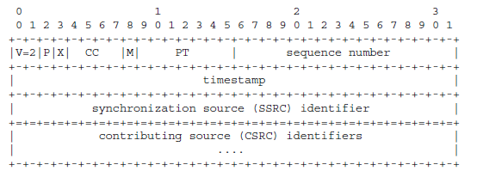
Figure 3.1 RTP Packet Header
RTP is designed around a fixed 12-byte header, along with a variable-length header extension field, as can be seen in Figure 3.1. Amongst other things, this header contains the Payload Type (PT) component, which specifies the type of data which is conveyed in this packet. Additionally, the header contains a timestamp and sequence counters, both of which will be discussed further. The last element to be aware of is the marker bit, which specifies that this packet contains “important data”, although the definition of importance is left to the payload type. Figure 3.2 provides an overview of the various IETF RFC’s which describe RTP.
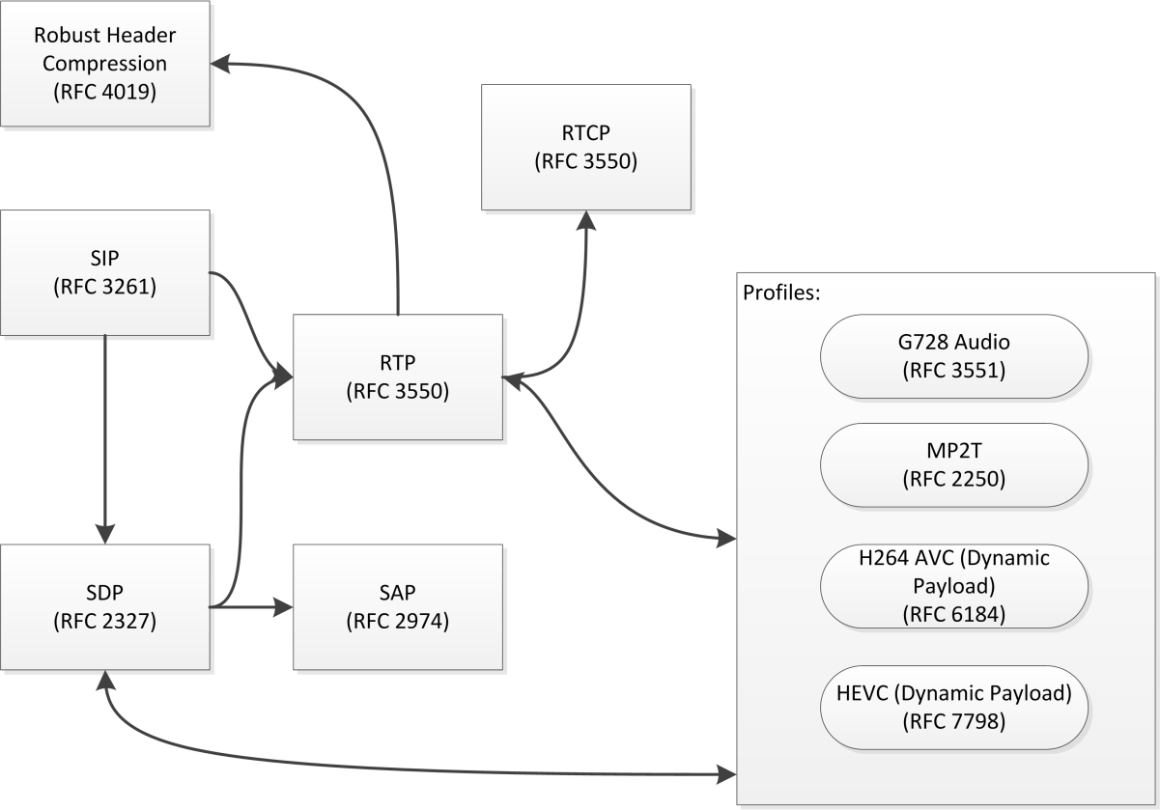
Figure 3.2 RTP Relationships
It is important to note that the RTP packet does not encode the size of the payload data, instead leaving that task to the underlying transport protocols. Furthermore, in order to prevent potential confusion, unless specifically mentioned, the term “payload” refers to the payload of the RTP packet, as opposed to the bundle payload.

RTP Program structure
RTP profiles, with the exception of the RTP MPEG-TS profile, stipulate that each RTP stream contains a single type of data, such as audio or video. Therefore, a single RTP program may comprise multiple RTP streams, each of which exists on their own channel. In an IP/multicast-based network, it is the responsibility of the receiver to subscribe to all relevant multicasts. This is a flexible mechanism which allows for robust programming; for example, a single RTP-based video encoder could transmit 2 unique video streams at different bitrates along with 2 audio streams in different languages. Based upon the out-of-band signaling information, which is discussed further throughout section 4, the receiver may select the video stream which is best-suited to the available bandwidth as well as the preferred audio language.
This model is also applicable to space-based RTP networks, albeit with some caveats. It is foreseen that a spacecraft network may be heterogeneous, with portions built around standard IP networking, while other segments may be built around DTN, as shown in Figure 3.3.
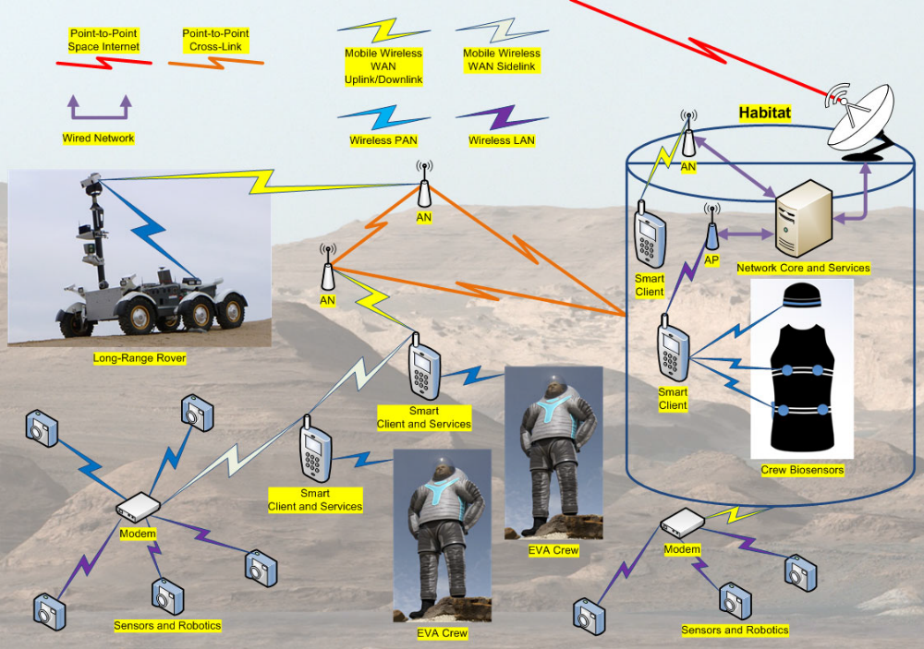
Figure 3.3 Spacecraft Network Design

Synchronization Primitives
RTP timestamps are based upon the sampling frequency of the encoded data and are intended to be independent to each other. For example, the sampling frequency of most video codecs is 90Khz, while the sampling frequency of telephone-quality audio is 8Khz. Therefore, even if these two programs are intended to be viewed simultaneously, their respective timestamps will increment by different quantities and at different frequencies. Furthermore, the timestamp may remain constant across multiple packets. RTP provides synchronization primitives which are applicable to streams sourced by a single encoder and/or multiple encoders, and provide sufficient fidelity to achieve “wall-clock” synchronization.
Inter-program synchronization may be accomplished via several mechanisms, each of which are covered in one or more IETF RFC’s. The primary mechanism specified by the RTP RFC is via the usage of Real-Time Control Protocol (RTCP) messages. RTCP, described in Section 6 of [1] provides monitoring and control functionality for RTP streams. In an IP network, RTCP data for a given stream is provided on the next odd-numbered port. For example, a RTP stream which exists at 224.0.0.1:4220 would have an accompanying RTCP stream on port 4221. RTP and RTCP share similar packet structures, as shown in Figure 3.4. However, a RTCP packet must be aligned on a 32-bit boundary.
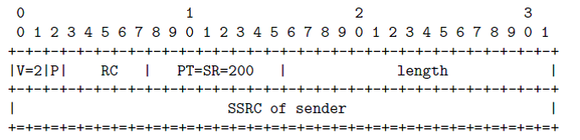
Figure 3.4 RTCP Overview
RTCP has several defined message types, each of which are intended to accomplish different tasks, and will not be described here. For synchronization, the RTCP Sender Report (SR) must be used. The Sender Report, described in section 6.4.1 of [1] and shown in Figure 3.5 is intended to be transmitted by all RTP senders or multiplexers, and contains all information required to synchronize RTP streams.
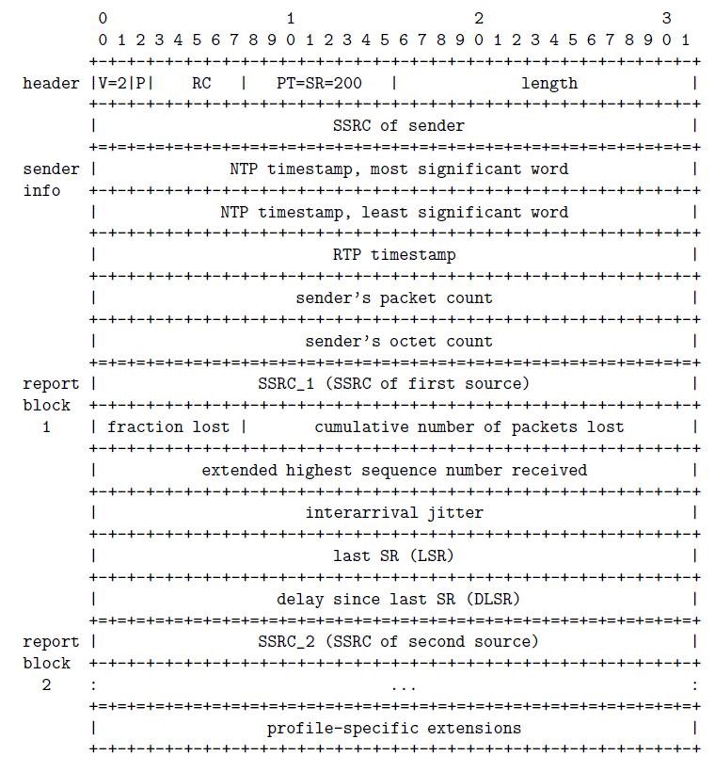
Figure 3.5 RTCP Sender Report Message
The Sender Report message is divided into one sender block and one or more reporting blocks. Encoders and processors which generate this block may omit the reporting blocks, and they may be stripped by re-multiplexers. The sender block contains the NTP timestamp at the time of generation, as well as the RTP timestamp for that media source, valid at the time of SR transmission. Receivers can use that information, along with the sampling frequency of the RTP stream to determine the offset from real-time. By receiving multiple sender reports for all components of the RTP stream, the streams may be coordinated.

Stream Signalling
RTP focuses upon the transmission of media, and does not contain media description functionality as is present in the MPEG-TS standard. Therefore, external protocols must be used to ensure that all parties are aware of the available video streams.

SDP
The Session Description Protocol (SDP) [3] is a versatile text-based format for the description of media streams. It provides a mechanism for the exchange of information which is required by a user or decoder, such as the multicast port and addresses for various stream types, as well as the start and end times, names, etc. SDP messages are designed to be relatively small, allowing for their conveyance in a multicast packet, file, or other mechanism (such as DLNA or another service discovery mechanism).
An SDP description is formatted as a set of key=value tokens, delimited by newline characters. Each key must be one-letter, while each value may be an indeterminate length. Per the specification, the key and value must be separated with an equals sign (=), and without spaces. The full list of keys are available in [3], and will not be explained here, other than the connection information parameter (c=), which describes the location where a media source may be accessed. If the SDP file describes an IP-based stream, the connection parameter is typically a multicast address. The parameter is formatted as a 3-tuple of (<nettype> <addrtype> <connection-address>.
If the connection parameter describes a multicast program, then nettype must be “IN”, addrtype must be “IP4” or “IP6” (depending upon the usage of IPv6), and the connection address must describe the message. If describing a IPv4 multicast stream, the connection address must be formatted as <base multicast>/<ttl>. Optionally, the address may be formatted as <base multicast>/[ttl]/<number of addresses>. If the number of addresses is provided, it is assumed that the data is encoded using a layered or hierarchical mechanism, and the network will prune un-used addresses.
The details of SDP addressing as is used within a DTN network is further expanded in section 4.1.4.1.

Transport of SDP Messages
SDP may be transported over an IP-based network within (amongst others) Session Announcement Protocol (SAP), and the Real Time Streaming protocol (RTSP). It is up to the implementer to determine which transport mechanisms should be supported within the DTN transmitter and receiver.

RTP in Space-Based Links

  - RTP Over DTN
RTP may be encapsulated into DTN bundles with minimal modification, instead treating the entirety of the RTP packet as a singular bundle, as outlined in section 4.1.1. However, astute observation of the RTP packet format may reveal redundancy between the RTP packet and the BP primary header; namely, both provide a timestamp and sequence number. Implementers of RTP over DTN must accept this, and not attempt to remove the RTP timestamp and sequence, as they are designed to accomplish differing goals, where the RTP timestamp is based upon the sample rate of the payload, while the BP timestamp is based upon seconds. Furthermore, the sequence count for the RTP packet can be repeated for a given payload, in order to allow for fragmentation.

1:1 encapsulation of RTP in DTN
The 1-to-1 encapsulation of RTP within the payload of a bundle may be accomplished without any modification of the RTP packet structure. This is the most basic possible implementation, but may not be efficient due to the fact that the average IP-based encoder uses a Maximum Transmission Unit (MTU) of 1400 bytes, which is acceptable for IP networks. However, given that the bundle protocol & convergence layer adapter will add their own headers, this may create unnecessary amounts of overhead. If possible, the MTU should be set to the largest reasonable number and/or RTP concatenation shall be used.

RTP Concatenation
In order to facilitate variable MTU’s in a single transmission path, it is possible to concatenate RTP packets. This is not to be confused with the concatenation function provided by the H.264/265 NAL. This concatenation function is applicable to data which is encapsulated within NAL transports, and is relatively complex. It is not recommended to do NAL concatenation within the encoded video data stream with additional concatenation being performed at the network layer.
When concatenating RTP packets for DTN transport, a single RTP header is used followed by a variable-length blob of data. The transmitter is responsible for the concatenation, while the receiver must recreate the individual RTP packets, prudent to the maximum applicable MTU for the receiving IP network. This is a similar approach to that which is taken by Robust Header Compression (RFC 4019), but is not identical. RFC 4019 relies upon packet identifiers and/or sequence numbers, while DTN-based RTP concatenation relies upon the sequence numbers and timestamps from within the bundle protocol.
The timestamp contained within the RTP header is critical for the decoding of data, but may be constant across multiple packets. The presence of a non-incrementing timestamp across multiple packets indicates that the data from all packets must be decoded at once. Therefore, the timestamp must be constant across all packets to be concatenated. Furthermore, when concatenating RTP data, care must be taken to avoid the loss of any data contained within the RTP header, as well as to prevent the interleaving of important and non-important data. Therefore, the following rules MUST be followed during RTP concatenation.
- The concatenated packet can contain an unlimited number of RTP packets.
- All concatenated packets must have the same timestamp. Therefore, concatenation shall be triggered based on incrementing of the RTP timestamp; Optionally, the RTP sequence counter can be used, in order to verify that there are no gaps prior to transmission of the concatenated data.
- The Marker bit for all packets within a single concatenated bundle must be set to the same value. If the marker changes (regardless of all other redundancy), the bundle must be transmitted and concatenation of a new bundle shall start with that marked packet.
- The state of the Extension (X) bit must remain constant for all concatenated packets in a single bundle. If the X bit is set, the extension data must remain constant across all packets. If the X bit is toggled or the extension data changes, then the bundle must be transmitted and concatenation of a new bundle shall start with the changed packet.
- All RTP packets destined for concatenation in a single bundle must be part of the same media stream, as defined by the Payload type as well as the RTP SSRC and/or multicast port. This extends the best practices established in section 5.2 of [1].
On the receiver, some basic rules shall be followed. These rules must be modified depending on the technology in use, and shall be expanded in following sections. It is also assumed that the receiver is in possession of a complete bundle. Any retransmission of the bundle or bundle segments is expected to occur at lower levels.
In order to successfully de-capsulate a concatenated RTP-based bundle, the receiver must:
- Cache the RTP header from the concatenated bundle.
- Fragment all data into acceptable segments.
- Transmit each segment with the (cached, and subsequently recreated) header, taking care to increment the sequence counter.
Figure 4.6 shows an example of a concatenated RTP bundle. The state of the Marker bit is shown, while the sequence counters and timestamps are omitted.
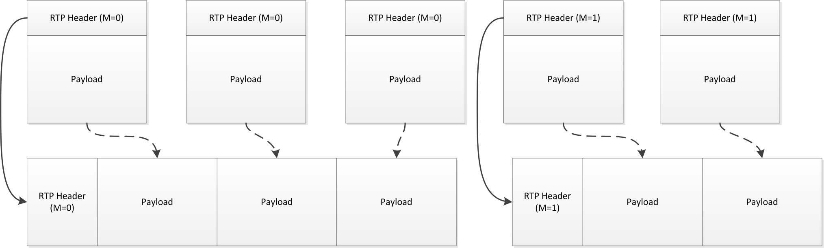
Figure 4.6 RTP Concatenation - Overview

DTN Transmission
As with standard IP-based networks, data which is destined for a DTN network may be transmitted in one of two ways: unicast or multicast. If more than two DTN endpoints have been factored into the mission design, BP Multicast [5] should be used for transmission over space networks.
When transmitting RTP over DTN, the following rules must be respected:
- Each RTP source which is a component of one or more programs shall be transmitted on an individual EID.
- The maximum bundle size shall be decided by the implementer.

Signaling
In a fully-featured implementation of RTP-over-DTN, it is assumed that there may be several signaling channels which are used for synchronization and discovery of various RTP programs. In order to simplify the transmission of these streams, all signaling shall follow the same rules for transmission and reception, regardless of the content of the signaling channel:
- All signaling messages shall be transmitted with custody transfer enabled.
- All signaling messages shall be transmitted at least once every 30 seconds.
- Each type of service message shall have its own EID.
This section outlines any further distinctions which must be made for individual types of messages.

SDP
Within a DTN network, SDP occupies a similar position as in an IP-based network, acting as a mechanism to signal the presence, configuration, and location of program components. However, as the Bundle Protocol provides all necessary transport and validation mechanisms, SDP is transmitted as-is, with no additional protocol overhead (e.g. SAP).
In order to uniquely describe the components of a single source, each component must be described by the connection information (c=) and the media name and transport address (m=). As the video and SDP data transits the DTN network, the SDP data must be created or altered by the transmitting node . Therefore, all connection information parameters (c=) shall be changed as follows:
- The nettype shall be set to “DTN”
- The addrtype shall be set to “BP”
- The address type shall be the EID where the stream or service may be found, formatted as text data. The scheme name shall be included, while the service number shall be omitted.
For example, a connection parameter received from an IP network may be formatted as:
c=IN IP4 224.1.0.1/255
The equivalent for a IPN-based BP network would be:
c=DTN BP ipn:1
As mentioned in section 3.3.1, multiple IP multicast addresses may be specified within the same connection parameter; this syntax shall not be used within a DTN-based video system; it is up to the implementer to decide if this shall be supported on the IP input and output, if they are used.
For each media description in the SDP data, the <port> element shall be changed to the service number of the BP EID which represents that element. Other elements of the media description shall not be altered.

RTCP & Media Source Synchronization
When compared to terrestrial RTP-based video systems, space-based networks are subject to unique difficulties with regards to the synchronization of video streams. Mission teams may require synchronization between received video and other sources of data, such as audio (either on camera or from a voice system) or telemetry.
If RTCP is used for synchronization, the reporting packets may be concatenated, as outlined in section 4.1.4.2.1. Care must be taken to ensure that the SSRC identifier does not change through the transmission path, including space-to-ground.

RTCP Concatenation
RTCP concatenation is slightly more complex than the RTP concatenation mechanism specified in section 4.1.2. RTCP packets are designed to be concatenated, and can be combined into a compound RTCP packet, as outlined in section 6.1 of [1]. When compared to the multiplexing rules specified by the RFC, the following differences must be observed by an implementer:
- The padding bit of all RTCP packets within the concatenated packet must be set to 0. If any component packets contain padding, it must be stripped by the multiplexer.
- Unlike RTP concatenation, RTCP packets from multiple SSRC’s may be multiplexed.
- The packet transmission algorithm outlined in section 6.3.1 of [1] may be ignored and replaced with a fixed transmission interval, preferably less than or equal to 15 seconds. The RTCP transmission interval determines the maximum period before synchronization of media sources may be achieved in real-time, and must be considered carefully.
  - If a centralized multiplexer is used, than the rules outlined in section 6.3 of [1] may be ignored.
- Unless required for troubleshooting, all non-sender report RTCP packets shall be ignored during the concatenation process.
- The SSRC’s within the RTCP packets shall not be changed.
As a result of these rules, the receiver must maintain additional state-related information, such as a table of SSRC’s and respective multicast addresses. The receiver must respect the following rules for retransmission of RTCP data:
- The receiver must de-capsulate every RTCP packet from a received and concatenated bundle.
- The receiver must retransmit the RTCP packet on multicast port which is one above the RTP stream. If the RTP and RTCP demultiplexers are different applications, the SSRC-port mapping from section 4.3 shall be used for enquiry.

In-Band signaling of H264 Data
Editors note: to be discussed as part of the archival discussion in §5.

Legacy Compatibility
The progression from MPEG-TS to RTP has been a multi-decade process, supported by the vast resources of the broadcast industry. Therefore, well-developed methods exist for legacy MPEG-TS support via RTP-based transports.
If the MPEG-TS RTP profile is used, it is the responsibility of the mission developer to announce the stream via SDP over the DTN network.

Interoperability
As discussed in prior sections, the reception of a DTN-encapsulated RTP program may be envisioned as a set of concurrent operations, each of which acts upon different DTN EIDs:
- Division and re-transmission of RTP packets.
- Division and re-transmission of RTCP packets, if required.
- Reception and retransmission of signaling data, if required.
In order to facilitate a flexible and interoperable structure for the receiving applications, it is required that data structures can be made available for exchange between the various applications.
Name | From | Description
EID Map | Signaling | A list of all EID’s for this program, used for subscription to BP multicast groups.
SSRC->port Map | RTP Transmitter | A list of all SSRC’s, along with the multicast ports which are being used for transmission.

Conceptual: Ground Systems & Display Systems
How this will be presented to ground systems & display devices. LOS handling. Division and replay of “real-time” data vs. that which was archived during LOS.

Implementation Conformance
Statement (ICS) Proforma
(normative)
  - INTRODUCTION
    - OVERVIEW
This annex provides the Implementation Conformance Statement (ICS) Requirements List (RL) for an implementation of [Specification]. The ICS for an implementation is generated by completing the RL in accordance with the instructions below. An implementation claiming conformance must satisfy the mandatory requirements referenced in the RL.
    - ABBREVIATIONS AND CONVENTIONS
The RL consists of information in tabular form. The status of features is indicated using the abbreviations and conventions described below.
Item Column
The item column contains sequential numbers for items in the table.
Feature Column
The feature column contains a brief descriptive name for a feature. It implicitly means “Is this feature supported by the implementation?”
Status Column
The status column uses the following notations:
- M mandatory;
- O optional;
- C conditional;
- X prohibited;
- I out of scope;
- N/A not applicable.
Support Column Symbols
The support column is to be used by the implementer to state whether a feature is supported by entering Y, N, or N/A, indicating:
Y Yes, supported by the implementation.
N No, not supported by the implementation.
N/A Not applicable.
The support column should also be used, when appropriate, to enter values supported for a given capability.
    - INSTRUCTIONS FOR COMPLETING THE RL
An implementer shows the extent of compliance to the Recommended Standard by completing the RL; that is, the state of compliance with all mandatory requirements and the options supported are shown. The resulting completed RL is called an ICS. The implementer shall complete the RL by entering appropriate responses in the support or values supported column, using the notation described in A1.2. If a conditional requirement is inapplicable, N/A should be used. If a mandatory requirement is not satisfied, exception information must be supplied by entering a reference Xi, where i is a unique identifier, to an accompanying rationale for the noncompliance.
  - ICS PROFORMA FOR [SPECIFICATION]
    - GENERAL INFORMATION
      - Identification of ICS
Date of Statement (DD/MM/YYYY)
ICS serial number
System Conformance statement cross-reference
      - Identification of Implementation Under Test
Implementation Name
Implementation Version
Special Configuration
Other Information
      - Identification of Supplier
Supplier
Contact Point for Queries
Implementation Name(s) and Versions
Other information necessary for full identification, e.g., name(s) and version(s) for machines and/or operating systems;

System Name(s)
      - Identification of Specification
[CCSDS Document Number]
Have any exceptions been required?  NOTE – A YES answer means that the implementation does not conform to the Recommended Standard. Non-supported mandatory capabilities are to be identified in the ICS, with an explanation of why the implementation is non-conforming. | Yes [ ] No [ ]
    - REQUIREMENTS LIST
[See CCSDS A20.1-Y-1, CCSDS Implementation Conformance Statements (Yellow Book, Issue 1, April 2014).]

Security, SANA, and Patent Considerations
(Informative)
  - Security Considerations
    - security concerns with respect to the CCSDS document
      - Data Privacy

      - Data Integrity

      - Authentication of Communicating Entities

      - Control of Access to Resources

      - Availability of Resources

      - Auditing of Resource Usage

    - Potential threats and attack scenarios

    - Consequences of not applying security to the technology

  - SANA Considerations
[See CCSDS 313.0-Y-1, Space Assigned Numbers Authority (SANA)—Role, Responsibilities, Policies, and Procedures (Yellow Book, Issue 1, July 2011).]
  - Patent Considerations
[See CCSDS A20.0-Y-4, CCSDS Publications Manual (Yellow Book, Issue 4, April 2014).]

