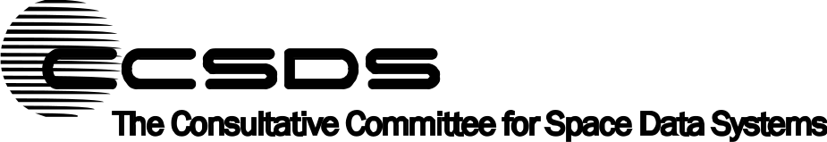
Report Concerning Space Data System Standards
Motion Imagery and Applications
Informational Report
CCSDS 706.1-G-1
Green Book
November 2010

AUTHORITY

 | Issue: | Informational Report, Issue 1
 | Date: | November 2010
 | Location: | Washington, DC, USA
This document has been approved for publication by the Management Council of the Consultative Committee for Space Data Systems (CCSDS) and reflects the consensus of technical panel experts from CCSDS Member Agencies. The procedure for review and authorization of CCSDS Reports is detailed in the Procedures Manual for the Consultative Committee for Space Data Systems.

This document is published and maintained by:

CCSDS Secretariat
Space Communications and Navigation Office, 7L70
Space Operations Mission Directorate
NASA Headquarters
Washington, DC 20546-0001, USA

FOREWORD
Through the process of normal evolution, it is expected that expansion, deletion, or modification of this document may occur. This Report is therefore subject to CCSDS document management and change control procedures, which are defined in the Procedures Manual for the Consultative Committee for Space Data Systems. Current versions of CCSDS documents are maintained at the CCSDS Web site:
http://www.ccsds.org/
Questions relating to the contents or status of this document should be addressed to the CCSDS Secretariat at the address indicated on page i.
At time of publication, the active Member and Observer Agencies of the CCSDS were:
Member Agencies
- Agenzia Spaziale Italiana (ASI)/Italy.
- Canadian Space Agency (CSA)/Canada.
- Centre National d’Etudes Spatiales (CNES)/France.
- China National Space Administration (CNSA)/People’s Republic of China.
- Deutsches Zentrum für Luft- und Raumfahrt e.V. (DLR)/Germany.
- European Space Agency (ESA)/Europe.
- Instituto Nacional de Pesquisas Espaciais (INPE)/Brazil.
- Japan Aerospace Exploration Agency (JAXA)/Japan.
- National Aeronautics and Space Administration (NASA)/USA.
- Federal Space Agency (FSA)/Russian Federation.
- UK Space Agency/United Kingdom.
Observer Agencies
- Austrian Space Agency (ASA)/Austria.
- Belgian Federal Science Policy Office (BFSPO)/Belgium.
- Central Research Institute of Machine Building (TsNIIMash)/Russian Federation.
- China Satellite Launch and Tracking Control General, Beijing Institute of Tracking and Telecommunications Technology (CLTC/BITTT)/China.
- Chinese Academy of Sciences (CAS)/China.
- Chinese Academy of Space Technology (CAST)/China.
- Commonwealth Scientific and Industrial Research Organization (CSIRO)/Australia.
- CSIR Satellite Applications Centre (CSIR)/Republic of South Africa.
- Danish National Space Center (DNSC)/Denmark.
- Departamento de Ciência e Tecnologia Aeroespacial (DCTA)/Brazil.
- European Organization for the Exploitation of Meteorological Satellites (EUMETSAT)/Europe.
- European Telecommunications Satellite Organization (EUTELSAT)/Europe.
- Geo-Informatics and Space Technology Development Agency (GISTDA)/Thailand.
- Hellenic National Space Committee (HNSC)/Greece.
- Indian Space Research Organization (ISRO)/India.
- Institute of Space Research (IKI)/Russian Federation.
- KFKI Research Institute for Particle & Nuclear Physics (KFKI)/Hungary.
- Korea Aerospace Research Institute (KARI)/Korea.
- Ministry of Communications (MOC)/Israel.
- National Institute of Information and Communications Technology (NICT)/Japan.
- National Oceanic and Atmospheric Administration (NOAA)/USA.
- National Space Agency of the Republic of Kazakhstan (NSARK)/Kazakhstan.
- National Space Organization (NSPO)/Chinese Taipei.
- Naval Center for Space Technology (NCST)/USA.
- Scientific and Technological Research Council of Turkey (TUBITAK)/Turkey.
- Space and Upper Atmosphere Research Commission (SUPARCO)/Pakistan.
- Swedish Space Corporation (SSC)/Sweden.
- United States Geological Survey (USGS)/USA.

DOCUMENT CONTROL

Document | Title | Date | Status
CCSDS 706.1-G-1 | Motion Imagery and Applications, Informational Report, Issue 1 | November 2010 | Current issue

CONTENTS
Section Page
1 Introduction 1-1

1.1 purpose and scope of this document 1-1
1.2 applicability 1-1
1.3 rationale 1-1

2 Examples of current spaceflight video applications 2-1

2.1 General 2-1
2.2 European Space Agency Manned space & microgravity Program 2-1
2.3 ISS ESA ATV Docking video 2-16
2.4 jaxa JAPANESE experiment module video system 2-20
2.5 nasa iss video system 2-23

3 Motion imagery parameters 3-1

3.1 background 3-1
3.2 video systems overview 3-1
3.3 RESOLUTION, SCANNING, AND FRAME RATE 3-4
3.4 cOMPRESSION 3-8
3.5 cHROMA SAMPLING 3-10
3.6 AUDIO 3-11
3.7 mOTION iMAGERY iNTERFACE pROTOCOLS AND TRANSMISSION 3-13
3.8 ASPECT RATIO MANAGEMENT 3-15
3.9 mETADATA AND ARCHIVING 3-16

4 potential future recommendations 4-1

4.1 overview of spacecraft motion imagery 4-1
4.2 bandwidth constraints 4-3
4.3 Integrating Video applications to other standards 4-5

ANNEX A Abbreviations and Acronyms A-1
Figure
2-1 IGS Locations Overview 2-4
2-2 MVDS Interfaces to External Sites 2-5
2-3 MVDS Context in Subsection Showing Relation to Other Systems/
External Facilities 2-6

CONTENTS (continued)
Figure Page
2-4 MVDS Overview 2-9
2-5 The Storage Facility Overview As Seen from the MVDS 2-11
2-6 Overview of the MVDS Distribution 2-14
2-7 HOSC Relay Video Equipment 2-15
2-8 MARS, Col-ESC, CADMOS, OMT, and MUSC Node Video Equipment 2-16
2-9 Docking Video: Interface in MCC-H 2-18
2-10 Docking Video: Interfaces and Video Transmissions between Col-CC,
ATV-CC, and MCC-M 2-20
2-11 Analog Video Distribution System in the JEM 2-21
2-12 Digital Video Distribution System in the JEM 2-22
2-13 HDTV Distribution from the ISS 2-23
3-1 Discrete Video System with Compression Before Transmission 3-2
3-2 Video System Integrated with Spacecraft Avionics 3-3
3-3 Video System with Compression in Camera 3-4
3-4 Aspect Ratio Comparisons 3-16
4-1 Spatial and Temporal Motion Imagery Requirements 4-3
4-2 Video Applications and Transmission Bandwidth 4-4

Table
2-1 Security Domains for Video 2-5
2-2 Summary of Multicast Video Channels 2-10
4-1 Transmission Scenarios for Imagery Applications 4-2

Introduction

purpose and scope of this document
The purpose of this document is to provide a common reference and framework for development of quality standards for digital video and motion imagery and to provide a foundation for future recommendations for utilization of international standards for sharing or distributing video and motion imagery between spacecraft elements and ground distribution systems.
This document provides background on current and planned uses of motion video, primarily in the International Space Station (ISS) context. Sections 2 and 3 examine current systems, and section 4 discusses potential future systems. Specialized motion imagery applications, such as high-speed scientific motion imagery and multi-spectral motion imagery, are not addressed in this document.

applicability
This information in this CCSDS Informational Report applies to space missions that require video and/or motion imagery. The focus is largely on manned missions, but it is not exclusive to that mission set.

rationale
In the early days of human spaceflight, motion imagery was accomplished with motion picture cameras, set at varying frame rates depending on lighting conditions. Upon safe return the film was processed and eventually shared with the world via documentaries or television. Inevitably live video became operationally desirable for situational awareness and for satisfying the public’s interest in high-profile events such as the Moon landings or the Apollo-Soyuz test project. Compromises were made with those first video systems to fit within the constraints of bandwidth, avionics, and transmission systems. Even in the modern era, video systems on spacecraft are a hybrid of analog and digital systems, typically made to work within the spacecraft’s avionics, telemetry, and command/control systems.
With the advent of digital cameras, encoding algorithms, and modulation techniques, it is desirable to treat video as data and utilize commercially available technologies to capture and transmit live and recorded motion imagery, possibly in high definition or even better.
Future Human Spaceflight endeavors are expected to be collaborations between many agencies, with complex interactions between spacecraft, and lunar/Mars surface systems, with intermediate locations (Extra-Vehicular Activity [EVA], crew, habitats, etc.) requiring the ability to view video generated by another agency’s systems. Therefore interoperability between these systems will be essential to mission success and in some cases crew safety. Such interoperability will be achieved only by use of common references and joint agreement on international standards, either commercial, CCSDS, or a combination of the two.

Examples of current spaceflight video applications

General
Before examining motion imagery parameters and potential recommendations for applications of motion imagery for spaceflight, it is beneficial to review current implementations of motion imagery, video, and television in existing spacecraft systems. This section documents analog, digital, and hybrid systems already deployed in spacecraft and ground systems. The reader is encouraged to pay special attention to the need for frequent format conversions and the many different interface standards required in these examples.

European Space Agency Manned space & microgravity Program

OVerview
In order to support the ISS missions of the European Space Agency (ESA) Manned Space & Microgravity (MSM) Program, which includes Columbus, Automated Transfer Vehicle (ATV), and other utilization of the ISS, a set of MSM Communications Infrastructure (MSM-CI) services is required for supporting data, voice, and video and their associated transport services.
The Video conferencing and Distribution Subsystem (ViDS) originally provided two video services, one a Moving Pictures Experts Group (MPEG)-2 Video Distribution Service (MVDS) and the other a Video Conferencing Service (VCS). The VCS is no longer supported by Columbus Control Centre (Col-CC) and is not discussed in this document.
The MVDS is implemented at Col-CC, which is the service termination point for all the sites requiring access to the ViDS services.

Scope
This subsection deals with the video distribution functions and therefore does not include discussion of the VCS video components procured as part of the infrastructure (cameras, overhead projectors, etc.).

MVDS Introduction
This subsection provides an overview of the MVDS, which includes the MVDS context (how it fits into the overall MSM ground segment) and the MVDS architecture.

Function and purpose

General
The MVDS supports both the MSM-CI for video distribution services, between Internet Protocol (IP) sites and MSM or intra-MSM sites, and the Col-CC internal video distribution.
Equipment employed includes the MVDS central services equipment (for MSM-CI video distribution); MVDS equipment to be integrated with the ESA relays at the Mission Control Center-Houston (MCC-H), Huntsville Operations Control Center (HOSC), and Mission Control Center-Moscow (MCC-M); and MVDS components to be integrated with Interconnecting Ground Segment (IGS) nodes at various European locations.
The video to be handled by the MVDS is as follows:
- MCC-H video, which includes also the space-to-ground video channels and the ATV /Sojus docking video;
- HOSC video(Station, Payload, BCC videos)
NOTE – In Backup Control Center HOSC (BCC-HOSC) mode, some of the HOSC video channels are rewired to BCC-HOSC.
- MCC-M video, which includes also the space-to-ground video channel;
- ATV Control Center (ATV-CC) video;
- European Astronaut Centre (EAC) video.
Col-CC Internal
The MVDS provides the video capture, distribution management capabilities, and interfaces with the Col-CC Storage & Archive Infrastructure for on-line storage, archiving, and retrieval. This service receives and distributes video channels coming from external sources (e.g., other sites via the IGS, cameras, recorders, computer-generated video, public broadcasters, etc.) to other Col-CC destinations (e.g., PCs/workstations, monitors, large screen displays, other sites via IGS, site and public relations destinations, and multi-media storage devices in the Col-CC Storage & Archive Infrastructure).
MVDS Components
The MVDS therefore includes the following components:
- relay and nodes video equipment:
- video signal ancillary equipment: processing/switching/distribution;
- MPEG-2/4 encoders, decoders, and gateways;
- Multi-Protocol Label Switching (MPLS) Customer Edge (CE) routers;
- video multicast server/video IP streamer;
- transrating, multiviewer, time, and logo insertion;
- video distribution element manager and DataMiner (management server);
- video storage manager and editing tools.

External Video Sources/Destinations
As presently baselined, 16 (+8 using the backup facility) operational video channels can be received from external partners. This number can be increased by adding new devices and upgrading the 64×64 Asynchronous Serial Interface (ASI) switch located at Col-CC prime. These channels are received on the T-Vips TVG420 video gateway. The contents of the video transmitted on these channels are selected by system controllers at Col-CC. They may include any of the space-to-ground channels from the ISS/Columbus, the NASA Space Shuttle, or the IP facility itself.
Currently Col-CC can send up to 20 streams (+8 using the backup facilities) to the external sites.
The IGS performs all real-time distribution of the video to European user sites. The handling of user requests and the distribution of video playbacks are automated to the extent practical, e.g., through the use of Communication Service Requests (CSRs).

MVDS Audio/Video Distribution
In addition, the Video System performs the distribution of video and audio to PCs/Workstations, video monitors, cameras, and to/from storage/archive devices as provided by the Col-CC Storage & Archive Infrastructure. The distribution to/from this equipment utilizes the already-installed network infrastructure dedicated Fast Ethernet fiber cabling.

Col-CC Infrastructure
Any MVDS components located at the Col-CC are integrated with the Col-CC Infrastructure. From the perspective of the MVDS the points of integration are:
- the Network Infrastructure Subsystem (NIS) for MVDS components, which need to be able to stream video or be managed;
- the computing infrastructure (servers and workstations) for MVDS software;
- the Storage & Archive Infrastructure, which consists of a Storage Area Network (SAN) and primary and secondary storage devices (the video storage manager is required to work with this infrastructure for video storage and retrieval);
- the German Space Operations Centre (GSOC) digital video system for encoding and decoding of video channels received or transmitted to the MVDS;
- the Timing Network Time Protocol (NTP) servers for time synchronization of MVDS components.

IGS Locations
Figure 2-1 provides an overview of the locations where the MVDS equipment is installed.
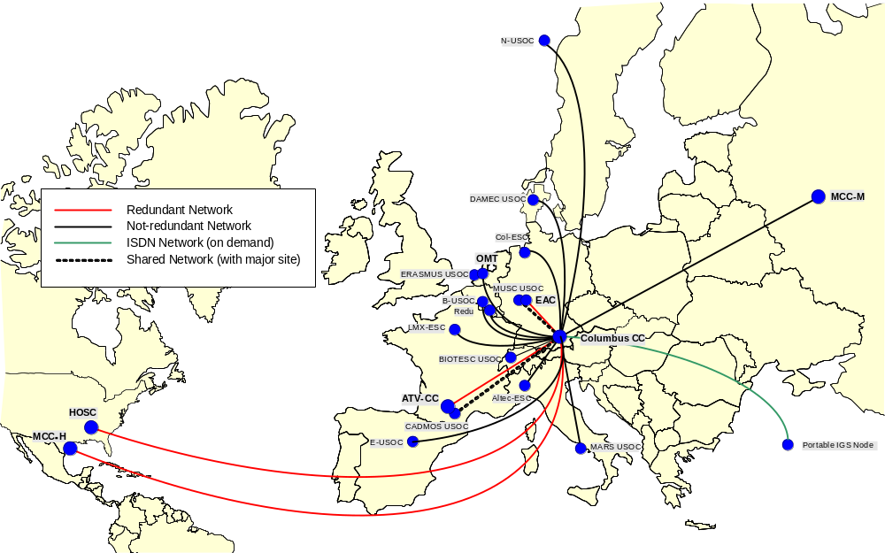
Figure 2-11: IGS Locations Overview

Security
The video channels handled by the MVDS travel through several domains, each of which has different security requirements and capabilities as defined in table 2-1.
Table 2-11: Security Domains for Video
Domain | Mechanism
IGS Remote Nodes (Contribution/Sources) | Physical protection of equipment  The data transmitted via MPLS is encrypted
IGS WAN | Physical protection of MPLS equipment at the sites of the WAN provider
Columbus CC | Physical protection of equipment  Columbus CC network security  System administrator procedures  Video security requirements
IGS Remote Nodes (Distribution/Destinations) | Physical protection of equipment  The data transmitted via MPLS is encrypted
Out-of-Band Management | Access provided and controlled by IGS node equipment

Relation to other systems/external facilities
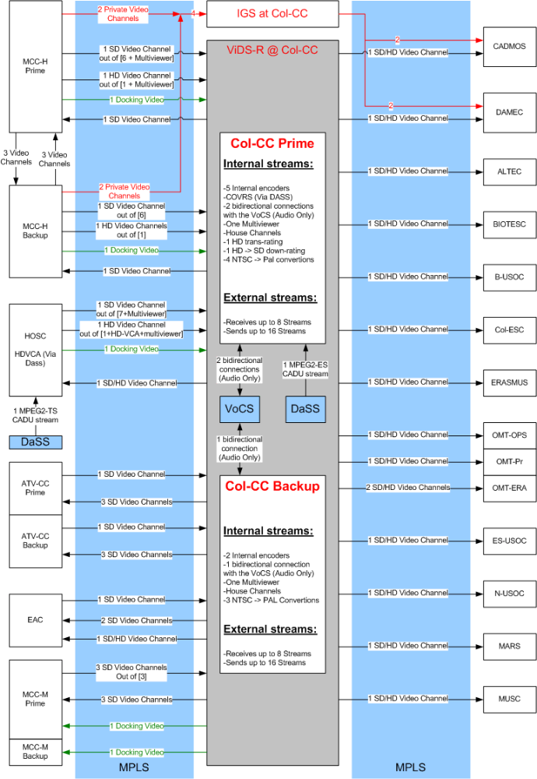
Figure 2-22: MVDS Interfaces to External Sites
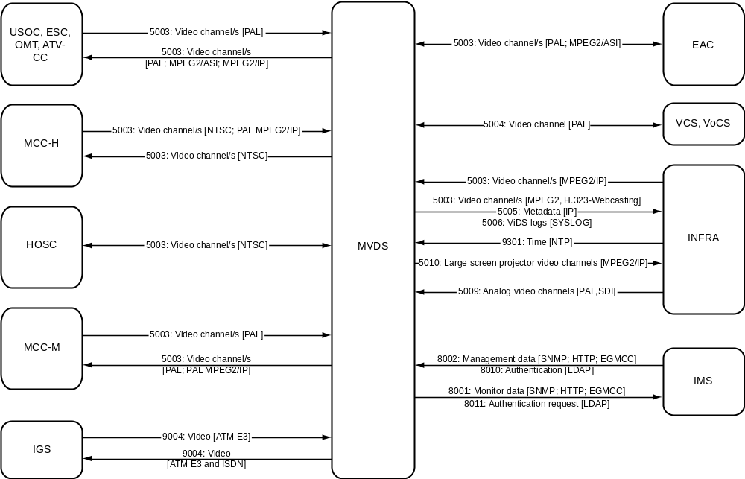
Figure 2-33: MVDS Context in Subsection Showing Relation to Other Systems/External Facilities

Integrated Management Subsystem Interfaces
In addition to the video interfaces, the MVDS element manager interfaces with the Integrated Management Subsystem (IMS) for purposes of providing MVDS monitoring and limited control capabilities. This interface allows reporting of video component failures, remote control of video switching, video multicast server configuration, video conferencing set-up, etc.

Relation to External Facilities

Mission Control Center-Houston
From MVDS to MCC-H
Video Channels National Standards Television Committee (NTSC)
From MCC-H to MVDS
Archived video NTSC
Video Channels NTSC, Phase Alternating Line (PAL) MPEG2/IP

Huntsville Operations Control Center
From MVDS To HOSC
Video Channels NTSC; MPEG2 TS / Mpeg 4
From HOSC To MVDS
Archived video NTSC, MPEG2 TS / Mpeg 4
Video Channels NTSC, MPEG2 TS / Mpeg 4

Mission Control Center-Moscow
From/to MVDS and MCC-M
Video Channels PAL and PAL MPEG2/IP

ATV Control Center
From MVDS to ATV-CC
Video channels retrievals MPEG2 TS / Mpeg 4
Video channels/retrievals PAL
From ATV-CC to MVDS
Video channels PAL

EAC and User Support Centers (USOCs)
From MVDS to EAC/USOCs
Video channels / retrievals MPEG2 TS / Mpeg 4
Video channels /retrievals PAL (MPEG2/IP for most USOCs)
From EAC/USOCs to MVDS
Video channels MPEG2 TS, Mpeg 4
LM 1024 Video channels/retrievals PAL

Public Relations
From MVDS to Public Relations
PM 5003 Video channel/s
LM 1024 Video channels MPEG2, PAL, Mpeg 4, IP

Video Conferencing System and Voice Conferencing System
The Voice Conferencing System (VoCS) are connected via analog video and audio interfaces to the MVDS.
From MVDS VoCS
Video channels PAL

MVDS ARchitecture

General
Unicast is used for all the transmissions between Col-CC and the different remote sites. Multicast will not be used (network technical restriction). Video for ATV-docking activities will also be transmitted using unicast.
Figure 2-4 shows that the MPEG2 video distribution needs to be functional from the Col-CC back-up facility. The Col-CC back-up facility was originally to be used only in the case of a catastrophe. However, careful design and testing confirms that coupling of the equipment can be achieved to alleviate service losses at the prime, allowing the prime and backup facilities to function jointly for a temporary period until the services are resumed. This saves on the number of components needed as spares and increases the availability and reliability of the MVDS services. The distance between the prime and back-up facility is approximately 300 m.
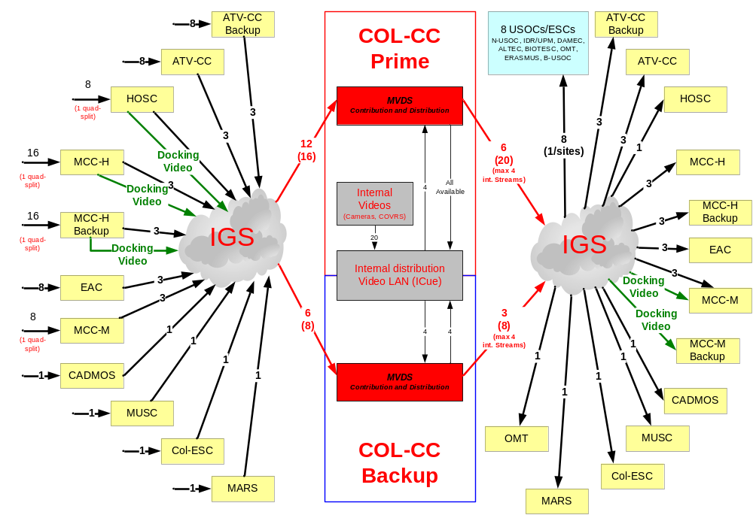
Figure 2-44: MVDS Overview

Col-CC Component Descriptions

General
The following subsections show the components used at the Col-CC. Several are duplicated at the Col-CC Backup but some have similar appliances.

Video Multicast Server

General
Col-CC internal video support functions include operational video reception and distribution to video end equipment and the video storage manager. The multicast server is able to use a video channel or file retrieved from the Col-CC Storage & Archive Infrastructure as a source of a multicast, in addition to the possible multicasting sources identified in table 2-2.
Table 2-22: Summary of Multicast Video Channels
Video Type | Number of Channels | Remarks
External Video Sources | 16 | External sites; includes space/ground. Compressed MPEG2. Is expandable to allow for more sources.
Internal:  Broadcast / Cameras / Recorders / Retrieved from Storage | 20+ | May be analog, digital, or already compressed. Need to be equipped for compression of all sources, audio and video. Are expandable to allow for more sources.
The Video Multicast Server component handles distribution of channels already in MPEG2 Digital Video Broadcasting (DVB) ASI format as received from the IGS. It further provides distribution management for unicasting and multicasting receiver-oriented channel selection at workstations, which is done via MPEG/IP. Selected channels are bridged from MPEG/IP back to the ASI switch by using a Path1 Video Gateway.
The Video Multicast Server comprises
- ASI Switch Matrix 64×64;
- Tandberg TT7140 IP Multicast Streamer;
- Path1 CX1800 IP to ASI Gateway;
- iCue Server and Software at Workstations.
These devices work together to provide internal multicasting/streaming to the desktop in a user-friendly environment.

IP Streamer
The Tandberg TT7140 IP Streamer converts each of the 20 ASI channels passed from the Leitch Switch to IP encapsulated streams. IP multicasts using User Datagram Protocol (UDP) are mapped to a 100 Mb/s Ethernet/IP interface. The IP Streamer can in effect be modeled as a DVB Service ID to a Multicast IP stream router. Each service on the ASI inputs is associated with its own multicast IP address and streamed out as a Single-Program Transport Stream (SPTS). Each SPTS typically contains a single audio Packet ID (PID) and a single video PID with the associated set of correctly regenerated Program Specific Information (PSI)/SI tables. The IP Streamer can handle up to 64 independent IP streams, so that multiple transport stream ASI inputs may be used. Although multiple program transport streams are not foreseen in the MVDS solution, it is good to keep the possibility in place.
Even though the IP Streamer can handle up to 64 streams, the number of streams being handled by one IP Streamer is in general limited by the output bit rate on the 100 Mb/s Ethernet interface. Effective output bit rate per Ethernet card is maximum 80 Mb/s. The IP Streamer can however be equipped with two 100 Mb/s Ethernet cards, making the total maximum effective output bit rate 160 Mb/s for each IP Streamer. For Deutsches Zentrum für Luft- und Raumfahrt e.V. (DLR), the IP Streamer has been equipped with 20 ASI inputs and one 100BaseT Ethernet output for streaming, which should meet the needs of the system.
The IP Streamer has an extra 100BaseT Ethernet interface for out-of-band management.
The Streamer interfaces the Leitch switch on the input side; and the Teracue iCue software handles the MPEG2/IP multicasts selections on the output side. Each MPEG2/IP stream has a unique IP address, and this address is identified as a unique video channel by the software to stream to end users at workstations, or to the storage area.
Configuration of the IP Streamer can be performed from eXpress Persistent Objects (XPO) Software, which is included into a Web browser.

Video Storage Manager and Workstation Streaming
The video storage manager handles the storage and retrieval of video channels on the Col-CC Storage & Archive Infrastructure. Only the Ground Controllers and MVDS Engineers are permitted to store and archive video; to avoid overflow of the storage area, this functionality should not be permitted by general users at workstations.
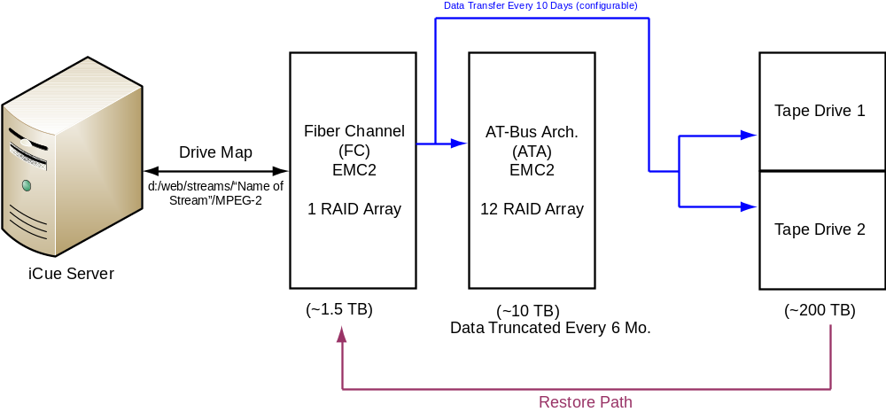
Figure 2-55: The Storage Facility Overview As Seen from the MVDS
The storage area consists of a cascade of RAID arrays and tape drives as shown in figure 2-5. From an iCue Web browser, the video storage manager requests the channels from the list of sources available (content coming from the Tandberg IP Streamer or one of the internal encoders). After selection by the operator, the channels are processed for sending to the RAID array. The total number of required channels to be handled by the storage facility in parallel is six.

Operational Control Room Cameras

General
The Operational Control Room (OCR) cameras are capable of operation in low-light conditions and provide remote controlled zoom and pan-tilt capabilities. The Infrastructure provides four camera feeds to the MVDS (two in each control room). The Serial Digital Interface (SDI) output of the camera is compressed by an internal encoder (see section on Col-CC Internal Encoders) and distributed accordingly.

Multiviewer
It is required that any nine video signals be processed into a single screen simultaneously. The ReCoder from Teracue handles this function. This is done in the IP domain, where all four streams are decoded and re-encoded within one dual-processor PC. The stream is re-introduced to the ASI switch matrix via the Path1 Gateway for MPLS unicast. The backup facility does the quarter split in a different way, decoding all four streams in Tandberg decoders, quarter splitting four analog streams, and re-encoding in a Tandberg encoder.

Time Insertion
Time insertion into the picture is performed by the ReCoder as well. This enables real-time insertion only. The ReCoder decodes the video stream, and the current time is inserted into each frame and then re-encoded before being streamed out again.

Columbus On-board Video Reconstruction Service
The video signal encoded on board the ISS by the Video Data Processing Unit (VDPU) will be reconstructed and provided to the 64×64 ASI matrix by Columbus On-board Video Reconstruction Service (COVRS). More information is contained in the COVRS Specification, OPS-SPEC-1 VID-330-GSOC. This is used for SD video only, for HD video a special configuration using a software decoder, called HD streamer, which extract the video from the science data (APID format) into CADU´s, then CCSDS packets and finally to MPEG4 video, to be transmitted in MPEG2 TS over the Atlantic. In this way the On Board video output of 27 Mbps is reduced to 6 Mbps .

Public Relations
The MVDS supports the following formats:
- analogue video (PAL);
- SDI (PAL) /IP ;
- MPEG2/MPEG 4/ASI (PAL).

Col-CC Back-up

General
The backup facility is a downsized mirror of Col-CC, as explained in 2.2.6.1. It is capable of receiving eight external MPEG2/MPLS channels and multicasting eight such channels back to the WAN. The 32×32 ASI switch allows interfaces to monitoring, IP multicast, and the Col-CC Prime interconnect.
The Col-CC Prime and Backup facilities were built in a ‘ring’ to connect the ASI switches. They are IP connected by the network at one end, and ASI connected via the Bluebell device on the other. This allows for a redundancy that prevents total services losses in any single-point-of-failure event. The number of IP connections is limited by the two Path1 Gateways. The Bluebell ASI interconnect allows four bidirectional connections and is expandable.
The monitoring in the analog domain consists of two Tandberg Decoders and two monitors. Both decoders are further used in a loop with a Tandberg Encoder to allow for transrating and logo insertion. Further functionality of this decoder/encoder combination includes quad split, and allows for an internal source stream to be connected, encoded, and distributed if necessary. The output of the encoder is introduced back into the 32×32 ASI switch for distribution.
The ASI/IP gateway and reverse IP/ASI gateway are handled by Path1 Gateway. This allows MPEG2/IP channels to be streamed to workstations and archived in the same manner as Col-CC, or for internal streams to be played back to remote sites.

ASI/IP Gateway
Since there are very strict latency requirements on ATV, Progress, and Soyuz docking video (1.5 seconds end-to-end) it has been decided to use an MPEG2 end-to-end approach. The video signal is directly encoded on board the ISS and transported to ATV-CC and MCC-M without any conversion in between. Therefore the video is received at the MCC-H relay in MPEG2/IP format. It is converted to ASI by the T-VIPS TVG420 Video Gateway, and converted back in MCC-M by another gateway to IP. ATV-CC uses the traditional analogue output of the ATV-CC relay.
The T-VIPS ASI / IP gateway is controlled with a Web interface.

General
Unicast is used for all the transmissions between Col-CC and the different remote sites. Multicast is not used. Video for ATV-docking activities is transmitted using unicast. The Columbus on-board video remains unchanged.
Figure 2-6 shows the new capacity of the MVDS. The following should be noted:
- Per requirement Col-CC Prime needs to be able to receive 12 channels; in the future Col-CC will be able to receive 16 unicasts.
- Per requirement Col-CC Prime needs to be able to send 6 multicasts; in the future Col-CC Prime will be able to transmit to the external sites 20 unicasts.
- Per requirement Col-CC Backup needs to be able to receive 6 channels; in the future Col-CC Backup will be able to receive 8 unicasts.
- Per requirement Col-CC Backup needs to be able to send 3 multicasts; in the future Col-CC Backup will be able to transmit to the external sites 8 unicasts.
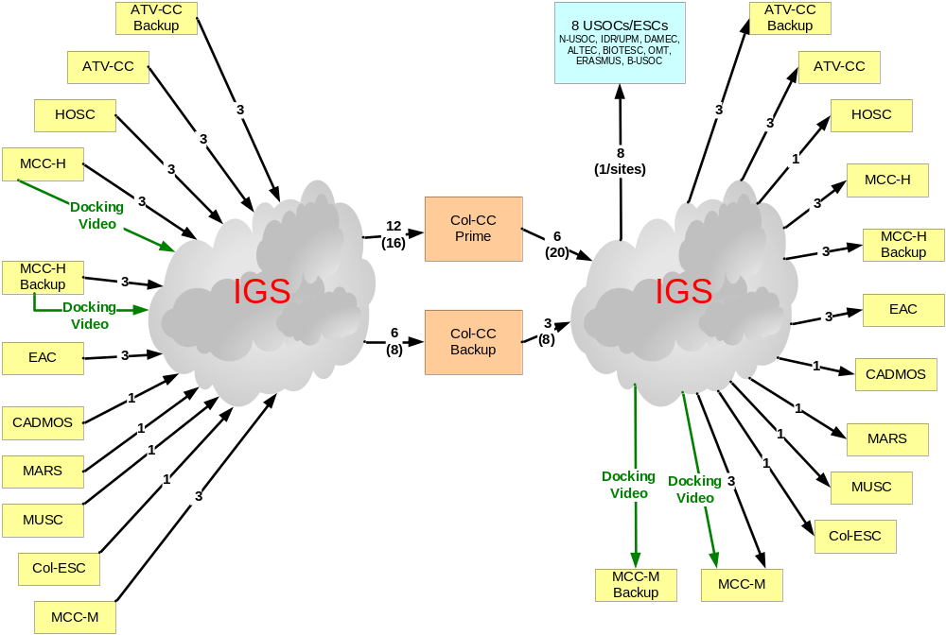
Figure 2-66: Overview of the MVDS Distribution

ATV Docking Activities
The MVDS gets an MPEG2/IP multicast video signal from MCC-H and has to transmit it to MCC-M. The T-Vips currently installed in MCC-H and in MCC-M will be updated (this is only a license key update and not a software update). With this update, this device will be able to transform a Multicast into a unicast and vice versa.

Col-CC Component Descriptions

HOSC Relay Video Equipment
The architecture of the video equipment at the HOSC is shown in figure 2-7.
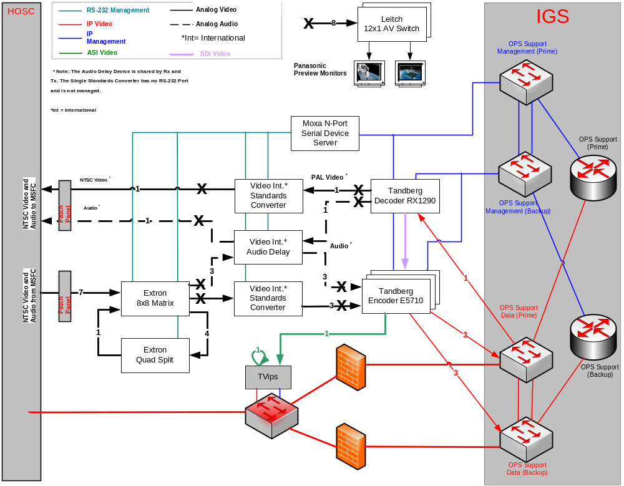
Figure 2-77: HOSC Relay Video Equipment

MARS, Col-ESC, CADMOS, OMT and MUSC Video Equipment
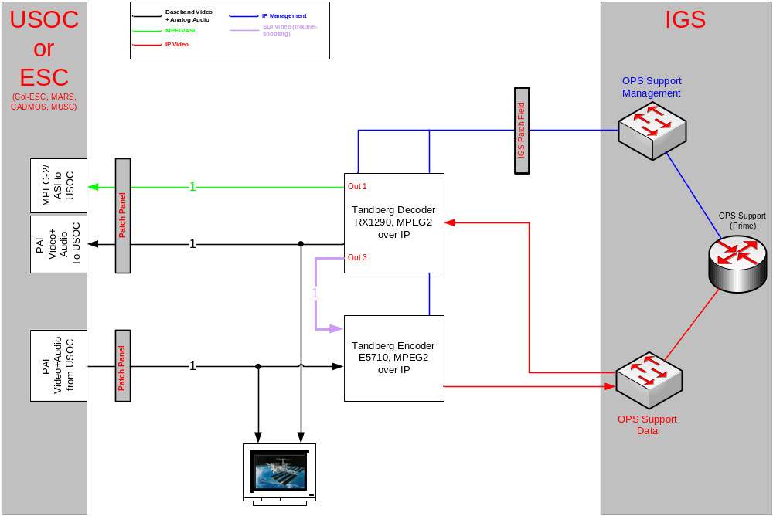
Figure 2-88: MARS, Col-ESC, CADMOS, OMT, and MUSC Node Video Equipment
NOTE – No encoder is currently installed at OMT.

ISS ESA ATV Docking video

General
This subsection summarizes the specification of the ISS ESA ATV docking video digital end-to-end implementation. It covers the definition of the encoding scheme and of the MPEG-2 transport stream produced by the ESA encoder mounted in the ISS Service Module and the transmission over an IP network. These specifications are also focusing on the definition of Ethernet frame structure which has to be prepared by the Ethernet interface of the encoder.
All the mentioned standards such as IEEE 802.3, IPv4, MPEG2-Transport Stream (TS) are widely documented, and detailed information is easily accessible on the Web.
This ATV docking video started as a special solution dedicated only to ATV, but now it is consider a vital operational interface for any docking video for Progress, Soyuz, and ATV vehicles.
This docking video is transmitted via the multicast protocol down to the Orbital Communications Adapter (OCA) system from the ISS Ops LAN/Joint Station LAN (JSL) to the Ground OCA LAN. From there it is routed to the ESA Gateway and subsequently to COL-CC and MCC-M.
The redundancy concept and configuration will be changed after the MPLS migration, delayed now only because of contractual issues with the Russian network provider. The configuration to be implemented is shown in the next two figures.

Technical Specification
The current baseline for the implementation of the transport of the MPEG-2 video from the ISS to the ground terminals (PC and TV displays) is depicted in figure 2-9.
MPEG2-TS is a way of formatting video information. It is designed for use in environments where errors are likely, such as transmission over long distances or noisy environments. The transport stream consists of one or more 188-byte packets. The packet consists of a header and data (also called Payload). Since this is a way of formatting the information, MPEG2-TS can be used to transport MPEG-4 data, H264 data, Microsoft Windows Media 9 data (that is the major reason Col-CC can receive HD video from HOSC and use MPEG4 encoders instead of MPEG2 encoders).
The next two figures show the current implementation (MVDS part). The current setup is subject to change per ongoing discussions.

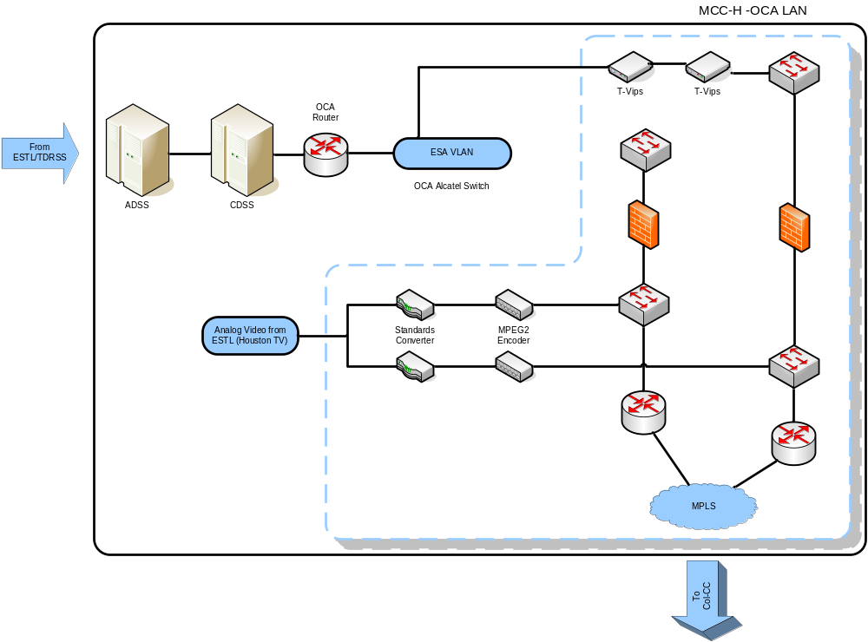
Figure 2-99: Docking Video: Interface in MCC-H
List of specs/parameters
- Source signal: Analog signal from the ATV docking camera distributed inside the ISS by the video switch (Коммутатор). The video signal contains telemetry and ancillary information overlay produced by the SIMBOL equipment.
- The signal is: composite 625 lines/50 Hz PAL
- The encoder produces: MPEG-2 encoded video
- Frame Resolution: 720 × 576 pixel 24 bit color
- Frame per second: 25
- YUV color space: 4:2:0
- Color conversion: Red-Green-Blue (RGB)-24 bit to YUV Conversion ITU-601 R
{R [0...255], G [0...255], B [0...255]} => {Y [16...235], U [16...240], V [16...240],
black: Y=16, white: Y = 235
- bit rate: constant bit rate
- Group Of Pictures (GOP): IPPPIPPPI without motion compensation (no B-frames and motion vectors)
- transport: MPEG-2 TS—MPEG-2 encoded video is transmitted at the constant transport stream bit rate of 4000000 Bits/second.
- transport stream ID: yes—Transport stream consist of a single component (video) with fixed PID.
- program stream ID: none—No PSI tables need be used.
- MPEG-TS packet size: standard—Each TS packet is 188 byte long.
- One TS packet is written into one UDP packet of 196 bytes.
- Seven UDP packets are encapsulated into one IP datagram.
- One IP datagram is encapsulated into one Ethernet frame.
- Maximum Transmission Unit (MTU) size: 1500 Bytes
- Every Ethernet Frame is delivered to the network by the Ethernet interface of the encoder.
- A single IP multicast address is used to group all possible destinations at layer-3.
- A single Ethernet address is used to group all possible destinations at layer-2.
- Every single Ethernet frame which has been send from the ESA encoder the Russian Smart Switch router has to be delivered to:
- Client(s) located in the Russian segment of the ISS, belonging to the same VLAN;
- OCA interface located in the American segment of the ISS.
- The Smart Switch routes IP multicast packets from ESA encoder with static entry of routing table, without processing of APR (or other) protocols.
- The protocol between the Smart Switch Router and the Edge Router is the IEEE 802.1q trunk protocol.
- The Edge Router routes IP multicast packets to the OCA interface.
- In MCC-H the IP multicast packet is received and delivered to the ESA MPEG-2 /IP to ASI interface hosted inside the ESA Relay.
- The ESA ground segment supports the distribution of the MPEG-2 video to the end systems in ATV-CC and MCC-M.
- For the end-to-end compatibility, the ESA Encoder MPEG-2 Transport Stream shall be compatible with the Client Software and the MPEG-2 /IP to ASI interface.
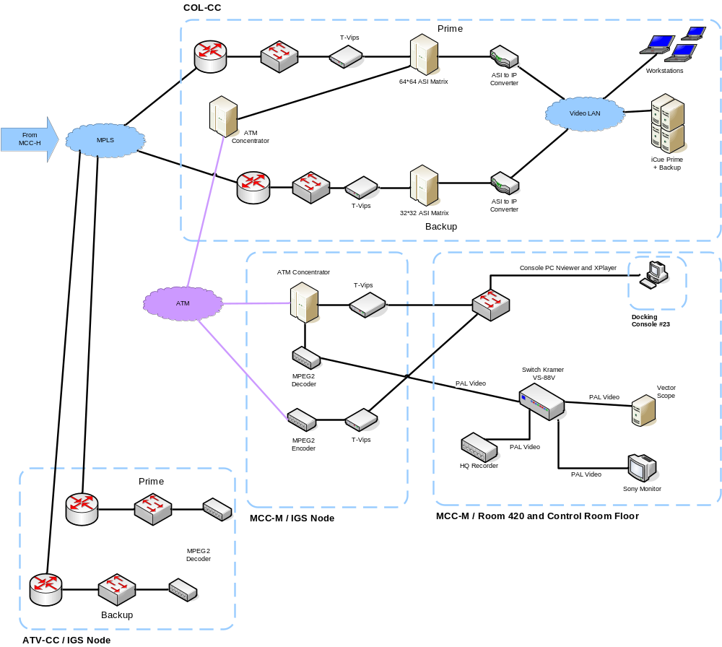
Figure 2-1010: Docking Video: Interfaces and Video Transmissions between Col-CC, ATV-CC, and MCC-M

jaxa JAPANESE experiment module video system

General
The following is a description of the Japanese Experiment Module (JEM) video system. The JEM video system is currently an analog system. A digital system with Standard Definition (SD) and High Definition (HD) video capability will be installed in the JEM in the future.

Analog Video System in JEM
In the JEM, there are 10 International Standard Payload Rack (ISPR) locations. From each location, NTSC video channels are routed to the US module via the JEM Video Control Unit (VCU). Also from the external port, NTSC video channels are routed to the US module. JEM system camera (both internal and external) images are also NTSC video and the route is the same.
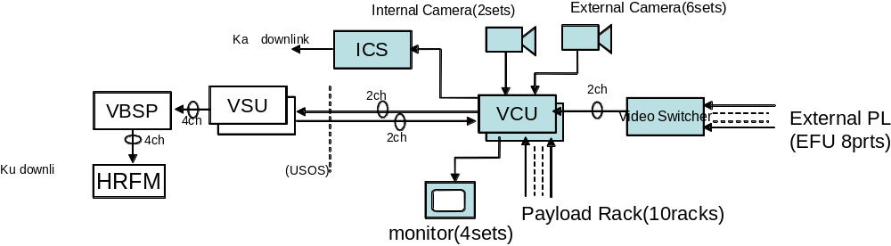
Figure 2-1111: Analog Video Distribution System in the JEM
NOTE – NTSC video which is downlinked via Inter-orbit Communication System (ICS)/Data Relay Test Satellite (DRTS) to Japan is MPEG-2 encoded video (one channel maximum).

DIGITAL VIDEO SYSTEM
There are two systems in the JEM which can transfer digital video images to the ground. One system is the Image Processing Unit (IPU) installed in the RYUTAI (Fluid) rack. The IPU can receive up to six NTSC video channels and multiplex them into one High Rate Data Links (HRDL) (Fiber Distributed Data Interface [FDDI]) channel. The IPU encodes the video into MPEG-2, and the encoding rate can be changed from 2 to 15 Mb/s. Also the IPU can change the GOP sequence (as one HRDL/FDDI channel, maximum rate is 43 Mb/s).
The other system is the Multi-Protocol Converter (MPC). The MPC receives HDTV Video (HDV) encoded video directly from an IEEE-1394 (Firewire) interface on the High Definition Television (HDTV) camera and transfers the signal into HRDL/FDDI. The HDV format is 27 Mb/s MPEG-2 streaming video.
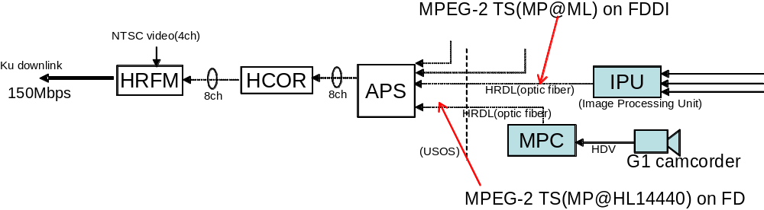
Figure 2-1212: Digital Video Distribution System in the JEM

HDTV END-TO-END SYSTEM
HDV can be downlinked to the ground via NASA Tracking and Data Relay Satellite (TDRS) to White Sands and JAXA DRTS to Tsukuba Space Center (TKSC). After preprocessing at JSC and TKSC, MPC-G receives the signal and outputs the HD video as DVB-ASI. The DVB-ASI signal can them be decoded to HD-SDI using a Commercial Off-The-Shelf (COTS) decoder and distributed as required for NASA and JAXA use.
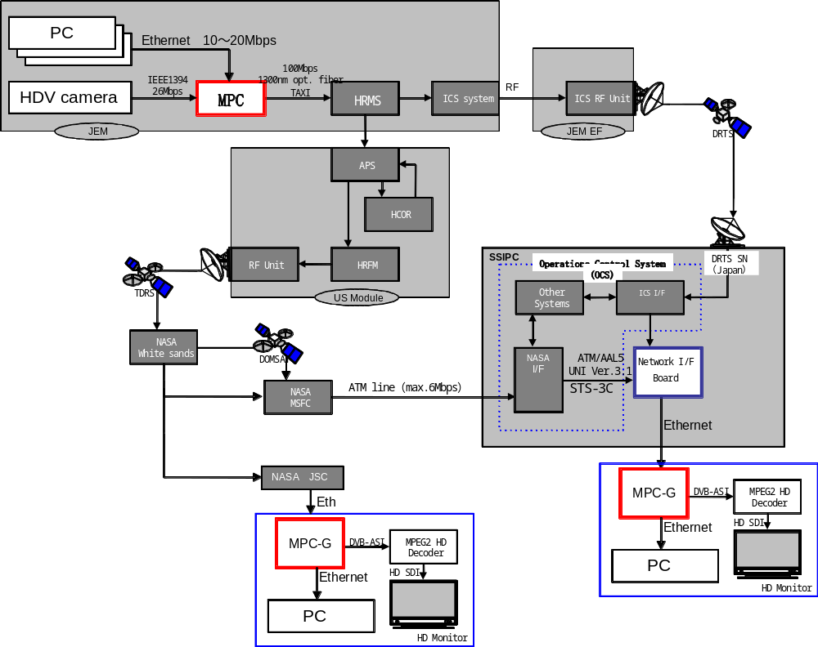
Figure 2-1313: HDTV Distribution from the ISS

nasa iss video system

General
The NASA-provided ISS video subsystem is part of the overall ISS communications system architecture. The initial system flown on the Destiny Module was centered around the Video Baseband Signal Processor (VBSP). The VBSP is a multi-channel device allowing up to four channels of video downlink in standard definition. However, it uses unique video compression and is obsolete. The VBSP was replaced as part of the Obsolescence Driven Avionics Redesign (ODAR) project. This project will provide up to six channels of MPEG-4, part 10 (Main Profile, 8-bit, 4:2:0), compressed standard definition video. Additionally, and for the first time on ISS, Internal Audio System (IAS) audio will be compressed using MPEG-4, part 3, Advanced Audio Coding (AAC) for insertion with the MPEG-4, part 10, video into MPEG2-TS to provide on-orbit audio-to-video synchronization.
Ground video distribution from VBSP video has multiple paths. The video is decoded into discrete video streams at MCC Houston. Internally, at MCC Houston, the video is sent to JSC Building 8 for archiving and distribution. From there, it is routed to the Marshall Space Flight Center (MSFC) Payload Operations Integration Center (POIC), provided for MCC Houston displays, and to gateways for all the ISS international partners. Building 8 also distributes video for Public Affairs use.

current analog ntsc system
The ISS video system consists of various cameras, video recorders, video switching units, internal monitoring, video synchronization, split-screen processing, the VBSP, and interfaces to the ISS Ku-band communications system. NASA system cameras (Video Distribution System and Space Station Remote Manipulator System) provide NTSC 525 line, interlaced, 29.97 (30) Frame Per Second (FPS) standard. The signal is transmitted in frequency modulated analog form from the cameras through the switching system. Up to 4 cameras or recorders can be switched to the VBSP for downlink. Due to the limitations of bandwidth from ISS, the 4 channels of video cannot all be transmitted to the ground at 30 FPS. Depending on the bandwidth available, the channels are scaled in frame rates of 3.75, 7.5, 15 and 30 FPS. Any frame rate transmission less than 30 FPS results in interlace odd field only transmission to the ground.
The output of the VBSP is in the form of CCSDS packets each consisting of fill bits (space once planned for IAS audio data but later deleted), one line of 6- or 8-bit luminance, sampled 400 times per video line, and 6- or 8-bit B-Y or R-Y, sampled 50 times per video line. The VBSP CCSDS packet output is then input to the Ku-Band High Rate Frame Multiplexer (HRFM) for multiplexing with other data streams intended for Ku-band downlink. Once received at MCC Houston, the video packets are routed to the ground Front End Processor (FEP) where the data streams are de-multiplexed. Video packets are sent to the Video Processor (VP) for conversion to Society of Motion Picture and Television Engineers (SMPTE)-259 Standard Definition-Serial Digital Interface (SD-SDI) signals and routed using a digital video switch to Building 8 for further pre-distribution and/or pre-archiving processing. For transmission to the MSFC POIC and the international partners, the video is re-encoded using a variety of MPEG-2 and MPEG-4 encoders. The data streams from those encoders are multiplexed into trunk circuits to the various end users not located at MCC Houston.

planned HYBRID digital/analog system
As part of ODAR, a new video processing system was developed for the ISS. This system makes use of existing components and replaced the previous custom VBSP compression with commercial standards for video compression, specifically H.264, Main Profile, 8-bit, 4:2:0 standard definition. The video switching units are used for on board transmission of digital data and continue to support FM analog video. When an analog device, such as a camera, monitor, or recorder, is replaced with a digital unit, such items will meet switching unit requirements for digital signals. The VBSP was replaced by six MPEG-4 encoders. The encoders are part of a card-/frame-based architecture, which will allow upgrades and I-level maintenance in the future without wholesale replacement of the encoding system. Use of FPGA-based compression code, for both video coding and audio codec, will permit in-situ FPGA image changes. The ODAR upgrade is capable of accepting two channels of audio. Each of the video encoder’s data streams are NAL packets in an MPEG-2 transport stream wrapped in RTP/UDP and encapsulated in CCSDS IP packets. In the ISS communications system, each of the video data streams will be a separate Virtual Channel Data Unit (VCDU) for downlink transmission and sent as a multicast IP.
Once on the ground, the video data in the Ku-band stream is processed similarly to the VBSP video data: MPEG-4 to SD-SDI conversion, SD-SDI to format requested for distribution, display, or archiving.
A feature of the new ODAR system will be a forward link Ku-band data channel capable of up to 25 Mb/s data rates. Up to now, forward link Ku-band data has been limited to 3 Mb/s. The 25 Mb/s forward link will enable much higher quality real-time video to be sent to the ISS.

Motion imagery parameters

background
In the history of analog television, there have essentially been two protocols for standard definition camera/production systems. The production standards use different color coding methodology, numbers of scan lines, and frame rates. One is American based and the other European based. The American system was developed first. Lessons learned from the American system implementation led to a different system for Europe. Regional differences, such as 50 Hz power compared to 60 Hz led to the frame rate differences. While similar in nature, the systems are not compatible. Standards converters have been in use to make video produced or transmitted in one system compatible with another. The two systems have matching transmission systems wherein the production format is transmitted essentially as it started in the camera. A third transmission system has been in use using the European color standard for production.
Digital television has done nothing to alleviate the problem and, in fact, has complicated it greatly. Two over-the-air transmission protocols for digital television are prevalent, but there are at least six camera/production standards in common use on those protocols. In addition, there are 18 camera/production formats in common use with two more being added that are converted and used on the over-the-air transmission protocols. This includes the existing American and European standard definition systems. Compatibility with the old systems is still a requirement. While virtually any resolution HDTV signal can be converted to existing standard definition formats with excellent results, each region of the world has stayed with existing frame rates with their respective HDTV implementations.
Because of the nature of digital television, virtually any type of data transmission system can be used for video transmission. The intent of the system designers has been to provide as much flexibility as possible when it comes to production and transmission of video. The result is a large combination of choices for video systems. It is confusing to many video professionals and almost undecipherable to the lay person.
Spacecraft video systems have reflected the television standards from their country of origin. This has often made it difficult for international partners to share video in real time with sufficient quality for use outside the public affairs arena. A common set of standards for future international cooperative space ventures is a requirement, not a luxury.

video systems overview
Video systems for spacecraft have many parallels to ground based systems. The system begins with a video source, generally a camera. The video source is switched to various components to be used within the spacecraft or sent to the ground. The switching system may allow the video source to be sent simultaneously to an on-board monitor, a recorder, and downlinked for ground operations support. Often, metadata is inserted in the video for ground use. Until recently, the signal was sent as an analog signal without compression. Updates to existing spacecraft systems as well as introduction of digital video have made video compression routine for transmitting video from spacecraft to the ground. The advent of digital video does give options not possible before. A spacecraft video system can be a discrete system with compression applied at the point where the video signal interfaces with the spacecraft communication system. Video compression can be applied at the point where the video signal first interfaces with the spacecraft avionics system to be multiplexed into the spacecraft data system and downlink data stream. Compression can also be applied at the camera, reducing the bandwidth needed for all internal spacecraft communications. There are pros and cons for both methods depending upon the specifics of each spacecraft’s avionics design.
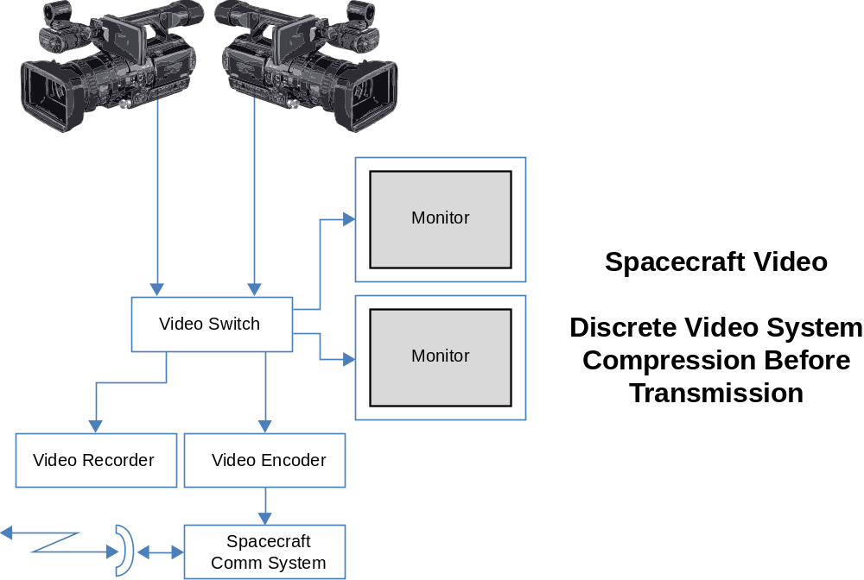
Figure 3-1414: Discrete Video System with Compression Before Transmission
The discrete video system with compression before transmission offers the highest possible viewing quality in the spacecraft and virtually no latency in the image when viewed in the spacecraft. It does require much higher bandwidth internally.
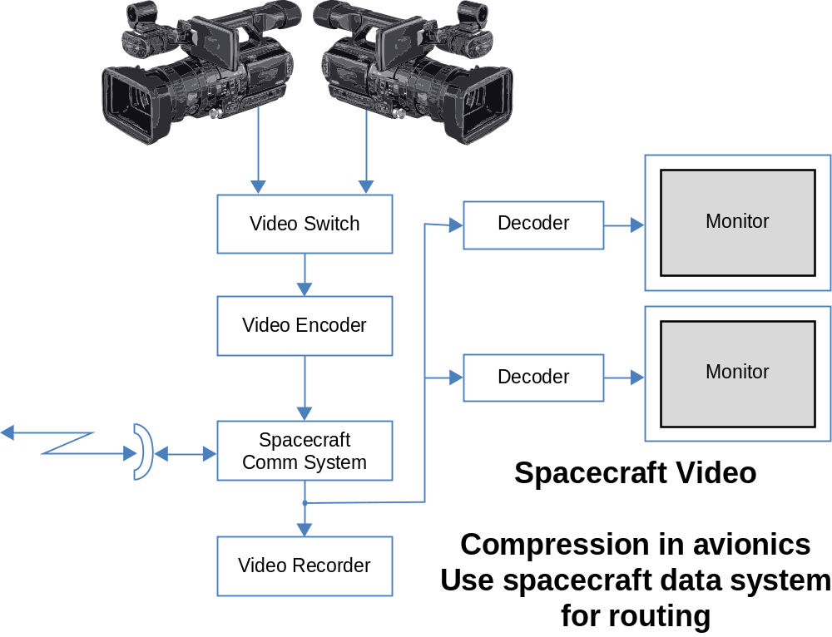
Figure 3-1515: Video System Integrated with Spacecraft Avionics
The video system integrated with spacecraft avionics has a video switch prior to compression. After compression, the video data uses the spacecraft data systems for signal routing for viewing, recording, and transmission. The advantage of this architecture is the ability to change compression systems without having to change other system components. It does require a wideband video switch ahead of the compressor(s). Latency is increased for viewing within the spacecraft, but the overall throughput is decreased, and only one system is required for all data distribution within the spacecraft.
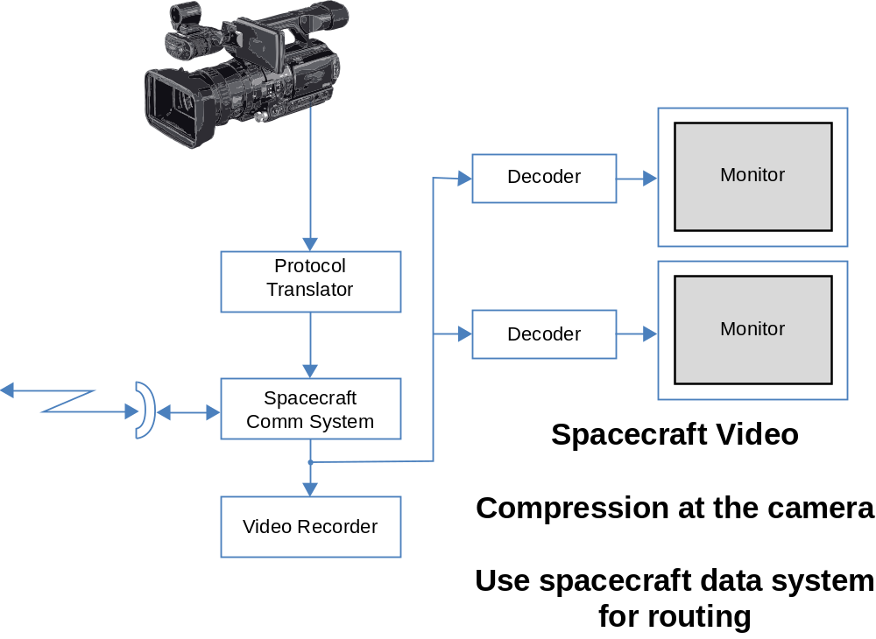
Figure 3-1616: Video System with Compression in Camera
The video system with compression in camera greatly reduces the bandwidth required from the camera and allows the spacecraft’s internal network system to handle video switching. However, the quality is always reduced and latency is introduced when viewing internally in the spacecraft. Upgrades in compression algorithms are difficult as it generally requires camera replacement as well.
The following subsections provide information to support recommendations made in section 4.

RESOLUTION, SCANNING, AND FRAME RATE
Resolution, scanning, and frame rate are inextricably linked together. It is the combination of resolution, scanning type, and frame rate that determine whether a video standard is applicable for any given situation.
From a historical basis, there have essentially been two SD analog/digital standards. One is defined by the American NTSC color system, the other by the European PAL color system. NTSC has a maximum resolution of 720 × 525 (720 × 483 active) pixels, interlace scanning, 29.97 FPS. PAL has a resolution of 720 × 625 (720 × 576 active) pixels, interlace scanning, 25 FPS.
Both NTSC and PAL are associated with everything from production through transmission. It should be noted there is a third transmission standard that is in common use, Séquentiel Couleur à Mémoire (SECAM). Because of the difficulties of making production equipment that works in SECAM, typically PAL video systems are used to feed SECAM transmission systems.
The differences between NTSC and PAL have to do with their countries of origin and when they were developed. When the American 525 black and white scanning line system was adopted in 1941, it used power-line frequency, 60 Hz in America, as its reference. A color standard was adopted by America in 1951, but it was not backwards compatible and was not supported by television set manufacturers. The second standard adopted, NTSC color, shifted the frame rate slightly from 30 Hz to 29.97 Hz. This was done to overcome a technical problem when color was added to the black and white signal. European black and white television systems had a variety of scanning formats in black and white, but almost all of them used European power-line frequency, 50 Hz, as a reference. When PAL color video was developed, it lead to a common standard for most of Europe. As the developers of PAL had the opportunity to study NTSC at great length, they developed a system with more accurate color reproduction that held up better after transmission. As before, it was still based on power-line frequency. Because of the lower frame rate, higher resolution could be incorporated within the same bandwidth as NTSC.
SECAM, developed by the French, was developed to provide a superior analog color transmission system. In both NTSC and PAL, the color is an additive signal to the black and white picture. Both systems generate artifacts because of this signal addition. SECAM transmits a black and white signal and a separate color signal. This eliminates the color artifacts.
A common method employed by NTSC, PAL, and SECAM is interlace scanning. NTSC, PAL, and SECAM television images are divided into vertical scan lines. NTSC uses 483 active scan lines, PAL and SECAM use 576. In interlace scanning, a frame (one complete image of either 483 or 576 scan lines) is divided in half. All of the odd number scan lines are shown first and the even ones second. The half of a frame is referred to as a field. Two fields make up a complete frame. Interlace results in a screen refresh rate of 59.94 Hz for American systems and 50 Hz for European systems. Interlace was done for multiple reasons. The transmission bandwidths allocated by the communications agencies in each country limited the bandwidth of television broadcast. It is not possible transmit 483 scan lines, 60 times per second, or 576 lines 50 times per second into the bandwidths allocated for an analog television broadcast. If the signals were sent out at 25 and 30 complete frames each, the Cathode Ray Tube (CRT) displays in use would have unacceptable flicker. Interlace scanning gave a higher refresh rate, thus mostly eliminating screen flicker. And not the least of the technical concerns, even if the bandwidth was large enough for 50 or 60 FPS, there was no equipment that could operate at the frequencies required. So, interlace can be looked at as a form of analog video compression.
It should be noted that CRT televisions, almost without exception, match the refresh rate of the incoming signal. That is not true for current digital flat panel and DLP/LCD/Plasma televisions. In the new televisions, the refresh rate is set, normally 60 Hz (with 120 Hz now available), and independent of the incoming signal. If a 25 or 30 FPS progressive signal is input to a new television, it still refreshes the picture at 60 Hz.
Progressive scanning, where every scan line is refreshed every frame, has only been used, until the advent of HDTV, in specialty cameras generally not used for broadcast applications.
NTSC, PAL, and SECAM transmission systems are in common use throughout the world. However, when the need arises to use video from one system with another, it causes difficulties. Video standards converters are required. In the analog domain, this usually meant a very expensive, difficult-to-operate piece of equipment. And, the results, converting in either direction between NTSC and PAL, were barely acceptable.
Since the invasion of digital based equipment into the television industry, starting in the 1980s, standards conversion became much easier, less expensive, and of better quality. Artifacts still remain, but the difficulty of doing conversions eased considerably. Digital video systems, starting with cameras that output digital signals, made a quantum leap in overall quality when conversion has to be applied.
HDTV has brought another whole set of parameters to deal with. In HDTV, there are two primary resolutions: 1920 × 1080 active pixels and 1280 × 720 active pixels. 1920 × 1080 formats employ both interlace and progressive scanning, with standard frame rates from 23.98 to 60 Hz. The 23.98 Hz frame rate is used to support motion picture production intended to be transmitted via American television. Motion picture production in America uses 24 Hz frame rate. When converted to 29.97 Hz video, the frame count does not come out correct. Shooting motion picture film at 23.98 Hz makes the frame rate conversion work out properly. European motion picture production is done at 25 Hz, which is a direct 2:1 conversion to 50 Hz PAL. Interlace 1920 × 1080 is commonly referred to as 1080i, with the progressive scan version called 1080p. 1280 × 720 HDTV only supports progressive scanning, at the above mentioned 23.98 to 60 Hz frame rates, and is commonly referred to as 720p.
1080i is considered to be a legacy system, growing directly out of the work done by the Japanese public broadcasting network, Nippon Hoso Kyokai (NHK). 1080i is a direct descendant of NTSC color television. 1080i is in the widest world-wide use today as it was the first practical HDTV format. 1080i is almost exclusively 25 and 29.97 FPS. Without compression, 1080i requires approximately 1.485 Gb/s of data per second. This is done in a serial interface, known as High Definition Serial Digital Interface (HDSDI).
720p is the result of a joint project between NASA and the Defense Advanced Research Projects Agency (DARPA). These two American government agencies co-funded the development of the first 720p camera sensors. Both NASA and DARPA recognized that there are some inherent flaws in interlace video when it comes to visual analysis. Progressive scanning eliminates those issues. 720p exists in 23.98, 24, 25, 30, 50, 59.94, and 60 FPS. The 23.98 and 59.94 frame rates are those intended for direct conversion to NTSC color. 24 and 30 FPS are considered to be digital cinema formats. 25 and 50 FPS are to be compatible with 50 Hz video systems. 60 FPS is used primarily for analysis applications, but is easily converted to other frame rates. 720p, up to 60 FPS non-compressed, can use the same HDSDI protocol as 1080i.
1080p is the result of further development of the 1080 standard for electronic cinematography. When it was first developed, 23.98, 24, 25, and 30 FPS were available. 1080p at 50 and 60 FPS was considered to be impractical. The 30 FPS and lower 1080p formats can use HDSDI protocol as do 1080i and 720p. However, when 1080p at 50 or 60 FPS is required, it requires almost double the bandwidth, 2.7 Gb/s. When first introduced, 1080p 50/60 was done using two 1.485 HS-SDI links, commonly referred to as Dual-Link HDSDI. Now, a new standard has been introduced to handle 1080p 50/60 as a single serial bit stream. The new standard is referred to as 3G/HD, for 3 Gigabit HDTV transmission.
When selecting a video format, there are always trade-offs between resolution, scanning methods, and frame rates. The easiest one of these to deal with for future systems is scanning. Interlace scanning in HDTV is a bridge to older systems. It was once thought it would not be possible to convert progressive scan systems to interlace with high quality. That, however, is not the reality of today. Progressive scan down-conversions have proved to provide superior results than those done from interlace HDTV.
Resolution and frame rate determine the spatial and temporal resolution of the motion imagery. In limited bandwidth systems, these two parameters have to be balanced to provide usable imagery. From the current commercial video production and broadcast standards, 1080p 60 would be the ultimate video imagery. However, since that doubles the required bandwidth, both native and compressed, compared to what is being broadcast now, it does not appear to be practical. Image analysis of the Space Shuttle program has shown that a frame rate of 60 or greater is needed to have adequate temporal resolution for launch image analysis. Due to the lack of 1080p equipment and the demands for transmission, 720p 60.0 was chosen. This has shown to be the best compromise among the available formats. When converting, using the 60.0 FPS even integer frame rate works best for all parties involved. Using 59.94 FPS makes a more difficult conversion to the 50.0 FPS rates used by ESA and RFSA. 60.0 FPS can be converted to 59.94 easily. This can be done in real time by dropping a frame approximately once every 16 seconds or during playback of a recorded sequence where the 60.0 recording is played at 59.94. The 59.94 720p converts very well to 1080i, which is what JAXA currently uses.
This discussion so far has been limited to full-motion video applications. In many of the space operating environments, this is not a requirement. A system that works at much lower frame rates, such as one frame per second, or variable frame rates based on motion may be acceptable and more suitable for a specific task. Lower frame rates would mean lower bandwidth requirements for transmission. There are also requirements that call for much higher frame rates.Launch vehicles, for example, typically have multiple cameras on the first and second stages which will acquire imagery at multiple frame rates. Systems like these are normally used for specific science and engineering applications and require special consideration based on the requirements of the end users of the imagery data. Image compression used for routine motion imager applications may not be acceptable. Each system of this type will have to be evaluated to determine how it is best deployed and how it can remain within recommended CCSDS protocols for data transmission.

cOMPRESSION
Compression of video signals is a requirement for almost all transmission systems. Very few transmission systems are capable of supporting the 1.485 Gb/s data rate of HDTV or the 270 Mb/s rate of Standard Definition Television (SDTV) systems (NTSC, PAL, SECAM). Spacecraft and the lunar outposts will have transmission bandwidth limitations. The Orion spacecraft, as an example, may have a very limited data transmission capability. The ISS has approximately 300 Mb/s on the NASA downlink, with other downlinks supplied by ISS partners’ equipment. A lunar base should have the same or more capability as the ISS. That is still far less than the 270 Mb/s or 1.485 Gb/s required for non-compressed HDTV and SDTV, respectively.
The compression type and amount are the keys to determining video quality. There are three basic categories of spacecraft video imagery: Analysis, Viewing, and Public Affairs. Analysis video has the highest quality requirement. When analyzing an event, it is essential that the video compression not hide important details or produce artifacts that mask vital image content. Viewing quality is often event-driven situational-awareness situations. The quality requirement is usually less than that for analysis video, but latency can become the key factor. Public Affairs video may contain elements of both analysis and viewing video in that high quality, combined with low latency is desirable when doing live events. Generally the Public Affairs requirement for live transmission is with crew interviews. This is comparatively easy video to encode, so the dual requirement of high quality and low latency can be met. In order to meet analysis requirements, it may be necessary to record the event at a higher data rate than the transmission system allows for in real time and downlink the data as files in a non–real-time basis. For real-time event viewing, the video quality may have to suffer to achieve the necessary latency.
There is not a single answer to what type and how much video compression is acceptable. As with the selection of a video standard, there are direct tradeoffs between resolution, frame rate, and latency to work within a set bandwidth. And, most video compressions systems efficiency varies depending upon scene content. A scene with little movement can support high spatial resolution at a low data rate. Should movement become a factor, the required data rate to maintain good spatial resolution goes up dramatically.
Digital video over-the-air broadcast to date has used MPEG-2 video compression. This is a very lossy algorithm for video transmission. When it was developed in the 1980s, it severely taxed the ability of existing microprocessors. It was considered to be the best that could be practically done throughout most of the 1990s and through the turn of the century. MPEG-2, like 1080i HDTV, is the most prevalent compression method because it was the first developed for broadcast and has been in use longer. It will still be in use for many more years. The American digital broadcast standard is based on MPEG-2. Considering the current American analog broadcast standard was adopted in 1953 and was in use until mid-2009, changing to another compression scheme in America will be very difficult. Additional compression schemes may be added, but MPEG-2 will likely not be replaced for many years.
Variants of MPEG compression, generally at much higher data rates than broadcast applications, have been used by the video equipment manufacturers for recording systems. Many of these provide excellent results, but the data rates required for ‘production’ quality video also exceed anticipated bandwidth.
Another MPEG standard, MPEG-4, has been developed and deployed. MPEG-4 is very similar to MPEG-2, but has an advanced algorithm that identifies objects in the image and works at that level. MPEG-4 requires almost an exponential gain in computing power for encoding. Fortunately, Moore’s Law has provided the micro-processors with sufficient power to do that in real time. The results are quite good, especially when compared to MPEG-2. MPEG-4 can provide the equal quality at half, or less, of the bandwidth required for MPEG-2. The video industry is always looking for ways to reduce bandwidth. As MPEG-4 matured, work began on an even more efficient video coding scheme. A joint ITU/MPEG task force began development of what is now called High Efficiency Video Coding (HEVC). HEVC has since been ratified as ITU H.265 and as of early 2013, begun deployment. The goal of HEVC is to reduce the bandwidth required by MPEG-4 by half with equivalent quality. In addition, it was designed to accommodate much higher resolution imagery. The ability to handle 4Kimagery, 4 times 1920 x 1080 HD resolution, was a primary design goal. HEVC is early in its development cycle but already appears to be meeting its design goals.
MPEG-2/4 and HEVC are considered to be a lossy encoding methods. MPEG-2 divides the image into 8 × 8 pixel macro-blocks and works from there. Information from a number of sequential frames of video is needed to determine what needs to be sent and what can be eliminated and reproduced in the decoding process. The sequence of frames is called a GOP. GOP structures are usually 15 frames or higher. In interlace HD or the SD standards, that works out to about one half second of delay, respectively, for both the encoding and decoding processes. MPEG-4, in its current implementation, has longer delay. GOP can be the same for progressive systems, but the more frames in a GOP, the more efficient the encoding process becomes. So 30 frame GOPs, or one half second, are common for 720p 60.
Tests by the NASA DTV Program and industry show MPEG works best for real-time distribution. Of the current compression standards, MPEG-4 has shown by testing to be the best compromise between bandwidth and quality. MPEG-4 introduced variable macro-block size and changing the coding structure between equivalent blocks on successive frames. HEVC carries that concept further, but also allows much larger macro-blocks for large areas of the picture with very little changes in a GOP. This leads to much greater efficiency in most video imagery.
The testing has also shown that MPEG-2 has been completely supplanted by MPEG-4. MPEG-2 should be considered a legacy format and its use not considered for new spacecraft systems. As HEVC is still in its infancy, it should be considered for any new project with a multi-year development cycle. By the time the mission launches, HEVC should become the mainstream method of video compression for best picture quality with the most efficient encoding.
For analysis quality video, a different approach is recommended. Recording at higher quality using a file-based system and then transferring files at less than real time allows for higher quality video to be transmitted to Earth. Even with this approach, full bandwidth HDTV is not practical. Compression is still required.
Wavelet compression was selected for use to record the image analysis HDTV cameras for space shuttle launches after the Columbia accident. Wavelet was chosen because it provides virtually lossless compression and has a data rate that works well with the bandwidth available between NASA centers to distribute launch video. Wavelet compression does not divide the image into macro-blocks and does not use GOP. It divides the image into frequency bands and looks for redundancies. It provides a higher quality recording than MPEG, but at higher bandwidth. Motion Joint Photographic Experts Group (JPEG) 2000 is the international standard wavelet encoding algorithm. JPEG 2000 was selected by the Digital Cinema Initiative (DCI) working group as the standard for digital distribution and playback of motion picture films. Another wavelet algorithm has been in widespread use, but with the adoption of JPEG2000, it is anticipated it will become the prevalent wavelet compression standard. JPEG2000 provides excellent results but does require significantly more bandwidth than MPEG-4.
For analysis or higher quality production video, the use of wavelet encoding and less than real-time file transfer has shown to give better results than an MPEG based system in real time. Extensive testing done by the NASA DTV Program and industry have proven this to be the case.
The differences between MPEG-4 and JPEG 2000 show MPEG-4 to be the encoding method of choice for live video transmission, because of better picture quality at low bandwidths with JPEG 2000 used for imagery where accuracy is the most important factor.

cHROMA SAMPLING
Human vision has two types of sensors for visible light. One type responds to differences in brightness only, the world in black and white. The other sensors in the eye respond to color. There are approximately twice as many sensors that respond to black and white, or luminance, as do color. Humans perceive most of the detail in the luminance portion of vision. The designers of color television systems have taken and continue to take advantage of that. Another factor that comes into play is the amount of red, green, and blue in daylight. What humans perceive as white in daylight contains about 66-percent green, 23-percent red, and only 11-percent blue.
Color television cameras use either one or three sensors for image pickup. Single sensor cameras use a stripe filter arrangement to derive red, green, and blue. Better cameras use three sensors, one each for RGB. Regardless of the type, full resolution RGB channels very seldom make it to the output of the camera. Internally, the full resolution RGB channels are combined, essentially in percentages of each in white light, to make up the luminance signal. Then, a process is done to subsample the red and blue channels to ½ full resolution. If it is an analog camera there is a complicated process of signal subtraction, rephrasing, and modulation to add the color channels to the luminance. Digital cameras have three distinct signals running serially. There is the luminance signal, referred to as Y, and the subsampled red and blue signals, referred to as Pr and Pb.
When the signal is fed to a display, it is necessary to decode the YPrPb signal to full RGB. Since 66% of white light is green, green is the majority of the Y signal, and relatively easy to decode from Y. The display does an interpolation of the ½ resolution Pr and Pb signals, using Y signal as well, to derive full resolution R and B. Since the eye is most sensitive to Y to derive resolution, the interpolation of the other color channels does not significantly degrade the signal.
The process, in digital cameras, of making YPrPb gives a sampling ratio of 4:2:2. This means that for every 4 samples of luminance on a scan line, there are two red and two blue samples. Because of the way television systems operate, 4:2:2 is considered to be full resolution video. However, there are several other sampling structures in common use. Broadcast television and DVDs use a sampling structure of 4:2:0. In this case, there is still a full resolution Y signal, but there is only one color represented on each scan line. The colors alternate scan lines, so on one scan line there will be two Pr samples for every four Y samples. On the next scan line, there will be two Pb samples for every four Y samples. 4:2:0 reduces the color data by half compared to 4:2:2, reducing the overall bandwidth needed for any given quality level by 25 percent. This has been found to be acceptable for live use or applications where the signal goes through very limited processing, such as editing for news. 4:2:0 will not stand up to program production with several layers of effects and overlays. The limited color reproduction causes edges to become fuzzy and generate aliasing artifacts. It also causes problems when doing image analysis. Single frame images are often blown up to look at small detail in the pixel level. 4:2:0 sampling limits the amount of detail that can be seen.
It is anticipated 4:2:0 sampling will be used for the MPEG-4 live transmission, as use of 4:2:0 reduces bandwidth requirements and is usable for most applications. 4:2:2 would be used for the wavelet recording and later downlink.
Full bandwidth RGB channels, referred to as 4:4:4 sampling, also has a place. Digital Cinema applications or those requiring resolution much higher than HDTV typically need 4:4:4 sampling. As a specific example, the Image Maximum (IMAX) 70 mm film cameras are too big to be flown in the Orion spacecraft unless one crew seat is sacrificed. Available now are digital cinema cameras that are not much bigger than small professional HDTV cameras. The digital cinema cameras have resolutions of 4 to 5 times that of the best HDTV. When this imagery is converted to IMAX, it is essential to have as much resolution in all three color channels as possible, as IMAX film has full resolution color. When the image is projected on a screen 15 meters or more in height, there can never be too much information. The recording systems for digital cinema cameras will likely be part of the camera package and not flown routinely. The recordings are file based, so a downlink of the files is a possibility. They will be much larger data files than a corresponding HDTV file, MPEG-4, or wavelet. This might limit the downlink to a limited amount of data to allow the quality of the imagery to be assessed on the ground, with the files being brought back on the original recording medium.

AUDIO
In the days of analog transmission of video from space, it was sufficient to use the air-to-ground audio signals with the video. With limited processing of the video, if the audio was out of synchronization, it was a fairly simple process to delay audio to match the video. With compressed digital video, it is not as simple. The latency caused by the GOP of MPEG-4 is significant and can vary, depending upon the difficulty of the material being encoded. For this reason, HD downlinks today have audio embedded. When the signal is decoded, the audio should be in synchronization. If not, the offset is minor and easily corrected. There is a complexity in that there is a microphone for air-to-ground and a different one connected to the HDTV camera. There have been occasions when the astronaut or cosmonaut speaking needs to talk through both at the same time. As a consideration in the future, it would simplify system if the air-to-ground system had an audio output of the spacecraft microphone(s) available for the video system. A separate microphone attached to the camera will still be needed, but having the spacecraft audio available will simplify many operations.
Production audio has a frequency response of 20 Hz-20 kHz. Spacecraft voice systems have a bandwidth limited to 3 kHz. For daily operations, there is no requirement for the voice system to have more bandwidth. When audio from the voice system is utilized, it will likely have the restricted audio bandwidth. It will not be as good as the encoder and recording systems will be able to handle, but the added convenience of using the spacecraft audio system more than makes up for the restricted bandwidth. Camera microphones fed as audio embedded in the video stream would be full bandwidth through the encoders and recording systems.
MPEG-4 encoders today generally have available two different audio compression standards available. MPEG-1 Level 3 (MP3), is an older MPEG audio standard that compresses two digital audio channels from 3 Mb/s to 128 kb/s. Advanced Audio Coding (AAC) is a newer audio codec which offers higher quality at the same 128 kb/s rate as MP3. Either have been found to be acceptable for almost all applications except retransmission through another highly compressed voice system. Normally, the air-to-ground voice signal, which will use different compression compatible with the voice systems, is used in that application. Whether this complication will be resolved in future systems is not known, but is not considered to be likely. The video production/broadcast industry treats audio differently than the communications industry.
The wavelet recorders in common use today record uncompressed digital audio at 3 Mb/s per audio pair. AES-3 is the audio standard used. As audio will be part of the downlink file transfer of wavelet video, this matches a high-quality audio signal with the high-quality video recording.
In-camera recording is another issue unto itself. Advanced Video Coding High Definition (AVCHD) compression in consumer and some prosumer camcorders record Dolby Digital encoded 5.1 channel audio. This is a great advancement for home use. The systems work quite well for that application, allowing a consumer to record surround sound audio using a very small camera. Dolby Digital, however, uses a very heavy compression, including decimating audio signals that are considered to be inaudible. If a recording of this type is used for production work, the editor may find gaps of complete silence in some channels due to this process.
There are AVCHD cameras being introduced that record Pulse Code Modulation (PCM) digital audio with little compression. While not surround sound, this provides a much better recording for future use. The ability to record PCM audio in camcorders should be a requirement.

mOTION iMAGERY iNTERFACE pROTOCOLS AND TRANSMISSION
There are multiple interface types available from current camcorders. The interface to be used is determined by the application. The interface for live video, for example, is usually different than the one used to transfer encoded or recorded material.
The video subsystem will need to have a single protocol for signal switching. At the professional level for HDTV, this is a component serial data stream using coax cable, HDSDI, as mentioned in section 3.2. Most consumer and prosumer HDTV cameras do not have HDSDI as it is not a common interface for consumer equipment. For camcorders at this level, High Definition Multimedia Interface (HDMI) is the standard for live camera output. IEEE-1394, Firewire, has been commonly used to access the encoded video data, either live or in playback. Firewire is losing favor to Universal Serial Bus (USB)-2 connections. There is not a standard for live streaming of encoded AVCHD from USB, and one is not anticipated. And, neither Firewire nor USB are video switching protocols, but electrical interface specifications.
Streaming from a USB interface has great potential for the ISS as there is currently a system on board ISS for streaming compressed HDTV from Firewire. This system was provided by JAXA. The Japanese Space Agency does not think it will be difficult to adapt the system to accept streaming compressed video via USB when that is available. However, for Orion and other missions, the data rate for AVCHD, up to 24 Mb/s, appear to be too high for real-time transmission, so USB as a video switching protocol does not appear to be feasible.
Some video encoders can accept HDMI directly, but HDSDI is the standard input interface for most encoders. HDMI is a multi-conductor interface. It was developed specifically for home theatre applications. HDSDI works on a single coax cable. There are HDMI to HDSDI converters readily available. HDSDI is an easier protocol than HDMI for a video routing system. With the use of converters, it is a relatively simple process to convert from one to the other.
The video compression system in a spacecraft could use HDSDI as a standard input. The wavelet recording system can use this as well. Monitors can easily use this also. It is not known what monitors might be used and whether they need to be multi-purpose. And, if they are multi-purpose to all sources, computer and video will need to be converted to the same input standard. There are monitors with multiple input types, and it possible to convert HDSDI to virtually any display interface required.
The outputs of the video compression system and the wavelet recorder for transmission will need to match systems being used for Orion and other space and lunar craft. This document assumes that video streams would be IP and treated as other data streams from the spacecraft. The downlink could be any of the CCSDS transmission protocols, including IP. Depending upon the transmission protocol that is used, the output of the video system may have to be encapsulated to match. This conversion is not difficult, but it does add another set of packets and associated data overhead. The additional overhead is wasted bandwidth, but as of now it appears this will be the only solution without custom hardware and software. The additional overhead is not of great significance.
As for handling the data on the ground, work done by NASA to date has shown that it is not difficult to transform the older CCSDS packet structure, as used by the ISS and Shuttle, to a compatible signal for decoding. Once the signal is decoded on the ground, it can be handled by commercial video equipment for switching, monitoring, and recording.
The use of IP is desirable in order to provide greater commonality with other systems on-board the spacecraft. However, video is a special case for IP. Because of the higher bandwidth and real-time nature of video streams, packet retransmission is not very practical. Also, jitter and network errors are problems when dealing with IP video, particularly with MPEG-4 encoded video. Excessive jitter and high Bit Error Rates (BERs) cause periodic freezing of video, requiring a second or two to recover. Depending upon what is considered acceptable for these single frame freeze events and the decoder used, jitter figures of 1-10 ms can cause issues. Decoders with the ability to reorder packets can sustain higher jitter than those that do not have that ability. BER varies a great deal, again based on what is acceptable performance. In the NASA tests, using packets of 1210 and 1374 bytes, respectively for the two MPEG-4 encoders tested, packet loss exceeding 0.001% caused freeze frame events.
Current direction is to use off-the-shelf cameras for crew compartment cameras. As noted above, HDMI has become the de facto standard for live HDTV from camcorders. With the use of proper cable, HDMI can be extended up to 30 meters, which should be sufficient for crew compartment use. Video connections for the cameras should then also be HDMI. If HDSDI is going to be used as the video routing protocol, then those video connections should have an integral HDMI-to-HDSDI converter.
The HDMI connection and subsequent conversion to HDSDI will also carry camera audio. Practice has shown that when it is necessary to use a separate microphone, it can be plugged into the camera’s microphone connections. If there is a need to connect the spacecraft communications system into the video system, that could connect to the camera as well. Once the audio is in the camera, it will be part of the HDMI connection to the spacecraft. In the conversion from HDMI to HDSDI, the audio is embedded onto the HDSDI stream. The encoder and wavelet video recorder should be of the type that can accept embedded audio. This simplifies connections and operations.
An alternative would be to use encoders built into the cameras. This allows a lower bandwidth to be used for the video system. It does make the video routing system more complex unless the switching is nothing more than a simple brute force signal switch. This would cause a short disruption of video at the receiving end of the signal. Depending upon the use, this may or may not be acceptable. When it is desirable to have higher quality, it would likely only be possible to have a single video encoder capable of multiple data rates per camera. Depending upon the requirement for the video, it is desirable to have different types of video encoders. Encoders at the camera would require each monitor to have an internal decoder to view video. This would put some latency in every video feed, even if it is internal to the spacecraft. This also causes problems with timing synchronization. If timing is added after the encoding process, it will be offset from real time. The offset may not be consistent, leading to unresolvable problems when attempting to pinpoint the exact time an event occurred.
Another issue is compatibility with CCSDS transmission protocol. Conversion of MPEG-2 to CCSDS packet structure has been done in the ISS. While it is not an inconsequential task, the conversion is fairly straightforward. The main consideration for the conversion is to be as efficient as possible so as to not add overhead and latency in the transmission process.

ASPECT RATIO MANAGEMENT
Aspect ratio management has been a big issue for broadcasters. Analog video has typically been in 4:3 ratio, regardless of the standard. HDTV is 16:9 ratio, also regardless of the standard. Encoding systems have the ability to handle either aspect ratio without issue. There is often a setup control to indicate 4:3 or 16:9 aspect ratio. This inserts a data flag in the encoded stream which the decoder uses to properly format the decoded video. It has been found that when using 16:9 video on legacy systems that there is considerable disagreement about whether to letterbox the wide screen video, thus preserving the entire image and having black bars on the top and bottom of the screen, or performing a video sidecut, making the 16:9 image go to full screen with the sides cut off. This method, as does letterboxing, preserves the correct aspect ratio of objects in the picture. A third method is used wherein the entire widescreen image is displayed at full height on a 4:3 monitor. This is termed a ‘squeeze’ conversion. This causes the aspect ratio to be incorrect. Circles would become tall ovals in squeeze conversion. As different users have different requirements for the video, NASA tests have shown the best policy is to provide imagery in its native resolution and let the end users determine what conversions are needed.
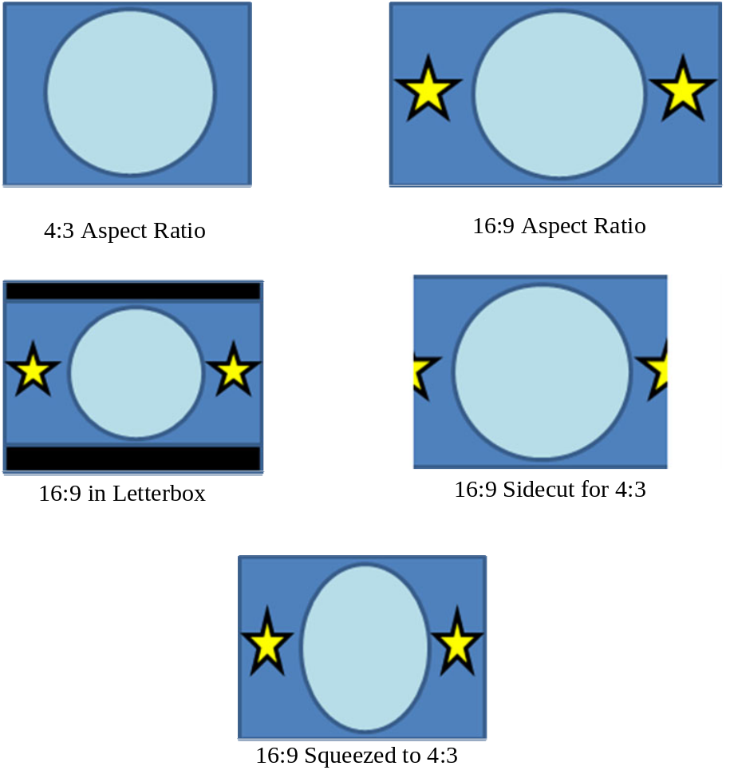
Figure 3-1717: Aspect Ratio Comparisons

mETADATA AND ARCHIVING
There are industry standards for the insertion of metadata into HDSDI streams. The HDSDI serial data interface allows for 256 kb/s of data. This has been expanded by some applications up to 512 kb/s. Metadata is currently used for insertion of Inter-Range Instrumentation Group (IRIG) timecode for shuttle launches. Another airborne video platform used by NASA inserts IRIG timing and aircraft positional data. The area within the HDSDI data stream for metadata is not limited and can be used for any data that can be formatted and inserted into the serial stream. Metadata, outside of time-stamping the video, can be used to insert data pertinent to the video image and have that data locked to the relevant video image. Video encoders that can handle metadata may use standard data compression techniques, but most pass it without compression.
Metadata requirements for spacecraft video applications are not well known at this point in time, but this is a capability that should be explored further for potential applications. Of great potential would be the use of metadata to automate archiving and downlink activities. Standardized descriptive metadata could be used to determine archiving rules for video files. A well-designed system could easily indicate what is to be saved, priority for downlinking, and what could be deleted.
Limited file sizes have become the norm for spacecraft operations. Limiting file sizes limits liability of file corruption and makes downlinking easier. Good metadata could make it possible to take only the portions of a recording that have meaningful information and discard the remainder. The metadata should be both a ground and crew asset for making archiving decisions.

potential future recommendations

overview of spacecraft motion imagery
There are always limitations on spacecraft communications systems. Mass, weight, and electrical tradeoffs are part of every spacecraft design. It is not practical to think that all communications systems can have access to unlimited bandwidth and transmission power. However, certain parameters have to be established as requirements for video systems. There are several uses for video on manned and unmanned spacecraft with huge variations in requirements. Unmanned spacecraft are generally purpose built with imaging requirements dictated by the purpose of the spacecraft. For the purposes of this discussion, unmanned spacecraft will not be considered.
For manned spacecraft, the uses are somewhat limited, but the requirements for each use can vary significantly. The main uses for video in manned spacecraft are:
- Personal Video Conferencing: for crew members to have one-on-one communication with other persons, be they family members or mission support staff;
- Medical: for crew members to talk to medical personnel with strict privacy and security requirements;
- Situational Awareness: for observing a wide range of activities, from docking operations to general activities to specific operations;
- Engineering/Science: for analysis of specific events, usually requiring the highest quality video generated;
- Public Affairs: for live interactivity between a crew member and the media, requiring high-quality video, generally at low latency;
- High Resolution Digital Motion Imaging: for high-resolution records of spaceflights, considered to be a replacement for the IMAX film cameras that have been used in previous spaceflights.
NOTE – The Space Shuttle was the only manned vehicle with the payload capacity at launch to carry IMAX cameras. The Soyuz and other planned manned spacecraft cannot accommodate such a camera without losing crew capacity. However, new digital cinema cameras appear to be practical to fly and should be looked at as not only a replacement for IMAX, but also as a high-resolution record of future spaceflight.
There are also several scenarios where this imagery needs to be transmitted and received. These include:
- spacecraft to spacecraft:
- includes EVA to spacecraft,
- Moon base is considered to be a spacecraft;
- spacecraft to ground station:
- ground station to ground station, ground station to spacecraft, and combinations thereof;
- lunar surface operations with orbiting spacecraft;
- multiple agency operations.
Not all applications will be used in every transmission scenario. The table below shows the transmission scenarios for each imagery application.
Table 4-33: Transmission Scenarios for Imagery Applications
 | Spacecraft to Spacecraft | Spacecraft to Ground | Ground Station to Ground Station | Ground Station to Spacecraft | Combinations
Personal Video Conferencing | X | X | X | X
Medical |  | X | X | X
Situational Awareness | X | X | X |  | X
Engineering/ Science |  | X | X |  | X
Public Affairs |  | X | X |  | X
High Resolution |  | X | X
Within each application and potential usage scenario, there are several levels of video standards that are applicable. These range from low resolution/slow frame rate, or low spatial and temporal resolution, to high resolution/high frame rate, or high spatial and temporal resolution. Also, each application has different associated latencies. Some applications are not latency critical, such as medical video, but for situational awareness for spacecraft docking it is critical to have low latency for the user of that imagery. The graphic below shows the range of spatial and temporal resolution that might be needed for each application of motion imagery.
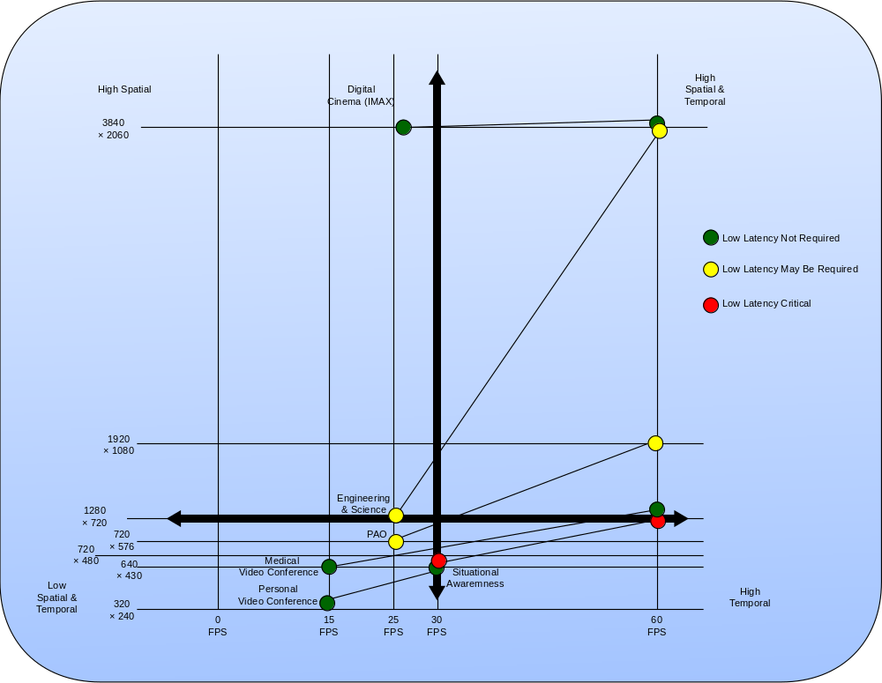
Figure 4-1818: Spatial and Temporal Motion Imagery Requirements

bandwidth constraints
In section 3, MPEG-4 and JPEG-2000 were introduced as the encoding systems of choice, based on currently available technology. MPEG-4 is the most efficient for live transmission and JPEG-2000 works best for video requiring analysis. Each has limitations. It is assumed, based on the differences in the encoding methods, that JPEG-2000 will be restricted to local recording with file transfers. This is due to the higher data required for acceptable picture quality using JPEG2000. HEVC should replace MPEG-4 over time.
MPEG-4 data rates vary a great deal depending upon the requirement. Personal Video Conferencing in the Low Spatial & Temporal quadrant of figure 4-18 can be done at or below 500 kb/s data rate. Testing done by NASA in 2008 indicates a data rate of 12-16 Mb/s using MPEG-4 is required to transmit a 720p HDTV signal at 60 FPS with latency low enough to satisfy real-time requirements for engineering analysis, science, and situational awareness video. A data rate of 8 – 10.5 Mb/s using MPEG-4 would satisfy Public Affairs requirements for live HDTV. As HEVC is implemented, the option will be available to reduce bandwidth further or increase picture quality using the same bandwidth. However, Digital Cinema recording may never be transmitted on a live basis as the data rates, compressed, will likely require 50 to 200 Mb/s of bandwidth or more.
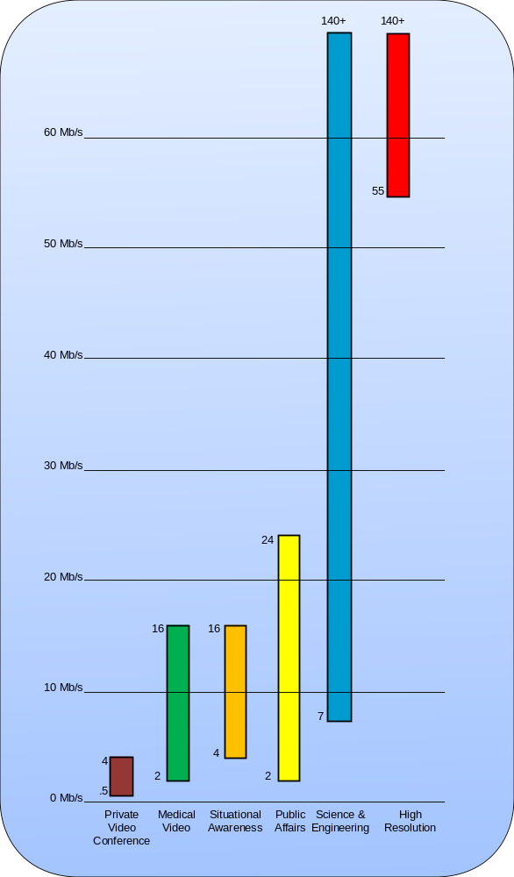
Figure 4-1919: Video Applications and Transmission Bandwidth
Figure 4-19 shows the video applications and associated transmission bandwidth. The range shown is from 8-bit 4:2:0 to 8-bit 4:2:2 within each video application.

Integrating Video applications to other standards
It is presumed that spacecraft and ground systems designers would prefer to utilize as much existing spacecraft and ground system avionics and distribution infrastructure as possible for video and motion imagery applications, versus creating standalone or single-purpose video distribution systems (like a closed-loop video production or cable TV system). Therefore, the Motion Imagery and Applications Working Group will analyze, test, prototype and report on recommendations and best practices for digital video and motion imagery utilizing existing CCSDS and industry standards and protocols, and establish recommendations for applications of digital video and motion imagery to include quality of service, IP, and broadcast protocols, including multicast and unicast, security, and privacy.

Abbreviations and Acronyms

AAC Advanced Audio Coding
ASI Asynchronous Serial Interface
ATV Automated Transfer Vehicle
ATV-CC ATV Control Center
AVCHD Advanced Video Coding High Definition
BCC-HOSC Backup Control Center HOSC
BER Bit Error Rate
CADMOS Centre d'Aide au Développement des activités en Micro-pesanteur et des Opérations Spatiales
CE Customer Edge
Col-CC Columbus Control Centre
COTS Commercial Off-The-Shelf
COVRS Columbus On-board Video Reconstruction Service
CRT Cathode Ray Tube
CSR Communication Service Request
DARPA Defense Advanced Research Projects Agency
DCI Digital Cinema Initiative
DLP Digital Light Processing
DLR Deutsches Zentrum für Luft- und Raumfahrt e.V.
DRTS Data Relay Test Satellite
DTV Digital TV
DVB Digital Video Broadcasting
EAC European Astronaut Centre
ESA European Space Agency
EVA Extra-Vehicular Activity
FDDI Fiber Distributed Data Interface
FEP Front End Processor
FPGA Field-Programmable Gate Array
FPS Frame Per Second
GOP Group of Pictures
GSOC German Space Operations Centre
HD High Definition
HDMI High Definition Multimedia Interface
HDSDI High Definition Serial Digital Interface
HDTV High Definition Television
HDV HDTV Video
HOSC Huntsville Operations Control Center
HRDL High Rate Data Links
HRFM High Rate Frame Multiplexer\
IAS Internal Audio System
ICS Inter-orbit Communication System
IGS Interconnecting Ground Segment
IMAX Image Maximum
IMS Integrated Management Subsytem
IP Internet Protocol
IPU Image Processing Unit
IRIG Inter-Range Instrumentation Group
ISPR International Standard Payload Rack
ISS International Space Station
ITU International Telecommunication Union
JEM Japenese Experiment Module
JPEG Joint Photographic Experts Group
JSC Johnson Space Center
JSL Joint Station LAN
LCD Liquid Crystal Display
MCC-H Mission Control Center-Houston
MCC-M Mission Control Center-Moscow
MPC Multi-Protocol Converter
MPEG Moving Pictures Experts Group
MPLS Multi-Protocol Label Switching
MSFC Marshall Space Flight Center
MSM Manned Space & Microgravity
MSM-CI MSM Communications Infrastructure
MTU Maximum Transmission Unit
MUSC Microgravity User Support Centre
MVDS MPEG-2 Video Distribution Service
NAL Network Abstraction Layer
NASA National Aeronautics and Space Agency
NHK Nippon Hoso Kyokai
NI Network Infrastructure
NIS Network Infrastructure Subsystem
NTP Timing Network Time Protocol
NTSC National Standards Television Committee
OCA Orbital Communications Adapter
OCR Operational Control Room
ODAR Obsolescence Driven Avionics Redesign
OMT Organization Management Team
PAL Phase Alternating Line
PCM Pulse Code Modulation
PID Packet ID
POIC Payload Operations Integration Center
PSI Program Specific Information
RFSA Russian Federal Space Agency
RGB Red, Green, Blue
RTP Real Time Protocol
SAN Storage Area Network
SD Standard Definition
SDI Serial Digital Interface
SD-SDI Serial Digital Interface
SDTV Standard Definition Television
SECAM Séquentiel Couleur à Mémoire
SMPTE Society of Motion Picture and Television Engineers
SPTS Single-Program Transport Stream
TDRS Tracking and Data Relay Satellite
TKSC Tsukuba Space Center
TS Transport Stream
UDP User Datagram Protocol
USB Universal Serial Bus
USOC User Support Center
VBSP Video Baseband Signal Processor
VCDU Virtual Channel Data Unit
VCS Video Conferencing Service; Video Conferencing System
VCU Video Control Unit
VDPU Video Data Processing Unit
ViDS Video conferencing and Distribution Subsystem
VLAN Virtual LAN
VoCS Voice Conferencing System
VP Video Processor
XPO eXpress Persistent Objects

