

REPORT CONCERNING SPACE
DATA SYSTEM STANDARDS

Cislunar Space Internetworking

CCSDS 000.0-G-0

GREEN BOOK

July 2005



AUTHORITY

 |  | This Green Book has not been approved; a later version will be submitted for approval.
 | Issue: | Version 0.1
 | Date: | 2004-08-01
 | Location:

This document has been approved for publication by the Management Council of the Consultative Committee for Space Data Systems (CCSDS) and reflects the consensus of technical panel experts from CCSDS Member Agencies. The procedure for review and authorization of CCSDS Reports is detailed in the Procedures Manual for the Consultative Committee for Space Data Systems.

This document is published and maintained by:
CCSDS Secretariat
Program Integration Division (Code M-3)
National Aeronautics and Space Administration
Washington, DC 20546, USA
Foreword
Through the process of normal evolution, it is expected that expansion, deletion, or modification to this Report may occur. This Report is therefore subject to CCSDS document management and change control procedures which are defined in the Procedures Manual for the Consultative Committee for Space Data Systems. Current versions of CCSDS documents are maintained at the CCSDS Web site:
http://www.ccsds.org/
Questions relating to the contents or status of this report should be addressed to the CCSDS Secretariat at the address on page i.
At time of publication, the active Member and Observer Agencies of the CCSDS were:

Member Agencies

- Agenzia Spaziale Italiana (ASI)/Italy.
- British National Space Centre (BNSC)/United Kingdom.
- Canadian Space Agency (CSA)/Canada.
- Centre National d’Etudes Spatiales (CNES)/France.
- Deutsches Zentrum für Luft- und Raumfahrt e.V. (DLR)/Germany.
- European Space Agency (ESA)/Europe.
- Instituto Nacional de Pesquisas Espaciais (INPE)/Brazil.
- National Aeronautics and Space Administration (NASA)/USA.
- National Space Development Agency of Japan (NASDA)/Japan.
- Russian Space Agency (RSA)/Russian Federation.

Observer Agencies

- Austrian Space Agency (ASA)/Austria.
- Central Research Institute of Machine Building (TsNIIMash)/Russian Federation.
- Centro Tecnico Aeroespacial (CTA)/Brazil.
- Chinese Academy of Space Technology (CAST)/China.
- Commonwealth Scientific and Industrial Research Organization (CSIRO)/Australia.
- Communications Research Centre (CRC)/Canada.
- Communications Research Laboratory (CRL)/Japan.
- Danish Space Research Institute (DSRI)/Denmark.
- European Organization for the Exploitation of Meteorological Satellites (EUMETSAT)/Europe.
- European Telecommunications Satellite Organization (EUTELSAT)/Europe.
- Federal Service of Scientific, Technical & Cultural Affairs (FSST&CA)/Belgium.
- Hellenic National Space Committee (HNSC)/Greece.
- Indian Space Research Organization (ISRO)/India.
- Institute of Space and Astronautical Science (ISAS)/Japan.
- Institute of Space Research (IKI)/Russian Federation.
- KFKI Research Institute for Particle & Nuclear Physics (KFKI)/Hungary.
- MIKOMTEK: CSIR (CSIR)/Republic of South Africa.
- Korea Aerospace Research Institute (KARI)/Korea.
- Ministry of Communications (MOC)/Israel.
- National Oceanic & Atmospheric Administration (NOAA)/USA.
- National Space Program Office (NSPO)/Taipei.
- Swedish Space Corporation (SSC)/Sweden.
- United States Geological Survey (USGS)/USA.
DOCUMENT CONTROL

Document | Title | Date | Status
CISLUNAR_GREEN | Cislunar Space Internetworking | November 2004 | Version 0.1

CONTENTS
Section Page
1 INTRODUCTION 7
1.1 PURPOSE OF THIS DOCUMENT 7
1.2 ORGANIZATION OF THIS DOCUMENT 7
1.3 DEFINITIONS 7
1.4 REFERENCES 7
2 BACKGROUND AND SCOPE 8
2.1 BACKGROUND 8
2.2 SCOPE 8
3 Mission Scenarios and Requirements 10
3.1 Overview 10
3.2 End-to-end characteristics 11
3.3 Ground (Terrestrial) characteristics 12
3.4 Earth Ascent/Descent 14
3.5 Earth Orbit 14
3.6 Lunar Transit 15
3.7 Lunar Orbit 16
3.8 Lunar Ascent / Descent 17
3.9 Lunar Surface 17
4 COMMUNICATIONS REQUIREMENTS 19
5 OPERATIONS CONCEPTS USING CURRENT ARCHITECTURE 20
5.1 Point-to-Point Links 20
5.2 MER Relay Operations 20
6 FAQs 21
7 PROPOSED ARCHITECTURE 22
7.1 Advantages and Disadvantages of an Automated, Layered, Networked Infrastructure 23
7.2 Disadvantages 24
7.3 What this architecture requires from the underlying layers 24
7.4 Connectivity (end-to-end connectivity vs. routed store-and-forward) 24
7.5 IP Error! Bookmark not defined.
7.6 Store-and-forward for (possibly) disconnected environments. 26
8 Ops concepts using the new architecture. 30
9 Technology Infusion Path 31
10 Security 19
11 Translunar [Move whatever’s here to the discussion of store-and-forward above?] 34
12 Recommendations (maybe break out into white paper?) 35
13 CONCLUSIONS 36
14 Appendix A: Rejected Elements 37

INTRODUCTION

PURPOSE OF THIS DOCUMENT
This document presents a high-level architecture and operations concept for communicating with and among elements in the Earth-Moon system (cislunar communications). Communicating elements include terrestrial endpoints such as development and test facilities, launch facilities, and scientists; orbiting endpoints in orbit around the Earth or Moon, or in transit from one to the other; and landed elements on the surface of the Moon.
This document does not specify how to construct a communications infrastructure based on any particular technology.

ORGANIZATION OF THIS DOCUMENT

DEFINITIONS

REFERENCES

BACKGROUND AND SCOPE

BACKGROUND
CCSDS has standardized aspects of communication from the physical layer through applications services (XXX_REF_XXX).
There has recently been increased interest from a number of space agencies in crewed missions to the Moon, and possibly later to Mars.

SCOPE
The architecture presented here is designed to function in the presence of round trip times that might include relay through geosynchronous satellites or satellites orbiting the L2 point of the Earth-Moon system. Thus the range of round trip times considered here extends to around 3.5s, slightly beyond the ~2.5s RTT of a direct Earth-Moon link.
Wherever possible, the concepts developed here should work equally well in any system with round-trip light times that are roughly equivalent to the Earth-moon system. Thus the arguments presented here should hold for the immediate vicinity of most planetary bodies in the Solar System, and in particular should hold for communications between Mars orbit and the planet's surface.
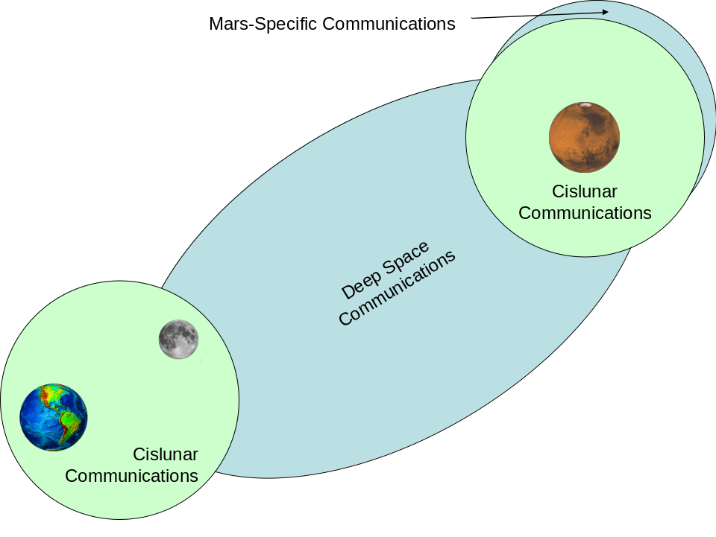
While this document addresses in detail the requirements and proposed approach of Cislunar operations, there is an implied goal of developing an architecture which is extensible to missions at Cismartian distances. When there is a requirement that is different for a Mars mission, or an architectural feature that does not support Cismartian communications, that is pointed out with a parenthetical note.

Lunar Mission Characteristics and requirements
This section will describe first the overview characteristics of anticipated lunar missions , and then for each physical mission space, the communications requirements in terms of services, users, environment characteristics, etc.
(ed. note - what needs to happen, not how to do it. Include stuff about environments with different scenarios.)

Overview
This document assumes a mission architecture which is based on current human technology (launch systems, crew/robotic vehicles, communications relays, etc.). It also assumes the limitations of those technologies, such as incomplete coverage, speed-of-light delays and contingency configurations.
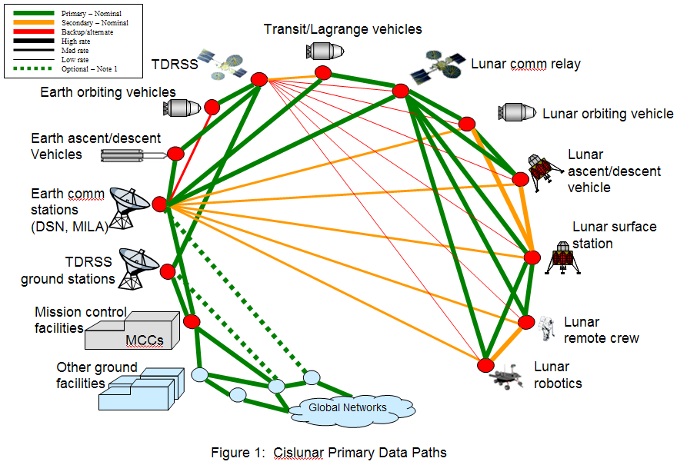
Figure 1 illustrates communications paths which are expected, based on usage of current or anticipated systems (TDRSS, Lunar landers, etc.)
Notes of explanation for Figure 1:
- Session data from other ground facilities may or may not be required to go through the MCC as a “gateway”. This architecture must support both options.
- TDRSS (per LRO plans) is assumed to be able to communicate at lunar distances at very low data rates (~5Kbps)
- Primary path as a vehicle makes transition from low Earth orbit to Lunar orbit is assumed to transition from TDRSS to DSN.
- For Lunar resources, primary path is DSN to Lunar comm relay to end point, however periodic DSN direct to lunar asset may be required for some operational scenarios.
- Permanent lunar station may or may not be a comm hub for nominal communications. This architecture must support both options.
- Primary communications for lower-than-geosynchronous is presumed to be TDRSS.
- For “other ground facilities” see detailed end points list, as described in following sections.
- Both TDRSS (or other earth-orbiting relay satellites) and Lunar Comm Relay in this illustration look like simple one-step hops, but in actuality, the network must support multiple comm satellite relays and/or constellations of satellite relays with multiple hops through the system before the destination.
(ed. Still to add…
Services and environmental characteristics that are common to all scenarios.
Architecture needs to still provide some (possibly degraded) level of service, even with loss of elements, whether there’s continuous coverage or not. )

End-to-end characteristics
This section describes characteristics that the architecture must deal with that apply to the whole architecture. Following sections will address more specific characteristics for different physical areas that the architecture serves (ground, LEO, etc.).

Services
- Security
End-to end security must be embedded in the system as part of protocol design. Security requirements will have the following general features:
    - Command authentication
    - Intrusion detection
    - Ability to interoperate with international partners (exportable technology)
    - Support for contingency scenarios such as commanding in the clear.
    - The ability to accommodate command and control from remote users in widely scattered remote locations such as universities and domiciles.
    - The ability to provide an “ironclad pipe” between a payload user in a remote location and his payload onboard a spacecraft or planetary surface facility. This will preclude unauthorized control/monitoring of his payload, and prevent him or someone who penetrates his system from affecting anything but that payload. Note that this must also accommodate contingency control of the payload by MCC authorities.
    - Security prototocls must be delay tolerant for extremely long latency signal delays. This delay tolerance must go beyond simple latency tolerance to also accommodate packet delivery delays due to LOS/AOS of signals for communications outages.
  - Time Synchronization
    - Time protocols must allow periodic ability to synchronize clocks between flight and ground systems across link delays of many light-seconds. (Goal for CisMartian – light-hours)
    - Time protocols must allow the accurate synchronization of clocks between globally distributed ground facilities
    - Time synchronization services apply to spacecraft, surface habitats, rovers, spacesuits, etc.
  - Telepresence/Telescience
    - Ground-based scientists and other operations teams have always asked for short-latency real-time command and control from earth to their science payloads. This has seldom if ever been realized to the degree that has been requested (“joystick control”). However, to the degree that it has historically occurred in existing programs in low earth orbit, this architecture must not degrade that capability at the same earth-orbital distances. At Cislunar (and Cismartian) distances, there will be significant degradation of such capabilities, and neither this architecture nor any realistic architecture with 21-century technology is anticipated to improve that situation.
  - Contingency operations
    - Communications services must allow for contingency operations features, such as commanding in the blind, range safety (terrestrial and lunar) and accident investigations.

    - Data Types
Description of data types should be location-independent, hence that is in the end-to-end section rather than the following location-specific sections. The architecture requirements should not preclude the delivery of any data types to any location. For example one would initially expect that no voice data type is needed on unmanned vehicles. But later we find that Later, we find that human voice control of robotic rovers is needed between lunar crew and the rover, and MCC operators need a downlink of the voice commands from the rover for troubleshooting.
For data types on spacecraft, the following data types are considered to apply to all types of spacecraft systems (core systems, science payloads, manned and unmanned systems, etc.). Also, most data types are expected to exist in realtime and playback forms.
An approximate listing of data types follows:
- Command
- Telemetry
- Internet Protocol session traffic
- Digital voice
- Digital Video (NTSC, PAL, SECAM, HDTV)
- Internet-based streaming media (audio, video)
- Multi-party videoconference data
- Onboard memory dumps
- Program uploads
- Mission planning and scheduling data
- File Transfer of all types of computer files (binary, executable, database, etc.)
- Trajectory and tracking data (state vectors, etc.)
- Environmental data (space radiation, etc.)
- Terrestrial weather data
- Data Quality Messages (Communications link quality messages)
- Data for remote control and monitoring of ground systems.
- Personnel biomedical data
- Personnel family and private communications
- Personnel entertainment data (CNN, MMORPGs, etc.)
- Personnel access to internet and WWW services
- Robotic access to internet-based data
- Search and rescue support data

Ground (Terrestrial) characteristics

end-Points
The terrestrial end-points to the communications network are the most complex and diverse of the network. This list is intended to describe the breadth of the end-users and end-points, but it can not be comprehensive.

- Spacecraft development facilities
- Spacecraft test & evaluation facilities
- Ground Processing Facilities
- Launch facilities (Pad, etc.)
- Launch control facilities (LCC, etc.)
- Range Safety facilities
- Launch vehicles on the ground
- Planning facilities (office environment)
- Planners at remote locations
- Crew trainers and simulators
- Mission Control Center (MCC) facilities
- Backup operations personnel at remote locations
- Off-duty operations personnel with pagers
- Relay through one MCC to another MCC
- Payload Development & test facilities
- Data Archive Facility
- Science Operations facilities
- Science user facilities (Universities, etc.)
- Ground Network facilities (DSN, etc.)
- Any of above facilities may sometimes be “lights-out”
- Remote scientists at home
- Public and news media
- Local civil authorities
- Astronauts’ families at home
- Landing facilities
- Other Agencies: FAA, NOAA, DoD, the White House
- Water Recovery facilities (Navy ships, etc.),

- Search and rescue teams
- Accident investigation teams

Notes on the above list:
  - Some of those facilities may be “lights out” unattended facilities at time, continuing to operate and exchange data with spacecraft.
  - Some of the distribution of data to these end points must be assumed to take place on terrestrial public and private networks.

Services
These are representative services that are needed for those end-points and users listed above. Trivial or obvious services which can be derived elsewhere in this document (like command, telemetry, etc.) are not repeated here.
- Transparent routing – Middleware (such as Grid middleware) should provide data mining services which allow terrestrial users to extract information from local or remote sources, in a way which requires the user to have little or no awareness of the location of the data.
- Distributed usage of resources - Computing and processing resources should be able to be shared transparently across a designated domain (facility, agency, etc.) in order to make most efficient usage of resources in general, and especially high-performance resources (supercomputers, etc.).
- Remote distribution of command and control of science payloads to remote locations (university, home/office, garage inventors, etc.)

- Security – While the prior section (end-to-end) addressed security for the whole mission space, it must be acknowledged that the threat for security penetration is greatest on the ground (terrestrial) segment. As a result while security features are implemented system wide, they are probably implemented with greater “strength” on the ground.
- Contingency operations – When a major control facility goes down, the system must provide services which accommodate transfer of control to a backup location. This means that control functions which were securely restricted to one location can be quickly reprogrammed to be at a new location. The new location may be a ground terminal, a hotel room, or other non-standard site.

Environment
This environment description explains the external forces that must be dealt with by the architecture. .
- Network environment – usage of commercial services (ATM, etc.) and the resulting impact in terms of what protocols need to deal with.
- Geopolitical environment – International operations drives multiple countries using same tools, but dealing with import/export regulations (only implement things that are exportable?)
- Physical environment – widely distributed, many environments. Landing and recover operations are distributed globally, especially search-and-rescue operations in remote locations.
- Computing environment – services and protocols must function in widely available computing platforms. (Ed. specify OS’s?)

Earth Ascent/Descent

End Points
This lists the vehicles serviced by the architecture during earth ascent/descent.
- Launch vehicles (w/o crews)
- Launch vehicles with crews
- Payloads reporting health
- Descent vehicles (w/o crews)
- Descent vehicles (with crews)

Services
These are representative services that are needed for those end-points and users listed above.
- Quick transition of data routing between the pad mode (umbilicals) and liftoff
- Dump of stored telemetry (big file transfer soon after launch)
- Mostly concerned with health monitoring of the spacecraft itself, not too interested in the instruments.

Environment
This environment description explains the external forces that must be dealt with by the architecture.
- Physical environment
  - Characteristics of changing comm mode between MILA and TDRSS
  - Descent blackout period characteristics…
- Computing environment onboard – services and protocols must function in currently available avionics platforms, and also those anticipated in the near future. (Ed. specify OS’s?)

Earth Orbit

End Points
- Space Network Facilities (TDRSS, etc.)
- Upper stage propulsion vehicles
- Free-flyer unmanned vehicles (science, cargo, etc.)
- Payloads on free-flyer unmanned vehicles
- Manned vehicles (CEV, etc.)
- Crew on manned vehicles
- Payloads on manned vehicles
- Crew in EVA suits
- Multiple spacecraft in rendezvous (automated, crew controlled)
- Multiple spacecraft docked to each other
- Relay through one vehicle to another

Services

Environment

Human earth orbit (merge with above sections?)
- More emphasis on QoS with crewed missions
- Starting now and continuing through all human activities, increased desire for ability to ship some data outside of the closed ground terrestrial network (e.g. to media, families of astronauts, …)
- For all elements
  - How to know when you don’t have a path, and what to do about it
  - [e.g. daemon running watches routing tables and if no path to X, has list of possible actions (bring up link, scream for help)]
- For all human elements, contingency plans for when things go all wrong
  - QoS protection of ‘special’ data – first line of defense
  - Ability to irradiate astronaut via 70m -DSN station.
  - If astronaut uses 802.11 most of the time, what happens when they need direct-to-Earth voice/video/telemetry support?

Lunar Transit

End Points
- Upper stage propulsion vehicles
- Free-flyer unmanned vehicles (science, cargo, etc.)
- Payloads on free-flyer unmanned vehicles
- Manned vehicles (CEV, etc.)
- Crew on manned vehicles
- Payloads on manned vehicles
- Crew in EVA suits
- Multiple spacecraft in rendezvous (automated, crew controlled)
- Multiple spacecraft docked to each other
- Relay through one vehicle to another

Services

Environment

Lunar Orbit

End Points
- Space Network Facilities (Lunar Relay Orbiter, etc.)
- Upper stage propulsion vehicles
- Free-flyer unmanned vehicles (science, cargo, etc.)
- Payloads on free-flyer unmanned vehicles
- Manned vehicles (CEV, etc.)
- Crew on manned vehicles
- Payloads on manned vehicles
- Crew in EVA suits
- Multiple spacecraft in rendezvous (automated, crew controlled)
- Multiple spacecraft docked to each other
- Relay through one vehicle to another

Services

Environment
- Error rates at the top of the data link layer ~ 1e-6 – 1e-7
- We assume a reasonable amount of processing power and storage for spacecraft (~300 MHz power-pc-class, a couple gig of “disk”, ~128-512M DRAM, and an operating system)
- Outages (due to rain, say) can sort of show up as either planned outage (if you’re expecting them) or as errors (if you’re not).
- May not have connectivity, or bi-directional connectivity, even though one-way light time is low and link quality is good (driver for CFDP vs. ftp)
  - Bi-directionality may be sort of erratic (always have downlink, only have uplink for a little while with long periods of outage)
  - Outages due to rain, etc.
- Data rates may be asymmetric
  - E.g. Data rate roughly symmetric ~ 100kbps
  - E.g. 100kbs up, 125Mbps down (~1250:1)
- Station Ku is 5Mbps up, 150Mbps down
- Station may use 128kbps up (S-band) and 150Mbps down
- May have multiple (parallel) RF links with some duplication of data (multigraph)

Robotic Lunar Orbit (Merge with above sections?)
- Spacecraft in orbit around the moon.
- May have more than one spacecraft.
- When only one spacecraft, almost certain to have periods of disconnection.
  - Store data and forward when in view of Earth.
- With more than one spacecraft, have the possibility of routing (layer-3), frame forwarding (layer 2+), RF-bent-pipe (layer-1)
  - Short contact times with relay(s)
- Data types
  - Science files (downlink)
  - Housekeeping files (down)
  - Real-time housekeeping / telemetry (down) [could include streaming video down]
  - Command uploads (maybe some real-time)
  - Software uploads
  - Relay traffic (real-time relay vs. store-and-forward (MER-type))
- Definitely more data coming down than going up.

Human lunar orbit (Merge with above sections?)
- More emphasis on QoS with crewed missions

Lunar Ascent / Descent
- More minimal environment, not much going on except watching what’s going on. Telemetry stream is mostly launch vehicle.
- Use QoS to change rules during this phase to ensure safety-of-life or mission-critical stuff gets through.

End Points
- Launch vehicles (w/o crews)
- Launch vehicles with crews
- Payloads reporting health
- Descent vehicles (w/o crews)
- Descent vehicles (with crews)

Services

Environment

Lunar Surface

End Points
- Crew in LSAM or habitat
- Lunar habitat systems (occupied or vacant)
- Crew during EVA
- Crew mobility system (moonbuggy)
- Unmanned lunar stations
- Autonomous robotic systems (stationary and rovers)
- Human-guided robotic systems
- Comm hubs as standalone stations or part of larger stations
- Science systems (at habitat, station or standalone)
- Crew or systems in safe haven (“escape pods”), in emergency mode

Services

Environment

Robotic lunar surface (pre-moon-base, no people)
- Robotic lander(s)/rover(s)/sensor network(s) on surface of moon
- Possibility of 0%, 100% view period to the Earth (for a lander)
- Rover might move in and out of view of Earth, Orbiter.
- If relay asset(s) available:
  - Short contact times with relay asset(s)
  - Possibility of 0%, 100% view period to the Earth (for a lander)
- When multiple assets in view of each other, possibility of ad-hoc local network among lunar surface assets
- Need for position location (esp. rovers)
- Same Data Types as above

Human lunar surface (plus robotic elements)
- This side of the moon or possibly the other side (get this from publicly available spiral-3 stuff)?
  - Possibility of a pretty high rate, pretty stable trunk line to lunar base.
- Network-based storage?
- More Data Types
  - Voice, video (1-way, 2-way, multipoint) [privacy stuff]
  - Crew health data (normal monitoring + highQ telemedicint)
  - Administrative data (timecards, etc.)
  - Email, Web, …
  - Video feeds from Earth (training, crew accommodations, …)
- More emphasis on QoS with crewed missions
- More ad-hoc networking required
  - Use of 802.11-type links to astronaut suits, rovers, robots
  - May have some 802.11 (e.g.) infrastructure pre-placed.
- Higher desire for increased RMA (reliability, maintainability, availability) (route around obstacles)
- Maybe a more symmetric environment in terms of data rates. (200:1?, 500:1?)

COMMUNICATIONS REQUIREMENTS
Derived from scenarios
End users and endpoints

Security
Talk about security implications of the different methods.

OPERATIONS CONCEPTS USING CURRENT ARCHITECTURE
How we would do the above scenarios with current capabilities, what we can do now and what of the scenarios would be difficult.
CFDP goes here? It’s on the brink between current and future architectures.
Can have up to several seconds of processing in the ground network (station).

Point-to-Point Links

MER Relay Operations
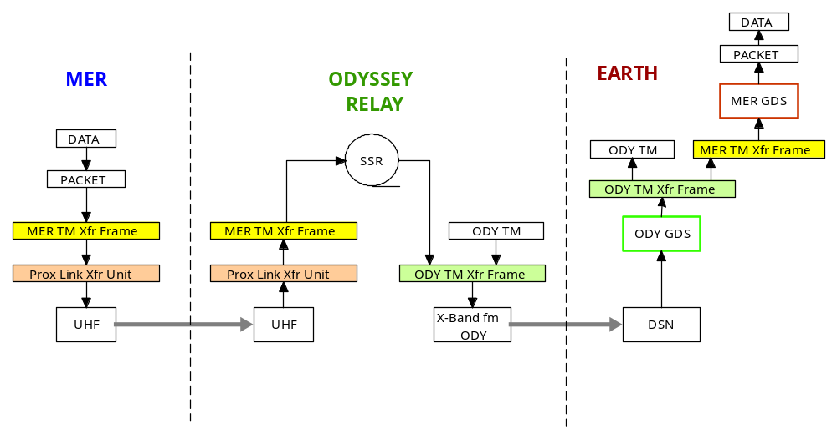
Figure 1: MER Relay Ops

FAQs
- Do we want to have something other than IP to support XXXX traffic type? [e.g. why not something separate for voice?]
- Do we need lunar relays?
  - If yes, do they need to support IP routing on-board? When does that become really helpful?
- How do I do blind commanding if I normally use MobileIP
- How does this work with SLE CLTU service, if I use SLE CLTU service to get stuff to the ground station?
- IP routing and not necessarily using multiple paths.
- Information about unmanned 'tug'-type vehicles that can go refuel/service things? Boeing orbital express idea is to do this for geosynchronous satellites now.
- Q: How does this architecture improve the ground infrastructure of the past?
  - A: For example the ISS program has multiple uplinks and downlinks to/from the same vehicle (US, Russian, Japanese). For one MCC to send a command through the other MCC uplink, much manual configuration is required, and many “special case” operational agreements were needed. With the routing capability proposed in this architecture, the network identifies which links are available, determines which of the authorized uplinks currently have AOS, and routes from source to destination based on previously agreed to authorization for the source to command the destination. Minimal manual reconfiguration, reducing manpower needs and increasing responsiveness of the overall system to operational needs.
- Q: What future technologies does this architecture support?
  - A: Communications relay satellites flying in formation with “plug-in” satellites using cross-link between the relays. One option for future technology in communications satellites allows for a constellation with a “primary” satellite with a high-capacity downlink and first-generation technology for links to exploration spacecraft. Later, a new technology “secondary” satellite that has only the “outbound” technology (for example laser communications) for deep space communications is added to the constellation, but it has no downlink to the ground, but rather uses a cross-link to the nearby primary satellite, and uses it’s high-capacity downlink to the ground station. Both (or all) satellites in this constellation use routing protocols across the cross links to get to the high-capacity downlink from the primary satellite. Using the routing protocols proposed in this architecture allow “plug-in” secondary satellites to be utilized by ground and flight systems with minimal manual reconfiguration and routine automated routing from ground user to exploration spacecraft. When the new technology has AOS with the spacecraft, the routing protocols take advantage of it, but otherwise it falls back to the lower capacity links from other comm satellites in the constellation.
  - A: Wireless mesh technologies (802.11s) may be deployed on a planetary surface, and the routing capabilities proposed in this architecture will work seamlessly with those new capabilities.

PROPOSED ARCHITECTURE
This document proposes an automated, layered, networked architecture for cislunar communications.
Target architecture is long-term goal, there are intermediate points and a reasonable growth path from current capabilities.
Layers are good. Advantage of being able to swap layers in and out.
Lessons learned from MER: shoe-horning the relay operations in around the orbiters’ (primary) science mission is difficult. Dedicated hardware for relay would be much better. Orbits aren’t particularly good for relay either.

Layers
In networking, 'layering' is used both to isolate functionality and to aggregate commonly-used functions (push them down in the stack). So long as the interfaces to the layers above and below are maintained, the technology and protocols used to implement a particular networking layer can be changed. This allows the system as a whole to evolve.
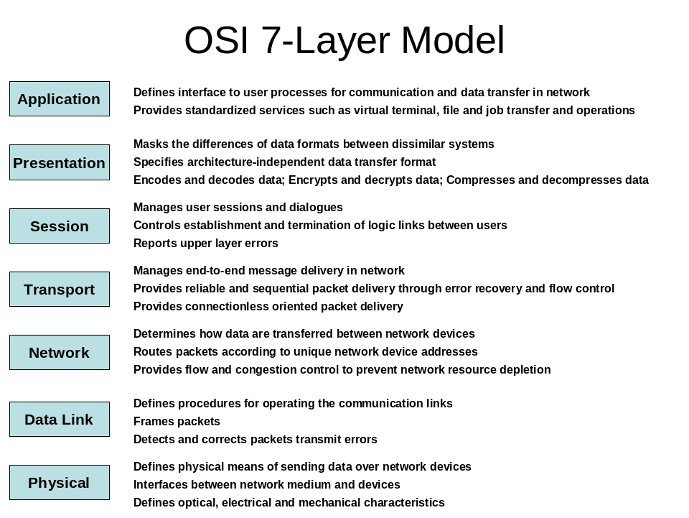
This document addresses mainly the network layer and above, with some data link layer considerations.
If a particular layer cannot be changed at all locations simultaneously, it may be possible to use a gateway to translate between the old and the new implementations. For example, if one wanted to change the physical communications from FDMA to CDMA, one could fly elements supporting both, using FDMA to communicate with legacy equipment and CDMA to communicate with other new equipment. Over time, as the FDMA-based equipment is retired, new elements can begin to carry only CDMA. This is perhaps the most extreme example, as the physical layer and its associated hardware are generally the most difficult to transition from one technology to another. A switch from IPv4 to IPv6, for example, could be achieved solely by applying software changes. The process of using a gateway to transition from one technology to another is illustrated in Figure 2.
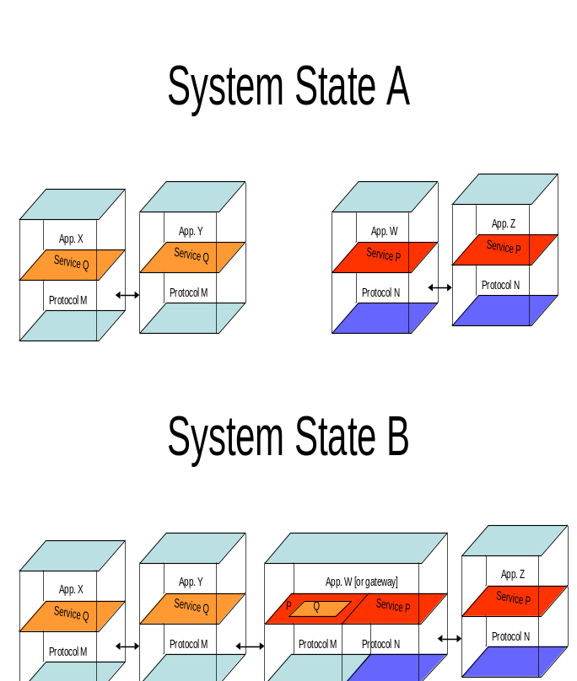
Figure 2: Layers and gateways

Advantages and Disadvantages of an Automated, Layered, Networked Infrastructure

Extensibility (Technology Injection)
Basic comms capability can support a lot of different applications and middleware (e.g. GRID, messaging middleware, …)

Scalability
Talk about scalability and why this is better than what we do now.
Complexity, cost.
Ability to accrete infrastructure, reuse existing infrastructure that’s already in space.

Risk Reduction
Mission risk: As long as I can see somebody to forward my data, I’m good (not relying on a single communications path, use redundant routers).
Program risk: good for the program, not necessarily for any particular mission. Can capitalize on off-the-shelf systems and applications, reuse of operational procedures and ops concepts, reduce budget and schedule risk.
Enable cross-support.

Disadvantages
- more software, more complex.
- People not (directly) in control of where every bit goes.
- Not necessarily optimized for near-term return (data return from a single mission, cost to any particular mission, …)
- Lose some control and insight into how data is moving in the network.
- For current missions already well-along in the design phase, re-engineering to support this would represent increased risk.

What this architecture requires from the underlying layers
Can we make the argument that we can function with a lower spectrum allocation due to better link utilization?
What requirements do we have with respect to data rate?

Connectivity (end-to-end connectivity vs. routed store-and-forward)
Sometimes you have contemporaneous end-to-end connectivity, sometimes you don’t.

Network Layer
In the OSI model, the network layer is responsible for XXXXX.

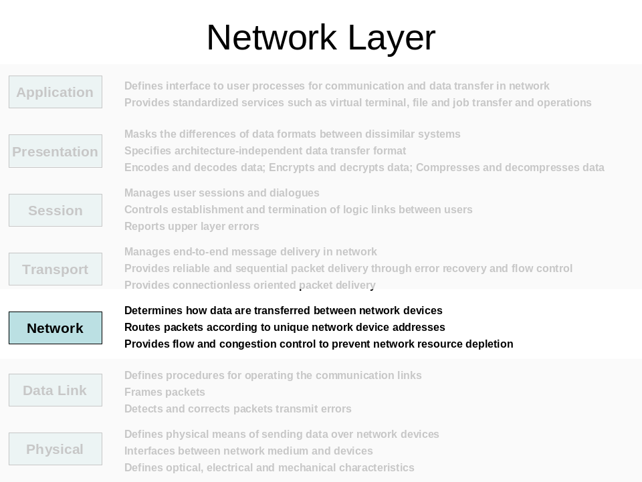
There are a number of network-layer protocols that could be used, including IP, IPX, ATM, and others. A brief review of some of these protocols is presented here, along with their pros and cons.

IP
IP uses 20-byte packet headers to identify the source, destination, quality of service, and transport protocol for each IP packet.

IPX

X.25

ATM

OSI

CCSDS Packets
Routing can be accomplished based on the combination of spacecraft ID and application ID in CCSDS frames/packets.

Conclusions
IP has a number of advantages: widely deployed in terrestrial network; lots of COTS products; support for QoS; … IP has also been adopted as a recommended standard by CCSDS [XXX_REF].

Transport Layer
TCP, UDP, pros/cons.
PEPs to improve TCP performance

Store-and-forward for (possibly) disconnected environments.

Overview
This section describes what we will refer to as 'long-term store-and-forward' communications, or simply store-and-forward communications. We differentiate here between long-term store-and-forward operations, where data may be held at intermediate points in the communications path for long, or even arbitrary, periods of time, versus a 'short-term store-and-forward' fabric such as IP. IP does indeed provide a store-and-forward communications service, where packets are stored momentarily in routers before being forwarded. The difference is that IP routers will drop packets immediately if they have no 'next hop' destination for them. A long-term store-and-forward system, on the other hand, can hold on to messages in the anticipation of future connectivity.
Long-term store-and-forward communications systems are best thought of as 'message-switched' systems, where applications inject messages with reasonable application semantics into the network, and those messages travel atomically to their destinations. This contrasts with IP-based networks, which usually split application messages into a number of relatively small datagrams. The rationale for larger messages is to restrict the state needed to track messages, dealing with reliability and security only at the message level rather than the datagram level, and to make efficient use of communications channels.
A number of research efforts are investigating store-and-forward models to provide communication when there is no end-to-end path between source and destination [XXX_REFS_CFDP_DTN_DARPA_XXX]. The store-and-forward overlay (extended procedures) in the CCSDS File Delivery Protocol (CFDP) implement a store-and-forward overlay, but do not include provisions for automated routing.
Perhaps the most comprehensive is the Delay/Disruption Tolerant Networking (DTN) effort, which provides a message-switched communications service with optional security that operates above a number of underlying communications services. DTN is organized around the following principles:
- Don’t plow the same ground twice – hold the gains you’ve achieved
- Don’t engage in unnecessary chit-chat – build complete transactions and make network accesses count
- Don’t depend on information from inaccessible/remote places if you can avoid it – build a sequence of local control operations and use late binding
- Don’t force homogeneity – allow different network components to use environmentally-relevant optimizations
DTN functions as an overlay network above whatever communications resources are available. Thus DTN can run over TCP/IP in the Internet, and over CCSDS Prox-1 (a link layer protocol) between an orbiter and a lander. DTN is an 'overlay' in that store-and-forward DTN nodes need not be present at every location, and the DTN nodes form their own 'virtual' topology above the underlying resources, as illustrated in Figure 3.

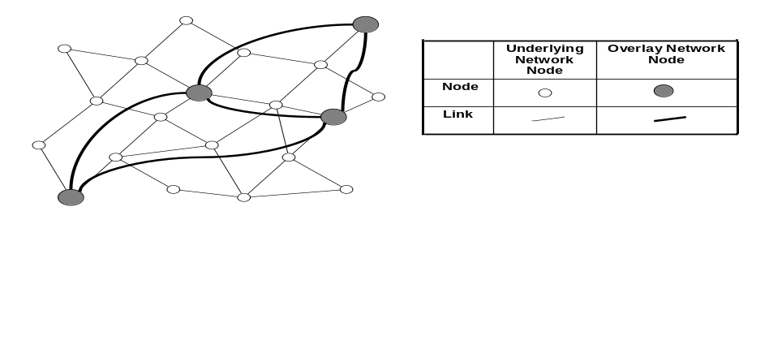
Figure 3: Store-and-Forward Overlay Network
This allows store-and-forward capabilities to be deployed where they make sense, while allowing other nodes (the underlying network nodes in Figure 3) to maintain minimal complexity.

Reliability
Long-term store-and-forward networks like DTN generally provide reliability through a custody transfer mechanism. In custody transfer, network nodes can 'take custody' of application messages, thereby assuming responsibility for their eventual delivery. When a node takes custody of a message, it frees the previous custodian to release retransmission resources associated with the message. This can be very helpful in space science missions, where a relatively lightly provisioned (in terms of memory) lander/rover/science instrument can 'give its data to the network' and then immediately make the memory associated with the transmitted data available to take new measurements. The does not decrease the overall memory requirements in the system, however it does transfer them from end systems, where they are not shared, into the shared communication fabric.

Performance
Store-and-forward systems usually attempt to provide performance equal to that of conventional routed systems when the network is connected. This means that if applications develop to the store-and-forward API, then they can function regardless of whether the network is (currently) connected or not. When there is generally not end-to-end connectivity, a message-based store-and-forward system can provide significantly better performance, both in terms of latency and total throughput.
Figure 4 shows two views of a notional four-hop network path. The top view uses end-to-end networking such as IP, between the source at the top and the destination at the bottom. Time in the figure progresses to the right, and up/down timelines for each link are shown. A heavy green bar indicates that a particular link is up at a particular time, and a thin black bar indicates that the link is down. The source is assumed to always have data to send. In the end-to-end figure, the source has to wait until there is a complete path to the destination before any data can be sent, which increases the latency and reduces throughput. The message-based store-and-forward system, on the other hand, gets the first bit to the destination much faster, and has a higher overall throughput.
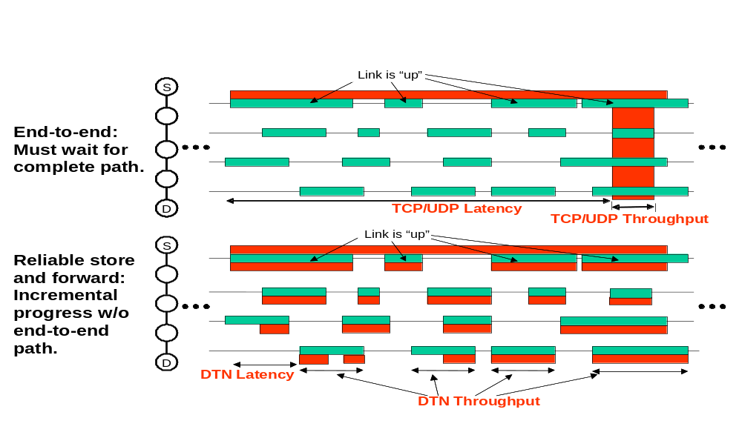
Figure 4: End-to-end networking requires a full path between source and destination before any data can be sent. A long-term store-and-forward system can use individual links as they are available.
As with IP-like routing, a store-and-forward system admits the possibility of doing efficient broadcast/multicast. Such a capability could be quite useful for messages of general interest (e.g. 'space weather' to crewed missions) or for software uploads.

Security
Security can be provided in a number of ways, depending on the requirements. In a secure configuration, nodes in the overlay may exhibit 'mutual suspicion' where every exchange of information has to be authenticated. This is particularly attractive for systems like space communications, since even if a hacker gained access to the network, they wouldn't be able to send packets more than one hop in the overlay. This can deny someone, even if they have access to the ground network, from being able to access a constrained space link. Additional end-to-end security can also be applied at a layer between the application and the overlay network for data confidentiality.

Mission Operations
The loose coupling of the custody transfer approach means that systems like DTN do not require bidirectional communications. Acknowledgements happen at the level of (relatively large) application messages, rather than small packets as is the case in TCP, and can be sent long after the entire message has been received and forwarded. Thus a store-and-forward system might use UDP, with or without a low-density parity check code (XXX_REF_XXX) to send data across a simplex channel, and get a custody acknowledgment for the data during a later pass that allows data to flow in the opposite direction.
Using a store-and-forward infrastructure should simplify the design of applications, as applications no longer have to worry about buffering data until a communications opportunity becomes available – the store-and-forward system provides a general mechanism for handling this relatively common occurrence. Also, while it is possible to provide 24x7 coverage for crewed missions at the moon, which is tidally locked with the Earth, it may not be possible to do so at Mars. A store-and-forward system can support intermittent connectivity to early robotic missions while building up the infrastructure needed for later crewed exploration.

Ops concepts using the new architecture.
How we would do the above scenarios with the new capabilities laid out in section 5.
CFDP goes here? It’s on the brink between current and future architectures.

Technology Infusion Path
XXX Can be combined with New Ops concepts, _is_ New Ops Concepts, or what?
The communications architecture proposed in Section 7 need not be deployed as a 'big-bang' upgrade to current systems. Instead, a measured growth path can be adopted that allows for the incremental infusion of new technology paralleling a controlled evolution in operations concepts. They first key to managing the move from point-to-point links to an automated routing infrastructure to a store-and-forward infrastructure is the realization that even with current DTE links, there is a networking layer. CCSDS frames and packets provide addressing capabilities that are currently managed communication parameters. These frames can flow directly from the spacecraft to the Earth, be relayed by a transponding satellite, or be demodulated onboard a relay satellite. From a networking point of view, a transponding relay is very similar to a DTE link, but the network protocols (the bits that identify the destination spacecraft, or the application sourcing a particular packet of data) are still there. What this means is that in the architecture of Section 7, transponding relays behave like single links in the network topology.
The hardware requirements to support either an "IP-like" routed infrastructure or a "DTN-like" store-and-forward infrastructure are in fact quite modest, even by spacecraft standards. Supporting routed and store-and-forward communications can be achieved with a standard space-qualified operating system such as VxWorks and including a transceiver on board the relay. Immediate gains from this approach include regeneration of signals on-board the relay spacecraft, improving signal-to-noise ratio of the relayed signal. Regenerating signals on-board relays would require separate ranging on each side of the relay, whereas with a transponding relay, ranging can be performed 'through' the relay.
Early missions using relays capable of on-board routing may choose to manage the relays' actions entirely by hand. This would involve simply populating the relays' routing tables from Earth with a set of static routes. These would tell the relay exactly what to do with each incoming packet, making it act very much like a transponding, bent-pipe system.

Figure 5: Picture of routing table with static entries.
In addition to the advantage of signal regeneration, the above approach will allow efficient use of spectrum if two landed assets want to communicate. Figure 6 shows two landed elements, C and D, that need to communicate with each other and with Earth. C and D are presumed to be beyond line-of-sight with each other, and so use a routing relay B to exchange information. While the same capabilities can be achieved with a transponding relay on B, it would require at least three transponders (Earth->Lunar, Lunar->Earth, Lunar->Lunar). Because the bandwidths of these transponders would need to be set ahead of time, it would be difficult for a single user to access all of the Lunar->Relay bandwidth in case it is the only landed element with data, or in an emergency.
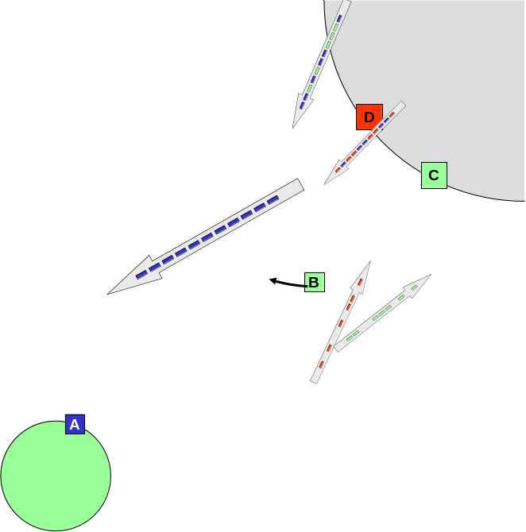
Figure 6: Routing relay B.
The above approach works well provided that the number and rate of changes to the relay's routing table is low. As the number of elements and the complexity of their interconnections increase, managing the routing tables will become increasingly complex and time-consuming. If early elements are equipped with the ability to support automated routing, then that capability can be invoked as the problem of managing routes by hand becomes cumbersome. Indeed, both static and protocol-injected routes can coexist, and network traffic engineering can force packets to use one or the other set of routes. This will allow experimentation with protocol-driven routing while maintaining a backup capability based on manually maintained routes.
Long-term (DTN-like) store-and-forward requires little more investment than a basic routed infrastructure. The main difference is the amount of storage on board the relay element. As with the transition from DTE links to a routed infrastructure, store-and-forward communications can be phased in gradually. Applications can choose whether they want to use store-and-forward services or not, and the number and placement of store-and-forward relays in the network can be controlled.
In summary, the hardware requirements of a routed system over a transponded system are small, and provide immediate benefits in signal quality. The infrastructure needed to support on-board routing, an operating system such as VxWorks, is already space-qualified and proven. Adding storage resources to a routed system allows it to support long-term store-and-forward operation. The behavior of a system capable of supporting full-up store-and-forward operation can be tuned from that of a system supporting DTE or bent-pipe relay links to store-and-forward operation in small steps, allowing time to adjust operational doctrine. Developing this technology now will improve performance of near-term operations as well as provide a growth path to configurations where store-and-forward operations are required due to lack of end-to-end communications.

Translunar [Move whatever’s here to the discussion of store-and-forward above?]
How the architecture might get reused around Mars, or other, and where this architecture might not apply.
How if you develop your applications to store-and-forward API, they keep working all the way to Mars over the automated store-and-forward architecture.

Recommendations (maybe break out into white paper?)
See why the new architecture is better?
Things that need to be developed
Prototyping / testing activities we think need to be done

CONCLUSIONS

Appendix A: Rejected Elements
Include here information about those protocols and elements that we think are NOT part of the solution, and why.

