INTRODUCTION

Purpose
<< Describe the application and support layer services from MOIMS and SOIS and how they use underlying communications services and data exchange standards >>

Scope
<< Application level services, support services, and data formats (syntax & semantics), on ground and in flight>>
<< Scope is explicitly just MOIMS & SOIS, this is a companion to the SCCS-ADDand must be read in that context >>
<< MOIMS services and data exchange standards and SOIS services and data exchange standards >>

Rationale
<< To provide an understanding of how all of the CCSDS services and data exchange standards work together >>

Document Structure

Definitions
<< Reference these from MOIMS & SOIS docs and also from SCCS-ADD and RASDS, as needed. Identify the source. >>

References
<< Lists references from MOIMS & SOIS docs and also from SCCS-ADD and RASDS. >>

Application and Support Layer Architecture Concepts

Background
<< Motivated by existing SCCS-ADD and desire of CMC to have a more complete “CCSDS Reference Architecture”. >>

Role of This Architecture Description Document
<< Provide an understanding of the application and support layer services and other supporting standards from MOIMS and SOIS and how they use underlying communications services and data exchange standards >>

General Description of Content
<< A gentle intro to the content: Application and support layer functions in flight and on ground. The information they exchange- that semantics and information content are important, not purely data formats; and that data items exposed at application level interfaces may reference other data items at the same level. How they are assembled to define services –which includes specification of the interaction between communicating entities . What the communications protocol stacks look like: may be a data format for file exchange, or an interactive service based on message exchange Underlying communications protocol stack may either be as already defined in the SCCS-ADD for space links, or make use of alternative terrestrial technologies depending on the deployment context.
This document seeks to model the mission operations aspects of a space system as a set of reference function; identify where the interactions between those functions may be at an interoperable boundary between agencies, organisations or systems; map these to existing or planned CCSDS standards; and identify any key gaps in coverage.>>

Application Support Layer Domains
<< Introduce the scope of the document in terms of the primary domains : Mission Operations (MOIMS and SOIS The flight and ground domains are connected and secured using underlying data transport and other services provided by the other CCSDS areas: SLS, SIS, CSS, and SEA. >>)>>

Mission Operations and Information Management
<< MOIMS defines MO services, common services, and an abstract message framework that may be deployed in a variety of ways. It also defines navigation data exchanges and data archive processes (and some services). These are primarily intended for terrestrial use, but some of them may appear in flight. List the top level functional areas includes

Spacecraft Onboard Interfaces
<<SOIS defines a dictionary of terms, the means for describing components and service interfaces using Electronic Data Sheets, spacecraft on-board services, subnetwork services, and on-board wireless.>>
The SOIS application support layer descriptions have all been retired as silver books. The diagram below describes the layers inside SOIS architecture before the retirement. The concepts of these layers continue to be referenced in discussions. The interfaces in the subnetwork layer are accessible to applications.
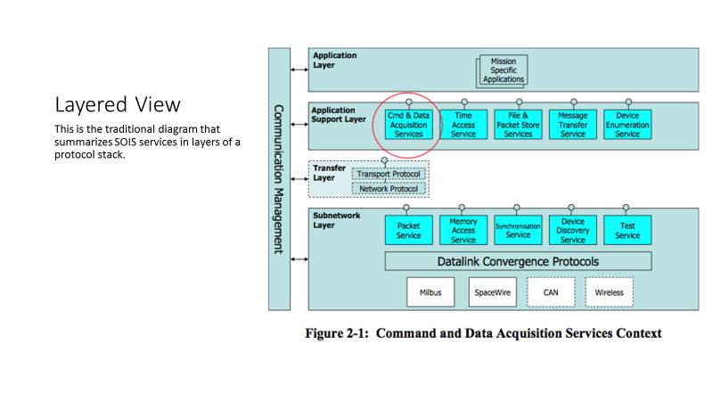
The diagram below presents one view of the aftermath of retirement. In place of the command and data acquisition service, a variety of application support architectures are possible, represented by a cloud in the diagram, in which the EDS defines the interfaces for devices presented to applications. The other functions of the Application Support layer persist, even after retirement.
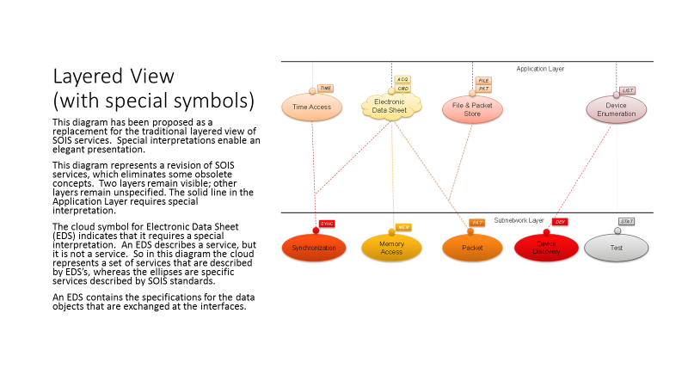

Relationship Between ASL and other CCSDS Architecture Documents
<< ASL uses underlying communications services and data exchange standard. This data transport architecture and security services are documented in the SCCS-ADD & ARD, and in the 80 other standards that they describe.>>

ASL Architecture: Assumptions, Goals, and Challenges
<< Biggest assumption is that these ASL services live on top of underlying CCSDS standard data transfer services (and terrestrial ones as needed). Other assumption, and challenge, is that the MOIMS service framework may be deployed in space as well as on the ground. >>
<<NIH, reinvention, tailoring; DoT could be widely applied and extended for other uses; acknowledging existing SW frameworks and the need to work with them>>

Application and Support Layer Reference Architecture

Introduction
<< Overview of the how the Reference Architecture is presented in the document, including use of an extended version of the RASDS representation – introduce structure of the remainder of the document>>

Six Views of System Architecture
<< Functions, Information, Services, Communications (protocols), Physical (nodes & types), and End-to-End (deployment)>> See comment proposing merging Physical and End-to-End views as a single Deployment view.

Graphical Conventions
<<Reference RASDS, provide a short summary of the graphical notation used in this document>>
<<Include RASDS extensions>>

Deployment Use Cases
<< Summarize the SCCS nodes and deployment cases (ABA and SSI) and explain how these relate to application layer MOIMS and SOIS interactions. Identify additional fundamental deployment patterns (in addition to ABA and SSI) to represent distributed networks on ground and on board>>
<< Consider alternative deployment use cases for MO services in the context of: ground only, space to ground, and within space. Also identifying which of these are current, and which future.>>
<< Consider how we are to handle constellations & formation flying, docking, and related subjects>>

Service Agreements and Access Arrangements
<< Discussion of the kinds of agreements and access management arrangements might be needed in multi-mission and multi-agency cross support and interoperability environments. >>

Transitional Strategies
<< Discussion of issues and strategies that might be employed in the transition from ABA to SSI style deployments and from MOS services only on the ground to MOS services in flight >>

Functional View

Overview
<< Functional view covers the groups of functions and brief descriptions of their behaviors. >>

MO functions (M&C, Nav, MP, DA, OpsPrep, Common)

SOIS functions (Time, File & Packet, Device Discovery & Enum, Data Acq)
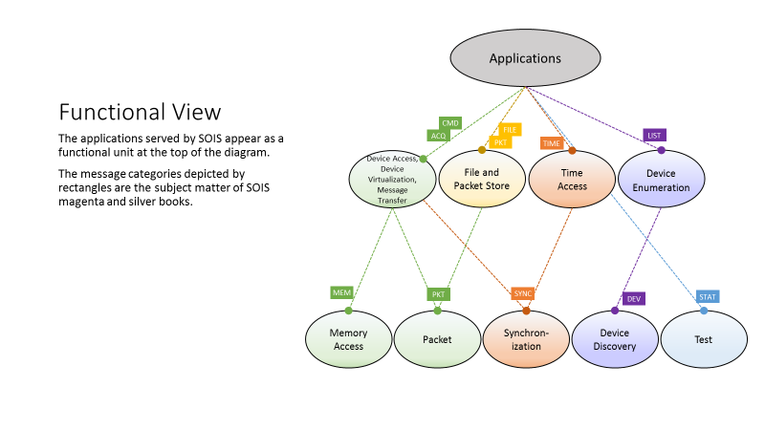

Integrated Flight/Ground Functions (future territory, ???)

Security Concepts for Functional View
<< Specific security functions, access control, encryption, authentication, key management. Anything still in the process of “becoming” gets marked [Future]. >>

Information View (Information Objects)

Overview
<< Information view covers the structure and contents (syntax & semantics) of the various information objects that are defined. Anything still in the process of “becoming” gets marked [Future]. >>

MO Information Views (Current Mo Materials, NAV, DAI (Incomplete))

SOIS Information Views (EDS, “containers”, DoT, naming & resolution, MIB)
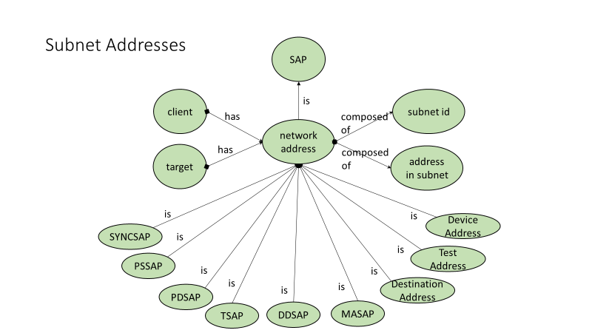
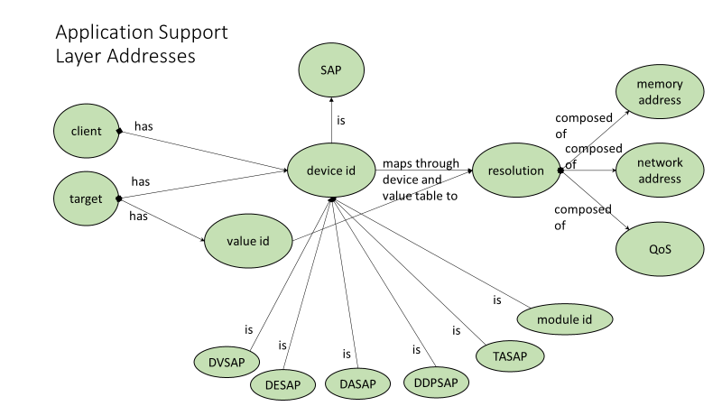
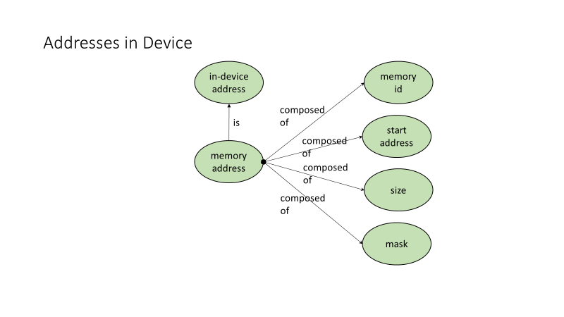
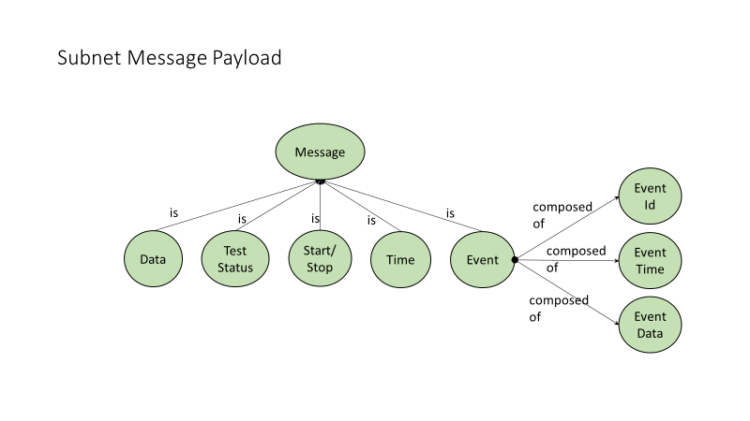
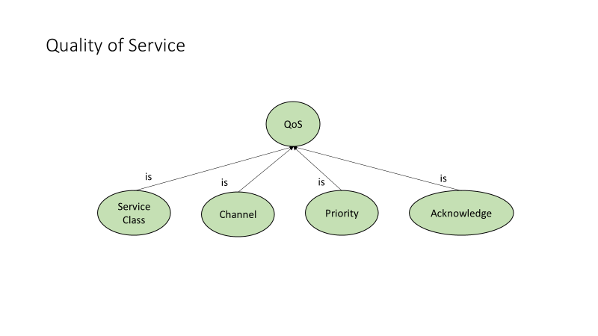
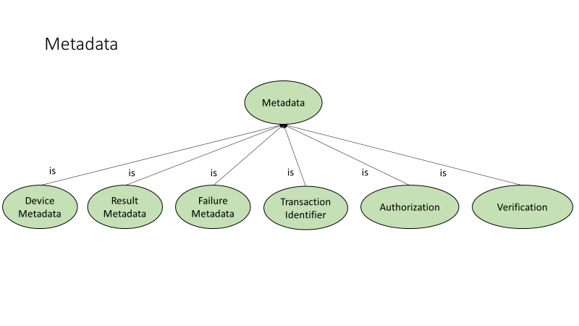

Security Concepts for Information View
<< Specific information / data security including for privacy purposes. Anything still in the process of “becoming” gets marked [Future]. >>

Service View

Overview
<< Service view covers the nature, interfaces, and behaviors of the various Service objects that are defined. Anything still in the process of “becoming” gets marked [Future]. >>

MO Services (current MO tables)

SOIS Services (current SOIS tables)
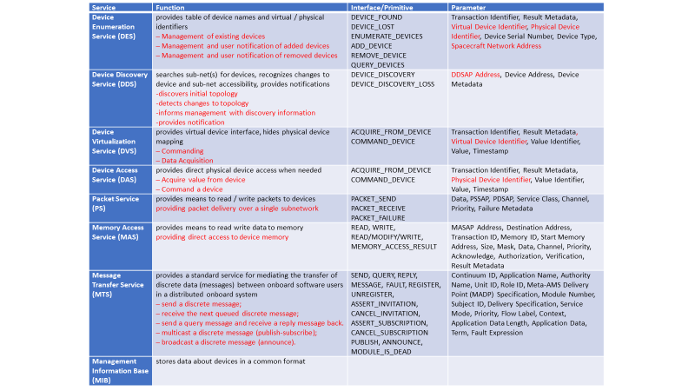
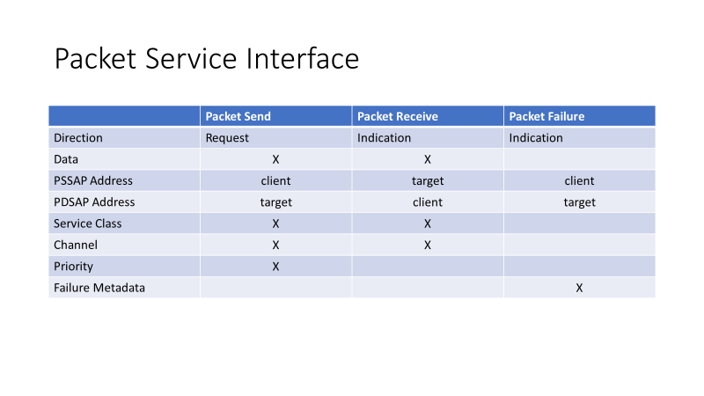
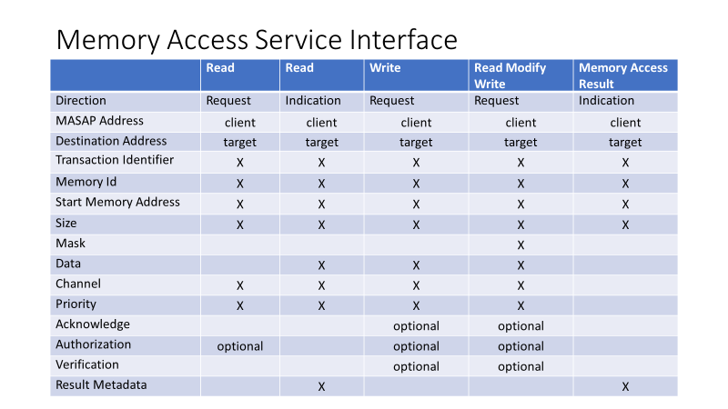
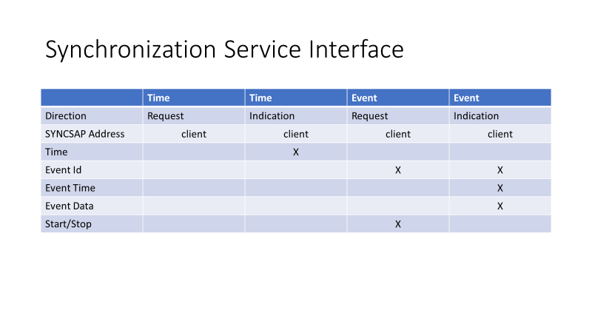
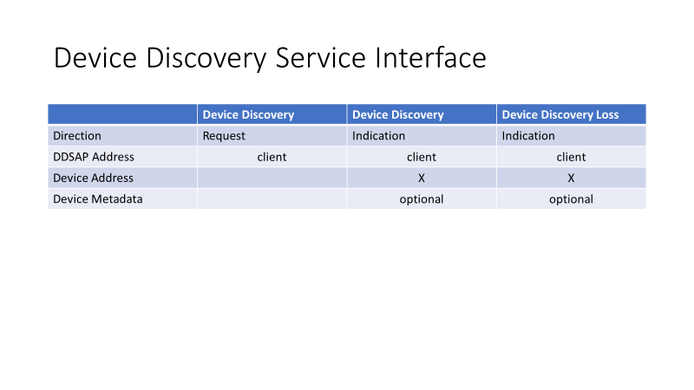
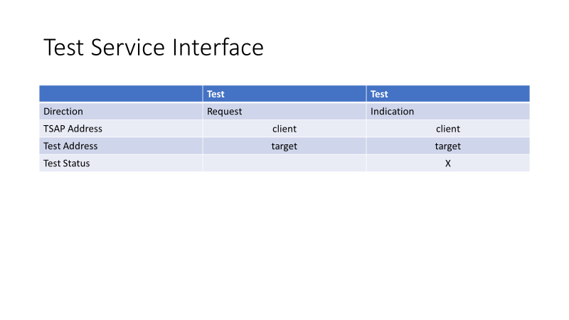
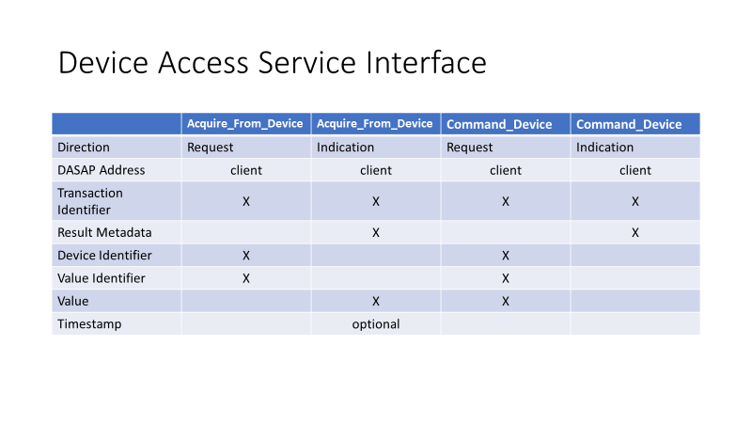

Integrated Flight/Ground Services (discussion)

Dependence of ASL Services on SCCS Architecture

Security Concepts for Service View
<< Secure service interfaces. Anything still in the process of “becoming” gets marked [Future]. >>

Communications View (Protocol stacks)

Overview
<< Communications view covers the protocol stacks that are defined. These will mostly, but not only, be associated with service interface bindings and should be thought of as “building blocks” for deploying services on nodes. Anything still in the process of “becoming” gets marked [Future]. >>

ISO Protocol Stack and Layer Definitions
<< Borrow from SCCS-ADD. >>

Specific Protocols for MO Service Interface Binding (MAL, lower level bindings (terrestrial & space), layered over SCCS & other links)

Space Link Context

Ground Context

On-board Context

Context Bridging
<< Will have to have two phases, MO only terrestrially and MO in space. Anything still in the process of “becoming” gets marked [Future]. >>

Specific Protocols for SOIS Service Interface Binding (sub-net, message bus, addressing & address mapping, WiFi (802.x or other))
<< Will need to address single S/C and also multi-S/C and Hab/EVA types of deployments. Anything still in the process of “becoming” gets marked [Future]. >>
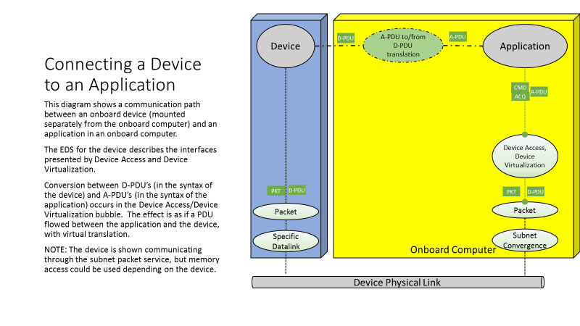
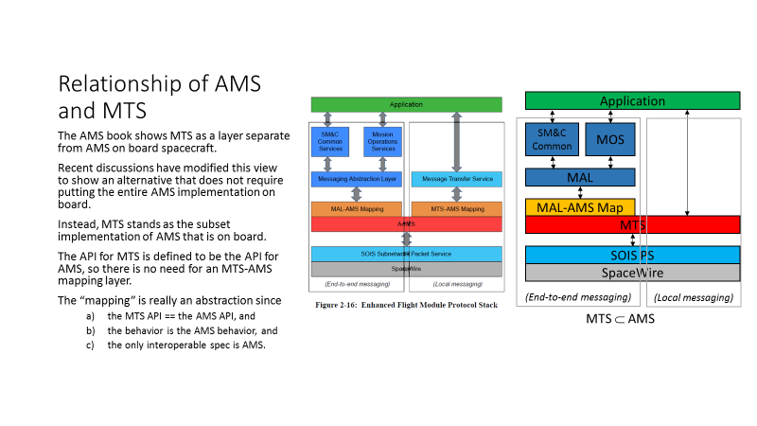

SOIS End-to-End Protocol Operation (set of subsections)
<< Will need to have two phases, ABA and SSI. Anything still in the process of “becoming” gets marked [Future]. >>
GAP

Remaining Challenges to Protocol Deployment
<<Multi-mission protocol interoperability for widely distributed heterogeneous systems>>

Security Concepts for Protocol View
<< Secure protocols, link and network layer encryption are handled in SCCS-ADD, application service layer encryption, & authentication. Key management protocols. Anything still in the process of “becoming” gets marked [Future]. >>

Physical (Connectivity) View (Representative component node / building blocks & connections among them)

Overview
<< Physical view covers the types of nodes that must be defined in addition to those SCCS nodes (ESLT & other). Much of this is likely to just be specialization of the User Nodes types (Space User Node & Earth User Node) from the SCCS ADD. Anything still in the process of “becoming” gets marked [Future].
Make it very plain that the deployment cases are just examples selected to illustrate cases where interfaces may be exposed to an interoperability boundary>>

MO Physical Elements (MOC, P/SOC, archive, User, current lexicon?)
<<Identify functions that may be distributed to PI, POC/SOC, MOC and Archive nodes – including Mission Planning, access to M&C data/services, Navigation data, etc.>>

SOIS Physical Elements (SOIS components, S/C of various kinds, orbital, relay, station, surface, formation, EVA participants, etc,)
GAP

Security Concepts for Physical View
<< Secure service sites (physical and logical). Anything still in the process of “becoming” gets marked [Future]. >>

End-To-End Deployment View (Representative end-to-end with multiple connected components & protocols)

Overview
<< End-to-end deployment views will just include a limited, but useful, set of examples. They cannot be exhaustive because there are un-countable numbers of possible deployments. The views will be end-to-end, possibly for interoperability and cross support, with a suitable set of nodes, protocol stacks, and application layer deployments. Anything still in the process of “becoming” gets marked [Future]. >>

MO End-to-End Deployment Views

SOIS End-to-End Deployment Views
GAP
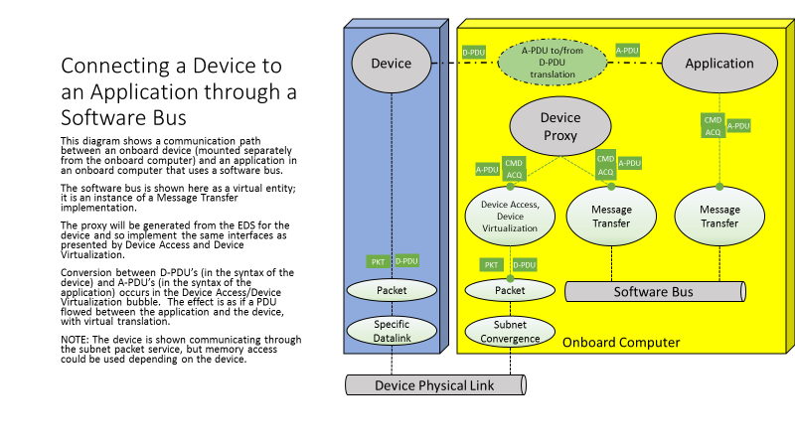
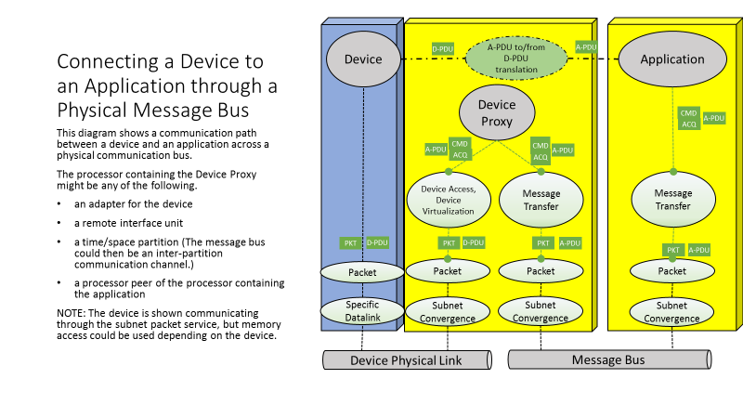
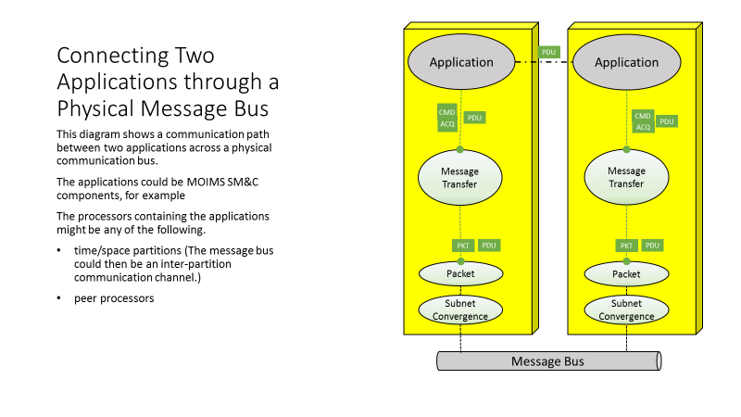

Security Concepts For End-to-End Protocol View
- ACRONYMS
- BACKGROUND

