

Draft Recommendation for  
Space Data System Practices

|  |
| --- |
| Spacecraft Onboard Interface Services—Specification for Dictionary of Terms for Electronic Data Sheets |

Proposed Draft Recommended Practice

AUTHORITY

|  |  |  |  |
| --- | --- | --- | --- |
|  |  |  |  |
|  | Issue: | , |  |
|  | Date: |  |  |
|  | Location: | Not Applicable |  |
|  |  |  |  |

**(WHEN THIS RECOMMENDED STANDARD IS FINALIZED, IT WILL CONTAIN THE FOLLOWING STATEMENT OF AUTHORITY:)**

This document has been approved for publication by the Management Council of the Consultative Committee for Space Data Systems (CCSDS) and represents the consensus technical agreement of the participating CCSDS Member Agencies. The procedure for review and authorization of CCSDS documents is detailed in *Organization and Processes for the Consultative Committee for Space Data Systems* (CCSDS A02.1-Y-4), and the record of Agency participation in the authorization of this document can be obtained from the CCSDS Secretariat at the e-mail address below.

This document is published and maintained by:

CCSDS Secretariat

National Aeronautics and Space Administration

Washington, DC, USA

E-mail: secretariat@mailman.ccsds.org

STATEMENT OF INTENT

**(WHEN THIS RECOMMENDED STANDARD IS FINALIZED, IT WILL CONTAIN THE FOLLOWING STATEMENT OF INTENT:)**

The Consultative Committee for Space Data Systems (CCSDS) is an organization officially established by the management of its members. The Committee meets periodically to address data systems problems that are common to all participants, and to formulate sound technical solutions to these problems. Inasmuch as participation in the CCSDS is completely voluntary, the results of Committee actions are termed **Recommendations** and are not in themselves considered binding on any Agency.

CCSDS Recommendations take two forms: **Recommended Standards** that are prescriptive and are the formal vehicles by which CCSDS Agencies create the standards that specify how elements of their space mission support infrastructure shall operate and interoperate with others; and **Recommended Practices** that are more descriptive in nature and are intended to provide general guidance about how to approach a particular problem associated with space mission support. This **Recommended Practice** is issued by, and represents the consensus of, the CCSDS members.  Endorsement of this **Recommended Practice** is entirely voluntary and does not imply a commitment by any Agency or organization to implement its recommendations in a prescriptive sense.

No later than five years from its date of issuance, this **Recommended Practice** will be reviewed by the CCSDS to determine whether it should: (1) remain in effect without change; (2) be changed to reflect the impact of new technologies, new requirements, or new directions; or (3) be retired or canceled.

In those instances, when a new version of a **Recommended Practice** is issued, existing CCSDS-related member standards and implementations are not negated or deemed to be non-CCSDS compatible. It is the responsibility of each member to determine when such Practices or implementations are to be modified. Each member is, however, strongly encouraged to direct planning for its new Practices and implementations towards the later version of the Recommended Practice.

FOREWORD

This document is a technical Recommended Practice for use in developing flight and ground systems for space missions and has been prepared by the Consultative Committee for Space Data Systems (CCSDS). The Dictionary of Terms described herein is intended for missions that are cross-supported between Agencies of the CCSDS, in the framework of the Spacecraft Onboard Interface Services (SOIS) CCSDS area.

This Recommended Practice specifies a dictionary of terms to be used as a vocabulary in electronic data sheets which describe components that communicate within a spacecraft network. The data sheets are for use by tool chains in the design, assembly, integration, testing, and operation of space missions. The SOIS Dictionary of Terms provides a common vocabulary regardless of the particular tool chain being used.

Through the process of normal evolution, it is expected that expansion, deletion, or modification of this document may occur. This Recommended Standard is therefore subject to CCSDS document management and change control procedures, which are defined in the *Organization and Processes for the Consultative Committee for Space Data Systems* (CCSDS A02.1-Y-4). Current versions of CCSDS documents are maintained at the CCSDS Web site:

http://www.ccsds.org/

Questions relating to the contents or status of this document should be sent to the CCSDS Secretariat at the e-mail address indicated on page i.

At time of publication, the active Member and Observer Agencies of the CCSDS were:

Member Agencies

* Agenzia Spaziale Italiana (ASI)/Italy.
* Canadian Space Agency (CSA)/Canada.
* Centre National d’Etudes Spatiales (CNES)/France.
* China National Space Administration (CNSA)/People’s Republic of China.
* Deutsches Zentrum für Luft- und Raumfahrt (DLR)/Germany.
* European Space Agency (ESA)/Europe.
* Federal Space Agency (FSA)/Russian Federation.
* Instituto Nacional de Pesquisas Espaciais (INPE)/Brazil.
* Japan Aerospace Exploration Agency (JAXA)/Japan.
* National Aeronautics and Space Administration (NASA)/USA.
* UK Space Agency/United Kingdom.

Observer Agencies

* Austrian Space Agency (ASA)/Austria.
* Belgian Federal Science Policy Office (BFSPO)/Belgium.
* Central Research Institute of Machine Building (TsNIIMash)/Russian Federation.
* China Satellite Launch and Tracking Control General, Beijing Institute of Tracking and Telecommunications Technology (CLTC/BITTT)/China.
* Chinese Academy of Sciences (CAS)/China.
* Chinese Academy of Space Technology (CAST)/China.
* Commonwealth Scientific and Industrial Research Organization (CSIRO)/Australia.
* Danish National Space Center (DNSC)/Denmark.
* Departamento de Ciência e Tecnologia Aeroespacial (DCTA)/Brazil.
* Electronics and Telecommunications Research Institute (ETRI)/Korea.
* European Organization for the Exploitation of Meteorological Satellites (EUMETSAT)/Europe.
* European Telecommunications Satellite Organization (EUTELSAT)/Europe.
* Geo-Informatics and Space Technology Development Agency (GISTDA)/Thailand.
* Hellenic National Space Committee (HNSC)/Greece.
* Indian Space Research Organization (ISRO)/India.
* Institute of Space Research (IKI)/Russian Federation.
* KFKI Research Institute for Particle & Nuclear Physics (KFKI)/Hungary.
* Korea Aerospace Research Institute (KARI)/Korea.
* Ministry of Communications (MOC)/Israel.
* National Institute of Information and Communications Technology (NICT)/Japan.
* National Oceanic and Atmospheric Administration (NOAA)/USA.
* National Space Agency of the Republic of Kazakhstan (NSARK)/Kazakhstan.
* National Space Organization (NSPO)/Chinese Taipei.
* Naval Center for Space Technology (NCST)/USA.
* Scientific and Technological Research Council of Turkey (TUBITAK)/Turkey.
* South African National Space Agency (SANSA)/Republic of South Africa.
* Space and Upper Atmosphere Research Commission (SUPARCO)/Pakistan.
* Swedish Space Corporation (SSC)/Sweden.
* Swiss Space Office (SSO)/Switzerland.
* United States Geological Survey (USGS)/USA.

PREFACE

This document is a draft CCSDS Recommended Practice. Its ‘Red Book’ status indicates that the CCSDS believes the document to be technically mature and has released it for formal review by appropriate technical organizations. As such, its technical contents are not stable, and several iterations of it may occur in response to comments received during the review process.

Implementers are cautioned **not** to fabricate any final equipment in accordance with this document’s technical content.

DOCUMENT CONTROL

|  |  |  |  |
| --- | --- | --- | --- |
| **Document** | **Title** | **Date** | **Status** |
|  | , , |  | Current proposed draft |
|  |  |  |  |
|  |  |  |  |

CONTENTS

1 introduction 1-1

1.1 Purpose and scope of this Document 1-1

1.2 Applicability 1-1

1.3 Rationale 1-1

1.4 Document Structure 1-1

1.5 Terms defined in this Recommended Practice 1-2

1.6 NOMENCLATURE 1-4

1.7 References 1-5

2 OvervieW 2-1

2.1 The Subject Matter of Electronic Data Sheets 2-2

2.2 Purpose and Function of SOIS Electronic Data SheetS 2-5

2.3 How The Dictionary of Terms Relates to Electronic Data Sheets 2-5

2.4 Use of Pre-Existing Standards 2-7

2.5 Principles of the Dictionary of Terms 2-7

2.6 Metadata 2-13

2.7 Maintaining the Dictionary of Terms 2-15

3 Basic Structure of the Dictionary of Terms 3-1

3.1 Overview 3-1

3.2 Access 3-1

3.3 BASIC Concepts 3-2

3.4 Model of Production 3-3

3.5 Semantic Attributes 3-4

3.6 User-Defined Ontologies 3-9

ANNEX A Dictionary of Terms for Electronic Data Sheets Implementation Conformance Statement Proforma (Normative) A-1

ANNEX B Security, SANA, and Patent CONSIDERATIONS (Informative or Normative as noted) B-1

ANNEX C Abbreviations (informative) C-2

ANNEX D Informative References (informative) D-1

ANNEX E Example DoT/XML Ontology Instantiations (Informative) E-1

Figure

Figure 2‑1 Major Concepts of this Book, and their Relationships 2-1

Figure 2‑2 SEDSs Describe Data Interfaces in a Spacecraft 2-2

Figure 2‑3: Command and Data Acquisition Services Context 2-3

Figure 2‑4 How the DoT Provisions the SEDS Schema 2-6

Figure 2‑5 References to a Model of Operation 2-11

Figure 2‑6 Defining a Discrete Variable Type 2-13

# introduction

## Purpose and scope of this Document

This document is one of a family of documents specifying the Spacecraft Onboard Interface Services (SOIS)-compliant service to be provided in support of applications.

This document defines the SOIS Specification for Dictionary of Terms (DoT) for Electronic Data Sheets (SOIS EDS) for Onboard Components. The SOIS DoT provides the vocabulary for electronically defining the interfaces offered by flight components such as sensors, actuators, and software components. This document describes the basic format of the vocabulary, while a publication on SANA contains the actual normative details of the vocabulary.

This edition describes the basic structure of vocabulary for representation of the data interfaces including functional interfaces and protocols used to access the data interfaces. This edition also describes how to continue to gather vocabulary from subject matter experts for publication through SANA.

## Applicability

This document applies to any mission or equipment claiming to provide CCSDS SOIS-compatible EDS for Onboard Components. The terms in the SANA publication have been collected from subject matter experts, representing engineering knowledge that applies not only in SOIS but also in other architectures of space data systems.

## Rationale

SOIS provides a DoT specification in order to enable toolchain compatibility and optional portability of components amongst systems implementing interfaces defined by SOIS EDS.

## Document Structure

This document has the following major sections:

* Section 1, this section, contains administrative information, definitions and references.
* Section 2 provides an overview of the Dictionary of Terms for Electronic Data Sheets. It also provides a summary of ontology and the justification for a model-based dictionary of terms.
* Section 3 provides a normative description of the structure of the ontology, and maintenance procedures.

In addition, the following annexes are provided:

* Annex A comprises an Implementation Conformance Statement (ICS) Proforma.
* Annex B discussing security, Space Assigned Numbers Authority (SANA), and patent considerations relating to the specifications of this document.
* Annex C contains a list of acronyms.
* Annex D contains a list of informative references.
* Annex E provides for illustrative purposes one or more example fragments of SOIS EDSs.

## Terms defined in this Recommended Practice

For the purposes of this Recommended Practice, the following definitions apply:

**actuator:** A part of a device that transfers action from an application to the physical world. See “transducer”.

**application**: An algorithm that applies SOIS services to accomplish the goals of a mission.

**component**: A logical element of a system accessed through defined interfaces. May be purely conceptual or realized in software or hardware (e.g., as a field-programmable gate array).

**coordinate system**: A frame for measurement of physical quantities, which may have one or more dimensions.

**device**:A physical element of a system accessed through subnetwork-layer interfaces. [D1]

**dictionary of terms, DoT**: Ontology of terms used to describe data in interfaces in Electronic Data Sheets. [D1]

**Electronic Data Sheet, EDS**: Electronic description of some details of a device, software component or standard. Unless qualified with the acronym “SOIS”, this term is general, referring to any machine-readable data sheet. See “SOIS Electronic Data Sheet, SEDS”.

**engineering profile**: A collection of attributes used to define the meaning of an item of data used in operations and parameters. [D1]

**glossary**: A collection of terms with brief informal explanations of their usage in a particular document.

**model of operation**: A representation of the parts of a device and their relations, and optionally objects outside the device, any of which can be referenced by semantic attributes in a SEDS. See section 2.5.2.

**ontology**: A collection of descriptions of entities, named by terms, and relationships among those entities (see 2.5). The information in a glossary is a subset of the information in an ontology.

**path expression**: A string used in referential semantics to identify a part in a model of operation. The string is delimited by ‘.’, and consists of alternating names of object relations and names of classes or individuals in the model of operations. The concept is similar to an XPath expression, but the graph to be traversed is not xml document syntax; the graph is the graph of relations among classes in the ontology. See section 2.5.2.2 for examples.

**portability**: The capability of a component to be integrated into an assembly without change either to the component or to the assembly interfaces. Portability requires that the definitions of interfaces be consistent across all systems to which they may be ported. Consistency requires that the terms used to define an interface are defined in the DoT. (See ‘toolchain compatibility’.)

**referential class:** A class in the DoT ontology which represents a part of a model of operation, for reference in describing an item of data in an interface.

**SANA DoT**: The normative DoT published in the SANA web site.

**semantic attribute**: A property of an engineering profile, such as reference frame or unit of measure.

**sensor**: A part of a device that transfers data from the physical world to an application. See “transducer”.

**SOIS Electronic Data Sheet, SEDS**: Electronic description of a device’s metadata, device-specific functional and access interfaces, device-specific access protocol, and, optionally, device abstraction control procedure [D1], compliant with SOIS standards. See EDS.

**standard engineering profile**: A collection of attributes used to define the meaning of an item of data used in SEDS interfaces, defined in the DoT and published in the form of a SEDS instance through SANA. [D1]

**syntactic type**: A type of data that is defined by attributes for encoding the data for storage (transmission through time) or communication (transmission through space). An example of an attribute for a syntactic type is the choice of interpretation of bits as an integer or as a floating point number. [D1]

**term**: A word or phrase that has a formally defined interpretation in a particular context of usage. The terms in the SOIS dictionary of terms are defined in the context of describing spacecraft components in Electronic Data Sheets.

**toolchain compatibility**: The capability of a component to be integrated into an assembly using an automated process that can generate any needed interface transformation. Some of the terms used to define the interface are not yet defined in the DoT, but are defined within the toolchain of a project. (See ‘portability’.)

**transducer**: A measurement probe in a sensor; the active part of an actuator. A transducer is the part of a device that has a coordinate system for measurement or for action.

**type**: A conceptual class that is defined in an EDS as a class. The instances of a type share some properties that define the type. The properties are defined in the dictionary of terms.

**user-defined DoT**: An extension to the SANA DoT used within a project for toolchain compatibility.

**value**: A formatted instance of data that is acquired from or used as a command to a component.

**vocabulary**: A collection of terms used as common knowledge in some context. In this document, a vocabulary is the same as an ontology. (See 2.5).

## NOMENCLATURE

### Normative Text

The following conventions apply for the normative specifications in this Recommended Standard:

1. the words ‘shall’ and ‘must’ imply a binding and verifiable specification;
2. the word ‘should’ implies an optional, but desirable, specification;
3. the word ‘may’ implies an optional specification;
4. the words ‘is’, ‘are’, and ‘will’ imply statements of fact.

NOTE – These conventions do not imply constraints on diction in text that is clearly informative in nature.

### Informative Text

In the normative sections of this document, informative text is set off from the normative specifications either in notes or under one of the following subsection headings:

* Overview;
* Background;
* Rationale;
* Discussion;
* Note;
* Example.

## References

The following publications contain provisions which, through reference in this text, constitute provisions of this document. At the time of publication, the editions indicated were valid. All publications are subject to revision, and users of this document are encouraged to investigate the possibility of applying the most recent editions of the publications indicated below. The CCSDS Secretariat maintains a register of currently valid CCSDS publications.

1. *Spacecraft Onboard Interface Services—XML Specification for Electronic Data Sheets*. Issue 0. Proposed Draft Recommendation for Space Data System Standards (Proposed Red Book), CCSDS 876.0-R-0. Washington, D.C.: CCSDS, March 2015.
2. Tim Bray, et al., eds. “Extensible Markup Language (XML) 1.0.” W3C Recommendation. 5th ed., 26 November 2008. <http://www.w3.org/TR/2008/REC-xml-20081126/>.
3. Shudi (Sandy) Gao, C. M. Sperberg-McQueen, and Henry S. Thompson, eds. “W3C XML Schema Definition Language (XSD) 1.1 Part 1: Structures.” W3C Recommendation. Version 1.1, 5 April 2012. <http://www.w3.org/TR/xmlschema11-1/>.
4. David Peterson, et al., eds. “W3C XML Schema Definition Language (XSD) 1.1 Part 2: Datatypes.” W3C Recommendation. Version 1.1, 5 April 2012. <http://www.w3.org/TR/xmlschema11-2/>.
5. Jonathan Marsh, David Orchard, and Daniel Veillard, eds. “XML Inclusions (XInclude) Version 1.0.” W3C Recommendation. 2nd ed., 15 November 2006. <http://www.w3.org/TR/xinclude/>.
6. W3C OWL Working Group, ed. “OWL 2 Web Ontology Language Document Overview.” W3C Recommendation. 2nd ed., 11 December 2012. <http://www.w3.org/TR/xinclude/>.
7. “Dublin Core Annotation Properties.” <http://protege.stanford.edu/plugins/owl/dc/protege-dc.owl>.
8. *Spacecraft Onboard Interface Services—Device Access Service*. Issue 1. Recommendation for Space Data System Practices (Magenta Book), CCSDS 871.0-M-1. Washington, D.C.: CCSDS, March 2013.
9. *Spacecraft Onboard Interface Services—Device Data Pooling Service*. Issue 1. Recommendation for Space Data System Practices (Magenta Book), CCSDS 871.1-M-1. Washington, D.C.: CCSDS, November 2012.
10. *Spacecraft Onboard Interface Services—Device Virtualization Service*. Issue 1. Recommendation for Space Data System Practices (Magenta Book), CCSDS 871.2-M-1. Washington, D.C.: CCSDS, March 2014.
11. *Spacecraft Onboard Interface Services—Subnetwork Packet Service*. Issue 1. Recommendation for Space Data System Practices (Magenta Book), CCSDS 851.0-M-1. Washington, D.C.: CCSDS, December 2009.
12. *Spacecraft Onboard Interface Services—Subnetwork Memory Access Service*. Issue 1. Recommendation for Space Data System Practices (Magenta Book), CCSDS 852.0-M-1. Washington, D.C.: CCSDS, December 2009.
13. *Spacecraft Onboard Interface Services—Subnetwork Synchronisation Service*. Issue 1. Recommendation for Space Data System Practices (Magenta Book), CCSDS 853.0-M-1. Washington, D.C.: CCSDS, December 2009.
14. *Spacecraft Onboard Interface Services—Subnetwork Device Discovery Service*. Issue 1. Recommendation for Space Data System Practices (Magenta Book), CCSDS 854.0-M-1. Washington, D.C.: CCSDS, December 2009.
15. *Spacecraft Onboard Interface Services—Subnetwork Test Service*. Issue 1. Recommendation for Space Data System Practices (Magenta Book), CCSDS 855.0-M-1. Washington, D.C.: CCSDS, December 2009.
16. *Space Assigned Numbers Authority*. SANA. [www.sanaregistry.org](http://www.sanaregistry.org)
17. *Quantities, Units, Dimensions, Values (QUDV) Ontology*. Object Management Group. <http://www.omgwiki.org/OMGSysML/doku.php?id=sysml-qudv:quantities_units_dimensions_values_qudv>
18. *Organization and Processes for the Consultative Committee for Space Data Systems (Yellow Book), CCSDS A02.*1-Y-4. Washington DC, USA, 2013.

NOTE – Informative references are contained in annex D.

# OvervieW

The SOIS Dictionary of Terms (DoT) provides definitions of terms that are used in SOIS Electronic Data Sheets (SEDSs). This section is a brief overview of the relationship between DoT and SEDS, arranged in the following topics. The first two topics are about SEDSs; they appear in this document because the subject and usage of SEDSs is also the subject matter of the DoT.

* The subject matter of SEDSs
* Using and storing SEDSs
* The mechanism that associates DoT content with SEDS content
* Pre-existing standards applied in this document
* The content and storage of the DoT

Figure 2‑1 is a map of the major concepts of this document, and the relationships among them. The topics this document focuses on are high-lighted in blue.

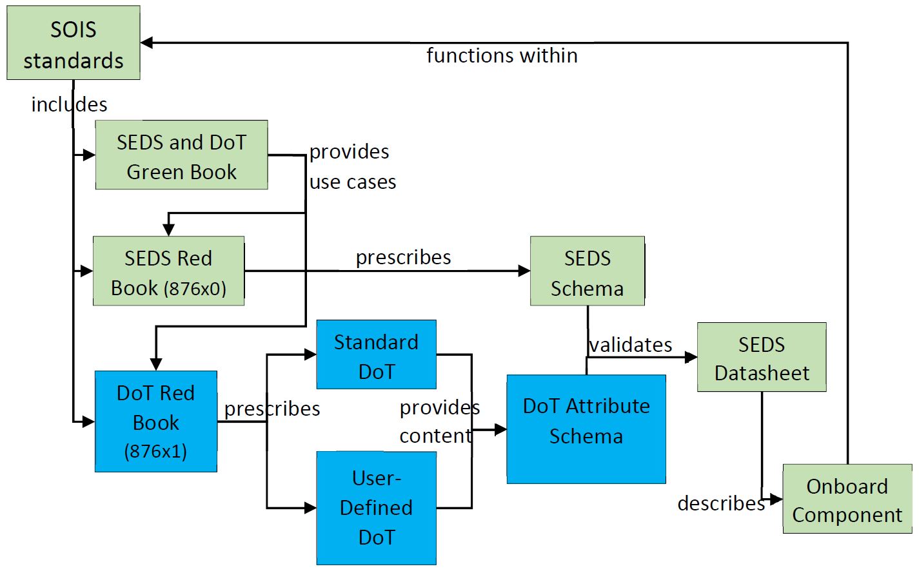

Figure ‑ Major Concepts of this Book, and their Relationships

A SOIS Electronic Data Sheet (SEDS) specifies access to an onboard device or software component using SOIS standards. The XML schema used to validate such a datasheet is defined in two parts:

* The SEDS Schema is fixed, and described in [1].
* The DoT Attribute schema is extensible, and comes from combining the standard, and optionally, a user-defined Dictionary of Terms (DoT), as described in this document.

## The Subject Matter of Electronic Data Sheets

The SOIS Electronic Datasheets (SEDS) are defined within the context of the overall SOIS architecture (see reference [D1]). This section is a series of diagrams beginning at the scope of a spacecraft, and descending in scope to the software layers within the SOIS protocol stack.

Figure 2‑2 shows how SEDSs describe data interfaces at various points in a spacecraft data system. Devices appear on the left side, with increasing degrees of aggregation of data interfaces in moving to the right side of the diagram. A more complete description of this diagram appears in the SEDS and DoT Green Book [D3]. The red circle encloses the scope of the next figure in this series.



Figure ‑ SEDSs Describe Data Interfaces in a Spacecraft

In Figure 2‑2, there are a number of abbreviations, which are explained in this paragraph.

* RIU – Remote Interface Unit
* SubPS and SubMAS – refer to subnetwork packet service and memory access service.
* OBC – on-board computer
* SpW – SpaceWire
* SW – Software
* TM/TC – telemetry/telecommands
* DVS, DAS, MTS – SOIS device virtualization service, device access service, and message transfer service.

A SEDS describes the format of information in a data interface for an onboard device accessed using the Packet, Memory Access, and Synchronisation Services of the Subnetwork Layer, as illustrated in Figure 2‑3.



Figure 2‑3 : Command and Data Acquisition Services Context

The Subnetwork Layer provides standard services mapped onto subnetwork-specific protocols to send and receive discrete packets [11], to access remote memory [12], to synchronise [13] with the subnetwork, and to discover [14] and test [15] devices on the subnetwork.

Some portions of the application layer corresponding to a device are sufficiently universally fixed to be usefully specified as an application-level service, i.e.:

* Clocks may support the Time Access Service.
* Mass Memory Devices may support the File and Packet Store Services
* Dynamically reconfigurable devices may support the Device Enumeration Service.

The remainder is specified by the SOIS Electronic Datasheet for that device. This captures all device-specific aspects, including those specified at some other level of commonality (i.e. agency, company, product line, etc.).

The interfaces defined in a datasheet may then be used in the implementation of other SOIS application services such as the DAS and DVS (see reference [D1]).

A full Electronic Data Sheet for a device specifies the following information, using terms in the DoT:

* the Device-Specific Functional Interface (DSFI) to the device;
* the Device-Specific Access Interface (DSAI) to the device
* the Device Abstraction Control Procedure (DACP) which maps the virtual device interface onto the physical interface;
* the Device-specific Access Protocol (DSAP) which maps the physical device interface onto the SOIS subnetwork services appropriate for the device;
* information specifying the use of the subnetwork by the device and any constraints placed on the subnetwork;
* ancillary information, i.e. the device metadata.

As a part of the rationale for the implementation of the DoT, the following features may be included in Electronic Data Sheets in the future:

* structural mounting interface;
* geometric properties, including device coordinate system and locations and orientations of fixed transducers on the device;
* mass properties, including moments of inertia and rotational momentum storage capacity, related to device coordinates;
* electrical power interface, including manufacturer-recommended operating extremes, and any applicable storage and generation characteristics;
* thermal interface, including manufacturer-recommended operating and storage extremes and any applicable storage and generation characteristics;
* radiation aspect, including manufacturer-recommended tolerances and generation characteristics;
* other information, to be determined, that must be transferred through traditional user manuals, specifications, and data sheets which accompany a device and are necessary to determine the operation of the device.

## Purpose and Function of SOIS Electronic Data SheetS

When a manufacturer produces a component, they can provide information about the usage of the component in form of a SEDS. By using a structured document, which is accessible to algorithms, a manufacturer enables the integration of their product into a space system using a tool chain that assures successful usage of the device.

An Electronic Data Sheet is intended to be a machine-interpretable mechanism for describing devices which may be accessed using the SOIS Command and Data Acquisition Services and Message Transfer Service. The SOIS Electronic Data Sheet is intended, in its fullest form, to replace the traditional user manuals, specifications, and data sheets which accompany a device and are necessary to determine the operation of the device and how to communicate with it. The function of Electronic Data Sheets is described in reference [1]. The dictionary of terms provides the formal vocabulary for Electronic Data Sheets, enabling the functions listed below. The indexes and other functions mentioned in the list are not specified by this document; rather, they are phenomena that are expected to develop as engineers and entrepreneurs write software to exploit the machine-readable information that will be available in SEDSs. Prior to SEDS technology, information about quantities, units, dimensions, values, and provenance and usage of data was informal and therefore inaccessible for these functions. A more complete discussion of these use cases appears in the SEDS and DoT Green Book [D3].

Use Cases for DoT

* assuring that two different SEDSs do not use the same term with different meanings;
* enabling a market index to components based on their interfaces;
* enabling an index to components in a vehicle, based on their interfaces;
* enabling an index to data in the spacecraft database;
* enabling lookup of topics published and subscribed on a software bus;
* enabling matching of interfaces of two components during design or during adaptive reconfiguration, so the two components can interact through the mutual interface: one component acts as a provider of data and services through the interface, while the other component acts as a consumer of data and services through the interface;
* enabling matching of interfaces of a device with interfaces of simulation models, to configure and to validate testing and simulation software;
* providing a glossary for human-readable documentation generated from SEDSs;

## How The Dictionary of Terms Relates to Electronic Data Sheets

A schema determines the syntax of SEDSs, which are xml files. The schema is described in the companion volume, SOIS XML Specification for EDSs [1]. A SEDS describes the syntax of data that passes across the data interfaces of a component. The DoT provides additional terms, that go beyond syntax to describe the suitability of data items for usage in applications. Because these terms are “beyond syntax”, they are referred to as “semantic” attributes of data. This section describes how the DoT provisions the SEDS schema with semantic terms.

One may ask why the DoT does not provide syntactic terms to the SEDS schema. There is no fundamental reason why it could not provide this service also. In fact, the extensibility of the DoT provisioning mechanism could also serve as a mechanism for adapting to new syntax. The practical reason for this idiosyncrasy in the mechanism is to prevent user-defined ontologies from altering the syntax of SEDS instances.

This recommended practice is not the SANA DoT; rather, the SANA DoT is the ontology published as described in Annex B. This recommended practice specifies the basic structure, usage, and maintenance of the SANA DoT. The SANA DoT is a normative specification of terms to be used in SEDS instances.

The SANA DoT stores information in an ontological syntax that facilitates management of terminology. That information is extracted in the form of an xml schema fragment, which is then included by the SEDS schema. The schema fragment defines semantic attributes that can be applied to items of data, as described in this document. See Figure 2‑4.

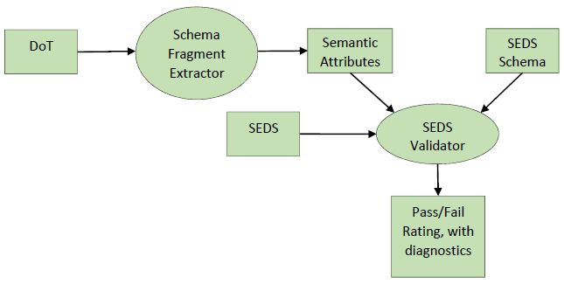

Figure ‑ How the DoT Provisions the SEDS Schema

In order to be able to relate the elements of the data sheet to physical (and non-physical) concepts, and to promote standardisation and interoperability, the SANA DoT provides core ontology for data sheet authors and users. These semantic terms effectively form part of the language that is used to write SOIS Electronic Data Sheets.

The SEDS schema supports the use of semantic attributes to describe the following elements of an electronic data sheet:

* Interfaces
* Commands
* Parameters
* Components
* Metadata
* Enumeration Members

Where the semantics provided by the SANA DoT are insufficient, a data sheet author may utilise an additional user-defined DoT which must then be supplied with the data sheet itself. This provides a standard, flexible, and extensible mechanism for capturing the semantics of component operation in a machine-interpretable form. The extension ontologies will later be integrated into the SANA DoT with mappings for synonyms, perhaps as an alternative name space with comments and formal relationships to explain the relation of the new namespace to existing namespaces. The use of an extension ontology reduces the portability of a SEDS, so it is toolchain compatible in the project where the extension ontology was developed; to become truly portable outside the original project, it is necessary to assimilate the extension ontology into the SANA ontology, and to adapt the SEDS to use the terms of the new SANA ontology.

The DoT can provide a powerful mechanism for future extensions of the SEDS, in cases where the extension can be obtained by adding terms to structure that is already present in the SEDS schema.

## Use of Pre-Existing Standards

The specification and use of SOIS Electronic Data Sheets makes use of a number of World-Wide Web Consortium (W3C) standards:

* XML—The Extensible Markup Language (reference [2]) is used to mark up data sheet documents in a machine-readable manner.
* XSD—The XML Schema Definition language (references [3] and [4]) is used to specify valid construction rules for data sheet documents. Version 1.1 of the XSD recommendation is used.
* OWL/RDF—In some cases a data sheet author may wish to specify a user-defined dictionary of terms. This may be accomplished by accompanying the data sheet document with a dictionary of terms document specified according to the Web Ontology Language and using the syntax of the Resource Description Framework [6].

## Principles of the Dictionary of Terms

The DoT relies upon conceptual models to define terms. It is noted, in this context, that a collection of descriptions of entities named by terms and their relationships defines an ontology. This section describes major models used in the DoT. One is language in which the DoT is encoded. Another is a set of models of the components described by SEDS instances, and the contexts in which those components operate. Yet another represents the interpretation of a discrete variable.

The structure chosen here is somewhat arbitrary, but the consistency defined in this document enables successful interpretation by people and by algorithms.

### The Representation of the DoT

The DoT is a model-based vocabulary. This idea is a variation on the idea of model-based engineering, in which a central data model stores knowledge and peripheral software tools render and exploit that knowledge in engineering documents.

The model selected for the DoT is an ontological description language known as Web Ontology Language, or OWL. Tools for working with this language are available without monetary cost to the user, and commercial tools are also available. These tools provide graphical user interfaces for writing, interpreting, and validating associations between terms. As a bonus, it is also possible to invoke a reasoning program to infer additional relations among terms, given the relations that are present. The description logic sublanguage of OWL has adequate expressive capabilities for the use cases considered. OWL is a W3C standard, and it has a community of hundreds of thousands of users.

A SEDS accompanies the component that it describes; however, the DoT exists in a centrally accessible location [16] where it can be used by tool chain software to interpret SEDSs.

In a model-based vocabulary, the model is the single source of information that is distributed through the medium of a variety of artefacts into a toolchain. Among those artefacts are a glossary of terms for humans to read and a schema of terms to be included in the SEDS schema. The latter was described in section 2.3. The glossary is discussed below. Some tool-chain elements may use the DoT directly, such as a hypothetical design-checking tool that checks the match between interfaces provided and required by components to assure that each data item is being used appropriately. Another useful feature of a model-based DoT is the capability to generate more than one form of schema fragment. We have already seen that there is a schema fragment that is appropriate for use by the SOIS EDS schema. There may be a need for similar fragments to be used in other descriptive tools, such as XTCE. By using the same terminology model for both schemas, the usage of terms will be consistent across both spacecraft and ground systems.

The glossary for humans facilitates correct usage of the terms when authoring SEDSs. It works in much the same way as do “intellisense” features of modern interactive development environments. In fact, the schema fragment can be applied by some xml editors to serve as an intellisense delivery artefact, with a purpose equivalent to that of the glossary.

The following example is important for appreciation of the ability to specify quantity kinds. A person may at first think that specifying the unit of measure is sufficient to identify the physical property in a measurement. However, the units of measure for torque and energy are the same, when reduced to base units. There is an informal reliance upon convention in the use of derived units to disambiguate situations like this example; for example, torque is often expressed as newton-meters, while energy is often expressed as Joules. The fact that torque is a vector is not always explicit when the axis is obvious. These conventions may be widespread, but they are fundamentally unreliable, because they are *de facto* conventions that may not be accessible to algorithmic interpretation of Electronic Data Sheets. To be clear, the quantity kind property provides an explicit disambiguation, which is defined in the ontology.

A specification of a required interface can be viewed during design of a spacecraft as a search argument for a component that provides a compatible interface. Software components may have required interfaces that are no more specific than quantity kind of data, so they can be matched with (and adapt to) interfaces with a variety of units of measure.

The following example will explain the relation between the model and the terms. The semantic attributes of items of data in an interface can be misused. For example, a SEDS author might specify that a given item of data has quantity kind ‘length’ and unit of measure ‘arc-second’. The mistake here is that only certain units of measure are possible for a given quantity kind. The author is going to have to change the quantity kind to ‘angle’, or to choose a unit of measure that measures length, such as ‘meter’. The model for the terms contains this kind of information, so it can be enforced at some point in the validation of SEDSs. In this example, the model would contain an association between quantity kinds and their meaningful units of measure.

A traditional dictionary is a list of terms, and each term has an explanation. In order to put the association in the examples into a traditional dictionary, a person could use one or the other of the following techniques:

* Place the association into the explanation of each term that needs it, using the natural language of the explanation.
* Extend the normal dictionary structure with a table of associations between specific classes of terms, such as units of measure and quantity kinds.

The first approach is inefficient for two reasons. It requires an algorithm to interpret natural language in order to make the information accessible for use in a validation program. It doubles the number of statements of the association, because it is necessary to state the association in both the unit terms and in the quantity kind terms.

The second approach is a little better, because it removes the doubling problem. Also, the table of associations can be interpreted algorithmically. However, it is necessary to invent a new table for every association.

An ontology is an algorithmic implementation of the new information served by the extended dictionary models described above. The ontology implementation uses a data model in computer memory and software to render and to exploit the information, in the style of model-based engineering as described at the beginning of this section.

### Models of operation

The purpose of a model of operation is to identify the objects whose properties are represented by data items in interfaces described in an Electronic Data Sheet. References to a model of operation link the information view in a SEDS instance to other viewpoints in a larger architectural design of the component described by the SEDS.

#### Standard Models of Operation

A model of operation is a description of the parts of a component and the context in which the component operates. A model of operation may be expressed in a data modelling language, such as MOF or SysML, and then extracted into a set of OWL classes and relations. A standard model of operation is one that appears in the DoT ontology. The DoT model of operation contains an individual in the ModelOfOperation class, called the anchor. The anchor has object relations to individuals in other classes that form a graph. A semantic attribute that corresponds to a referential class has for its value a string that describes a path through the graph starting from the name of the anchor and traversing relations by name to a set of target individuals. The meaning of the attribute is a relationship between the SEDS object in which the attribute appears and target individuals in the model of operation.

For example, the dictionary of terms may define a referential class named ‘subject’. The description of the class could say that a parameter in a SEDS that has the ‘subject’ attribute is a property of the target individuals in the model of operation.

More specifically, and continuing the ‘subject’ example above, an imaging device may carry some thermistors to measure temperature at different points in the instrument. The focal plane is often a point of interest. There could be an electronics package attached to the imager for processing the images, and the temperature of that package could be of interest. In order to recognize which thermistor measures the temperature of which part of the imager, it is necessary to define a model of the parts of the imager, and then it is necessary to attach a semantic attribute to the measurement from each thermistor that refers to the model part where the thermistor is located.

For an example of context in a model of operation, a device that tracks signals from ships at sea would have a model of operation that contains the device, the vehicle, the Earth, and the ships at sea. This model of operation would likely be defined in a user-defined ontology (3.6) during its development.

#### User Provided Models of Operation

Authors of Electronic Data Sheets may write a user-defined ontology that adds individuals to the ‘ModelOfOperation’ class, plus related classes for reference by attributes in the SEDS.

Making each SEDS a model of operation enables the semantic properties of one parameter to refer to another parameter. For example, a measure of variance could refer to a separate parameter that contains the most recent measurement in the distribution.

Standard models of operation cannot efficiently represent the variety of details that may occur in a specific instrument. To address this difficulty, the parts of a standard model of operation, which are classes, can be interpreted as a skeletal model. Individuals in the classes of a standard model of operation can be defined in an Electronic Data Sheet, and can be related to those classes by a referential attribute, ‘memberOf’. This convention allows SEDSs to define a variety of operating models without needing a user-defined ontology, which would diminish their portability. See Figure 2‑5.

Continuing the example of an imaging device above, the SEDS could describe part of the model of operation of a particular instrument by means of an element that represents the focal plane, containing the attributes <… name="focalPlane" memberOf="imager.hasA.focalPlane" …>, where the imager.hasA.focalPlane is a path through a standard model of operation of an imager in the SANA ontology.

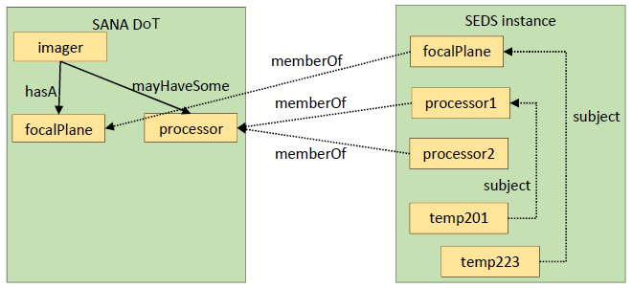

Figure ‑ References to a Model of Operation

The example of the imaging device now contains a focal plane and two processors. Suppose that the housekeeping data reported by the device contains measurements of temperature of those parts. It is possible to describe explicitly which measurement applies to which part. The SEDS could also contain two elements, one with attributes <… name="processor1" memberOf="imager.mayHaveSome.processor" …>, and the other with attributes <… name="processor2" memberOf="imager.mayHaveSome.processor" …>. In a description of a housekeeping interface in the SEDS, one parameter that is a measure of temperature could have the attributes <… subject="focalPlane" quantityKind=”Temperature” …>, while another parameter in the same interface that is also a measure of temperature could have the attributes <… subject="processor1" quantityKind=”Temperature” …>.

The example of the imaging device contains names “temp201” and “temp223”, which demonstrate the ambiguity that is natural in names. The “temp” in the names could be mistaken to mean “temporary”, instead of “temperature”. The “201” and the “223” could be references to a table in a paper document that tells the locations of thermistors, but a person or algorithm trying to make sense of those names would need access to that table, and the convention used to construct the names is not a standard that can be encoded in an algorithm that works across multiple projects. Compare this ambiguity to the greater clarity of expression in using the attributes. The attribute <… quantityKind=”Temperature” …> states explicitly that the data items represent temperatures. Other attributes not shown in the example provide additional information. The attribute <… unit …> can identify the units of measurement. The attribute <… purpose…> can state whether the data item is a measurement, a set point, or other intended use.

It is important to note that, while the word “parameter” was used in the example of the imaging device, the use of semantic attributes is not limited to parameters. Any item of data described by a SOIS Electronic Data Sheet can have semantic attributes.

### Labels for Enumeration Data

An enumeration of labels, without assigning numbers to the labels, is a model of a discrete variable. The DoT contains this kind of description of a discrete variable. A SEDS instance refers to the description in the DoT, and assigns numbers to the labels, to realize a discrete variable. A “discrete variable”, as used in this section, could appear in a SEDS instance as a parameter, a variable, or an argument of a command.

There are at least three stakeholders in describing the meanings of discrete variables.

* A manufacturer of an instrument would like to describe some of the standard meanings of the values of a discrete variable, while possibly including some extra special meanings that differentiate their product from others on the market.
* A spacecraft designer would like to design systems that respond to the values of discrete variables appropriately, so the meanings of each value must be described explicitly.
* A mission operations team would like to see discrete variables with similar semantics presented in a way that is consistent across missions, in order to minimize the chance of errors of interpretation.

In order to satisfy the different stakeholders, the semantics of discrete variables in the dictionary of terms map to the values of discrete variables in SEDS instances, as described in this section. The enumerations discussed in this section do not enumerate the values possible for an attribute in a SEDS schema. Instead, these enumerations apply to the data that appears in an interface during operation of a component described by a SEDS instance.

Electronic Data Sheets assign semantics to enumeration members for discrete data variables in interfaces as shown in Figure 2‑6. The example in the figure is the operating modes of a thermo-electric controller. The <… tecOperatingMode …> attributes assign enumeration labels in a SEDS instance to members of the tecOperatingMode enumeration model in the dictionary of terms. The manufacturer is free to define their own labels and values for the discrete variable. The mapping provided by the attributes provides the explanation of meanings of operating modes for vehicle designers. The labels in the dictionary of terms may be used in the user interface of mission control systems to present discrete variables to human operators consistently across missions. The annotation properties in the ontology may be used to provide additional help to operators.

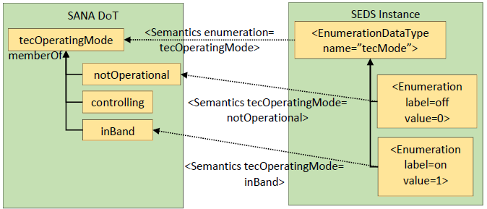

Figure ‑ Defining a Discrete Variable Type

An enumerated data type for a discrete variable does not need to use all the individuals in its enumeration class. If the ‘enumeration’ attribute is absent in an enumeration data type in a SEDS instance, then an interface that uses that type in the SEDS instance cannot be matched to an interface that uses an enumeration type with similar names in another SEDS instance; if the ‘enumeration’ attribute is present, then matching, perhaps with conversion, is possible.

## Metadata

The SEDS schema supports a metadata section in a SEDS instance. The DoT defines tags that can be applied to metadata elements to indicate how to interpret the metadata. Metadata consists of categories and values, both of which can be tagged.

To identify the manufacturer and model of a device described by a SEDS instance, the following metadata elements can be used.

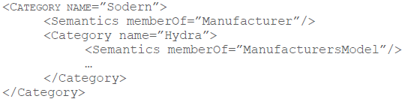

The categories are nested above in order to facilitate expressions elsewhere in the SEDS instance that refer to other metadata values for the device. The ellipsis above indicates where the other metadata values for the device would be specified. References to those metadata values are made by a period-delimited path through the tree of category names; in the example above, the references would begin with the string “Sodern.Hydra…”.

To specify the serial number of the device, the ellipsis above could be replaced by the following.

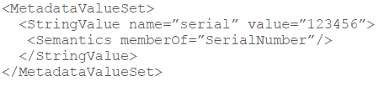

In the example above, the name=”serial” provides a handle for reference to the string value, but it does not indicate the meaning of the value. The memberOf=”SerialNumber” semantic tag tells how to interpret the value. There could be multiple values, which must have different names, but which have the same interpretation.

The following example shows that it may be necessary to indicate explicitly the subject of a metadata value, when the position in the metadata category tree does not represent the subject implicitly.

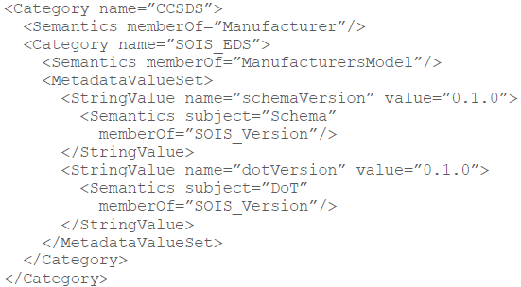

In the example above, the version numbers of both the schema and the DoT are specified, to indicate the versions of those documents to be used to parse a SEDS instance.

## Maintaining the Dictionary of Terms

While standard terminology is important for reusable application software, innovative applications and new technologies will not always fit within those constraints. The freedom to define new terms and new relationships among terms is built into the SOIS architecture for Electronic Data Sheets.

The following stakeholders participate in the maintenance of the SANA DoT.

* Manufacturers find that portability can increase the size of the market for their products.
* Integrators can reuse portable components in multiple missions.
* Subject matter experts understand the descriptions of the real world that must appear in an ontology in order to describe data efficiently. Agencies enlist members of their organizations to provide the role of subject matter experts by matching the subject matter of the topic under discussion to the appropriate experts.
* A managing authority builds consensus and provides arbitration to determine the content of the SANA DoT that optimizes the usefulness of the SANA DoT. The CCSDS can organize a Special Interest Group [18] to provide this role.

The procedure for extending the dictionary of terms is the same as the procedure for constructing the dictionary of terms initially.

1. A manufacturer builds a new component that has innovative features that must be described in an Electronic Data Sheet.
2. The manufacturer writes the Electronic Data Sheet using new terms as necessary. The new terms are defined in a user-defined ontology.
3. The managing authority for the dictionary reviews the user-defined ontology and decides whether it should be integrated with the existing ontology.
4. If the decision in step c is to proceed, then the managing authority integrates the user-defined ontology.
5. As a result of step c, it may be discovered that some of the novel terms represent concepts that can be expressed by other existing terms.
6. Another result of step c is the recognition of new terms.
7. Yet another result is the addition of new structure to the ontology.
8. If the integration results in changes to terms in the user-defined ontology, the managing authority notifies the manufacturer. The manufacturer can decide to keep the user-defined ontology (not portable) or to issue new SEDSs that are compatible with the revised SANA ontology (portable).
9. The managing authority for the dictionary publishes the latest version periodically.

# Basic Structure of the Dictionary of Terms

## Overview

This section describes the structure of the DoT ontology. The structure defined here is normative, in order to assure the capability of the DoT to provide terms that are compatible with usage in SEDSs and in the SEDS schema. Each part of this section addresses a separate issue of expression or usage in SEDSs.

Beyond the structure of the DoT ontology, this document defines a minimal set of concepts to support that structure in the ontology. This document does not specify in detail the actual content of the DoT ontology. Instead, this document designates the SANA DoT ontology as its formal, normative extension, to be curated by an expert group within CCSDS, as specified in Annex B2.

## Access

The Dictionary of Terms shall be accessible for public use at least to the extent defined in this subsection.

### Access to Ontology

The Dictionary of Terms ontology shall be accessible for public use through SANA [16] with web and programmatic HTTP/REST access. Any included ontologies that are not already publicly accessible shall be accessible or referenced on the same CCSDS resource.

NOTE – The DoT ontology is currently available as described in B2.

### Access to Derivatives

The files listed in this section, which are generated from the content of the ontology, shall be accessible for public use through SANA, where the ontology is accessible:

* the human-readable Dictionary of Terms;
* the schema representing the Dictionary of Terms, which is included by the SEDS schema.

NOTE – The files above are currently available as described in B2.

## BASIC Concepts

The dictionary of terms shall contain at least the basic concepts and structure described in this section, for use in defining the terms that can be used in authoring SEDSs.

NOTE – Extensions to the dictionary of terms are described in section 3.6.

### Human-readable Comments

The ‘dc:description’ annotation property shall contain a human-readable description of the meaning of each class, object property, data property, and individual defined in the dictionary of terms ontology.

NOTE – The annotation can be extracted from the ontology along with terms to build a human-readable artefact called the ‘glossary’. The namespace ‘dc’ indicates that the annotation property is defined in the ‘Dublin core’ [7].

### SEDS Attributes

The dictionary of terms shall provide content for the SEDS schema through an includable schema, using the following mechanism.

* The includable schema shall contain one or more attribute groups.
* The includable schema shall have no target namespace.
* The SEDS schema shall include the includable schema.
* The SEDS schema shall refer to the attribute groups in the includable schema in the definitions of types or of elements where those attributes will be used in a SEDS.

NOTE – This mechanism allows for the definition of attributes to be used in various contexts in a SEDS schema. Potential examples of those contexts appear in the list below.

* **semantic attributes:** See section 3.5
* **subnetwork attributes:** These attributes define the properties of a subnetwork interface.
* **metadata:** See section 3.4.

### Enumerated SEDS Attribute

A class that represents a schema attribute whose range is an enumeration, and which is used in an element of a SEDS, shall map to the SEDS schema such that the name of the class is the name of the attribute, and the names of the individuals in the class are the names of the labels of the enumeration. When consecutive inheritance layers of classes are needed in the ontology, the more inclusive classes with data property “sedsAttribute” shall be the classes whose names are the attribute names.

NOTE – The enumerations described here are the ranges of attributes in an Electronic Data Sheet. Enumerations of possible values for discrete data variables in component interfaces are the subject of 3.5.2.5, which also provides an example of a two-layer mapping of names between ontology and schema.

## Model of Production

The DoT shall define semantic tags for metadata in SEDS instances.

### Model of Manufacture

The DoT shall define terms that identify a device or software component by telling how it was made. Those terms include the following.

1. manufacturer
2. manufacturer’s model
3. serial number

### Language of Data Sheets

The DoT shall define terms that indicate the documents that define the syntax and semantics of SEDS, so a tool chain may use the appropriate versions of those documents to parse a SEDS instance. Those documents include the following.

1. The schema for electronic data sheets
2. The SANA DoT
3. The QUDV ontology used by the DoT

#### Format of SOIS Version Numbers

The version numbers for the schema and for the DoT shall have the form of three positive integers concatenated with period-characters, “.”.

1. The first integer shall be zero for the first version and incremented by 1 for versions that are not backward compatible with the previous version.
2. The second integer shall be zero for each new value of the first integer and incremented by 1 for each change that extends the previous version while maintaining compatibility.
3. The third integer shall be zero for each new value of the second integer, and incremented by 1 for each change that corrects errors in previous versions without breaking compatibility and without extending compatibly.

Example – “1.2.0” indicates a version that resulted from one change that was not backwards compatible and two subsequent backward-compatible extensions of function.

## Semantic Attributes

Overview: Section 3.5 contains the following topics.

* Relationship between SEDS schema and DoT for semantic terms
* Representation of semantic terms in the DoT
* A mechanism for constraining the combinations of terms that can be applied together in an EDS element
* Representation of standard combinations of semantic terms in the DoT.

### Relationship Between SEDS Schema and DoT for Semantic Terms

#### Overview

Semantic terms describe the interpretation of numbers. Examples of such terms are reference frame and unit of measure. These terms are called ‘semantic attributes’ in the SEDS schema.

This subsection describes the relationship between the SEDS schema and the DoT for semantic terms. Semantic terms are defined by the DoT, and transferred to the SEDS schema as specified in section 3.3.

By defining semantic terms in the dictionary of terms, the generation of human-readable artefacts from the DoT can include semantic terms. The ontology can also be used to describe restrictions on the usage of the terms. The ontology can define standard engineering profiles as combinations of the terms.

#### The dictionary of terms shall define terms that can be used to describe the interpretation of numbers and data structures in SEDS.

NOTE – Examples of such terms are ‘referenceFrame’ and ‘unit’. The combination of semantic attributes of an item of data is called its ‘engineering profile’.

### Ontology for Semantic Attributes

#### Representation of Semantic Attributes in DoT

The dictionary of terms shall represent each semantic attribute as a class derived from the class ‘SemanticProperty’, and the name of the class shall be the name of the attribute in the schema.

#### Enumerated Semantic Attributes

For semantic attributes whose range of values is an enumeration, the names of individuals in the class shall be the names of the values of the attribute in the schema (This is an instance of the specification in section 3.3.2).

NOTE – An example of an enumerated semantic attribute is ‘referenceFrame’, which may have individuals with names like ‘device’ or ‘ECI’.

#### QUDV Semantics

The dictionary of terms shall include the QUDV ontology [17] to obtain definitions of quantity kinds and units of measure. Until a stable publication of QUDV allows reference to specific version numbers, the QUDV ontology shall be stored on SANA as a copy of the Object Management Group publication.

The dictionary of terms shall extend the QUDV ontology as necessary.

Users of the dictionary of terms, both people and software, shall treat the QUDV classes for quantity kinds and units of measure as subclasses of ‘SemanticProperty’.

NOTE: This formula generalizes the description of enumerated semantic attributes to include subclasses of the class that names the attribute. The names of the subclasses are not used, but the names of the individuals in the subclasses are used as the enumeration values. The quantity kind class and the unit class are not defined as subclasses of ‘SemanticProperty’ in order to keep the DoT ontology separate from the QUDV ontology.

#### Referential Semantics

Overview: An informative discussion of models of operation appears in section 2.5.2.

##### Models of Operation Provide a Target for References

The dictionary of terms shall contain a class named ‘ModelOfOperation’.

The dictionary of terms shall define a subclass of the class ‘SemanticProperty’ named ‘RefersToModel’.

A class derived from RefersToModel may be called a referential class, and shall have no individual members.

A semantic attribute in the SEDS schema that corresponds to a referential class shall have a range of values in ‘xsd:string’.

The prefix of the string shall be the name of an individual in the ‘ModelOfOperation’ class or the name of a class derived from ModelOfOperation.

The remainder of the string shall be a path expression delimited by ‘.’, which consists of alternating names of object relations and names of classes or individuals in the SANA or user-defined ontology.

The definition of the semantic attribute shall relate the part of the Electronic Data Sheet that bears the attribute to the individuals or classes in the ontology that are at the end of the path specified by the value of the attribute.

Note: As an example, a navigation application that uses the nadir point of its satellite could be designed to ignore latitude-longitude parameters whose ‘subject’ attribute is not ‘GNS.onBoard.artificialSatellite.over.nadirPoint’. This would allow other applications onboard the vehicle to produce latitude-longitude parameters that are relevant to other objects of interest on the planet orbited by the satellite, without harming the navigation application.

##### Standard Models of Operation

The dictionary of terms shall define standard models of operation, with standard names for the parts of the model that can be referenced.

The standard models of operation shall be individuals of the class ‘ModelOfOperation’ or classes derived from ModelOfOperation.

The parts of the standard models of operation shall be related classes and individuals in related classes.

##### User-Defined Models of Operation

The document object model of a SEDS shall be treated as a model of operation with the anchor being the trunk element of the SEDS.

The dictionary of terms shall define a referential class named ‘memberOf’, which shall have the interpretation that an element bearing the attribute in the document object model of a SEDS is a member of the class in a standard or user-defined model of operation, named by the value of the attribute.

#### Enumeration Data

General: An Electronic Data Sheet may associate enumeration tags with numbers, to describe the representation of discrete variables in a data interface. The normative statements in this section say that there will be a semantic attribute ‘enumeration=x’ that can be applied to discrete data types in a SEDS. The ‘x’ is the name of a class in the ontology derived from the class ‘enumeration’. The meaning of this semantic attribute is to say that an item of data will contain integer values that correspond to enumeration values of individuals in the enumeration class ‘x’. The Electronic Data Sheet provides the association between integer values and names of individuals in each enumeration class that it uses.

##### The dictionary of terms shall define the meanings of enumeration tags.

##### The association of tags with numbers shall be local to Electronic Data Sheets.

##### The dictionary of terms shall define a subclass of ‘SemanticProperty’ named ‘enumeration’, whose derived classes are enumerations of the possible values of discrete data items described by a SEDS.

##### The range of values of the ‘enumeration’ attribute in the schema shall be the names of the classes derived from the class ‘enumeration’.

##### The ‘enumeration’ attribute may appear in the ‘Semantics’ element of an enumerated data type in a SEDS.

##### The values of the semantic attributes of enumeration members of the enumerated data type shall be the names of individuals in the class named by the ‘enumeration’ attribute, if it is present, and the semantic attribute name shall be the name of the class named by the ‘enumeration’ attribute.

##### Standard Enumerations

The dictionary of terms shall define standard enumerations, with standard names for the enumerated labels.

The standard enumerations shall be classes derived from the class ‘enumeration’.

##### User-Defined Enumerations

Authors of Electronic Data Sheets may write a user-defined ontology that adds classes derived from the ‘enumeration’ class. These classes can then be named in the ‘enumeration’ attribute of a data item to indicate its meaning.

#### Schema for Semantic Attributes

The dictionary of terms shall be accompanied by open-source software for extraction of a schema that can be included in the SEDS schema to define semantic attributes. See Annex B2 for location of that software.

The schema shall contain an attribute group named ‘CoreSemanticsAttributeGroup’, which contains semantic attributes and restricts their values.

### Combinatorial Constraints on Semantics

The constraints on combinations of semantic attributes form an open-world model: Combinations that are not explicitly excluded are allowed. This policy places the least unintentional restrictions on the community of users.

#### Excluded Semantics

The dictionary of terms may define any necessary constraints on legal combinations of semantic attributes.

Each such constraint shall be an individual in the class ‘ExcludedSemantics’.

The class ‘ExcludedSemantics’ shall have an object property for each enumerated semantic attribute, with the name [‘value’ prefixed to the name of the enumerated semantic attribute class].

An individual in ‘ExcludedSemantics’ shall be interpreted as an illegal combination of attributes.

Example – To indicate that chirality cannot be used with coordinateType latLon, there would be two individuals in ExcludedSemantics, one with valueChirality=leftHanded and one with valueChirality=rightHanded, both with valueCoordinateType=latLon.

#### External Constraints

The dictionary of terms shall instantiate the ‘sysml-qudv:quantityKind’ object property for individuals in classes derived from ‘unit’.

NOTE – External software can use this information to validate the pairing of quantityKind and unit attributes.

### Standard Engineering Profiles

#### Overview

Some engineering profiles will be used so often that it will be useful to define those combinations with standard names. Examples of standard engineering profiles include the description of the quaternion provided by a star tracker, and the description of the torque to be distributed to a single-axis actuator onboard the vehicle.

#### Ontology for Standard Engineering Profiles

The dictionary of terms shall define each standard combination of semantic attributes as an individual in the class ‘EngineeringProfile’.

The class ‘EngineeringProfile’ shall have an object property for each enumerated semantic attribute in a profile, with the name [‘value’ prefixed to the name of the enumerated semantic attribute class].

Example – A standard combination of semantic attributes for a rotation emitted by a star tracker would be represented by an individual in EngineeringProfile with valueReferenceFrame=ECI and valueToFrame=device.

#### Electronic Data Sheet for Standard Engineering Profiles

The dictionary of terms shall be accompanied by open-source software for extraction of a SEDS that contains the definitions of standard engineering profiles. See Annex B2 for location of that software.

## User-Defined Ontologies

### Overview

This subsection describes how user-defined ontologies may be used to extend the SANA ontology when the latter lacks information necessary for a description.

NOTE – Electronic Data Sheets that contain user-defined ontologies may be useful within a project, but the components that they describe are not portable outside the project. Agencies with a policy of promoting portable components will have to require their suppliers to use only terms that are in the SANA DoT, or to participate actively in the process of integrating new terms into the SANA DoT.

### Structure of User-Defined Ontologies

#### Structural Consistency

The structure of a user-defined ontology shall be consistent with the structure of the SANA Dictionary of Terms ontology.

#### Discussion

If the purpose is simply to provide additional term(s) within the existing structure, then a user-defined ontology can define the additional term(s) as individuals in the appropriate class. In this case, the programs that generate derivatives from the ontology will be able to include the term(s) without change.

When the user-defined ontology must add new structure that is absent in the SANA DoT, it may add some new classes to the Dictionary of Terms that do not inherit any information from classes already present. In this case, the programs that generate derivatives from the ontology will require modification in order to generate the new structure. This action is not a violation of this standard.

### Omissions

NOTE – Section 3 in this document may omit some issues that are needed for particular components or for particular kinds of interfaces. For example, the present description only covers data interfaces; it does not cover physical interfaces, such as thermal, electrical, mass, geometry, and others. Unforeseen issues of data interfaces may have been omitted.

In case an issue is omitted that is needed for a particular interface, the SEDS author may provide a user-defined ontology to cover the issue.

After appropriate consideration, the SANA DoT managing authority, shall decide whether to integrate the user-defined ontology into the SANA DoT.

If the decision is positive, then the managing authority, shall integrate the user-defined ontology, and amend this document to cover the issue.

NOTE – The process of integration can alter the user-defined ontology.

### Validation

The Dictionary of Terms ontology shall be accompanied by open source software that reads a user-defined DoT and reports its level of compatibility with the SANA DoT. See Annex B2 for the location of this software. The following reports shall be possible:

* The user-defined ontology adds terms in a way that is compatible with the design of toolchain software, so the latter can use the user-defined ontology without change within a project.
* The user-defined ontology adds new structure that cannot be used by the toolchain software, unless the latter is modified.
* The user-defined ontology redefines SANA terms and relationships, so even the routine content of the ontology no longer can be expected to function correctly with the toolchain software.

1. Dictionary of Terms for Electronic Data Sheets Implementation Conformance Statement Proforma  
     
   (Normative)
   1. Introduction

This annex provides the Implementation Conformance Statement (ICS) Requirements List (RL) for implementation of the DoT, CCSDS 876.1-R-0. The ICS for an implementation is generated by completing the RL in accordance with the instructions below. An implementation shall satisfy the mandatory conformance requirements of the base standards referenced in the RL.

The RL in this annex is blank. An implementation’s complete RL is called a ICS. The ICS states which capabilities and options of the services have been implemented. The following can use the ICS:

* An author of a SEDS that contains a user-defined DoT, as a checklist to reduce the risk of failure to conform to the standard through oversight;
* An author of toolchain software, as a basis for extracting information from the SANA DoT and from user-defined DoT, for use by the toolchain.
  1. Notation

The following are used in the RL to indicate the status of features:

Status Symbols

|  |  |
| --- | --- |
| M | mandatory |
| O | optional |

Support Column Symbols

The support of every item as claimed by the implementer is stated by entering the appropriate answer (Y, N or N/A) in the Support column:

|  |  |
| --- | --- |
| Y | Yes, supported by the implementation |
| N | No, not supported by the implementation |
| N/A | Not applicable |

* 1. Referenced Base Standards

The base standards references in the RL are:

* Dictionary of Terms for Electronic Data Sheets – this document.
  1. Generation Information
     1. Identification of ICS

|  |  |  |
| --- | --- | --- |
| Ref | Question | Response |
| 1 | Date of Statement (DD/MM/YYYY) |  |
| 2 | ICS serial number |  |
| 3 | System Conformance statement cross-reference |  |

* + 1. Identification of Implementation Under Test (IUT)

|  |  |  |
| --- | --- | --- |
| Ref | Question | Response |
| 1 | Implementation name |  |
| 2 | Implementation version |  |
| 3 | Special configuration |  |
| 4 | Other information |  |

* + 1. Identification

|  |  |  |
| --- | --- | --- |
| Ref | Question | Response |
| 1 | Supplier |  |
| 2 | Contact Point for Queries |  |
| 3 | Implementation name(s) and Versions |  |
| 4 | Other information necessary for full identification, e.g., name(s) and version(s) for machines and/or operating systems:  System Name(s) |  |

* + 1. Ontology Summary

|  |  |  |
| --- | --- | --- |
| Ref | Question | Response |
| 1 | Service Version |  |
| 2 | Addenda implemented |  |
| 3 | Amendments implemented |  |
| 4 | Have any exceptions been required?  NOTE – A YES answer means that the implementation does not conform to the service. Non-supported mandatory capabilities are to be identified in the ICS, with an explanation of why the implementation is non-conforming. | Yes                No |
|  |  |  |

* + 1. Instructions for Completing the RL

An implementer of tool chain software shows the extent of compliance to the specification by completing the RL; that is, compliance to all mandatory requirements and the options that are not supported are shown. The resulting completed RL is called a ICS. In the Support column, each response shall be selected either from the indicated set of responses or it shall comprise one or more parameter values as requested. If a conditional requirement is inappropriate, N/A shall be used. If a mandatory requirement is not satisfied, exception information must be supplied by entering a reference X*i*, where *i* is a unique identifier, to an accompanying rationale for the non-compliance.

* 1. General/Major Capabilities of DoT Ontology

|  |  |  |  |
| --- | --- | --- | --- |
| Service Feature | Reference | Status | Support |
| Access to Ontology | 3.2.1 | M |  |
| Access to Derivatives | 3.2.2 | M |  |
| Human-Readable Comments | 3.3.1 | M |  |
| Enumerated SEDS Attribute | 3.3.3 | M |  |
| Model of Production | 3.4 | M |  |
| Semantic Attributes | 3.5.1.2 | M |  |
| Representation of Semantic Attributes | 3.5.2.1 | M |  |
| Enumerated Semantic Attributes | 3.5.2.2 | M |  |
| QUDV Semantics | 3.5.2.3 | M |  |
| Referential Semantics | 3.5.2.4 | M |  |
| Enumeration Data | 3.5.2.5 | M |  |
| Schema for Semantic Attributes | 3.5.2.6 | M |  |
| Combinatorial Constraints on Semantics | 3.5.3 | M |  |
| External Constraints | 3.5.3.2 | M |  |
| Standard Engineering Profiles | 3.5.4 | O |  |
| User-Defined Ontologies | 3.6 | O |  |

* 1. Software Extracting Information from Ontology

This subsection provides identification of the software that extracts information from the ontology.

|  |  |  |  |
| --- | --- | --- | --- |
| Service Feature | Reference | Status | Support |
| Human-readable Comments | 3.3.1 | M |  |
| Enumerated SEDS Attributes | 3.3.2 | M |  |
| Runtime Enumerations | 3.5.2.5 | M |  |
| Ontology for Semantic Attributes | 3.5.2 | M |  |
| Combinatorial Constraints on Semantics | 3.5.3 | O |  |
| Standard Engineering Profiles | 3.5.4 | O |  |
| Validation of User-Defined Ontologies | 3.6.4 | O |  |

1. Security, SANA, and Patent CONSIDERATIONS   
     
   (Informative or Normative as noted)
   1. Security Considerations (Informative)
      1. Security Background

The SOIS dictionary of terms for Electronic Data Sheets is publicly available for use in design toolchains, and is designed to accommodate extension by its users. This openness may be exploited to affect adversely the operation of a toolchain. Users must rely upon trusted manufacturers to provide safe Electronic Data Sheets. The specification of such security services is out of scope of this document.

* + 1. Security concerns

At the time of writing there are no identified security concerns. If confidentiality of data is required within a project, some degree of proprietary control may be obtained by using user-defined ontologies that are never submitted to the Dictionary of Terms managing authority for integration into the SANA DoT.

* + 1. Potential threats and attack scenarios

Potential threats and attack scenarios typically derive from outside the mission-manufacturer relationship and are therefore not the direct concern of the SOIS dictionary of terms. It is assumed that all Electronic Data Sheets within the spacecraft have been thoroughly tested and cleared for use by the mission implementer.

* + 1. Consequences of not applying security

The security services are out of scope of this document and are expected to be applied at organizational layers above or below those specified in this document. If confidentiality is not implemented, science data or other parameters transmitted within the spacecraft might be misused.

* + 1. Reliability

While it is assumed that the underlying mechanisms used to implement a toolchain operate correctly, the initial implementation of the dictionary of terms can make no promises of reliability. After a sufficient body of experience with real Electronic Data Sheets has developed, useful estimates of reliability will be possible.

* 1. SANA Considerations (Normative as noted)

The recommendations of this document request SANA [16] to create a registry named ‘Spacecraft Onboard Interface Services Electronic Data Sheets and Dictionary of Terms’ that consists of a set of files that constitute an ontology and related files. The candidate registry is located at the following URL: <http://sanaregistry.org/r/sois/sois.html>. When funding is available, the OWL files should be made available as a triple-store that can be queried through an HTTP/REST API.

The registration rule for change to this registry requires an engineering review by a designated managing authority. The managing authority shall be assigned by the SOIS-APP working group Chair, or in absence, Area Director. Because the material in the SANA DoT is often outside the domain of expertise of CCSDS personnel, the managing authority shall request assistance from subject matter experts provided or recommended by participating agencies.

The registry shall contain at least the following items. The content of some items is normative, as indicated in the “Norm” column.

|  |  |  |  |
| --- | --- | --- | --- |
| File | Description | Norm | Reference |
| [seds.xsd](http://beta.sanaregistry.org/r/sois/seds.xsd) | The schema for SOIS Electronic Data Sheets. | yes |  |
| [seds-core-semantics.xsd](http://beta.sanaregistry.org/r/sois/seds-core-semantics.xsd) | The SOIS Dictionary of Terms in the form of a schema to be included by seds.xsd. | yes |  |
| [seds.xml](http://beta.sanaregistry.org/r/sois/seds.xml) | A non-normative collection of definitions that can reduce the number of definitions in an electronic data sheet. | no |  |
| [sois.0.owl](http://beta.sanaregistry.org/r/sois/sois.0.owl) | The ontology for SOIS Dictionary of Terms. This ontology imports sysml-qudv-si-sois.owl. | yes |  |
| [sysml-qudv.owl](http://beta.sanaregistry.org/r/sois/sysml-qudv.owl) | The original proof-of-concept definition of quantities, units, dimensions, and values. | yes | [17] |
| [sysml-qudv-si.owl](http://beta.sanaregistry.org/r/sois/sysml-qudv-si.owl) | The original proof-of-concept extension of QUDV to the International System of Units. This ontology imports SysML-QUDV.owl. | yes | [17] |
| [sysml-qudv-si-sois.owl](http://beta.sanaregistry.org/r/sois/sysml-qudv-si-sois.owl) | An extension of the original QUDV ontologies to support units used in SOIS EDS. This ontology imports SysML-QUDV-SI.owl. | yes |  |
| soisOwlTools.zip | A compressed project that contains open-source utilities that are intended to perform the following functions:   * Converts a conformant ontology into a seds-core-semantics.xsd * Extracts a SEDS instance that contains definitions of standard types | no |  |

Table B2-1 SANA Registry Content

* 1. PATENT Considerations (Informative)

The technology used in managing the Dictionary of Terms (xml, xsd, and owl) is in the public domain.

1. Abbreviations  
     
   (informative)

|  |  |
| --- | --- |
| CCSDS | Consultative Committee for Space Data Standards |
| DACP | Device Abstraction Control Procedure |
| DAP | Device-specific Access Protocol |
| DAS | Device Access Service |
| DDPS | Device Data Pooling Service |
| DoT | Dictionary of Terms |
| DVS | Device Virtualisation Service |
| EDS | Electronic Data Sheet |
| SOIS | Spacecraft Onboard Interface Services |
| XML | Extensible Markup Language |

1. Informative References (informative)

[D1] *Spacecraft Onboard Interface Services*. Issue 2. Report Concerning Space Data System Standards (Green Book), CCSDS 850.0-G-2. Washington, D.C.: CCSDS, December 2013.

[D2] *XML Telemetric and Command Exchange (XTCE)*. Issue 1. Recommendation for Space Data System Standards (Blue Book), CCSDS 660.0-B-1. Washington, D.C.: CCSDS, October 2007.

[D3] *Electronic Data Sheets and Common Dictionary of Terms for Onboard Devices and Components.* Under construction. Report Concerning Space Data System Standards (Green Book), CCSDS 85x.x-G-x. Washington, D.C.: CCSDS, 20xx.

1. Example DoT/XML Ontology Instantiations (Informative)

The following excerpts from a SEDS for a star tracker demonstrate the information carried by semantic tags. More complete examples appear in the associated green book [D3].

The FloatDataType element below defines semantics that are common to many temperature measurements that appear in the housekeeping data for the star tracker.

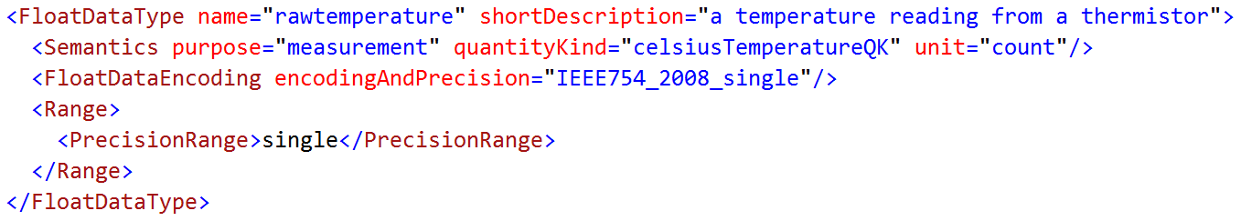

Any items of data that are of this type will be measurements, not set points. They will represent temperature in units of analog-to-digital counts.

The Entry elements below use the FloatDataType above to define some of the items of data in a housekeeping packet produced by the star tracker.

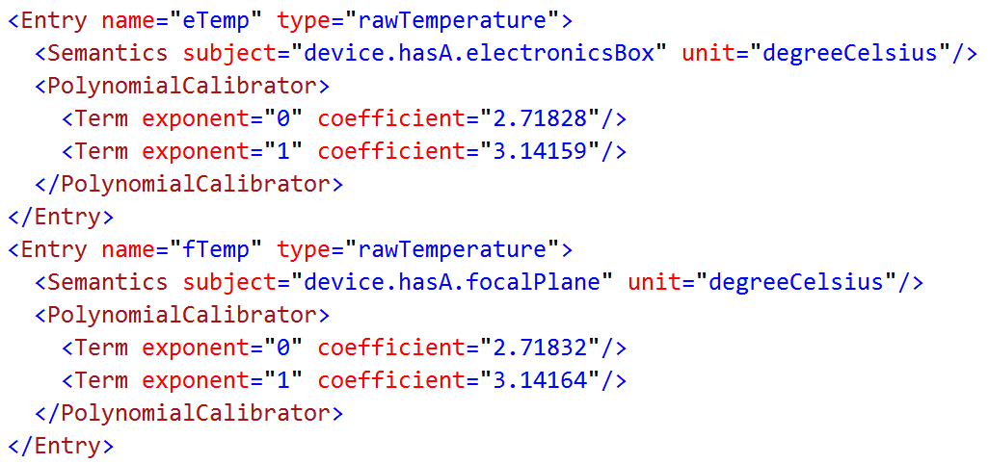

The first item is the temperature measured at the electronics box of the star tracker. A calibrator element describes how to convert the raw temperature counts into Celsius degrees. The second item is the temperature measured at the focal plane, with a slightly different calibrator. The “subject” attributes in this case refer to parts in the model of operation of the star tracker, by tracing a path in model of operations.

The ContainerDataType below defines a quaternion, which represents a rotation. Such an object can be used to compute a rotational transformation from one coordinate system to another. This definition does not specify the coordinate systems related by the transformation; that information is left to be specified in the particular items of data that use a quaternion. The semantic information in this definition is just the set of assumptions that are implicit in many implementations of quaternions; those assumptions appear once in this type definition, and need not be repeated for each item of data that represents a quaternion.

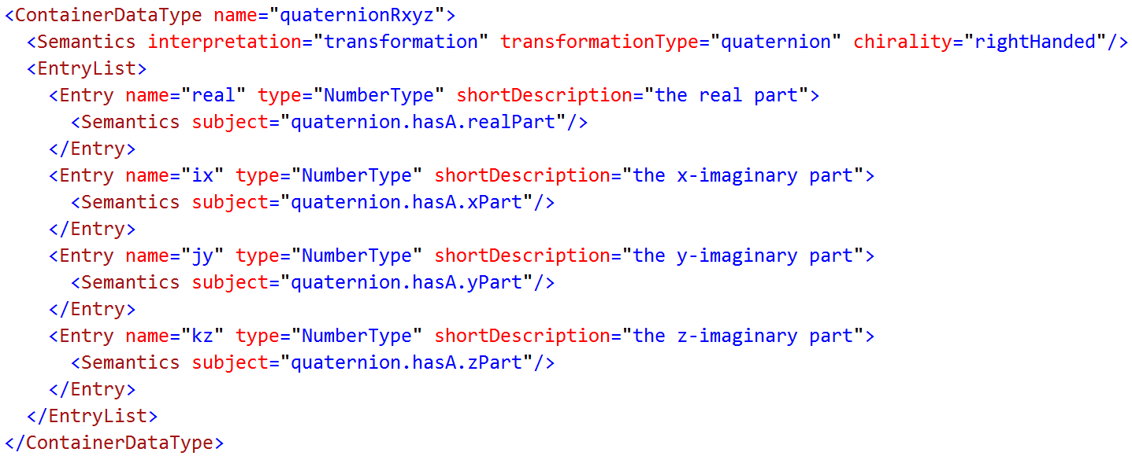

This definition clarifies the arrangement of parts, which can differ between groups of users, such as computer graphics displays and attitude control logic. In this case, the real part of the quaternion appears first; in other contexts, the real part may appear last. The algorithmically accessible identification of the real part is the “subject” attribute of the semantics element, which traces a path through the model of operation for quaternions in general. The “shortDescription” is unstructured text, and so is useful only to human readers. By using standard semantic tags, quaternions from different sources, such as star trackers and graphics rendering packages, can be automatically adapted to the interface where they are used.

The Entry element below defines an item of data measured by the star tracker, which is the rotation from Earth-centered inertial coordinates “J2000” to the coordinates of the device.



Another item of data in the star tracker SEDS defines the orientation of the mounting face of the device. An item of data in the vehicle manifest defines the orientation of the star tracker mount relative to the vehicle coordinate system. By composing these rotational transformations, it is possible to compute the attitude of the vehicle.