CCSDS Reference Architecture: MOIMS Area Inputs
The CCSDS System Architecture Working Group (SAWG) is currently developing a reference architecture that addresses all aspects of CCSDS standardisation. This builds upon the previous CCSDS Communications System Architecture, which showed how the communication layers of the SLS, SIS and CSS area standards related to each other, but did not address the application layer standardisation activities of the MOIMS and SOIS areas.
The CCSDS Reference Architecture will be a model that comprises 5 views:
- Functional: identifying standard functions of a space mission system, and the interactions between them in terms of service interfaces and/or information exchanged at application level.
- Service: characterisation of potential application level services in terms of the operations performed and information exchanged.
- Data: information model of the top level data objects exchanged between functions and the relationships between them.
- Protocol: communications protocol stack view, showing how application level services can be overlaid on CCSDS communication layers.
- Deployment: example deployment architectures identifying where key interfaces between functions are exposed to interoperability boundaries.
The work is scheduled in two phases: first to produce a set of diagrams and tables giving a “cartoon” overview of the model using [extended] CCSDS RASDS notation; second to produce a green or magenta book that presents the agreed model.
This document contains draft Functional and Service viewpoints covering the MOIMS area of standardisation.

Functional Viewpoint
The Functional viewpoint has been represented as a set of Powerpoint diagrams using the RASDS notation (see graphical conventions below) . As the view shows application level functions, the notation for logical links between elements has been extended to show:
- Which function is the Data or Service Provider (shown by a circle at one end of the link)
- The principal information or data items exchanged across the logical link (shown as labels in coloured boxes annotating the links).
All MOIMS functions and data are also colour coded [external functions/entities in grey], grouping functions into major functional areas as follows:
Mission Control [MCS]
Planning & Scheduling [MPS]
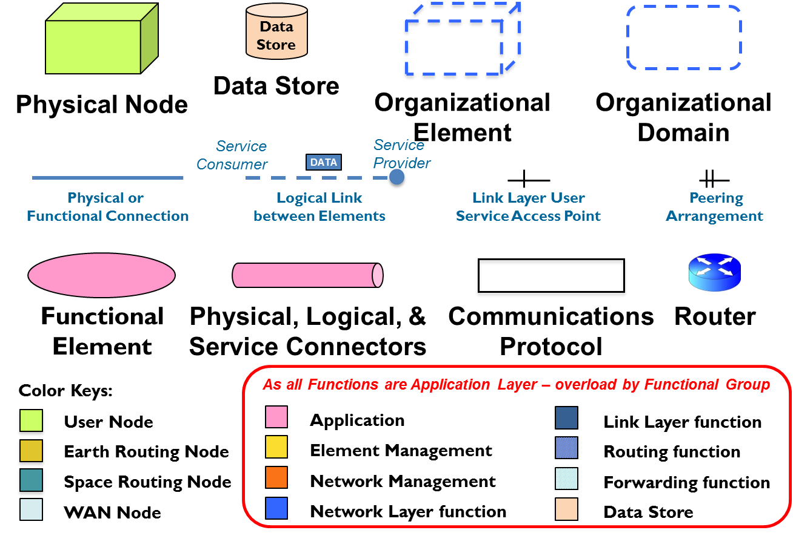
Navigation & Timing [NAVT]
Data Storage & Archiving
Operations Preparation [OPD]
Mission Data Products [MDP]
Common Services
A high level diagram shows these main areas and their interactions. This is followed by lower level diagrams expanding each area. These lower level diagrams are provided in two alternative presentations:
- The classic functional view
- A service/data oriented view using “tramlines” to show the interactions between functions that are the subject of standardisation.

MOIMS Data and Services
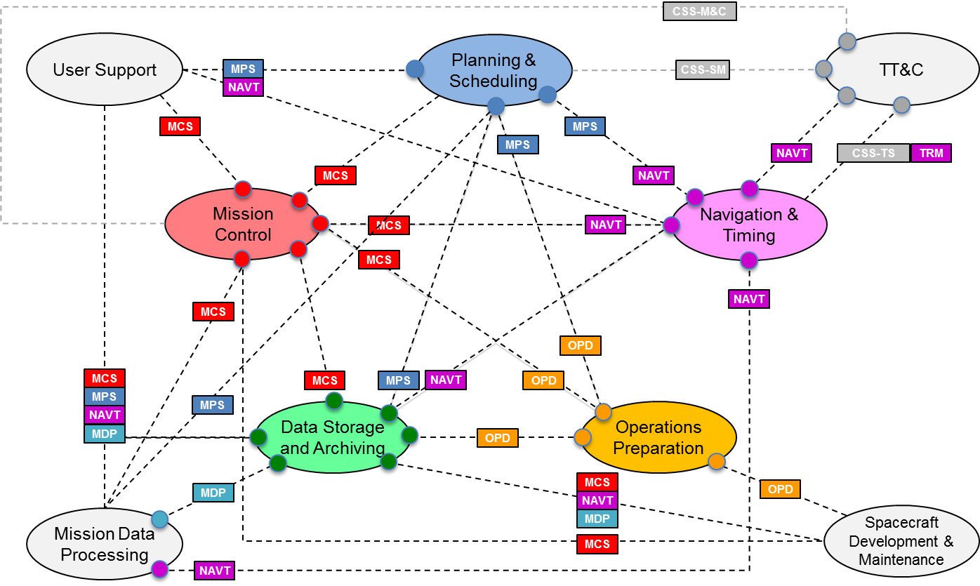
CSS: Cross Support Services
CSS-M&C: CSS Monitoring & Control
CSS-SM: CSS Service Management
CSS-TS: CSS Transfer Services

Common Services
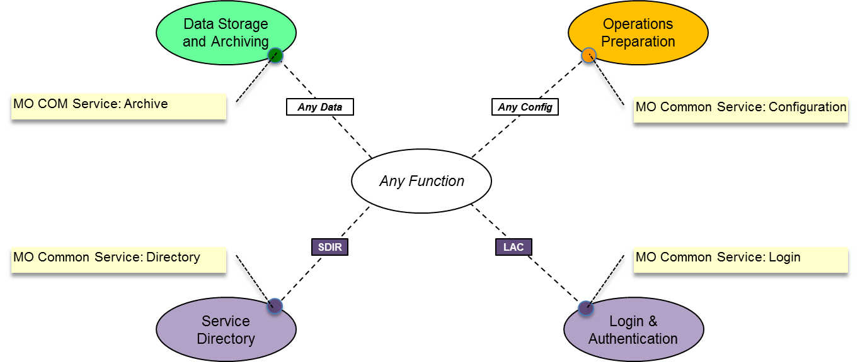

SDIR: Service Directory
LAC: Login and Authentication Credentials
MO: Mission Operations [Services]
COM: Common Object Model

Mission Control
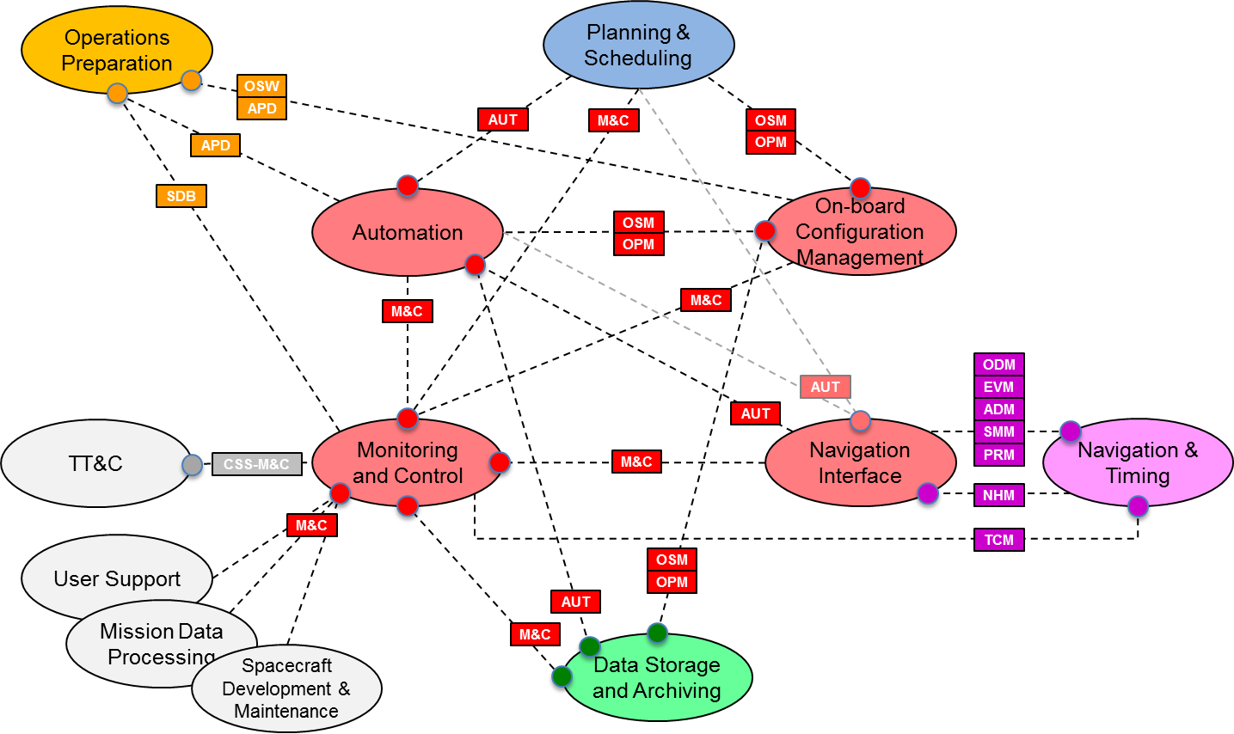
M&C: Monitoring & Control
AUT: Automation
OSM: On-board Software Management
OPM: On-board Procedure Management

Mission Control (Alternative View)
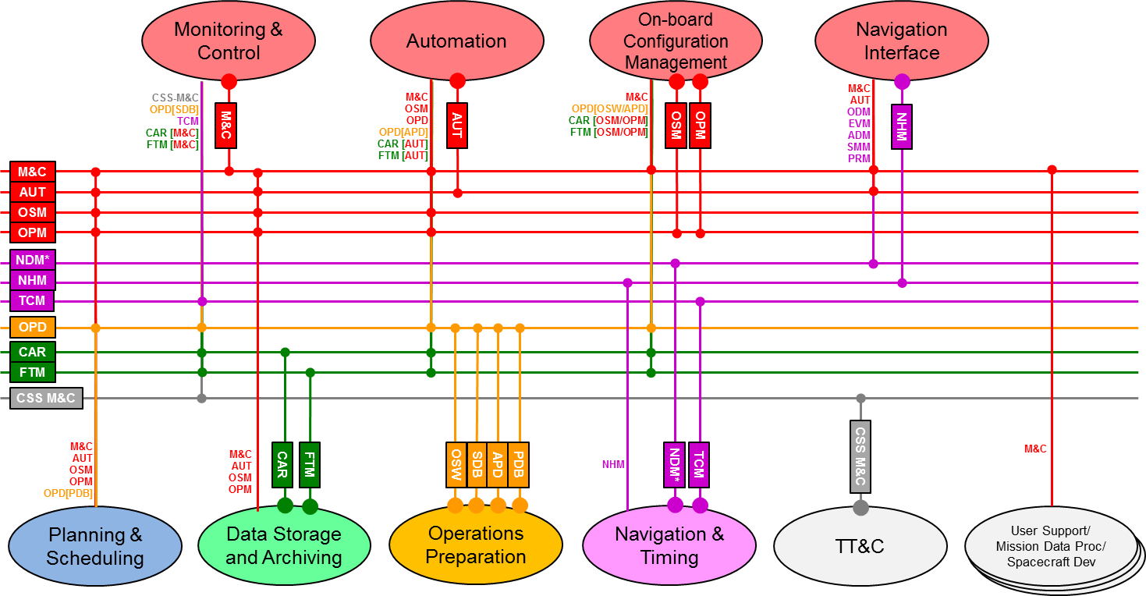

Navigation and Timing
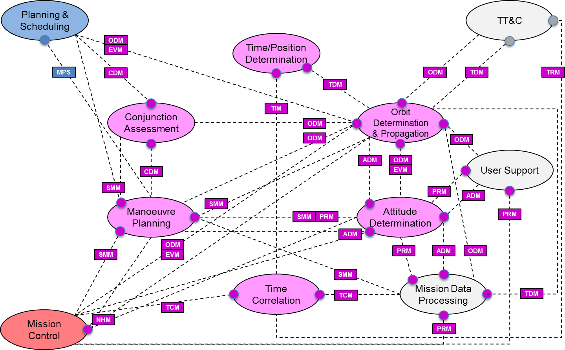
ADM Attitude Data Message
CDM Conjunction Data Message
EVM Event Message
NHM Network Hardware Message
ODM Orbit Data Message
PRM Pointing Request Message
SMM Spacecraft Manoeuvre Message
TDM Tracking Data Message
TIM Time Report
TRM Time Reception Message
TCM Time Correlation Message

Navigation and Timing (Alternative View)
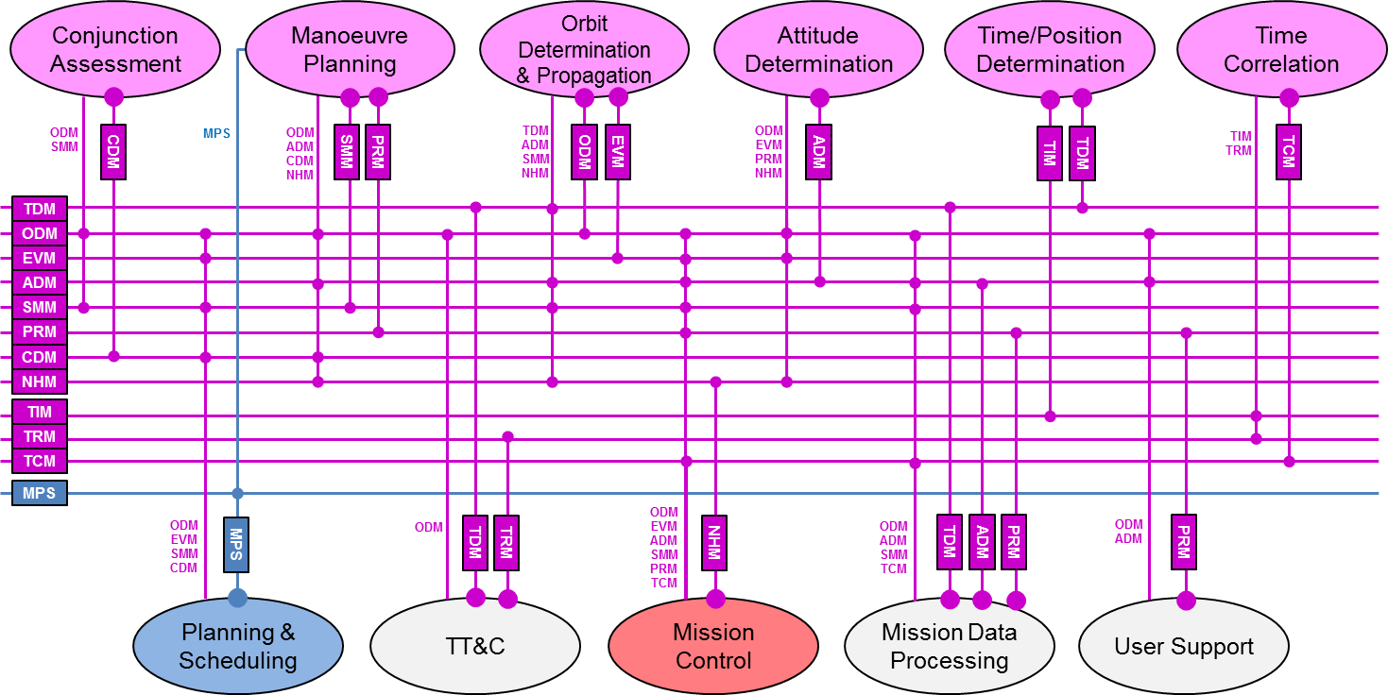

Mission Planning and Scheduling
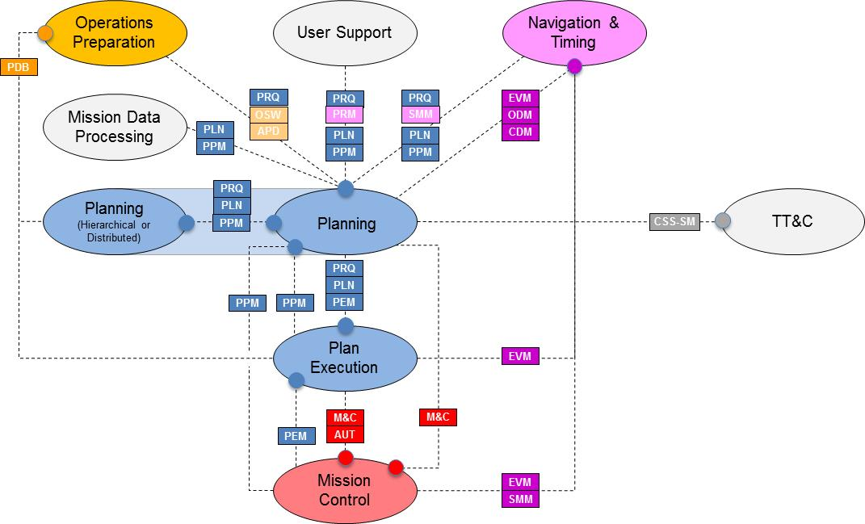
PRQ: Planning Request
PLN: Plan [Distribution/Retrieval]
PLC: Planning Control
PEC: Plan Execution Control

Mission Planning and Scheduling (Alternative View)
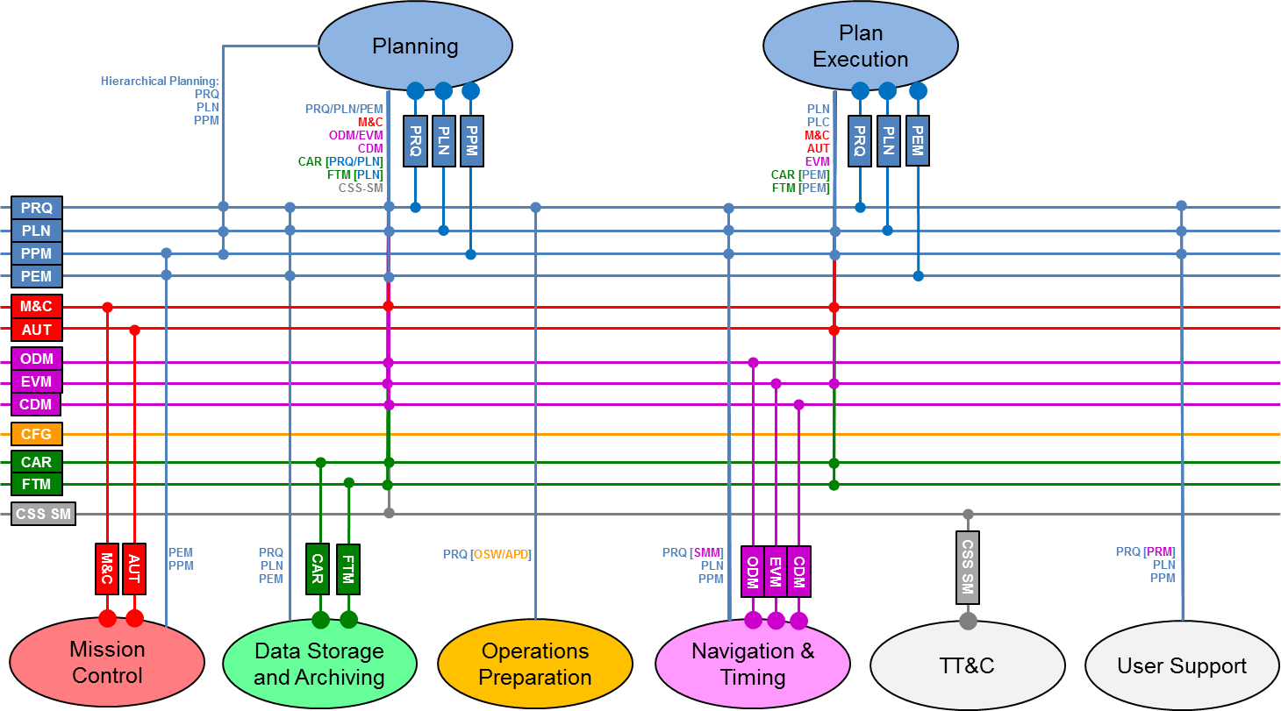

Operations Preparation
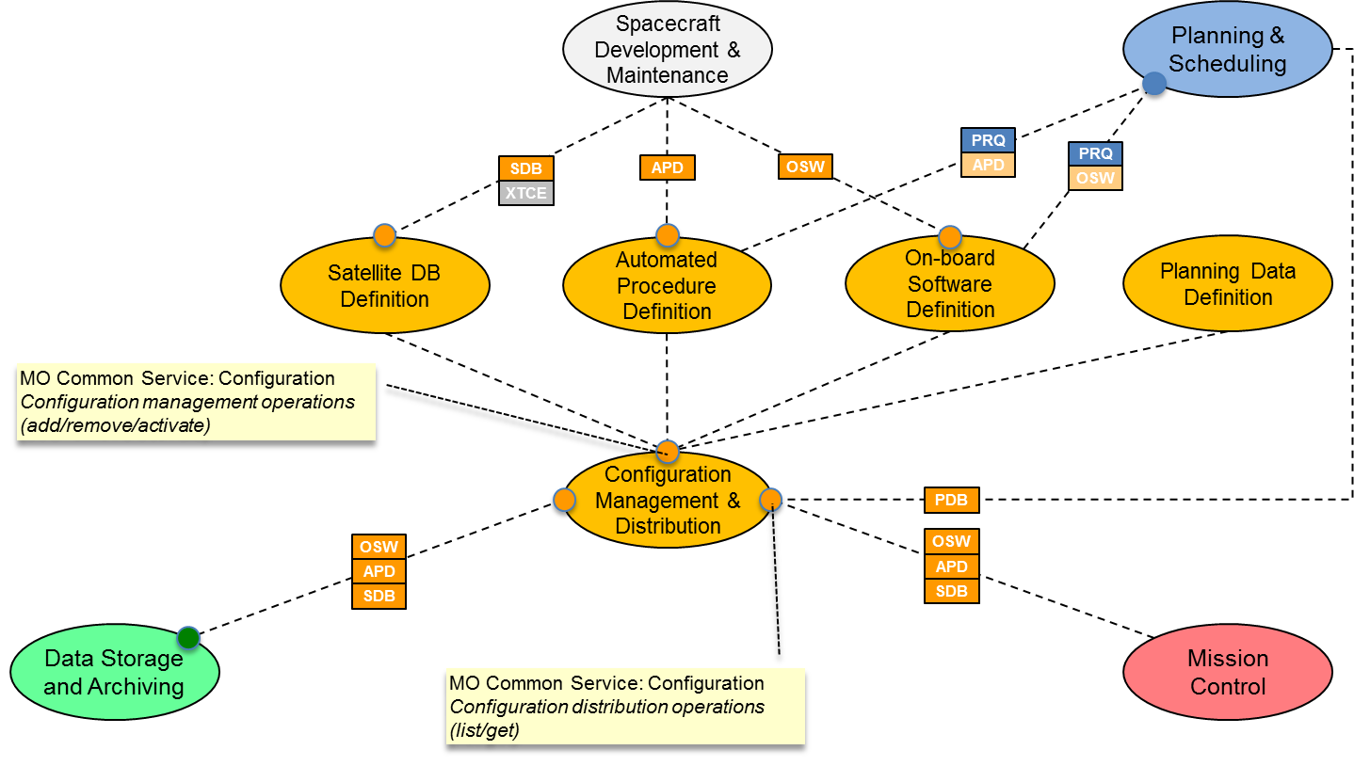
SDB: Satellite Database
OSW: On-board Software
APD: Automated Procedure Definition
PDB: Planning Database [Planning Data Definitions]
XTCE: XML Telemetry and Command Exchange – TM/TC Database Exchange format (OMG/CCSDS standard)

Operations Preparation (Alternative View)
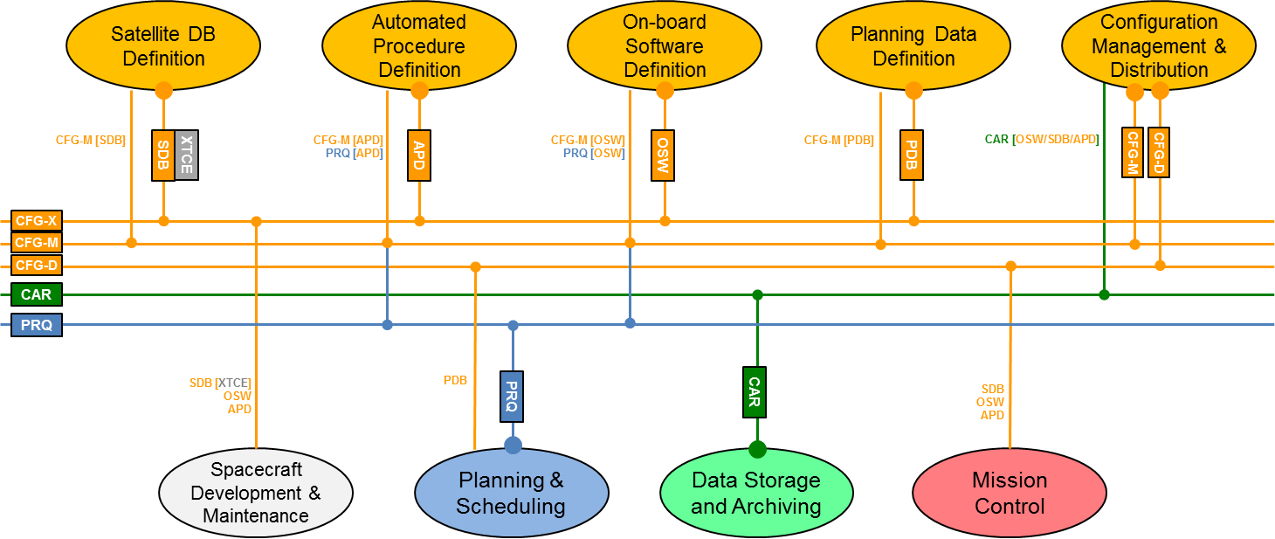
CFG: Configuration (MO Common Service)
CFG-M: Configuration Management (Add/Remove/Activate)
CFG-D: Configuration Distribution (List/Get)
CFG-X: Configuration Exchange (Import/Export)
CAR: Common Archive (MO COM Service)

Data Storage and Archiving
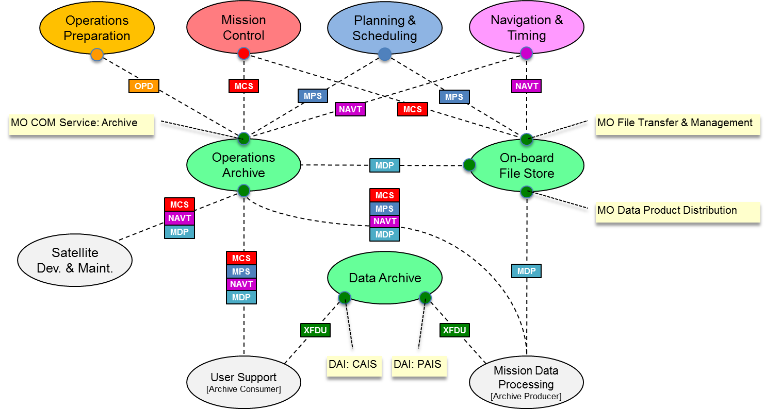
DAI: Data Archive and Ingestion working group
PAIS: Producer-Archive Interface Specification
CAIS: Consumer-Archive Interface Specification
XFDU: XML Formatted Data Unit

Data Storage and Archiving (Alternative View)
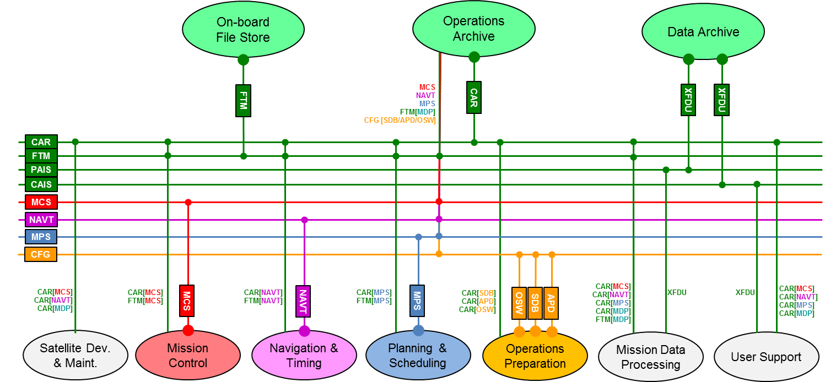
CAR: Common Archive (MO COM Service)
FTM: File Transfer and Management (MO Service)
CAIS: Consumer Archive Interface Specification
PAIS: Producer Archive Interface Specification

Service Viewpoint
The Service viewpoint is presented as a table that lists potential services together with the operations they provide, and the data objects exchanged or referenced by the service. Services may be grouped together within a single standard. The Functions column references functions identified in the functional viewpoint, either as a provider of the service [in bold] or as a consumer. The Data column references information objects identified in the data viewpoint. The Standards column identifies the CCSDS standards that identify or specify the service or associated key data formats. Other columns are colour coded:
- Column A: correlates to the functional areas identified within the Functional view:
Common Services
Mission Control
Planning & Scheduling
Navigation & Timing
Data Storage & Archiving
Operations Preparation
Mission Data Products
- Column S and D: show the current status of CCSDS specification with respect to standard CCSDS book colours for both the Service (S) and Data format (D). White indicates no specification has yet been produced; pastel green indicates a green book in production.

COM and Common Services

A | Group | Service | Functions | Operations | Data | Description | Standards | S | D
 | MO COM | Archiving | Providers:  Ops. Archive  Consumers:  <any function> | Store  Update  Query | <any COM obj> | Generic archive service for MO services defined in terms of the Common Object Model [COM]. | MO Common Object Model  [CCSDS 521.1-B-1]
 |  | Activity Tracking | Providers:  <any function>  Consumers:  <any function> | Publish/Subscribe | <any Activity> | Activities are COM objects that have a limited duration. The service provides a mechanism to report progress/status and uses the COM Event service.
 |  | Event | Providers:  <any function>  Consumers:  <any function> | Publish/Subscribe | <any Event> | Events are COM objects that represent an occurrence at a point in time. Each service can define the Events it supports.
 | MO Common | Directory | Providers:  Service Directory  Consumers:  <any function> | Publish Provider  Withdraw Provider  Lookup Provider  Get Service XML | Service Descriptor | Allows Providers to publish information about the services they provide; and Consumers to query the Service Directory and retrieve Service XML descriptors. | MO Common Services  [CCSDS 522.0-R-n]
 |  | Login | Providers:  Login and Authentication  Consumers:  <any function> | Login  Logout  Report Available Roles  Handover to other User | Authentication Credentials | Common login service for submission of authentication details to a deployment specific security system. Integrated with Access Control aspect of MO MAL.
 |  | Configuration | Providers:  Configuration Management & Distribution  Consumers:  <any function> | Activate  List  Get Current  Get XML  Add  Remove  Store Current  Store XML | Configurations  XML Configurations  <any Config Data> | Configurations can be hard-coded, use bespoke configuration data, or a standard COM service configuration.  Service consumers can activate predefined configurations of a service provder; and list, get, add, remove and store current configurations.  It also defines a standardised XML representation for configurations.

M&C Services

A | Group | Service | Functions | Operations | Data | Description | Standards | S | D
 | MO M&C | Action | Providers:  Monitoring & Control  Consumers:  Automation  On-board Configuration Management  Navigation Interface  Planning  Plan Execution  Operations Preparation  Operations Archive  User Support  Mission Data Processing  Spacecraft Development & Maintenance | Submit Action  preCheck Action  Manage Action Definitions | Action | Allows control directives (e.g. a spacecraft telecommand) to be invoked and their evolving status to be monitored.  Uses COM Services for Action Tracking and Archiving. | MO Monitoring & Control Services  [CCSDS 522.1-R-n]
 |  | Parameter |  | Monitor Value  Get Value  Set Value  Enable Generation  Manage Parameter Definitions | Parameter | Provides the capability to monitor and set parameter values.  Uses COM Archiving service for Parameter Archiving.
 |  | Alert |  | Enable Generation  Manage Alert Definitions | Alert | Provides a mechanism for asynchronous notification of operationally significant events or anomalies.  Uses COM Event and Archiving services to publish/subscribe to Alerts and to archive them.
 |  | Check |  | Get Current Transition List  Get Summary Report  Enable Service  Get Service Status  Enable Check  Trigger Check  Manage Check Definitions | Parameter  Check  Check Link  Check Transition Event | Provides on-line checking of Parameter values against defined checks [Limit, Constant, Delta] and notification of check violations.  Uses COM Event service to publish/subscribe to check status transition events.
 |  | Statistics |  | Get Statistics  Reset Evaluation  Monitor Statistics  Enable Service  Get Service Status  Enable Generation  Add Parameter Evaluation  Update Parameter Evaluation  Remove Parameter Evaluation | Parameter  Statistic Link  Statistic Value | Provides on-line statistical evaluation of Parameter values.  Uses COM Archive service.
 |  | Aggregation |  | Monitor Value  Get Value  Enable Generation  Enable Filter  Manage Aggregate Definitions | Aggregation of Parameters | Provides aggregation of separate Parameter values into coherent sets.  Uses COM Archive service.
 |  | Conversion |  | none | Parameter  Conversion | Provides conversion of raw Parameter values into engineering units.  Uses COM Archive service
 |  | Group |  | none | Group of <any COM object>s | Provides the ability to define groupings of objects to simplify the operations of other services.  Uses COM Archive service
 | MO AUT | Automation | Providers:  Automation  Consumers:  Monitoring and Control  Navigation Interface  Plan Execution  Operations Archive | Start Procedure  Stop Procedure  Suspend/Resume Procedure  Manual Control  Manage Procedure Definitions [TBD] | Procedure | Provides support for automation of mission operations. The service allows automated procedures or autonomous functions to be invoked, controlled, and their evolving status to be monitored.  Uses COM Services for Procedure Tracking and Archiving. | MO Services Concept  [CCSDS 520.0-G-3]  Automation Service
 | MO OSM | Software Management | Providers:  On-board Configuration Management  Consumers:  Automation  Plan Execution | Load Software Image  Dump Software Image  Check Software Image | On-board Software Image | Supports the management of software loaded into the remote system [spacecraft]. | MO Services Concept  [CCSDS 520.0-G-3]  Software Management Service
 |  | Procedure Management | Providers:  On-board Configuration Management  Consumers:  Automation  Plan Execution | Load Procedure Definition  Dump Procedure Definition  Check Procedure Definition  Manage Procedure Definitions [TBD] | On-board Procedure Definition | Supports the management of automated procedure definitions loaded into the remote system [spacecraft]. | Proposed extension to scope of MO OSM service.

Other MO Services

A | Group | Service | Functions | Operations | Data | Description | Standards | S | D
 | MO MDP | Data Product Distribution | Providers:  Operations Archive  On-board File Store  Consumers:  Mission Data Processing  User Support  Spacecraft Development & Maintenance | Subscribe Online  Subscribe Batch  Retrieve  [TBD] | Mission Data Product | Mission Data Product Distribution Service is used for the distribution of historical archived data and on-line 'live' data  It provides two delivery modes, batch mode and stream mode. | MO Services Concept  [CCSDS 520.0-G-3]  Data Product Management Service
 | MO FTM | File Transfer & Management | Providers:  On-board File Store  Consumers:  Mission Control  Planning & Scheduling  Navigation and Timing | List, Rename, Move, Copy and Delete Files and Directories  Add Directory  Get Drive Information  Upload File  Download File | Directory  File  Drive | Supports the management of a remote [on-board] file store and the initiation of transfers of files between local and remote file stores. | MO Services Concept  [CCSDS 520.0-G-3]  Remote Buffer Management Service

Mission Planning and Scheduling Services

A | Group | Service | Functions | Operations | Data | Description | Standards | S | D
 | MO MPS | Planning Request [PRS] | Providers:  Planning  Plan Execution  Consumers:  User Support  Operations Preparation  Navigation & Timing  Planning [Distributed] | Submit Request  Update or cancel Requests  Provide Request Status feedback  Manage Request Definitions | Planning Request  Plan  Planning Activity  Planning Event  Planning Resource  Planning Constraint | Asynchronous submission of planning requests, associated responses and their subsequent management and status feedback.  A planning request may reference a Plan (output from an earlier planning process), in which case the provided feedback includes the status of the plan in terms of its contained activities and other items. | MO Services Concept  [CCSDS 520.0-G-3]  Planning Request  Mission Planning and Scheduling Concept  [Draft Green Book]
 |  | Plan Distribution & Retrieval [PLS] | Providers:  Planning  Plan Execution  Consumers:  User Support  Navigation & Timing  Mission Data Processing  Planning [Distributed] | Retrieve Plan or Plan Status  Subscribe to Plan or Plan Status | Plan  Planning Activity  Planning Event  Planning Resource  Planning Constraint | Provides distribution and access to plans generated by the planning function. | MO Services Concept  [CCSDS 520.0-G-3]  Scheduling [Part]  Mission Planning and Scheduling Concept  [Draft Green Book]
 |  | Planning Process Management [PMS] | Providers:  Planning  Consumers:  Plan Execution  Mission Control  Navigation & Timing  User Support  Mission Data Processing  Planning [Distributed] | Initiate, Monitor and Control Planning Processes  Update Plan Status  Manage Planning Definitions | Plan  Planning Activity  Planning Event  Planning Resource  Planning Constraint | Management of the planning process itself - initiation, status feedback and control.  Also supports provision of plan status updates by a third party. | MO Services Concept  [CCSDS 520.0-G-3]  Scheduling [Part]  Mission Planning and Scheduling Concept  [Draft Green Book]
 |  | Plan Execution Management [PES] | Providers:  Plan Execution  Consumers:  Planning  Mission Control | Initiate, Monitor and Control Plan execution  Edit Plan content  Update Planning Events and Resources.  Manage Planning Definitions | Plan  Planning Activity  Planning Event  Planning Resource  Planning Constraint | Control and management of the execution of a plan, including actions to Start/Stop and Pause/Resume execution.  Update [editing] of the executing plan at activity level.  Update planning events/resources. | MO Services Concept  [CCSDS 520.0-G-3]  Scheduling [Part]  Mission Planning and Scheduling Concept  [Draft Green Book]

Navigation and Timing Services

A | Group | Service | Functions | Operations | Data | Description | Standards | S | D
 | TIM | Time | Providers:  Time/Position Determination  Consumers:  Time Correlation | Report Time  Set Time  Configure rate of Time Report generation. | Time Report | Provides accurate reporting of on-board time. For an unsynchronised on-board clock this may require correlation with the system reference time | MO Services Concept  [CCSDS 520.0-G-3]  Time
 |  | Time Correlation | Providers:  Time Correlation  Consumers:  Mission Control  Mission Data Processing | Correlate Time | Time Correlation | Supports Time correlation between on-board clocks and the system reference time. | MO Services Concept  [CCSDS 520.0-G-3]  Time
 |  | Time Reception | Providers:  TT&C  Consumers:  Time Correlation | Report Reception Time | Reception Time | Provides accurate ground reception time reporting that can be associated with a Time Report.  This is currently supported by the CSS Space Link Extension Transfer Services, where Earth Receive Time is provided as an annotation parameter to the transfer data.  An alternative service may be required where SLE is not used. | Space Link Extension – Return All Frames Service Specification  [CCSDS 911.1-B-4]  And related CSS SLE Transfer Services
 | NAV | Navigation Services | Providers:  Navigation Functions  Consumers:  Mission Control  Mission Planning & Scheduling  Mission Data Processing  Data Storage & Archiving  User Support  TT&C  Satellite Dev. & Maintenance | Request Navigation Message  Retrieve Navigation Message  Subscribe to Navigation Message | Orbit Vector  Attitude  Tracking Data  Predicted Orbital Events  Spacecraft Manoeuvre  Conjunction  Pointing Request | Supports the provision of spacecraft positioning information such as:  - Position reports (e.g., from on-board GPS)  - Spacecraft ranging and range-rate measurements  - Antenna tracking azimuth and elevation  - Orbit vectors  - Attitude vectors  - Trajectory requests  - Predicted orbital events (including ground station visibilities)  The services will use the following data message formats defined by the CCSDS Navigation working group, but wrap these as service specifications based on the MO framework. | MO Services Concept  [CCSDS 520.0-G-3]  Navigation
 |  | Orbit Data Message [ODM] | Providers:  Orbit Determination and Propagation  Consumers:  Manoeuvre Planning  Attitude Determination  Conjunction Assessment  Mission Control  Mission Planning & Scheduling  Mission Data Processing  TT&C  User Support | - | Orbit Vector | The ODM contains information that defines the orbit state of a spacecraft at one or more times. | Orbit Data Messages  [CCSDS 502.0-B-2]
 |  | Attitude Data Message [ADM] | Providers:  Attitude Determination  Consumers:  Orbit Determination and Propagation  Manoeuvre Planning  Mission Control  Mission Data Processing  User Support | - | Attitude | The ADM contains information that defines the attitude state of a spacecraft at one or more times. | Attitude Data Messages  [CCSDS 504.0-B-1]
 |  | Tracking Data Message [TDM] | Providers:  Time/Position Determination  TT&C  Mission Data Processing  Consumers:  Orbit Determination and Propagation | - | Tracking Data | The TDM contains information that can be used to determine the orbit state of a spacecraft. | Tracking Data Messages  [CCSDS 503.0-B-1]
 |  | Event Message [EVM] | Providers:  Orbit Determination and Propagation  Consumers:  Attitude Determination  Manoeuvre Planning  Mission Planning & Scheduling  Mission Control | - | Predicted Orbital Events | The EVM contains the predicted timings of orbital events, such as ground station visibilities, sensor blindings, eclipses, etc. | Proposed new Navigation message.
 |  | Spacecraft Manoeuvre Message [SMM] | Providers:  Manoeuvre Planning  Consumers:  Orbit Determination and Propagation  Attitude Determination  Conjunction Assessment  Mission Planning & Scheduling  Mission Control  Mission Data Processing | - | Spacecraft Manoeuvre | The SMM contains information on the transformation from one state (attitude or orbit) to another. | Navigation Data Messages Overview  [CCSDS 500.2-G-1]  SMM
 |  | Conjunction Data Message [CDM] | Providers:  Conjunction Assessment  Consumers:  Manoeuvre Planning  Mission Planning & Scheduling | - | Conjunction | The CDM contains information that defines the relationship between the orbit states of different space objects at different times. | Conjunction Data Messages  [CCSDS 508.0-B-1]
 |  | Navigation Hardware Message [NHM] | Providers:  Mission Control  Consumers:  Manoeuvre Planning  Orbit Determination and Propagation  Attitude Determination | - | Navigation Hardware Data | The NHM contains information that can be used to determine both the spacecraft attitude and orbit state. It also contains information that can be used for spacecraft manoeuvre reconstruction. | Navigation Data Messages Overview  [CCSDS 500.2-G-1]  NHM
 |  | Pointing Request Message [PRM] | Providers:  User Support  Mission Data Processing  Consumers:  Attitude Determination  Manoeuvre Planning  Mission Control | - | Pointing Request | The PRM contains information on the pointing of a spacecraft or instrument desired by a mission user at one or more times. | Pointing Request Message  [CCSDS 509.0-R-1]

Operations Preparation Services

A | Group | Service | Functions | Operations | Data | Description | Standards | S | D
 | OPD | Satellite DB [SDB] | Providers:  Satellite DB Definition  Spacecraft Development & Maintenance  Consumers:  Mission Control  Spacecraft Development & Maintenance | - | Satellite DB | Contains definition of Telemetry Data, Telecommands and Events present in the TM/TC interface with the spacecraft and represented within the Mission Control System.  XTCE provides an exchange format for TM/TC data between systems. | XML Telemetric and Command Exchange (XTCE)  [CCSDS 660.0-B-1]
 |  | Automated Procedure Definition [APD] | Providers:  Automated Procedure Definition  Spacecraft Development & Maintenance  Consumers:  Mission Control  Spacecraft Development & Maintenance | - | Automated Procedure | Definition of an operational procedure that can be automatically executed within a space system (either on-board a spacecraft, or within the mission control system). | No CCSDS standard.  ECSS PLUTO [ECSS E-70-32] defines a standard model for a procedure, but not a normative representation.
 |  | Planning Data Definitions [PDB] | Providers:  Planning DB Definition  Consumers:  Mission Planning & Scheduling | - | Planning Data Definitions | Definitions of Planning Data (Activities, Events, Resources and Constraints) and potentially of Planning Rules. | No CCSDS standard  Mission Planning and Scheduling Concept  [Draft Green Book] introduces Planning Data Model.
 |  | On-board Software [OSW] | Providers:  On-board Software Definition  Spacecraft Development & Maintenance  Consumers:  Mission Control  Spacecraft Development & Maintenance | - | On-board Software | On-board Software Image | No CCSDS standard

Data Archiving Services

A | Group | Service | Functions | Operations | Data | Description | Standards | S | D
 | DAI | Producer Archive Interface [PAIS] | Providers:  Data Archive  Consumers:  Mission Data Processing | TBD | Submission Information Package (SIP)  SIP Sequencing Contraint  Transfer Object  Collection Descriptor | The current PAIS standard provides the abstract syntax and an XML implementation of descriptions of data to be sent to an archive. It addresses how these data will be aggregated into packages for transmission and one concrete implementation for the packages based on the XML Formatted Data Unit (XFDU) standard.  A service specification is proposed but has not yet been developed. | Reference Model for an Open Archival Information System (OAIS)  [CCSDS 650.0-M-2]  Producer-Archive Interface Specification (PAIS)  [CCSDS 651.1-B-1]  XML Formatted Data Unit (XFDU) Structure and Construction Rules  [CCSDS 661.0-B-1]
 |  | Consumer Archive Interface [CAIS] | Providers:  Data Archive  Consumers:  User Support | TBD | TBD | Delivery of digital sources from the Archive. | Reference Model for an Open Archival Information System (OAIS)  [CCSDS 650.0-M-2]

