
Recommendation for Space Data System Standards
Mission Operations Monitor & Control Services
Recommended Standard
CCSDS 522.1-B-1
Blue Book
October 2017

AUTHORITY

 | Issue: | Recommended Standard, Issue 1
 | Date: | October 2017
 | Location: | Washington, DC, USA
This document has been approved for publication by the Management Council of the Consultative Committee for Space Data Systems (CCSDS) and represents the consensus technical agreement of the participating CCSDS Member Agencies. The procedure for review and authorization of CCSDS documents is detailed in Organization and Processes for the Consultative Committee for Space Data Systems (CCSDS A02.1-Y-4), and the record of Agency participation in the authorization of this document can be obtained from the CCSDS Secretariat at the e-mail address below.

This document is published and maintained by:

CCSDS Secretariat
National Aeronautics and Space Administration
Washington, DC, USA
E-mail: secretariat@mailman.ccsds.org
STATEMENT OF INTENT
The Consultative Committee for Space Data Systems (CCSDS) is an organization officially established by the management of its members. The Committee meets periodically to address data systems problems that are common to all participants, and to formulate sound technical solutions to these problems. Inasmuch as participation in the CCSDS is completely voluntary, the results of Committee actions are termed Recommended Standards and are not considered binding on any Agency.
This Recommended Standard is issued by, and represents the consensus of, the CCSDS members. Endorsement of this Recommendation is entirely voluntary. Endorsement, however, indicates the following understandings:
o Whenever a member establishes a CCSDS-related standard, this standard will be in accord with the relevant Recommended Standard. Establishing such a standard does not preclude other provisions which a member may develop.
o Whenever a member establishes a CCSDS-related standard, that member will provide other CCSDS members with the following information:
-- The standard itself.
-- The anticipated date of initial operational capability.
-- The anticipated duration of operational service.
o Specific service arrangements shall be made via memoranda of agreement. Neither this Recommended Standard nor any ensuing standard is a substitute for a memorandum of agreement.
No later than five years from its date of issuance, this Recommended Standard will be reviewed by the CCSDS to determine whether it should: (1) remain in effect without change; (2) be changed to reflect the impact of new technologies, new requirements, or new directions; or (3) be retired or canceled.
In those instances when a new version of a Recommended Standard is issued, existing CCSDS-related member standards and implementations are not negated or deemed to be non-CCSDS compatible. It is the responsibility of each member to determine when such standards or implementations are to be modified. Each member is, however, strongly encouraged to direct planning for its new standards and implementations towards the later version of the Recommended Standard.
FOREWORD
Attention is drawn to the possibility that some of the elements of this document may be the subject of patent rights. CCSDS has processes for identifying patent issues and for securing from the patent holder agreement that all licensing policies are reasonable and non-discriminatory. However, CCSDS does not have a patent law staff, and CCSDS shall not be held responsible for identifying any or all such patent rights.
Through the process of normal evolution, it is expected that expansion, deletion, or modification of this document may occur. This Recommended Standard is therefore subject to CCSDS document management and change control procedures, which are defined in Organization and Processes for the Consultative Committee for Space Data Systems (CCSDS A02.1-Y-4). Current versions of CCSDS documents are maintained at the CCSDS Web site:
http://www.ccsds.org/
Questions relating to the contents or status of this document should be sent to the CCSDS Secretariat at the e-mail address indicated on page i.
At time of publication, the active Member and Observer Agencies of the CCSDS were:
Member Agencies
- Agenzia Spaziale Italiana (ASI)/Italy.
- Canadian Space Agency (CSA)/Canada.
- Centre National d’Etudes Spatiales (CNES)/France.
- China National Space Administration (CNSA)/People’s Republic of China.
- Deutsches Zentrum für Luft- und Raumfahrt (DLR)/Germany.
- European Space Agency (ESA)/Europe.
- Federal Space Agency (FSA)/Russian Federation.
- Instituto Nacional de Pesquisas Espaciais (INPE)/Brazil.
- Japan Aerospace Exploration Agency (JAXA)/Japan.
- National Aeronautics and Space Administration (NASA)/USA.
- UK Space Agency/United Kingdom.
Observer Agencies
- Austrian Space Agency (ASA)/Austria.
- Belgian Federal Science Policy Office (BFSPO)/Belgium.
- Central Research Institute of Machine Building (TsNIIMash)/Russian Federation.
- China Satellite Launch and Tracking Control General, Beijing Institute of Tracking and Telecommunications Technology (CLTC/BITTT)/China.
- Chinese Academy of Sciences (CAS)/China.
- Chinese Academy of Space Technology (CAST)/China.
- Commonwealth Scientific and Industrial Research Organization (CSIRO)/Australia.
- Danish National Space Center (DNSC)/Denmark.
- Departamento de Ciência e Tecnologia Aeroespacial (DCTA)/Brazil.
- Electronics and Telecommunications Research Institute (ETRI)/Korea.
- European Organization for the Exploitation of Meteorological Satellites (EUMETSAT)/Europe.
- European Telecommunications Satellite Organization (EUTELSAT)/Europe.
- Geo-Informatics and Space Technology Development Agency (GISTDA)/Thailand.
- Hellenic National Space Committee (HNSC)/Greece.
- Indian Space Research Organization (ISRO)/India.
- Institute of Space Research (IKI)/Russian Federation.
- Korea Aerospace Research Institute (KARI)/Korea.
- Ministry of Communications (MOC)/Israel.
- Mohammed Bin Rashid Space Centre (MBRSC)/United Arab Emirates.
- National Institute of Information and Communications Technology (NICT)/Japan.
- National Oceanic and Atmospheric Administration (NOAA)/USA.
- National Space Agency of the Republic of Kazakhstan (NSARK)/Kazakhstan.
- National Space Organization (NSPO)/Chinese Taipei.
- Naval Center for Space Technology (NCST)/USA.
- Research Institute for Particle & Nuclear Physics (KFKI)/Hungary.
- Scientific and Technological Research Council of Turkey (TUBITAK)/Turkey.
- South African National Space Agency (SANSA)/Republic of South Africa.
- Space and Upper Atmosphere Research Commission (SUPARCO)/Pakistan.
- Swedish Space Corporation (SSC)/Sweden.
- Swiss Space Office (SSO)/Switzerland.
- United States Geological Survey (USGS)/USA.

DOCUMENT CONTROL

Document | Title | Date | Status
CCSDS 522.1-B-1 | Mission Operations Monitor & Control Services, Recommended Standard, Issue 1 | October 2017 | Original issue
CCSDS 522.1-B-2 | Mission Operations Monitor & Control Services, Recommended Standard, Issue 2 | 11 October 2022 | Ongoing revision, services Action, Parameter & ConfigurationManagement
 |  | 9 December 2022 | Ongoing revision, services Action, Parameter, Alert, Conversions, after comments from CCSDS Fall’22.
 |  | 2 June 2023 | Complete draft for internal review.
 |  | 24 July 2023 | Complete draft for WG review.

CONTENTS
Section Page
1 Introduction 1-1
1.1 General 1-1
1.2 Purpose and Scope 1-1
1.3 Applicability 1-1
1.4 Rationale 1-2
1.5 Document structure 1-2
1.6 Definitions 1-2
1.7 NOMENCLATURE 1-3
1.8 Conventions 1-4
1.9 References 1-5
2 Overview 2-1
2.1 General 2-1
2.2 Monitor and Control concept 2-2
2.3 Monitor and Control System composition 2-3
2.4 Access Control 2-4
2.5 Concurrency Control 2-4
2.6 M&C services generic Data Model 2-4
2.7 Action Service 2-5
2.8 Parameter service 2-7
2.9 Alert Service 2-9
2.10 Check Service 2-11
2.11 Aggregation Service 2-12
2.12 Packet service 2-13
3 Specification: MC 3-1
3.1 Overview 3-1
3.2 Global conventions 3-1
3.3 Service: Action 3-1
3.4 Service: Parameter 3-9
3.5 Service: Alert 3-21
3.6 Service: Check 3-26
3.7 Service: Aggregation 3-29
3.8 Service: Packet 3-40
4 Data types 4-1
4.1 Area data types: MC 4-1
4.2 Action Service data types 4-4
4.3 Parameter Service data types 4-7
4.4 Alert Service data types 4-10
4.5 Check Service data types 4-12
4.6 Aggregation Service data types 4-13
4.7 Packet Service data types 4-1
5 Error codes 5-3
6 SERVICE SPECIFICATION XML 6-1

ANNEX A Protocol IMPLEMENTATION CONFORMANCE
Statement Proforma (Normative) A-1
ANNEX B Security, SANA, and Patent Considerations (Informative) B-1
ANNEX C Definition of Acronyms (Informative) C-1
ANNEX D Informative References (Informative) D-1
Figure
2-1 Mission Operations Services Concept Document Set 2-1
2-2 MO Service Layering Using Monitor and Control Services 2-2
2-3 Example Service Consumers and Providers 2-3
2-4 Service Data Augmentation 2-3
2-5 Service Extension 2-4
3-1 Nominal Sequence of Action Submission and Monitoring 3-2
3-3 Flow Chart for Determining the Validity of a Parameter 3-19
3-4 Parameter Service COM Object Relationships 3-24
3-5 Alert Service COM Object and Event Relationships 3-40
3-6 Check Service Nominal Sequence 3-49
3-7 Flow Chart for Determining the Status of a Check 3-50
3-8 Check Service COM Object and Event Relationships 3-59
3-9 Statistic Service Nominal Sequence 3-82
3-10 Example Statistic Interval Reporting 3-83
3-11 Statistic Service COM Object Relationships 3-88

CONTENTS (continued)
Figure Page
3-12 Aggregation Delta Time Calculation 3-105
3-13 Aggregation Service COM Object Relationships 3-110
3-14 Conversion Service COM Object Relationships 3-126
3-15 Group Service COM Object Relationships 3-129

Table
1-1 Example Operation Template 1-5
3-1 Action Service Operations 3-3
3-2 Action Service Object Types 3-5
3-3 Action Service Events 3-6
3-2Action Service COM Object and Event Relationships 3-6
3-4 Parameter Service Operations 3-20
3-5 Parameter Service Object Types 3-23
3-6 Alert Service Operations 3-37
3-7 Alert Service Object Types 3-39
3-8 Alert Service Events 3-39
3-9 Check Service Operations 3-51
3-10 Check Service Object Types 3-58
3-11 Check Service Events 3-58
3-12 Statistic Service Operations 3-84
3-13 Statistic Service Object Types 3-88
3-14 Aggregation Service Operations 3-106
3-15 Aggregation Service Object Types 3-109
3-16 Conversion Service Operations 3-123
3-17 Conversion Service Object Types 3-125
3-18 Group Service Operations 3-127
3-19 Group Service Object Types 3-128
5-1 MC Error Codes 5-1

Introduction

General
This Recommended Standard defines the Mission Operations (MO) Monitor and Control (M&C) services in conformance with the service framework specified in reference [D4], Mission Operations Services Concept.
The M&C services are a set of services that enables a mission to perform basic monitoring and control of a local or remote mission operations entity. It provides basic monitoring and control services that are expected, but not required, to be used in conjunction with higher level mission operations services, such as Automation and Planning, as identified in reference [D4].
These services are defined in terms of the Message Abstraction Layer (MAL) (see reference [2], Mission Operations Message Abstraction Layer). They have undergone significant changes as a result of the revision of the MAL book, and the discontinuation of the COM book.

Purpose and Scope
This Recommended Standard defines, in an abstract manner, the M&C services in terms of:
- the operations necessary to provide the services;
- the parameter data associated with each operation;
- the required behaviour of each operation.

It does not specify:
- individual implementations or products;
- the implementation of entities or interfaces within real systems;
- the methods or technologies required for communications.

Applicability
This specification is applicable to any mission operations component that provides a control interface or provides monitoring information to other mission operations components. Nominally, but not exclusively, this applies to mission operations onboard software across the space link, mission operations ground control systems to external mission operations entities, and between external mission operations entities.

Rationale
The primary goal of CCSDS is to increase the level of interoperability among agencies. This Recommended Standard furthers that goal by providing a standard service specification for the basic monitor and control of a remote entity. This supports multi-agency missions by providing a single specification for the exchange of basic monitor and control information, which, when combined with the other MO specifications of MAL, and any supported protocol and message transport, provides an interoperable service for the basic monitor and control of a remote entity.

Document structure
This Recommended Standard is organised as follows:
- section 1 provides purpose and scope, applicability, and rationale of this Recommended Standard and lists the definitions, conventions, and references used throughout the document;
- section 2 presents an overview of the concepts;
- section 3 presents the M&C services specification;
- section 4 is a formal specification of the M&C services data structures;
- section 5 is a formal specification of the M&C services error codes;
- section 6 specifies the internet location of the formal service specification eXtensible Markup Language (XML).

Definitions

Terms from CCSDS MO Message Abstraction Layer
This Recommended Standard makes use of a number of terms defined in reference [2]. Those terms are
- service;
- service interface;
- service consumer;
- service provider;
- service capability set;

Terms from CCSDS Space Packet Protocol
This Recommended Standard makes use of a number of terms defined in reference [3]. Those terms are
- space packet.

Terms defined in this Recommended Standard
action: A single executable task of a service provider, a telecommand is an example of an Action.
aggregation: A collection of parameters provided as a set by a service provider.
alert: Any operationally significant event.
argument: A single part of either an action or an alert.

parameter: A single unit of data reported by a service provider.

  - NOMENCLATURE

Normative Text
The following conventions apply for the normative specifications in this Recommended Standard:
- the words ‘shall’ and ‘must’ imply a binding and verifiable specification;
- the word ‘should’ implies an optional, but desirable, specification;
- the word ‘may’ implies an optional specification;
- the words ‘is’, ‘are’, and ‘will’ imply statements of fact.
NOTE – These conventions do not imply constraints on diction in text that is clearly informative in nature.

Informative Text
In the normative sections of this document, informative text is set off from the normative specifications either in notes or under one of the following subsection headings:
- Overview;
- Background;
- Rationale;
- Discussion.

Conventions

Figures
In figures illustrating this document, Unified Modelling Language (UML) modelling diagrams are used. Reference [1] provides further information regarding diagrams types and their meaning
.

Tables
The table format information presented here is extracted from section 2 of reference [2]. It is repeated here to aid in understanding tables as they are presented in this document. A full description of the table formats presented in this document can be found in section 2 of referencee [3].
Each interaction pattern definition contains a table that defines the template for operations that use that pattern.
Table 1-11: Example Operation Template
Operation Identifier | <<Operation name>>
Interaction Pattern | <<Interaction pattern name>>
Pattern Sequence | Message | Type Signature
<<Message direction>> | <<Message name>> | <<Message type>>
… | … | …
The message direction denotes the direction of the message relative to the provider of the pattern and is either IN or OUT. So all messages directed towards the provider are IN messages, and all messages directed away from the provider are OUT messages.
Blue cells (dark grey when printed on a monochrome printer) contain table headings, light grey cells contain fields that are fixed for a pattern, and white cells contain values that must be provided by the operation or structure.
Where types are required from other MO specifications, the following notation is used to denote the area in which the referenced definition resides:
<area>::<type name>

References
The following publications contain provisions which, through reference in this text, constitute provisions of this document. At the time of publication, the editions indicated were valid. All publications are subject to revision, and users of this document are encouraged to investigate the possibility of applying the most recent editions of the publications indicated below. The CCSDS Secretariat maintains a register of currently valid CCSDS publications.
[1] Mission Operations Reference Model. Issue 1. Recommendation for Space Data System Practices (Magenta Book), CCSDS 520.1-M-1. Washington, D.C.: CCSDS, July 2010.
[2] Mission Operations Message Abstraction Layer. Issue 2. Recommendation for Space Data System Standards (Blue Book), CCSDS 521.0-B-2. Washington, D.C.: CCSDS, March 2013.

[3] Space Packet Protocol. Issue 2. Recommendation for Space Data System Standards (Blue Book), CCSDS 133.0-B-2. Washington, D.C.: CCSDS, June 2020.
NOTE – Informative references are listed in annex ANNEX D.

Overview

General
The M&C services provide operations for generic monitoring and control of a remote service provider (e.g., a spacecraft or ground system component)

.
The following diagram presents the set of standards documentation in support of the Mission Operations Services Concept. The M&C services belong to the ‘Service Specifications’ documentation referenced in figure 2-1.
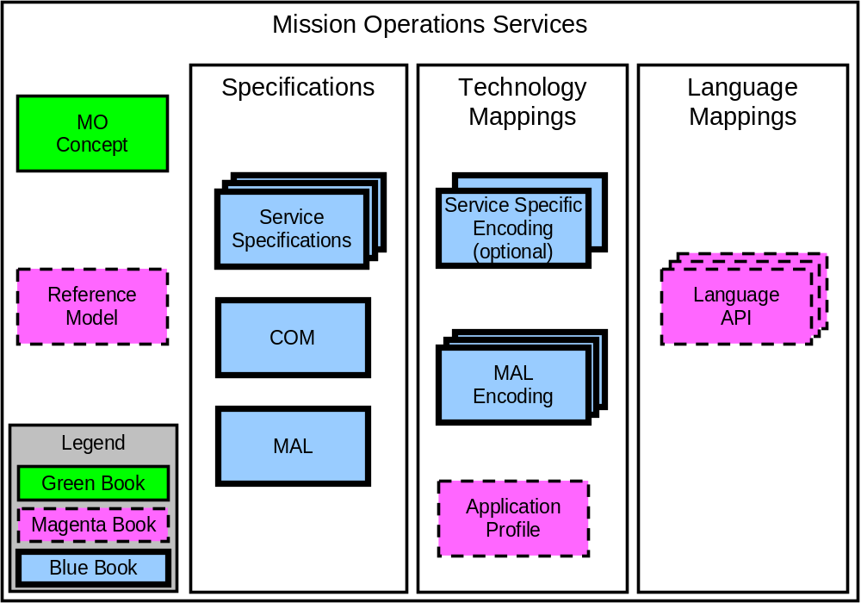
Figure 2-11: Mission Operations Services Concept Document Set
NOTE – References [D4] and [1] contain additional information about the MO Services Concept and the MO Reference Model, respectively.
The MO M&C services build upon the layering concept outlined in reference [D4] and are defined in terms of the MO MAL outlined in reference [2], so it is possible to deploy them over any supported protocol and message transporve.
NOTE – The services defined in this specification are not dependent on any of the other services, and are complete in their own right. An implementation is free to opt out of any service and also any capability set of these services; however, it may not make sense to support certain services without others.

Monitor and Control concept
The M&C services provide the basic ability to monitor and control a remote entity. They provide three basic classes of information:
- Actions allow executable tasks to be invoked and their evolving status to be monitored: spacecraft telecommands are an example of an action.
- Parameters provide status monitoring capability but also may have their value set.
- Alerts provide a mechanism for asynchronous notification of operationally significant events or anomalies by the service provider to the service consumer.
To be compatible with “classical” operation expectations, Packets are also provided.
In most modern systems the M&C services will be used in conjunction with higher level services such as automation and planning, which utilise the M&C services to fulfil their high level functions. For example, a planning service may take in requests to perform activities, these may get decomposed into automated procedures executed by the automation system, which in turn may monitor and control the remote entity using the M&C services:
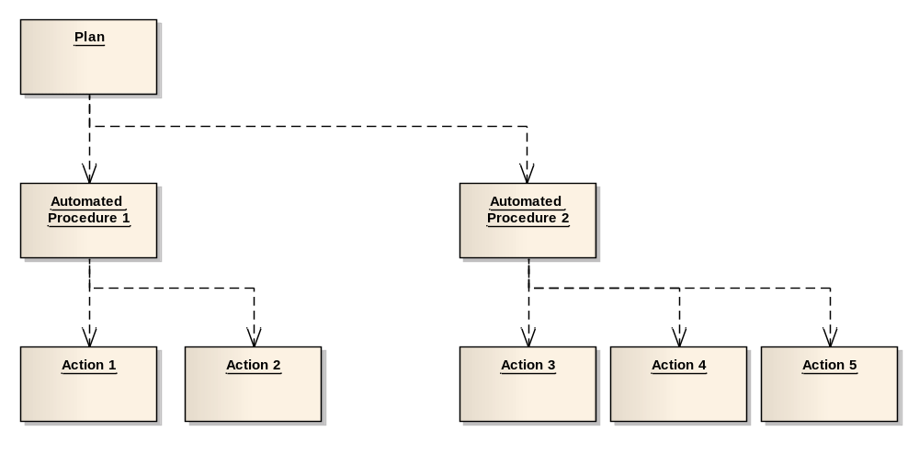
Figure 2-32: MO Service Layering Using Monitor and Control Services
Figure 2-3 shows an information view of the services and demonstrates how the services offered in one area may build upon the services from another area. However, the deployment of those services in a specific system may be different from one deployment to the next.

Monitor and Control System composition
A system as a whole may be composed of many components that support some, all, or none of the M&C services. Any reasonably complex system is also likely to include other services outside of the M&C area, such as planning and scheduling services, or even mission-specific services. It is also likely that more than one component is a provider of M&C services, so not just the end spacecraft, or some component of it, but also ground components such as the Mission Control System (MCS) in the case of mission operations (or a Central Checkout System [CCS] in the case of assembly Integration and Test) may be controllable via the M&C services. Figure 2-5 shows relationships between service consumers and providers in an M&C system and also illustrates how services can be run over different communication protocols appropriate to the link.
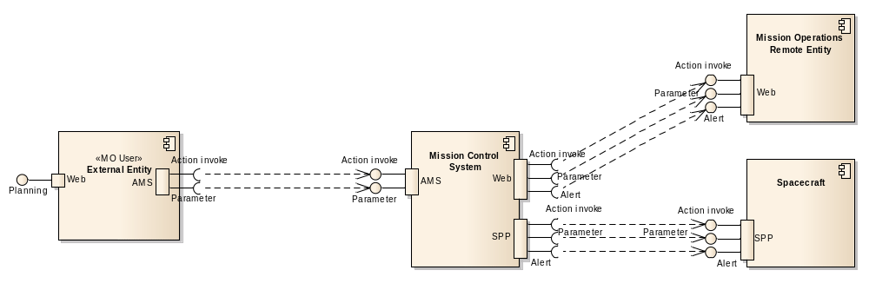
Figure 2-53: Example Service Consumers and Providers
Some components may augment the capabilities of other components by providing extra capabilities on top of those provided by the original component. An example of this is a ground system augmenting the basic parameter information obtained from a spacecraft with validity, check, and statistic information. Figure 2-6 shows a service data augmentation where the MCS augments the raw parameter values from the spacecraft with calibrated/converted values.
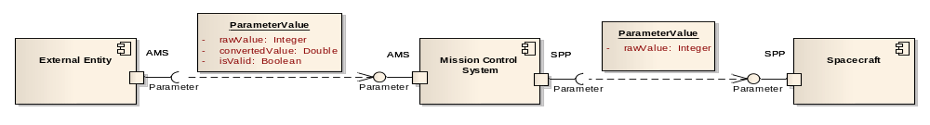
Figure 2-64: Service Data Augmentation

The services defined in this document provide the basis for M&C of a component, local or remote. The following subsections describe the basic uses of each of these services.

Access Control
For many situations there may be a deployment or mission specific policy for limiting either access to specific received data or the ability to execute specific operations. This concept of authentication and authorisation is provided by the MAL access control concept and is covered in subsections 3.6, 5.2, and 5.3 of the Reference Model (reference [1]).

  - Concurrency Control
The main objective of the M&C services specification is to enable a space agency to open its monitoring and control system to other agencies. The scope of the operations allowed for external agency execution is completely controled by the responsible agency, using the Access control features. However, once the operation has been allowed, then the concurrency issue remains.
A complete specification of a service in a parallel execution environment requires the specification of the concurrent access to the service operations. Several choices are available, such as for example:
- the service provider implementation is safe against concurrent access ; the consumers are allowed to call the operation without additional constraint ;
- the service provider segments the actual usages of the operation, so that all consumers are actually isolated from each other ; this segmentation may rely for example on the domain of the objects involved in the operation ;
- the service provider requires an external synchronisation of the consumers before the operation may be called.
Whatever the choice of the service provider implementation, this is not part of the current specification of the service. However the conditions of concurrent use of the service shall be defined in an out of band agreement.

M&C services generic Data Model
Some of the M&C services share the need for an evolving model of service objects. These objects present the following properties :
- they can be uniquely identified over the whole system ;
- they are similar in concept, but different in characteristics ;
- their characteristics are statically defined, but they may occasionaly evolve when a dependent system component changes ;
- they require data structures which depend on those changing characteristics to allow interaction (e.g. arguments for commands or values for monitoring).
The characteristics of these objects could be modeled as MAL types, but this would imply defining several types for all the possibly different objects. Objects could even be made to change type when their characteristics change. In order to avoid those problems, the M&C services specification defines a modeling pattern based on configurable types (using abstract MAL types), which can be interpreted using an object Definition.
The generic M&C services data model is based on a Definition Composite type, each service defining its own Definition type. The service Definition type defines static properties shared by all the service objects, and it may define dynamic properties specific to a service object using a generic list of properties. Each service object (i.e. each instance) is an instance of that type, configured so that it captures the specific characteristics of the object. This service object specific Definition type actually derives from the MAL::Object type, making each service object an MO object (ref). The service object can then be uniquely identified over the whole system using MAL::ObjectRef references. When the characteristics of the object evolve, then a new Definition object can be created, reusing the values of all the fields but the version field of the object identity/reference. The service object is then properly identified by the (domain, area, type, key) tuple, while the version field identifies the version of the object definition.
Beyond the main type of service objects defined as above, each service may define a secondary type of service objets which are usually mapped as MAL composite objects instead of MO Objects. The actual structure of those secondary service objects may also be dynamic, as defined in the main service Definition object. The secondary service objects are attached to a main service object, and are identified relatively to this main service object with a specific local identifier (e.g. an index for the ActionExecutionRequest or a timestamp for the ParameterValue).
The M&C services require representing data values (e.g. action argument values or parameter values). This concept is represented by an extended model which includes an engineering unit conversion capability. Values may then be provided and processed as raw values and/or converted values. Converted values are obtained by applying a Conversion to raw values. In the M&C services, Conversions are defined as a concept and uniquely identified by a MAL::Identifier. However the precise definition of transforming a value by the Conversion is provided as out of band knowledge. A data value is then represented by 7 fields (i.e. raw value type, raw value unit, raw value, conversion, converted value type, converted value unit, converted value), which are used inline and not as a separate type for simplicity.

  - Action Service

General
Actions enable consumers of the service to control the remote system, typically a spacecraft; however, there is no restriction on what mission operations entity the remote system may be. Action invocation operations include issuing of action directives by an authorized client to the remote service provider, and the subsequent monitoring of the evolving execution status of that action by both the initiator and other client functions. It should be noted that the action service is concerned with the execution of actions; the control of when that execution happens is a function of the scheduling service outlined in reference [D4].

Action service data model
The action service defines two major service object types: the ActionDefinition and ActionExecutionRequest objects. The ActionDefinition object implements the action concept of the M&C services, and identifies an executable task defined by the provider. When the provider is asked to actually execute the task, then an ActionExecutionRequest object is created to represent this particular execution of the ActionDefinition.
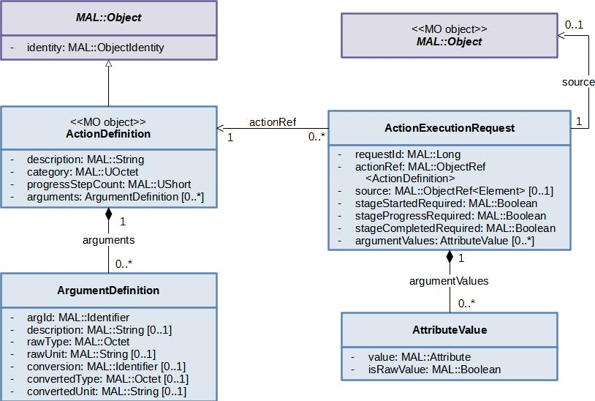
Figure 2-8: Action service data model
The ActionDefinition object follows the template of the M&C services generic data model (ref). It is mapped onto the MO Object concept defined in the MAL (ref). It is identified by a MAL::ObjectIdentity and may be referenced globally by a MAL::ObjectRef. The ActionExecutionRequest object is a contextual object associated to the ActionDefinition. It is uniquely identified by the requestId index relative to the ActionDefinition object.
The ActionExecutionRequest object requires a list of arguments declared as a list of data values. The actual value types, units, and conversion are specified in the associated ActionDefinition object, and may differ for each object. The ActionExecutionRequest object only holds the actual values.

Interleaving of Actions from separate consumers
There are some situations where having multiple sources of actions being submitted, in parallel, to an action provider can cause issues. In these situations, it is a requirement that actions from a single source not be interleaved with those of another; this is sometimes referred to ‘blocking’ or ‘grouping’. The action service as it is currently defined does not support these concepts.
If this feature is needed, it can achieved by using the automation services, or with deployment specific logics.

    - Action authentication
Authentication of received Actions is an essential step of pre-execution checking. It is vital to the security of missions that authentication is covered in the action concept.
For the action service, authentication information is provided by the MAL layer in the header of the submitAction operation. How this is used is a deployment specific decision; however, the concept of authentication is covered in subsections 3.6, 5.2, and 5.3 of the Reference Model (reference [1]).

Action verification
The action service reports to consumers the progress of actions. This verification information provides feedback to consumers about the execution progress (inside the provider). It should be noted that the action service does not model the predicted execution state of an action; it only reports on progress when each stage is reached.
The action execution model mirrors that of the MAL interaction patterns, in that if an error is raised during the execution of the action then the action fails and stops execution. Therefore, in terms of the execution progress reporting, once a report of failure has been made there will not be any more execution progress reports for that action, as it has failed and therefore ended.

  - Parameter service

General

Parameter value monitoring is performed by the reception of reports of a set of predefined monitoring parameters that are published by a Parameter service provider.
Monitoring parameters have an evolving value represented by a chronological sequence of value reports over an unbounded lifetime. Value reports are issued on a periodic base.
A parameter value basically includes a raw value of the monitoring parameter. It may be extended by a converted value when the parameter definition specifies a conversion. The parameter value also defines a validity state which describes how the raw and converted values should be interpreted.
The M&C parameter service does not define the provided parameter information in the service specification; it delegates the definition of the provided parameter information to the runtime configuration of the provider. This does not mean that a component that provides the M&C parameter service has to support dynamic definition of parameters (that may be impossible if the component is a temperature sensor), but that the service specification of the M&C parameter service does not fix what parameters are to be returned for a component, only what the structures look like, and how the parameter information is returned.
Monitoring parameters are basic types such as strings or integers. Composition of parameters is supported by defining an appropriate aggregation (see Aggregation service in 2.12).
In most cases it is expected that the service consumer will register with the service provider for one or more parameters for a period of time and will perform this operation as a set of the following well-defined stages:
- subscribe for parameters;
- receive reports;
- (optional) modify requested parameter list;
- unsubscribe.
It is also possible, when supported, for a consumer of the service to set the value of parameters.
Monitoring parameters will acquire new values by one of the following three methods:
- Physical changes in the properties of a real-world device. This is the case for a spacecraft parameter whose values directly indicate a physical state of the spacecraft.
- Calculations arising from changes to the value of other monitoring parameters. This is the case for a ‘derived’ or ‘synthetic’ parameter that takes the values of other monitoring parameters as inputs and applies a function to produce its value.
- The value being supplied by a consumer of the service to the provider using the setValue operation.

Methods a) and b) can be achieved through a specific deployment which would trigger the service to publish the reports, or by having the physical modules or calculations modules be consumer of the parameter service.

Parameter service data model
The parameter service defines two major service object types: the ParameterDefinition and ParameterValue objects. The ParameterDefinition object implements the monitoring parameter concept of the M&C services. It uniquely identifies a monitoring parameter in the system, and provides a definition of the parameter and of its values. The ParameterValue object is used to represent the evolving value of the monitoring parameter at some time.
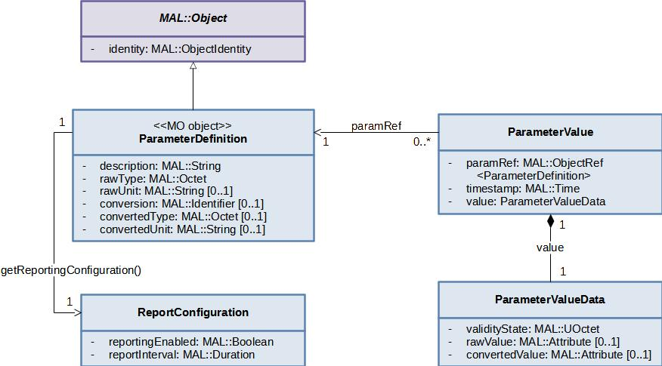
Figure 2-9: Parameter service data model
The ParameterDefinition object follows the template of the M&C services generic data model (ref). It is mapped onto the MO Object concept defined in the MAL (ref). It is identified by a MAL::ObjectIdentity and may be referenced globally by a MAL::ObjectRef. The ParameterValue object is a contextual object associated to the ParameterDefinition. It is identified by a timestamp relative to the ParameterDefinition object.
The actual value types, units, and conversion of the ParameterValue object are actually specified in the associated ParameterDefinition object, and may differ for each object. The ParameterValue object only holds the actual values, together with a state of validity.

Alert Service
Alerts are raised asynchronously to report a significant event or anomaly. Alerts may originate within the remote service provider (spacecraft or other controlled system) itself or within an associated ground-based component in response to a transition in some monitored status.
Alerts are characterised by an identifier and a set of arguments. However, it is possible that some systems require text-only alert messages where the body of the alert is a free-form text message. For these systems it is possible to define a single alert definition that contains a single string argument; however, it should be noted that translation software shall be required when moving argument-based messages and string-based messages between the two formats.

Alert service data model
The alert service defines two major service object types: the AlertDefinition and AlertEvent objects. The AlertDefinition object implements the alert concept of the M&C services. It uniquely identifies a type of alert, and describes the arguments required to notify an alert event of that type. The AlertEvent object is used to represent a specific occurrence of the alert.
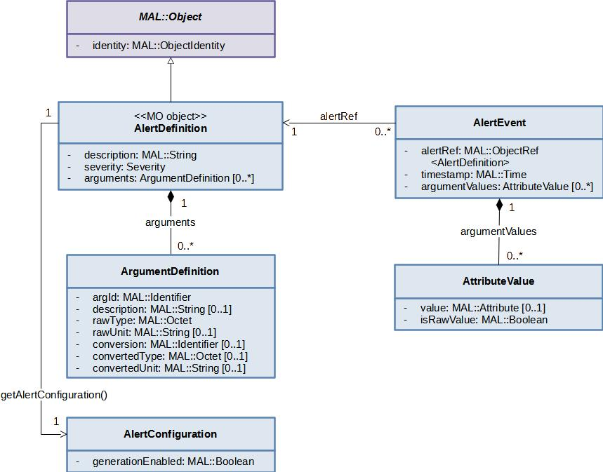
Figure 2-10: Alert service data model
The AlertDefinition object follows the template of the M&C services generic data model (ref). It is mapped onto the MO Object concept defined in the MAL (ref). It is identified by a MAL::ObjectIdentity and may be referenced globally by a MAL::ObjectRef. The AlertEvent object is a contextual object associated to the AlertDefinition. It is identified by a timestamp relative to the AlertDefinition object.
The AlertEvent object requires a list of arguments declared as a list of data values. The actual value types, units, and conversion are specified in the associated AlertDefinition object, and may differ for each object. The AlertEvent object only holds the actual values.

Check Service

General
The monitoring and control of a component includes automatic checks of the parameter values to detect abnormal behaviours. The check service only provides the result of these checks.
The actual definition of the check and how they are executed is not part of the interoperability interfaces. If this information needs to be exchanged, this can be done either by service extension or deployment specific exchange.
The check service allows the consumer to reference the check procedures defined by the provider, and to subscribe to the results of the execution of those check procedures.
A check procedure may be commonly defined to monitor a specific parameter. However it can also be used to monitor any provider specific entity, such as a set of correlated parameters. The definition of the monitored entity is not part of the service specification.

Check service data model
The check service defines a single major service object type: the CheckDefinition object. The CheckDefinition object identifies a check procedure defined by the provider.
The CheckDefinition object is defined according to the template of the M&C services generic data model (ref). It is mapped onto the MO Object concept defined in the MAL (ref). It is identified by a MAL::ObjectIdentity and may be referenced globally by a MAL::ObjectRef.
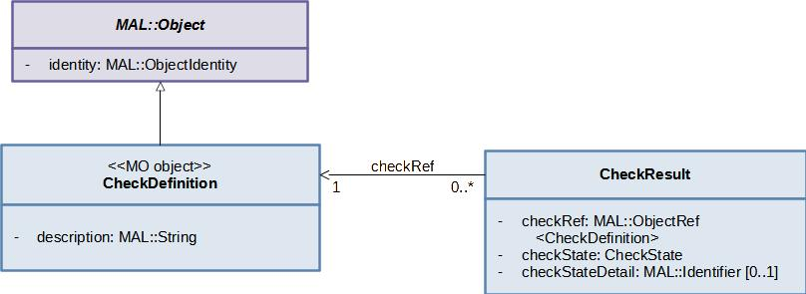
Figure 2-11: Check service data model

  - Aggregation Service

General
A logical extension to basic parameter monitoring is data aggregation. The aggregation service provides the capability to acquire several parameter values in a single request. The aggregation might be one of the following:
- predefined by the service provider, e.g., housekeeping parameters;
- predefined at runtime by the consumer, e.g., a diagnostic report.
For example, the user may request a data product that comprises the accelerations and angular rates of the spacecraft. This would be acquired by reading the appropriate gyros and accelerometers onboard and returning the data as a set. However, if the service provider is actually on the ground, for example an MCS kernel acting as a proxy, then it may collate the set from its current ‘state vector’ of all reported parameters.
The aggregation service provides operations to define which parameters to aggregate and reports the current values of those parameters.

Aggregation service data model
The Aggregation service defines two major service object types: the AggregationDefinition and AggregationValue objects. The AggregationDefinition object uniquely identifies an aggregation in the system, and provides a definition of the aggregation including the list of parameters. The AggregationValue object is used to represent the periodic reports of the values of the aggregation parameters.
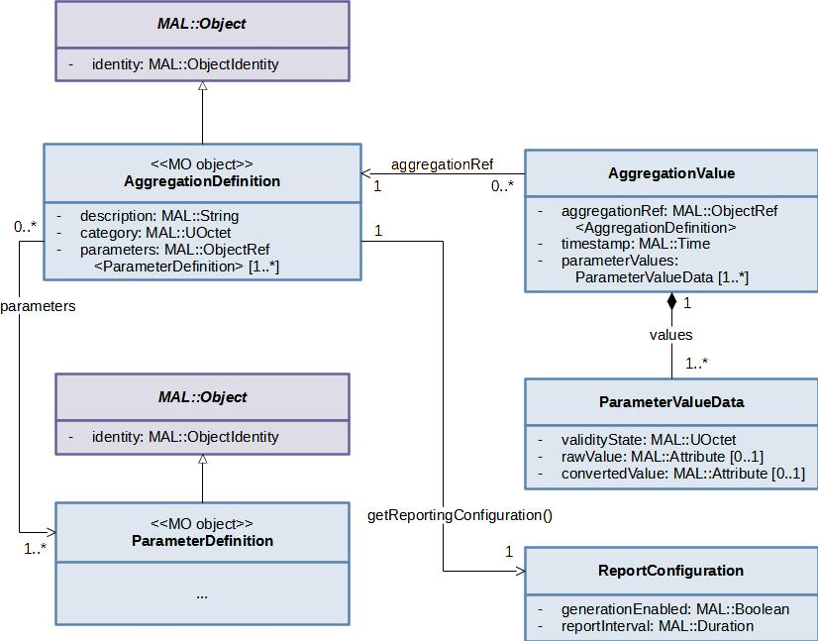
Figure 2-12: Aggregation service data model
The AggregationDefinition object follows the template of the M&C services generic data model (ref). It is mapped onto the MO Object concept defined in the MAL (ref). It is identified by a MAL::ObjectIdentity and may be referenced globally by a MAL::ObjectRef. The AggregationValue object is a contextual object associated to the AggregationDefinition. It is identified by a timestamp relative to the AggregationDefinition object.

Packet service

General
The packet service provides a read only access to the raw space packets exchanged by the provider. It enables consumers to subscribe to a subset of the space packets, based on filtering capabilities which may be specific to the packet types.

Packet service data model
The packet service defines two major service object types: the PacketDefinition and PacketValue objects. The PacketDefinition object implements a type of packets exchanged by the provider. It uniquely identifies a type of packets in the system, and lists the subscription keys that are relevant to the packet type. The PacketValue object is used to represent each published packet.
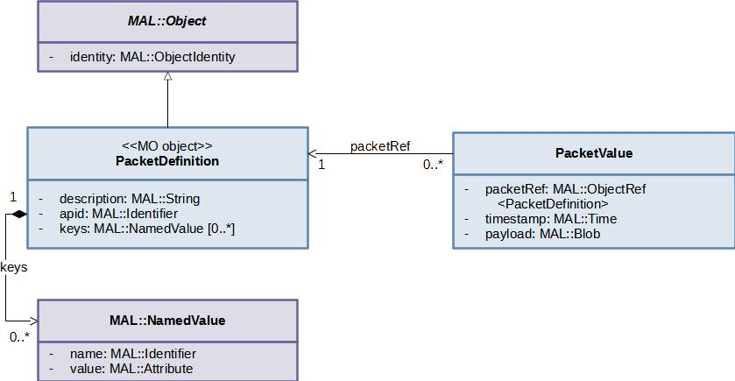
Figure 2-13: Packet service data model
The PacketDefinition object is defined according to the template of the M&C services generic data model (ref). It is mapped onto the MO Object concept defined in the MAL (ref). It is identified by a MAL::ObjectIdentity and may be referenced globally by a MAL::ObjectRef.
The PacketValue object is a contextual object associated to the PacketDefinition. As the use of this object is limited to the single monitorPacket operation, it defines no personal identifier.
The subscription keys implement the meta data associated to the packets which are made accessible to the consumer for filtering purpose. A subscription key is defined by an Identifier, and is associated with an attribute type. The set of subscription keys is globally consistent for all the packet types handled by the provider, i.e. when two packet types declare the same subscription key, then the associated type of the key is the same in the two PacketDefinition objects. The global ordered list of all subscription keys with their associated type used by the packets exchanged by the provider is defined by an out of band agreement. The list of subscription keys defined in each PacketDefinition object shall be a subset of that global list, respecting the list order and the key types.

Specification: MC

Overview
This section details the M&C services; the structures used by the services are detailed in section 4. Both the services and structures are defined in terms of the MO MAL, which is defined in reference [2], so it is possible to deploy them over any supported protocol and message transport
.
To aid comprehension, several tables are included for each service and operation definition. The table formats are briefly described in 1.8.2[3].
All service specifications in this document are part of the MC area, which has a short form number of ‘4’.

Global conventions

Index of elements in lists
This specification refers to the index of elements in lists. The value 0 shall be used to represent the index of the first element.

Service: Action

Overview
The action service allows consumers to submit an action for execution and to subsequently monitor the execution progress of these actions.
An action is represented as an ActionDefinition object. It follows the pattern of a MAL MO Object (ref), i.e. it derives from the MAL::Object type and may be referenced globally by a MAL::ObjectRef. The ActionDefinition object more precisely represents a version of the action definition, while the action itself may be assimilated to the latest version if its definition and may be referenced by a MAL::ObjectRef where the version field is set to 0.
The provider may be requested to execute an action using the requestExecution operation. This specific execution request is represented as an ActionExecutionRequest object. The ActionExecutionRequest object references the ActionDefinition to be executed (field actionRef), and is identified by a numeric identifier (field requestId) relative to the action. The action request identifier must be provided by the consumer, but it must be unique in the system. Coordination may be required between Action service consumers to ensure the action request identifiers are unique. How this is done is outside the scope of this specification. In a distributed command scenario, an ICD may be used to prevent collision of Ids.
If the provider accepts the action execution request, then the ActionExecutionRequest object reference may be subsequently used to monitor the execution progress of the action.

The nominal sequence of action submission and execution monitoring are shown in figure 3-14.

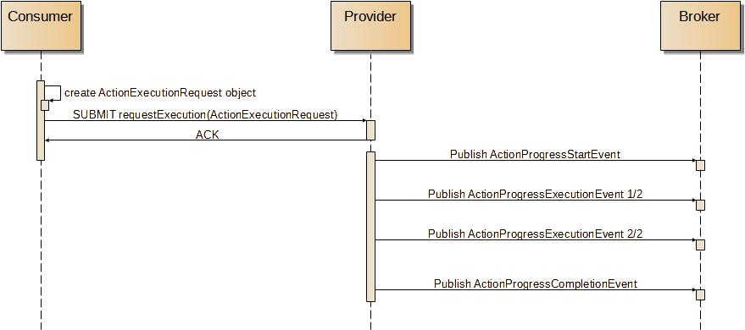
Figure 3-146: Nominal Sequence of Action Submission and Monitoring
The sequence above shows the activity execution progress events being published to a MAL broker). The sequence does not show the broker passing the events to any subscribed consumers, as that is outside the intent of the figure.
The consumer is responsible for creating the ActionExecutionRequest object, with its unique key, and then using the requestExecution operation to submit it to the Action provider for execution. The Action provider reports the execution progress of the action, through events published by its monitorActionExec operation. Once the supplied action request details have been checked and execution of the action validated by the requestExecution operation, that operation finishes, whilst the execution of the action possibly continues (depends on the actual action).
If the execution of an action fails with an error, the action service provider can publish a progress event with a success status set to false.

Table 3-22: Action Service Operations
Area Identifier | Service Identifier | Area Number | Service Number | Area Version
MC | Action | 4 | 1 | 2
Interaction Pattern | Operation Identifier | Operation Number | Support in Replay | Capability Set
SUBMIT | requestExecution | 7 | No | 1
PUBLISH-SUBSCRIBE | monitorActionExec | 8 | Yes | 2

High-Level Requirements
      - The action service shall provide:
- the capability for submitting execution requests of actions;

- the capability for monitoring the execution progress of actions;

      - The list of actions that are supported by the action service shall be declared when deploying that service.
      - Each action execution request shall include:
- the action definition object reference;
- the request identifier;
- the ordered list of action arguments;
- the reporting instructions.
      - The service consumer shall be responsible for choosing the action execution request identifier.
      - The service consumer shall be able to provide an argument value as either a raw values or a converted values, when a conversion is supplied in the related ArgumentDefinition.
      - The service provider shall control the unicity of the action execution request identifier supplied by the service consumer.
      - The service provider shall accept to monitor the progress of an execution request that has not yet been submitted.
      - The service provider shall accept an argument value whether provided as a raw value or a converted value, when a conversion is supplied in the related ArgumentDefinition.
      - Whenever actions are referenced as MAL::ObjectRef typed parameters in operations, then it shall be possible to use references with a version field set to 0 to reference the latest version of the action definition.

Functional Requirements

      - The requestExecution operation shall be used to request the execution of an action.
      - The monitorActionExec operation shall be used to monitor the execution progress of submitted execution requests with request identifiers that match the subscription, whether the execution requests have been submitted before or after the subscription.
      - The monitorActionExec operation shall only publish the progress reporting events that have been declared as parameters of the requestExecution operation call that started the action execution.

OPERATION: requestExecution

Overview
The requestExecution operation allows a consumer to request a provider to execute an action.
Operation Identifier | requestExecution
Interaction Pattern | SUBMIT
Pattern Sequence | Message | Type Signature
IN | SUBMIT | executionRequest : (ActionExecutionRequest)

Structures
        - The executionRequest parameter shall describe the requested action and the modalities for its execution.
        - The requestId field of the executionRequest parameter shall contain the numeric identifier of the action execution request.
        - If the numeric identifier of the action execution request is already known by the provider, then a DUPLICATE error shall be returned.
        - In the context of an Action forwarding scenario, the numeric identifier of the action execution request shall be the same for all Action service providers in the forwarding chain, including the front provider and the final provider.
        - The actionRef field of the executionRequest parameter shall contain the object reference of the action definition.

        - If the actionRef field of the executionRequest parameter does not match a known ActionDefinition object then an UNKNOWN error shall be returned.
        - The stageStartedRequired, stageProgressRequired, and stageCompletedRequired fields of the executionRequest parameter shall control the messages actually published by the monitorActionExec operation as regards the progress of the action execution.
        - The argumentValues field of the executionRequest parameter shall contain the ordered list of arguments to use when starting the action execution.
        - The size of the argumentValues list of the executionRequest parameter shall be compared to the size of the arguments list in the matched ActionDefinition object and an INVALID error shall be returned if they are not the same.

        - If a supplied argument value is provided as a converted value while there is no conversion supplied in the related ArgumentDefinition, then an INVALID error shall be returned.
        - If a supplied argument value does not match the attribute type specified in the action definition for that argument, taking into account the raw or converted nature of the supplied argument, then an INVALID error shall be returned.
        - A service provider may apply some deployment specific checks to the action execution request and can return an INVALID error if they fail.
        - If an error is raised then no action shall be executed.
        - The SUBMIT acknowledgement shall be returned once the action has been accepted for execution but before execution starts.

      - Errors
The operation may return one of the following errors:
- ERROR: DUPLICATE: submitted execution request identifier is already used.
- the provided execution request identifier in a requestExecution operation call is already known by the provider;
Error | Error # | ExtraInfo Type
DUPLICATE | 70022 | Not Used
- ERROR: INVALID:
- the argumentValues list size of the ActionExecutionRequest does not match the arguments definition or it contains one or more invalid argument values;
- if the two lists are not the same length then the extra information field shall contain a singleton list with the first index of the element in the largest list which does not have corresponding element in the other list;
- the extra information field contains a list of the indexes of the erroneous values from the originating list supplied;
Error | Error # | ExtraInfo Type
INVALID | 70023 | List<MAL::UInteger>
- ERROR: UNKNOWN: submitted action definition is unknown.
- the provided action definition reference is not known by the provider;
Error | Error # | ExtraInfo Type
UNKNOWN | Defined in MAL | Not Used

The preCheckAction operation allows a consumer to check that an action would be successfully accepted for execution without actually submitting the action. The operation is expected to be provided by local action proxies rather than the remote system to allow for quick local checks before sending the action over long and slow space links.

- action definition is unknown.

The listDefinition operation allows a consumer to request the object instance identifiers of the latest ActionIdentity and ActionDefinition objects for the supported actions of the provider.

The addAction operation allows a consumer to define one or more actions that do not currently exist. The new ActionIdentity and ActionDefinition objects are expected to be stored in the COM archive by the provider of the action service.

- extra information field contains a list of the indexes of the erroneous values from the originating request list.

The operation does not remove the previous ActionDefinition object from the COM archive, merely removes the object from the provider. This permits existing, and completed, ActionInstance objects to continue to reference the correct ActionIdentity and ActionDefinition objects in the COM archive.

- list of the indexes of the error values shall be contained in the extra information field.

The operation does not remove the ActionIdentity or ActionDefinition object from the COM archive, merely removes the objects from the provider. This permits existing, and completed, ActionInstance objects to continue to reference the correct ActionIdentity and ActionDefinition objects in the COM archive.

list of the indexes of the error values shall be contained in the extra information field.

OPERATION: monitorActionExec

Overview
The monitorActionExec operation allows a consumer to be informed of the progress in the execution of an action or a set of actions.
The model for monitoring the progress in the execution of an action is simple, as a sequence of stages published as ActionProgressBaseEvents. The first execution stage is a started stage, and shall be published as an ActionProgressStartEvent. The last execution stage in a successful execution is a completed stage, and shall be published as an ActionProgressCompletionEvent. In between the started and completed stages, a variable number of anonymous execution progress stages are allowed, which shall be published as ActionProgressExecutionEvents.
Each execution of an action defines a total number of execution progress stages to be reported. This concerns only the ActionProgressExecutionEvent typed events, and for a nominal execution. This number shall be set to the stageCount field of the corresponding ActionProgressExecutionEvent structure.
A new message shall be published whenever a new execution stage has been reached, and if the reporting of this stage has been required in the ActionExecutionRequest object representing the executed action.
Each actually published execution progress stage is identified by its sequence number, starting at 1.
The message includes a success marker, defined in the base type. If it is false then the sequence is stopped and no further progress message will be issued for that specific execution.
The set of action request executions to monitor is defined by filters provided mainly as subscription keys of the Publish-Subscribe operation.
Operation Identifier | monitorActionExec
Interaction Pattern | PUBLISH-SUBSCRIBE  requestId : MAL::Long  actionKey : MAL::Identifier  actionCategory : MAL::UOctet  sourceKey : MAL::Identifier
Pattern Sequence | Message | Type Signature
OUT | PUBLISH/NOTIFY | progressEvent : (ActionProgressBaseEvent)

Structures
        - The value of the domain field of the MAL::UpdateHeader of the Publish message shall be set to the domain field of the identity field of the ActionDefinition object representing the executed action definition.
        - The value of the requestId subscription key shall be set to the requestId field of the ActionExecutionRequest object representing the executed action.
        - The value of the actionKey subscription key shall be set to the key field of the identity field of the ActionDefinition object representing the executed action definition.
        - The value of the actionCategory subscription key shall be set to the category field of the ActionDefinition object representing the executed action definition.
        - The value of the sourceKey subscription key shall be set to the key field of the source field of the ActionExecutionRequest object representing the executed action.
        - The executionStage field of the ActionProgressExecutionEvent typed progressEvent parameter of the successive publish messages published with the same set of subscription key values shall be set to successive numeric values starting at 1.
        - The executionStage field of the ActionProgressExecutionEvent typed progressEvent parameter shall be less than or equal to the stageCount field.
        - If the success field of the progressEvent parameter of a publish message is set to False, then this message shall be the last one sent with that set of subscription key values.

Service: Parameter

Overview
The parameter service allows the user to subscribe to parameter value report and optionally be able to set new values. A single PUBSUB operation is provided for monitoring and publishing of parameter values.
A parameter value also contains a calculation of the validity of the parameter, .which describes how the raw and converted values of the parameter should be interpreted.

This standard supports the concept of non-standard invalidity states but the meaning and calculation of these is outside the scope of this document.

The generation of value reports, including effective generation and generation frequency, is initially configured externally to the Parameter service. This initial configuration can then be browsed and changed using a set of dedicated operations.
The parameter service does not include any value checking, this is delegated to the check service.

Table 3-55: Parameter Service Operations
Area Identifier | Service Identifier | Area Number | Service Number | Area Version
MC | Parameter | 4 | 2 | 2
Interaction Pattern | Operation Identifier | Operation Number | Support in Replay | Capability Set
PUBLISH-SUBSCRIBE | monitorValue | 1 | Yes | 1
REQUEST | getValue | 2 | Yes | 2
SUBMIT | setValue | 3 | No | 3
REQUEST | getReportingConfiguration | 9 | No | 4
SUBMIT | enableReporting | 10 | No | 4
SUBMIT | disableReporting | 11 | No | 4
SUBMIT | setReportingPeriod | 12 | No | 4

High-Level Requirements
      - The parameter service shall provide:
- the capability for publishing and receiving periodic reports of the value of a monitoring parameter;

- the capability for setting the raw parameter value of a set of parameters;
- the capability for requesting the current value of a set of parameters;
- the capability for requesting and modifying the configuration of the periodic publication of reports for a parameter;

      - The list of parameters that are supported by the action service shall be declared when deploying that service.
      - A default configuration for the periodic generation of reports for each parameter shall be defined by the provider of the Parameter service, but this is not part of its interface.
      - Each parameter value report shall contain:
- The validity of the parameter value;
- The raw value of the parameter, if applicable;
- The converted value of the parameter, if applicable.
      - The validity of parameter values shall be calculated by implementation specific mechanisms.

    - Functional Requirements
      - The actual generation of reports of a parameter shall be enabled by the enableReporting operation, and disabled by the disableGeneration operation.

      - If a parameter is required to send periodic reports then the time between these reports shall be controlled using the setReportingPeriod operation.

      - For onboard parameters, the interval should be a multiple of the minimum sampling interval of those parameters.
      - If an interval that is not supported by the provider is requested, then an INVALID error shall be returned, and the change rejected.
      - A default configuration for the generation of reports shall exist for each parameter. It shall be set by implementation specific mechanisms.
      - The getReportingConfiguration operation shall return the current configuration for the generation of reports for a parameter.
      - If the parameter is periodic and reported via a periodic aggregation, and a new report has not been received in the aggregation period, then the validity shall be set to EXPIRED by setting the ParameterValueData validityState field to ‘1’ and the rawValue set to the last known parameter raw value.
      - If the parameter raw value cannot be obtained, or calculated for synthetic parameters, then the validity state shall be INVALID_RAW by setting the ParameterValueData validityState field to ‘2’ and the rawValue set to NULL.
      - If the parameter raw value is deemed to be valid by the provider, and the ParameterDefinition either does not contain a conversion or the conversion is successful, then the validity state shall be set to VALID by setting the ParameterValueData validityState field to ‘0’ and the rawValue set to the parameter raw value.
      - If the parameter raw value is deemed to be valid by the provider, and the conversion of the parameter value fails (for example an unexpected value for a discrete conversion), then the validity state shall be INVALID_CONVERSION by setting the ParameterValueData validityState field to ‘3’, and the rawValue set to the parameter raw value.
      - If the validity of the raw value cannot be evaluated because of invalid dependant data, then the validity state shall be set to UNVERIFIED by setting the ParameterValueData validityState field to ‘4’, and the rawValue set to the parameter raw value.
      - If the parameter raw value is deemed to be invalid by the provider, then the validity state shall be set to INVALID by setting the ParameterValueData validityState field to ‘5’, and the rawValue set to the parameter raw value.
      - If the validity of the parameter is INVALID_CONVERSION then the convertedValue of the ParameterValueData shall be set to NULL.
      - If the validity of the parameter is either EXPIRED, UNVERIFIED or INVALID and the ParameterDefinition contains a conversion, then the convertedValue of the ParameterValueData shall contain the converted value, or NULL if the conversion fails.

      - It is supported that other, deployment specific, validityState values be used; however, the meaning of those values is deployment specific and outside the scope of this standard. They must use values greater than 127.

OPERATION: monitorValue

Overview
The monitorValue operation allows a consumer to subscribe for parameter value reports.
Operation Identifier | monitorValue
Interaction Pattern | PUBLISH-SUBSCRIBE  parameterKey: MAL::Identifier  parameterVersion: MAL::Uinteger
Pattern Sequence | Message | Type Signature
OUT | PUBLISH/NOTIFY | timestamp: MAL::Time  newValue : (ParameterValueData)

Structures
        - The value of the domain field of the UpdateHeader shall be set to the domain field of the identity of the ParameterDefinition object whose value is reported.
        - The value of the parameterKey subscription key shall be set to the key field of the identity of the ParameterDefinition object whose value is reported.
        - The value of the parameterVersion subscription key shall be set to the version field of the identity of the ParameterDefinition object whose value is reported.
        - The newValue parameter of the publish message body shall be set to the new value of the parameter.
        - The timestamp parameter of the publish message body shall be set to the time when the newValue has originally been issued.

      - Errors
The operation does not return any errors.

OPERATION: getValue

Overview
The getValue operation returns the latest received value for a requested parameter.
Operation Identifier | getValue
Interaction Pattern | REQUEST
Pattern Sequence | Message | Type Signature
IN | REQUEST | parameterIds : (List<MAL::ObjectRef<ParameterDefinition>>)
OUT | RESPONSE | parameterValues : (List<ParameterValue>)

Structures
        - The parameterIds field shall provide the list of object references to ParameterDefinition objects whose values are requested.
        - An object reference with its version field set to 0 shall refer to the latest version of the ParameterDefinition object.
        - A NULL value for parameterIds shall be supported and matches all parameters of the provider.

        - If a requested parameter is unknown then an UNKNOWN error shall be returned.
        - If a parameter is being reported periodically, using the operation shall not reset the reportInterval timer.
        - The response shall contain a list of returned parameter values matching the input list of references.
        - The new value shall not be published via the monitorValue operation.

Errors
The operation may return the following error: ERROR: UNKNOWN:
- one or more of the requested parameters is unknown;
- a list of the indexes of the error values shall be contained in the extra information field.
Error | Error # | ExtraInfo Type
UNKNOWN | Defined in MAL | List<MAL::UInteger>

OPERATION: setValue

Overview
The setValue operation allows a consumer to set the raw value for one or more parameters.
Operation Identifier | setValue
Interaction Pattern | SUBMIT
Pattern Sequence | Message | Type Signature
IN | SUBMIT | parameterRefs: (List<MAL::ObjectRef <ParameterDefinition>>)  newRawValues : (List<MAL::Attribute>)

Structures
        - The submitted parameterRefs contains the list of references to parameters to set the new value of.
        - The submitted newRawValues shall hold a matching list of new raw values to be set.
        - The values in newRawValues shall not be NULL.
        - If parameterRefs contains a NULL value then an INVALID error shall be returned.
        - An object reference with its version field set to 0 shall refer to the latest version of the ParameterDefinition object.
        - If a requested ParameterDefinition reference is unknown then an UNKNOWN error shall be returned.
        - If a requested parameter listed in parameterRefs is not settable because of its being read only, then a READONLY error shall be returned.

        - If any supplied new parameter raw value does not match the defined type in the matching ParameterDefinition then an INVALID error shall be returned.
        - If an error is raised then no modifications shall be made as a result of this operation call.
        - The parameter values shall be set concurrently, by this it is meant that all values are set at the same time without interleaving of other values being (ATOMIC behaviour). How this is implemented is an implementation detail.
        - The service provider shall publish the new values through the monitorValue operation.

Errors
The operation may return one of the following errors:
- ERROR: UNKNOWN:
- one or more of the referenced parameters is unknown;
- a list of the indexes of the error values shall be contained in the extra information field;
Error | Error # | ExtraInfo Type
UNKNOWN | Defined in MAL | List<MAL::UInteger>
- ERROR: INVALID:
- one of the supplied parameter values contains an invalid value;
- the extra information field contains a list of the indexes of the erroneous values from the originating list supplied;
Error | Error # | ExtraInfo Type
INVALID | 70023 | List<MAL::UInteger>
- ERROR: READONLY:
- one or more of the parameters being set is read only;
- a list of the indexes of the error values shall be contained in the extra information field.
Error | Error # | ExtraInfo Type
READONLY | 70020 | List<MAL::UInteger>

OPERATION: getReportingConfiguration

Overview
The getReportingConfiguration operation allows a consumer to retrieve the current configuration for the generation of reports for a parameter.
Operation Identifier | getReportingConfiguration
Interaction Pattern | REQUEST
Pattern Sequence | Message | Type Signature
IN | REQUEST | parameterRefs : (List<MAL::ObjectRef <ParameterDefinition>>)
OUT | RESPONSE | reportConfigs : (List<ReportConfiguration>)

Structures
        - The parameterRefs parameter shall contain references to ParameterDefinition objects.
        - An object reference with its version field set to 0 shall refer to the latest version of the ParameterDefinition object.
        - If a requested ParameterDefinition reference is unknown then an UNKNOWN error shall be returned.
        - The response shall contain the list of report configurations for each ParameterDefinition object of the input list.

Errors
The operation may return one of the following errors:
- ERROR: UNKNOWN:
- one or more of the requested parameters is unknown;
- a list of the indexes of the error values shall be contained in the extra information field;
Error | Error # | ExtraInfo Type
UNKNOWN | Defined in MAL | List<MAL::UInteger>

OPERATION: enableReporting

Overview
The enableReporting operation allows a consumer to request the generation of reports for specific parameters.
Operation Identifier | enableReporting
Interaction Pattern | SUBMIT
Pattern Sequence | Message | Type Signature
IN | SUBMIT | parameterRefs : (List<MAL::ObjectRef <ParameterDefinition>>)

Structures
        - The parameterRefs parameter shall contain references to the ParameterDefinition objects for which reports are requested to be generated.

        - If parameterRefs is NULL, then the operation effects shall be applied to all known ParameterDefinition objects of the provider.

        - No error shall be raised if report generation is already enabled for a matched ParameterDefinition object; i.e., enabling an already enabled parameter will not result in an error.
        - If a requested ParameterDefinition reference is unknown then an UNKNOWN error shall be returned.

        - If an error is raised then no modifications shall be made as a result of this operation call.

        - If the generation of reports is being enabled, while it was not before, then the provider shall generate a report immediately and start the report interval from that report.

Errors
The operation may return one of the following errors:
- ERROR: UNKNOWN:
- one or more of the requested parameters is unknown;
- a list of the indexes of the error values shall be contained in the extra information field;
Error | Error # | ExtraInfo Type
UNKNOWN | Defined in MAL | List<MAL::UInteger>

- .

OPERATION: disableReporting

Overview
The disableReporting operation allows a consumer to stop the generation of reports for specific parameters.
Operation Identifier | disableReporting
Interaction Pattern | SUBMIT
Pattern Sequence | Message | Type Signature
IN | SUBMIT | parameterRefs : (List<MAL::ObjectRef <ParameterDefinition>>)

Structures
        - The parameterRefs parameter shall contain references to the ParameterDefinition objects for which reports are requested to be stopped.
        - If parameterRefs is NULL, then the operation effects shall be applied to all known ParameterDefinition objects of the provider.
        - No error shall be raised if report generation is already disabled for a matched ParameterDefinition object; i.e., disabling an already disabled parameter reporting will not result in an error.
        - If a requested ParameterDefinition reference is unknown then an UNKNOWN error shall be returned.
        - If an error is raised then no modifications shall be made as a result of this operation call.

Errors
The operation may return one of the following errors:
- ERROR: UNKNOWN:
- one or more of the requested parameters is unknown;
- a list of the indexes of the error values shall be contained in the extra information field;
Error | Error # | ExtraInfo Type
UNKNOWN | Defined in MAL | List<MAL::UInteger>

OPERATION: setReportingPeriod

Overview
The setReportingPeriod operation allows a consumer to set the reporting interval for specific parameters.
Operation Identifier | setReportingPeriod
Interaction Pattern | SUBMIT
Pattern Sequence | Message | Type Signature
IN | SUBMIT | parameterRefs : (List<MAL::ObjectRef <ParameterDefinition>>)  reportInterval : MAL::Duration

Structures
        - The parameterRefs parameter shall contain references to the ParameterDefinition objects for which the report generation period is to be set.
        - If parameterRefs is NULL, then the operation effects shall be applied to all known ParameterDefinition objects of the provider.
        - If a requested ParameterDefinition reference is unknown then an UNKNOWN error shall be returned.
        - If an error is raised then no modifications shall be made as a result of this operation call.
        - The reportInterval parameter shall contain the new report generation period to set to all the ParameterDefinition objects involved in the operation.
        - If reportInterval is NULL then an INVALID error shall be returned.
        - If reportInterval is 0 then the lowest possible value for each parameter shall be used by the provider.
        - If the provided reportInterval value is not supported by the provider for a parameter, then an INVALID error shall be returned.
        - The report generation period shall be set to the parameters involved in the operation whatever their reporting status. If the reporting of a parameter is disabled, then the new reporting period shall be used when the reporting of the parameter is enabled again.

Errors
The operation may return one of the following errors:
- ERROR: UNKNOWN:
- one or more of the requested parameters is unknown;
- a list of the indexes of the error values shall be contained in the extra information field;
Error | Error # | ExtraInfo Type
UNKNOWN | Defined in MAL | List<MAL::UInteger>
- ERROR: INVALID:
- the report interval is NULL, or its value is not supported for one or more of the requested parameters;
- the extra information field contains a list of the indexes of the erroneous values from the originating list supplied;
Error | Error # | ExtraInfo Type
INVALID | 70023 | List<MAL::UInteger>

The listDefinition operation allows a consumer to request the latest object instance identifiers of the ParameterIdentity and ParameterDefinition objects for the supported parameters of the provider.

list of the indexes of the error values shall be contained in the extra information field.

The new ParameterIdentity and ParameterDefinition objects are expected to be stored in the COM archive by the provider of the parameter service.

- extra information field contains a list of the indexes of the erroneous values from the originating request list.

merely removes the object from the provider.

- list of the indexes of the error values shall be contained in the extra information field.

The operation does not remove the ParameterIdentity or ParameterDefinition objects from the COM archive, merely removes the objects from the provider. This permits existing parameter values to continue to reference the correct ParameterIdentity and ParameterDefinition objects in the COM archive.

list of the indexes of the error values shall be contained in the extra information field.

Service: Alert

Overview
The alert service defines the structures and patterns for the publishing and monitoring of alerts.
The generation of value reports, including effective generation and generation frequency, is initially configured externally to the Parameter service. This initial configuration can then be browsed and changed using a set of dedicated operations
The generation of alerts is initially enabled or disabled by the provider. This initial configuration can then be browsed and changed using a set of dedicated operations.

Table 3-77: Alert Service Operations
Area Identifier | Service Identifier | Area Number | Service Number | Area Version
MC | Alert | 4 | 3 | 2
Interaction Pattern | Operation Identifier | Operation Number | Support in Replay | Capability Set
REQUEST | getAlertConfiguration | 6 | No | 1
SUBMIT | enableGeneration | 7 | No | 1
SUBMIT | disableGeneration | 8 | No | 1
PUBLISH-SUBSCRIBE | monitorAlert | 9 | Yes | 1

High-Level Requirements
      - The alert service shall provide:
- the capability for publishing and receiving alerts;
- the capability for controlling reporting of alerts
- .
      - The alert reporting service shall provide the capability for requesting and modifying the configuration of the generation of alert reports.

      - The list of alert definitions that are supported by the alert service shall be declared when deploying that service.

Functional Requirements
      - The actual generation of alerts shall be enabled by the enableGeneration operation, and disabled by the disableGeneration operation.

      - Generation of all alerts shall be initially disabled.
      - The getGenerationConfig operation shall return the current configuration for the generation of an alert.

OPERATION: getAlertConfiguration

Overview
The getAlertConfiguration operation allows a consumer to retrieve the current configuration for the generation of an alert.
Operation Identifier | getAlertConfiguration
Interaction Pattern | REQUEST
Pattern Sequence | Message | Type Signature
IN | REQUEST | alertRefs : (List<MAL::ObjectRef <AlertDefinition>>)
OUT | RESPONSE | alertConfigs : (List<AlertConfiguration>)

Structures
        - The alertRefs parameter shall contain references to AlertDefinition objects.
        - An object reference with its version field set to 0 shall refer to the latest version of the AlertDefinition object.
        - If a requested AlertDefinition reference is unknown then an UNKNOWN error shall be returned.
        - The response shall contain the list of alert configurations for each AlertDefinition object of the input list.

Errors
The operation may return one of the following errors:
- ERROR: UNKNOWN:
- one or more of the requested alerts is unknown;
- a list of the indexes of the error values shall be contained in the extra information field;
Error | Error # | ExtraInfo Type
UNKNOWN | Defined in MAL | List<MAL::UInteger>

OPERATION: enableGeneration

Overview
The enableGeneration operation allows a consumer to control whether instances of specific alerts are generated or not.
Operation Identifier | enableGeneration
Interaction Pattern | SUBMIT
Pattern Sequence | Message | Body Signature
IN | SUBMIT | alertRefs : (List<MAL::ObjectRef <AlertDefinition>>)

Structures
        - The alertRefs field shall contain references to the AlertDefinition objects for which instances are requested to be generated.

        - If parameterRefs is NULL, then the operation effects shall be applied to all known AlertDefinition objects of the provider.

        - No error shall be raised if alert generation is already enabled for an alert object; i.e., enabling an already enabled alert will not result in an error.
        - If a requested AlertDefinition reference is unknown then an UNKNOWN error shall be returned.

        - If an error is raised then no modifications shall be made as a result of this operation call.

Errors
The operation may return one of the following errors:

- ERROR: UNKNOWN:
- one or more of the requested alerts or group objects is unknown;
- a list of the indexes of the error values shall be contained in the extra information field.
Error | Error # | ExtraInfo Type
UNKNOWN | Defined in MAL | List<MAL::UInteger>

OPERATION: disableGeneration

Overview
The disableGeneration operation allows a consumer to stop the generation of instances of specific alerts.
Operation Identifier | disableGeneration
Interaction Pattern | SUBMIT
Pattern Sequence | Message | Type Signature
IN | SUBMIT | alertRefs : (List<MAL::ObjectRef <AlertDefinition>>)

Structures
        - The alertRefs parameter shall contain references to the AlertDefinition objects for which instances generation is requested to be disabled.
        - If alertRefs is NULL, then the operation effects shall be applied to all known AlertDefinition objects of the provider.
        - No error shall be raised if alert generation is already disabled for a matched AlertDefinition object; i.e., disabling an already disabled alert will not result in an error.
        - If a requested AlertDefinition reference is unknown then an UNKNOWN error shall be returned.
        - If an error is raised then no modifications shall be made as a result of this operation call.

Errors
The operation may return one of the following errors:
- ERROR: UNKNOWN:
- one or more of the requested alerts is unknown;
- a list of the indexes of the error values shall be contained in the extra information field;
Error | Error # | ExtraInfo Type
UNKNOWN | Defined in MAL | List<MAL::UInteger>

OPERATION: monitorAlert

Overview
The monitorAlert operation allows a consumer to subscribe for alerts. The operation conceptually publishes AlertEvent structures, but it actually publishes the fields that are not present in the list of subscription keys.
Operation Identifier | monitorAlert
Interaction Pattern | PUBLISH-SUBSCRIBE  alertKey: MAL::Identifier  alertVersion: MAL::Uinteger  alertSeverity: MAL::UOctet
Pattern Sequence | Message | Type Signature
OUT | PUBLISH/NOTIFY | timestamp : MAL::Time  arguments : (List<AttributeValue>)

Structures
        - The value of the domain field of the UpdateHeader shall be set to the domain field of the identity of the AlertDefinition object whose instance is reported.
        - The value of the alertKey subscription key shall be set to the key field of the identity of the AlertDefinition object whose instance is reported.
        - The value of the alertVersion subscription key shall be set to the version field of the identity of the AlertDefinition object whose instance is reported.
        - The value of the alertSeverity subscription key shall be set to the severity field of the AlertDefinition object whose instance is reported.
        - The timestamp parameter of the publish message body shall be set to the time when the alert has been detected.
        - The arguments parameter of the publish message body shall be set to the values of the parameters declared in the alert definition.

Errors
The operation does not return any errors.

The listDefinition operation allows a consumer to request the latest object instance identifiers of the AlertIdentity and AlertDefinition objects for the supported alerts of the provider.

list of the indexes of the error values shall be contained in the extra information field.

The new AlertIdentity and AlertDefinition objects are expected to be stored in the COM archive by the provider of the alert service.

- extra information field contains a list of the indexes of the erroneous values from the originating list supplied.

The operation does not remove the previous object from the COM archive, merely removes the object from the provider.

- list of the indexes of the error values shall be contained in the extra information field.

The operation does not remove the AlertIdentity or AlertDefinition objects from the COM archive, merely removes the objects from the provider. This permits existing AlertEvent objects to continue to reference the correct AlertDefinition object in the COM archive.

list of the indexes of the error values shall be contained in the extra information field.

Service: Check

Overview
The check service allows the consumer to reference the check procedures defined by the provider, and to subscribe to the results of the execution of those check procedures.
The consumer knowledge of the check procedure is provided by an out of band agreement. This includes the identifier of the check procedure (domain, key and version fields of the CheckDefinition object), and the description of the check procedure semantics. It may also include other details related to the execution of the check procedure, but this is not mandatory.
The check procedure is executed by the provider according to the provider’s politics. The consumer may register to the provider in order to receive a report whenever the check procedure is executed. The main content of this report is the state of the execution which indicates whether the execution completed successfully, and if so whether the monitored entity respects the semantics of the check procedure.

Table 3-1010: Check Service Operations
Area Identifier | Service Identifier | Area Number | Service Number | Area Version
MC | Check | 4 | 4 | 2
Interaction Pattern | Operation Identifier | Operation Number | Support in Replay | Capability Set
PUBLISH-SUBSCRIBE | monitorCheck | 14 | Yes | 1

High-Level Requirements
      - The check service shall provide:
- the capability for reporting the check procedure executions

- .

    - Functional Requirements

      - Check procedures execution reports shall be published and received using the monitorCheckProcedure operation.
      - Each execution of the check procedure shall cause a new message to be published.
      - If the provider disables the execution of a check procedure, then a new message shall be published with the checkState set to DISABLED.
      - If the execution of a check procedure has been disabled when a new consumer registers for receiving the execution reports for that check procedure, then a new message shall be published with the checkState set to DISABLED.
      - If the execution of a check procedure fails because the associated entity is not in a valid state, then the checkState of the report shall be set to INVALID.
      - If the execution of a check procedure fails for any other reason, then the checkState of the report shall be set to UNCHECKED.
      - If the check procedure execution completes successfully, and if the associated entity value is found acceptable according to the check procedure semantics, then the checkState of the report shall be set to OK.
      - If the check procedure execution completes successfully, and if the associated entity value is not found acceptable according to the check procedure semantics, then the checkState of the report shall be set to NOT_OK.

The getCurrentTransitionList operation allows a consumer to obtain the latest result of a number of checks filtering on check state.

- list of the indexes of the error values shall be contained in the extra information field.

The getSummaryReport operation allows a consumer to obtain the status of a number of checks and the result of any check evaluations linked to them.

list of the indexes of the error values shall be contained in the extra information field.

It should be noted that no check reports will be generated if the service provider has been disabled via the enableService operation.

The getServiceStatus operation allows a consumer to determine the global check service enabled status.

The enableCheck operation allows a consumer to control whether evaluation of a set of checks is performed or not. The operation allows the consumer to select the checks directly or indirectly using groups.

- extra information field contains a list of the indexes of the erroneous values from the originating list supplied.

It should be noted that no check reports will be generated if the service provider has been disabled via the enableService operation.

A list of the indexes of the error values shall be contained in the extra information field.

The listDefinition operation allows a consumer to request the latest object instance identifiers of the CheckIdentity and actual check definition objects for the supported checks of the provider.

list of the indexes of the error values shall be contained in the extra information field.

The listCheckLinks operation allows a consumer to request the object instance identifiers of the CheckLink objects for the checks of the provider.

list of the indexes of the error values shall be contained in the extra information field.

The new CheckIdentity and actual check definition objects are expected to be stored in the COM archive by the provider of the check service.

- extra information field contains a list of the indexes of the erroneous values from the originating request list.

has CheckLink objects linked to it. The CheckLink objects should first be removed using removeParameterCheck before calling this operation.

- list of the indexes of the error values shall be contained in the extra information field.

The operation does not remove the CheckIdentity and actual check definition objects from the COM archive, merely removes the objects from the provider. This permits existing CheckLink objects to continue to reference the correct check object in the COM archive.

- list of the indexes of the error values shall be contained in the extra information field.

The new CheckLink and CheckLinkDefinition objects are expected to be stored in the COM archive by the provider of the check service.

- list of the indexes of the error values shall be contained in the extra information field.

The operation does not remove the CheckLink or CheckLinkDefinition objects from the COM archive, merely removes them from the provider. This permits existing CheckTransition events to continue to reference the correct check link/definition objects in the COM archive.

list of the indexes of the error values shall be contained in the extra information field.

OPERATION: monitorCheck

Overview
The monitorCheck operation allows a provider to publish the execution reports of check procedures, and a consumer to get those reports.
The report semantically corresponds to a CheckResult structure. However all of the CheckResult fields shall actually be reported using the subscription keys of the PUBLISH/NOTIFY message. As a result, the body of the message is empty.
Operation Identifier | monitorCheck
Interaction Pattern | PUBLISH-SUBSCRIBE  checkKey: MAL::Identifier  checkVersion: MAL:UInteger  checkState: CheckState  checkStateDetail: MAL::Identifier
Pattern Sequence | Message | Type Signature
OUT | PUBLISH/NOTIFY

Structures
        - The value of the domain field of the MAL::UpdateHeader of the Publish message shall be set to the domain field of the identity field of the CheckDefinition object representing the check procedure.
        - The value of the checkKey subscription key shall be set to the key field of the identity field of the CheckDefinition object representing the check procedure.
        - The value of the checkVersion subscription key shall be set to the version field of the identity field of the CheckDefinition object representing the check procedure.
        - The value of the checkState subscription key shall be set as defined in the Functional requirements section.
        - The value of the checkStateDetail subscription key shall be used by the provider to provide more detailed variants of the standard value in checkState. The actual provided value is implementation dependant and shall be shared by an out of band agreement. It may be left as NULL.

The getStatistics operation returns the latest value for a set of existing statistic evaluations.

- extra information field contains a list of the indexes of the erroneous values from the originating list supplied.

The operation allows a consumer to reset the statistical evaluations so the evaluations restart from the current time (without changing the collection interval), optionally returning the evaluation up to that point. Resetting the evaluation will affect all consumers.

- list of the indexes of the error values shall be contained in the extra information field.

It should be noted that no evaluation reports will be generated if the service provider has been disabled via the enableService operation.

The enableService operation allows a consumer to globally control whether evaluation of all statistics is performed or not.

The getServiceStatus operation allows a consumer to determine the global statistic service enabled status.

The enableReporting operation allows a consumer to control whether reports for specific statistical functions are generated or not. The operation allows the consumer to select the functions directly or indirectly using groups.

- extra information field contains a list of the indexes of the erroneous values from the originating list supplied.

The listParameterEvaluations operation allows a consumer to request the object instance identifiers of the StatisticLink objects for the evaluations of the provider.

list of the indexes of the error values shall be contained in the extra information field.

The new StatisticLink and StatisticLinkDefinition objects are expected to be stored in the COM archive by the provider of the statistic service.

- list of the indexes of the error values shall be contained in the extra information field.

be stored in the COM archive by the service provider. The operation does not remove the previous object from the COM archive, merely removes the object from the provider.

- extra information field contains a list of the indexes of the erroneous values from the originating list supplied.

The operation does not remove the StatisticLink or StatisticLinkDefinition objects from the COM archive, merely removes them from the provider. This permits existing evaluation results to continue to reference the correct StatisticLink and StatisticLinkDefinition objects in the COM archive.

list of the indexes of the error values shall be contained in the extra information field.

Service: Aggregation

Overview
The aggregation service allows the user to acquire several parameter values in a single request.
Aggregations are generated periodically, at a specific and configurable generation interval.

Table 3-1515: Aggregation Service Operations
Area Identifier | Service Identifier | Area Number | Service Number | Area Version
MC | Aggregation | 4 | 6 | 2
Interaction Pattern | Operation Identifier | Operation Number | Support in Replay | Capability Set
PUBLISH-SUBSCRIBE | monitorValue | 1 | Yes | 1
REQUEST | getValue | 2 | Yes | 2
REQUEST | getReportingConfiguration | 9 | No | 3
SUBMIT | enableReporting | 10 | No | 3
SUBMIT | disableReporting | 11 | No | 3
SUBMIT | setReportingPeriod | 12 | No | 3
REQUEST | listDefinition | 5 | Yes | 4
REQUEST | addAggregation | 6 | No | 5
SUBMIT | removeAggregation | 8 | No | 5

High-Level Requirements
      - The aggregation service shall provide:
- the capability for creating and deleting aggregations;
- the capability for periodic reporting of predefined or newly created aggregation values;
- the capability for requesting the current values of the aggregation;
- the capability for controlling reporting of the aggregation values
- .

      - Periodic reports for aggregations shall be generated once for each cycle of a specified interval.

    - Functional Requirements
      - The actual generation of reports for an aggregation shall be enabled by the enableReporting operation, and disabled by the disableGeneration operation.

      - If an aggregation is required to send periodic reports, then the time between these reports shall be controlled using the setReportingPeriod operation.

      - No periodic reports shall be generated when the reportInterval field is set to ‘0’.

      - The ordering of the values in the AggregationValue object shall match the ordering of parameters in the AggregationDefinition structure.

OPERATION: monitorValue

Overview
The monitorValue operation allows a consumer to subscribe for aggregation value reports.
Operation Identifier | monitorValue
Interaction Pattern | PUBLISH-SUBSCRIBE  aggregationKey: MAL::Identifier  aggregationVersion: MAL::Uinteger
Pattern Sequence | Message | Type Signature
OUT | PUBLISH/NOTIFY | timestamp : MAL::Time  values : (List<ParameterValueData>)

Structures
        - The value of the domain field of the MAL::UpdateHeader of the Publish message shall be set to the domain field of the identity field of the AggregationDefinition object representing the aggregation.
        - The value of the aggregationKey subscription key shall be set to the key field of the identity field of the AggregationDefinition object representing the aggregation.
        - The value of the aggregationVersion subscription key shall be set to the version field of the identity field of the AggregationDefinition object representing the aggregation.

        - The timestamp parameter of the publish message body shall be set to the time when the AggregationValue is built.
        - The values parameter of the publish message body shall be set to the latest known values of the aggregation parameters at the time when the AggregationValue is built.

      - Errors
The operation does not return any errors.

OPERATION: getValue

Overview
The getValue operation returns the latest received value for a requested aggregation.
Operation Identifier | getValue
Interaction Pattern | REQUEST
Pattern Sequence | Message | Type Signature
IN | REQUEST | aggregationRef : (MAL::ObjectRef<AggregationDefinition>)
OUT | RESPONSE | aggregationValue : (AggregationValue)

Structures
        - The aggregationRef field shall refer to the AggregationDefinition object whose values are requested.

        - If the requested aggregation is unknown, or if it has been removed by a call to the removeAggregation operation, then an UNKNOWN error shall be returned.

        - Using the operation shall have no impact on the periodic reporting of the aggregation.
        - The parameter values in the aggregationValue returned parameter shall be set to the latest known values of the aggregation parameters at the time of the call, and the timestamp field of the parameter shall be set accordingly to that time.

      - Errors
The operation may return the following error: ERROR: UNKNOWN:
- the requested aggregation is unknown
- .
Error | Error # | ExtraInfo Type
UNKNOWN | Defined in MAL | Not Used

OPERATION: getReportingConfiguration

Overview
The getReportingConfiguration operation allows a consumer to retrieve the current configuration for the generation of reports for an aggregation.
Operation Identifier | getReportingConfiguration
Interaction Pattern | REQUEST
Pattern Sequence | Message | Type Signature
IN | REQUEST | aggregationRefs : (List<MAL::ObjectRef <AggregationDefinition>>)
OUT | RESPONSE | reportConfigs : (List<ReportConfiguration>)

Structures
        - The aggregationRefs parameter shall contain references to AggregationDefinition objects.
        - An object reference with its version field set to 0 shall refer to the latest version of the AggregationDefinition object.
        - If a requested AggregationDefinition reference is unknown, or if the corresponding object has been removed by the removeAggregation operation, then an UNKNOWN error shall be returned.
        - The response shall contain the matching list of report configurations for each AggregationDefinition object of the input list.

Errors
The operation may return one of the following errors:
- ERROR: UNKNOWN:
- one or more of the requested aggregations is unknown;
- a list of the indexes of the error values shall be contained in the extra information field;
Error | Error # | ExtraInfo Type
UNKNOWN | Defined in MAL | List<MAL::UInteger>

OPERATION: enableReporting

Overview
The enableReporting operation allows a consumer to request the generation of reports for specific aggregations.
Operation Identifier | enableReporting
Interaction Pattern | SUBMIT
Pattern Sequence | Message | Type Signature
IN | SUBMIT | aggregationRefs : (List<MAL::ObjectRef <AggregationDefinition>>)

Structures
        - The aggregationRefs parameter shall contain references to the AggregationDefinition objects for which reports are requested to be generated.
        - If aggregationRefs is NULL, then the operation effects shall be applied to all known AggregationDefinition objects of the provider.
        - No error shall be raised if report generation is already enabled for a matched AggregationDefinition object; i.e., enabling an already enabled aggregation will not result in an error.
        - If a requested AggregationDefinition reference is unknown, or if the corresponding object has been removed by the removeAggregation operation, then an UNKNOWN error shall be returned.
        - If an error is raised then no modifications shall be made as a result of this operation call.
        - If the generation of reports is being enabled for an aggregation, while it was not before, then the provider shall generate a report immediately and start the report interval from that report.

Errors
The operation may return one of the following errors:
- ERROR: UNKNOWN:
- one or more of the requested aggregations is unknown;
- a list of the indexes of the error values shall be contained in the extra information field;
Error | Error # | ExtraInfo Type
UNKNOWN | Defined in MAL | List<MAL::UInteger>

OPERATION: disableReporting

Overview
The disableReporting operation allows a consumer to stop the generation of reports for specific aggregations.
Operation Identifier | disableReporting
Interaction Pattern | SUBMIT
Pattern Sequence | Message | Type Signature
IN | SUBMIT | aggregationRefs : (List<MAL::ObjectRef <AggregationDefinition>>)

Structures
        - The aggregationRefs parameter shall contain references to the AggregationDefinition objects for which reports are requested to be stopped.
        - If aggregationRefs is NULL, then the operation effects shall be applied to all known AggregationDefinition objects of the provider.
        - No error shall be raised if report generation is already disabled for a matched AggregationDefinition object; i.e., disabling an already disabled aggregation reporting will not result in an error.
        - If a requested AggregationDefinition reference is unknown, or if the corresponding object has been removed by the removeAggregation operation, then an UNKNOWN error shall be returned.
        - If an error is raised then no modifications shall be made as a result of this operation call.

Errors
The operation may return one of the following errors:
- ERROR: UNKNOWN:
- one or more of the requested aggregations is unknown;
- a list of the indexes of the error values shall be contained in the extra information field;
Error | Error # | ExtraInfo Type
UNKNOWN | Defined in MAL | List<MAL::UInteger>

OPERATION: setReportingPeriod

Overview
The setReportingPeriod operation allows a consumer to set the reporting interval for specific aggregations.
Operation Identifier | setReportingPeriod
Interaction Pattern | SUBMIT
Pattern Sequence | Message | Type Signature
IN | SUBMIT | aggregationRefs : (List<MAL::ObjectRef <AggregationDefinition>>)  reportInterval : MAL::Duration

Structures
        - The aggregationRefs parameter shall contain references to the AggregationDefinition objects for which the report generation period is to be set.
        - If aggregationRefs is NULL, then the operation effects shall be applied to all known AggregationDefinition objects of the provider.
        - If a requested AggregationDefinition reference is unknown, or if the corresponding object has been removed by the removeAggregation operation, then an UNKNOWN error shall be returned.
        - If an error is raised then no modifications shall be made as a result of this operation call.
        - The reportInterval parameter shall contain the new report generation period to set to all the AggregationDefinition objects involved in the operation.
        - If reportInterval is 0, then no report shall be generated for the aggregations involved in the operation.
        - If reportInterval is NULL or holds a negative value, then an INVALID error shall be returned.
        - The report generation period shall be set to the aggregations involved in the operation whatever their reporting status. If the reporting of an aggregation is disabled, then the new reporting period shall be used when the reporting of the aggregation is enabled again.

Errors
The operation may return one of the following errors:
- ERROR: UNKNOWN:
- one or more of the requested aggregations is unknown;
- a list of the indexes of the error values shall be contained in the extra information field;
Error | Error # | ExtraInfo Type
UNKNOWN | Defined in MAL | List<MAL::UInteger>
- ERROR: INVALID:
- the report interval is NULL, or its value is negative;
Error | Error # | ExtraInfo Type
INVALID | 70023 | Not Used

and ad-hoc.

- extra information field contains a list of the indexes of the erroneous values from the originating list supplied.

The enableFilter operation allows a consumer to control whether reports for specific aggregations are filtered or not. The operation allows the consumer to select the aggregations directly or indirectly using groups. This affects both periodic and ad-hoc aggregations.

- list of the indexes of the error values shall be contained in the extra information field.

The listDefinition operation allows a consumer to request the latest object instance identifiers of the AggregationIdentity and AggregationDefinition objects for the supported aggregations of the provider.

list of the indexes of the error values shall be contained in the extra information field.

OPERATION: addAggregation

Overview
The addAggregation operation allows a consumer to define one or more aggregations that do not currently exist.
The new AggregationIdentity and AggregationDefinition objects are expected to be stored in the COM archive by the provider of the aggregation service.
Operation Identifier | addAggregation
Interaction Pattern | SUBMIT
Pattern Sequence | Message | Type Signature
IN | SUBMIT | newObjects : (List<AggregationDefinition>)

Structures
        - The newObjects field shall hold the complete values of the AggregationDefinition objects to be added.
        - The consumer shall be responsible for allocating the identities of the objects. If the provider considers that an identity is invalid, for example with a wildcard value ‘*’ in a domain part, or with an empty key, then an INVALID error shall be returned.

        - If one of the supplied aggregation identities is already known by the provider for an existing aggregation, then a DUPLICATE error shall be raised.
        - If an error is raised then no object shall be created as a result of this operation call.
        - If a previously existing aggregation has been removed by the removeAggregation operation, then it shall be possible to create a new aggregation with the same identity of the removed one.

        - The aggregation shall be created with a default value defined by the provider for its generation interval. This value may be 0.
        - The aggregation reporting shall be enabled as soon as the aggregation is created.

Errors
The operation may return one of the following errors:
- ERROR: DUPLICATE:
- one or more of the aggregation objects being added has supplied an aggregation identity that is already known by the provider for an existing object;
- the extra information field contains a list of the indexes of the erroneous values from the originating request list;
Error | Error # | ExtraInfo Type
DUPLICATE | 70022 | List<MAL::UInteger>
- ERROR: INVALID:
- one of the supplied aggregation objects contains an invalid identity according to the rules defined by the provider;
- the extra information field contains a list of the indexes of the erroneous values from the originating list supplied.
Error | Error # | ExtraInfo Type
INVALID | 70023 | List<MAL::UInteger>

be stored in the COM archive by the service provider. The operation does not remove the previous object from the COM archive, merely removes the object from the provider.

- extra information field contains a list of the indexes of the erroneous values from the originating list supplied.

OPERATION: removeAggregation

Overview
The removeAggregation operation allows a consumer to remove one or more aggregations from the list of aggregations supported by the aggregation provider.
The operation deletes the AggregationDefinition object, allowing its identity to be reused by a new aggregation created by the addAggregation operation.
Operation Identifier | removeAggregation
Interaction Pattern | SUBMIT
Pattern Sequence | Message | Type Signature
IN | SUBMIT | aggregationIds : (List<MAL::ObjectRef<AggregationDefinition>>)

Structures
        - The aggregationIds field shall hold the object references of the AggregationDefinition objects to be removed from the provider.
        - A NULL value for aggregationIds shall be supported and matches all aggregations of the provider.

        - If a provided aggregation reference is unknown then this operation shall fail with an UNKNOWN error.
        - Matched AggregationDefinition objects shall be deleted by the provider.
        - Reusing the object identity of a deleted aggregation shall be allowed in the addAggregation operation to create a new aggregation.
        - If an error is raised then no aggregations shall be removed as a result of this operation call.
        - If the operation succeeds then the provider shall not publish aggregation values for the deleted AggregationIdentity objects anymore.

Errors
The operation may return the following error: ERROR: UNKNOWN:
- one of the supplied AggregationIdentity object instance identifiers is unknown;
- a list of the indexes of the error values shall be contained in the extra information field.
Error | Error # | ExtraInfo Type
UNKNOWN | Defined in MAL | List<MAL::UInteger>

Service: Packet

Overview
The packet service allows a consumer to subscribe to a subset of the space packets, based on filtering capabilities which may be specific to the packet types.
The consumer knowledge of the packet types handled by the provider is provided by an out of band agreement. This includes the identifier of the PacketDefinition object (i.e. its domain, key and version fields), and the list and types of the additional subscription keys attached to the packet type.
The provider defines a global list of additional subscription keys that includes the additional keys of all the type of packets it exchanges. This global list defines an order of those keys.
Table 3-1717: Packet Service Operations
Area Identifier | Service Identifier | Area Number | Service Number | Area Version
MC | Packet | 4 | 9 | 2
Interaction Pattern | Operation Identifier | Operation Number | Support in Replay | Capability Set
PUBLISH-SUBSCRIBE | monitorPacket | 1 | Yes | 1

High-Level Requirements
      - The packet service shall provide:
- the capability for receiving the packets exchanged by the provider;
- The capability for filtering the received packets;
- The capability to define filtering keys specific to each packet type.

Functional Requirements
      - Packets shall be published and received using the monitorPacket operation.

OPERATION: monitorPacket

Overview
The monitorPacket operation allows a provider to publish space packets with associated meta data, and a consumer to receive a filtered set of those packets.
The published messages semantically correspond to a PacketValue structure. However the fields of that structure are actually splitted into the update header and the body of the PUBLISH/NOTIFY messages.
Operation Identifier | monitorPacket
Interaction Pattern | PUBLISH-SUBSCRIBE  packetKey: MAL::Identifier  packetVersion: MAL:UInteger  apid: MAL::Identifier
Pattern Sequence | Message | Type Signature
OUT | PUBLISH/NOTIFY | timestamp : (MAL::Time)  payload : (MAL::Blob)

Structures
        - The list and types of subscription keys declared in the PUBLISH_REGISTER message shall be extended from the operation template by the global list of subscription keys defined by an out of band agreement.
        - The value of the domain field of the MAL::UpdateHeader of the Publish message shall be set to the domain field of the identity field of the PacketDefinition object representing the published packet type.
        - The value of the packetKey subscription key shall be set to the key field of the identity field of the PacketDefinition object representing the published packet type.
        - The value of the packetVersion subscription key shall be set to the version field of the identity field of the PacketDefinition object representing the published packet type.
        - The value of the apid subscription key shall be set to the APID field of the published space packet header.
        - The value of the additional subscription keys defined in the PacketDefinition object associated with the published packet shall be set to the value defined in the PacketDefinition.
        - The value of the additional subscription keys defined in the global list of subscription keys of the provider but not in the PacketDefinition object associated with the published packet shall be set to NULL.
        - The exact semantics of the timestamp body field is implementation specific. It may or not match the time field of the space packet secondary header.
        - The value of the payload body field contains the full raw content of the published space packet.

Data types

Area data types: MC

ENUMERATION: Severity
The severity enumeration shall be used to hold the possible values for a severity.
NOTE – The numerical value represents the increasing severity, and therefore CRITICAL is more severe than ALARM.
Name | Severity
Short Form Part | 6
Enumeration Value | Numerical Value | Comment
INFORMATIONAL | 1 | Indicates a nominal situation with no consequences.
WARNING | 2 | Indicates unexpected behaviour without directly threatening consequences.
ALARM | 3 | Indicates behaviour of serious concern requiring the attention of an operator, but not necessarily a malfunction.
SEVERE | 4 | Indicates that the monitored item has malfunctioned. Requires operator attention.
CRITICAL | 5 | Indicates behaviour with mission threatening consequences. Requires operator attention.

Composite: ArgumentDefinition
      - The ArgumentDefinition structure shall be used to hold the details of an argument definition with a set of associated attributes, such as conversion used.
      - The conversion shall define the referenced conversion to apply.
      - Only the first TRUE conversion should be applied.
Name | ArgumentDefinition
Extends | MAL::Composite
Short Form Part | 1
Field | Type | Nullable | Comment
argId | MAL::Identifier | No | Holds the argument definition identifier.
description | MAL::String | Yes | Optional argument description.
rawType | MAL::Octet | No | Holds the attribute short form part of the raw type of the argument; e.g., for a MAL::String argument it shall hold 15.
rawUnit | MAL::String | Yes | The unit for the raw value.
conversion | MAL::Identifier | Yes | The conversion to apply to the argument.
convertedType | MAL::Octet | Yes | Holds the attribute short form part of the converted type of the argument; e.g., for a MAL::String argument it shall hold 15. Must not be NULL if a conversion is supplied.
convertedUnit | MAL::String | Yes | The converted argument units.

Composite: AttributeValue
The AttributeValue structure shall be used to hold an Attribute value. The value may be provided as a raw value or as a converted value.
whereas List<Attribute> would require the values to be all of the same type.
Name | AttributeValue
Extends | MAL::Composite
Short Form Part | 2
Field | Type | Nullable | Comment
value | MAL::Attribute | Yes | The argument value. May be NULL to represent a NULL AttributeValue.
isRawValue | MAL::Boolean | No | If TRUE value is provided as a raw value. If false value is provided as a converted value.

In the case that no test is required, i.e., the conversion should always be used, then the condition field should be set to NULL.

represent a simple expression between a parameter and a value for that parameter.

to hold the object instance identifier of an Identity object with its associated Definition object.

Action Service data types

ENUMERATION: ActionCategory
Contains the default Action category values. It is implementation specific what the meaning of the values are in a particular context.
Name | ActionCategory
Short Form Part | 10
Enumeration Value | Numerical Value | Comment
DEFAULT | 1 | Default category
HIPRIORITY | 2 | Category for high priority actions
CRITICAL | 3 | Category for critical actions

Composite: ActionDefinition
The ActionDefinition structure holds the definition information of an action.
Name | ActionDefinition
Extends | MAL::Object
Short Form Part | 11
Field | Type | Nullable | Comment
identity | MAL::ObjectIdentity | No | The Identity of the action.
description | MAL::String | No | The description of the action.
category | MAL::UOctet | No | Category of the action. Value taken from ActionCategory enumeration, although the use of a UOctet allows deployment specific extension. Extensions must use values greater than 127.
progressStepCount | MAL::UShort | No | Total number of steps that will be reported if PROGRESS reporting is selected in the sent Action. 0 if PROGRESS reporting is not used.
arguments | List<ArgumentDefinition> | Yes | The list of argument definitions. If no arguments are defined, then the complete list is replaced with a NULL.

Composite: ActionExecutionRequest
The ActionExecutionRequest structure holds the information required for a specific execution of an action such as the argument values to use when requesting a provider to execute the action.
Name | ActionExecutionRequest
Extends | MAL::Composite
Short Form Part | 12
Field | Type | Nullable | Comment
requestId | MAL::Long | No | A unique id of the action request.  It must be provided by the consumer, but how uniqueness is ensured is deployment specific.
actionRef | MAL::ObjectRef <ActionDefinition> | No | Refers to the ActionDefinition object of this action request.
source | MAL::ObjectRef <Element> | Yes | Generic reference to the entity that created the ActionExecutionRequest. The actual content of this optional field is left to the consumer.
stageStartedRequired | MAL::Boolean | No | If TRUE, then a progress event published by the monitorActionExec operation is required for the started stage.
stageProgressRequired | MAL::Boolean | No | If TRUE, then progress events published by the monitorActionExec operation are required for the anonymous progress stages.
stageCompletedRequired | MAL::Boolean | No | If TRUE, then a progress event published by the monitorActionExec operation is required for the completed stage.
argumentValues | List<AttributeValue> | Yes | List containing the values of the arguments. The ordering of the list matches that of the action definition. If a value for a particular entry is not being supplied, then its position is filled with a structure with a NULL value field. If no arguments are defined, then the complete list is replaced with a NULL.

The ActionCreationRequest contains all the fields required when creating a new action in a provider.

Composite: ActionProgressBaseEvent
The ActionProgressBaseEvent is the base type of all events used by the monitorActionExec operation to publish a new execution stage reached by the execution of an action.
Name | ActionProgressBaseEvent
Extends | MAL::Composite
Abstract
Field | Type | Nullable | Comment
success | MAL::Boolean | No | True if success, False otherwise.

Composite: ActionProgressStartEvent
The ActionProgressStartEvent type is used for publishing an action execution reaching the started stage.
Name | ActionProgressStartEvent
Extends | ActionProgressBaseEvent
Short Form Part | 13
Field | Type | Nullable | Comment

Composite: ActionProgressExecutionEvent
The ActionProgressExecutionEvent type is used for publishing an action execution reaching a new execution stage.
Name | ActionProgressExecutionEvent
Extends | ActionProgressBaseEvent
Short Form Part | 14
Field | Type | Nullable | Comment
stageCount | MAL::UInteger | No | Total number of expected stages in the nominal execution of the action.
executionStage | MAL::UInteger | No | Sequence number of this stage, starting at 1.

Composite: ActionProgressCompletionEvent
The ActionProgressCompletionEvent type is used for publishing an action execution reaching the completion stage.
Name | ActionProgressCompletionEvent
Extends | ActionProgressBaseEvent
Short Form Part | 15
Field | Type | Nullable | Comment

Parameter Service data types

ENUMERATION: ValidityState
The ValidityState enumeration shall be used to hold the validity states and their numeric values.
This enumeration defines the standard values for the parameter validity state. It is not used as such in the ParameterValueData structure, in order to allow the use of extended values in specific deployments. However the VALID value shall always be used when the parameter value is in a valid state. Any extended value beyond the standard values shall represent a variant of an invalid state.
Name | ValidityState
Short Form Part | 20
Enumeration Value | Numerical Value | Comment
VALID | 0 | Valid. The raw value of the ParameterValueData structure shall not be NULL. If the conversion field of the parameter definition is not NULL, then the converted value of the ParameterValueData structure shall not be NULL.
EXPIRED | 1 | The parameter has a timeout associated which has expired. The ParameterValueData structure holds old values of the raw and converted values.
INVALID_RAW | 2 | The parameter raw value cannot be obtained, or calculated for synthetic parameters. Both values of the ParameterValueData structure are NULL.
INVALID_CONVERSION | 3 | The raw value of the ParameterValueData structure is valid and shall not be NULL.However the conversion of the parameter value has failed (for example an unexpected value for a discrete conversion), and the converted value of the ParameterValueData structure shall be NULL.
UNVERIFIED | 4 | The validity of the raw value cannot be evaluated because of invalid dependant data. If a conversion exists and succeeds, then the converted value of the ParameterValueData structure shall not be NULL.
INVALID | 5 | The raw value of the ParameterValueData structure shall not be NULL, however this value is deemed invalid by the provider. If a conversion exists and succeeds, then the converted value of the ParameterValueData structure shall not be NULL.

Composite: ParameterDefinition
The ParameterDefinition structure holds a parameter definition. The conversion field defines the conditions where the relevant conversion is applied. For onboard parameters, the report interval should be a multiple of the minimum sampling interval of that parameter.
Name | ParameterDefinition
Extends | MAL::Object
Short Form Part | 21
Field | Type | Nullable | Comment
identity | MAL::ObjectIdentity | No | The Identity of the parameter.
description | MAL::String | No | The description of the parameter. May be empty.
rawType | MAL::Octet | No | Holds the attribute short form part of the raw type of the parameter; e.g., for a MAL::String parameter it shall hold 15.
rawUnit | MAL::String | Yes | The unit for the raw value. If NULL then raw type has no unit.
conversion | MAL::Identifier | Yes | The conversion to be applied. If NULL then the next fields convertedType and convertedUnit shall be NULL.
convertedType | MAL::Octet | Yes | Holds the attribute short form part of the converted type of the parameter; e.g., for a MAL::String parameter it shall hold 15. Shall not be NULL if conversion is not NULL.
convertedUnit | MAL::String | Yes | The converted parameter unit. May be NULL if conversion is not NULL, then converted type has no unit.

Composite: ParameterValueData
      - The ParameterValueData structure shall be used to hold a specific value of the parameter.
      - The type of the value shall match that specified in the parameter definition.
Name | ParameterValueData
Extends | MAL::Composite
Short Form Part | 22
Field | Type | Nullable | Comment
validityState | MAL::UOctet | No | Holds the validity state for a parameter value. If the parameter is valid then this should be set to ‘0’.
rawValue | MAL::Attribute | Yes | The parameter raw value. The value of NULL is a valid value and carries no special significance in the parameter service.
convertedValue | MAL::Attribute | Yes | The parameter converted value.

to be applied to a parameter.

all the fields required when creating a new parameter in a provider.

hold a new raw value for a specific parameter.

Composite: ParameterValue
      - The ParameterValue structure shall be used to hold a specific time stamped value of the parameter.
      - The type of the value shall match that specified in the parameter definition.
Name | ParameterValue
Extends | MAL::Composite
Short Form Part | 24
Field | Type | Nullable | Comment
paramRef | MAL::ObjectRef<ParameterDefinition> | No | The ParameterDefinition object reference.
timestamp | MAL::Time | No | The timestamp of the value.
value | ParameterValueData | No | The actual value of the parameter.

Composite: ReportConfiguration
The ReportConfiguration structure is used to retrieve the configuration of the report generation of a parameter. For onboard parameters, the report interval should be a multiple of the minimum sampling interval of that parameter.
Name | ReportConfiguration
Extends | MAL::Composite
Short Form Part | 25
Field | Type | Nullable | Comment
generationEnabled | MAL::Boolean | No | Indicates whether reports for the related parameter are to be generated.
reportInterval | MAL::Duration | No | Periodic report interval.

Alert Service data types

Composite: AlertDefinition
The AlertDefinition structure shall be used to provide the definition of an alert including any argument definitions.
Name | AlertDefinition
Extends | MAL::Object
Short Form Part | 30
Field | Type | Nullable | Comment
identity | MAL::ObjectIdentity | No | The Identity of the alert.
description | MAL::String | No | The description of the alert.
severity | Severity | No | Severity of the alert.
arguments | List<ArgumentDefinition> | Yes | The list of argument definitions.

Composite: AlertEvent
The AlertEvent structure shall be used to hold the details of an instance of an alert.
Name | AlertEvent
Extends | MAL::Composite
Short Form Part | 31
Field | Type | Nullable | Comment
alertRef | MAL::ObjectRef<AlertDefinition> | No | The AlertDefinition object reference.
timestamp | MAL::Time | No | Time when the alert is generated.
argumentValues | List<AttributeValue> | Yes | List containing the values of the arguments. The ordering of the list matches that of the definition. If a value for a particular entry is not being supplied, then its position is filled with a structure with a NULL value field. If no arguments are defined, then the complete list is replaced with a NULL.

Composite: AlertConfiguration
The AlertConfiguration structure is used to retrieve the configuration of the generation of an alert
Name | AlertConfiguration
Extends | MAL::Composite
Short Form Part | 32
Field | Type | Nullable | Comment
generationEnabled | MAL::Boolean | No | Controls whether instances of the related alert are to be generated.

contain all the fields required when creating a new alert in a provider.

Check Service data types

ENUMERATION: CheckState
      - The CheckState enumeration shall be used to hold the possible basic states of a check procedure execution.
      - The meaning of the NOT_OK value actually depends on the check procedure semantics.
Name | CheckState
Short Form Part | 40
Enumeration Value | Numerical Value | Comment
DISABLED | 1 | The check is disabled.
UNCHECKED | 2 | The check is enabled but could not be executed successfully.
INVALID | 3 | Check is enabled, but the entity being checked is not in a valid state and therefore has not been checked.
OK | 4 | The check is OK.
NOT_OK | 5 | The check is not OK.

Composite: CheckDefinition
The CheckDefinition structure shall be used to represent a check procedure.
Name |  |  | CheckDefinition
Extends |  |  | MAL::Object
Short Form Part |  |  | 41
Abstract
Field | Type |  |  |  | Nullable | Comment
identity | MAL::ObjectIdentity |  |  |  | No | The Identity of the check procedure.
description | MAL::String |  |  |  | No | The description of the check. May be empty.

represent the link from a check definition to a check result for a specific parameter.

Composite: CheckResult
The CheckResult structure shall be used to hold basic information about the related check procedure execution, and the value of the parameter at the time of the check.

Name | CheckResult
Extends | MAL::Composite
Short Form Part | 2
Field | Type | Nullable | Comment
checkRef | MAL::ObjectRef<CheckDefinition> | No | The reference to the CheckDefinition object.
checkState | CheckState | No | The current evaluation state of the check
checkStateDetail | MAL::Identifier | Yes | A more detailed variant of the standard value provided in checkState. This field is optional and implementation specific.

s of a specific check link and the check and parameter it links to.

hold details about a specific check link and its evaluated result.

hold a filter for the current check result transition information.

would compare against the previous sample value.

hold the constant values to compare against for a consistency check.

hold the key to another entity to compare against for a consistency check.

define a delta transition check.

assumed to be the relevant maximum supported by the type being checked in this case.

hold the object instance identifiers of one or more check link objects to monitor for a compound check.

hold the two COM object instance identifiers that form the identity and the body of the check definition in combination with the COM object type of the check body definition.

the details of the function.

the sampling, reporting, and collection intervals for one parameter statistic function link.

hold the statistical result for a parameter.

hold the link details for a specific parameter and function association.

s of a specific statistic link and the function and parameter it links to.

hold the set of statistical results.

Aggregation Service data types

hold the categories of aggregations.

hold the types of filtering thresholds.

hold the reasons for the aggregation to be generated.

Composite: AggregationDefinition
      - The AggregationDefinition structure shall be used to hold definition details of an aggregation.
      - The category field shall hold the category of the aggregation. The current specification defines no standard value. The possible values are deployment specific.
hold definition details of an aggregation.
Name | AggregationDefinition
Extends | MAL::Object
Short Form Part | 50
Field | Type | Nullable | Comment
identity | MAL::ObjectIdentity | No | The Identity of the aggregation.
description | MAL::String | No | The description of the aggregation. May be empty.
category | MAL::Identifier | No | Category of the aggregation. The possible values are deployment specific.
parameters | List<ObjectRef  <ParameterDefinition>> | No | List containing the parameters which define the aggregation.

hold the identifier and optional filter for a parameter, or set of parameters, in an aggregation.

Composite: AggregationValue
      - The AggregationValue structure shall be used to hold the values of the aggregation parameters.
      - The values must be held in the same order as that defined in the matching AggregationDefinition.
Name | AggregationValue
Extends | MAL::Composite
Short Form Part | 3
Field | Type | Nullable | Comment
aggregationRef | MAL::ObjectRef<AggregationDefinition> | No | The AggregationDefinition object reference.
timestamp | MAL::Time | No | The timestamp assigned to all parameter values in the aggregation.
parameterValues | List<ParameterValueData> | No | The parameterValues list holds the values of the aggregation parameters. The values must be held in the same order as that defined in the aggregation definition.

The parameter values must be held in the same order as that defined in the matching AggregationDefinitionDetails.

hold a single parameter value with its definition instance identifier.

hold the filter for a parameter.

contain all the fields required when creating a new aggregation in a provider.

hold a specific time stamped value of the aggregation.

Both sets of values must be unique.

It is defined by a series of points between which values are to be interpolated. The extrapolate attribute indicates if values can also be linearly extrapolated beyond the initial and final points.

They are defined by a series of points for the polynomial coefficients.

from this point up to, but not including, the next point.

hold the object type, domain, and set of object instance identifiers for a set of objects from another service.

Packet Service data types

Composite: PacketDefinition
      - The PacketDefinition structure shall be used to hold definition details of a type of space packet.
      - The keys field shall define the additional subscription keys defined for this packet type with their value.
      - All values in the keys field shall not be null.
Name | PacketDefinition
Extends | MAL::Object
Short Form Part | 60
Field | Type | Nullable | Comment
identity | MAL::ObjectIdentity | No | The Identity of the packet type.
description | MAL::String | No | The description of the packet type. May be empty.
apid | MAL::Identifier | No | The APID of the packet type.
keys | List<MAL::NamedValue> | No | List describing the additional subscription keys defined for this packet type with their value.

Composite: PacketValue
      - The PacketValue structure is used to represent each space packet published by the provider. The structure is actually not used, as the structure fields are actually splitted into UpdateHeader and the body of the Publish/Notify messages.
      - On the provider side, each key name declared in the keys list of all the PacketDefinition objects used in the provider shall be given a value in the keyValues field. Keys that are not listed in the PacketDefinition object associated with this packet shall be given a NULL value.
      - On the provider side, the order of the values provided in keyValues shall match the order of the subscription keys in the PUBLISH_REGISTER message.
      - On the consumer side, each key name declared in the filters field of the original Subscription structure shall be given a value in the keyValues field in matching order.
Name | PacketValue
Extends | MAL::Composite
Short Form Part | 3
Field | Type | Nullable | Comment
packetRef | MAL::ObjectRef<PacketDefinition> | No | The PacketDefinition object reference.
timestamp | MAL::Time | No | Timestamp of the packet. The exact time semantics is provider specific.
payload | MAL::Blob | No | The payload of the packet.

Error codes
Errors codes defined in table 5-22 shall apply for this specification.
Table 5-2222: MC Error Codes
Error | Error # | Comment
READONLY | 70020 | Operation specific
REFERENCED | 70021 | Operation specific
DUPLICATE | 70022 | Operation specific
INVALID | 70023 | Operation specific

SERVICE SPECIFICATION XML
The use of XML for service specification provides a machine-readable format rather than the text-based document format. The service specification in XML notation as specified in reference [2] may be accessed at the URLs below.
The published specifications and XML schemas are held in an online SANA registry, located at the following URL:
http://sanaregistry.org/r/moschemas/
The normative XML for this specification, validated against the XML schemas, is located at the following URL:
http://sanaregistry.org/r/moschemas/ServiceDefMC-v.v.xml
where the ‘v.v’ part is replaced with the issue number of the corresponding document.
The latest version of any specification may always be directly addressed by removing the ‘-v.v’ part from the URL; for example:
http://sanaregistry.org/r/moschemas/ServiceDefMC.xml

Protocol IMPLEMENTATION CONFORMANCE Statement Proforma
(Normative)
  - INTRODUCTION
    - OVERVIEW
This annex provides the Protocol Implementation Conformance Statement (PICS) Requirements List (PRL) for an implementation of the Mission Operations M&C Services standard. The PICS for an implementation is generated by completing the PRL in accordance with the instructions below. An implementation claiming conformance must satisfy the mandatory requirements referenced in the PRL.
An implementation’s completed PRL is called the PICS. The PICS states which protocol features have been implemented. The following entities can use the PICS:
- the protocol implementer, as a checklist to reduce the risk of failure to conform to the standard through oversight;
- the supplier and acquirer or potential acquirer of the implementation, as a detailed indication of the capabilities of the implementation, stated relative to the common basis for understanding provided by the standard PICS proforma;
- the user or potential user of the implementation, as a basis for initially checking the possibility of interworking with another implementation (while interworking can never be guaranteed, failure to interwork can often be predicted from incompatible PICSes);
- a protocol tester, as the basis for selecting appropriate tests against which to assess the claim for conformance of the implementation.
    - Notation
      - Status Column Symbols
The following are used in the PRL to indicate the status of features:
Symbol | Meaning
M | Mandatory
O | Optional
      - Support Column Symbols
The support of every item as claimed by the implementer is stated by entering the appropriate answer (Y, N, or N/A) in the support column.
Symbol | Meaning
Y | Yes, supported by the implementation
N | No, not supported by the implementation
N/A | Not applicable
  - GENERAL INFORMATION
    - IDENTIFICATION OF PICS
Ref | Question | Response
1 | Date of Statement (DD/MM/YYYY)
2 | CCSDS document number containing the PICS
3 | Date of CCSDS document containing the PICS
    - IDENTIFICATION OF IMPLEMENTATION UNDER TEST (IUT)
Ref | Question | Response
1 | Implementation name
2 | Implementation version
3 | Machine name
4 | Machine version
5 | Operating System name
6 | Operating System version
7 | Special Configuration
8 | Other Information
    - USER IDENTIFICATION
Supplier
Contact Point for Queries
Implementation name(s) and Versions
Other Information Necessary for full identification, e.g., name(s) and version(s) for machines and/or operating systems;
System Name(s)
    - INSTRUCTIONS FOR COMPLETING THE PRL
An implementer shows the extent of compliance to the protocol by completing the PRL; the resulting completed PRL is called a PICS.
  - MO M&C SERVICES PICS
Item | Protocol Feature | Reference | Status | Support
1-1 | Action service | 3.2 and 4.2 | O
1-2 | Parameter Service | 3.3.12 and 4.2.5 | O
1-3 | Alert Service | 3.5 and 4.3.8 | O
1-4 | Check Service | 3.6 and 4.5 | O
1-5 | Statistics Service | 3.6.19 and 4.6 | O
1-6 | Aggregation Service | 3.8 and 4.9 | O
1-7 | Conversion Service | 3.9 and 4.10 | O
1-8 | Group Service | and 4.15 | O

Security, SANA, and Patent Considerations
(Informative)
  - SECURITY CONSIDERATIONS
The security considerations of this specification are the same as those of reference [2]. Specifically, authentication and authorisation of a participating consumer or provider is provided by the MAL access control concept and is covered in subsections 3.6, 5.2, and 5.3 of the Reference Model (reference [1]).
Security of a communications link is delegated to the transport layer.
  - SANA CONSIDERATIONS
The recommendations of this document request SANA populate the registry specified in reference [2] with the schema and XML detailed in section 6 of this document.
As stated in reference [2], the registration rule for change to this registry requires an engineering review by a designated expert. The expert shall be assigned by the WG Chair, or in absence, Area Director.
  - PATENT CONSIDERATIONS
The recommendations of this document have no patent issues.

Definition of Acronyms
(Informative)
API Application Program Interface
AMS CCSDS Asynchronous Messaging System
CCS Central Checkout System
CCSDS Consultative Committee for Space Data Systems
COM Common Object Model
MAL Message Abstract Layer
M&C Monitor and Control
MCS Mission Control System
MO Mission Operations

SPP [CCSDS] Space Packet Protocol
UML Unified Modeling Language
XML eXtensible Markup Language

Informative References
(Informative)
[D4] Mission Operations Services Concept. Issue 3. Report Concerning Space Data System Standards (Green Book), CCSDS 520.0-G-3. Washington, D.C.: CCSDS, December 2010.
NOTE – Normative references are contained in 1.9.

