CCSDS Spacecraft Monitoring & Control (SM&C) Working Group
Spring 2020 Workshop
“A Series of Five 2-hour Telecons”
May 4-14, 2020

MEETING MINUTES

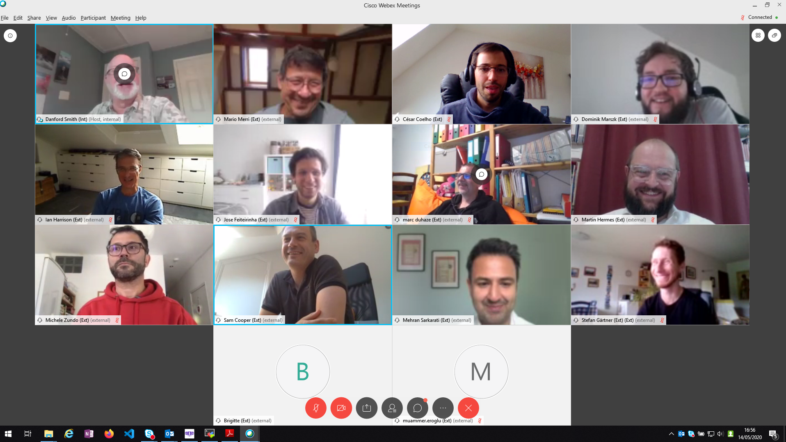
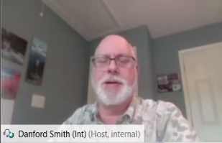

Just a few of the 41 people that attended Spring 2020 Virtual SM&C Working Group Meetings.

Summary

- Artemis has made it clear that MO is not being considered for the 2024 missions. SM&C would like to work with the Artemis Program to identify areas in which SM&C products could eventually meet their needs.

- Early OPS-SAT efforts have already shown the value of multiple Mission Operations (MO) service capabilities. There is a lot of interest in the effort and the potential of feeding back OPS-SAT findings into the SM&C technical plans for MO.

- The IOAG/MOSSG team presented their status and details on the baselined Catalog #3 and then discussed the activities of the ongoing Mission Interoperability Demo. SM&C may take MOSSG and the demo findings into consideration in the MO Review.

- SM&C has decided to solicit inputs from each agency on possible changes to MO to better meet their agency’s needs. A key concern is the desire to reduce the overall complexity. The MO Review results will be used to help create a forward plan for the SM&C Working Group.

- Overall, the team is doing well and staying active. It is difficult to meet virtually more than two hours at a time, and everyone has different challenges with working remotely. It is not possible to be as productive as we would be if we had a full week of face-to-face meetings.

Agenda (as revised throughout the week)

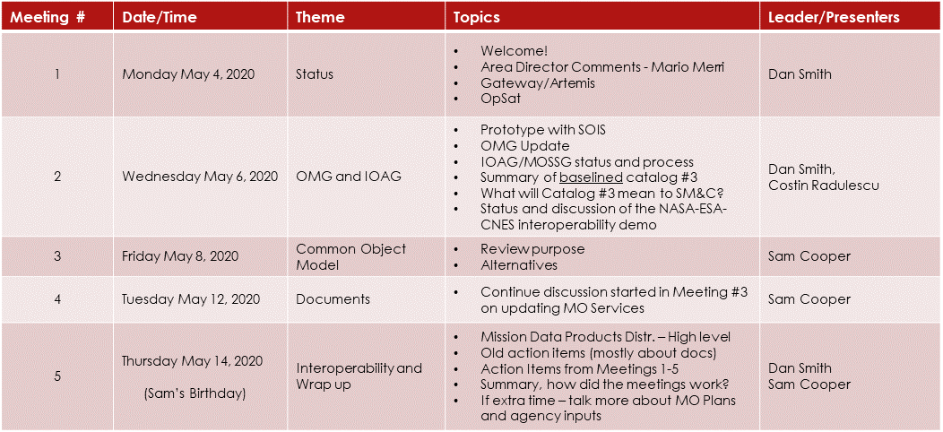
Notes on the agenda:
- The team agreed that 2 hours was the practical limit for meeting durations.
- With meetings fairly short, topics were moved to new dates or dropped throughout the week. This made it difficult for those that were dialing in only for specific topics.
- Meeting agendas were not posted on CWE ahead of time this year.
- Document Status was taken off of the agenda and will be handled by Dan Smith and Sam Cooper.

Attendance

Great attendance! Forty-one people joined the WEBEX meetings at some point.
There were no attendance sheets to pass around. Attendance was taken by looking at the list on on-line participants periodically throughout each meeting. As such, there may be a few mistakes in the list.

Action Items

Spring 2020 - Virtual
(those still open from Fall 2019 have been moved to this list)

ID | ACTION | ASSIGNED TO | DUE | NOTES | STATUS
2020-0514-1  (was 2019-1024-07) | Review books for possible PINK sheets to remove MAL polymorphic restriction. | Olivier (ZMTP), Stefan (SPP), Sam (TCP/IP, misc.), Adrian (HTTP). | 2/1/2020 | May need to justify why no prototype is needed. | Revisit in June 2020 WG meeting. Important to MPS
2020-0514-2  (was 2019-1024-08) | Mission Data Product Services – put out a new concept paper update | Sam and Tiago | 12/30/2019 |  | Discussed at Spring 2020 meeting, outline out by June 15.
2020-0514-3  (was 2019-1024-09) | Review SOIS Yellow Book conclusions section. | Sam and ALL | Sam to distribute by 12/30/2019, ALL to review by 2/1/2020 |  | Dan and Mario to check email status then check with Jonathan, report out in June
2020-0514-4 | Engage Artemis with our evolving plans | Dan Smith | June 30, 2020
2020-0514-5 | List recommended major changes, reasons, and priorities. Identify areas of interest and potential commitment. Provide inputs for schedule. | All Agencies | May 26, 2020
2020-0514-6 | Consolidate inputs from all agencies and distribute to full team. | Sam, Dan | June 5, 2020
2020-0514-7 | Update CWE and report document status | Sam, Dan | June 15, 2020

Fall 2019 – Darmstadt, Germany
May 2020 Status
(those still open will move to the Spring 2020 list)
ID | ACTION | ASSIGNED TO | DUE | NOTES | STATUS
2019-1024-01  (was 2019-0509-1) | JAVA API 5-yr review - Find single agency to do the work. (was 2018-1019-3) | All | 3/15/2020 | No volunteers. Sam and Dan may decide to reconfirm | CLOSE.  Plan to RECONFIRM. There may be changes required as part of the MO Review and there are a couple RIDs now.
2019-1024-02  (was 2019-0509-2) | Provide updated draft file services spec (was 2018-1019-6) | ESA | 3/15/2020 | Defer until after Data Products | CLOSE, not current high priority.
2019-1024-03  (was 2019-0509-3) | Find a second Agency (besides ESA) for supporting the binding to DTN (was 2018-1019-7) | All | 3/15/2020 | May create DRAFT project | CLOSE.  Should be binding to BP. CREATE DRAFT PROJECT as placeholder
2019-1024-04  (was 2019-0509-6) | Ensure XML files are moved to the SANA registry. | Sam, Olivier | 12/30/2019 | Completed.  Spring 2020 meeting. | CLOSE.  Sam will ask SANA to move Olivier’s registries to final
2019-1024-05 | Distribute XTCE Elements Green Book for WG Review | Dan Smith | 11/1/2019 | WG Review Complete | CLOSE.  Dan to request next level polling
2019-1024-06 | Review discussion of Object Model definition and consider alternatives. | Sam, Olivier, Ceasar | 12/30/2019 | CLOSE | Great job, presented at Spring 2020 meetings
2019-1024-07 | Review books for possible PINK sheets to remove MAL polymorphic restriction. | Olivier (ZMTP), Stefan (SPP), Sam (TCP/IP, misc.), Adrian (HTTP). | 2/1/2020 | May need to justify why no prototype is needed. | Revisit in June 2020 WG meeting. Important to MPS
2019-1024-08 | Mission Data Product Services – put out a new concept paper update | Sam and Tiago | 12/30/2019 | IN PROGRESS | Discussed at Spring 2020 meeting, outline out by June 15, 2020.
2019-1024-09 | Review SOIS Yellow Book conclusions section. | Sam and ALL | Sam to distribute by 12/30/2019, ALL to review by 2/1/2020 |  | Dan and Mario to check email status then check with Jonathan, report out in June

Document Status

Time did not permit the review of all documents listed in CWE. Dan Smith and Sam Cooper accepted an action to review the status and report to the Area Director within the next several weeks.
Several decisions were made during the meetings regarding documents:
- We should RECONFIRM the JAVA API. There are several RIDs right now, but there is a thought that the MO Review may result in additional changes. So we will RECONFIRM now and provide a more thorough update when more details are known.
- XTCE Elements Green Book. WG review has now completed. Dan needs to request the next level of polling.
- The recommended document for a binding to DTN should be a binding to bundled protocol. A DRAFT PROJECT should be initiated as a place holder for this work. No plans to start immediately.

Files posted to CWE

Powerpoint and WORD files from the meeting have been posted to the CWE under the MOIMS Area / SM&C / Meeting Materials / 2020 / Spring 2020 Virtual directory:

- CCSDS SMandC Spring 2020 DAY 1 – Opening charts plus report on Artemis
- OPS-SAT and MO – Dominik Marszk’s presentation on OPS-SAT
- CCSDS SMandC Spring 2020 DAY 2 – Day 2 intro plus OMG status
- IOAG interop demo status for CCSDS Spring 2020 – Costin Radelescu’s talk on the IOAG interoperability demo
- MOSSG to CCSDS SMC May 2020 f – IOAG/MOSSG presentation of Catalog #3
- CCSDS_Technical_Meetings_EDS_MO – Cesar Coelho’s presentation on the MOS Services – SOIS EDS prototype
- COM 5 year review_update – Sam Cooper’s presentation on COM Object Model issues
- History_service – Cesar Coelho’s presentation on potential approach to handle the COM history service issues
- COM 5 year review_update – second day - Sam’s updated charts based on the group discussion on Meeting #4
- CCSDS SMandC Spring 2020 Day 5 – final agenda, plan for the meeting
- COM-Update_History_service - César Coelho’s WORD doc that goes with his powerpoint charts.
- Spring2020Minutes – These Minutes
There were no CCSDS or MOIMS Plenary presentations this time.

Daily Summaries and Notes

Meeting 1. Monday May 4, 2020
Opening Comments. Mario Merri provided some opening comments as the Area Director. He noted that the CESG and the CMC would also be virtual. He hoped the virtual meetings we were trying out would be successful and hoped to see everyone in Toulouse in the Fall as the world tries to get back to normal.
Artemis Update. Dan Smith presented the Artemis status. Artemis is relying on the major contractors to plan their systems – NASA has not directed specific mission ops interface standards. Something will need to be done [later] to enable interoperability between the many systems. However, MO services is not being considered due to its complexity and lack of maturity. Final solution for Artemis is not clear.
OPS-SAT Update. Dominik Marszk presented the OPS-SAT status. OPS-SAT is now working well and is providing an excellent opportunity to test out selective MO services. About 10,000 parameters were included in the system. The goal has been to validate the MO services – the software is not considered ops-certified for later missions. Collecting many technical and non-technical lessons learned and noted that its takes time to really understand MO before one can really start benefitting from all its capabilities. Note that OPS-SAT is still open for new proposals.

Meeting 2. Wednesday May 6, 2020
MO-SOIS Prototype. César Coelho presented the status of a proof of concept for using SOIS Electronic Data Sheet with MO services onboard. He identified three different integration scenarios where it could work. A lot of work has been done and all the individual pieces are now ready to be put together to demonstrate the capabilities.
OMG Update. Dan presented the OMG status. Not a lot of news. Their primary products continue to be XTCE and C2MS. They went to virtual meetings starting in March.
IOAG/MOSSG Update. Dan Smith presented the IOAG/MOSSG status. Most of the other MOSSG members were also on the telecon and added additional information. Catalog #3 is now baselined. It identified information exchanges (services) applicable to ground-to-ground inter-agency mission operations interoperability. MOSSG did not address on-board or agency-internal interfaces. Catalog #3 will be updated to incorporate findings and make clarifications based on the interoperability demo now underway. CCSDS will, at a later date, be asked to identify available standards which may meet the Catalog #3 needs and to create a plan to address the gaps.
Interoperability Demo Update. Costin Radulescu presented the status of the IOAG/MOSSG interoperability demo that ESA, NASA, and CNES are working on to demonstrate a portion of Catalog #3. Creating the basic communications capabilities has taken a significant effort. The team has agreed to an “edge-to-edge” approach and is working on one service-based information exchange and one formats-based information exchange. They are paying attention to what level of an ICD is needed for each approach they are taking.Meeting 3. Friday May 8, 2020
COM Object Model. Sam led the discussion of work he, César and Olivier had been doing as they looked at the 5-year review of the Common Object Model. Primary issues noted were the lack of a history capability, the use of COM object identifiers, the overall complexity, and the usefulness of the COM Archive.
César Coelho presented a solution to the problem of COM not having a history service. His detailed approach looks like it could allow for changes (calibrations, definitions, etc.) to be linked to an object over its lifecycle. The concern, however, came back to one of complexity and future plans. If COM is to be upgraded, this service could be added.
It was a great discussion by the entire Working Group. The team kept coming back to the complexity issue and how the COM Object Model in the center of it all had implications with many of the services. Options ranging from “fix the issues with COM” to “shrink COM”, to “eliminate COM” were debated. The decision was made to continue the discussion at Meeting Number 4.

Meeting 4. Tuesday May 12, 2020
COM Object Model (continued). The full meeting was used to discuss potential changes to MO. The goal was to begin developing the plan for major changes seen as necessary. Dan mentioned that NASA was more enthusiastic about MO than they had been in years and that there was hope that Artemis could help provide inputs as new plans are developed. Mario noted that a major driver for any change should be to increase the adoption of MO by the different agencies.
A few guidelines the team was aligning with:
- Don’t start from scratch. We have many many years of invested work in MO. The functional service capabilities may be very good the way they are.
- We may need a new name if we are really making big changes. “MO 2.0” was discussed. For now, the effort should be the “MO Review”, since the overall scope of change is not yet determined.
- We should probably leave the transport layer alone, we will have too much on our plate looking at everything else.
- This can not be the start of another 10- or 15-year effort. Pick a reasonable timeframe and work to it.
- Be great if anything new would still work with what agencies may already have implemented.
The discussion lasted the entire meeting. Near the end it was decided that ideas should be documented and submitted by each agency. Following the meeting Dan and Sam sent an email asking for inputs on the following by May 26, 2020.
1) What are the key issues you would like to see addressed, please provide justification as why it is an issue and the problems it causes?
2) What is the priority list of the issues you see above?
3) Regarding a schedule, how soon do you think we need to have resolved the above issues? Any other comments on schedule?
4) Are there areas you or your agency may be willing to work on regarding the raised issues?
[this is not a firm commitment yet, we need to judge the overall interest level]
5) Any other comments do you have on how we should move forward as a Working Group?

Meeting 5. Thursday May 14, 2020
Mission Data Product Distribution. Sam provided a summary work he and Jose have been doing on MDPD. The new plan is being greatly simplified and made more general. It will still include the concept of taking action to construct a product for delivery. He does not feel there is any overlap with the parameter service for real-time data streaming although there could be some overlap with the COM Archive service.
Packet Delivery Service. A short discussion was had on how there was no basic packet distribution service in MO. An action was given to Sam to make note of this and look at where it may be added in the future. It should not be part of MDPD but probably belongs in M and C services.
Acton Item Review. The team reviewed all existing action items. Those not closed were moved to the new action list and combined with those identified during the 5 virtual meetings. See action item tables contained in these minutes.
How Did Virtual Meetings Work? As good as could have hoped. Never as good as face-to-face. Anything longer than 2 hours would be hard. Spacing out to every other day worked well. Webex worked well. Good attendance level. SOIS not well coordinated. Sticking to schedules becomes more important if there are people only joining for areas they are interested in.
Mario’s Final Comments. The series of SM&C meetings went very very well, but virtual meetings can never replace the full value of multi-day in-person meetings. He is looking for continued progress on the changes discussed through the series of meeting. It really can make a positive difference if the agencies can all participate and help decide changes that can help gain traction and mission infusion within each agency. Special hope that NASA will increase participation and involve Artemis and others in anticipation of MO infusion within NASA.

We look forward to the next face-to-face meeting.
[currently planned for]
October 26-30, 2020 in Toulouse, France
Stay Safe, Stay Healthy
-- END --

