**CCSDS Spacecraft Monitor and Control (SM&C) Working Group**

**Spring 2019 Workshop - May 6-9, 2019**

**NASA Ames Research Center. Mountain View, California, USA**

**MEETING MINUTES**

**May 28, 2019**

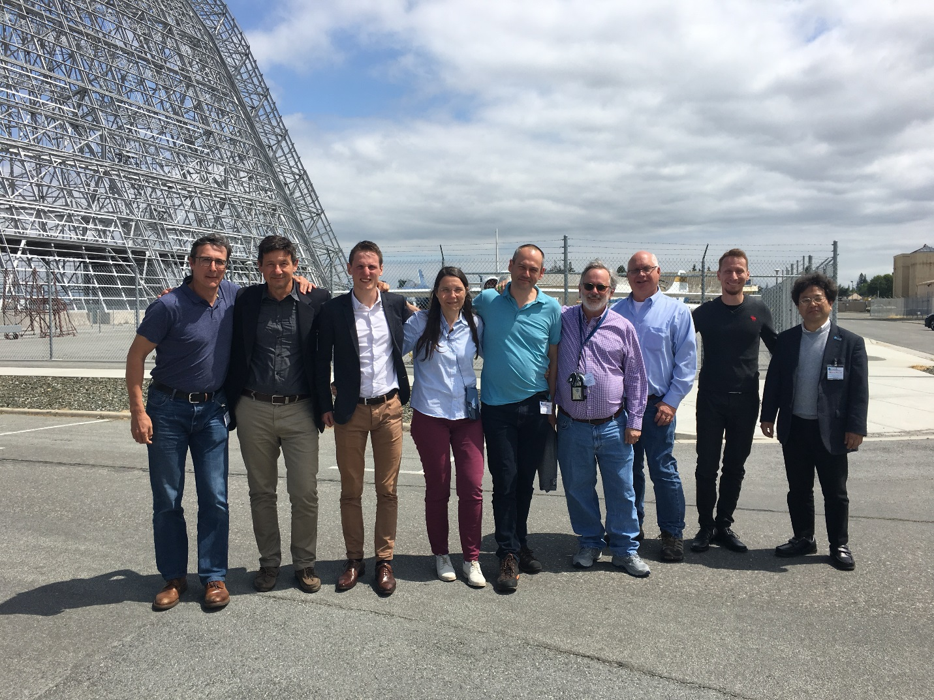

# Summary (from the final plenary presentation to the MOIMS Area Director)

# Discussed potential engagement in Gateway and BoM2024 and the realities presented by the new commitment to 2024. We need to start working soon to hope for influencing their technology infusion choices for the 2024-2030 time period.

# After lengthy discussions, we believe that there is no inherent scope issue between MO Services and SOIS but that diagrams can be clearer and certain terms should be used very carefully (ex: device control vs device management).

# We are encouraged by the positive start to the IOAG-directed effort to develop an inter-agency interoperability demonstration which will include a mix of both service- and formats-based approaches. SM&C will benefit from the demo effort feedback.

# Good progress was made on the MO Services Green Book and the Mission Data Products Distribution (MDPD) Blue Book. MDPD will require a second agency review.

# Developed a “brainstorm list” of potential future efforts for the WG, with an emphasis on being responsive to the needs of flagship missions such as Gateway and BoM2024.

# Determined that the “Formats vs Services” issues are really issues of complexity when trying to establish simple inter-agency interfaces. A simple parameter request was studied in detail. The Interoperability demo will provide a great mechanism for addressing some of the concerns.

# Reviewed the great job being done to link together information on MO services through a single website

# Agenda (revised throughout the meeting)



# Attendance

Seventeen people attended all or portions of the SM&C meetings, with the group growing even larger during joint meetings.



# Files posted to CWE

Files from the meeting have been posted to the CWE under the MOIMS Area / SM&C / Meeting Materials / 2019 / Spring directory:

1. MOIMS-SC-Agenda
2. These minutes
3. Mario’s ESA presentation to Gateway (from MOIMS Plenary)
4. Dan’s NASA status of potentially working with Gateway
5. Security stuff (ask Dan for copies – they did not want them posted)
6. Sam’s 2 files on data formats and data distribution
7. Jose’s OPS-SAT Slides

Also, the presentation given at the main Plenary Meeting can be found on CWE at:

<https://cwe.ccsds.org/cesg/docs/CWE%20Private/Meetings/2019%20Spring%20Meeting%20Mountain%20View/CESG%20Opening%20Plenary%2C%206th%20May%202019>

Wikipedia entry on MO is at: <https://en.wikipedia.org/wiki/CCSDS_Mission_Operations>

# Day 1. Monday May 6, 2019

1. Full CCSDS and MOIMS Plenary meetings were held in the morning.
   * 1. At the full plenary, Phil Liebrecht from NASA NQ presented an overview of the plans for Gateway and the importance that standards will play.
     2. At the MOIMS plenary, Mario Merri presented the charts he had prepared for April 2019 meetings at ESTEC with the Gateway ground systems and mission ops team (presentation posted in SM&C meeting area).
2. SM&C WG began at 11:00 am with general discussion of the week’s plans.
3. The team had a lengthy discussion to prepare for the meeting on Tuesday with Peter Shames concerning boundary issues between SM&C and SOIS and the perception that SM&C was trying to take over new territory and needs to be stopped. No one in the SM&C WG could figure out what Peter was talking about.
4. Mario explained that in the future MO could move into the area of device management with camera control or star trackers being examples. Although possible, it could lead to a very large set of services and may be difficult due to the differences and evolution of capabilities of different devices.
5. Dan gave the OMG status update, with no conflicts or issues noted. The C2MS message specifications are now approved and posted, with the final release is in the technical editing cycle now. The OMG has approved XTCE 1.2 – Dan and Mario will talk with Tom Gannet on how to initiate the agency up/down review for accepting it as a joint OMG-CCSDS standard.
6. After lunch Dan presented the status of recent talks with the Gateway team and the impacts of the new U.S. decision to have “Boots on the Moon” by 2024. (see charts) The schedules are being so condensed that it may not be practical to incorporate new approaches and allow for full man-rated development and testing prior to 2024. There is a phase from 2024-2030 where the Gateway and BoM2024 will work on technology infusion.
7. The team discussed the idea of partnering soon with the Gateway and BoM2024 teams. All agreed that it would be a great way to ensure that SM&C work is directed towards a major tangible goal even if it means changes in direction to some degree. A resolution was proposed that the highest levels of CCSDS management for the initial relationship with Gateway.
8. Dan provided the status of the IOAG MOSSG team. The MOSSG has completed its work per its charter. Its final report and Catalog 3 are now being voted on for final acceptance by the IOAG. The MOSSG team has stopped all regular meetings and will not meet only when needed. The MOSSG proposed the development of an interoperability demonstration which is now getting started.
9. Costin explained the goals of the new IOAG interoperability demonstration and the participation of NASA, ESA, and CNES. The team is tasked to develop an approach for meeting the information exchange requirements of IOAG Catalog #3 assuming that some agencies will be service-based and others prefer formats-based approaches. They will keep track of the challenges and findings. The team again showed there can be debates between those with preferences for one approach or another and some that say they are essentially the same and it is easy to transition between services and formats.
10. CWE Document Review. The DRAFT documents were reviewed. SM&C will wait to delete the Scheduling, Planning, and Automation documents until the new Planning and Scheduling WG confirms that the documents are now in their scope and plans. File Management has been approved as a project and should no longer be shown as draft.

# Day 2. Tuesday May 7, 2019

1. Olivier Churlaud led the discussion of the MO website he has created.

* Our primary website is now CCSDSMO.github.io . This should be our central point to either include available MO information or provide links to other sites.
* Really need a “getting started” guide.
* Need a way to submit questions, possibly as emails. We are not obligated to provide a HELP service. One approach is to have them request to be on the CCSDS mailing list after getting a CWE account. Another approach is to have them go to the SM&C site where they will see the names and email addresses of the WG chair and deputy.
* Jose has a great tool that he developed on his own to show all the message fields. Could consider linking to it.
* Stefan Gartner has an editor that could be of use.
* We need to link to this site FROM the CCSDS Implementation site, since that is where many people may go first.
* The text on the opening page about “What is CCSDS Mission Operations?” came from Wikipedia and should be updated. (Sam?)

1. Met with Peter Shames to talk about several systems engineering topics:
2. **Time BoF Charter to become a Working Group**. The SM&C WG agrees that there is sufficient interest to create the Time WG per the developed charter. The only note was that MO still will develop time management functions for operations commonality which may access the new time capabilities.
3. **Glossary.** Peter talked about how other WGs and Area and becoming consistent within their groups. SM&C has already worked to make its terms consistent across its many documents.
4. **SOIS/SM&C.** There was another long discussion on SOIS and SM&C. Peter veered into many topic areas that seemed unrelated (business case for SM&C for example). The bottom line seems to be that there is very little, if any, conflict. MO does not handle drive-level device functions or the true real-time closed loop applications that SOIS may deal with. The problem may be with the use of certain words such as control vs manage. A single bullet chart or common diagram may help solve the problem.
5. **Spacecraft IDs.** Peter explained that different forward and return link CCSDS protocols have different sized fields for spacecraft ID. There are many more spacecraft now than had been anticipated when these fields were defined and we have “run out of numbers”. So the decision was made to reuse the numbers across different frequency bands. There should be no acquisition confusion since an assigned number will be unique within the frequency band. Spacecraft may now be given multiple IDs – one per frequency band used. But this ignores the needs of mission ops that relies on a single reference to a satellite – historically this has been the spacecraft ID. Although Peter suggested a new ops approach of using OIDs as identifies, this seemed odd and unworkable to the mission ops team. Missions should be encouraged to move as quickly as possible to formats which provide an adequate range of spacecraft IDs. The SM&C WG later wrote up an issue statement for the Area Director to take forward.
6. Dan drafted a resolution during the break regarding support to the Gateway / BoM2024. A number of small changes were made to it and was considered final for delivery to the Area Director. Later, Margherita diGiulio reviewed it while in the SM&C area and did not have any issues.   The resolution is included near the end of these minutes.
7. The team reviewed the Fall 2018 minutes and actions and the current documentation status in CWE, but several updates required inputs from Sam Cooper. Sam Cooper is attending the next day, so the full review effort was moved to Wednesday.
8. The MO Services Green Book, Section 10 was discussed. This is the section about future directions of MO. The team created a brainstorm list of possible future directions or capabilities of MO and provided the material, as raw input, to Sam Cooper for consideration in adding text to the section. Because of the desire to work more closely with Gateway / BoM, we did not want to prioritize any new work and instead want to mention in the section that we are driven by the needs of future users and will create actions and set priorities accordingly. Following is the list of items the team came up with:
   1. That we can be directed/influenced by the short term and longer needs of larger programmes starting up
   2. Looking to work closely with other CCSDS areas to leverage each others standards
   3. Usage of standards in university projects / research satellites / cubesats.
   4. Confirm MO is Multi-mission aware, one control system controlling multiple missions (multi-mission displays & control).
   5. Document the business cases of using the standards, for agencies and industries/vendors.
      1. Cost savings or performance improvements.
   6. Reference model updates.
      1. Deployment descriptions and the possible idea of components and component types
   7. This section gives examples of future directions for the MO standards and also some examples of how they may be deployed in future scenarios:
   8. The idea of an enterprise MO bus between Agencies for more collaborative service deployment
   9. Promote MO onboard
   10. Talk about the services we wish to work on, so “as of the time of publication…”
   11. More technology mappings

In addition, the need for one additional scenario was discussed for chapter 1, where agency A ground system provides parameters values, packets, events and files to agency B ground system. This could be a “MO-lite” case (minimal list of standards and services (capability sub-set) that can be used for a successful mission).

# Day 3. Wednesday May 8, 2019

1. Sam is here! Reviewed past two days’ of progress. Discussed spacecraft IDs and SOIS again – no disagreements. Meeting has gone pretty good so far.
2. Worked on Green Book. Current draft of Green book was reviewed and remaining comments were addressed. Next draft is expected end of June.
3. Mission Data Products Distribution. Sam gave a short presentation on the main issues raised as part of the recent Agency review. Concerns were raised with the capabilities and complexity of the current draft and the need to make sure it handles simple file distribution. Possible approaches to address the limitations were reviewed and discussed and it was agreed that a rework of the specification is needed. A second agency review will be required for the next revision.

# Day 4. Thursday May 9, 2019

1. Spent a good bit of time discussing the issue of “Services v Formats”. Sam showed the message that MO services sends to request the values of multiple parameters. It was clear that formatted messages that represent a request and a response equate to having a service – there is little or no difference. However, in the case of the parameter request message, things got a little complicated. The MO-based message requires an ID instead of the parameter name (mnemonic). There is another service that is used to request the internal ID from the other system. For simple inter-agency interfaces it seems like there are advantages to simply asking for the parameters by mnemonic. Most agreed, but the reasons for the ID approach were also explained. The numeric values are more compact than the full mnemonic and therefore better for across the space-ground interface. In addition, the numeric values provide keys into the com object model features of MO. A solution of adding a numeric ID into XTCE was discussed, but it may also have issues. It was decided to wait and see that the interoperability demo team thinks.

In summary, the issue of Services v Formats may have been mislabeled and misleading all along. They can be shown to be the same thing. The issues has probably been with the complexity of the MO services when applied to simple inter-agency interfaces. This will need more work.

Dan provided the following list of guidelines based on discussions at NASA and the IOAG MOSSG team. These are general guidelines preferred by some, and not meant as direction:

* 1. Support needed for both formats and services. Alignment of the two should be a goal to allow for the development of bridges/translators between the two.
  2. Use mnemonics (names) to reference parameters. Do not use locally generated IDs when talking to external users.
  3. Provide full text of log/event/memo messages when sending across external interfaces. May also include an ID number, flags, etc.
  4. Minimize storage of one’s configuration information on other users’ systems.
  5. Identify the subset of functions applicable across agencies for the primary purpose of interoperability. This may be a small list. MO may have other benefits for reuse, ease of ops, on-board, etc.
  6. Assume each agency has its own security approach and may not be as simple as a unique plug-in.
  7. Minimize need for cross agency remote DB queries and registries. Can assume, for example, that each partner has an XTCE file. I would think that agencies involved in a mission know they are involved in that mission and have planned for it with their partners! No need for registries to find out who supports a mission or what software is available any day of the week.

1. A joint meeting was held with the Security WG. Daniel Fischer presented specific recommended changes to multiple MO books to properly address security both in function but also in terminology. They also provided the summary report that has been written by Maxime to provide some insights behind the proposed modifications. Both documents should be considered as CCSDS internal and should not be stored on the open area of the CWE.
2. Updated the document status in CWE.
   1. The following documents are ready for RECONFIRMATION:
      1. SM&C-052019-4: MAL Blue Book 521.0
      2. SM&C-052019-5: COM Object Model Blue Book 521.1
      3. SM&C-052019-6: JAVA API Magenta Book 523.1
   2. XTCE 1.2 is ready for an agency UP/DOWN vote
   3. An action was created to write an email to the Planning and Scheduling WG to confirm that there are several draft books on the SM&C list that can now transition to P&S and be deleted from SM&C: Planning Services, Scheduling Services, and Automation.
   4. The table below shows the revised dates for the open projects:

|  |  |  |  |  |
| --- | --- | --- | --- | --- |
| **Area and WG name** | **CCSDS Ref Nr** | **Document Title** | **Status / Comments** | **Start and / or Target Publication Date** |
| MOIMS SM&C | 522.0 | Mission Operations - Common Services | On Schedule | Start date 1/1/2006 End date 10/1/2019 |
| MOIMS SM&C | 522.2 | Mission Operations - Mission Data Product Distribution Services | On Schedule | Start date 1/1/2015 End date 1/6/2020 |
|  |  |  |  |  |
| MOIMS SM&C |  | Mission Operations - File Management Services | On Schedule | Start date 1/6/2018 End date 1/8/2020 |
| MOIMS SM&C | 520.0 | Mission Operations Services Concept (Issue 4) | On Schedule | Start date 1/12/2016 End date 1/12/2019 |
| MOIMS SM&C | 520.1 | MO Reference Model 5yr update | On Schedule | Start date 19/10/2018 End date 1/1/2020 |
| MOIMS SM&C | 660.0 | XML Telemetric and Command Exchange (XTCE) 1.2 | On Schedule | Start date 1/1/2008 End date 1/7/2019 |
| MOIMS SM&C | 660.1 | XML Telemetric and Command Exchange (XTCE) Element Description | On Schedule | Start date 15/4/2019 End date 20/1/2020 |
| MOIMS SM&C | 660.2 | XML Telemetric and Command Exchange (XTCE) Informational Report | On Schedule | Start date 1/5/2019 End date 1/3/2020 |

1. Preparations for the MOIMS Plenary

* The week was reviewed and summary charts were prepared for the Area Director and the MOIMS Plenary scheduled for Thursday afternoon. There was consensus that it had been a very productive week.

Resolutions agreed upon this meeting

* + SM&C-052019-1: Engagement with Gateway and BoM2024
  + SM&C-052019-2: Supports the establishment of a Time WG per the Charter that was distributed.
  + SM&C-052019-3: Initiate Up/Down vote on the acceptance of OMG’s XTCE 1.2 as an adopted CCSDS standard
  + SM&C-052019-4: Initiate MAL Blue Book 521.0 RECONFIRMATION
  + SM&C-052019-5: Initiate COM Object Model Blue Book 521.1 RECONFIRMATION
  + SM&C-052019-6: Initiate JAVA API Magenta Book 523.1 RECONFIRMATION

Further Resolutions anticipated in the next 6 months:

* + Agency review of two XTCE Green Books

**Resolution SM&C-052019-1: Engagement with Gateway and BoM2024**

The MOIMS/SM&C WG is requesting the CESG or CMC create an ongoing working relationship between CCSDS and the Gateway and Boots-on-the-Moon-2024 (BoM2024) flagship mission organizations.

* By establishing the relationship at the CCSDS-level (CESG/CMC), CCSDS management can instruct or prioritize what each Area should work on to help meet schedule or technical needs set by these major flagship international missions. With concurrence of the CMC/CESG, some Areas or WGs may develop their own direct relationships with the mission team.
* Given the compressed schedule of the programs, it is understood that some standards may not be able to be incorporated by the 2024 timeframe (MO Services, for example), and that the teams should immediately begin work together on longer-term needs and plans to allow the introduction of additional standards at a later date.
* The advantage of a closer working relationship with major international missions early in their lifecycle is that the involved CCSDS WG’s can adjust their technical efforts and priorities to meet tangible needs in the most practical manner.

**SM&C WG Issues for CESG / CMC (raised to the AD for possible discussion at CESG)**

The SM&C WG is very concerned about the impacts of the planned change to the assignment of Spacecraft IDs. Having multiple spacecraft IDs per mission and non-unique IDs (but using different frequency bands) can be problematic for ground and space components and systems – both commercial and agency-owned. Changes will be needed in many commercial products. Historically, a spacecraft’s ID is its identifier for building uplink data streams, archiving data, discerning between different space systems, etc. It appears that the proposed solution was developed to support a specific need related to space-ground communications without discussions with the mission ops teams. This may be a short-term fix, but a long-term approach should be developed and a roadmap presented to the impacted working groups.

# Day 5. Friday May 10, 2019

CESG Day – No working group meetings.

**We look forward to the next face-to-face meeting**

**October 21 – 24, 2019 in Darmstadt, Germany.**

# ACTIONS

**Fall 2018 Action Item List**

**(with May 2019 status update; remaining OPEN actions will be moved to the Spring 2019 action list so that this list is no longer needed)**

|  |  |  |  |  |  |
| --- | --- | --- | --- | --- | --- |
| **ID** | **ACTION** | **ASSIGNED TO** | **DUE** | **NOTES** | **STATUS** |
| **2018-1019-1** | Contact Jonathan Wilmot for LOP-G access ideas, since SOIS has been very successful. | Dan Smith | 1/1/2019 | Presentation made in Mountain View May 6, 2019. | COMPLETE |
| **2018-1019-2** | Request AD to start poll for MAL BB reconfirmation. | Sam Cooper | 12/30/2018 | Requested on 5/9/2019 | COMPLETE |
| **2018-1019-3** | JAVA API - Find single agency to do the work. | All | 1/31/2019 | Can JPL? Anyone? | OPEN; will move to Spring 2019 action list |
| **2018-1019-4** | Add to Agenda for Spring 2019 meeting a topic to review and produce this SM&C Glossary of Terms. | Dan Smith | 2/15/2019 | Reviewed by Brigitte and Sam. SM&C is consistent, should submit list to Area | COMPLETE |
| **2018-1019-5** | Provide update to the MO GB by the end of 2018 | Sam Cooper | 12/3/2018 | New versions delivered for review | COMPLETE |
| **2018-1019-6** | Provide updated draft file services spec | Tiago Nogueira | 4/1/2019 | Replacement for Tiago needed | OPEN; will move to Spring 2019 action list |
| **2018-1019-7** | Find a second Agency (besides ESA) for supporting the binding to DTN | All | 2/15/2019 | Keep open | OPEN; will move to Spring 2019 action list |
| **2018-1019-8** | Set up joint meeting with CSS in Spring 2019 meeting to discuss file services | Dan Smith | 2/15/2019 | Next meeting | OPEN; will move to Spring 2019 action list |
| **2018-1019-9** | Coordinate approval of new projects for 5-yr revision of MO Reference Model MB, XTCE GB, XTCE Element Description GB, and MO File Management Services BB. | Dan Smith | 11/1/2018 | Projects were approved at the October 24, 2018 CMC meeting | COMPLETE |

**Action List**

**Spring 2019 – Mountain View, California**

|  |  |  |  |  |  |
| --- | --- | --- | --- | --- | --- |
| **ID** | **ACTION** | **ASSIGNED TO** | **DUE** | **NOTES** | **STATUS** |
| **2019-0509-1** | JAVA API - Find single agency to do the work. (was 2018-1019-3) | All | 8/31/2019 | Can JPL? Anyone? |  |
| **2019-0509-2** | Provide updated draft file services spec (was 2018-1019-6) | ESA | 8/1/2019 | Tiago no longer available |  |
| **2019-0509-3** | Find a second Agency (besides ESA) for supporting the binding to DTN (was 2018-1019-7) | All | 9/15/2019 |  |  |
| **2019-0509-4** | Set up joint meeting with CSS in Fall 2019 to discuss file services (was 2018-1019-8) | Dan Smith | 9/15/2019 |  |  |
| **2019-0509-5** | Confirm that P&S WG will handle certain documents so they can be removed as SM&C DRAFTs. | Dan Smith | 6/30/2019 |  |  |
| **2019-0509-6** | Ensure XML files are moved to the SANA registry. | Sam | 6/30/2019 |  |  |
| **2019-0509-7** | SOIS Diagram – Review with Jonathan Wilmot and Peter Shames | Dan/Sam | 7/15/2019 |  |  |
| **2019-0509-8** | Continue contact with the Gateway team, possibly through the CESG or CMC. Report status. | Dan | 6/30/2019 |  |  |
| **2019-0509-9** | Review security red-line proposal | All | 7/15/2019 |  |  |
| **2019-0509-10** | Resume sending out the document status report at least quarterly | Dan | Quarterly |  |  |