GSOC –
German Space Operations Center

JSC – OTF
Johnson Space Center
Operations Technology Facility


Prototype Interoperability Document between NASA-JSC and DLR-GSOC Describing the CCSDS SM&C Mission Operations Prototype

Version 1.4
Date 17.09.2010

Prepared::
S.Gully, E.Wolfer Date

Approved JSC:
E. Wolfer Date
JSC-OTF

Approved DLR:
H.Hofmann Date
DLR-GSOC

© All rights reserved. No part of this document may be reproduced, in any form or by any means, without permission in writing from the German Aerospace Center (DLR)

Distribution
Organisation | Copies | Name

Custodian of this document is: S. Gully

Document Change Control
Issue | Rev. | Date | Pages | Changes | Status
1 | 0 | 25.08.2009 | all | New document | Issued
1 | 1 | 01.10.2009 | Chapter 5.2.1 | Update MAL XML Schema | issued
1 | 2 | 17.03.2010 | Chapter 6 | Added service conifiguration data | issued
1 | 3 | 21.04.2010 | Various | Updates from Phase One Review and removed XML-SOAP encoding over HTTP | Issued
1 | 4 | 17.09.2010 | Chapter 6.3 | Corrections to the Alert Service configuration | Issued

CONTENTs ….…..Page

1 Purpose 6
2 Agencies agreement 6
2.1 Statement of mutual benefit and interests 6
2.2 JSC-OTF shall 6
2.3 DLR-GSOC shall 6
2.4 Mutually understood and agreed 7
2.5 Network Architecture 7
2.6 Security Issues 7
2.7 Principal contacts 8
2.7.1 GSOC-DLR / ESA Contacts 8
2.7.2 JSC-OTF Contacts 8
3 Technical description of prototype 9
3.1 Design 9
3.1.1 Mission Operations Concept 9
3.1.2 Standard used 10
3.1.3 JSC-OTF Prototype design 11
3.1.4 DLR-GSOC Prototype Design 14
3.1.5 Combined Protocol Description 14
3.2 Layers To Be Implemented 15
3.2.1 Application Layer 15
3.2.2 Service Layer 15
3.2.3 Common Object Model 16
3.2.4 Message Abstraction Layer 18
3.2.5 Encoding Layer 19
3.2.6 Transport layer 19
3.3 Services to be implemented 21
3.3.1 Directory Service 21
3.3.2 Parameter Service 24
3.3.3 Login Service 25
3.3.4 Alert Service (optional) 26
3.4 Test environment 28
3.4.1 Communication 28
3.4.2 Security policy 28
3.4.3 Test environment in JSC-OTF 28
3.4.4 Test environment in DLR-GSOC 29
3.4.5 Use Cases 29
3.4.6 Bridging System Domains 32
4 Planning 34
4.1 Stages 34
4.1.1 Stage 1 34
4.1.2 Stage 2 34
4.2 Schedule 35
4.3 Document delivery 35
5 Encoding 36
5.1 Binary Encoding 36
5.2 XML Encoding 41
5.2.1 Message Abstraction Layer Structures 41
5.2.2 Common Structures 52
5.2.3 Directory Service Structures 53
5.2.4 Directory Service Operation Structures 57
5.2.5 Directory Service WSDL 57
6 Service Configuration 58
6.1 Action Service 58
6.1.1 XTCE Entity Definitions 58
6.1.2 Action Definition 80
6.2 Parameter Service 82
6.2.1 XTCE Entity Definitions 82
6.2.2 Parameter Definition 86
6.3 Alert Service 90
6.3.1 JSC-OTF Alert Service Provider Configuration Data 92
6.3.2 JSC OTF Alert Definition 94
6.3.3 DLR-GSOC Alert Service Configuration Data 94
6.3.4 GSOC-DLR Alert Definition 95

Figures ….…..Page

Figure 2-1 Network Communications 7
Figure 3-1 Overview of the Mission Operations Service Framework 9
Figure 3-2 Mission Operations Service Layers 10
Figure 3-3 Action, Parameter and Alert Service Interoperability 12
Figure 3-4 Directory Service Interoperability 13
Figure 3-5 JSC-OTF Prototype 13
Figure 3-6 DLR-GSOC Prototype 14
Figure 3-7 DLR-GSOC Application Layer 15
Figure 3-8 DLR-GSOC Transport Layer 20
Figure 3-9 Directory Service Sequence 29
Figure 3-10 Action Service Sequence 30
Figure 3-11 Parameter Service Sequence 31
Figure 3-12 Alert Service Sequence – Subscribe 31
Figure 3-13 Alert Service Sequence – Raise 32

Tables ….…..Page

Table 3-1 JSC-OTF Common Model Operations 17
Table 3-2 DLR-GSOC Common Model Operations 18
Table 3-3 JSC-OTF Directory Service Operations 21
Table 3-4 DLR-GSOC Directory Service Operations 22
Table 3-5 JSC-OTF Action Service Operations 22
Table 3-6 JSC-OTF Supported Verification Stages 23
Table 3-7 DLR-GSOC Action Service Operations 24
Table 3-8 JSC-OTF Parameter Service Operations 24
Table 3-9 DLR-GSOC Parameter Service Operations 25
Table 3-10 JSC-OTF Login Service Operations 26
Table 3-11 DLR-GSOC Login Service Operations 26
Table 3-12 JSC-OTF Alert Service Operations 27
Table 3-13 DLR-GSOC Alert Service Operations 28
Table 4-1 Project Schedule 34
Table 5-1 Abstract Data Type Short Forms 35
Table 5-2 Basic Data Type Properties 36
Table 5-3 Sample Message Header 38
Table 5-4 Standard Error with Extra Information 40
Table 5-5 Binary Standard Error with Null Value 40

Listings ….…..Page

Listing 5-1 Binary Message Header 39
Listing 5-2 Binary Standard Error with Extra Information 40
Listing 5-3 Binary Standard Error with Null Value 40
Listing 5-4 Schema for Message Abstraction Layer Structures 50
Listing 5-5 Schema for Common Service Structures 53
Listing 5-6 Schema for Directory Service Structures 57
Listing 5-7 Schema for Directory Service WSDL Creation 60
Listing 5-8 Directory Service WSDL 68
Listing 6-1 Alert Service Configuration Schema 71
Listing 6-2 JSC-OTF Alert Service Provider Configuration Data 72

This PROTOTYPE INTEROPERABILITY DOCUMENT is hereby made and entered into by and between the Johnson Space Center (JSC) Operations Technology Facility (JSC - OTF) and the Deutsches Zentrum für Luft- und Raumfahrt (DLR – GSOC).

Purpose
The purpose of the PROTOTYPE INTEROPERABILITY DOCUMENT is to document the design and interfaces for the service providers and consumers of a Mission Operations prototype between JSC-OTF and DLR-GSOC.
The primary goal is to test the interoperability sections of the CCSDS Spacecraft Monitor & Control (SM&C) Mission Operations (MO) specifications between both control centers. An additional goal is to provide feedback to the Spacecraft Monitor and Control (SM&C) working group through the Review Item Disposition (RID) process.
This Prototype is considered a proof of concept and should increase the knowledge base of the CCSDS SM&C Mission Operations standards. No operational capabilities will be provided.
The CCSDS Mission Operations (MO) initiative was previously called Spacecraft Monitor and Control (SM&C). The specifications have been renamed to better reflect the scope and overall objectives. The working group retains the name Spacecraft Monitor and Control working group and is under the Mission Operations and Information Services Area (MOIMS) of CCSDS. This document will refer to the specifications as SM&C Mission Operations, Mission Operations or just MO.

Agencies agreement

Statement of mutual benefit and interests
DLR-GSOC and JSC-OTF desire to work together to investigate the use of the CCSDS SM&C Mission Operations protocols between two independent and disparate control centers. This collaboration will help validate the use of Mission Operations communications standards.

JSC-OTF shall
JSC-OTF shall construct a spacecraft simulation test bed within the OTF that will allow GSOC users in designated GSOC development labs to command the simulated spacecraft and receive the associated telemetry, as well as other useful data streams, in accordance with the SM&C Mission Operations standards being developed.
JSC-OTF shall provide example test data (in encoded binary format) for the Action, Parameters and Alert service providers. The data will be used by DLR-GSOC to perform local testing.

DLR-GSOC shall
DLR-GSOC shall jointly exercise the OTF Spacecraft Simulator using SM&C Mission Operations protocols to validate the usefulness and completeness of the Mission Operations standards for spacecraft monitoring and control.
DLR-GSOC shall provide one example request test data (in encoded binary format) for each of the following service consumers: Action, Parameters and Alert. The data will be used by JSC-OTF to perform local testing

Mutually understood and agreed
DLR-GSOC and JSC-OTF will develop independent implementations of the SM&C Mission Operations specifications to exchange actions, parameters, and alerts. This agreement will allow both parties to validate the specifications and provide feedback to the MOIMS SM&C working group.
DLR-GSOC and JSC-OTF agree to exchange the Data and Reports related to the SM&C Mission Operations Prototype in a transparent way. No exchange of software is planned.

Network Architecture
The configuration of the communications link between the GSOC and OTF prototype labs will utilize the ESA Gateway located in the MCC-Houston. Figure 2-1 describes the network communications architecture.

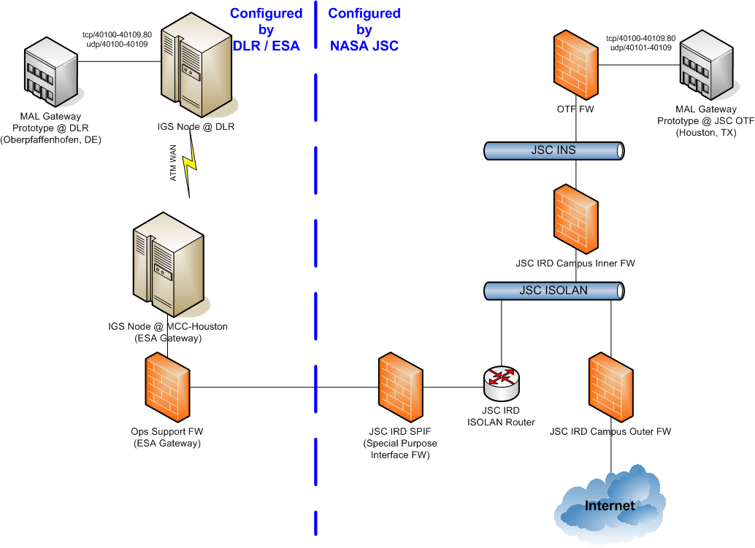
Figure 2-1 Network Communications

Security Issues
Transport of messages across the link is performed unencrypted to meet the firewall requirements of both agencies. Firewall configuration will be used to prove identity of the agency gateways.
Authentication and authorisation is done locally on both sides using Login Services. Interaction between JSC-OTF login service and GSOC-DLR login service is not planned for this prototype.
T
Components of the prototype that are installed on the COL/IGS Network will enforce the COL security rules (such as virus checking, authentication, a.s.o.)

Principal contacts

GSOC-DLR / ESA Contacts
Project Office: Harald Hofmann, Harald.Hofmann@dlr.de, +49–815328-3631
Technical Management: Sylvain Gully, Sylvain.Gully@dlr.de, +49–815328-2142
Security: Martin Pilgram, Martin.Pilgram@dlr.de, +49–815328-1266
Software: Sylvain Gully, Sylvain.Gully@dlr.de, +49–815328-2142
COL/IGS Contacts: Bob Chesson, Bob.Chesson@esa.int
Francios Allard, Francois.Allard@esa.int +31-71565-3250

JSC-OTF Contacts
Project Sponsor: Eric Wolfer, Eric.J.Wolfer@nasa.gov, 281-483-6709
Management: Lindolfo Martinez, Lindolfo.Martinez-1@nasa.gov 281-483-4346
Technical Lead: Steve Lucord, Steven.A.Lucord@nasa.gov 281-483-9711
Security: Craig Biggerstaff Craig.Biggerstaff-1@nasa.gov 281-483-2027
Software: Walt Reynolds, Walter.F.Reynolds@nasa.gov 281-483-6723
Steve Lucord, Steven.A.Lucord@nasa.gov 281-483-9711
COL/IGS Contacts: Shashi Gowda, Shashi.Gowda-1@nasa.gov 281-483-7057
Rochelle Brown, Rochelle.A.Brown@nasa-gov 281-483-9417

Technical description of prototype

Design

Mission Operations Concept
The Mission Operations Service Framework is intended to increase the level of interoperability between agencies. The CCSDS Spacecraft Monitoring & Control (SM&C) working group has developed a concept for a Mission Operations (MO) Service Framework, which follows the principles of Service Oriented Architectures. It defines an extensible set of end-to-end services that support interactions between distributable mission operations functions, e.g., software applications specific to the mission operations domain:
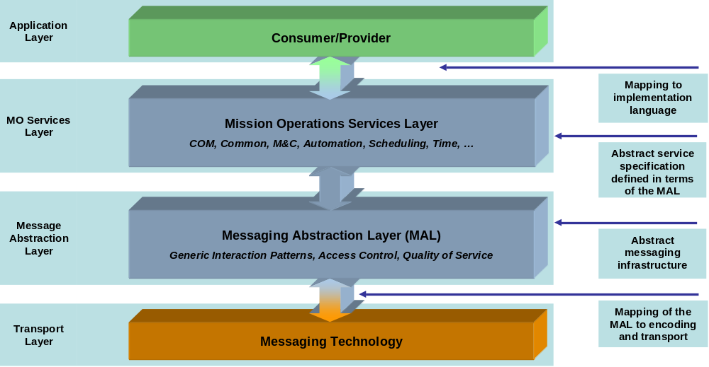
Figure 3-2 Overview of the Mission Operations Service Framework

The Mission Operations Services Layer provides the end-to-end services that are exposed to mission operations applications. Internally it is composed of three aspects:
- Functional Services
- Common Services
- Common Object Model

The Message Abstraction Layer provides a standard messaging layer between the Consumer and Provider sides of the service framework. This, together with standardised bindings between the MO Service Framework layers, ensures that different implementations of the service framework can interoperate across the service interfaces, providing the underlying communications protocol stack is equivalent on both sides of the interface. The layer provides the following fundamental aspects:
- A specification of the fundamental data types, enumerations and structures;
- A definition of the rules for combining data types and structures;
- Generic Messaging Interaction Patterns that define the allowed sequence of message exchange;
- Fundamental concepts such as security and Quality of Service (QoS).

In practice, the service layers are slightly more complex as Illustrated below. A similar format is used to illustrate the relationships between the service layers in this document. The formal and thorough explanation of the Mission Operations Concepts is documented in CCSDS 520.0-G-3 Mission Operations Concepts Informational Report April 2009.
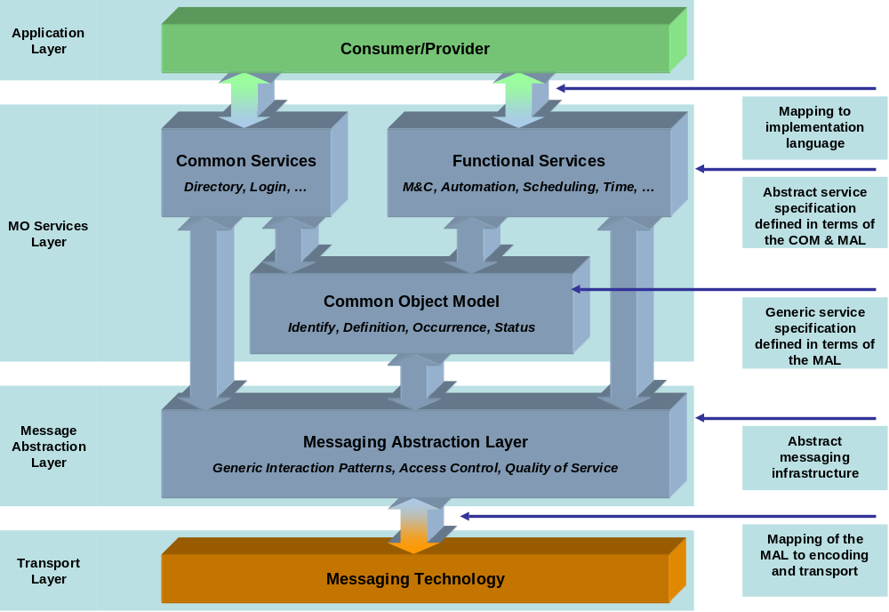
Figure 3-3 Mission Operations Service Layers

Standard used

Mission Operations Specifications
The interoperability prototype will be implemented according to the Mission Operations / SM&C Red Books, without security specifications. The latest versions, at the time of agreement, are listed below. As updates are made, we will mutually agree to step up to the new versions.
Mission Operations Service Abstraction Framework CCSDS 521.0.R-2, September 2009
[Updated to Agency Review MAL 17/03/2010]
Mission Operations Common Object Model CCSDS 52x.0.R-x.x Draft A, April 2009
Spacecraft Monitor and Control Common Services CCSDS 521.1-R-2 April 2008
Spacecraft Monitor and Control Core Services CCSDS 522.-R-2 April 2008

JSC-OTF Directory Service
The JSC-OTF Directory service provider and consumer will use a binary encoding as described in Section 5.1. The transport layer will be implemented with a bridge to connect a DDS and JMS middleware solution.
- Transport
- Data Distribution System (DDS) Version 1.2 as defined by the Object Manager Group (OMG): http://www.omg.org/spec/DDS/1.2/
Java Message Service (JMS) Version 1.1 as defined by Oracle-Sun: http://java.sun.com/products/jms (PDF download available)
[Removed SOAP/XML encoding over HTTP 23/04/2010]

DLR-GSOC Directory Service
The DLR-GSOC Directory Service provider and consumer will use a binary encoding, as described in Section 5.1, over a JMS transport.
- Transport
- Java Message Service (JMS) Version 1.1 as defined by Oracle-Sun: http://java.sun.com/products/jms (PDF download available)
[Removed SOAP/XML encoding over HTTP 23/04/2010]

JSC-OTF Service Providers
The JSC-OTF implemented service providers, with the exception of the Directory Service, will use a binary encoding as described in Section 5.1. The transport layer will be implemented with a bridge to connect a DDS and JMS middleware solution.
- Transport
- Data Distribution System (DDS) Version 1.2 as defined by the Object Manager Group (OMG): http://www.omg.org/spec/DDS/1.2/
- Java Message Service (JMS) Version 1.1 as defined by Oracle-Sun: http://java.sun.com/products/jms (PDF download available)

DLR-GSOC Service Consumers
The DLR-GSOC service consumers, with the exception of the Directory Service, will use a binary encoding, as described in Section 5.1, over a JMS transport.
- Transport
- Java Message Service (JMS) Version 1.1 as defined by Oracle-Sun: http://java.sun.com/products/jms (PDF download available)

JSC-OTF Prototype design
In this prototype, JSC-OTF will implement the service providers for the Action, Parameter, Login and optionally, the Alert Services. JSC-OTF may also implement an Alert Service consumer. DLR-GSOC is responsible for the service consumers; DLR-GSOC may also implement an Alert Service provider. For two agencies to interoperate using the Mission Operations standards they must agree on 1) the versions of the specifications to implement 2) the encoding and 3) the transport layer. JSC-OTF and DLR-GSOC have chosen different transport layers. A bridge is necessary to connect the middleware products. JSC-OTF will implement a binary encoding over a DDS transport. DLR-GSOC is implementing a binary encoding over a JMS transport. Figure 3-4 illustrates the communication flow between JSC-OTF and DLR-GSOC. The bridge will be maintained at JSC to provide the illusion the two homogonous prototypes communicating using binary encoding over JMS. The Common Object Model is outlined using dashes to highlight a minimum amount of functionality will be implemented. The Login Service will be implemented for internal access control to the JSC-OTF system; the Login Service will not publish its availability to the DLR-GSOC Directory Service.
The Mission Operations specifications are language agnostic. DLR-GSOC will implement the service consumers using C++. JSC-OTF will implement the service providers using C++.

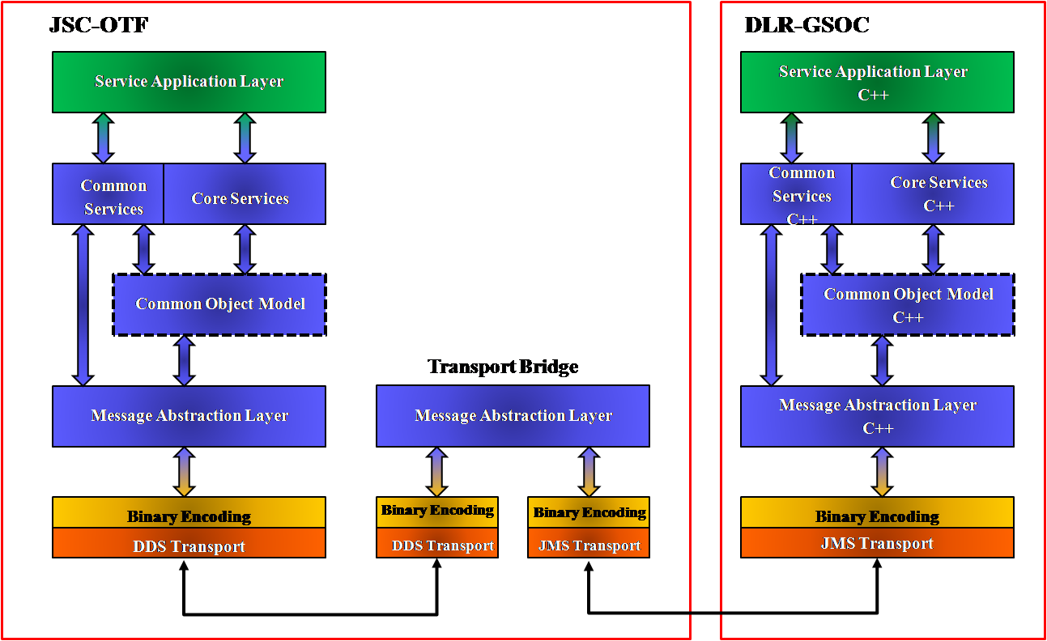
Figure 3-4 Action, Parameter and Alert Service Interoperability

For the Directory Service, JSC-OTF and DLR-GSOC will utilize a binary encoding. A bridge will be necessary to to connect a DDS and JMS transport layer. This service includes operations that allow for deployment as a federated service. JSC-OTF will publish service availability to its Directory Service implementation. DLR-GSOC will request lookup operations from its Directory Service implementation. Figure 3-10 in Section 3.4.5 provides the necessary steps to keep the two implementations synchronized. The Figure 3-5 illustrates the communications flow for the Directory Service.
[Removed SOAP/XML encoding over HTTP 23/04/2010]
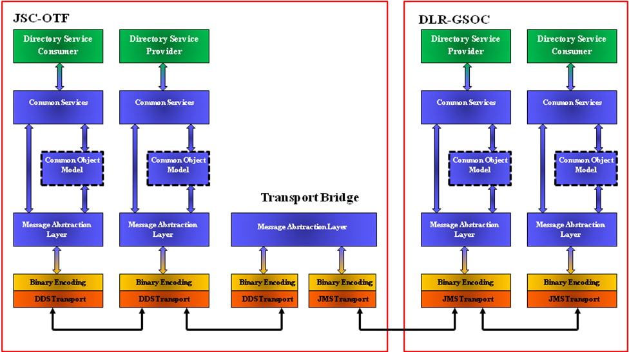
Figure 3-5 Directory Service Interoperability

JSC-OTF will implement the provider for the Action, Parameter and, optionally, Alerts services. These services will front existing OTF systems to provide the necessary capabilities. A spacecraft simulator will receive actions and provide telemetry feedback. The available telemetry parameters will be chosen so the values will be affected by actions that are invoked. The Alerts Service will allow exchange of advisory messages among service providers and consumers. Figure 3-6 provides a high level over view of the prototype from the perspective of the service provider. The Login Service controls internal access to the JSC-OTF prototype; hence, the lighter shade and different shape outline.
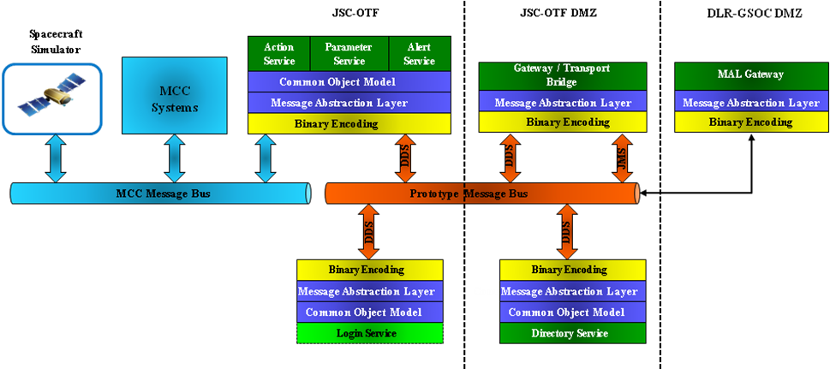

Figure 3-6 JSC-OTF Prototype

DLR-GSOC Prototype Design
Here is a preliminary design of the Mission Operations Prototype running at DLR-GSOC:
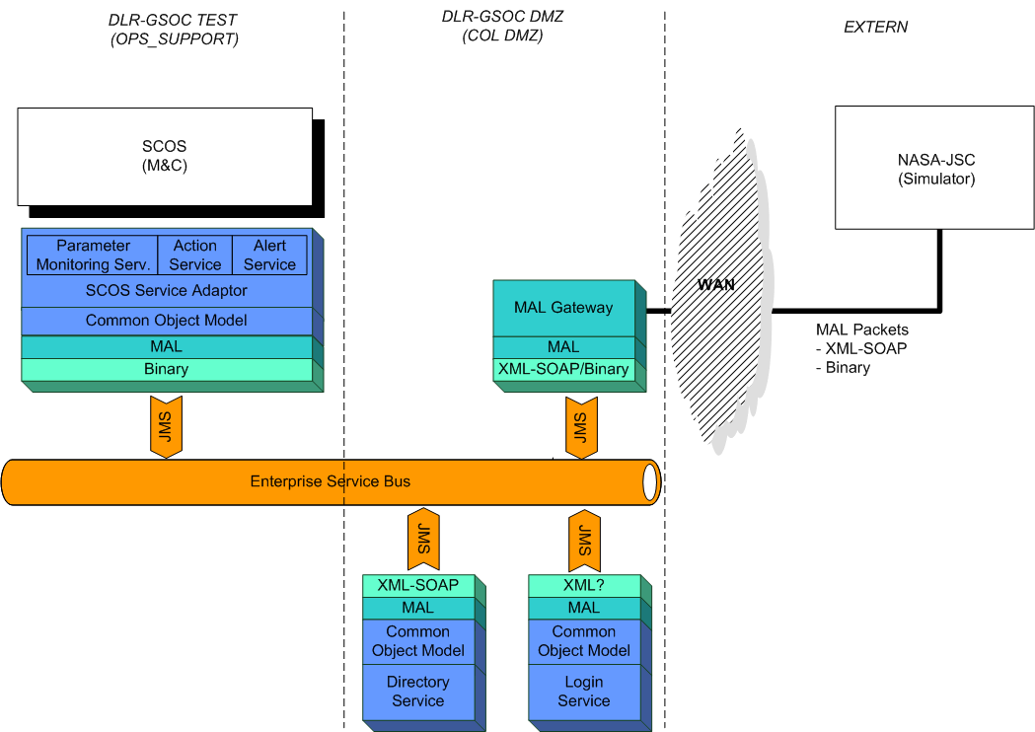
Figure 3-7 DLR-GSOC Prototype

The Prototype will be distributed over 2 different segments of DLR LAN because of security directives.
The internal communication should be implemented with an Enterprise Service Bus (based on JMS message exchanges)
The communication with JSC-OTF will be performed through a “MAL Gateway” that is able to forward the MAL Packets between the external communication line and the internal ESB.
Firewalls are located at each border between 2 LAN segments (the dotted lines in the figure)

Combined Protocol Description
The Mission Operations specifications do not currently address the encoding of the MAL, Common or Core data structures. For the Action, Parameter Alert and Directory Services, JSC-OTF and DLR-GSOC will exchange the data in a binary format. The binary encoding format is presented in Section 5.1. It is based upon the encoding used in the JSC-OTF Parameter Service prototype effort. The Directory Service will use and XML encoding for the MAL and Common data structures. The schemas for the XML encoding are included in Section 5.2.

Blue book definition of serveral encoding mechanisms is on the road map for the Mission Operations specifications. However, the service configuration data is left as an implementation detail to be agreed upon by the interoperating agencies. The configuration data is included in Section 5.2.4.

Layers To Be Implemented

Application Layer

JSC-OTF
JSC-OTF will use a spacecraft simulator as illustrated in Figure 3-5. The Mission Operations service providers will leverage existing OTF systems to provide the required capabilities.

DLR-GSOC
DLR-GSOC will use the SCOS M&C Application from ESA. This application is commonly used by most of the satellite projects currently flown by GSOC.
This will be done by implementing a “SCOS Service Adaptor” to communicate using services.
DLR will make this implementation in C++
The Graphical User Interfaces to communicate with SCOS will be SATMON, already used in most of the GSOC satellite missions.

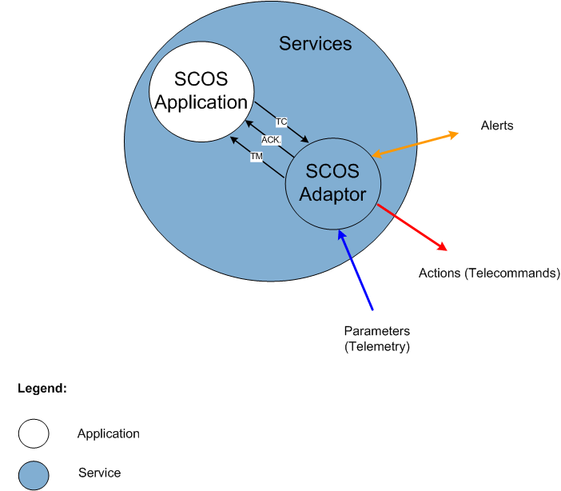
Figure 3-8 DLR-GSOC Application Layer

Service Layer
The service layer will be implemented using the Common Object Model based on the MAL. The services to be implemented are described in chapter 3.3
All the services will be registered in a database and called through the “Directory service”.
The following Services existing in the Mission Operations specifications will not be implemented in this prototype:
- Common Services
  - Configuration Services
  - Interaction Service
  - Retrieval Service
  - Replay Service
- Core Services
  - Aggregation Service*
  - Argument Service
  - Conversion Service
  - Check Service
  - Statistics Service

*The Aggregation Service may be implemented as more details become available.

JSC-OTF
JSC-OTF will implement the service providers for Directory, Action, Parameters, Alerts and Login. Alerts are optional. A Login Service will be implemented for internal access control; however, this service will not provide authentication for the DLR-GSOC service consumers at this time. All the services, with exception of the Login Service, will publish availability to the JSC-OTF Directory Service.

DLR-GSOC
DLR will make an implementation in C++
The Services implemented for this prototype will be divided in two categories:
- Core Services:
The core services are the “Parameter Monitoring Service”, the “Action Service” and the “Alert Service”. They are all directly communicating with SCOS and will be realised in the “SCOS Service Adaptor”.
- Common Services:
The Common Services are the “Directory Service” and the “Login Service”. They are not related with SCOS and will be realised each as a separate component. These services will be designed to be later reused by other Services.

Common Object Model

JSC-OTF
The Common Object Model (COM) will be partially implemented in the prototype. No archival of data or history will be initially supported; therefore, REPLAY sessions are not available. The COM operations are listed in Table 3-1. A column for each inter-center service in the prototype is included. A check mark in the service column indicates the operation will be supported. The Directory Service maintains information about capability sets that are available for services as opposed to individual operations. The request and list of occurrences require historical data to be fully implemented. As archival is not being performed, the “O” indicates the operation is available but will always return an empty list. Although the operation to monitor definitions is available, the operations to add, modify and delete a definition are not implemented. No notifications for definition changes will be issued.

Operation Name | Operation Number | Capability Set | Directory Service | Action Service | Parameter Service | Alert Service
requestDefinition | 0 | 0 |  | ✓ | ✓ | ✓
listDefinition | 1 | 0 |  | ✓ | ✓ | ✓
monitorDefinition | 2 | 0 |  | ✓ | ✓ | ✓
requestOccurrence | 4 | 1 |  |  |  | O
listOccurrence | 5 | 1 |  |  |  | O
monitorOccurrence | 6 | 1 |  |  |  | ✓
requestStatus | 7 | 2 |  |  | O
listStatus | 8 | 2 |  |  | O
monitorStatus | 9 | 2 |  |  | ✓
addDefinition | 10 | 3
modifyDefinition | 11 | 3
deleteDefinition | 12 | 3
Table 3-1 JSC-OTF Common Model Operations

DLR-GSOC
DLR will make a partial implementation of the Common Object Model in C++ for the prototype. No archival of data or history will be initially supported; therefore, REPLAY sessions are not available.
The Common Object Model Layer will be based on the MAL and will consist of Class/Object definitions for structures that will be used by the Service definitions.
This model will consist of definitions of the following elements as described in the Mission Operations specifications:
- Identity
- Definition
- Occurrence
- Status
Here is a list of the operations supported:
Operation Name | Operation Number | Capability Set | Directory Service | Action Service | Parameter Service | Alert Service
requestDefinition | 0 | 0 |  | ✓ | ✓ | ✓
listDefinition | 1 | 0 |  | ✓ | ✓ | ✓
monitorDefinition | 2 | 0 |  | ✓ | ✓ | ✓
requestOccurrence | 4 | 1
listOccurrence | 5 | 1
monitorOccurrence | 6 | 1 |  |  |  | ✓
requestStatus | 7 | 2
listStatus | 8 | 2
monitorStatus | 9 | 2 |  |  | ✓
addDefinition | 10 | 3
modifyDefinition | 11 | 3
deleteDefinition | 12 | 3
Table 3-2 DLR-GSOC Common Model Operations

Message Abstraction Layer

JSC-OTF
JSC-OTF will implement the Message Abstract Layer in C++. No history or archival capabilities will be implemented.
JSC-OTF will support a MAL QoS level of “Assured”, that means:
- Ensure delivery of messages to its destination
- Messages are not duplicated
- The order of messages is preserved between a single provider and consumer
- No support for Loose Time Coupling
- No time guarantees
- No messages will be queued if a destination is not available

DLR-GSOC
DLR will make an implementation of the Message Abstraction Layer in C++. No history or archival capabilities will be implemented.
The MAL Attribute formats are defined in the MAL specifications but for the details (big/little endian, values of TRUE and FALSE, a.s.o) DLR-GSOC will take the MAL Attribute format already implemented by JSC-OTF.
DLR-GSOC will support a MAL QoS level of “Assured”, that means:
- Ensure delivery of messages to its destination
- Messages are not duplicated
- The order of messages is preserved between a single provider and consumer
- No support for Loose Time Coupling
- No time guarantees
- No messages will be queued if a destination is not available

The MAL will implement authentication and authorisation in the form of an identifier (generated by the “Directory Service” and “Login Service”). There will be no encryption implemented in the “Directory Service” or “Login Service”.

Encoding Layer

JSC-OTF

Directory Service

The Directory Service will use binary encoding. The encoding rules are defined in Section 5.1.
[Removed SOAP/XML encoding over HTTP 23/04/2010]

Action, Parameter and Alert Services

The service providers will use binary encoding. The encoding rules are defined in Section 5.1.

DLR-GSOC
DLR-GSOC DLR will make an implementation in C++.
The encoding layer should be coded over an abstract definition, to allow using different coding without changing the MAL API.

Directory Service

The Directory Service will use binary encoding. The encoding rules are defined in Section 5.1.
[Removed SOAP/XML encoding over HTTP 23/04/2010]

Action, Parameter and Alert Services

The service consumers will use the same binary encoding as the service providers. The encoding rules are defined in Section 5.1.

Transport layer

JSC-OTF

Directory Service

The Directory Service will communicate via a Data Distribution Service (DDS) transport layer. A bridge will be implemented to allow interaction between DDS and JMS.
[Removed SOAP/XML encoding over HTTP 23/04/2010]

Action, Parameter, and Alert Services

JSC-OTF service providers will communicate via a Data Distribution Service (DDS) transport layer. A bridge will be implemented to allow interaction between DDS and JMS.

DLR-GSOC

Directory Service

The Directory Service will communicate via a JMS transport layer.

Action, Parameter, and Alert Services

DLR-GSOC service consumers will communicate via JMS transport layer.

The internal communication in GSOC will be done through JMS messaging. The OTF is responsbile for bridging between the JMS and DDS transports.

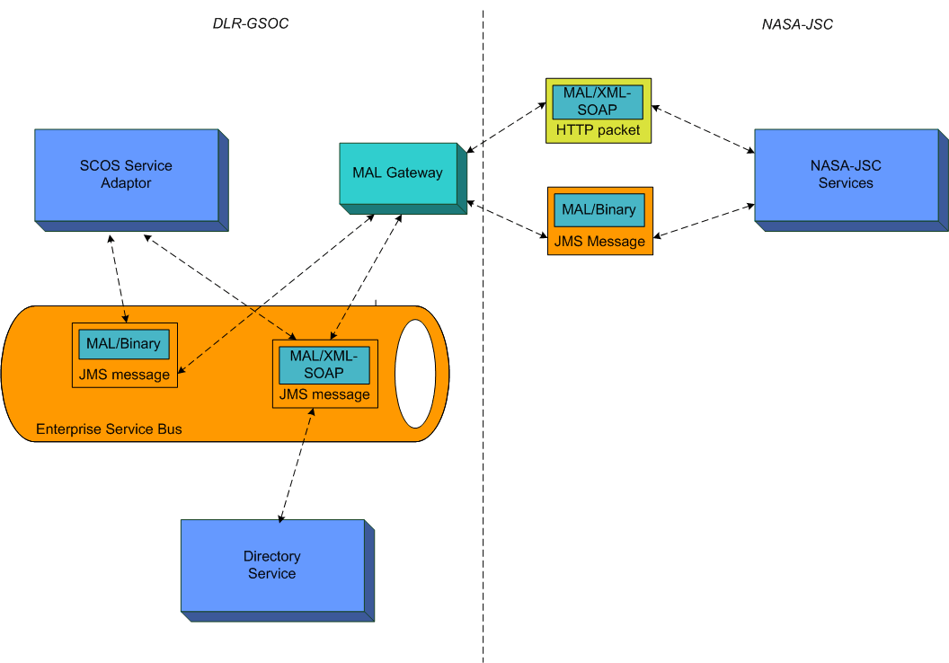
Figure 3-9 DLR-GSOC Transport Layer

Services to be implemented

Directory Service

JSC-OTF
JSC-OTF will implement a Directory Service provider. The current implementation will be modified to meet to the current red book specifications for Common Services as specified in Section 3.1.2. The service operations are listed in Table 3-3. All common service operations for this service will be implemented.

Service Identifier | Area Number | Service Number | Availability
Directory | 0 | 1
Operation Name | Operation Number | Capability Set
Common Model Operations
None
Service Operations
createNode | 100 | 100 | ✓
removeNode | 101 | 100 | ✓
resolveNodeURI | 102 | 100 | ✓
addLink | 103 | 101 | ✓
removeLink | 104 | 101 | ✓
publishService | 105 | 102 | ✓
lookupService | 106 | 102 | ✓
withdrawService | 107 | 102 | ✓
Table 3-3 JSC-OTF Directory Service Operations

The JSC-OTF Service definitions (Action, Parameter, and Alert) will be added to the DLR-GSOC Directory database using the external node capabilities.

DLR-GSOC
The JSC-OTF Service definitions (Action, Parameter, and Alert) will be added to the DLR-GSOC Directory database
The Directory Service will be developed as a standalone component using a SQL database for serialisation of the service information
Encoding of the “Directory Service” will be Binary; the schemas are defined in Section 5.1.

Here is a list of the operation supported by DLR-GSOC “Directory Service”:
Service Identifier |  | Area Number |  |  | Service Number
Directory |  | 0 |  |  | 1
Interaction Pattern | Operation Name |  | Operation Number | Support in Replay |  | Capability Set
Common Model Operations:
Service specific Operations:
SUBMIT | createNode |  | 100 | No |  | 100
SUBMIT | removeNode |  | 101
REQUEST | resolveNodeURI |  | 102
SUBMIT | addLink |  | 103 | No |  | 101
SUBMIT | removeLink |  | 104
SUBMIT | publishService |  | 105 | No |  | 102
SUBMIT | lookupService |  | 106
SUBMIT | withdrawService |  | 107
Table 3-4 DLR-GSOC Directory Service Operations

Action Service

JSC-OTF
JSC-OTF will implement the Action Service provider. The service will be implemented as described in the current red book specifications for Core Services as specified in Section 3.1.2. The service operations are listed in Table 3-5. All core service operations will be implemented by the service provider.

Service Identifier | Area Number | Service Number | Availability
Action | 1 | 1
Operation Name | Operation Number | Capability Set
Common Object Model Operations
requestDefinition | 0 | 0 | ✓
listDefinition | 1 | 0 | ✓
monitorDefinition | 2 | 0 | ✓
Service Operations
invokeAction | 100 | 100 | ✓
preCheckAction | 101 | 100 | ✓
Table 3-5 JSC-OTF Action Service Operations
The monitorDefinition operation is supported as part of the capability set 0; however, the creation, update and delete of definitions will not be implemented. This operation will not provide notifications.

The service provider will support the Verification Stage as identified in Table 3.6. Stages not supported will be marked with Verification State ASSUMED as subsequent stages are completed.

Verification Stage
Enumeration Value | Short Form | Comment | Supported
RELEASE | 1 | Release from the source | ✓
RECEIPT | 2 | Reception by the destination | ✗
ACCEPTANCE | 3 | Acceptance by the destination | ✗
EXECUTION | 4 | Execution started by destination | ✗
PROGRESS | 5 | Execution is progressing in the destination | ✗
COMPLETION | 6 | Execution completed by the destination | ✓
Table 3-6 JSC-OTF Supported Verification Stages

The Action Service configuration data will be included in Section 6.1 when available.

DLR-GSOC
DLR-GSOC will act as a consumer of the “Action Service”, invoking Telecommand for the emulated spacecraft
The “Action Service” will be developed as a module of the “SCOS Service Adaptor”.
The DLR-GSOC “Action Service” will use the “Directory Service” and the “Login Service” to communicate with the NASA-JSC “Action Service”.
The format of a Command will be defined by JSC-OTF and the “SCOS Service Adaptor” will transform a generated SCOS Telecommand (TC) in a Mission Operations Action.
The “Action Service” should send an acknowledge using the VerificationStage entity.
Here is a list of the operations supported by the DLR-GSOC “Action Service” consumer:
Service Identifier |  | Area Number |  |  | Service Number
Action |  | 1 |  |  | 1
Interaction Pattern | Operation Name |  | Operation Number | Support in Replay |  | Capability Set
Common Model Operations:
REQUEST | requestDefinition |  | 0 | No |  | 0
REQUEST | listDefinition |  | 1 |  |  | 0
PUBSUB | monitorDefinition |  | 2 |  |  | 0
Service specific Operations:
PROGRESS | inkokeAction |  | 100 | No |  | 100
REQUEST | preCheckAction |  | 101 |  |  | 100
Table 3-7 DLR-GSOC Action Service Operations

Parameter Service

JSC-OTF
JSC-OTF will implement the Parameter Service provider. The service will be implemented as described in the current red book specifications for Core Services as specified in Section 3.1.2. The service operations are listed in Table 3-8. Capability Set 100 is not implemented. The impact of these operations on the middleware is unknown.

The operations requestStatus and listStatus for the Common Object Model are designated with an “O”. The interoperability prototype will not initially support history or archival. These operations will return an empty list.

Service Identifier | Area Number |  | Service Number | Availability
Parameter | 1 |  | 2
Operation Name | Operation Number |  | Capability Set
Common Object Model
requestDefinition | 0 | 0 |  | ✓
listDefinition | 1 |  |  | ✓
monitorDefinition | 2 |  |  | ✓
requestStatus | 6 | 2 |  | O
listStatus | 7 |  |  | O
monitorStatus | 8 |  |  | ✓
Service Operations
setFiltered | 100 |  | 100 | ✗
getFiltered | 101 |  | 100 | ✗
setTimeouts | 102 |  | 100 | ✗
getTimeouts | 103 |  | 100 | ✗
Table 3-8 JSC-OTF Parameter Service Operations

The monitorDefinition operation is supported as part of the capability set 0; however, the creation, update and delete of definitions will not be implemented. This operation will not provide notifications.

The layout of the parameter definitions described in the specifications is sufficient for data exchange. The list of available parameters, provided by JSC-OTF as configuration data, will be included in Section 6.2 when available.

DLR-GSOC
DLR-GSOC will act as a consumer of the Parameter service, receiving Telemetry from emulated spacecraft
The “Parameter Service” will be developed as a module of the “SCOS Service Adaptor”.
The DLR-GSOC “Parameter Service” will use the “Directory Service” to communicate with the JSC-OTF “Parameter Service”.
The format/calibration of a Parameter is defined in a parameter database from JSC-OTF. The parameters are sent using the MAL layer and have already been decommutated and calibrated by the Service Provider. SCOS Adapter should not have to do any decommutation or calibration, but still needs a list of the parameters/formats in calibrated state (see chapter 6.2 for a details of the configuration data). A SCOS database has to be generated by DLR-GSOC, using this information.
The following status will not be implemented by the Parameter Service consumer: parameter checking status, statistics status.

Following functionalities will be supported by the “Parameter Service consumer”
- Subscribe for parameter
- Receive update
- Unsubscribe

Here is a list of the operations supported by the DLR-GSOC “Parameter Service” consumer:
Service Identifier |  | Area Number |  | Service Number
Parameter |  | 1 |  | 2
Interaction Pattern | Operation Name |  | Operation Number | Support in Replay | Capability Set
Common Model Operations:
REQUEST | requestDefinition |  | 0 | No | 0
REQUEST | listDefinition |  | 1 | No | 0
PUBSUB | monitorDefinition |  | 2 | No | 0
PUBSUB | monitorStatus |  | 8 | No | 2
Service specific Operations:
Table 3-9 DLR-GSOC Parameter Service Operations

Login Service

JSC-OTF
JSC-OTF will implement a Login Service. The service will be implemented as described in the current red book specifications for Common Services as specified in Section 3.1.2. This service will only provide internal access control to the JSC-OTF prototype and will not publish its availability to the DLR-GSOC Directory Service.

Service Identifier | Area Number | Service Number | Availability
Login | 0 | 2
Operation Name | Operation Number | Capability Set
Common Model Operations
None
Service Operations
login | 100 | 100 | ✓
logout | 101 | 100 | ✓
reportRoles | 102 | 100 | ✗
handover | 103 | 101 | ✗
Table 3-10 JSC-OTF Login Service Operations

DLR-GSOC
The Login Service will be developed as a standalone component.
The Login Service will assure authentication of a service request. An identifier will be used to bind this information with the authorisation information from the “Directory Service” to the data packet.
No encryption will be used for the prototype.

Here is a list of the operation supported by the DLR-GSOC “Login Service” provider:

Service Identifier |  | Area Number |  | Service Number
Login |  | 0 |  | 2
Interaction Pattern | Operation Name |  | Operation Number | Support in Replay | Capability Set
Common Model Operations:
Service specific Operations:
REQUEST | login |  | 100 | No | 100
SUBMIT | logout |  | 101 | No | 100
Table 3-11 DLR-GSOC Login Service Operations

Alert Service (optional)
This service is optional, although desired. Time permitting, JSC-OTF and DLR-GSOC will implement the service provider and consumer as part of the interoperability prototype.

JSC-OTF
JSC-OTF may implement the Alert Service provider and a consumer. The service will be implemented as described in the current red book specifications for Core Services as specified in Section 3.1.2. The available operations are listed in Table 3-12. Capability Set 101 will not be implemented at this time since these operations would require authentication.
The operations requestOccurrence and listOccurrence for the Common Object Model are designated with an “O”. The interoperability prototype will not support history or archival. These operations will return an empty list.

Service Identifier | Area Number | Service Number | Availability
Alert | 1 | 6
Operation Name | Operation Number | Capability Set
Common Model Operations
requestDefinition | 0 | 0 | ✓
listDefinition | 1 | 0 | ✓
monitorDefinition | 2 | 0 | ✓
requestOccurrence | 3 | 1 | O
listOccurrence | 4 | 1 | O
monitorOccurrence | 5 | 1 | ✓
Service Operations
raiseAlert | 100 | 100 | ✓
enableGeneration | 101 | 101 | ✗
disableGeneration | 102 | 101 | ✗
Table 3-12 JSC-OTF Alert Service Operations
The implementation of the service provider will require JSC-OTF to provide the list of available alerts as part of the service configuration data. The list is included in Section 6.3.

DLR-GSOC
The “Alert Service” is optional and will be implemented if time and resources are available.
DLR-GSOC “Alert Service” will act as a consumer and as a provider of the Parameter service, sending Alert to JSC-OTF as well as receiving Alerts from JSC-OTF.
The “Alert Service” will be developed as a module of the “SCOS Service Adaptor”.
The DLR-GSOC “Alert Service” will use the “Directory Service” to communicate with the JSC-OTF “Alert Service”.
Here is a list of the operations supported by the DLR-GSOC “Alert Service” consumer / provider
Service Identifier |  | Area Number |  | Service Number
Alert |  | 1 |  | 6
Interaction Pattern | Operation Name |  | Operation Number | Support in Replay | Capability Set
Common Model Operations:
REQUEST | requestDefinition |  | 0 | No | 0
REQUEST | listDefinition |  | 1 | No | 0
PUBSUB | monitorDefinition |  | 2 | No | 0
PUBSUB | monitorOccurence |  | 5 | No | 1
Service specific Operations:
SUBMIT | raiseAlert |  | 100 | No | 100
Table 3-13 DLR-GSOC Alert Service Operations

Test environment

Communication
Communication will be realised through the existing Columbus IGS network (see chapter 2.5). The corresponding firewall configuration will be organised by each agency on its side.

Security policy
For the use of the Columbus communication link, the security policy of Columbus-IGS will apply.

JSC-OTF
The standard NASA IT & Security policies will apply as documented in the JSC-OTF IT security plan (SPDA5100)

DLR-GSOC
The general GSOC/Col-CC security policy will apply (t.b.d. doc. reference)

Test environment in JSC-OTF
Prototype will be located in a segment of the JSC-OTF development lab. A bridge and application servers are planned:
- OTF Mission Operations Bridge to host the following:
- Mission Operations Transport Bridge will use ports from 40100 to 40109
- [Removed HTTP port 80 for Directory Services 23/04/2010]
- GSOC Loopback Test bed.
- OTF Application Servers to host the following:
- OTF Spacecraft Simulator.
- OTF Systems
- Mission Operations Service Providers

Test environment in DLR-GSOC
The prototype will be located in the COL DMZ and in a special VLAN of the OPS_SUPPORT area at GSOC Control Center:
- “MAL Gateway” Server in COL DMZ:
This Server will hold the „MAL Gateway“, the “Directory Service” application/database, the “Login Service” application and a “JMS Access Point” for the communication.
- “SMC” Server in OPS_SUPPORT:
This Server will hold the “SCOS Service Adaptor“(responsible for the “Parameter Monitoring Service”, the “Action Service” and the “Alert Service”), the SCOS application/database and a “JMS Access Point” for the communication.
The ports described in section 3.4.3 are also applicable here

Use Cases
High level sequence diagrams providing an overview of each of the services (except Login) are presented in this section. Figure 3-10 illustrates the JSC-OTF interpretation of the Directory Services specification from April 2008. The service provides operations that indicate that a federated deployment is possible; however, the descriptions do not explicitly state how the operations should be used.
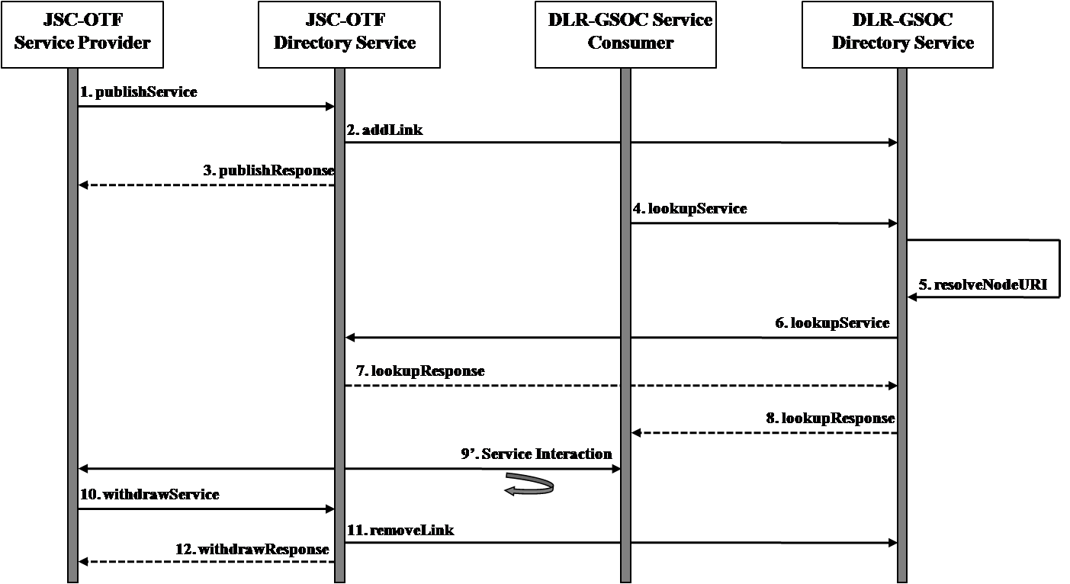
Figure 3-10 Directory Service Sequence

Figure 3-11 illustrates the sequence of operations to invoke an action via the Action Service.
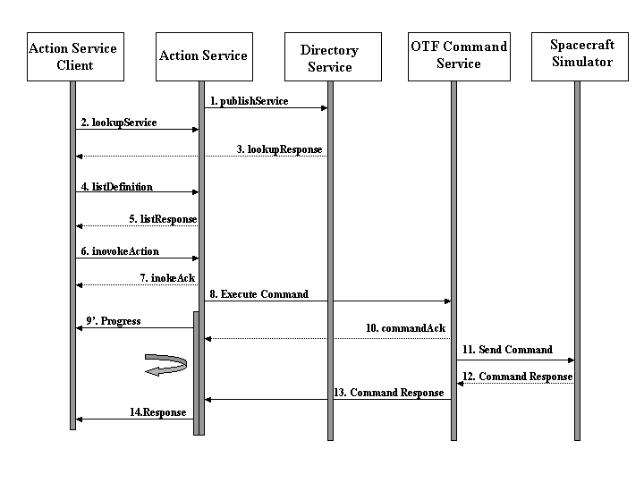
Figure 3-11 Action Service Sequence

The telemetry stream is constantly flowing between the spacecraft simulator and the OTF Telemetry Service. The necessary steps shown in Figure 3-12 assume the connection between the simulator and telemetry service has already been established.
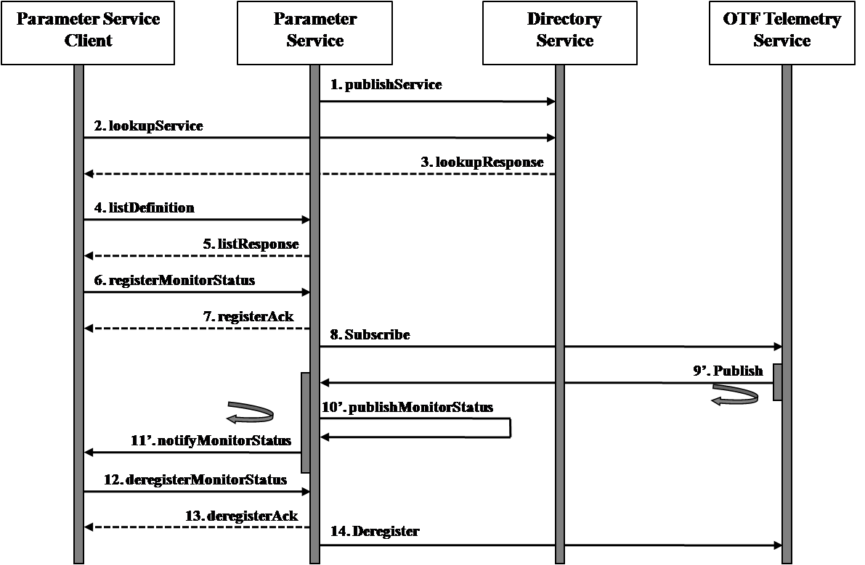
Figure 3-12 Parameter Service Sequence

The steps to subscribe for Alerts are shown in Figure 3-13. Alerts may be raised by a service provider or consumer in the prototype. The sequence to raise alerts is illustrated in Figure 3-14.

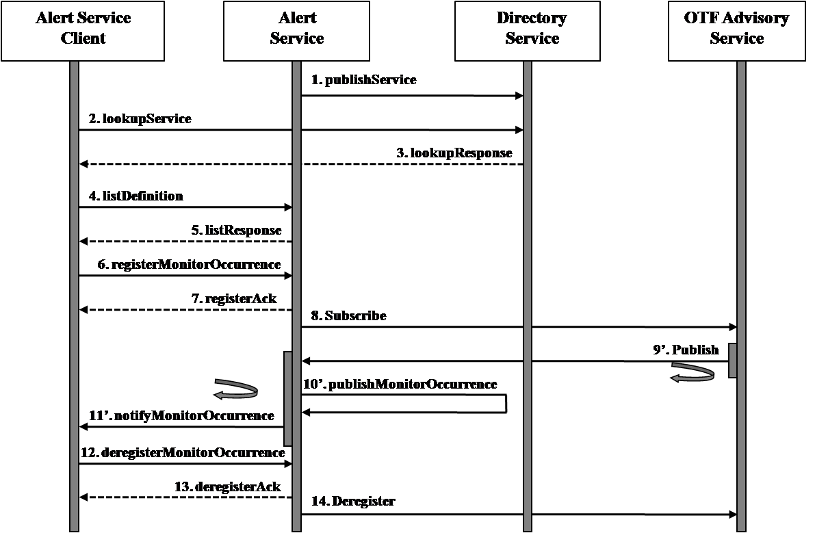
Figure 3-13 Alert Service Sequence – Subscribe

t.b.d. DLR-GSOC has to provide an Alert Service Sequence use case to subscribe to SCOS service

The Alert - Raise sequence assumes the registration for Alerts has been completed. The raise and notify of an alert is shown.
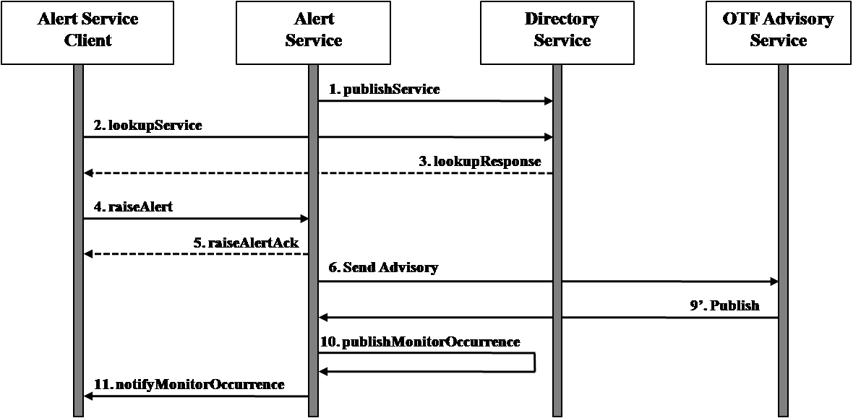
Figure 3-14 Alert Service Sequence – Raise

t.b.d. DLR-GSOC has to provide an Alert Service Sequence use case to raise a SCOS service alert.

Bridging System Domains
The prototype will use an “in-care of” address strategy to permit messages to be exchanged between the gateway machines. The complete routine information will be contained in the URIto and URIfrom values in the MAL Message Header. The value otf-service-uri@otf-gateway-uri indicates the message should be sent to the otf-gateway-uri. The otf gateway is responsible for forwarding the message on to the OTF service provider.

The service providers will publish the entire routing sequence in the service URI contained in the Directory Service. An OTF service provider will publish its URI value as the following: ddsbin:otf-service-provider@jmsbin:otf-gaway@jmsbin:dlr-gateway. A DLR service provider will publish its URI value as the following: jmsbin:dlr-service-provider@jmsbin:dlr-gateway@ddsbin:otf-gateway. The OTF gateway uses the JMS-Binary (jmsbin) protocol for external communications and the DDS-Binary (ddsbin) protocol for internal communications. The OTF Gateway is responsible for modifiying the protocol as the messages are forwareded.

The gateway bridges follows two rules wheenver a message is received:
- Removes its URI value from the end of the URIto
- Append its URI value to the end of the URIfrom.

Table 3-14 illustrates the URI values for a message sent from a DLR Service Consumer to an OTF Service Provider. The initial URIto value of the OTF Service Provider was provided on the publish to the Directory Service.
 | DLR Client | DLR Gateway | OTF Gateway | OTF Service
Request 
URIto | ddsbin:otf-service@ jmsbin:otf-gateway@ jmsbin:dlr-gateway | ddsbin:otf-service@ jmsbin:otf-gateway | ddsbin:otf-service | ddsbin:otf-service
URIfrom | jmsbin:dlr-client | jmsbin:dlr-client@ jmsbin:dlr-gateway | jmsbin:dlr-client@ jmsbin:dlr-gateway@ ddsbin:otf-gateway | jmsbin:dlr-client@ jmsbin:dlr-gateway@ ddsbin:otf-gateway
Reply
URIto | jmsbin:dlr-client | jmsbin:dlr-client | jmsbin:dlr-client@ jmsbin:dlr-gateway | jmsbin:dlr-client@ jmsbin:dlr-gateway@ ddsbin:otf-gateway
URIfrom | ddsbin:otf-service@ jmsbin:otf-gateway@ jmsbin:dlr-gateway | ddsbin:otf-service@ jmsbin:otf-gateway@ jmsbin:dlr-gateway | ddsbin:otf-service@ jmsbin:otf-gateway | ddsbin:action-service

Table 3-14 URI Values from DLR Consumer to OTF Provder

Table 3-15 illustrates the URI values for a message sent from an OTF Service Consumer to a DLR Service Provider. The initial URIto value of the DLR Service Provider was provided on the publish to the Directory Service.
 |  | OTF Client | OTF Gateway | DLR Gateway |  | DLR Service
Request
URIto | jmsbin:dlr-service@ jmsbin:dlr-gateway@ ddsbin:otf-gateway |  | jmsbin:dlr-service@ jmsbin:dlr-gateway |  | jmsbin:dlr-service |  |  | jmsbin:dlr-service
URIfrom | ddsbin:otf-client |  | ddsbin:otf-client@ jmsbin:otf-gatway |  | ddsbin:otf-client@ jmsbin:otf-gateway@ jmsbin:dlr-gateway |  | ddsbin:otf-client@ jmsbin:otf-gateway@ jmsbin:dlr-gateway
Reply
URIto | ddsbin:otf-client@ |  | ddsbin:otf-client |  | ddsbin:otf-client@ jmsbin:otf-gateway |  | ddsbin:otf-client@ jmsbin:otf-gateway@ jmsbin:dlr-gateway
URIfrom | jmsbin:dlr-service@ jmsbin:dlr-gateway@ ddsbin:otf-gateway |  | jmsbin:dlr-service@ jmsbin:dlr-gateway@ ddsbin:otf-gateway |  | jmsbin:dlr-service@ jmsbin:dlr-gateway@ |  | jmsbin:dlr-service
Table 3-15 URI Values from OTF Consumer to DLR Provider

Planning

Stages
The “Mission Operations Prototype” is divided in 2 stages. The idea is first to develop the lower layer components and make a communication test at the end of the first stage. With this test succeeded, the development of the Service components will be started, that will lead to a Service test at the end of stage 2.
On this way it is possible to have a better management of the time and resources affected to the project.

Stage 1
The stage 1 consists of developing the MAL and a basic communication allowing both agencies to interact on MAL layer by January 2010. Here is a list of the different tasks contained in Stage 1:
- Define a Project Schedule for the whole SM&C Prototype
- Gather all information about format, protocols and technical specifications and document findings in a PID (Prototype Interoperability Document).
- Coordinate network connection between JSC-OTF and DLR-GSOC
- Connectivity test to send bits over port 40100 through 40109 using TCP/IP
- Develop (for DLR-GSOC and JSC-OTF) a MAL on both sides
- Develop (for DLR-GSOC) or update (for JSC-OTF) a draft “Directory Service” to make a first authorisation. Initialization vectors to start Mission Operations messaging can de sent via email
- Develop some MAL managing tool allowing to display the MAL traffic (incoming & outgoing) to help by trouble shooting.
- JSC-OTF to implement the DDS-JMS protocol bridge
- Communication test on MAL level (t.b.d. which interaction patterns should be tested)

Stage 2
The stage 2 is started after success of the end tests of stage 1.
The stage 2 consists of developing the ‘real’ Services and their interaction between both agencies. After the services are developed, they should be used to allow an end-to-end communication between both agencies.
The JSC/OTF system provides telemetry from and accepts commands to an emulated spacecraft. In the other direction, the DRL-GSOC SCOS Monitoring & Control System displays the telemetry and generates the commands.
Here is a list of the different tasks contained in Stage 2:
- Develop (for DLR-GSOC and JSC-OTF) “Common Object Model” based on MAL
- Develop (for DLR-GSOC and JSC-OTF) “Parameter Service”, “Action Service”: JSC-OTF is provider of these services and DLR-GSOC consumer.
- Implement JSC-OTF “Parameter and Command database” in SCOS using the configuration data (see chapter 6.1 and 6.2)
- Provide full “Directory Service” : both agencies are provider and consumer of the “Directory Service”. The “Directory Service” will have entries loaded to locate the “Directory Service” of the other agency.
- Provide full “Login Service” : the “Login Services” will be located via their own local “Directory Service” and used internally by each agency.
- Develop (for DLR-GSOC and JSC-OTF) the “Alert Service” (optional). Both agencies will be provider and consumer of that service.
- DLR-GSOC to implement the HTTP-JMS protocol bridge
- Test on Service level with “Directory Service” and “Parameter Service”
- Test on Service level with “Directory Service“ and “Action Service”
- Test on Service level with “Directory Service” and “Alert Service” (optional)
- Definition of Test Procedures for the end test
- End test on application level with “JSC-OTF Simulator” and “DLR-GSOC SCOS M&C”, using “Directory Service”, “Parameter Service”, “Action Service” and eventually “Alert Service”
- Write a “Prototype Report”

Schedule
Milestone | Planned Date
Start of project | CCSDS conference in Colorado Springs April 2009
Definition Prototype Interoperability Document (PID) | June/August 2009
Meeting in Munich for finalised PID | August 2009
Begin Stage 1 | June 2009
Connectivity Test | December 2009
Communication test on MAL Level | February 2010
Review Stage 1 in Houston | March 2010
Begin Stage 2 | March 2010
Tests on service level | June 2010 Target
Communication test on application level | June 2010 Target
Review Stage 2 in Munich
End of project | September 2010
Table 4-16 Project Schedule

Document delivery
- Agreement between NASA-JSC-OTF and DLR-GSOC
- Prototype Interoperability Document (PID)
- Prototype Report
- RIDS for Misson Operation specifications

Encoding

Binary Encoding
This section presents a strategy for encoding the Mission Operations structures in binary. The encoding rules are provided using a BNF grammar followed by examples of encoded Message Header and Standard Error data structures. The sample values provided are for illustration purposes only.

The Service Abstraction Framework requires an encoding to be able to represent the NULL value. This encoding strategy includes a Boolean indicator for each element to indicate if the attribute is NULL. Abstract data types needs a Short Form to indicate the data type of the NULL attribute when no value is provided. Short Forms are not specified in the standards so a value is assigned for encoding purposes:

Abstract Data Type | Short Form
Element | 0
Attribute | 1
Composite | 2
Table 5-17 Abstract Data Type Short Forms

All bytes will be transported in network order. Bytes are assumed to be octets, or 8-bits. The basic data types are defined first:
S8 ::= a signed byte (8 –bits, an octet)
S16 ::= a signed 16-bit integer
S32 ::= a signed 32-bit integer
S64 ::= a signed 64-bit integer
S128 ::= a signed 128-bit integer
FLOAT ::= a 4-byte IEEE-754 single precision floating point value
DOUBLE ::= a 8-byte IEEE-754 double precision floating point value
UTF-16 ::= Variable length character string encoded in UTF-16

The specifications also describe basic data types that are structures:
<octet-list> ::= S8 [ {S8}...]
<time-structure> ::= <seconds> <milliseconds> ; Elapsed time since Epoch of
<seconds> ::= S64 ; January 01, 1970
<milliseconds> ::= S16
<finetime-structure> ::= <seconds> <picoseconds> ; Elapsed time since Epoch of
<picoseconds> ::= S128 ; January 01, 1970

The attributes, composites, enumerations and lists are defined in the Mission Operations specifications. The BNF grammar is intended to provide enough information to perform the binary encoding of all the data types. All composites and attributes can be reduced to the basic data types contained in Table 5-18.

Attribute | Short Form | Fixed Length | Variable Length | Basic Data Type | Notes
Blob | L |  | ✓ | octet-list
Boolean | B | ✓ |  | S8 | 0x00 = FALSE, x01=TRUE
Duration | D | ✓ |  | S32 | Value / 1000 = seconds  Value % 1000 = milliseconds
Float | F | ✓ |  | FLOAT | NaN=Quiet (non-signaling) NaN value
Double | Z | ✓ |  | DOUBLE | NaN=Quiet (non-signaling) NaN value
Identifier | I |  | ✓ | UTF-16
Octet | A | ✓ |  | S8
Short | H | ✓ |  | S16
Integer | N | ✓ |  | S32
Long | Y | ✓ |  | S64
String | S |  | ✓ | UTF-16
Time | T | ✓ |  | time-structure | Epoch=01/01/1970 00:00:00
Finetime | C | ✓ |  | finetime-structure | Epoch=01/01/1970 00:00:00
URI | U |  | ✓ | UTF-16
Table 5-18 Basic Data Type Properties

The element encoding rules will now be described.

<short-form> ::= 4*<alpha-numeric>
<alpha-numeric> ::= <alpha><digit>
<alpha> :== a-z / A-Z
<digit> :== 0-9

<encoded-value> :== S8 | S16 | S32 | S128 | FLOAT | DOUBLE | UTF-16 |
<time-structure> | <finetime-structure> | <octet-list> | enumeration-value>
<enumeration-value> ::== S32
<null-indicator> ::= S8
<element-count> ::= S32

!! The element is the parent of all attributes and composites.
<element> ::= <attribute> | <composite>

!! All of Attributes are specified in the Service Abstraction Framework draft.
!! The enumerations are defined throughout the proposed blue books. The intent
!! is to provide enough information to encode/decode all attributes and
!! enumerations

!! Attributes may either be fixed length, variable length or enumerations.
!! Enumerations are actually fixed length but treated separately as they
!! are in the proposed blue books.
<attribute> ::= <fixed-length-attribute> | <variable-length-attribute> |
<enumeration>

!! If the null-indicator is true, no encoded value is provided.
<fixed-length-attribute> ::= <short-form> <null-indicator> [<encoded-value>]

!! Variable length attributes contain repeatable basic types.
!! If the null indicator is true, no element count or encoded values are
!! provided.
<variable-length-attribute> ::= <short-form> <null-indicator>
[<element-count> (<encoded-value> | [{encoded-value}...])]

!! The short form values for enumerations are encoded/decoded.
!! If the null-indicator is true, no encoded value is provided.
<enumeration> ::= <short-form> <null-indicator> [<enumeration-value>]

!! Composites are structures that contain other structures or attributes.
!! Lists are also composites which contains repeatable elements of the same
!! type. Composites and lists are defined throughout the proposed blue books.
!! The intent is to provide enough information to encode/decode all
!! composites and lists

!! The composite may contain an element or list of elements. The composite
!! can be though of as a set of heterogeneous elements. If the null indicator
!! is true no encoded structures are provided.
<composite> ::= <short-form> <null-indicator>
[(<element> | [{<element>}...])] | [<list>]

!! A list is a composite that contains repeatable elements of the same type.
!! A element count is necessary to indicate the size. If the null-indicator
!! is true, no element count or encoded values are provided.
<list> ::= <short-form> <null-indicator>
[<element-count> (<element> | [{element}...])]

Table 5-19 describes the attributes and values of a sample Message Header. The binary encoding of the composite follows in Listing 5-1.

Structure | Short Form
MessageHeader | x
Field | Type | Null | Short Form | Size in Bytes | Element Count | Value
URIfrom | URI |  | U |  | 25 | name:ipd.otf.jsc.nasa.gov
authenticationId | Blob |  | L |  | 9 | superuser
URIto | URI |  | U |  | 20 | name:ipd.dlr.gsoc.de
timestamp | Time |  | T | 10 |  | 2009-06-19 08:59:59.424
QoSLevel | QoSLevel |  | O | 4 |  | ASSURED
priority | Integer |  | N | 4 |  | 99
Domain | DomainIdentifier |  | W |  | 4
domain[1] | Identifier |  | I |  | 3 | dlr
domain[2] | Identifier |  | I |  | 3 | otf
domain[3] | Identifier |  | I |  | 9 | prototype
domain[4] | Identifier |  | I |  | 3 | smc
networkZone | Identifier |  | I |  | 11 | esa.gateway
Session | SessionType |  | g | 4 |  | SIMULATION
interactionType | InteractionType |  | G | 4 |  | PROGRESS
interactionStage | Octet |  | A | 1 |  | 2
transactionId | Identifier |  | I |  | 6 | 000001
area | Identifier |  | I |  | 4 | core
service | Identifier |  | I |  | 13 | ActionService
operation | Identifier |  | I |  | 12 | invokeAction
version | Octet |  | A | 1 |  | 1
isError | Boolean |  | B | 1 |  | True
Table 5-19 Sample Message Header

Listing 5-1 illustrates the sample message header after encoding. The encoded fields alternate between bold and regular font. The color scheme for all listings follows:

This message represents an error that was returned instead of the acknowledgement for a invokeAction request for the ActionService. The interaction type is PROGRESS, the stage is 2 (Ack) and the isError indicator is true.
00000000 78 00 00 00 00 55 00 00 00 00 00 00 00 19 00 6e |x....U.........n|
00000010 00 61 00 6d 00 65 00 3a 00 69 00 70 00 64 00 2e |.a.m.e.:.i.p.d..|
00000020 00 6f 00 74 00 66 00 2e 00 6a 00 73 00 63 00 2e |.o.t.f...j.s.c..|
00000030 00 6e 00 61 00 73 00 61 00 2e 00 67 00 6f 00 76 |.n.a.s.a...g.o.v|
00000040 4c 00 00 00 00 00 00 00 09 73 75 70 65 72 75 73 |L........superus|
00000050 65 72 55 00 00 00 00 00 00 00 14 00 6e 00 61 00 |erU.........n.a.|
00000060 6d 00 65 00 3a 00 69 00 70 00 64 00 2e 00 64 00 |m.e.:.i.p.d...d.|
00000070 6c 00 72 00 2e 00 67 00 73 00 6f 00 63 00 2e 00 |l.r...g.s.o.c...|
00000080 64 00 65 54 00 00 00 00 00 00 00 00 4a 3b 53 8f |d.eT........J;S.|
00000090 01 a8 4f 00 00 00 00 00 00 00 02 4e 00 00 00 00 |..O........N....|
000000a0 00 00 00 63 57 00 00 00 00 00 00 00 04 49 00 00 |...cW........I..|
000000b0 00 00 00 00 00 03 00 64 00 6c 00 72 49 00 00 00 |.......d.l.rI...|
000000c0 00 00 00 00 03 00 6f 00 74 00 66 49 00 00 00 00 |......o.t.fI....|
000000d0 00 00 00 09 00 70 00 72 00 6f 00 74 00 6f 00 74 |.....p.r.o.t.o.t|
000000e0 00 79 00 70 00 65 49 00 00 00 00 00 00 00 03 00 |.y.p.eI.........|
000000f0 73 00 6d 00 63 49 00 00 00 00 00 00 00 0b 00 65 |s.m.cI.........e|
00000100 00 73 00 61 00 2e 00 67 00 61 00 74 00 65 00 77 |.s.a...g.a.t.e.w|
00000110 00 61 00 79 67 00 00 00 00 00 00 00 02 47 00 00 |.a.yg........G..|
00000120 00 00 00 00 00 05 41 00 00 00 00 02 49 00 00 00 |......A.....I...|
00000130 00 00 00 00 06 00 30 00 30 00 30 00 30 00 30 00 |......0.0.0.0.0.|
00000140 31 49 00 00 00 00 00 00 00 04 00 63 00 6f 00 72 |1I.........c.o.r|
00000150 00 65 49 00 00 00 00 00 00 00 0d 00 41 00 63 00 |.eI.........A.c.|
00000160 74 00 69 00 6f 00 6e 00 53 00 65 00 72 00 76 00 |t.i.o.n.S.e.r.v.|
00000170 69 00 63 00 65 49 00 00 00 00 00 00 00 0c 00 69 |i.c.eI.........i|
00000180 00 6e 00 76 00 6f 00 6b 00 65 00 41 00 63 00 74 |.n.v.o.k.e.A.c.t|
00000190 00 69 00 6f 00 6e 41 00 00 00 00 01 42 00 00 00 |.i.o.nA.....B...|
000001a0 00 01 |..|
000001a2
Listing 5-1 Binary Message Header

A sample Standard Error follows. The errorNumber indicates a BAD_ENCODING. The extraInformation is an abstract element that is replaced with a DoubleList. The list composite was chosen to provide an example of a floating point encoding. The value is not representative of an operational scenario.

Structure | Short Form
StandardError | X
Field | Type | Null | Short Form | Size in Bytes | Element Count | Value
errorNumber | Integer |  | N | 4 |  | 65548
extraInformation | DoubleList |  | z |  | 4
extraInformation[1] | Double |  | Z | 8 |  | POSITIVE_INFINITY
extraInformation[2] | Double |  | Z | 8 |  | NEGATIVE_INFINITY
extraInformation[3] | Double |  | Z | 8 |  | NaN
extraInformation[4] | Double |  | Z | 8 |  | 1.1
Table 5-20 Standard Error with Extra Information

00000000 58 00 00 00 00 4e 00 00 00 00 00 01 00 0c 7a 00 |X....N........z.|
00000010 00 00 00 00 00 00 04 5a 00 00 00 00 7f f0 00 00 |.......Z........|
00000020 00 00 00 00 5a 00 00 00 00 ff f0 00 00 00 00 00 |....Z...........|
00000030 00 5a 00 00 00 00 7f f8 00 00 00 00 00 00 5a 00 |.Z............Z.|
00000040 00 00 00 3f f1 99 99 99 99 99 9a |...?.......|
0000004b
Listing 5-2 Binary Standard Error with Extra Information

A second Standard Error is shown to illustrate the representation of a NULL value. The extraInformation is NULL. The null indicator is set to true. The abstract data types are not assigned short forms in the specifications so values were assigned in Table 5-17. The values are needed to allow the applications to confirm the null attribute is of the expected type for its location in the binary structure.

Structure | Short Form
StandardError | X
Field | Type | Null | Short Form | Size in Bytes | Element Count | Value
errorNumber | Integer |  | N | 4 |  | 65548
extraInformation | Element | ✓ | 0
Table 5-21 Binary Standard Error with Null Value

As shown in Listing 5-3, when a attributes is NULL, no further encoded fields are necessary. In this example, the NULL element is the last field. The encoding would pickup with the short form of the next element.
00000000 58 00 00 00 00 4e 00 00 00 00 00 01 00 0c 30 00 |X....N........0.|
00000010 00 00 01 |...|
00000013
Listing 5-3 Binary Standard Error with Null Value

XML Encoding
[Note: The XML encoding was removed from the prototype on 23/04/2010. The Directory Service will use the Binary Encoding described in Section 5.1.
The schema definitions for the Directory Service are included in this section. The WSDL for the operations in listed in Section 5.2.5 was generated from the schema in Section 5.2.4. The WSDL is tentative and subject to change with agreement of JSC-OTF and DLR-GSOC.

Message Abstraction Layer Structures
t.b.d substituion Group issue

<?xml version="1.0" encoding="utf-16"?> describes the MAL data structures that would be required for the Directory Service implementation.

<?xml version="1.0" encoding="utf-16"?>
<xsd:schema xmlns:mal="http://www.gsoc.dlr.de/smc/mal" elementFormDefault="qualified" targetNamespace="http://www.gsoc.dlr.de/smc/mal" xmlns:xsd="http://www.w3.org/2001/XMLSchema">
<!-- General types -->
<xsd:complexType name="Composite">
<xsd:complexContent mixed="false">
<xsd:extension base="mal:Element" />
</xsd:complexContent>
</xsd:complexType>
<xsd:complexType name="Attribute">
<xsd:complexContent mixed="false">
<xsd:extension base="mal:Element" />
</xsd:complexContent>
</xsd:complexType>
<xsd:complexType name="Element" />
<!-- Abstract types -->
<xsd:complexType name="List" abstract="true">
<xsd:complexContent mixed="false">
<xsd:extension base="mal:Composite" />
</xsd:complexContent>
</xsd:complexType>
<xsd:complexType name="Enumeration" abstract="true">
<xsd:complexContent mixed="false">
<xsd:extension base="mal:Element" />
</xsd:complexContent>
</xsd:complexType>
<!-- Basis data types -->
<xsd:complexType name="Long">
<xsd:complexContent mixed="false">
<xsd:extension base="mal:Attribute">
<xsd:sequence>
<xsd:element name="longValue" type="xsd:long" />
</xsd:sequence>
<xsd:attribute default="Y" name="shortForm" type="xsd:string" />
</xsd:extension>
</xsd:complexContent>
</xsd:complexType>
<xsd:complexType name="Short">
<xsd:complexContent mixed="false">
<xsd:extension base="mal:Attribute">
<xsd:sequence>
<xsd:element name="shortValue" type="xsd:short" />
</xsd:sequence>
<xsd:attribute default="H" name="shortForm" type="xsd:string" />
</xsd:extension>
</xsd:complexContent>
</xsd:complexType>
<xsd:complexType name="Time">
<xsd:complexContent mixed="false">
<xsd:extension base="mal:Attribute">
<xsd:sequence>
<xsd:element name="time" type="xsd:long" />
</xsd:sequence>
<xsd:attribute default="T" name="shortForm" type="xsd:string" />
</xsd:extension>
</xsd:complexContent>
</xsd:complexType>
<xsd:complexType name="NamedValue">
<xsd:complexContent mixed="false">
<xsd:extension base="mal:Composite">
<xsd:sequence>
<xsd:element name="name" type="mal:Identifier" />
<xsd:element name="value" type="mal:Attribute" />
</xsd:sequence>
<xsd:attribute default="J" name="shortForm" type="xsd:string" />
</xsd:extension>
</xsd:complexContent>
</xsd:complexType>
<xsd:complexType name="Float">
<xsd:complexContent mixed="false">
<xsd:extension base="mal:Attribute">
<xsd:sequence>
<xsd:element name="floatValue" type="xsd:float" />
</xsd:sequence>
<xsd:attribute default="F" name="shortForm" type="xsd:string" />
</xsd:extension>
</xsd:complexContent>
</xsd:complexType>
<xsd:complexType name="Octet">
<xsd:complexContent mixed="false">
<xsd:extension base="mal:Attribute">
<xsd:sequence>
<xsd:element name="octetValue" type="xsd:byte" />
</xsd:sequence>
<xsd:attribute default="A" name="shortForm" type="xsd:string" />
</xsd:extension>
</xsd:complexContent>
</xsd:complexType>
<xsd:complexType name="Boolean">
<xsd:complexContent mixed="false">
<xsd:extension base="mal:Attribute">
<xsd:sequence>
<xsd:element name="booleanValue" type="xsd:boolean" />
</xsd:sequence>
<xsd:attribute default="B" name="shortForm" type="xsd:string" />
</xsd:extension>
</xsd:complexContent>
</xsd:complexType>
<xsd:complexType name="Integer">
<xsd:complexContent mixed="false">
<xsd:extension base="mal:Attribute">
<xsd:sequence>
<xsd:element name="intValue" type="xsd:int" />
</xsd:sequence>
<xsd:attribute default="N" name="shortForm" type="xsd:string" />
</xsd:extension>
</xsd:complexContent>
</xsd:complexType>
<xsd:complexType name="Blob">
<xsd:complexContent mixed="false">
<xsd:extension base="mal:Attribute">
<xsd:sequence>
<xsd:element name="byteValue" type="xsd:hexBinary" />
</xsd:sequence>
<xsd:attribute default="L" name="shortForm" type="xsd:string" />
</xsd:extension>
</xsd:complexContent>
</xsd:complexType>
<xsd:complexType name="Duration">
<xsd:complexContent mixed="false">
<xsd:extension base="mal:Attribute">
<xsd:sequence>
<xsd:element name="durationValue" type="xsd:int" />
</xsd:sequence>
<xsd:attribute default="D" name="shortForm" type="xsd:string" />
</xsd:extension>
</xsd:complexContent>
</xsd:complexType>
<xsd:complexType name="IdBooleanPair">
<xsd:complexContent mixed="false">
<xsd:extension base="mal:Composite">
<xsd:sequence>
<xsd:element name="id" type="mal:Identifier" />
<xsd:element name="value" type="mal:Boolean" />
</xsd:sequence>
<xsd:attribute default="V" name="shortForm" type="xsd:string" />
</xsd:extension>
</xsd:complexContent>
</xsd:complexType>
<xsd:complexType name="Double">
<xsd:complexContent mixed="false">
<xsd:extension base="mal:Attribute">
<xsd:sequence>
<xsd:element name="doubleValue" type="xsd:double" />
</xsd:sequence>
<xsd:attribute default="Z" name="shortForm" type="xsd:string" />
</xsd:extension>
</xsd:complexContent>
</xsd:complexType>
<xsd:complexType name="FineTime">
<xsd:complexContent mixed="false">
<xsd:extension base="mal:Attribute">
<xsd:sequence>
<xsd:element name="time" type="xsd:long" />
</xsd:sequence>
<xsd:attribute default="C" name="shortForm" type="xsd:string" />
</xsd:extension>
</xsd:complexContent>
</xsd:complexType>
<xsd:complexType name="Identifier">
<xsd:complexContent mixed="false">
<xsd:extension base="mal:Attribute">
<xsd:sequence>
<xsd:element name="stringValue" type="xsd:string" />
</xsd:sequence>
<xsd:attribute default="I" name="shortForm" type="xsd:string" />
</xsd:extension>
</xsd:complexContent>
</xsd:complexType>
<xsd:complexType name="URI">
<xsd:complexContent mixed="false">
<xsd:extension base="mal:Attribute">
<xsd:sequence>
<xsd:element name="stringValue" type="xsd:string" />
</xsd:sequence>
<xsd:attribute default="U" name="shortForm" type="xsd:string" />
</xsd:extension>
</xsd:complexContent>
</xsd:complexType>
<xsd:complexType name="String">
<xsd:complexContent mixed="false">
<xsd:extension base="mal:Attribute">
<xsd:sequence>
<xsd:element name="stringValue" type="xsd:string" />
</xsd:sequence>
<xsd:attribute default="S" name="shortForm" type="xsd:string" />
</xsd:extension>
</xsd:complexContent>
</xsd:complexType>
<!-- List types -->
<xsd:complexType name="QoSLevelList">
<xsd:complexContent mixed="false">
<xsd:extension base="mal:List">
<xsd:sequence maxOccurs="unbounded">
<xsd:element name="item" type="mal:QoSLevel" />
</xsd:sequence>
<xsd:attribute default="o" name="shortForm" type="xsd:string" />
</xsd:extension>
</xsd:complexContent>
</xsd:complexType>
<xsd:complexType name="UpdateList">
<xsd:complexContent mixed="false">
<xsd:extension base="mal:List">
<xsd:sequence maxOccurs="unbounded">
<xsd:element name="item" type="mal:Update" />
</xsd:sequence>
<xsd:attribute default="m" name="shortForm" type="xsd:string" />
</xsd:extension>
</xsd:complexContent>
</xsd:complexType>
<xsd:complexType name="IdentifierList">
<xsd:complexContent mixed="false">
<xsd:extension base="mal:List">
<xsd:sequence maxOccurs="unbounded">
<xsd:element name="item" type="mal:Identifier" />
</xsd:sequence>
<xsd:attribute default="i" name="shortForm" type="xsd:string" />
</xsd:extension>
</xsd:complexContent>
</xsd:complexType>
<xsd:complexType name="IntegerList">
<xsd:complexContent mixed="false">
<xsd:extension base="mal:List">
<xsd:sequence maxOccurs="unbounded">
<xsd:element name="item" type="mal:Integer" />
</xsd:sequence>
<xsd:attribute default="n" name="shortForm" type="xsd:string" />
</xsd:extension>
</xsd:complexContent>
</xsd:complexType>
<xsd:complexType name="IdBooleanList">
<xsd:complexContent mixed="false">
<xsd:extension base="mal:List">
<xsd:sequence maxOccurs="unbounded">
<xsd:element name="item" type="mal:IdBooleanPair" />
</xsd:sequence>
<xsd:attribute default="v" name="shortForm" type="xsd:string" />
</xsd:extension>
</xsd:complexContent>
</xsd:complexType>
<xsd:complexType name="PairList">
<xsd:complexContent mixed="false">
<xsd:extension base="mal:List">
<xsd:sequence maxOccurs="unbounded">
<xsd:element name="item" type="mal:Pair" />
</xsd:sequence>
<xsd:attribute default="p" name="shortForm" type="xsd:string" />
</xsd:extension>
</xsd:complexContent>
</xsd:complexType>
<xsd:complexType name="StringList">
<xsd:complexContent mixed="false">
<xsd:extension base="mal:List">
<xsd:sequence maxOccurs="unbounded">
<xsd:element name="item" type="mal:String" />
</xsd:sequence>
<xsd:attribute default="s" name="shortForm" type="xsd:string" />
</xsd:extension>
</xsd:complexContent>
</xsd:complexType>
<xsd:complexType name="EntityRequestList">
<xsd:complexContent mixed="false">
<xsd:extension base="mal:List">
<xsd:sequence maxOccurs="unbounded">
<xsd:element name="item" type="mal:EntityRequest" />
</xsd:sequence>
<xsd:attribute default="q" name="shortForm" type="xsd:string" />
</xsd:extension>
</xsd:complexContent>
</xsd:complexType>
<xsd:complexType name="SubscriptionUpdateList">
<xsd:complexContent mixed="false">
<xsd:extension base="mal:List">
<xsd:sequence maxOccurs="unbounded">
<xsd:element name="item" type="mal:SubscriptionUpdate" />
</xsd:sequence>
<xsd:attribute default="w" name="shortForm" type="xsd:string" />
</xsd:extension>
</xsd:complexContent>
</xsd:complexType>
<xsd:complexType name="DomainIdentifier">
<xsd:complexContent mixed="false">
<xsd:extension base="mal:List">
<xsd:sequence maxOccurs="unbounded">
<xsd:element name="item" type="mal:Identifier" />
</xsd:sequence>
<xsd:attribute default="W" name="shortForm" type="xsd:string" />
</xsd:extension>
</xsd:complexContent>
</xsd:complexType>
<xsd:complexType name="NamedValueList">
<xsd:complexContent mixed="false">
<xsd:extension base="mal:List">
<xsd:sequence maxOccurs="unbounded">
<xsd:element name="item" type="mal:NamedValue" />
</xsd:sequence>
<xsd:attribute default="j" name="shortForm" type="xsd:string" />
</xsd:extension>
</xsd:complexContent>
</xsd:complexType>
<xsd:complexType name="EntityKeyList">
<xsd:complexContent mixed="false">
<xsd:extension base="mal:List">
<xsd:sequence maxOccurs="unbounded">
<xsd:element name="item" type="mal:IdentifierList" />
</xsd:sequence>
<xsd:attribute default="k" name="shortForm" type="xsd:string" />
</xsd:extension>
</xsd:complexContent>
</xsd:complexType>
<xsd:complexType name="BlobList">
<xsd:complexContent mixed="false">
<xsd:extension base="mal:List">
<xsd:sequence maxOccurs="unbounded">
<xsd:element name="item" type="mal:Blob" />
</xsd:sequence>
<xsd:attribute default="l" name="shortForm" type="xsd:string" />
</xsd:extension>
</xsd:complexContent>
</xsd:complexType>
<xsd:complexType name="BooleanList">
<xsd:complexContent mixed="false">
<xsd:extension base="mal:List">
<xsd:sequence maxOccurs="unbounded">
<xsd:element name="item" type="mal:Boolean" />
</xsd:sequence>
<xsd:attribute default="b" name="shortForm" type="xsd:string" />
</xsd:extension>
</xsd:complexContent>
</xsd:complexType>
<xsd:complexType name="DurationList">
<xsd:complexContent mixed="false">
<xsd:extension base="mal:List">
<xsd:sequence maxOccurs="unbounded">
<xsd:element name="item" type="mal:Duration" />
</xsd:sequence>
<xsd:attribute default="d" name="shortForm" type="xsd:string" />
</xsd:extension>
</xsd:complexContent>
</xsd:complexType>
<xsd:complexType name="FloatList">
<xsd:complexContent mixed="false">
<xsd:extension base="mal:List">
<xsd:sequence maxOccurs="unbounded">
<xsd:element name="item" type="mal:Float" />
</xsd:sequence>
<xsd:attribute default="f" name="shortForm" type="xsd:string" />
</xsd:extension>
</xsd:complexContent>
</xsd:complexType>
<xsd:complexType name="DoubleList">
<xsd:complexContent mixed="false">
<xsd:extension base="mal:List">
<xsd:sequence maxOccurs="unbounded">
<xsd:element name="item" type="mal:Double" />
</xsd:sequence>
<xsd:attribute default="z" name="shortForm" type="xsd:string" />
</xsd:extension>
</xsd:complexContent>
</xsd:complexType>
<xsd:complexType name="OctetList">
<xsd:complexContent mixed="false">
<xsd:extension base="mal:List">
<xsd:sequence maxOccurs="unbounded">
<xsd:element name="item" type="mal:Octet" />
</xsd:sequence>
<xsd:attribute default="a" name="shortForm" type="xsd:string" />
</xsd:extension>
</xsd:complexContent>
</xsd:complexType>
<xsd:complexType name="ShortList">
<xsd:complexContent mixed="false">
<xsd:extension base="mal:List">
<xsd:sequence maxOccurs="unbounded">
<xsd:element name="item" type="mal:Short" />
</xsd:sequence>
<xsd:attribute default="h" name="shortForm" type="xsd:string" />
</xsd:extension>
</xsd:complexContent>
</xsd:complexType>
<xsd:complexType name="LongList">
<xsd:complexContent mixed="false">
<xsd:extension base="mal:List">
<xsd:sequence maxOccurs="unbounded">
<xsd:element name="item" type="mal:Long" />
</xsd:sequence>
<xsd:attribute default="y" name="shortForm" type="xsd:string" />
</xsd:extension>
</xsd:complexContent>
</xsd:complexType>
<xsd:complexType name="TimeList">
<xsd:complexContent mixed="false">
<xsd:extension base="mal:List">
<xsd:sequence maxOccurs="unbounded">
<xsd:element name="item" type="mal:Time" />
</xsd:sequence>
<xsd:attribute default="t" name="shortForm" type="xsd:string" />
</xsd:extension>
</xsd:complexContent>
</xsd:complexType>
<xsd:complexType name="FineTimeList">
<xsd:complexContent mixed="false">
<xsd:extension base="mal:List">
<xsd:sequence maxOccurs="unbounded">
<xsd:element name="item" type="mal:FineTime" />
</xsd:sequence>
<xsd:attribute default="c" name="shortForm" type="xsd:string" />
</xsd:extension>
</xsd:complexContent>
</xsd:complexType>
<xsd:complexType name="URIList">
<xsd:complexContent mixed="false">
<xsd:extension base="mal:List">
<xsd:sequence maxOccurs="unbounded">
<xsd:element name="item" type="mal:URI" />
</xsd:sequence>
<xsd:attribute default="u" name="shortForm" type="xsd:string" />
</xsd:extension>
</xsd:complexContent>
</xsd:complexType>
<!-- Enumeration types -->
<xsd:complexType name="UpdateType">
<xsd:complexContent mixed="false">
<xsd:extension base="mal:Enumeration">
<xsd:sequence>
<xsd:element name="enum" type="mal:UpdateTypeEnumeration" />
</xsd:sequence>
<xsd:attribute default="M" name="shortForm" type="xsd:string" />
</xsd:extension>
</xsd:complexContent>
</xsd:complexType>
<xsd:simpleType name="UpdateTypeEnumeration">
<xsd:restriction base="xsd:string">
<xsd:enumeration value="CREATION" />
<xsd:enumeration value="UPDATE" />
<xsd:enumeration value="MODIFICATION" />
<xsd:enumeration value="DELETION" />
</xsd:restriction>
</xsd:simpleType>
<xsd:complexType name="SessionType">
<xsd:complexContent mixed="false">
<xsd:extension base="mal:Enumeration">
<xsd:sequence>
<xsd:element name="enum" type="mal:SessionTypeEnumeration" />
</xsd:sequence>
<xsd:attribute default="g" name="shortForm" type="xsd:string" />
</xsd:extension>
</xsd:complexContent>
</xsd:complexType>
<xsd:simpleType name="SessionTypeEnumeration">
<xsd:restriction base="xsd:string">
<xsd:enumeration value="LIVE" />
<xsd:enumeration value="SIMULATION" />
<xsd:enumeration value="REPLAY" />
</xsd:restriction>
</xsd:simpleType>
<xsd:complexType name="InteractionType">
<xsd:complexContent mixed="false">
<xsd:extension base="mal:Enumeration">
<xsd:sequence>
<xsd:element name="enum" type="mal:InteractionTypeEnumeration" />
</xsd:sequence>
<xsd:attribute default="G" name="shortForm" type="xsd:string" />
</xsd:extension>
</xsd:complexContent>
</xsd:complexType>
<xsd:simpleType name="InteractionTypeEnumeration">
<xsd:restriction base="xsd:string">
<xsd:enumeration value="SEND" />
<xsd:enumeration value="SUBMIT" />
<xsd:enumeration value="REQUEST" />
<xsd:enumeration value="INVOKE" />
<xsd:enumeration value="PROGRESS" />
<xsd:enumeration value="PUBSUB" />
</xsd:restriction>
</xsd:simpleType>
<xsd:complexType name="QoSLevel">
<xsd:complexContent mixed="false">
<xsd:extension base="mal:Enumeration">
<xsd:sequence>
<xsd:element name="enum" type="mal:QoSLevelEnumeration" />
</xsd:sequence>
<xsd:attribute default="O" name="shortForm" type="xsd:string" />
</xsd:extension>
</xsd:complexContent>
</xsd:complexType>
<xsd:simpleType name="QoSLevelEnumeration">
<xsd:restriction base="xsd:string">
<xsd:enumeration value="BEST_EFFORT" />
<xsd:enumeration value="ASSURED" />
<xsd:enumeration value="QUEUED" />
<xsd:enumeration value="TIMELY" />
</xsd:restriction>
</xsd:simpleType>
<!-- Extented types -->
<xsd:complexType name="SubscriptionUpdate">
<xsd:complexContent mixed="false">
<xsd:extension base="mal:Composite">
<xsd:sequence>
<xsd:element name="subscriptionId" type="mal:Identifier" />
<xsd:element name="updateList" type="mal:UpdateList" />
</xsd:sequence>
<xsd:attribute default="r" name="shortForm" type="xsd:string" />
</xsd:extension>
</xsd:complexContent>
</xsd:complexType>
<xsd:complexType name="MessageHeader">
<xsd:complexContent mixed="false">
<xsd:extension base="mal:Composite">
<xsd:sequence>
<xsd:element name="uriFrom" type="mal:URI" />
<xsd:element name="uriTo" type="mal:URI" />
<xsd:element name="authenticationId" type="mal:Blob" />
<xsd:element name="timeStamp" type="mal:Time" />
<xsd:element name="qoSLevel" type="mal:QoSLevel" />
<xsd:element name="priority" type="mal:Integer" />
<xsd:element name="domain" type="mal:DomainIdentifier" />
<xsd:element name="networkZone" type="mal:Identifier" />
<xsd:element name="session" type="mal:SessionType" />
<xsd:element name="interactionType" type="mal:InteractionType" />
<xsd:element name="interactionStage" type="mal:Octet" />
<xsd:element name="transactionId" type="mal:Integer" />
<xsd:element name="area" type="mal:Identifier" />
<xsd:element name="service" type="mal:Identifier" />
<xsd:element name="operation" type="mal:Identifier" />
<xsd:element name="version" type="mal:Octet" />
<xsd:element name="isError" type="mal:Boolean" />
</xsd:sequence>
<xsd:attribute default="x" name="shortForm" type="xsd:string" />
</xsd:extension>
</xsd:complexContent>
</xsd:complexType>
<xsd:complexType name="Update">
<xsd:complexContent mixed="false">
<xsd:extension base="mal:Composite">
<xsd:sequence>
<xsd:element name="timeStamp" type="mal:Time" />
<xsd:element name="sourceURI" type="mal:URI" />
<xsd:element name="updateType" type="mal:UpdateType" />
<xsd:element name="key" type="mal:IdentifierList" />
</xsd:sequence>
<xsd:attribute default="" name="shortForm" type="xsd:string" />
</xsd:extension>
</xsd:complexContent>
</xsd:complexType>
<xsd:complexType name="Subscription">
<xsd:complexContent mixed="false">
<xsd:extension base="mal:Composite">
<xsd:sequence>
<xsd:element name="subscriptionId" type="mal:Identifier" />
<xsd:element name="entities" type="mal:EntityRequestList" />
</xsd:sequence>
<xsd:attribute default="R" name="shortForm" type="xsd:string" />
</xsd:extension>
</xsd:complexContent>
</xsd:complexType>
<xsd:complexType name="Pair">
<xsd:complexContent mixed="false">
<xsd:extension base="mal:Composite">
<xsd:sequence>
<xsd:element name="first" type="mal:Attribute" />
<xsd:element name="second" type="mal:Attribute" />
</xsd:sequence>
<xsd:attribute default="P" name="shortForm" type="xsd:string" />
</xsd:extension>
</xsd:complexContent>
</xsd:complexType>
<xsd:complexType name="EntityRequest">
<xsd:complexContent mixed="false">
<xsd:extension base="mal:Composite">
<xsd:sequence>
<xsd:element name="entityKeys" type="mal:EntityKeyList" />
<xsd:element name="onlyOnChange" type="mal:Boolean" />
</xsd:sequence>
<xsd:attribute default="Q" name="shortForm" type="xsd:string" />
</xsd:extension>
</xsd:complexContent>
</xsd:complexType>
<xsd:complexType name="StandardError">
<xsd:complexContent mixed="false">
<xsd:extension base="mal:Composite">
<xsd:sequence>
<xsd:element name="errorNumber" type="mal:Integer" />
<xsd:element name="extraInformation" type="mal:Element" />
</xsd:sequence>
<xsd:attribute default="X" name="shortForm" type="xsd:string" />
</xsd:extension>
</xsd:complexContent>
</xsd:complexType>
</xsd:schema>
Listing 5-4 Schema for Message Abstraction Layer Structures

Common Structures
Listing 5-5 describes the structures for Common Services.
<?xml version="1.0" encoding="UTF-8"?>
<xsd:schema xmlns:xsd="http://www.w3.org/2001/XMLSchema"
xmlns:MAL="http://otf.jsc.nasa.gov/smc/mal"
xmlns:Common="http://otf.jsc.nasa.gov/smc/common"
targetNamespace="http://otf.jsc.nasa.gov/smc/common"
elementFormDefault="qualified">

<xsd:import namespace="http://otf.jsc.nasa.gov/smc/mal"
schemaLocation="http://localhost:8080/directory-ws/schema/MessageAbstractionLayer.xsd"/>

<xsd:annotation>
<xsd:documentation>
This schema provides data types necessary for the supporting an
implementation of the Directory Service as defined in the Common
Services Red Book for for CCSDS Spacecraft Monitor and Control (CCSDS
521.1-R-2 April 2008). The structures for the Common Object Model
support are not included.
</xsd:documentation>
</xsd:annotation>

<xsd:complexType name="OccurrenceKeyType">
<xsd:annotation>
<xsd:documentation>
</xsd:documentation>
</xsd:annotation>
<xsd:sequence>
<xsd:element name="entityId" type="MAL:Identifier" nillable="true"/>
<xsd:element name="definitionId" type="MAL:Identifier" nillable="true"/>
<xsd:element name="occurrenceId" type="MAL:Identifier" nillable="true"/>
</xsd:sequence>
</xsd:complexType>

<xsd:complexType name="OccurrenceKeyListType">
<xsd:annotation>
<xsd:documentation>
This type represents a list of OccurrenceKey structures.
</xsd:documentation>
</xsd:annotation>
<xsd:sequence minOccurs="0" maxOccurs="unbounded">
<xsd:element name="occurrenceKey" type="Common:OccurrenceKeyType"/>
</xsd:sequence>
</xsd:complexType>

<xsd:complexType name="OccurrenceType">
<xsd:annotation>
<xsd:documentation>
</xsd:documentation>
</xsd:annotation>
<xsd:sequence>
<xsd:element name="key" type="Common:OccurrenceKeyType"/>
<xsd:element name="timestamp" type="MAL:Time"/>
</xsd:sequence>
</xsd:complexType>

<xsd:complexType name="OccurrenceListType">
<xsd:annotation>
<xsd:documentation>
This type represents a list of Occurrence structures.
</xsd:documentation>
</xsd:annotation>
<xsd:sequence minOccurs="0" maxOccurs="unbounded">
<xsd:element name="occurrence" type="Common:OccurrenceType"/>
</xsd:sequence>
</xsd:complexType>

<xsd:complexType name="StatusKeyType">
<xsd:annotation>
<xsd:documentation>
</xsd:documentation>
</xsd:annotation>
<xsd:sequence>
<xsd:element name="entityId" type="MAL:Identifier" nillable="true"/>
<xsd:element name="definitionId" type="MAL:Identifier" nillable="true"/>
<xsd:element name="occurrenceId" type="MAL:Identifier" nillable="true"/>
<xsd:element name="statusId" type="MAL:Identifier" nillable="true"/>
</xsd:sequence>
</xsd:complexType>

<xsd:complexType name="StatusKeyListType">
<xsd:annotation>
<xsd:documentation>
This type represents a list of StatusKey structures.
</xsd:documentation>
</xsd:annotation>
<xsd:sequence minOccurs="0" maxOccurs="unbounded">
<xsd:element name="statusKey" type="Common:StatusKeyType"/>
</xsd:sequence>
</xsd:complexType>

<xsd:complexType name="StatusType">
<xsd:annotation>
<xsd:documentation>
</xsd:documentation>
</xsd:annotation>
<xsd:sequence>
<xsd:element name="key" type="Common:StatusKeyType"/>
<xsd:element name="timestamp" type="MAL:Time"/>
</xsd:sequence>
</xsd:complexType>

<xsd:complexType name="StatusListType">
<xsd:annotation>
<xsd:documentation>
This type represents a list of Status structures.
</xsd:documentation>
</xsd:annotation>
<xsd:sequence minOccurs="0" maxOccurs="unbounded">
<xsd:element name="status" type="Common:StatusType"/>
</xsd:sequence>
</xsd:complexType>
</xsd:schema>
Listing 5-5 Schema for Common Service Structures

Directory Service Structures
Listing 5-6 describes the structures needed for the Directory Service.

<?xml version="1.0" encoding="UTF-8"?>
<xsd:schema xmlns:xsd="http://www.w3.org/2001/XMLSchema"
xmlns:MAL="http://otf.jsc.nasa.gov/smc/mal"
xmlns:Common="http://otf.jsc.nasa.gov/smc/common"
xmlns:Directory="http://otf.jsc.nasa.gov/smc/common/directory"
targetNamespace="http://otf.jsc.nasa.gov/smc/common/directory"
elementFormDefault="qualified">

<xsd:import namespace="http://otf.jsc.nasa.gov/smc/mal"
schemaLocation="http://localhost:8080/directory-ws/schema/MessageAbstractionLayer.xsd"/>
<xsd:import namespace="http://otf.jsc.nasa.gov/smc/common"
schemaLocation="http://localhost:8080/directory-ws/schema/CommonStructures.xsd"/>

<xsd:annotation>
<xsd:documentation>
This schema provides data types necessary to implement the Directory
Service as defined in the Common Services Red Book for for CCSDS
Spacecraft Monitor and Control (CCSDS 521.1-R-2 April 2008). The
structures for Common Object Model support are not included.
</xsd:documentation>
</xsd:annotation>

<xsd:complexType name="DomainOccurrenceType">
<xsd:annotation>
<xsd:documentation>
This structure holds all the information required by the Directory
Service to uniquely identify a Node in the Directory Service tree
</xsd:documentation>
</xsd:annotation>
<xsd:complexContent>
<xsd:extension base="Common:OccurrenceType">
<xsd:sequence>
<xsd:element name="sessionType" type="MAL:SessionType"/>
<xsd:element name="sourceSessionName" type="MAL:Identifier"/>
<xsd:element name="isExternal" type="MAL:Boolean"/>
<xsd:element name="subDomains" type="MAL:IdBooleanListType"/>
<xsd:element name="alternateNetworks" type="MAL:IdBooleanListType"/>
<xsd:element name="alternateSessions" type="MAL:IdBooleanListType"/>
<xsd:element name="services" type="MAL:IdentifierList"/>
</xsd:sequence>
</xsd:extension>
</xsd:complexContent>
</xsd:complexType>

<xsd:complexType name="DomainOccurrenceListType">
<xsd:annotation>
<xsd:documentation>
This type represent a list of DomainOccurrence structures
</xsd:documentation>
</xsd:annotation>
<xsd:sequence minOccurs="1" maxOccurs="unbounded">
<xsd:element name="domainOccurrence" type="Directory:DomainOccurrenceType"/>
</xsd:sequence>
</xsd:complexType>

<xsd:complexType name="NodeStatusType">
<xsd:annotation>
<xsd:documentation>
This structure holds all information required by the Directory
service for the services held at a Node
</xsd:documentation>
</xsd:annotation>
<xsd:complexContent>
<xsd:extension base="Common:StatusType">
<xsd:sequence>
<xsd:element name="services" type="Directory:ServiceDetailsListType"/>
</xsd:sequence>
</xsd:extension>
</xsd:complexContent>
</xsd:complexType>

<xsd:complexType name="NodeStatusListType">
<xsd:annotation>
<xsd:documentation>
This type represent a list of NodeStatus structures.
</xsd:documentation>
</xsd:annotation>
<xsd:sequence minOccurs="0" maxOccurs="unbounded">
<xsd:element name="nodeStatus" type="Directory:NodeStatusType"/>
</xsd:sequence>
</xsd:complexType>

<xsd:complexType name="ServiceDetailsType">
<xsd:annotation>
<xsd:documentation>
This structure holds all information required by the Directory
service for a single service
</xsd:documentation>
</xsd:annotation>
<xsd:sequence>
<xsd:element name="area" type="MAL:Identifier"/>
<xsd:element name="service" type="MAL:Identifier"/>
<xsd:element name="version" type="MAL:Short"/>
<xsd:element name="providers" type="Directory:ServiceProviderInformationListType"/>
</xsd:sequence>
</xsd:complexType>

<xsd:complexType name="ServiceDetailsListType">
<xsd:annotation>
<xsd:documentation>
This type represents a list of ServiceDetails structures.
</xsd:documentation>
</xsd:annotation>
<xsd:sequence minOccurs="1" maxOccurs="unbounded">
<xsd:element name="serviceDetails" type="Directory:ServiceDetailsType"/>
</xsd:sequence>
</xsd:complexType>

<xsd:complexType name="ServiceProviderInformationType">
<xsd:annotation>
<xsd:documentation>
This structure holds all the information required by the Directory
Service about a provider of a service and its capabilities. The
structure contains a list of ServiceAddress structures; a service may
support more than one transport technology and therefore can be
reached using more than one address
</xsd:documentation>
</xsd:annotation>
<xsd:sequence>
<xsd:element name="serviceProviderName" type="MAL:Identifier"/>
<xsd:element name="supportedCapablities" type="MAL:IntegerList"/>
<xsd:element name="serviceProperties" type="MAL:NamedValueListType"/>
<xsd:element name="serviceAddresses" type="Directory:ServiceAddressListType"/>
</xsd:sequence>
</xsd:complexType>

<xsd:complexType name="ServiceProviderInformationListType">
<xsd:annotation>
<xsd:documentation>
This type represents a list of ServiceProviderInformation structures.
</xsd:documentation>
</xsd:annotation>
<xsd:sequence minOccurs="1" maxOccurs="unbounded">
<xsd:element name="serviceProviderInformation" type="Directory:ServiceProviderInformationType"/>
</xsd:sequence>
</xsd:complexType>

<xsd:complexType name="ServiceAddressType">
<xsd:annotation>
<xsd:documentation>
This structure holds all information required by the Dirctory
service about a service URI and attributes relating to QoS. If the
dataName field contains a value and the dataURI field is NULL, then
the dataURI value of the named provider shall be used. The name
provider shall exist as another ProviderInformation entry in the
ServiceStatusNodeStaus
</xsd:documentation>
</xsd:annotation>
<xsd:sequence>
<xsd:element name="supportedLevels" type="MAL:QoSLevelList"/>
<xsd:element name="qosProperties" type="MAL:NamedValueListType"/>
<xsd:element name="priorityLevels" type="MAL:IntegerList"/>
<xsd:element name="serviceURI" type="MAL:URI" nillable="true"/>
<xsd:element name="dataURI" type="MAL:URI" nillable="true"/>
<xsd:element name="dataName" type="MAL:Identifier" nillable="true"/>
</xsd:sequence>
</xsd:complexType>

<xsd:complexType name="ServiceAddressListType">
<xsd:annotation>
<xsd:documentation>
This type represents a list of ServiceAddress structures.
</xsd:documentation>
</xsd:annotation>
<xsd:sequence minOccurs="1" maxOccurs="unbounded">
<xsd:element name="serviceAddress" type="Directory:ServiceAddressType"/>
</xsd:sequence>
</xsd:complexType>

<xsd:complexType name="DomainLinkType">
<xsd:annotation>
<xsd:documentation>
This structure holds the link information for linking on directory
service to another. It holds a DomainOccurrence structure that is
the Node on the Directory service tree that is actually held in
the external directory service, it also holds a ServiceInformation
Provider structure taht provides all the informatino required to
contact the external directory service
</xsd:documentation>
</xsd:annotation>
<xsd:sequence>
<xsd:element name="domainInfo" type="Directory:DomainOccurrenceType"/>
<xsd:element name="directoryInfo" type="Directory:ServiceProviderInformationType"/>
</xsd:sequence>
</xsd:complexType>

<xsd:complexType name="DomainLinkListType">
<xsd:annotation>
<xsd:documentation>
This type represents a list of DomainLink structures.
</xsd:documentation>
</xsd:annotation>
<xsd:sequence minOccurs="1" maxOccurs="unbounded">
<xsd:element name="domainLink" type="Directory:DomainLinkType"/>
</xsd:sequence>
</xsd:complexType>

<xsd:complexType name="ServiceFilterType">
<xsd:annotation>
<xsd:documentation>
This structure holds all information required by the Directory
service for the service lookup operation
</xsd:documentation>
</xsd:annotation>
<xsd:sequence>
<xsd:element name="domainOccurrence" type="Common:OccurrenceKeyType"/>
<xsd:element name="area" type="MAL:Identifier" nillable="true"/>
<xsd:element name="service" type="MAL:Identifier" nillable="true"/>
<xsd:element name="version" type="MAL:Short" nillable="true"/>
<xsd:element name="requiredCapabilities" type="MAL:IntegerList" nillable="true"/>
<xsd:element name="serviceProviderName" type="MAL:String" nillable="true"/>
</xsd:sequence>
</xsd:complexType>
</xsd:schema>
Listing 5-6 Schema for Directory Service Structures

Directory Service Operation Structures
Removed at Phase One Review 03/18/2010. The information is contained in the Mission Operations specifications.

Directory Service WSDL
Removed at Phase One Review 03/18/2010. The information is contained in the Mission Operations specifications.

Service Configuration

Action Service

XTCE Entity Definitions
The Action Service configuration data is provided in XTCE format. The data is contained in Listing 6-7.

<?xml version="1.0" encoding="UTF-8"?>
<xtce:SpaceSystem
name="otf.dlr.smc.prototype"
xsi:schemaLocation="http://www.omg.org/space/xtce http://www.omg.org/spec/XTCE/20061101/06-11-06.xsd"
xmlns:xtce="http://www.omg.org/space/xtce"
xmlns:xsi="http://www.w3.org/2001/XMLSchema-instance">

<xtce:CommandMetaData>

<xtce:ParameterTypeSet>

<xtce:IntegerParameterType name="JSDC00CC0780KType"
shortDescription="APID EXT.">
</xtce:IntegerParameterType>

<xtce:IntegerParameterType name="JSDC00CC0800KType"
shortDescription="Command Code">
</xtce:IntegerParameterType>

<xtce:IntegerParameterType name="LAPR96IM0152KType"
shortDescription="RPCM_LA1B_A_RPC_04_Cl">
</xtce:IntegerParameterType>

<xtce:IntegerParameterType name="LAPR96IM0350KType"
shortDescription="RPCM_LA1B_A_RPC_04_Op">
</xtce:IntegerParameterType>

<xtce:IntegerParameterType name="P6PS96IM0032KType"
shortDescription="SSU_2B_PVCE_1_2_3_Off">
</xtce:IntegerParameterType>

<xtce:IntegerParameterType name="P6PS96IM0035KType"
shortDescription="SSU_2B_PVCE_1_2_3_On">
</xtce:IntegerParameterType>

<xtce:IntegerParameterType name="SPAREType"
shortDescription="">
</xtce:IntegerParameterType>

<xtce:IntegerParameterType name="USDG00CC0110KType"
shortDescription="Version Number">
</xtce:IntegerParameterType>

<xtce:IntegerParameterType name="USDG00CC0140KType"
shortDescription="APID">
</xtce:IntegerParameterType>

<xtce:IntegerParameterType name="USDG00CC0220KType"
shortDescription="Packet Sequence Count">
</xtce:IntegerParameterType>

<xtce:IntegerParameterType name="USDG00CC0300KType"
shortDescription="Packet Length">
</xtce:IntegerParameterType>

<xtce:IntegerParameterType name="USDG00CC0400KType"
shortDescription="Coarse Time">
</xtce:IntegerParameterType>

<xtce:IntegerParameterType name="USDG00CC0610KType"
shortDescription="Fine Time">
</xtce:IntegerParameterType>

<xtce:IntegerParameterType name="USDG00CC0810KType"
shortDescription="Packet ID Command ID">
</xtce:IntegerParameterType>

<xtce:IntegerParameterType name="USDG00CC0820KType"
shortDescription="Function Code">
</xtce:IntegerParameterType>

<xtce:IntegerParameterType name="USDG00CC1001KType"
shortDescription="LSM Override Code">
</xtce:IntegerParameterType>

<xtce:IntegerParameterType name="USPZ20MD0128KType"
shortDescription="RPCM_Switches_Close">
</xtce:IntegerParameterType>

<xtce:IntegerParameterType name="USPZ21MD1983KType"
shortDescription="PV_PSN_Targeted_Mode_Select">
</xtce:IntegerParameterType>

<xtce:EnumeratedParameterType name="JSDC00CC0760KType"
shortDescription="Command Flag 2">
<xtce:EnumerationList>
<xtce:Enumeration label="All commands except for FMT Commands" value="0"/>
<xtce:Enumeration label="FMT Commands" value="1"/>
</xtce:EnumerationList>
</xtce:EnumeratedParameterType>

<xtce:EnumeratedParameterType name="USDG00CC0120KType"
shortDescription="Type Core">
<xtce:EnumerationList>
<xtce:Enumeration label="Core Packet" value="0"/>
<xtce:Enumeration label="Payload Packet" value="1"/>
</xtce:EnumerationList>
</xtce:EnumeratedParameterType>

<xtce:EnumeratedParameterType name="USDG00CC0130KType"
shortDescription="Secondary Header Flag">
<xtce:EnumerationList>
<xtce:Enumeration label="Secondary Header Present" value="1"/>
</xtce:EnumerationList>
</xtce:EnumeratedParameterType>

<xtce:EnumeratedParameterType name="USDG00CC0210KType"
shortDescription="Sequence Flags">
<xtce:EnumerationList>
<xtce:Enumeration label="Unsegmented Data" value="3"/>
</xtce:EnumerationList>
</xtce:EnumeratedParameterType>

<xtce:EnumeratedParameterType name="USDG00CC0620KType"
shortDescription="Time ID">
<xtce:EnumerationList>
<xtce:Enumeration label="Time Field Not Used for Authentication" value="0"/>
<xtce:Enumeration label="Time Field Is Used for Authentication" value="1"/>
</xtce:EnumerationList>
</xtce:EnumeratedParameterType>

<xtce:EnumeratedParameterType name="USDG00CC0630KType"
shortDescription="Checkword Indication">
<xtce:EnumerationList>
<xtce:Enumeration label="Checkword Present" value="1"/>
</xtce:EnumerationList>
</xtce:EnumeratedParameterType>

<xtce:EnumeratedParameterType name="JSDC00CC06C0KType"
shortDescription="Packet Type (NASDA)">
<xtce:EnumerationList>
<xtce:Enumeration label="CCSDS Command Packet - RT Payload Cmd" value="10"/>
<xtce:Enumeration label="CCSDS Command Packet - Essential Command" value="8"/>
<xtce:Enumeration label="CCSDS Command Packet - System Command" value="9"/>
</xtce:EnumerationList>
</xtce:EnumeratedParameterType>

<xtce:EnumeratedParameterType name="USDG00CC0650KType"
shortDescription="Packet Type">
<xtce:EnumerationList>
<xtce:Enumeration label="CCSDS Command Packet - RT Payload Cmd" value="10"/>
<xtce:Enumeration label="CCSDS Command Packet - Essential Command" value="8"/>
<xtce:Enumeration label="CCSDS Command Packet - System Command" value="9"/>
</xtce:EnumerationList>
</xtce:EnumeratedParameterType>

<xtce:EnumeratedParameterType name="USDG00CC0710KType"
shortDescription="Element ID">
<xtce:EnumerationList>
<xtce:Enumeration label="NASA defines the packet" value="1"/>
<xtce:Enumeration label="NASDA owns the packet definition" value="3"/>
<xtce:Enumeration label="RSA owns the packet definition" value="4"/>
<xtce:Enumeration label="CSA owns the packet definition" value="5"/>
<xtce:Enumeration label="ASI owns the packet definition" value="7"/>
</xtce:EnumerationList>
</xtce:EnumeratedParameterType>

<xtce:EnumeratedParameterType name="USDG00CC0712KType"
shortDescription="Packet Data Type">
<xtce:EnumerationList>
<xtce:Enumeration label="Command Packet" value="0"/>
</xtce:EnumerationList>
</xtce:EnumeratedParameterType>

<xtce:EnumeratedParameterType name="USDG00CC0720KType"
shortDescription="Logical Destination Processor">
<xtce:EnumerationList>
<xtce:Enumeration label="C&amp;C_HOT" value="10"/>
<xtce:Enumeration label="RWS_CEU_Cupola" value="100"/>
<xtce:Enumeration label="JEM_RMS" value="103"/>
<xtce:Enumeration label="PL_Pri" value="105"/>
<xtce:Enumeration label="PL_Back" value="106"/>
<xtce:Enumeration label="C&amp;C_WARM" value="11"/>
<xtce:Enumeration label="C&amp;C_COLD" value="12"/>
<xtce:Enumeration label="N2-1" value="142"/>
<xtce:Enumeration label="N2-2" value="143"/>
<xtce:Enumeration label="RWS_CEU_Active" value="148"/>
<xtce:Enumeration label="HCZ_Primary" value="151"/>
<xtce:Enumeration label="HCZ_Backup" value="152"/>
<xtce:Enumeration label="N3-1" value="153"/>
<xtce:Enumeration label="N3-2" value="154"/>
<xtce:Enumeration label="Int_Primary_N1_Pri" value="158"/>
<xtce:Enumeration label="PCS C-1" value="2"/>
<xtce:Enumeration label="N1_Primary" value="20"/>
<xtce:Enumeration label="N1_Secondary" value="21"/>
<xtce:Enumeration label="GNC_Pri" value="22"/>
<xtce:Enumeration label="GNC_Back" value="23"/>
<xtce:Enumeration label="PEHG-APM" value="238"/>
<xtce:Enumeration label="PEHG-1" value="254"/>
<xtce:Enumeration label="PEHG-2" value="255"/>
<xtce:Enumeration label="APS-1" value="28"/>
<xtce:Enumeration label="APS-2" value="29"/>
<xtce:Enumeration label="PCS C-2" value="3"/>
<xtce:Enumeration label="JCP_Active" value="33"/>
<xtce:Enumeration label="EXT_Pri" value="35"/>
<xtce:Enumeration label="EXT_Back" value="36"/>
<xtce:Enumeration label="STR" value="37"/>
<xtce:Enumeration label="PTR" value="38"/>
<xtce:Enumeration label="P1-2" value="39"/>
<xtce:Enumeration label="PCS C-3" value="4"/>
<xtce:Enumeration label="P1-1" value="40"/>
<xtce:Enumeration label="S1-1" value="41"/>
<xtce:Enumeration label="S1-2" value="42"/>
<xtce:Enumeration label="S0-1" value="43"/>
<xtce:Enumeration label="S0-2" value="44"/>
<xtce:Enumeration label="PMCU_Pri" value="49"/>
<xtce:Enumeration label="PCS C-4" value="5"/>
<xtce:Enumeration label="PMCU_Back" value="50"/>
<xtce:Enumeration label="PVCU_S4_Pri" value="51"/>
<xtce:Enumeration label="PVCU_S4_Bk" value="52"/>
<xtce:Enumeration label="PVCU_S6_Pri" value="53"/>
<xtce:Enumeration label="PVCU_S6_Bk" value="54"/>
<xtce:Enumeration label="PVCU_P4_Pri" value="55"/>
<xtce:Enumeration label="PVCU_P4_Bk" value="56"/>
<xtce:Enumeration label="PVCU_P6_Pri" value="57"/>
<xtce:Enumeration label="PVCU_P6_Bk" value="58"/>
<xtce:Enumeration label="S3-1" value="59"/>
<xtce:Enumeration label="PCS C-5" value="6"/>
<xtce:Enumeration label="S3-2" value="60"/>
<xtce:Enumeration label="P3-2" value="61"/>
<xtce:Enumeration label="P3-1" value="62"/>
<xtce:Enumeration label="PCS C-6" value="7"/>
<xtce:Enumeration label="INT_Primary" value="72"/>
<xtce:Enumeration label="INT_Backup" value="73"/>
<xtce:Enumeration label="LAB-1" value="74"/>
<xtce:Enumeration label="LAB-2" value="75"/>
<xtce:Enumeration label="LAB-3" value="76"/>
<xtce:Enumeration label="PCS C-7" value="8"/>
<xtce:Enumeration label="Airlock" value="80"/>
<xtce:Enumeration label="CH_MEC" value="82"/>
<xtce:Enumeration label="CH_IV_CPDS" value="83"/>
<xtce:Enumeration label="CH_TEPC" value="84"/>
<xtce:Enumeration label="CH_CPDS-1" value="85"/>
<xtce:Enumeration label="CH_CPDS-2" value="86"/>
<xtce:Enumeration label="CH_CPDS-3" value="87"/>
<xtce:Enumeration label="CH_VOA" value="89"/>
<xtce:Enumeration label="PCS C-8" value="9"/>
<xtce:Enumeration label="N1-1" value="92"/>
<xtce:Enumeration label="N1-2" value="93"/>
<xtce:Enumeration label="MPLM" value="94"/>
<xtce:Enumeration label="RWS_CEU_Lab" value="99"/>
</xtce:EnumerationList>
</xtce:EnumeratedParameterType>

<xtce:EnumeratedParameterType name="USDG00CC0812KType"
shortDescription="Command Queue">
<xtce:EnumerationList>
<xtce:Enumeration label="Command goes into the Application Queue" value="0"/>
<xtce:Enumeration label="Command goes into the System Queue" value="1"/>
</xtce:EnumerationList>
</xtce:EnumeratedParameterType>

<xtce:EnumeratedParameterType name="USDG00CC0910KType"
shortDescription="ASCR Mode, Untended State">
<xtce:EnumerationList>
<xtce:Enumeration label="Message Effective in this mode" value="1"/>
</xtce:EnumerationList>
</xtce:EnumeratedParameterType>

<xtce:EnumeratedParameterType name="USDG00CC0911KType"
shortDescription="Survival Mode, Untended State">
<xtce:EnumerationList>
<xtce:Enumeration label="Message Effective in this mode" value="1"/>
</xtce:EnumerationList>
</xtce:EnumeratedParameterType>

<xtce:EnumeratedParameterType name="USDG00CC0912KType"
shortDescription="External Ops Mode, Untended State">
<xtce:EnumerationList>
<xtce:Enumeration label="Message Effective in this mode" value="1"/>
</xtce:EnumerationList>
</xtce:EnumeratedParameterType>

<xtce:EnumeratedParameterType name="USDG00CC0913KType"
shortDescription="Proximity Ops Mode, Untended State">
<xtce:EnumerationList>
<xtce:Enumeration label="Message Effective in this mode" value="1"/>
</xtce:EnumerationList>
</xtce:EnumeratedParameterType>

<xtce:EnumeratedParameterType name="USDG00CC0914KType"
shortDescription="Reboost Mode, Untended State">
<xtce:EnumerationList>
<xtce:Enumeration label="Message Effective in this mode" value="1"/>
</xtce:EnumerationList>
</xtce:EnumeratedParameterType>

<xtce:EnumeratedParameterType name="USDG00CC0915KType"
shortDescription="Microgravity Mode, Untended State">
<xtce:EnumerationList>
<xtce:Enumeration label="Message Effective in this mode" value="1"/>
</xtce:EnumerationList>
</xtce:EnumeratedParameterType>

<xtce:EnumeratedParameterType name="USDG00CC0916KType"
shortDescription="Standard Mode, Untended State">
<xtce:EnumerationList>
<xtce:Enumeration label="Message Effective in this mode" value="1"/>
</xtce:EnumerationList>
</xtce:EnumeratedParameterType>

<xtce:EnumeratedParameterType name="USDG00CC1010KType"
shortDescription="ASCR Mode, Habitable State">
<xtce:EnumerationList>
<xtce:Enumeration label="Message Effective in this mode" value="1"/>
</xtce:EnumerationList>
</xtce:EnumeratedParameterType>

<xtce:EnumeratedParameterType name="USDG00CC1011KType"
shortDescription="Survival Mode, Habitable State">
<xtce:EnumerationList>
<xtce:Enumeration label="Message Effective in this mode" value="1"/>
</xtce:EnumerationList>
</xtce:EnumeratedParameterType>

<xtce:EnumeratedParameterType name="USDG00CC1012KType"
shortDescription="External Ops Mode, Habitable State">
<xtce:EnumerationList>
<xtce:Enumeration label="Message Effective in this mode" value="1"/>
</xtce:EnumerationList>
</xtce:EnumeratedParameterType>

<xtce:EnumeratedParameterType name="USDG00CC1013KType"
shortDescription="Proximity Ops Mode, Habitable State">
<xtce:EnumerationList>
<xtce:Enumeration label="Message Effective in this mode" value="1"/>
</xtce:EnumerationList>
</xtce:EnumeratedParameterType>

<xtce:EnumeratedParameterType name="USDG00CC1014KType"
shortDescription="Reboost Mode, Habitable State">
<xtce:EnumerationList>
<xtce:Enumeration label="Message Effective in this mode" value="1"/>
</xtce:EnumerationList>
</xtce:EnumeratedParameterType>

<xtce:EnumeratedParameterType name="USDG00CC1015KType"
shortDescription="Microgravity Mode, Habitable State">
<xtce:EnumerationList>
<xtce:Enumeration label="Message Effective in this mode" value="1"/>
</xtce:EnumerationList>
</xtce:EnumeratedParameterType>

<xtce:EnumeratedParameterType name="USDG00CC1016KType"
shortDescription="Standard Mode, Habitable State">
<xtce:EnumerationList>
<xtce:Enumeration label="Message Effective in this mode" value="1"/>
</xtce:EnumerationList>
</xtce:EnumeratedParameterType>

<xtce:EnumeratedParameterType name="USPZ21MD1381KType"
shortDescription="PV_ECU_BGA_Targeted_Mode">
<xtce:EnumerationList>
<xtce:Enumeration label="Autotrack" value="0"/>
<xtce:Enumeration label="Directed Position" value="1"/>
<xtce:Enumeration label="Rate" value="2"/>
<xtce:Enumeration label="Manual Free" value="3"/>
<xtce:Enumeration label="Null" value="4"/>
<xtce:Enumeration label="Safe Lock" value="5"/>
<xtce:Enumeration label="Blind" value="6"/>
</xtce:EnumerationList>
</xtce:EnumeratedParameterType>

<xtce:EnumeratedParameterType name="USPZ20MD0102KType"
shortDescription="RPCM_x">
<xtce:EnumerationList>
<xtce:Enumeration label="RPCM LAP3-1A4A-A34" value="44"/>
<xtce:Enumeration label="RPCM LAC6-2A3B-A25" value="45"/>
<xtce:Enumeration label="RPCM LAC6-2A3B-A26" value="46"/>
<xtce:Enumeration label="RPCM LAC6-2A3B-A31" value="47"/>
<xtce:Enumeration label="RPCM LAP3-1A4A-A32" value="48"/>
<xtce:Enumeration label="RPCM LAP3-1A4A-A33" value="49"/>
<xtce:Enumeration label="RPCM LAP3-1A4A-A38" value="50"/>
<xtce:Enumeration label="RPCM CAM-1A-A" value="51"/>
<xtce:Enumeration label="RPCM CAM-1A-B" value="52"/>
<xtce:Enumeration label="RPCM CAM-1A-C" value="53"/>
<xtce:Enumeration label="RPCM CAM-1A-D" value="54"/>
<xtce:Enumeration label="RPCM CAM-3B-B" value="55"/>
<xtce:Enumeration label="RPCM CAM-3B-C" value="56"/>
<xtce:Enumeration label="RPCM CAM-3B-D" value="57"/>
<xtce:Enumeration label="RPCM N3O4-1B4A-1F" value="58"/>
<xtce:Enumeration label="RPCM N3O5-2A2B-1F" value="59"/>
<xtce:Enumeration label="RPCM LAAFT-2B-A13" value="60"/>
<xtce:Enumeration label="RPCM LAAFT-2B-A24" value="61"/>
<xtce:Enumeration label="RPCM LAC6-2A3B-A29" value="62"/>
<xtce:Enumeration label="RPCM LAF2-2B-A58" value="63"/>
<xtce:Enumeration label="RPCM LAF4-2B-A59" value="64"/>
<xtce:Enumeration label="RPCM LAFWD-1B-A1" value="65"/>
<xtce:Enumeration label="RPCM LAFWD-1B-A11" value="66"/>
<xtce:Enumeration label="RPCM LAP5-1A4A-A60" value="67"/>
<xtce:Enumeration label="RPCM LAS5-2A3B-A61" value="68"/>
<xtce:Enumeration label="RPCM N2NAD-1B4B-A" value="69"/>
<xtce:Enumeration label="RPCM N2PRT-2A3A-A" value="70"/>
<xtce:Enumeration label="RPCM N2STB-1B4A-B" value="71"/>
<xtce:Enumeration label="RPCM N2ZEN-2B3A-B" value="72"/>
<xtce:Enumeration label="RPCM CAM-3B-A" value="73"/>
<xtce:Enumeration label="RPCM N2STB-1B4A-C" value="74"/>
<xtce:Enumeration label="RPCM N2PRT-2A3A-C" value="75"/>
<xtce:Enumeration label="RPCM LAP4-2A3B-A63" value="90"/>
</xtce:EnumerationList>
</xtce:EnumeratedParameterType>

</xtce:ParameterTypeSet>

<xtce:ArgumentTypeSet>

<xtce:EnumeratedArgumentType name="JSDC00SWV156KType" shortDescription="HCTL_heater_mode">
<xtce:EnumerationList>
<xtce:Enumeration label="Temp_cntl" value="1"></xtce:Enumeration>
<xtce:Enumeration label="Heater_on" value="2"></xtce:Enumeration>
<xtce:Enumeration label="Heater_off" value="3"></xtce:Enumeration>
</xtce:EnumerationList>
</xtce:EnumeratedArgumentType>

<xtce:EnumeratedArgumentType name="USPZ21MD1986KType" shortDescription="PV_PSN_Targeted_Mode">
<xtce:EnumerationList>
<xtce:Enumeration label="Fully Commanded" value="0"></xtce:Enumeration>
<xtce:Enumeration label="Autonomous" value="1"></xtce:Enumeration>
<xtce:Enumeration label="Non-Solar Tracking" value="2"></xtce:Enumeration>
<xtce:Enumeration label="Contingency Safe" value="3"></xtce:Enumeration>
</xtce:EnumerationList>
</xtce:EnumeratedArgumentType>

<xtce:EnumeratedArgumentType name="USPZ21MD1003KType" shortDescription="PV_Cmd_Hdr">
<xtce:EnumerationList>
<xtce:Enumeration label="Arm" value="1"></xtce:Enumeration>
<xtce:Enumeration label="Fire" value="2"></xtce:Enumeration>
<xtce:Enumeration label="2-Step" value="4"></xtce:Enumeration>
<xtce:Enumeration label="1-Step" value="8"></xtce:Enumeration>
</xtce:EnumerationList>
</xtce:EnumeratedArgumentType>

<xtce:EnumeratedArgumentType name="USPZ20MD0129KType" shortDescription="RPCM_Switches_Close_Cmd_Hdr">
<xtce:EnumerationList>
<xtce:Enumeration label="Arm" value="1"></xtce:Enumeration>
<xtce:Enumeration label="Fire" value="2"></xtce:Enumeration>
<xtce:Enumeration label="2-Step" value="4"></xtce:Enumeration>
<xtce:Enumeration label="1-Step" value="8"></xtce:Enumeration>
</xtce:EnumerationList>
</xtce:EnumeratedArgumentType>

<xtce:EnumeratedArgumentType name="USPZ20MD0130KType" shortDescription="RPCM_Close_Selected_Switches_1">
<xtce:EnumerationList>
<xtce:Enumeration label="No Change" value="0"></xtce:Enumeration>
<xtce:Enumeration label="Switch 1" value="1"></xtce:Enumeration>
<xtce:Enumeration label="Switch 8" value="128"></xtce:Enumeration>
<xtce:Enumeration label="Switch 5" value="16"></xtce:Enumeration>
<xtce:Enumeration label="Switch 2" value="2"></xtce:Enumeration>
<xtce:Enumeration label="Switch 6" value="32"></xtce:Enumeration>
<xtce:Enumeration label="Switch 3" value="4"></xtce:Enumeration>
<xtce:Enumeration label="Switch 7" value="64"></xtce:Enumeration>
<xtce:Enumeration label="Switch 4" value="8"></xtce:Enumeration>
</xtce:EnumerationList>
</xtce:EnumeratedArgumentType>

<xtce:EnumeratedArgumentType name="USPZ20MD0132KType" shortDescription="RPCM_Close_Selected_Switches_3">
<xtce:EnumerationList>
<xtce:Enumeration label="No Change" value="0"></xtce:Enumeration>
<xtce:Enumeration label="Switch 17" value="1"></xtce:Enumeration>
<xtce:Enumeration label="Switch 18" value="2"></xtce:Enumeration>
</xtce:EnumerationList>
</xtce:EnumeratedArgumentType>

<xtce:EnumeratedArgumentType name="USPZ21MD1222KType" shortDescription="PSN_x">
<xtce:EnumerationList>
<xtce:Enumeration label="PSN_S4LWR_1A" value="16668"></xtce:Enumeration>
<xtce:Enumeration label="PSN_S6LWR_3B" value="16924"></xtce:Enumeration>
<xtce:Enumeration label="PSN_P4LWR_2A" value="17180"></xtce:Enumeration>
<xtce:Enumeration label="PSN_P6LWR_4B" value="17436"></xtce:Enumeration>
<xtce:Enumeration label="PSN_S4UPR_3A" value="33052"></xtce:Enumeration>
<xtce:Enumeration label="PSN_S6UPR_1B" value="33308"></xtce:Enumeration>
<xtce:Enumeration label="PSN_P4UPR_4A" value="33564"></xtce:Enumeration>
<xtce:Enumeration label="PSN_P6UPR_2B" value="33820"></xtce:Enumeration>
</xtce:EnumerationList>
</xtce:EnumeratedArgumentType>

<xtce:EnumeratedArgumentType name="USPZ20MD0131KType" shortDescription="RPCM_Close_Selected_Switches_2">
<xtce:EnumerationList>
<xtce:Enumeration label="No Change" value="0"></xtce:Enumeration>
<xtce:Enumeration label="Switch 9" value="1"></xtce:Enumeration>
<xtce:Enumeration label="Switch 16" value="128"></xtce:Enumeration>
<xtce:Enumeration label="Switch 13" value="16"></xtce:Enumeration>
<xtce:Enumeration label="Switch 10" value="2"></xtce:Enumeration>
<xtce:Enumeration label="Switch 14" value="32"></xtce:Enumeration>
<xtce:Enumeration label="Switch 11" value="4"></xtce:Enumeration>
<xtce:Enumeration label="Switch 15" value="64"></xtce:Enumeration>
<xtce:Enumeration label="Switch 12" value="8"></xtce:Enumeration>
</xtce:EnumerationList>
</xtce:EnumeratedArgumentType>

</xtce:ArgumentTypeSet>

<xtce:ParameterSet>

<xtce:Parameter name="JSDC00CC0780K"
shortDescription="APID EXT."
parameterTypeRef="JSDC00CC0780KType"
initialValue="0">
</xtce:Parameter>

<xtce:Parameter name="JSDC00CC0800K-1"
shortDescription="Command Code"
parameterTypeRef="JSDC00CC0800KType"
initialValue="1973">
</xtce:Parameter>

<xtce:Parameter name="JSDC00CC0800K-2"
shortDescription="Command Code"
parameterTypeRef="JSDC00CC0800KType"
initialValue="1974">
</xtce:Parameter>

<xtce:Parameter name="JSDC00CC0800K-3"
shortDescription="Command Code"
parameterTypeRef="JSDC00CC0800KType"
initialValue="1975">
</xtce:Parameter>

<xtce:Parameter name="JSDC00CC0800K-4"
shortDescription="Command Code"
parameterTypeRef="JSDC00CC0800KType"
initialValue="1976">
</xtce:Parameter>

<xtce:Parameter name="LAPR96IM0152K-1"
shortDescription="RPCM_LA1B_A_RPC_04_Cl"
parameterTypeRef="LAPR96IM0152KType"
initialValue="0x007f007f">
</xtce:Parameter>

<xtce:Parameter name="LAPR96IM0152K-2"
shortDescription="RPCM_LA1B_A_RPC_04_Cl"
parameterTypeRef="LAPR96IM0152KType"
initialValue="0x020d0041">
</xtce:Parameter>

<xtce:Parameter name="LAPR96IM0152K-3"
shortDescription="RPCM_LA1B_A_RPC_04_Cl"
parameterTypeRef="LAPR96IM0152KType"
initialValue="0x00020008">
</xtce:Parameter>

<xtce:Parameter name="LAPR96IM0152K-4"
shortDescription="RPCM_LA1B_A_RPC_04_Cl"
parameterTypeRef="LAPR96IM0152KType"
initialValue="0x00000000">
</xtce:Parameter>

<xtce:Parameter name="LAPR96IM0350K-1"
shortDescription="RPCM_LA1B_A_RPC_04_Op"
parameterTypeRef="LAPR96IM0350KType"
initialValue="0x007f007f">
</xtce:Parameter>

<xtce:Parameter name="LAPR96IM0350K-2"
shortDescription="RPCM_LA1B_A_RPC_04_Op"
parameterTypeRef="LAPR96IM0350KType"
initialValue="0x020e0041">
</xtce:Parameter>

<xtce:Parameter name="LAPR96IM0350K-3"
shortDescription="RPCM_LA1B_A_RPC_04_Op"
parameterTypeRef="LAPR96IM0350KType"
initialValue="0x00020008">
</xtce:Parameter>

<xtce:Parameter name="LAPR96IM0350K-4"
shortDescription="RPCM_LA1B_A_RPC_04_Op"
parameterTypeRef="LAPR96IM0350KType"
initialValue="0x00000000">
</xtce:Parameter>

<xtce:Parameter name="P6PS96IM0032K-1"
shortDescription="SSU_2B_PVCE_1_2_3_Off"
parameterTypeRef="P6PS96IM0032KType"
initialValue="0x007f007f">
</xtce:Parameter>

<xtce:Parameter name="P6PS96IM0032K-2"
shortDescription="SSU_2B_PVCE_1_2_3_Off"
parameterTypeRef="P6PS96IM0032KType"
initialValue="0x010f840d">
</xtce:Parameter>

<xtce:Parameter name="P6PS96IM0032K-3"
shortDescription="SSU_2B_PVCE_1_2_3_Off"
parameterTypeRef="P6PS96IM0032KType"
initialValue="0x00020007">
</xtce:Parameter>

<xtce:Parameter name="P6PS96IM0035K-1"
shortDescription="SSU_2B_PVCE_1_2_3_On"
parameterTypeRef="P6PS96IM0035KType"
initialValue="0x007f007f">
</xtce:Parameter>

<xtce:Parameter name="P6PS96IM0035K-2"
shortDescription="SSU_2B_PVCE_1_2_3_On"
parameterTypeRef="P6PS96IM0035KType"
initialValue="0x010d840d">
</xtce:Parameter>

<xtce:Parameter name="P6PS96IM0035K-3"
shortDescription="SSU_2B_PVCE_1_2_3_On"
parameterTypeRef="P6PS96IM0035KType"
initialValue="0x00020007">
</xtce:Parameter>

<xtce:Parameter name="SPARE"
shortDescription=""
parameterTypeRef="SPAREType"
initialValue="0">
</xtce:Parameter>

<xtce:Parameter name="USDG00CC0110K"
shortDescription="Version Number"
parameterTypeRef="USDG00CC0110KType"
initialValue="0">
</xtce:Parameter>

<xtce:Parameter name="USDG00CC0140K-1"
shortDescription="APID"
parameterTypeRef="USDG00CC0140KType"
initialValue="33">
</xtce:Parameter>

<xtce:Parameter name="USDG00CC0140K-2"
shortDescription="APID"
parameterTypeRef="USDG00CC0140KType"
initialValue="57">
</xtce:Parameter>

<xtce:Parameter name="USDG00CC0140K-3"
shortDescription="APID"
parameterTypeRef="USDG00CC0140KType"
initialValue="49">
</xtce:Parameter>

<xtce:Parameter name="USDG00CC0220K"
shortDescription="Packet Sequence Count"
parameterTypeRef="USDG00CC0220KType"
initialValue="0">
</xtce:Parameter>

<xtce:Parameter name="USDG00CC0300K-1"
shortDescription="Packet Length"
parameterTypeRef="USDG00CC0300KType"
initialValue="13">
</xtce:Parameter>

<xtce:Parameter name="USDG00CC0300K-2"
shortDescription="Packet Length"
parameterTypeRef="USDG00CC0300KType"
initialValue="23">
</xtce:Parameter>

<xtce:Parameter name="USDG00CC0300K-3"
shortDescription="Packet Length"
parameterTypeRef="USDG00CC0300KType"
initialValue="27">
</xtce:Parameter>

<xtce:Parameter name="USDG00CC0400K"
shortDescription="Coarse Time"
parameterTypeRef="USDG00CC0400KType"
initialValue="0">
</xtce:Parameter>

<xtce:Parameter name="USDG00CC0610K"
shortDescription="Fine Time"
parameterTypeRef="USDG00CC0610KType"
initialValue="0">
</xtce:Parameter>

<xtce:Parameter name="USDG00CC0810K"
shortDescription="Packet ID Command ID"
parameterTypeRef="USDG00CC0810KType"
initialValue="0">
</xtce:Parameter>

<xtce:Parameter name="USDG00CC0820K"
shortDescription="Function Code"
parameterTypeRef="USDG00CC0820KType"
initialValue="0">
</xtce:Parameter>

<xtce:Parameter name="USDG00CC1001K"
shortDescription="LSM Override Code"
parameterTypeRef="USDG00CC1001KType"
initialValue="0">
</xtce:Parameter>

<xtce:Parameter name="USPZ20MD0128K"
shortDescription="RPCM_Switches_Close"
parameterTypeRef="USPZ20MD0128KType"
initialValue="525">
</xtce:Parameter>

<xtce:Parameter name="USPZ21MD1983K"
shortDescription="PV_PSN_Targeted_Mode_Select"
parameterTypeRef="USPZ21MD1983KType"
initialValue="1409">
</xtce:Parameter>

<xtce:Parameter name="JSDC00CC0760K"
shortDescription="Command Flag 2"
parameterTypeRef="JSDC00CC0760KType"
initialValue="0 - All commands except for FMT Commands">
</xtce:Parameter>

<xtce:Parameter name="USDG00CC0120K"
shortDescription="Type Core"
parameterTypeRef="USDG00CC0120KType"
initialValue="0 - Core Packet">
</xtce:Parameter>

<xtce:Parameter name="USDG00CC0130K"
shortDescription="Secondary Header Flag"
parameterTypeRef="USDG00CC0130KType"
initialValue="1 - Secondary Header Present">
</xtce:Parameter>

<xtce:Parameter name="USDG00CC0210K"
shortDescription="Sequence Flags"
parameterTypeRef="USDG00CC0210KType"
initialValue="3 - Unsegmented Data">
</xtce:Parameter>

<xtce:Parameter name="USDG00CC0620K"
shortDescription="Time ID"
parameterTypeRef="USDG00CC0620KType"
initialValue="1 - Time Field Is Used for Authentication">
</xtce:Parameter>

<xtce:Parameter name="USDG00CC0630K"
shortDescription="Checkword Indication"
parameterTypeRef="USDG00CC0630KType"
initialValue="1 - Checkword Present">
</xtce:Parameter>

<xtce:Parameter name="JSDC00CC06C0K"
shortDescription="Packet Type (NASDA)"
parameterTypeRef="JSDC00CC06C0KType"
initialValue="9 - CCSDS Command Packet - System Command">
</xtce:Parameter>

<xtce:Parameter name="USDG00CC0650K"
shortDescription="Packet Type"
parameterTypeRef="USDG00CC0650KType"
initialValue="9 - CCSDS Command Packet - System Command">
</xtce:Parameter>

<xtce:Parameter name="USDG00CC0710K-1"
shortDescription="Element ID"
parameterTypeRef="USDG00CC0710KType"
initialValue="3 - NASDA owns the packet definition">
</xtce:Parameter>

<xtce:Parameter name="USDG00CC0710K-2"
shortDescription="Element ID"
parameterTypeRef="USDG00CC0710KType"
initialValue="1 - NASA defines the packet">
</xtce:Parameter>

<xtce:Parameter name="USDG00CC0712K"
shortDescription="Packet Data Type"
parameterTypeRef="USDG00CC0712KType"
initialValue="0 - Command Packet">
</xtce:Parameter>

<xtce:Parameter name="USDG00CC0720K-1"
shortDescription="Logical Destination Processor"
parameterTypeRef="USDG00CC0720KType"
initialValue="57 - PVCU_P6_Pri">
</xtce:Parameter>

<xtce:Parameter name="USDG00CC0720K-2"
shortDescription="Logical Destination Processor"
parameterTypeRef="USDG00CC0720KType"
initialValue="49 - PMCU_Pri">
</xtce:Parameter>

<xtce:Parameter name="USDG00CC0812K"
shortDescription="Command Queue"
parameterTypeRef="USDG00CC0812KType"
initialValue="0 - Command goes into the Application Queue">
</xtce:Parameter>

<xtce:Parameter name="USDG00CC0910K"
shortDescription="ASCR Mode, Untended State"
parameterTypeRef="USDG00CC0910KType"
initialValue="1 - Message Effective in this mode">
</xtce:Parameter>

<xtce:Parameter name="USDG00CC0911K"
shortDescription="Survival Mode, Untended State"
parameterTypeRef="USDG00CC0911KType"
initialValue="1 - Message Effective in this mode">
</xtce:Parameter>

<xtce:Parameter name="USDG00CC0912K"
shortDescription="External Ops Mode, Untended State"
parameterTypeRef="USDG00CC0912KType"
initialValue="1 - Message Effective in this mode">
</xtce:Parameter>

<xtce:Parameter name="USDG00CC0913K"
shortDescription="Proximity Ops Mode, Untended State"
parameterTypeRef="USDG00CC0913KType"
initialValue="1 - Message Effective in this mode">
</xtce:Parameter>

<xtce:Parameter name="USDG00CC0914K"
shortDescription="Reboost Mode, Untended State"
parameterTypeRef="USDG00CC0914KType"
initialValue="1 - Message Effective in this mode">
</xtce:Parameter>

<xtce:Parameter name="USDG00CC0915K"
shortDescription="Microgravity Mode, Untended State"
parameterTypeRef="USDG00CC0915KType"
initialValue="1 - Message Effective in this mode">
</xtce:Parameter>

<xtce:Parameter name="USDG00CC0916K"
shortDescription="Standard Mode, Untended State"
parameterTypeRef="USDG00CC0916KType"
initialValue="1 - Message Effective in this mode">
</xtce:Parameter>

<xtce:Parameter name="USDG00CC1010K"
shortDescription="ASCR Mode, Habitable State"
parameterTypeRef="USDG00CC1010KType"
initialValue="1 - Message Effective in this mode">
</xtce:Parameter>

<xtce:Parameter name="USDG00CC1011K"
shortDescription="Survival Mode, Habitable State"
parameterTypeRef="USDG00CC1011KType"
initialValue="1 - Message Effective in this mode">
</xtce:Parameter>

<xtce:Parameter name="USDG00CC1012K"
shortDescription="External Ops Mode, Habitable State"
parameterTypeRef="USDG00CC1012KType"
initialValue="1 - Message Effective in this mode">
</xtce:Parameter>

<xtce:Parameter name="USDG00CC1013K"
shortDescription="Proximity Ops Mode, Habitable State"
parameterTypeRef="USDG00CC1013KType"
initialValue="1 - Message Effective in this mode">
</xtce:Parameter>

<xtce:Parameter name="USDG00CC1014K"
shortDescription="Reboost Mode, Habitable State"
parameterTypeRef="USDG00CC1014KType"
initialValue="1 - Message Effective in this mode">
</xtce:Parameter>

<xtce:Parameter name="USDG00CC1015K"
shortDescription="Microgravity Mode, Habitable State"
parameterTypeRef="USDG00CC1015KType"
initialValue="1 - Message Effective in this mode">
</xtce:Parameter>

<xtce:Parameter name="USDG00CC1016K"
shortDescription="Standard Mode, Habitable State"
parameterTypeRef="USDG00CC1016KType"
initialValue="1 - Message Effective in this mode">
</xtce:Parameter>

<xtce:Parameter name="USPZ21MD1381K-1"
shortDescription="PV_ECU_BGA_Targeted_Mode"
parameterTypeRef="USPZ21MD1381KType"
initialValue="0 - Autotrack">
</xtce:Parameter>

<xtce:Parameter name="USPZ21MD1381K-2"
shortDescription="PV_ECU_BGA_Targeted_Mode"
parameterTypeRef="USPZ21MD1381KType"
initialValue="4 - Null">
</xtce:Parameter>

<xtce:Parameter name="USPZ20MD0102K"
shortDescription="RPCM_x"
parameterTypeRef="USPZ20MD0102KType"
initialValue="65 - RPCM LAFWD-1B-A1">
</xtce:Parameter>

</xtce:ParameterSet>

<xtce:MetaCommandSet>

<xtce:MetaCommand name="JSTH96IM0066K" shortDescription="JLP_HCTL_Htr01_Cntl_Mode_Sel_Tmplt">
<xtce:CommandContainer name="JSTH96IM0066KPacket">
<xtce:EntryList>
<xtce:ParameterRefEntry parameterRef="USDG00CC0110K"/>
<xtce:ParameterRefEntry parameterRef="USDG00CC0120K"/>
<xtce:ParameterRefEntry parameterRef="USDG00CC0130K"/>
<xtce:ParameterRefEntry parameterRef="USDG00CC0140K-1"/>
<xtce:ParameterRefEntry parameterRef="USDG00CC0210K"/>
<xtce:ParameterRefEntry parameterRef="USDG00CC0220K"/>
<xtce:ParameterRefEntry parameterRef="USDG00CC0300K-1"/>
<xtce:ParameterRefEntry parameterRef="USDG00CC0400K"/>
<xtce:ParameterRefEntry parameterRef="USDG00CC0610K"/>
<xtce:ParameterRefEntry parameterRef="USDG00CC0620K"/>
<xtce:ParameterRefEntry parameterRef="USDG00CC0630K"/>
<xtce:ParameterRefEntry parameterRef="SPARE"/>
<xtce:ParameterRefEntry parameterRef="JSDC00CC06C0K"/>
<xtce:ParameterRefEntry parameterRef="SPARE"/>
<xtce:ParameterRefEntry parameterRef="USDG00CC0710K"/>
<xtce:ParameterRefEntry parameterRef="USDG00CC0712K"/>
<xtce:ParameterRefEntry parameterRef="JSDC00CC0760K"/>
<xtce:ParameterRefEntry parameterRef="SPARE"/>
<xtce:ParameterRefEntry parameterRef="JSDC00CC0780K"/>
<xtce:ParameterRefEntry parameterRef="JSDC00CC0800K-1"/>
<xtce:ArgumentRefEntry argumentRef="JSDC00SWV156K"/>
</xtce:EntryList>
</xtce:CommandContainer>
<xtce:ArgumentList>
<xtce:Argument name="JSDC00SWV156K"
argumentTypeRef="JSDC00SWV156KType"
shortDescription="HCTL_heater_mode"
initialValue="1">
</xtce:Argument>
</xtce:ArgumentList>
</xtce:MetaCommand>

<xtce:MetaCommand name="JSTH96IM0067K" shortDescription="JLP_HCTL_Htr02_Cntl_Mode_Sel_Tmplt">
<xtce:CommandContainer name="JSTH96IM0067KPacket">
<xtce:EntryList>
<xtce:ParameterRefEntry parameterRef="USDG00CC0110K"/>
<xtce:ParameterRefEntry parameterRef="USDG00CC0120K"/>
<xtce:ParameterRefEntry parameterRef="USDG00CC0130K"/>
<xtce:ParameterRefEntry parameterRef="USDG00CC0140K-1"/>
<xtce:ParameterRefEntry parameterRef="USDG00CC0210K"/>
<xtce:ParameterRefEntry parameterRef="USDG00CC0220K"/>
<xtce:ParameterRefEntry parameterRef="USDG00CC0300K-1"/>
<xtce:ParameterRefEntry parameterRef="USDG00CC0400K"/>
<xtce:ParameterRefEntry parameterRef="USDG00CC0610K"/>
<xtce:ParameterRefEntry parameterRef="USDG00CC0620K"/>
<xtce:ParameterRefEntry parameterRef="USDG00CC0630K"/>
<xtce:ParameterRefEntry parameterRef="SPARE"/>
<xtce:ParameterRefEntry parameterRef="JSDC00CC06C0K"/>
<xtce:ParameterRefEntry parameterRef="SPARE"/>
<xtce:ParameterRefEntry parameterRef="USDG00CC0710K"/>
<xtce:ParameterRefEntry parameterRef="USDG00CC0712K"/>
<xtce:ParameterRefEntry parameterRef="JSDC00CC0760K"/>
<xtce:ParameterRefEntry parameterRef="SPARE"/>
<xtce:ParameterRefEntry parameterRef="JSDC00CC0780K"/>
<xtce:ParameterRefEntry parameterRef="JSDC00CC0800K-2"/>
<xtce:ArgumentRefEntry argumentRef="JSDC00SWV156K"/>
</xtce:EntryList>
</xtce:CommandContainer>
<xtce:ArgumentList>
<xtce:Argument name="JSDC00SWV156K"
argumentTypeRef="JSDC00SWV156KType"
shortDescription="HCTL_heater_mode"
initialValue="1">
</xtce:Argument>
</xtce:ArgumentList>
</xtce:MetaCommand>

<xtce:MetaCommand name="JSTH96IM0068K" shortDescription="JLP_HCTL_Htr03_Cntl_Mode_Sel_Tmplt">
<xtce:CommandContainer name="JSTH96IM0068KPacket">
<xtce:EntryList>
<xtce:ParameterRefEntry parameterRef="USDG00CC0110K"/>
<xtce:ParameterRefEntry parameterRef="USDG00CC0120K"/>
<xtce:ParameterRefEntry parameterRef="USDG00CC0130K"/>
<xtce:ParameterRefEntry parameterRef="USDG00CC0140K-1"/>
<xtce:ParameterRefEntry parameterRef="USDG00CC0210K"/>
<xtce:ParameterRefEntry parameterRef="USDG00CC0220K"/>
<xtce:ParameterRefEntry parameterRef="USDG00CC0300K-1"/>
<xtce:ParameterRefEntry parameterRef="USDG00CC0400K"/>
<xtce:ParameterRefEntry parameterRef="USDG00CC0610K"/>
<xtce:ParameterRefEntry parameterRef="USDG00CC0620K"/>
<xtce:ParameterRefEntry parameterRef="USDG00CC0630K"/>
<xtce:ParameterRefEntry parameterRef="SPARE"/>
<xtce:ParameterRefEntry parameterRef="JSDC00CC06C0K"/>
<xtce:ParameterRefEntry parameterRef="SPARE"/>
<xtce:ParameterRefEntry parameterRef="USDG00CC0710K"/>
<xtce:ParameterRefEntry parameterRef="USDG00CC0712K"/>
<xtce:ParameterRefEntry parameterRef="JSDC00CC0760K"/>
<xtce:ParameterRefEntry parameterRef="SPARE"/>
<xtce:ParameterRefEntry parameterRef="JSDC00CC0780K"/>
<xtce:ParameterRefEntry parameterRef="JSDC00CC0800K-3"/>
<xtce:ArgumentRefEntry argumentRef="JSDC00SWV156K"/>
</xtce:EntryList>
</xtce:CommandContainer>
<xtce:ArgumentList>
<xtce:Argument name="JSDC00SWV156K"
argumentTypeRef="JSDC00SWV156KType"
shortDescription="HCTL_heater_mode"
initialValue="1">
</xtce:Argument>
</xtce:ArgumentList>
</xtce:MetaCommand>

<xtce:MetaCommand name="JSTH96IM0069K" shortDescription="JLP_HCTL_Htr04_Cntl_Mode_Sel_Tmplt">
<xtce:CommandContainer name="JSTH96IM0069KPacket">
<xtce:EntryList>
<xtce:ParameterRefEntry parameterRef="USDG00CC0110K"/>
<xtce:ParameterRefEntry parameterRef="USDG00CC0120K"/>
<xtce:ParameterRefEntry parameterRef="USDG00CC0130K"/>
<xtce:ParameterRefEntry parameterRef="USDG00CC0140K-1"/>
<xtce:ParameterRefEntry parameterRef="USDG00CC0210K"/>
<xtce:ParameterRefEntry parameterRef="USDG00CC0220K"/>
<xtce:ParameterRefEntry parameterRef="USDG00CC0300K-1"/>
<xtce:ParameterRefEntry parameterRef="USDG00CC0400K"/>
<xtce:ParameterRefEntry parameterRef="USDG00CC0610K"/>
<xtce:ParameterRefEntry parameterRef="USDG00CC0620K"/>
<xtce:ParameterRefEntry parameterRef="USDG00CC0630K"/>
<xtce:ParameterRefEntry parameterRef="SPARE"/>
<xtce:ParameterRefEntry parameterRef="JSDC00CC06C0K"/>
<xtce:ParameterRefEntry parameterRef="SPARE"/>
<xtce:ParameterRefEntry parameterRef="USDG00CC0710K"/>
<xtce:ParameterRefEntry parameterRef="USDG00CC0712K"/>
<xtce:ParameterRefEntry parameterRef="JSDC00CC0760K"/>
<xtce:ParameterRefEntry parameterRef="SPARE"/>
<xtce:ParameterRefEntry parameterRef="JSDC00CC0780K"/>
<xtce:ParameterRefEntry parameterRef="JSDC00CC0800K-4"/>
<xtce:ArgumentRefEntry argumentRef="JSDC00SWV156K"/>
</xtce:EntryList>
</xtce:CommandContainer>
<xtce:ArgumentList>
<xtce:Argument name="JSDC00SWV156K"
argumentTypeRef="JSDC00SWV156KType"
shortDescription="HCTL_heater_mode"
initialValue="1">
</xtce:Argument>
</xtce:ArgumentList>
</xtce:MetaCommand>

<xtce:MetaCommand name="P6PX96IM0051K" shortDescription="P6_BGA_Autotrk_Ch_Tgtd_Mode_Sel_Tmplt">
<xtce:CommandContainer name="P6PX96IM0051KPacket">
<xtce:EntryList>
<xtce:ParameterRefEntry parameterRef="USDG00CC0110K"/>
<xtce:ParameterRefEntry parameterRef="USDG00CC0120K"/>
<xtce:ParameterRefEntry parameterRef="USDG00CC0130K"/>
<xtce:ParameterRefEntry parameterRef="USDG00CC0140K-2"/>
<xtce:ParameterRefEntry parameterRef="USDG00CC0210K"/>
<xtce:ParameterRefEntry parameterRef="USDG00CC0220K"/>
<xtce:ParameterRefEntry parameterRef="USDG00CC0300K-2"/>
<xtce:ParameterRefEntry parameterRef="USDG00CC0400K"/>
<xtce:ParameterRefEntry parameterRef="USDG00CC0610K"/>
<xtce:ParameterRefEntry parameterRef="USDG00CC0620K"/>
<xtce:ParameterRefEntry parameterRef="USDG00CC0630K"/>
<xtce:ParameterRefEntry parameterRef="SPARE"/>
<xtce:ParameterRefEntry parameterRef="USDG00CC0650K"/>
<xtce:ParameterRefEntry parameterRef="SPARE"/>
<xtce:ParameterRefEntry parameterRef="USDG00CC0710K"/>
<xtce:ParameterRefEntry parameterRef="USDG00CC0712K"/>
<xtce:ParameterRefEntry parameterRef="SPARE"/>
<xtce:ParameterRefEntry parameterRef="USDG00CC0720K"/>
<xtce:ParameterRefEntry parameterRef="USDG00CC0810K"/>
<xtce:ParameterRefEntry parameterRef="USDG00CC0812K"/>
<xtce:ParameterRefEntry parameterRef="USDG00CC0820K"/>
<xtce:ParameterRefEntry parameterRef="SPARE"/>
<xtce:ParameterRefEntry parameterRef="USDG00CC0910K"/>
<xtce:ParameterRefEntry parameterRef="USDG00CC0911K"/>
<xtce:ParameterRefEntry parameterRef="USDG00CC0912K"/>
<xtce:ParameterRefEntry parameterRef="USDG00CC0913K"/>
<xtce:ParameterRefEntry parameterRef="USDG00CC0914K"/>
<xtce:ParameterRefEntry parameterRef="USDG00CC0915K"/>
<xtce:ParameterRefEntry parameterRef="USDG00CC0916K"/>
<xtce:ParameterRefEntry parameterRef="USDG00CC1001K"/>
<xtce:ParameterRefEntry parameterRef="SPARE"/>
<xtce:ParameterRefEntry parameterRef="USDG00CC1010K"/>
<xtce:ParameterRefEntry parameterRef="USDG00CC1011K"/>
<xtce:ParameterRefEntry parameterRef="USDG00CC1012K"/>
<xtce:ParameterRefEntry parameterRef="USDG00CC1013K"/>
<xtce:ParameterRefEntry parameterRef="USDG00CC1014K"/>
<xtce:ParameterRefEntry parameterRef="USDG00CC1015K"/>
<xtce:ParameterRefEntry parameterRef="USDG00CC1016K"/>
<xtce:ParameterRefEntry parameterRef="USPZ21MD1983K"/>
<xtce:ArgumentRefEntry argumentRef="USPZ21MD1222K"/>
<xtce:ArgumentRefEntry argumentRef="USPZ21MD1003K"/>
<xtce:ParameterRefEntry parameterRef="USPZ21MD1381K"/>
<xtce:ArgumentRefEntry argumentRef="USPZ21MD1986K"/>
</xtce:EntryList>
</xtce:CommandContainer>
<xtce:ArgumentList>
<xtce:Argument name="USPZ21MD1222K"
argumentTypeRef="USPZ21MD1222KType"
shortDescription="PSN_x"
initialValue="17436">
</xtce:Argument>
<xtce:Argument name="USPZ21MD1003K"
argumentTypeRef="USPZ21MD1003KType"
shortDescription="PV_Cmd_Hdr"
initialValue="2">
</xtce:Argument>
<xtce:Argument name="USPZ21MD1986K"
argumentTypeRef="USPZ21MD1986KType"
shortDescription="PV_PSN_Targeted_Mode"
initialValue="1">
</xtce:Argument>
</xtce:ArgumentList>
</xtce:MetaCommand>

<xtce:MetaCommand name="P6PX96IM0055K" shortDescription="P6_BGA_Null_Ch_Tgtd_Mode_Sel_Tmplt">
<xtce:CommandContainer name="P6PX96IM0055KPacket">
<xtce:EntryList>
<xtce:ParameterRefEntry parameterRef="USDG00CC0110K"/>
<xtce:ParameterRefEntry parameterRef="USDG00CC0120K"/>
<xtce:ParameterRefEntry parameterRef="USDG00CC0130K"/>
<xtce:ParameterRefEntry parameterRef="USDG00CC0140K-2"/>
<xtce:ParameterRefEntry parameterRef="USDG00CC0210K"/>
<xtce:ParameterRefEntry parameterRef="USDG00CC0220K"/>
<xtce:ParameterRefEntry parameterRef="USDG00CC0300K-2"/>
<xtce:ParameterRefEntry parameterRef="USDG00CC0400K"/>
<xtce:ParameterRefEntry parameterRef="USDG00CC0610K"/>
<xtce:ParameterRefEntry parameterRef="USDG00CC0620K"/>
<xtce:ParameterRefEntry parameterRef="USDG00CC0630K"/>
<xtce:ParameterRefEntry parameterRef="SPARE"/>
<xtce:ParameterRefEntry parameterRef="USDG00CC0650K"/>
<xtce:ParameterRefEntry parameterRef="SPARE"/>
<xtce:ParameterRefEntry parameterRef="USDG00CC0710K"/>
<xtce:ParameterRefEntry parameterRef="USDG00CC0712K"/>
<xtce:ParameterRefEntry parameterRef="SPARE"/>
<xtce:ParameterRefEntry parameterRef="USDG00CC0720K"/>
<xtce:ParameterRefEntry parameterRef="USDG00CC0810K"/>
<xtce:ParameterRefEntry parameterRef="USDG00CC0812K"/>
<xtce:ParameterRefEntry parameterRef="USDG00CC0820K"/>
<xtce:ParameterRefEntry parameterRef="SPARE"/>
<xtce:ParameterRefEntry parameterRef="USDG00CC0910K"/>
<xtce:ParameterRefEntry parameterRef="USDG00CC0911K"/>
<xtce:ParameterRefEntry parameterRef="USDG00CC0912K"/>
<xtce:ParameterRefEntry parameterRef="USDG00CC0913K"/>
<xtce:ParameterRefEntry parameterRef="USDG00CC0914K"/>
<xtce:ParameterRefEntry parameterRef="USDG00CC0915K"/>
<xtce:ParameterRefEntry parameterRef="USDG00CC0916K"/>
<xtce:ParameterRefEntry parameterRef="USDG00CC1001K"/>
<xtce:ParameterRefEntry parameterRef="SPARE"/>
<xtce:ParameterRefEntry parameterRef="USDG00CC1010K"/>
<xtce:ParameterRefEntry parameterRef="USDG00CC1011K"/>
<xtce:ParameterRefEntry parameterRef="USDG00CC1012K"/>
<xtce:ParameterRefEntry parameterRef="USDG00CC1013K"/>
<xtce:ParameterRefEntry parameterRef="USDG00CC1014K"/>
<xtce:ParameterRefEntry parameterRef="USDG00CC1015K"/>
<xtce:ParameterRefEntry parameterRef="USDG00CC1016K"/>
<xtce:ParameterRefEntry parameterRef="USPZ21MD1983K"/>
<xtce:ArgumentRefEntry argumentRef="USPZ21MD1222K"/>
<xtce:ArgumentRefEntry argumentRef="USPZ21MD1003K"/>
<xtce:ParameterRefEntry parameterRef="USPZ21MD1381K"/>
<xtce:ArgumentRefEntry argumentRef="USPZ21MD1986K"/>
</xtce:EntryList>
</xtce:CommandContainer>
<xtce:ArgumentList>
<xtce:Argument name="USPZ21MD1222K"
argumentTypeRef="USPZ21MD1222KType"
shortDescription="PSN_x"
initialValue="17436">
</xtce:Argument>
<xtce:Argument name="USPZ21MD1003K"
argumentTypeRef="USPZ21MD1003KType"
shortDescription="PV_Cmd_Hdr"
initialValue="2">
</xtce:Argument>
<xtce:Argument name="USPZ21MD1986K"
argumentTypeRef="USPZ21MD1986KType"
shortDescription="PV_PSN_Targeted_Mode"
initialValue="2">
</xtce:Argument>
</xtce:ArgumentList>
</xtce:MetaCommand>

<xtce:MetaCommand name="LAPR96IM0152K" shortDescription="RPCM_LA1B_A_RPC_04_Cl">
<xtce:CommandContainer name="LAPR96IM0152KPacket">
<xtce:EntryList>
<xtce:ParameterRefEntry parameterRef="USDG00CC0110K"/>
<xtce:ParameterRefEntry parameterRef="USDG00CC0120K"/>
<xtce:ParameterRefEntry parameterRef="USDG00CC0130K"/>
<xtce:ParameterRefEntry parameterRef="USDG00CC0140K-3"/>
<xtce:ParameterRefEntry parameterRef="USDG00CC0210K"/>
<xtce:ParameterRefEntry parameterRef="USDG00CC0220K"/>
<xtce:ParameterRefEntry parameterRef="USDG00CC0300K-3"/>
<xtce:ParameterRefEntry parameterRef="USDG00CC0400K"/>
<xtce:ParameterRefEntry parameterRef="USDG00CC0610K"/>
<xtce:ParameterRefEntry parameterRef="USDG00CC0620K"/>
<xtce:ParameterRefEntry parameterRef="USDG00CC0630K"/>
<xtce:ParameterRefEntry parameterRef="SPARE"/>
<xtce:ParameterRefEntry parameterRef="USDG00CC0650K"/>
<xtce:ParameterRefEntry parameterRef="SPARE"/>
<xtce:ParameterRefEntry parameterRef="USDG00CC0710K"/>
<xtce:ParameterRefEntry parameterRef="USDG00CC0712K"/>
<xtce:ParameterRefEntry parameterRef="SPARE"/>
<xtce:ParameterRefEntry parameterRef="USDG00CC0720K"/>
<xtce:ParameterRefEntry parameterRef="USDG00CC0810K"/>
<xtce:ParameterRefEntry parameterRef="USDG00CC0812K"/>
<xtce:ParameterRefEntry parameterRef="USDG00CC0820K"/>
<xtce:ParameterRefEntry parameterRef="LAPR96IM0152K-1"/>
<xtce:ParameterRefEntry parameterRef="LAPR96IM0152K-2"/>
<xtce:ParameterRefEntry parameterRef="LAPR96IM0152K-3"/>
<xtce:ParameterRefEntry parameterRef="LAPR96IM0152K-4"/>
</xtce:EntryList>
</xtce:CommandContainer>
</xtce:MetaCommand>

<xtce:MetaCommand name="LAPR96IM0350K" shortDescription="RPCM_LA1B_A_RPC_04_Op">
<xtce:CommandContainer name="LAPR96IM0350KPacket">
<xtce:EntryList>
<xtce:ParameterRefEntry parameterRef="USDG00CC0110K"/>
<xtce:ParameterRefEntry parameterRef="USDG00CC0120K"/>
<xtce:ParameterRefEntry parameterRef="USDG00CC0130K"/>
<xtce:ParameterRefEntry parameterRef="USDG00CC0140K-3"/>
<xtce:ParameterRefEntry parameterRef="USDG00CC0210K"/>
<xtce:ParameterRefEntry parameterRef="USDG00CC0220K"/>
<xtce:ParameterRefEntry parameterRef="USDG00CC0300K-3"/>
<xtce:ParameterRefEntry parameterRef="USDG00CC0400K"/>
<xtce:ParameterRefEntry parameterRef="USDG00CC0610K"/>
<xtce:ParameterRefEntry parameterRef="USDG00CC0620K"/>
<xtce:ParameterRefEntry parameterRef="USDG00CC0630K"/>
<xtce:ParameterRefEntry parameterRef="SPARE"/>
<xtce:ParameterRefEntry parameterRef="USDG00CC0650K"/>
<xtce:ParameterRefEntry parameterRef="SPARE"/>
<xtce:ParameterRefEntry parameterRef="USDG00CC0710K"/>
<xtce:ParameterRefEntry parameterRef="USDG00CC0712K"/>
<xtce:ParameterRefEntry parameterRef="SPARE"/>
<xtce:ParameterRefEntry parameterRef="USDG00CC0720K"/>
<xtce:ParameterRefEntry parameterRef="USDG00CC0810K"/>
<xtce:ParameterRefEntry parameterRef="USDG00CC0812K"/>
<xtce:ParameterRefEntry parameterRef="USDG00CC0820K"/>
<xtce:ParameterRefEntry parameterRef="LAPR96IM0350K-1"/>
<xtce:ParameterRefEntry parameterRef="LAPR96IM0350K-2"/>
<xtce:ParameterRefEntry parameterRef="LAPR96IM0350K-3"/>
<xtce:ParameterRefEntry parameterRef="LAPR96IM0350K-4"/>
</xtce:EntryList>
</xtce:CommandContainer>
</xtce:MetaCommand>

<xtce:MetaCommand name="LAPR96IM0035K" shortDescription="RPCM_LA1B_A_RPC_Cl_Tmplt">
<xtce:CommandContainer name="LAPR96IM0035KPacket">
<xtce:EntryList>
<xtce:ParameterRefEntry parameterRef="USDG00CC0110K"/>
<xtce:ParameterRefEntry parameterRef="USDG00CC0120K"/>
<xtce:ParameterRefEntry parameterRef="USDG00CC0130K"/>
<xtce:ParameterRefEntry parameterRef="USDG00CC0140K-3"/>
<xtce:ParameterRefEntry parameterRef="USDG00CC0210K"/>
<xtce:ParameterRefEntry parameterRef="USDG00CC0220K"/>
<xtce:ParameterRefEntry parameterRef="USDG00CC0300K-3"/>
<xtce:ParameterRefEntry parameterRef="USDG00CC0400K"/>
<xtce:ParameterRefEntry parameterRef="USDG00CC0610K"/>
<xtce:ParameterRefEntry parameterRef="USDG00CC0620K"/>
<xtce:ParameterRefEntry parameterRef="USDG00CC0630K"/>
<xtce:ParameterRefEntry parameterRef="SPARE"/>
<xtce:ParameterRefEntry parameterRef="USDG00CC0650K"/>
<xtce:ParameterRefEntry parameterRef="SPARE"/>
<xtce:ParameterRefEntry parameterRef="USDG00CC0710K"/>
<xtce:ParameterRefEntry parameterRef="USDG00CC0712K"/>
<xtce:ParameterRefEntry parameterRef="SPARE"/>
<xtce:ParameterRefEntry parameterRef="USDG00CC0720K"/>
<xtce:ParameterRefEntry parameterRef="USDG00CC0810K"/>
<xtce:ParameterRefEntry parameterRef="USDG00CC0812K"/>
<xtce:ParameterRefEntry parameterRef="USDG00CC0820K"/>
<xtce:ParameterRefEntry parameterRef="SPARE"/>
<xtce:ParameterRefEntry parameterRef="USDG00CC0910K"/>
<xtce:ParameterRefEntry parameterRef="USDG00CC0911K"/>
<xtce:ParameterRefEntry parameterRef="USDG00CC0912K"/>
<xtce:ParameterRefEntry parameterRef="USDG00CC0913K"/>
<xtce:ParameterRefEntry parameterRef="USDG00CC0914K"/>
<xtce:ParameterRefEntry parameterRef="USDG00CC0915K"/>
<xtce:ParameterRefEntry parameterRef="USDG00CC0916K"/>
<xtce:ParameterRefEntry parameterRef="USDG00CC1001K"/>
<xtce:ParameterRefEntry parameterRef="SPARE"/>
<xtce:ParameterRefEntry parameterRef="USDG00CC1010K"/>
<xtce:ParameterRefEntry parameterRef="USDG00CC1011K"/>
<xtce:ParameterRefEntry parameterRef="USDG00CC1012K"/>
<xtce:ParameterRefEntry parameterRef="USDG00CC1013K"/>
<xtce:ParameterRefEntry parameterRef="USDG00CC1014K"/>
<xtce:ParameterRefEntry parameterRef="USDG00CC1015K"/>
<xtce:ParameterRefEntry parameterRef="USDG00CC1016K"/>
<xtce:ParameterRefEntry parameterRef="USPZ20MD0128K"/>
<xtce:ParameterRefEntry parameterRef="USPZ20MD0102K"/>
<xtce:ArgumentRefEntry argumentRef="USPZ20MD0129K"/>
<xtce:ArgumentRefEntry argumentRef="USPZ20MD0130K"/>
<xtce:ArgumentRefEntry argumentRef="USPZ20MD0131K"/>
<xtce:ArgumentRefEntry argumentRef="USPZ20MD0132K"/>
</xtce:EntryList>
</xtce:CommandContainer>
<xtce:ArgumentList>
<xtce:Argument name="USPZ20MD0129K"
argumentTypeRef="USPZ20MD0129KType"
shortDescription="RPCM_Switches_Close_Cmd_Hdr"
initialValue="2">
</xtce:Argument>
<xtce:Argument name="USPZ20MD0130K"
argumentTypeRef="USPZ20MD0130KType"
shortDescription="RPCM_Close_Selected_Switches_1"
initialValue="1">
</xtce:Argument>
<xtce:Argument name="USPZ20MD0131K"
argumentTypeRef="USPZ20MD0131KType"
shortDescription="RPCM_Close_Selected_Switches_2"
initialValue="0">
</xtce:Argument>
<xtce:Argument name="USPZ20MD0132K"
argumentTypeRef="USPZ20MD0132KType"
shortDescription="RPCM_Close_Selected_Switches_3"
initialValue="0">
</xtce:Argument>
</xtce:ArgumentList>
</xtce:MetaCommand>

<xtce:MetaCommand name="P6PS96IM0032K" shortDescription="SSU_2B_PVCE_1_2_3_Off">
<xtce:CommandContainer name="P6PS96IM0032KPacket">
<xtce:EntryList>
<xtce:ParameterRefEntry parameterRef="USDG00CC0110K"/>
<xtce:ParameterRefEntry parameterRef="USDG00CC0120K"/>
<xtce:ParameterRefEntry parameterRef="USDG00CC0130K"/>
<xtce:ParameterRefEntry parameterRef="USDG00CC0140K-2"/>
<xtce:ParameterRefEntry parameterRef="USDG00CC0210K"/>
<xtce:ParameterRefEntry parameterRef="USDG00CC0220K"/>
<xtce:ParameterRefEntry parameterRef="USDG00CC0300K-2"/>
<xtce:ParameterRefEntry parameterRef="USDG00CC0400K"/>
<xtce:ParameterRefEntry parameterRef="USDG00CC0610K"/>
<xtce:ParameterRefEntry parameterRef="USDG00CC0620K"/>
<xtce:ParameterRefEntry parameterRef="USDG00CC0630K"/>
<xtce:ParameterRefEntry parameterRef="SPARE"/>
<xtce:ParameterRefEntry parameterRef="USDG00CC0650K"/>
<xtce:ParameterRefEntry parameterRef="SPARE"/>
<xtce:ParameterRefEntry parameterRef="USDG00CC0710K"/>
<xtce:ParameterRefEntry parameterRef="USDG00CC0712K"/>
<xtce:ParameterRefEntry parameterRef="SPARE"/>
<xtce:ParameterRefEntry parameterRef="USDG00CC0720K"/>
<xtce:ParameterRefEntry parameterRef="USDG00CC0810K"/>
<xtce:ParameterRefEntry parameterRef="USDG00CC0812K"/>
<xtce:ParameterRefEntry parameterRef="USDG00CC0820K"/>
<xtce:ParameterRefEntry parameterRef="P6PS96IM0032K-1"/>
<xtce:ParameterRefEntry parameterRef="P6PS96IM0032K-2"/>
<xtce:ParameterRefEntry parameterRef="P6PS96IM0032K-3"/>
</xtce:EntryList>
</xtce:CommandContainer>
</xtce:MetaCommand>

<xtce:MetaCommand name="P6PS96IM0035K" shortDescription="SSU_2B_PVCE_1_2_3_On">
<xtce:CommandContainer name="P6PS96IM0035KPacket">
<xtce:EntryList>
<xtce:ParameterRefEntry parameterRef="USDG00CC0110K"/>
<xtce:ParameterRefEntry parameterRef="USDG00CC0120K"/>
<xtce:ParameterRefEntry parameterRef="USDG00CC0130K"/>
<xtce:ParameterRefEntry parameterRef="USDG00CC0140K-2"/>
<xtce:ParameterRefEntry parameterRef="USDG00CC0210K"/>
<xtce:ParameterRefEntry parameterRef="USDG00CC0220K"/>
<xtce:ParameterRefEntry parameterRef="USDG00CC0300K-2"/>
<xtce:ParameterRefEntry parameterRef="USDG00CC0400K"/>
<xtce:ParameterRefEntry parameterRef="USDG00CC0610K"/>
<xtce:ParameterRefEntry parameterRef="USDG00CC0620K"/>
<xtce:ParameterRefEntry parameterRef="USDG00CC0630K"/>
<xtce:ParameterRefEntry parameterRef="SPARE"/>
<xtce:ParameterRefEntry parameterRef="USDG00CC0650K"/>
<xtce:ParameterRefEntry parameterRef="SPARE"/>
<xtce:ParameterRefEntry parameterRef="USDG00CC0710K"/>
<xtce:ParameterRefEntry parameterRef="USDG00CC0712K"/>
<xtce:ParameterRefEntry parameterRef="SPARE"/>
<xtce:ParameterRefEntry parameterRef="USDG00CC0720K"/>
<xtce:ParameterRefEntry parameterRef="USDG00CC0810K"/>
<xtce:ParameterRefEntry parameterRef="USDG00CC0812K"/>
<xtce:ParameterRefEntry parameterRef="USDG00CC0820K"/>
<xtce:ParameterRefEntry parameterRef="P6PS96IM0035K-1"/>
<xtce:ParameterRefEntry parameterRef="P6PS96IM0035K-2"/>
<xtce:ParameterRefEntry parameterRef="P6PS96IM0035K-3"/>
</xtce:EntryList>
</xtce:CommandContainer>
</xtce:MetaCommand>

</xtce:MetaCommandSet>

</xtce:CommandMetaData>

</xtce:SpaceSystem>

Listing 6-7 Action Service Configuration Data

Action Definition
The Action Definition data structure for the Action Service is based upon the XTCE file in Section 6.1.1. Static data for this structure is shown in Table 6-22. The action serverity is always INFORMATIONAL and is not illustrated.

Action Definition
EntityId | DefinitionId | Description
JSTH96IM0066K | JSTH96IM0066K | JLP_HCTL_Htr01_Cntl_Mode_Sel_Tmplt
Arguments |  |  | EntityId | DefinitionId
 |  |  | JSDC00SWV156K | JSDC00SWV156K
EntityId | DefinitionId | Description
JSTH96IM0067K | JSTH96IM0067K | JLP_HCTL_Htr02_Cntl_Mode_Sel_Tmplt
Arguments |  |  | EntityId | DefinitionId
 |  |  | JSDC00SWV156K | JSDC00SWV156K
EntityId | DefinitionId | Description
JSTH96IM0068K | JSTH96IM0068K | JLP_HCTL_Htr03_Cntl_Mode_Sel_Tmplt
Arguments |  |  | EntityId | DefinitionId
 |  |  | JSDC00SWV156K | JSDC00SWV156K
EntityId | DefinitionId | Description
JSTH96IM0069K | JSTH96IM0069K | JLP_HCTL_Htr04_Cntl_Mode_Sel_Tmplt
Arguments |  |  | EntityId | DefinitionId
 |  |  | JSDC00SWV156K | JSDC00SWV156K
EntityId | DefinitionId | Description
P6PX96IM0051K | P6PX96IM0051K | P6_BGA_Autotrk_Ch_Tgtd_Mode_Sel_Tmplt
Arguments |  |  | EntityId | DefinitionId
 |  |  | USPZ21MD1222K | USPZ21MD1222K
 |  |  | USPZ21MD1003K | USPZ21MD1003K
 |  |  | USPZ21MD1986K | USPZ21MD1986K
EntityId | DefinitionId | Description
P6PX96IM0055K | P6PX96IM0055K | P6_BGA_Null_Ch_Tgtd_Mode_Sel_Tmplt
Arguments |  |  | EntityId | DefinitionId
 |  |  | USPZ21MD1222K | USPZ21MD1222K
 |  |  | USPZ21MD1003K | USPZ21MD1003K
 |  |  | USPZ21MD1986K | USPZ21MD1986K
EntityId | DefinitionId | Description
LAPR96IM0152K | LAPR96IM0152K | RPCM_LA1B_A_RPC_04_Cl
Arguments |  |  | EntityId | DefinitionId
 |  |  | N/A | N/A
EntityId | DefinitionId | Description
LAPR96IM0350K | LAPR96IM0350K | RPCM_LA1B_A_RPC_04_Op
Arguments |  |  | EntityId | DefinitionId
 |  |  | N/A | N/A
EntityId | DefinitionId | Description
LAPR96IM0035K | LAPR96IM0035K | RPCM_LA1B_A_RPC_Cl_Tmplt
Arguments |  |  | EntityId | DefinitionId
 |  |  | USPZ20MD0129K | USPZ20MD0129K
 |  |  | USPZ20MD0130K | USPZ20MD0130K
 |  |  | USPZ20MD0131K | USPZ20MD0131K
 |  |  | USPZ20MD0132K | USPZ20MD0132K
EntityId | DefinitionId | Description
P6PS96IM0032K | P6PS96IM0032K | SSU_2B_PVCE_1_2_3_Off
Arguments |  |  | EntityId | DefinitionId
 |  |  | N/A | N/A
EntityId | DefinitionId | Description
P6PS96IM0035K | P6PS96IM0035K | SSU_2B_PVCE_1_2_3_On
Arguments |  |  | EntityId | DefinitionId
 |  |  | N/A | N/A

Table 6-22 Action Definition Data Structure

Parameter Service

XTCE Entity Definitions
The Parameter Service configuration data is provided in XTCE format. The data is contained in Listing 6-8

<?xml version="1.0" encoding="UTF-8"?>
<xtce:SpaceSystem
name="otf.dlr.smc.prototype"
xsi:schemaLocation="http://www.omg.org/space/xtce http://www.omg.org/spec/XTCE/20061101/06-11-06.xsd"
xmlns:xtce="http://www.omg.org/space/xtce"
xmlns:xsi="http://www.w3.org/2001/XMLSchema-instance">

<xtce:TelemetryMetaData>

<xtce:ParameterTypeSet>

<xtce:FloatParameterType name="JSDC00FCT21BJType"
shortDescription="JLP_HCTL_Htr01_Cntl_Status">
</xtce:FloatParameterType>

<xtce:FloatParameterType name="JSDC00FCT21CJType"
shortDescription="JLP_HCTL_Htr02_Cntl_Status">
</xtce:FloatParameterType>

<xtce:FloatParameterType name="JSDC00FCT21DJType"
shortDescription="JLP_HCTL_Htr03_Cntl_Status">
</xtce:FloatParameterType>

<xtce:FloatParameterType name="JSDC00FCT21EJType"
shortDescription="JLP_HCTL_Htr04_Cntl_Status">
</xtce:FloatParameterType>

<xtce:FloatParameterType name="JSDC00FCT22NJType"
shortDescription="JLP_HCTL_Htr01_Temp">
</xtce:FloatParameterType>

<xtce:FloatParameterType name="JSDC00FCT22OJType"
shortDescription="JLP_HCTL_Htr02_Temp">
</xtce:FloatParameterType>

<xtce:FloatParameterType name="JSDC00FCT22PJType"
shortDescription="JLP_HCTL_Htr03_Temp">
</xtce:FloatParameterType>

<xtce:FloatParameterType name="JSDC00FCT22QJType"
shortDescription="JLP_HCTL_Htr04_Temp">
</xtce:FloatParameterType>

<xtce:FloatParameterType name="P6PB08FC0462UType"
shortDescription="BGA_2B_Integration_Counter">
</xtce:FloatParameterType>

<xtce:FloatParameterType name="P6DP34MD5464JType"
shortDescription="PVCU_P6_Prim_Channel_2B_Mode">
</xtce:FloatParameterType>

<xtce:FloatParameterType name="P6DP34MD5468JType"
shortDescription="PVCU_P6_Prim_BGA_2B_BGA_Mode">
</xtce:FloatParameterType>

<xtce:FloatParameterType name="LAPR01FC0617UType"
shortDescription="RPCM_LA1B_A_Integration_Counter">
</xtce:FloatParameterType>

<xtce:FloatParameterType name="LAPR01FC1019JType"
shortDescription="RPCM_LA1B_A_RPC_04_Load_On_Off_Stat">
</xtce:FloatParameterType>

<xtce:FloatParameterType name="P6PS08FC0290UType"
shortDescription="SSU_2B_Integration_Counter">
</xtce:FloatParameterType>

<xtce:FloatParameterType name="LAPR01FC1044JType"
shortDescription="RPCM_LA1B_A_RPC_04_Load_Cl_Cmd_Stat">
</xtce:FloatParameterType>

<xtce:FloatParameterType name="P6PS08FC0295VType"
shortDescription="SSU_2B_PVCE_1_V">
</xtce:FloatParameterType>

<xtce:FloatParameterType name="P6PS08FC0296VType"
shortDescription="SSU_2B_PVCE_2_V">
</xtce:FloatParameterType>

<xtce:FloatParameterType name="P6PS08FC0297VType"
shortDescription="SSU_2B_PVCE_3_V">
</xtce:FloatParameterType>

<xtce:FloatParameterType name="P6PS08FC0324CType"
shortDescription="SSU_2B_Integ_Iout">
</xtce:FloatParameterType>

<xtce:FloatParameterType name="P6PS08FC0327VType"
shortDescription="SSU_2B_PVCE_Error_Bus_Integ_V">
</xtce:FloatParameterType>

</xtce:ParameterTypeSet>

<xtce:ParameterSet>

<xtce:Parameter name="JSDC00FCT21BJ"
shortDescription="JLP_HCTL_Htr01_Cntl_Status"
parameterTypeRef="JSDC00FCT21BJType">
</xtce:Parameter>

<xtce:Parameter name="JSDC00FCT21CJ"
shortDescription="JLP_HCTL_Htr02_Cntl_Status"
parameterTypeRef="JSDC00FCT21CJType">
</xtce:Parameter>

<xtce:Parameter name="JSDC00FCT21DJ"
shortDescription="JLP_HCTL_Htr03_Cntl_Status"
parameterTypeRef="JSDC00FCT21DJType">
</xtce:Parameter>

<xtce:Parameter name="JSDC00FCT21EJ"
shortDescription="JLP_HCTL_Htr04_Cntl_Status"
parameterTypeRef="JSDC00FCT21EJType">
</xtce:Parameter>

<xtce:Parameter name="JSDC00FCT22NJ"
shortDescription="JLP_HCTL_Htr01_Temp"
parameterTypeRef="JSDC00FCT22NJType">
</xtce:Parameter>

<xtce:Parameter name="JSDC00FCT22OJ"
shortDescription="JLP_HCTL_Htr02_Temp"
parameterTypeRef="JSDC00FCT22OJType">
</xtce:Parameter>

<xtce:Parameter name="JSDC00FCT22PJ"
shortDescription="JLP_HCTL_Htr03_Temp"
parameterTypeRef="JSDC00FCT22PJType">
</xtce:Parameter>

<xtce:Parameter name="JSDC00FCT22QJ"
shortDescription="JLP_HCTL_Htr04_Temp"
parameterTypeRef="JSDC00FCT22QJType">
</xtce:Parameter>

<xtce:Parameter name="P6PB08FC0462U"
shortDescription="BGA_2B_Integration_Counter"
parameterTypeRef="P6PB08FC0462UType">
</xtce:Parameter>

<xtce:Parameter name="P6DP34MD5464J"
shortDescription="PVCU_P6_Prim_Channel_2B_Mode"
parameterTypeRef="P6DP34MD5464JType">
</xtce:Parameter>

<xtce:Parameter name="P6DP34MD5468J"
shortDescription="PVCU_P6_Prim_BGA_2B_BGA_Mode"
parameterTypeRef="P6DP34MD5468JType">
</xtce:Parameter>

<xtce:Parameter name="LAPR01FC0617U"
shortDescription="RPCM_LA1B_A_Integration_Counter"
parameterTypeRef="LAPR01FC0617UType">
</xtce:Parameter>

<xtce:Parameter name="LAPR01FC1019J"
shortDescription="RPCM_LA1B_A_RPC_04_Load_On_Off_Stat"
parameterTypeRef="LAPR01FC1019JType">
</xtce:Parameter>

<xtce:Parameter name="P6PS08FC0290U"
shortDescription="SSU_2B_Integration_Counter"
parameterTypeRef="P6PS08FC0290UType">
</xtce:Parameter>

<xtce:Parameter name="LAPR01FC1044J"
shortDescription="RPCM_LA1B_A_RPC_04_Load_Cl_Cmd_Stat"
parameterTypeRef="LAPR01FC1044JType">
</xtce:Parameter>

<xtce:Parameter name="P6PS08FC0295V"
shortDescription="SSU_2B_PVCE_1_V"
parameterTypeRef="P6PS08FC0295VType">
</xtce:Parameter>

<xtce:Parameter name="P6PS08FC0296V"
shortDescription="SSU_2B_PVCE_2_V"
parameterTypeRef="P6PS08FC0296VType">
</xtce:Parameter>

<xtce:Parameter name="P6PS08FC0297V"
shortDescription="SSU_2B_PVCE_3_V"
parameterTypeRef="P6PS08FC0297VType">
</xtce:Parameter>

<xtce:Parameter name="P6PS08FC0324C"
shortDescription="SSU_2B_Integ_Iout"
parameterTypeRef="P6PS08FC0324CType">
</xtce:Parameter>

<xtce:Parameter name="P6PS08FC0327V"
shortDescription="SSU_2B_PVCE_Error_Bus_Integ_V"
parameterTypeRef="P6PS08FC0327VType">
</xtce:Parameter>

</xtce:ParameterSet>

</xtce:TelemetryMetaData>

</xtce:SpaceSystem>

Listing 6-8 Parameter Service Configuration Data

Parameter Definition
The Parameter Definition data structure for the Parameter Service is based upon the XTCE file in Section 6.2.1. Static data for this structure is shown in Table 6-23 Parameter Definition Data Structure.
Parameter Definition
EntityId |  | DefinitionId | Validity  Expression |  |  | Monitoring  Interval |  | Check  Criteria |  | Conversion  Criteria
Description |  |  | Converted  Unit |  |  | Apply  Filter |  | Filtered  Timeout |  | Parameter  Filter
JSDC00FCT21BJ |  | JSDC00FCT21BJ | NULL |  |  | NULL |  | NULL |  | NULL
JLP_HCTL_Htr01_Cntl_Status |  |  | NULL |  |  | False |  | NULL |  | NULL
EntityId |  | DefinitionId | Validity  Expression |  |  | Monitoring  Interval |  | Check  Criteria |  | Conversion  Criteria
Description |  |  | Converted  Unit |  |  | Apply  Filter |  | Filtered  Timeout |  | Parameter  Filter
JSDC00FCT21CJ |  | JSDC00FCT21CJ | NULL |  |  | NULL |  | NULL |  | NULL
JLP_HCTL_Htr02_Cntl_Status |  |  | NULL |  |  | False |  | NULL |  | NULL
EntityId |  | DefinitionId | Validity  Expression |  |  | Monitoring  Interval |  | Check  Criteria |  | Conversion  Criteria
Description |  |  | Converted  Unit |  |  | Apply  Filter |  | Filtered  Timeout |  | Parameter  Filter
JSDC00FCT21DJ |  | JSDC00FCT21DJ | NULL |  |  | NULL |  | NULL |  | NULL
JLP_HCTL_Htr03_Cntl_Status |  |  | NULL |  |  | False |  | NULL |  | NULL
EntityId |  | DefinitionId | Validity  Expression |  |  | Monitoring  Interval |  | Check  Criteria |  | Conversion  Criteria
Description |  |  | Converted  Unit |  |  | Apply  Filter |  | Filtered  Timeout |  | Parameter  Filter
JSDC00FCT21EJ |  | JSDC00FCT21EJ | NULL |  |  | NULL |  | NULL |  | NULL
JLP_HCTL_Htr04_Cntl_Status |  |  | NULL |  |  | False |  | NULL |  | NULL
EntityId |  | DefinitionId | Validity  Expression |  |  | Monitoring  Interval |  | Check  Criteria |  | Conversion  Criteria
Description |  |  | Converted  Unit |  |  | Apply  Filter |  | Filtered  Timeout |  | Parameter  Filter
JSDC00FCT22NJ |  | JSDC00FCT22NJ | NULL |  |  | NULL |  | NULL |  | NULL
JLP_HCTL_Htr01_Temp |  |  | C |  |  | False |  | NULL |  | NULL
EntityId |  | DefinitionId | Validity  Expression |  |  | Monitoring  Interval |  | Check  Criteria |  | Conversion  Criteria
Description |  |  | Converted  Unit |  |  | Apply  Filter |  | Filtered  Timeout |  | Parameter  Filter
JSDC00FCT22OJ |  | JSDC00FCT22OJ | NULL |  |  | NULL |  | NULL |  | NULL
JLP_HCTL_Htr02_Temp |  |  | C |  |  | False |  | NULL |  | NULL
EntityId |  | DefinitionId | Validity  Expression |  |  | Monitoring  Interval |  | Check  Criteria |  | Conversion  Criteria
Description |  |  | Converted  Unit |  |  | Apply  Filter |  | Filtered  Timeout |  | Parameter  Filter
JSDC00FCT22PJ |  | JSDC00FCT22PJ | NULL |  |  | NULL |  | NULL |  | NULL
JLP_HCTL_Htr03_Temp |  |  | C |  |  | False |  | NULL |  | NULL
EntityId |  | DefinitionId | Validity  Expression |  |  | Monitoring  Interval |  | Check  Criteria |  | Conversion  Criteria
Description |  |  | Converted  Unit |  |  | Apply  Filter |  | Filtered  Timeout |  | Parameter  Filter
JSDC00FCT22QJ |  | JSDC00FCT22QJ | NULL |  |  | NULL |  | NULL |  | NULL
JLP_HCTL_Htr04_Temp |  |  | C |  |  | False |  | NULL |  | NULL
EntityId |  | DefinitionId | Validity  Expression |  |  | Monitoring  Interval |  | Check  Criteria |  | Conversion  Criteria
Description |  |  | Converted  Unit |  |  | Apply  Filter |  | Filtered  Timeout |  | Parameter  Filter
P6PB08FC0462U |  | P6PB08FC0462U | NULL |  |  | NULL |  | NULL |  | NULL
BGA_2B_Integration_Counter |  |  | NULL |  |  | False |  | NULL |  | NULL
EntityId |  | DefinitionId | Validity  Expression |  |  | Monitoring  Interval |  | Check  Criteria |  | Conversion  Criteria
Description |  |  | Converted  Unit |  |  | Apply  Filter |  | Filtered  Timeout |  | Parameter  Filter
P6DP34MD5464J |  | P6DP34MD5464J | NULL |  |  | NULL |  | NULL |  | NULL
PVCU_P6_Prim_Channel_2B_Mode |  |  | NULL |  |  | False |  | NULL |  | NULL
EntityId |  | DefinitionId |  | Validity  Expression |  |  | Monitoring  Interval |  | Check  Criteria | Conversion  Criteria
Description |  |  |  | Converted  Unit |  |  | Apply  Filter |  | Filtered  Timeout | Parameter  Filter
P6DP34MD5468J |  | P6DP34MD5468J |  | NULL |  |  | NULL |  | NULL | NULL
PVCU_P6_Prim_BGA_2B_BGA_Mode |  |  |  | NULL |  |  | False |  | NULL | NULL
EntityId |  | DefinitionId |  |  | Validity  Expression |  | Monitoring  Interval |  | Check  Criteria |  | Conversion  Criteria
Description |  |  |  |  | Converted  Unit |  | Apply  Filter |  | Filtered  Timeout |  | Parameter  Filter
LAPR01FC0617U |  | LAPR01FC0617U |  |  | NULL |  | NULL |  | NULL |  | NULL
RPCM_LA1B_A_Integration_Counter |  |  |  |  | NULL |  | False |  | NULL |  | NULL
EntityId |  | DefinitionId |  |  | Validity  Expression |  | Monitoring  Interval |  | Check  Criteria |  | Conversion  Criteria
Description |  |  |  |  | Converted  Unit |  | Apply  Filter |  | Filtered  Timeout |  | Parameter  Filter
LAPR01FC1019J |  | LAPR01FC1019J |  |  | NULL |  | NULL |  | NULL |  | NULL
RPCM_LA1B_A_RPC_04_Load_On_Off_Stat |  |  |  |  | NULL |  | False |  | NULL |  | NULL
EntityId |  | DefinitionId |  |  | Validity  Expression | Monitoring  Interval |  | Check  Criteria |  | Conversion  Criteria
Description |  |  |  |  | Converted  Unit | Apply  Filter |  | Filtered  Timeout |  | Parameter  Filter
P6PS08FC0290U |  | P6PS08FC0290U |  |  | NULL | NULL |  | NULL |  | NULL
SSU_2B_Integration_Counter |  |  |  |  | NULL | False |  | NULL |  | NULL
EntityId |  | DefinitionId | Validity  Expression |  |  | Monitoring  Interval |  | Check  Criteria |  | Conversion  Criteria
Description |  |  | Converted  Unit |  |  | Apply  Filter |  | Filtered  Timeout |  | Parameter  Filter
LAPR01FC1044J |  | LAPR01FC1044J | NULL |  |  | NULL |  | NULL |  | NULL
RPCM_LA1B_A_RPC_04_Load_Cl_Cmd_Stat |  |  | NULL |  |  | False |  | NULL |  | NULL
EntityId |  | DefinitionId | Validity  Expression |  |  | Monitoring  Interval |  | Check  Criteria |  | Conversion  Criteria
Description |  |  | Converted  Unit |  |  | Apply  Filter |  | Filtered  Timeout |  | Parameter  Filter
P6PS08FC0295V |  | P6PS08FC0295V | NULL |  |  | NULL |  | NULL |  | NULL
SSU_2B_PVCE_1_V |  |  | V |  |  | False |  | NULL |  | NULL
EntityId |  | DefinitionId | Validity  Expression |  |  | Monitoring  Interval |  | Check  Criteria |  | Conversion  Criteria
Description |  |  | Converted  Unit |  |  | Apply  Filter |  | Filtered  Timeout |  | Parameter  Filter
P6PS08FC0296V |  | P6PS08FC0296V | NULL |  |  | NULL |  | NULL |  | NULL
SSU_2B_PVCE_2_V |  |  | V |  |  | False |  | NULL |  | NULL
EntityId |  | DefinitionId | Validity  Expression |  |  | Monitoring  Interval |  | Check  Criteria |  | Conversion  Criteria
Description |  |  | Converted  Unit |  |  | Apply  Filter |  | Filtered  Timeout |  | Parameter  Filter
P6PS08FC0297V |  | P6PS08FC0297V | NULL |  |  | NULL |  | NULL |  | NULL
SSU_2B_PVCE_3_V |  |  | V |  |  | False |  | NULL |  | NULL
EntityId |  | DefinitionId | Validity  Expression |  |  | Monitoring  Interval |  | Check  Criteria |  | Conversion  Criteria
Description |  |  | Converted  Unit |  |  | Apply  Filter |  | Filtered  Timeout |  | Parameter  Filter
P6PS08FC0324C | P6PS08FC0324C |  | NULL |  |  | NULL |  | NULL |  | NULL
SSU_2B_Integ_Iout |  |  | NULL |  |  | False |  | NULL |  | NULL
EntityId |  | DefinitionId | Validity  Expression |  |  | Monitoring  Interval |  | Check  Criteria |  | Conversion  Criteria
Description |  |  | Converted  Unit |  |  | Apply  Filter |  | Filtered  Timeout |  | Parameter  Filter
P6PS08FC0327V | P6PS08FC0327V |  | NULL |  |  | NULL |  | NULL |  | NULL
SSU_2B_PVCE_Error_Bus_Integ_V |  |  | V |  |  | False |  | NULL |  | NULL

Table 6-23 Parameter Definition Data Structure

Alert Service
The Alert Service configuration data is provided in this section. The schema in Listing 6-9 is used to define the XML document containing the available alerts. This schema uses the MessageAbstractionLayer structures defined earlier.

<?xml version="1.0" encoding="UTF-8"?>
<xsd:schema xmlns:xsd="http://www.w3.org/2001/XMLSchema"
xmlns:MAL="http://otf.jsc.nasa.gov/smc/mal"
xmlns:Alert="http://otf.jsc.nasa.gov/smc/core/alert"
targetNamespace="http://otf.jsc.nasa.gov/smc/core/alert"
elementFormDefault="qualified">

<xsd:annotation>
<xsd:documentation>
This schema describes an Alert message that is part of the service
configuration for the Mission Operations Alert Service. A
sample alert based on this schema follows:

<!--
<Alert:alertEntity>
<Alert:entityId>Action_0001</Alert:entityId>
<Alert:text>Action {0} does not exist.</Alert:text>
<Alert:ArgumentList>
<Alert:Argument>
<Alert:entityId>Action_0001_00</Alert:entityId>
<Alert:name>Action Entity Identifier</Alert:name>
</Alert:Argument>
</Alert:ArgumentList>
<Alert:description>Unknown Action</Alert:description>
<Alert:severity>INFORMATIONAL</Alert:severity>
<Alert:help>
The selected action does not exists in the repository of
available Actions.
</Alert:help>
<Alert:alertEntity>
-->

The entityId is a unique identifier and consists of the form
&lt;service&gt;_&lt;identifier&gt;.
The first part of the entityId is the service to which is belongs or
"Alert" if no service is applicable. The second part is a four digit
numeric identifier to maintain uniqueness within the service.

The text may contain arguments. The {0} is a place holder for the
argument values of the message. The argument values are provided in the
AlertOccurrence when the alert is raised. The index to the arguments
starts at 0 as increments sequentially.

The arguments are also assigned an entityId. The entityId is a unique for
the Alert and is composed of the form
&lt;service&gt;_&lt;identifier&gt;_&lt;index&gt;

The help text is optional an may be displayed by an Alert Service
consumer.
</xsd:documentation>
</xsd:annotation>

<xsd:annotation>
<xsd:documentation>
This element is the root of the XML document
</xsd:documentation>
</xsd:annotation>
<xsd:element name="alertEntityList" type="Alert:AlertEntityListType"/>

<xsd:annotation>
<xsd:documentation>
The AlertEntityId is composed of the following elements:
&gt;service&lt;_&gt;identifier&lt; The service and identifier are
seperated by an underscore. The pattern in the type definition
validatates an alphabetic string and a four digit numeric value.
</xsd:documentation>
</xsd:annotation>
<xsd:simpleType name="AlertEntityId">
<xsd:restriction base="xsd:string">
<xsd:pattern value="^[a-zA-Z]+_[0-9]{4}$"/>
</xsd:restriction>
</xsd:simpleType>

<xsd:annotation>
<xsd:documentation>
The AlertArgumentEntityId is composed of the following elements:
&gt;service&lt;_&gt;identifier&lt;_&gt;index&lt; The first part of this
entity identifier is the AlertEntityId followed by an underscore and
the two digit zero filled argument index.
The pattern in the type definition validatates an alphabetic
string, a four digit numeric value and a two digit numeric value.
</xsd:documentation>
</xsd:annotation>
<xsd:simpleType name="AlertArgumentEntityId">
<xsd:restriction base="xsd:string">
<xsd:pattern value="^[a-zA-Z]+_[0-9]{4}_[0-9]{2}$"/>
</xsd:restriction>
</xsd:simpleType>

<xsd:complexType name="AlertEntityType">
<xsd:annotation>
<xsd:documentation>
This structure holds all the information required by the Directory
Service to uniquely identify a Node in the Directory Service tree
</xsd:documentation>
</xsd:annotation>
<xsd:sequence>
<xsd:element name="entityId" type="Alert:AlertEntityId"/>
<xsd:element name="argumentList" type="Alert:AlertArgumentListType"/>
<xsd:element name="text" type="xsd:string"/>
<xsd:element name="help" type="xsd:string" nillable="true"/>
<xsd:element name="description" type="xsd:string" nillable="true"/>
<xsd:element name="severity" type="xsd:string" nillable="true"/>

</xsd:sequence>
</xsd:complexType>

<xsd:complexType name="AlertEntityListType">
<xsd:annotation>
<xsd:documentation>
This type represents a list of AlertEntityType structures
</xsd:documentation>
</xsd:annotation>
<xsd:sequence minOccurs="0" maxOccurs="unbounded">
<xsd:element name="alertEntity" type="Alert:AlertEntityType"/>
</xsd:sequence>
</xsd:complexType>

<xsd:complexType name="AlertArgumentType">
<xsd:annotation>
<xsd:documentation>
This structure holds the information about the alert
arguments such as the entityId and name. The Values will
be provided as part of the AlertOccurrence
</xsd:documentation>
</xsd:annotation>
<xsd:sequence>
<xsd:element name="entityId" type="Alert:AlertArgumentEntityId"/>
<xsd:element name="name" type="xsd:string"/>
</xsd:sequence>
</xsd:complexType>

<xsd:complexType name="AlertArgumentListType">
<xsd:annotation>
<xsd:documentation>
This type represents a list of AlertArgument structures. The
arguments represent variable parts of the alert text. The
list may be empty.
</xsd:documentation>
</xsd:annotation>
<xsd:sequence minOccurs="0" maxOccurs="99">
<xsd:element name="argument" type="Alert:AlertArgumentListType"/>
</xsd:sequence>
</xsd:complexType>

</xsd:schema>

Listing 6-9 Alert Service Configuration Schema

JSC-OTF Alert Service Provider Configuration Data
The Alerts that may be raised by the JSC-OTF Alert Service provider are included in Listing 6-10. The XML document is based upon the schema in the presented in the previous section.
<?xml version="1.0" encoding="UTF-16"?>
<Alert:alertEntityList
xmlns:Alert="http://otf.jsc.nasa.gov/smc/core/alert"
xmlns:xsi="http://www.w3.org/2001/XMLSchema-instance"
schemaLocation="http://otf.jsc.nasa.gov/smc/core/alert AlertServiceConfiguration.xsd">

<Alert:alertEntity>
<Alert:entityId>Action_0001</Alert:entityId>
<Alert:text>Action {0} does not exist.</Alert:text>
<Alert:argumentList>
<Alert:argument>
<Alert:entityId>Action_0001_00</Alert:entityId>
<Alert:name>ActionEntityIdentifier</Alert:name>
</Alert:argument>
</Alert:argumentList>
<Alert:description>Unknown Action</Alert:description>
<Alert:severity>INFORMATIONAL</Alert:severity>

<Alert:help>
The selected action does not exist in the repository of available
Actions.
</Alert:help>
</Alert:alertEntity>

<Alert:alertEntity>
<Alert:entityId>Action_0002</Alert:entityId>
<Alert:text>Execution status of Action {0} is unkown.</Alert:text>
<Alert:argumentList>
<Alert:argument>
<Alert:entityId>Action_0002_00</Alert:entityId>
<Alert:name>ActionEntityIdentifier</Alert:name>
</Alert:argument>
</Alert:argumentList>
<Alert:description>Action Status Unknown</Alert:description>
<Alert:severity>INFORMATIONAL</Alert:severity>

<Alert:help>
The execution status of the invoked action was not received from the
spacecraft.
</Alert:help>
</Alert:alertEntity>

<Alert:alertEntity>
<Alert:entityId>Action_0003</Alert:entityId>
<Alert:text>
Execution of Action {0} was rejected onboard due to {1}.
</Alert:text>
<Alert:argumentList>
<Alert:argument>
<Alert:entityId>Action_0003_00</Alert:entityId>
<Alert:name>ActionEntityIdentifier</Alert:name>
</Alert:argument>
<Alert:argument>
<Alert:entityId>Action_0003_01</Alert:entityId>
<Alert:name>RejectionReason</Alert:name>
</Alert:argument>
</Alert:argumentList>
<Alert:description>Action Rejected Onboard</Alert:description>
<Alert:severity>INFORMATIONAL</Alert:severity>

<Alert:help>
The execution of the invoked action was rejected by the spacecraft due
to the reason provided.
</Alert:help>
</Alert:alertEntity>

<Alert:alertEntity>
<Alert:entityId>Action_0004</Alert:entityId>
<Alert:text>Action {0} release rejected: {1}.</Alert:text>
<Alert:argumentList>
<Alert:argument>
<Alert:entityId>Action_0004_00</Alert:entityId>
<Alert:name>ActionEntityIdentifier</Alert:name>
</Alert:argument>
<Alert:argument>
<Alert:entityId>Action_0004_01</Alert:entityId>
<Alert:name>RejectionReason</Alert:name>
</Alert:argument>
</Alert:argumentList>
<Alert:description>Action Release Rejected</Alert:description>
<Alert:severity>INFORMATIONAL</Alert:severity>
<Alert:help>
The release of the invoked action was rejected due to the reason
provided.
</Alert:help>
</Alert:alertEntity>

</Alert:alertEntityList>

Listing 6-10 JSC-OTF Alert Service Provider Configuration Data

JSC OTF Alert Definition
The Alert Definition data structure for the Alert Service is based upon the XML listing in Section 6.3.2. Static data for this structure is shown in Table 6-24 JSC-OTF Alert Definition. The Severity will default to INFORMATIONAL and the Generation Enabled indicator is always true.

Action Definition
EntityId | DefinitionId | Description
Action_0001 | Action_0001 | Unknown Action
Arguments |  |  | EntityId | DefinitionId
 |  |  | Action_0001_01 | Action_0001_01
EntityId | DefinitionId | Description
Action_0002 | Action_0003 | Action Status Unknown
Arguments |  |  | EntityId | DefinitionId
 |  |  | Action_0002_01 | Action_0002_01
EntityId | DefinitionId | Description
Action_0003 | Action_0003 | Action Rejected Onboard
Arguments |  |  | EntityId | DefinitionId
 |  |  | Action_0001_01 | Action_0001_01
Table 6-24 JSC-OTF Alert Definition Data Structure

DLR-GSOC Alert Service Configuration Data
<?xml version="1.0" encoding="UTF-16"?>
<Alert:alertEntityList
xmlns:Alert="http://dlr.de/smc/core/alert"
xmlns:xsi="http://www.w3.org/2001/XMLSchema-instance"
schemaLocation="http://dlr.de/smc/core/alert AlertServiceConfiguration.xsd">

<Alert:alertEntity>
<Alert:entityId>Action_0001</Alert:entityId>
<Alert:text>
The communications link is not available.
</Alert:text>
<Alert:argumentList>
</Alert:argumentList>
<Alert:description>
Communications Link is not available
</Alert:description>
<Alert:severity>INFORMATIONAL</Alert:severity>

<Alert:help>
The communications link to the controlled device is not available.
</Alert:help>
</Alert:alertEntity>

</Alert:alertEntityList>
.

GSOC-DLR Alert Definition
The Alert Definition data structure for the Alert Service is based upon the XML listing in Section 6.3.3. Static data for this structure is shown in Table 6-25 GSOC-DLR Alert Definition. The Severity will default to INFORMATIONAL and the Generation Enabled indicator is always true.

Action Definition
EntityId | DefinitionId | Description
Action_0001 | Action_0001 | Communications Link is not available
Arguments |  |  | EntityId | DefinitionId
Table 6-25 GSOC-DLR Alert Definition Data Structure

