MINUTES OF NAVIGATION WORKING GROUP SPRING 2024 WORKSHOP 09-May-2024

David S. Berry / Chair

The CCSDS Spring 2024 Navigation Working Group (NavWG) Meetings were conducted in person in Washington, DC, USA, from 29-Apr-2024 through 03-May-2024. Although the meetings were held in person, the ability to attend virtually was also offered to those who could not travel. NASA hosted the meetings, which were conducted in the US Department of Commerce Building. This is a summary of the activities of the NavWG during the Meetings. The Navigation WG is an element of the Mission Operations and Information Management Services (MOIMS) Area in the CCSDS organization.

ON-SITE NAV WG PARTICIPANTS

David Berry (NASA/JPL), Juan Crenshaw (NASA/GSFC), Cheryl Gramling (NASA/GSFC), Julie Halverson (NASA/GSFC), Ralph Kahle (DLR), Alain Lamy (CNES), Jose Miguel Lozano (GMV/ESA/ESOC), Dan Oltrogge (NASA (COMSPOC, ISO TC20/SC14)), Dianne Poster (NASA (NIST/NOAA)).

VIRTUAL/TELECON NAV WG PARTICIPANTS

Vitali Braun (ESA/ESOC), Frank Dreger (ESA/ESOC), Hideaki Hinagawa (JAXA), Patrick Zimmerman (NASA/JSC)

OTHER PARTICIPANTS

Julien Bernard (SANA), Michel Bernier (SANA), Daniel Fischer (ESA, MOIMS Area Director), Christine Joseph (NOAA), Jim Lux (NASA), Sergey Polyakov (NIST), Costin Radulescu, Mehran Sarkarati (ESA), Klaus-Jürgen Schulz (ESA, CESG Chair), Javier Vicente (ESA), Chris Volk (NASA), several members of SM&C WG.

AGENDA

The final agenda for the WG meetings is available on the Navigation WG CWE at:
https://cwe.ccsds.org/moims/docs/MOIMS-NAV/Meeting%20Materials/2024/Spring/navwg-agenda-spring-202404-final.pdf . In the meeting proceedings below, the detailed agenda for each meeting day (approximately as realized) is included in the minutes to provide context.

CURRENT ACTION ITEMS

The following action items were either produced during the meetings or carried forward from previous meetings if they had not yet been completed. They are also available on the CWE at https://cwe.ccsds.org/moims/docs/MOIMS-NAV/Meeting%20Materials/2024/Spring/navwg-action-items-202404.pdf . The action items and due dates below reflect the status as of the end of the meetings; the list on the CWE will be updated periodically between the end of this meeting series and the beginning of the next meeting series. The list on the CWE will thus reflect relative completion progress and any new action items added after the meeting series.

New Action/Outstanding Action Items
If "Status" = "Open", then "Date" = "Target Date"
If "Status" = "Complete", then "Date" = "Completion Date"
If "Status" = "Cancelled", then "Date" = "Cancellation Date"
Sort by "Status" (Descending), "Date" (Ascending), "##" (Ascending)
Highlighted = In Progress, Completed, or Cancelled since last telecon

## | Action Item | Category | Actionee | Status | Due Date (Original) | Date
85 | Participate in TraCSS Listening Session | TraCSS | All | Open | 09-May-2024 | 09-May-2024
03 | Prepare Navigation Composite Message proposal and submit to Area Director | NCM | David | Open | 10-May-2024 | 10-May-2024
86 | Discuss Blue Book PDF names with CCSDS Tech Support (e.g., ...e2c2.pdf) | Web | David | Open | 03-May-2024 | 10-May-2024
11 | Update CDM schemas for CDM 2.0 (P-1.0.7) (#50, #12 are dependent) | CDM | David | Open | 20-Nov-2022 | 12-May-2024
50 | Create XML schema 4.0.A Test Set (depends on #11) | CDM | David | Open | 14-May-2023 | 12-May-2024
81 | Prepare Corrigendum for Green Book | NDDC | David | Open | 10-Apr-2024 | 12-May-2024
60 | Prepare new project for update of Navigation Data Definitions & Conventions | NDDC | David | Open | 31-Dec-2023 | 15-May-2024
92 | Analyze needed corrections to erroneous covariance matrix columns | SANA | Dan | Open | 15-May-2024 | 15-May-2024
71 | Review TDM P-2.0.2 draft | TDM | All, as assigned | Open | 20-Dec-2022 | 17-May-2024
12 | Update CDM style sheet for CDM 2.0 (depends on #11) | CDM | David | Open | 04-Dec-2022 | 19-May-2024
74 | Prepare Navigation references for SANA Registry (#96 is dependent) | SANA | David | Open | 31-Oct-2018 | 26-May-2024
17 | Update Navigation Terms in CCSDS Glossary (original + RDM terms) | Glossary | Secretariat | Open | 31-Aug-2019 | 31-May-2024
78 | Produce initial draft CDM V.2 Test Plan/Report | CDM | Brian/Dan | Open | 07-Feb-2024 | 31-May-2024
89 | Provide sample Plotly file (or link) to SANA Team for experiment with support | Potentially "All" | Dan | Open | 31-May-2024 | 31-May-2024
90 | Suggest addition of "SANA Boot Camp" to CCSDS Plenary meetings | SANA | David | Open | 31-May-2024 | 31-May-2024
91 | Review NavWG registry "Provisional" assignments and request change to "Assigned", as applicable. | SANA | David | Open | 31-May-2024 | 31-May-2024
36 | Check all SANA Links to References (depends on #96) | SANA | David | Open | 15-Jun-2023 | 09-Jun-2024
02 | Prepare LDM White Book 2 | LDM | Dan | Open | 12-Jun-2024 | 12-Jun-2024
04 | Prepare FDM White Book 2 | FDM | Vitali | Open | 12-Jun-2024 | 12-Jun-2024
05 | Prepare LDM White Book 2 | NEM | Alain / Frank | Open | 12-Jun-2024 | 12-Jun-2024
96 | SANA implementation of Nav References (depends on #74) | SANA | SANA | Open | 31-Jan-2019 | 15-Jun-2024
94 | Library of referenced papers on CWE | CWE | David | Open | 10-May-2021 | 16-Jun-2024
00 | Research "master" XML schema conversions to JSON | NEM | David | Open | 30-Jun-2024 | 30-Jun-2024
16 | Request deletion of "Conjunction Data Message Catalog Name" registry (post-CDM 2.0 publication) | SANA | David | Open | 18-Jan-2023 | 30-Jun-2024
51 | Arrange for floating point number and other data type changes in other documents after CDM V.2 is Blue. | "All" | David | Open | 31-Jan-2024 | 30-Jun-2024
70 | Create mock-up of segmented Green Book for placement on SANA. | NDDC | Julie | Open | 31-Dec-2023 | 30-Jun-2024
87 | Experiment with recording one of the Nav WG Telecons (benefit for those who cannot attend) | Other | Jose Miguel | Open | 30-Jun-2024 | 30-Jun-2024
06 | Provide multiple references for NDMXML schemas (505+50x as applicable... do with NDM/XML 4) | NDM/XML | David | Open | 31-Aug-2024 | 31-Aug-2024
93 | Solicit input for RDM 5 Year Review in the Fall 2024 Meetings? | RDM | David | Open | 01-Sep-2024 | 01-Sep-2024
88 | Consider soliciting comments for RDM Five Year Review | RDM | Jose Miguel | Open | 31-Oct-2024 | 31-Oct-2024
01 | Provide detail on ISO "Revisable Figure Rule" issue | General | Dan | Complete | 29-Apr-2024 | 29-Apr-2024
84 | Add Dianne Poster & Christine Joseph to NavWG email list | Email | David | Complete | 29-Apr-2024 | 29-Apr-2024
80 | Produce FDM White Book initial draft | FDM | Vitali | Complete | 31-Mar-2024 | 30-Apr-2024
83 | Prepare initial LDM White Book draft | LDM | Dan | Complete | 29-Apr-2024 | 30-Apr-2024
67 | Prepare updated Nav WG 5 Year Plan | 5 Year | David | Complete | 17-Nov-2023 | 02-May-2024
98 | Produce Navigation Events Message initial draft | NEM | Alain / Frank | Complete | 31-Jan-2018 | 03-May-2024

WORKSHOP PROCEEDINGS

MONDAY 29-Apr-2024

0845-1030: CCSDS Opening Plenary / Area Director Presentations / Logistics / Schedule
Sami Asmar opened the meetings and offered thanks to NIST and the Department of Commerce (DOC) for allowing the meetings to be conducted in their facilities. He cited the large number of Lunar missions currently in planning and in operations, which will have large dependence on interoperability and standards... He summed it up by saying to the meeting attendees that "your work matters". He concluded his brief remarks by mentioning that the Fall 2024 Meetings would be conducted in London, hosted by UKSA. The dates are set, but other important details are still being worked out. Sami turned the meeting over to Dianne Poster of the US National Institute of Standards and Technology (NIST).
A series of speakers from the hosting organization led off the meeting with prepared remarks: Dianne Poster (NIST), Richard Dalbello (Director, DOC Office of Space Commerce, (OSC)) who introduced Deputy Secretary of Commerce Don Graves. Mr. Graves characterized himself as "partial to the space industry (being a failed astrophysicist and failed astronaut)". He asserted that CCSDS is important to support the future of the global space economy and cited a need to ensure access to space safely and securely. He noted that the OSC, by taking over monitoring of civil space from the US Department of Defense (DOD) (via the Traffic Coordination System for Space, TraCSS), will provide data to keep space safe and accessible. Listening sessions have afforded them the feedback they need, helping set direction. They are also working with the US Department of Defense (DOD) to promote seamless transition from DOD to TraCSS. The Phase 1 Beta will be available in just a few months, and collaboration will continue into the future. The future of Space Situational Awareness (SSA) will be executed through a range of components, including standards. He closed by emphasizing that OSC is working to facilitate international cooperation.
The final opening speaker was Dr. Diane Howard, Director of Commercial Space at the National Space Council (NSpC). She has extensive experience in government, academia, and industry, and is an internationally recognized subject matter expert in space traffic management. In her remarks, she stated that standards figure strongly in space operations, and that the CCSDS work is right in line with the work of the NSpC. Her "call to action" to CCSDS: Keep doing what you're doing!
After the opening speakers, Klaus-Jurgen Schulz, CESG Chair, provided the customary presentation itemizing new publications since the last meetings in Fall 2023 (note that this included the ADM). He cited the number of CESG/CMC polls and Agency Reviews in the last six months (these included the CDM update). The Area Directors then previewed the works in progress in their respective WGs and also their plans for the week: Peter Shames, Daniel Fischer, Erik Barkley, Jonathan Wilmot, Ignacio Sanchez, and Vinny Ristovski (representing Tomaso de Cola).
Some logistics for the current meetings were provided. Most important was the announcement that escorts would be required at all times; each WG will have an escort appointed. The Navigation WG was fortunate to have Dianne Poster, one of the driving forces in TraCSS, as our dedicated escort. All meetings were required to be concluded by 1700 each day.
Unfortunately, information on other future meetings that was formerly provided was not provided this time. With the exception of the Fall 2024 information, the information below is from past meeting notes, so it may not be reliable:

- Fall 2024 hosted by UKSA at London, 04-08 Nov 2024, location details and further logistics TBA
- Spring 2025 hosted by NASA at TBD, dates TBD
- Fall 2025 hosted by ESA at TBD, dates TBD
- Spring 2026 hosted by NASA at TBD, dates TBD
- Fall 2026 hosted by TBD at TBD, dates TBD

The MOIMS Opening Plenary began immediately after the post-Plenary group photo (shown below).

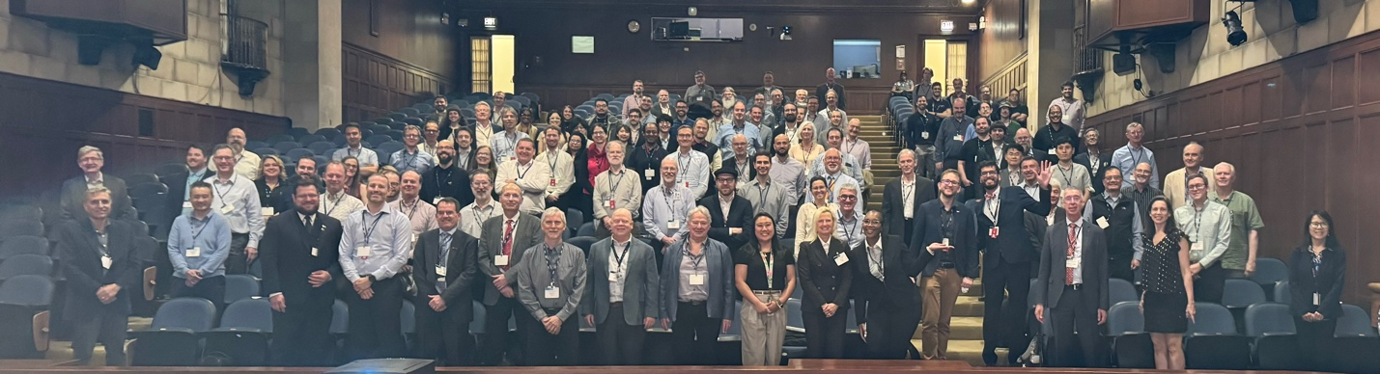

1030-1050: MOIMS Plenary

There was a very abbreviated MOIMS Opening Plenary due to the escort issue (many people were milling about trying to meet up with their escorts). All of the MOIMS WG members stayed in the main auditorium, but it was difficult to have much of a meeting given that a large number of other attendees remained in the room while Daniel was attempting to hold his meeting. Daniel asked each MOIMS WG Chair to provide information about what they would be doing this week; each of the WG Chairs did so. Daniel continued planning for the traditional MOIMS Dinner, which he indicated would be held Wednesday evening. The NavWG meeting began immediately after the MOIMS Plenary.

1050-1250: Navigation WG Meeting (Intro, etc., including Computer Problems)

Attendance this day included: David Berry, Vitali Braun, Juan Crenshaw, Frank Dreger, Cheryl Gramling, Ralph Kahle, Alain Lamy, Jose Miguel Lozano, Dan Oltrogge, Sergey Polyakov, Dianne Poster, Patrick Zimmerman.

The NavWG meeting started off with complications related to the conference room. Computer problems with the ClickShare application required to display materials in the room slowed down the beginning of the meetings (the app was quarantined by David's JPL-required virus scanner). Dan saved the day by devising a functioning configuration of his own equipment and the equipment in the room. Once we got past the technical difficulties, David presented the "Introduction to the Navigation WG" material. As part of this, we conducted an around the room "face-to-face" introduction since Dr. Dianne Poster of NIST was in attendance; she is heavily involved in the OSC effort to implement TraCSS. The presentation was distributed to the WG mailing list, and also uploaded to the Nav WG CWE (https://cwe.ccsds.org/moims/docs/MOIMS-NAV/Meeting%20Materials/2024/Spring/navwg-intro-202404.pdf ).

1350-1510: ISO Revisable Figure Rules

After lunch, David experienced more issues with ClickShare! The JPL Help Desk reportedly had made the software so it would not be rejected by SentinelOne, and indeed, the Clickshare app was allowed to be installed on David's computer. However, when an attempt to execute was made, it was blocked. In the interest of time, this was the last attempt to make ClickShare work.

Dan described the problem he is having with ISO's "revisable figure rule". For co-published documents (like some of the Nav WG standards, which cross from CCSDS/ISO TC20/SC13 into ISO TC20/SC14), figures must be "revisable". The premise is that some nations want to be able to revise figures to provide text in their native languages. Dan described the "battle" he is having with the Lead ISO Editor regarding this ISO rule. The documents can be edited with Adobe Acrobat, but that appears to be insufficient to satisfy the rule. Dan suggested that figures in standards documents be built up front with these ISO rules in mind. One course of action is to limit the use of figures, but if they are needed, capture them in a way such that they can be revised after the fact. Dan took an action item to describe the issue concisely so it can be conveyed to Sami Asmar, the Chair of ISO TC20/SC13 aka CCSDS. Also, to distribute the applicable documentation. Dan posed the question: "Given the ISO Revisable Figure Rule, what is the benefit of co-publication with ISO TC20/SC14?"

1510-1640: CDM for TraCSS

We discussed the version of CDM that will be used for TraCSS, and the schedule of implementation. TraCSS is nominally scheduled to be operational in the last quarter of calendar 2024. The desired target is end of fiscal 2024. David explained that this is probably not possible given the constraints presented by the CCSDS "end game", i.e., once the book is out of the WG hands, it takes about a year until publication. David estimated that it will be December 2024 before the CDM V.2 is actually published based on the date it was conveyed to the Area Director for the required Resolution to process the document for Agency Review (19-Dec-2023). It is possible it may not take that long, but the CCSDS "end game" has some more or less built-in delays. David and Dan reiterated that the best time for the TraCSS development to propose CDM modifications is now, during the official Agency Review period... it is the perfect time to request missing items. At the conclusion of this discussion, David inquired of Dianne whether there were any other CCSDS Working Groups producing standards relevant to TraCSS; she responded that the standards of the NavWG were the primary standards of interest to TraCSS (with special interest in the CDM and ODM/OCM). David took an action item to add Dianne to the CCSDS Nav WG email list (also Christine Joseph of NOAA, another major TraCSS participant).

1640-1700: Lunar Interoperability Forum

In the closing minutes, we discussed a bit about the Lunar Interoperability Forum scheduled for the following week (07-May-2024). Cheryl, Juan, and Dan all indicated that they would be in attendance. We had brief discussion regarding a Lunar time scale similar to UTC. Sergey offered to connect the WG members with someone at NIST with expertise in these areas. Dan noted that the OCM doesn't have keywords in the Orbit Determination section for consideration of relativistic effects; David indicated that a Corrigendum would be possible.

TUESDAY 30-Apr-2024

Attendance this day included: David Berry, Vitali Braun, Juan Crenshaw, Frank Dreger, Cheryl Gramling, Christine Joseph, Ralph Kahle, Alain Lamy, Jose Miguel Lozano, Jim Lux, Dan Oltrogge, Dianne Poster, Patrick Zimmerman.

0845-1230, 1345-1435: Tracking Data Message (TDM)
Juan Crenshaw led us through the various modifications made to the TDM document in the 2.0.2 draft. One of the new additions is a covariance structure for tracking measurements. Juan had developed a plan and numbering scheme involving an upper triangular matrix that could represent the covariance between any two tracking data types. This was a major effort that until now has not been present in the TDM, but is present in many other NavWG standards. During discussion of the arrangement, Dan suggested using a lower triangular representation (similar to one arrangement in the OCM) given the notation for the matrix Juan had developed for expressing the covariates in a linear fashion in the TDM. Other additions to the 2.0.2 TDM included new keywords OBS_CALIBRATION, OBS_GRANULARITY (the smallest representable change in the value of an observable). We also reviewed some 2.0.2 review comments submitted by Alain and by Ralph. The 2.0.2 document was distributed for review and comment on 19-Apr-2024, only a week prior to the meetings, so the small number of comments was not a matter of concern. In general, review comments on the TDM 2.0.2 are not expected until around 20-May-2024, so it was good to have some early comments to review.

1435-1520, 1600-1610: Launch Data Message (LDM)

Dan presented White Book version 1 draft of the Launch Data Message (LDM) which had been approved after the Spring 2023 Meetings at Huntsville. Given that the WG is planning the innovations of the Navigation Composite Message, David had suggested that Dan focus only on the material that would be unique to the LDM. Given this guidance, there were a number of areas where the LDM White Book 1.0 necessarily had placeholders for future development. Even in its skeletal state, there was a good reception to the LDM concept, especially from our visitor Jim Lux, who is in consideration for filling the vacancy that will be created by Peter Shames' impending retirement. As part of the LDM presentation, Dan had occasion to mention the high degree of NavWG use of the SANA Registry; stewardship of the SANA Registry may become part of Lux's domain.

1520-1550: AstroLab FLEX Rover Demonstration

We were offered the opportunity to witness a demonstration of the Astrolab "FLEX" (Flexible Logistics & Exploration (FLEX) rover that is targeted for Lunar deployment in 2026 in support of the Artemis program (https://astrolab.space). This was an interesting way to spend a break from document development. A couple of our intrepid navigators took the offered opportunity to operate the rover. Afterwards, we completed a few more minutes discussion of the LDM draft.

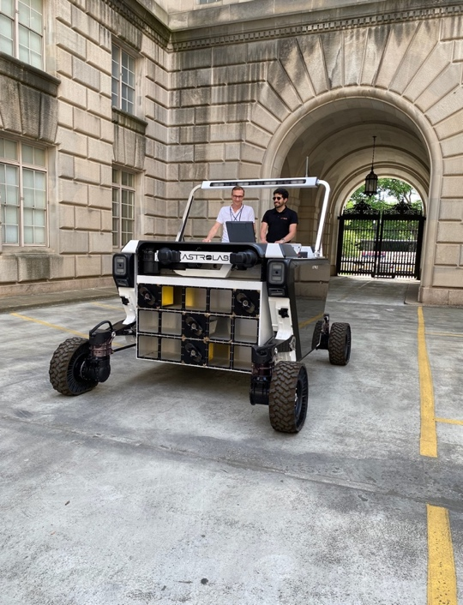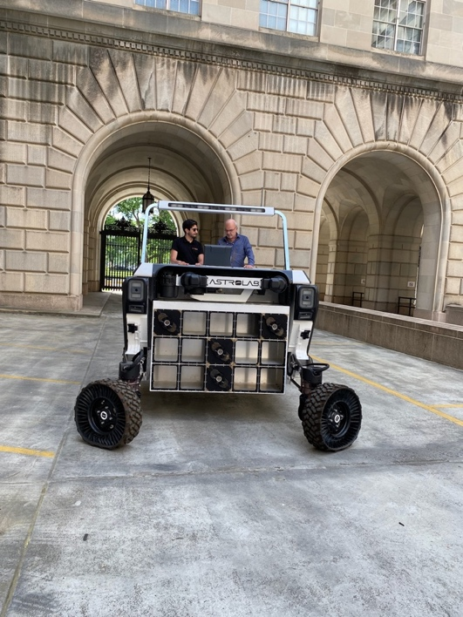

1550-1700: Fragmentation Data Message (FDM)

Vitali started presenting material from the White Book Version 1 draft of the Fragmentation Data Message (FDM) which had been approved after the Fall 2023 Meetings at The Hague. As it was with Dan, given the impending proposal of the Navigation Composite Message, David had suggested that Vitali focus only on the material that would be unique to the FDM in this early draft. As with the LDM, there were a number of areas where the FDM White Book 1.0 had placeholders for future development. We had good discussion of several factors of the FDM that are unique. One unresolved structural matter at this point is whether or not an FDM will have two distinct metadata/data pairs (as with the CDM) or whether or not there will be a single metadata/data pair for the fragmentation event as with most of the NavWG standards. Some other outstanding questions revolve around differences based on relative velocity of fragmentation events, when does one start counting the fragmentation event, how much pre-event data to provide, how to handle the evolution of the debris cloud, etc. After some discussion, Vitali and Dan speculated that two messages may be required to describe the event (alternatively, as noted above a CDM-like organization could be employed). Another question was raised regarding what the consumer of the message is looking for. Even though this was a short discussion, it was quite interesting. Discussion of the FDM was tentatively scheduled to continue on the next day.

The FDM White Book 1.0 is available on the CWE at https://cwe.ccsds.org/moims/docs/MOIMS-NAV/Draft%20Documents/Fragmentation%20Data%20Message%20(FDM) . [still waiting for this]

WEDNESDAY 01-May-2024

Attendance this day included: David Berry, Vitali Braun, Juan Crenshaw, Frank Dreger, Daniel Fischer, Cheryl Gramling, Julie Halverson, Hideaki Hinagawa, Ralph Kahle, Alain Lamy, Dan Oltrogge, Dianne Poster, Costin Radulescu, Mehran Sarkarati (+SM&C members), Klaus-Juergen Schulz.

0845 1130 LunaNet Concept Paper Discussion (w/Daniel Fischer)
1130 1230 Fragmentation Data Message Issues & Discussion
1230 1330 Lunch
1330 1600 Navigation Events Message Issues & Discussion
1600 1700 Navigation Comprehensive Message Concept Paper

0845-1130 LunaNet Concept Paper Discussion (w/Daniel Fischer)

The day started off with the detailed discussion of the LunaNet Concept Paper prepared by Cheryl and Juan. Cheryl led discussion; she indicated that she and Juan are working with the ESA and JAXA colleagues on LunaNet topics and issues. Cheryl and Juan had prepared a presentation that is available on the CWE at https://cwe.ccsds.org/moims/docs/MOIMS-NAV/Meeting%20Materials/2024/Spring/presentation-LN-LNIS-CCSDS-Concept-Paper-Summary-01May2024.pdf . The purpose of the presentation was to report to the leadership of the Consultative Committee for Space Data Standards (CCSDS) regarding their interest in the LunaNet Interoperability Standard (LNIS), particularly focused on the applicability of current or future CCSDS NavWG standards to LunaNet. The presentation addresses specific areas detailed in a companion concept paper in which the CCSDS NavWG may elect to support LNIS development and testing. The philosophy of the approach is to (a) adopt and use NavWG standards where they already exist, (b) or adopt "nearby" standards. LunaNet has leveraged a number of CCSDS standards (e.g., CCSDS 414 and 415), but is not limited to using CCSDS standards. Standards from different governing bodies such as the ITU (International Telecommunications Union), or GNSS (Global Navigation Systems & Services) may apply in some way. Some of the applicable standards exist outside the NavWG in particular and the CCSDS in general. NASA's Moon-to-Mars human missions with Lunar Return (e.g., Artemis 3-5) have requirements for scalability and interoperability. A number of different communications paradigms will apply, e.g., point-to-point, broadcast, cross-link, direct with Earth (DWE). For the broadcast service, most communications will be scheduled. There is a well-recognized need for the definition of a "Lunar Time Coordinated" (LTC, analogous to UTC) which implies a need for precise clocks on the Moon. In short, LunaNet is a system of heterogeneous systems, and message exchange is fundamental to LunaNet. But many of the required related standards are outside the purview of the CCSDS NavWG.

1130-1230: Fragmentation Data Message (FDM)

We continued with discussion of the FDM. We spent some time discussing the concept that Vitali had termed "MASS_LOSS", trying to estimate the effect of the weight of material that broke off due to a fragmentation event on a large, mainly unaffected spacecraft. Also, the evolution of a debris cloud was discussed, e.g., when a fragmentation event has happened, analysts will want to report that fact, but the detail is something that will evolve over time. At first there is a "representative cloud", and individual orbits will probably not yet exist. Over time, more and better information is acquired about the associated fragments. Analysts want the mass of all fragments and the mass of large fragments to be consistent. In terms of a message structure, the FDM could have one metadata/data section in the case of an explosion, or two metadata/data sections in the case of a collision. There will need to be distinctions between analyses of data observed versus data simulated. An "Environmental Impact Block" could describe specific operations that could be endangered. In the FDM White Book 1.0, there are many keywords yet to be defined. This is largely because of the parallel work on the Navigation Composite Message Concept Paper; if that concept is accepted, the work of producing an FDM standard should be reduced.

1330-1600: Navigation Events Message Issues & Discussion

Alain and Frank provided an overview of the long awaited first draft of the Navigation Events Message (NEM) White Book. Alain indicated that he feels the main concepts are now much clearer than they were when presented in the Fall 2023 Meetings. He listed several main concepts:

- Navigation Events can cover all possible cases of events which occur or are planned in a certain period in time.
- All events are instantaneous (duration = 0).
- Mandatory information is an event type and an event time (2 types: absolute, and relative to another event)
- Depending on the event, additional properties (attributes and/or parameters) are necessary to characterize, qualify, and/or quantify the event. Alain stated that there were no optional parameters in the NEM design (this was not discussed at length, but there was some concern about this... it may be clearer in the actual White Book).

The concept of an instantaneous (i.e., "durationless") event inspired a fair amount of discussion; it was not a popular notion (although we have been defining it that way for several years). Alain explained that the duration of a phenomenon that lasts for a period of time can be calculated by subtracting the event start time from the event end time.

An NEMD (Navigation Event Message Definition) file constitutes a scheme for defining events with their characteristics. A SANA based NEMD listing predefined events was proposed. A few simple examples of predefined events were described. One of these was "AOS", a common event for spacecraft tracking. David suggested that this could constitute an overlap with the Cross Support Management Services 902.2-B-1 Communications Planning Information Formats Blue Book. This type of overlap may be tolerable, but that is yet to be determined.

The NEM makes use of XML to validate the definition of the structure of events, although NEMs can be formatted in KVN or XML. Guidelines regarding events are provided to promote consistency between various users. Re-use of predefined events is encouraged. The NEM document defines the event structure, the types of information that can appear in an event message, how to format an event, and the NEMD events message definition. There is no list of events in the NEMD. Use of the Cross Support Services Service Management "Abstract Event Definition Structure" provides compatibility with the Service Management document, ensuring that NEM events can be converted to CSS-SM events. Structurally, an events message can contain one or more metadata/data segments, and there is only one time scale for the entire message.

During discussion of Alain's and Frank's presentation, there was some assertion of preference for JSON format in event messages. In the past, the NavWG has not ventured to produce JSON messages, but David demonstrated how XML messages can be converted to JSON using XMLSpy, which is already used for the NDM/XML. David took an action item to experiment with converting a master NEM schema to a JSON schema so interested parties could validate JSON formatted event messages.

The first version of the NEM White Book is available on the CWE at:
https://cwe.ccsds.org/moims/docs/MOIMS-NAV/Draft%20Documents/Navigation%20Events%20Message%20(NEM)/507.0-W-1.0-Navigation-Event-Message_2024-05-03.pdf .

The NEM presentation from this session is available on the CWE at: https://cwe.ccsds.org/moims/docs/MOIMS-NAV/Meeting%20Materials/2024/Spring/presentation_NEM_spring2024_v2.pdf

1600 1700 Navigation Comprehensive Message Concept Paper

Given an "empty hour" at the end of the day, David commenced the process of reading through the content of the Navigation Comprehensive Message Concept Paper. No "presentation" had been prepared, because the Concept Paper itself is the best expression of the group's ideas. As David read through the document, based on WG member comments several places were marked for consideration of tone, word choice, deletion, augmentation, clarification, etc. Approximately half of the document reading was completed in this first hour. It was planned to complete the effort during the allocated time slot on Thursday. The WG endorsed the idea of proposing the NCM project, however, David indicated that we still had some work to do (specifically, the determination of agencies that would prototype the project and the determination of resource requirements). These were scheduled for later in the week. The draft (not yet complete) NCM Concept Paper from this session is available on the CWE at: https://cwe.ccsds.org/moims/docs/MOIMS-NAV/Draft%20Documents/Concept%20Papers/NCM/navigation-composite-message-concept-paper-changesaccepted-20240501.pdf .

THURSDAY 02-May-2024

Attendance this day included: Julien Bernard, Michel Bernier, David Berry, Vitali Braun, Juan Crenshaw, Frank Dreger, Cheryl Gramling, Julie Halverson, Ralph Kahle, Alain Lamy, Jose Miguel Lozano, Dan Oltrogge, Dianne Poster, Patrick Zimmerman.

(a) 0845-0930: Preparations for Joint Meeting with SANA Registry Team
(b) 0930-1030: Joint Meeting with SANA Registry Team

The purpose of the first of these two sessions was to identify discussion topics for the Joint Meeting between the Nav WG and the SANA Registry team regarding the NavWG use of the SANA Registries, e.g., "What's New at SANA?", new schemas, etc. For the second session, Julien Bernard and Michel Bernier of the SANA Registry team joined us for discussion of the identified topics issues.

Julien let us know about some new things that were coming up with the SANA Registry:
- The sign in to SANA and the CWE now uses the same login service (a SCAN app), but the passwords are not yet synchronized. So the SANA password and CWE password are currently different.
- The NavWG Fall 2023 Request for Collision Probability Method Registry: Change header "Collision Probability Method" to "Value" (columns are now sorted by "Value" by default). Julien indicated that this change has now been made in the nav.sanaregistry beta registry.
- The "CCSDS Navigation Standards Registries" are now sorted alphabetically instead of by OID (another response to our Fall 2023 request).

After the discussion of "What's New?", we commenced making some new requests, and posing a few questions of Julien:

- In response to a question about entries in the registries that are marked "Provisional" (orange) as opposed to "Assigned" (green), Julien indicated that this is up to the Working Group. It is only necessary to notify them to change the status.
- New Request: Can SANA handle multiple entries in the "Reference" column? (Do it for XML4 plus the underlying standard... Action item to David).
- Heads Up to Julien: There will be some registry changes based on review of the CDM (which has not yet completed). The Agency Review will be complete 31-May-2024 and we will have some follow up work.
- Dan inquired about SANA support for "Plotly" files. Dan has an action item to send a sample file to Julien so the SANA Team can experiment with it.

Towards the end of this session an inquiry was made as to the SANA Team's support of other Working Groups in CCSDS. Julien responded that most other Working Groups are not making much use of SANA, and that the NavWG is still in the vanguard. During this discussion, Jose Miguel suggested that maybe there should be a "SANA Boot Camp", similar to the "Document Editor Boot Camp" that the CCSDS offers. Dan provided an explanation of how the Nav WG is using the SANA Registry. Other Working Groups may find SANA as useful as the Nav WG does. We concluded with the thought that the NavWG vision of the utility of SANA could be a more common vision among the CCSDS Working Groups.

1030-1230: NDM/XML Status/Issues

David explained the current status of the NDM/XML specification, starting with the history. The Blue Book version 1 contained instructions for encoding all of the messages that existed at the time (i.e., ADM, ODM, and TDM Version 1 Blue Books). When the WG started working on the CDM, it was realized that this approach was not sustainable because it would require 2 Blue Books for each subject matter area. Ever since the beginning of the CDM era there has been an effort to reduce the number of updates necessary to the NDM/XML document; each successive version of the NDM/XML has removed material that is now in the subject matter Blue Book. The NDM/XML Version 4 now in CESG Polling for Agency Review will only contain instructions for the "combined instantiation", thus, it may be the last major update of the document. However, David pointed out that we will need at least one "internal RID" to help achieve this goal; the background concept was not conceived until the document had already been sent to the Secretariat for document processing. The remainder of the presentation provided the details regarding the "internal RID", which essentially involves genericizing Table 3-1 in the NDM/XML document. Once the NDM/XML Version 4 Agency Review starts, the RID will be formalized and implemented in the Pink Book P-1.2. The presentation material is on the CWE at https://cwe.ccsds.org/moims/docs/MOIMS-NAV/Meeting%20Materials/2024/Spring/presentation-ndmxml-status-issues-20240501.pdf .

1330-1430: Joint Meeting w/Delta-DOR (TDM requests)

Chris Volk (NASA) and Javier Vicente (ESA) joined us for a discussion of Delta-DOR topics with relevance to the TDM. WG members Jose Miguel, Alain, Vitali, Frank, Juan, Dianne, Dan, and David were present for this discussion. The material for Delta DOR has been provided to Juan. We plan a joint session in London. The Delta-DOR group will try to get further information from Hiroshi Takeuchi regarding several ideas he suggested for improving the Delta-DOR data in the TDM.

1430-1700: Navigation Comprehensive Message Concept Paper)

David completed the process of reading through the content of the NCM Concept Paper that had commenced the previous day. WG members continued to suggest updates to the text to improve the tone, word choices, reorganization of text, and be a little more complete in several areas. It was planned to conclude the effort on Friday morning with the preparation of the formal "New Project" information form to be submitted to Daniel Fischer, MOIMS-AD, along with the Concept Paper, but that had to be deferred until after the meetings had concluded. The final NCM Concept Paper from this session is available on the CWE at:
https://cwe.ccsds.org/moims/docs/MOIMS-NAV/Draft%20Documents/Concept%20Papers/NCM/navigation-composite-message-concept-paper-changesaccepted-20240502.pdf

1745-2000: Navigation WG ADM Celebration

After the day's meetings had concluded, the members of the WG all went to Café du Parc and celebrated the publication of the ADM in January 2024 with a round provided by Alain & Julie. This WG custom had lapsed during the pandemic and had not yet been restarted. It was nice to restart it...

FRIDAY 03-May-2024

Attendance this day included: David Berry, Vitali Braun, Frank Dreger, Alain Lamy, Jose Miguel Lozano, Dianne Poster, Patrick Zimmerman.

0845-1200: Closing Report, Action Items, Doc Schedules, Five Year Plan, End of Meeting

Several of the WG members had other commitments for the Friday morning meeting, so we were diminished in number. The remaining WG members went over the Navigation WG Report that was scheduled to be presented at the MOIMS Closing Plenary later in the day; the report as presented at the plenary is shown below [to be provided in the final minutes]. David went page-by-page through the report that had been developed through the week, and members of the Working Group offered comments, suggestions, improvements, things that had been missed, etc. Jose Miguel inquired as to whether or not we should solicit commentary/inputs for the RDM 5 Year Review; David took an action item to query for input at the appropriate time.

We reviewed the 5 Year Plan last updated in Fall 2022 at the Huntsville meetings. Since it had been a while, and several of the attendees had not been through the process, David explained the methodology: the process starts by roughly synchronizing the plan with the schedules on the CWE Framework that had been updated through the week. After that initial plan, several simplifications are utilized in order to keep the detail in the plan manageable. For example, there is a focus on the face-to-face meetings (restricted to April=Spring, October=Fall, other months are "rounded" to the closest of these meetings). David has considered the probable need for greater granularity in the dates because the half year range causes some unrealistic bunching when a document schedule is very rapid; monthly may be too much granularity for a 5 Year Plan, but quarterly might be feasible. There is a focus on 4 major events (Initial White book, Red/Pink Book/Agency Review complete, Blue Book complete, 5 Year Review), so most of the items in the full Framework schedule are ignored. A simple prioritization scheme is used for sorting the entries for any given meeting (Blue Book=1, Red Book=2, White Book=3 or 4). The outcome of this process shows the number of major events that are planned to complete around the meeting series. Below is the plot for the current plan after the updates included in this session. Note the spike for Spring 2024; it is large due to the anticipated PRM Reconfirmation, 3 new White Books (LDM, FDM, NEM), and the anticipated Concept Paper for the NCM:

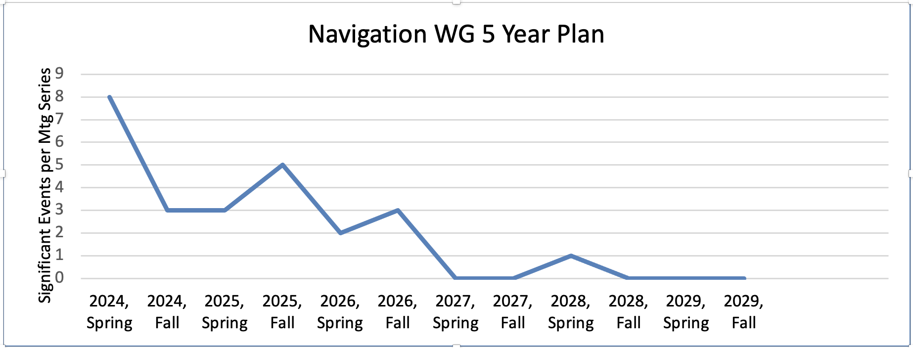

The dates and times for monthly telecons are listed at the end of these minutes. Meeting announcements will be sent in advance of each meeting. The single 1-hour meeting approximately once per month will be maintained. All materials from these Spring meetings (action items, agenda, introductory presentation, report, document presentations, and these minutes) are available on the CWE at the following link: https://cwe.ccsds.org/moims/docs/MOIMS-NAV/Meeting%20Materials/2024/Spring/. Draft documents and concept papers reviewed during the meetings are in their respective directories on the CCSDS CWE: https://cwe.ccsds.org/moims/docs/MOIMS-NAV/Draft%20Documents/ (sort by "Name" for easier searching).

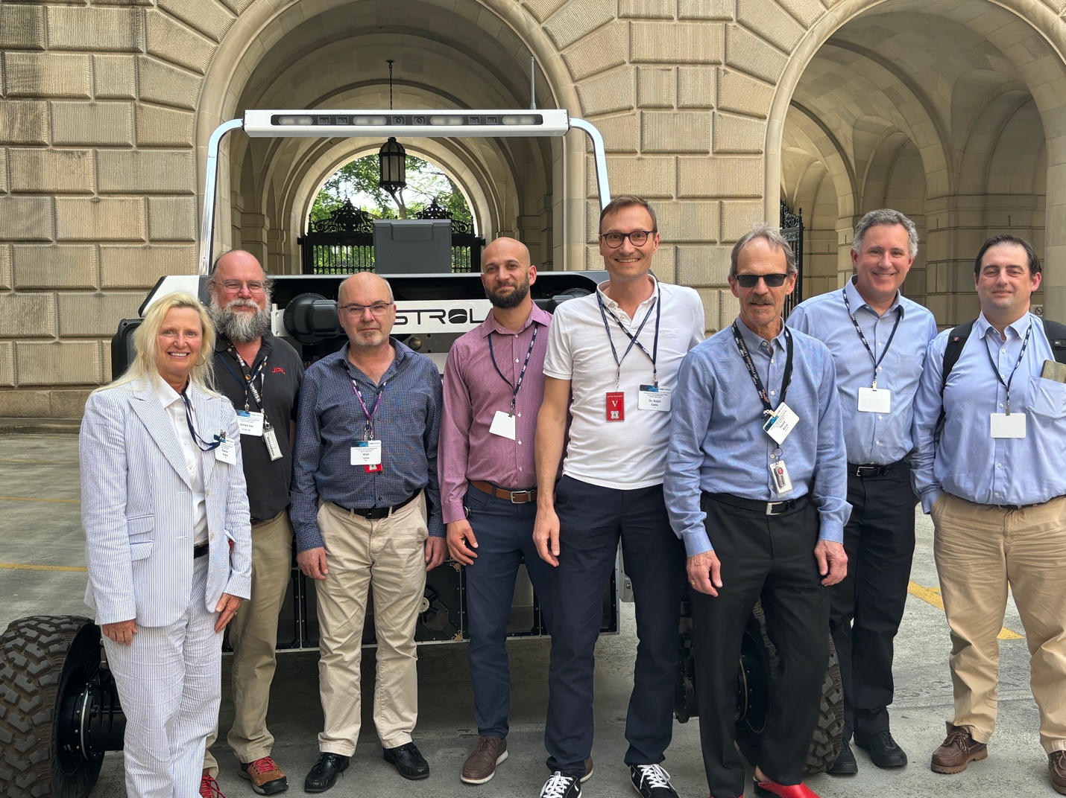
The CCSDS Navigation WG Spring 2024 (Minus Virtual Attendees) with AstroLab FLEX Rover (Unfortunately, Cheryl was on another meeting telecon, Julie arrived next day...)

1300-1420: MOIMS Closing Plenary

Attendance at the Plenary included: Daniel Fischer (MOIMS Area Director), David Berry (Nav Chair), Frank Dreger (Nav Deputy Chair), David Giaretta (DAI Chair), John Garrett (DAI Deputy Chair), Dominik Marszk (representing SM&C), and Peter van der Plas (MP&S Chair). There were also several other members of the various MOIMS Working Groups.
The Working Group Chairs and/or representatives delivered their reports: David Giaretta for Digital Archive Ingest (DAI), Dominik Marszk for Spacecraft Monitor & Control (SM&C), David Berry for Navigation (NavWG), and Peter van der Plas for Mission Planning and Scheduling (MP&S). The Navigation report immediately below was presented during the Plenary. The report is also available on the CWE at https://cwe.ccsds.org/moims/docs/MOIMS-NAV/Meeting%20Materials/2024/Spring/navwg-report-202404.pdf . Daniel reminded all to format their reports to facilitate Daniel's report at the CESG Meeting, including a request that participant counts not include members of joint meetings that would be counted in their own WG reports. David modified the NavWG report to meet the specification.

NAVIGATION WORKING GROUP CLOSING REPORT for WASHINGTON, DC

NAV WG EXECUTIVE SUMMARY

MOIMS/Nav Meeting Demographics

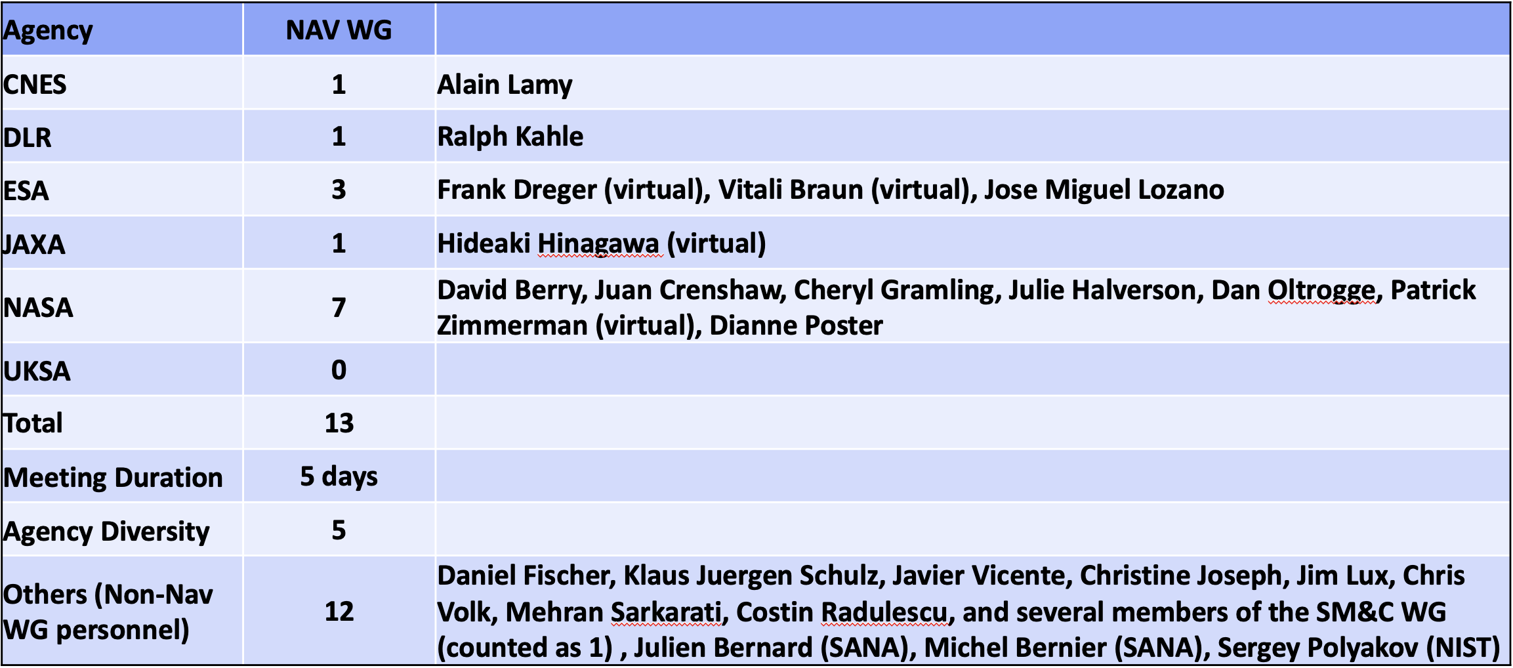

NAV WG Executive Summary
- << To be in final minutes>>
Problems and Issues:
- << To be in final minutes>>
Resolutions & Agreed upon this Meeting:
- << To be in final minutes>>
Further Resolutions Anticipated in the Next 6 Months:
- << To be in final minutes>>
Planning (Only Approved Projects):
- << To be in final minutes>>

NAV WG Upcoming New Work Items
- << To be in final minutes>>

NAV WG Issues for CESG/CMC
- << To be in final minutes>>

NEXT TELECONS:

We will continue the 1-hour telecons approximately monthly between Spring and Fall Meetings. The schedule for the monthly telecons is below:

- 05-Jun-2024 1300-1400 UTC
- 10-Jul-2024 1300-1400 UTC
- 31-Jul-2024 1300-1400 UTC
- 04-Sep-2024 1300-1400 UTC
- 09-Oct-2024 1300-1400 UTC
- Fall Meetings: 04-Nov-2024 through 08-Nov-2024 at London, England (details to be announced)

NOTE:
Europe Daylight Savings Time ends 27-Oct-2024
US Daylight Savings Time ends 03-Nov-2024

