MINUTES OF NAVIGATION WORKING GROUP FALL 2023 WORKSHOP xx-Nov-2023

David S. Berry / Chair

The CCSDS Fall 2023 Navigation Working Group Meetings were conducted in person in The Hague, Netherlands, from 06-Nov-2023 through 10-Nov-2023. Although the meetings were held in person, the ability to attend virtually was also offered to those who could not travel. ESA/ESTEC hosted the meetings. This is a summary of the activities of the Navigation Working Group (WG) during the Meetings. The Navigation WG is an element of the Mission Operations and Information Management Services (MOIMS) Area in the CCSDS organization.

ON-SITE PARTICIPANTS

David Berry (NASA/JPL), Julien Bernard (SANA), Vitali Braun (ESA/ESOC), Juan Crenshaw (NASA/GSFC), Frank Dreger (ESA/ESOC), Daniel Fischer (ESA, MOIMS Area Director), Cheryl Gramling (NASA/GSFC), Kiyoshi Hamada (JAXA), Hideaki Hinagawa (JAXA), Ralph Kahle (DLR), Alain Lamy (CNES), Jose Miguel Lozano (GMV/ESA/ESOC), Robert Rovetto (NASA), Miriam Sawczuck (JAXA), Klaus-Jürgen Schulz (ESA), Brian Swinburne (Airbus/UKSA), Patrick Zimmerman (NASA/JSC).

TELECON PARTICIPANTS

Julie Halverson (NASA/GSFC), Dan Oltrogge (NASA (COMSPOC, ISO TC20/SC14)),

AGENDA

The final agenda for the WG meetings is available on the Navigation WG CWE at:
https://cwe.ccsds.org/moims/docs/MOIMS-NAV/Meeting%20Materials/2023/Fall/navwg-agenda-fall-202311-final.pdf . In the meeting proceedings below, the detailed agenda for each meeting day (as
realized) is included in the minutes to provide context.

CURRENT ACTION ITEMS

The following action items were either produced during the meetings or carried forward from previous meetings if they had not yet been completed. They are also available on the CWE at https://cwe.ccsds.org/moims/docs/MOIMS-NAV/Meeting%20Materials/2023/Fall/navwg-action-items-202311.pdf . The action items and due dates below reflect the status as of the end of the meetings; the list on the CWE will be updated periodically between the end of this meeting series and the beginning of the next meeting series. The list on the CWE will thus reflect relative completion progress and any new action items added after the meeting series.

New Action/Outstanding Action Items
If "Status" = "Open", then "Date" = "Target Date"
If "Status" = "Complete", then "Date" = "Completion Date"
If "Status" = "Cancelled", then "Date" = "Cancellation Date"
Sort by "Status" (Descending), "Date" (Ascending), "##"
Highlighted = In Progress, Completed, or Cancelled since last telecon

CURRENT ACTION ITEMS

The following action items were produced during the meetings and completed or cancelled prior to the succeeding meetings. Action items that were produced but not completed are moved into the action items list of the succeeding meeting series. They are also available on the CWE at https://cwe.ccsds.org/moims/docs/MOIMS-NAV/Meeting%20Materials/2023/Fall/navwg-action-items-202311.pdf . (Note that the table below reflects the state as the "Last Update Date", which is not necessarily the state as of the end of the meetings.)

New Action/Outstanding Action Items
If "Status" = "Open", then "Date" = "Target Date"
If "Status" = "Complete", then "Date" = "Completion Date"
If "Status" = "Cancelled", then "Date" = "Cancellation Date"
Sort by "Status" (Descending), "Date" (Ascending), "##" (Ascending)
Highlighted = In Progress, Completed, or Cancelled since last telecon

## | Action Item | Category | Actionee | Status | Due Date (Original) | Date
29 | Produce NDM/XML P-3.0.1 Pink Book Draft | NDM/XML | David | Open | 09-Apr-2023 | 24-Nov-2023
67 | Prepare updated Nav WG 5 Year Plan | 5 Year | David | Open | 17-Nov-2023 | 24-Nov-2023
58 | Send NEM presentation from Fall Meetings to David | NEM | Alain | Open | 17-Nov-2023 | 27-Nov-2023
91 | Prepare new project for Fragmentation Data Message | FDM | David / Vitali | Open | 31-Dec-2022 | 27-Nov-2023
34 | Commercial, Military(?) survey for TDM interest | TDM | Dan /  Jose Miguel | Open | 31-Oct-2023 | 30-Nov-2023
36 | Check all SANA Links to References | SANA | David | Open | 15-Jun-2023 | 03-Dec-2023
61 | Produce TDM P-2.0.2 update (#08 is dependent) | TDM | Juan / Cheryl | Open | 18-Nov-2022 | 10-Dec-2023
08 | Distribute "Divide & Conquer" TDM P-2.0.2 draft review assignments (depends on #61) | TDM | David | Open | 17-Aug-2022 | 12-Dec-2023
53 | Determine organization for Italian RDM Provider role | RDM | Elena | Open | 26-Feb-2020 | 13-Dec-2023
62 | Produce CDM P-1.0.7 update | CDM | Brian/Dan | Open | 13-Dec-2023 | 13-Dec-2023
66 | Distribute "Divide & Conquer" NDM/XML P-3.0.1 draft review assignments (changed pages only) (depends on #29) | NDM/XML | David | Open | 13-Dec-2023 | 13-Dec-2023
75 | Consider adding value "Dead" to CDM "OPS_STATUS" (note: if approved this will require updating the Operational Status SANA registry. | CDM | Brian/Dan | Open | 13-Dec-2023 | 13-Dec-2023
76 | Email Matt Hejduk regarding "Effective Hard Body Radius". | CDM | Dan | Open | 13-Dec-2023 | 13-Dec-2023
39 | Propose release of ADM V.2 schemas with document publication | NDM/XML | David | Open | 15-Jun-2023 | 15-Dec-2023
63 | Distribute "Divide & Conquer" CDM P-1.0.7 draft review assignments (depends on #62) Do we need this? | CDM | David | Open | 15-Dec-2023 | 15-Dec-2023
79 | Provide CDM materials to MOIMS Area Director and request resolution for Agency Review | CDM | David | Open | 16-Dec-2023 | 16-Dec-2023
11 | Update CDM schemas for CDM 2.0 (P-1.0.7) (#50, #12 are dependent) | CDM | David | Open | 20-Nov-2022 | 20-Dec-2023
68 | Solicit feedback on the CDM P-1.0.7 from US Space Force | CDM | Dan /  Jose Miguel | Open | 10-Dec-2023 | 20-Dec-2023
50 | Create XML 5.0 Test Set (depends on #11) | CDM | David | Open | 14-May-2023 | 21-Dec-2023
69 | Complete internal review of NDM/XML P-3.0.1 draft (changed pages only) (depends on #66) | NDM/XML | David | Open | 15-Dec-2023 | 31-Dec-2023
30 | Submit NDM/XML P-3.0.1 Pink Book to MOIMS Area Director and Request Resolution for Agency Review (depends on #29, #66, #69) | NDM/XML | David | Open | 01-May-2023 | 31-Dec-2023
17 | Update Navigation Terms in CCSDS Glossary (original + RDM terms) | Glossary | Secretariat | Open | 31-Aug-2019 | 31-Dec-2023
60 | Prepare new project for update of Navigation Data Definitions & Conventions | NDDC | David | Open | 31-Dec-2023 | 31-Dec-2023
64 | Strengthen argument for Navigation Functions Message in Concept Paper | NFM | David | Open | 31-Dec-2023 | 31-Dec-2023
70 | Create mock-up of segmented Green Book for placement on Green Book. | NDDC | David | Open | 31-Dec-2023 | 31-Dec-2023
74 | Prepare Navigation references for SANA Registry (#96 is dependent) | SANA | David | Open | 31-Oct-2018 | 31-Dec-2023
94 | Library of referenced papers on CWE | CWE | David | Open | 10-May-2021 | 31-Dec-2023
12 | Update CDM style sheet for CDM 2.0 (depends on #11) | CDM | David | Open | 04-Dec-2022 | 10-Jan-2024
71 | Review TDM P-2.0.2 draft (depends on #08) | TDM | All, as assigned | Open | 20-Dec-2022 | 15-Jan-2024
96 | SANA implementation of Nav References (depends on #74) | SANA | SANA | Open | 31-Jan-2019 | 15-Jan-2024
78 | Produce initial draft CDM V.2 Test Plan/Report | CDM | Brian/Dan | Open | 07-Feb-2024 | 07-Feb-2024
77 | Involve agency groups in CDM Agency Review, once it commences. | CDM | All | Open | 15-Feb-2024 | 15-Feb-2024
65 | Prepare "Concept Paper" related to potential CCSDS NavWG standard(s) in support of LunaNet. | LunaNet | Cheryl / Juan | Open | 31-Mar-2024 | 31-Mar-2024
98 | Produce Navigation Events Message initial draft | NEM | Alain | Open | 31-Jan-2018 | 31-Mar-2024
16 | Request deletion of "Conjunction Data Message Catalog Name" registry (post-CDM 2.0 publication) | SANA | David | Open | 18-Jan-2023 | 30-Jun-2024
51 | Arrange for floating point number and other data type changes in other documents after CDM V.2 is Blue. | "All" | David | Open | 31-Jan-2024 | 30-Jun-2024
59 | Send TDM presentation from Fall Meetings to David | TDM | Juan | Complete | 17-Nov-2023 | 15-Nov-2023
80 | Next available action item number |  |  | AAAAA | 31-Dec-2035 | 31-Dec-2035

WORKSHOP PROCEEDINGS

MONDAY 06-Nov-2023

0845-1015: CCSDS Opening Plenary / Schedule Details

The Opening Plenary commenced with brief introductory comments by Ignacio Aguilar Sánchez (SLS Area Director, who works at ESA/ESTEC in the Netherlands). He welcomed all CCSDS meeting attendees to The Hague. Klaus-Jürgen Schulz then provided an overview of CCSDS progress since the Spring 2023 meetings in Huntsville, stating that "the machinery of the CCSDS is working" (with thanks offered to Tom Gannett, a key component of all CCSDS documentation). Schulz announced that the previously planned LunaNet Developer's Forum had been cancelled, citing issues with conducting the forum while contracts were still outstanding. There was however a LunaNet briefing scheduled for Wednesday evening during the meeting week.

Klaus-Jürgen provided a number of statistics on CCSDS documents that had been published since the Spring 2023 Meetings (5 new Blue Books since Spring 2023, 2 Orange Books, 3 Green Books); there were also 5 Agency reviews, 12 new projects, and 7 appointments to CCSDS leadership positions. He also provided information on the distribution of leadership across the CCSDS Member Agencies.

Peter Shames then provided a brief presentation focusing on the LunaNet Interoperability Specification (LNIS); materials were provided by Jim Schier, the Chief Engineer in NASA's Space Communications and Networking (SCaN) from in June 2023 (https://cwe.ccsds.org/moims/docs/MOIMS-NAV/Meeting%20Materials/2023/Fall/presentation_LunaNet-Overview-for-CCSDS-Nov23.pdf). Many attendees raised their hands in response to Peter's question as to whether anyone was familiar with the LNIS; it contains networked communications, PNT, detection/information services, science services. and a conceptual set of other services. Questions posed included:
- Is there interest in CCSDS in standardizing LNIS?
- What would that look like? reformat? adherence to CCSDS policy? become CCSDS specs?
- Would the organizers provide funding?
- Which WGs might be involved? Most CCSDS WGs could conceivably be involved.

The prospect of a more comprehensive presentation on LNIS later in the week was raised.

The Opening Plenary covered a few of the customary topics. Here are a few keynotes:

The Area Directors (ADs) each discussed the charter and plans for their associated working groups. This was thankfully a bit shorter than usual as the ADs didn't give as much detail as has been provided in the past. Notably Daniel Fischer indicated that there was not yet a Deputy AD for MOIMS; all Working Groups were characterized as busy. Much of this information is covered in a Secretariat presentation on the CWE at https://cwe.ccsds.org/moims/docs/MOIMS-NAV/Meeting%20Materials/2023/Fall/presentation_CCSDS%20Fall%202023%20Opening%20Plenary_11062023.pdf , including information on the site of the next meetings to be held in Spring 2024. The Spring 2024 Meetings will be hosted by NASA/GSFC(?) at Washington, DC, 29-Apr-2024 through 03-May-2024. The venue for the meeting will be National Institute of Standards and Technology (NIST), Department of Commerce (Herbert C. Hoover Building), in Washington, DC.

Unfortunately, information on other future meetings that was formerly provided was not provided this time. Below is from past meeting notes, so it may not be reliable:

- Spring 2024 hosted by NASA at Washington, DC, dates 29-Apr through 03-May
- Fall 2024 hosted by UKSA at London(?), dates TBD
- Spring 2025 hosted by NASA at TBD, dates TBD
- Fall 2025 hosted by ESA at TBD, dates TBD
- Spring 2026 hosted by NASA at TBD, dates TBD
- Fall 2026 hosted by TBD at TBD, dates TBD

The MOIMS Opening Plenary began immediately after the post-Plenary coffee break.

1045-1130: MOIMS Opening Plenary

Daniel Fischer presented information about what the MOIMS working groups would be doing this week. Each of the WG Chairs presented material regarding their plans for this meeting series; these had been prepared and submitted prior to the meetings at Daniel's request. Daniel continued planning for the traditional MOIMS Dinner, which he preferred on Wednesday evening, but may need to move to Thursday given the LunaNet session and CCSDS Happy Hour scheduled for Wednesday evening. The Navigation Working Group meeting began immediately after the MOIMS Plenary.

1100-1240: Navigation WG Meeting (Intro, Action Items, etc.)

Attendance this day included: David Berry, Vitali Braun, Juan Crenshaw, Frank Dreger, Cheryl Gramling, Julie Halverson, Kiyoshi Hamada, Hideaki Hinagawa, Ralph Kahle, Alain Lamy, Jose Miguel Lozano, Dan Oltrogge, Brian Swinburne, Patrick Zimmerman.

Kiyoshi Hamada was introduced as a member of the JAXA flight dynamics team. Kiyoshi is leading a
JAXA project to replace in-house software with COTS software, and wants to know more about the available flight dynamics related standards.

Dan raised a question about outreach to non-participating agencies, to encourage them to become engaged in the Navigation WG. David suggested that Dan contact Sami Asmar, which he subsequently did. Perhaps this inquiry will be helpful at adding some new resources to the Nav WG.

David presented the "Introduction to the Navigation WG" material. As part of this, David called for an around the room "face-to-face" introduction since Kiyoshi was a new attendee. We went through a bit more detail due to Kiyoshi's presence; however the full set of details of each document was not presented. The presentation was distributed to the WG mailing list, and also uploaded to the Nav WG CWE (https://cwe.ccsds.org/moims/docs/MOIMS-NAV/Meeting%20Materials/2023/Fall/navwg-intro-202311.pdf ).

1330-1730: Conjunction Data Messages (CDM)

The next document to be published by the Nav WG (after the ADM update that is currently in CESG/CMC Approval to Publish polling) will most likely be the CDM V.2. Thus the CDM led off the discussion in these Fall Meetings. Discussion of the CDM focused on resolution of comments from the internal WG reviews and CRMs. One topic raised was whether or not the Operational Status SANA Registry should be updated to include a value of "Dead" (as opposed to "Active"). Many of the items in the registry already imply an active status, so adding "Active" doesn't seem sufficient; "Dead" may be in a different category. Action item to Brian to resolve.

David raised the subject of an email he had received from NASA/CARA indicating that they are adding some COMMENT keywords containing operational data fields to the CARA version of the CDM. When David responded to CARA that the Nav WG is working on an update and would like to consider adding the items needed by CARA, the response seemed as though CARA was not interested. David took an action to forward the email exchange to Lauri Newman, the NASA Conjunction Assessment Project Officer. Presumably this may help get info on the CARA changes so they can be formally considered for the CDM. We had a great deal of discussion about HBR (Hard Body Radius) and "effective HBR", a concept, not especially new, that has been added to NASA/CARA processing. Action item to Dan to email Matt Hejduk on this topic. There is also a paper AAS 18-272 that seems to apply.

TUESDAY 07-Nov-2023

Attendance this day included: David Berry, Vitali Braun, Juan Crenshaw, Frank Dreger, Cheryl Gramling, Julie Halverson, Kiyoshi Hamada, Hideaki Hinagawa, Ralph Kahle, Alain Lamy, Jose Miguel Lozano, Dan Oltrogge, Brian Swinburne, Patrick Zimmerman.

0845-1035: Conjunction Data Messages (CDM)

Discussion of the CDM continued (and completed) on this day. One item that was brought up was that we should ensure US Space Force review of the revised CDM. Another important group to review the document would be NASA/CARA. There are also several technical groups that could be informed of opportunity to review the draft: SC14 Technical Advisory Group, SC13 Technical Advisory Group, NASA Office of the Chief Engineer (NASA Standards), similar groups in the various agencies, etc. Strictly speaking, review by these groups can actually wait until the formal Agency Review commences. Action item to all to involve agency groups in CDM Agency Review, once it commences.

The conclusion of the WG discussion was that we should proceed to Agency review. Action item to David to provide the draft materials to Daniel Fischer and request the Area Director resolution for the Agency Review once Brian completes the P-1.0.7 draft.

After we discussed the status of the CDM draft, Brian requested that we spend some time discussing the required testing process, which will be the next phase for which the WG is responsible. Essentially what is necessary is for Brian (and Dan) to develop a Test Plan document. David indicated that it would be good to refer to the CWE repository https://cwe.ccsds.org/moims/docs/MOIMS-NAV/Test-Plans-Reports for examples; it contains PDF and MS Word copies of most (if not all) Blue Book Test Plans/Reports.

1035-1230: Fragmentation Data Message (FDM) Concept Paper

Discussion of the CDM completed somewhat earlier than anticipated, so the agenda was modified. We commenced discussion of Vitali's updated Fragmentation Data Message (FDM) Concept Paper earlier than was previously planned. Vitali started by noting that the FDM and RDM had been proposed at the same time, but there was a decision to choose one and complete it, then work on the other standard. The RDM was selected at that time. Given that the RDM has long since been completed, it is now an opportune time to propose the FDM.

Vitali noted that the RDM does not appear to be widely used at this point. Ralph speculated that he thought the FDM would have a "big market" given the current situation in Earth orbit, but the RDM not so much. Vitali noted that at this point, various prototype implementations of the FDM already exist at ESA and GMV in various phases of development and sensitivity; updating these to reflect the standard would likely accelerate the CCSDS prototyping process. Vitali suggested that the FDM could also re-use parts of the ODM (e.g., the deployment function) or link to ODMs (and vice versa). Other potential users and/or promoters of an FDM standard could be the Aerospace Corporation and NASA's Orbital Debris Quarterly. One potentially problematic case was raised, e.g., what about cases where different agencies disagree on the same fragmentation event? In one sense, this seems very likely since the FDM will enable agencies and other orbital debris analysts to present fragmentation event analyses in a standardized way, but the underlying analytical models could likely produce different conclusions.

The WG endorsed the idea of proposing the FDM project, however, David indicated that we still had some work to do (specifically, the determination of agencies that would prototype the project and the determination of resource requirements). These were not done at this time, but given the opportunity on Friday of the meeting week, these prerequisites were completed.

Towards the end of the discussion period, Dan suggested that the WG build the Navigation Functions Message (NFM) first, and then follow up with the FDM. There was no discussion of this alternative given that the lunch hour was approaching, although it is a possible approach.

Vitali's updated FDM Concept Paper may be accessed via the Nav WG CWE: https://cwe.ccsds.org/moims/docs/MOIMS-NAV/Draft%20Documents/Concept%20Papers/FDM/CCSDS_Concept_Paper_FDM_2023_v3.pdf

1400-1530: Navigation Data - Definitions and Conventions (NDDC)

David commenced this discussion topic with a history of the use of informative annexes in Nav WG standards. The CDM was the first standard to use an informative annex directly in a Blue Book that would formerly have led to a Green Book update. The thought at the time was that it is more efficient from a reader's perspective to have terms and concepts described directly in the same document one is reading rather than have to find and refer to a different document (typically a Green Book in the CCSDS context). Note that the use of informative annexes in the manner the Nav WG has done is not strictly in conformance with the CCSDS A02.1-Y-4 Organization and Processes for the Consultative Committee for Space Data Systems Yellow Book. We have even come close to having conditions placed on a document by the CESG; the following is quoted from the CESG Approval to Publish Poll for the NDM/XML V.3 Blue Book (CESG-P-2023-03-003):
https://cwe.ccsds.org/fm/Lists/CESGPollQuestion/DispFormClosed.aspx?ID=68&Source=open.aspx
What follows are not conditions for approval but a request for clarification concerning the allocation of certain standard-related information to a BB rather than a GB.
​I have noticed that this BB includes Annexes E, F and G that in my view could be placed at a GB.
Furthermore, I have noticed that there are two GBs touching NAV Data Messages.
And I have noticed as well that Annex J, where J2 points to a WG agreement concerning how to rearrange the Annexes of their BBs.
So I would appreciate to know what drives the WG and the MOIMS AD to place that content in a BB Annex and not in a GB?
My concern, which I have already observed in another BB in another area, is that CCSDS may risk downgrading the value of GBs when placing too much rationale into a BB. My experience tells me that already now not many potential readers of CCSDS documents read the GBs, limiting themselves to the BBs. Are we CCSDS reinforcing such trend when including more and mroe [sic] rationale into a BB?
[Note: I was previously aware of this poll comment, but could not locate it during the Hague meetings, so it appears here not as a record of our Fall Meeting activities, but rather as something that would have been presented had my efforts to locate it while at the Hague been successful.]

In the revision draft of the CDM, there is now an annex that initially appeared in the expansion of the ODM to include the OCM that contains material common to both the ODM and the CDM (specifically, the "Optimally Encompassing Box" and the "Apparent-to-Absolute Visual Magnitude Relationship" material). It is conceivable that this material might apply to additional Nav WG standards, and therefore be propagated further. We already identified in the CDM a case where this annex material was not copied correctly from the ODM into the CDM. The duplication of this material seems straightforward, but checking it does take time, and discrepancies can appear (and have appeared). These considerations argue for a return to centralized Green Book material when the exact same material is relevant to multiple standards. David proposed updating the Nav WG Green Book because it can help us avoid disharmonized content. Dan and Cheryl reminded David of the previously proposed idea of spreading the Green Book material using the SANA Registry to avoid having to update the Green Book. It was suggested we could use the SANA Meeting on Thursday to explore the concept of an "interactive Green Book". Realization of this idea may require being able to point to a PDF... but at this time (to our knowledge) SANA does not support PDF files. Importantly, the WG is aligned on the idea of not duplicating material, however, the idea of updating the Green Book is not popular. A decision on this was deferred. Ultimately, we should have a project to update the NDDC Green Book, even if it is to be divided into many segments and posted on SANA.

In a semi-related topic, Dan brought up the new ISO rules regarding editable figures, which is causing some perturbation at ISO with respect to the ODM.

1530 1730 Navigation Functions Message (NFM) Concept Paper

David presented the Concept Paper for the Navigation Functions Message. As there was no PowerPoint presentation, David talked through the Word document to introduce the concept (see https://cwe.ccsds.org/moims/docs/MOIMS-NAV/Draft%20Documents/Concept%20Papers/NFM/navigation-functions-message-concept-paper-changesaccepted.pdf )

In general, based on previous notional discussions, the group feels that the NFM is a good idea based on its perceived potential advantages, and people like the concept, but it may not be universally applicable to all of the Nav WG standards. Juan inquired whether or not the NFM concept can "be restricted to very common things?" He noted that the concept doesn't necessarily fit well with the TDM (also, for example, the PRM), but it's a good idea for ODM/ADM/CDM/RDM/FDM consistency. One potential disadvantage mentioned will be a difficulty to update "blocks" (e.g., a block of common keywords that contains one or more keywords that don't apply to all standards). Concepts of "container", "encapsulation", and trees of dependence arose in this discussion but were not resolved in this short session. There was not a strong feeling that we are ready to propose a formal project at this time; perhaps in the next 6 months. Action item to David to try to strengthen the arguments in the Concept Paper.

Also in this presentation, David presented the keyword compendium document he had prepared (in conjunction with the NFM preview). This document (although still incomplete) facilitates identification of areas that are common to more than one Nav WG standard, and also makes it very easy to see where inconsistencies in wording will need to be resolved.

Final Note: Dan prefers the name "Navigation Composite Message"; eventually we will have to discuss and achieve consensus on the name, assuming it becomes an approved project.

WEDNESDAY 08-Nov-2023

Attendance this day included: David Berry, Vitali Braun, Juan Crenshaw, Frank Dreger, Cheryl Gramling, Kiyoshi Hamada, Hideaki Hinagawa, Ralph Kahle, Alain Lamy, Jose Miguel Lozano, Brian Swinburne, Patrick Zimmerman.

0845-1230, 1330-1600: Tracking Data Message (TDM)

Juan continued presenting material as he had done at Huntsville. He started by reminding us of his notational convention use of color: green = WG consensus, red = still needs to be worked out, blue = suggested edits, changes, new content or comments. He also reiterated some of his priorities for the TDM:
1. Maximize backward compatibility
2. Evolve the data structures
3. Add support for Real Time Tracking Data
4. Consistency
Some of the changes planned are addition of links to other related messages, improvement of data quality representation, expansion/extension of the multi-part data line, major changes in the corrections apparatus, providing corrections applied in the data section, while trying to preserve backwards compatibility. Some architectural changes include a new system configuration block, new system status block, and new corrections block. A data type change is to remove DOPPLER_COUNT as an observable since it can be accommodated with other existing Doppler-related keywords. Some data types have been added based on a request from the IADC (Inter-Agency Space Debris Coordination Committee). Towards the end of the session, we prepared for our meeting with the Cross Support Transfer Services WG to discuss their CSTS/TD real-time tracking data standard; this included a discussion of a bit of the history of the push for CCSDS to accommodate real time tracking. Notably, it appears that there has not yet been an operational implementation of that standard.

The material presented by Juan is available on the CWE at
https://cwe.ccsds.org/moims/docs/MOIMS-NAV/Meeting%20Materials/2023/Fall/presentation_TDM-v2.02-Overview-CCSDS-fall-2023-Discussion_live_set.pdf

1600 1700 Joint Meeting with CSTS/Real Time Tracking Data Service

Juan, Patrick, and David met with the Cross Support Transfer Services WG led by Holger Dreihan to discuss their CSTS/TD real time tracking data application. Because this was at the end of the meeting day, the remainder of the Nav WG was free to use their time per their preferences. The meeting started by Juan and Holger each describing the essential features of the TDM and CSTS/TD respectively, including description of the history of the "atomic segment" concept provided by David. David noted that he had worked with John Pietras several years ago on the CSTS/TD standard. Holger described the differences between the CSTS/TD "complete mode" and "incomplete mode". One key question posed by Juan was "What happens if the first 'atomic segment' is dropped?" in his proposed streamlining using the TRACK_ID keyword. The answer to this is important, since the first atomic segment contains the metadata that is referred to by the value of the TRACK_ID keyword. Holger responded that there is a response called the "Start Return" that is always provided at the beginning of the CSTS/TD session (after the bind); it is essentially "complete mode" regardless of the mode of the overall session. The content of the "Start Return" can conceivably be augmented to include the metadata referred to by the TRACK_ID. Since the TDM metadata is not necessarily static depending on how the segments are composed, Holger added that a "Start Return" (or similar "complete mode" construct such as a "synchronous notification") could be issued whenever metadata changes. Holder added that CSTS/TD offers the use of different service instances, one connection for each, though we did not venture into discussion of the fundamental nature of service instances. The basic conclusion of the joint meeting was that the use of TRACK_ID to reduce the size of a real time TDM data stream is feasible and compatible with a CSTS/TD application modified to issue synchronous notifications whenever there is a change of metadata in the session. It was a very positive meeting. The joint meeting broke just prior to the LunaNet Briefing.

Juan's related material is available on the CWE at https://cwe.ccsds.org/moims/docs/MOIMS-NAV/Meeting%20Materials/2023/Fall/presentation_Realtime_TDM_8Nov2023_Discussion_Set.pdf

1700 1800 LunaNet Briefing

The Marriott A1 Conference Hall was full for a briefing on the LunaNet concept and the LNIS (LunaNet Interoperability Specification). One of the small set of principal presenters was Cheryl Gramling, who went into as much LNIS detail as was possible in one hour. There is definitely a place for CCSDS in this large new project that is intended to support Artemis missions, CLPS missions, and other Lunar exploration activities of the world's space agencies, but Cheryl emphasized that the LNIS is not an architecture. So there is an opportunity for CCSDS to play a role in development of underlying standards. Klaus-Jürgen Schulz made a case for all CCSDS Working Groups to consider what they might contribute to Luna Net. David pointed out that the Special Interest Group organizational construct, already documented in the A02.1-Y-4 Yellow Book may apply to CCSDS LunaNet efforts.

THURSDAY 09-Nov-2023

Attendance this day included: Julien Bernard, David Berry, Vitali Braun, Juan Crenshaw, Frank Dreger, Cheryl Gramling, Kiyoshi Hamada, Hideaki Hinagawa, Ralph Kahle, Alain Lamy, Jose Miguel Lozano, Dan Oltrogge, Miriam Sawczuck, Klaus-Jürgen Schulz, Brian Swinburne, Patrick Zimmerman.

(a) 0845-1000: Preparations for Joint Meeting with SANA Registry Team
(b) 1000-1100: Joint Meeting with SANA Registry Team

The purpose of the first of these two sessions was to identify discussion topics for the Joint Meeting between the Nav WG and the SANA Registry team regarding the NavWG use of the SANA Registries, e.g., "What's New at SANA?", registry migration plans, etc. For the second session, Julien Bernard of the SANA Registry joined us for discussion of the identified topics issues.

Julien let us know about some new things that were coming up with the SANA Registry:
- Including ISO SC14 terms in the SANA... there will be separate branches for SC14 terms and CCSDS terms.
- The sign in to SANA and the CWE now uses the same login service (a SCAN app).
- After the Fall 2023 meetings they moved a lot of Nav updates into Production. There are not many new Nav objects per Julien.
- There is a new feature: Users can set up "favorites" in SANA

After the discussion of "What's New?", we commenced checking the status of some prior requests, making some new requests, and posing a few questions of Julien:

- We checked progress on removing references from "Description" text and moving it to the "References" column in applicable registries. This is largely done.
- New Request for Collision Probability Method Registry: Change header "Collision Probability Method" to "Value" (columns now sorted by "Value" by default).
- New Request: remove "Gravity Models" and other ODM related registries from "Candidate Registries" in all SANA instantiations. With the ODM publication these have now been moved to "Approved" Registries.
- New Request: remove "Attitude & Spacecraft Conventions" registry and "Spacecraft Body Reference Frames" from "Candidate Registries" in all SANA instantiations (Production, beta, nav.beta). This is because they are now included in the nav.beta Registry set, and will be in Production once the ADM is published (Approval to Publish polls now in progress)
- New Request: Currently the " CCSDS Navigation Standards Registries" is sorted by OID... it would be nice if it were alphabetical.
- Heads Up to Julien: There will be some registry changes based on review of the CDM (which has not yet occurred).
- The search function in SANA works great, but only searches the CCSDS PDF documents (e.g., try search term "maneuver"... there are no hits in the SANA registry itself, but this term is in the Glossary/Terms. Julien indicated that SANA would research this.
- We inquired about SANA's support for PDF files; Julien responded that this is not currently possible, but he will look into it.
- Will it be a problem to have ndmxml-4.0.0-* and ndmxml-5.0.0-* schema files both on the nav.sanaregistry beta at the same time? Response: No problem. (NOTE: David anticipates this is a possible scenario given the ADM and CDM document schedules and the NDM/XML schemas.)
- We brought up the idea of segmenting the Green Book (as previously described in these minutes) and putting it on SANA. Julian requested a mock up of the ultimate "Green Book" concept.

During this Joint Meeting with SANA, Klaus-Jürgen Schulz joined us and was interested to know what we were doing with respect to LunaNet (now the hottest topic in CCSDS). David indicated that Cheryl and Juan were very involved in LunaNet; Cheryl pointed out she and Juan were NASA (i.e., non-ESA and non-JAXA), and that it is necessary to work with ESA and JAXA on LunaNet. Cheryl was assigned an action item to determine what the Nav WG could provided to LunaNet.

1100-1245: Navigation Events Message

Alain and Frank led us through a refresher of past progress, and the current state of affairs for the NEM. The material covered applicable definitions, requirements, and concepts, etc. Alain stated that a list of applicable events could be on SANA rather than be documented in the standard (as in the Cross Support Service Management - Communications Planning Information Format (CPIF) 902.2-B-1). Alain noted that the messages could be formatted in XML and/or KVN, but noted that more detailed discussion may be required on this point. Alain and Frank provided the definition of an "event". We have been defining an event since the beginning of the NEM discussions as something of zero duration, i.e., an instantaneous state change. There was some distaste for the idea of instantaneous event and its implications, so this may require some further discussion, but generally a non-instantaneous span of time can be easily calculated by subtracting the time between a state exit and a state entry. Alain described how the WG could provide lists of proposed events, e.g., for a simple mission, and methods for combining, but also described how users can define their own events. Dan suggested that event structures could be defined similar to the way in which the OCM defines a trajectory state using orbital elements (e.g., see https://sanaregistry.org/r/orbital_elements/ ). Alain predicted that we would see a White Book prior to the Spring 2024 Meetings.

Alain's material from the NEM discussion is on the CWE at https://cwe.ccsds.org/moims/docs/MOIMS-NAV/Meeting%20Materials/2023/Fall/presentation_<<TBD>>.pdf .

1400-1730: Tracking Data Message Issues & Discussion

Since we had some free agenda time, and there were still TDM topics to discuss, Juan brought up a topic related to Delta-DOR for the Spring 2024 Meetings. He had spoken with Javier de Vicente (Chair of the Delta DOR WG), who had made a request for the addition of 3-sigma values into the TDM. This led to a discussion of "time difference of arrival" (TDOA) and a related metric that uses similar techniques as Delta-DOR.

We spent the remainder of the session digging into the requirements for a Tracking Data Message now in Annex G. David explained that we had standardized the Annex ordering a few years ago; Juan was not aware of this. David forwarded him the agreed Annex order; the requirements will be moved to Annex E in the next TDM version.

Juan's material from the TDM discussion is on the CWE at https://cwe.ccsds.org/moims/docs/MOIMS-NAV/Meeting%20Materials/2023/Fall/presentation_TDM-v2.02-Overview-CCSDS-fall-2023-Discussion_live_set.pdf .

FRIDAY 10-Nov-2023

Attendance this day included: David Berry, Vitali Braun, Juan Crenshaw, Frank Dreger, Hideaki Hinagawa, Alain Lamy, Jose Miguel Lozano, Patrick Zimmerman.

0845-1045: Closing Report, Action Items, Doc Schedules

Before anyone else departed (Brian had departed the previous day, and Ralph had to leave early Friday), Secretariat member Amber Massaquoi took a group picture (see below). Then the WG members went over the Navigation WG Report that was scheduled to be presented at the MOIMS Closing Plenary later in the day; the report as presented at the plenary is shown below. David went page-by-page through the report that had been developed throughout the week, and members of the working group offered comments, suggestions, improvements, things that had been missed, etc. Although an update of the Five Year Plan (last updated at Huntsville) had been on the original agenda plan, David had removed it since there had not been time to do the advance work that is usually done. This will be deferred to a WG telecon. We confirmed in progress document schedules on the CWE. The dates for monthly telecons are listed at the end of these minutes. Meeting announcements will be sent in advance of each meeting. The single 1-hour meeting approximately once per month will be maintained. All materials from these Fall meetings (action items, agenda, introductory presentation, report, document presentations, and these minutes) are available on the CWE at the following link: https://cwe.ccsds.org/moims/docs/MOIMS-NAV/Meeting%20Materials/2023/Fall/ .Draft documents and concept papers reviewed during the meetings are in their respective directories on the CCSDS CWE: https://cwe.ccsds.org/moims/docs/MOIMS-NAV/Draft%20Documents/ (sort by "Name" for easier searching).

1045-1230: NDM/XML Status/Issues

David explained the current situation with the NDM/XML specification. After the ODM 3.0 and NDM/XML 3.0 were published, there was an effort to try to publish the ADM 2.0 and NDM/XML 4.0 "at the same time", but due to David's budgetary issues, that plan became unachievable. The current reality is that the ADM 2.0 will likely be published by the end of calendar year 2023, and the NDM/XML 4.0 will hopefully go into Agency Review some time in January 2024. However, the ADM 2.0 schemas were included in the NDM/XML 4.0.0 schema set, which is currently available on the nav.sanaregistry.org beta site. These schemas were used in the ADM 2.0 prototype testing by 3 testers (Luc Maisonobe "representing" CNES, Jose Miguel Lozano representing ESA, and David Berry representing NASA). The results of this ADM/XML testing are published in the ADM 2.0 Test Report. So, although there will be for a period several months a disconnect between the NDM/XML document and the ADM schemas, it should not be too terrible because we can point any interested parties to the NDM/XML V.4 draft.

CDM schemas have not yet been updated to correspond to the CDM 2.0 drafts. Depending on how that document progresses, it is possible that the CDM 2.0 schemas will be part of NDM/XML version 4.0 document, or possibly an NDM/XML 5.0 document (but that is not yet even a valid project).

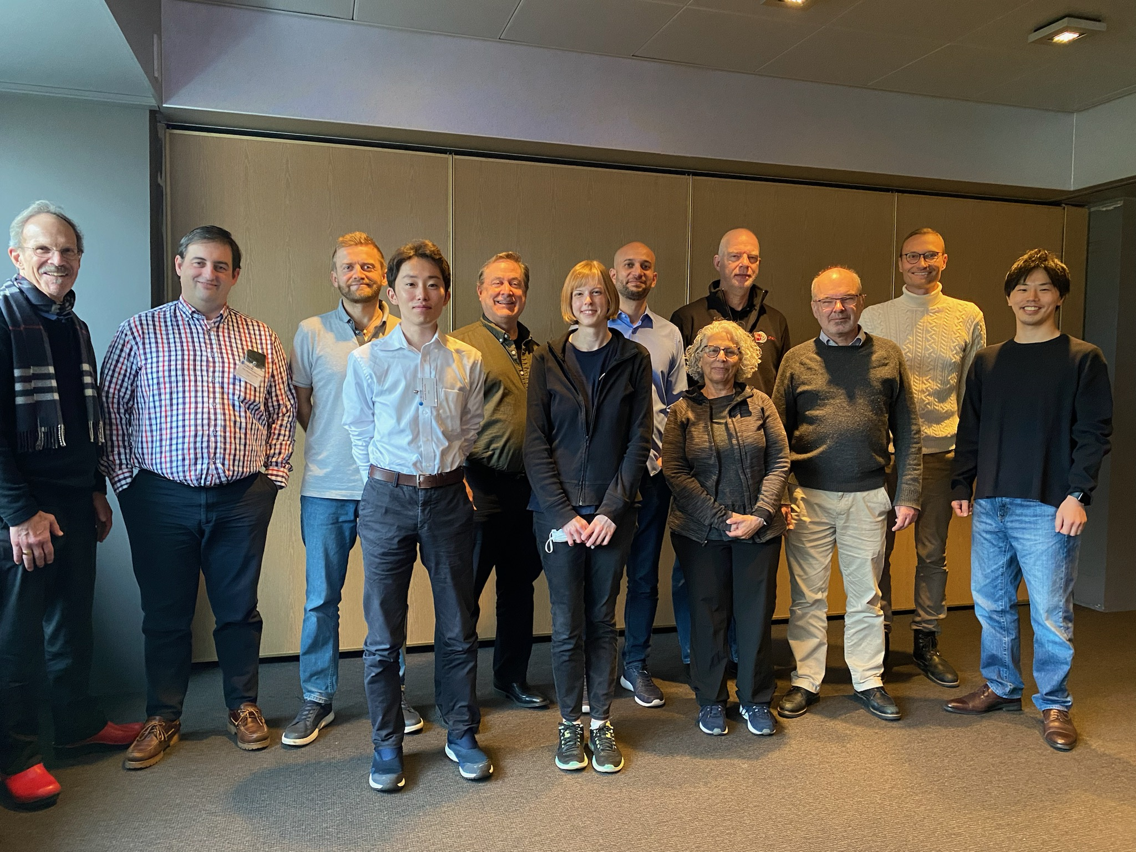

The CCSDS Navigation WG Fall 2023 (Minus Virtual Attendees): Unfortunately, Brian had to depart the preceding day, so is not pictured...

1400-1530: MOIMS Closing Plenary

Attendance at the Plenary included: Daniel Fischer (MOIMS Area Director), David Berry (Nav Chair), Frank Dreger (Nav Deputy Chair), David Giaretta (DAI Chair), John Garrett (DAI Deputy Chair), Mehran Sarkarati (SM&C Chair), Costin Radulescu (SM&C Deputy Chair), and Peter van der Plas (MP&S Chair). There were also several members of the various MOIMS working groups.

The Working Group Chairs delivered their reports: Mehran Sarkarati for Spacecraft Monitor & Control (SM&C), Peter van der Plas for Mission Planning and Scheduling (MP&S), David Berry for Navigation (Nav), and David Giaretta for Digital Archive Ingest (DAI). The Navigation report immediately below was presented during the Plenary. The report is also available on the CWE at https://cwe.ccsds.org/moims/docs/MOIMS-NAV/Meeting%20Materials/2023/Fall/navwg-report-202311.pdf

NAVIGATION WORKING GROUP CLOSING REPORT for THE HAGUE, NETHERLANDS

NAV WG EXECUTIVE SUMMARY

MOIMS/Nav Meeting Demographics

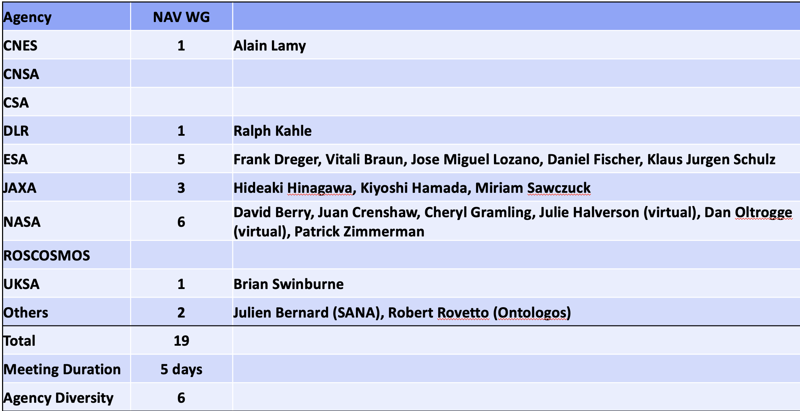

NAV WG Executive Summary

Achievements for this Meeting Cycle:
- Completed participation in the special LunaNet briefing 08-Nov-2023. Nav WG member Cheryl Gramling was a main presenter; she has been assigned an action item to prepare a "Concept Paper" discussing potential new and/or existing CCSDS Navigation WG standard(s) that will support LunaNet.
- Completed discussion of Conjunction Data Message V.2 Pink Book comments from internal technical + proofreading review of Pink Book P1.0.6
- Completed Reconfirmation of Pointing Requests Message now that recent Corrigendum has been published
- Continued discussion of plans for content updates in Tracking Data Message V.3 draft
- Resumed discussion of Navigation Events Message in preparation for initial draft
- Continued discussion of NDM/XML V.4 Pink Book draft 3.0.1 and issues with the document schedule
- Completed review of the Concept Papers for 2 potential new projects, and completed preparation of proposal for new project for one of them ("Fragmentation Data Message") and requested CMC Poll.
Working Group Status:
- Active, "High Momentum" with very good attendance.
Interaction with Other WGs:
- Met with CSTS/TD WG to discuss changes in the Tracking Data Message that will affect the 922.2 Blue Book.
- Met with a representative of SANA Operator Team to discuss various topics related to Nav WG use of SANA
Problems and Issues:
- Room was a bit small for the size of our group, but we managed. Some audio difficulty with virtual attendees.
Resolutions & Agreed upon this Meeting:
- NAV-01: The Navigation WG thanks ESA/ESTEC for the fine meeting facilities, refreshments, and audio/visual support!
- NAV-02: To "Reconfirm" the Pointing Request Message 509.0-B-1
- NAV-03: To cancel the Draft Project "Navigation Hardware Message" and remove it from the IOAG-CCSDS Product Agreements. (The need for this document has been superseded). See column "IOAG Priority" at link https://cwe.ccsds.org/fm/Lists/Projects/AllOpenChartersWithDraftProjects.aspx, Charter : 2.02 Navigation Working Group
- NAV-04: To create a new project "Fragmentation Data Message" (already a Draft Project, CMC Poll needed)
Further Resolutions Anticipated in the Next 6 Months:
- NAV-05: To submit the Conjunction Data Message Pink Book 1.0.7 for Secretariat Data Processing and Agency Review
- NAV-06: To submit the Navigation Data Messages/XML Specification Pink Book 3.0.x for Secretariat Data Processing and Agency Review
- NAV-07: To create a new project "Navigation Functions Message"

Planning (Only Approved Projects):

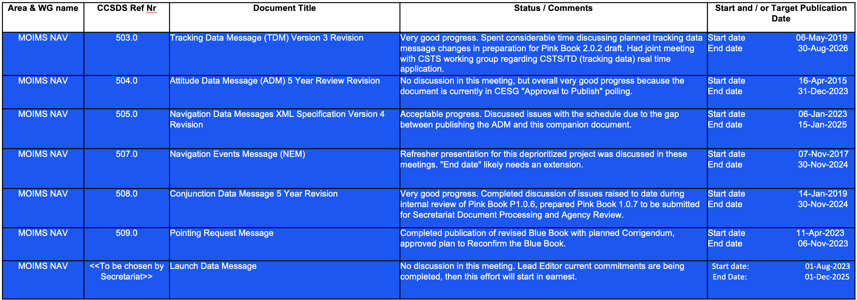

NAV WG Upcoming New Work Items

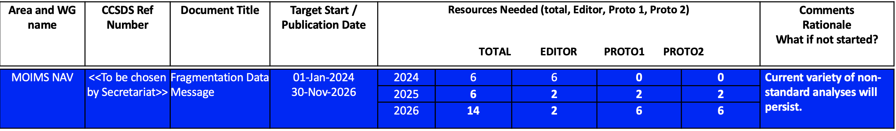

NAV WG Issues for CESG/CMC

Minor Issue Related to CCSDS Draft Projects and Concept Papers
- Note that the CCSDS A02.1-Y-4 "Organization and Processes for the Consultative Committee for Space Data Systems" states in 6.1.1 "Every CCSDS document (or family of related documents) starts out as a CCSDS concept paper".
- A02.1-Y-4 contains extensive discussion about the purpose, content, etc. of concept papers, but there is no current way to associate a concept paper with a Draft Project on the CWE when a CMC Poll is requested (https://cwe.ccsds.org/fm/Lists/Projects/AllOpenChartersWithDraftProjects.aspx).
- It seems logical that a Concept Paper could be attached to the Draft Project form.

NEXT TELECONS:

We will continue the 1-hour telecons approximately monthly between Fall and Spring Meetings.

- 13-Dec-2023 14:00-15:00 UTC
- 10-Jan-2024 14:00-15:00 UTC
- 07-Feb-2024 14:00-15:00 UTC
- 06-Mar-2024 14:00-15:00 UTC
- 10-Apr-2023 13:00-14:00 UTC
- 29-Apr-2024 through 03-May-2024 Spring Meetings at Washington, D.C., USA

NOTE:
Europe Daylight Savings Time begins 31-Mar-2024
US Daylight Savings Time begins 10-Mar-2024

