Page | Section | Line | Type | Comment/ Rationale | Source of Comment (Name/Agency) | Suggested Disposition | Disposition  (Completed by Principal Editor)
5-20 | 5 | 11 | Ge | May wish to include the new attitude interpolation section contained in the latest OCM annex. | Oltrogge/NASA | Consider.
5-20 | 5 | 5 | Ge | May wish to include a description of how it is possible to have multiple ACMs in a single message, e.g.,  “NOTE: A sequence of ACMs for either a single object or for multiple objects may be aggregated into a single Navigation Data Message (NDM) XML file as shown in ANNEX XX.” | Oltrogge/NASA | Consider.
5-21 | 5 | 4 | Ge | May wish to include a picture equivalent to the new Fig 6-1 to better share the structure of an ACM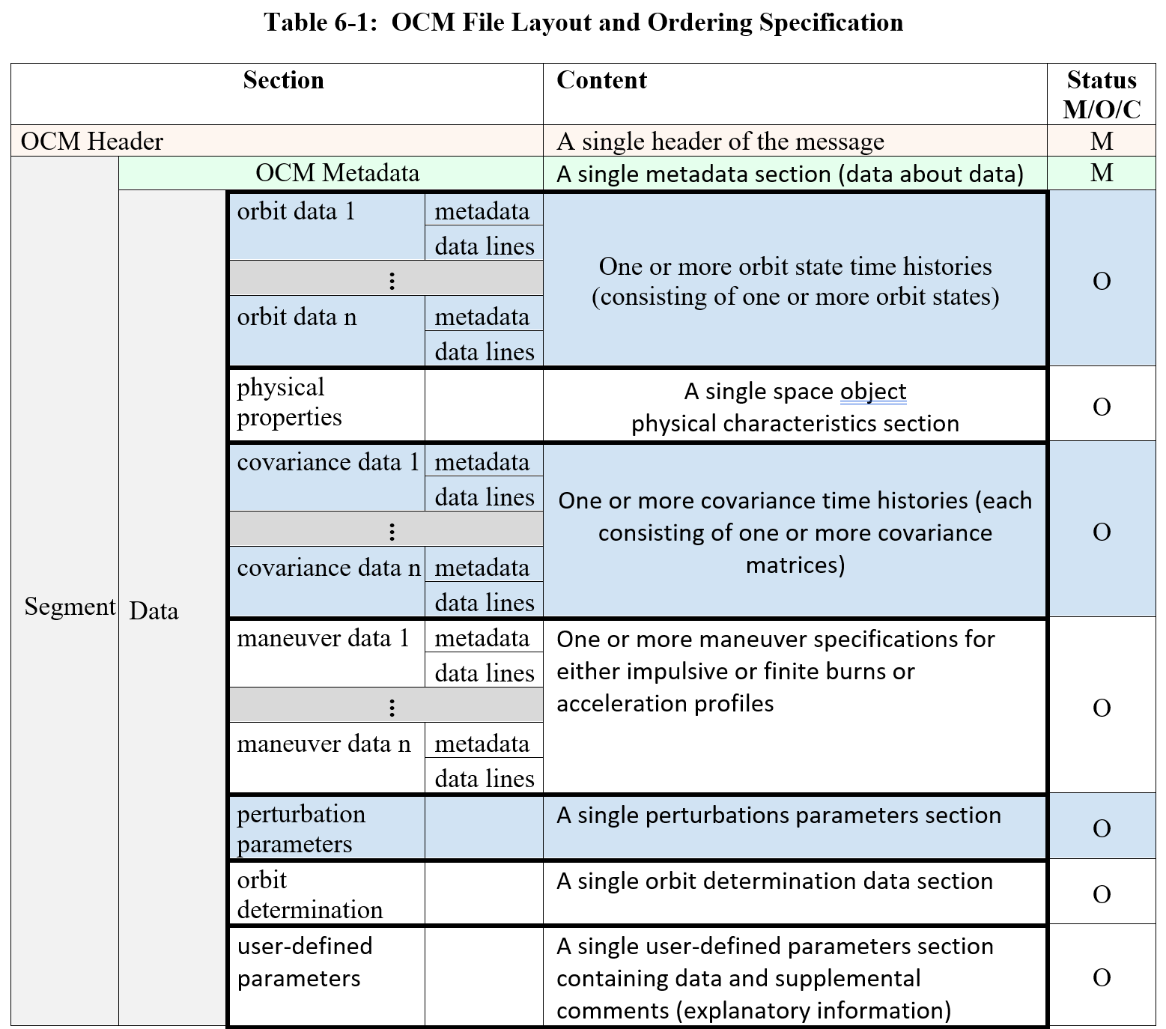 | Oltrogge/NASA | Consider.
5-21 | 5 | 1 | GE | More of a question: Is there utility in including an attitude “perturbation” section (torques, SRP, etc.)? | Oltrogge/NASA | Consider.
5-22 | 5 | 5 | GE | Consider switching to the new agreed-upon OCM use of “M”, “C” (conditional) and “O” (Optional), per:  “Within the tables of each OCM section, each keyword is labeled as being Mandatory (M), Optional (O), or Conditional (C). An ‘M’ denotes mandatory keywords that must be included in this section if that particular data section is included. Keywords that have a pre-defined (default) value are listed as ‘O’ (optional), because if the keyword is not provided, then the default value is defined in the corresponding table, that value shall be used. A ‘C’ denote keywords that are mandatory if certain conditions are met, as delineated in the keyword description.” | Oltrogge/NASA | Consider.
5-22 | 5 | 10 | Ge | May wish to mirror the “signed” language for relative time in the OCM, per: “All time-tags may be specified by either a (signed) double precision relative time (e.g., 20157.26) measured in SI seconds with respect to the specified epoch time (EPOCH_TZERO) or as an absolute time (e.g., 2018-11-13T11:13:20.5Z in CCSDS Time String A or B format, as specified in Section 7.5.10)” | Oltrogge/NASA | Consider.
5-23 | 5 | 20 | Ge | Per agreement on the OCM, the language for each section, “The “ACM Metadata” section is mandatory; “mandatory” in the context of Table  5-3 denotes those keywords which must be included in this section.” Can be moved to the general top-level requirement above, and deleted here. | Oltrogge/NASA | Consider.
5-23 | 5 | ~40 | Ge | Perhaps “The TIME_SYSTEM value must remain fixed within an ACM.” Is now redundant, since you only allow one METADATA block (?) | Oltrogge/NASA | On the other hand, it is harmless to leave it.
1-3 | 1 | !35 | Ge | (may wish to color yellow the ODM reference, in case a new one is published (if ever!) | Oltrogge/NASA | Consider.
5-23 | 5 | Bottom | Ge | May wish to include agreed-upon language, “NOTE 2 – While specification of OBJECT_NAME, OBJECT_DESIGNATOR, and INTERNATIONAL_DESIGNATOR are individually optional, it is recommended that at least one of these three keywords be supplied.” | Oltrogge/NASA | Consider.
5-24 | 5 | Top | Ge | May wish to include “CLASSIFICATION” keyword for consistency w/OCM | Oltrogge/NASA | Consider.
5-25 | 5 | Mid | GE | Question: in the OCM, the ordering of keywords is sort of based on overall flow, but is otherwise random. Probably likewise here. Would there be value in us harmonizing this ordering, at least for keywords that are in common? | Oltrogge/NASA | Consider.
5.2.5.4 | 5 | Bottom | Ge | Per above, may be able to delete, “The “ACM Data: Attitude State Time History” section is optional; “mandatory” in  the context of Table 5-4 denotes those keywords which must be included in this section if  this section is included.” | Oltrogge/NASA | Consider.
5.2.5.7.3 | 5 | 10 | Ge | May wish to include something like, “Where multiple orbit state time history data blocks are provided for the same ORB_BASIS and ORB_BASIS_ID, the top-most depiction shall be adopted as the true or master depiction.“ | Oltrogge/NASA | Consider.
5.2.5.8 | 5 | 15 | Ge | May want to remove, “All attitude state values in the ACM data shall be time-tagged by a relative time  value measured with respect to the epoch time specified via the EPOCH_TZERO keyword.” Since it is discussed above in the general section. | Oltrogge/NASA | Consider.
5.2.2.7 | 5 | 20 | Ge | May wish to add, “Duplicate time tags shall not be permitted. Where one or more duplicate time tags are discovered, the former value(s) shall be supplanted by the single latter entry.” And delete 5.2.5.9 per our agreement in CCSDS plenary. | Oltrogge/NASA | Consider.
Table 5.4 | 5 | Bottom | Ge | Just before the “… <Insert…” section, may want to include an ATT_UNITS keyword containing something like, “A comma-delimited set of SI unit designations for each element of the orbit state time history after the orbit state time tag shall be provided in aggregate as an alphanumeric free-text string enclosed in square brackets. All orbit state elements shall have a corresponding units entry; non-dimensional values (such as orbit eccentricity) shall be labelled as “nd”. Suggested units are recommended for each ORB_TYPE, per ANNEX B, Section B7.” | Oltrogge/NASA | (this is text reflecting a recent XML-based agreement that David and I are proposing, and to make that Keyword mandatory
5.2.6.7 | 5 | 10 | GE | Definition of reference [H2] (already highlighted) | Oltrogge/NASA
5.2.6.4 | 5 | 5 | Ge | May be able to remove, “The “ACM Data: Space Object Physical Characteristics” section is optional;  “mandatory” in the context of Table 5-5 denotes those keywords which must be included in  this section if this section is included” (and all other similar) | Oltrogge/NASA | Consider.
5.2.7.5 | 5 | 10 | Ge | May be able to remove, “All covariance matrices in the ACM data shall be time-tagged by a relative time  value measured with respect to the epoch time specified via the EPOCH_TZERO keyword.” | Oltrogge/NASA | Consider.
Table 5.6 | 5 | Bottom | Ge | Just above “…< Insert covariance”, may wish to consider COV_UNITS as per OCM, e.g., “A comma-delimited set of SI unit designations for each element of the covariance time history after the covariance time tag shall be provided in aggregate as an alphanumeric free-text string enclosed in square brackets. Specifically, these units designations shall correspond to the standard deviations (or square roots) of each of the covariance matrix diagonal elements (or variances), respectively. All diagonal elements shall have a corresponding units entry; non-dimensional values (such as dispersion in orbit eccentricity) shall be labelled as “nd”. Suggested units are recommended for each COV_TYPE, per ANNEX B, Sections B7 and B8).” | Oltrogge/NASA | Consider.
5.2.8.6 | 5 | Bottom | Ge | May be able to remove, “Attitude maneuver data in the ACM data shall be time-tagged by a relative time  value measured with respect to the epoch time specified via the EPOCH_TZERO keyword.” | Oltrogge/NASA | Consider.
5.2.10 | 5 | Mid | GE | New language to consider from our Plenary for the OCM: “6.2.10.1 A single section of User Defined Parameters is allowed. In principle, this provides flexibility, but also introduces complexity, non-standardization, potential ambiguity, and potential processing errors. Accordingly, if used, the keywords and their meanings must be described in an ICD. User Defined Parameters, if included, should be used as sparingly as possible; their use is not encouraged.” | Oltrogge/NASA | Consider.
5.2.10.2 | 5 | Mid | Ge | Perhaps can remove, “The “ACM data: User-Defined Parameters” section is optional; “mandatory” in the  context of Table 5-9 denotes those keywords which must be included in this section if this  section is included.” | Oltrogge/NASA | Consider.
(immediately after section 5) | 6 | Bottom | Ge | Page numbering for section 6 needs to be reset from “Page 6-35” to Page 6-1 | Oltrogge/NASA | Consider.
B-1 | Annex B | Top | GE | May wish to include general overview of using the SANA registry, e.g., “These recommended values are stored on the SANA Registry, globally accessible on the CCSDS SANA registry website located at:  https://sanaregistry.org/r/navigation_standard_normative_annexes  Note that the message creator or recipient may wish to automate processing of SANA registry normative content, which can be done by ingesting and processing of such content in electronic format. These formats can be accessed via the “Actions” link on each registry, e.g. for the Orbital Elements registry, a comma separated value (CSV) format can be exported at: https://www.sanaregistry.org/r/orbital_elements?_export=csv and a (JSON) format at: https://www.sanaregistry.org/r/orbital_elements?_export=json. Note that both the registry and these electronic data formats contain the specification of how many vector elements corresponding to each keyword value.  Exchange partners may submit additional (new) keyword values for consideration of future inclusion into the SANA registry by submitting a detailed email request (mailto:info@sanaregistry.org) per ANNEX M, Section M2. The CCSDS Area or Working Group responsible for the maintenance of the ODM at the time of the request is the approval authority. Until a suggested value is included in the SANA registry, exchange partners may define and use values that are not listed in the SANA registry if mutually agreed between message exchange partners.” | Oltrogge/NASA | Consider.
B5 | Annex B | 4 | Ge | “Quaternion ESTimator” -> “QUaternion ESTimator” (?) | Oltrogge/NASA | Consider.
B5 | Annex B | 6 | Ge | “Considered the best deterministic algorithm to estimate a spacecraft  attitude quaternion.” – is that universally acknowledged, or editorial? Are there other descriptors/uniqueness traits that could be shared on Q_METHOD? | Oltrogge/NASA | Consider.

