

|  |
| --- |
| **TRACKING DATA MESSAGE PROTOTYPING TEST PLAN/REPORT** |

FOREWORD

This document describes the plan for testing prototype implementations of the CCSDS Tracking Data Message version 2, and presents the results of that testing.

Through the process of normal evolution, it is expected that expansion, deletion, or modification of this document may occur. This document is therefore subject to CCSDS document management and change control procedures, which are defined in the *Procedures Manual for the Consultative Committee for Space Data Systems*. Current versions of CCSDS documents are maintained at the CCSDS Web site:

http://www.ccsds.org/

Questions relating to the contents or status of this document should be addressed to the CCSDS Secretariat at the address indicated on page i.

At time of publication, the active Member and Observer Agencies of the CCSDS were:

Member Agencies

* Agenzia Spaziale Italiana (ASI)/Italy.
* Canadian Space Agency (CSA)/Canada.
* Centre National d’Etudes Spatiales (CNES)/France.
* China National Space Administration (CNSA)/People’s Republic of China.
* Deutsches Zentrum für Luft- und Raumfahrt (DLR)/Germany.
* European Space Agency (ESA)/Europe.
* Federal Space Agency (FSA)/Russian Federation.
* Instituto Nacional de Pesquisas Espaciais (INPE)/Brazil.
* Japan Aerospace Exploration Agency (JAXA)/Japan.
* National Aeronautics and Space Administration (NASA)/USA.
* UK Space Agency/United Kingdom.

Observer Agencies

* Austrian Space Agency (ASA)/Austria.
* Belgian Federal Science Policy Office (BFSPO)/Belgium.
* Central Research Institute of Machine Building (TsNIIMash)/Russian Federation.
* China Satellite Launch and Tracking Control General, Beijing Institute of Tracking and Telecommunications Technology (CLTC/BITTT)/China.
* Chinese Academy of Sciences (CAS)/China.
* Chinese Academy of Space Technology (CAST)/China.
* Commonwealth Scientific and Industrial Research Organization (CSIRO)/Australia.
* Danish National Space Center (DNSC)/Denmark.
* Departamento de Ciência e Tecnologia Aeroespacial (DCTA)/Brazil.
* European Organization for the Exploitation of Meteorological Satellites (EUMETSAT)/Europe.
* European Telecommunications Satellite Organization (EUTELSAT)/Europe.
* Geo-Informatics and Space Technology Development Agency (GISTDA)/Thailand.
* Hellenic National Space Committee (HNSC)/Greece.
* Indian Space Research Organization (ISRO)/India.
* Institute of Space Research (IKI)/Russian Federation.
* KFKI Research Institute for Particle & Nuclear Physics (KFKI)/Hungary.
* Korea Aerospace Research Institute (KARI)/Korea.
* Ministry of Communications (MOC)/Israel.
* National Institute of Information and Communications Technology (NICT)/Japan.
* National Oceanic and Atmospheric Administration (NOAA)/USA.
* National Space Agency of the Republic of Kazakhstan (NSARK)/Kazakhstan.
* National Space Organization (NSPO)/Chinese Taipei.
* Naval Center for Space Technology (NCST)/USA.
* Scientific and Technological Research Council of Turkey (TUBITAK)/Turkey.
* South African National Space Agency (SANSA)/Republic of South Africa.
* Space and Upper Atmosphere Research Commission (SUPARCO)/Pakistan.
* Swedish Space Corporation (SSC)/Sweden.
* Swiss Space Office (SSO)/Switzerland.
* United States Geological Survey (USGS)/USA.

DOCUMENT CONTROL

|  |  |  |  |
| --- | --- | --- | --- |
| **Document** | **Title and Issue** | **Date** | **Status** |
|  |  |  | Final report. |

CONTENTS

Section Page

DOCUMENT CONTROL iii

CONTENTS iv

1 INTRODUCTION 1

1.1 PURPOSE 1

1.2 SCOPE 1

1.3 APPLICABILITY 1

1.4 RATIONALE 1

1.5 DOCUMENT STRUCTURE 1

1.6 DEFINITIONS 1

1.7 REFERENCES 2

2 BLUE BOOK PROMOTION CRITERIA 3

3 SUMMARY CONCLUSION 4

4 TRACKING DATA MESSAGE TEST PLAN 5

4.1 TEST PLAN OVERVIEW 5

4.2 TEST PLAN DETAILS 6

4.2.1 TEST CASE #1: DOPPLER COUNTS 6

4.2.2 TEST CASE #2: PHASE COUNTS 7

4.2.3 TEST CASE #3: OPTICAL MAGNITUDE 7

4.2.4 TEST CASE #4: RADAR CROSS SECTION 8

4.2.5 TEST CASE #5: XML TRACKING DATA MESSAGE 8

5 TRACKING DATA MESSAGE TEST REPORT 10

5.1 TEST RESULTS OVERVIEW 10

5.2 TEST RESULTS DETAIL 10

5.2.1 TEST CASE #1: DOPPLER COUNTS 11

5.2.2 TEST CASE #2: PHASE COUNTS 13

5.2.3 TEST CASE #3: OPTICAL MAGNITUDE 16

5.2.4 TEST CASE #4: RADAR CROSS SECTION 18

5.2.5 TEST CASE #5: XML TRACKING DATA MESSAGE 20

**Figure 5‑1 Test Case #1: AGI and NASA/GSFC Doppler Count Comparison** 12

**Figure 5‑2 Test Case #2: Doppler Residuals as Calculated by JPL Navigation Operations Software** 15

**Figure 5‑3 Test Case #2: Doppler Residuals as Calculated by JPL Navigation TDM V.2 Prototype** 15

**Figure 5‑4 Test Case #3: ESA Results. NOTE: Each color is from a different TDM segment.** 17

**Figure 5‑5 Test Case #3: DLR Results. NOTE: Each color is from a different TDM segment.** 17

**Figure 5‑6 Test Case #4: ESA/ESOC Results** 19

**Figure 5‑7 Test Case #4: DLR Results** 19

**Figure 5‑8 Test Case #5: XML Spy Report on TDM/XML Validation Tests (JPL)** 21

**Figure 5‑9 Test Case #5: XML Spy Report on TDM/XML Validation Tests (ESA)** 21

# INTRODUCTION

## PURPOSE

The purpose of this document is to provide the Test Plan and Test Report for the Tracking Data Message (TDM) Version 2 (reference [3]). As the execution of the Test Plan has progressed, the results of the testing have been included in document updates. When all tests have been satisfactorily completed, the document will be presented to the MOIMS Area Director for review and subsequent submission to the CCSDS CESG.

## SCOPE

The scope of this document is test plans and test results for the new metadata and new data types incorporated in the TDM Version 2. Unchanged metadata and data types tested as part of the TDM Version 1 will not be re-tested in this Test Plan as they are already being used in flight operations. The TDM is part of the technical program of the CCSDS Navigation Working Group. The TDM Version 2 updated draft completed the CCSDS Agency Review 24 July 2018; this process is described in reference [1].

Note that in applicable places the prototyping includes results based on modifications to the TDM document (reference [3]) provided via the Review Item Discrepancy (RID) process of the Agency Review. These updated but unpublished versions of the TDM document are available internally through the Navigation Working Group.

## APPLICABILITY

This document applies only to the sections of the TDM that are changed or added in the TDM Version 2. For the test plan and test results from the TDM Version 1, please see the Reference [2] in Section 1.7.

## RATIONALE

A test plan and test report are required by the CCSDS standardization process documented in reference [1].

## DOCUMENT STRUCTURE

The first sections of this document describe the Test Plan for the prototyping activity; the last sections of the document provide a Test Report of the realized plan. This plan has been prepared and executed by the members of the CCSDS Navigation Working Group who are coordinating the prototyping for their respective agencies.

## DEFINITIONS

None.

## REFERENCES

The following publications are referenced in this document. At the time of publication, the editions indicated were valid. All publications are subject to revision, and users of this document are encouraged to investigate the possibility of applying the most recent editions of the publications indicated below. The CCSDS Secretariat maintains a register of currently valid CCSDS publications.

[1] Organization and Processes for the Consultative Committee for Space Data Systems, CCSDS A02.1-Y-4. Yellow Book - CCSDS Normative Procedures. Issue 4. April 2014. https://public.ccsds.org/Pubs/A02x1y4c2.pdf

[2] Tracking Data Message Version 1 Prototyping Test Plan/Report, https://cwe.ccsds.org/moims/docs/MOIMS-NAV/Draft%20Documents/Tracking%20Data%20Message%20(TDM)/TDM%20Archive/TDM-Prototyping-Plan+Report-final-changesaccepted.pdf , 05-October-2007.

[3] Tracking Data Message, CCSDS 503.0-P-1.1, Pink Book, May 2018, https://public.ccsds.org/Lists/CCSDS%205030P11/503x0p11.pdf.

# BLUE BOOK PROMOTION CRITERIA

The CCSDS procedures manual [1] states that for a Recommendation to become a Blue Book, the standard must be tested in an operational manner. The following requirements for an implementation exercise were excerpted from reference [1]:

“At least two independent and interoperable prototypes or implementations must have been developed and demonstrated in an operationally relevant environment, either real or simulated, unless a waiver of the interoperability testing requirement has been approved”.

This document will outline the Navigation Working Group’s approach to meeting this requirement for the Tracking Data Message (TDM) Version 2, along with the results of applying said approach.

# SUMMARY CONCLUSION

TDM Prototypes were developed at 3 CCSDS member agencies: (ESA, DLR, NASA) and 2 supporting companies (AGI, GMV). A suite of 5 test cases covered the interagency exchange and processing of the new tracking data types. The tracking data were collected during operational tracking passes for 5 different space objects (4 spacecraft, 1 debris) managed by 3 different member agencies. Operational tracking assets situated on 3 continents managed by 4 different tracking networks were used in the data collection. Based on this operational diversity and the positive test results, the TDM prototyping effort successfully addresses the Blue Book promotion criteria. It is thus proposed to approve the updated Tracking Data Message as a CCSDS Recommended Standard.

# TRACKING DATA MESSAGE TEST PLAN

## TEST PLAN OVERVIEW

Changes in the TDM Version 2 included revisions as follows:

* Metadata: DATA_TYPES, TRACK_ID, CORRECTION_ABERRATION_YEARLY, CORRECTION_ABERRATION_DIURNAL keywords added.
* Doppler Counts: Data keyword and associated metadata added.
* Phase Counts: Data keywords and associated metadata added.
* Optical Magnitude: Data keywords and associated metadata added.
* Radar Cross Section: Data keywords and associated metadata added.
* XML Tracking Data Message: Schema updated to reflect above changes.
* Use of the SANA Registry was added as the recommended source of the values associated with the ORIGINATOR, TIME_SYSTEM, and REFERENCE_FRAME keywords.

The test of the TDM will exercise the following data types:

* Doppler Counts: See Test Case #1
* Phase Counts: See Test Case #2
* Optical Magnitude: See Test Case #3
* Radar Cross Section: See Test Case #4
* XML Tracking Data Message: See Test Case #5
* SANA Registries:
  + Organizations (https://sanaregistry.org/r/organizations),
  + Time Systems (https://sanaregistry.org/r/time_systems), and
  + Celestial Body Reference Frames (https://sanaregistry.org/r/celestial_body_reference_frames).

The following table identifies the test number, spacecraft, and agencies involved in the tests.

|  |  |  |  |
| --- | --- | --- | --- |
| **Test#** | **Spacecraft** | **Agencies** | **Data Types** |
| 1 | AQUA | NASA/GSFC  AGI | Doppler Counts |
| 2 | MEX  MRO | ESA/ESOC  GMV  NASA/DSN  NASA/JPL Navigation | Phase Counts |
| 3 | Titan IIIC transtage debris | ESA/ESOC  DLR | Optical Magnitude |
| 4 | AVUM rocket body | ESA/ESOC  DLR | Radar Cross Section |
| 5 | As used in test cases #1 through #4 | NASA/JPL  ESA/ESOC  GMV | XML TDM |

The tests described in the remainder of this section will be conducted in order to meet the CCSDS requirements. In Section 5, the results of the testing are presented.

Note: initially it was thought that a test of the new DATA_TYPES and TRACK_ID metadata keywords would be necessary, however, given that these effectively function as "COMMENT" statements, the Working Group determined that no testing would be required. TDM processing will be the same regardless of whether or not this keyword is present. The new CORRECTION_ABERRATION_* keywords are functionally identical to the existing set of CORRECTION_* metadata keywords and are thus tested by analogy.

## TEST PLAN DETAILS

### TEST CASE #1: DOPPLER COUNTS

For this test case, NASA/GSFC Flight Dynamics Facility will send TDMs to AGI that contain the metadata and data keywords relevant to Doppler represented as counts for the AQUA spacecraft. The counts will be real tracking data from the selected mission. The data type will be two-way Doppler from the Space Network (SN), also known as the Tracking and Data Relay Satellite System (TDRSS), S-band Single Access coherent service. In addition to CCSDS TDMs, NASA/GSFC will provide the recipient with the same Doppler Count tracking data in a legacy-based Universal Tracking Data Format (UTDF) Tracking Data Messages, if required.

AGI will process the CCSDS TDMs with their system and provide a file with time delimited Doppler conversion to Hertz . Similarly, the recipient can process the UTDF TDMs with their system and provide a file with time delimited Doppler conversion to Hertz. The Hertz file(s) will be compared to a file of Doppler in Hertz developed at GSFC FDF. These output files with Doppler in Hertz will be compared. All test artifacts will be sent back to NASA/GSFC for verification.

**Expected Results**

Both the CCSDS TDM and/or the UTDF TDM files should produce identical results of Doppler converted to Hertz with resolution to 0.1 milliHertz. Meeting this criterion renders the test successful.

### TEST CASE #2: PHASE COUNTS

Part 1: ESA/ESOC will provide a number of files (e.g. from MEX) containing phase count data. These are actual files that are used in the MEX orbit determination process. The test case is implemented in two steps:

The input files are converted to TDM. In this process the mapping between the data elements in the input file are mapped into the data elements provided by the TDM. The main purpose is to ensure that the information required for the processing of the phase count data can be conveyed by the definition of the TDM for phase count data.

Verify that data provided by the TDM is sufficient to support the orbit determination process as if the original input files were given. Note however, that it is not the purpose of the test to fully reconstruct the original input files. In the process both XML and KVN files will be generated: (a) XML files mainly to verify the completeness and consistency of the generated TDM, and (b) KVN to be provided to ESOC’s flight dynamics team for the analysis of the second step described above.

Part 2: The NASA/DSN will prepare a test TDM(s) containing both TRANSMIT_PHASE data and RECEIVE_PHASE data. The TDM(s) will be provided to the JPL navigation section for processing (note: this is a current operational TDM transmission path for some interagency missions tracked by NASA/DSN, i.e., from the DSN to JPL Navigation to the non-NASA mission navigation team). JPL Navigation will process the provided TDM(s) and compare the results to DSN tracking data analysis prepared using TRANSMIT_FREQ and RECEIVE_FREQ data.

**Expected Results**

Part 1: ESA's IFMS phase count data is converted successfully to TDM format (both KVN and XML), and the TDM content is sufficient for use in orbit determination.

Part 2: JPL comparison of the phase and frequency TDM data provides commensurate results.

### TEST CASE #3: OPTICAL MAGNITUDE

For this test case, ESA/ESOC will provide a number of KVN TDMs containing optical magnitude, right ascension, and declination for Titan IIIC transtage debris to DLR/GSOC. The TDMs will contain the TIME_SYSTEM, START_TIME, STOP_TIME, PARTICIPANT_1, PARTICPANT_2, MODE, PATH, ANGLE_TYPE, and REFERENCE_FRAME keywords in the metadata sections, and the ANGLE_1, ANGLE_2, and MAG keywords in the data sections. Both ESA/ESOC and DLR/GSOC will process these TDMs with their TDM v2 prototypes. Both agencies will produce plots of MAG against time for each TDM segment.

**Expected Results**

It is anticipated that both the ESA/ESOC and DLR/GSOC prototypes will generate the same magnitude variation plots and that they will match the values in the TDM. Assuming that these criteria are met, the test will be considered successful.

### TEST CASE #4: RADAR CROSS SECTION

For this test case, ESA/ESOC will provide a number of KVN TDMs containing RCS, azimuth, elevation, range, and Doppler for an AVUM Rocket Body (2012-006K) to DLR/GSOC. The TDMs will contain the TIME_SYSTEM, START_TIME, STOP_TIME, PARTICIPANT_1, PARTICPANT_2, MODE, PATH, TIMETAG_REF, INTEGRATION_INTERVAL, INTEGRATION_REF, RANGE_MODULUS, RANGE_UNITS, and ANGLE_TYPE keywords in the metadata sections, and the ANGLE_1, ANGLE_2, RANGE, DOPPLER_INSTANTANEOUS, and RCS keywords in the data sections. Both ESA/ESOC and DLR/GSOC will process these TDMs with their TDM v2 prototypes. Both agencies will produce plots of RCS against time for each TDM segment.

**Expected Results**

It is anticipated that both the ESA/ESOC and DLR/GSOC prototypes will generate the same radar cross-section variation plots and that they will match the values in the TDM. Assuming that these criteria are met, the test will be considered successful.

### TEST CASE #5: XML TRACKING DATA MESSAGE

Premise #1: Prototype Test Cases #1 through #4 have already established that the Version 2 modifications to the TDM can be used to support the exchange and processing of tracking data. In order for this premise to be true, execution of Test Case #5 must occur after Test Cases #1 through #4 have already been successfully completed.

Premise #2: The prototype testing performed at ESA/ESOC and NASA/JPL using the same (or similar) technical content as was described in Test Cases #1 through #4, and described in this document, has established that the flight dynamics content of the Version 2 modifications to the TDM standard can be rendered in an XML format.

For this test case, an updated version of the TDM/XML schema will be prepared (the updates will involve adding the new Version 2 Metadata Section keywords and Data Section keywords). TDMs in XML format containing all of the new Version 2 keywords will be created by JPL using the TDMs created for Test Cases #1 through #4, validated using the updated schema, and transmitted to ESA/ESOC along with the KVN messages. The ESA/ESOC tests will involve automated conversion of the KVN TDMs used in Test Case #1 through Test Case #4 into XML format . ESA/ESOC will process the received TDMs using the updated TDM schema. The test XML format TDMs will be added to the library of NDM/XML test cases for future use.

**Expected Results**

It is anticipated that the XML formatted TDMs will be valid when processed with the updated XML schema by both JPL and ESA/ESOC. Assuming that this criterion is met, the test will be considered successful.

# TRACKING DATA MESSAGE TEST REPORT

## TEST RESULTS OVERVIEW

Engineers at the participating agencies will prepare test data sheets as noted in the Test Plan Details above, and send them to the Navigation Working Group via email.

The Test Report Details will be found in the following sections of this document. A summarization of the test process and the recommendation of the Navigation Working Group may be found in Section 3 of the report. The report will be posted to the Navigation Working Group Common Working Environment (CWE) on the CCSDS web page at <http://cwe.ccsds.org> . The report will be submitted to the MOIMS Area Director, the CCSDS Engineering Steering Group (CESG), and the CCSDS Management Council (CMC), along with results of the Agency Reviews. Assuming successful CESG and CMC "approval to publish" polls, the TDM will proceed to CCSDS Blue Book status.

ANNEX A contains a format for the test data sheets that will be used to report the results of individual tests.

## TEST RESULTS DETAIL

In the remainder of this document, the detailed test data sheets from the TDM V.2 Prototype Testing will be presented.

### TEST CASE #1: DOPPLER COUNTS

**Tracking Data Message Prototype Test Data Sheet**

|  |  |  |
| --- | --- | --- |
| 1 | Test Case Number: | 1 |
| 2 | Report Date: | 25-Jan-2020 |
| 3 | Program Under Test: | Tracking Data Message V2 (TDM) Prototype |
| 4 | Agencies/Companies Participating in this Test Case: | NASA/GSFC  Analytical Graphics, Inc. |
| 5 | Agency Responsible for Prototype: | TDM Generation: NASA/GSFC  TDM Processing: NASA/GSFC, Analytical Graphics, Inc. |
| 6 | Test Engineer: | TDM Generation: Cheryl Gramling  TDM Processing: Cheryl Gramling (NASA), James Woodburn (AGI) |
| 7 | Spacecraft: | Aqua |
| 8 | Tracking Data Types: | Doppler Counts |
| 9 | Tracking Data Date/Time Range: | 2019-081T14:39:02.0  2019-081T14:49:00.0 |
| 10 | Variances from Expected Results: | None |
| 11 | Results (Pass, Partial Pass, Fail): | Pass |
| 12 | Comments: | The test met criteria identified in the test plan: identical results of Doppler converted to Hertz with resolution to 0.1 mHz. |

The original data for the test came from the Space Network (SN) Legacy system that provides tracking data to the FDF in the Universal Tracking Data Format (UTDF). FDF used their UTDF to XMLTDM converter developed for the SN that transfers UTDF fields to associated XML keywords and creates an XML version of a TDM. FDF also provided a file of the Doppler observation in Hertz as converted from the UTDF TDM, that was compared to AGI's conversion of Doppler from the resultant XML TDM v2 for the test. Data conversion from SN to TDM to Doppler calculation and validation went as follows:

AGI Doppler (Hz)

Comparison (Hz)

XML TDM

SN UTDF

FDF Doppler (Hz)

Below is a representative sample of data from the Doppler comparison based on data from the TDM. The two columns on the far right show the difference between the Doppler as calculated by both TDM recipients (delta time and delta Hz).

|  |  |  |  |  |  |  |  |  |
| --- | --- | --- | --- | --- | --- | --- | --- | --- |
| *Data taken from tab "FDF Data"* | | | *Data taken from tab "aqua_sband_v4_measurements-AGI"* | | | | *Difference of time and Doppler converted to Hz by each source* | |
| **FDF CONVERTED DOPPLER DATA** | | | **AGI CONVERTED DOPPLER DATA** | | | | **COMPARISON** | |
| HHMMSS | MMSS.s | O | MMSS.s | KHz | Hz | Merged Hz | D-TIME | FDF-AGI DOPPLER |
| -------- |  | ------------- |  |  |  | KHz+Hz | S.ss | Hz |
| 143902 | 0:39:02 | 0 |  |  |  |  |  |  |
| 143903 | 0:39:03 | -240000 | 0:39:03 | -240 | 0 | -240000 | 0.00 | 0.00000 |
| 143904 | 0:39:04 | -240000 | 0:39:04 | -240 | 0 | -240000 | 0.00 | 0.00000 |
| 143905 | 0:39:05 | -240000 | 0:39:05 | -240 | 0 | -240000 | 0.00 | 0.00000 |
| 143906 | 0:39:06 | -240000 | 0:39:06 | -240 | 0 | -240000 | 0.00 | 0.00000 |
| 143907 | 0:39:07 | -240000 | 0:39:07 | -240 | 0 | -240000 | 0.00 | 0.00000 |
| 143908 | 0:39:08 | -240000 | 0:39:08 | -240 | 0 | -240000 | 0.00 | 0.00000 |
| 143909 | 0:39:09 | -240000 | 0:39:09 | -240 | 0 | -240000 | 0.00 | 0.00000 |
| 143910 | 0:39:10 | 95803.307 | 0:39:10 | 95 | 803.307 | 95803.307 | 0.00 | 0.00000 |
| 143911 | 0:39:11 | 95761.008 | 0:39:11 | 95 | 761.008 | 95761.008 | 0.00 | 0.00000 |
| 143912 | 0:39:12 | 95718.531 | 0:39:12 | 95 | 718.531 | 95718.531 | 0.00 | 0.00000 |
| 143913 | 0:39:13 | 95675.98 | 0:39:13 | 95 | 675.98 | 95675.98 | 0.00 | 0.00000 |
| 143914 | 0:39:14 | 95633.267 | 0:39:14 | 95 | 633.267 | 95633.267 | 0.00 | 0.00000 |
| 143915 | 0:39:15 | 95590.423 | 0:39:15 | 95 | 590.423 | 95590.423 | 0.00 | 0.00000 |
| 143916 | 0:39:16 | 95547.455 | 0:39:16 | 95 | 547.455 | 95547.455 | 0.00 | 0.00000 |
| 143917 | 0:39:17 | 95504.324 | 0:39:17 | 95 | 504.324 | 95504.324 | 0.00 | 0.00000 |
| 143918 | 0:39:18 | 95461.144 | 0:39:18 | 95 | 461.144 | 95461.144 | 0.00 | 0.00000 |
| 143919 | 0:39:19 | 95417.766 | 0:39:19 | 95 | 417.766 | 95417.766 | 0.00 | 0.00000 |
| 143920 | 0:39:20 | 95374.275 | 0:39:20 | 95 | 374.275 | 95374.275 | 0.00 | 0.00000 |
| 143921 | 0:39:21 | 95330.663 | 0:39:21 | 95 | 330.663 | 95330.663 | 0.00 | 0.00000 |
| 143922 | 0:39:22 | 95286.965 | 0:39:22 | 95 | 286.965 | 95286.965 | 0.00 | 0.00000 |
| 143923 | 0:39:23 | 95243.049 | 0:39:23 | 95 | 243.049 | 95243.049 | 0.00 | 0.00000 |
| 143924 | 0:39:24 | 95199.078 | 0:39:24 | 95 | 199.078 | 95199.078 | 0.00 | 0.00000 |
| 143925 | 0:39:25 | 95154.918 | 0:39:25 | 95 | 154.918 | 95154.918 | 0.00 | 0.00000 |
| 143926 | 0:39:26 | 95110.682 | 0:39:26 | 95 | 110.682 | 95110.682 | 0.00 | 0.00000 |
| 143927 | 0:39:27 | 95066.288 | 0:39:27 | 95 | 66.288 | 95066.288 | 0.00 | 0.00000 |
| 143928 | 0:39:28 | 95021.733 | 0:39:28 | 95 | 21.733 | 95021.733 | 0.00 | 0.00000 |
| 143929 | 0:39:29 | 94977.093 | 0:39:29 | 94 | 977.093 | 94977.093 | 0.00 | 0.00000 |
| 143930 | 0:39:30 | 94932.337 | 0:39:30 | 94 | 932.337 | 94932.337 | 0.00 | 0.00000 |
| 143931 | 0:39:31 | 94887.423 | 0:39:31 | 94 | 887.423 | 94887.423 | 0.00 | 0.00000 |
| 143932 | 0:39:32 | 94842.365 | 0:39:32 | 94 | 842.365 | 94842.365 | 0.00 | 0.00000 |
| 143933 | 0:39:33 | 94797.224 | 0:39:33 | 94 | 797.224 | 94797.224 | 0.00 | 0.00000 |
| 143934 | 0:39:34 | 94751.896 | 0:39:34 | 94 | 751.896 | 94751.896 | 0.00 | 0.00000 |
| 143935 | 0:39:35 | 94706.471 | 0:39:35 | 94 | 706.471 | 94706.471 | 0.00 | 0.00000 |
| 143936 | 0:39:36 | 94660.925 | 0:39:36 | 94 | 660.925 | 94660.925 | 0.00 | 0.00000 |
| 143937 | 0:39:37 | 94615.191 | 0:39:37 | 94 | 615.191 | 94615.191 | 0.00 | 0.00000 |
| 143938 | 0:39:38 | 94569.395 | 0:39:38 | 94 | 569.395 | 94569.395 | 0.00 | 0.00000 |
| 143939 | 0:39:39 | 94523.438 | 0:39:39 | 94 | 523.438 | 94523.438 | 0.00 | 0.00000 |
| 143940 | 0:39:40 | 94477.365 | 0:39:40 | 94 | 477.365 | 94477.365 | 0.00 | 0.00000 |
| 143941 | 0:39:41 | 94431.142 | 0:39:41 | 94 | 431.142 | 94431.142 | 0.00 | 0.00000 |
| 143942 | 0:39:42 | 94384.833 | 0:39:42 | 94 | 384.833 | 94384.833 | 0.00 | 0.00000 |

**Figure 5‑1 Test Case #1: AGI and NASA/GSFC Doppler Count Comparison**

### TEST CASE #2: PHASE COUNTS

**Tracking Data Message Prototype Test Data Sheet**

|  |  |  |
| --- | --- | --- |
| 1 | Test Case Number: | 2 |
| 2 | Report Date: | 09-May-2019 |
| 3 | Program Under Test: | Tracking Data Message V2 (TDM) Prototype |
| 4 | Agencies Participating in this Test Case: | ESA/ESOC  GMV |
| 5 | Agency Responsible for Prototype: | TDM Generation: GMV  TDM Processing/Analysis: ESA/ESOC |
| 6 | Test Engineer: | TDM Generation: Fran Martinez  TDM Processing/Analysis: Frank Budnik |
| 7 | Spacecraft: | Mars Express (MEX) |
| 8 | Tracking Data Types: | TRANSMIT_FREQ, RECEIVE_PHASE_CT |
| 9 | Tracking Data Date/Time Range: | 2018-08-09T16:19:13.000000  2018-08-09T19:12:21.000000 |
| 10 | Variances from Expected Results: | The outcome of the test is in my view Partially Passed. There is no field in the TDM to convey the coherency of the Doppler. Only for range measurements the RANGE_MODE keyword is defined. For the purpose of the test, RANGE_MODE has been used for similarity in the contents of the field but it formally is a misuse of the standard. If the same type of field is required for Doppler we have to extend the TDM or modify the RANGE_MODE keyword or its definition (or both). |
| 11 | Results (Pass, Partial Pass, Fail): | Partial Pass |
| 12 | Comments: | The initially intended step where ESOC would ingest the TDM file in their software has been replaced by the analysis of the TDM generated files to ensure that they convey the required information for orbit determination. Although this is a modification on the initial approach I think it is still valid for the purpose of the test. TDM Analysis has confirmed that the data is sufficient for orbit determination. |

**Tracking Data Message Prototype Test Data Sheet**

|  |  |  |
| --- | --- | --- |
| 1 | Test Case Number: | 2 |
| 2 | Report Date: | 07-Feb-2020 |
| 3 | Program Under Test: | Tracking Data Message V2 (TDM) Prototype |
| 4 | Agencies Participating in this Test Case: | NASA/DSN  NASA/JPL Navigation |
| 5 | Agency Responsible for Prototype: | TDM Generation: NASA/DSN  TDM Processing: NASA/JPL Navigation |
| 6 | Test Engineer: | TDM Generation: Dong K. Shin  TDM Processing/Analysis: Kyong J. Lee, Ted Drain |
| 7 | Spacecraft: | Mars Reconnaissance Orbiter (MRO) |
| 8 | Tracking Data Types: | TRANSMIT_PHASE_CT, RECEIVE_PHASE_CT |
| 9 | Tracking Data Date/Time Range: | 2019-338T13:30:37 TAI  2019-338T14:45:37 TAI |
| 10 | Variances from Expected Results: | There are variations in the pre-fit Doppler residual data that are traceable to variations of about 0.0001 Hz in the uplink ramp data (i.e., those points where the uplink frequency is changed to accommodate Doppler compensation at the spacecraft). The small differences are based on the fact that the exact algorithm for timetagging those points is not known to the navigation TDM prototype software. It turns out that every time a ramp changes rate, there is about 1-2 seconds where the actual rate reported by the uplink phase count is in between the old and new ramp rates.  The prototype code for converting phase data to ramps doesn't take that into account and produces a short ramp which causes the outliers shown in the plot. Of the 1972 Doppler residuals, 36 points (1.83%) were affected in this manner (see Figure 5-2) by about 0.5 Hz maximum. A third test was conducted using the operations uplink ramp data for this track along with the recieved phase data TDM, and the plot is identical to Figure 5-1. |
| 11 | Results (Pass, Partial Pass, Fail): | Pass |
| 12 | Comments: | None. |

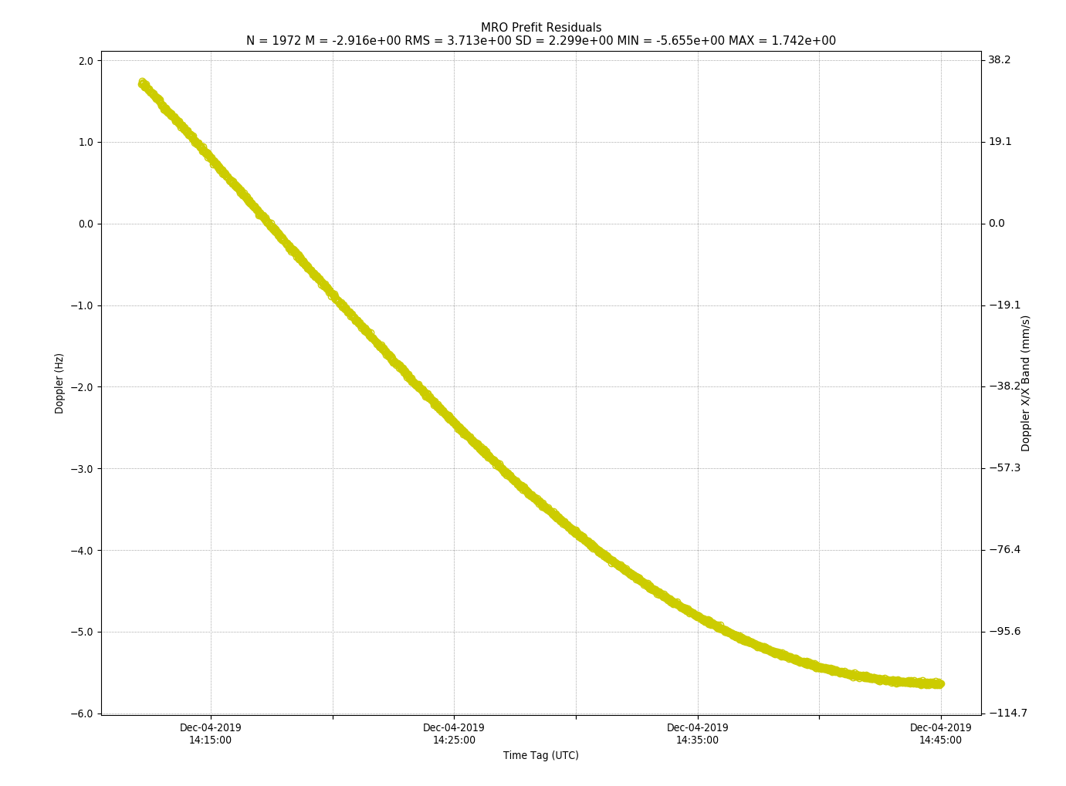

**Figure 5‑2 Test Case #2: Doppler Residuals as Calculated by JPL Navigation Operations Software**

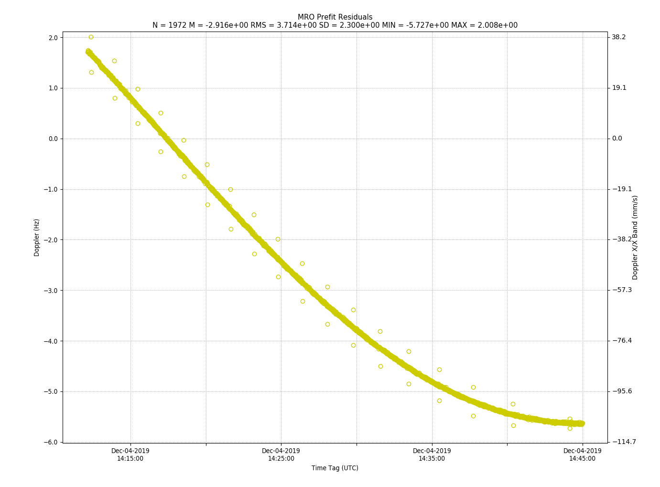

**Figure 5‑3 Test Case #2: Doppler Residuals as Calculated by JPL Navigation TDM V.2 Prototype**

### TEST CASE #3: OPTICAL MAGNITUDE

**Tracking Data Message Prototype Test Data Sheet**

|  |  |  |
| --- | --- | --- |
| 1 | Test Case Number: | 3 |
| 2 | Report Date: | 15-Oct-2018, 29-Nov-2019 |
| 3 | Program Under Test: | Tracking Data Message V2 (TDM) Prototype |
| 4 | Agencies Participating in this Test Case: | ESA/ESOC  DLR/GSOC |
| 5 | Agency Responsible for Prototype: | TDM Generation: ESA/ESOC  TDM Processing: ESA/ESOC, DLR/GSOC |
| 6 | Test Engineer: | TDM Generation: Alexandru Mancas  TDM Processing: Alexandru Mancas, Ralph Kahle |
| 7 | Spacecraft: | TITAN 3C TRANSTAGE DEBRIS |
| 8 | Tracking Data Types: | ANGLE_1, ANGLE_2, MAG |
| 9 | Tracking Data Date/Time Range: | 2017-05-21T23:10:35.310  2017-05-22T00:51:41.610 |
| 10 | Variances from Expected Results: | It was noted by DLR that when they normalize time, 1.000 is calculated for the middle of the dark blue data. It is hypothesized that different reference times may have been used for the ESA/ESOC and DLR/GSOC analyses.  In response, ESA/ESOC stated that the GSOC plot looks the same as the ESOC plot, but ESA does use different 'normalisation' schemes for time. For the ESA plot there was a fixed gap imposed between passes (0.001 days), which is why the passes themselves look wider and closer together. If you account for this the plots look the same. |
| 11 | Results (Pass, Partial Pass, Fail): | Pass |
| 12 | Comments: | DLR/GSOC finalized TDM v2 prototyping and we are able to read and process the six TDM files provided by ESA. The DLR plot on TEST CASE #3: OPTICAL MAGNITUDE, looks pretty similar to the one provided by ESA. |

**Figure 5‑4 Test Case #3: ESA Results. NOTE: Each color is from a different TDM segment.**

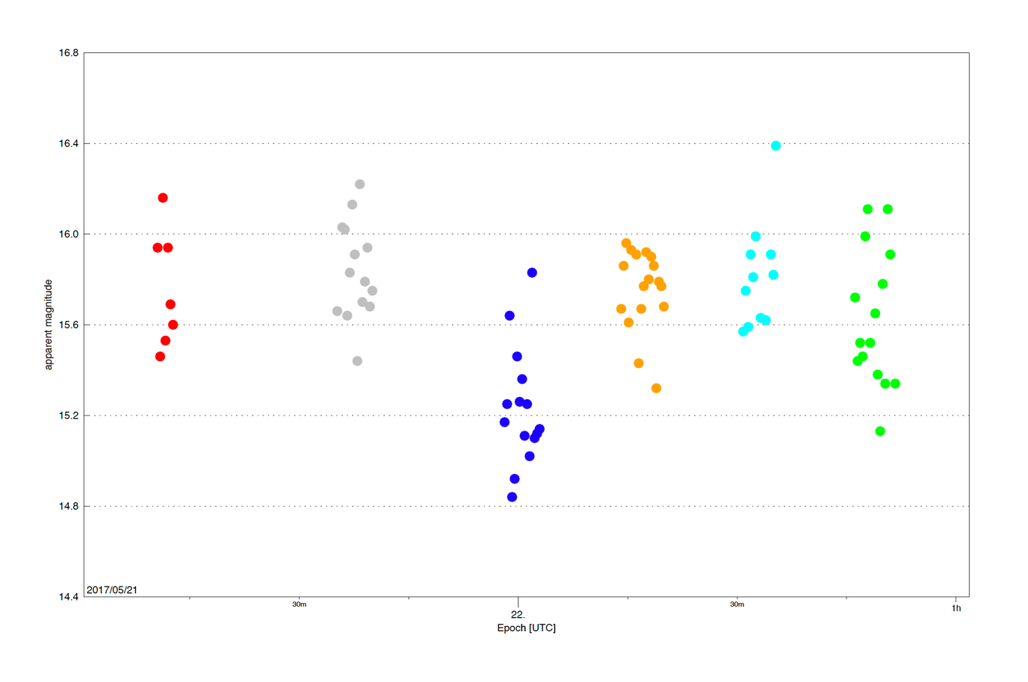

**Figure 5‑5 Test Case #3: DLR Results. NOTE: Each color is from a different TDM segment.**

### TEST CASE #4: RADAR CROSS SECTION

**Tracking Data Message Prototype Test Data Sheet**

|  |  |  |
| --- | --- | --- |
| 1 | Test Case Number: | 4 |
| 2 | Report Date: | 15-Oct-2018, 08-Jan-2020 |
| 3 | Program Under Test: | Tracking Data Message V2 (TDM) Prototype |
| 4 | Agencies Participating in this Test Case: | ESA/ESOC  DLR |
| 5 | Agency Responsible for Prototype: | TDM Generation: ESA/ESOC  TDM Processing: ESA/ESOC, DLR |
| 6 | Test Engineer: | TDM Generation: Alexandru Mancas  TDM Processing: Alexandru Mancas, Ralph Kahle |
| 7 | Spacecraft: | AVUM R/B (2012-006K) |
| 8 | Tracking Data Types: | ANGLE_1, ANGLE_2, RANGE, DOPPLER_INSTANTANEOUS, RCS |
| 9 | Tracking Data Date/Time Range: | 2016-10-27T11:54:20.897308  2016-10-27T11:59:27.153196 |
| 10 | Variances from Expected Results: | None |
| 11 | Results (Pass, Partial Pass, Fail): | Pass |
| 12 | Comments: | DLR: We successfully read and processed the ESOC TDM. The attached RCS plot looks good. We don’t see variances from ESOC result and consider the test as passed. |

**Figure 5‑6 Test Case #4: ESA/ESOC Results**

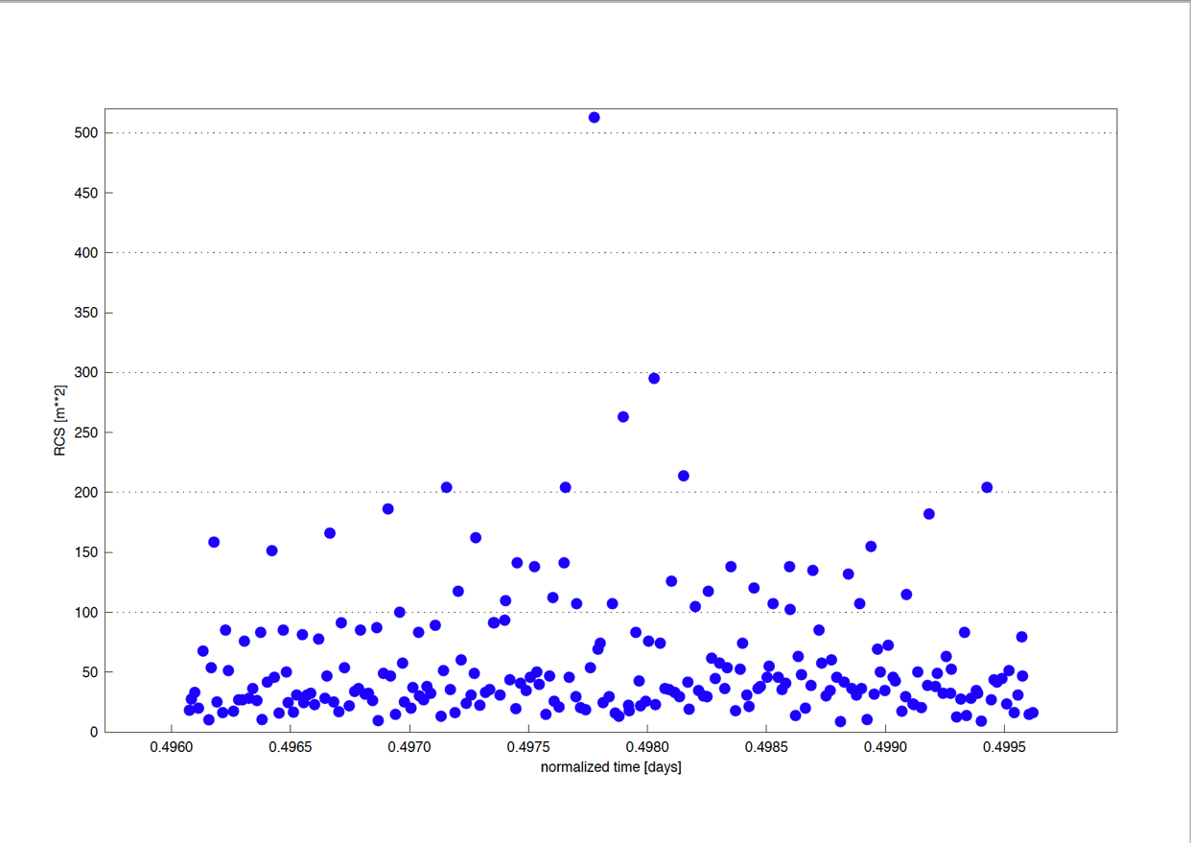

**Figure 5‑7 Test Case #4: DLR Results**

### TEST CASE #5: XML TRACKING DATA MESSAGE

**Tracking Data Message Prototype Test Data Sheet**

|  |  |  |
| --- | --- | --- |
| 1 | Test Case Number: | 5 |
| 2 | Report Date: | 11-Feb-2020 |
| 3 | Program Under Test: | Tracking Data Message V2 (TDM) Prototype |
| 4 | Agencies Participating in this Test Case: | NASA/JPL, ESA/ESOC |
| 5 | Agency Responsible for Prototype: | TDM Generation: As shown for Test Cases #1-#4  TDM Processing: As shown for Test Cases #1-#4 |
| 6 | Test Engineer: | TDM XML Generation and Processing:  David Berry, Fran Martinez |
| 7 | Spacecraft: | As shown for Test Cases #1-#4 |
| 8 | Tracking Data Types: | As shown for Test Cases #1-#4 |
| 9 | Tracking Data Date/Time Range: | As shown for Test Cases #1-#4 |
| 10 | Variances from Expected Results: | ESA/ESOC reported no issues with Test Cases #1 through #3:  #1: Converted XML to KVN and back to XML. Status: OK  #2: Converted KVN to XML: Status: OK  #3: Converted KVN to XML: Status: OK  For Test Case #4, the following phenomena were observed:  #4: Converted KVN to XML: Status: Partial OK Metadata INTEGRATION_INTERVAL has invalid value 0.000000 (as per schema must be positive non-null).  Metadata REFERENCE_FRAME has invalid value ITRF (as per schema, this value is not in the reference enumeration)  In Test Case#4 when the INTEGRATION_INTERVAL is made positive and the REFERENCE_FRAME changed to ITRF2000, the XML test is valid. The issue with the INTEGRATION_INTERVAL is a minor parameter error that does not affect the overall success of the test. The error with the REFERENCE_FRAME is most likely a coding error in the schema. It had been coded in the TDM version 1 schema with ITRF-93, ITRF-97, and ITRF2000 as the enumerated acceptable values (it should probably not have been enumerated in the first place). Also, now the Nav WG is referring to the SANA registry for reference frame values, which allows simply "ITRF" as the value. So the schema will be fixed. After the values for INTEGRATION_INTERVAL and REFERENCE_FRAME are updated, the test is successful. |
| 11 | Results (Pass, Partial Pass, Fail): | Pass |
| 12 | Comments: | A variety of TDMs in XML format were analyzed. These included the TDMs from previous TDM Version 1 testing (updated to 'CCSDS_TDM_VERS="2.0"'), TDMs from previous NDM/XML testing, the XML TDM from Test Case #1 in this document, and the set of TDMs in KVN format used in Test Cases #2 through #4 in this document converted to XML. As a final test, the XML files created by the ESA test engineer were validated by the JPL test engineer. |

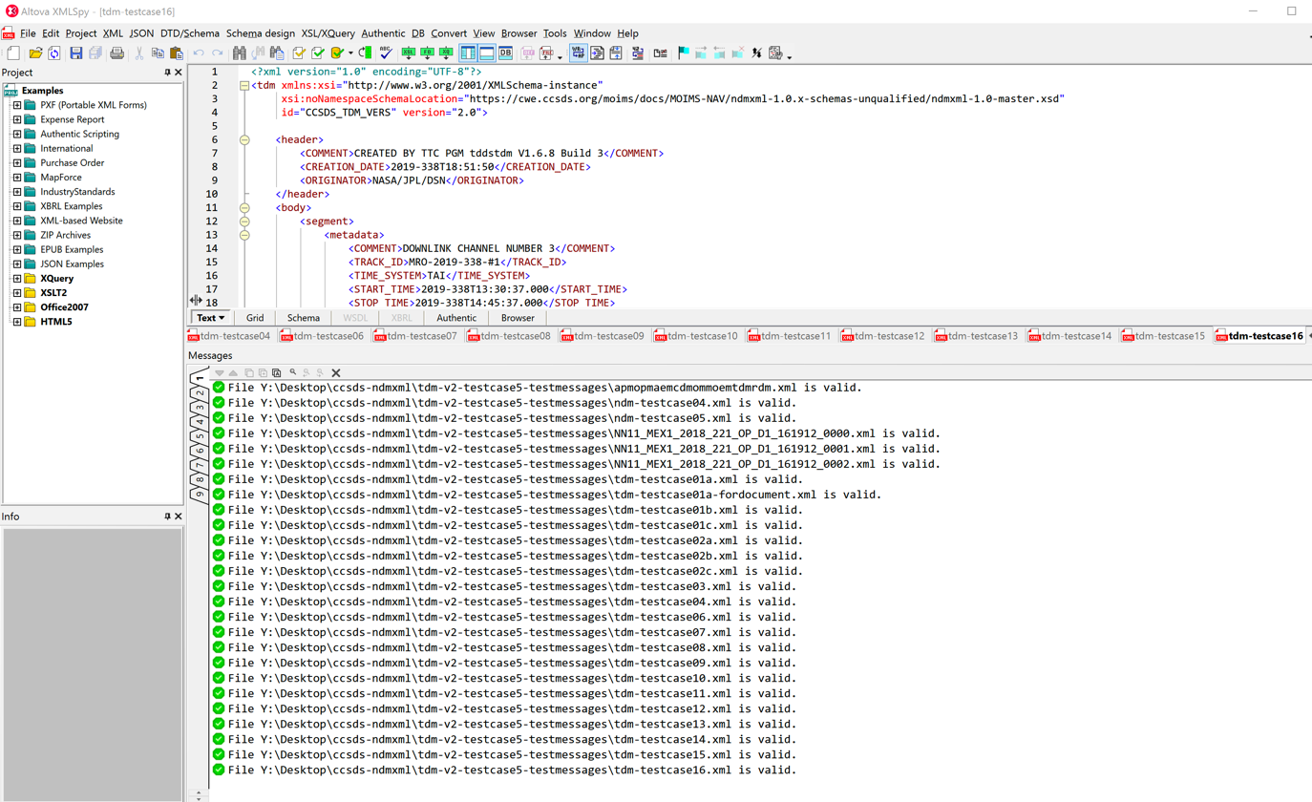

**Figure 5‑8 Test Case #5: XML Spy Report on TDM/XML Validation Tests (JPL)**

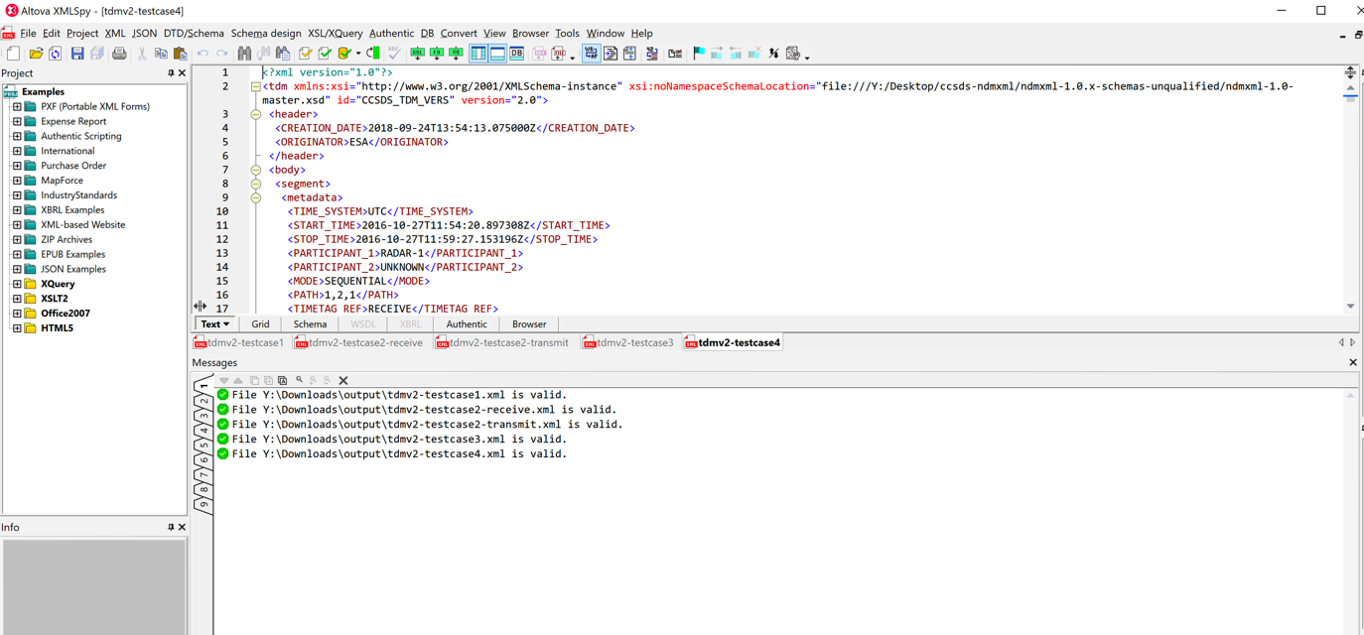

**Figure 5‑9 Test Case #5: XML Spy Report on TDM/XML Validation Tests (ESA)**

1. Tracking Data Message Prototype Test Data Sheet

**SAMPLE**

|  |  |  |
| --- | --- | --- |
| 1 | Test Case Number: |  |
| 2 | Report Date: |  |
| 3 | Program Under Test: | Tracking Data Message V2 (TDM) Prototype |
| 4 | Agencies Participating in this Test Case: |  |
| 5 | Agency Responsible for Prototype: | TDM Generation:  TDM Processing: |
| 6 | Test Engineer: | TDM Generation:  TDM Processing: |
| 7 | Spacecraft: |  |
| 8 | Tracking Data Types: |  |
| 9 | Tracking Data Date/Time Range: |  |
| 10 | Variances from Expected Results: |  |
| 11 | Results (Pass, Partial Pass, Fail): |  |
| 12 | Comments: |  |

1. Acronyms

|  |  |
| --- | --- |
| AGI | Analytical Graphics, Inc. |
| CCSDS | Consultative Committee for Space Data Systems |
| CESG | CCSDS Engineering Steering Group |
| CMC | CCSDS Management Council |
| CWE | Common Working Environment |
| DLR | Deutsches Zentrum für Luft und Raumfahrt |
| DSN | Deep Space Network |
| ESA | European Space Agency |
| ESOC | European Space Operations Center |
| FDF | Flight Dynamics Facility |
| GMV | GMV (not an acronym) |
| GSFC | Goddard Space Flight Center |
| GSOC | German Space Operations Center |
| IFMS | Intermediate Frequency and Modem System |
| JPL | Jet Propulsion Laboratory |
| KVN | Keyword Value Notation |
| MOIMS | Mission Operations and Information Management Services |
| NASA | National Aeronautics and Space Administration |
| NDM | Navigation Data Message |
| RCS | Radar Cross Section |
| RID | Review Item Discrepancy |
| SANA | Space Assigned Numbers Authority |
| SN | Space Network |
| TBD | To Be Determined |
| TDM | Tracking Data Message |
| TDRSS | Tracking and Data Relay Satellite System |
| UTDF | Universal Tracking Data Format |
| XML | eXtensible Markup Language |