MO 2.0 – MAL Identifier (string <-> number)
Motivation: One of the requests from the Agencies was to have more verbose messages on the data exchange on Ground-to-Ground interfaces in order to facilitate debugging. Therefore, the use of Identifiers in MO 2.0 has been widened. At the same time, the WG intends to maintain or improve the efficiency of the data exchange on the Ground-to-Space link.

Potential Solution: Use Dictionaries when needed
- For Encoding that encode the Identifier as string (e.g XML), the dictionary is not needed
- For Encoding that encode the Identifier as a number (e.g. Binary), the dictionary is needed

For an Encoder that requires a numeric encoding on-the-wire, the Identifiers shall be encoded as a number IF there is a dictionary set with the encoder. If there is no Dictionary, the Identifier shall be encoded in a textual form.

Definition of “Dictionary” - A Key-Value pair where the Key corresponds to the numeric form of the Identifier and the Value corresponds to its respective textual form of the Identifier. The dictionary translation converts numbers into strings upwards, and converts strings into numbers downwards.

Numeric Key | Textual Value
1 | First_Value
2 | Second_Value
3 | Third_Value
4 | Fourth_Value

Type of possible Dictionary for Identifiers:
- Static Dictionary – Defined by the specification as an Enumeration
- Static Dictionary – Defined by a given deployment
- Dynamic Dictionary (?)

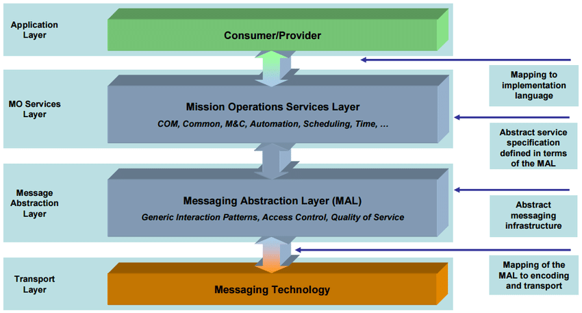

Dictionary translation location:
- Application Layer: Identifiers would always be numeric values and the Application layer would have to resolve the numeric value to a string. The translation would then no longer be a MAL problem however it would still need to be solved in the upper layers. This would however not allow string-based encodings (e.g. XML) to encode the Identifier as a String.
- MAL
- Transport Layer

Dictionary mechanisms of exchange:
- Out-of-band Agreement?
- Via a service? Example: https://nanosat-mo-framework.github.io/interfaces/index.html?u=COM/ArchiveSync/getDictionary
- Intertwined with the encoded messages? (explained below)

Dynamic Dictionary directly at the Encoding/Decoding Layer:
First time you encode the Identifier, you add the index plus the actual String value. The next times the encoding is performed, the string part would no longer need to be encoded and just the index would be included. Problems: The Encoder/Decoder would no longer be stateless and would need to store the dictionary locally. Other problem might be that in case of connection loss, there might be missing translations.

