|  |
| --- |
| Mission planning Service operations |

Approval

|  |  |
| --- | --- |
| Title Mission Planning Service Operations - discussion | |
| Issue Number 1 | Revision Number 0 |
| Author Zlobin, Veniamin | Date 01/10/2018 |
| Approved By | Date of Approval |
|  |  |

Change Log

|  |  |  |  |
| --- | --- | --- | --- |
| Reason for change | Issue Nr. | Revision Number | Date |
| Initial Version | 1 | 0 | 01/10/2018 |

Change Record

|  |  |  |  |
| --- | --- | --- | --- |
| Issue Number  1 | Revision Number  0 | | |
| Reason for change | Date | Pages | Paragraph(s) |
| Initial Issue | 01/10/2018 | All | All |

Distribution

|  |
| --- |
| Name/Organisational Unit |
|  |

Table of contents:

1 Introduction 4

1.1 References 4

1.2 Terms 4

2 services overview 5

2.2 Green Book services overview 6

2.2.1 Planning Request, PRS 7

2.2.2 Plan Distribution and Retrieval, PLS 8

2.2.3 Planning Process Management, PMS 9

2.2.5 Plan Execution Management, PES 10

2.4 Operations summary 11

2.4.2 Content management 12

2.4.3 Process management 12

3 Service Operations 13

3.1 Data: Planning Request 13

3.2 Data: Planning Activity 14

3.3 Data: Planning Event 15

3.4 Data: Planning Resource 16

3.5 Data: Plan 17

3.6 Process: Plan Distribution 18

3.7 Process: Planning Process Management 19

3.8 Process: Plan Execution Management 20

4 MO Service Packaging 21

5 APPENDIX: M&C services overview 22

5.1 Action service 22

5.2 Parameter service 22

5.4 Alert Service 23

Table of tables:

Table 1: References 4

Table 2 - Planning Request service [MP-GB] 7

Table 3 - Plan Distribution and Retrieval service [MP-GB] 8

Table 4 - Planning Process Management service [MP-GB] 9

Table 5 - Plan Execution Management service [MP-GB] 10

Table 6 - Planning objects summary 12

Table 7 - Operations on Planning Request objects 13

Table 8 - Operations on Planning Activity objects 14

Table 9 - Operations on Planning Event objects 15

Table 10 - Operations on Planning Resource objects 16

Table 11 - Operations on Plan objects 17

Table 12 - Operations for Plan distribution 18

Table 13 - Operations for Planning process management 19

Table 14 - Operations for Plan execution management 20

# Introduction

This TN is a base for discussion of the Mission Planning service operations in the CCSDS Fall 2018 meeting in Berlin.

## References

|  |  |  |  |
| --- | --- | --- | --- |
| ID | Document Title | Document Reference | Date |
| MP-GB | Mission Planning and Scheduling Green Book |  | 06/2017 |
| MP-SA | MPS Services Inputs for San Antonio.docx |  | 2016 |
| MC-BB | Mission Operations Monitor & Control Services | CCSDS 522.1-B-1 | 10/2017 |
| MAL | Mission Operations Message Abstraction Layer | CCSDS 521.0-B-2 | 03/2013 |
| COM | Mission Operations Common Object Model | CCSDS 521.1-B-1 | 02/2014 |

Table 1: References

## Terms

MAL Message Abstraction Layer

MO Mission Operations

PES Plan Execution Management service (defined in GB)

PLS Distribution and Retrieval service (defined in GB)

PMS Planning Process Management service (defined in GB)

PRS Planning Request service (defined in GB)

TN Technical Note

# 

# services overview

An approach and a partial summary of defining planning MO services is the following:

1. Summarise the services outlined in [MP-GB] and [MP-SA].
2. In order to facilitate operations discussion, identify broad categories of operations: 1) plan content management, and 2) process management (plan distribution, planning, plan execution).
3. Discuss service operations for above categories.
4. Discuss packaging of MO services. It could make sense to define the MO services in such a way as to avoid overlap of functionality in services. E.g. if there is configuration management in several services then consider factoring it out.

## Green Book services overview

[MP-GB] The interactions within the scope of Mission Planning and Scheduling standardization can be grouped into four principal topics, potentially corresponding to services, as follows:

1. Planning Request, PRS
2. Plan Distribution and Retrieval, PLS
3. Planning Process Management, PMS
4. Plan Execution Management, PES

Figure 1 show the correspondence of planning use cases to services.

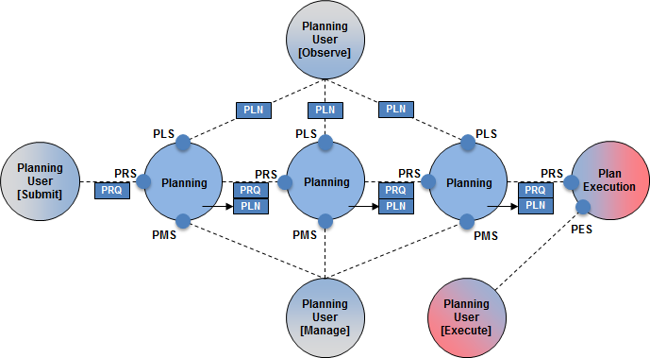

Figure 1 - Correspondence of Planning Use Cases to Services [GB]

### Planning Request, PRS

[MP-GB] Asynchronous submission of Planning Requests, associated responses and their subsequent management and status feedback;

[MP-SA] The Planning Request service supports the submission of discrete planning requests by a consumer function. This includes the associated responses and provision of asynchronous status feedback by the provider function at the level of those planning requests; and the ability to manage requests post submission.

[MP-GB] **Planning Request**: A Planning Request constitutes an input to the planning process, which requests one or more activities. Each Planning Request contains all the information that the requester can provide.

NOTE - The prefix Planning is used to disambiguate from other uses of the term Request.

NOTE - Typically the planning process depends on other inputs, which is not provided through the Planning Requests, such as orbital information, or the previous plan.

***Discussion Item***

* *Note about terminology: The Planning Request by definition requests activities, but the Planning Request Service does more, such as edit plan content and update planning events and resources.*

|  |  |  |  |
| --- | --- | --- | --- |
| **Service *Provider*** | **Capabilities** | **Data** | **Description** |
| **Planning Request, PRS**  ***Planning*** | * Submit Request * Update or cancel Requests * Edit Plan content * Update Planning Events and Resources. * Provide Request Status feedback * Manage Request Definitions | * Planning Request * Plan * Planning Activity * Planning Event * Planning Resource * Planning Constraint | Asynchronous submission of Planning Requests, associated responses and their subsequent management and status feedback.  Update (editing) of the executing Plan at activity level.  Update of Planning Events and resources.  A Planning Request may reference a Plan (output from an earlier planning process), in which case the provided feedback includes the status of the Plan in terms of its contained activities and other items. |

Table 2 - Planning Request service [MP-GB]

### Plan Distribution and Retrieval, PLS

[MP-GB] For distribution and access to the Plans *generated* by the planning function;

***Discussion Item***

* *Note about terminology: What is the meaning of Plan generation: Is it a) building a plan by adding data, or b) planning product generation, such as extracting from a Plan a ground schedule and an on-board schedule?*

[MP-SA] The Plan Distribution and Retrieval Service provides distribution and access to Plans generated by a Mission Planning function and the associated feedback, or Plan Status.

|  |  |  |  |
| --- | --- | --- | --- |
| **Service *Provider*** | **Capabilities** | **Data** | **Description** |
| **Plan Distribution & Retrieval, PLS**  ***Planning*** | * Retrieve Plan or Plan Status * Subscribe to Plan or Plan Status | * Plan * Planning Activity * Planning Event * Planning Resource * Planning Constraint | Provides distribution and access to Plans generated by the planning function. |

Table 3 - Plan Distribution and Retrieval service [MP-GB]

### Planning Process Management, PMS

[MP-GB] Management of the planning process itself - initiation, monitoring and control, and configuration;

[MP-SA] The Planning Process Management Service supports the monitoring, control and configuration of the planning process itself. This includes the initiation of implementation specific planning tasks, provision of status feedback on the execution of those planning tasks, and the ability to control ongoing planning tasks. The service also supports the management of Planning object definitions (Planning Requests, Activities, Events, Resources and potentially self-standing Constraints).

***Discussion Item***

* *It is noted that this is essentially a Monitoring and Control service for the Planning function. It may therefore be appropriate to implement the Planning Control Service as an instance of the MO Monitoring & Control service.*

|  |  |  |  |
| --- | --- | --- | --- |
| **Service *Provider*** | **Capabilities** | **Data** | **Description** |
| **Planning Process Management, PMS**  ***Planning*** | * Initiate, Monitor and Control Planning Processes * Update Plan Status * Manage Planning Definitions | * Plan * Planning Activity * Planning Event * Planning Resource * Planning Constraint | Management of the planning process itself - initiation, status feedback and control.  Also supports provision of Plan status updates by a third party. |

Table 4 - Planning Process Management service [MP-GB]

### Plan Execution Management, PES

[MP-GB] Management of the execution of Plans by a Plan Execution function - initiation, monitoring and control, editing of the currently executing Plan, update of Planning Events and resources, and configuration (*configuration == Definitions*).

[MP-SA] The Plan Execution Control service supports the execution of plans by a Plan Execution function, including plan execution status feedback and update [editing] of the executing Plan. The service also supports the management of Planning object definitions used by the Plan Execution function (Planning Activities, Events and Resources).

***Discussion Item***

* *Is the input to Plan Execution a Plan or a planning product, such as ground or on-board schedule? (*Figure 1*) Is it a planning product represented as a Plan?*

|  |  |  |  |
| --- | --- | --- | --- |
| **Service *Provider*** | **Capabilities** | **Data** | **Description** |
| **Plan Execution Management, PES**  ***Plan Execution*** | * Initiate, Monitor and Control execution of a Plan * Manage Planning Definitions | * Plan * Planning Activity * Planning Event * Planning Resource * Planning Constraint | Control and management of the execution of a plan, including actions to Start/Stop and Pause/Resume execution. |

Table 5 - Plan Execution Management service [MP-GB]

## Operations summary

For discussion purposes the four proposed services have two broad categories of operations:

1. Content management with status
   1. Planning data submission / update / retrieval. These are the CRUD operations (create/read/update/delete) of adding planning requests and other planning data (Figure 2).
   2. Definition management (the CRUD operations). Configure the data objects, e.g. *Request Template* in the model (Table 6).
   3. Status of planning requests and other planning objects. E.g. receive status updates on plan execution, when the plan status changes.
2. Process management
   1. Plan distribution management. Corresponds to PLS, excluding content management.
   2. Planning process management. Corresponds to PMS, excluding content management.
   3. Plan execution management. Corresponds to PES, excluding content management.

### Content management

Figure 2 summarizes the data objects. Some are configurable, which means there is a corresponding definition/template object (Table 6).



Figure 2 – Mission Planning High-Level Data View [MP-GB]

|  |  |  |  |
| --- | --- | --- | --- |
| Type | Top-level | Configurable |  |
| Planning Request | ✓ | ✓ |  |
| Plan | ✓ |  |  |
| Planning Activity |  | ✓ |  |
| Planning Event |  | ✓ |  |
| Planning Resource |  | ✓ |  |
| Planning Constraint |  |  |  |

Table 6 - Planning objects summary

### Process management

Discussed in sections 3.6, 3.7, 3.8

# Service Operations

The operations are grouped by plan / planning request data objects and by function, i.e. discuss the services grouped by main data object.

## Data: Planning Request

Management of plan content through planning requests.

Capabilities:

1. Submit / cancel /update planning requests.
2. Get planning request status.
3. Subscribe to monitor planning requests.
4. Manage planning request definitions.

|  |  |  |  |  |
| --- | --- | --- | --- | --- |
| Interaction Pattern | Operation Identifier | Operation Number | Support in Replay | Capability Set |
| REQUEST | submitRequest | 1 | No | 1 |
| REQUEST | updateRequest | 2 | No | 2 |
| SUBMIT | cancelRequest | 3 | No |
| REQUEST | getRequestStatus | 4 | No | 3 |
| PUBLISH-SUBSCRIBE | monitorRequests | 5 | No | 4 |
| REQUEST | listRequestDefinition | 6 | No | 5 |
| REQUEST | addRequestDefinition | 7 | No | 6 |
| REQUEST | updateRequestDefinition | 8 | No |
| SUBMIT | removeRequestDefinition | 9 | No |

Table 7 - Operations on Planning Request objects

**submitRequest**: a similar operation in M&C Action service uses Activity Tracking service, which reports progress on request delivery and execution.

**getRequestStatus**: returns a *RequestUpdate* object.

**monitorRequests**: subscribe to monitoring all planning requests (the *Request Update* objects). The PUB-SUB interaction pattern does not allow a filter object.

***Discussion Item***

* *Capability to update/remove Activities using Planning Requests? This can be done on the Activity level, but then the RequestUpdate is not used, which is a “request log”.*
* *The use of Activity Tracking service in submitRequest (similar to submitAction in M&C Action Service).*

## Data: Planning Activity

Management of planning activities, e.g. *editing of the currently executing Plan*.

Capabilities:

* Insert / update /delete planning activities.
* Get planning activity status.
* Subscribe to monitor planning activities.
* Manage planning activity definitions.

|  |  |  |  |  |
| --- | --- | --- | --- | --- |
| Interaction Pattern | Operation Identifier | Operation Number | Support in Replay | Capability Set |
| REQUEST | insertActivity | 1 | No | 1 |
| REQUEST | updateActivity | 2 | No | 2 |
| SUBMIT | deleteActivity | 3 | No |
| REQUEST | getActivityStatus | 4 | No | 3 |
| PUBLISH-SUBSCRIBE | monitorActivities | 5 | No | 4 |
| REQUEST | listActivityDefinition | 6 | No | 5 |
| REQUEST | addActivityDefinition | 7 | No | 6 |
| REQUEST | updateActivityDefinition | 8 | No |
| SUBMIT | removeActivityDefinition | 9 | No |

Table 8 - Operations on Planning Activity objects

***Discussion Item***

* *Is planning activity status required?*

## Data: Planning Event

Management of planning events.

Capabilities:

1. Submit / cancel /update planning events.
2. Get planning event status.
3. Subscribe to monitor planning events.
4. Manage planning event definitions.

|  |  |  |  |  |
| --- | --- | --- | --- | --- |
| Interaction Pattern | Operation Identifier | Operation Number | Support in Replay | Capability Set |
| REQUEST | submitEvent | 1 | No | 1 |
| REQUEST | updateEvent | 2 | No | 2 |
| SUBMIT | deleteEvent | 3 | No |
| REQUEST | getEventStatus | 4 | No | 3 |
| PUBLISH-SUBSCRIBE | monitorEvents | 5 | No | 4 |
| REQUEST | listEventDefinition | 6 | No | 5 |
| REQUEST | addEventDefinition | 7 | No | 6 |
| REQUEST | updateEventDefinition | 8 | No |
| SUBMIT | removeEventDefinition | 9 | No |

Table 9 - Operations on Planning Event objects

## Data: Planning Resource

Management of planning resources.

Capabilities:

1. Get / set planning resource values.
2. Get planning resource status.
3. Subscribe to monitor planning resources.
4. Manage planning resource definitions.

|  |  |  |  |  |
| --- | --- | --- | --- | --- |
| Interaction Pattern | Operation Identifier | Operation Number | Support in Replay | Capability Set |
| REQUEST | setValue | 1 | No | 1 |
| REQUEST | getValue | 2 | No | 2 |
| REQUEST | listResourceDefinition | 3 | No | 5 |
| REQUEST | addResourceDefinition | 4 | No | 6 |
| REQUEST | updateResourceDefinition | 5 | No |
| SUBMIT | removeResourceDefinition | 6 | No |

Table 10 - Operations on Planning Resource objects

## Data: Plan

Management of plan content at the granularity of a Plan, which is the same as loading/getting a plan.

Capabilities:

1. Submit / remove / update plan.
2. Get plan status.
3. Subscribe to monitor plan statuses.

|  |  |  |  |  |
| --- | --- | --- | --- | --- |
| Interaction Pattern | Operation Identifier | Operation Number | Support in Replay | Capability Set |
| REQUEST | submitPlan | 1 | No | 1 |
| SUBMIT | removePlan | 2 | No | 2 |
| REQUEST | udpatePlan | 3 | No |
| REQUEST | getPlan | 4 | No | 3 |
| REQUEST | getPlanStatus | 5 | No | 4 |
| PUBLISH-SUBSCRIBE | monitorPlanStatuses | 6 | No | 5 |

Table 11 - Operations on Plan objects

***Discussion Item***

* *submitPlan is used in the context of Planning Process Management and Plan Execution Management, where the operations are loadPlan and mergePlan.*
* *Submitting a plan does not use the planning request structures?*
* *updatePlan: replaces existing plan.*

## Process: Plan Distribution

Operations for getting a plan.

Capabilities:

* List available plans.
* Get plan and plan status.
* Subscribe to plan and plan status updates.

|  |  |  |  |  |
| --- | --- | --- | --- | --- |
| Interaction Pattern | Operation Identifier | Operation Number | Support in Replay | Capability Set |
| REQUEST | listPlans | 1 | No | 1 |
| REQUEST | getPlan | 2 | No | 2 |
| REQUEST | getPlanStatus | 4 | No | 3 |
| PUBLISH-SUBSCRIBE | monitorPlanStatuses | 5 | No | 4 |

Table 12 - Operations for Plan distribution

**listPlans**: [MP-SA] Returns a list of available Plans (subject to filter: All, by Domain, by Status, by Predecessor).

***Discussion Item***

* *Add operation subscribeToPlan? As a shortcut for monitorPlanStatuses + getPlan.*
* *Should there be a planning product management, e.g. ground vs on-board schedule generated from a Plan? And status constants for the planning product (Same as RequestStatus)?*
* *Some operations overlap with Table 11 - Operations on Plan objects.*

## Process: Planning Process Management

Operations for planning process management.

Capabilities:

1. Get plan status.
2. Subscribe to plan status updates.

|  |  |  |  |  |
| --- | --- | --- | --- | --- |
| Interaction Pattern | Operation Identifier | Operation Number | Support in Replay | Capability Set |
| REQUEST | getPlanStatus | 1 | No | 1 |
| PUBLISH-SUBSCRIBE | monitorPlanStatuses | 2 | No | 2 |

Table 13 - Operations for Planning process management

***Discussion Item***

* *Use the M&C Action and Parameter service (APPENDIX: M&C services overview) due to the planner specifics.*
* *The operations in Table 13 overlap with Table 11 - Operations on Plan objects.*

## Process: Plan Execution Management

Operations for plan execution management.

Capabilities:

1. Load or merge plan.
2. Get plan status.
3. Subscribe to plan status updates.

|  |  |  |  |  |
| --- | --- | --- | --- | --- |
| Interaction Pattern | Operation Identifier | Operation Number | Support in Replay | Capability Set |
| REQUEST | LoadOrMergePlan | 1 | No | 1 |
| REQUEST | getPlanStatus | 2 | No | 2 |
| PUBLISH-SUBSCRIBE | monitorPlanStatuses | 3 | No | 3 |

Table 14 - Operations for Plan execution management

[MP-SA] **LoadOrMergePlan**

Requests that the Plan Execution Provider loads or merges a specified Plan into the currently executing Plan (or Schedule).

The operation has two option flags: Load/Merge and Return Execution Status.

Load implies clearing and replacing the currently executing Plan (or Schedule) with the specified Plan.

Merge implies applying changes [relative to the predecessor Plan] to the currently executing Plan only [insertions, updates and deletions].

The provider acknowledges synchronously and, if the Return Execution Flag is set returns a final Plan Status once the Plan has been executed.

***Discussion Item***

* *Use the M&C Action and Parameter service (APPENDIX: M&C services overview).*
* *Start/stop/pause/resume execution operations.*
* *The operations in Table 14 overlap with Table 11 - Operations on Plan objects.*

# MO Service Packaging

An obvious choice of defining the services is proposed in the Green Book. However, to avoid overlap in definition management for example, it could make sense to define more granular MO services. For example a “Plan service” operates with Plan objects (list plans, create/add/remove/load/merge plans, plan status monitoring). The four main services are then assembled from the lower-level MO services. It is impossible to define the four services as standalone services without any duplication anyway, since the PMS and PES are likely to delegate some functionality to M&C services, the persistence layer is already factored out to COM Archive, the events are propagated using COM Event service, etc.

Assembling a specific planner using “micro services” can use only relevant planning services. This allows for more choices in assembling systems. Figure 3 shows such scenario.

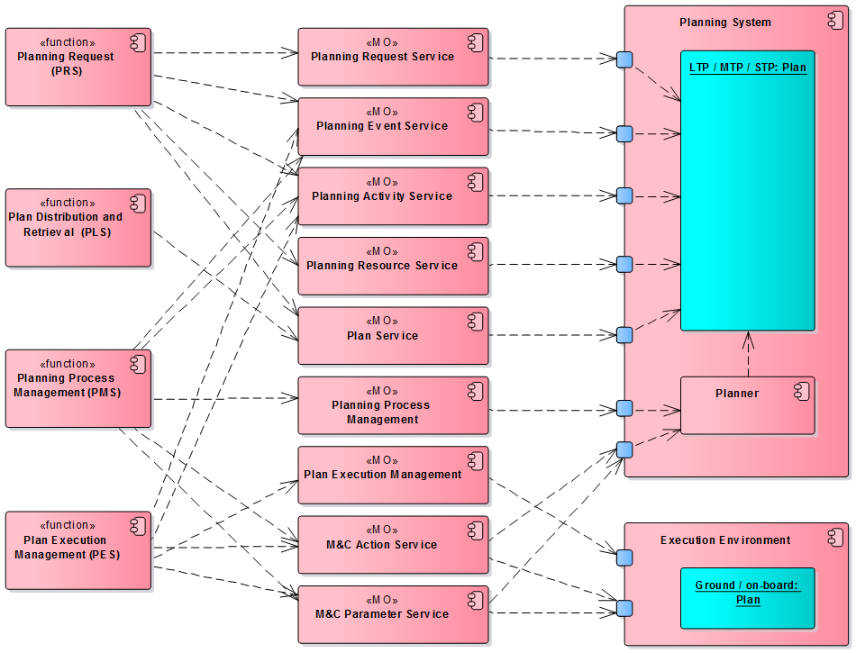

Figure - Planning functions using "micro" services

# APPENDIX: M&C services overview

The following services are taken from [MC-BB] for reference.

## Action service

The action service allows consumers to submit an action for execution and to subsequently

monitor the execution progress of these actions via the COM activity tracking pattern. The

progress of the action is split into two parts, firstly transfer from the consumer to the

provider, and secondly execution in the provider.



## Parameter service

The parameter service allows the user to subscribe to parameter value report and optionally

be able to set new values. A single PUBSUB operation is provided for monitoring and

publishing of parameter values.



## Alert Service

The alert service defines the structures and patterns for the publishing and monitoring of

alerts. The alert service uses COM event service to monitor and publish alert events.

The generation of alerts can be controlled using the enableGeneration operation, which

supports the use of groups. Groups must reference either other groups or alerts only.

Alert definitions are maintained using the operations defined in this service but storage of

definitions is delegated to the COM archive.



*Alerts are events that are defined dynamically (in a deployment), in contrast to COM events that are static (defined in service spec.).*