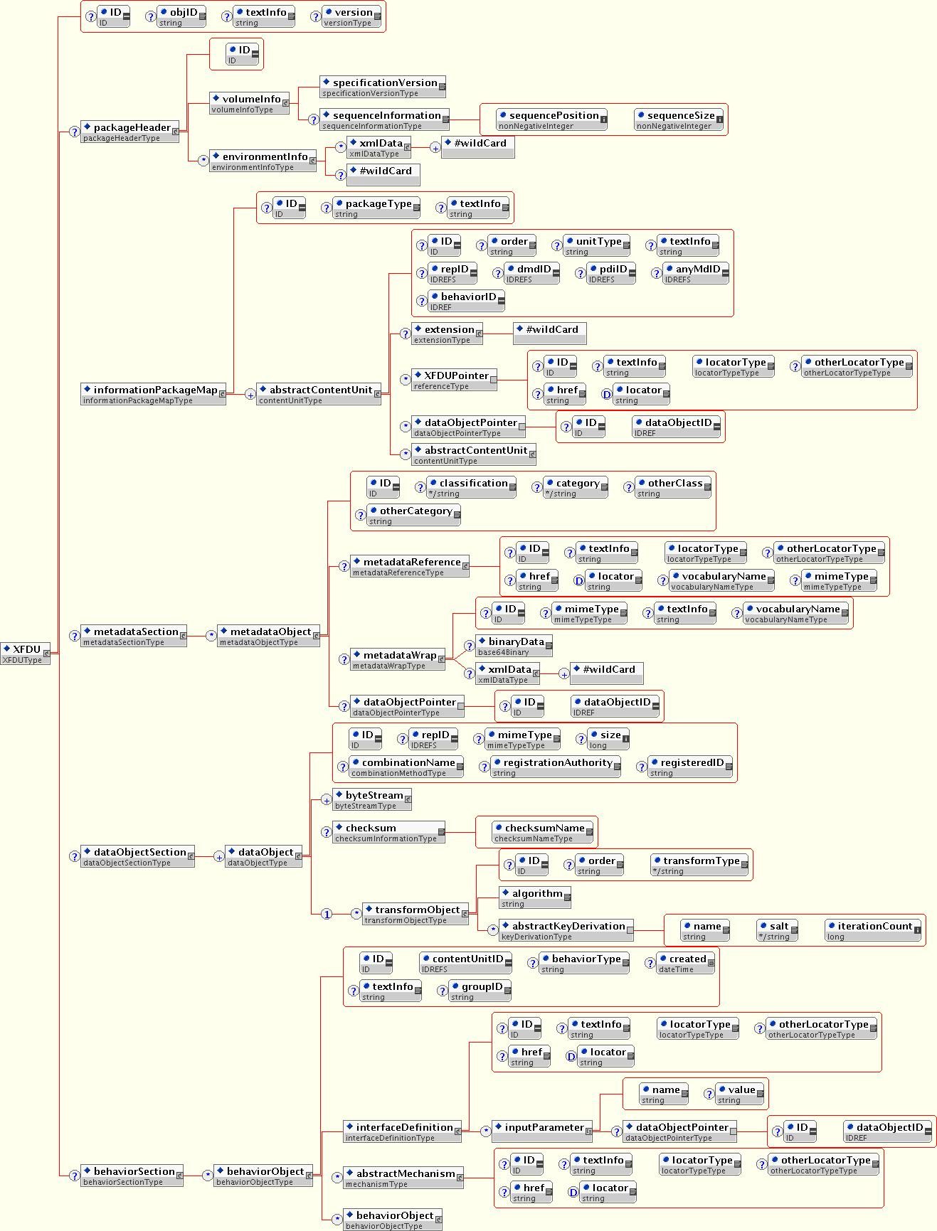
11: Full XFDU Schema Diagram

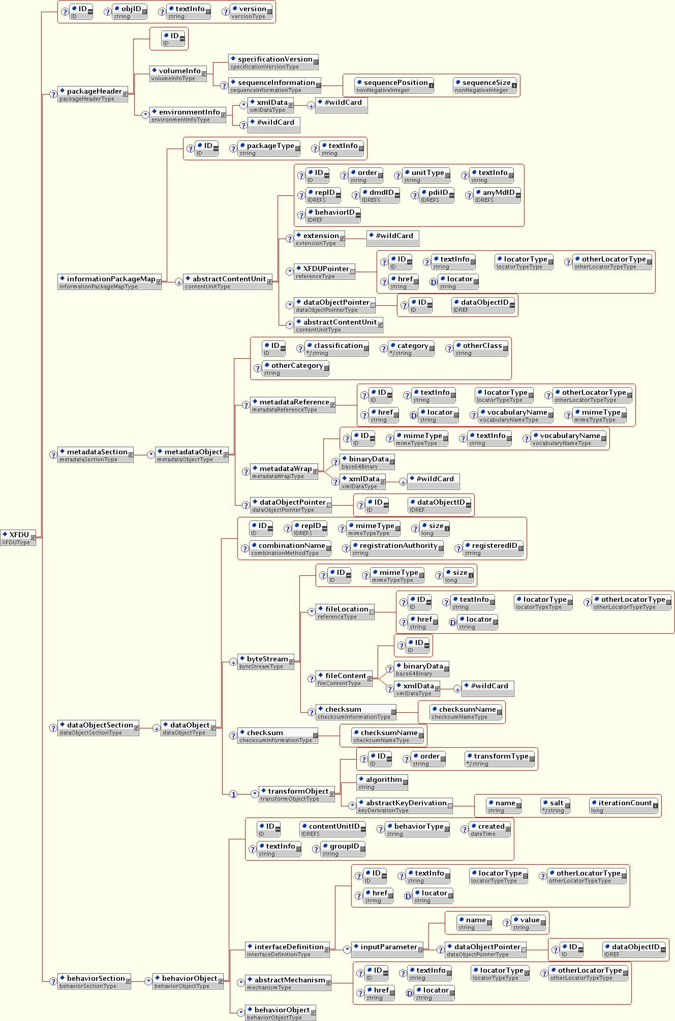
Figure 2 XFDU Schema with bytestream expanded

