
Draft Recommendation for
Space Data System Standards
Spacecraft Monitor and Control—Message Abstraction Layer
Draft Recommended Standard
CCSDS 521.0-R-2
Red Book
April 2008

AUTHORITY

 | Issue: | Red Book, Issue 2
 | Date: | April 2008
 | Location: | Not Applicable
(WHEN THIS RECOMMENDED STANDARD IS FINALIZED, IT WILL CONTAIN THE FOLLOWING STATEMENT OF AUTHORITY:)
This document has been approved for publication by the Management Council of the Consultative Committee for Space Data Systems (CCSDS) and represents the consensus technical agreement of the participating CCSDS Member Agencies. The procedure for review and authorization of CCSDS documents is detailed in the Procedures Manual for the Consultative Committee for Space Data Systems, and the record of Agency participation in the authorization of this document can be obtained from the CCSDS Secretariat at the address below.

This document is published and maintained by:

CCSDS Secretariat
Office of Space Communication (Code M-3)
National Aeronautics and Space Administration
Washington, DC 20546, USA
STATEMENT OF INTENT
(WHEN THIS RECOMMENDED STANDARD IS FINALIZED, IT WILL CONTAIN THE FOLLOWING STATEMENT OF INTENT:)
The Consultative Committee for Space Data Systems (CCSDS) is an organization officially established by the management of its members. The Committee meets periodically to address data systems problems that are common to all participants, and to formulate sound technical solutions to these problems. Inasmuch as participation in the CCSDS is completely voluntary, the results of Committee actions are termed Recommended Standards and are not considered binding on any Agency.
This Recommended Standard is issued by, and represents the consensus of, the CCSDS members. Endorsement of this Recommendation is entirely voluntary. Endorsement, however, indicates the following understandings:
o Whenever a member establishes a CCSDS-related standard, this standard will be in accord with the relevant Recommended Standard. Establishing such a standard does not preclude other provisions which a member may develop.
o Whenever a member establishes a CCSDS-related standard, that member will provide other CCSDS members with the following information:
-- The standard itself.
-- The anticipated date of initial operational capability.
-- The anticipated duration of operational service.
o Specific service arrangements shall be made via memoranda of agreement. Neither this Recommended Standard nor any ensuing standard is a substitute for a memorandum of agreement.
No later than five years from its date of issuance, this Recommended Standard will be reviewed by the CCSDS to determine whether it should: (1) remain in effect without change; (2) be changed to reflect the impact of new technologies, new requirements, or new directions; or (3) be retired or canceled.
In those instances when a new version of a Recommended Standard is issued, existing CCSDS-related member standards and implementations are not negated or deemed to be non-CCSDS compatible. It is the responsibility of each member to determine when such standards or implementations are to be modified. Each member is, however, strongly encouraged to direct planning for its new standards and implementations towards the later version of the Recommended Standard.
FOREWORD
Through the process of normal evolution, it is expected that expansion, deletion, or modification of this document may occur. This Recommended Standard is therefore subject to CCSDS document management and change control procedures, which are defined in the Procedures Manual for the Consultative Committee for Space Data Systems. Current versions of CCSDS documents are maintained at the CCSDS Web site:
http://www.ccsds.org/
Questions relating to the contents or status of this document should be addressed to the CCSDS Secretariat at the address indicated on page i.

At time of publication, the active Member and Observer Agencies of the CCSDS were:

Member Agencies

- Agenzia Spaziale Italiana (ASI)/Italy.
- British National Space Centre (BNSC)/United Kingdom.
- Canadian Space Agency (CSA)/Canada.
- Centre National d’Etudes Spatiales (CNES)/France.
- Deutsches Zentrum für Luft- und Raumfahrt e.V. (DLR)/Germany.
- European Space Agency (ESA)/Europe.
- Federal Space Agency (FSA)/Russian Federation.
- Instituto Nacional de Pesquisas Espaciais (INPE)/Brazil.
- Japan Aerospace Exploration Agency (JAXA)/Japan.
- National Aeronautics and Space Administration (NASA)/USA.

Observer Agencies

- Austrian Space Agency (ASA)/Austria.
- Belgian Federal Science Policy Office (BFSPO)/Belgium.
- Central Research Institute of Machine Building (TsNIIMash)/Russian Federation.
- Centro Tecnico Aeroespacial (CTA)/Brazil.
- Chinese Academy of Sciences (CAS)/China.
- Chinese Academy of Space Technology (CAST)/China.
- Commonwealth Scientific and Industrial Research Organization (CSIRO)/Australia.
- Danish National Space Center (DNSC)/Denmark.
- European Organization for the Exploitation of Meteorological Satellites (EUMETSAT)/Europe.
- European Telecommunications Satellite Organization (EUTELSAT)/Europe.
- Hellenic National Space Committee (HNSC)/Greece.
- Indian Space Research Organization (ISRO)/India.
- Institute of Space Research (IKI)/Russian Federation.
- KFKI Research Institute for Particle & Nuclear Physics (KFKI)/Hungary.
- Korea Aerospace Research Institute (KARI)/Korea.
- MIKOMTEK: CSIR (CSIR)/Republic of South Africa.
- Ministry of Communications (MOC)/Israel.
- National Institute of Information and Communications Technology (NICT)/Japan.
- National Oceanic and Atmospheric Administration (NOAA)/USA.
- National Space Organization (NSPO)/Taiwan.
- Naval Center for Space Technology (NCST)/USA.
- Space and Upper Atmosphere Research Commission (SUPARCO)/Pakistan.
- Swedish Space Corporation (SSC)/Sweden.
- United States Geological Survey (USGS)/USA.
PREFACE
This document is a draft CCSDS Recommended Standard. Its ‘Red Book’ status indicates that the CCSDS believes the document to be technically mature and has released it for formal review by appropriate technical organizations. As such, its technical contents are not stable, and several iterations of it may occur in response to comments received during the review process.
Implementers are cautioned not to fabricate any final equipment in accordance with this document’s technical content.

DOCUMENT CONTROL

Document | Title | Date | Status
CCSDS 521.0-R-2 | Spacecraft Monitor and Control—Message Abstraction Layer, Draft Recommended Standard, Issue 2 | April 2008 | Current proposed draft

CONTENTS
Section Page
1 Introduction 1-1
1.1 General 1-1
1.2 Purpose and Scope 1-1
1.3 Document structure 1-1
1.4 Definition of Terms 1-2
1.5 Normative references 1-2
2 SM&C Service COncept 2-1
2.1 Overview 2-1
2.2 Patterns of Interaction 2-2
2.3 Message Abstraction 2-2
2.4 Common services 2-3
2.5 SM&C Framework 2-4
2.6 Interoperability 2-6
3 Message Abstraction Layer COncept 3-1
3.1 Overview 3-1
3.2 Multiplicity OF ServiceS 3-1
3.3 Security and Access Control 3-4
3.4 Quality of Service 3-9
4 Interaction Patterns 4-1
4.1 Overview 4-1
4.2 Pattern template 4-1
4.3 Interaction Pattern DEFINITIONS 4-6
4.4 SEND Interaction Pattern 4-6
4.5 SUBMIT Interaction Pattern 4-9
4.6 REQUEST Interaction Pattern 4-13
4.7 INVOKE Interaction Pattern 4-17
4.8 PROGRESS Interaction Pattern 4-23
4.9 Publish-Subscribe Interaction Pattern 4-30
4.10 Error handling Pattern 4-45
5 Service specification conventions 5-1
5.1 Service Overview 5-1
5.2 Message structures 5-2
5.3 Message extension 5-3
5.4 Containing abstract elements 5-4
5.5 Representing Enumerations 5-5
5.6 Representing Lists 5-6
5.7 Representing NULL 5-6
5.8 Errors 5-7
6 Message abstraction layer Structures 6-1
6.1 Message structures 6-1
6.2 Basic Composites 6-9
6.3 Basic Lists 6-11
7 Message Abstraction Layer Data Types 7-1
7.1 Overview 7-1
7.2 Base types 7-1
7.3 Attributes 7-2

ANNEX A Definition of Acronyms (Informative) 7-1
Figure
2-1 Generic Service Model 2-1
2-2 Service Stack View 2-4
2-3 Service Layering 2-5
2-4 Example Entity Interoperability 2-7
2-5 Protocol Bridge Example 2-7
3-1 Authentication and Authorisation Sequence Example 3-7
3-2 Security Bridging 3-9
4-1 Message Exchange Sequence Example 4-2
4-2 Message Decomposition Key 4-4
4-3 Message Header Decomposition Example 4-4
4-4 Message Body Decomposition Example 4-4
4-5 SEND Interaction Pattern Message Sequence 4-6
4-6 SUBMIT Interaction Pattern Message Sequence 4-9
4-7 SEND Interaction Pattern Error Sequence 4-11
4-8 REQUEST Interaction Pattern Message Sequence 4-13
4-9 REQUEST Interaction Pattern Error Sequence 4-15
4-10 INVOKE Interaction Pattern Message Sequence 4-17
4-11 INVOKE Interaction Pattern Error Sequence 4-20
4-12 PROGRESS Interaction Pattern Message Sequence 4-23
4-13 PROGRESS Interaction Pattern Error Sequence 4-27
4-14 PUBLISH-SUBSCRIBE Interaction Pattern Message Sequence 4-30
4-15 PUBLISH-SUBSCRIBE Pattern Alternative Message Sequence 4-31
4-16 PUBLISH-SUBSCRIBE Interaction Pattern Error Sequence 4-40
4-17 PUBLISH-SUBSCRIBE Interaction Pattern Error Sequence 4-41
4-18 PUBLISH-SUBSCRIBE Interaction Pattern Error Sequence 4-41
4-19 PUBLISH-SUBSCRIBE Interaction Pattern Error Sequence 4-42

Table
5-1 Standard MAL Error Codes 3-13
4-1 Message Header Fields 4-3
5-1 Standard MAL Error Codes 5-7

Introduction

General
This Recommended Standard defines the Spacecraft Monitor and Control (SM&C) Message Abstraction Layer (MAL) in conformance with the service framework specified in reference [1], Mission Operations Services Concept.
The SM&C MAL is a framework that provides generic service patterns to the Mission Operation services defined in reference [1]. These Mission Operations services are defined in terms of the MAL.

Purpose and Scope
This Recommended Standard defines, in an abstract manner, the SM&C MAL in terms of:
- the concepts that it builds upon;
- the basic types it provides;
- the message headers required by the layer;
- the relationship between, and the valid sequence of, the messages and resulting behaviours.
It does not specify:
- individual implementations or products;
- the implementation of entities or interfaces within real systems;
- the methods or technologies required for communications.

Document structure
This Recommended Standard is organised as follows:
- section 1 provides purpose and scope, and lists definitions, conventions, and references used throughout the Recommended Standard;
- section 2 presents an overview of the SM&C service concepts;
- section 3 presents an overview of the Message Abstraction Layer concepts;
- section 4 specifies the interaction patterns used to define services;
- section 5 defines the tables and representations used in sections 6 & 7;
- section 6 is a formal specification of the MAL message structures;
- section 7 is a formal specification of the MAL data types.

Definition of Terms
Service: A service is an operation, or set of operations, that is well defined, self-contained, and does not depend on the state or context of another service. A service may be implemented in terms of, or use another service but this should not be apparent to a service consumer.
Service provider: A service provider is an entity that implements a service, equivalent to the target in a controller and target pattern. A service provider may also be a service consumer of lower level services. However, this would and should be transparent to the consumers of the service; i.e., this is an implementation detail.
Service consumer: A service consumer is an entity that uses a service being supplied by a service provider. A service consumer may also be a service provider to higher level service consumers. However, this would and should be transparent to the lower level service being invoked; i.e., this is an implementation detail.
Service directory: A service directory is an entity that provides publish and lookup facilities to service providers and consumers. Strictly speaking a directory is not required if a well known service is to be used; however, in most circumstances a directory provides required flexibility in the location of services. Service location can be statically configured, dynamically discovered through a service directory, or a combination of the two; this is an implementation choice. The service directory is itself, by definition, a service.

Normative references
The following documents contain provisions which, through reference in this text, constitute provisions of this Recommended Standard. At the time of publication, the editions indicated were valid. All documents are subject to revision, and users of this Recommended Standard are encouraged to investigate the possibility of applying the most recent editions of the documents indicated below. The CCSDS Secretariat maintains a register of currently valid CCSDS Recommended Standards.
- Mission Operations Services Concept. Report Concerning Space Data System Standards, CCSDS 520.0-G-2. Green Book. Issue 2. Washington, D.C.: CCSDS, August 2006.
- Spacecraft Monitor and Control—Common Services. Proposed Recommendation for Space Data System Standards, CCSDS 522.0-W-6. White Book. Issue 6. n.p: n.p., May 2007.

SM&C Service COncept

Overview
A service is an operation, or set of operations, that is well defined, self-contained, and does not depend on the state or context of another service.
The services given in reference [1] are based on a generic service pattern. This pattern covers not only the primary service interface but also includes the configuration data and history associated with the service. This is illustrated in the figure below:
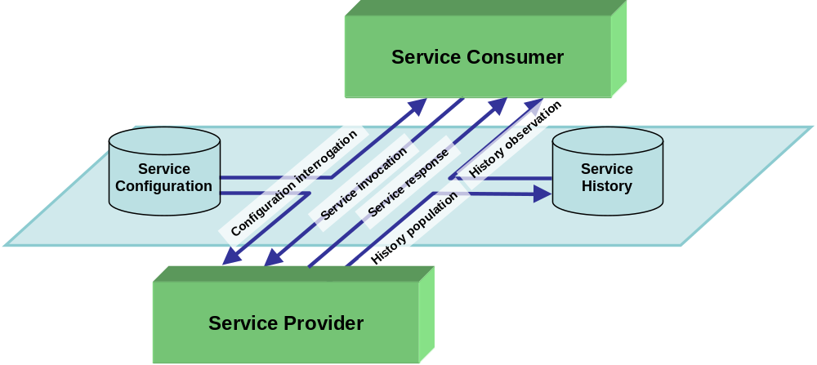
Figure 2-11: Generic Service Model
The pattern comprises four main components:
- The Service Provider is responsible for supporting the service functions.
- The Service Consumer is a user of the service functions, and is typically either a Human-Computer Interface, or another software application.
- The Service Configuration specifies the entities that exist for a specific instance of the service. This must be available to both Service Provider and Service Consumer if they are to communicate effectively; however for simple services this may be implicit for one component if the configuration is hard-coded into it.
- The Service History maintains persistent storage of service history, such that a Service Consumer can retrieve historical information for the service.
NOTE – The service specification does not define the actual implementation of any of these four collaborating components; it confines itself to definition of the high-level service layer that binds them together. This is represented in figure 2-1 by the shaded area and the arrows within it.

Patterns of Interaction
An operation of a service is composed of a set of messages exchanged between a service provider and consumer and form a pattern of interaction. Analysis of the services given in reference [1] shows that there are a limited number of these patterns of interaction that can be applied to all currently identified services.
Standardising a pattern of interaction, which defines the sequence of messages passed between consumer and provider, makes it possible to define a generic template for an operation of a service.
The Message Abstraction Layer (MAL) (this document) defines this limited set of generic interaction patterns (templates) that must be used by services defined in the SM&C service framework. Each operation of a service is defined in terms of one of the MAL interaction patterns.
By defining a pattern and stating that a given operation is an instance of that pattern, the service specification can focus on the specifics of that operation and rely on the standard pattern to define the messaging rules.
For example, if an operation named ‘sendCommand’ were defined and it were to be stated that it is an instance of a pattern called ‘SUBMIT’ then this operation can be separated into two parts, the pattern of messages that are exchanged (the ‘SUBMIT’ pattern) and the meaning of those messages and what ‘sendCommand’ does. By defining the pattern as a standard (‘SUBMIT’) the service specification that defines ‘sendCommand’ only need define the meaning of the messages and what the operation does. The MAL defines this standard set of patterns.

Message Abstraction
To provide implementation language and message transport independence all operations of a service must be defined by a language/platform/encoding agnostic specification for the sake of implementation language and message transport independence. The MAL defines this set of basic data types, and how they must be used to build up the messages that make up the operations of a service, as an abstract API. This only then has to be mapped once, in a SM&C standard, to a specific implementation language or transport encoding to apply to all services that are defined in terms of the MAL.
In addition to the patterns of interaction and the abstract API the MAL provides support for the following:
- generic concepts, such as domain, session and zone;
- generic facilities such as access control (authentication and authorisation) and Quality of Service.

Common services
Whilst the MAL provides message abstraction and generic concepts such as access control and quality of service there is a set of facilities that are common to all missions that conceptually reside above the MAL as services. These facilities are split into a Common Model and the associated Common Services that support the model.
The Common Model defines a standard service model that, if exploited by a Mission Operations (MO) service, allows the Common Services to provide support facilities and functionality to the MO service.
The Common Services are defined in terms of the MAL and are used to support the specific MO services.
The Common Services are:
- Directory
Service publish and lookup.
- Login
Operator login.
- Configuration
Service configuration management.
- Interaction
Operator interaction.
- Retrieval
Historic archive retrieval and management.
- Replay
Replay session management and control.
The layering of the MAL, message transport, Common and MO services and the service provider and consumer is shown below (Each layer builds upon the layers below):
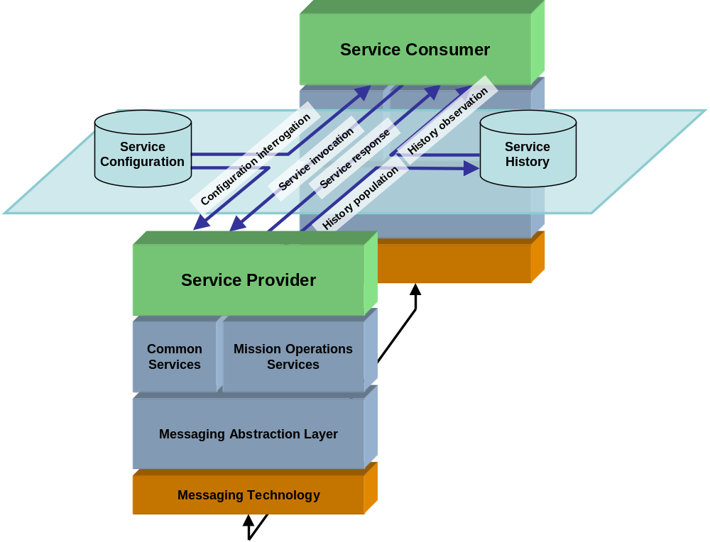
Figure 2-22: Service Stack View
NOTE – A benefit of implementing multiple services over a message abstraction layer is that it is easier to bind these to different underlying technologies and protocol encodings. All that is required is an ‘adapter’ layer between the MAL and the underlying protocol to enable all services over that technology, this can either be an implementation of the MAL that is bound to a specific technology or an implementation that supports multiple technologies. Hence the same service can be implemented over ground-based network technologies and middleware, or it could even be carried across the space link itself.
The services, in the form of standard language specific APIs, themselves provide the ‘plug-and-play’ interface for applications, allowing them to be integrated and deployed wherever is appropriate for the mission.

SM&C Framework
The service specifications and the MAL are abstract in their definition; they do not contain any specific information on how to represent them for a particular implementation language or transport encoding.
However the service specifications are supplemented by a set of standard SM&C specifications for representing the MAL in specific implementation languages and also for mapping the MAL to a specific message encoding and transport:
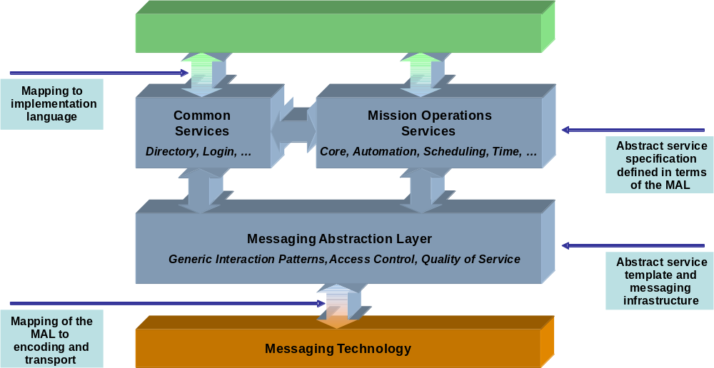
Figure 2-33: Service Layering
NOTE – Only the MAL specification needs to be mapped to a specific implementation language. The service specifications are defined in terms of the MAL and therefore the same language mapping applies to these services unmodified.
Of the Recommended Standards produced for the SM&C specification, each book falls into one of the following four categories:
- Language mapping:
One book for each mapping from the MAL to the specific implementation language.
- MAL specification:
Only one book exists defining the MAL.
- Service specifications:
Only one book exists for each service specification.
- Transport mapping:
One book for each mapping from the MAL to the specific transport and encoding.
Language-mapping Recommended Standards define a standard mapping of the MAL to a specific implementation language. This provides a standard API for application developers to develop against allowing the reuse of both applications and also MAL implementation.
Transport-mapping Recommended Standards define technology mappings to specific transports, such as CCSDS AMS (Asynchronous Messaging Service), and message encodings such as XML, ASCII and CCSDS Space Packets. This allows system engineers to choose a message transport and encoding appropriate for a specific deployment.
To provide a working implementation of a service one book of each category must be selected and used.

Interoperability
The MAL is defined in a language- and protocol-agnostic manner as it only standardises the message exchange at an information level; it leaves the language used to implement it, the encoding mechanism, and the transport used open to be selected in the system implementation phase.
This flexibility in the specification of the MAL allows two types of interoperability to be provided: firstly the choice of encoding and transport allows interoperability between entities such as cooperating agencies, and secondly the choice of language allows interoperability of an application with a specific implementation of the MAL (allow reuse of software across missions).
Using the book numbering from 2.5:
- language mapping;
- MAL specification;
- service specifications;
- transport mapping.
For two agencies to interoperate they must standardise on the transport and encoding selected (books selection BCD must match). The choice of implementation language chosen (book selection A) at each agency is hidden from the other by the MAL and therefore not required for entity interoperability:

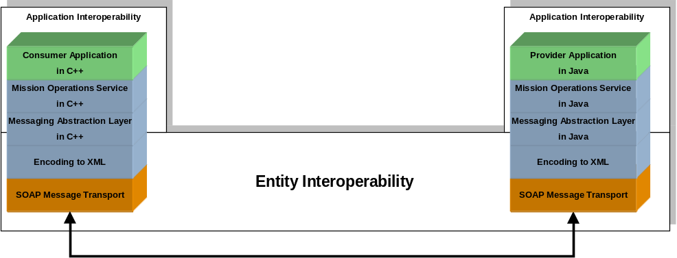
Figure 2-44: Example Entity Interoperability
The key benefits of this approach are:
- support for heterogeneous implementations;
- ability to change the transport infrastructure within a system, without major re-work to the application level software. Only have to re-do the mapping to the transport encoding.
The separation of information interoperability (MAL and higher layers) and protocol interoperability (encoding and transport) allows simple processes to be created that allowing bridging from one encoding/transport choice to another:
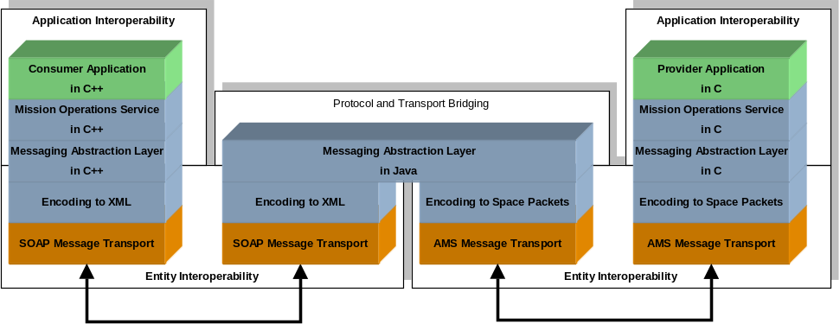
Figure 2-55: Protocol Bridge Example
Figure 2-5 shows that the two components are still fully interoperable even though they utilise different transports encodings. An implementation of the MAL may be fixed to one specific encoding and transport but the MAL specification permits this to still be interoperable with other implementations using a different transport/encoding through the use of the protocol bridge. It should be noted that a bespoke transport/encoding can be used, for example to utilise existing infrastructure, all that is required is a mapping from the MAL to that transport.

Message Abstraction Layer COncept

Overview
The MAL, as outlined in section 2.3, provides the definition and requirements for the messaging framework of the SM&C Mission Operation services. All SM&C MO services are defined in terms of the concepts, data types and the message interaction patterns it provides.
This section extends the concepts outlined in section 2 with regard to the MAL.

Multiplicity OF ServiceS

General
A service instance is a single occurrence of a service interface. A service provider may support one or more service instances; however, it is also possible that another service provider supports the same service instances (e.g., for redundancy).
A single service instance can have many service consumers – for example many operators could wish to display data from the same instance. Conversely, a single service consumer may be associated with multiple service instances, potentially from multiple service providers – for example an overall mission timeline may require data from multiple domains.
Typically service instances will be partitioned according to some form of service domain hierarchy, and a separate service configuration database will be maintained per domain.
The MAL addresses the multiplicity of service instances within its design to allow such deployments by identifying each service provider instance with its session, domain and network zone.
NOTE – In a real-world deployment of a service there may be many service instances, many service providers and many service consumers.

Session
For a given service it may be possible to observe both current (live) data and also data replayed from stored history. In a given system it may be possible to observe both live and historical data in parallel and it may also be possible to observe data originating from a simulator or test configuration in parallel to that originating from the live operational system.
The entities being controlled in the real, simulated or test cases (and monitored in both these and historical replay cases) may be the same, and in order to distinguish these parallel operational scenarios it is necessary to partition data by operational session.
While partitioning can be achieved physically, in a distributed network environment it is preferable that services are defined in such a way that session is explicit to avoid any possibility of confusion, and to enable data to be combined in a single system.
The data delivery of a session has two aspects, the epoch and the rate. Services are expected to operate at the correct rate for real operations using the current epoch; however, a simulation might be able to use a different epoch. Replay of a session may be run at a faster or slower rate than real-time, for example a replay of the real-session’s history at a slower speed than originally received.
In the context of SM&C, the term session is used to refer to a coherent data source, relating to one of the following:
- the operational system in live;
- the operational system in replay;
- a simulation of the operational system.
It is noted that multiple sessions may exist in parallel (particularly for cases 3 with 1).

Domain
A service does not always simply relate to the control of a single spacecraft. Many existing space agencies and missions require the control of multiple remote assets such as spacecraft fleets and constellations, ground stations, etc.
In order to ensure that unique referencing of entities and data items is possible, the concept of a hierarchy of system components or domains is required. This is used to scope the frame of reference of monitoring and control, for example agency>mission>spacecraft>subsystem. It provides a framework for the control of namespaces for operational data, such as telemetry monitoring parameters and actions.
The domain concept for SM&C services is defined as a list of identifiers, each of which narrows the preceding domain, reading left to right in which the leftmost is the most significant.
NOTE – This is the reverse of an Internet address (ccsds.org) which reads right to left, rightmost being most significant.
For example, Action C1234 ‘Heater C On’ for a specific Agency/Mission/Craft becomes:
AgencyY.MissionA.SatB.C1234
or even
AgencyY.MissionA.SatB.HeaterC.ON
which cannot inadvertently be sent to AgencyY.MissionX.SatY and executed.
Within a specific operation, the domain may be implicit to allow generic multi-domain operations to be defined and to ensure that the specification of operations is not unduly verbose.
The support for multi-domain facilities is not a mandatory aspect of the service specification and it should be noted that the services are designed to cover single domain infrastructures as well as multi-domain.

Network Zone
Network Zone indicates to a consumer how ‘local’ a service provider is, and is distinct from domain. Domain does not specify physical location or network connectivity. There may sometimes be a coincidental mapping through practicality, but it is not universal.
All network traffic in a distributed system can be affected by a pipe-line delay and data link capacity. In the case of offline services, service providers may be restricted by firewall access, link capacity and link latency. An everyday example is email collection over a dial-up modem to a remote and protected email server. The mail protocol will try to deliver mail regardless of the ability of the link to support the delivery.
For the purposes of service provision, a system’s architecture can be physically modelled in terms of network zones. A service provider specifies which network zone it resides in. When looking up a service in a service directory, a service consumer can specify which zone is preferred. Typically, a service consumer might prefer or be configured to use a local provider, i.e., one that resides in the same network zone as itself.
The network zone is used as part of the lookup of services and also contained in the header fields of the messages exchanged when interacting with a service provider.

Service Addressing
Each service, identified by its domain, session, and network zone is located by an address. This address, represented by a URI (Universal Resource Indicator), allows a consumer to locate and communicate with it. The URI address itself is not required to contain any reference to the domain, session, and network zone as the service provider may support several, this information is contained in the message header of all messages.
The URI syntax follows that of the Internet Standard 66, namely:

<scheme name> : <hierarchical part> [ ? <query> ] [ # <fragment> ]
Each message transport shall define the scheme name it uses so that an implementation of the MAL will be able to identify which transport to use for a specific URI. A transport may define many scheme names if there is a choice of encodings.
NOTE – A transport is not required to encode URIs as strings if a more efficient alternative is available to it (such as tokenisation or Ids), however the URI must arrive at the destination with the correct value.

Security and Access Control

General
To ensure that only authorised operational clients have access to service functions, it is critical that some form of authentication, both client and server, is an integral part of the MAL. To avoid the need for a client to support multiple authentication methods, it is highly desirable that all service capabilities use the same mechanism and that client authentication is only required once per client ‘login’ even if multiple services are used (this does not preclude the ability of an implementation to challenge a security client however the mechanism for this is outside the scope of this specification).
Where services are supported over open or public communications paths, then a level of security is required to avoid unauthorised access or intrusion. Services must be defined in such a way as to allow them to make use of secure communications channels.
It is not part of this specification to detail any applicable security methods or standards (that is a deployment decision); however, the MAL supports a generic security and authorisation concept that allows the appropriate mechanism to be used. This concept is similar to the MAL hiding the transport protocol used.
The MAL also does not impose any specific set of access restrictions regarding what operations and services may be accessed by whom but provides a framework of messages and patterns that can be restricted using an appropriate policy for a particular domain, implementation or agency. For example, a simple spacecraft that is operated by a small enterprise may only require very simple access control provided at the login level whereas a multi-craft agency with many operators will require a much finer grain of access control.

Aspects of Security
Security is typically separated into:
- Data & Data Origin Authentication
Corroboration of the source of information that is contained in a message.
- Authorisation
Conveyance, to another entity, of official sanction to do or be something.
- Confidentiality
Keeping information secret from all but those who are authorised to see it.
- Integrity
Detecting that information has not been altered by unauthorised or unknown means.
- Non-Repudiation
Preventing the denial of previous commitments or action.
In SM&C it is assumed that confidentiality is provided by the lower transport layer and is transparent to the MAL and above. The effect of this is that once a message rises above the transport mechanism all encryption will have been removed.
In the case where confidentiality is required all the way to the payload then alternative methods must be employed to support this. One possible mechanism relies on a custom encoding scheme that encodes specific messages privately and uses the normal message handing functionality to transfer the encrypted information.
Authentication and authorisation are the main areas of concern for SM&C. Non-repudiation and integrity are supported by certain authentication solutions and therefore only possible with specific message encodings.
Authorisation is not possible without authentication (one cannot authorise an operation if one does not know from whom that operation originated from) so authentication is mandatory if authorisation is required in a deployment.
Therefore there shall be three modes of access control supported:
- Nothing
An open system where anyone can perform any operation. Can only log operations performed but not by whom.
- Authentication only
A closed system where clients must log in but once in they can perform any supported operation. Can log who performed what.
- Authentication and Authorisation
A closed system where everyone must log in and with different levels of access. Can restrict who performs what.
It is a deployment decision which mode of access control a specific system uses.

Authentication and Authorisation
Authentication is a function of the specific protocol in use. For example digital signatures are used to ‘sign’ a specific message and through some feature specific to the authentication mechanism the receiver of that message can confirm that the source actually generated the message. A digital signature is derived from a specific binary representation (or encoding) of that message and because of this the digital signing can only be performed at the encoding stage. Different encodings may support different authentication technologies and also different ways of representing authentication signatures.
Authorisation requires authentication; any process that attempts to restrict access to specific functionality must be able to determine where a specific message originated before it can attempt to perform authorisation. Authorisation is performed by checking that a specific operation is being performed by an authorised consumer. The specific checks are application/deployment specific but it is expected that this will involve a lookup of some configuration based on the information passed as part of the message.
Authorisation shall be performed in the MAL. Presented to the MAL by the lower encoding layer is a generic message with an authenticated consumer identifier (which may contain time information for ensuring ‘freshness’). It is the responsibility of the MAL to confirm, using an implementation dependent mechanism, that the specific consumer is authorised to perform the operation. If the operation is permitted then the MAL passes the message to the higher layer as normal; if not, then a standard error message is returned to the consumer indicating an authorisation failure.
The Login service provided by the Common Services (reference [2]) provides the mechanisms by which an operator provides his or her security credentials to the system; from this point the MAL performs authentication and authorisation using these verified credentials.

Authentication and Authorisation Sequence
Every operation that is invoked by an application level service on the MAL must have supplied with it a consumer identifier (the operation identifier is part of the standard MAL message header). The meaning of that consumer identifier is dependent on the security system used for the deployment. This identifier must allow the MAL to perform some kind of lookup for authorisation purposes.
The MAL, after performing any required authorisation check at the sending side, passes the message and consumer identifier down to the encoding layer for encoding to the wire protocol. The encoding layer performs any actions required for the authentication process and then passes the authorised and authenticated message to the message transport layer:
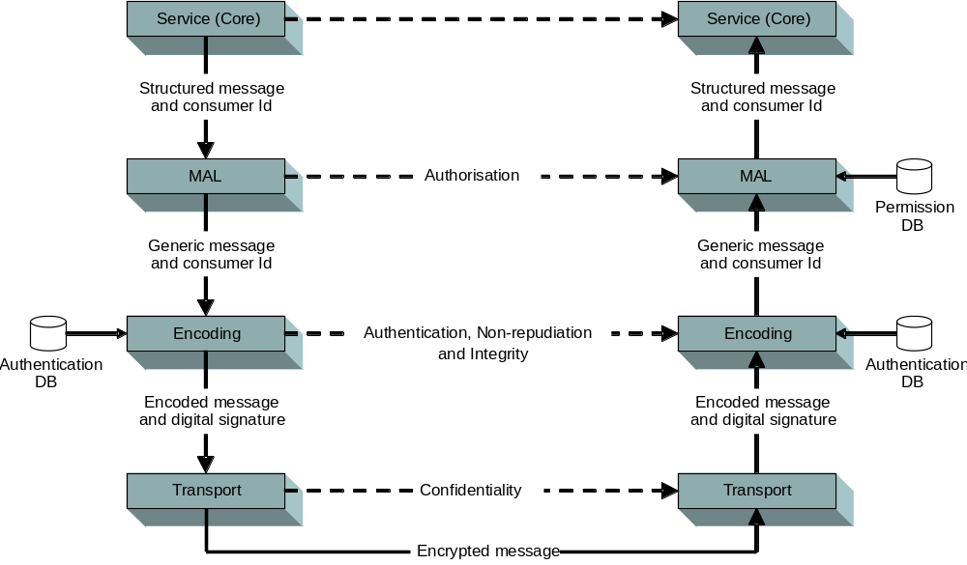
Figure 3-66: Authentication and Authorisation Sequence Example
NOTE – In the above example Authentication and Permission (Authorisation) configuration are shown as databases. This is completely implementation dependent and is shown only as an example. Also, permission filtering may also be performed in the client.
The receiving transport removes any encryption and passes the encoded message to the encoding layer. The encoding layer authenticates the message—any authentication failure should generate the appropriate MAL error message—and then decodes the message and passes it with the consumer identifier up to the provider MAL implementation.
The provider MAL implementation can then check any authorisation requirements with its permission database, either rejecting message or passing the message upwards into the service layer.
For the case where no authorisation is required then the MAL shall always accept any messages passed to it.
For the case when no authentication is required then an empty consumer identifier should be used. It is expected that an implementation of the MAL will be configured to accept this and not perform any authorisation in this case.
NOTE – The API between the MAL and the higher application layer is a standard API that by definition contains no encryption. This exposes a potential security weakness through the use of a standard API and no encryption. This can be mitigated by the use of a non-standard hardcoded API between the two although this then removes the flexibility of the standard API. This is a deployment decision.

Authentication Challenges and Security Handover
During the lifetime of a security session it may be required by the deployment security concept to periodically challenge the operator to resupply their security credentials. Whilst the mechanism for reacquiring these credentials is outside of the scope of the specification, as it is driven by the system rather than the operator, it is a concept that shall be supported in the MAL language mappings.
Also, there may be a case for the operator to change either their current role or to completely change the operator due to operations handover. An operation in the Common Login service triggers this handover and the security implementation in the MAL shall support this if required in the deployment. It may also be possible that an authentication challenge will be triggered as a result of the handover request, for example the new operator supplies their credentials and then the system challenges the existing operator to supply their credentials before the handover takes place.
It is important that during a handover there shall be no loss of messages unless the new security credentials restrict them, for example, any ongoing telemetry reception shall not be affected by the handover unless the new security credentials do not permit access to the data source.

Security Bridge
The protocol bridge concept (see 2.6) can also be extended to an authentication bridge. For example a control centre can use a Mission Control Centre (MCS) as a proxy and have fine grained security/authentication inside on the LAN and then put in place a bridge to step across to the coarse authentication used over the space link, i.e., control centre level:
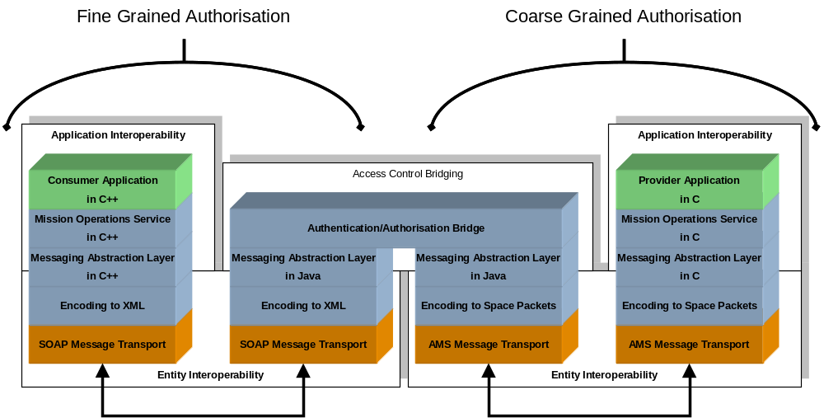
Figure 3-77: Security Bridging
By extending the capabilities of the bridge component above the MAL layer it is possible for a bridge component to filter the messages, according to an implementation-specific internal security model, between the two security areas.

Quality of Service

General
Many things can happen to messages as they travel from source to destination, resulting in the following issues:
- Dropped messages
The messaging layer might fail to deliver (drop) some messages if they arrive when the buffers are already full. Some, none, or all of the messages might be dropped, depending on the state of the network, and it is impossible to determine what will happen in advance. The receiving component must ask for this information to be retransmitted, possibly causing severe delays in the overall transmission.
- Duplication
Multiple instances of the same message can be received when the network is designed to adopt a multiple path forwarding strategy. The receiver has to detect when such a condition occurs so that just the first instance of the message is taken, while other instances are discarded.
- Delay
It might take a long time for a message to reach its destination, because it gets held up in long queues, or takes a less direct route. Alternatively, it might follow a fast, direct route. Thus delay is very unpredictable.
- Jitter
Messages from source will reach the destination with different delays. This variation in delay is known as jitter and can seriously affect the quality of streaming audio, video and also onboard systems that rely on messaging being deterministic.
- Out-of-order delivery
When a collection of related messages are routed through a network, different messages may take different routes, each resulting in a different delay. The result is that the messages arrive in a different order to the one with which they were sent.
- Error
Sometimes messages are misdirected, or combined together, or corrupted, while en route. The receiver has to detect this and, just as if the message was dropped, ask the sender to repeat itself.
- Time coupling
If a destination is not present on the network when a message arrives for it, unless the transport holds the message for it, that message will be dropped. This is called time coupling. Tight Time Coupling requires that both sender and receiver be present at the same time. Loose Time Coupling allows both to be present at non-overlapping times.
Quality of Service (QoS) abilities are specific to the messaging transports employed but also to a particular implementation of an application. Different transports may overcome some of the QoS issues listed above, but in the case that one does not, then, depending on the requirements of an application, the application software or the MAL implementation itself may have to provide functionality to overcome an issue.
There may, of course, be other driving factors on the QoS requirements of an implementation, such as the cost of developing reliable messaging transports compared to the likelihood and impact of message loss. For example, with a direct RPC style connection over a LAN most of the main QoS issues are relatively low especially for non-critical operations or functions.
This requirement for varying degrees of QoS support requires that there exist more than one level of QoS provision from the MAL specification.

Supported QoS levels
The following QoS levels are supported by SM&C:
- Best Effort
- Makes a single attempt to deliver a message to its destination but cannot ensure that it will be delivered successfully.
- Messages are provided without errors but may be duplicated.
- The order of messages is not necessarily preserved.
- Does not provide Loose Time Coupling.
- Assured
- Builds on Best Effort.
- Ensures delivery of messages to its destination.
- Messages are not duplicated.
- The order of messages is preserved between a single provider and consumer.
- Queued
- Builds on Assured.
- Provides support for Loose Time Coupling.
- Timely
- Builds on Assured.
- Provides time guarantees (delay and jitter within specified limits).
A service provider can also support a number of priority levels that apply across all QoS levels it supports. The provider must respond to a higher priority message before a lower priority message regardless of which QoS level is in use.
NOTE – The QoS levels are interaction pattern independent; each pattern can be deployed over any QoS level.

QoS negotiation
A given service provider need not offer all QoS levels and in fact will probably only offer a single level, as the specifics of a QoS level often have application implementation implications.
The set of QoS levels a service provider supports is a factor of two items, the QoS levels that the provider application supports and the QoS levels that the chosen transport supports.
Service providers inform service consumers of their QoS level support and the number of priorities through the Common Directory Service (reference [2]).
What QoS levels a service provider publishes in the Common Directory Service (reference [2]) will be driven by what it can support and what transports are available to it.
A given service provider also specifies the number of priority levels it supports, which may be only one (in which case all messages are of the same priority). These are numbered from zero (lowest) to the number of levels minus one (highest). For example, if a provider supports four priority levels these are numbered zero to three.
A service consumer selects the QoS level and priority by sending those values in the relevant fields of the message header of the initial message.
NOTE – The priority and QoS level of a connection from a consumer to a provider is fixed and cannot change during the lifetime of that link. However, this does not preclude a consumer closing the link and reopening at a different level or having multiple links open concurrently.

QoS Failure
A QoS level provides certain guarantees, depending on chosen level, about messages passed on that link. However, it is possible that at some point, possibly due to network issues, those constraints will be violated. The sender of a message will be informed of these conditions using the standard error reporting mechanisms provided for in the patterns and using standard error code given in 5.8.
It is also possible that a specific message transport will report transport-specific errors to a message sender when errors are detected by it outside of the normal message exchange of an interaction pattern. In this case the error is reported using an implementation language-specific mechanism (detailed in the relevant language mapping) asynchronously.
It is also possible that a specific transport is able to detect the loss of connection between a provider and consumer. In this case the transport shall send an appropriate standard error code to the application using asynchronous error reporting mechanism outlined above.
NOTE – When a protocol bridge is in use (see 2.6) there is an issue with what QoS can be provided to a consumer. The multiple transports in use when using bridges may affect the QoS offered by a provider, with both consumer and provider being affected by the link. Methods to mitigate this are currently outside this specification.

QoS properties
For a specific connection there are certain properties that must be defined before a connection can be made. These properties are associated with the service provider and must be communicated to the consumer is some means, possibly through configuration but most likely via the Common Directory Service (reference [2]).
The following table provides the list of standard QoS properties, however more may be defined or required by a particular implementation or message transport:
Table 3-11: Standard QoS Properties
Property identifier | Permitted values | Default value | Description
timeToLive | Non negative integer values | 0 | This is the time allowed by the consumer for delivering the messages to the provider. If the message cannot be delivered before then it must be dropped and a Delivery timed out error must be returned to the consumer if the interaction pattern allows it. Values are in milliseconds, a value of ‘0’ means no timeout.

Interaction Patterns

Overview
The SM&C service specifications detail a standard set of services. These services form a contract between a consumer of a service and the provider of that service. Each operation of a service has a set behaviour, a message is sent from the consumer to the provider to instigate the operation and zero or more messages may be exchanged after this depending on the specific pattern and operation. This set of messages, and the pattern that they are exchanged in, must be defined for each operation of each service.
An interaction pattern details a standard exchange pattern that removes the need for each operation to detail this individually. By defining a pattern and stating that a given operation is an example of that pattern, the operation definition can focus on the specifics of that operation and rely on the standard pattern to facilitate this.
By defining this limited set of patterns it allows application developers to concentrate on providing support for these patterns in the messaging system.

Pattern template

General
Each interaction pattern definition listed in represents an operation template. It defines the template of that pattern which is used by service definitions to outline an operation as an occurrence of that pattern. The following sections detail the various aspects of the templates.

Message exchange sequence
The overview section of each pattern contains the message exchange sequence. This shows the interaction sequence between a source consumer and a destination provider.
The main thing to note is the direction of the arrows (giving message direction) and the order of the messages (top down).
The bars under the consumer and provider show synchronicity of the message exchange. In the following example it can be seen that the consumer sends an initial message to the provider which responds with an acknowledgement. The acknowledgement is in response to the initial message which is shown by the connected bars under the consumer and provider.
At some time in the future the provider will send another response:
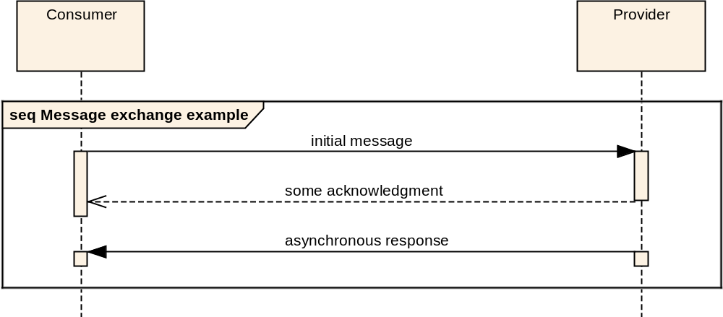
Figure 4-88: Message Exchange Sequence Example
Because the pattern shows the response the consumer must expect it but because the bars are not connected it is considered to be indeterminate, this means that although the message must arrive it cannot be determined when this shall occur. It should be noted that any synchronicity shown is only concerned with messages; it does not imply, or require, a synchronous (blocking) behaviour in either the client or provider as these are implementation issues.

Operation tables
Each interaction pattern definition contains a number of tables that define the template for operations that use that pattern and also how instances of that pattern must populate the message header fields:

Operation Name | <<Operation name>>
Interaction Pattern | <<Interaction pattern name>>
Pattern Sequence | Message | Field Type
<<Message direction>> | <<Message description>> | <<Message type>>
… | … | …
The message direction denotes the direction on the message relative to the provider of the pattern and is either IN or OUT. So, all messages directed towards the provider are IN messages and all messages directed away from the provider are OUT messages.
Blue cells (light grey when printed) contain table headings, dark grey cells contain fields that are fixed for a pattern, and white cells contain values that must be provided by the specific operation.

Standard Message Header
The interaction patterns define a set of header fields that are used to manage the interaction. The following header fields are common to all interaction patterns:
Table 4-22: Message Header Fields
Field | Value
URI From | Message Source URI
Authentication Id | Source Authentication Identifier
URI To | Message Destination URI
Timestamp | Message generation timestamp
QoSlevel | The QoS level of message
Priority | The QoS priority of message
Domain | Domain of message
Network Zone | Network zone of message
Session | Session of message
Session Name | Name of the session of the message. Shall be ‘LIVE’ if session type is LIVE.
Interaction Type | Interaction Pattern Type
Interaction Stage | Interaction Pattern Stage
Transaction Id | Unique to consumer
Service Area | Service Area Identifier
Service | Service Identifier
Operation | Service Operation Identifier
Service version | Service version number
Is Error Message | If this is a normal message or an error message
The full definition of the message header structure is provided in 6.1.7 and is provided here for reference purposes only.
Each pattern definition defines how the header is populated for each message.

Transaction handling
The message header contains a transaction identifier field. This provides a mechanism for the originator of a message exchange to uniquely identify the response, or set of responses, to a client message.
Each instance of a pattern is considered a single transaction.
The transaction ID does not hold any meaning to the messaging abstraction layer. It is returned by the service provider in matching messages (returns from submits, etc.), but it is the responsibility of the service consumer to ensure that the combination of the pattern type, transaction ID, the source address, the service and operation ID, form a unique index.

Message decomposition Examples
Each pattern is illustrated with an example which shows how each message would look like when decomposed into a packet structure. It must be noted that any representation is entirely protocol specific and that the messages represented here are for illustration purposes only. They are there to detail the information that must be passed but do not impose any restriction of format and order.
For example, the interaction pattern type field, in an efficient packet-based protocol, may be placed first in a packet header and use a single byte to aid efficient decommutation of the packet whereas an XML based protocol might use XML tags in a less space restricted network domain. As long as the message information is preserved then that is all that is required.
For the example decomposition each message is split into up to three parts, a standard message header, possibly a standard pattern body, and finally there may be a service-specific body:
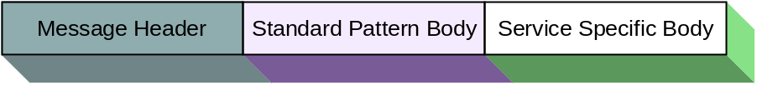
Figure 4-99: Message Decomposition Key
Each message, in the examples, is split into the relevant fields and the example value is shown in the box and the field name is given above:
Figure 4-1010: Message Header Decomposition Example
Session is just shown as LIVE and does not include bothe the type and name (as they are the same) to save space.
When more complex structures are being shown, a single field may be part of a more complex structure which is itself part of another composite structure:
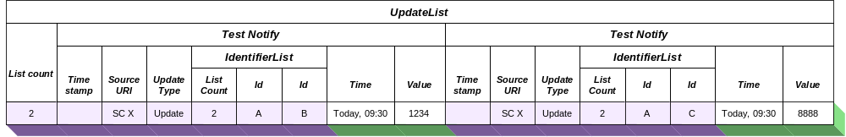
Figure 4-1111: Message Body Decomposition Example
In the example above the ‘Update Type’ field is part of a TestNotify structure which is itself part of the overall UpdateList structure.
The above example also demonstrates the difference between a pattern body and a service-specific body. The UpdateList is the pattern body but it contains a part that is specific to the service in question, the TestNotify part.
NOTE – The structures used in the body of the examples for each pattern are only examples and as such no explanation of contained values or meanings is provided or required.

Interaction Pattern DEFINITIONS

General
This section defines the interaction patterns defined in, and supported by, the MAL. Each section defines a separate interaction pattern, the message required to support it, the behaviour of that pattern, and provides a simple example.

SEND Interaction Pattern

Overview
The SEND pattern is the most basic interaction; it is a single message from the consumer to the provider. No acknowledgement is sent by the provider.
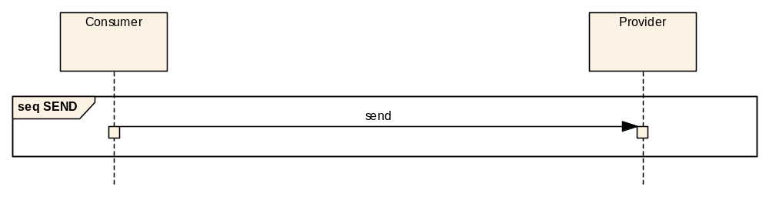
Figure 4-1616: SEND Interaction Pattern Message Sequence

Operation template
The SEND template contains an operation name and the field name of the structure that is sent as the message body:

Operation Name | <<Operation name>>
Interaction Pattern | SEND
Pattern Sequence | Message | Field Type
IN | Send | <<Body type>>

Message header
For the Send message the following message header fields are used:
Field | Value
URI From | Consumer URI
Authentication Id | Consumer Authentication Identifier
URI To | Provider URI
Timestamp | Message generation timestamp
QoS Level | QoS Level of message
Priority | QoS Priority of message
Domain | Domain of message
Network Zone | Network zone of message
Session | Session of message
Session Name | Session Name of the message
Interaction Type | SEND
Interaction Stage | Not used
Transaction Id | Provided by consumer
Service Area | Service Area Identifier
Service | Service Identifier
Operation | Service Operation Identifier
Service Version | Service Version number
Is Error Message | FALSE

Description
The SEND pattern is the basic interaction that all other patterns can be considered extensions of. It is the simple passing of a message from a consumer to a provider. Because there is no message ‘conversation’ implied with a simple SEND there is no requirement for transaction identifier in the message however one may be specified. No return message is sent from the provider to the consumer so the consumer has no indication the provider has received the message.

Usage
The SEND pattern is expected to be used for non-critical messages where the possible loss of one or more of these messages is not considered critical. For example, regular heartbeat type messages.

Error handling
Errors (see 6.1.8) may be generated by the consumer service layers but no messaging error will be generated because the interaction pattern does not allow for the provider to return an error.

Example
The following example shows a simple example service with a single send pattern based operation:
Operation Name | testSend
Interaction Pattern | SEND
Pattern Sequence | Message | Field Type
IN | Send | TestBody
The TestBody structure is defined below:
Structure Name | TestBody
Extends | Composite
Short form | Example Only
Field | Type | Comment
FirstItem | String | Example String item
SecondItem | Integer | Example Integer item
This corresponds to the following message:
NOTE – An actual service specification, rather than the example given here, would fully specify the meaning of, and required values of, all structures used by the service.

SUBMIT Interaction Pattern

Overview
The SUBMIT pattern is a simple confirmed message exchange pattern. The consumer sends a message to a provider and the provider acknowledges it.
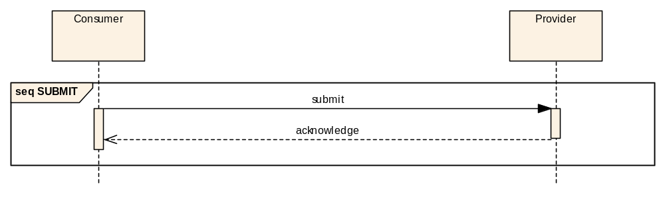
Figure 4-1717: SUBMIT Interaction Pattern Message Sequence

Operation template
The SUBMIT template is identical to the SEND template and only contains a method name and the name of the structure that is submitted as the message body:

Operation Name | <<Operation name>>
Interaction Pattern | SUBMIT
Pattern Sequence | Message | Field Type
IN | Submit | <<Body type>>
The acknowledge message is fixed to keep the operation as simple as possible, because of this it is not shown in the operation template. If a service-defined return message is required, for example to return an identifier for the operation, then the REQUEST pattern should be used.

Message header
For the Submit message the following message header fields are used:
Field | Value
URI From | Consumer URI
Authentication Id | Consumer Authentication Identifier
URI To | Provider URI
Timestamp | Message generation timestamp
QoS Level | QoS Level of message
Priority | QoS Priority of message
Domain | Domain of message
Network Zone | Network zone of message
Session | Session of message
Session Name | Session Name of the message
Interaction Type | SUBMIT
Interaction Stage | 1
Transaction Id | Provided by consumer
Service Area | Service Area Identifier
Service | Service Identifier
Operation | Service Operation Identifier
Service Version | Service Version number
Is Error Message | FALSE
For the acknowledgement message the following message header fields are used:
Field | Value
URI From | Provider URI
Authentication Id | Provider Authentication Identifier
URI To | Consumer URI
Timestamp | Message generation timestamp
QoS Level | QoS Level of message
Priority | QoS Priority of message
Domain | Domain of message
Network Zone | Network zone of message
Session | Session of message
Session Name | Session Name of the message
Interaction Type | SUBMIT
Interaction Stage | 2
Transaction Id | Transaction Id from initial message
Service Area | Service Area Identifier
Service | Service Identifier
Operation | Service Operation Identifier
Service Version | Service Version number
Is Error Message | FALSE

Description
The SUBMIT pattern extends the SEND pattern by providing a return acknowledgement message from the provider back to the consumer. The service specification shall state the meaning of the acknowledgement message for a specific operation.

Usage
Simple operations that complete quickly but must be confirmed to the consumer.

Error handling
The return acknowledgement will be replaced with an error message (see 6.1.8) if an error occurs during the processing of the operation.
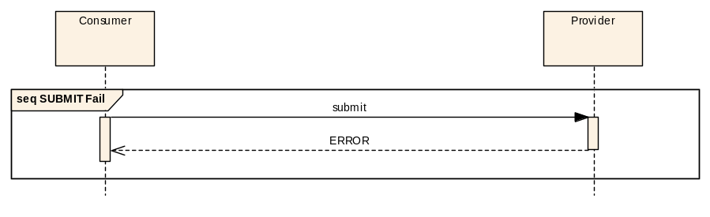
Figure 4-1818: SUBMIT Interaction Pattern Error Sequence
It should be noted that either the acknowledgement or the error message shall be returned but never both. If a service need to be able to return an error during the processing of the message the service specification must specify that the acknowledgement is not returned until all processing that can generate an error has been completed.

Example
The following example shows a simple example service with a single submit pattern based operation:
Operation Name | testSubmit
Interaction Pattern | SUBMIT
Pattern Sequence | Message | Field Type
IN | Submit | TestBody
The TestBody structure is defined in 4.7.7.
This corresponds to the following message being submitted:
and corresponds to the following acknowledgement being returned:
NOTE – An actual service specification, rather than the example given here, would fully specify the meaning of, and required values of, all structures used by the service.

REQUEST Interaction Pattern

Overview
The REQUEST pattern extends the SUBMIT pattern by replacing the simple acknowledgement with a data response message. No acknowledgement other than the data response is sent.
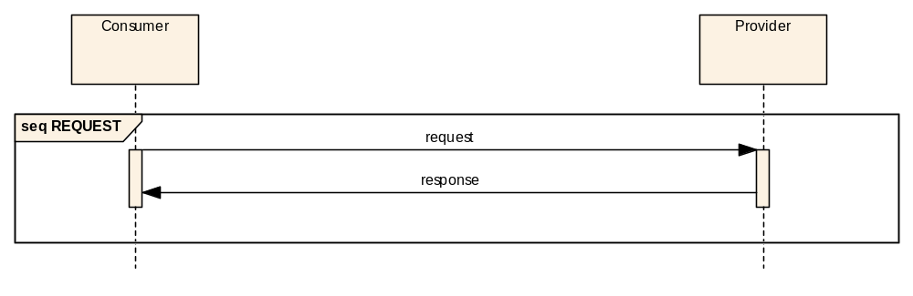
Figure 4-1919: REQUEST Interaction Pattern Message Sequence

Operation template
The REQUEST pattern template extends the SUBMIT template by adding the requirement for a return type:
Operation Name | <<Operation name>>
Interaction Pattern | REQUEST
Pattern Sequence | Message | Field Type
IN | Request | <<Request type>>
OUT | Response | <<Response type>>

Message header
For the Request message the following message header fields values shall be used:
Field | Value
URI From | Consumer URI
Authentication Id | Consumer Authentication Identifier
URI To | Provider URI
Timestamp | Message generation timestamp
QoS Level | QoS Level of message
Priority | QoS Priority of message
Domain | Domain of message
Network Zone | Network zone of message
Session | Session of message
Session Name | Session Name of the message
Interaction Type | REQUEST
Interaction Stage | 1
Transaction Id | Provided by consumer
Service Area | Service Area Identifier
Service | Service Identifier
Operation | Service Operation Identifier
Service Version | Service Version number
Is Error Message | FALSE
For the return data response message the following message header fields are used:
Field | Value
URI From | Provider URI
Authentication Id | Provider Authentication Identifier
URI To | Consumer URI
Timestamp | Message generation timestamp
QoS Level | QoS Level of message
Priority | QoS Priority of message
Domain | Domain of message
Network Zone | Network zone of message
Session | Session of message
Session Name | Session Name of the message
Interaction Type | REQUEST
Interaction Stage | 2
Transaction Id | Transaction Id from initial message
Service Area | Service Area Identifier
Service | Service Identifier
Operation | Service Operation Identifier
Service Version | Service Version number
Is Error Message | FALSE

Description
The REQUEST pattern provides a simple request/response message exchange. Unlike the SUBMIT pattern no acknowledgement is sent in reception of the request however a data response is sent. The lack of an acknowledgement and only the return data response for this pattern means that it is primarily expected to be used for situations where the operation takes minimal time.

Usage
It is expected that the REQUEST pattern is to be used only for operations that complete in a relatively short period of time. If a more extended or indeterminate period is possible then the more advanced INVOKE or PROGRESS patterns should be specified.

Error handling
The data response will be replaced with an error message (see 6.1.8) if an error occurs during the processing of the operation.
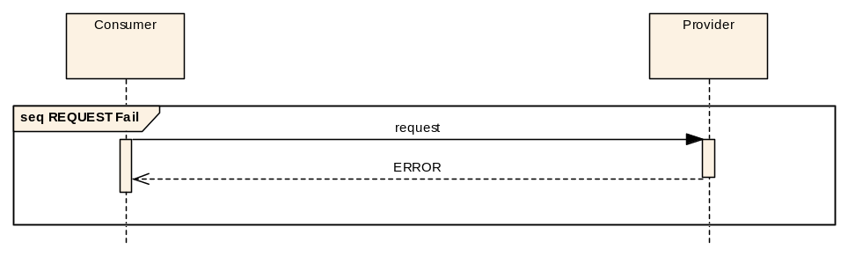
Figure 4-2020: REQUEST Interaction Pattern Error Sequence
It should be noted that either the data response or the error message shall be returned but never both.

Example
The following example shows a simple service that defines a single REQUEST operation:
Operation Name | testRequest
Interaction Pattern | REQUEST
Pattern Sequence | Message | Field Type
IN | Request | TestBody
OUT | Response | TestResponse
The TestBody structure is defined in 4.7.7 and the TestResponse structure is defined below:
Structure Name | TestResponse
Extends | Composite
Short form | Example Only
Field | Type | Comment
RspnItem | Boolean | Example Boolean item
RspnField | Float | Example Float item
This corresponds to the following message being sent:
And corresponds to the following response being returned:
NOTE – An actual service specification, rather than the example given here, would fully specify the meaning of, and required values of, all structures used by the service.

INVOKE Interaction Pattern

Overview
The INVOKE pattern extends the REQUEST pattern to add a mandatory acknowledgement of the request message. This allows the operation to confirm the receipt of the request before proceeding to process the request.
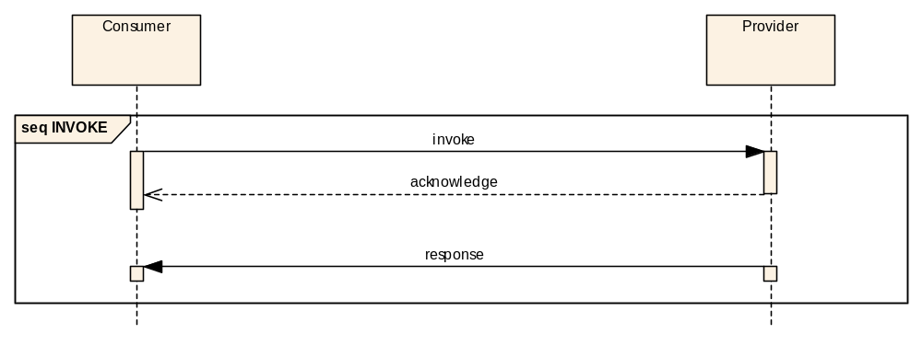
Figure 4-2121: INVOKE Interaction Pattern Message Sequence
The acknowledgement message is an extension of the acknowledgement used in the SUBMIT pattern. This pattern allows the acknowledgement to return a service-specific message body. A service-defined acknowledgement is required because the INVOKE pattern is indeterminate and this allows an operation to provide an indication of the operation status upon INVOKE reception, for example validation of the invoke arguments.

Operation template
The INVOKE template extends the REQUEST pattern template by requiring a structure for the acknowledgement message. INVOKE operations take a single message body argument, return an acknowledgement structure, and a single data response:
Operation Name | <<Operation name>>
Interaction Pattern | INVOKE
Pattern Sequence | Message | Field Type
IN | Invoke | <<Request type>>
OUT | Acknowledgement | <<Ack type>>
OUT | Response | <<Response type>>

Message header
For the INVOKE message the following message header fields are used:
Field | Value
URI From | Consumer URI
Authentication Id | Consumer Authentication Identifier
URI To | Provider URI
Timestamp | Message generation timestamp
QoS Level | QoS Level of message
Priority | QoS Priority of message
Domain | Domain of message
Network Zone | Network zone of message
Session | Session of message
Session Name | Session Name of the message
Interaction Type | INVOKE
Interaction Stage | 1
Transaction Id | Provided by consumer
Service Area | Service Area Identifier
Service | Service Identifier
Operation | Service Operation Identifier
Service Version | Service Version number
Is Error Message | FALSE
For the acknowledgement message the following message header fields are used:
Field | Value
URI From | Provider URI
Authentication Id | Provider Authentication Identifier
URI To | Consumer URI
Timestamp | Message generation timestamp
QoS Level | QoS Level of message
Priority | QoS Priority of message
Domain | Domain of message
Network Zone | Network zone of message
Session | Session of message
Session Name | Session Name of the message
Interaction Type | INVOKE
Interaction Stage | 2
Transaction Id | Transaction Id from initial message
Service Area | Service Area Identifier
Service | Service Identifier
Operation | Service Operation Identifier
Service Version | Service Version number
Is Error Message | FALSE
For the return data response message the following message header fields are used:
Field | Value
URI From | Provider URI
Authentication Id | Provider Authentication Identifier
URI To | Consumer URI
Timestamp | Message generation timestamp
QoS Level | QoS Level of message
Priority | QoS Priority of message
Domain | Domain of message
Network Zone | Network zone of message
Session | Session of message
Session Name | Session Name of the message
Interaction Type | INVOKE
Interaction Stage | 3
Transaction Id | Transaction Id from initial message
Service Area | Service Area Identifier
Service | Service Identifier
Operation | Service Operation Identifier
Service Version | Service Version number
Is Error Message | FALSE

Description
The INVOKE pattern extends the REQUEST pattern with the addition of a mandatory acknowledgement of the initial message.

Usage
This pattern is expected to be used when there is a significant or indeterminate amount of time taken to process the request and produce the data response. The provision of the service-defined acknowledgement message allows an operation to return supplementary, status, or summary information about the request before processing continues (for example an identifier used for querying INVOKE status using another operation).

Error handling
The INVOKE pattern can report failure in two distinct ways. The first is when the acknowledgement is replaced with an error message (see 6.1.8), shown in the first sequence below, and the second is when an error is generated during the processing of the body of the invoke operation but after the acknowledgement is sent:
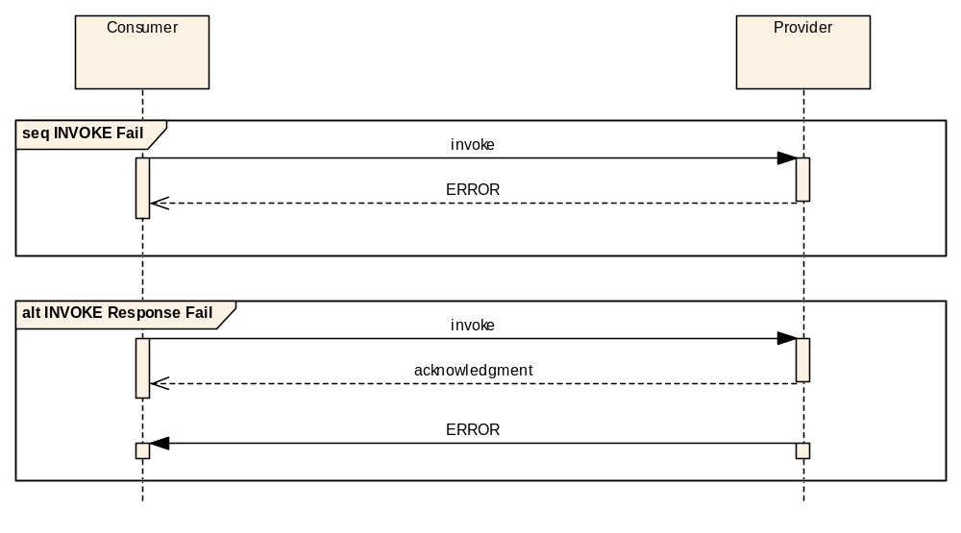
Figure 4-2222: INVOKE Interaction Pattern Error Sequence
These two patterns are the only error patterns supported. It should be noted that after an error message is sent no further messages shall be generated as part of the pattern. It is expected that the first case shall be used to report an error with the invoke request and the second when an error occurs during processing.

Example
The following example shows a simple Example service that contains a single INVOKE operation. The operation sends a TestBody structure and returns a TestAck acknowledgement structure followed by a TestResponse structure:
Operation Name | testInvoke
Interaction Pattern | INVOKE
Pattern Sequence | Message | Field Type
IN | Invoke | TestBody
OUT | Acknowledgement | TestAck
OUT | Response | TestResponse
The TestBody structure is defined in 4.7.7 and the TestResponse structure is defined in 4.9.7. The TestAck structure is defined below:
Structure Name | TestAck
Extends | Composite
Short form | Example Only
Field | Type | Comment
AckId | Identifier | Example Identifier item
This corresponds to the following message being sent:
And corresponds to the following acknowledgement being returned:
And finally corresponds to the following response being returned:
NOTE – An actual service specification, rather than the example given here, would fully specify the meaning of, and required values of, all structures used by the service.

PROGRESS Interaction Pattern

Overview
The PROGRESS pattern extends the INVOKE pattern to add a set of mandatory progress updates of the request message. This allows the operation to confirm the receipt of the request before proceeding to process the request and also show progress of the operation.
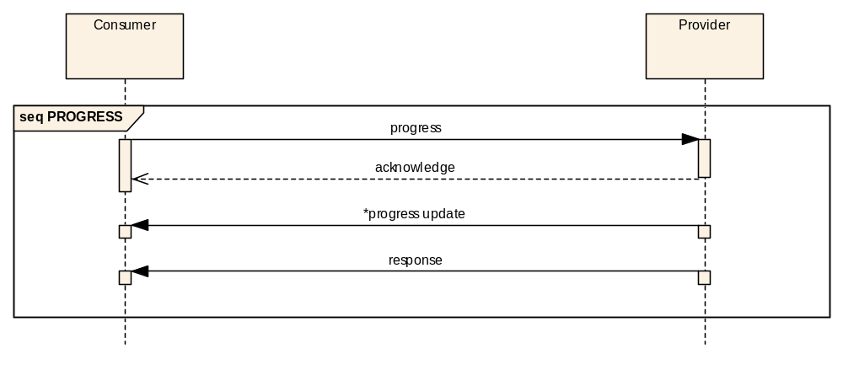
Figure 4-2323: PROGRESS Interaction Pattern Message Sequence

Operation template
The PROGRESS template is similar to the INVOKE pattern template but adds a progress update type:
Operation Name | <<Operation name>>
Interaction Pattern | PROGRESS
Pattern Sequence | Message | Field Type
IN | Progress | <<Request type>>
OUT | Acknowledgement | <<Ack type>>
OUT | Update | <<Update type>>
OUT | Response | <<Response type>>

Message header
For the PROGRESS message the following message header fields are used:
Field | Value
URI From | Consumer URI
Authentication Id | Consumer Authentication Identifier
URI To | Provider URI
Timestamp | Message generation timestamp
QoS Level | QoS Level of message
Priority | QoS Priority of message
Domain | Domain of message
Network Zone | Network zone of message
Session | Session of message
Session Name | Session Name of the message
Interaction Type | PROGRESS
Interaction Stage | 1
Transaction Id | Provided by consumer
Service Area | Service Area Identifier
Service | Service Identifier
Operation | Service Operation Identifier
Service Version | Service Version number
Is Error Message | FALSE
For the acknowledgement message the following message header fields are used:
Field | Value
URI From | Provider URI
Authentication Id | Provider Authentication Identifier
URI To | Consumer URI
Timestamp | Message generation timestamp
QoS Level | QoS Level of message
Priority | QoS Priority of message
Domain | Domain of message
Network Zone | Network zone of message
Session | Session of message
Session Name | Session Name of the message
Interaction Type | PROGRESS
Interaction Stage | 2
Transaction Id | Transaction Id from initial message
Service Area | Service Area Identifier
Service | Service Identifier
Operation | Service Operation Identifier
Service Version | Service Version number
Is Error Message | FALSE
For the progress update message, of which there may be several, the following message header fields are used:
Field | Value
URI From | Provider URI
Authentication Id | Provider Authentication Identifier
URI To | Consumer URI
Timestamp | Message generation timestamp
QoS Level | QoS Level of message
Priority | QoS Priority of message
Domain | Domain of message
Network Zone | Network zone of message
Session | Session of message
Session Name | Session Name of the message
Interaction Type | PROGRESS
Interaction Stage | 3
Transaction Id | Transaction Id from initial message
Service Area | Service Area Identifier
Service | Service Identifier
Operation | Service Operation Identifier
Service Version | Service Version number
Is Error Message | FALSE
For the final message, the response message, the following message header fields are used:
Field | Value
URI From | Provider URI
Authentication Id | Provider Authentication Identifier
URI To | Consumer URI
Timestamp | Message generation timestamp
QoS Level | QoS Level of message
Priority | QoS Priority of message
Domain | Domain of message
Network Zone | Network zone of message
Session | Session of message
Session Name | Session Name of the message
Interaction Type | PROGRESS
Interaction Stage | 4
Transaction Id | Transaction Id from initial message
Service Area | Service Area Identifier
Service | Service Identifier
Operation | Service Operation Identifier
Service Version | Service Version number
Is Error Message | FALSE

Description
The PROGRESS pattern extends the INVOKE pattern with the addition of a set of mandatory progress messages. The type of progress messages and the number is defined by the service not the pattern.

Usage
This pattern is expected to be used when there is a significant or indeterminate amount of time taken to process the request and produce the data response and where monitoring of the progress of the operation is required.

Error handling
The PROGRESS pattern can report failure in two distinct ways. The first is when the acknowledgement is replaced with an error message (see 6.1.8), shown in the first sequence below, and the second is when an error is generated during the processing of the body of the operation but after the initial acknowledgement is sent:
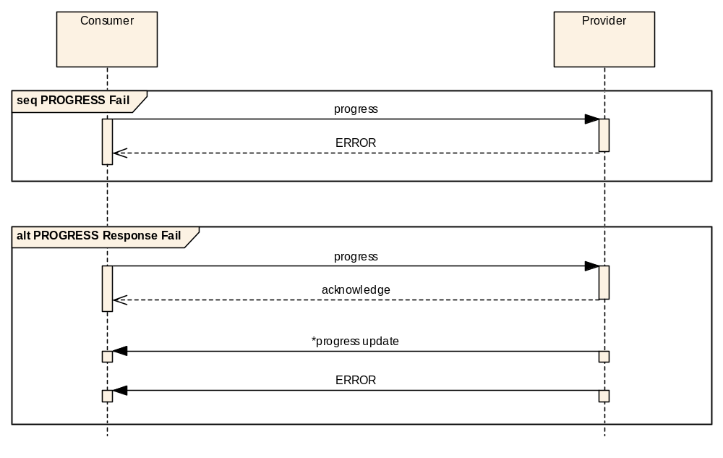
Figure 4-2424: PROGRESS Interaction Pattern Error Sequence
These two patterns are the only error patterns supported, the second error case may replace any of the progress updates or the final progress return message.
It should be noted that after an error message is sent no further messages shall be generated as part of the pattern. It is expected that the first case shall be used to report an error with the progress request and the second when an error occurs during processing.

Example
The following example shows a simple Example service that contains a single PROGRESS operation. The operation sends a TestBody structure, which is acknowledged with a TestAck structure, reports progress with a TestProgress structure, and returns a TestResponse structure:
Operation Name | testProgress
Interaction Pattern | PROGRESS
Pattern Sequence | Message | Field Type
IN | Progress | TestBody
OUT | Acknowledgement | TestAck
OUT | Update | TestProgress
OUT | Response | TestResponse
The TestBody structure is defined in 4.7.7, TestAck structure is defined in 4.10.7, and the TestResponse structure is defined in 4.9.7. The TestProgress structure is defined below:
Structure Name | TestProgress
Extends | Composite
Short form | Example Only
Field | Type | Comment
RspnStage | Integer | Example Integer item
This corresponds to the following message being sent:
And corresponds to the following acknowledgement being returned:
Progress is reported using the following message; in this example two stages are reported:
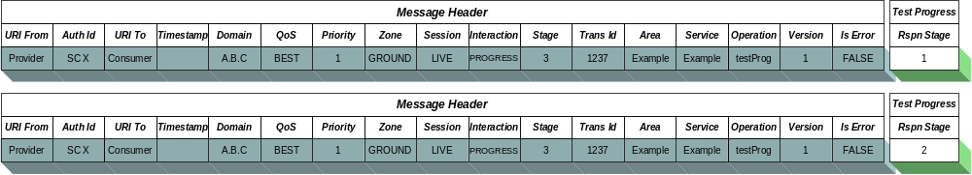
And finally corresponds to the following response being returned:
NOTE – An actual service specification, rather than the example given here, would fully specify the meaning of, and required values of, all structures used by the service.

Publish-Subscribe Interaction Pattern

Overview
The PUBLISH-SUBSCRIBE pattern provides the ability for consumers to register interest in a specific topic and receive updates from one or more providers without requiring awareness of the number of, and location of, these providers.
The basic outline of the pattern is consumers register interest by sending a subscription list; updates are then sent to that consumer; and when no further updates are required the consumer cancels its subscription by deregistering that list. The deregister message only takes the identifier of the subscription list to cancel and completely removes that subscription from the list of active subscriptions.
A specific consumer can define many subscription lists concurrently by specifying a different subscription identifier during the registration. To change the contents of a subscription list a consumer can redefine it by registering a new list with the same identifier. The URI of the consumer and the subscription identifier form the unique identifier of the subscription; this means that two consumers cannot share subscriptions as they have different consumer URIs.
The PUBLISH-SUBSCRIBE pattern can be deployed in two distinct ways; the first is where an intermediary shared message broker resides between the consumers and the providers. In this deployment the shared broker permits a decoupling of the consumer from the providers, receiving the subscriptions from consumers and the updates from providers, and is responsible for dispatching the required updates to registered consumers:
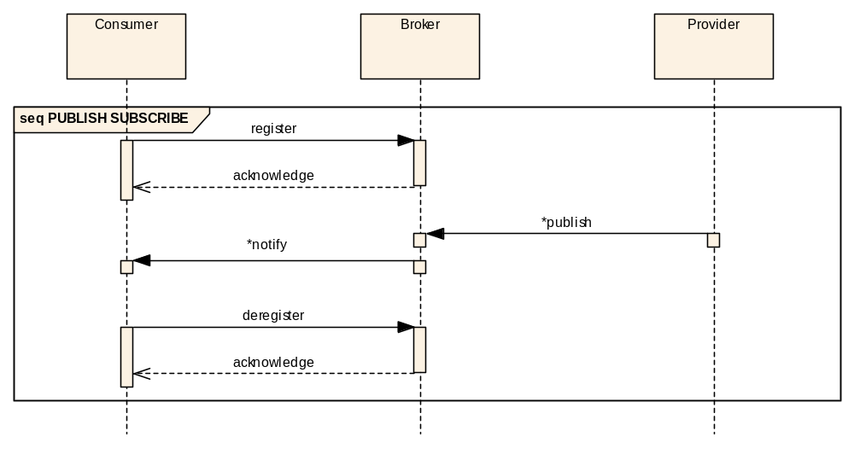
Figure 4-2525: PUBLISH-SUBSCRIBE Interaction Pattern Message Sequence
The shared message broker manages the consumer subscription lists; the providers are not aware of what consumers there are and what entities they require. Because of this they must publish all items they are configured to generate to the broker so that it can manage the updates to the consumers.
At a later time, when updates are no longer required, the consumer can deregister for these updates from the message broker.
The broker acknowledges both the register and deregister operations; these are treated like normal SUBMIT messages. No acknowledgement of the publish message is provided by the broker and no acknowledgement by the consumer of the update message is required.
The second deployment of the PUBLISH-SUBSCRIBE pattern is when there is a single provider of updates with which a consumer registers directly. This is an example of an observe type relationship where a consumer observes some aspect of a specific provider:
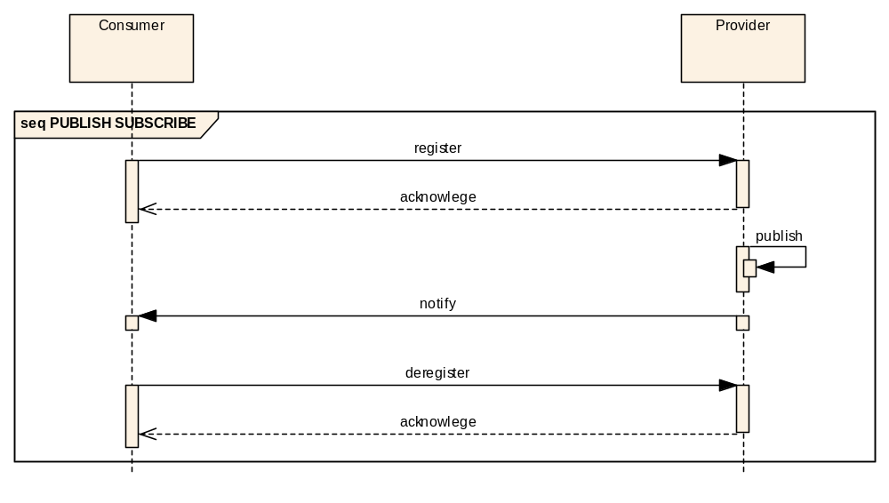
Figure 4-2626: PUBLISH-SUBSCRIBE Pattern Alternative Message Sequence
In this deployment, because of the one to one relationship between the consumer and the provider, the functionality of a shared message broker does not necessarily require a separate entity as it is completely possible for the message broker logic to reside in the provider application and in effect acts like a private message broker where the provider publishes updates to itself for distribution to consumers.
However, because the pattern is still the same, all features of the first deployment (multiple concurrent subscription lists) are still supported.

Operation template
The PUBLISH-SUBSCRIBE template is below:
Operation Name | <<Operation name>>
Interaction Pattern | PUBLISH-SUBSCRIBE
Pattern Sequence | Message | Field Type
OUT | Publish/Notify | <<Update type>>
The method name is the PUBLISH-SUBSCRIBE operation and the update type is the structure that is returned in the provider to broker publish and broker to consumer notify message. The update type MUST extend the abstract Update structure to be a valid type for this pattern.
Because the PUBLISH-SUBSCRIBE pattern is actually made up of register, publish, notify, and deregister messages, the templates of these are given below, the message directions (IN/OUT) are all from the point of view of the broker as it is involved in all operations:
Operation Name | register<< PUBLISH-SUBSCRIBE Operation Name>>
Interaction Pattern | SUBMIT
Pattern Sequence | Message | Field Type
IN | Register | Subscription

Operation Name | publish<< PUBLISH-SUBSCRIBE Operation Name>>
Interaction Pattern | SEND
Pattern Sequence | Message | Field Type
IN | Publish | UpdateList

Operation Name | notify<< PUBLISH-SUBSCRIBE Operation Name>>
Interaction Pattern | SEND
Pattern Sequence | Message | Field Type
OUT | Notify | SubscriptionUpdateList

Operation Name | deregister<< PUBLISH-SUBSCRIBE Method Name>>
Interaction Pattern | SUBMIT
Pattern Sequence | Message | Field Type
IN | Deregister | IdentifierList
The content of these messages are fixed and therefore not present in the operation Template for PUBLISH-SUBSCRIBE, however they are directly affected by the template as described below.
The register method takes a subscription which is composed of an identifier and a list of entity requests. The identifier is used by the broker to uniquely identify the subscription when combined with the consumer URI; this allows a consumer to set up several different concurrent subscriptions. Each subscription contains a list of individual entity requests which contain an entity key (as a list of identifiers – see section 4.12.5) and an indication of whether updates are required only on change or for all updates.
The provider-to-broker publish message contains an update list. Each update contains the timestamp of the update, the sourceURI of the provider (used to identify the source of an update when multiple providers are using a shared broker), an Enumeration denoting if it is considered a new object, an update, a modification or an object deletion by the provider (context specific) and then the service specific data. The actual structure is service specific as the base Update structure is abstract and must be extended by the service definition.
Each update, as listed above, can be one of four possible types: creation, update, modification, or deletion. A creation notification is used when a new object has been created in the provider (for example a new parameter is now being published by a service provider). An update notification is used when an object’s value has not changed but a new update of it has been generated (for example a periodic update of telemetry parameter). A modification notification is used when an object’s value has changed from the previously generated notification (for example a changed telemetry value update). A deletion notification is used when an object is being removed from the provider (for example an existing parameter is no longer being published by a service provider).
The deregister method takes a list of identifiers of the active subscription lists to cancel.
In both cases, for register and deregister, the SUBMIT Acknowledge message is sent only when the registration/deregistration has completed and is a confirmation that the operation has succeeded. If an error occurs during registration/deregistration, an appropriate error (as defined in the relevant service specification) shall be returned.

Message header
For the Register message the following message header fields are used:
Field | Value
URI From | Consumer URI
Authentication Id | Consumer Authentication Identifier
URI To | Broker URI
Timestamp | Message generation timestamp
QoS Level | QoS Level of message
Priority | QoS Priority of message
Domain | Domain of message
Network Zone | Network zone of message
Session | Session of message
Session Name | Session Name of the message
Interaction Type | PUBSUB
Interaction Stage | 1
Transaction Id | Provided by consumer
Service Area | Service Area Identifier
Service | Service Identifier
Operation | Service Operation Identifier
Service Version | Service Version number
Is Error Message | FALSE
For the follow up acknowledgement message the following message header fields are used:
Field | Value
URI From | Broker URI
Authentication Id | Broker Authentication Identifier
URI To | Consumer URI
Timestamp | Message generation timestamp
QoS Level | QoS Level of message
Priority | QoS Priority of message
Domain | Domain of message
Network Zone | Network zone of message
Session | Session of message
Session Name | Session Name of the message
Interaction Type | PUBSUB
Interaction Stage | 2
Transaction Id | Transaction Id from initial message
Service Area | Service Area Identifier
Service | Service Identifier
Operation | Service Operation Identifier
Service Version | Service Version number
Is Error Message | FALSE
For the Publish message the following message header fields are used:
Field | Value
URI From | Provider URI
Authentication Id | Provider Authentication Identifier
URI To | Broker URI
Timestamp | Message generation timestamp
QoS Level | QoS Level of message
Priority | QoS Priority of message
Domain | Domain of message
Network Zone | Network zone of message
Session | Session of message
Session Name | Session Name of the message
Interaction Type | PUBSUB
Interaction Stage | 3
Transaction Id | Not used
Service Area | Service Area Identifier
Service | Service Identifier
Operation | Service Operation Identifier
Service Version | Service Version number
Is Error Message | FALSE
For the Notify message the following message header fields are used:
Field | Value
URI From | Broker URI
Authentication Id | Broker Authentication Identifier
URI To | Consumer URI
Timestamp | Message generation timestamp
QoS Level | QoS Level of message
Priority | QoS Priority of message
Domain | Domain of message
Network Zone | Network zone of message
Session | Session of message
Session Name | Session Name of the message
Interaction Type | PUBSUB
Interaction Stage | 4
Transaction Id | Transaction Id from initial message
Service Area | Service Area Identifier
Service | Service Identifier
Operation | Service Operation Identifier
Service Version | Service Version number
Is Error Message | FALSE
The Transaction Id must be taken from the initial Register message regardless of subsequent Register messages that have been sent by the consumer to modify an active subscription. If all subscriptions are deregistered, and therefore the active subscription has ended, and then a Register message is sent, and therefore a new active subscription is started, it shall be this newer Transaction Id that shall then be used for subsequent Notify messages.
For the Deregister message the following message header fields are used:
Field | Value
URI From | Consumer URI
Authentication Id | Consumer Authentication Identifier
URI To | Broker URI
Timestamp | Message generation timestamp
QoS Level | QoS Level of message
Priority | QoS Priority of message
Domain | Domain of message
Network Zone | Network zone of message
Session | Session of message
Session Name | Session Name of the message
Interaction Type | PUBSUB
Interaction Stage | 5
Transaction Id | Provided by consumer
Service Area | Service Area Identifier
Service | Service Identifier
Operation | Service Operation Identifier
Service Version | Service Version number
Is Error Message | FALSE
For the follow up acknowledgement message the following message header fields are used:
Field | Value
URI From | Broker URI
Authentication Id | Broker Authentication Identifier
URI To | Consumer URI
Timestamp | Message generation timestamp
QoS Level | QoS Level of message
Priority | QoS Priority of message
Domain | Domain of message
Network Zone | Network zone of message
Session | Session of message
Session Name | Session Name of the message
Interaction Type | PUBSUB
Interaction Stage | 6
Transaction Id | Transaction Id from deregister message
Service Area | Service Area Identifier
Service | Service Identifier
Operation | Service Operation Identifier
Service Version | Service Version number
Is Error Message | FALSE

Description
The PUBLISH-SUBSCRIBE pattern has a predefined pattern message structure for both register and deregister which allow an implementation of the message broker to manage the mapping of consumers to updates and hide this complexity from Provider applications.
The update rate is an aspect of a provider; the consumer cannot specify this.

A consumer can specify many concurrent subscriptions. To modify a single subscription of observed items a consumer sends a new register message to the message broker. This message should contain the complete new list of items to subscribe to. For example, if a consumer initially registers for updates on the set (A, B, C) but at a later date requires also ‘D’, another register message should be sent with the set (A, B, C, D). The register call replaces the previous subscription list with the new list. The deregister message completely cancels the identified lists.
Another way of looking at the register/deregister messages is that register defines an update ‘report’ and deregister clears that ‘report’ definition.
NOTE – If a single subscription definition lists the same parameter more than once only one update is sent to the consumer for that list. However, if a consumer defines two concurrent subscription lists that request the same parameters then the consumer will receive two updates of those common parameters, one for each subscription. If this is an issue then the consumer still has the option of maintaining a single subscription and splitting the results internally.

Entity Key
The entity key is represented as an IdentifierList in the EntityRequest structure. For the majority of services a single identifier will be enough to uniquely key an entity, however there are cases where an entity can only uniquely be keyed using more than one identifier i.e. a compound key. This section details the generic rules for entity key matching in the PUBLISH-SUBSCRIBE pattern.
The key is composed of a set of sub-keys which are represented by the entries in the IdentifierList. The order of these sub-keys is that the first in the list is the most significant, followed by the second etc.
A sub-key specified in the EntityRequest structure can take one of three types of value, an actual value, a NULL or empty value, and the special wildcard identifier of ‘*’. In the first case it shall only match updates that have the same value, in the second case it shall match all values not including sub-keys (but a value must exist), and in the third case it shall match all values and include sub-identifiers.
For example, if a provider is publishing the a set of updates with the following keys (the dot notation is used to separate the sub-keys):
- A
- A.B
- A.B.C
- A.B.C.D
- B
- Q.B.C
An EntityRequest using the key of ‘A’ would only match to the first update.
An EntityRequest using the key of ‘A.[null]’ would only match to the second update.
An EntityRequest using the key of ‘A.*’ would only match to all but the last two updates.
An EntityRequest using the key of ‘A.B.[null]’ would only match to updates 2 and 3.
An EntityRequest using the key of ‘A.B.*’ would only match to updates 2 to 4.
An EntityRequest using the key of ‘[null].B.[null]’ would only match to updates 3 and 6.
An EntityRequest using the key of ‘*.B.*’ would only match to updates 2 to 6.
In the case where a key refers to a specific entity (where neither NULL or ‘*’ are not used) and that entity is not known to the broker or provider then an UNKNOWN error shall be returned from the register operation.
NOTE – The meaning of the entity key value is context specific and must be detailed in the relevant service specification.

Usage
The PUBLISH-SUBSCRIBE pattern provides the ability for asynchronous updates to be sent to registered consumers.

Error handling
The PUBLISH-SUBSCRIBE pattern can report failure in four distinct ways. The first is when the acknowledgement is replaced with an error message (see 6.1.8) for the register operation:
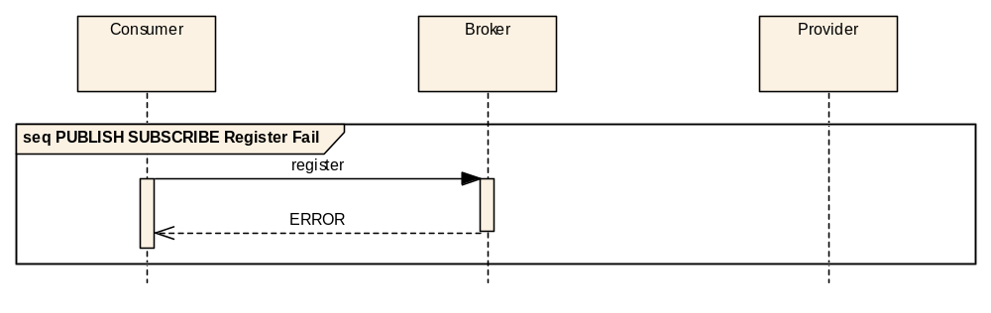
Figure 4-2727: PUBLISH-SUBSCRIBE Interaction Pattern Register Error Sequence
The second is when the provider replaces a publish with an error (this is then passed to any consumers):
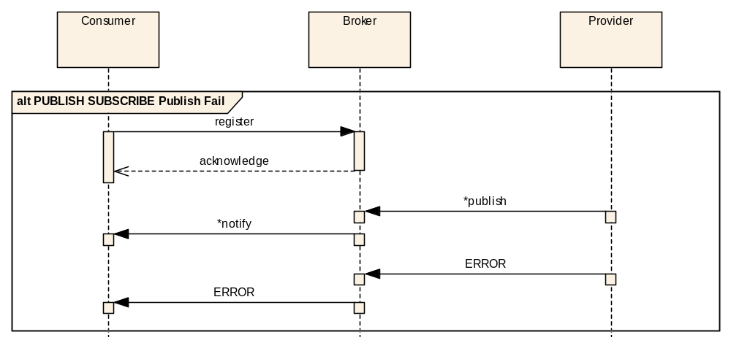
Figure 4-2828: PUBLISH-SUBSCRIBE Interaction Pattern Publish Error Sequence
The third is when a notify is replaced by an error:
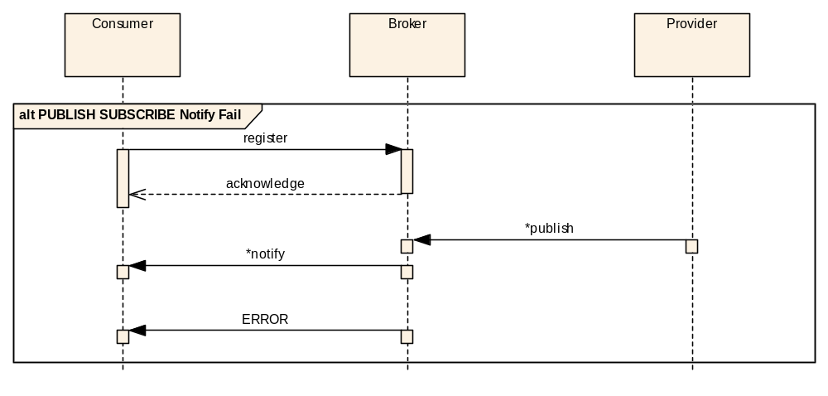
Figure 4-2929: PUBLISH-SUBSCRIBE Interaction Pattern Notify Error Sequence
The fourth is when an error is generated during the deregister operation:
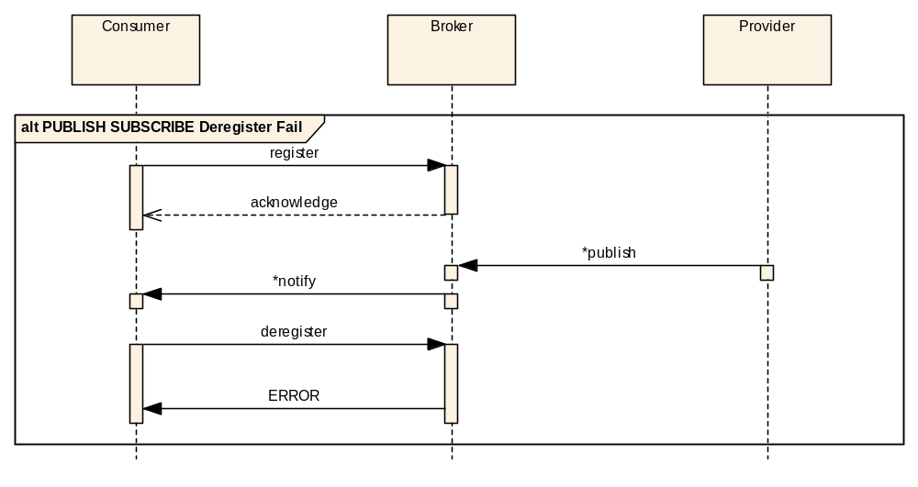
Figure 4-3030: PUBLISH-SUBSCRIBE Interaction Pattern Deregister Error Sequence
In all cases the consumer should assume that no further messages shall be received from the message broker in relation to this PUBLISH-SUBSCRIBE pattern.

Example
The following example shows a simple Example service that contains a single PUBLISH-SUBSCRIBE operation:
Operation Name | testPubSub
Interaction Pattern | PUBLISH-SUBSCRIBE
Pattern Sequence | Message | Field Type
OUT | Publish/Notify | TestNotify
The TestNotify structure is defined below:
Structure Name | TestNotify
Extends | Update
Short form | Example Only
Field | Type | Comment
time | Time | Example Time item
value | Integer | Example Integer item
For the purposes of this example it is defined that the key for the TestNotify structure is a compound key of two sub keys.
To register for this PUBLISH-SUBSCRIBE pattern, a consumer shall send the following message:
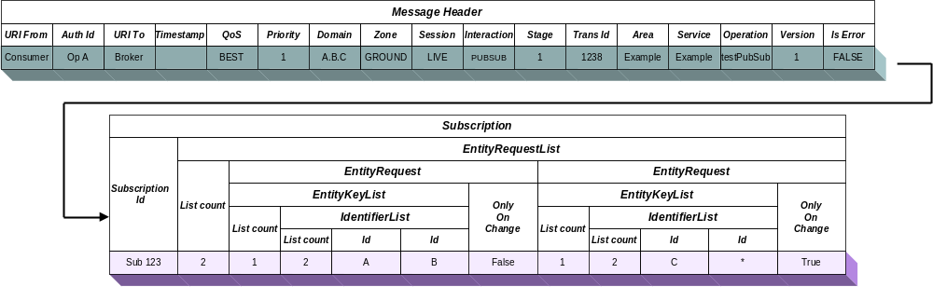
It contains a standard pattern body for the register message. This shall result in the following acknowledgement message being sent:
To publish an update on this topic a message provider would send the following message to the message broker, in this example two updates are being generated at the same time:
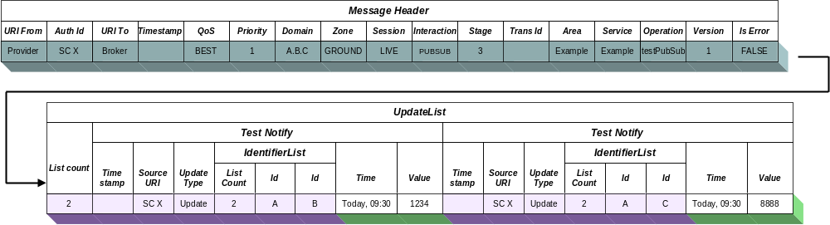
When an update is required the following notify message will be sent from the message broker to the consumer:
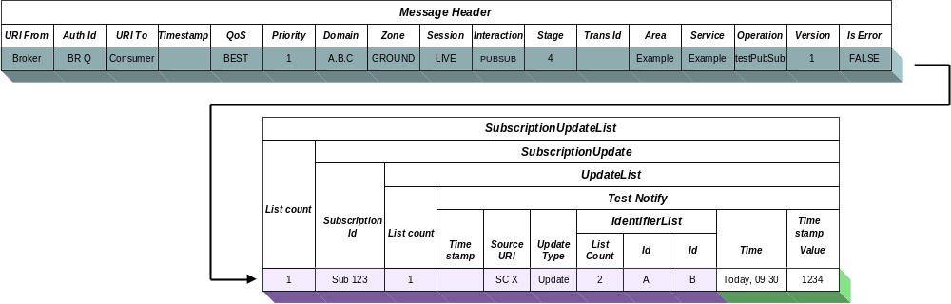
No acknowledgement of the notify message shall be sent by the consumer.
When the consumer wants to deregister the following message would be sent:
Which would result in the following acknowledgement being received:
NOTE – An actual service specification, rather than the example given here, would fully specify the meaning of, and required values of, all structures used by the service.

Error handling Pattern

Overview
For message exchange patterns that return to the consumer messages may be replaced with an error message. The following patterns are affected:
- SUBMIT;
- REQUEST;
- INVOKE;
- PROGRESS;
- PUBLISH-SUBSCRIBE.
Each pattern shows the possible error return points if applicable in the relevant section. When a pattern returns an error there shall be no further messages passed for that instance of the pattern. What this implies for a specific operation of a service is completely service specific and shall be detailed in the relevant service specification.

Message header
For the Error message, the Pattern Stage field is set to the correct value for the stage being replaced and the isError field is set to TRUE:
Field | Value
URI From | Source URI
Authentication Id | Source Authentication Identifier
URI To | Consumer URI
Timestamp | Message generation timestamp
QoS Level | QoS Level of message
Priority | QoS Priority of message
Domain | Domain of message
Network Zone | Network zone of message
Session | Session of message
Session Name | Session Name of the message
Interaction Type | Relevant Interaction Type
Interaction Stage | Relevant Pattern Stage
Transaction Id | Transaction Id from initial message
Service Area | Service Area Identifier
Service | Service Identifier
Operation | Service Operation Identifier
Service Version | Service Version number
Is Error Message | TRUE
The URI From field above has the source URI for the error. This would normally be the provider URI but may be the broker URI in the case of the Publish/Subscribe pattern or even the Consumer itself in case of loss of contact to the provider.

Description
The error message replaces the relevant pattern message. The body of the error message must be the standard error structure of StandardError (see 6.1.8). The relevant service specification should detail the possible errors that may be returned from a specific operation. The error structure allows a service specification to add extra information to the error returned but this must be specified by the service operation definition.
Standard errors also exist, for example failed delivery, and these are detailed in 5.8. With the standard errors they may be generated by the consumer software stack or by the provider software stack rather than just the provider application. This is dependent on the specific error; however, all service level errors should be generated by the provider application.

Example
In the following example an error is generated in response to the example REQUEST pattern detailed in 4.9.7.
So, for the following message being sent:
If an error occurred, then the following error message may be returned:
NOTE – An actual service specification, rather than the example given here, would fully specify the meaning of, and required values of, all structures used by the service.

Service specification conventions
The following sections describe the table formats to be used in the definition of each service. By using a common way of representing a service and the operations it contains it is possible for the service documents to concentrate on the service specifics and leave the pattern definitions in this document.

Service Overview
A service comprises a set of operations; each operation uses one of the interaction patterns defined in section 4.
The following gives the service definition for an ‘Example’ service. It contains a single operation ‘operation_name’:
Area Identifier | Service Identifier | Area Number | Service Number | Service Version
Test | Example | 99 | 10 | 1
Interaction Pattern | Operation Name | Operation Number | Support in replay | Capability Set
PATTERN | operation name | 10 | Yes | 1
The main point of interest is the ‘PATTERN’ before the operation name as this signifies which pattern this operation is an example of.
The Service Area shall contain the identifier of the area (Core, Common, Planning, etc.) that the service belongs to and is defined in the relevant service specification. This removes any conflict with service numbers between service area definitions.
The service version shall match that defined in the service specification being implemented, this allows the concurrent use of future versions of service specifications.
The ‘Support in Replay’ field denotes that the operation can be used in replay sessions as it does not alter the replay data.

Message structures
The specification of the service will also detail the structures passed as the message bodies and message returns. These fall into four main categories: attributes, composites, enumerations and lists. There is a base type for all attributes, composites, enumerations and lists which is Element.
Attributes are simple discrete components of a structure such as a string or an integer whereas composites are structures that contain either other structures or attributes, enumerations are detailed in section 5.5, lists are detailed in section 5.6. Composites are represented in a table as illustrated below:
Structure Name | TestBody
Extends | Composite
Short form | ABC
Field | Type | Comment
FirstItem | String | Example String item
SecondItem | Integer | Example Integer item

Structure Name | ExampleStructure
Extends | Composite
Short form | CDE
Field | Type | Comment
first_item | String | Example String item
second_item | Integer | Example Integer item
third_item | TestBody | Contained structure
The ExampleStructure would decompose to a sequence of:
Field | Type | Comment
first_item | String | from ExampleStructure
second_item | Integer | from ExampleStructure
FirstItem | String | from contained TestBody
SecondItem | Integer | from contained TestBody

Message extension
The message structure can extend another structure like below (multiple extension is not permitted):
Structure Name | ComplexStructure
Extends | ExampleStructure
Short form | DEF
Field | Type | Comment
extra_item | Boolean | Extra Boolean item
second_item | Integer | Example Integer item
third_item | TestBody | Contained structure
This shows that ComplexStructure can be considered an extension of ExampleStructure and contains all the contents of ExampleStructure plus its own extra items:
Field | Type | Comment
first_item | String | from ExampleStructure
second_item | Integer | from ExampleStructure
FirstItem | String | from ExampleStructure contained TestBody
SecondItem | Integer | from ExampleStructure contained TestBody
extra_item | Boolean | from ComplexStructure
second_item | Integer | from ComplexStructure
FirstItem | String | from ComplexStructure contained TestBody
SecondItem | Integer | from ComplexStructure contained TestBody
The short form field is a simplified numerical version of the composite. It is expected to be used in efficient encodings and transport mappings.

Containing abstract elements
It is possible that a structure can contain one of several possible types and the specific type is not known until the message is created during operations. For example, the type of the value of a telemetered parameter report is not known until the specific parameter is reported. Without allowing a structure to specify that an element is abstract it would require a report defined for each possible type of parameter.
A structure contains an abstract element by including it just like any normal element; it is the fact that the contained element has been defined as abstract, as shown for type AbstractComposite below, that changes the behaviour of the structure. Any composites that extend that abstract composite are possible substitutes in an actual message:
Structure Name | AbstractComposite
Extends | Composite
Abstract
Field | Type | Comment
FirstItem | String | Example String item
SecondItem | Integer | Example Integer item

Structure Name | ConcreteCompositeA
Extends | AbstractComposite
Short form | CCA
Field | Type | Comment
ThirdItem | Float | Example Float item

Structure Name | ConcreteCompositeB
Extends | AbstractComposite
Short form | CCB
Field | Type | Comment
ThirdItem | Time | Example Time item

Structure Name | OuterComposite
Extends | Composite
Short form | OC
Field | Type | Comment
SomeItem | Time | Example Time item
AbstractPart | AbstractComposite | This element is the abstract part
In this example, when an OuterComposite is encoded the ‘AbstractPart’ will contain either a ConcreteCompositeA or a ConcreteCompositeB, it is encoding dependent how this is represented, but the encoding must provide enough information for the receiver to decode the correct type. For example, this could be implemented by preceding the contents of the abstract part with the short form identifier of the actual contained structure.
It is also possible to extend a non-abstract composite, and as long as that extended composite is referenced directly this is not a problem. An issue arises when the extended composite is used in place of the base composite (which is not marked as abstract). Because there is no indication to the receiving application that the message contains extra information it is not possible to decode the message correctly. Some transport encodings may be able to support this but many will not be able to so as a general rule only abstract composites should be extended.

Representing Enumerations
Enumerations are defined sets of possible values. All enumerations are extensions of the basic Element and therefore can only be used to replace abstract Elements. They are represented as shown below:
Enumeration Name | ExampleEnum
Short form | Example only
Enumeration Value | Short form | Comment
FIRST | 1 | First enumeration possible value
SECOND | 2 | Second enumeration value
OTHER | 3 | Etc.
DELETION | 4 | Object has been deleted
The short form field is a simplified numerical version of the enumeration. It is expected to be used in efficient encodings and transport mappings.

Representing Lists
A list is an arbitrary length sequence of items. All lists are extensions of the basic Composite structure and therefore can be used to replace abstract Composite elements. The definition of a List is as below:
List Name | ExampleList
Short form | Example only
List of | ExampleStructure
The ExampleList is shown as having a ‘type’ of ExampleStructure and is therefore a list of ExampleStructure‘s. A list has a length part but it is dependent on the protocol as to whether an actual length field is required. For example, an efficient packet based protocol may include an initial length field to allow correct decommutation whereas an XML based protocol would not require this due to XML tags denoting the end of the list.
The ordering of the elements of the List must be preserved.

Representing NULL
In some message structures it may be required to have optional components. To this end it is required to be able to represent, for each type of component, the concept of NULL. This is separate and completely different to the concept of empty, for example an empty string (“”) is different from a NULL string which has no value. Language mappings must have the ability to represent NULL in messages and transport mappings must have the ability to transport NULL.

Errors
Each operation shall list any errors, specific to that operation over and above any standard errors, that can be raised by an implementation. Error codes for an operation should start at zero ‘0’ and increment; standard errors start at 65536, 0x10000 in hex, and increment; operation-specific errors shall therefore remain inside the inclusive range of 0 to 65535.
The following table lists the standard errors:
Table 5-33: Standard MAL Error Codes
Error | Error # | Comments
DELIVERY_FAILED | 65536 | Confirmed communication error
DELIVERY_TIMEDOUT | 65537 | Unconfirmed communication error
DELIVERY_DELAYED | 65538 | Message queued somewhere awaiting contact
DESTINATION_UNKNOWN | 65539 | Destination cannot be contacted
DESTINATION_TRANSIENT | 65540 | Destination middleware reports destination application does not exist
DESTINATION_LOST | 65541 | Destination lost halfway through conversation
AUTHENTICATION_FAIL | 65542 | A failure to authenticate the message correctly
AUTHORISATION_FAIL | 65543 | A failure in the MAL to authorise the message
ENCRYPTION_FAIL | 65544 | A failure in the MAL to encrypt/decrypt the message
UNSUPPORTED_AREA | 65545 | The destination does not support the service area
UNSUPPORTED_OPERATION | 65546 | The destination does not support the operation
UNSUPPORTED_VERSION | 65547 | The destination does not support the service version
BAD_ENCODING | 65548 | The destination was unable to decode the message
UNKNOWN | 65549 | Operation specific
Only two errors are possible from the MAL and below with regards to Authentication and Authorisation, they are concerned with message level issues and do not cover login issues such as an incorrect username/password combination.
NOTE – The authentication and authorisation failure messages are very generic in nature; it is possible that a weakness in a specific protocol or authentication mechanism could be exploited if too much information is returned about the specific nature of an authentication or authorisation failure.

Message abstraction layer Structures
NOTE – This section details the structures provided to other services by the MAL. The MAL does not use most of these structures directly but they are defined here to provide common building blocks for other services to reuse without needing to duplicate them in many specifications.

Message structures

General
These simple message structures and types provide enumeration definitions and composites used directly by the interaction patterns.

InteractionType Enumeration
Enumeration definition holding the possible interaction pattern types.
Enumeration Name | InteractionType
Short form | G
Enumeration Value | Short form | Comment
SEND | 1 | Used for Send interactions
SUBMIT | 2 | Used for Submit interactions
REQUEST | 3 | Used for Request interactions
INVOKE | 4 | Used for Invoke interactions
PROGRESS | 5 | Used for Progress interactions
PUBSUB | 6 | Used for Publish/Subscribe interactions

SessionType Enumeration
Enumeration definition holding the session types.
Enumeration Name | SessionType
Short form | g
Enumeration Value | Short form | Comment
LIVE | 1 | Used for Live sessions
SIMULATION | 2 | Used for Simulation sessions
REPLAY | 3 | Used for Replay sessions

QoSLevel Enumeration
Enumeration definition holding the possible QoS levels.
Enumeration Name | QoSLevel
Short form | O
Enumeration Value | Short form | Comment
BESTEFFORT | 1 | Used for Best Effort QoS Level
ASSURED | 2 | Used for Assured QoS Level
QUEUED | 3 | Used for Queued QoS Level
TIMELY | 4 | Used for Timely QoS Level

UpdateType Enumeration
Enumeration definition holding the possible Update types.
Enumeration Name | UpdateType
Short form | M
Enumeration Value | Short form | Comment
CREATION | 1 | Update is notification of the creation of the item.
UPDATE | 2 | Update is just a periodic update of the item and has not changed its value.
MODIFICATION | 3 | Update is for a changed value or modification of the item.
DELETION | 4 | Update is notification of the removal of the item.

DomainIdentifier
A DomainIdentifier is a list of identifiers that is defined as a separate type from the normal IdentifierList so that encodings and transports can handle it in a specialised mechanism dependent on their architecture.
List Name | DomainIdentifier
Short form | W
List of | Identifier
The most significant domain part is listed first in the list (for example Agency) and each subsequent domain identifier in the list narrows the preceding domain.
Each Identifier part of the Domain is allowed the full range of Identifier values with the restriction that it is NOT allow to contain the ‘.’ character. A DomainIdentifier can also be represented using a single Identifier. Each part of the DomainIdentifier is concatenated using the ‘.’ character with the most significant first, For example:
Agency.Mission.Craft.Subsystem

MessageHeader
The MessageHeader structure is used to hold all fields that are passed for each message exchanged between a consumer and provider. See 4.1 for more information.
Structure Name | MessageHeader
Extends | Composite
Short form | x
Field | Type | Comment
URIfrom | URI | Message Source URI
authenticationId | Blob | Source Authentication Credentials
URIto | URI | Message Destination URI
timestamp | Time | Message generation timestamp
QoSlevel | QoSLevel | The QoS level of the message
priority | Integer | The QoS priority of the message
domain | DomainIdentifier | Domain of the message
networkZone | Identifier | Network zone of the message
session | SessionType | Type of session of the message
sessionName | Identifier | Name of the session of the message. Shall be ‘LIVE’ if session type is LIVE.
interactionType | InteractionType | Interaction Pattern Type
interactionStage | Octet | Interaction Pattern Stage
transactionId | Identifier | Unique to consumer
area | Identifier | Service Area Identifier
service | Identifier | Service Identifier
operation | Identifier | Service Operation Identifier
version | Octet | Service version
isError | Boolean | True if this is an error message else False.

StandardError
This basic structure allows an operation to return an error code. The service specification shall define which error codes may be returned for a specific operation and also what extra information structure is provided.
If no extra information is provided by an error then the extraInformation field should be set to NULL.
Structure Name | StandardError
Extends | Composite
Short form | X
Field | Type | Comment
errorNumber | Integer | Operation-specific error code
extraInformation | Element | Allows provision of extra error-specific values if required. Normally left empty.

Subscription
This structure is used when subscribing for updates using the PUBSUB interaction pattern. It contains a single identifier that identifies the subscription being defined and a set of entities being requested.
Structure Name | Subscription
Extends | Composite
Short form | R
Field | Type | Comment
subscriptionId | Identifier | The identifier of this subscription
entities | EntityRequestList | The list of entities that are being subscribed for by this identified subscription.

EntityRequest
This structure is used when subscribing for updates using the PUBSUB interaction pattern.
Structure Name | EntityRequest
Extends | Composite
Short form | Q
Field | Type | Comment
entityKeys | EntityKeyList | The list of entities to be monitored.
onlyOnChange | Boolean | The Boolean denotes that only change updates to be sent rather than all updates.

SubscriptionUpdate
This structure is used for updates sent to a consumer of a PUBSUB interaction pattern.
Structure Name | SubscriptionUpdate
Extends | Composite
Short form | r
Field | Type | Comment
subscriptionId | Identifier | The identifier of this subscription
updateList | UpdateList | The list of object updates that are being updated by this identified subscription.

Update
This structure is used by updates using the PUBSUB interaction pattern. It must be extended by the specific service to be used.
Structure Name | Update
Extends | Composite
Abstract
Field | Type | Comment
timestamp | Time | Creation timestamp of the update.
sourceURI | URI | URI of the source of the update, usually a PUBSUB provider.
updateType | UpdateType | Type of update being reported.
key | IdentifierList | The list of identifiers that form the compound key of the entity.

EntityRequestList
List Name | EntityRequestList
Short form | q
List of | EntityRequest

SubscriptionUpdateList
List Name | SubscriptionUpdateList
Short form | w
List of | SubscriptionUpdate

UpdateList
List Name | UpdateList
Short form | m
List of | Update

EntityKeyList
Simple list structure that holds a set of Entity keys structures. The list of identifiers form the key of the entity to be monitored.
List Name | EntityKeyList
Short form | k
List of | IdentifierList

Basic Composites

Overview
This section contains the basic structures used by the interaction patterns and higher services.

Pair
Simple composite structure for holding pairs. The pairs can be user defined attributes.
Structure Name | Pair
Extends | Composite
Short form | P
Field | Type | Comment
first | Attribute | The attribute value for the first element of this pair.
second | Attribute | The attribute value for the second element of this pair.

IdBooleanPair
Simple pair type of an identifier and Boolean value.
Structure Name | IdBooleanPair
Extends | Composite
Short form | V
Field | Type | Comment
id | Identifier | The Identifier value.
value | Boolean | The Boolean value.

NamedValue
This structure represents a simple pair type of an identifier and abstract attribute value which could be a new user defined type.
Structure Name | NamedValue
Extends | Composite
Short form | J
Field | Type | Comment
name | Identifier | The Identifier value.
value | Attribute | The Attribute value.

Basic Lists

Overview
This section contains predefined list structures that are used by structures defined in this and other specifications.

BlobList
List Name | BlobList
Short form | l
List of | Blob

BooleanList
List Name | BooleanList
Short form | b
List of | Boolean

FloatList
List Name | FloatList
Short form | f
List of | Float

DoubleList
List Name | DoubleList
Short form | z
List of | Double

IdentifierList
List Name | IdentifierList
Short form | i
List of | Identifier

OctetList
List Name | OctetList
Short form | a
List of | Octet

ShortList
List Name | ShortList
Short form | h
List of | Short

IntegerList
List Name | IntegerList
Short form | n
List of | Integer

LongList
List Name | LongList
Short form | y
List of | Long

StringList
List Name | StringList
Short form | s
List of | String

DurationList
List Name | DurationList
Short form | d
List of | Duration

TimeList
List Name | TimeList
Short form | t
List of | Time

FineTimeList
List Name | FineTimeList
Short form | c
List of | FineTime

URIList
List Name | URIList
Short form | u
List of | URI

QoSLevelList
List Name | QoSLevelList
Short form | o
List of | QoSLevel

PairList
List Name | PairList
Short form | p
List of | Pair

IdBooleanList
List Name | IdBooleanList
Short form | v
List of | IdBooleanPair

NamedValueList
List Name | NamedValueList
Short form | j
List of | NamedValue

Message Abstraction Layer Data Types

Overview
This section details the types provided to other services by the MAL.

Base types

Overview
This subsection details the three basic types in the MAL.

Element
Abstract
This is the base type of all data constructs. All types that make up the common data model are derived from it.

Attribute
Abstract Structure Extends: Element
The base type of all attributes of the common model. Attributes are contained within Composites and are used to build complex structures that make the data model.

Composite
Abstract Structure Extends: Element
The base structure for composite structures that contains a set of elements.

Attributes

General
Attributes are the simplest MAL type; they cannot be decomposed into any smaller elements and are used to build more complex structures.
Each type is defined below but the actual representation, or encoding, of them is completely dependent on the language and transport/encoding mapping used. However, because the limits and behaviour of the types are constant (defined here) the informational content is preserved when moving between mappings.
For example, a Boolean value may be represented by a single bit in some encodings or by the text strings ‘True/False’ in others; however, the meaning of the value is identical regardless of the encoding used.

Blob
Extends: Attribute
Short form: L
This structure is used to store binary object attributes. It is a variable-length, unbounded, octet array. The distinction between this type and a list of Octet attributes is that this may allow language mappings and encodings to use more efficient or appropriate representations.

Boolean
Extends: Attribute
Short form: B
Structure for Boolean attributes. Possible values are TRUE or FALSE.

Float
Extends: Attribute
Short form: F
Structure representing floating point attributes using the IEEE 754 32 bit range.
Three special values exist for this type: POSITIVE_INFINITY, NEGATIVE_INFINITY, and NaN (Not A Number).

Double
Extends: Attribute
Short form: Z
Structure representing floating point attributes using the IEEE 754 64 bit range.
Three special values exist for this type: POSITIVE_INFINITY, NEGATIVE_INFINITY, and NaN (Not A Number).

Identifier
Extends: Attribute
Short form: I
Structure representing an identifier. An Identifier is an extension of the String attribute that can be used for indexing.

Octet
Extends: Attribute
Short form: A
Structure for 8 bit signed attributes. The permitted range is -128 to 127.

Short
Extends: Attribute
Short form: H
Structure for 16 bit signed attributes. The permitted range is -32768 to 32767.

Integer
Extends: Attribute
Short form: N
Structure for 32 bit signed attributes. The permitted range is -2147483648 to 2147483647.

Long
Extends: Attribute
Short form: Y
Structure for 64 bit signed attributes. The permitted range is -9223372036854775808 to 9223372036854775807.

String
Extends: Attribute
Short form: S
Structure for String attributes. It is a variable-length, unbounded, UTF-16 Unicode string.

Duration
Extends: Attribute
Short form: D
Structure for Duration attributes. It represents a length of time in seconds. It may contain a fractional component.

Time
Extends: Attribute
Short form: T
Structure for absolute time attributes. It represents an absolute date and time to millisecond resolution.

FineTime
Extends: Attribute
Short form: C
Structure for high resolution absolute time attributes. It represents an absolute date and time to picosecond resolution.

URI
Extends: Attribute
Short form: U
Structure for URI addresses. It is a variable length, unbounded, UTF16 string.

Definition of Acronyms
(Informative)
AMS CCSDS Asynchronous Message Service
API Application Programming Interface
ASCII American Standard Code for Information Interchange
BLOB Binary Large OBject
LAN Local Area Network
MAL Message Abstract Layer
MCS Mission Control System
MO Mission Operations
QoS Quality of Service
RPC Remote Procedure Call
SM&C CCSDS Spacecraft Monitor & Control
XML eXtensible Markup Language
URI Universal Resource Identifier

