

Report Concerning Space Data System Standards

|  |
| --- |
| OPEN ARCHIVAL  INFORMATION SYSTEM  INTEROPERABILITY  FRAMEWORK (OAIS-IF) Rationale, Scenarios, and Requirements |

Draft Informational Report

CCSDS 000.0-G-0

Draft Green Book

January 2021

AUTHORITY

|  |  |  |  |
| --- | --- | --- | --- |
|  | | | |
|  | Issue: | Draft Green Book, Issue 0 |  |
|  | Date: | January 2021 |  |
|  | Location: | Not Applicable |  |
|  | | | |

**(WHEN THIS INFORMATIONAL REPORT IS FINALIZED, IT WILL CONTAIN THE FOLLOWING STATEMENT OF AUTHORITY:)**

This document has been approved for publication by the Management Council of the Consultative Committee for Space Data Systems (CCSDS) and reflects the consensus of technical experts from CCSDS Member Agencies. The procedure for review and authorization of CCSDS documents is detailed in *Organization and Processes for the Consultative Committee for Space Data Systems* (CCSDS A02.1-Y-4).

This document is published and maintained by:

CCSDS Secretariat

Space Communications and Navigation Office, 7L70

Space Operations Mission Directorate

NASA Headquarters

Washington, DC 20546-0001, USA

FOREWORD

[Foreword text specific to this document goes here. The text below is boilerplate.]

Through the process of normal evolution, it is expected that expansion, deletion, or modification of this document may occur. This document is therefore subject to CCSDS document management and change control procedures which are defined in *Organization and Processes for the Consultative Committee for Space Data Systems* (CCSDS A02.1-Y-4). Current versions of CCSDS documents are maintained at the CCSDS Web site:

http://www.ccsds.org/

Questions relating to the contents or status of this document should be addressed to the CCSDS Secretariat at the address indicated on page i.

At time of publication, the active Member and Observer Agencies of the CCSDS were:

Member Agencies

* Agenzia Spaziale Italiana (ASI)/Italy.
* Canadian Space Agency (CSA)/Canada.
* Centre National d’Etudes Spatiales (CNES)/France.
* China National Space Administration (CNSA)/People’s Republic of China.
* Deutsches Zentrum für Luft- und Raumfahrt (DLR)/Germany.
* European Space Agency (ESA)/Europe.
* Federal Space Agency (FSA)/Russian Federation.
* Instituto Nacional de Pesquisas Espaciais (INPE)/Brazil.
* Japan Aerospace Exploration Agency (JAXA)/Japan.
* National Aeronautics and Space Administration (NASA)/USA.
* UK Space Agency/United Kingdom.

Observer Agencies

* Austrian Space Agency (ASA)/Austria.
* Belgian Federal Science Policy Office (BFSPO)/Belgium.
* Central Research Institute of Machine Building (TsNIIMash)/Russian Federation.
* China Satellite Launch and Tracking Control General, Beijing Institute of Tracking and Telecommunications Technology (CLTC/BITTT)/China.
* Chinese Academy of Sciences (CAS)/China.
* Chinese Academy of Space Technology (CAST)/China.
* Commonwealth Scientific and Industrial Research Organization (CSIRO)/Australia.
* Danish National Space Center (DNSC)/Denmark.
* Departamento de Ciência e Tecnologia Aeroespacial (DCTA)/Brazil.
* European Organization for the Exploitation of Meteorological Satellites (EUMETSAT)/Europe.
* European Telecommunications Satellite Organization (EUTELSAT)/Europe.
* Geo-Informatics and Space Technology Development Agency (GISTDA)/Thailand.
* Hellenic National Space Committee (HNSC)/Greece.
* Indian Space Research Organization (ISRO)/India.
* Institute of Space Research (IKI)/Russian Federation.
* KFKI Research Institute for Particle & Nuclear Physics (KFKI)/Hungary.
* Korea Aerospace Research Institute (KARI)/Korea.
* Ministry of Communications (MOC)/Israel.
* National Institute of Information and Communications Technology (NICT)/Japan.
* National Oceanic and Atmospheric Administration (NOAA)/USA.
* National Space Agency of the Republic of Kazakhstan (NSARK)/Kazakhstan.
* National Space Organization (NSPO)/Chinese Taipei.
* Naval Center for Space Technology (NCST)/USA.
* Scientific and Technological Research Council of Turkey (TUBITAK)/Turkey.
* South African National Space Agency (SANSA)/Republic of South Africa.
* Space and Upper Atmosphere Research Commission (SUPARCO)/Pakistan.
* Swedish Space Corporation (SSC)/Sweden.
* Swiss Space Office (SSO)/Switzerland.
* United States Geological Survey (USGS)/USA.

DOCUMENT CONTROL

|  |  |  |  |
| --- | --- | --- | --- |
| **Document** | **Title and Issue** | **Date** | **Status** |
| CCSDS 000.0-G-0 | [Document Title], Draft Informational Report, Issue 0 | January 2021 | Current draft |
|  |  |  |  |
|  |  |  |  |

CONTENTS

Contents

DOCUMENT CONTROL iv

CONTENTS v

1 Introduction 1-1

1.1 Purpose 1-1

1.2 Scope 1-1

1.3 Applicability 1-1

1.4 Rationale 1-1

1.5 References 1-1

2 OVERVIEW 2-1

3 OAIS-IF Scenarios 3-2

3.1 Information Creator sends Information to an OAIS ConformaNt Archive 3-2

3.2 Information Creator sends Information to a Non-OAIS conformant archive 3-3

3.3 OAIS conformant archive sends information to an Information Consumer 3-3

3.4 Non-OAIS conformant archive sends information to an information consumer 3-4

3.5 OAIS conformant archive exchanges information to another OAIS Archive 3-4

3.6 OAIS conformant archive exchanges information to a non-OAIS Archive 3-4

3.7 Non-OAIS conformant archive exchanges information with another non-OAIS Archive 3-4

3.8 Additional scenarios 3-5

3.8.1 The Consumer wants to obtain information from a repository 3-5

3.8.2 If required, users are authenticated and authorized 3-5

3.8.3 A user wished to get an AIP 3-5

3.8.4 A user wishes to get information derived from an AIP 3-5

3.8.5 Information is transferred as an Information Package 3-5

4 OAIS-IF Requirements 4-1

# Introduction

## Purpose

The purpose of this document is to describe the rationale, scenarios and requirements for the CCSDS and International Organization for Standardization (ISO) Open Archival Information System Interoperability Framework (OAIS-IF).

The purpose of the set of standards which make up OAIS-IF is to define APIs and services which go beyond the exchange of data and instead will enable the exchange of information. The aim is to improve interoperability between users and archives, and to enable the increased usability of information of all types across all domains.

## Scope

An OAIS is an Archive, consisting of an organization, which may be part of a larger organization, of people and systems, that has accepted the responsibility to preserve information and make it available for a Designated Community. One of the OAIS Mandatory Responsibilities is to make the preserved information available to the Designated Community and enable the information to be disseminated as copies of, or as traceable to, the original submitted Content Information with evidence supporting its Authenticity.

The OAIS-IF is a supplement to the overarching OAIS Reference Model standard that adds capabilities for system interoperability between more general Consumers and Producers and archives, whether the archive is OAIS conformant or not. Consumers and Producers may themselves be archives.

OAIS-IF does not define what should happen within an archive or user systems. The scope is to describe how information is transferred between users and archives in such a way that the information is understandable, as far as possible, and also, if required, can be accompanied by evidence about its Authenticity.

## Applicability

OAIS-IF should be applicable to any archive and any user.

## Rationale

Information is valuable and becomes increasingly valuable when it can be combined with other information beyond its initial use.

## References

The following documents are referenced in this Report. At the time of publication, the editions indicated were valid. All documents are subject to revision, and users of this Report are encouraged to investigate the possibility of applying the most recent editions of the documents indicated below. The CCSDS Secretariat maintains a register of currently valid CCSDS documents.

[A list of documents referenced in the report goes here. See CCSDS A20.0-Y-4, *CCSDS Publications Manual* (Yellow Book, Issue 4, April 2014) for reference list format.]

# OVERVIEW

Digitally encoded information is very important. The OAIS standard tells us how to preserve that information so that it will continue to be usable by a Designated Community. However each Archive will have different Designated Communities. Many users of such information will not be members of any Designated Community. Moreover not all archives are OAIS conformant (as defined in OAIS section 1.4), yet they too contain important information.

It will be of general benefit if all can understand and use information from all domains.

The OAIS-IF set of documents are designed for use by archives, Producers and Consumers

# OAIS-IF Scenarios

The following provide a limited set of user scenarios which OAIS-IF will support.

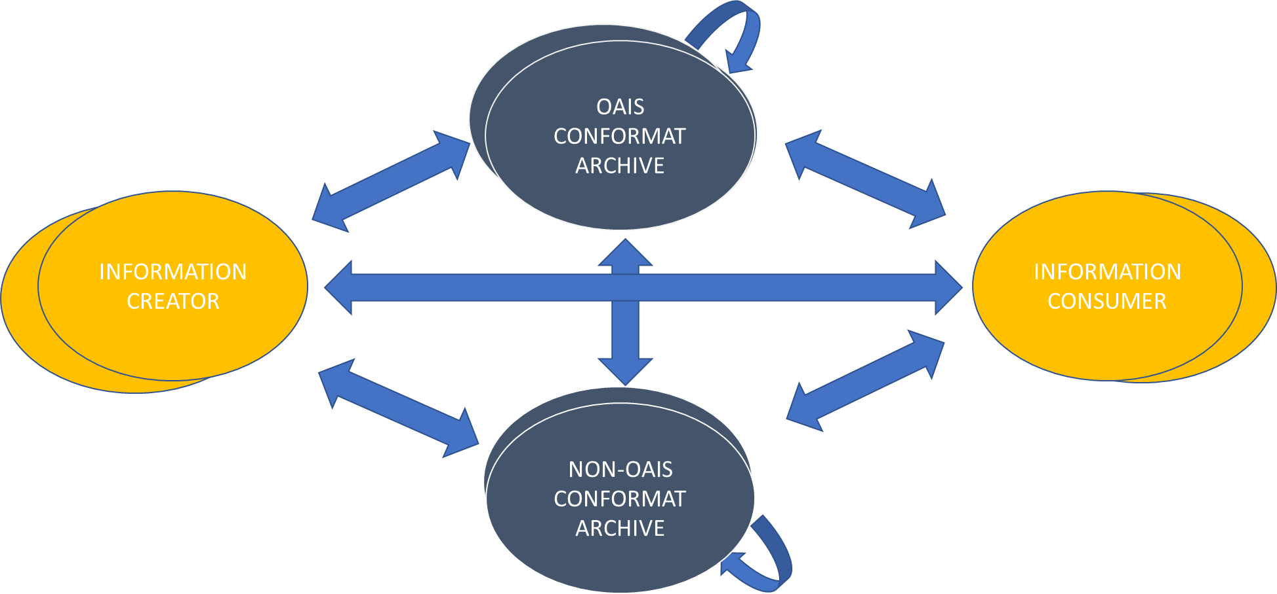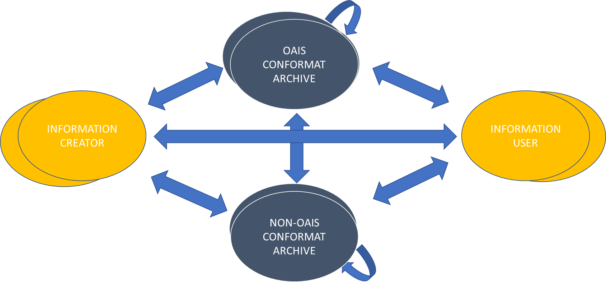

Information of various types is exchanged between

* Information creators
* Information consumers, some of whom may be members of one or more Designated Communities of one or more OAIS conformant archives
* OAIS conformant archives
* Archives which are not OAIS conformant

In the OAIS-IF set of documents all these exchanges of information are assumed to be encoded in one or more Data Objects, with associated Representation Information. It is reasonable to propose that these are packaged together into OAIS Information Packages. The Information Packages are themselves sets of bits, in other words Data Objects. These must be associated with their own Representation Information, of which Packaging Information is a part. The Information Packages will be transmitted between the entities by communication protocols such as TCP/IP, CCSDS DTN etc.

Specific scenarios are listed next.

## Information Producer sends Information to an OAIS ConformaNt Archive

Information is created by an Information Creator. It is sent to an OAIS Archive, via an Information Producer, which may be different from the Information Creator. OAIS defines, in general terms, a Submission Agreement that specifies the intended formats and content descriptions, and any other arrangements needed (such as delivery or transmission protocols), for the Data Submission Sessions. Such specifications establish the intended deliverables from the Producer and how they are represented on each delivery through physical media or in a telecommunication dialogue.

The Submission Agreement may be a document to be interpreted by a human. However of interest for the OAIS-IF requirements is the extent to which these things can be computer interpretable.

The Information Producer may use the PAIS standard to encode the SIPs, in which case OAIS-IF may be used to define how the SIPs are transferred to the OAIS.

However the Information Producer may use a different encoding for the SIPs, in which case OAIS-IF may be used to ensure that the SIPs may be understood by the OAIS.

Issues to be addressed include:

* How to arrange and carry out the transmission
* How to ensure that the Representation Information (Packaging Information) of the package is provided to the archive..
  + If the Producer uses PAIS then the PAIS standard itself can be referred to, but if in the future there are multiple versions of PAIS then the correct version must be identified.
* How to ensure that the Archive can extract components from the Information Package Data Object.
* The OAIS archive will expect to receive, perhaps over the course of several packages, the information required to create an AIP.

If a sequence of transmissions is to be arranged, with authentication mechanisms and fixity checks In these cases a context may need to be maintained for the Information Packages, or the information may be provided in documentary form, rather than through an API.

## Information Creator sends Information to a Non-OAIS conformant archive

This scenario is similar to the one with the OAIS archive. One significant difference is that the archive might not require all the components of an AIP.

## OAIS conformant archive sends information to an Information Consumer

In this scenario the Consumer searches for the information he/she requires and the OAIS Archive sends back information as a response to the search and then the information requested in the form of one or more DIPs.

The following steps are involved:

1. Consumer inputs search criteria and identifies repositories which contain required information
2. Consumer chooses one (or more repositories) and queries what is available.
   1. The user may need to log in to see what s/he is allowed to access
3. The Consumer then obtains the information from the repository
   1. The Consumer may simply get a copy of the whole AIP or
   2. The Consumer may get a piece of information created by the repository suitably processing its holdings

OAIS-IF treats queries and responses as messages in Information Packages. The DIPs are also Information Packages.

Since the archive is OAIS conformant then according to one of the Mandatory Responsibilities a Consumer who is a member of the Designated Community must be able to

1. obtain enough Representation Information to understand/use the Data Object in the DIP and
2. obtain all the information related to Authenticity, and so the OAIS-IF must support this.

If the Consumer is not a member of the Designated Community then it does no harm to allow him/her to have the same functionality but in this case the Archive will not guarantee to be able to supply enough Representation Information to allow that Consumer to understand/use the Data Object.

## Non-OAIS conformant archive sends information to an information consumer

This scenario is similar to the previous one except that the archive may not be able to guarantee to be able to supply Representation Information or evidence about Authenticity.

## OAIS conformant archive exchanges information to another OAIS Archive

The previous scenarios involving an OAIS could apply here, with one of the OAISes acting as either a Producer or Consumer. The special case is where the first OAIS should be able to send a copy of a complete AIP to the second OAIS, either as a single Information Package or as several related packages.

## OAIS conformant archive exchanges information with a non-OAIS Archive

In this case either archive could play the role of Producer or Consumer. The difference from the previous scenario is that complete copies of AIPs are unlikely to be sent from the non-OAIS conformant archive.

## Non-OAIS conformant archive exchanges information with another non-OAIS Archive

This scenario is similar to the previous one but copies of complete AIPs are not likely to be exchanged.

## Additional scenarios

In the following, for generality the term “User” can refer to a Consumer, an archive (whether OAIS conformant or not) or an Information Creator or an Information Producer.

### The USER wants to obtain information from a repository

1. User uses an “identifier” for repository to search and select specific information to obtain an object identifier
2. The user requests the object or part of an object
3. The user receives the object requested

### If required, users are authenticated and authorized

1. User requests authentication
2. The user provides the appropriate username/password or private key etc

### A User wishes to get an AIP

1. The object identifier is confirmed as pointing to an AIP rather than any other object
2. The Data Object of the AIP is retrieved
3. The Representation Information, of which Packaging Information is a part, associated with the Data Object is retrieved.
4. The Package Description Information is retrieved if required

### A User wishes to get information derived from an AIP

1. The user uses the identifier for the AIP to obtain object identifiers for the components of the AIP
2. The user uses that identifier to obtain identifiers for any components of that component for example if the original AIP is an AIC then identifiers for the components

AIPs can be obtained and then identifiers for the components of those AIPs can be obtained, and so on.

### Information is transferred as one or more Information Packages

1. The user uses the object identifier that has been used to obtain local identifiers for the various components of the AIP, or other pieces of information
2. It constructs the object to be transferred e.g.
   1. Extracting the components from internal storage such as a database or filestore
   2. Some components may have sub-components such as individual events relevant to Provenance

# OAIS-IF Requirements

The term “archive” is used for a general information repository, whether conformant to OAIS or not; the term “OAIS” is used where the archive is OAIS conformant.

The following list of requirements for APIs have been identified. Requirements are not placed on the internal workings of the various entities, however some requirements may imply functionality from the archive, but if this functionality is not available then a NULL response may be made, and will be acceptable.

1. APIs, based on, but not restricted to, the OAIS Information Model will be available.
   1. API to deliver entire "AIP”
   2. API to deliver Reference Info / Content Data Object / RepInfo / entire PDI / Context Info / Fixity Info / Rights Info component from an identified AIP
2. An API which allows a negotiation to allow additional Representation Information to be provided, if available, should be part of the set of APIs.
3. An API which allows a negotiation on transformations of the Data Object before transmission, should be part of the set of APIs.
4. An API which allows the parties to agree on or discover a communications protocol to use should be part of the set of APIs.
5. An API to allow the archive to be able to verify that a Consumer requesting access to the archive is authorized.
6. An API to allow the archive to be able to accept SIPs, in particular
   1. Allow the archive to verify that Producer requesting access to the archive is authorized.
   2. Make available the definitions of the types of submission packages that the archive will accept.
   3. one or more interfaces which can be used to submit an SIP and reports back on status of the ingest
7. APIs to support search of the archive to provide an identifier for required information.
8. APIs to retrieve information, as Information Packages, given one or more identifiers.
9. [ANNEX TITLE]

[Annexes contain ancillary information. See CCSDS A20.0-Y-4, *CCSDS Publications Manual* (Yellow Book, Issue 4, April 2014) for discussion of the kinds of material contained in annexes.]