Motivation Aspect

eArchiving Reference Architecture

v0.2 Preliminary Review Version
(shared in a limited group)

CEF eArchiving Building Block, E-ARK3
CEF-TC-2019-3 eArchiving

Cover Sheet

Document Status:
Status
Preliminary Review Version (shared in a limited group)

Document Approver(s)
Name | Role

Document Reviewer(s)
Name | Role

Summary of Changes:
Version | Date | Created by | Short Description of Changes
V0.1 | 08/04/2020 | István Alföldi | First draft
V0.2 | 11/08/2020 | István Alföldi | Preliminary Review Version  (shared in a limited group)

Contributors
Name | Organisation
Aas, Kuldar | National Archives of Estonia
Alföldi, István | Poliphon
Holmelund, Frederik | The Danish National Archives
Jacobsen, Kristin | The National Archives of Norway
Kruithof, Gijsbert | National Archives of the Netherlands
Langeland, Øivind | The National Archives of Norway
Lund, Audun | Swiss Federal Archives
Merenmies, Markus | National Archives of Finland
Nielsen, Anders Bo | The Danish National Archives
Proença, Diogo | University of Lisbon
Schlarb, Sven | Austrian Institute of Technology
Skofljanec, Jože | Archives of the Republic of Slovenia
Skog, Björn | ESS Solutions
Silva, Hélder | KEEP SOLUTIONS
Tømmerholt, Phillip | The Danish National Archives
Trani, Silvia | Central State Archives

Table of Contents

Introduction 8
Our approach 10
Motivation aspect – Metamodel 12
Motivation aspect 16
Stakeholders 16
Drivers 18
Stakeholder – Archive 19
Stakeholder – Data Producer 21
Stakeholder – Solution Provider 23
Stakeholder – Regulatory agencies and policy makers 26
Stakeholder – Data Consumer 27
Principles 29
Goals 30
Requirements 63

Table of Figures
Figure 1: Layers and aspects of the ArchiMate® full framework 9
Figure 2: ArchiMate® elements of the Motivation Aspect 12
Figure 3: Metamodel 13
Figure 4: ArchiMate® aggregation and composition 13
Figure 5: Stakeholders of the eArchiving Reference Architecture 17
Figure 6: Driver Groups 19
Figure 7: Drivers of the Archive stakeholder 20
Figure 8: Drivers of the Data Producer stakeholder 22
Figure 9: Drivers of the Solution Provider stakeholder 24
Figure 10: Drivers of the Regulatory agencies and Policy makers stakeholder 26
Figure 11: Drivers of the Data Consumer stakeholder 28
Figure 12: Principles 30
Figure 13: Drivers of providing long-term accessibility 31
Figure 14: Goals and Principles associated with the driver “Long-term access to information” 32
Figure 15: Goals and principles associated with the drivers of changing environment 34
Figure 16: Goals and principles associated with the driver “Management of information and processes in archives” 36
Figure 17: Goals and principles associated with the drivers 38
Figure 18: Goals and principles associated with the driver “Usability” 41
Figure 19: Goals and principles associated with the driver “Value creation by the reuse of information” 43
Figure 20: Drivers of ensuring trust and compliance 46
Figure 21: Goals and principles associated with the drivers 46
Figure 22: Goals and principles associated with the drivers 49
Figure 23: Goals and principles associated with the driver “Solution trustworthiness” 52
Figure 24: Drivers of sustainability 53
Figure 25: Goals and principles associated with the drivers of sustainability 54
Figure 26: Goals and principles associated with the driver “Business continuity” 56
Figure 27: Goals and principles associated with the driver “Efficiency” 58
Figure 28: Goals and principles associated with the driver “Solution competitiveness” 61

Tables

Table 1: ArchiMate® elements of the Motivation Aspect 13
Table 2: ArchiMate® relationship elements of the Motivation Aspect 13
Table 3: Drivers of the Archive stakeholder 20
Table 4: Drivers of the Data Producer stakeholder 22
Table 5: Drivers of the Solution Provider stakeholder 25
Table 6: Drivers of the Regulatory agencies and Policy makers stakeholder 26
Table 7: Drivers of the Data Consumer stakeholder 28
Table 8: Goals 31
Table 9: Principles realising the goals 32
Table 10: Goals 34
Table 11: Principles realising the goals 35
Table 12: Goals 36
Table 13: Principles realising the goals. 37
Table 14: Goals. 39
Table 15: Principles realising the goals. 40
Table 16: Goals. 41
Table 17: Principles realising the goals. 42
Table 18: Goals. 43
Table 19: Principles realising the goals. 44
Table 20: Goals. 46
Table 21: Principles realising the goals. 47
Table 22: Goals. 49
Table 23: Principles realising the goals. 50
Table 24: Goals. 51
Table 25: Principles realising the goals. 51
Table 26: Goals. 53
Table 27: Principles realising the goals. 54
Table 28: Goals. 55
Table 29: Principles realising the goals. 57
Table 30: Goals. 58
Table 31: Principles realising the goals. 60
Table 32: Goals. 60
Table 33: Principles realising the goals. 62

Introduction
This document defines and describes the motivation elements of the eArchiving Reference Architecture.
eArchiving Reference Architecture
The aim of digital archiving is to help organisations keep their information accessible for as long as it is needed. Trusted availability of information is always dependent on the legal, organisational, and business context of an institution, as well as the evolving needs of the users and customers. Therefore, the implementation of an effective digital archiving solution requires that the technological components of archiving software and hardware are integrated with the aforementioned business and organisational context and needs. Digital archiving can only be reasonably implemented if you understand its role in relation to the rest of your functions.
The eArchiving Reference Architecture aims to support institutions by mapping the crucial strategy and business components of digital preservation. These components are connected to eArchiving specifications and Sample Software in order to help eArchiving implementers decide which components are most reasonable to be used for their specific business context.
The task describes a neutral core eArchiving Reference Architecture which is:
- aligned with the best practices established by the European Interoperability Reference Architecture (EIRA) and
- inspired by Enterprise Architecture conceptual models in the domains of digital preservation and information governance (for example, the outputs of the EC-funded SHAMAN project).
Background and purpose
This document presents the motivations, or reasons, that guide the design of the eArchiving Reference Architecture. It aims to answer the questions of “Why do I need eArchiving?” and “What are the benefits of implementing eArchiving?”
The eArchiving Reference Architecture follows the ArchiMate® specification, where the general logical structure of an Enterprise Architecture is a matrix with Layers modelling the enterprise in a top-down approach and Aspects classifying the elements of the model based on layer-independent characteristics related to the concerns of different stakeholders.
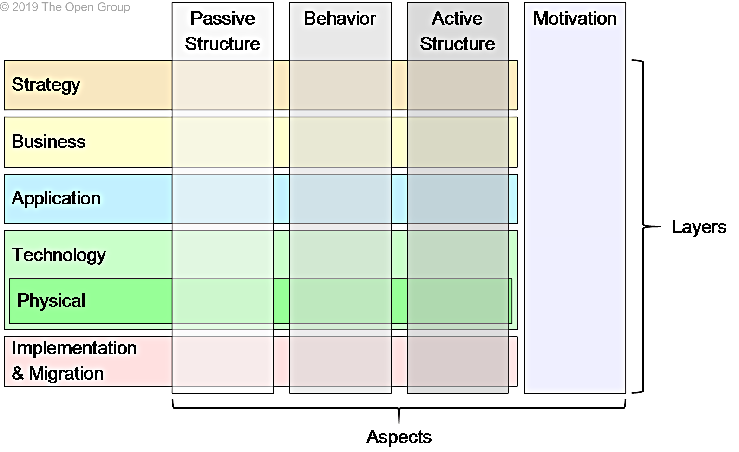
Figure 1: Layers and aspects of the ArchiMate® full framework

Internally the motivation aspect includes the elements of stakeholders, value, drivers, assessments, goals, outcomes, principles, and requirements. The motivation aspect connects specific stakeholders like archives or data creators to the specific needs and benefits like improving transparency or ensuring customer satisfaction.
One of the most important components within the motivation aspect are drivers or the factors that influence the motivation of stakeholders. Drivers can originate from either within or outside an organisation. Internal drivers, also called concerns, are associated with stakeholders, which can be some individual human being or some group of human beings, such as a project team, the entire organisation, or society. Examples of such internal drivers are customer satisfaction, compliance to legislation, or profitability. However, drivers of change may also be external to the organisation (e.g. economic change or changing legislation).
Documents of the eArchiving Reference Architecture
At the time of publishing this v.02 release, the documentation of the eArchiving Reference Architecture consists of the following documents:
- Motivation Aspect document – a detailed description of the motivation aspect elements (stakeholders, drivers, goals and requirements) and their relationships (this document).
- Principles – a separate document defining the eArchiving principles.

Our approach
The eArchiving Motivation Aspect approximately follows the motivation metamodel as defined by ArchiMate® (see next section for further details). The work to date (summer 2020) covers the following elements of the model.

Principles
The first element developed within the eArchiving Reference Architecture work was the Principles for long-term accessibility of information. Though the Motivation aspect defines Principles as one component, we decided to separate and prioritise the work because of extensive community interest. As such, the first version of eArchiving principles has already been released in early 2020 and reviewed by a limited set of experts. This document is accompanied by a second revision of the principles document which takes into account received feedback.
Stakeholders
The eArchiving Reference Architecture reuses the three direct generic stakeholder types defined for the wider eArchiving Building Block: archives, data producers, and solution providers. However, the reference architecture extends the list with two additional indirect stakeholders: regulatory agencies and data consumers. The reason is that while both are not directly involved in the establishment of digital archives, they are highly relevant in terms of the motivation and drivers in digital archiving.

Drivers and Goals
Within the ArchiMate® specification, a driver represents an external or internal condition that motivates an organisation to define its goals and implement the changes necessary to achieve them. The drivers and goals of the eArchiving Reference Architecture have been developed from the top down. This means that first drivers were defined separately for each of the five stakeholder groups. The work then continued by defining specific goals for each driver. Finally, the goals were grouped and presented by drivers in order to also visualise overlaps across different stakeholders (i.e. see what is common and what is different in the drivers and goals of individual stakeholders).
Goals and Principles
In the ArchiMate® motivation metamodel, a goal associated with a driver is realised by some principles. As the eArchiving principles already existed before the development of goals, we had the opportunity to check the consistency of goals by linking them with principles. This allowed us to combine both top-down and bottom-up approaches and created the opportunity to adjust the goals and principles until they accurately matched each other.
Requirements
The most detailed component of the Motivation aspect is the requirements which define a specific realisation for the principles and goals. This version of the motivation aspect does not contain any requirements yet. Instead, requirements will be added after the definition of the Business Layer.

Archival terms and concepts are defined in many related standards (e.g. ISO 16175, ISO 17068 ISO 15489, ISO 14721, ISO 16363), and (to say the least) they are not consistent with each other. We do not intend to create a new set of definitions; on the other hand, we would like to use the archival terms consistently throughout the documents of the reference architecture. Please, refere to the Glossary section of the Principles document, where we provide explanations about the intended meaning of the most important or most ambiguous terms.

This document includes the textual descriptions, rationales and relevant diagrams for eArchiving stakeholders, drivers and goals. The full motivation aspect model is also available as an ArchiMate® file on demand.

Motivation aspect – Metamodel
ArchiMate® defines a number of standard viewpoints for modelling motivational aspects. Each of these viewpoints presents a different perspective on modelling the motivation that underlies some Enterprise Architecture and allows to focus on certain aspects. Therefore, each viewpoint considers only a selection of the elements and relationships. The following viewpoints are identified:
- The stakeholder viewpoint focuses on modelling the stakeholders, drivers, and the initial goals to address these drivers and assessments.
- The goal realisation viewpoint focuses on refining the initial, high-level goals into more concrete (sub-) goals using the composition and/or aggregation relationship, and finally into requirements.
- The goal contribution viewpoint focuses on modelling and analysing the influence of relationships between goals (and requirements).
- The principles viewpoint focuses on modelling the relevant principles and the goals that motivate these principles.
- The requirements realisation viewpoint focuses on modelling the realisation of requirements by means of core elements, such as actors, services, processes, application components, etc.
- The motivation viewpoint covers the entire motivational aspect and allows the use of all motivational elements.
To generate these viewpoints, the set which the E-ARK Reference Architecture team decided to use were identified, which is highlighted in the image below.

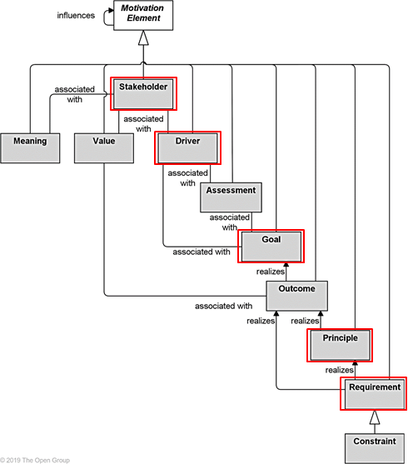
Figure 2: ArchiMate® elements of the Motivation Aspect

This selection of motivation elements result in the following metamodel that is used throughout this document.
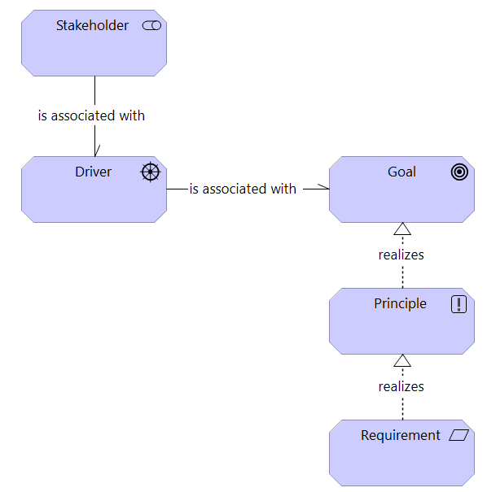
Figure 3: Metamodel
A stakeholder can be associated with one or more drivers, and a driver can be associated with one or more goals. A goal is realised by one or more principles. Finally, a principle is realised by one or more requirements. These motivation elements can be decomposed into elements of the same type. For example, a goal can be decomposed into sub-goals, this relationship is depicted with the composition relationship (when a sub-goal is only part of one goal) or with the aggregation relationship (when a sub-goal is part of more than one goal). These relationships are depicted in the image below.

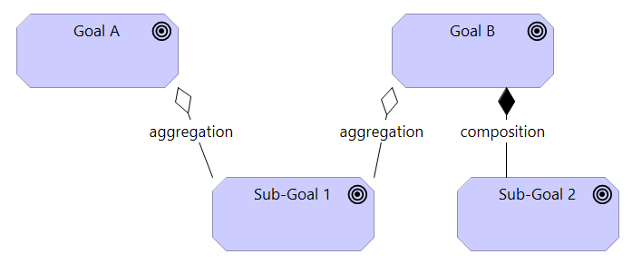
Figure 4: ArchiMate® aggregation and composition

The motivation elements and respective definitions and notation are detailed in the table below.
Element | Definition | Notation
Stakeholder | The role of an individual, team, or organisation (or classes thereof) that represents their interests in the effects of the architecture.
Driver | An external or internal condition that motivates an organisation to define its goals and implement the changes necessary to achieve them.
Goal | A high-level statement of intent, direction, or desired end state for an organisation and its stakeholders.
Principle | A statement of intent defining a general property that applies to any system in a certain context in the architecture.
Requirement | A statement of need defining a property that applies to a specific system as described by the architecture.

Table 1: ArchiMate® elements of the Motivation Aspect

Relationship | Definition | Notation
Structural relationships
Aggregation | The aggregation relationship indicates that an element combines one or more other concepts.
Composition | The composition relationship indicates that an element consists of one or more other concepts.
Realisation | The realisation relationship indicates that an entity plays a critical role in the creation, achievement, sustenance, or operation of a more abstract entity.
Other relationships
Association | An association relationship indicates an unspecified relationship or one that is not represented by another ArchiMate® relationship.
Table 2: ArchiMate® relationship elements of the Motivation Aspect
Status of the document
The motivation aspect elements below are not final. At this point, we have gathered a consistent initial set of drivers, goals, and principles sufficient to continue with defining the strategy and business layers of the Reference Architecture. We are well aware that we will most likely have to reformulate or restructure them.

We would like to share this (and later) versions of the Motivation Aspect with a restricted group of professionals in order to hear their opinion and suggestions. So, this document represents an intermediate stage of our work. It can be shared with anybody understanding the above limitations.

Motivation aspect

Stakeholders
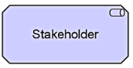

In the ArchiMate® specification, a Stakeholder represents the role of an individual, team, or organisation (or classes thereof) that represents their interests in the effects of the architecture. This definition is based on the TOGAF® (The Open Group Architecture Framework) definition where a Stakeholder has one or more interests in, or concerns about, the organisation and its enterprise architecture. In order to direct efforts to these interests and concerns, stakeholders change, set, and emphasise goals.
The CEF eArchiving Building Block has defined three generic stakeholder types of the building block: archives, data producers, solution providers. The stakeholder list of the reference architecture is extended with two additional stakeholders: regulatory agencies and the data consumer. In a very high-level view, these stakeholders can include a variety of institutions, groups or even individuals. In order to be practical, these stakeholder groups have to be more clearly defined and refined.

For the initial stages of the eArchiving Reference Architecture development (2020), the work will concentrate on addressing the needs of the following specific institutional settings:

- Data Producers
Those entities that are, or expect to be in the future, directly or indirectly responsible for the depositing of content in a digital archive for long-term digital preservation, which guarantees that information has not changed over time, and still have the same legal value, and attributes such as fixity that shows it is authentic etc. This might include any entity that, in the course of its business activities, is producing or receiving information that is subject to the requirements of long-term access. Examples include:
  - Public sector agencies creating long-term valuable and archival value records (such as, government departments that are obliged to transfer their records to local, regional or national archives for long-term digital preservation).
  - Any organisation that produces records that need to be stored (such as private sector organisations/businesses).
  - Organisations producing any type of digital material (such as museums with digital displays, art galleries with software art, etc.
  - Records/information management service providers.

- Archives
Those entities that are, or expect to be, directly or indirectly responsible for the governance of a digital archive, which provides long-term digital preservation. Examples are:
  - Public archives (national, regional, local)
  - Long-term preservation and access units/departments in public and private sector agencies
  - Private archives (incl. long-term preservation and access service providers)

- Solution Providers
Those entities that are, or expect to be in the future, providers of technology or services for digital archives or for data creators. Examples are:
  - Software providers
  - Cloud hosts
  - Cloud-based archiving service providers
  - Digitisation, technology integrators, etc.

- Regulatory agencies and policymakers
Those entities (public authorities or government agencies) that are, or expect to be in the future, responsible for preparing, issuing and/or supervising the execution of regulations and policies related to the long-term preservation of digital information. Examples are:
  - Ministries or public administration bodies responsible for information governance
  - Ministries or public administration bodies responsible for cultural heritage
  - Ministries or public administration bodies responsible for IT security
  - National archives.

- Data Consumers
Organisations or individuals that want and/or need to reuse the information kept within an archive. Consumers are a wide stakeholder group with further subgroups. The most common ones are:
  - Organisations accessing information they had earlier archived within the archive.
  - Individuals accessing information stored in the archive about themselves, in order to prove identities or rights
  - Individuals accessing information about their relatives, municipalities or past events as a hobby or personal interest (i.e. hobby historians)
  - Researchers accessing public or restricted information needed for their research.

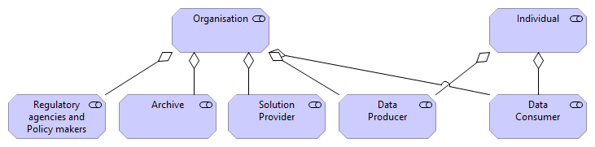

Figure 5: Stakeholders of the eArchiving Reference Architecture

Drivers
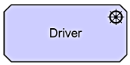

In the ArchiMate® specification, a Driver represents an external or internal condition that motivates an organisation to define its goals and implement the changes necessary to achieve them.
Drivers that are associated with a stakeholder are often called “concerns” of that stakeholder. Stakeholder concerns are defined in the TOGAF® framework as “an interest in a system relevant to one or more of its stakeholders. Concerns may pertain to any aspect of the system’s functioning, development, or operation, including considerations such as performance, reliability, security, distribution, and evolvability and may determine the acceptability of the system.
The drivers are listed by stakeholders, mostly because the generic approach to drivers is different for each stakeholder:
- for archives and solution providers the drivers are mainly about “how to do digital archiving”;
- for data providers and regulatory agencies it is about “what is the benefit of doing/implementing digital archiving”;
- for data consumers, it is about “what is the user expectation towards archives”.
Please note, that drivers for the service providers, data providers, regulatory agencies are partial as we have included only the ones related to digital archiving (i.e. not the ones related to the core business of the stakeholder).
In order to provide a better understanding of the drivers, we have grouped them into three categories:
- Provide long-term accessibility,
- Ensure trust and compliance,
- Sustainability and business support.

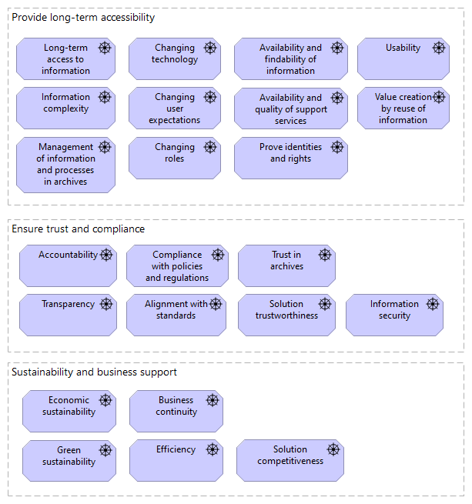
Figure 6: Driver Groups

Stakeholder – Archive

Drivers for an archive are mainly concerns about:
- how to implement or improve digital archiving,
- how to ensure trust and compliance,
- how to answer the challenges of an ever-changing environment.

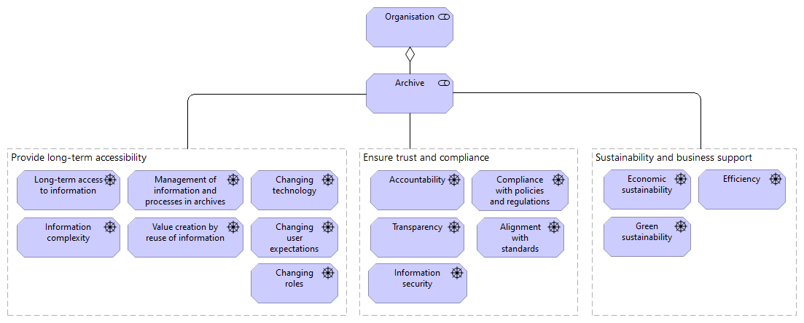
Figure 7: Drivers of the Archive stakeholder

Driver | Description
Group: Provide long-term accessibility
Long-term access to information | The key value provided by archiving is long-term accessibility (the ability to find and reuse information to offer services, prove transactions, rights, etc.).
Information complexity | New types of information structures and increasing information volumes drive the need for new approaches to long-term accessibility.
Management of information and processes in archives | Delivering authentic, complete, usable, and understandable objects to the designated user community motivates the need for management of the digital objects and processes which ensure the preservation of the objects.
Value creation by reuse of information | One key reason for organisations to establish an archive is the need to reuse information either in the long-term or in contexts other than the initial creation of information.  Examples of archival reuse and value creation include: longitudinal studies in science, big data analysis to evaluate new business opportunities, or the use of geo- and meteorological data in rural planning.
Changing technology | The main goal of archiving is to ensure access to authentic information and its context, as long as necessary. Consequently, organisations must strive to be in line with the ever-changing technology environment.
Changing user expectations | Users have continuously-changing expectations regarding access and navigation of materials. Example: Navigation on mobile devices.
Changing roles | The digital transformation of the society as a whole, and also of the public sector, challenges the way responsibilities and tasks regarding long-term accessibility traditionally have been understood across data producers and archives. These stakeholders now must redefine and reframe their roles in the context of a digital public sector.
Group: Ensure trust and compliance
Accountability | Accountability is the obligation to answer for actions for which one is responsible.
Transparency | Through transparency, we improve trust from users and reduce the risk of losing trust.
Information security | Establishing and maintaining appropriate digital security procedures that guarantee accessibility and Confidentiality.
Compliance with policies and regulations | To fulfil their mission, every organisation that is concerned with long-term information accessibility must be aware and comply with national, local and institutional policies and regulations.  The policies and regulations that are relevant for long-term information accessibility come in three main categories:  - Records and archives management, data and information governance,  - Data protection, access to information, public sector Information,  - Use of ICT, IT interoperability, architecture, and security.
Alignment with standards | Long-term accessibility is, to a large extent concerned with the standardisation of processes, data, information and infrastructures. Alignment with international and local de jure and de facto standards helps organisations to provide continuous preservation and access in a more sustainable manner and is also a crucial factor in fulfilling the aim of accountability, transparency, security and compliance.
Group: Sustainability and business support
Green sustainability  Economic sustainability | Long-term availability of information has an environmental price. IT infrastructures have a huge impact on the environment. There is a need for data producers and archives to keep their “carbon footprint” as small as possible to guarantee green sustainability. All organisations must guarantee that solutions and procedures support long-term economic growth without impacting economic sustainability.
Efficiency | Long-term access should not require excessive resources (like storage, electricity, staff, etc.). Every organisation must always take into account that the measures and processes implemented are pragmatic, sufficient; and politically, technically, organisationally and financially possible.

Table 3: Drivers of the Archive stakeholder

Stakeholder – Data Producer

The drivers for a data producer are mainly concerns about:
- what is the benefit of doing/implementing digital archiving,
- how can digital archiving provide solutions to the challenges of an ever-changing environment.

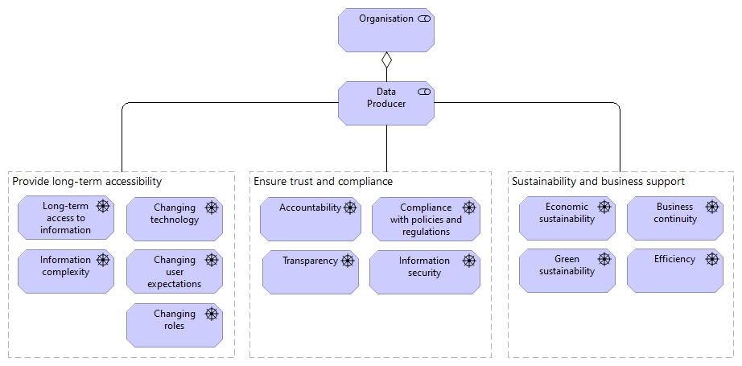
Figure 8: Drivers of the Data Producer stakeholder

Driver | Description
Group: Provide long-term accessibility
Long-term access to information | The key value provided by archiving is long-term accessibility – the possibility to find and reuse information in order to offer services, prove transactions, rights, etc.
Information complexity | New types of information structures and increasing information volumes drive the need for new approaches to long-term accessibility.
Changing technology | The main goal of archiving is to ensure access to authentic information and its context, as long as necessary; as a result, organisations must strive to be in line with the ever-changing technology environment.
Changing user expectations | Users have ever-changing expectations regarding access and navigation of materials. Example: Navigation on mobile devices.
Changing roles | The digital transformation of the society as a whole, and also of the public sector, challenges the way responsibilities and tasks regarding long-term accessibility traditionally have been understood across data producers and archives. These stakeholders now must redefine and reframe their roles in the context of a digital public sector.
Group: Ensure trust and compliance
Accountability | Accountability is the obligation to answer for actions for which one is responsible.
Transparency | Through transparency, we improve trust from users and reduce the risk of losing trust.
Information security | Establishing and maintaining appropriate digital security procedures that guarantee accessibility and confidentiality.
Compliance with policies and regulations | To fulfil their mission, every organisation that is concerned with long-term information accessibility must be aware and comply with national, local and institutional policies and regulations.  The policies and regulations which are relevant for long-term information accessibility come in three main categories:  - Records and archives management, data and information governance,  - Data protection, Access to Information, Public Sector Information,  - Use of ICT, IT interoperability, architecture, and security.
Group: Sustainability and business support
Green sustainability  Economic sustainability | Long-term availability of information has an environmental price. IT infrastructures have a huge impact on the environment. There is a need for data producers and archives to keep their “carbon footprint” as small as possible to guarantee green sustainability.  All organisations must guarantee that solutions and procedures support long-term economic growth without impacting economic sustainability.
Business continuity | Available and accessible information can be a powerful asset in crisis situations. It is necessary to understand that archiving is, therefore, one of the key components for ensuring business continuity.
Efficiency | It is necessary to ensure that Long-term access does not require too many resources (like storage, electricity, staff, etc.). Every organisation must always take into account that the measures and processes implemented are pragmatic, sufficient; and politically, technically, organisationally and financially possible.
Table 4: Drivers of the Data Producer stakeholder

Stakeholder – Solution Provider

The drivers for a solution provider are mainly concerns about:
- how to provide or improve digital archiving solutions,
- how to ensure trust and compliance through the provided solutions,
- how to answer the challenges of an ever-changing environment.

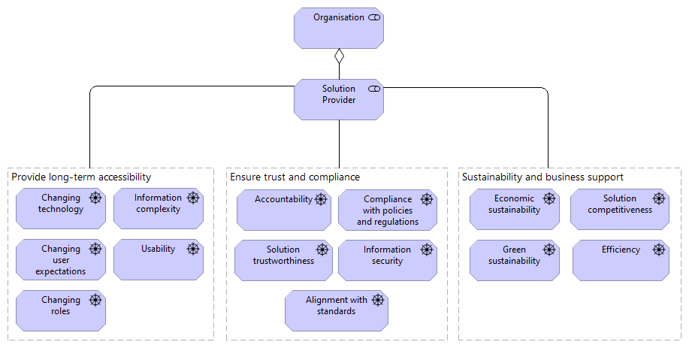
Figure 9: Drivers of the Solution Provider stakeholder

Driver | Description
Group: Provide long-term accessibility
Information complexity | New types of information structures and increasing information volumes drive the need for new approaches to long-term accessibility.
Usability | One of the main goals of archives is to ensure the long-term availability and usability of information. Usability from the data consumer perspective includes:  - sufficient metadata to interpret the information and its context,  - sufficient presentation capabilities,  - appropriate links to connected resources,  - tools and methods to view and interpret information.
Changing technology | The main goal of archiving is to ensure access to authentic information and its context, as long as necessary, as a result organiations must strive to be in line with the ever-changing technology environment.
Changing user expectations | Users have ever changing expectations regarding access and navigation of materials. Example: Navigation on mobile devices.
Changing technology | The main goal of archiving is to ensure access to authentic information and its context, as long as necessary, as a result, organisations must strive to be in line with the ever-changing technology environment.
Changing user expectations | Users have ever-changing expectations regarding access and navigation of materials. Example: Navigation on mobile devices.
Changing roles | The digital transformation of the society as a whole, and also of the public sector, challenges the way responsibilities and tasks regarding long-term accessibility traditionally have been understood across data producers and archives. These stakeholders now must redefine and reframe their roles in the context of a digital public sector.
Group: Ensure trust and compliance
Accountability | Accountability is the obligation to answer for actions for which one is responsible.
Information security | Establishing and maintaining appropriate digital security procedures that guarantee accessibility and Confidentiality.
Compliance with policies and regulations | To fulfil their mission, every organisation that is concerned with long-term information accessibility must be aware of and comply with regulations.  Examples: Legislation affecting and influencing the availability of information (Freedom of Information and public sector information acts), retention periods (sector-specific regulations), and data protection (GDPR); national records management, data and information governance acts.
Alignment with standards | Long-term accessibility is, to a large extent concerned with the standardisation of processes, data, information and infrastructures. Alignment with international and local de jure and de facto standards helps organisations to provide continuous preservation and access in a more sustainable manner and is also a crucial factor in fulfilling the aim of accountability, transparency, security and compliance.
Solution trustworthiness | Solutions have to be able to ensure credibility, dependability and transparency. This means how well solutions comply to requirements, how reliable solutions are in relation to expectations and how transparent and transferable solutions will be today and tomorrow.
Group: Sustainability and business support
Green sustainability  Economic sustainability | Long-term availability of information has an environmental price. IT infrastructures have a huge impact on the environment. There is a need for data producers and archives to keep their “carbon footprint” as small as possible to guarantee green sustainability.  All organisations must guarantee that solutions and procedures support long-term economic growth without impacting economic sustainability.
Efficiency | Long-term access has to make sure that it does not require too many resources (like storage, electricity, staff, etc.). Every organisation must always take into account that the measures and processes implemented are pragmatic, sufficient; and politically, technically, organisationally and financially possible.
Solution Competitiveness | Solutions must be competitive in relation to other solutions to ensure market shares, trustworthiness and innovation.

Table 5: Drivers of the Solution Provider stakeholder

Stakeholder – Regulatory agencies and policy makers

Drivers for a regulatory agency or policy maker are mainly concerns about:
- what is the benefit of doing/implementing digital archiving,
- how can trust and usability ensured/improved with standardisation or legislation,
- how can digital archiving regulations provide solutions to the challenges of an ever-changing environment.

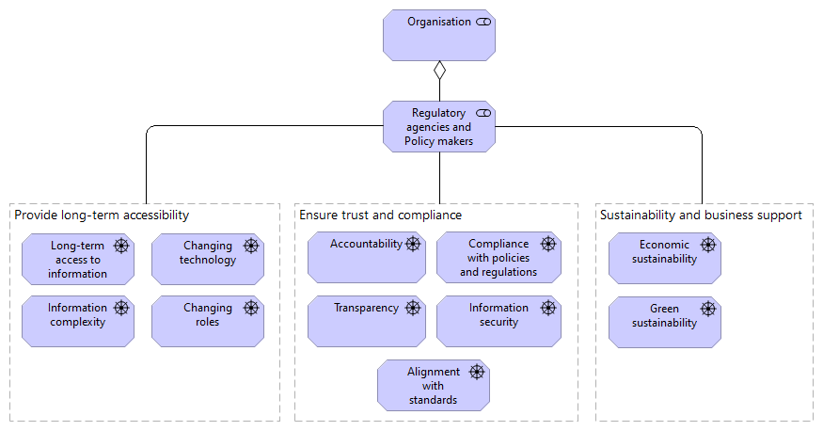
Figure 10: Drivers of the Regulatory agencies and Policy makers stakeholder

Driver → Subdriver | Description
Group: Provide long-term accessibility
Long-term access to information | The key value provided by archiving is long-term accessibility – the possibility to find and reuse information in order to offer services, prove transactions, rights, etc.
Information complexity | New types of information structures and increasing information volumes drive the need for new approaches to long-term accessibility.
Changing technology | The main goal of archiving is to ensure access to authentic information and its context, as long as necessary, as a result, organisations must strive to be in line with the ever-changing technology environment.
Changing roles | The digital transformation of society as a whole, and also of the public sector, challenges the way responsibilities and tasks regarding long-term accessibility traditionally have been understood across data producers and archives. These stakeholders now must redefine and reframe their roles in the context of a digital public sector.
Group: Ensure trust and compliance
Accountability | Accountability is the obligation to answer for actions for which one is responsible.
Transparency | Through transparency, we improve trust from users and reduce the risk of losing trust.
Information security | Establishing and maintaining appropriate digital security procedures that guarantee accessibility and confidentiality.
Compliance with policies and regulations | To fulfill their mission every organisation that is concerned with long-term information accessibility must be aware and comply with regulations.  Examples: Legislation affecting and influencing the availability of information (Freedom of Information and public sector information acts), retention periods (sector-specific regulations), and data protection (GDPR); national records management, data and information governance acts.
Group: Sustainability and business support
Green sustainability  Economic sustainability | Long-term availability of information has an environmental price. IT infrastructures have a huge impact on the environment. There is a need for data producers and archives to keep their “carbon footprint” as small as possible to guarantee green sustainability.  All organisations must guarantee that solutions and procedures support long-term economic growth without impacting economic sustainability.

Table 6: Drivers of the Regulatory agencies and Policy makers stakeholder

Stakeholder – Data Consumer
Drivers for a data consumer are mainly concerns about:
- what kind of information can an archive provide,
- what kind of access services and support can an archive provide,
- and in general “why should I choose one archive instead of another”.

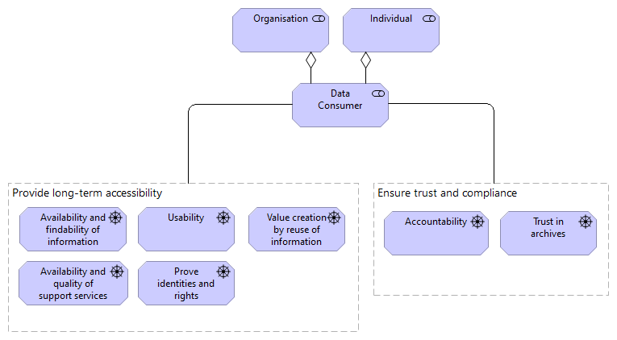
Figure 11: Drivers of the Data Consumer stakeholder

Driver → Subdriver | Description
Group: Provide long-term accessibility
Availability and findability of information | Data consumers (e.g. citizens, researchers) are interested in the availability and easy finding of the information they are looking for.
Availability and quality of support services | Quality of the access services as well as skills of the staff are essential for professional users like researchers, who work with archival repositories on a daily basis. They need state-of-the-art search, access, visualisation and support services.
Prove identities and rights | Citizens and organisations frequently turn to archives for information proving their (or their families’) rights or identities. They are usually not practised archive users. They need help and easy-to-use services in order to find the required information.
Usability | One of the main goals of archives is to provide the long-term availability and usability of information. Usability from the data consumer perspective include:  - sufficient metadata to interpret the information and its context,  - sufficient presentation capabilities,  - appropriate links to connected resources,  - tools and methods to view and interpret information.
Value creation by reuse of information | One key reason for organisations to establish an archive is the need to reuse information either in long-term or in contexts other than the initial creation of information.  Examples of archival reuse and value creation include: longitudinal studies in science, big data analysis to evaluate new business opportunities, or the use of geo- and meteorological data in rural planning.
Group: Ensure trust and compliance
Accountability | Accountability is the obligation to answer for actions for which one is responsible.
Trust in archives | Data consumers must trust the archival repository that the information managed in the repository is authentic, reliable and accessible with the required access rights (and rejected without them).

Table 7: Drivers of the Data Consumer stakeholder

Principles

In the ArchiMate® specification a Principle represents a statement of intent defining a general property that applies to any system in a certain context in the architecture. A system may refer to any active structural element, behaviour element, or passive structural element of some organisation, such as a business actor, application component, business process, application service, business object, or data object.

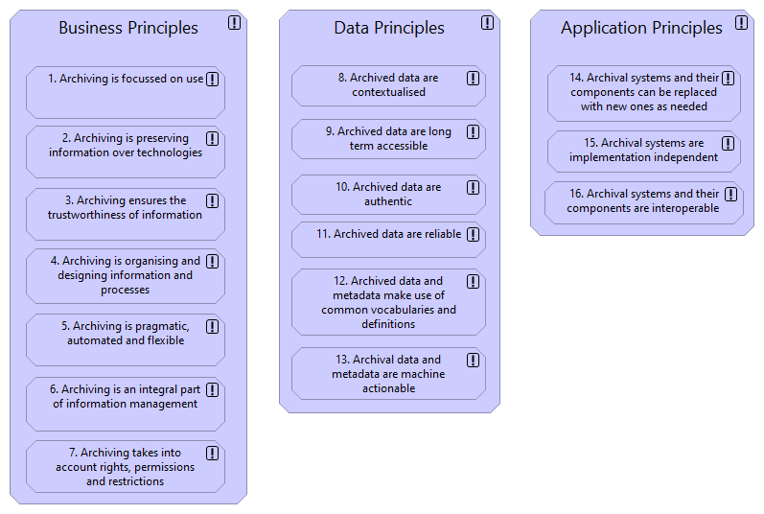
Figure 12: Principles

The eArchiving principles are described in a separate document: Principles for long-term accessibility of information.

Goals
In the ArchiMate® specification a Goal represents a high-level statement of intent, direction, or desired end state for an organisation and its stakeholders.
In principle, a goal can represent anything a stakeholder may desire, such as a state of affairs, or a produced value. Examples of goals are: to increase profit, to reduce waiting times at the helpdesk, or to introduce online portfolio management. Goals are typically used to measure the success of an organisation.
A goal is always associated with a driver. The goals below are presented by driver (in some cases a pair or group of similar drivers). In the ArchiMate® specification the goals are then “realised” by principles. Here we present the principles along with the goals they realise.

Figure 13: Drivers of providing long-term accessibility

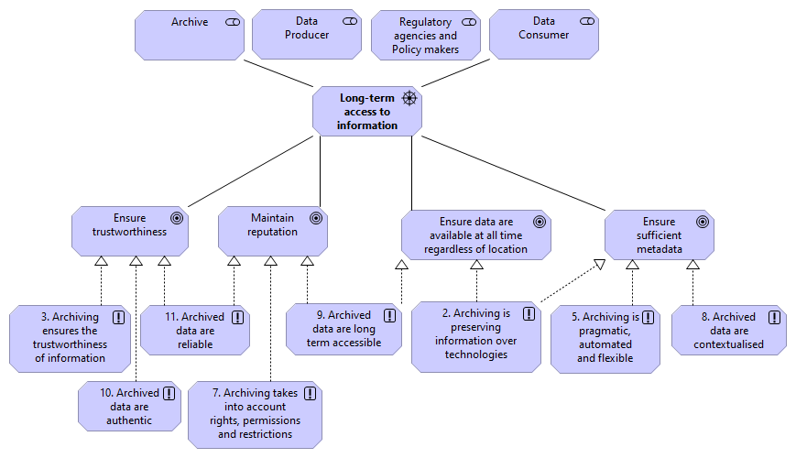
Figure 14: Goals and Principles associated with the driver “Long-term access to information”

Goal | Description
Ensure trustworthiness | It is possible for users in the designated communities to assess the trustworthiness of relevant archives.
Maintain reputation | Actors involved with archives conduct themselves in order to maintain their reputation.
Ensure data are available at all times regardless of location | Archived data are accessible for the intended users whenever needed, not bound by location or time, but adhering to any relevant regulations, such as the GDPR.
Ensure sufficient metadata | Information in archives have sufficient metadata to enable long-term accessibility.

Table 8: Goals

Goal  Principle | Rational
Ensure trustworthiness
3. Archiving ensures the trustworthiness of information | Users must be able to assess the preserved information to ensure trustworthiness.
10. Archive data are authentic | Users must be able to establish whether the information object is what it claims to be, that it was created or submitted by the person or organisation that claims to have created or submitted it, and that it was created and submitted at the time indicated by the information object.
11. Archive data are reliable | Users must be able to establish the reliability of archived information.
Maintain reputation
7. Archiving takes into account rights, permissions and restrictions | Archiving respects legal restrictions to the reuse of data and makes sure that information is available only when appropriate rights and permissions are in place.
9. Archived data are long-term accessible | Archiving should ensure that information is identifiable, available, interpretable, and meaningful for as long as it is needed
11. Archived data are reliable | Users must be able to establish the reliability of archived information.
Ensure data are available at all times regardless of location
2. Archiving is preserving information over technologies | Not being reliant on originating systems, technologies, and media allows for increased flexibility in the choice of solutions which in turn improves competitiveness.
9. Archived data are long-term accessible | Archiving should ensure that information is identifiable, available, interpretable, and meaningful for as long as it is needed
Ensure sufficient metadata
2. Archiving is preserving information over technologies | Not being reliant on originating systems, technologies, and media allows for increased flexibility in the choice of solutions which in turn improves competitiveness.
5. Archiving is pragmatic, automated, and flexible | In order to be able to implement solutions which are sufficient, automated as possible, and possible to be efficiently updated or changed in future the organisation must retain relevant staff and skills capable of completing these tasks.
8. Archived data are contextualised | Data usability is greatly improved when data in archives are sufficiently contextualised so that it can be correctly interpreted.

Table 9: Principles realising the goals

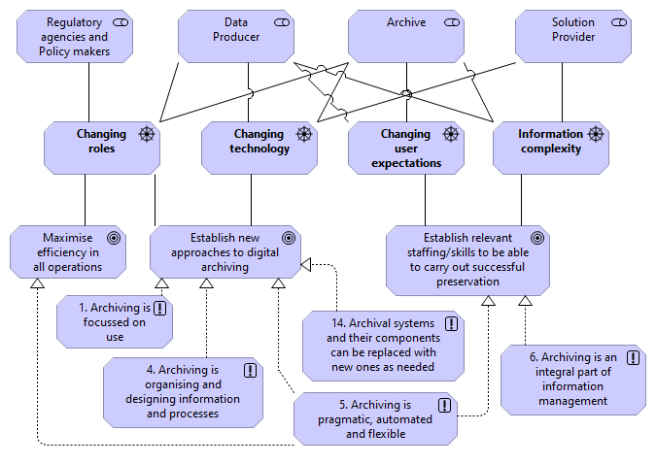
Figure 15: Goals and principles associated with the drivers of changing environment

Goal | Description
Changing roles
Establish new approaches to digital archiving | Regulations, business models, work processes and IT-solutions open up and facilitate exploration of new ways to work with archives in a digital age.
Maximise efficiency in all operations | Efficiency is a key concern when designing both regulations, business models, work processes, IT-solutions and so forth. This is not only a matter of going faster but also doing things differently.
Changing technology
Establish new approaches to digital archiving | Regulations, business models, work processes and IT-solutions open up and facilitate exploration of new ways to work with archives in a digital age.
Changing user expectations
Establish relevant staffing/skills to be able to carry out successful preservation | Institutions that deal with archives work in an interdisciplinary way and combine new skill sets to cope with the challenges of long-term digital accessibility.
Information complexity
Establish relevant staffing/skills to be able to carry out successful preservation | Institutions that deal with archives work in an interdisciplinary way and combine new skill sets to cope with the challenges of long-term digital accessibility.
Table 10: Goals

Goal  Principle | Rational
Establish new approaches to digital archiving
1. Archiving is focussed on use | Solution providers play a key role in bringing new features and capabilities into archival systems. The process of selecting and prioritising feature requests needs to be closely coordinated with the archival community and other interest groups, always taking the legislation of the corresponding European country into consideration. It needs to be ensured that this process is not decoupled from the actual community needs and the intended use of archiving, and therefore requires a strategy and related management practice.
4. Archiving is organising and designing information and processes | Adding an archiving function after the work processes and information systems are fully operational requires extra time, effort, and money. In turn, it reduces competitiveness. The solution is to determine which transactions should be archived in which way when designing work processes and designing information systems that support work processes.
5. Archiving is pragmatic, automated, and flexible | To be able to implement solutions which are sufficient, automated as possible, and possible to be efficiently updated or changed in future the organisation must retain relevant staff and skills capable of completing these tasks.
14. Archival systems and their components can be replaced with new ones as needed | Ensuring that archival systems and their components can be replaced with new ones as needed facilitates the establishment of new approaches to digital archiving.
Maximise efficiency in all operations
5. Archiving is pragmatic, automated, and flexible | To be able to implement solutions which are sufficient, automated as possible, and possible to be efficiently updated or changed in future the organisation must retain relevant staff and skills capable of completing these tasks.
Establish relevant staffing/skills to be able to carry out successful preservation
5. Archiving is pragmatic, automated, and flexible | To be able to implement solutions which are sufficient, automated as possible, and possible to be efficiently updated or changed in future the organisation must retain relevant staff and skills capable of completing these tasks.
6. Archiving is an integral part of information management | Many of the tasks that ensure long-term accessibility are not unique to archiving but also relevant to information management in general. As a result, organisations must possess the relevant staff and skills in the information management domain.

Table 11: Principles realising the goals

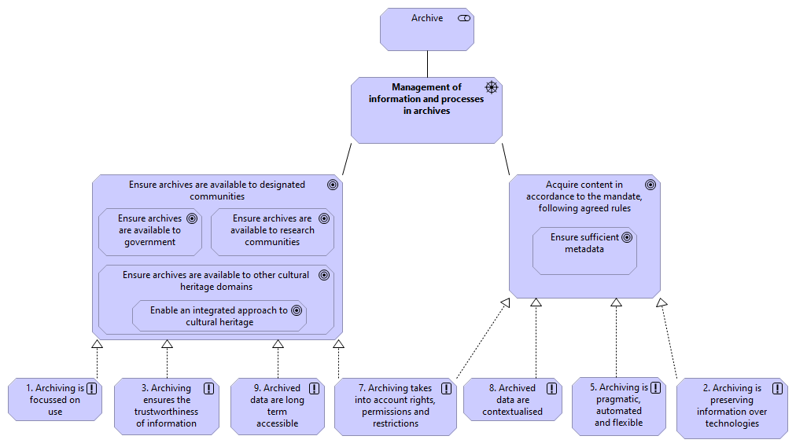
Figure 16: Goals and principles associated with the driver “Management of information and processes in archives”

Goal | Description
Ensure archives are available to designated communities | Institutions that deal with archives amass knowledge about the relevant designated communities and use this to plan for long-term accessibility.
- Ensure archives are available to research communities | Research communities are a special type of designated community. Their needs are well understood and given considerable weight when planning for long-term accessibility.
- Ensure archives are available to Government | Government is a special type of designated community. Their needs are well understood and given considerable weight when planning for long-term accessibility.
- Ensure archives are available to other cultural heritage domains | The needs of other cultural heritage domains are considered when planning for long-term accessibility.
- Enable an integrated approach to cultural heritage | Information in archives underpins an integrated approach to cultural heritage for Europe as approved by the European Parliament on 8 September 2015.
Acquire content in accordance with the mandate, following agreed rules | Information that is intended for long-term preservation is identified and processed to ensure long-term accessibility.
- Ensure sufficient metadata | Information in archives have sufficient metadata to enable long-term accessibility.

Table 12: Goals

Goal  Principle | Rational
Ensure archives are available to designated communities
1. Archiving is focussed on use | Solution providers play a key role in bringing new features and capabilities into archival systems. The process of selecting and prioritising feature requests needs to be closely coordinated with the archival community and other interest groups, always taking the legislation of the corresponding European country into consideration. It needs to be ensured that this process is not decoupled from the actual community needs and the intended use of archiving, and therefore requires a strategy and related management practice.
3. Archiving ensures the trustworthiness of information | To ensure trustworthiness, users must be able to assess the preserved information.
7. Archiving takes into account rights, permissions and restrictions | Archiving respects legal restrictions to the reuse of data and makes sure that information is available only when appropriate rights and permissions are in place.
9. Archived data are long-term accessible | Archiving should ensure that information is identifiable, available, interpretable, and meaningful for as long as it is needed
Acquire content in accordance with the mandate, following agreed rules
2. Archiving is preserving information over technologies | Not being reliant on originating systems, technologies, and media allows for increased flexibility in the choice of solutions which in turn improves competitiveness.
5. Archiving is pragmatic, automated, and flexible | In order to be able to implement solutions which are sufficient, automated as possible, and possible to be efficiently updated or changed in future the organisation must retain relevant staff and skills capable of completing these tasks.
7. Archiving takes into account rights, permissions and restrictions | Archiving respects legal restrictions to the reuse of data and makes sure that information is available only when appropriate rights and permissions are in place.
8. Archived data are contextualised | Data usability is greatly improved when data in archives are sufficiently contextualised so that it can be correctly interpreted.
Ensure sufficient metadata
2. Archiving is preserving information over technologies | Not being reliant on originating systems, technologies, and media allows for increased flexibility in the choice of solutions which in turn improves competitiveness.
5. Archiving is pragmatic, automated, and flexible | In order to be able to implement solutions which are sufficient, automated as possible, and possible to be efficiently updated or changed in future the organisation must retain relevant staff and skills capable of completing these tasks.
8. Archived data are contextualised | Data usability is greatly improved when data in archives are sufficiently contextualised so that it can be correctly interpreted.

Table 13: Principles realising the goals.
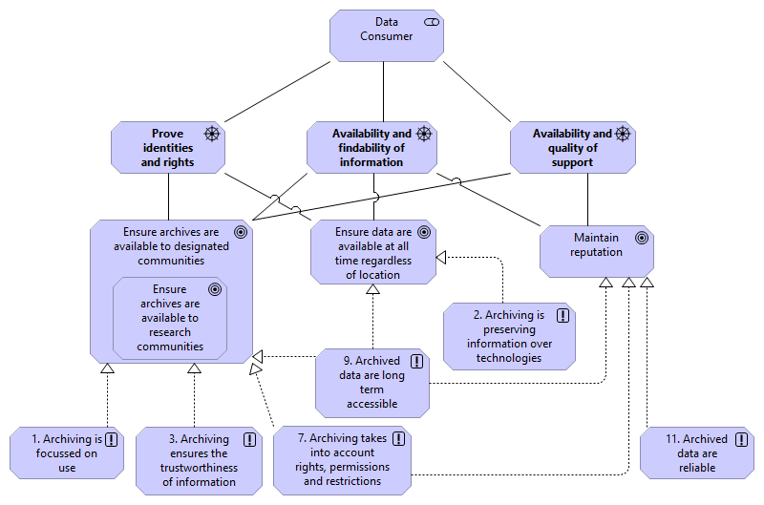
Figure 17: Goals and principles associated with the drivers

Driver  Goal | Description
Availability and findability of information
Ensure archives are available to designated communities | Institutions that deal with archives amass knowledge about the relevant designated communities and use this to plan for long-term accessibility.
- Ensure archives are available to research communities | Research communities are a special type of designated community. Their needs are well understood and given considerable weight when planning for long-term accessibility.
Ensure data are available at all times regardless of location | Archived data are accessible for the intended users whenever needed, not bound by location or time, but adhering to any relevant regulations, such as the GDPR.
Maintain reputation | Actors involved with archives conduct themselves in order to maintain their reputation.
Availability and quality of support
Ensure archives are available to designated communities | Institutions that deal with archives amass knowledge about the relevant designated communities and use this to plan for long-term accessibility.
- Ensure archives are available to research communities | Research communities are a special type of designated community. Their needs are well understood and given considerable weight when planning for long-term accessibility.
Maintain reputation | Actors involved with archives conduct themselves in order to maintain their reputation.
Prove identities and rights
Ensure archives are available to designated communities | Institutions that deal with archives amass knowledge about the relevant designated communities and use this to plan for long-term accessibility.
Ensure data are available at all times regardless of location | Archived data are accessible for the intended users whenever needed, not bound by location or time, but adhering to any relevant regulations, such as the GDPR.

Table 14: Goals.

Goal  Principle | Rational
Ensure archives are available to designated communities
1. Archiving is focussed on use | Solution providers play a key role in bringing new features and capabilities into archival systems. The process of selecting and prioritising feature requests needs to be closely coordinated with the archival community and other interest groups, always taking the legislation of the corresponding European country into consideration. It needs to be ensured that this process is not decoupled from the actual community needs and the intended use of archiving, and therefore requires a strategy and related management practice.
3. Archiving ensures the trustworthiness of information | Users must be able to assess the preserved information to ensure trustworthiness.
7. Archiving takes into account rights, permissions and restrictions | Archiving respects legal restrictions to the reuse of data and makes sure that information is available only when appropriate rights and permissions are in place.
9. Archived data are long-term accessible | Archiving should ensure that information is identifiable, available, interpretable, and meaningful for as long as it is needed
Ensure data are available at all times regardless of location
2. Archiving is preserving information over technologies | Not being reliant on originating systems, technologies, and media allows for increased flexibility in the choice of solutions which in turn improves competitiveness.
9. Archived data are long-term accessible | Archiving should ensure that information is identifiable, available, interpretable, and meaningful for as long as it is needed
Maintain reputation
7. Archiving takes into account rights, permissions and restrictions | Archiving respects legal restrictions to the reuse of data and makes sure that information is available only when appropriate rights and permissions are in place.
9. Archived data are long-term accessible | Archiving should ensure that information is identifiable, available, interpretable, and meaningful for as long as it is needed
11. Archived data are reliable | Users must be able to establish the reliability of archived information.

Table 15: Principles realising the goals.

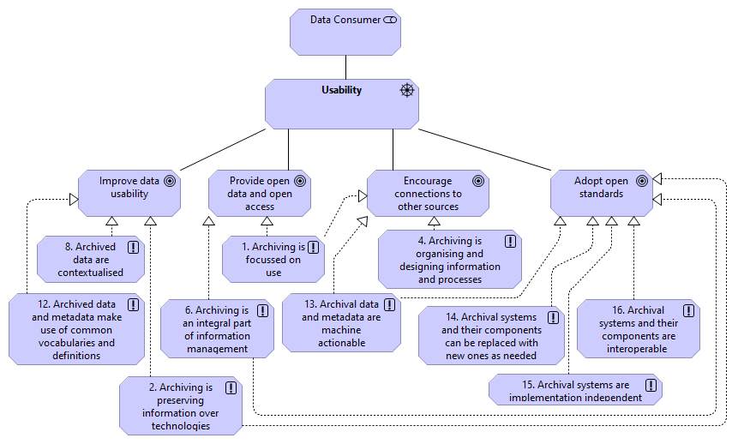
Figure 18: Goals and principles associated with the driver “Usability”

Goal | Description
Improve data usability | Data usability is a key concern and a prerequisite for long-term accessibility and is taken into account through the entire lifecycle of the information.
Encourage connections to other sources | Archives are made accessible in a way that enables and encourages users to enrich the material with cross-references and connection to other sources while upholding provenance and authenticity.
Provide open data and open access | Information in archives is available immediately and freely unless restricted by the GDPR or other relevant regulations.
Adopt open standards | Products and services offered are based on open and non-proprietary standards that are freely available.

Table 16: Goals.

Goal  Principle | Rational
Improve data usability
2. Archiving is preserving information over technologies | To improve data usability, the archive must ensure access to authentic information and its context, as long as necessary, without being reliant on originating systems, technologies and media.
8. Archived data are contextualised | Data usability is greatly improved when data in archives are sufficiently contextualised so that it can be correctly interpreted.
12. Archived data and metadata make use of common vocabularies and definitions | Explicit common definitions improve data usability. The use of common vocabularies facilitates communication and accessibility.
Encourage connections to other sources
1. Archiving is focussed on use | Solution providers play a key role in bringing new features and capabilities into archival systems. The process of selecting and prioritising feature requests needs to be closely coordinated with the archival community and other interest groups, always taking the legislation of the corresponding European country into consideration. It needs to be ensured that this process is not decoupled from the actual community needs and the intended use of archiving, and therefore requires a strategy and related management practice.
4. Archiving is organising and designing information and processes | Adding an archiving function after the work processes and information systems are fully operational requires extra time, effort, and money. In turn, it reduces competitiveness. The solution is to determine which transactions should be archived in which way when designing work processes and designing information systems that support work processes.
13. Archival data and metadata are machine actionable | Data in archives should be Findable, Accessible, Interoperable and Reusable for both humans and machines. (FAIR principles) To cope with the increase in volume, complexity, and creation speed of data, humans rely on computational support to process data in a meaningful and scalable manner.
Provide open data and open access
1. Archiving is focussed on use | Solution providers play a key role in bringing new features and capabilities into archival systems. The process of selecting and prioritising feature requests needs to be closely coordinated with the archival community and other interest groups, always taking the legislation of the corresponding European country into consideration. It needs to be ensured that this process is not decoupled from the actual community needs and the intended use of archiving, and therefore requires a strategy and related management practice.
6. Archiving is an integral part of information management | Gathering and providing open data is part of the tasks relevant to information management.
Adopt open standards
2. Archiving is preserving information over technologies | Not being reliant on originating systems, technologies, and media allows for increased flexibility in the choice of solutions which in turn improves competitiveness.
6. Archiving is an integral part of information management | Gathering and providing open data is part of the tasks relevant to information management.
13. Archival data and metadata are machine actionable | Data in archives should be Findable, Accessible, Interoperable and Reusable for both humans and machines. (FAIR principles) To cope with the increase in volume, complexity, and creation speed of data, humans rely on computational support to process data in a meaningful and scalable manner.
14. Archival systems and their components can be replaced with new ones as needed | Ensuring that archival systems and their components can be replaced with new ones as needed facilitates the establishment of new approaches to digital archiving.
15. Archival systems are implementation independent | Implementation independent systems allow for the absence of monopoly power and the ease of new players entering and exiting the market.
16. Archival systems and their components are interoperable | Having interoperable systems and components allows for the absence of monopoly power and the ease of new players entering and exiting the market.

Table 17: Principles realising the goals.

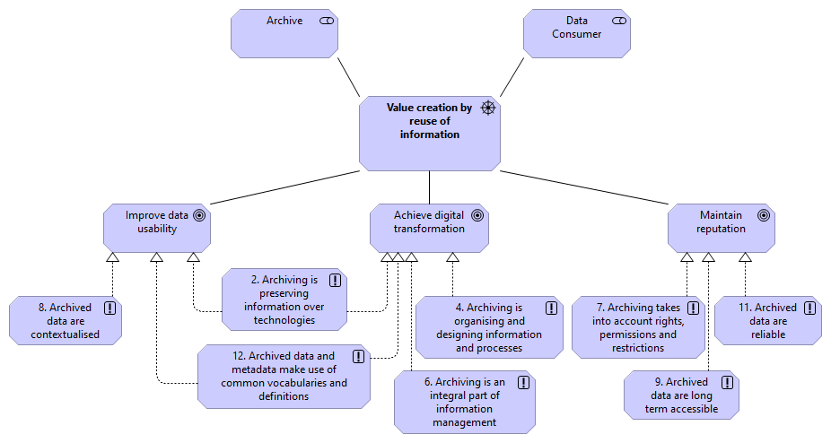

Figure 19: Goals and principles associated with the driver “Value creation by the reuse of information”

Goal | Description
Improve data usability | Data usability is a key concern and a prerequisite for long-term accessibility and is taken into account through the entire lifecycle of the information.
Achieve digital transformation | Regulations, business models, work processes, culture etc are underpinned by IT-solutions, and all these elements work seamlessly together and are optimised for a digitised society, without being held back by reproducing analogue concepts.
Maintain reputation | Actors involved with archives conduct themselves in order to maintain their reputation.

Table 18: Goals.

Goal  Principle | Rational
Improve data usability
2. Archiving is preserving information over technologies | To improve data usability, the archive must ensure access to authentic information and its context, as long as necessary, without being reliant on originating systems, technologies and media.
8. Archived data are contextualised | Data usability is greatly improved when data in archives are sufficiently contextualised so that it can be correctly interpreted.
12. Archived data and metadata make use of common vocabularies and definitions | Explicit common definitions improve data usability. The use of common vocabularies facilitates communication and accessibility.
Achieve digital transformation
2. Archiving is preserving information over technologies | Not being reliant on originating systems, technologies and media allows for increased flexibility in the choice of solutions which in turn improves competitiveness.
4. Archiving is organising and designing information and processes | Adding an archiving function after the work processes and information systems are fully operational requires extra time, effort, and money. In turn it reduces competitiveness. The solution is to determine which transactions should be archived in which way when designing work processes and designing information systems that support work processes.
6. Archiving is an integral part of information management | Gathering and providing open data is part of the tasks relevant to information management.
12. Archived data and metadata make use of common vocabularies and definitions | Explicit common definitions improve data usability. The use of common vocabularies facilitates communication and accessibility.
Maintain reputation
7. Archiving takes into account rights, permissions and restrictions | Archiving respects legal restrictions to the reuse of data and makes sure that information is available only when appropriate rights and permissions are in place.
9. Archived data are long-term accessible | Archiving should ensure that information is identifiable, available, interpretable, and meaningful for as long as it is needed
11. Archived data are reliable | Users must be able to establish the reliability of archived information.

Table 19: Principles realising the goals.

Figure 20: Drivers of ensuring trust and compliance

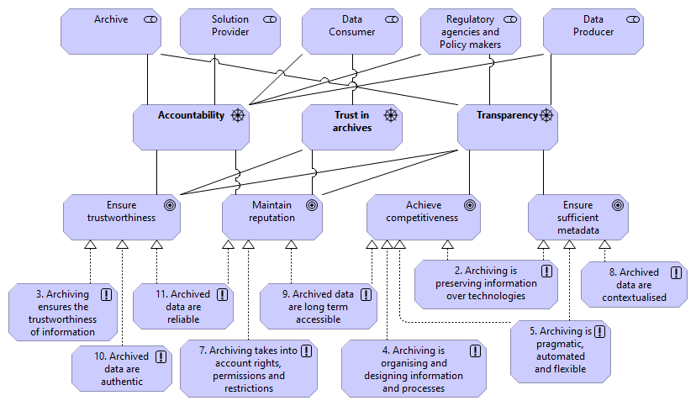
Figure 21: Goals and principles associated with the drivers

Goal | Description
Accountability
Ensure trustworthiness | It is possible for users in the designated communities to assess the trustworthiness of relevant archives.
Maintain reputation | Actors involved with archives conduct themselves in order to maintain their reputation.
Trust in archives
Ensure trustworthiness | It is possible for users in the designated communities to assess the trustworthiness of relevant archives.
Maintain reputation | Actors involved with archives conduct themselves in order to maintain their reputation.
Transparency
Ensure trustworthiness | It is possible for users in the designated communities to assess the trustworthiness of relevant archives.
Maintain reputation | Actors involved with archives conduct themselves in order to maintain their reputation.
Achieve competitiveness | Products and services offered are perceived as attractive by the users, while at the same time being based on business models that ensure the longevity of the solution providers.
Ensure sufficient metadata | Information in archives have sufficient metadata to enable long-term accessibility.

Table 20: Goals.

Goal  Principle | Rational
Ensure Trustworthiness
3. Archiving ensures the trustworthiness of information | To ensure trustworthiness, users must be able to assess the preserved information.
10. Archive data are authentic | Users must be able to establish whether the information object is what it claims to be, that it was created or submitted by the person or organisation that claims to have created or submitted it, and that it was created and submitted at the time indicated by the information object.
11. Archive data are reliable | Users must be able to establish the reliability of archived information.
Maintain Reputation
7. Archiving takes into account rights, permissions and restrictions | Archiving respects legal restrictions to the reuse of data and makes sure that information is available only when appropriate rights and permissions are in place.
9. Archived data are long-term accessible | Archiving should ensure that information is identifiable, available, interpretable, and meaningful for as long as it is needed
11. Archived data are reliable | Users must be able to establish the reliability of archived information.
Achieve competitiveness
2. Archiving is preserving information over technologies | Not being reliant on originating systems, technologies, and media allows for increased flexibility in the choice of solutions which in turn improves competitiveness.
4. Archiving is organising and designing information and processes | Adding an archiving function after the work processes and information systems are fully operational requires extra time, effort, and money. In turn, it reduces competitiveness. The solution is to determine which transactions should be archived in which way when designing work processes and designing information systems that support work processes.
5. Archiving is pragmatic, automated, and flexible | In order to be able to implement solutions which are sufficient, automated as possible, and possible to be efficiently updated or changed in future the organisation must retain relevant staff and skills capable of completing these tasks.
9. Archived data are long-term accessible | Ensuring that information is identifiable, available, interpretable, and meaningful for as long as it is needed improves competitiveness.
Ensure sufficient metadata
2. Archiving is preserving information over technologies | Not being reliant on originating systems, technologies, and media allows for increased flexibility in the choice of solutions which in turn improves competitiveness.
5. Archiving is pragmatic, automated, and flexible | In order to be able to implement solutions which are sufficient, automated as possible, and possible to be efficiently updated or changed in future the organisation must retain relevant staff and skills capable of completing these tasks.
8. Archived data are contextualised | Data usability is greatly improved when data in archives are sufficiently contextualised so that it can be correctly interpreted.

Table 21: Principles realising the goals.

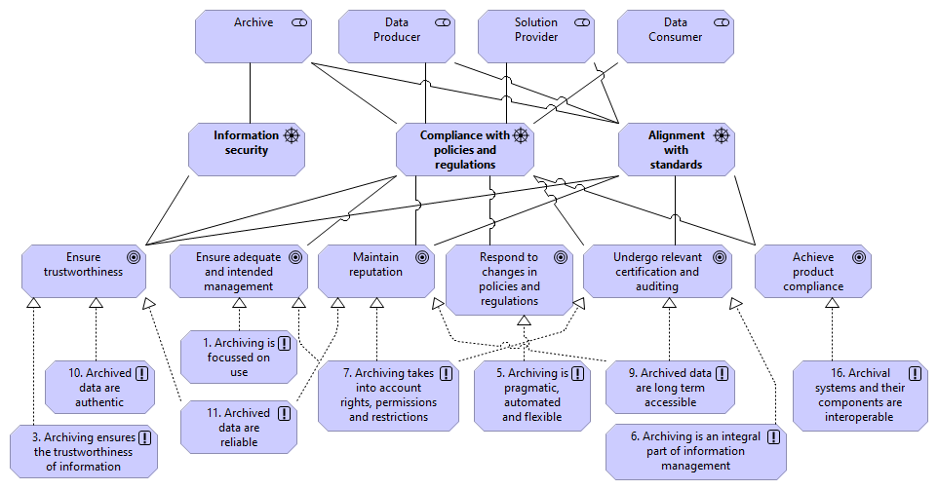
Figure 22: Goals and principles associated with the drivers

Driver  Goal | Description
Information security
Ensure trustworthiness | It is possible for users in the designated communities to assess the trustworthiness of relevant archives.
Compliance with policies and regulations
Ensure trustworthiness | It is possible for users in the designated communities to assess the trustworthiness of relevant archives.
Maintain reputation | Actors involved with archives conduct themselves in order to maintain their reputation.
Ensure adequate and intended management | Archives are managed adequately according to risk assessments.
Respond to changes in policies and regulations | A number of policies and regulations influence how organisations carry out their core business and/or activities. Over time these policies and regulations tend to change, affecting how business processes and information structures are implemented. The implementation of an archive which is, to a large degree independent of specific business contexts can help institutions decrease the cost of adopting to changes and improve information availability.
Undergo relevant certification and auditing | Actors responsible for providing products and services for long-term accessibility document to what extent they are certified according to relevant standards and practices for auditing.
Achieve product compliance |  | Products and services offered comply with any applicable regulation. Solutions providers can document compliance in a standardised way, and it is easy for users to assess the level of compliance.
Alignment with standards
Ensure trustworthiness | It is possible for users in the designated communities to assess the trustworthiness of relevant archives.
Maintain reputation | Actors involved with archives conduct themselves in order to maintain their reputation.
Undergo relevant certification and auditing | Actors responsible for providing products and services for long-term accessibility document to what extent they are certified according to relevant standards and practices for auditing.
Achieve product compliance |  | Products and services offered comply with any applicable regulation. Solutions providers can document compliance in a standardised way, and it is easy for users to assess the level of compliance.

Table 22: Goals.

Goal  Principle | Rational
Ensure adequate and intended management
1. Archiving is focussed on use | Solution providers play a key role in bringing new features and capabilities into archival systems. The process of selecting and prioritising feature requests needs to be closely coordinated with the archival community and other interest groups, always taking the legislation of the corresponding European country into consideration. It needs to be ensured that this process is not decoupled from the actual community needs and the intended use of archiving, and therefore requires a strategy and related management practice.
Ensure trustworthiness
3. Archiving ensures the trustworthiness of information | Users must be able to assess the preserved information to ensure trustworthiness.
10. Archive data are authentic | Users must be able to establish whether the information object is what it claims to be, that it was created or submitted by the person or organisation that claims to have created or submitted it, and that it was created and submitted at the time indicated by the information object.
11. Archive data are reliable | Users must be able to establish the reliability of archived information.
Maintain reputation
7. Archiving takes into account rights, permissions and restrictions | Archiving respects legal restrictions to the reuse of data and makes sure that information is available only when appropriate rights and permissions are in place.
9. Archived data are long-term accessible | Archiving should ensure that information is identifiable, available, interpretable, and meaningful for as long as it is needed
11. Archived data are reliable | Users must be able to establish the reliability of archived information.
Respond to changes in policies and regulations
5. Archiving is pragmatic, automated, and flexible | In order to be able to implement solutions which are sufficient, automated as possible, and possible to be efficiently updated or changed in future the organisation must retain relevant staff and skills capable of completing these tasks.
Undergo relevant certification and auditing
6. Archiving is an integral part of information management | Gathering and providing open data is part of the tasks relevant to information management
7. Archiving takes into account rights, permissions and restrictions | Archiving respects legal restrictions to the reuse of data and makes sure that information is available only when appropriate rights and permissions are in place.
9. Archived data are long-term accessible | Archiving should ensure that information is identifiable, available, interpretable, and meaningful for as long as it is needed
Achieve product compliance
16. Archival systems and their components are interoperable | Having interoperable systems and components allows for the absence of monopoly power and the ease of new players entering and exiting the market.

Table 23: Principles realising the goals.

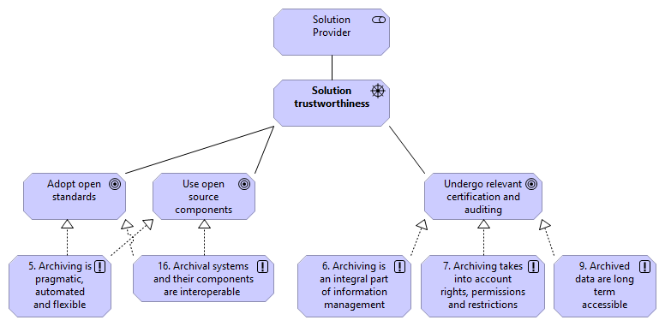
Figure 23: Goals and principles associated with the driver “Solution trustworthiness”

Goal | Description
Adopt open standards | Products and services offered are based on open and non-proprietary standards that are freely available.
Use open source components | IT-solutions are based on open source components that are well documented and freely available.
Undergo relevant certification and auditing | Actors responsible for providing products and services for long-term accessibility document to what extent they are certified according to relevant standards and practices for auditing.

Table 24: Goals.

Goal  Principle | Rational
Adopt open standards
5. Archiving is pragmatic, automated, and flexible | In order to be able to implement solutions which are sufficient, automated as possible, and possible to be efficiently updated or changed in future the organisation must retain relevant staff and skills capable of completing these tasks.
16. Archival systems and their components are interoperable | Having interoperable systems and components allows for the absence of monopoly power and the ease of new players entering and exiting the market.
Use open source components
5. Archiving is pragmatic, automated, and flexible | In order to be able to implement solutions which are sufficient, automated as possible, and possible to be efficiently updated or changed in future the organisation must retain relevant staff and skills capable of completing these tasks.
16. Archival systems and their components are interoperable | Having interoperable systems and components allows for the absence of monopoly power and the ease of new players entering and exiting the market.
Undergo relevant certification and auditing
6. Archiving is an integral part of information management | Gathering and providing open data is part of the tasks relevant to information management.
7. Archiving takes into account rights, permissions and restrictions | Archiving respects legal restrictions to the reuse of data and makes sure that information is available only when appropriate rights and permissions are in place.
9. Archived data are long-term accessible | Ensuring that information is identifiable, available, interpretable, and meaningful for as long as it is needed improves competitiveness.

Table 25: Principles realising the goals.

Figure 24: Drivers of sustainability

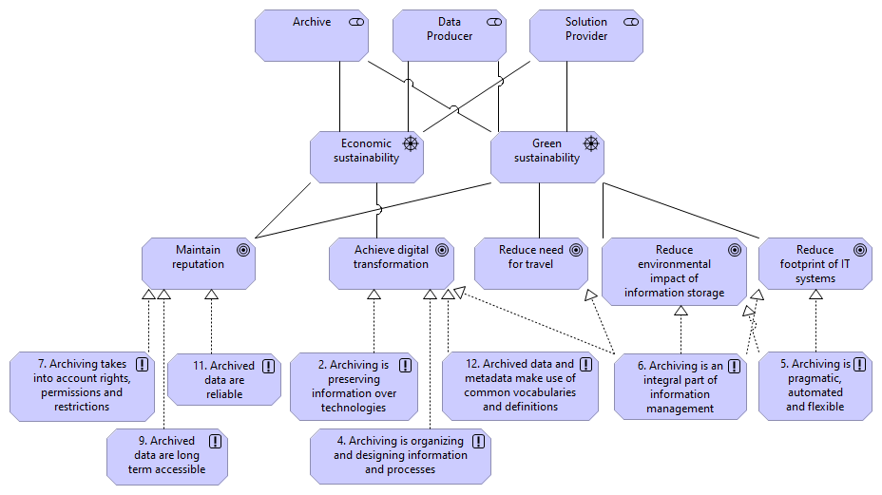
Figure 25: Goals and principles associated with the drivers of sustainability

Goal |  | Description
Economic sustainability
Achieve digital transformation |  | Regulations, business models, work processes, culture etc. are underpinned by IT-solutions, and all these elements work seamlessly together and are optimised for a digitised society, without being held back by reproducing analogue concepts.
Maintain reputation |  | Actors involved with archives conduct themselves in order to maintain their reputation.
Green sustainability
Maintain reputation |  | Actors involved with archives conduct themselves in order to maintain their reputation.
Reduce the need for travel |  | An archive provides sufficient online access options and does not require consumers to visit archives physically.
Reduce the environmental impact of information storage |  | Archiving should prefer the usage of storage technologies with less impact on the environment.
Reduce the carbon footprint of IT systems |  | Archiving helps organisations to move information out of business systems and into a digital archive which is less time-critical and can, therefore, be implemented at a smaller environmental price (i.e. an archive requires less computational power than a business system).

Table 26: Goals.

Goal  Principle | Rational
Achieve digital transformation
2. Archiving is preserving information over technologies | Not being reliant on originating systems, technologies, and media allows for increased flexibility in the choice of solutions which in turn improves competitiveness.
4. Archiving is organising and designing information and processes | Adding an archiving function after the work processes and information systems are fully operational requires extra time, effort, and money. In turn, it reduces competitiveness. The solution is to determine which transactions should be archived in which way when designing work processes and designing information systems that support work processes.
6. Archiving is an integral part of information management | Gathering and providing open data is part of the tasks relevant to information management
12. Archived data and metadata make use of common vocabularies and definitions | Explicit common definitions improve data usability. The use of common vocabularies facilitates communication and accessibility.
Maintain reputation
7. Archiving takes into account rights, permissions and restrictions | Archiving respects legal restrictions to the reuse of data and makes sure that information is available only when appropriate rights and permissions are in place.
9. Archived data are long-term accessible | Archiving should ensure that information is identifiable, available, interpretable, and meaningful for as long as it is needed
11. Archived data are reliable | Users must be able to establish the reliability of archived information.
Reduce the need for travel
6. Archiving is an integral part of information management | Gathering and providing open data is part of the tasks relevant to information management.
Reduce the environmental impact of information storage
6. Archiving is an integral part of information management | Gathering and providing open data is part of the tasks relevant to information management.
5. Archiving is pragmatic, automated, and flexible | In order to be able to implement solutions which are sufficient, automated as possible, and possible to be efficiently updated or changed in future the organisation must retain relevant staff and skills capable of completing these tasks.
Reduce the carbon footprint of IT systems
6. Archiving is an integral part of information management | Gathering and providing open data is part of the tasks relevant to information management.
5. Archiving is pragmatic, automated, and flexible | In order to be able to implement solutions which are sufficient, automated as possible, and possible to be efficiently updated or changed in future the organisation must retain relevant staff and skills capable of completing these tasks.

Table 27: Principles realising the goals.

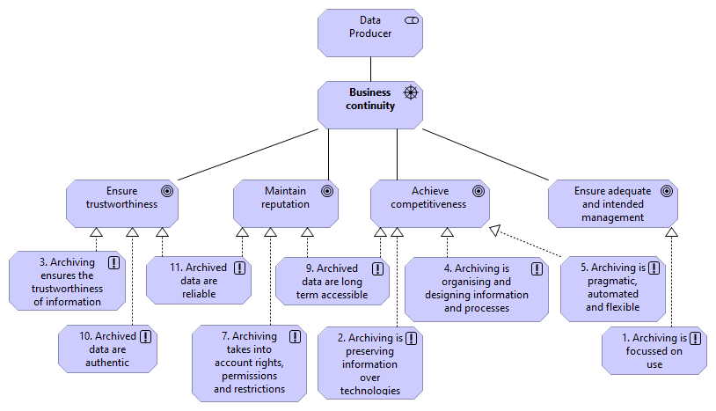
Figure 26: Goals and principles associated with the driver “Business continuity”

Goal | Description
Ensure trustworthiness | It is possible for users in the designated communities to assess the trustworthiness of relevant archives.
Maintain reputation | Actors involved with archives conduct themselves in order to maintain their reputation.
Achieve competitiveness | Products and services offered are perceived as attractive by the users, while at the same time are based on business models that ensure the longevity of the solution providers.
Ensure adequate and intended management | Archives are managed adequately according to risk assessments.

Table 28: Goals.

Goal  Principle | Rational
Ensure trustworthiness
3. Archiving ensures the trustworthiness of information | Users must be able to assess the preserved information to ensure trustworthiness.
10. Archive data are authentic | Users must be able to establish whether the information object is what it claims to be, that it was created or submitted by the person or organisation that claims to have created or submitted it, and that it was created and submitted at the time indicated by the information object.
11. Archive data are reliable | Users must be able to establish the reliability of archived information.
Maintain reputation
7. Archiving takes into account rights, permissions and restrictions | Archiving respects legal restrictions to the reuse of data and makes sure that information is available only when appropriate rights and permissions are in place.
9. Archived data are long-term accessible | Archiving should ensure that information is identifiable, available, interpretable, and meaningful for as long as it is needed
11. Archived data are reliable | Users must be able to establish the reliability of archived information.
Achieve competitiveness
2. Archiving is preserving information over technologies | Not being reliant on originating systems, technologies, and media allows for increased flexibility in the choice of solutions which in turn improves competitiveness.
4. Archiving is organising and designing information and processes | Adding an archiving function after the work processes and information systems are fully operational requires extra time, effort, and money. In turn, it reduces competitiveness. The solution is to determine which transactions should be archived in which way when designing work processes and designing information systems that support work processes.
5. Archiving is pragmatic, automated, and flexible | In order to be able to implement solutions which are sufficient, automated as possible, and possible to be efficiently updated or changed in future the organisation must retain relevant staff and skills capable of completing these tasks.
9. Archived data are long-term accessible | Ensuring that information is identifiable, available, interpretable, and meaningful for as long as it is needed improves competitiveness.
Ensure adequate and intended management
1. Archiving is focussed on use | Solution providers play a key role in bringing new features and capabilities into archival systems. The process of selecting and prioritising feature requests needs to be closely coordinated with the archival community and other interest groups, always taking the legislation of the corresponding European country into consideration. It needs to be ensured that this process is not decoupled from the actual community needs and the intended use of archiving, and therefore requires a strategy and related management practice.
Table 29: Principles realising the goals.

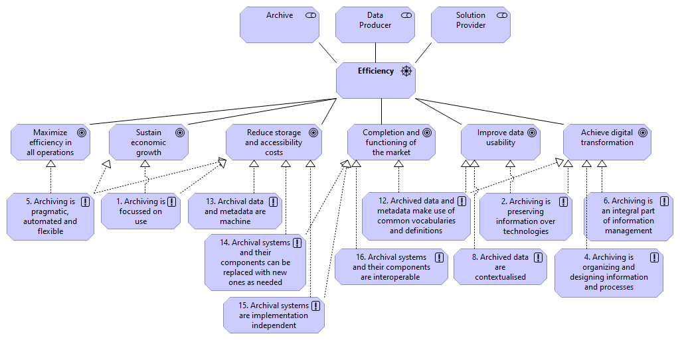
Figure 27: Goals and principles associated with the driver “Efficiency”

Goal | Description
Sustain economic growth | Regulations, business models, work processes, culture and IT-solutions are designed in a way that underpins sustainable economic growth.
Maximise efficiency in all operations | Efficiency is a key concern when designing both regulations, business models, work processes, IT-solutions and so forth. This is not only a matter of going faster but also doing things differently.
Reduce storage and accessibility costs | Regulations, appraisal practices and the IT-solutions are optimised to reduce storage and accessibility cost, without placing undue restrictions on the designated communities.
Completion and functioning of the market | Products and services offered underpin the internal market between EU member states.
Improve data usability | Data usability is a key concern and a prerequisite for long-term accessibility and is taken into account through the entire lifecycle of the information.
Achieve digital transformation | Regulations, business models, work processes, culture, etc. are underpinned by IT-solutions, and all these elements work seamlessly together and are optimised for a digitised society, without being held back by reproducing analogue concepts.
Table 30: Goals.

Goal  Principle | Rational
Sustain economic growth
1. Archiving is focussed on use | Solution providers play a key role in bringing new features and capabilities into archival systems. The process of selecting and prioritising feature requests needs to be closely coordinated with the archival community and other interest groups, always taking the legislation of the corresponding European country into consideration. It needs to be ensured that this process is not decoupled from the actual community needs and the intended use of archiving, and therefore requires a strategy and related management practice.
5. Archiving is pragmatic, automated, and flexible | In order to be able to implement solutions which are sufficient, automated as possible, and possible to be efficiently updated or changed in future the organisation must retain relevant staff and skills capable of completing these tasks.
Maximise efficiency in all operations
5. Archiving is pragmatic, automated, and flexible | In order to be able to implement solutions which are sufficient, automated as possible, and possible to be efficiently updated or changed in future the organisation must retain relevant staff and skills capable of completing these tasks.
Reduce storage and accessibility costs
1. Archiving is focussed on use | Solution providers play a key role in bringing new features and capabilities into archival systems. The process of selecting and prioritising feature requests needs to be closely coordinated with the archival community and other interest groups, always taking the legislation of the corresponding European country into consideration. It needs to be ensured that this process is not decoupled from the actual community needs and the intended use of archiving, and therefore requires a strategy and related management practice.
5. Archiving is pragmatic, automated, and flexible | In order to be able to implement solutions which are sufficient, automated as possible, and possible to be efficiently updated or changed in future the organisation must retain relevant staff and skills capable of completing these tasks.
13. Archival data and metadata are machine actionable | Archived data should be Findable, Accessible, Interoperable and Reusable for both humans and machines. (FAIR principles) To cope with the increase in volume, complexity, and creation speed of data, humans rely on computational support to process data in a meaningful and scalable manner.
14. Archival systems and their components can be replaced with new ones as needed | Ensuring that archival systems and their components can be replaced with new ones as needed facilitates the establishment of new approaches to digital archiving.
15. Archival systems are implementation independent | Implementation independent systems allow for the absence of monopoly power and the ease of new players entering and exiting the market.
Completion and functioning of the market
12. Archived data and metadata make use of common vocabularies and definitions | Explicit common definitions improve data usability. The use of common vocabularies facilitates communication and accessibility.
14. Archival systems and their components can be replaced with new ones as needed | Ensuring that archival systems and their components can be replaced with new ones as needed facilitates the establishment of new approaches to digital archiving.
15. Archival systems are implementation independent | Implementation independent systems allow for the absence of monopoly power and the ease of new players entering and exiting the market.
16. Archival systems and their components are interoperable | Having interoperable systems and components allows for the absence of monopoly power and the ease of new players entering and exiting the market.
Improve data usability
2. Archiving is preserving information over technologies | To improve data usability, the archive must ensure access to authentic information and its context, as long as necessary, without being reliant on originating systems, technologies and media.
8. Archived data are contextualised | Data usability is greatly improved when data in archives are sufficiently contextualised so that it can be correctly interpreted.
12. Archived data and metadata make use of common vocabularies and definitions | Explicit common definitions improve data usability. The use of common vocabularies facilitates communication and accessibility.
Achieve digital transformation
2. Archiving is preserving information over technologies | Not being reliant on originating systems, technologies, and media allows for increased flexibility in the choice of solutions which in turn improves competitiveness.
4. Archiving is organising and designing information and processes | Adding an archiving function after the work processes and information systems are fully operational requires extra time, effort, and money. In turn, it reduces competitiveness. The solution is to determine which transactions should be archived in which way when designing work processes and designing information systems that support work processes.
6. Archiving is an integral part of information management | Gathering and providing open data is part of the tasks relevant to information management.
12. Archived data and metadata make use of common vocabularies and definitions | Explicit common definitions improve data usability. The use of common vocabularies facilitates communication and accessibility.

Table 31: Principles realising the goals.

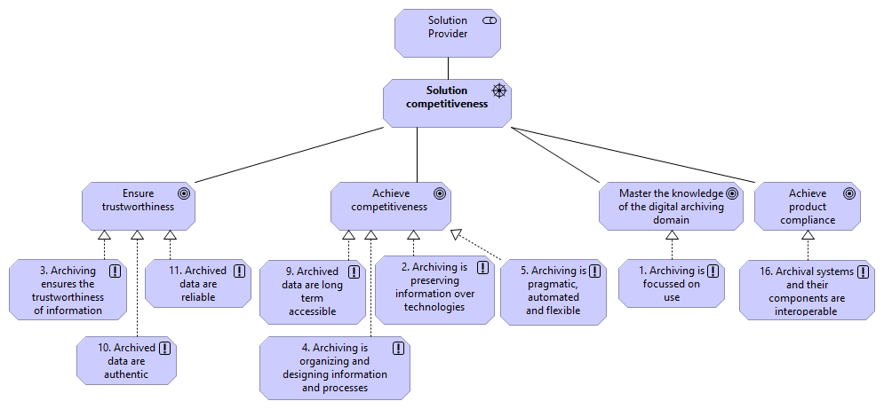
Figure 28: Goals and principles associated with the driver “Solution competitiveness”

Goal | Description
Ensure trustworthiness | It is possible for users in the designated communities to assess the trustworthiness of relevant archives.
Achieve competitiveness | Products and services offered are perceived as attractive by the users, while at the same time are based on business models that ensure the longevity of the solution providers.
Master the knowledge of the digital archiving domain | Institutions that deal with archives work systematically to develop competencies within digital archiving, drawing upon both academia and new ways of working, for instance with prototyping.
Achieve product compliance | Products and services offered comply with any applicable regulation. Solutions providers can document compliance in a standardised way, and it is easy for users to assess the level of compliance.

Table 32: Goals.

Goal  Principle | Rational
Ensure trustworthiness
3. Archiving ensures the trustworthiness of information | Users must be able to assess the preserved information to ensure trustworthiness.
10. Archive data are authentic | Users must be able to establish whether the information object is what it claims to be, that it was created or submitted by the person or organisation that claims to have created or submitted it, and that it was created and submitted at the time indicated by the information object.
11. Archive data are reliable | Users must be able to establish the reliability of archived information.
Achieve competitiveness
2. Archiving is preserving information over technologies | Not being reliant on originating systems, technologies, and media allows for increased flexibility in the choice of solutions which in turn improves competitiveness.
4. Archiving is organising and designing information and processes | Adding an archiving function after the work processes and information systems are fully operational requires extra time, effort, and money. In turn, it reduces competitiveness. The solution is to determine which transactions should be archived in which way when designing work processes and designing information systems that support work processes.
5. Archiving is pragmatic, automated, and flexible | In order to be able to implement solutions which are sufficient, automated as possible, and possible to be efficiently updated or changed in future the organisation must retain relevant staff and skills capable of completing these tasks.
9. Archived data are long-term accessible | Ensuring that information is identifiable, available, interpretable, and meaningful for as long as it is needed improves competitiveness.
Master the knowledge of the digital archiving domain
1. Archiving is focussed on use | Solution providers play a key role in bringing new features and capabilities into archival systems. The process of selecting and prioritising feature requests needs to be closely coordinated with the archival community and other interest groups, always taking the legislation of the corresponding European country into consideration. It needs to be ensured that this process is not decoupled from the actual community needs and the intended use of archiving, and therefore requires a strategy and related management practice.
Achieve product compliance
16. Archival systems and their components are interoperable | Having interoperable systems and components allows for the absence of monopoly power and the ease of new players entering and exiting the market.

Table 33: Principles realising the goals.

Requirements
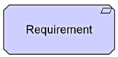

In the ArchiMate® specification, a Requirement represents a statement of need defining a property that applies to a specific system as described by the architecture.
In the end, a business goal must be realised by a plan or concrete change goal, which may or may not require a new system or changes to an existing system. Requirements model the properties of these elements that are needed to achieve the “ends” that are modelled by the goals. In this respect, requirements represent the “means” to realise goals.
Please note: Requirements will be part of the eArchiving Reference Architecture. The workgroup intends to add requirements after the definition and layout of the Business Layer.

Directly responsible organisations (from a juridical and an intellectual point of view), have a mandate “for the depositing of content in a digital archive for long-term digital preservation”. Indirectly responsible organisations can be third parties that are contracted by the directly responsible organisations for storing and later transferring digital objects to Archives for long-term digital preservation.
https://pubs.opengroup.org/architecture/archimate3-doc/chap06.html#_Toc10045334

