Example for Representation Information Network (RIN)
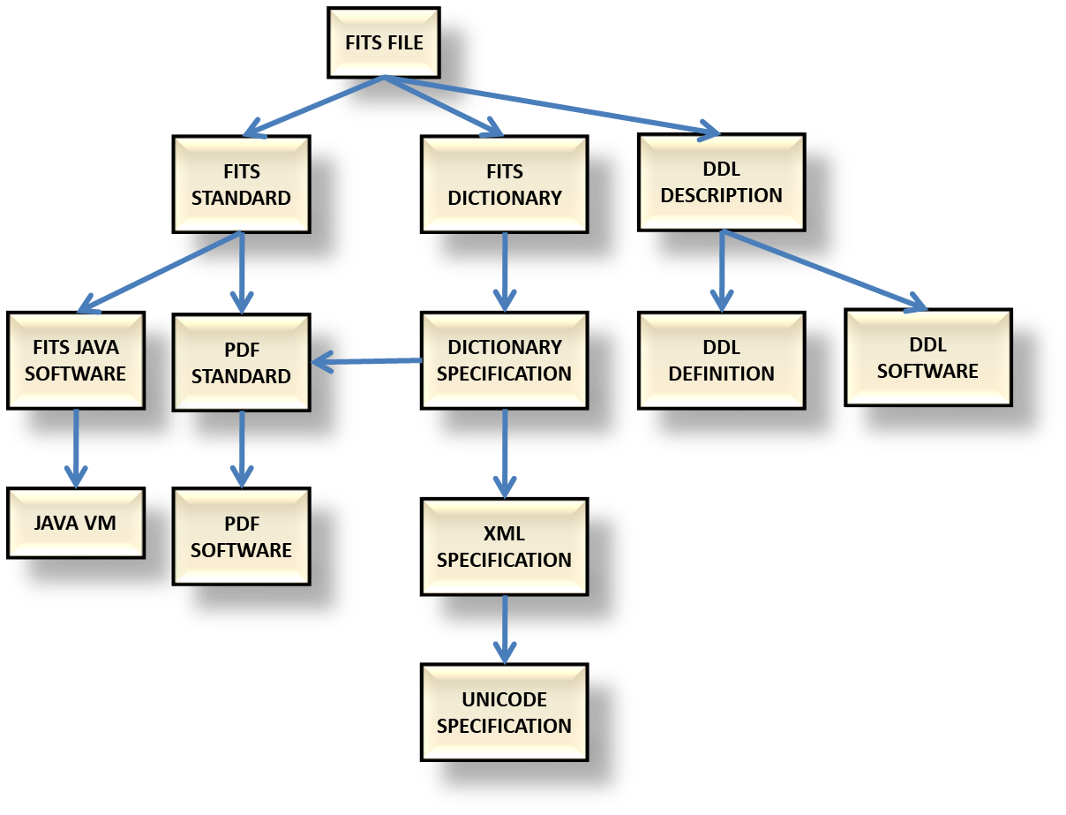
The incomplete Representation Information Network shown above may be described as follows. The arrows point from a Data Object to one or more pieces of Representation Information encoded in another Data Object.
In this case we consider the RIN for a specific FITS file.
- FITS files are defined by the set of FITS standards
- The FITS file may have many keywords in its header, but the FITS standard only defines a limited number of such keywords. The meaning of the additional keywords should be defined in a FITS Dictionary provided by the Producer.
- This dictionary may be encoded in a specific way, defined by the Dictionary Specification
- The Dictionary Specification may be encoded as a PDF file or encoded in XML.
- The Representation Information for the PDF could be the PDF standard.
- The Representation Information for the XML encoding would include the XML specification.
- The XML specification depends upon the UNICODE specification
- The FITS standard may be encoded as a PDF file.
- The Representation Information for a PDF file may be the PDF software
- Another way of using the FITS standard is using FITS software which uses Java
- The FITS Java software needs an appropriate Java Virtual Machine (VM) in order for it to be used.
This is an incomplete RIN.
A FITS file is currently well known to Astronomers i.e. is within their Knowledge Base. Astronomers, and many others, currently have access to PDF software and Java VMs.
The extent to which an Archive must be able to provide the various pieces of Representation Information which make up the RIN will depend upon the definition of the Designated Community.

