INTRODUCTION

OAIS CONCEPTS

OAIS Responsibilities

DETAILED MODELS

PRESERVATION PERSPECTIVES

ARCHIVE INTEROPERABILITY
Users of multiple OAIS Archives may have reasons to wish for some uniformity or cooperation among them. For example, Consumers of several Archives may wish to have:
- common Finding Aids to aid in locating information across several Archives;
- a common Package Description schema for access;
- a common DIP schema for dissemination; or
- a single global access site.
Producers may wish to have:
- a common SIP schema for submission to different Archives; or
- a single depository for all their products.
Managers may wish to have means for
- cost reduction through sharing of expensive hardware, software, and preservation efforts; and
- increasing the uniformity and quality of interactions with several Archives.
Therefore, it may be advantageous for Archives to cooperate to meet these wishes. The motivation might come from the Archives themselves, or an authority that has some influence over them may impose it. The motivations could include:
- the desire to reduce costs;
- the desire to keep Consumers happy with their products;
- the desire to keep users happy with their quality of service; or
- the need to compete with other Archives in order to survive or grow.
Situations like this can and have motivated agreements without the need for any explicit federation establishing an external authority. However, it is possible to formally establish the relationships.

Levels of Interaction between OAIS Archives
In general one OAIS is not interoperable with another. However, there are a number of reasons that some level of interoperability may be desirable, motivated for example by Users, Producers or Management. Even interoperable Archives may have different Designated Communities—even for the same digital objects—and hence different requirements for Representation Information and/or Descriptive Information.
Regardless of the reason for Interactions between Archives and other organizations, there is a requirement for agreements, formal and informal, covering many areas, in order to make the Archives interoperate. Each time the OAIS exchanges data with another organization the agreements include:
- the protocol(s) to be used in the transfer e.g. TCP/IP, HTTP, USB memory stick etc
- the interfaces to use
- the definition of the packages (SIP/DIP/AIP) transferred
- the processes which the sending and receiving organizations should follow
These agreements may include standards (current or future standards that will be developed which will specify these agreements and processes). The type and extent of these agreements and the level of formality of the agreements can be the basis of categorizing these interactions.
OAIS associations can be categorized technically by both external and internal factors. External factors include characteristics of the Producer and Consumer communities. Internal factors could include common implementations of the information models presented in Error: Reference source not found, or multi-Archive sharing of one or more of the functional entities presented in Error: Reference source not found.
This subsection describes some possible categories (not an exhaustive or mutually exclusive list) of Archive associations. This first set of three categories has successively higher degrees of organizational interaction:
- Independent: Archives motivated by local concerns with no management or technical interaction among them.
- Cooperating: Archives with potential common Producers, common submission standards, and common dissemination standards, but no common Finding Aids.
- Federated: Archives with both a Local Community (i.e., the original Designated Community served by the Archive) and a Global Community (i.e., an extended Designated Community) which has interests in the holdings of several OAIS Archives and has influenced those Archives to provide access to their holdings via one or more common Finding Aids. The Access needs of the Local Community usually have priority over those of the Global Community. Global dissemination and Ingest are optional features.
Another set of categories, somewhat orthogonal to the previous set, differentiates according to how internal Archive functions and functional areas are addressed and by styles of resource sharing.
- All In-house: Archives that perform all archival functions in-house.
- Shared resources: Archives that have entered into agreements with other organizations to share resources, perhaps to reduce cost. This requires various standards internal to the Archive (such as ingest-storage and access-storage interface standards) but does not alter the user community’s view of the Archive.
- Distributed Digital Preservation: Archives that have distributed the OAIS functionality either geographically or organizationally. Different levels, forms and organization of the distribution are possible. In every case, the Archive is required to oversee and manage the Archive’s use of the distributed functions, but in a way that does not alter the user community’s view of the Archive.
Since these are two somewhat separate sets of categories, a single Archive would be categorized in each category separately. For example an Archive could be categorized as an Independent, All-In-House or an Independent, Distributed Archive and other Archives could be a Federated Archive with Shared Resources or a Federated and Distributed Archive.
The remainder of this subsection gives a more detailed view of these categories.

Independent Archives
An independent Archive is assumed to serve only a single set of Designated Communities. (Note Each AIP in the Archive may have its own single Designated Community.) The Archive and the Designated Community must agree on the design of the DIPs and the Finding Aids. An independent Archive may choose to design these structures based on formal or de-facto standards. However use of formal or de-facto standands and would be supportive of future cooperation with other Archives that implement the same standards and may be helpful to users who may interact with other Archives. The design decisions to use these standards are not based on the possibility of inter-operation with other Archives, but rather on local requirements and cost savings.
The classification of an Archive as independent is not based on its size or distributed functionality. An independent Archive may occupy one site, or may be physically distributed over many sites. It may use many standards for a given internal element. However, if there is no dependence on other organizations, the Archive is independent.

Cooperating Archives
Cooperating Archives are based on standards agreements among two or more Archives.
A simple form of cooperation between Archives is when one Archive acts as a Consumer of material from another Archive. In this case the consuming Archive must support the DIP format of the producing Archive as a SIP format. No common access, submission or dissemination standards are assumed. The only requirement for this architecture is that the cooperating groups support at least one set of compatable SIP and DIP formats for inter-Archive requests. . This does not necessarily require common access, dissemination and submission methods for all participants, although that might encourage more exchange. This level of agreement would also be useful when the holdings of one Archive were consolidated/transferred into another Archive because of Management issues.
The control mechanism for this sort of inter-operation may be an event based order requests at each Archive.
Figure 6-1 represents a simple mutual information exchange agreement between Archives.
NOTE – In this and the following figures, the OAIS is represented as a multi-port device following the arrangement of figure 6-1. In each case, a two-Archive federation is shown for simplicity, although the concept can be extended indefinitely.
The essential requirement for this cooperation is a set of mutual Submission Agreements, event based orders, and user interface standards to allow DIPs from one Archive to be ingested as SIPs by another. Therefore, it assumes that some pair-wise compatibility has between established between the Archives. This does not necessarily require common access, dissemination and submission methods for all participants, although that might encourage more exchange. This level of agreement would also be useful when the holdings of one Archive were consolidated/transferred into another Archive because of Management issues.
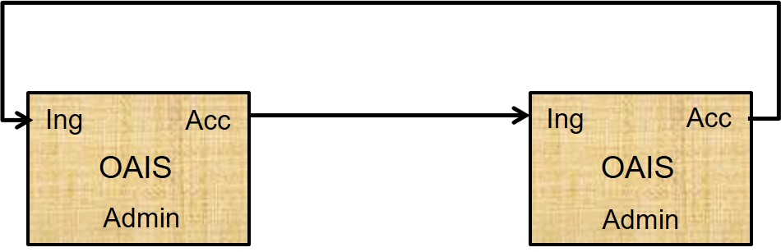
Figure 6-11: Cooperating Archives with Mutual Exchange Agreement
Figure 6-2 is an example of OAIS Archives that have standardized their submission and dissemination methods for the benefit of users. No special external element is needed for this. Its disadvantage is that there is no formal mechanism for exchange of Description Information so Consumers must have separate search sessions to locate AIPs of interest.
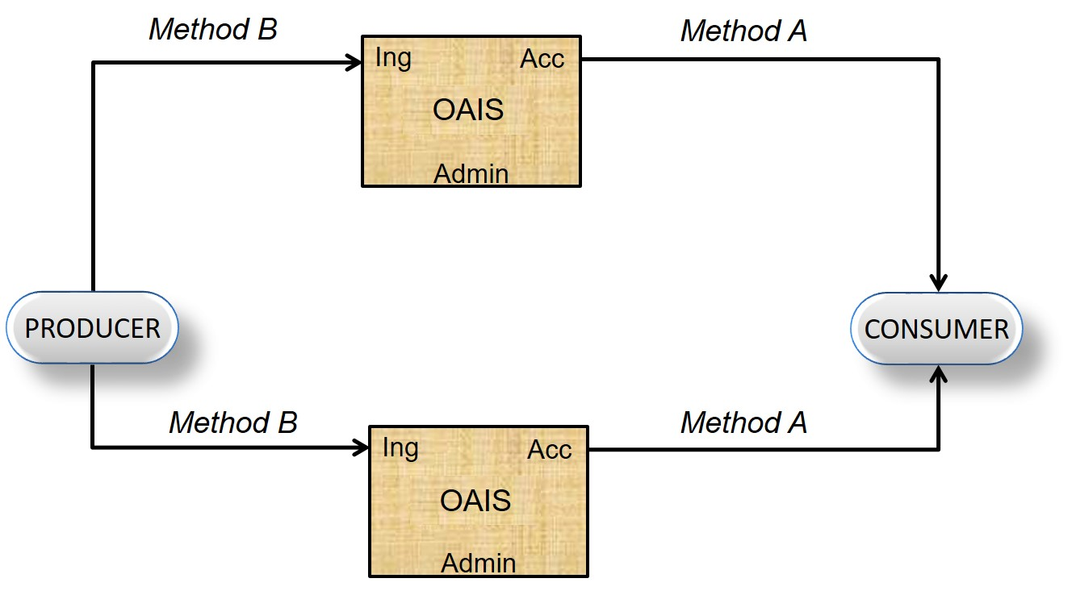
Figure 6-22: Cooperating Archives with Standard Ingest and Access Methods

Federated Archives
Federated Archives are conceptually Consumer-oriented. In addition to the local community (i.e., the original Designated Community served by the Archive), there exists a global community (i.e., an extended Designated Community) which has interests in the holdings of several OAIS Archives and has influenced those Archives to provide access to their holdings via one or more common Finding Aids. However, the local consumers are likely to have access priority over the global Consumers.
At the federated level of association, external elements can be introduced to improve inter-operability. For example, figure 6-3 illustrates a functional architecture to solve the Access problem described in 6.1.2, using an entity external to the Federated OAISes. Here, two OAIS Archives that have similar Designated Communities have decided to federate to allow Consumers to locate AIPs of interest from either OAIS with a single Search Session. The Common Catalog & Manager is the external (global) binding element that serves as a common access point for the information in both Archives. DIPs containing the Finding Aids from each OAIS are ingested into the Common Catalog as is shown by the dotted lines in figure 6-3. The Common Catalog may limit its activity to being a Finding Aid or it may include common dissemination of products from either or both OAISes as shown by the dashed lines in the figure.
NOTE – Extra access ports are added to the diagram to illustrate the potentially differing views of each consumer community.
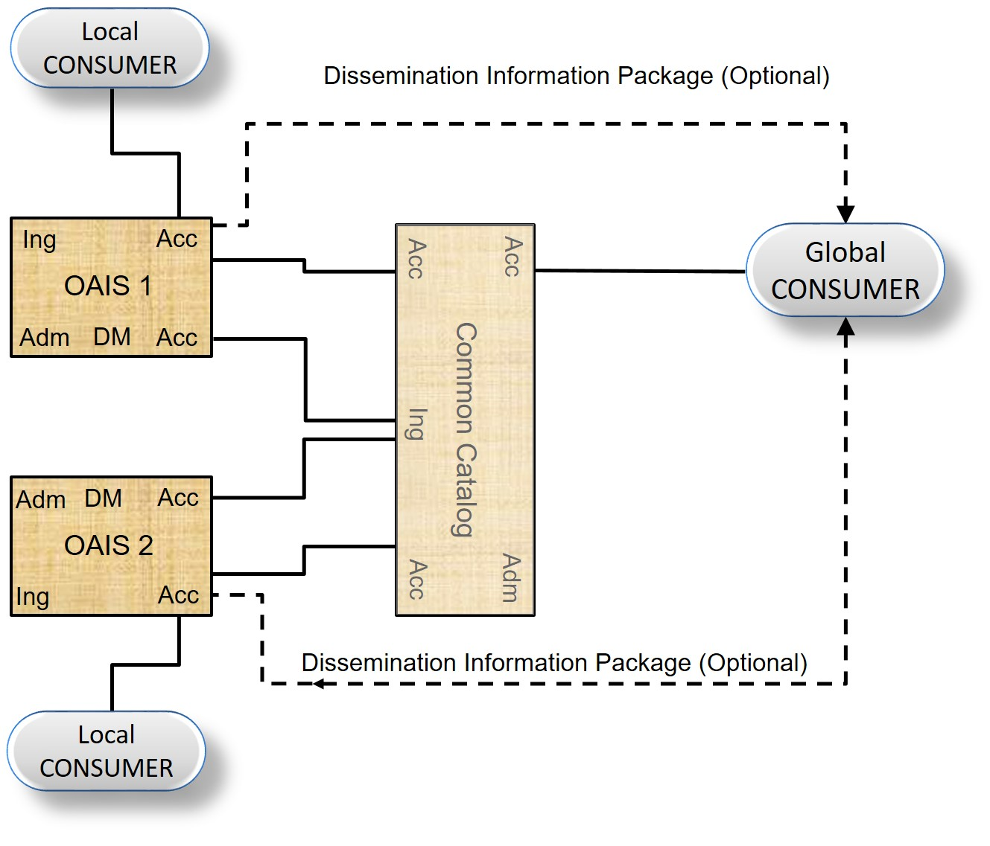
Figure 6-33: An OAIS Federation Employing a Common Catalog
Federated Archives may be further classified into three levels of functionality.
- Central Site: Global access is accomplished by the export of a standard-format Associated Description to a global site. The global site independently manages a set of descriptors from many Archives and has Finding Aids to locate which Archive owns a collection of interest. The Consumer is given a combined view of the holdings of multiple sites, which is maintained centrally. To view details of the documents, the user must access the site that contains the actual document. This is made easier when sites and clients support a standard set of protocols.
- Distributed Finding Aid: Global access is accomplished by having a global node that can distribute a query to multiple local Archives. This means that the local Data Management Functional Entity must store an additional Associated Description in the global format or have a translator from the global queries to local queries.
- Distributed Access Aid: Global access is accomplished through addition of a standard ordering and dissemination mechanism, available through the global nodes to the functionality of the Distributed Finding Aids discussed above. This is a fully functional, federated system. Here, the global system may influence the Associated Description schema designs in each local Archive; it would be optimal to build new local Archives based on the global schemas and Finding Aids to ensure high degrees of inter-operability.
There are several major policy/technology issues that must be addressed when an OAIS joins a Federation. These issues include:
- Unique AIP Identifiers for each AIP in the Federation; it would be advantageous for these identifiers to be Unique Persistent Identifiers within some specified naming system. An OAIS has the responsibility to provide each of its AIPs with a unique identity. When an OAIS joins a Federation, there is no assurance that some of its current OAIS AIP identifiers are not already used by other members of the Federation. An example of a general solution to this problem is to form the AIP identifiers in the Federation by assigning a Unique ID for each OAIS in the Federation and concatenating it to each AIP preserved by that OAIS. This OAIS name could be formatted according to a standard that gives the Consumer or other Federation members the information needed to establish a connection to the OAIS that contains the AIP of interest. An example of a standard that accomplishes this is the ISO X.500 Directory Services Naming.
- Duplicate AIPs in several different OAISes with different AIP names. This problem is caused by the fact that prior to Federation, some OAISes will have ingested the same Content Information In this case a Global Consumer will see all the copies as separate, uniquely identified AIPs. Detailed examination of the PDI associated with the Content Information should allow the Consumer to locate the original, authoritative copy, but the search process could be very frustrating to the user. A practical way to handle this is to have a field in the Associated Description of all AIPs that identifies whether they are the original or a copy. This technique is not effective if, prior to federation, two or more Archives received the Content Information from the Producer to Archive. In this case the federated Archive would view these duplicate AIPs as unique, original AIPs.
- The Preservation of Federation Access to AIPs when an OAIS terminates operations. Unfortunately, many Archives will close while their holdings still are of value to the Federation community. The federation should have an agreement for each member OAIS, which states which OAIS has the responsibility to take over the preservation of a closed OAIS’s holdings.
- User Authentication and Access Management for global users. If an OAIS has a policy that restricts the access to some of its AIPs or charges for the dissemination of some Information Packages, there is a problem of how to identify and authenticate the user who is making requests through the central node. Each OAIS will have implemented an Authentication and Access Management system for its Local Users and the infrastructure for this function will have to be extended to include global users. Some examples of techniques used for this in current systems are:
- Default priorities where all members from the global node share a common set of access constraints and the global node handles all the authentication to verify the Consumer as a legitimate user of the global node. The authentication at member OAIS is done assuming that all requests from the global node are from a single user.
- User Credential passing where the specific remote user can be authenticated by any of the Federation OAISes and the global node simply acts as an intermediary to carry the authentication dialog.
There are many factors influencing the decision of which of these techniques should be used by a specific Federation. The major criterion is the granularity of the Access Constraints in the Federation. If there is little private data and no charge for data dissemination, a policy that determines a user’s access constraints by the source he uses to discover and order AIPs is very reasonable. This involves little modification to the OAIS Authentication system, simply adding the global node as a Consumer. The global Nnode will have to include mechanisms to identify global users to each of the Federated OAIS Authentication mechanisms.
If there are charges for disseminating preserved information or significant private data that needs individual user authentication, the proxy techniques will not be sufficient, and User Credential passing techniques such as passwords and Certificates must be applied. The technologies to enable these supporting mechanisms are still evolving.

The above examples show that the OAIS model is consistent with federation to accomplish specific objectives. However, it should also be considered that some of these objectives might be accomplished through voluntary action. This is an important dimension in the association of systems, including Archives, because it establishes the degree of autonomy for each system. At the heart of the autonomy issue is the ease with which an association may be altered by one of the participants. Some possible characterizations of autonomy levels might be:
- No interactions and therefore no association (and not part of a federation).
- Associations that maintain an association member’s autonomy. An association member may have to do certain things to participate, but can leave the association without notice or impact. An example is participation in the Internet, including operation as a domain name server. A member will need to meet certain requirements to participate, including the maintenance of a site with certain characteristics, but the member will in effect be expunged from the association if the site simply stops conforming. However, there is no penalty for this. Therefore, the members maintain full autonomy the whole time because they are free, without penalty, to do what they want.
- Associations that bind an association member by contract. To change the nature of this association, a member will have to re-negotiate the contract. The amount of autonomy retained depends on how difficult it is to negotiate the changes. The difficulty may rise as more entities become a party to the contract.
So, the autonomy dimension is a key one for interacting Archives, determining the ease with which each can effect changes in the nature of the association and the impact/penalty to each for recovering full autonomy. This dimension is different from the degree of technical homogeneity the association implements or supports, but it is not totally independent. For example, a high degree of technical homogeneity can be achieved in a broad association where each participating entity is free to leave without penalty. However, the permanence of such an association cannot be guaranteed, and may be improved by making it more difficult to re-negotiate the association, or by establishing penalties for recovering full autonomy. Also, a given degree of technical homogeneity might be achieved more rapidly and at lower cost when the contract is more binding.

All In-house Archives
One of the simplest allocations of functions in an Archive is the all in-house arrangement. Archives that is a single organization that performs all the required functions on its own, using its own equipment and primarily at a single location can be referred to as an All In-House Archive. Note that a few tasks, such as preservation backup may require off-site storage.

Archives with Shared Resources
In an association involving Archives with shared resources, Management has entered into agreements with Archives to share or integrate some resource. The motive for this may be to share expensive resources such as hierarchical file management system for Archival Storage, peripheral device for Ingest or dissemination of Information Packages or supercomputers for complicated transformations between SIPs, AIPs or DIPs. This association is fundamentally different from the previous examples, in that it is no longer possible to ignore the internal architecture of the Archive.
Figure 6-4 illustrates the sharing of a common storage function, consisting of an Archival Storage Functional Entity and a Data Management Functional Entity, between two Archives, OAIS 1 and OAIS 2. The Access and Ingest facilities can be at any of the previously described levels of inter-operability. In fact, each Archive can serve totally independent communities as implied in this figure. However, for the common storage element to succeed, standards are needed at the internal Ingest-storage and Access-storage interfaces.
Additional potential shared services include registries of Representation Information and name resolvers such as the DNS. In the former case a registry of Representation Information should also be an OAIS and the Representation Information it holds should be part of the Content Information it holds. The Representation Information it holds might, for example, be part of the Representation Information Network for the Content Information within an AIP in another OAIS. In such a case the OAIS holding that AIP may cache copies of the Representation Information Network held in the registry. Whether it does so or instead relies on the registry to maintain the Representation Information Network, the ultimate responsibility for the understandability of the Content Information remains with the OAIS which holds the AIP.
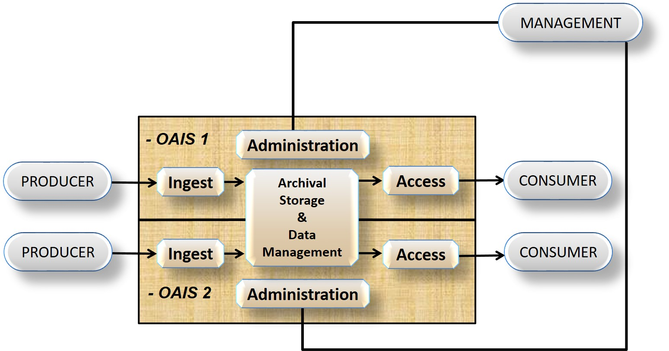
Figure 6-44: Archives with Shared Storage

Archives with Distributed Functionality
An OAIS may distribute its functionality either geographically or organizationally. Different levels, forms and organization of the distribution are possible. In every case, the Archive is required to oversee and manage the Archive’s use of the distributed functions, but in a way that does not alter the user community’s view of the Archive.
Such a distribution of functional areas or functional entities of an OAIS, as well as their composition into distributed OAIS, can be of a physical, organizational, or administrative nature. The motivation could be to distribute resources to achieve the complete set of functional entities or functional areas to establish a distributed OAIS in a complementary and collaborative way. Other motivation factors can be to mitigate risks or outsource parts of the OAIS in a way that enables the OAIS to remain an OAIS.
Archives could handle the distribution by itself. For example, an Archive could distribute its Archival Storage hardware in various geographic locations. In this example, such distribution would allow the Archive to maintain copies of its preserved data in ways that minimized the risk from natural disasters.
Another example could be the distribution of the Ingest functionality. One aspect of this example could be a physical distribution of Archive personnel, some of whom could be co-located with various Producers supplying the Archive. In addition, the Ingest functionality could also be distributed. For example, the Archive’s co-located personnel could receive and quality check the SIP and they could then use the Archive’s approved procedures to generate the AIPs and Descriptive Information. Once these activities have been completed, the co-located Archive personnel would send the AIPs and Descriptive Information to the central Archive site where other employees would coordinate the update of Archival Storage and Data Management.

A similar example could be envisioned on the Access side. Again for example, the Archive may provide geographically distributed locations and employees to support and interact with Consumers.
Section [1.4] describes the requirements for a conforming OAIS as supporting the Information Model (see section [1.2]) and fulfils the Mandatory Requirements (section [3.1]). To achieve this an OAIS may use a distributed set of organisations, taking advantage of specific expertise and competences, to address the known threats to Long-Term Preservation.
Examining the Mandatory Responsibilities, one could imagine that an OAIS may distribute a number of the responsibilities specified in section 3.1, as illustrated in the table below, together with pointers to some of the categories described in earlier sections.

Mandatory Responsibilities | Potential Distribution of Responsibility
Negotiate for and accept appropriate information from information Producers. | Help to negotiate the information to be received from Producers  Help to accept information from Producers (see Co-operating Archives)
Obtain sufficient control of the information provided to the level needed to ensure Long Term Preservation. | Appropriate responsibility must be held by any organisation which plays a role in the OAIS.
Determine, either by itself or in conjunction with other parties, which entities should become the Designated Community. i.e., the communities that should be able to understand the information provided Definition of the Designated Community includes a determination of their Knowledge Base.. | The responsibility for decisions about the appropriate Designated Community will depend on the organisation which plays a role in the OAIS:
Ensure that the information to be preserved is Independently Understandable to the Designated Community. In particular, the Designated Community should be able to understand the information without needing special resources such as the assistance of the experts who produced the information. | Help to ensure that the information to be preserved is Independently Understandable to the Designated Community, for example:  - Responsibility to hold Representation Information – this is a key component od the Information Model  - Responsibility to determine whether the information is Independently Understandable to the Designated Community
Follow documented policies and procedures which ensure that the information is preserved against all reasonable contingencies, including the demise of the Archive, ensuring that it is never deleted unless allowed as part of an approved strategy. There should be no ad-hoc deletions. | Help to ensure that the information is preserved against all reasonable contingencies, including the demise of the Archive.  (see Archives with Shared Resources)  Other examples include distribution of:  - Responsibility for Preservation Planning  - Responsibility for Archival Storage
Make the preserved information available to the Designated Community and enable the information to be disseminated as copies of, or as traceable to, the original submitted Data Objects with evidence supporting its Authenticity. | Help to make the preserved information available to the Designated Community  (see Co-operating Archives and Federated Archives)
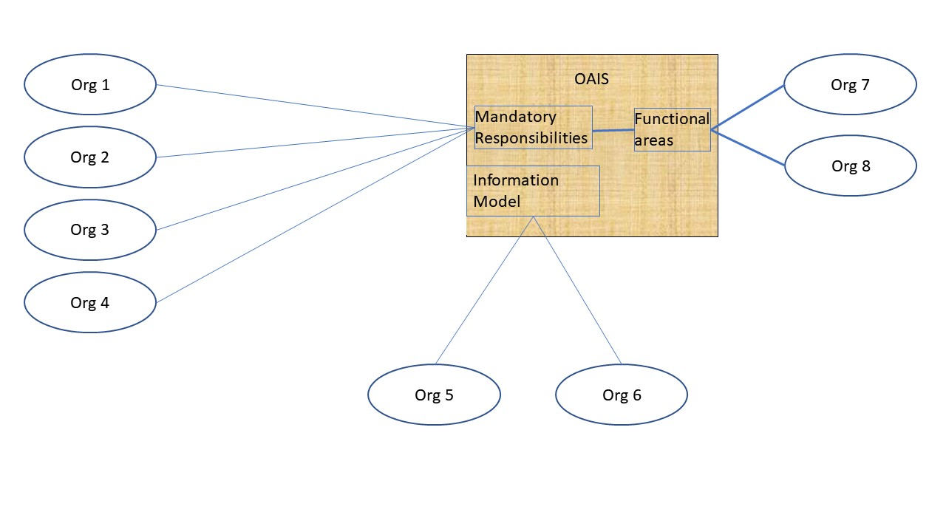
Figure 5 Potential distributed conformance requirements and associated functional areas
The figure indicates potential distribution of support for conformance requirements including support for mandatory responsibilities and the information model; it also includes a potential distribution of functional areas which support these conformance requirements.
Note this distribution can be implemented in any number of ways, either by the Archive itself handling the distribution or the Archive may enter into agreements with one or more other organizations (possibly other OAISes) to perform some functionality or perhaps even provide all the functionality of some OAIS functional area. A combination of these is also possible where the Archive itself distributes some of its functionality and contracts out other tasks. Once again the distribution can be in terms of the physical location, organisation, or logical functions. Note also that an OAIS may cooperate with or federate with other OAISes to aid their distribution efforts.
In cases where other organizations (or other OAISes) are involved, the original OAIS retains the responsibility for ensuring that the distributed functionality is properly carried out. This will likely require that some type of service level contracts will be required between the organizations and the original OAIS will need to appropriately monitor performance and products.
It is possible that development of these agreements and oversight of the results might be accomplished more easily and more reliably with another OAIS. For example, oversight and monitoring of the OAIS providing the service could be simplified by requiring the OAIS by certified as a Trustworthy Digital Repository in accordance with the metrics specified by CCSDS 652.0 (also known as ISO 16363) and the procedures specified in CCSDS 652.1 (also known as ISO 16919). In this example, use of certification to these standards would eliminate the need to re-negotiate the many details already covered in OAIS and those standards.
As indicated in the table above, illustrations of support being provided for some of the Mandatory Responsibilities have been provided in earlier sections.
The figure below illustrates the Information Model being supported by an OAIS which preserves Representation Information, and in particular Representation Information Networks.

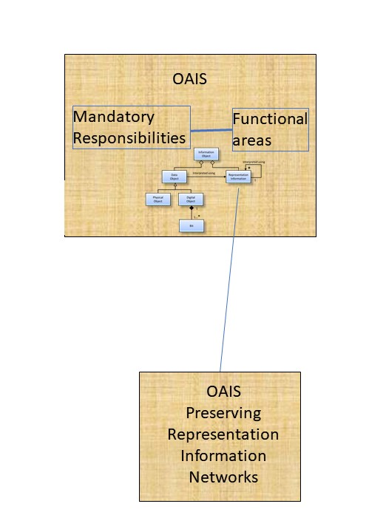
Figure 6 Information Model of OAIS supported by another OAIS
Functional areas and Functional Entities may also be distributed to other organisations, perhaps taking advantage of special expertise or competence of those other organisations.
[PERHAPS ADD DIAGRAM SUCH AS THAT FROM MATTHIAS AND FELIX ]
In the special case that these supporting organisations are themselves OAISes, one can describe the arrangement as a primary OAIS using a supporting OAIS for specific functional areas. In such cases one can then further analyse the supporting OAIS in terms of how it fulfils its requirements for conformance, namely the Mandatory Responsibilities and support for the Information Model.
The term ‘Outer OAIS-Inner OAIS’ has been used in the literature in a way that is consistent with being primary OAIS and supporting OAIS, specifically when mapping to the OAIS Functional Model.

Many implementations of a distributed Archive are possible. For example, one possible implementation is for an primary Archive to rely on one or more other supporting Archives to provide all the functions of the Archival Storage Functional Area.
Figure 6-5 is illustrating an example where an OAIS has physically, organizationally, and administratively distributed Archival Storage to three other organizations. In this example the primary OAIS 1 has distributed the functionality to three other organizations, which in this case happen to all be OAISes and which are referred to as the supporting OAISes. Note that in the example and elsewhere whenever we name something as an OAIS, we expect that anything that is spoken about as an OAIS conforms to the full suite of OAIS criteria specified in the conformance section (Section 1.4).
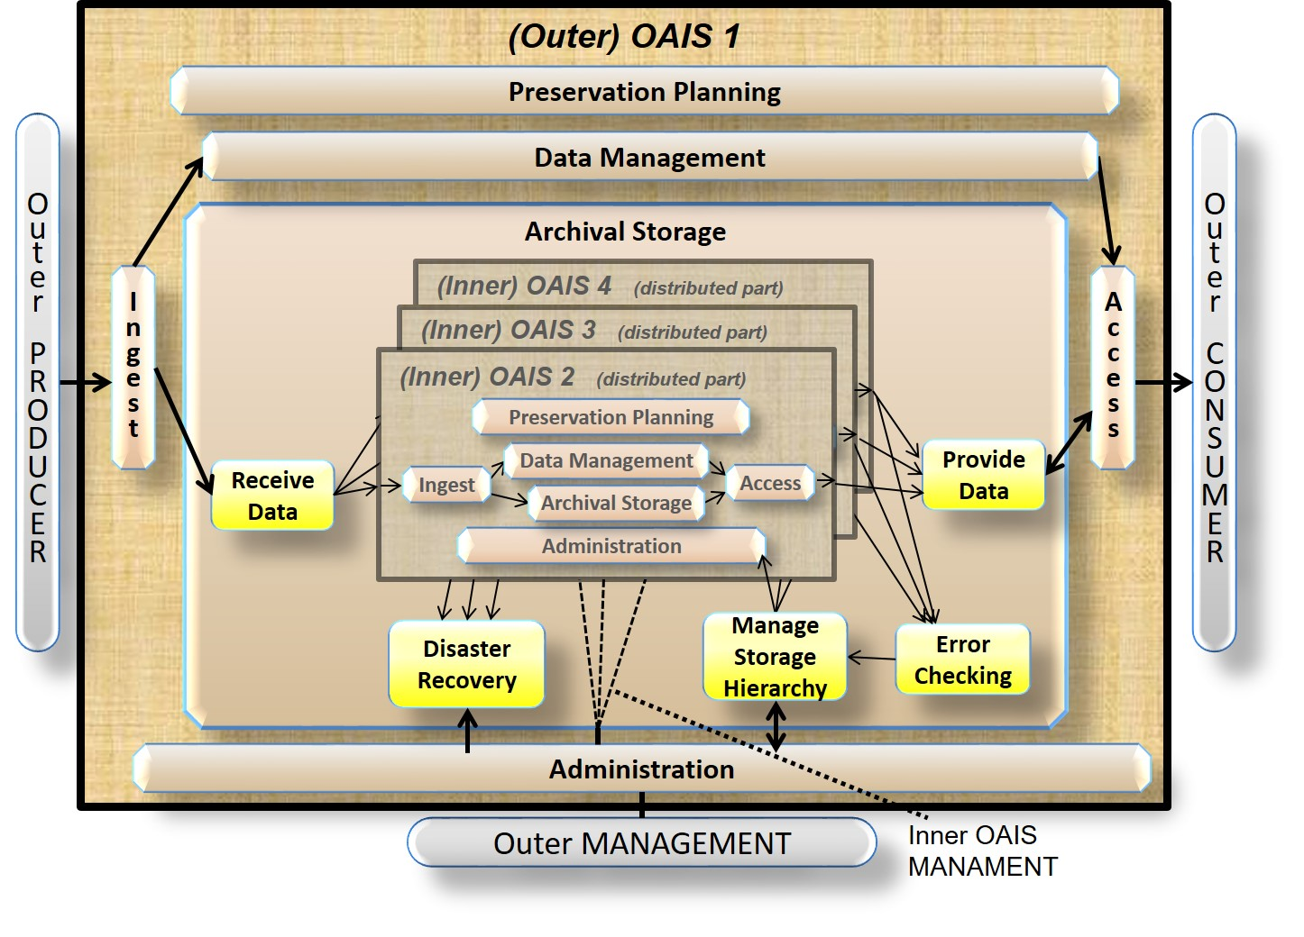
In the example from Figure 6-5, the supporting OAISes contain different parts of the functions that constitute parts of the Archival Storage for the primary OAIS. In this example, the primary OAIS is part of the Designated Community, and is a Producer and a Consumer for the supporting OAISes. The primary OAIS is only interested in ensuring that bit sequences are intact and accessible for the AIPs it provides to the supporting OAISes. The Preservation Objectives for the supporting OAISes could differ. Of course each supporting OAIS will need to handle Provenance Information for its AIPs and make this Provenance Information available to the primary OAIS to pass along with the supporting OAIS’s AIPs provided to the primary OAIS’s Consumers.
Figure 6-5: Example of a Distributed OAIS Archive for Archival Storage

In this example, all Preservation Planning concerning internal Archival Storage concerns are distributed to the Inner OAISs. However in this example, the Outer OAIS still needs the function Developing Preservation Strategies to ensure that threats to copies are mitigated, functions to Manage Storage Hierarchy and initiate repairs through Disaster Recovery, in case Error Checking e.g. discover differences between copies placed in the different Inner OAISes. In this example, it is clear that the Outer OAIS is not an OAIS without the Inner OAISes, whereas the Inner OAISes individually and independently can be regarded as an OAIS if they independently fulfil the OAIS criteria.

It is also possible for an Archive with distributed functions to itself provide distributed functionality to another OAIS, i.e. distributed Archives can be recursively distributed. It is also possible that an OAIS that provides distributed functionality may provide that (or other) distributed functionality to more than 1 outer OAISes. As an example of this, Figure 6-7 is shown. OAIS 1 in this figure is the same OAIS 1 from Figure 6-5. OAIS 2, OAIS 3 and OAIS 4 are denoted and acting as Inner OAISes in Figure 6-5,. Additionally in Figure 6-7, OAIS 5 and OAIS 6 each use OAIS 1 to provide their Archival Storage Functional Area tasks.
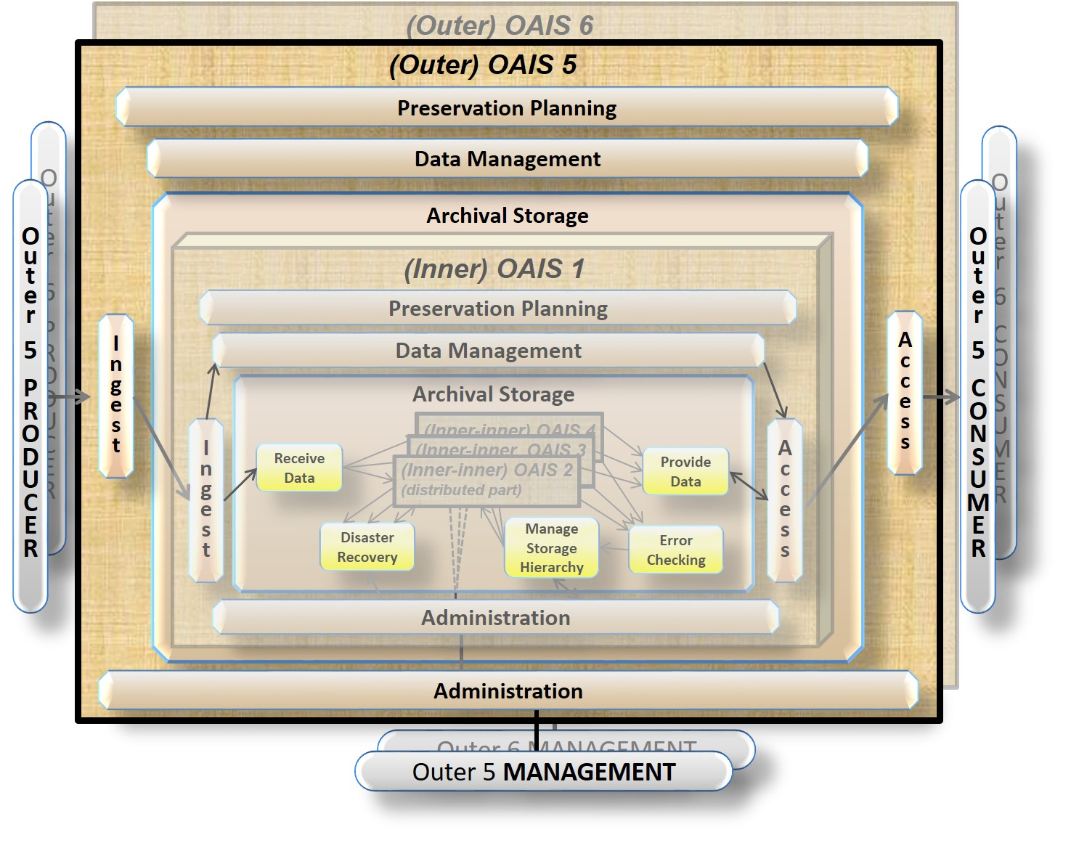
In this example, the focus on OAIS 5 would mean that the OAIS 5 is the Outer OAIS depending on the Inner OAIS 1. A similar case can be made for OAIS 6 as an Outer OAIS that also depends on the OAIS 1 as an Inner OAIS.
Figure 6-7: Another Example of a Distributed OAIS Archive for Archival Storage

Further and more detailed examples can be found in [D13] and [D14].

