Ch 1

These blank pages are to keep the section numbering correct, without having to alter the numbering system.
The proposed text starts at section 6.
This was created by accepting all changes in 650x0w2x1JGG20180821.doc and then removing the text from all but section 6. I did have to put some diagrams back in section 6 for some reason.

Ch 2

Ch 3

Ch 4

Ch 5

ARCHIVE INTEROPERABILITY
A single OAIS may be geographically distributed but with all parts under the same Management, for example the Archival Storage Functional Entity could be divided over several separate locations to increase resilience against disaster.
An OAIS may wish to work with other OAISes, each with separate Managements, and with organisations which are not OAISes. It may wish to do this, for example, in order to carry out its preservation activities or to provide services to Consumers and Producers. A number of such configurations are described below. Working with other organisations could also be advantageous for example because
users of multiple OAISes may have reasons to wish for some uniformity or cooperation among them. For example, Consumers of several Archives may wish to have:
- common Finding Aids to aid in locating information across several Archives;
- a common Package Description schema for access;
- a common DIP schema for dissemination; or
- a single global access site.
Producers may wish to have:
- a common SIP schema for submission to different Archives; or
- a single depository for all their products.
Managers may wish to have means for
- cost reduction through sharing of expensive hardware, software, and preservation efforts; and
- increasing the uniformity and quality of interactions with several Archives.
Therefore, it may be advantageous for Archives to cooperate to meet these wishes. The motivation might come from the Archives themselves, or an authority that has some influence over them may impose it. In the former case, the Archive might be motivated by:
- desire to reduce costs;
- desire to keep Consumers happy with their products;
- desire to keep users happy with their quality of service; or
- the need to compete with other Archives in order to survive or grow.
Situations like this can and have motivated agreements without the need for any explicit federation establishing an external authority. However, in cases where explicit federation is established, the external authority is represented in this Reference Model by Management.
In general one OAIS is not interoperable with another; however, there are a number of reasons that some level of interoperability may be desirable, motivated for example by Users, Producers or Management; even interoperable Archives may have different Designated Communities—even for the same digital objects—and hence different requirements for Representation Information and/or Descriptive Information.
The following subsections describe a number of ways in which this may occur and the advantages of each.
Subsection 6.1 gives an overview of the types of dependencies which may occur between an OAIS and other organisations, some of which may themselves be OAISes. Subsection 6.1.1 provides a view of an independent OAIS in this context. Subsection 6.2 provides more details of these organisational arrangements. while subsection 6.3 discusses some technical issues.

Overview of types of Organisational Interactions with an OAIS
As a way to organise the ways in which an OAIS may work with other OAISes and organisations one can discuss the possibilities according to whether the OAIS plays the roles of Consumer, Producer, service user or service provider.
The terminology such as cooperating, federated, inner etc are explained in the following subsections.
Table 6-1 Possible OAIS interactions
Interoperability with→ | Itself | Other OAIS | non-OAIS
OAIS plays the role ↓
Consumer | Independent i.e. using information such as RepInfo which it is preserving | Cooperating archive | Independent archive
Producer | Independent i.e. creating information to be preserved | Cooperating archive | Independent archive
Service user | Independent i.e. using its own services to preserve | Outer OAIS | General distributed archive
Federated archives and
Archives with shared functional entities
Service provider | Independent  i.e. providing services to itself |  | Independent archive
 |  | Inner OAIS

Independent Archives
An independent Archive is assumed to serve only a single set of Designated Communities. The Archive and each Designated Community must agree on the design of their DIPs and Finding Aids. An independent Archive may choose to design these structures based on formal or de-facto standards, which would allow cooperation with other Archives that implement the same standards. However, the design decisions to use these standards are not based on the possibility of inter-operation with other Archives, but rather on local requirements and cost savings.
The classification of an Archive as independent is not based on its size or distributed functionality. An independent Archive may occupy one site, or may be physically distributed over many sites. It may use many standards for a given internal element. However, if there is no dependence with other organisations, the Archive is independent.
The OAIS provides and uses a number of internal services, some of which are described in section 4.2, in order to preserve its holdings. In particular it may play the role of a Consumer of its own preservation services when it preserves, for example, Representation Information that it requires for its AIPs. It can also play the role of a Producer as it creates, for example, Provenance Information or some Content Data Object which it needs to preserve.

General Distributed Archives with Distributed Functional Entities
A distributed OAIS with distributed functionalities is one which has entered into agreements with other organisations to provide some or part of their functional entities.
Such a distribution of functional entities of an OAIS, as well as their collaborative composition into distributed OAIS, can be of a physical, organizational, or administrative nature. The motivation for such a distribution of functional entities of distributed OAIS may be to take advantage of the competencies and capacities of the contributing organisations in a way that enables the OAIS to conform to this standard.
The distribution of functionalities would normally be achieved through formal, contractual, service level agreements. However it should also be considered that some of these objectives might be accomplished through voluntary action. This is an important dimension in the association of systems, including Archives, because it establishes the degree of autonomy for each system. At the heart of the autonomy issue is the ease with which an association may be altered by one of the participants. Some possible characterizations of autonomy levels might be:
- No interactions and therefore no association.
- Associations that maintain an association member’s autonomy. An association member may have to do certain things to participate, but can leave the association without notice or impact. A non-OAIS example is participation in the Internet, including operation as a domain name server. A member will need to meet certain requirements to participate, including the maintenance of a site with certain characteristics, but the member will in effect be expunged from the association if the site simply stops conforming. However, there is no penalty for this. Therefore, the members maintain full autonomy the whole time because they are free, without penalty, to do what they want.
- Associations that bind an association member by contract. To change the nature of this association, a member will have to re-negotiate the contract. The amount of autonomy retained depends on how difficult it is to negotiate the changes. The difficulty may rise as more entities become a party to the contract.
So, the level of autonomy is a key one for interacting Archives, determining the ease with which each can effect changes in the nature of the association and the impact/penalty to each for recovering full autonomy. This dimension is different from the degree of technical homogeneity the association implements or supports, but it is not totally independent. For example, a high degree of technical homogeneity can be achieved in a broad association where each participating entity is free to leave without penalty. However, the permanence of such an association cannot be guaranteed, and may be improved by making it more difficult to re-negotiate the association, or by establishing penalties for recovering full autonomy. Also, a given degree of technical homogeneity might be achieved more rapidly and at lower cost when the contract is more binding.
The following subsections discuss the various options shown in Table 6-1.

Cooperating Archives
Cooperating Archives are based on standards agreements among two or more Archives. The simplest form of cooperation between Archives is when one Archive acts as a Consumer of material from another Archive. In this case the consuming Archive must support the DIP format of the producing Archive as a SIP format. Cooperating Archives may have related communities of interest, so they order and ingest data from other cooperating Archives and possibly have common data Producers. No common access, submission or dissemination standards are assumed. The only requirement for this architecture is that the cooperating groups support at least one common SIP and DIP format for inter-Archive requests. The control mechanism for this sort of inter-operation may be Event Based Order requests at each Archive.
Figures 6-1 and 6-2 illustrate the concept of cooperating Archives.
At a rudimentary level of Archive interaction, figure 6-1 represents a simple mutual information exchange agreement between Archives.
NOTE – In this and the following figures, the OAIS is represented as a multi-port device following the arrangement of figure 6-1. In each case, a two-Archive federation is shown for simplicity, although the concept can be extended indefinitely.
The essential requirement for this federation is a set of mutual Submission Agreements, Event Based Orders, and user interface standards to allow DIPs from one Archive to be ingested as SIPs by another. Therefore, it assumes that some pair-wise compatibility has between established between the Archives. This does not necessarily require common access, dissemination and submission methods for all participants, although that might encourage more exchange. This level of agreement would also be useful when the holdings of one Archive were consolidated/transferred into another Archive because of Management issues.
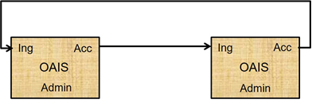
Figure 6-1 : Cooperating Archives with Mutual Exchange Agreement
Figure 6-2 is an example of OAIS Archives that have standardized their submission and dissemination methods for the benefit of users. No special external element is needed for this. Its disadvantage is that there is no formal mechanism for exchange of Description Information so Consumers must have separate Search Sessions to locate AIPs of interest.
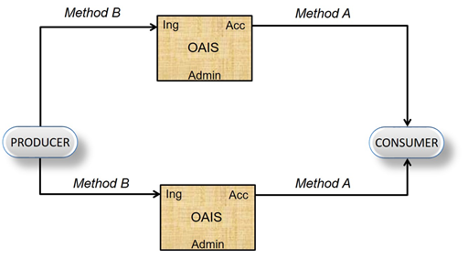
Figure 6-2 : Cooperating Archives with Standard Ingest and Access Methods

OAISes as Mutual service providers and users
OAISes can share their services, either combining them or by one OAIS providing one or more of its services to another OAIS. The following subsections describe a set of different options for such mutual service provision.

Federated Archives
Federated Archives are conceptually Consumer-oriented. In addition to the Local Community (i.e., the original Designated Community served by the Archive), there exists a Global Community (i.e., an extended Designated Community) which has interests in the holdings of several OAIS Archives and has influenced those Archives to provide access to their holdings via one or more common Finding Aids. However, the Local Consumers are likely to have access priority over the global Consumers.
At the federated level of association, external elements can be introduced to improve inter-operability. For example, figure 6-3 illustrates a functional architecture to solve the Access problem described in 6.2.1, using an entity external to the Federated OAISes. Here, two OAIS Archives that have similar Designated Communities have decided to federate to allow Consumers to locate Archival Information Packages of interest from either OAIS with a single Search Session. The Common Catalog & Manager is the external (global) binding element that serves as a common access point for the information in both Archives. DIPs containing the Finding Aids from each OAIS are ingested into the Common Catalog as is shown by the dotted lines in figure 6-3. The Common Catalog may limit its activity to being a Finding Aid or it may include common dissemination of products from either or both OAISes as shown by the dashed lines in the figure.
NOTE – Extra access ports are added to the diagram to illustrate the potentially differing views of each consumer community.
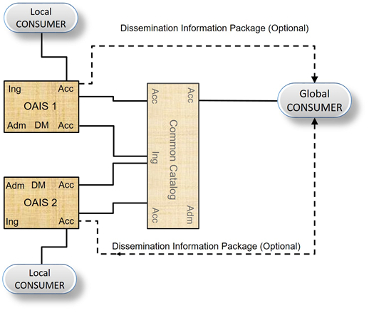
Figure 6-3 : An OAIS Federation Employing a Common Catalog
Federated Archives may be further classified into three levels of functionality.
- Central Site: Global access is accomplished by the export of a standard-format Associated Descriptions to a global site. The global site independently manages a set of descriptors from many Archives and has Finding Aids to locate which Archive owns a collection of interest. The Consumer is given a combined view of the holdings of multiple sites, which is maintained centrally. To view details of the documents, the user must access the site that contains the actual document. This is made easier when sites and clients support a standard set of protocols.
- Distributed Finding Aid: Global access is accomplished by having a global node that can distribute a query to multiple local Archives. This means that the local Data Management Functional Entity must store an additional Associated Description in the global format or have a translator from the global queries to local queries.
- Distributed Access Aid: Global access is accomplished through addition of a standard ordering and dissemination mechanism, available through the global nodes to the functionality of the Distributed Finding Aids discussed above. This is a fully functional, federated system. Here, the global system may influence the Associated Description schema designs in each local Archive; it would be optimal to build new local Archives based on the global schemas and Finding Aids to ensure high degrees of inter-operability.
There are several major policy/technology issues that must be addressed when an OAIS joins a Federation. These issues include:
- Unique AIP Identifiers for each AIP in the Federation; it would be advantageous for these identifiers to be Unique Persistent Identifiers within some specified naming system. An OAIS has the responsibility to provide each of its AIPs with a unique identity. When an OAIS joins a Federation, there is no assurance that some of its current OAIS AIP identifiers are not already used by other members of the Federation. An example of a general solution to this problem is to form the AIP identifiers in the Federation by assigning a Unique ID for each OAIS in the Federation and concatenating it to each AIP preserved by that OAIS. This OAIS name could be formatted according to a standard that gives the Consumer or other Federation members the information needed to establish a connection to the OAIS that contains the AIP of interest. An example of a standard that accomplishes this is the ISO X.500 Directory Services.

- Duplicate AIPs in several different OAISes with different AIP names. This problem is caused by the fact that prior to Federation, some OAISes will have ingested the same Content Information. In this case a Global Consumer will see all the copies as separate, uniquely identified AIPs. Detailed examination of the PDI associated with the Content Information should allow the Consumer to locate the original, authoritative copy, but the search process could be very frustrating to the user. A practical way to handle this is to have a field in the Associated Description of all AIPs that identifies whether they are the original or a copy. This technique is not effective if, prior to federation, two or more Archives received the Content Information from the Producer to Archive. In this case the federated Archive would view these duplicate AIPs as unique, original AIPs.

- The Preservation of Federation Access to AIPs when an OAIS terminates operations. Unfortunately, many Archives will close while their holdings still are of value to the Federation community. The federation should have an agreement for each member OAIS, which states which OAIS has the responsibility to take over the preservation of a closed OAIS’s holdings.

- User Authentication and Access Management for global users. If an OAIS has a policy that restricts the access to some of its AIPs or charges for the dissemination of some Information Packages, there is a problem of how to identify and authenticate the user who is making requests through the central node. Each OAIS will have implemented an Authentication and Access Management system for its Local Users and the infrastructure for this function will have to be extended to include Global Users. Some examples of techniques used for this in current systems are:

- Default priorities where all members from the Global Node share a common set of access constraints and the Global Node handles all the authentication to verify the Consumer as a legitimate user of the Global node. The authentication at member OAIS is done assuming that all requests from the global node are from a single user.

- User Credential passing where the specific remote user can be authenticated by any of the Federation OAISes and the global node simply acts as an intermediary to carry the authentication dialog.
There are many factors influencing the decision of which of these techniques should be used by a specific Federation. The major criterion is the granularity of the Access Constraints in the Federation. If there is little private data and no charge for data dissemination, a policy that determines a user’s access constraints by the source he uses to discover and order AIPs is very reasonable. This involves little modification to the OAIS Authentication system, simply adding the Global Node as a Consumer. The Global Node will have to include mechanisms to identify Global Users to each of the Federated OAIS Authentication mechanisms.
If there are charges for disseminating preserved information or significant private data that needs individual user authentication, the proxy techniques will not be sufficient, and User Credential passing techniques such as passwords and Certificates must be applied. The technologies to enable these supporting mechanisms are still evolving.

Archives with Shared Functional Entities
In an association involving Archives with shared functional entities, Management has entered into agreements with Archives to share or integrate functional entities. The motive for this may be to share expensive resources such as a hierarchical file management system for Archival Storage, a peripheral device for Ingest or dissemination of Information Packages or supercomputers for complicated transformations between SIPs, AIPs or DIPs. This association is fundamentally different from the previous examples, in that it is no longer possible to ignore the internal architecture of the Archive.
Figure 6-4 illustrates the sharing of a common storage function, consisting of an Archival Storage Functional Entity and a Data Management Functional Entity, between two Archives, OAIS 1 and OAIS 2. The Access and Ingest facilities can be at any of the previously described levels of inter-operability. In fact, each Archive can serve totally independent communities as implied in this figure. However, for the common storage element to succeed, standards are needed at the internal Ingest-storage and Access-storage interfaces.
Additional potential shared services include registries of Representation Information and name resolvers such as the DNS. In the former case a registry of Representation Information should also be an OAIS and the Representation Information it holds should be part of the Content Information it holds. The Representation Information it holds might, for example, be part of the Representation Information Network for the Content Information within an AIP in another OAIS. In such a case the OAIS holding that AIP may cache copies of the Representation Information Network held in the registry. Whether it does so or instead relies on the registry to maintain the Representation Information Network, the ultimate responsibility for the understandability of the Content Information remains with the OAIS which holds the AIP.
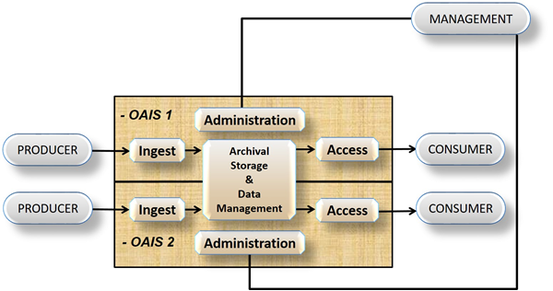
Figure 6-4 : Archives with Shared Storage

Inner OAIS and Outer OAIS
Rather than sharing functional entities equally, one OAIS may provide one of its functional entities as service to another OAIS. The service provider will be referred to as the inner OAIS, while the service user will be referred to as the outer OAIS. Note that the outer OAIS requires the inner OAIS in order to fulfil its preservation responsibilities. One advantage of this way of doing things is that the inner OAIS can be evaluated by using, for example, ISO 16363 [XXX].

Figure 6-5 illustrates an example of an overall OAIS with physically, organizationally, and administratively distributed Archival Storage Functional Entities which themselves use distributed functions managed by other OAISes. In this way the inner OAIS(es) contain different parts of the functions that constitute the Archival Storage for the overall (outer) OAIS. In other words, the Functions in the inner OAISes are contributing to the overall distributed OAIS, which is built by a distributed complementary collaboration between several OAISes. The involved functional entities and functions of each of the participating OAISes can be at any of the previously described levels of interoperability. In fact, each OAIS in this sense holds a part of the overall functional entities and functions that serves very independent parts of the overall distributed OAISes.
The outer OAIS example from Figure 6-5 can only be considered as an OAIS if the distributed parts (the inner OAIS) are taken into account, since it will not have an OAIS Archival Storage Functional Entity without them. The outer OAIS manages the inner OAIS by acting as part of Management and defining themselves as Producer and Consumer to the inner OAIS. This means that they become the Designated Community, which is only interested in preservation of bit streams constituting AIPs for the outer OAIS, while all preservation related to interpretation of bit streams remains in the outer OAIS. This also means that the outer OAIS will exclude parts of the Preservation Planning as e.g. Monitoring Technology related to media migration and Developing Preservation Strategies, to ensure that threats to copies are mitigated. Instead, these parts of the Functions are handled by the inner OAIS.
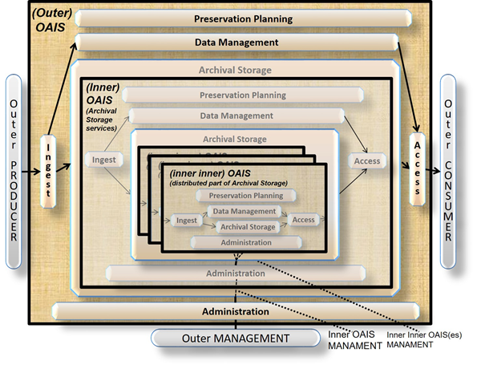
Figure 6-5: Example of a Distributed OAIS Archive for Archival Storage

In the same way as for the outer OAIS, the inner OAIS in Figure 6-5 can only be considered as an OAIS if the distributed parts (the inner inner OAISes) are taken into account. The Management of the inner inner OAISes is also defined in the same way. In this example, parts of the Preservation Planning as e.g. Monitoring Technology related to media migration is placed in the inner inner OAISes, while Developing Preservation Strategies to ensure that threats to copies are mitigated - will remain in the Inner OAIS.
The inner inner OAISes in Figure 6-5 are not dependent on other OAISes, but they only serve a very narrowly defined Designated Community small parts of the Functions that in the overall contributes to the outer OAIS, and with no required knowledge of how they contribute to this or other outer OAISes.
Another example of distributed OAIS for Archival Storage is if the Outer OAIS is only collaborate on replicated copies as illustrated in Figure 6.6

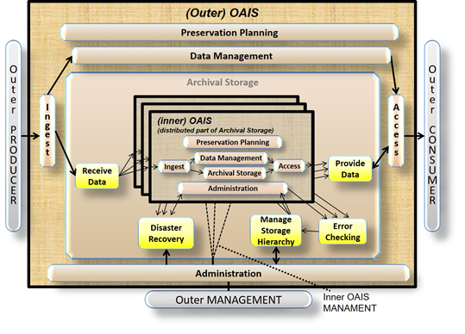
Figure 6-6: Another Example of a Distributed OAIS Archive for Archival Storage

In this example all Preservation Planning concerning media migration and functions related to Replace Media are distributed to the Inner OAISs as well as parts of the other Archival Storage Functions. On the other hand, the Developing Preservation Strategies to ensure that threats to copies are mitigated will remain in the Outer OAIS.
A third example of distributed OAIS for Archival Storage would be if the Outer OAIS manage one of the copies and have the other copies at different organization. In this case distribution of the different Functional Entities and Functions would be different.

Technical issues with Interoperability of Archives
Interactions between Archives and other organisations requires agreements, formal and informal, covering many areas, in order to make the archives interoperate. Section 6.2 describes the potential interactions, each of which will require organizational and management arrangements. This section discusses some of the technical agreements which must be agreed in order to implement these interactions..
Each time the OAIS exchanges data with another organisation the agreements include:
- the protocol(s) to be used in the transfer e.g. TCP/IP, HTTP, USB memory stick etc
- the interfaces to use
- the definition of the packages (SIP/DIP/AIP) transferred
- the processes which the sending and receiving organisations should follow
It is expected that there will be other standards developed which will specify these agreements and processes.

