Distributed Archives with Distributed Functional Entities
A distributed OAIS with distributed functional entities can appear in the form of, e.g., an OAIS that has entered into agreements with other OAISes to link or integrate their distributed functionalities or/and services in a complementary way.
Such a distribution of functional entities of an OAIS, as well as their collaborative composition into distributed OAIS, can be of a physical, organizational, or administrative nature. The motivation for such a physical, organizational, or administrative distribution of functional entities of distributed OAIS may be to distribute resources to achieve the complete set of functional entities to establish a distributed OAIS in a complementary and collaborative way, to mitigate risks or outsource parts of the OAIS in a way that enables the OAIS to remain an OAIS.
This type of association of functional entities of an OAIS is fundamentally different from the previous examples, in that it does not only federate, share or cooperate with respect to. functional entities but physically, logically or organizationally distributes them in accordance with competencies and capacities of contributing archives, locations, organizations or administrations.
Figure 6-5 illustrates an example of an overall OAIS with physically, organizationally, and administratively distributed Archival Storage Functional Entities which themselves use distributed functions managed by other OAISes. In this way the inner OAIS(es) contain different parts of the functions that constitute the Archival Storage for the overall (outer) OAIS. In other words, the functions in the inner OAISes are contributing to the overall distributed OAIS, which is built by a distributed complementary collaboration between several OAISes. The involved functional entities and functions of each of the participating OAISes can be at any of the previously described levels of interoperability. In fact, each OAIS in this sense holds a part of the overall functional entities and functions that serves very independent parts of the overall distributed OAISes.
The outer OAIS example from Figure 6-5 can only be considered as an OAIS if the distributed parts (the inner OAISes) are taken into account, since it will not have an OAIS Archival Storage Functional Entity without them. The outer OAIS manages the inner OAIS by acting as part of Management and defining themselves as Producer and Consumer to the inner OAIS. This means that they become the Designated Community, which is only interested in preservation of bit streams constituting AIPs for the outer OAIS, while all preservation related to interpretation of bit streams remains in the outer OAIS. This also means that the outer OAIS will exclude parts of the Preservation Planning as e.g. Monitoring Technology related to media migration and Developing Preservation Strategies, to ensure that threats to copies are mitigated. Instead, these parts of the Functions is handled by the Inner OAIS.
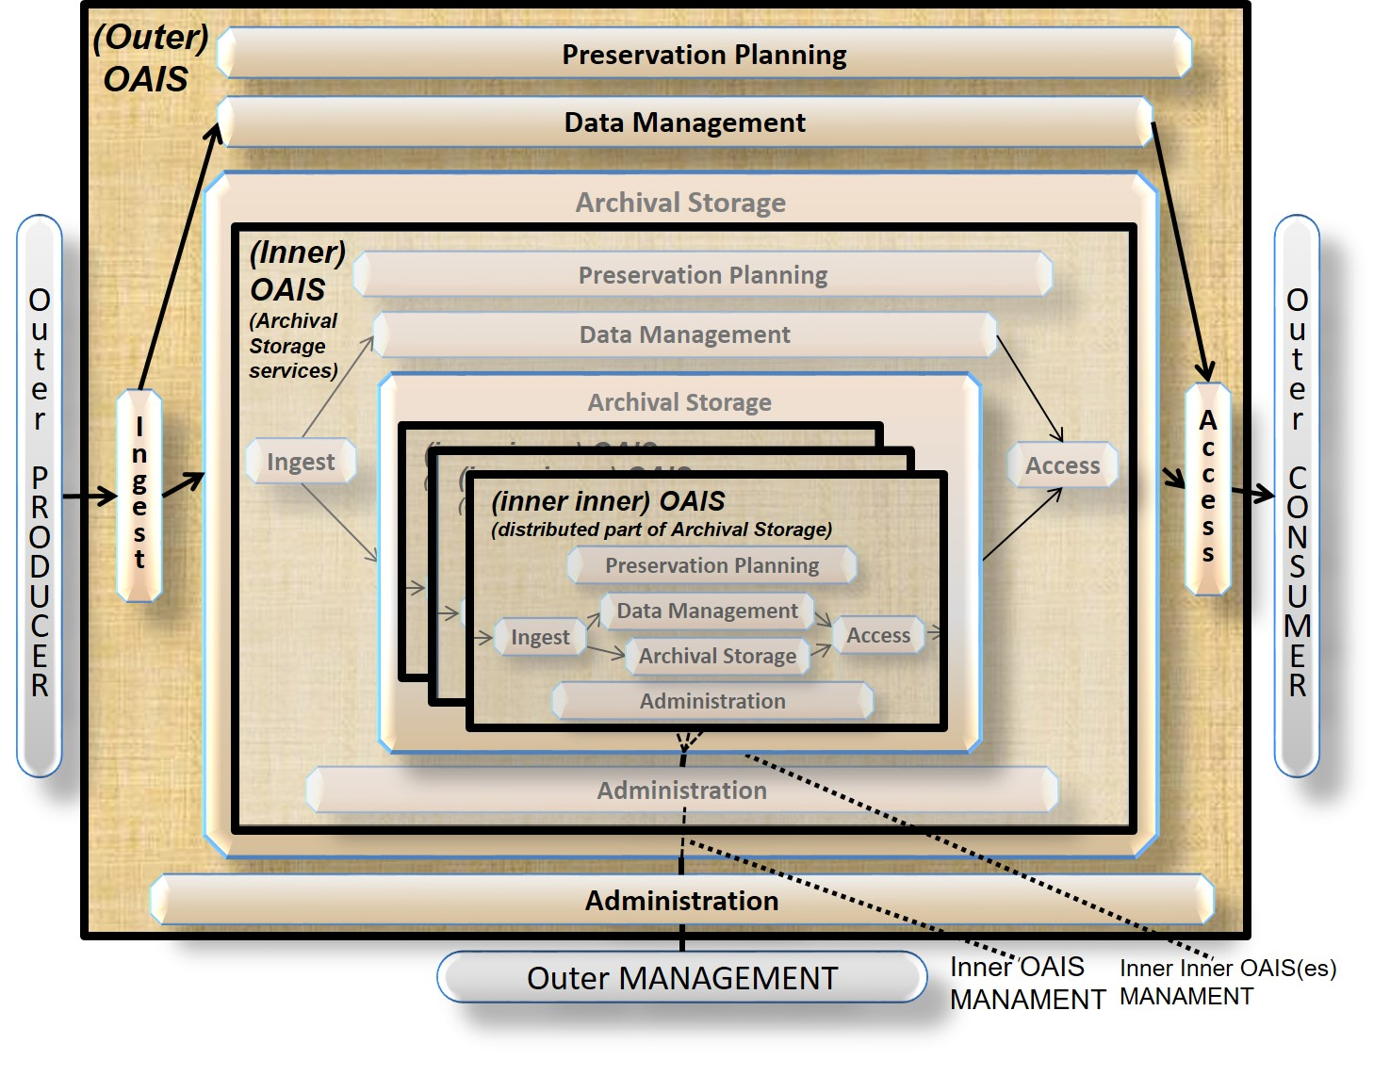
Figure 6-5: Example of a Distributed OAIS Archive for Archival Storage
In the same way as for the outer OAIS, the inner OAIS in Figure 6-5 can only be considered as an OAIS if the distributed parts (the inner inner OAISes) are taken into account. The Management of the inner inner OAISes is also defined in the same way. In this example, parts of the Preservation Planning as e.g. Monitoring Technology related to media migration is placed in the inner inner OAISes, while Developing Preservation Strategies to ensure that threats to copies are mitigated - will remain in the Inner OAIS.
The inner inner OAISs in Figure 6-5 are not dependent on other OAISes, but they only serve a very narrowly defined Designated Community small parts of the Functions that in the overall contributes to the outer OAIS, and with no required knowledge of how they contribute to this or other outer OAISs.
Another example of distributed OAIS for Archival Storage is if the Outer OAIS is only collaborate on replicated copies as illustrated in Figure 6.6

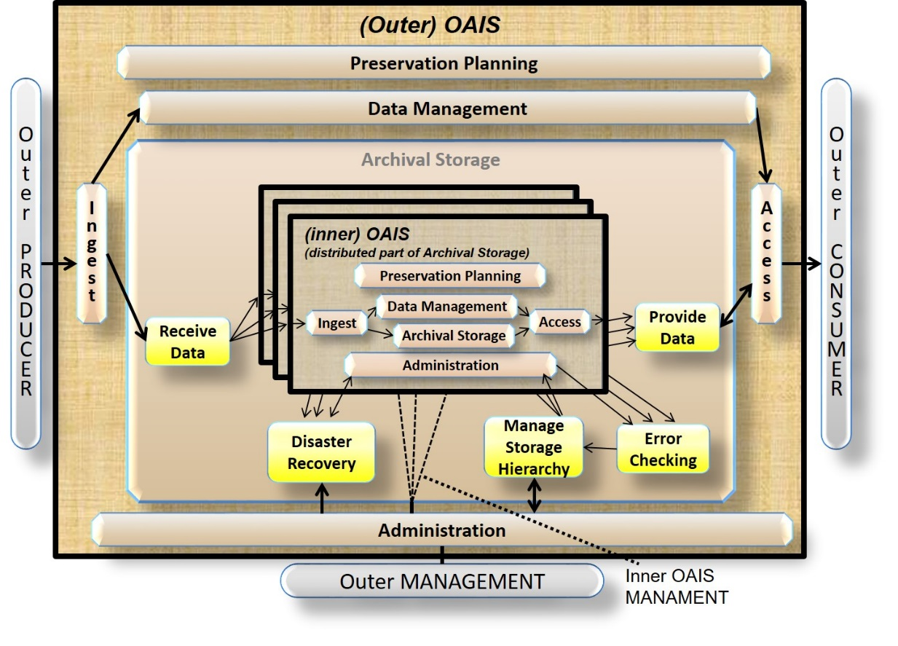
Figure 6-6: Another Example of a Distributed OAIS Archive for Archival Storage
In this example all Preservation Planning concerning media migration and functions related to Replace Media are distributed to the inner OAISes as well as parts of the other Archival Storage Functions. On the other hand, the Developing Preservation Strategies to ensure that threats to copies are mitigated will remain in the outer OAIS.
A third example of distributed OAIS for Archival Storage would be if the outer OAIS manages one of the copies and have the other copies at different organizations. In this case distribution of the different functional entities and functions would be different.

