6.1.5 Virtual Archives with Distributed Functional Entities
A quasi Virtual OAIS with Distributed Functional Entities can appear in the form of, e.g., an association involving an OAIS with distributed Functional Entities that has entered into agreements with other OAISs to link or integrate their distributed functionalities or/and services with each other in a complementary way.

Such a distribution of Functional Entities of an OAIS as well their collaborative composition into a quasi Virtual OAIS, can be of a physical, organizational, or administrative nature. The motivation for such a physical, organizational, or administrative distribution of Functional Entities of a quasi Virtual OAIS may be to distribute resources to achieve the complete set of Functional Entities to establish a quasi Virtual OAIS in a complementary and collaborative way.

This type of association of Functional Entities of an OAIS is fundamentally different from the previous examples, in that it does not only federate, share or cooperate w.r.t. Functional Entities but really physically, logically or organsiationally distributes them in accordance with competencies and capacities of contributing archives, locations, organisations or administrations.

Figure 6-5 illustrates an example of a Virtual OAIS with physically, organizationally, and administratively distributed Archival Storage Functional Entities which themselves use physically distributed Functions like Manage Storage Hierarchy, Error Checking, and Desaster Recovery. In this way these functions are contributing to two different and overall distributed OAISs which are build by a distributed complementary collaboration between several OAIS (OAIS 1 and OAIS 2). The involved Functional Entities and functions of each of the participating OAISs can be at any of the previously described levels of interoperability. In fact, each OAIS in this sense holds a part of the overall Functional Entities and Functions that serves very independent parts of the two overall quasi virtual OAISs as implied in this figure.

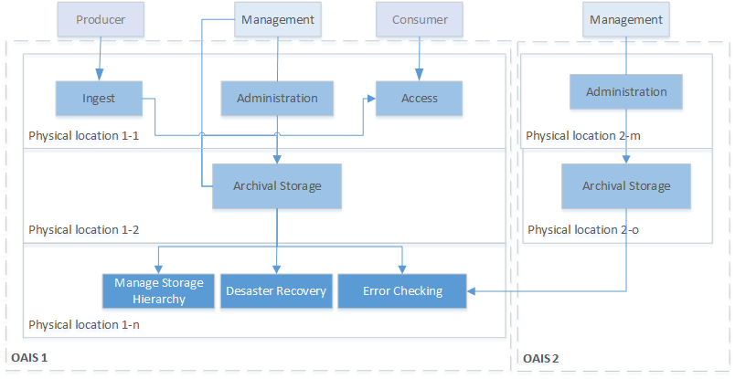
Figure 6-5 Example of two Virtual OAIS with Distributed Functional Entities

