Functional Area: A body of possibly distributed functions or services that addresses a specific need of a Functional Entity, i.e., provides underlying partial functions to it.

6.1.5 Virtual Archives with Distributed Functional Areas or Functional Entities
In an association, involving an OAIS with a Functional Area that has entered into agreements with other OAISs to link or integrate their distributed functions or services with each other in a complementary way. The motivation for this may be to distribute resources to achieve the complete set of Functional Entities to establish a Virtual OAIS in a complementary and collaborative way. This association is fundamentally different from the previous examples, in that it does not only federate, share or cooperate w.r.t. Functional Areas but really distributes them in accordance with Competencies and Capacities of contributing Archives.

Potential distributed Functional Entities include, e.g., registries of Representation Information and name resolvers such as the DNS. In the former case, a registry of Representation Information should also be an OAIS and the Representation Information it holds should be part of the Content Information it holds. The Representation Information it holds might, for example, be part of the Representation Network for the Content Information within an AIP in another OAIS. In such a case the OAIS holding that AIP may cache copies of the Representation Network held in the registry. Whether it does so or instead relies on the registry to maintain the Representation Network, the ultimate responsibility for the understandability of the Content Information remains with the OAIS which holds the AIP.

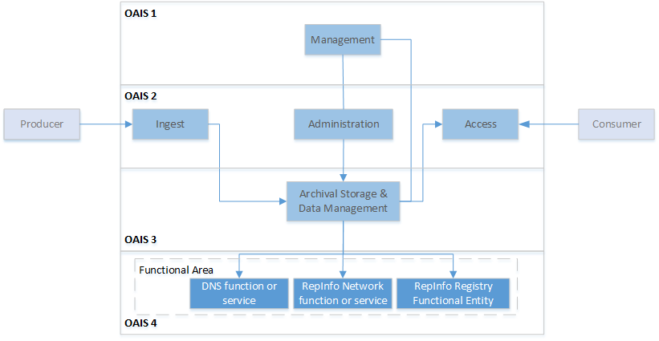
Figure 6-5
Figure 6-5 illustrates a Functional Area supporting an Archival Storage and Data Management, Functional Entity consisting of a RepInfo-, RepInfo Network- as well as a Name Resolver functionality or service, that is itself contributing to an overall distributed OAIS that is build by a distributed collaboration between several OAIS (OAIS 1 through OAIS 4). The involved functionalities or/and services of the OAISs can be at any of the previously described levels of interoperability. In fact, each OAIS in this sense holds a body of functions and services that serves very independent parts of the overall quasi virtual collaborative OAIS as implied in this figure.

