CCSDS RID System – Pre-Requirements
Overview
These requirements address key needs for the next CCSDS RID system upgrade. The RID System should allow more visibility and accountability into RID dispositions for documents that are being submitted for CCSDS reviews
R1.0
The RID System shall support RID submission approval through center-level (optional, depending on specific Agencies) and agency-level.
R2.0
The RID system shall allow the following roles for each document to be tracked by the RID Tool:
- Author
  - At Agency level
  - At CCSDS level
- Viewer
  - At Agency level
  - At CCSDS level
- Coordinator
  - At Agency level
  - At Centre level
  - At CCSDS level (tbd)
- CCSDS Review Coordinator (i.e. usually a WG Chair)
- Administrator
R2.1
For a given Agency the only users allowed to enter RIDs shall be
- Users of that agency having a CWE ID
- Users of that Agency not having a CWE ID but having a RID Review ID granted by the Agency (tbd)
R3.0
The RID system shall allow, based on role, the following activities
- Create RID (Author, ADMIN)
- Update RID (Author, ADMIN)
- Delete RID (Author, ADMIN)
- Search / View RID (including filter or list by category (editorial, etc.) (All)
- Approve RID (Coordinators, ADMIN)
- ACTIONS (placed upon Authors/Reviewers/Co-ordinators during review): Create, search, update, view, review (Coordinators, ADMIN)
R3.1
The RID System shall have an on-line help function providing assistance on how to use it.
R3.2
The RID system shall have an export function (e.g. to Excel, Winword). From the tabular listing sorted by any header, or from a tabular listing resulting from a search query, a user shall be able to click “export” and get an Excel Spreadsheet download of that listing.
R3.3
The RID system shall have a report function displaying a Summary, a detailed Summary or an Action summary.
Note: More details will be given in a second iteration of these requirements
R3.4
The RID system shall provide a screen where the different actors can select the required review (CCSDS can have several reviews on going in parallel and at different lifecycle times)
R3.5
Every RID shall have a number allocated per review (e.g. DDOR BB 01, DDOR BB 02, etc.)). The RID system shall assign a fixed, unique number to each RID entered into the system using a TBD algorithm. Sorts by RID number become possible.
R3.6
Every author shall be able (in addition to the RID Review number) to assign its own number (i.e. Nestor-01, Nestor-02, etc.) when creating the RID
R3.7
The RID status shall be
- draft
- open,
- reviewed by Agency/Centre Coordinator,
- reviewed by CCSDS reviewer,
- closed
R3.8
The RID system shall generate some sort of “nag” email with a “click here to confirm receipt of notification” from all review Coordinators. Also, some sort of notification such as the poll closure reminder to each review coordinator shall help to keep attention on this important activity.
R3.9
The RID system shall allow a new reviewer to request registration to get its role
R3.10
The RID System shall generate automatically, upon request of Viewer / Coordinator/Administrator,all the RIDs raised within his role privileges.
R4.0
The RID lifecycle shall be as follows
- T0 = CCSDS RID Submission Closure Date (RID Closure date after which no additional RIDs are accepted)
This is the international review final date for formal submission of RIDs to CCSDS.
Agency Review is announced and a call for review coordinators is made (these can be one Agency representative (e.g. ESA, NASA, …), but also the Area Directors (they should not come with major RIDs later on at CESG approval time) and other working groups that have an interest in that review. Center and Agency reviews are allowed to have their internal co-ordination provided they respect the RID submittal closure date.
Note:
The elapsed time between the CCSDS Agency Review announcement and T0 is normally 2 months. Coordinators at Agency/Center/Area level are free to plan their internal milestones within this 2 months period.
To support center and agency reviews, these dates will be established:
- T3 = Agency internal RID closure date, it is “n” days before T0 (e.g. 14 days before T0). T3 to be individually decided by each Agency.
- T2 = Agency / Center RID Closure date – Optional, Agency specific, it is after T3 and ”m” days before T0 (e.g. 10 days before T0). T2 to be individually decided by each Agency.
- T1 = Agency coordination deadline – Agency specific, it is after T2 (if T2 exists, or after T3), in general “q” days before T0 (e.g. 1 day before T0).
- Once T0 is due, the CCSDS review Coordinator, together with the WG responsible for the book under review, assesses and dispositions all the RIDs
R4.1
It shall be possible to extend the deadline (RID closure date) easily
Product Selection:
R5.0
The new CCSDS RID System will be developed using either the SharePoint 2013 Platform or an open source system such as Bugzilla.
R5.1
A trade-off shall be performed. The selection of an open source product would require no development, but only adaptation to our process.
R5.2
The RID tool shall be web-based with no need to download any applications.
R6.0
The system shall make a basic consistency check (tbd) to prevent accidental mistakes.
R7.0
Area (ADs/DADs) / WG Chairs shall be able to submit RIDs independently of the Agency Review directly to the CCSDS Review Coordinator.

RID Input Form:
R8.0
The RID system shall provide an online RID entry form like the current online RID entry form.
Example (see also figure): http://public.ccsds.org/sites/cwe/rids/Lists/CCSDS%2091011R2/NewForm.aspx?Source=http%3A%2F%2Fpublic%2Eccsds%2Eorg%2Fsites%2Fcwe%2Frids%2FLists%2FCCSDS%252091011R2%2FNASAUSOverview%2Easpx)
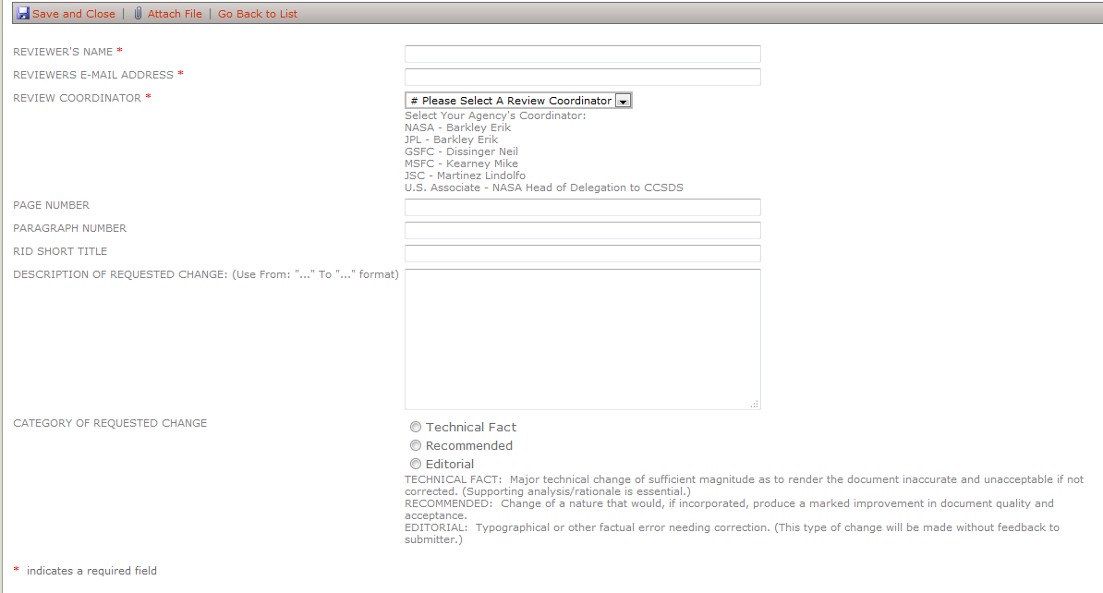

R8.1
The RID form shall have pull down boxes for which Agency/Center the RID Author works for.
R8.2
The RID system shall have a box “Rationale for the requested change”
R8.3
Once the reviewer is registered and has started a session their information shall be filled in automatically on successive RID forms.
R8.4
The RID system shall associate the role of a Review coordinator to an “agency-Center” (NASA-MSFC, NASA-JSC, ESA-ESOC, JAXA, etc.). Agency Center shall have the option “Blank” for those Agencies not needing a Center.
R8.5
It shall be possible to "copy / paste" text sections of any document (word, pdf …) submitted to review into the RID system itself.
R8.6
It shall be possible to attach a file describing for example a diagram or a flowchart to explain a RID
R8.7
The RID System shall provide a batch entry capability (generated via an ASCII text form or MS Word form), to essentially upload all RIDs in one shot and not have to re-enter the same meta-data (e.g, Review Coordinator), etc.
R8.8
Before or during RID entry, the RID Author can see RIDs, which have already been submitted within its Organization (Agency/ Center or Area). This might allow the RID Author to avoid submitting duplicate entries. After the formal Agency submission RIDs are visible to all those having the right privileges (see R3.0)
R8.9
The RID Author shall have access to a tabular listing of RIDs sortable by any header (e.g. unique RID ID or number, author number, etc.), a search capability for RIDs with keywords, and a full-screen display of any RID selected. (like having a pop-up box (other RIDs for this section) that would allow the reviewer to click and then see a list of other RID titles prior to drill down.)

RID Submission Review Capabilities
R9.0
There shall be three levels of “submission concurrence”. This is the concurrence to submit the RID, not related to actually disposition the RID itself. Concurrence to submit occurs in sequence through levels of Coordinators:
- Center level (e.g. JSC, JPL, ESOC, ESTEC, etc.).)
- Agency level (e.g. NASA, ESA, INPE, etc.) and CCSDS Areas
- CCSDS Review Coordinator (the RID coordinator) shall only gather all the RIDS to start the review
This shall be optional and left to each Agency because
- A given Agency may not want to use/have centers
- A given Agency may want to delegate a center to submit RIDs directly
- A given Agency even using Centers may want to have only a centralized approval at Agency level
R9.1
The ability to inject RIDs at agency, at CCSDS Area or international coordinator (i.e. CCSDS liaisons via the Secretariat) level shall be allowed.
R9.2
At each concurrence level, the review coordinators (or an authorized person) shall be able to access the CCSDS RID system and view the RIDs that had been submitted within its Organization or CCSDS Area.
R9.3
The RID System shall have a checkbox for “approved to submit to the next level” (i.e from Center to Agency, from Center to CCSDS Review Co-ordinator, from Agency to CCSDS Review Co-ordinator or from Area to CCSDS Review Coordinator)
R9.4
The checkbox shall offer the following options:
- Approved
- Disapproved
- Not yet reviewed (default status)
R9.5
Coordinators at each level (Center, Agency, CCSDS Area, CCSDS Review Coordinator) shall see a similar display (approved /disapproved / not yet reviewed) and shall have similar capabilities.
R9.6
Coordinators at each level (Center, Agency, CCSDS Area) shall also see a column that displays the result of its coordinator review’s level
R9.7
Coordinators at each level (Center, Agency, CCSDS Area) shall also have buttons for “approve all”, “disapprove all”, “clear all”.
R9.8
Only approved RIDs shall be moved to the next level.
R9.9
There will be a disposition (in effect, rationale or supporting analysis) required for any disapproved RID. This can be implemented via a “disposition” field in the RID form.
R9.9.1
Any disapproved RID shall be sent back to the originator, who can modify and seek concurrence as a new RID or accept the rejection.
R9.10
It shall be only one Agency authority at each level
R9.11
RID authors shall have the capability after its creation to
- save it without forwarding to the coordinator (i.e “Save for later”)
- save it and forward to the coordinator (“Submit”).”.
R9.12
Each RID author shall be able to see the list of his RIDs (saved for later or submitted), open them, revise, and deleted them if they are not yet submitted.
R9.13
A RID author shall be able to delete a “save for later”RID, in which case it shall be marked as “withdrawn”, left in the list, but not forwarded as a submission. .
R9.14
Immediately after the RID submission closure date (T0) the CCSDS Review Coordinator shall be alerted that RIDs are queued for review.
Clarification on the review process:
The Review process shall not last more than 2 months. The CCSDS Review Coordinator has the responsibility of reviewing and resolving RIDs in agreement with the rest of the CCSDS WG.
R9.15
The RID System shall provide to the CCSDS Review Coordinator the capability to select between
- a full-screen view of each RID individually
- a tabular listing with just the short descriptions. On the tabular listing, the user will be able to “approve all”, “clear all” (revert to not reviewed), sort by any header (date, title, RID Author, etc.).
R9.16
The CCSDS Review Coordinator shall also be able to export the tabular listing to Excel (but not import it… selection boxes must be made online).
R9.17
The Agency / Center Coordinators and the CCSDS Review Coordinator shall not update the originator’s RID; they can only return it to the originator and ask for changes.
R9.18
After T0, any RID author, Center / Agency / Area Coordinator must ask the CCSDS Review coordinator to make any potential changes. They are in a “locked in” status.
R9.19
During the review period a RID author shall be able to update its RID only if the status is “forwarding/rejected” .
R9.20
The RID System shall have the capability to generate a report of all existing RIDs at each review level (Center, Agency, CCSDS Area, CCSDS Review Coordinator)

Clarification on the RID Procedure submission for Observers, Associates, Liaisons and Others
- Observer agencies shall submit directly to the CCSDS Review Coordinator after agency level concurrence.
- Associates shall submit to the Agency Review coordinator with which they are associated. Note
  - Associates that are contractors at Agency centers should be handled as Agency center authors. We need guidelines to explain to the RID writer how to figure out his “chain of command” for RID reviews. These guidelines should probably happen when they submit their info for their profile, which they can update at any time (from one review to the next)
- Liaisons and “Others” shall submit RIDs to the CCSDS Review Coordinator.

RID Disposition Capabilities
R10.0
The CCSDS Review Coordinator, together with the related Working Group level shall enter the proposed dispositions and coordinates their proposed dispositions with the RID Authors (during face-to-face meetings or be e-mail or via webex) .
R10.1
The RID Authors shall also be able to see the dispositions on the website.
R10.2
The RID system shall have a checkbox allowing the CCSDS Review Coordinator to submit all RID dispositions.
R10.3
The RID system shall automatically generate e-mails to inform all RID authors about the Review results.
R10.4
Beneath the disposition text, the RID System shall have these check boxes:
- RID Author agrees with disposition
- RID Author disagrees with disposition
And this text field: “RID author statement about disagreement”.
- RID Author allows closure with registered disagreement
And this text field: “RID author statement about disagreement”.
R10.5
After the RID disposition process is over and after it is requested, the RID System database for a particular review of a particular document shall be “locked” into display mode only.
R10.6
Procedurally the RID database shall be locked by the Secretariat when
- requested by the CCSDS Review coordinator,
- directed by the CESG, or
- the document is submitted for a CESG or CMC poll which is based on completion of the RID process.
R10.7
If some additional changes are to be made to the database, the Secretariat, with approval from one of the CESG co-chairs, shall “unlock” the RID database and allow modifications (for example, from “RID Author allows closure with registered disagreement” to “RID Author agrees with disposition”).

Post-RID Review Capabilities
R11.0
All of the “read-only” capabilities described in earlier phases shall be available to any CWE user. Any CWE user shall be able to log onto the RID database for any document at any time (after T0) and see the full-page listing of any RID, or the tabular summary listing. In the process, they shall be able to search for a RID by the content of any of the fields.
R11.1
In the tabular listing displays, any RID with “disapprove” in any column shall get a red or other distinctively colored background.

