Vint Cerf discussions on Digital Preservation
Read first 300 pages of David Giaretta’s book, Advanced Digital Preservation (http://www.springer.com/us/book/9783642168086).
Has some knowledge of our ISO work with OAIS Reference Model, Trustworthy Digital Repositories, Audit and Certification of TDRs, etc.
Believes we need to demonstrate multiple trustworthy digital repositories that can interoperate to move the adoption of the standards forward.
Acknowledges that emulation is only one tool at best.
“Digital Vellum” focused primarily on relatively simple electronic documents, software, and games.
Compound digital objects present special problems.
Mashing up emulated data with current data problematic.
Digital Vellum presentation:
(https://ecolloq.gsfc.nasa.gov/Current/announce.cerf.html)
Similar presentation at: https://www.youtube.com/watch?v=STeLOogWqWk

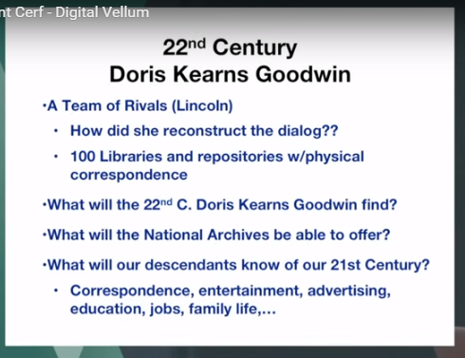

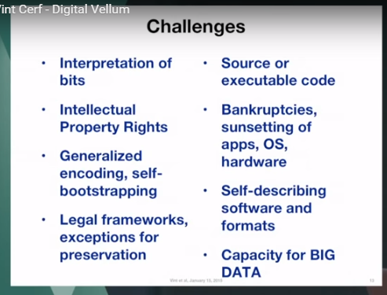

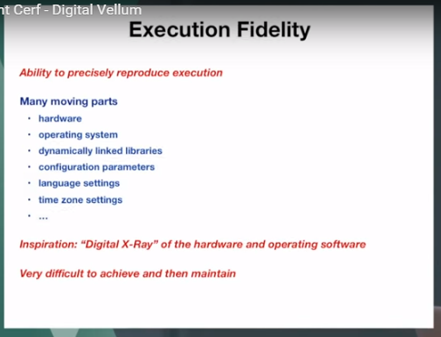
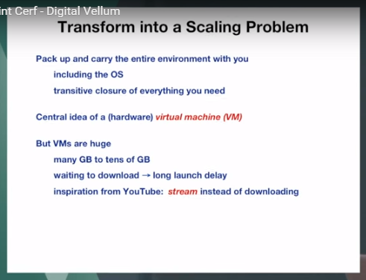
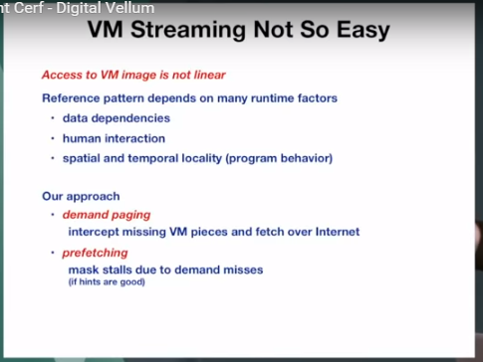
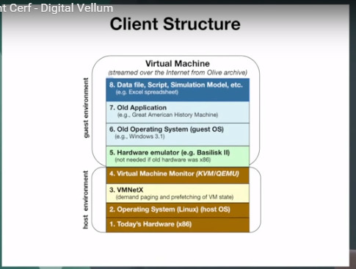
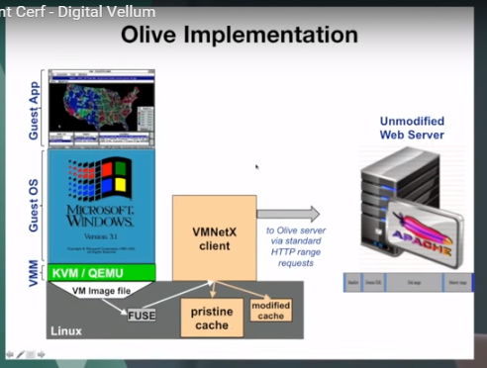
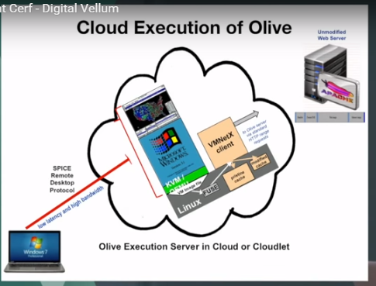
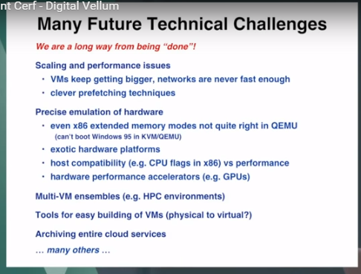
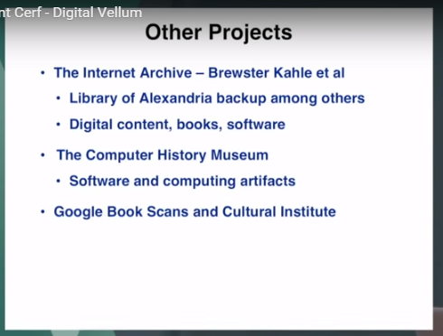

No suggestions for a business model for keeping the data usable for as long as it is needed.
Google in collaboration with the Computer History Museum are collecting software much like the NIST NSRL.

